Design of a Planar Spiral Antenna for Dual Band 5G applications

ABSTRACT
This work presents a customized spiral antenna exhibiting dual band operating in the (3.17-3.53) GHz frequency range which can be used for 5G applications. This frequency range is widely employed for RFID, IoT devices, wireless sensor networks, and short-range industrial communications, all of which demand cost-effective antennas with stable radiation characteristics. The proposed antenna, was designed and optimized on FR-4 substrate with dielectric value (4.3) using CST Studio Suite. It achieved efficient impedance matching and wideband coverage across the S-band. A return loss less than -10 dB and VSWR below 2 were maintained throughout the operating frequency range, confirming proper impedance matching . The antenna exhibits radiation efficiency of 50.1%. Featuring a simple structure, wide operational bandwidth, and stable omnidirectional radiation pattern, the proposed spiral antenna shows strong potential for S-band applications.
Keywords:
compact size, ism, high gain, biomedical, miniaturize size, high efficiency
INTRODUCTION
As modern wireless communication technologies develop, the complexity of microstrip patch antennas has increased correspondingly [1]. Spirals are one of the oldest forms of frequency-independent antennas. Owing to their size, they had been discarded since they were in wide use prior to World War II [2]. The bandwidth of Archimedean spiral antennas makes them good choices for a variety of commercial products [3]. Archimedean spirals dominate in patch antenna designs due to their appropriateness for unidirectional applications; centre-fed Archimedean spirals using baluns traditionally sacrificed frequency independence and generated bulky designs. [4]. The Archimedean spiral antennas' phase centre is not fixed and the relatively complex feeding network will bring massive distortion while broadcasting and receiving wide signals [5]. Spirals are often used in antenna applications and for further miniaturization thanks to their ability to decelerate wave propagation inside the antenna structure, thus enabling size reduction [6]. Spirals are one of the most popular structures when designing frequency-independent antennas [7]. These antennas' materials exhibit distinctly different electrical properties and fabrication techniques than those of traditional metallic antennas, which complicate the design and fabrication process despite the enhancement of flexibility and stretchability. It is worth noting that the good circularly polarized radiation and broad bandwidth are two prominent attributes of the planar spiral antenna. [8][9]. Moreover, its spiral structure inherently possesses mechanical deformability which allows flexibility and adaptability in various physical environments or applications. [10]. When bent or stretched, the in-plane and out-of-plane deformations of spiral antennas can offer flexibility that is necessary for soft electronics. However, the balun structure for balanced-to-unbalanced conversion and impedance transformation in conventional planar spiral antennas is one of the major contributors to the overall antenna bulk [11]. This is against the demand for developing low-profile and miniaturized soft electronic s. The balun structure is relatively difficult to be made flexible since its performance under deformation is sensitive. An Archimedean spiral antenna with a hybrid structure combining both Archimedean and equiangular spirals was proposed by Choi et al. to reduce impedance. [12]. The designs of spiral antennas are generally based on logarithmic or Archimedean geometries [13][14] [15] [16] [17] [18][19]. According to the scaling principle by Rumsey, the Archimedean spiral antennas cannot be considered as fully frequency independent even though they exhibit large operating bandwidths [20]. Logarithmic spirals definitely present more frequency-independent characteristics than the Archimedean spirals especially in the configurations with fewer numbers of turns. [21] [22]. The geometries of the spiral antenna can take up square or circular shapes; it is important to note that the square spiral antennas have desirable features to be used for comparable performance at lower frequencies while considering the first radiating bands as compared to the circular spiral counterparts. [23][24][25]. SPIRAL antennas have been a topic of comprehensive study in the engineering literature since their invention in the 1950s [26]. Some common uses of these antennas include the classic applications in monopulse direction finding systems [27]. Spiral antennas are an excellent choice for mobile and satellite communication antennas because of their broad bandwidth and variation in the emission patterns [28][29][30][31][32][33] [34] [35] [36] [37] [38].

ANTENNA DESIGN GEOMETRY :
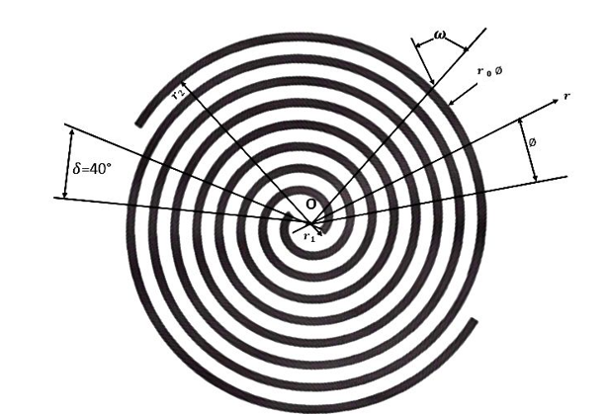
Figure 1: A typical Spiral antenna geometry
In this paper, a self-complementary Archimedean spiral antenna design is shown. The following formulas were used to build the Archimedean spiral: –
${r = r }_{0} ∅ +{ r}_{1}$ and
${r= r}_{0} (∅ - π) +{ r}_{1}$ (1)

Where,
${ r}_{1}$ serves as the spiral's inner radius.
value of $r_{0}$ is established using the subsequent formula. –

$r_{0}$ $= \frac{(s+w)}{π} = \frac{2w}{π}$ (2)
Where,
w is each arm's strip width.
s is the distance between each rotation.
The valse of a self-complimenting Archimedean spiral s is equal to w. This equation can be used to determine the strip width:

s = w =$\frac{r_{2}}{4N}$ (3)

Where,
$r_{2}$ is the spiral's outer radius.
N is the quantity of turns.
The spiral's operational frequency is based on the value of ${ r}_{1}$ and ${ r}_{2}$${ r}_{1}$. Using the fol lowing formula, the outer radius of the spiral determines the lower resonance frequency:
$f_{low}$ = $\frac{c}{2πr_{2} }$ $\frac{c}{2πr }{r= r}_{0}$ (4)

Where,
is light's speed. Likewise, using the following formula, the inner radius of the spiral determines the high resonance frequency.
$f_{high}$ = $\frac{c}{2πr_{1} }$ (5)
The antenna structure is designed to use a FR-4 dielectric substrate with a dielectric constant of 4.4 and a height of 5 cm. [33]. The Archimedean spiral antenna geometry was designed using the empirical formula’s of equations 1.2.3.4 and 5 [33]. The antenna was then optimized to obtain optimum results. The Archimedean spiral structure is inserted into an Archimedean spiral slot engraved into a circular patch antenna intended for a particular frequency. A circular patch with an embedded Archimedean spiral, fed by a microstrip feed line and positioned in the x-y plane with its normal parallel to the z-axis make up the resulting antenna.

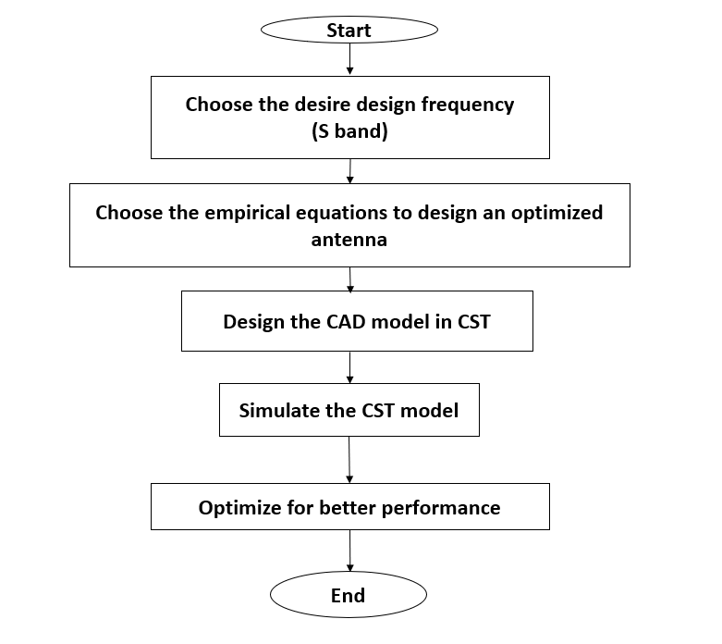
Figure 2 : Antenna Design Flow Chart.
Designing of the proposed spiral antenna employs a holistic approach in order to obtain the best results in the desired frequency band (S-band). The design approach for the antenna is explained in the flow chart in Fig. 1, which gives the entire process starting from the design frequency up to final simulations. The design process starts with choosing the design frequency, which in the proposed design is within the S-band. This aspect of design is very essential, which gives the basis for calculating geometric and electric properties of the antenna. The multi-layer antenna design consists of a metallic top layer in the form of a spiral, which is placed on the dielectric material with a fixed height of B = 5 cm, and a ground plane, which is shown in Fig. 3. Antenna dimensions and properties of the dielectric material, together with values of spirals P, Q, and R, largely determine results in the form of antenna characteristics. These parameters can be optimized through simulation to accomplish desirable characteristics for the antenna such as increased bandwidth or improved radiation patterns. Also, fabrication tolerances and material properties may rob reality from some simulation results in actual performance. The thickness of the metal A and the thickness of the ground C are 0.05 cm each, according to Table 2. In this configuration, mechanical stability will be achieved along with proper isolation, which is important to maintain constant radiation characteristics.

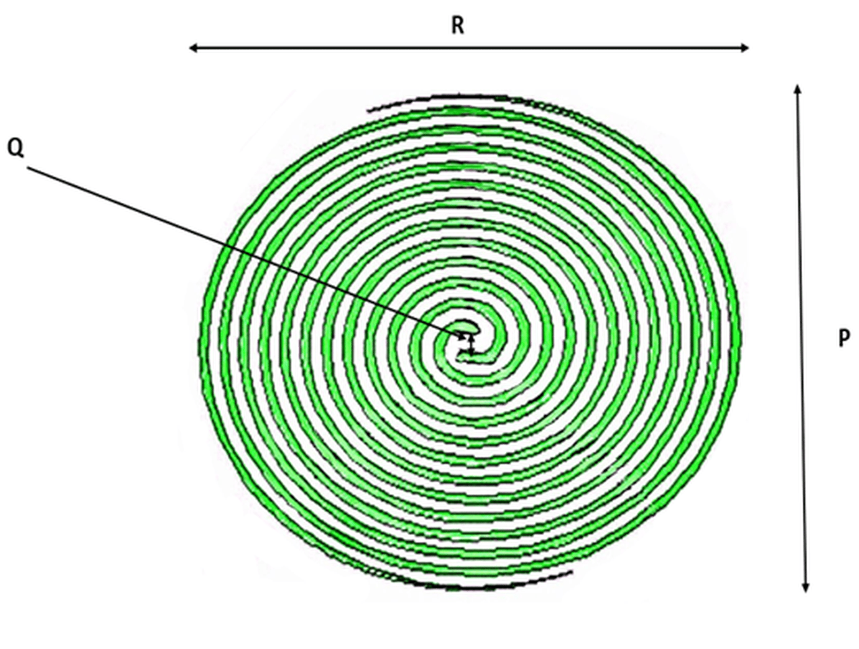

Figure 3: Proposed antenna geometry

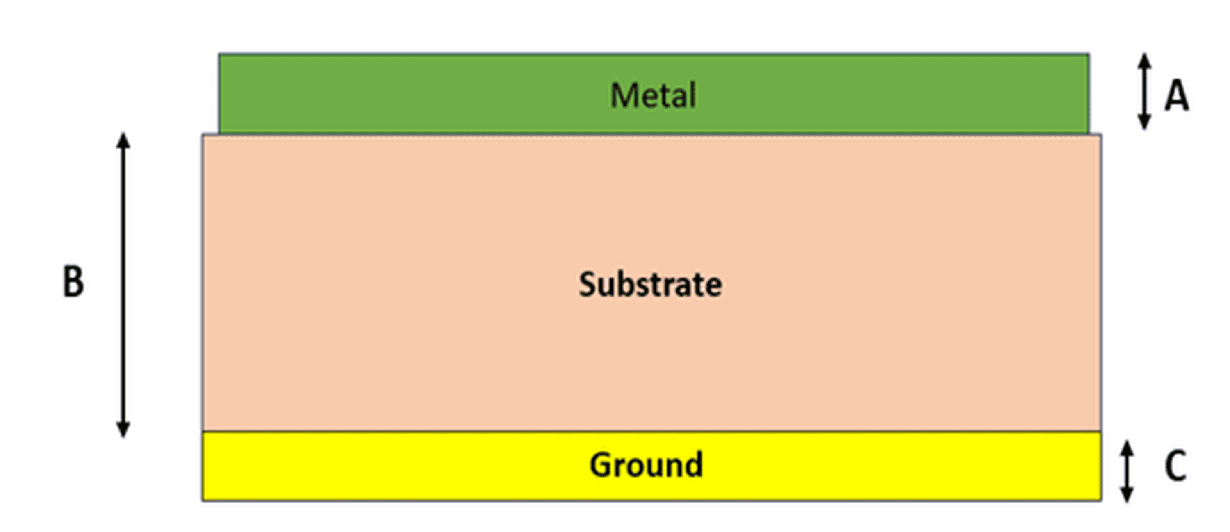

Figure 4: Stacked view of the proposed antenna geometry

TABLE 1: ANTENNA DIMENSIONS

Serial no. | Notations | Dimension(cm)
1 | P | 9.5
2 | R | 9.28
3 | Q | 0.199
4 | A | 0.05
5 | B | 5
6 | C | 0.05

SIMULATION RESULTS
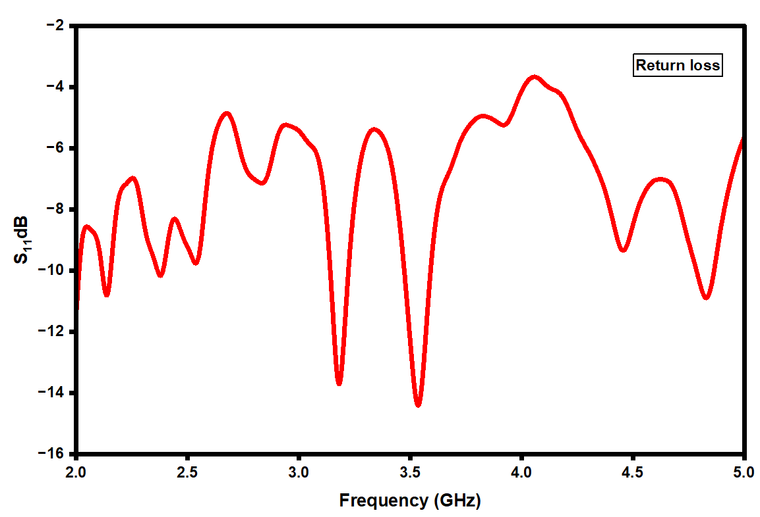

Figure 5 : S₁₁ plot for spiral antenna
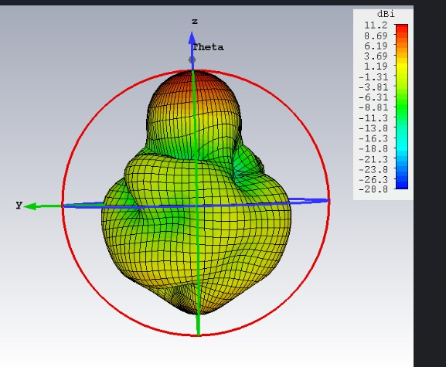
Figure 6 : 3D Gain plot of the antenna
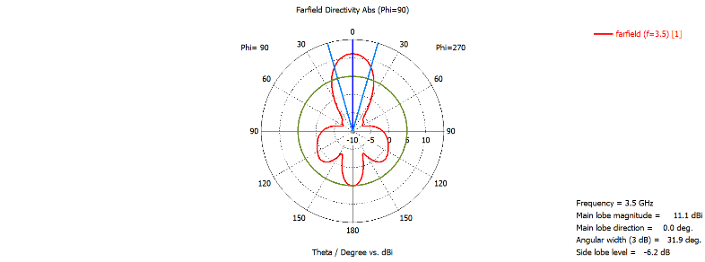
Figure 7 : Polar plot of the antenna

The simulated reflection coefficient (S₁₁) depicted in Fig. 5 exhibits multiple resonance dips below -10 dB indicating good impedance matching and wideband characteristics of the optimized spiral antenna. Meanwhile, Fig. 6 illustrates the antenna’s 3D gain radiation pattern revealing directional or radiation characteristics. Wideband behaviour and impedance matching are crucial for antenna applications ensuring efficient signal transmission and reception. Resonance dips below -10 dB typically signify acceptable impedance matching whereas radiation patterns inform antenna’s directional properties and gain distribution., showing a directional radiation profile with significant gain, suggesting suitability for directional communication applications. The polar radiation plot shown in Fig. 7, exhibit a narrow pencil beam with a well-defined main lobe. These plots confirm the antenna’s directive nature, with a 3 dB beamwidth that supports high directivity and focused radiation
CONCLUSION:
A customized spiral antenna with high efficiency that resonates at 3.17 and 3.53 GHz has been described in the study, observing the outcomes of the simulation. It displays a simulated gain of 11.1 dBi and a radiation efficiency of roughly 50.1%. A state of art comparison table is presented in table 2.It shows that our proposed antenna model out performs the contemporary works in terms of gain and has also moderate a radiation efficiency as compare to other reported works. We can now say that our proposed antenna model is a good candidate if we are going to design antenna for S-band application. Another advantage for our antenna is that it can be used for dual band applications

TABLE 2: STATE OF THE ART COMPARISON
Ref no
Ref no | Parameter
Ref no | Operating frequency (GHz) | Gain  (dBi) | Radiation Efficiency  (%)
34 | 3.25- 3.625 | 5.87 | 97%
35 | 3.1 - 5 | 22 | NA
36 | 3.4 - 3.6 | -22 | NA
37 | 3.6 - 4.1 | -7.37 | NA
38 | 3.3 - 3.7 | -15 | NA
This work | 3.17 - 3.53 | 11.1 | 50.1%.

REFRENCE:
- Banerjee, Utsab, Anirban Karmakar, and Anuradha Saha. "A review on circularly polarized antennas, trends and advances." International Journal of Microwave and Wireless Technologies 12, no. 9 (2020): 922-943.

- Nakano, Hisamatsu, Kazuo Nogami, Satoshi Arai, Hiroaki Mimaki, and Junji Yamauchi. "A spiral antenna backed by reflector a conducting plane." IEEE Transactions on Antennas and Propagation 34 (1986): 791-796.

- D. S. Filipovic and T. P. Cencich Sr., “Frequency independent antennas,” Antenna Engineering Handbook, 4th ed. New York, NY, USA: McGraw Hill, 2007.

- Kinezos, Christos, and Vichate Ungvichian. "Ultra-wideband circular polarized microstrip Archimedean spiral antenna loaded with chip resistor." In IEEE Antennas and Propagation Society International Symposium. Digest. Held in conjunction with: USNC/CNC/URSI North American Radio Sci. Meeting (Cat. No. 03CH37450), vol. 3, pp. 612-615. IEEE, 2003

- A. R. Guraliuc, R. Caso, P. Nepa of a wideband thick Archimedea Wireless Propagation Letters, vol a and J. L. Volakis, "Numerical analysis an spiral antenna," IEEE Antennas and l. 11, pp. 168-171, 2012.

- N. Rahman and M. N. Afsar, "A spiral antenna," IEEE Transactio 61, pp. 54-61, 2013. novel modified Archimedean polygonal ons on Antennas and Propagation, vol.

- Rahman, N., Afsar, M.N., “A Novel Modified Archimedean Polygonal Spiral Antenna,” IEEE Trans. Antennas Propag., vol. 61, no. 1, pp.54-61, 2013.

- J. Kaiser, "The Archimedean two-wire spiral antenna," IRE Trans. Antennas Propag., vol. 8, no. 3, pp. 312-323, June. 1960.

- Bell, and Iskander, "A low-profile Archimedean spiral antenna using an EBG ground plane," IEEE Antennas Wirel. Propag. Lett., vol. 3, no. 1, pp. 223-226, Jan. 2005.

- C. Lv, H. Yu, and H. Jiang, "Archimedean spiral design for extremely stretchable interconnects," Extreme Mech. Lett., vol. 1, no. 3, pp. 29-34, Dec. 2014.

- S. P. Mathur, A. K. Sinha, and A. K. Sinha, "Design of microstrip exponentially tapered lines to match helical antennas to standard coaxial transmission lines," IEE Proc. H, Microw. Antennas Propag., vol. 135, no. 4, pp. 272-274, Sep. 1988.

- K. Louertani and T. Chio, "Hybrid equi-angular to Archimedean spiral antenna," in Proc. 2012 IEEE International Symposium on Antennas and Propagation, July, 2012, pp. 1-2.

- Bawer, R., and Wolfe, J.J., “The Spiral Antenna,”. IRE Int. Convention Record, New York, U.S.A., March 1960, pp. 84-95.

- J. Ely. C. Christodoulou and D. Shively, " Square Spiral Antennas for Wireless Applications,". IEEE NTC Conference, Orlando, FL., May 1995, pp. 229-232.

- K. Hirose, N. Saito, and H. Nakano, “A Cavity-Backed Spiral Antenna with an Unbalanced Feed System—Analyses Using FD-TD and Moment Methods,”. Electronics and Communications in Japan, Part 1, Vol. 88, No. 1, 2005.

- Brown, E. R., Lee, A. W. M., Navi, B.S. and Bjarnason, J.E., “Characterization of Planar Self-Complementary Square-Spiral Antenna in the THz Region,”. Microwave and Optical Tech. Lett., March 2006, Vol. 48, No. 3, pp. 524-528.

- Kramer, B.A., Lee, M., Chen, C.C., and Volakis, J.L., “Design and Performance of an Ultrawide-Band Ceramic-Loaded Slot Spiral,”. IEEE Trans. Antennas and Propagat, Vol. 53, No. 7, July 2005, pp. 2193 2199.

- Filipovic D.S., and Volakis J.L., “Broadband Meanderline Slot Spiral Antenna,”. IEE Proc-Microw. Antennas Propagat., Vol. 149. 2 April 2002, pp. 98-104.

- Dyson, J.D., “The Equiangular Spiral Antenna,”. IRE Trans. Antennas Propagat., 1959, 7, pp. 181-188.

- Rumsey, V.H., “Frequency Independent Antennas,”. 1957 IRE National Convention Record, Pt. 1, pp.114-118.

- Balanis C.A., Antenna Theory-Analysis and Design, Wiley, New York, 1997.

- Kraus, J.D., Marhefka, R.J., Antennas, McGraw-Hill, New York, 2002.

- Bawer, R., and Wolfe, J.J., “The Spiral Antenna,”. IRE Int. Convention Record, New York, U.S.A., March 1960, pp. 84-95.

- Kramer, B.A., Lee, M., Chen, C.C., and Volakis, J.L., “Design and Performance of an Ultrawide-Band Ceramic-Loaded Slot Spiral,”. IEEE Trans. Antennas and Propagat, Vol. 53, No. 7, July 2005, pp. 2193 2199.

- Kaiser, J.A., “The Archimedean two-wire spiral antenna,”. IRE Trans. Antenna Propagat., Vol. AP-8, pp. 312-323, May 1960.

- J. A. Kaiser, “The archimedean two-wire spiral antenna,” IRE Trans. Antennas Propag., vol. 8, pp. 312–323, May 1960.

- R.G.CorzineandJ.A.Mosko,Four-ArmSpiralAntennas. Norwood, MA: Artech House, 1990.

- H. Nakano, R. Satake, and J. Yamauchi, "Extremely low profile, single-arm, wideband spiral antenna radiating a circularly polarized wave ," iEEE Transactions on Antennas and Propagation, vol. 58, No.5, pp. 1511-1520, May 2010.

- H. Nakano, T. Igarashi, H. Oyanagi, Y. Ilisuka, and J. Yamauchi, "Unbalanced-mode spiral antenna backed by an extremely shallow cavity," iEEE Transactions on Antennas and Propagation, vol. 57, no. 6, pp. 1625-1633, June 2009.

- H. Nakano, K. Nogami, S. Arai, H. Mimaki, and J. Yamauchi, "A spiral antenna backed by a conducting plane reflector," iEEE Transactions on Antennas and Propagation, vol. 34, no. 6, pp. 791-796, June 1986.

- H. Nakano, H. Oyanagi, and J. Yamauchi, "Spiral Antenna Radiating a Conical Beam of Circular Polarization," Electromagnetics in Advanced Applications(iCEAA), pp.109-112,July 2010.

- Daeyoung Oh and Ikmo Park, "Two-arm microstrip spiral antenna with a circular aperture on the ground plane for generating a circularly polarized conical beam," iEEE Antennas and Propagation Society international Symposium, vol. 3, pp. 866-869, June 2003.

- Richard C. Johnson, Antenna Engineering Handbook, third edition, Mc-Graw Hill publishing company.

- Sura Khalil Ibrahim, Samir Salem Al-Bawri, Mandeep Jit Singh, Husam Hamid Ibrahim, Mohammad Tariqul Islam, "A High Gain and Low Cross-Polarization Compact Slotted Patch Antenna for 5G Wireless Communication Applications", 2021 7th International Conference on Space Science and Communication (IconSpace), pp.161-166, 2021.

- An Ping Zhao and J. Rahola, "Quarter-wavelength wideband slot antenna for 3-5 GHz mobile applications," in IEEE Antennas and Wireless Propagation Letters, vol. 4, pp. 421-424, 2005, doi: 10.1109/LAWP.2005.859382.

- N Smitha, Kartik Sanagond, B Ankitha, A N Anushree, S Ananya, "Design of Patch Antennas for 5G Applications", 2024 Second International Conference on Intelligent Cyber Physical Systems and Internet of Things (ICoICI), pp.578-583, 2024
.
- K. Karasawa, T. Kusama, A. Komiyama, K. Ashida, T. Karakama and T. Kaneko, "3.7GHz Band Planar Antenna for 5th Generation Mobile Communication System," 2020 IEEE 9th Global Conference on Consumer Electronics (GCCE), Kobe, Japan, 2020, pp. 694-697, doi: 10.1109/GCCE50665.2020.9291870.

- J. Guo, F. Liu and L. Zhao, "A Meta-Surface Antenna Array Decoupling (MAAD) Method for Two Linear Polarized Compact Antenna Elements at 3.5GHz," 2019 IEEE International Symposium on Antennas and Propagation and USNC-URSI Radio Science Meeting, Atlanta, GA, USA, 2019, pp. 633-634, doi: 10.1109/APUSNCURSINRSM.2019.8889013.

