Title:-Hydrogen Production Technologies, Storage and Handling Challenges, and Future Prospects.
Abstract
Hydrogen is emerging as a promising clean energy carrier due to its high energy content and zero carbon emissions during utilization. This paper presents a comprehensive review of hydrogen production technologies, storage systems, and handling challenges. Various hydrogen production methods, including thermochemical, electrochemical, and biological processes, are critically analyzed in terms of efficiency, cost, and environmental impact. The study also examines storage techniques such as compressed gas, liquid hydrogen, and solid-state storage, along with associated safety and material challenges. Furthermore, key issues related to hydrogen handling, including high flammability, leakage risks, and infrastructure limitations, are discussed. The paper highlights recent technological advancements and explores future prospects for improving hydrogen utilization. The findings suggest that although hydrogen has significant potential for supporting a low-carbon energy transition, challenges related to cost, storage efficiency, and large-scale infrastructure development must be addressed for its widespread adoption.
Keywords:-
Hydrogen energy, electrolysis, steam methane reforming, hydrogen storage, fuel cells, renewable energy, sustainability
Introduction
The growing global demand for energy, driven by rapid industrialization, urbanization, and population growth, has intensified the need for sustainable and clean energy alternatives. Currently, the world relies heavily on fossil fuels such as coal, petroleum, and natural gas, which have significantly contributed to environmental issues including air pollution, greenhouse gas emissions, and climate change. In addition, the depletion of these non-renewable resources poses a serious challenge to long-term energy security.
In this context, hydrogen has emerged as a promising energy carrier due to its high energy content and environmentally benign nature. With an energy density of approximately 120 MJ/kg, hydrogen offers a significantly higher energy-to-weight ratio compared to conventional fuels. When utilized in fuel cells or combustion processes, hydrogen produces only water as a by-product, making it a clean alternative for various applications. However, hydrogen does not exist in its free form in nature and must be produced from compounds such as water or hydrocarbons through energy-intensive processes.
Hydrogen has already demonstrated its practical potential in advanced applications. For instance, NASA has long utilized liquid hydrogen as a fuel in space missions due to its high efficiency, lightweight properties, and clean combustion characteristics. The successful use of hydrogen in aerospace applications has significantly encouraged further research into its adoption across transportation, industrial processes, and power generation sectors.
This paper aims to provide a comprehensive overview of hydrogen production technologies, storage systems, and handling challenges. It also examines current limitations and explores future prospects for the large-scale adoption of hydrogen as a sustainable energy solution.
Objective
The objectives of this research study are:
To analyze different hydrogen storage technologies in detail
To evaluate the advantages and limitations of each storage method
To identify key challenges associated with hydrogen storage systems
To examine safety, efficiency, and economic considerations
To explore future research directions and technological advancements
To assess the role of storage technologies in the hydrogen economy
Hydrogen Production Technologies
Hydrogen from fossil fuels
Hydrogen can be produced from most fossil fuels. The complexity of the processes varies, and in this chapter hydrogen production from natural gas and coal is briefly discussed. Since carbon dioxide is produced as a by-product, the CO2 should be captured to ensure a sustainable (zero-emission) process. The feasibility of the processes will vary with respect to a centralised or distributed production plant.
Production from natural gas
Hydrogen is commonly produced from natural gas using three main processes: SMR(Steam methane reforming), POX(Partial oxidation), and ATR(Autothermal reforming).
Steam methane reforming is an endothermic process in which methane reacts with steam to produce hydrogen and carbon monoxide at high temperatures (700–850 °C). The carbon monoxide is further converted into hydrogen through the water-gas shift reaction.
CH₄ + H₂O + heat CO + 3H2
C0 +H₂O CO₂ + H₂+ heat
Partial oxidation involves the reaction of methane with a limited supply of oxygen to produce hydrogen and carbon monoxide. This is an exothermic process and does not require external heating.
CH₄ + ½ O₂ CO + 2H₂ + heat
Autothermal reforming combines both SMR and POX processes, allowing the reaction to be self-sustaining. It operates at high temperatures (950–1100 °C) and pressures, producing hydrogen along with carbon monoxide, which is further converted via the water-gas shift reaction.
However, the purification of output gases increases plant cost and reduces overall efficiency.
Production from coal
Comparison of Reforming Processes
Steam methane reforming (SMR) offers high efficiency but involves complex systems, high costs for large-scale units, and sensitivity to natural gas quality. In contrast, autothermal reforming (ATR) and partial oxidation (POX) are simpler and more compact, making them suitable for smaller units, although they have lower efficiency and require additional hydrogen purification, leading to emissions concerns.
Production from Coal
Hydrogen can also be produced from coal through gasification processes. High-temperature processes are generally preferred to maximize carbon conversion and minimize the formation of by-products such as char and tar. The primary reaction is:
C + H₂O → CO + H₂
This endothermic reaction requires an external heat supply. The carbon monoxide produced is further converted into hydrogen through the water-gas shift reaction. Although hydrogen production from coal is a mature technology, it is more complex and expensive compared to natural gas-based production. However, due to the wide availability of coal, the development of cleaner and more efficient technologies remains important.
Hydrogen from splitting of water
Hydrogen can be produced from the splitting of water through various processes. This paper briefly discusses water electrolysis, photo-electrolysis, photo-biological production and high-temperature water decomposition
Water electrolysis
Water electrolysis is the process of splitting water into hydrogen and oxygen using electrical energy:
2H₂O → 2H₂ + O₂
The efficiency of electrolysis depends on temperature, with high-temperature processes reducing electrical energy requirements. Therefore, high-temperature electrolysis is advantageous when waste heat is available.
Although electrolysis produces clean hydrogen, its overall efficiency and cost depend on the source of electricity. Ongoing advancements aim to reduce production costs and improve system efficiency
Alkaline electrolysis
Alkaline electrolysers use an aqueous KOH solution as the electrolyte. They are widely used for stationary applications and can operate at pressures up to 25 bar. This technology is well established and widely applied in industrial hydrogen production.
The following reactions occur in an alkaline electrolysis cell:
Electrolyte: 4H₂O → 4H⁺ + 4OH⁻
Cathode: 4H⁺ + 4e⁻ → 2H₂
Anode: 4OH⁻ → O₂ + 2H₂O + 4e⁻
Overall: 2H₂O → 2H₂ + O₂
Commercial electrolysers consist of multiple cells arranged in stacks .Current research focuses on reducing cost, improving energy efficiency, and increasing operational flexibility.
Polymer electrolyte membrane (PEM) electrolysis
PEM electrolysers use a solid acidic polymer membrane as the electrolyte, eliminating the need for liquid electrolytes and simplifying system design. They can operate at high pressures (up to several hundred bar) and are suitable for both stationary and mobile applications.
The main limitation of PEM technology is the relatively short membrane lifetime. However, compared to alkaline electrolysers, PEM systems offer advantages such as higher operational flexibility, improved safety (due to the absence of KOH), compact design, and higher operating pressures.
The electrochemical reactions are:
Anode: H₂O → ½O₂ + 2H⁺ + 2e⁻
Cathode: 2H⁺ + 2e⁻ → H₂
Currently, PEM electrolysers are less mature and more expensive than alkaline systems, with lower efficiency and shorter lifetimes. However, ongoing research in materials and cell design is expected to significantly improve their performance.
High-temperature electrolysis
High-temperature electrolysis operates at elevated temperatures (700–1000 °C), reducing the electrical energy required for water splitting and improving overall efficiency compared to low-temperature electrolysis.
A common technology used is the solid oxide electrolyser cell (SOEC), which is derived from solid oxide fuel cell systems. At high temperatures, electrochemical reactions become more efficient and reversible, enhancing hydrogen production.
Part of the electrical energy demand can be replaced by external heat sources such as solar, geothermal, or natural gas, further improving system efficiency.
However, key challenges include high material costs, durability issues, and thermo-mechanical stress in ceramic components, which require further research and development.
Photo-electrolysis (photolysis)
Photo-electrolysis is a process in which light energy is directly used to split water into hydrogen and oxygen. It combines light absorption and electrolysis into a single system, offering a potential alternative to conventional PV-electrolysis methods.
Photo-electrochemical (PEC) systems, including tandem and multi-junction designs, are currently under development worldwide. Laboratory-scale devices have achieved solar-to-hydrogen conversion efficiencies of up to 16%.
Despite its potential to reduce hydrogen production costs, this technology faces significant challenges, including low material efficiency, limited durability, and corrosion issues. Further advancements in photo-electrode materials and system design are essential for improving performance and long-term stability.
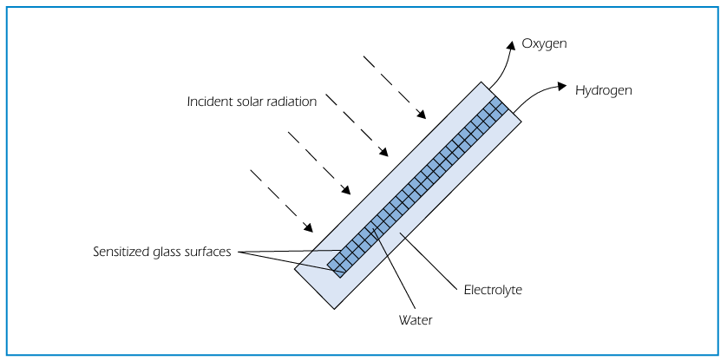
Photo-biological production (biophotolysis)
Photo-biological hydrogen production involves two main steps: photosynthesis and hydrogen generation catalyzed by hydrogenase enzymes in microorganisms such as green algae and cyanobacteria.
Photosynthesis: 2H₂O → 4H⁺ + 4e⁻ + O₂
Hydrogen production: 4H⁺ + 4e⁻ → 2H₂
This approach has the potential to provide a sustainable and renewable route for hydrogen production. However, it requires further research to improve efficiency, understand genetic and metabolic processes, and enable large-scale production in bioreactors. Artificial photosynthesis is also being explored as an alternative approach
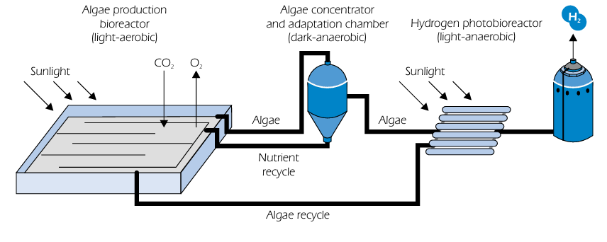
High-temperature decomposition
High-temperature water splitting occurs at around 3000 °C, where a portion of water is decomposed into hydrogen and oxygen, while the remaining water can be recycled. To reduce the required temperature, alternative methods have been developed, including thermochemical cycles, hybrid thermo-electrolytic systems, catalytic decomposition with membrane separation, and plasma-chemical processes.
These approaches can achieve efficiencies above 50%, offering potential for reduced hydrogen production costs. However, significant challenges remain, particularly in the development of materials resistant to high temperatures and corrosion, as well as efficient heat transfer, separation technologies, and system safety.
Thermo-chemical water splitting
Thermo-chemical water splitting is the conversion of water into hydrogen and oxygen by a series of thermally driven chemical reactions. While there is no question about the technical feasibility and the potential for high efficiency, cycles with proven low cost and high efficiency have yet to be developed commercially. An example of a thermo-chemical process is the iodine/sulphur cycle, For this process, the research and development needs are to capture the thermally split H2, to avoid side reactions and to eliminate the use of noxious substances. The corrosion problems associated with the handling of such materials are likely to be extremely serious.
(850 °C): H₂SO₄ SO₂ + H₂O + ½ O₂
(120 °C): I₂ + SO₂ + 2H₂O H₂SO₄ + 2HI
(450 °C): 2HI I₂ + H₂
SUM: H₂O H₂ + ½ O₂
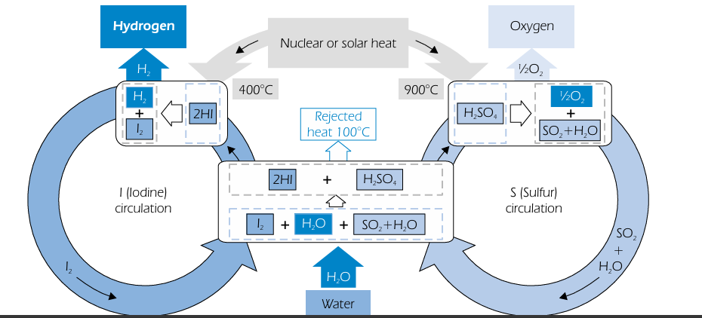
Biomass to Hydrogen
In biomass conversion processes, hydrogen-rich gas is produced through thermochemical methods. However, commercial-scale hydrogen production from biomass is still under development. Pathways such as steam gasification and advanced conversion techniques are being explored, but have not yet reached full demonstration stage.
Gasification and pyrolysis are considered the most promising technologies for medium-term hydrogen production. While dry biomass processing can be energy-intensive, wet biomass conversion methods are also being investigated. System performance depends on fuel quality, consistency, and plant scale.
Key challenges for biomass-based hydrogen production include:
Feedstock preparation and characterization
Efficient gasification processes
Gas cleaning and purification
System integration and scale optimization
Addressing these issues is essential to improve process efficiency and economic feasibility.
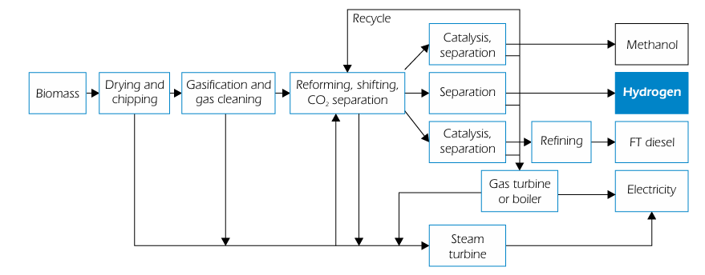
Hydrogen Storage and Transportation
High-Pressure Gaseous Hydrogen
Technical Characteristics and Equipmen
High-pressure gaseous hydrogen storage is a widely used method where hydrogen is compressed and stored in cylinders. Commonly used high-pressure gas cylinder materials include carbon steel, aluminum alloy, and carbon fiber composite materials. Storage pressures can reach up to 70 MPa with moderate hydrogen density, high-pressure gaseous hydrogen storage due to their advantages of light weight, high strength ,and relatively high hydrogen storage density. Currently, the working pressure of on-board high-pressure gaseous hydrogen storage systems can reach 35MPa or even 70MPa. At 70MPa pressure, the hydrogen storage density (mass fraction) of carbon fiber composite cylinders can reach about 5%-6%. The system includes compressors, storage cylinders, and pressure control devices
Application Status and Challenges
High-pressure gaseous hydrogen storage technology is mature and relatively low in cost, and has been widely used incurrent hydrogen fuel cell vehicles, hydrogen refueling stations and other fields. However, this technology also has some obvious challenges. Firstly, the hydrogen storage density of high-pressure gaseous hydrogen storage is relatively low. Even at a high pressure of 70MPa, its volumetric hydrogen storage density is much lower than that of liquid Interdisciplinary Energy Judgement & Transition .hydrogen and some solid-state hydrogen storage materials. This means that to store a sufficient amount of hydrogen, a large space is required, which is a limitation for application scenarios with limited space (such as on-board hydrogen storage). Secondly, high-pressure storage of hydrogen has certain safety risks, requiring strict safety measures and equipment to ensure the safety of storage and use processes.
Low-Temperature Liquid Hydrogen Storage
Liquefaction Principles and Processes
Low-temperature liquid hydrogen storage is a method of storing hydrogen by cooling it below its boiling point (-253℃) to convert it into a liquid state. The liquefaction process of hydrogen requires a series of complex refrigeration cycles The process involves compression and multi-stage cooling using advanced refrigeration techniques Finally, the liquefied hydrogen is stored in a specially made low-temperature insulated storage tank. Low-temperature insulated storage tanks usually adopt a double-layer vacuum structure and are filled with insulation materials to reduce heat input and maintain the low-temperature state of liquid hydrogen.
Advantages and Limitations
The greatest advantage of low-temperature liquid hydrogen storage is its high hydrogen storage density. The density of liquid hydrogen which is several times the volumetric hydrogen storage density of high-pressure gaseous hydrogen storage at 70MPa. This enables more hydrogen to be stored in the same storage space, making it very suitable for large-scale, long-distance hydrogen transportation and storage. However, it requires high energy for liquefaction, has high equipment cost, and suffers from evaporation losses during storage.
Solid-State Hydrogen Storage
Metal Hydride Hydrogen Storage
Metal hydride hydrogen storage is a method of storing hydrogen by reacting metals or alloys with hydrogen to form metal hydrides. Its principle is that under certain temperature and pressure conditions, metal (or alloy) M reacts with hydrogen to form metal hydride MHₙ, and the reaction equation is: M + n/2H₂ ⇌MHₙ + heat. When hydrogen needs to be released, the metal hydride is decomposed by heating or reducing pressure to release hydrogen. Commonly used hydrogen storage metals or alloys include magnesium-based alloys, titanium-based alloys, rare earth-based alloys, etc. The advantages of metal hydride hydrogen storage are high hydrogen storage density good safety, and high purity of hydrogen However, its disadvantages are also obvious. For example, the hydrogen storage and release processes require certain temperature and pressure conditions, the response speed is relatively slow, and the cost of some hydrogen storage alloys is high, and the cycle life needs to be further improved.
Chemical Hydride Hydrogen Storage
Chemical hydride The advantages of chemical hydride hydrogen storage are extremely high hydrogen storage density. For example, the theoretical hydrogen storage mass fraction of ammonia borane can reach 19.6%, which is much higher than other hydrogen storage methods. At the same time, chemical hydrides are usually solid or liquid, which are convenient for storage and transportation and have high safety. However, this technology also has some problems. For example, the preparation cost of chemical hydrides is high, and the recovery and regeneration of by-products after the reaction are difficult. Currently, no economically efficient regeneration method has been found, which limits its large-scale application .
MOFs and COFs for Hydrogen Storage
Metal-organic frameworks (MOFs) and covalent organic frameworks (COFs) are a class of new porous crystalline materials with large specific surface areas and adjustable pore structures. Their hydrogen storage principle is to adsorb hydrogen molecules in the pores of the materials through physical adsorption. The hydrogen storage performance of MOFs and COFs mainly depends on their structural parameters such as specific surface area, pore size, and pore volume. By reasonably designing and regulating the structure of the materials, their adsorption capacity and adsorption/desorption kinetic performance for hydrogen can be improved. Some materials achieve over 5% hydrogen storage under low-temperature and high-pressure conditions. However, MOFs and COFs hydrogen storage technologies are still in the laboratory research stage. The main challenge is that the hydrogen storage capacity under normal temperature and pressure is low, which is difficult to meet the needs of practical applications. In addition, the synthesis cost of materials is high, and large-scale preparation is difficult .
Hydrogen Transportation
High-Pressure Gaseous Transportation
High-pressure gaseous transportation is one of the most commonly used hydrogen transportation methods at present. It involves compressing hydrogen to high pressure (usually 20-50MPa) and transporting it through high-pressure tube trailers or pipelines. High-pressure tube trailers consist of multiple high-pressure gas cylinders and are suitable for medium-short distance, small-batch hydrogen transportation, with advantages such as high flexibility and low initial investment. High-pressure pipeline transportation is suitable for large-scale, long-distance hydrogen transportation, with advantages such as high transportation efficiency and low cost. Currently, a certain scale of hydrogen pipeline networks has been built globally, mainly distributed in industrially developed regions. However, high-pressure gaseous transportation also has some problems. For example, the transportation efficiency of high-pressure tube trailers is low,and the energy consumption and cost per unit transportation volume are relatively high; high-pressure pipeline transportation has large initial investment, long construction period, and needs to consider issues such as hydrogen corrosion and sealing.
Low-Temperature Liquid Transportation
Low-temperature liquid transportation is a method of transporting hydrogen after liquefaction through low-temperature tank trucks or ships. Low-temperature tank trucks are suitable for medium-short distance transportation of liquid hydrogen, while ships are suitable for long-distance, large-scale liquid hydrogen transportation across oceans .Compared with high-pressure gaseous transportation, low-temperature liquid transportation has a larger unit volume transportation capacity and higher transportation efficiency, especially for long-distance, large-scale hydrogen transportation, its cost advantage is more obvious. For example, the transportation capacity of a large liquid hydrogen transport ship can reach thousands of tons, which is much higher than that of high-pressure tube trailers. However, low-temperature liquid transportation also has some disadvantages. For example, the liquefaction process of hydrogen consumes high energy, increasing transportation costs; the manufacturing and maintenance costs of low-temperature tank trucks and ships are high, and there is a certain amount of evaporation loss during transportation .
Solid-State Transportation
Solid-state transportation is a method of transporting hydrogen using solid substances formed after hydrogen storage materials (such as metal hydrides, chemical hydrides, etc.) absorb hydrogen. Its advantages are high safety. Hydrogen is stored in solid substances, which is not easy to leak or explode; no high-pressure or low-temperature equipment is needed during transportation, and the operation is relatively simple. In addition, the volumetric hydrogen storage density of solid-state transportation is relatively high, which is beneficial to improving transportation efficiency .However, solid-state transportation also faces some challenges. For example, the cost of hydrogen storage materials is high, the hydrogen storage and release processes need to consume a certain amount of energy, and the cycle life of some hydrogen storage materials is short, which limits their large-scale application .
Challenges in Hydrogen Energy System
Hydrogen Handling Challenges
Safety Concerns
Safety is one of the most critical challenges in hydrogen handling due to its highly flammable nature. Hydrogen has a wide flammability range (approximately 4% to 75% in air), which means it can ignite under many conditions. It also requires very low ignition energy, making accidental ignition more likely compared to other fuels. Another complication is that hydrogen burns with a nearly invisible flame, which makes fire detection difficult and increases the risk for workers and emergency responders. Additionally, hydrogen disperses rapidly in open environments, which can be beneficial in some case but in enclosed spaces it can accumulate and create explosive conditions. Therefore, strict safety protocols, proper ventilation, and advanced detection systems are essential during hydrogen handling.
Leakage Issues
Hydrogen leakage is a significant technical challenge because hydrogen molecules are extremely small and light. This allows them to easily escape through microscopic pores, cracks, and imperfect seals in storage tanks, pipelines, and valves. Continuous leakage not only leads to energy loss but also increases the risk of fire and explosion. Moreover, hydrogen can cause a phenomenon known as hydrogen embrittlement, where metals—especially high-strength steels—become brittle and crack over time when exposed to hydrogen. This weakens the structural integrity of pipelines and storage systems, increasing maintenance requirements and operational risks. Detecting hydrogen leaks is also more difficult than with other gases, requiring highly sensitive sensors and monitoring systems.
Infrastructure Limitations
A major barrier to effective hydrogen handling is the lack of suitable infrastructure. Existing natural gas pipelines and fuel systems are not fully compatible with hydrogen due to differences in physical and chemical properties. Developing dedicated hydrogen pipelines, storage facilities, and refueling stations requires large capital investments and long-term planning. Additionally, hydrogen often needs to be stored either at very high pressures or at extremely low temperatures (in liquid form), both of which demand specialized equipment and increase operational complexity. Transportation of hydrogen over long distances is also inefficient due to its low volumetric energy density, making logistics more challenging compared to conventional fuels. As a result, the current infrastructure is limited and not yet ready for widespread hydrogen adoption.
Hydrogen Storage Challenges
Low Energy Density (Volumetric)
Hydrogen has a very low volumetric energy density under normal conditions, which makes its storage a major challenge. Even though hydrogen contains high energy per unit mass, it occupies a large volume as a gas. To store sufficient energy, hydrogen must either be compressed to very high pressures or liquefied at extremely low temperatures. Both approaches increase system complexity and cost, making large-scale storage less efficient compared to conventional fuels.
High Pressure Requirements
Storing hydrogen in compressed form requires pressures typically between 350 to 700 bar. Maintaining such high pressures demands strong and heavy storage tanks made from advanced materials like carbon fiber composites. These tanks are expensive and require strict safety measures to prevent leakage or rupture. Additionally, repeated pressurization and depressurization can lead to material fatigue over time.
Cryogenic Storage Issues
Liquid hydrogen storage requires extremely low temperatures (around -253°C). Maintaining such cryogenic conditions is energy-intensive and requires highly insulated tanks. Even with advanced insulation, some hydrogen gradually evaporates, leading to boil-off losses. This makes long-term storage inefficient and costly, especially for transportation and industrial applications.
Material Compatibility and Embrittlement
Hydrogen can penetrate many metals and cause a phenomenon known as hydrogen embrittlement, which weakens the material and can lead to cracks or failure. This creates challenges in selecting suitable materials for storage tanks, pipelines, and valves. Special alloys and coatings are often required, increasing overall system costs.
High Cost of Storage Technologies
Hydrogen storage systems, whether compressed, liquefied, or solid-state, are currently expensive. The need for advanced materials, insulation systems, and safety mechanisms increases the overall cost. This is a major barrier to the widespread adoption of hydrogen as a clean energy carrier.
Future Prospects of Hydrogen Energy
Advancement in Green Hydrogen Production
One of the most important future prospects of hydrogen energy lies in the large-scale development of green hydrogen, which is produced through water electrolysis using renewable energy sources such as solar, wind, and hydropower. As renewable energy technologies become more affordable and efficient, the cost of green hydrogen is expected to decrease significantly. Future research is focused on improving electrolyzer efficiency, reducing dependence on expensive catalysts like platinum, and developing scalable systems. This advancement will play a crucial role in reducing global carbon emissions and achieving climate neutrality.
Development of Advanced Storage Technologies
Efficient storage of hydrogen remains a major challenge due to its low density and high flammability. Future research is expected to focus on advanced storage materials such as metal-organic frameworks (MOFs), carbon nanotubes, and graphene-based materials. These materials have the potential to store hydrogen safely at lower pressures and higher densities. Improvements in solid-state hydrogen storage will make transportation and handling easier, thereby enhancing its commercial viability.
Integration with Renewable Energy Systems
Hydrogen has great potential as an energy storage medium for renewable energy systems. Since renewable sources like solar and wind are intermittent, hydrogen can be used to store excess energy generated during peak production periods. This stored hydrogen can later be converted back into electricity using fuel cells when demand is high. This integration will improve grid stability and enable a more reliable and efficient renewable energy system.
Industrial Decarbonization
Hydrogen is expected to play a vital role in decarbonizing industries that are difficult to electrify, such as steel production, cement manufacturing, and chemical industries. Green hydrogen can replace fossil fuels in high-temperature industrial processes, significantly reducing carbon emissions. In the future, hydrogen-based industrial processes will contribute to sustainable manufacturing and environmental protection.
Global Policy and Investment Trends
Governments around the world are recognizing the importance of hydrogen energy and are implementing policies to support its development. Countries such as Japan, Germany, and the United States have launched national hydrogen strategies and are investing heavily in research, infrastructure, and commercialization. In the future, international collaboration and policy support will accelerate the transition toward a hydrogen-based economy.
Result and Discussion
The analysis of hydrogen production technologies shows that conventional methods such as steam methane reforming are currently dominant due to their low cost and established infrastructure. However, these methods produce significant carbon emissions, limiting their environmental benefits.
Electrolysis, particularly when powered by renewable energy sources such as solar and wind, is identified as the most sustainable method of hydrogen production. Although currently more expensive, advancements in technology and decreasing renewable energy costs are expected to improve its economic viability.
Hydrogen storage remains a major challenge due to its low density. Compressed gas storage and liquid hydrogen storage are commonly used, but both methods require high energy input and advanced infrastructure. Solid-state storage methods, such as metal hydrides, offer safer alternatives but are still under development.
In terms of applications, hydrogen is widely used in industrial processes such as ammonia production and petroleum refining. The transportation sector is also adopting hydrogen fuel cell vehicles, which offer long driving ranges and zero emissions. Hydrogen can also be used in power generation, particularly for storing excess renewable energy.
The study also highlights several challenges, including high production costs, lack of infrastructure, safety concerns, and energy losses during conversion processes. Addressing these challenges is essential for the large-scale adoption of hydrogen energy.
Conclusion
Hydrogen energy has significant potential to support the transition to a sustainable and low-carbon future due to its high energy content and clean utilization. Various hydrogen production techniques, including steam methane reforming, electrolysis, and biomass-based methods, offer different advantages and limitations, with green hydrogen emerging as the most environmentally sustainable option.
However, the development of hydrogen energy systems faces key challenges related to storage, transportation, cost, and infrastructure. Among these, hydrogen storage remains a critical issue due to limitations in efficiency, safety, and practicality across existing technologies.
Despite these challenges, ongoing advancements in materials science, renewable integration, and technological innovation are expected to enhance the feasibility of hydrogen systems. Supportive policies and investments will further accelerate its adoption.
In conclusion, hydrogen energy represents a promising solution to global energy challenges, and continued research and development will be essential to realize its full potential in achieving long-term sustainability goals.
References:-
1. Gielen, D., Boshell, F., Saygin, D., Bazilian, M. D., Wagner, N., & Gorini, R. (2019). The role of renewable energy in the global energy transformation. Energy strategy reviews, 24, 38-50.
2. Amoo, L.M. and Fagbenle, R.L. (2014) An Integrated Impact Assessment of Hydrogen as a Future Energy Carrier in Nigeria’s Transportation, Energy and Power Sectors. International Journal of Hydrogen Energy, 39, 12433-12409.
3. Bradhurst D, Heuer P, Stolarski G. Hydrogen production and storage; 1981.
4. Abad AV, Dodds PE. Production of hydrogen, vol. 3, no. 2015. Elsevier; 2017.
5. C. Acar, I. Dincer ScienceDirect comparative assessment of hydrogen production methods from renewable and non-renewable sources. Int J Hydrogen Energy, 39 (1) (2013), pp. 1-12.
6. M. Krumpelt, T.R. Krause, J.D. Carter, J.P. Kopasz, S. Ahmed. Fuel processing for fuel cell systems in transportation and portable power applications. Catal Today, 77 (1–2) (2002),
7. Demirbaş A. Biomass resource facilities and biomass conversion processing for fuels and chemicals. Energy Convers Manage. 2001;42(11):1357–78.
8. Ehsan S, Wahid MA. Hydrogen production from renewable and sustainable energy resources: Promising green energy carrier for clean development. Renew Sustain. Energy Rev. 2016; 57:850–66.
9. Wang Z, et al. Gasification of biomass with oxygen-enriched air in a pilot scale two-stage gasifier. Fuel. 2015; 150:386–93.
10. Levin DB, Pitt L, Love M. Biohydrogen production: prospects and limitations to practical application. Int J Hydrogen Energy. 2004;29(2):173–85.
11. Safari, F.; Dincer, I. A Review and Comparative Evaluation of Thermochemical Water Splitting Cycles for Hydrogen Production. Energy Convers. Manag. 2020, 205, 112182.
12. Ni M, Leung MKH, Leung DYC. Technological development of hydrogen production by solid oxide electrolyzer cell (SOEC). Int J Hydrogen Energy 2008; 33:2337–54
13. Laguna-Bercero MA. Recent advances in high temperature electrolysis using solid oxide fuel cells: A review. J Power Sources 2012;203:4–16.
14. Aric`o AS, Siracusano S, Briguglio N, Baglio V, Di Blasi A, Antonucci V. Polymer electrolyte membrane water electrolysis: Status of technologies and potential applications in combination with renewable power sources. J Appl Electrochem 2013;43:107–18.
15. Zeng K, Zhang D. Recent progress in alkaline water electrolysis for hydrogen production and applications. Prog Energy Combust Sci 2010;36:307–26.
16. Dawood, F.; Anda, M.; Shaﬁullah, G.M. Hydrogen Production for Energy: An Overview. Int. J. Hydrogen Energy 2020, 45, 3847–3869.
17. Najjar, Y.S. Hydrogen Safety: The Road toward Green Technology. Int. J. Hydrogen Energy 2013, 38, 10716–1072…
18. Liu Yingshu, Zhang Hui, Liu Wenhai. Hydrogen Energy Storage and Transportation Technologies and Equipment. Beijing:Metallurgical Industry Press, 2021
19. Chen Changpin, Wang Qidong. Hydrogen Storage Materials and Their Applications. Hangzhou: Zhejiang University Press,2020
20. Huang Dianhui, Li Fu. New Energy Technologies for Rail Transit. Chengdu: Southwest Jiaotong University Press, 2021
21. Zhang Jianbo, Wang Shumao, Zhou Shaoxiang. Distributed Energy Systems. Beijing: China Electric Power Press, 2021.
22. International Energy Agency. Hydrogen Future Development Outlook. Paris: International Energy Agency, 2020.
23. International Hydrogen Energy Commission. Hydrogen Energy Vision 2050. Brussels: International Hydrogen EnergyCommission,
24.International Energy Agency (IEA). (2023). Global Hydrogen Review.
25. U.S. Department of Energy (DOE). (2022). Hydrogen Program Plan.
26.Turner, J. A. (2004). Sustainable Hydrogen Production. Science, 305(5686), 972–974.
27. Holladay, J. D., Hu, J., King, D. L., & Wang, Y. (2009). An Overview of Hydrogen Production Technologies. Catalysis Today, 139, 244–260.
28. Crabtree, G. W., Dresselhaus, M. S., & Buchanan, M. V. (2004). The Hydrogen Economy. Physics Today, 57(12), 39–44.
29. Züttel, A. (2003). Materials for Hydrogen Storage. Nature Materials, 2, 123–131.
30. Momirlan, M., & Vezirogl T. N. (2005). The Properties of Hydrogen as Fuel. International Journal of Hydrogen Energy, 30, 795–802.
31. National Renewable Energy Laboratory (NREL). (2022). Hydrogen Production and Delivery.
32. European Commission. (2020). A Hydrogen Strategy for a Climate-Neutral Europe.
33. IRENA (International Renewable Energy Agency). (2022). Green Hydrogen Cost Reduction Report.
34. Edwards, P. P., Kuznetsov, V. L., David, W. I. F., & Brandon, N. P. (2008). Hydrogen and Fuel Cells: Towards a Sustainable Energy Future. Energy Policy, 36, 4356–4362.
35. Dincer, I., & Acar, C. (2015). Review and Evaluation of Hydrogen Production Methods. International Journal of Hydrogen Energy, 40, 11094–11111.
36. Ogden, J. M. (1999). Prospects for Building a Hydrogen Energy Infrastructure. Annual Review of Energy and the Environment, 24, 227–279.
37. Lewis, N. S., & Nocera, D. G. (2006). Powering the Planet: Chemical Challenges. Proceedings of the National Academy of Sciences, 103, 15729–15735.
High-pressure gaseous hydrogen storage is one of the most widely used hydrogen storage methods at present. Its
principle is to compress hydrogen to a high-pressure state and store it in specially made high-pressure gas cylinders.
Commonly used high-pressure gas cylinder materials include carbon steel, aluminum alloy, and carbon fiber composite
materials. With the development of technology, carbon fiber composite cylinders have gradually become the
mainstream choice for high-pressure gaseous hydrogen storage due to their advantages of light weight, high strength,
and relatively high hydrogen storage density. Currently, the working pressure of on-board high-pressure gaseous
hydrogen storage systems can reach 35MPa or even 70MPa. At 70MPa pressure, the hydrogen storage density (mass
fraction) of carbon fiber composite cylinders can reach about 5%-6%. High-pressure gaseous hydrogen storage
equipment mainly includes hydrogen compressors, high-pressure cylinder groups, pressure reducing devices, etc.
Hydrogen compressors are used to compress low-pressure hydrogen to a set high-pressure state, high-pressure cylinder
groups are used to store compressed hydrogen, and pressure reducing devices reduce high-pressure hydrogen to an
appropriate pressure for users during use
High-pressure gaseous hydrogen storage is one of the most widely used hydrogen storage methods at present. Its
principle is to compress hydrogen to a high-pressure state and store it in specially made high-pressure gas cylinders.
Commonly used high-pressure gas cylinder materials include carbon steel, aluminum alloy, and carbon fiber composite
materials. With the development of technology, carbon fiber composite cylinders have gradually become the
mainstream choice for high-pressure gaseous hydrogen storage due to their advantages of light weight, high strength,
and relatively high hydrogen storage density. Currently, the working pressure of on-board high-pressure gaseous
hydrogen storage systems can reach 35MPa or even 70MPa. At 70MPa pressure, the hydrogen storage density (mass
fraction) of carbon fiber composite cylinders can reach about 5%-6%. High-pressure gaseous hydrogen storage
equipment mainly includes hydrogen compressors, high-pressure cylinder groups, pressure reducing devices, etc.
Hydrogen compressors are used to compress low-pressure hydrogen to a set high-pressure state, high-pressure cylinder
groups are used to store compressed hydrogen, and pressure reducing devices reduce high-pressure hydrogen to an
appropriate pressure for users during use
High-pressure gaseous hydrogen storage is one of the most widely used hydrogen storage methods at present. Its
principle is to compress hydrogen to a high-pressure state and store it in specially made high-pressure gas cylinders.
Commonly used high-pressure gas cylinder materials include carbon steel, aluminum alloy, and carbon fiber composite
materials. With the development of technology, carbon fiber composite cylinders have gradually become the
mainstream choice for high-pressure gaseous hydrogen storage due to their advantages of light weight, high strength,
and relatively high hydrogen storage density. Currently, the working pressure of on-board high-pressure gaseous
hydrogen storage systems can reach 35MPa or even 70MPa. At 70MPa pressure, the hydrogen storage density (mass
fraction) of carbon fiber composite cylinders can reach about 5%-6%. High-pressure gaseous hydrogen storage
equipment mainly includes hydrogen compressors, high-pressure cylinder groups, pressure reducing devices, etc.
Hydrogen compressors are used to compress low-pressure hydrogen to a set high-pressure state, high-pressure cylinder
groups are used to store compressed hydrogen, and pressure reducing devices reduce high-pressure hydrogen to an
appropriate pressure for users during use

