From Preferential Access to Regulatory Competitiveness: Nepal’s LDC Graduation and the Legal Architecture of Post-Preference Trade

Abstract
Graduation for Nepal from least developed country (LDC) status is generally viewed as a development milestone. Yet it is likely to have most impact in terms of law and regulations. As part of graduating from the group of LDCs, Nepal would lose access to special international support measures for LDCs, such as preferential market access, transition periods, and flexibilities under the WTO, and other unilateral preferences. This article contends that Nepal's problem will not just be the reduction of preference margins, but the lack of a fully developed post-preference legal architecture for trade relations. Drawing upon legal doctrine and policy-related legal analysis, the article analyzes Nepal's situation with regard to its obligations and options under the relevant aspects of WTO law, preferential market access mechanisms, regional economic integration, transit arrangements, intellectual property rules, trade remedies, customs law, foreign investment rules, and standards regime. By making use of relevant trade statistics, the article highlights how Nepal's limited basket of exports, heavy reliance on India, lack of manufacturing sector, and service-based economy make Nepal vulnerable after graduation. The article aims to provide insights into international economic law with respect to LDC graduation as a problem of legal preparedness, rather than just one of economic transition. It presents a regulatory competitiveness model which includes: GSP+ preparation; rules-of-origin capacity; customs laws; SPS and TBT obligations; intellectual property reform; trade-remedies framework; services negotiations; hydroelectricity export law; and cooperation between public and private sectors.
Keywords: LDC graduation, international trade law, WTO, GSP+, trade remedies, TRIPS, regulatory competitiveness

INTRODUCTION
Nepal's exclusion from the LDC category is more than just a symbolic development milestone. It also changes the legal conditions for Nepal's involvement in international trade.... The non-reciprocal tariff preferences, duty-free and quota-less access in certain markets, extended implementation periods, technical assistance, and special and differential treatment have been instrumental in Nepal's promotion of its LDC status. Nepali exports will encounter more stringent regulations on origin, increased competition, higher compliance costs, and limited policy flexibility once these benefits are eliminated or reduced.
Nepal's graduation is regarded as a matter of legal transition in this article. The issue at hand is not only whether Nepal can expand its exports beyond 2026, but also whether the country's trade-law authorities are prepared to provide assistance to businesses in a post-preference setting. Access to markets is not limited to the border in contemporary commerce. It is built on customs, product certification, SPS and TBT compliance, rule-of origin documentation, investment regulation, intellectual property protection, services regulation transit rights, export finance as well as credible dispute resolution capacity.
The articles examined highlight Nepal's fundamental trade predicament, as it has made gains in human assets and economic vulnerability indicators, yet struggles with structural weaknesses in productive capacity, manufacturing, export diversification. Additionally: its infrastructure and institutional coordination are still weak. Although Nepal's export trade is limited to a few items and consumers, the country'S import sector remains broad and crucial in fuel, industrial inputs, and imported products from India and China. The article converts the findings into a critical legal case: Nepal needs — not to persist with preference-led trade policy –... an environment of post-LDC regulatory competitiveness framework". "The Constitution sets out for it.
The text is divided into six parts.. The research problem and contribution are first recognized.... The relevant literature and research gaps are then examined. Methodology provides a description of the doctrinal and policy-oriented approach. The examination scrutinizes WTO law, preferential regimes, domestic legal readiness, trade data, and sectoral possibilities.... The graduation paradox and preference trap are elaborated on in the critical discussion. This report describes the policy and regulatory implications for Nepal's transition....
Research Issue, Research Question and Original Contribution.
The gap between Nepal's formal trade-law framework and its practical legal readiness after the LDC is a significant research issue. Trade-remedy, intellectual property, industrial, and trade-policy are among the customs regulations in Nepal. Furthermore, it engages in WTO disciplines and participates within regional frameworks like SAFTA or BIMSTEC, as well as in bilateral trade and transit arrangements. However, these legal instruments are not yet functioning as a coherent system to compete after preferences.
What steps can Nepal take to transform its international trade legal system from a preference-driven model to based on competitiveness, rules, and development-sensitive measures after completing LDC? The question is deliberately legal. Nepal's efforts to enhance exports are not limited to addressing the issue of law, but also focused on enhancing export competitiveness, market diversification, productive upgrading, compliance capacity, and trade resilience.
It contains three original contributions. The classification of Nepal's LDC graduation is reframed as a legal-readiness challenge, rather than focusing on macroeconomic issues. It also consolidates WTO law, unilateral preference schemes, domestic trade legislation, transit dependence on foreign goods imports and exports as part of one comprehensive analysis.[A]. A regulatory competitiveness model is proposed to guide Nepal's post-graduation reforms and serve as a benchmark for other developing countries graduating from universities.
LITERATURE REVIEW
Four strands are the usual framework for literature on Nepal's LDC graduation.? First, the macroeconomic exposure (loss of preferential tariff treatment, concessional financing and flexibility specific to LDCs) is examined. This second strand. The usefulness of this literature lies in its identification of probable economic risks to labour-intensive and preference-sensitive sectors such as textiles, carpeting (Federation of Nepalese Chamberses of Commerce and Industry [FNCCI], n.d.; International Trade Centre & UN-OHRLLS, 2022) and light manufacturing (extraction from the Federation of Kathmandu's Website).
Second, export diversification and competitiveness. According to Pant (2021) and other policy studies, Nepal has remained open and trade-dependent without transforming liberalization into sustained export dynamism. Nepal's import footprint is extensive and stable, with a primary focus on essential goods and industrial inputs. The literature acknowledges the production and market issue, but frequently treats law as a precondition rather than facilitating trade transformation.
The third aspect concerns WTO law and special and differential treatment. LDCs are granted the opportunity to exploit transition periods, technical assistance, and preference schemes, but WTO law doesn't provide permanent preferential treatment. Intellectual property scholarship holds significance in Nepal's TRIPS transition, as Adhikari (2024) highlights the limitations posed by inadequate technology transfer and limited research and development capacity, along with institutional under-preparedness. The Enabling Clause allows for differentiable and more favorable treatment, but the WTO case law states that preferential schemes must remain legally structured rather than arbitrary (European Communities-Conditions for the Granting of Tariff Preferences to Developing Countries, 2004). This is especially relevant in the context of Nepal, where post-graduation access to schemes such as the European Union's Global Supply Chain Plus (GSP+) will depend on treaty ratification, implementation and reporting obligations while other countries may not.
Domestic policy and institutional readiness are the focus of the fourth strand. Nepal's policy direction includes the Smooth Transition Strategy, Trade Policy 2015, Nepal Trade Integration Strategy and institutional efforts by MoICS, TEPC, customs authorities, FNCCI, and Nepal Rastra Bank. However, Q1-level legal scholarship requires more attention: whether these instruments establish enforceable institutional duties and systems for compliance with lawsuits in addition to export-facing legal services for firms. The Nepal Trade Integration Strategy is still significant because it aligns trade diversification with implementation capability and top export sectors (Government of Nepal, 2016)..
There is a significant research gap as there is no integrated legal analysis that connects LDC graduation, WTO obligations and preferences, domestic trade law erosion and remedies, TRIPS transition and service trade, transit dependence, customs modernization, and compliance with standards. To address the gap, this article proposes a legal-ready framework for Nepal's post LDC period.
METHODOLOGY
Doctrinal and policy-based legal research is utilized in the article. The doctrinal aspect evaluates WTO agreements, WOR cases, regional trade instruments, unilateral preference schemes, and Nepal's national laws and policy instruments. Examples of relevant law include GATT 1994, GATS, TRIPS, Dispute Settlement Understanding, WTO Agreement on Trade Facilitation, SAFTA Agreement and BIMSTEC Free Trade Area framework, Customs Act 2007, Foreign Investment and Technology Transfer Act 2019, Industrial Enterprises 2020 from the Safeguards Law, Anti-Dumping and Countervailing Act 2019 and Nepal's trade policy documents including South Asian Freetrade Area agreement (2004) and Agreement between North Korea and India in 2004.Accordingly, various laws have been introduced to address disputes.
A policy-oriented element assesses whether these instruments can handle Nepal's real world trade challenges. It relies on secondary trade data derived from Nepal Rastra Bank annual reports and World Integrated Trade Solution datasets. These numbers are used illustratively and not as economic models. The goal of their legal presentation is to illustrate the impact of Nepal's export dominance, import dependence on other countries, limited product range, and market vulnerability. Moreover
This study does not include interviews or primary fieldwork. This is a legal-analytical contribution that examines the redesigning of existing rules and institutions to support Nepal'S transition from preference-based participation towards regulatory competitiveness.
Figure 1: Nepal's merchandise exports and imports, FY2019/20-FY2024/25
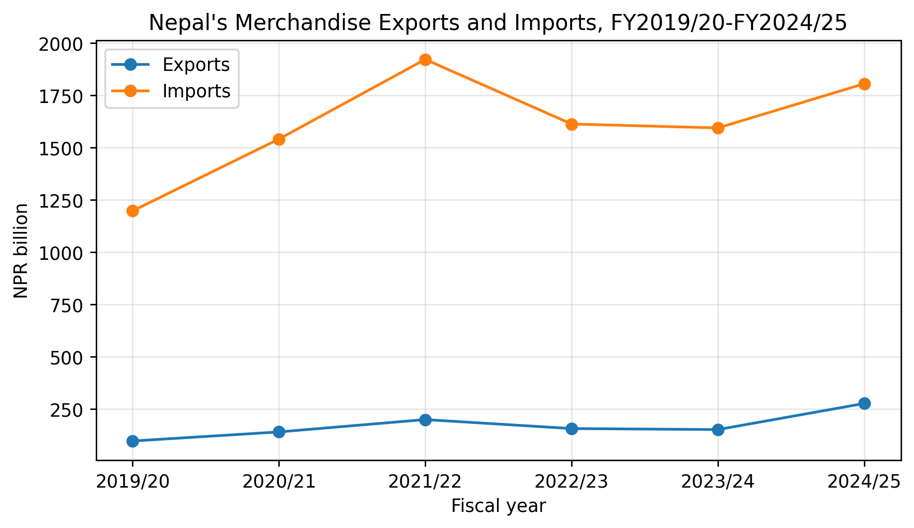
Note. Values are in NPR billion. Data compiled from Nepal Rastra Bank annual macroeconomic reports for FY2019/20-FY2024/25 (Nepal Rastra Bank, 2020-2025).

ANALYSIS

LDC Graduation as a Legal Transition
Nepal’s graduation is legally significant because many LDC advantages are status-based and time-bound. Nepal has been scheduled to graduate on November 24, 2026, after meeting the human assets and economic vulnerability criteria while remaining below the GNI per capita threshold. That profile creates a policy paradox: Nepal is formally eligible for graduation while its productive and export structures remain fragile.
The WTO Ministerial Decision on smooth transition gives graduating LDCs some support, including time-limited access to certain LDC-related measures after graduation (WTO, 2024). However, it does not preserve all commercial preferences indefinitely. Nor does it solve domestic compliance problems. The smooth-transition framework should therefore be treated as a bridge, not as a substitute for legal reform.
The European Union’s GSP+ illustrates the shift from status-based preferences to conditional regulatory access. GSP+ requires eligible countries to ratify and effectively implement 27 international conventions on human rights, labour rights, environmental protection, climate change, and good governance; the EU also monitors continued compliance through reporting and dialogue (European Commission, n.d.). For Nepal, this means that post-LDC market access will depend on labour inspection, freedom of association, environmental governance, treaty reporting, and administrative credibility as much as on tariff schedules.
This shift is supported by WTO jurisprudence. In European Communities-Conditions for the Granting of Tariff Preferences to Developing Countries (2004), the Appellate Body accepted that preference-granting countries may differentiate among developing countries only when the differentiation responds to objective development needs and is available to similarly situated beneficiaries. The lesson for Nepal is clear: vulnerability alone is not a legal entitlement to the same preferences after graduation. Nepal must prepare to satisfy the objective eligibility conditions of alternative schemes.

Domestic Trade Law: Broad Framework, Weak Integration
Nepal’s domestic legal framework is broader than is sometimes assumed. WTO’s recent Trade Policy Review records significant reforms, including amendments to trade and investment laws, the Customs Tariff Act 2024, the E-commerce Act 2025, the Safeguards, Anti-Dumping and Countervailing Act 2019, food safety reforms, and an updated trade integration strategy (Customs Tariff Act, 2024; E-commerce Act, 2025; Food Safety and Quality Act, 2024; WTO, 2025a, 2025b, 2025c). The same review also notes Nepal’s ongoing customs modernization, risk-based selectivity, ASYCUDA implementation, and National Single Window development.
Yet breadth is not the same as readiness. Nepal’s post-LDC trade challenge is institutional integration. Customs administration, export promotion, investment approval, standards certification, intellectual property registration, trade-remedy investigation, private-sector consultation, and trade negotiation are distributed across multiple bodies. Unless these institutions operate through enforceable coordination duties and shared compliance targets, legal reform will remain fragmented.
Trade remedies are a useful example. The Safeguards, Anti-Dumping and Countervailing Act 2019 gives Nepal a formal basis to respond to injurious imports, dumped products, and subsidized goods. But trade remedies require technical capacity: injury analysis, confidential data handling, transparent hearings, cost and price comparison, causal-link assessment, and WTO-consistent notification. A law without the institutional ability to investigate is not a usable remedy.
Investment law presents a similar problem. The Foreign Investment and Technology Transfer Act 2019 seeks to attract capital and technology, but post-LDC competitiveness requires FDI to be linked to export upgrading, skills transfer, quality infrastructure, and sectoral priorities. If investment inflows do not support productive capacity, Nepal may attract capital without improving its trade balance or export sophistication.
Table 1
Nepal’s legal-readiness matrix for post-LDC trade
Legal domain | Current framework | Post-LDC risk | Priority reform
Customs and trade facilitation | Customs Act 2007; Customs Tariff Act 2024; ASYCUDA; National Single Window | Higher compliance costs, rules-of-origin pressure, border delays | Adopt export-facing customs services, advance rulings, digital certificates, and time-release monitoring.
Investment and technology transfer | FITTA 2019; Industrial Enterprises Act 2020; PPP and Investment Act 2019 | FDI may not build export capacity or technology upgrading | Link approvals and incentives to export diversification, skills transfer, and local supplier development.
Trade remedies | Safeguards, Anti-Dumping and Countervailing Act 2019 | Domestic industries may face stronger competition after preference erosion | Create a technically independent investigation unit and publish WTO-consistent procedures.
Standards, SPS, and TBT | Food safety, quarantine, standards, and certification laws | Niche agro-exports may fail market-entry requirements | Invest in accredited laboratories, traceability, mutual recognition, and exporter compliance support.
Intellectual property | Patent, Design and Trademark Act 1965; Copyright Act 2002; TRIPS obligations | Loss of LDC TRIPS flexibility and weak protection for GI/traditional knowledge | Modernize IP law, protect geographical indications, and preserve public-health flexibilities.
Services trade | GATS commitments; ICT, tourism, foreign employment and investment policies | LDC services waiver benefits are time-limited and underused | Negotiate Mode 4 recognition, ICT market access, tourism facilitation, and ethical labour mobility.
Regional and transit law | SAFTA, BIMSTEC, bilateral trade and transit arrangements with India and China | Landlocked geography and dependence on limited transit routes | Strengthen transit diplomacy, energy-trade rules, and legally enforceable corridor predictability.
Note. The matrix synthesizes Nepalese statutes and policy instruments with recent WTO Trade Policy Review findings (Government of Nepal, National Planning Commission, 2024; WTO, 2025a, 2025b).

WTO Case-Law Lessons for Nepal
The legal system in Nepal is not determined by WTO jurisprudence, but rather by it. Four cases are especially useful.
Preference schemes are subject to legal limitations as outlined in EC-Tariff Preferential Predictions. The expectation that market access would be automatically maintained is not the reason why Nepal should develop its post-LDC strategy. The case of India-Quantitative Restrictions reveals that trade restrictions are not always in line with macroeconomic difficulties. Legal discipline and evidence-based, temporary, and temporary measures must be implemented for import controls or balance-of-payments measures. Turkey-Textiles affirms that WTO violations cannot be justified under regional trade agreements unless strict conditions are met. This has implications for Nepal's use of SAFTA, BIMSTEC and bilateral agreements. According to GATT Article V, transit predictability is a crucial legal concern, as highlighted in Russia-Traffic in Transit.

Table 2
Selected WTO case-law lessons for Nepal’s post-LDC trade strategy
WTO dispute | Legal principle | Relevance for Nepal
EC-Tariff Preferences | Differentiated preferences must respond to objective development needs and be available to similarly situated beneficiaries. | Nepal must prepare for GSP+ and other conditional schemes rather than rely on LDC identity.
India-Quantitative Restrictions | Trade restrictions justified on balance-of-payments grounds require evidence and WTO-consistent process. | Any import-control or foreign-exchange measure must be carefully designed and temporary.
Turkey-Textiles | Regional trade arrangements do not automatically justify WTO-inconsistent restrictions. | SAFTA, BIMSTEC, and bilateral measures must be WTO-compatible.
Russia-Traffic in Transit | Transit obligations and exceptions are legally reviewable within the WTO framework. | Nepal’s landlocked position makes transit law central to export competitiveness.
Note. Cases summarized from WTO reports (European Communities-Conditions for the Granting of Tariff Preferences to Developing Countries, 2004; India-Quantitative Restrictions, 1999; Russia-Measures Concerning Traffic in Transit, 2019; Turkey-Textiles, 1999).

Export Concentration and Legal Vulnerability
Nepal’s trade data reveal why law must be part of the competitiveness agenda. Figure 1 shows that imports remain many times larger than exports. Exports rose until FY2021/22 and then declined, while imports also contracted after their peak but remained structurally dominant. This pattern is not merely an economic imbalance. It has legal consequences because a small export sector is less able to absorb new compliance costs, rules-of-origin changes, and preference erosion.
Market concentration is equally important. In 2022, India accounted for approximately 71.93% of Nepal’s merchandise exports and 63.21% of its imports, while China accounted for about 13.49% of imports. Such dependence reflects geography and historical integration, but it also increases legal and commercial exposure to border frictions, transit interruptions, standards disputes, and unilateral policy changes in a small number of markets (World Bank, 2022).
Product concentration creates another risk. Nepal’s leading exports in 2022 included soybean oil, palm oil, carpets, cardamom, and felt. Its leading imports were petroleum products, gas, crude soybean oil, and iron or steel inputs. This structure indicates a weak base in value-added manufacturing and a strong dependence on imported fuel and industrial inputs. If preferences erode in markets for carpets, textiles, apparel, or semi-processed goods, firms may not have alternative products or markets ready.
Figure 2
Nepal's export market concentration, 2022
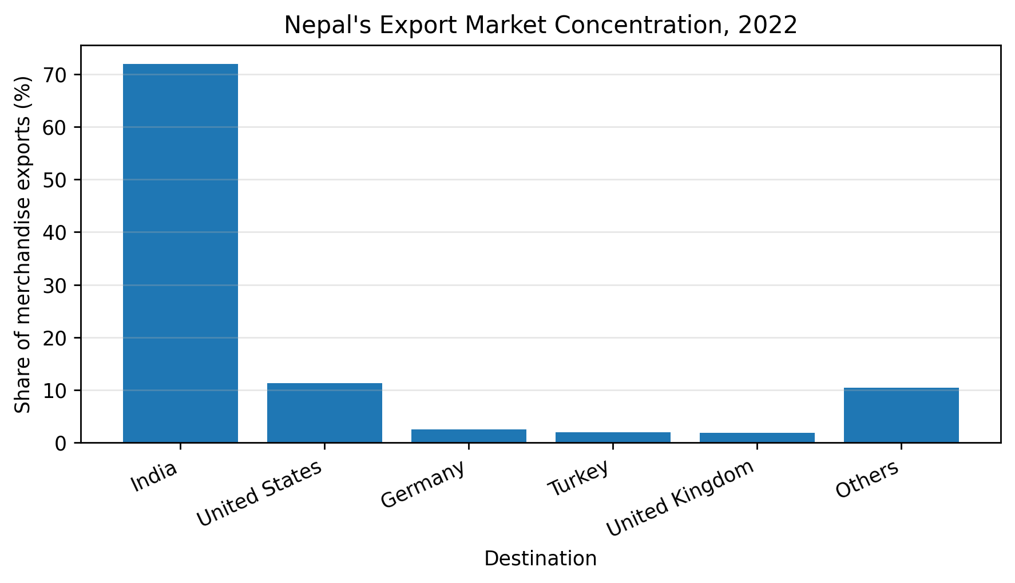
Note. Data compiled from World Integrated Trade Solution 2022 partner-share data (World Bank, 2022).
Figure 3: Nepalese export and import partner countries, 2013-2022
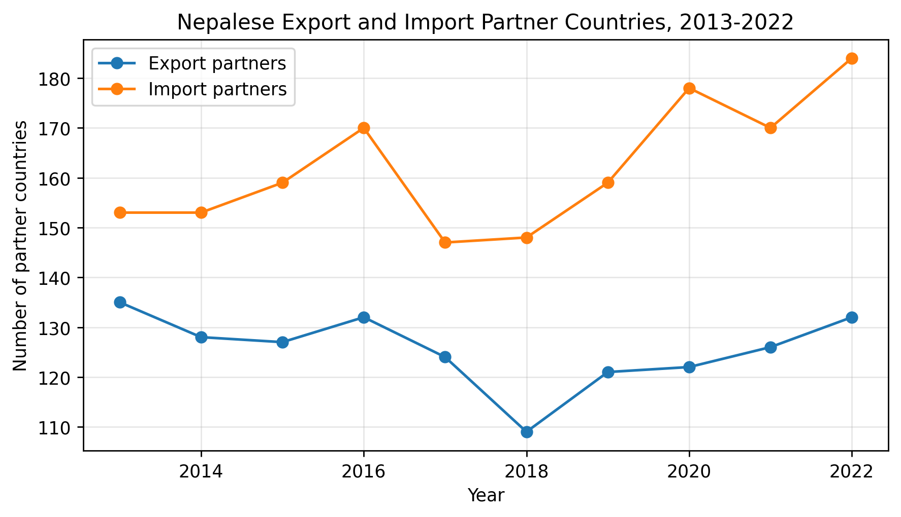
Note. Data compiled from WITS trade-flow data (World Bank, 2022).
Figure 4: Products exported and imported by Nepal, 2013-2022
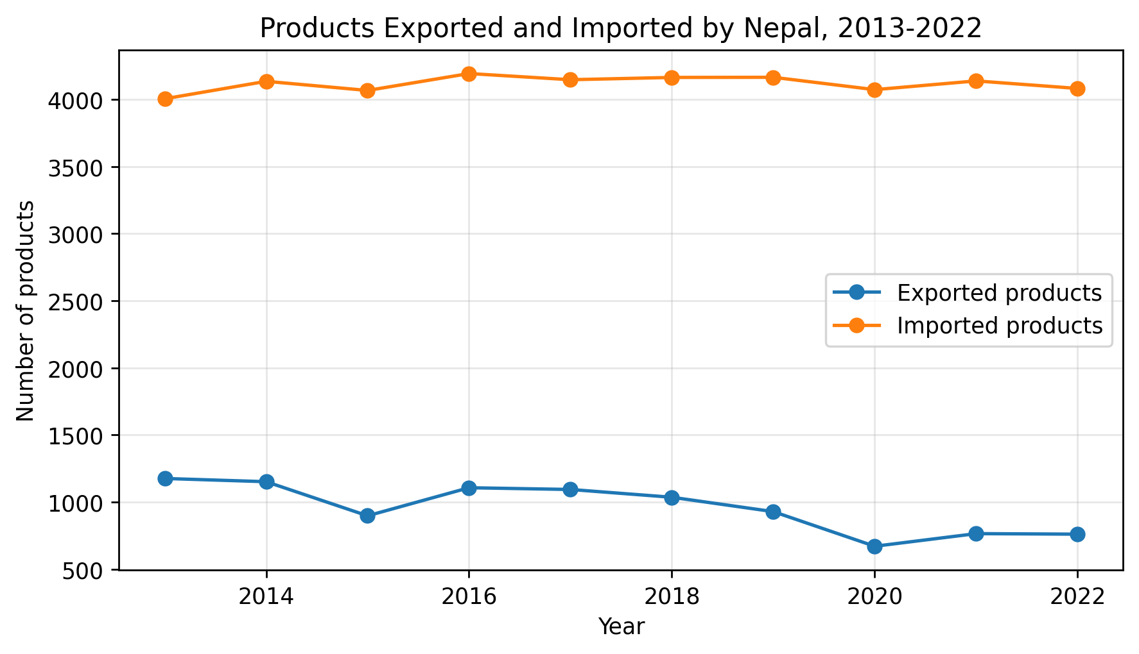
Note. Data compiled from WITS country profile data (World Bank, 2022).
Table 3: Nepal’s top five export and import products at HS-6 level, 2022
Rank | Export product | Exports (US$ thousand) | Import product | Imports (US$ thousand)
1 | Soybean oil, excluding crude and fractions | 186,905.71 | Petroleum oils and preparations, excluding crude | 2,281,003.78
2 | Palm oil, excluding crude and liquid fraction | 186,001.52 | Petroleum gases and other gaseous hydrocarbons | 516,422.71
3 | Carpets and other textile floor coverings | 84,665.89 | Crude soybean oil | 347,768.88
4 | Cardamoms | 46,642.78 | Semi-finished iron or non-alloy steel products | 288,973.80
5 | Felt, n.e.s. | 38,132.14 | Ferrous products obtained by direct reduction | 259,395.12
Note. Data compiled from WITS Nepal country profile data for 2022 (World Bank, 2022).

Sectoral Prospects: Hydropower, Agriculture, Services, and Intellectual Property
Nepal’s post-LDC strategy should not attempt to replicate the manufacturing path of larger graduating LDCs without adaptation. Nepal’s comparative possibilities are sector-specific. Hydropower is the most visible long-term opportunity: Nepal has large untapped hydropower potential, and regional demand, especially from India and Bangladesh, creates a plausible export pathway. Legally, hydropower trade depends on cross-border electricity rules, power-purchase agreements, investment protection, transmission access, land acquisition, environmental approval, benefit sharing, and dispute resolution.
Agriculture remains important because it contributes roughly one quarter of Nepal’s GDP and provides export possibilities in tea, coffee, cardamom, herbs, spices, vegetables, and organic products (Nepal Rastra Bank, 2024). However, agricultural export potential is legally mediated by SPS compliance, quality certification, residue testing, traceability, packaging rules, and geographical indication protection. Nepal’s problem is not lack of promising products; it is the absence of a fully reliable compliance pathway from farm to foreign market.
Services may be Nepal’s most underdeveloped legal opportunity. Services account for more than 60% of GDP, and tourism, ICT, education, health services, professional services, and labour mobility remain important export channels (Nepal Rastra Bank, 2024). The WTO LDC services waiver has been extended until 2030, but Nepal must use the remaining period strategically by seeking improved market access for tourism services, ICT providers, and Mode 4 labour mobility (WTO, 2021a). A post-graduation services strategy should include skill recognition, ethical recruitment, portability of social benefits, and labour-rights safeguards.
Intellectual property reform is also central. Under TRIPS, LDC members are not required to apply most TRIPS provisions until July 1, 2034, or until they cease to be LDCs, whichever is earlier (Agreement on Trade-Related Aspects of Intellectual Property Rights, 1994; WTO, 2021b). Nepal’s graduation will therefore intensify pressure to modernize IP law. The Patent, Design and Trademark Act 1965 and the Copyright Act 2002 require updating to cover modern innovation, geographical indications, traditional knowledge, technology transfer, digital works, and enforcement safeguards. Stronger IP protection should not be equated with TRIPS-plus commitments. Nepal should preserve public-health flexibilities and avoid commitments that narrow development policy space.

DISCUSSION
Nepal’s case exposes a graduation paradox. The country qualifies for graduation through social and vulnerability indicators, but its trade capacity remains fragile. Graduation may therefore reduce international support before domestic productive transformation has matured. This does not mean Nepal should reject graduation as a matter of principle. It means graduation should be governed as a legal transition with enforceable preparation duties.
A second problem is the preference trap. Preferential market access can help vulnerable economies, but it may also delay deeper reform. When market access is granted because of status, governments and firms may postpone the harder work of quality upgrading, productivity growth, standards compliance, and contractual reliability. Nepal’s export data show that preference-supported access has not automatically generated broad diversification. The post-LDC moment should therefore be used to redesign trade law around competitiveness rather than entitlement.
A third problem is institutional accountability. Nepal has many trade-related institutions, but no single legally empowered body appears responsible for coordinating all aspects of post-LDC legal readiness. The Smooth Transition Strategy should therefore be converted into a statutory or cabinet-backed implementation framework with measurable indicators, deadlines, and public reporting obligations. Without such accountability, reforms will remain aspirational.
Comparatively, Nepal differs from Bangladesh and Lao PDR. Bangladesh has a much larger manufacturing base and a deep export sector in garments. Lao PDR has stronger integration in regional value chains and resource-based trade. Nepal’s landlocked geography, smaller industrial base, heavy reliance on India, services-driven economy, and hydropower potential make its transition distinctive. A copy-and-paste development model would be inappropriate. Nepal requires a tailored legal strategy anchored in transit security, services trade, energy exports, niche agriculture, standards capacity, and gradual manufacturing upgrading.
The theoretical contribution of this article is to show that development status in international economic law is not only an income or vulnerability category. It is also a condition of regulatory capacity. Formal equality under trade law may expose substantive inequality when a country lacks the institutions required to use legal rights, comply with standards, challenge unlawful barriers, or negotiate alternative preferences. Nepal’s graduation therefore tests whether international economic law can support transition without producing premature exposure.

CONCLUSION: POLICY AND REGULATORY IMPLICATIONS
Nepal’s LDC graduation should be understood as a shift from preference reliance to regulatory competitiveness. The country’s legal framework is not empty. It contains customs law, investment law, industrial legislation, trade-remedy law, intellectual property statutes, trade-policy instruments, and regional and multilateral commitments. The challenge is that these instruments are not yet sufficiently integrated, export-facing, or institutionally accountable.
The first implication is that Nepal should adopt a Post-LDC Trade Readiness Act or binding cabinet framework. This instrument should translate the Smooth Transition Strategy into institutional mandates, timelines, sectoral targets, and public reporting duties. It should identify responsible agencies for GSP+ preparation, rules-of-origin capacity, SPS/TBT infrastructure, customs reform, trade remedies, IP modernization, and services negotiations.
Second, Nepal should prepare a GSP+ compliance roadmap. This requires a legal audit of the 27 conventions, ratification gaps, labour inspection capacity, environmental governance, human-rights reporting, and good-governance monitoring. GSP+ should be treated not merely as a trade benefit but as a cross-ministerial compliance project.
Third, Nepal should strengthen export-facing legal services. Small and medium exporters need practical support on contracts, certification, rules of origin, customs valuation, product standards, foreign-market regulations, and dispute avoidance. Export promotion without legal compliance support will not be enough.
Fourth, Nepal should modernize IP law while preserving development flexibilities. Reform should cover patents, trademarks, industrial designs, copyright, geographical indications, traditional knowledge, digital commerce, and enforcement, while retaining compulsory licensing and public-interest safeguards.
Fifth, Nepal should professionalize trade-remedy institutions. Investigations must be transparent, evidence-based, and WTO-consistent. A credible trade-remedy system can protect domestic industry without becoming arbitrary protectionism.
Sixth, Nepal should pursue sector-specific legal reform in hydropower, agro-processing, tourism, ICT, and labour mobility. Hydropower requires bankable cross-border energy rules. Agriculture requires SPS and quality infrastructure. Tourism requires air connectivity, safety regulation, and market access. ICT requires data, tax, payment, and services-trade clarity. Labour mobility requires skill recognition and rights protection.
Finally, Nepal should use regional and bilateral diplomacy strategically. SAFTA and BIMSTEC should be treated as instruments for corridor predictability, standards cooperation, services mobility, and energy trade rather than symbolic regionalism. Because Nepal is landlocked, transit law must be placed at the centre of trade strategy. A legally prepared Nepal will be better positioned not only to survive preference erosion, but to use graduation as a platform for more resilient, rules-based development.
Table 4: Policy and regulatory recommendations for Nepal’s post-LDC trade readiness
Reform area | Recommendation | Lead institutions
Post-LDC governance | Adopt a binding trade-readiness framework with agency mandates, indicators, and annual reporting. | Prime Minister’s Office; MoICS; National Planning Commission
GSP+ preparation | Complete a legal audit of the 27 conventions, ratification gaps, and implementation capacity. | MoICS; Ministry of Labour; Ministry of Law; Ministry of Foreign Affairs
Customs and origin compliance | Create exporter support desks for rules of origin, advance rulings, and digital certificates. | Department of Customs; TEPC
Standards infrastructure | Expand accredited laboratories, traceability systems, and mutual-recognition diplomacy. | Nepal Bureau of Standards and Metrology; SPS agencies
Trade remedies | Build a professional investigation authority for safeguard, anti-dumping, and countervailing cases. | Department of Commerce, Supplies and Consumer Protection
IP modernization | Replace or comprehensively amend outdated IP statutes and protect GIs/traditional knowledge. | Ministry of Industry; Department of Industry; Parliament
Services exports | Negotiate Mode 4, tourism, and ICT market access while strengthening ethical labour migration. | MoICS; Ministry of Labour; Ministry of Tourism
Transit and energy trade | Strengthen legally predictable transit and cross-border electricity trade arrangements. | MoFA; Ministry of Energy; MoICS
Note. Recommendations synthesize the article’s legal analysis with WTO and EU legal requirements (European Commission, n.d.; Government of Nepal, National Planning Commission, 2024; WTO, 2024, 2025a).

REFERENCES
Adhikari, L. D. (2024). TRIPS agreement and least developed countries: A case study of Nepal.
Agreement on South Asian Free Trade Area. (2004). South Asian Association for Regional Cooperation.
Agreement on Trade-Related Aspects of Intellectual Property Rights. (1994). Marrakesh Agreement Establishing the World Trade Organization, Annex 1C.
BIMSTEC Framework Agreement on Free Trade Area. (2004). Bay of Bengal Initiative for Multi-Sectoral Technical and Economic Cooperation.
Copyright Act, 2059 (2002) (Nepal).
Customs Act, 2064 (2007) (Nepal).
Customs Tariff Act, 2081 (2024) (Nepal).
E-commerce Act, 2082 (2025) (Nepal).
European Commission. (n.d.). Generalised scheme of preferences plus (GSP+). Access2Markets. https://trade.ec.europa.eu/access-to-markets/en/content/generalised-scheme-preferences-plus-gsp
European Communities-Conditions for the Granting of Tariff Preferences to Developing Countries, WT/DS246/AB/R (World Trade Organization Appellate Body Report, adopted April 20, 2004).
Federation of Nepalese Chambers of Commerce and Industry. (n.d.). Nepal’s graduation from LDC: A private sector perspective.
Food Safety and Quality Act, 2081 (2024) (Nepal).
Foreign Investment and Technology Transfer Act, 2075 (2019) (Nepal).
General Agreement on Tariffs and Trade 1994. Marrakesh Agreement Establishing the World Trade Organization, Annex 1A.
General Agreement on Trade in Services. (1994). Marrakesh Agreement Establishing the World Trade Organization, Annex 1B.
Government of Nepal, Ministry of Commerce and Supplies. (2015). Trade Policy 2015.
Government of Nepal, National Planning Commission. (2024). Nepal LDC graduation smooth transition strategy.
India-Quantitative Restrictions on Imports of Agricultural, Textile and Industrial Products, WT/DS90/AB/R (World Trade Organization Appellate Body Report, adopted September 22, 1999).
Industrial Enterprises Act, 2076 (2020) (Nepal).
International Trade Centre, & United Nations Office of the High Representative for the Least Developed Countries, Landlocked Developing Countries and Small Island Developing States. (2022). Nepal after LDC graduation: New avenues for exports.
Nepal Rastra Bank. (2020-2025). Annual macroeconomic and financial situation reports for FY2019/20-FY2024/25. Economic Research Department. https://www.nrb.org.np/category/current-macroeconomic-situation/
Nepal Rastra Bank. (2024). Current macroeconomic and financial situation of Nepal: Based on annual data of 2023/24. Economic Research Department.
Pant, B. (2021). Nepal’s trade sector: Review, repercussions and recommendations. Economic Review, 86, 1-24.
Patent, Design and Trademark Act, 2022 (1965) (Nepal).
Public-Private Partnership and Investment Act, 2075 (2019) (Nepal).
Russia-Measures Concerning Traffic in Transit, WT/DS512/R (World Trade Organization Panel Report, adopted April 26, 2019).
Safeguards, Anti-Dumping and Countervailing Act, 2076 (2019) (Nepal).
Turkey-Restrictions on Imports of Textile and Clothing Products, WT/DS34/AB/R (World Trade Organization Appellate Body Report, adopted November 19, 1999).
United Nations. (2026). Nepal graduation status. LDC Portal.
World Bank. (2022). World Integrated Trade Solution: Nepal country profile and trade-flow data.
World Trade Organization. (2021a). Services waiver for least-developed countries extended until 2030.
World Trade Organization. (2021b). WTO members agree to extend TRIPS transition period for LDCs until July 1, 2034.
World Trade Organization. (2024). Smooth transition support measures in favour of countries graduated from the least-developed country category. WT/MIN(24)/34; WT/L/1189.
World Trade Organization. (2025a). Trade policy review: Nepal.
World Trade Organization. (2025b). Trade Policy Review: Nepal: Report by the Secretariat. WT/TPR/S/478.
World Trade Organization. (2025c). Trade Policy Review: Nepal: Report by Nepal. WT/TPR/G/478.

