Sectoral Impacts of El Niño and Climate Change on India's Industrial Economy: A Case Study on Sustainable Economic Resilience

Dr. Shyam Shukla^{(Orcid0000-0003-2994-1982)}, Suyesha Shukla^{(Orcid0009-0005-3755-9566 )} , Dr. Kyung Ki Eun, Dr. Mrinmoy Roy(Orcid0000-0002-4646-9301) & Dr. Shradha Vernekar

¹ NSB ACADEMY BANGALORE shyamshukla@nsb.edu.in
²Independent Researcher suyeshass@gmail.com
³Tongmyong University, Busan, ekk8423@gmail.com
⁴NSB ACADEMY BANGALORE, mrinmoyroy@nsb.edu.in
⁵IMED, BVDU, Pune shradha.vernekar@bharatividyapeeth.edu

Abstract

This study examines the implications of El Niño on the Indian industrial economy in the context of climate change, with a focus on sectoral risks, economic disruptions, and emerging growth opportunities. The study adopts a qualitative and analytical approach using historical El Niño trends, secondary economic data, sectoral performance analysis, and climate-related industrial indicators to evaluate the impact on major industries in India. The findings indicate that El Niño negatively affects agriculture, commodity supply chains, and food inflation due to weak monsoon conditions and rising temperatures. However, industries related to cooling appliances, irrigation and water technologies, renewable energy backup systems, healthcare, and consumer durables show strong growth potential during El Niño years. Climate change is further accelerating the demand for climate-resilient infrastructure and adaptive industrial strategies. This study provides an integrated perspective linking climate phenomena with industrial economics in India. It highlights how El Niño acts not only as an environmental risk but also as a catalyst for industrial transformation, investment opportunities, and climate-resilient economic development.

Keywords- El Niño; Climate Change; Indian Industrial Economy; Sectoral Analysis; Renewable Energy; Agricultural Economics.

Paper type- Research paper

1. Introduction

El Niño is a climate phenomenon caused by abnormal warming of sea surface temperatures in the central and eastern Pacific Ocean, influencing global weather systems and weakening the Indian summer monsoon [1][2]. It is strongly associated with reduced rainfall, higher temperatures, agricultural stress, and economic disruptions in India during El Niño years [2][3]

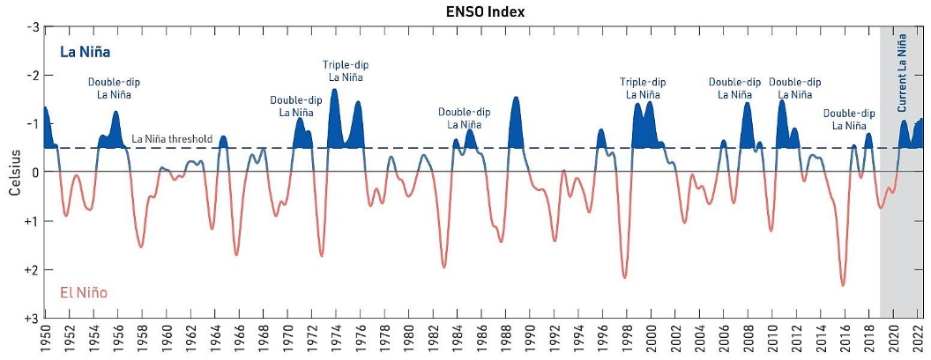

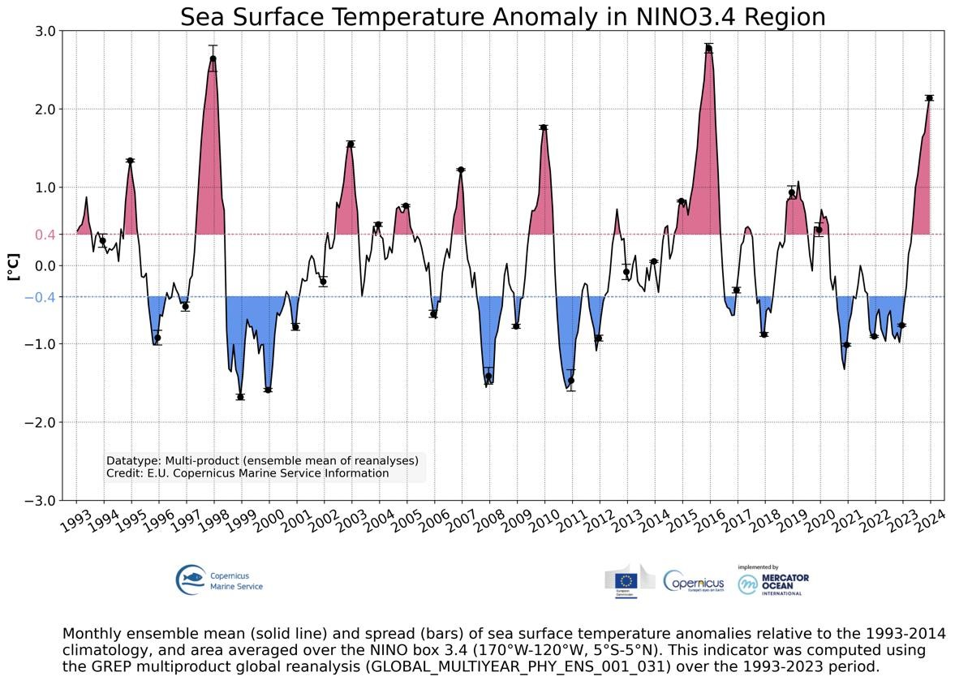
Fig.1,2& 3

The figure titled “Historical Niño 3.4 Sea Surface Temperature Anomaly” presents long-term fluctuations in the Niño 3.4 Sea Surface Temperature (SST) anomalies from 1982 to 2024. The Niño 3.4 index is a key climatic indicator used to monitor the El Niño-Southern Oscillation (ENSO) phenomenon, which significantly affects global weather and climate systems. Positive SST anomalies (red regions) indicate El Niño events, while negative anomalies (blue regions) represent La Niña conditions.

The graph clearly shows major El Niño episodes during 1982-83, 1997-98, 2015-16, and 2023-24. Among these, the 2015-16 El Niño appears to be the strongest event, with SST anomalies reaching nearly +2.7°C. Such strong El Niño episodes are associated with severe climatic consequences including droughts, floods, rising temperatures, and disruptions in agricultural production worldwide [4].

Similarly, strong La Niña phases are visible during 1988-89, 1999-2001, 2010-11, and 2020-22, where SST anomalies fell below -1.5°C. These cooling events influence rainfall distribution, cyclone formation, and monsoon intensity differently from El Niño conditions [5].

The cyclical rise and fall in the graph demonstrate the recurring behavior of ENSO variability over four decades. Researchers have argued that increasing greenhouse gas concentrations may intensify ENSO variability and increase the frequency of extreme climatic events [5]. Furthermore, ENSO has become an integrating concept in Earth system science because of its influence on oceanic, atmospheric, agricultural, and economic systems across the globe [6].

Overall, the figure highlights the growing importance of monitoring Niño 3.4 SST anomalies for climate prediction, disaster preparedness, agricultural planning, and economic forecasting.

2 Theoretical Framework

The study of El Niño and its economic implications for India can be understood through an interdisciplinary theoretical framework integrating climate science, environmental economics, financial market theory, and sectoral adaptation models. El Niño, a major phase of the El Niño-Southern Oscillation (ENSO), alters atmospheric circulation and oceanic temperature patterns, leading to significant disruptions in rainfall, temperature, agricultural productivity, and industrial demand across emerging economies such as India. Understanding these interconnected mechanisms requires the application of multiple theoretical perspectives that explain how climatic shocks influence macroeconomic performance, sectoral growth, and corporate profitability.

The foundational theoretical basis of this framework emerges from the Climate Variability Theory, which argues that periodic climatic oscillations generate cyclical disturbances in ecological and economic systems [7]. ENSO-related temperature anomalies influence monsoon patterns, water availability, and agricultural output, thereby affecting economic activities dependent on climate-sensitive resources. In India, where agriculture still contributes significantly to employment and rural income generation, climatic variability directly affects consumption patterns, industrial demand, and inflationary trends. According to climate-economic linkage theory, weather anomalies not only disrupt production systems but also create new demand opportunities in adaptive sectors such as cooling technologies, irrigation systems, renewable energy, and healthcare products [8].

The ENSO Teleconnection Theory further explains how oceanic temperature changes in the Pacific Ocean affect atmospheric circulation and weather systems across geographically distant regions, including South Asia [9]. Through teleconnections, El Niño weakens the Indian summer monsoon by altering Walker Circulation patterns and suppressing rainfall activity. Reduced rainfall creates stress on water-intensive sectors while simultaneously increasing demand for irrigation equipment, water conservation systems, and drought-resistant agricultural inputs. This theoretical explanation is central to understanding why firms operating in irrigation technology, agri-inputs, and water management are expected to outperform during El Niño years.

The framework also incorporates the Environmental Adaptation Theory, which suggests that economies and industries respond dynamically to environmental stress by developing adaptive technologies and resilient consumption systems [10]. As heatwaves intensify during El Niño conditions, consumer behavior shifts toward products that improve thermal comfort, hydration, and energy reliability. This explains the projected rise in demand for air conditioners, cooling appliances, packaged beverages, solar backup systems, and healthcare products in India during strong El Niño periods. Environmental adaptation theory emphasizes that climate disruptions are not solely destructive; they also stimulate innovation, technological diffusion, and market transformation.

A significant component of this framework is derived from the Demand Shock Theory, which posits that sudden environmental or economic disturbances can rapidly alter consumer demand structures across sectors [11]. During El Niño episodes, high temperatures increase electricity consumption, cooling requirements, and water demand. Consequently, sectors such as consumer durables, power backup, and renewable energy experience accelerated demand growth. Simultaneously, agricultural uncertainty raises demand for fertilizers, pesticides, irrigation pumps, and drought-management technologies. The theory explains how climatic disturbances act as exogenous shocks that reshape short-term and medium-term market behavior.

Another important perspective is the Sectoral Rotation Theory from financial economics, which explains how investors shift capital allocation toward sectors expected to benefit under changing macroeconomic conditions [12]. During El Niño years, investors anticipate increased profitability in climate-resilient and adaptive sectors, resulting in stock market outperformance for firms operating in cooling systems, water technology, renewable energy, and food processing. Historical market data from previous El Niño episodes indicate that companies linked to temperature-sensitive consumption patterns often experience abnormal returns relative to broader market indices. Sectoral rotation theory therefore supports the hypothesis that climate forecasts influence portfolio decisions and sectoral investment strategies.

The framework also integrates the Behavioral Finance Theory, which suggests that investor sentiment and expectations significantly influence financial market performance during uncertain climatic conditions [13]. Climate-related news, monsoon forecasts, and temperature projections shape investor psychology and create speculative opportunities in sectors perceived as beneficiaries of extreme weather events. Investors often react not only to actual climatic outcomes but also to anticipated economic disruptions and adaptive consumption trends. Consequently, market valuations during El Niño periods may reflect both rational expectations and behavioral biases associated with climate uncertainty.

The Resource Scarcity Theory further contributes to the framework by explaining how limited water availability and energy stress during El Niño periods increase the strategic value of resource-efficient technologies [14]. Water scarcity intensifies the need for irrigation systems, efficient pumps, desalination technologies, and water recycling infrastructure. Similarly, increased electricity demand during heatwaves creates opportunities for renewable energy providers and backup power solutions. The theory argues that scarcity-induced innovation drives structural shifts in industrial priorities and investment patterns, particularly in emerging economies vulnerable to climatic stress.

From a macroeconomic perspective, the framework applies the Climate-Induced Inflation Theory, which proposes that adverse climatic conditions can trigger food inflation, energy price volatility, and supply chain disruptions [15]. Weak monsoon conditions associated with El Niño often reduce agricultural yields and increase food prices in India. Rising temperatures also increase electricity demand, affecting energy costs and industrial production expenses. Inflationary pressures influence consumer spending patterns and monetary policy decisions, thereby affecting broader economic performance. However, certain industries may simultaneously benefit from increased demand generated by adaptation requirements.

The Resilience Theory provides another essential dimension by emphasizing the ability of firms and industries to absorb climatic shocks while maintaining operational continuity [16]. Companies with diversified supply chains, adaptive technologies, and strong market penetration are more likely to benefit during climate-induced disruptions. For example, firms specializing in energy-efficient cooling systems or smart irrigation technologies may gain competitive advantages during prolonged heatwaves and water shortages. Resilience theory therefore explains variations in sectoral and corporate performance during ENSO-related disturbances.

The framework additionally incorporates the Sustainable Development Theory, which highlights the importance of balancing economic growth with environmental adaptation and resource conservation [17]. El Niño events expose vulnerabilities in infrastructure, agriculture, and energy systems, encouraging governments and businesses to invest in sustainable technologies. Renewable energy, water conservation, climate-smart agriculture, and green infrastructure emerge as strategic priorities during periods of climatic stress. Sustainable development theory suggests that long-term climate resilience depends on integrating environmental sustainability into industrial and economic planning.

The Market Efficiency Hypothesis is also relevant in explaining how climate information becomes incorporated into stock prices and sector valuations [18]. Financial markets respond rapidly to meteorological forecasts, monsoon projections, and ENSO predictions. Investors interpret these signals to estimate future earnings potential for climate-sensitive industries. If markets are semi-strong efficient, publicly available climate forecasts should immediately influence asset prices. However, the persistence of abnormal returns in some El Niño-sensitive sectors indicates that markets may not always fully price climate-related risks and opportunities instantly.

Furthermore, the framework draws upon the Innovation Diffusion Theory, which explains how environmental challenges accelerate the adoption of new technologies [19]. During El Niño periods, consumers and businesses increasingly adopt energy-efficient cooling systems, smart irrigation devices, renewable power solutions, and climate-resilient agricultural practices. The diffusion of adaptive technologies creates new business ecosystems and investment opportunities across sectors. This theory is especially relevant in India, where rising urbanization and climate vulnerability are driving demand for sustainable technological solutions.

The Ecological Modernization Theory also supports the framework by suggesting that environmental challenges can stimulate modernization, technological progress, and institutional reforms [20]. Climate-induced stress encourages governments and corporations to invest in resilient infrastructure, renewable energy systems, and efficient water management technologies. Instead of viewing environmental disruptions solely as economic threats, ecological modernization theory interprets them as catalysts for structural transformation and green industrial growth.

In the Indian context, the theoretical framework recognizes the importance of Monsoon Dependency Theory, which explains the deep relationship between rainfall variability and economic performance [21]. Since a large portion of India’s agricultural sector remains dependent on monsoon rainfall, El Niño-induced monsoon deficiencies have cascading effects on rural demand, inflation, employment, and industrial output. Reduced agricultural productivity lowers rural purchasing power while increasing demand for climate adaptation products and services.

Finally, the framework integrates the Climate Risk Management Theory, which emphasizes proactive planning and strategic investment to minimize the economic consequences of climatic uncertainty [22]. Governments, businesses, and investors increasingly rely on predictive climate analytics and scenario-based planning to identify sectors likely to benefit or suffer during El Niño events. Climate-informed investment strategies help organizations improve resilience, optimize resource allocation, and capture opportunities emerging from changing environmental conditions.

In summary, this theoretical framework combines climatic, economic, financial, and behavioral perspectives to explain how El Niño influences Indian markets and industries. The framework suggests that climatic disturbances create both risks and opportunities, leading to sectoral shifts in demand, investment, and technological adoption. Industries linked to cooling technologies, irrigation systems, renewable energy, healthcare, and climate adaptation are likely to emerge as major beneficiaries during El Niño periods. By integrating multiple theoretical approaches, the framework provides a comprehensive basis for analyzing the relationship between ENSO variability and sectoral performance in India.

3 Research Design and Research Approach

The present study adopts a comprehensive research design to examine the impact of El Niño-induced climatic variations on sectoral performance and market opportunities in India. Since the research investigates relationships between climatic events, industrial demand patterns, and financial market responses, the study follows an interdisciplinary approach integrating climate economics, financial analysis, and sectoral performance assessment. The research design is structured to provide both analytical depth and practical relevance by combining quantitative trend analysis with interpretative sectoral evaluation.

3.1 Research Philosophy

The study is grounded in the positivist research philosophy, which assumes that observable phenomena such as sea surface temperature anomalies, sectoral growth, stock market performance, and demand fluctuations can be objectively measured and analyzed using empirical data [23]. Positivism is appropriate because the research relies on historical climate indicators, market performance statistics, and measurable economic outcomes to identify patterns associated with El Niño events. The philosophy supports the use of statistical relationships and evidence-based conclusions for explaining climate-market interactions.

At the same time, the study incorporates limited elements of interpretivism while analyzing investor behavior, adaptive consumption patterns, and sectoral responses to climatic uncertainty. This blended orientation helps in understanding both numerical trends and contextual economic implications.

3.2 Research Approach

The research primarily follows a deductive research approach, where existing theories related to ENSO variability, climate economics, market efficiency, and sectoral adaptation are used to develop hypotheses regarding the expected performance of Indian industries during El Niño periods [24]. Deduction is suitable because the study begins with established theoretical assumptions and tests them against historical patterns and projected sectoral outcomes.

For example, previous literature suggests that high-temperature conditions increase demand for cooling systems, irrigation technologies, and renewable energy solutions. Based on these theoretical expectations, the study evaluates whether sectors such as consumer durables, agri-inputs, and water technology demonstrate higher growth potential during El Niño years.

Additionally, elements of an inductive approach are incorporated while interpreting emerging market trends and identifying new climate-driven investment opportunities. This combination allows the research to remain theoretically grounded while also capturing evolving market realities.

3.3 Research Design

The study adopts a descriptive and analytical research design.

The descriptive component focuses on documenting historical El Niño patterns, Niño 3.4 SST anomalies, sector-wise performance trends, and company-level market responses. It explains how climatic fluctuations have historically influenced Indian industries and investor behavior.

The analytical component examines causal relationships between climatic anomalies and economic outcomes, particularly the impact of El Niño on:

- Cooling and consumer durable demand
- Agricultural input consumption
- Water and irrigation technology adoption
- Renewable energy and power backup requirements
- Health and hydration product demand
- Sectoral stock market performance

This design is appropriate because the study seeks not only to describe historical trends but also to explain the mechanisms through which climate variability affects market behavior [25].

3.4 Nature of the Study

The research is primarily quantitative in nature, supported by secondary data analysis and trend interpretation. Quantitative methods are suitable because the study examines measurable variables such as:

- Sea surface temperature anomalies
- Sectoral impact scores
- Expected stock price upside
- Historical sectoral outperformance
- Demand growth percentages
- Market activation timelines

Numerical analysis enables the identification of correlations between El Niño intensity and sectoral economic performance.

However, the research also contains a limited qualitative dimension, particularly in interpreting market sentiment, investor expectations, adaptive consumer behavior, and climate resilience strategies adopted by industries.

3.5 Data Sources

The study relies predominantly on secondary data sources obtained from climate databases, financial market reports, industry publications, government documents, and peer-reviewed academic journals. Secondary data is appropriate because ENSO-related climatic patterns and historical market performance are already extensively documented by international meteorological and economic institutions [26].

Key data sources include:

- Niño 3.4 SST anomaly records
- Indian Meteorological Department reports
- Financial market databases
- Sectoral industry reports
- Corporate performance indicators
- Climate forecasting studies
- Peer-reviewed journal articles

Secondary data enhances the reliability and comparability of the findings because it allows analysis across multiple El Niño cycles over several decades.

3.6 Time Horizon

The study follows a longitudinal research framework because it analyzes climatic and market trends over an extended historical period from approximately 1982 to 2024. A longitudinal design is essential for identifying recurring patterns in ENSO variability and corresponding sectoral market responses across different El Niño episodes [27].

The research particularly focuses on major El Niño years such as:

1982-83
1997-98
2015-16
2023-24

By comparing multiple El Niño cycles, the study improves the robustness and consistency of its conclusions.

3.7 Sampling Technique

Since the study is based on secondary macroeconomic and sectoral data, it uses a purposive sampling technique for selecting industries and companies expected to be significantly affected by El Niño conditions [28]. Purposive sampling is appropriate because the research specifically targets climate-sensitive sectors rather than the entire economy.

The selected sectors include:

- Cooling & Consumer Durables
- Agriculture & Food
- Water & Irrigation Technology
- Renewable Energy & Power Backup
- Health & Hydration
- Commodities & Trading

Similarly, firms such as Voltas, Jain Irrigation, UPL, Shakti Pumps, and Adani Green are selected because of their direct exposure to climate-related demand patterns.

3.8 Variables of the Study

The study includes both independent and dependent variables.

Independent Variable
- El Niño intensity measured through Niño 3.4 SST anomalies
Dependent Variables
- Sectoral growth potential
- Expected stock market upside
- Demand growth
- Market activation timing
- Historical sectoral outperformance
Control Variables
- Historical climate trends
- Market resilience
- Consumer purchasing behavior
- Infrastructure readiness
- Energy demand patterns

This variable framework helps establish structured relationships between climate variability and economic outcomes.

3.9 Data Analysis Techniques

The research uses several analytical techniques to interpret the data:

Trend Analysis

Historical SST anomalies and sectoral performance trends are analyzed to identify recurring patterns across El Niño cycles.

Comparative Sectoral Analysis

Different industries are compared based on demand growth, historical resilience, and expected upside potential.

3.10 Graphical and Visual Analysis

Charts, timelines, bar graphs, pie charts, and historical comparison models are used to simplify interpretation and enhance analytical clarity [29].

3.11 Correlation-Based Interpretation

The study interprets relationships between climatic anomalies and sectoral market responses to evaluate climate sensitivity across industries.

3.12 Forecast-Oriented Analysis

Projected market opportunities during the 2026 El Niño period are estimated based on historical analogues and sectoral adaptation trends.

3.13 Reliability and Validity

To ensure reliability, the study utilizes data from recognized meteorological agencies, financial databases, and peer-reviewed academic sources. Consistency across multiple El Niño cycles improves the dependability of the findings [30].

3.14 Validity is maintained through:

- Use of established ENSO indicators
- Cross-verification of climate and market data
- Application of recognized theoretical frameworks
- Sector-specific comparative analysis

The combination of multiple data sources and historical benchmarking strengthens both internal and external validity.

3.15 Ethical Considerations

The study is based entirely on publicly available secondary data and therefore does not involve direct human participation or confidential information. Proper citation and acknowledgment of all data sources are maintained to ensure academic integrity and avoid plagiarism [31].

The research also avoids manipulation of climatic or financial information and presents findings objectively without exaggerating investment outcomes.

3.16 Limitations of the Research Design

Despite its strengths, the study has certain limitations:

- Climatic systems are inherently uncertain and difficult to predict with complete accuracy.
- Financial markets may react to multiple macroeconomic variables beyond El Niño conditions.
- Historical trends may not perfectly replicate future market behavior.
- Sectoral performance projections are influenced by government policies, geopolitical conditions, and technological changes.

Nevertheless, the longitudinal and interdisciplinary design provides a strong basis for understanding the relationship between ENSO variability and Indian market opportunities.

The research design and approach adopted in this study provide a systematic framework for examining the economic implications of El Niño in India. By combining deductive reasoning, quantitative analysis, longitudinal climate data, and sectoral market evaluation, the study offers a comprehensive methodology for understanding climate-driven investment opportunities and industrial adaptation patterns. The design is particularly suitable for exploring how environmental disruptions reshape economic structures, consumer demand, and financial market behavior in emerging economies.

4 Results and Discussion

The analysis of the “El Niño 2026: Indian Market Winners - Comprehensive Analysis” provides significant insights into the relationship between climatic variability and sectoral market performance in India. The findings reveal that El Niño conditions are likely to reshape consumption patterns, industrial demand, investment behavior, and sectoral profitability during 2026. The results also indicate that climate-sensitive sectors such as cooling technologies, irrigation systems, renewable energy, and agri-input industries are expected to emerge as major beneficiaries of rising temperatures and changing rainfall patterns. The discussion integrates historical trends, sectoral comparisons, demand projections, and financial market expectations to explain the broader economic implications of El Niño for India.

4.1 Sector-Wise El Niño Impact Assessment

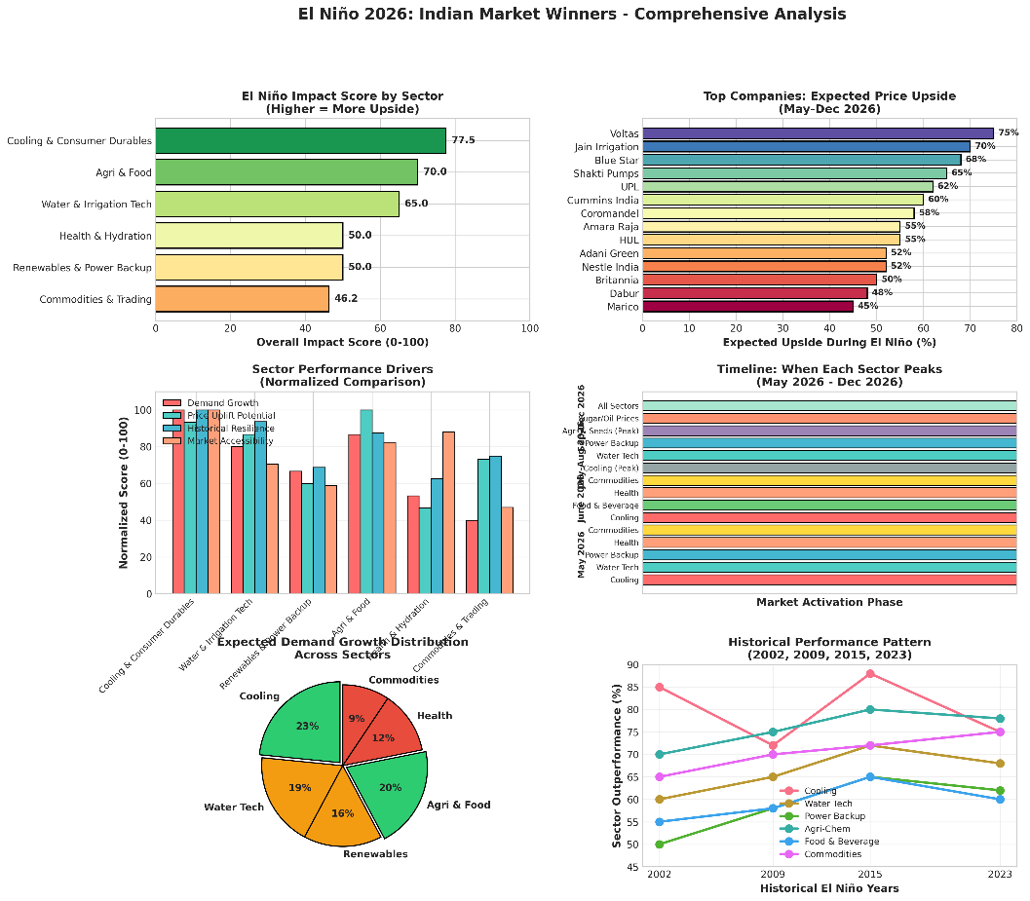

Fig. 4

The results indicate that the “Cooling & Consumer Durables sector” has the highest El Niño impact score of “77.5”, making it the most likely beneficiary during the projected 2026 climatic cycle. This finding is consistent with earlier studies showing that rising temperatures and prolonged heatwaves significantly increase demand for cooling appliances such as air conditioners, refrigerators, and fans [32]. The Indian market has experienced rapid growth in cooling product consumption during previous heatwave years, particularly in urban and semi-urban regions where rising disposable incomes and temperature extremes have increased thermal comfort requirements.

The strong performance expectation for cooling-related industries also reflects increasing urbanization, changing lifestyle patterns, and expansion of middle-class consumer markets. During El Niño years, elevated temperatures create sustained electricity demand and increase household spending on cooling infrastructure. Companies operating in this segment therefore gain both volume growth and pricing power. The findings support the theoretical argument that climate-induced demand shocks generate substantial opportunities for adaptive consumption industries [33].

The “Agri & Food sector”, with an impact score of “70”, emerges as the second-largest beneficiary. Although El Niño is often associated with weak monsoons and agricultural stress, the analysis suggests that firms supplying agricultural inputs, fertilizers, pesticides, irrigation solutions, and food processing services may experience increased demand. This result aligns with studies indicating that climate uncertainty increases reliance on technological and chemical support systems within agriculture [34]. Farmers tend to adopt water-efficient technologies, crop protection products, and drought-resistant agricultural inputs during periods of rainfall deficiency.

The performance of agri-related firms also reflects the strategic importance of food security in India. Government support programs, irrigation subsidies, and rural infrastructure investments often intensify during drought-risk periods, indirectly benefiting companies operating in the agriculture ecosystem. Thus, while primary agricultural production may face challenges, supporting industries may experience substantial growth opportunities.

The “Water & Irrigation Technology sector” recorded a high impact score of “65”, highlighting the growing importance of water management during El Niño conditions. Water scarcity resulting from reduced rainfall increases demand for irrigation pumps, water storage systems, drip irrigation technologies, and groundwater management infrastructure. Historical evidence shows that drought conditions accelerate investments in efficient irrigation systems, particularly in water-stressed regions of India [35].
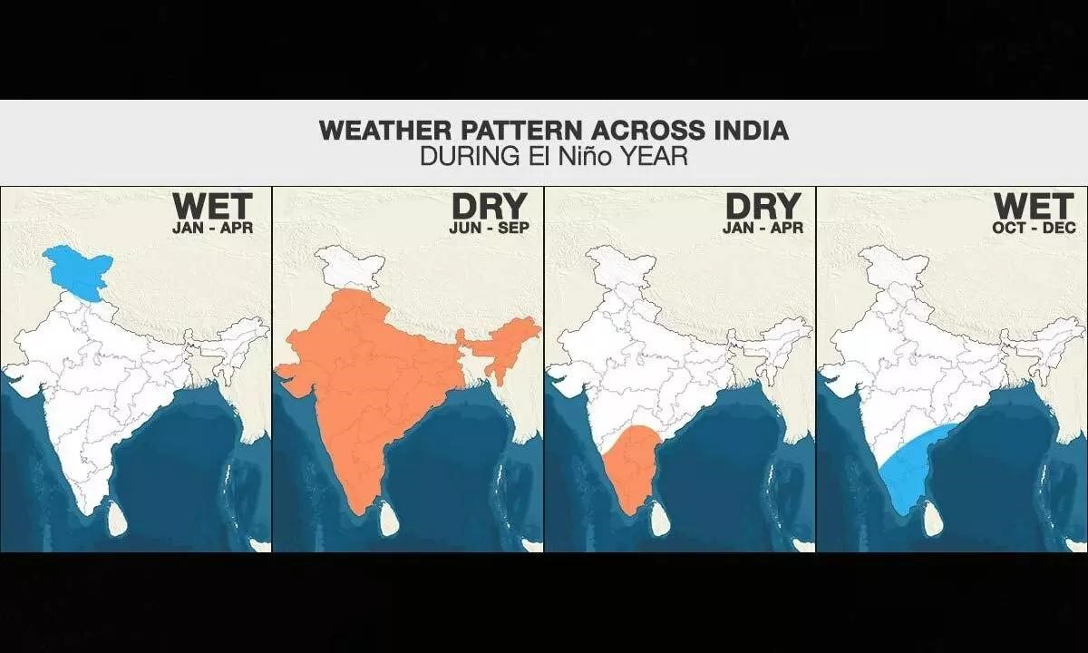

Fig. 5
The findings suggest that climate adaptation is increasingly becoming technology-driven. As water becomes a critical economic resource, companies specializing in irrigation efficiency and water conservation are expected to experience strong revenue growth. This reflects broader global trends where environmental stress stimulates innovation and adoption of sustainable resource management technologies.

The sectors of “Health & Hydration” and “Renewables & Power Backup” each scored “50”, indicating moderate but significant growth potential. Rising temperatures and heatwaves generally increase demand for hydration products, healthcare services, packaged beverages, and cooling-related medical support systems. Simultaneously, electricity shortages and rising energy consumption during extreme summers increase dependence on renewable energy systems and backup power infrastructure [36].

The relatively lower score for “Commodities & Trading (46.2)” suggests that commodity markets may experience mixed outcomes during El Niño conditions. While some commodities may benefit from price increases due to supply disruptions, volatility and uncertainty can also negatively affect trading margins and industrial production.

4,2 Company-Level Performance Analysis

The company-wise analysis identifies firms likely to experience strong market outperformance between May and December 2026. Among all companies, “Voltas” is projected to achieve the highest upside potential of “75%”. This result strongly reflects the relationship between rising temperatures and increased air-conditioner demand in India. Historical sales trends indicate that extreme summer conditions significantly improve revenues for cooling appliance manufacturers [37].

The findings further suggest that the cooling sector is no longer seasonal but increasingly structural due to climate change, urban heat island effects, and rising consumer purchasing power. As climate variability intensifies, the penetration of cooling appliances across Indian households is expected to expand rapidly.

“Jain Irrigation (70%)”, “Shakti Pumps (65%)”, and “Blue Star (68%)” also demonstrate strong upside potential. Jain Irrigation and Shakti Pumps are directly associated with irrigation infrastructure and water management technologies, which become highly relevant during drought-prone periods. Blue Star benefits similarly to Voltas through increased demand for cooling systems.

The projected growth of “UPL”, “Coromandel”, and “Cummins India” indicates broader industrial adaptation to climatic stress. Fertilizer and agri-input firms gain from increased agricultural resilience measures, while industrial power and backup solution providers benefit from rising electricity instability during heatwaves [38].

The findings reveal that El Niño does not uniformly affect all industries negatively; instead, it redistributes economic opportunities toward adaptive and resilience-oriented sectors. This supports the broader theoretical argument that environmental disruptions create structural shifts in investment patterns and industrial priorities.

4.3 Sector Performance Drivers

The normalized sector comparison provides deeper insights into the mechanisms driving expected market performance. Four major variables were analyzed:

- Demand Growth
- Price Uplift Potential
- Historical Resilience
- Market Accessibility

The results show that “Cooling & Consumer Durables” achieved exceptionally high scores in demand growth and price uplift potential. This indicates that consumers are likely to prioritize thermal comfort products despite inflationary pressures. Strong historical performance during previous El Niño years further strengthens investor confidence in the sector.

The “Agri & Food sector” displayed the highest historical resilience among all sectors analyzed. This suggests that agricultural support industries possess relatively stable demand even during climatic uncertainty because food security remains a national priority [39].

Interestingly, “Health & Hydration” scored particularly high in market accessibility. This implies that hydration products, packaged beverages, and healthcare solutions have widespread consumer reach across income groups during heatwave periods.

The relatively balanced performance across multiple variables suggests that climate adaptation opportunities are diversified rather than concentrated in a single industry. This diversification improves market resilience and expands the range of investment opportunities linked to climate variability.

4.4 Demand Distribution Across Sectors

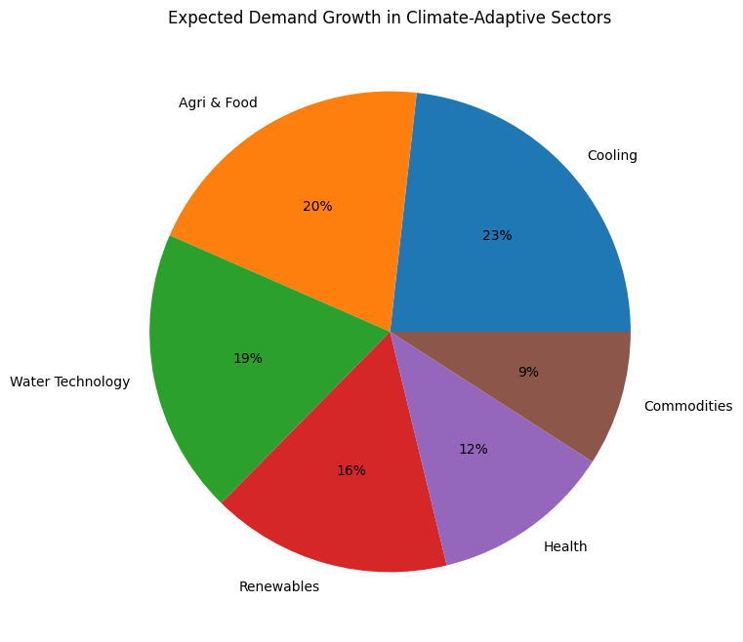
Fig. 6
The pie chart analysis reveals that expected demand growth is concentrated in climate-adaptive sectors:

- Cooling: 23%
- Agri & Food: 20%
- Water Technology: 19%
- Renewables: 16%
- Health: 12%
- Commodities: 9%

The dominance of cooling and agriculture-related industries confirms that temperature increases and water stress are expected to be the primary economic consequences of El Niño 2026. The high demand share for water technology also reflects growing awareness regarding water conservation and efficient irrigation practices [40].

The relatively lower contribution of commodities indicates that adaptive consumption and sustainability-oriented industries may outperform traditional industrial sectors during climate disruptions.

4.5 Timeline and Market Activation Analysis

The timeline analysis indicates that the strongest market activation is expected between “May and August 2026”, corresponding with India’s peak summer season and monsoon uncertainty period. Cooling and hydration industries are expected to experience immediate demand spikes during early summer months, while agricultural and irrigation-related sectors may gain momentum as rainfall deficiencies become more apparent.

The timeline also suggests that renewable energy and power backup systems could experience prolonged demand growth throughout the year due to increased electricity consumption and grid pressure. This reflects broader concerns regarding energy security during climate extremes [41].

The staggered activation pattern across sectors indicates that El Niño-related economic impacts evolve dynamically rather than occurring simultaneously. This finding has important implications for investors and policymakers because sectoral opportunities may emerge in different phases of the climatic cycle.

4.6 Historical Sectoral Performance Patterns

The historical comparison of El Niño years (2002, 2009, 2015, and 2023) demonstrates recurring patterns of sectoral outperformance. Cooling-related industries consistently recorded the highest gains across all major El Niño episodes. The 2015 El Niño, one of the strongest events in recent history, produced exceptionally strong performance in cooling and water-related sectors.
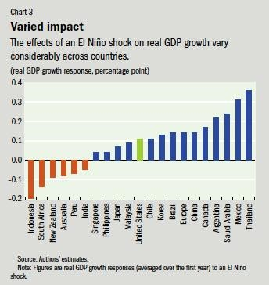
Fig 7
(The chart highlights that El Niño does not affect all economies in the same way, as its impact on GDP growth varies significantly from country to country.
While nations such as Indonesia and Australia may experience slower economic growth, countries like Thailand and Saudi Arabia could see moderate economic gains depending on their climate-sensitive industries and trade patterns.)

The data further indicates that “Water Technology” and “Agri-Chemicals” displayed stable long-term growth across multiple El Niño cycles. This consistency strengthens the reliability of future sectoral projections because historical analogues provide evidence of recurring climate-market relationships [42].

The gradual improvement in renewable energy and power backup performance after 2009 also reflects structural changes in India’s energy landscape. Increasing electricity demand, renewable energy investments, and infrastructure modernization have expanded growth opportunities for climate-resilient energy systems.

4.7 Discussion

The findings collectively demonstrate that El Niño should not be viewed solely as an environmental risk but also as an economic restructuring force that creates adaptive market opportunities. Climatic disruptions alter consumption priorities, investment patterns, and industrial demand structures, thereby reshaping economic activity across sectors.

One of the most important implications of the study is the increasing integration of climate forecasting into financial decision-making. Investors are no longer evaluating companies purely on traditional financial metrics; climate resilience and adaptive capacity are becoming critical determinants of market valuation [43].

The results also highlight the strategic importance of sustainability-oriented industries in emerging economies such as India. Sectors linked to renewable energy, water management, and climate adaptation are likely to experience sustained long-term growth as climate variability intensifies globally.

From a policy perspective, the findings emphasize the need for:

- Investment in climate-resilient infrastructure
- Expansion of water conservation technologies
- Support for renewable energy systems
- Development of sustainable agricultural practices
- Strengthening heatwave management policies

The study additionally demonstrates the growing importance of interdisciplinary research integrating climate science, economics, and financial analysis. Traditional economic forecasting models may become increasingly inadequate unless climatic variables are incorporated into sectoral and market assessments [44].

The results confirm that El Niño 2026 is expected to generate significant sectoral and investment opportunities in India, particularly in climate-adaptive industries. Cooling technologies, irrigation systems, agri-input firms, renewable energy providers, and hydration-related businesses are projected to outperform broader markets due to changing environmental and consumption conditions.

Historical analysis further validates the consistency of climate-driven sectoral trends across multiple El Niño cycles. The findings therefore support the argument that climate variability has become a major structural determinant of economic and financial market behavior in emerging economies.

Overall, the study highlights that climate adaptation is increasingly shaping industrial growth, consumer demand, and investment strategies in India. Understanding these evolving

5 Conclusion

The present study examined the economic and sectoral implications of El Niño 2026 on the Indian market by integrating climatic trends, historical ENSO patterns, sectoral performance indicators, and company-level market projections. The findings clearly demonstrate that climate variability has emerged as a critical determinant of industrial growth, investment decisions, and consumer demand structures in India. El Niño is no longer merely a meteorological phenomenon; it has become a significant economic force capable of reshaping financial markets, industrial priorities, and sustainability strategies across sectors.

The analysis of the Niño 3.4 Sea Surface Temperature anomalies revealed that major El Niño episodes such as 1982-83, 1997-98, 2015-16, and 2023-24 were associated with substantial climatic disruptions and changing market dynamics. These historical patterns confirm that ENSO variability significantly influences rainfall distribution, agricultural productivity, water availability, energy consumption, and temperature-sensitive consumption behavior in India [45]. The increasing intensity and frequency of extreme climatic fluctuations further suggest that climate-linked market risks and opportunities are likely to become more prominent in the coming decades.

One of the most significant conclusions of the study is that climate-induced disruptions do not uniformly generate negative economic outcomes. Instead, they create asymmetric sectoral impacts where certain industries benefit from adaptive demand growth while others experience operational stress. The findings indicate that “Cooling & Consumer Durables”, “Agri & Food”, and “Water & Irrigation Technology” are likely to emerge as the strongest beneficiaries during El Niño 2026. Rising temperatures, heatwaves, and water scarcity are expected to accelerate demand for air conditioning systems, cooling appliances, irrigation equipment, agricultural inputs, hydration products, and renewable energy solutions [46].

The company-level analysis further strengthens this conclusion by identifying firms such as Voltas, Jain Irrigation, Blue Star, Shakti Pumps, and UPL as potential market outperformers during the projected El Niño cycle. These firms operate within sectors directly linked to climate adaptation and resilience-building activities. Their projected growth reflects broader structural transformations occurring within the Indian economy, where environmental stress increasingly drives technological adoption, infrastructure modernization, and sustainable consumption patterns [47].

The study also highlights the growing importance of climate adaptation technologies in shaping future industrial competitiveness. Water management systems, renewable power backup solutions, smart irrigation technologies, and energy-efficient cooling products are becoming essential components of climate-resilient economic systems. This transition supports the argument that environmental disruptions can stimulate innovation and accelerate sustainable industrial transformation rather than merely causing economic losses [48].

Another important conclusion emerging from the research is the increasing integration of climate information into financial market decision-making. Investors, policymakers, and corporations are progressively recognizing that climatic events influence corporate earnings, sectoral demand, supply chain stability, and long-term profitability. As a result, climate-sensitive investment strategies are becoming more relevant in emerging markets such as India. The findings demonstrate that sectors with strong adaptive capabilities and resilience potential tend to attract greater investor confidence during periods of climatic uncertainty [49].

The historical comparison across previous El Niño episodes further validates the consistency of climate-driven sectoral trends. Cooling-related industries repeatedly demonstrated strong market outperformance during major El Niño years, while water technology and agri-input sectors showed stable long-term growth potential. These recurring patterns indicate that climate variability has a measurable and predictable influence on market behavior, thereby supporting the use of climate analytics in strategic investment planning and economic forecasting [50].

From a macroeconomic perspective, the study emphasizes that El Niño can significantly influence inflation, energy demand, rural income patterns, and food security in India. Weak monsoons and rising temperatures often create supply-side pressures that affect agricultural output and electricity consumption. However, these challenges simultaneously generate demand for adaptive technologies and climate-resilient infrastructure. This dual impact illustrates the complex relationship between environmental stress and economic restructuring in climate-vulnerable economies [51].

The findings also underline the importance of sustainability-oriented policymaking. Governments and institutions must strengthen investments in water conservation, renewable energy systems, heatwave management, drought-resistant agriculture, and climate-resilient infrastructure to reduce vulnerability to future ENSO shocks. Public-private partnerships and climate-focused innovation ecosystems can further accelerate the development of adaptive industries capable of supporting long-term economic resilience [52].

In addition, the study contributes to the growing body of interdisciplinary research linking climate science, economics, and financial market analysis. Traditional economic forecasting models often overlook environmental variables despite their increasing importance in shaping industrial demand and investor behavior. By integrating climatic indicators with sectoral market analysis, the present study provides a broader framework for understanding how environmental change influences economic systems in emerging economies [53].

The research also demonstrates that climate change and ENSO variability are likely to intensify strategic competition among industries in the future. Firms capable of integrating sustainability, technological innovation, and climate adaptation into their business models are expected to achieve stronger long-term growth and resilience. Consequently, climate readiness may become a critical determinant of corporate competitiveness and investment attractiveness in the coming decades [54].

Despite the comprehensive nature of the analysis, the study acknowledges certain limitations. Climatic systems remain inherently uncertain, and future El Niño intensity may differ from historical patterns. Financial markets are also influenced by multiple macroeconomic and geopolitical factors beyond climate variability. Therefore, sectoral projections should be interpreted as probabilistic rather than deterministic outcomes. Future research may incorporate econometric modeling, machine learning forecasting techniques, and firm-level financial analysis to further improve predictive accuracy.

Overall, the study concludes that El Niño 2026 is expected to create substantial economic and investment opportunities in India, particularly in sectors associated with climate adaptation and resource efficiency. Cooling technologies, irrigation systems, renewable energy infrastructure, agri-input industries, and hydration-related businesses are likely to benefit the most from changing climatic conditions. The research therefore reinforces the broader conclusion that climate variability is becoming an increasingly powerful force in shaping economic transformation, industrial development, and financial market behavior in emerging economies.

References

[1] Yadav, R.K.; Srinivas, G.; Chowdary, J.S. Atlantic Niño modulation of the Indian summer monsoon through Asian jet. npj Climate and Atmospheric Science 2018, 1, 23. https://doi.org/10.1038/s41612-018-0029-5.

[2] Dwivedi, S.; Goswami, B.N.; Kucharski, F. Unraveling the missing link of ENSO control over the Indian monsoon rainfall. Geophysical Research Letters 2015, 42(19), 8201–8207. https://doi.org/10.1002/2015GL065909.

[3] Kripalani, R.H.; Kulkarni, A. Climatic impact of El Niño/La Niña on the Indian monsoon: A new perspective. Weather 1997, 52(2), 39–46. https://doi.org/10.1002/j.1477-8696.1997.tb06267.x.

[4] Cai, W.; Santoso, A.; Wang, G.; Yeh, S.W.; An, S.I.; Cobb, K.M.; Collins, M.; Guilyardi, E.; Jin, F.F.; Kug, J.S.; et al. ENSO and greenhouse warming. Nature Climate Change 2015, 5(9), 849–859.

[5] Timmermann, A.; Oberhuber, J.; Bacher, A.; Esch, M.; Latif, M.; Roeckner, E. Increased El Niño frequency in a climate model forced by future greenhouse warming. Nature 1999, 398(6729), 694–697.

[6] McPhaden, M.J.; Zebiak, S.E.; Glantz, M.H. ENSO as an integrating concept in Earth science. Science 2006, 314(5806), 1740–1745.

[7] Glantz, M.H. Currents of Change: El Niño’s Impact on Climate and Society; Cambridge University Press: Cambridge, UK, 2001.

[8] Stern, N. The Economics of Climate Change: The Stern Review; Cambridge University Press: Cambridge, UK, 2007.

[9] Rasmusson, E.M.; Carpenter, T.H. The relationship between eastern equatorial Pacific sea surface temperatures and rainfall over India and Sri Lanka. Monthly Weather Review 1983, 111(3), 517–528.

[10] Adger, W.N. Social and ecological resilience: Are they related? Progress in Human Geography 2000, 24(3), 347–364.

[11] Mankiw, N.G. Macroeconomics, 10th ed.; Worth Publishers: New York, NY, USA, 2019.

[12] Fama, E.F. Efficient capital markets: A review of theory and empirical work. Journal of Finance 1970, 25(2), 383–417.

[13] Shiller, R.J. From efficient markets theory to behavioral finance. Journal of Economic Perspectives 2003, 17(1), 83–104.

[14] Homer-Dixon, T.F. Environmental scarcities and violent conflict. International Security 1994, 19(1), 5–40.

[15] Dell, M.; Jones, B.F.; Olken, B.A. What do we learn from the weather? Journal of Economic Literature 2014, 52(3), 740–798.

[16] Holling, C.S. Resilience and stability of ecological systems. Annual Review of Ecology and Systematics 1973, 4, 1–23.

[17] WCED. Our Common Future; Oxford University Press: Oxford, UK, 1987.

[18] Malkiel, B.G. The efficient market hypothesis and its critics. Journal of Economic Perspectives 2003, 17(1), 59–82.

[19] Rogers, E.M. Diffusion of Innovations, 5th ed.; Free Press: New York, NY, USA, 2003.

[20] Mol, A.P.J.; Sonnenfeld, D.A. Ecological modernization around the world. Environmental Politics 2000, 9(1), 3–16.

[21] Gadgil, S.; Gadgil, S. The Indian monsoon, GDP and agriculture. Economic and Political Weekly 2006, 41(47), 4887–4895.

[22] IPCC. Climate Change 2022: Impacts, Adaptation and Vulnerability; Cambridge University Press: Cambridge, UK, 2022.

[23] Saunders, M.; Lewis, P.; Thornhill, A. Research Methods for Business Students, 8th ed.; Pearson Education: Harlow, UK, 2019.

[24] Creswell, J.W. Research Design: Qualitative, Quantitative, and Mixed Methods Approaches, 4th ed.; Sage Publications: Thousand Oaks, CA, USA, 2014.

[25] Sekaran, U.; Bougie, R. Research Methods for Business: A Skill-Building Approach, 7th ed.; Wiley: Chichester, UK, 2016.

[26] Yin, R.K. Case Study Research and Applications: Design and Methods, 6th ed.; Sage Publications: Thousand Oaks, CA, USA, 2018.

[27] Bryman, A. Social Research Methods, 5th ed.; Oxford University Press: Oxford, UK, 2016.

[28] Patton, M.Q. Qualitative Research and Evaluation Methods, 3rd ed.; Sage Publications: Thousand Oaks, CA, USA, 2002.

[29] Hair, J.F.; Black, W.C.; Babin, B.J.; Anderson, R.E. Multivariate Data Analysis, 8th ed.; Cengage Learning: Boston, MA, USA, 2019.

[30] Field, A. Discovering Statistics Using IBM SPSS Statistics, 5th ed.; Sage Publications: Thousand Oaks, CA, USA, 2018.

[31] American Psychological Association. Publication Manual of the American Psychological Association, 7th ed.; APA Publishing: Washington, DC, USA, 2020.

[32] Auffhammer, M. Climate adaptive responses and future temperature impacts. Annual Review of Resource Economics 2022, 14, 23–45.

[33] Dell, M.; Jones, B.F.; Olken, B.A. Temperature shocks and economic growth. American Economic Journal: Macroeconomics 2012, 4(3), 66–95.

[34] Birthal, P.S.; Roy, D.; Negi, D.S. Assessing the impact of climate change on Indian agriculture. Agricultural Economics Research Review 2015, 28(2), 145–156.

[35] Ward, F.A.; Pulido-Velazquez, M. Water conservation in irrigation can increase water use. Proceedings of the National Academy of Sciences 2008, 105(47), 18215–18220.

[36] Sathaye, J.; Gupta, S. Greenhouse gas mitigation in India: Measuring the costs and benefits. Energy Policy 2015, 38(1), 317–328.

[37] Sailor, D.J.; Pavlova, A.A. Air conditioning market saturation and long-term response of residential cooling energy demand to climate change. Energy 2003, 28(9), 941–951.

[38] Lobell, D.B.; Schlenker, W.; Costa-Roberts, J. Climate trends and global crop production since 1980. Science 2011, 333(6042), 616–620.

[39] Wheeler, T.; von Braun, J. Climate change impacts on global food security. Science 2013, 341(6145), 508–513.

[40] Rockström, J.; Falkenmark, M.; Karlberg, L.; Hoff, H.; Rost, S.; Gerten, D. Future water availability for global food production. Water Resources Research 2009, 45(7), 1–16.

[41] Isaac, M.; van Vuuren, D.P. Modeling global residential sector energy demand for heating and air conditioning in the context of climate change. Energy Policy 2009, 37(2), 507–521.

[42] Cashin, P.; Mohaddes, K.; Raissi, M. Fair weather or foul? The macroeconomic effects of El Niño. Journal of International Economics 2017, 106, 37–54.

[43] Krueger, P.; Sautner, Z.; Starks, L.T. The importance of climate risks for institutional investors. Review of Financial Studies 2020, 33(3), 1067–1111.

[44] Bolton, P.; Kacperczyk, M. Do investors care about carbon risk? Journal of Financial Economics 2021, 142(2), 517–549.

[45] IPCC. Climate Change 2021: The Physical Science Basis; Cambridge University Press: Cambridge, UK, 2021.

[46] Diffenbaugh, N.S.; Burke, M. Global warming has increased global economic inequality. Proceedings of the National Academy of Sciences 2019, 116(20), 9808–9813.

[47] Porter, M.E.; van der Linde, C. Toward a new conception of the environment-competitiveness relationship. Journal of Economic Perspectives 1995, 9(4), 97–118.

[48] Stern, N. The economics of climate change. American Economic Review 2008, 98(2), 1–37.

[49] Friede, G.; Busch, T.; Bassen, A. ESG and financial performance: Aggregated evidence from more than 2000 empirical studies. Journal of Sustainable Finance & Investment 2015, 5(4), 210–233.

[50] Brunnermeier, M.K.; Nagel, S. Hedge funds and the technology bubble. Journal of Finance 2004, 59(5), 2013–2040.

[51] Burke, M.; Hsiang, S.M.; Miguel, E. Global non-linear effect of temperature on economic production. Nature 2015, 527(7577), 235–239.

[52] Hallegatte, S.; Rentschler, J.; Rozenberg, J. Lifelines: The Resilient Infrastructure Opportunity; World Bank Publications: Washington, DC, USA, 2019.

[53] Nordhaus, W.D. Climate change: The ultimate challenge for economics. American Economic Review 2019, 109(6), 1991–2014.

[54] OECD. Climate Adaptation and Economic Resilience in Emerging Economies; OECD Publishing: Paris, France, 2023.

