From Input to Output: Examining L2 Learners’ Essays through

Abstract

This study explores how Krashen’s (1982) Second Language Acquisition (SLA) hypotheses are manifested in the essays of Senior High School (SHS) L2 learners and analyzes what these patterns suggest about their ongoing language acquisition processes. The corpus, consisting of six (6) selected essays written by SHS students who speak Filipino as their first language (L1) and English as their second language (L2), served as the primary source of linguistic data. The analysis reveals that learners’ essays reflect varied hypotheses of SLA. Patterns of grammatical errors, lexical choices, and syntactic control align with Krashen’s five hypotheses, including Acquisition-Learning, Monitor, Natural Order, Input, and Affective Filter. Five themes emerged: 1) Acquisition vs. Learning, 2) Monitoring and Self-Correction, 3) Developmental Patterns and Natural Order, 4) Input Exposure and Processing, and 5) Emotional Factors and Affective Filter. The study affirms Krashen’s framework, showing that students acquire language at different paces, influenced by how they process input, manage emotions, and engage with the task. Some learners show signs of natural development, while others rely on conscious learning and monitoring. Emotional factors like anxiety and limited time affect performance, emphasizing the need for safe, input-rich environments. Future studies should explore both oral and written outputs across diverse contexts, integrating qualitative and quantitative methods to gain deeper insights into learner behavior and second language development. Lastly, language fluency stems from subconscious acquisition through rich, meaningful input, not rule-based learning thus, pedagogy should prioritize low-stress, input-rich environments that support natural language acquisition.

Keywords: Essay, First Language, Second Language, Second Language Acquisition Hypotheses

Introduction
Background of the Study
Among the four language skills, writing is considered as the most challenging and difficult skill for most foreign language learners (Reid, 2002; Ceylan, 2019). “Writing is a fundamental component of second language acquisition (SLA), enhancing learners' ability to internalize grammatical structures, expand vocabulary and engage in deeper language processing.” (Khudaverdiyeva, 2025, p.127). Additionally, writing is an important communication skill and has an essential role in second language learning process (Simin & Tavangar, 2009, as cited in Javadi-Safa, 2018).
According to Dahl et al. (2023), essays served as a platform for integrating theoretical understanding with practical clinical experience. In an ESL classroom, ESL writers are expected to do enough practice in order to write well. However, it has always been difficult for second language learners (Nedaet al., 2012). Moreover, academic writing plays a crucial role in helping students grow intellectually and personally, especially through tasks like opinion pieces and grant proposals. Despite its importance, many learners continue to struggle with key components of academic writing, specifically in developing content, structuring their ideas, managing discourse, and applying proper writing mechanics (Nenotek, 2022). Clark (2009, as cited in Omar & Shamsudin, 2022) found that young learners often struggle to construct compound sentences, have limited vocabulary, and fail to use varied word choices in their writing, while also neglecting capitalization, punctuation, and spelling. Similarly, students face difficulties with English structural components, which hinder content clarity and comprehension due to the cognitive demands involved (Quintero, 2008; Nik et al., 2010, as cited in Omar & Shamsudin, 2022). Additional challenges include first language interference, low motivation, and insufficient reading and practice (Fareed et al., 2016).
According to Krashen (1982), language acquisition is a subconscious process where individuals naturally absorb language elements like vocabulary and structure. In contrast, language learning involves deliberate effort in formal educational settings. While acquisition happens naturally, learning is typically guided and systematic. The motivation behind learning a language often stems from goals like academic success, whereas acquisition is driven by the need to interact and communicate. Language learning focuses on understanding grammatical rules, while acquisition prioritizes the development of communicative competence.
Krashen's theory has been widely criticized for lacking a strong empirical basis, relying mainly on anecdotal evidence, and not being clearly defined or verifiable through research (Mammadova, 2024). Despite numerous studies on Krashen’s Second Language Acquisition (SLA) Theory, such as Alharbi and Febrianib (2024) on the learned-acquisition hypothesis in language education, Almohawes (2024) on SLA theories and their pedagogical implications, Ding (2021) on the importance of understanding SLA processes for educators, and Hajimia et al. (2020) on the role of the Monitor Model and Natural Approach in second language development, there remains a gap in empirical research specifically examining the manifestations of the hypotheses of Krashen’s SLA in written discourse of L2 learners. Thus, this study aims to examine how hypotheses of second language acquisition (SLA) of Krashen (1982) are reflected in the linguistic choices of L2 learners in their written essays and interpret what these manifestations reveal about the learners’ second language acquisition process.

Statement of the Problem
To guide this inquiry, the study is anchored on the following research questions:
- How do L2 learners’ linguistic choices in their essays reflect Krashen’s Second Language Acquisition hypotheses?
- What do these hypotheses reveal about the learners' second language acquisition process?
Limitations of the Study
This study centers on Senior High School learners acquiring English as a second language, which means the findings may not be broadly applicable across all ESL learning environments. The analysis is based solely on handwritten essays, focusing exclusively on written output and excluding spoken language or interactive communication. As a result, the study does not account for other variables that may influence learners’ writing performance, such as classroom dynamics, feedback mechanisms, or individual affective factors. Additionally, certain Second Language Acquisition theories, particularly the Input Hypothesis and Affective Filter, are less observable in written texts, which may constrain the depth and scope of the linguistic analysis.
Theoretical Framework
Stephen Krashen's theory of Second Language Acquisition (SLA) is one of the most influential and widely known theories in the field of linguistics and language education. Developed in the 1970s and 1980s, Krashen's model significantly shifted the approach linguists and educators took towards language learning. This theory emphasizes that language acquisition is primarily a natural and subconscious process, distinct from formal language learning.
Krashen's theory is built upon five main hypotheses: (1) the acquisition-learning hypothesis, which differentiates unconscious acquisition from conscious learning; (2) the natural order hypothesis, which claims that grammatical structures are acquired in a predictable sequence; (3) the monitor hypothesis, which states that learned knowledge functions as an editor rather than a source of fluency; (4) the input hypothesis, which emphasizes that language acquisition occurs when learners understand input slightly beyond their current level; and (5) the affective filter hypothesis, which asserts that emotional factors like motivation and anxiety influence the intake of comprehensible input.
Moreover, this theory provides a comprehensive framework built on five core hypotheses that offer a structured way to analyze the complex process of language acquisition. This allows the present study to systematically examine the linguistic choices in L2 learners' essays as manifestations of underlying acquisition and learning processes. By applying each of these hypotheses, it can provide a deeper understanding of how learners' linguistic abilities are developing and the factors influencing their second language acquisition.
Figure 1
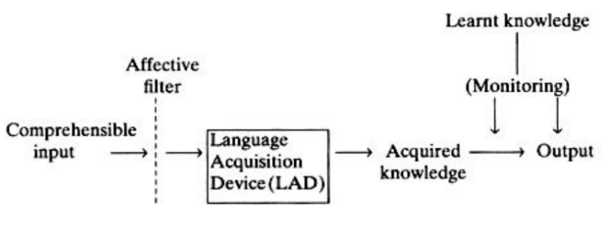
The Input Hypothesis Model of L2 learning and production (adapted from Krashen, 1982, pp.16 and 32;and Gregg, 1984)

Methods
Research Design
This study is a qualitative research method, employing descriptive design, using textual analysis guided by SLA—Hypotheses (Krashen, 1982) theory. Descriptive research, as defined by Calderon (2006), involves a systematic and structured process of collecting, analyzing, and organizing data to provide insights into existing conditions, practices, processes, trends, and cause-effect relationships. In this context, textual analysis refers to the methodical examination of written material, emphasizing its content, structure, and language to uncover social implications and ideological influences (Fairclough, 2003, as cited in Que & Patty, 2023).
Data Gathering Procedure
To ensure the relevance and integrity of the linguistic data, the researchers employed purposive sampling in selecting academic essays that meet specific criteria. This approach allows for the deliberate inclusion of texts that reflect the authentic language use of Senior High School (SHS) learners in academic contexts. The selection process focused on six (6) handwritten essays that adhere to the following parameters:
1.The essays must be handwritten by Senior High School (SHS) learners who use Filipino as their first language (L1) and English as their second language (L2).
2.The essays must be produced within an academic setting.
3.The essays must be original compositions by the learners.
Corpus
The linguistic data for this study drawn from selected corpus of six (6) written essays originally composed by Senior High School (SHS) learners who use Filipino as their first language (L1) and English as their second language (L2). These texts, produced within formal academic settings, serve as authentic representations of bilingual language use in educational contexts. By focusing on original compositions, the study aims to capture the learners’ natural syntactic and stylistic choices, providing a reliable basis for linguistic analysis and interpretation.
Data Analysis
The analysis of the corpus was guided by Krashen’s Second Language Acquisition (SLA) theory (1982), which offers a comprehensive framework for examining how learners internalize and produce language. Through this lens, the researchers systematically investigated the lexical and syntactic features present in the selected essays to identify linguistic patterns and cognitive processes indicative of SLA development.
To ensure methodological rigor, the following procedures was undertaken:
1. read and select handwritten essays;
2. anonymize the selected essays;
3. convert the selected written essays into digital text;
4. code the lexical and syntactic features in the text that indicate evidence of Krashen’s hypotheses:
a. Look for spontaneous or creative language use and rule-based corrections (Acquisition-Learning Hypothesis).
b. Check if grammatical structures appear in predictable sequences (Natural Order Hypothesis).
c. Identify signs of self-correction, over-correction, or failed correction (Monitor Hypothesis).
d. Examine evidence of structures slightly beyond current proficiency like use of complex sentences (Input Hypothesis).
e. Highlight motivation and anxiety indicators in writing (Affective Filter Hypothesis).
5. categorize the identified linguistic choices under each hypothesis; and
6. synthesize findings to explain the learners’ SLA process in relation to Krashen’s theory with excerpts from essays to illustrate each hypothesis.

Results and Discussion
- Students’ SLA Process via Krashen’s Hypotheses
This section presents a detailed analysis of each student's handwritten essay, systematically examined through the lens of Krashen’s Second Language Acquisition (SLA) theory. The tables that follow illustrate the presence of linguistic features aligned with Krashen’s five key hypotheses: Acquisition-Learning, Natural Order, Monitor, Input, and Affective Filter, showing the evidence and its meaning.
Table 1
Student A’s SLA Process via Krashen’s Hypotheses
Krashen’s Hypotheses | Evidence | Meaning
Acquisition-Learning Hypothesis | “I firmly believe that these two are equally valuable and come hand in hand with one another.” | Student A uses fluent, natural language with minimal grammatical errors, suggesting that much of their English proficiency comes from subconscious acquisition rather than formal instruction.
 | “two sides of the same coin” | The ability to express abstract ideas implies internalized language structures beyond rote learning.
Monitor Hypothesis | “Reading helps our writing because it teaches us new words, ideas, and sentence patterns…” | Student A shows awareness of grammar and organization, likely applying learned rules during revision or composition. While the essay does not overtly show self-correction, the structured coherence and transitions suggest a conscious monitoring system is active during writing.
Natural Order Hypothesis | “our grammar, coherence, and organization naturally improve when we get exposed to well-written materials.” | Student A’s syntax and vocabulary reflect developmental progression, basic sentence structures are mastered, and more complex constructions are emerging. Student A’s writing suggests that grammatical features are acquired in a predictable sequence, consistent with Krashen’s hypothesis.
Input Hypothesis | “Reading helps our writing because it teaches us new words, ideas, and sentence patterns…” | Student A acknowledges that reading provides exposure to language that enhances writing, this is Krashen’s core idea, input that is slightly above the learner’s current level (i+1) drives acquisition. The learner is actively engaging with texts that offer rich linguistic input, which they then use in their own output.
Affective Filter Hypothesis | “Writing helps us express our thoughts, emotions, and perspectives…” | The student writes with confidence, personal voice, and emotional investment. This suggests low anxiety, high motivation, and a positive attitude toward language use. Student A’s affective state facilitates acquisition, Krashen argues that when learners feel safe and motivated, input is more likely to be internalized.
Student A’s essay reflects strong evidence of language acquisition through natural exposure, as seen in the use of idiomatic expressions and fluent, well-structured writing. The presence of creative phrasing suggests internalized language use beyond formal instruction. The student also demonstrates effective use of the monitor, balancing grammatical accuracy with natural expression. Complex sentence structures and consistent verb usage indicate progression through the natural order of acquisition. References to reading as a source of linguistic improvement align with the Input Hypothesis, showing engagement with comprehensible input slightly beyond current proficiency. Finally, the confident tone and personal assertions suggest a low affective filter, enabling the student to write with clarity and ease. As Tahamid (2015) notes, when learners are motivated, confident, and experience low anxiety, they are more likely to absorb and benefit from the input available to them.
Table 2
Student B’s SLA Process via Krashen’s Hypotheses
Krashen’s Hypotheses | Evidence | Meaning
Acquisition-Learning Hypothesis | “It is like breathing in the information from a textbook and inhaling it to your body…”  “If reading is a way of breathing in, writing is a way of breathing out.” | These metaphorical constructions indicate that Student B is engaging with English as a tool for personal expression rather than merely reproducing formulaic patterns. The language reflects originality and communicative intent, clear indicators of internalized, acquired competence.
 | "There is a lot of studies"  "when you are knowledgeable the more powerful you become" | These errors implies that the student is still in the process of internalizing the grammatical rules of English and is likely relying on a conscious "learned" language.
Monitor Hypothesis | “These websites is sometimes the reason why most students today are just relying…”  “This comfort can give a positive and negative effect to us.” | The errors such as “websites is” and awkward phrasing “effect to us” suggest the learner’s monitor is not consistently active. Student B may know the rules but are not applying them during spontaneous writing. The learner is focused on meaning over form, which Krashen argues is typical when the monitor is inactive or underdeveloped. This stems from the constrained timeframe allotted to the student for engaging with the essay task.
Natural Order Hypothesis | “Practice your vocabularies and spellings.”  “Writing in the other hand…” | Use of “vocabularies” (non-count noun error) and omission of “on” in “on the other hand” reflect typical developmental errors. These mistakes suggest that Student B is progressing through the natural order of grammar acquisition, mastering simpler structures before more complex ones.
Input Hypothesis | “Reading is where knowledge comes from.”  “It is important that we realize that reading is where all the learning will start.” | While Krashen emphasizes input over output, these part of the essay show how rich input has led to meaningful output. The student is synthesizing ideas and expressing them in a way that reflects both linguistic and cognitive growth.
Affective Filter Hypothesis | “These websites is sometimes the reason why most students today are just relying on these robots like ChatGPT…”  “We are being deceived by a false intelligence.” | This emotional stance reflects a low affective filter, the learner is motivated and values genuine engagement, which facilitates acquisition. However, the anxiety about “false intelligence” may raise the filter in certain contexts. The confident tone and assertive phrasing imply that the student is emotionally engaged and motivated.

Student B’s language growth shows that they are in a transitional phase of acquiring English, as seen through how their responses align with Krashen’s five hypotheses. Their figurative phrasing, like “reading is a way of breathing in, writing is a way of breathing out”, reveals that they are beginning to use English for personal expression, not just repeating textbook patterns. At the same time, their sentence construction still shows signs of conscious rule application, which reflects the Monitor Hypothesis. The way they use connectors and vocabulary, even with minor errors, suggests that their grammar is developing in a natural sequence, consistent with the Natural Order Hypothesis. Their mention of reading academic texts implies they are receiving input that challenges them just enough to promote growth. However, their fear of making mistakes, “I am afraid to give a false sentence” indicates that anxiety may be interfering with their ability to use the language freely. In sum, Student B is progressing through meaningful exposure and internalization, but their emotional hesitation and reliance on monitored output highlight the need for encouragement and confidence-building in the classroom. This observation supports the findings of Huang and Zhang (2019), who identified insufficient input and a high affective filter as key factors contributing to the failure of language learning goals.
Table 3
Student C’s SLA Process via Krashen’s Hypotheses
Krashen’s Hypotheses | Evidence | Meaning
Acquisition-Learning Hypothesis | “Step researcher can work producing high quality and original research…” | Student C attempts to express a complex idea about research integrity, but the phrasing is awkward and lacks grammatical precision. This suggests that the learner is still transitioning from learned rules to acquired fluency. The message is communicative, but the form is underdeveloped, indicating reliance on conscious learning rather than natural acquisition.
Monitor Hypothesis | “verify source through academic databes and reputable publication asses author expert…” | Errors in word choice “asses” likely meant “assess”, missing articles, and noun-verb agreement suggest the monitor is not fully active during composition. The learner may know some rules but struggles to apply them in real-time writing. This aligns with Krashen’s view that the monitor is limited unless conditions time, focus, rule knowledge are met.
Natural Order Hypothesis | “by dissclosing methologies and limitation by adding to there pradise researches can uphold trust aa credibilities.” | Errors in spelling “pradise” instead of “precise”, “disclosing” instead of disclosing, and “methologies” instead of “methodologies”, possessive pronouns “there” instead of “their”, article use, and pluralization “credibilities” reflect typical developmental patterns. The learner is acquiring grammatical structures in a predictable sequence, with basic forms emerging first and more complex ones still in progress.
Input Hypothesis | “Verify information through reputable sources such as pre-reviewed journais…” | Student C references academic journals and databases, suggesting exposure to comprehensible input from formal texts. While the output is fragmented, the student C is engaging with input-rich environments which supports Krashen’s claim that input drives acquisition.
Affective Filter Hypothesis | “Ensuring the credibity and avoiding plogiansm require diligence…” | In Student C’s case, the numerous errors, from spelling to syntax, could indeed signal a high affective filter. These conditions can prevent the learner from fully processing input or applying learned structures.

Student C’s language use shows that they are still in the process of shifting from relying on learned grammar rules to developing more natural fluency. Their sentence “These researcher can work producing high quality and original research” communicates a clear idea, but the grammar is awkward, suggesting that they are still dependent on textbook knowledge rather than acquired language. This supports the Acquisition-Learning Hypothesis, where learning is present, but acquisition is not yet solid. In terms of the Monitor Hypothesis, errors like “asses author expert” and missing articles show that while the student knows some rules, they struggle to apply them smoothly, possibly due to pressure or lack of confidence. The Natural Order Hypothesis is evident in phrases like “disclosure knowledge” and “imitation by adding,” which sound memorized and don’t follow the typical developmental sequence of grammar. For the Input Hypothesis, the student tries to express complex ideas using terms like “article, video, and book,” but the phrasing lacks fluency, suggesting that the input they receive may not be challenging enough to help them progress. While the Affective Filter Hypothesis is reflected with high affective due to the errors committed by the student. Overall, Student C is still making an effort and is engaged, but they would benefit from more advanced input, guided feedback, and chances to use English in more natural and meaningful ways. As Repová (2004) emphasizes, comprehensible input is essential for language acquisition and ensuring that input is both accessible and stimulating is key to helping learners like Student C advance.
Table 4
Student D’s SLA Process via Krashen’s Hypotheses
Krashen’s Hypotheses | Evidence | Meaning
Acquisition-Learning Hypothesis | "it can avoid plagiarism by simply doing this..."  “I can ensure credibility of the information and avoid plagarism...” | The reliance on simple, repetitive sentence structures of the student suggests that they have some formal learning but little acquisition. The grammatical errors and unnatural phrasing suggest they have not "acquired" the language structures to express these ideas accurately.
Monitor Hypothesis | "plagarism"  "somthing"  "creadible"  "depend's"  "aplying"  “The only credible source is Google Scholar, Chrome and many more that has the information you needed to write a credible study or information.” | The student’s use of a simple and repetitive vocabulary and sentence structure, as well as numerous grammatical and spelling errors of words, such as plagiarism, something, credible, depends, and applying, indicates they are likely not using the monitor effectively. They are not checking their output for accuracy. This points to the lack of time for self-correction or a limited development of their learned language system.
Natural Order Hypothesis | "you can find creadible source depend’s on the site were you took it" | The omission of the indefinite article “a” in "you can find creadible source..." instead of writing “a credible source” and incorrect verb forms like “depend’s” and “took” are common in the initial stages of second language acquisition. Articles are often acquired later than other fundamental grammatical structures. The use of simple past tense, on the other hand, is often acquired earlier than the present perfect. The student's choice to use "you took it" instead of “you have taken it” shows a predictable error for a beginner learner. This preference for the simpler, single-word verb form, "took," over the more complex "have taken," is a natural step in the acquisition process.
Input Hypothesis | “The only credible source is Google Scholar, Chrome and many more that has the information you needed to write a credible study or information.” | These errors suggest the student may not have received enough input that is just slightly beyond their current level. The grammatical errors, such as subject-verb agreement and article usage, demonstrate insufficient comprehensible input.
Affective Filter Hypothesis | “I can ensure credibility of the information and avoid plagarism”  “ensuring credibility makes you avoid complains from the owner of a certain study or somthing you took”  “copyright is taking something without the owners permision that leads to plagarism” | The choice of simple sentences over complex sentences suggests a high effective filter as the student might be afraid to take risks with more complex sentence structures or varied vocabulary, sticking to what they feel safe expressing. This results in the repetitive phrasing and basic syntax seen in the text.
The table highlights how Krashen’s SLA hypotheses explain both the cognitive and emotional dimensions of language learning. Learner reflections show that while conscious learning fosters metalinguistic awareness, true fluency stems from natural acquisition. Grammar rules serve as monitors but are not central to language production. As Krashen (1982) explains, conscious learning involves explicit grammar instruction and serves primarily as a “monitor” or “editor” during communication. The patterns of errors and corrections observed in student writing support the Natural Order Hypothesis, which posits that language structures are acquired in a predictable sequence. For example, the student’s use of the simple past tense “you took it” instead of the present perfect “you have taken it” reflects a predictable preference for simpler forms, consistent with early acquisition stages. This aligns with Krashen’s (1982) claim that language is acquired in a specific, consistent sequence. Moreover, exposure to slightly challenging input aids acquisition, aligning with the Input Hypothesis. Finally, self-consciousness and anxiety may hinder progress, affirming the role of affective factors in shaping language outcomes. Wu (2010) emphasizes that the application of comprehensible input not only builds learners’ confidence but also enhances their critical thinking. When learners receive input they can understand, their anxiety decreases, and they become more willing to participate in meaningful language use.
Table 5
Student E’s SLA Process via Krashen’s Hypotheses
Krashen’s Hypotheses | Evidence | Meaning
Acquisition-Learning Hypothesis | “recognized citation style”  “maintain the integrity”  “accurate research is essential for knowledge advancement” | The student uses formal academic phrases. These are likely learned through explicit instruction.
 | “credebility”  “intellectualy properly” | On the other hand, the lack of syntactic control such as run-on sentences, missing punctuation especially the comma and period, and lexical errors, “credibility”, “intellectual property” suggest that these structures have not been internalized. Student D may be relying on memorized chunks without full syntactic integration.
Monitor Hypothesis | “intellectualy properly”  “I gave credit” | The essay shows signs of under-monitoring errors which suggest that the student is not applying learned rules consistently.
Natural Order Hypothesis | “I properly use cite sources…” | Student D struggles with basic sentence boundaries and verb tense consistency. These errors suggest that foundational grammatical structures are still developing.
Input Hypothesis | “I gave credit”  “I properly use cite sources…” | While student D attempts academic register, the errors suggest that input may not have been fully processed. This phrase could be a misremembered chunk from a model text.
Affective Filter Hypothesis | “By doing so I maintain the integrity of my works and I gave credit to the original authors this approach ensures the credebility and originality of my works allowing me to contribute meaningfully to the field…” | The student clearly values research ethics and expresses a desire to contribute meaningfully. However, the lack of punctuation and frequent errors manifest high affective filter, especially that the student feels pressure to perform academically.

Student E’s essay shows that they are beginning to develop academic language skills, especially through the use of formal phrases likely learned through direct instruction, which supports Krashen’s Acquisition-Learning Hypothesis. However, errors in grammar, punctuation, and sentence structure suggest that these forms have not been fully acquired yet, as seen in the Monitor, Natural Order, and Input Hypotheses. The student seems to rely on memorized expressions without fully understanding how to use them correctly. Despite these issues, the Affective Filter Hypothesis reveals that the student is motivated and eager to write academically in English. Overall, Student E is showing progress but still needs help with grammar and sentence construction to improve their academic writing. As Wu (2010) recommends, the application of comprehensible input in the classroom helps build learners’ confidence and enhances their critical thinking. It is also noted that with appropriate error analysis, some mistakes can be tolerated, which further boosts confidence and encourages deeper involvement in critical thinking. Li (2023) further informs that the use of authentic language materials can stimulate interest and motivation of students, allowing what is “learned” to transform into “acquired” language in a natural environment. In summary, Student E is making meaningful progress but would benefit from more exposure to authentic, comprehensible input and support in grammar and sentence construction.
Table 6
Student F’s SLA Process via Krashen’s Hypotheses
Krashen’s Hypotheses | Evidence | Meaning
Acquisition-Learning Hypothesis | “To avoid plagiarism. I check first the words...”  “to ensure the credibility of the information is to I have to review the information” | The student uses academic terms like "plagiarism" and "credibility," which suggests some formal learning. However, the sentences are ungrammatical and disorganized, which indicates that there is a subconscious or acquired system that has not yet developed enough to form coherent and grammatically correct sentences.
Monitor Hypothesis | “To avoid plagiarism. I check first the words I made to know the words if I copy from the research I pick from the website I enter then,”  “I change the words and meaning but relate to study and I review again and then, the information I used the tools to prove the information” | The persistent errors show no evidence of using monitor to self-correct. There are errors in grammar, syntax, punctuation, word choice and spelling that would likely be corrected by a more advanced student who uses their monitor to edit their output. The complete lack of commas, incorrect use of conjunctions like "then," and awkward phrasing suggest the student is focusing on getting their ideas on paper without using the monitor. This indicates a very limited or undeveloped monitor or a context where the learner is writing under time pressure.
Natural Order Hypothesis | “I change the words and meaning but relate to study and I review again and then, the information I used the tools to prove the information” | The use of run-on sentences connected by "and then" indicates a natural stage where students rely on simple connectors because they may have not yet acquired the rules for complex sentences, subordinate clauses, or proper punctuation.
Input Hypothesis | "I check first the words I made to know the words if I copy from the research I pick from the website I enter then, I change the words and meaning but relate to study and I review again," | The essay is written with run-on sentences, awkward phrasing, and a general lack of coherence. This shows that the student has not yet acquired the syntactic structures like proper use of subordinate clauses, conjunctions, and punctuation to express complex thoughts. This indicates a gap in their exposure to "i+1" or above their current level that would allow them to acquire these structures naturally. Additionally, the use of basic verbs like "check," "made," "pick," and "enter" instead of more precise and varied vocabulary, such as "verify," "composed," "selected," or "accessed" suggests that the student's exposure to new vocabulary in a meaningful context has been limited.
Affective Filter Hypothesis | “I check first the words I made to know the words if I copy from the research I pick from the website I enter then,” | The use of run-on sentences, simple words, and repetitive phrasing may imply that the student has high affective filter as being anxious about writing tend to be overly focused on simply getting one's thoughts out while neglecting the proper structure, resulting in the jumbled, run-on writing style.

The student reflections provide strong qualitative support for Krashen’s Second Language Acquisition (SLA) hypotheses, revealing how learners acquire language through natural exposure, intuitive restructuring, and comprehensible input, while also being influenced by emotional factors like self-confidence. Each quote aligns with a specific hypothesis, illustrating the interplay between cognitive awareness and affective conditions in language development. These findings suggest that effective teaching should prioritize meaningful input, minimize overreliance on grammar instruction, foster emotionally supportive environments, and respect the natural sequence of language acquisition. Li (2023) reinforces these insights by recommending that students be provided with sufficient comprehensible input to gradually improve their overall English proficiency. Importantly, the use of authentic language materials to stimulate interest and motivation, allowing what is “learned” to transform into “acquired” language in a natural environment. Overall, the results reinforce the relevance of Krashen’s framework in shaping learner-centered, evidence-based pedagogy.
- Revelations from Krashen’s Hypotheses on Students’ SLA Process

  - Acquisition vs. Learning
The learners’ writing reveals a dynamic interplay between acquired and learned language. Students who use idiomatic expressions and abstract phrasing such as metaphors or nuanced academic terms, demonstrate signs of subconscious acquisition. These learners appear to have internalized language structures through meaningful exposure rather than rote memorization. In contrast, others rely heavily on repetitive expressions and show signs of grammatical strain, suggesting that their output is shaped more by conscious learning than by natural acquisition. This distinction underscores Krashen’s view that true fluency stems from acquisition, while learned language often lacks spontaneity and depth. This observation is further supported by Marzuki (2012), who explains that language acquisition is influenced by multiple factors, such as the degree of exposure, instructional methods, learner competence, affective variables, and age. These factors interact to shape how language is internalized. For instance, learners with high motivation and access to rich, comprehensible input are more likely to acquire language naturally, while those with limited exposure or high anxiety may rely more on conscious learning strategies.
  - Monitoring and Self-Correction
The Monitor Hypothesis is evident in how students apply or fail to apply, learned grammatical rules during composition. Some learners show signs of active monitoring, producing coherent and grammatically sound sentences that reflect deliberate editing. Others, however, write with minimal self-correction, resulting in persistent errors and awkward phrasing. This suggests that their internal monitor is either underdeveloped or suppressed due to time constraints or cognitive overload. Krashen (1982) emphasizes that the monitor functions best when learners have sufficient time, focus, and explicit rule knowledge, conditions that may not be consistently present in classroom writing tasks.
  - Developmental Patterns and Natural Order
Across the essays, grammatical errors follow predictable developmental sequences. Learners commonly misuse articles, struggle with verb tense consistency, and rely on basic connectors like “and then.” Vâlcea (2020) adds that language transfer between a learner’s first language (L1) and second language (L2) plays a significant role in shaping this process. When the transfer is positive, it facilitates easier learning and results in more accurate output. However, negative transfer can lead to persistent errors that require targeted clarification and support. Tanpoco et al. (2019) further found that grammatical errors, particularly in verb, pronoun, and preposition usage, were the most prevalent in the written compositions of learners. These patterns also align with Krashen (1982)’s Natural Order Hypothesis, which posits that language structures are acquired in a fixed sequence. Simpler forms tend to emerge first, while more complex constructions such as subordinate clauses or perfect tenses, appear later. Recognizing these patterns allows educators to scaffold instruction in a way that respects the natural progression of language development, rather than forcing premature mastery of advanced grammar.
  - Input Exposure and Processing
Students frequently reference reading and academic sources, indicating exposure to linguistic input. However, the quality of their output varies, suggesting that not all input meets the “i+1” threshold, language that is just beyond their current level. Learners who engage with rich, comprehensible texts tend to produce more fluent and expressive writing, while others mimic academic register without fully processing its structure. This supports Krashen (1982)’s Input Hypothesis, which argues that acquisition occurs when learners are exposed to language that challenges them slightly beyond their current competence. Effective input must be both accessible and stimulating to drive meaningful growth. Similarly, the findings of Panggua et al. (2023) concluded that comprehensible input significantly improves EFL students’ listening and speaking skills. Their study also emphasizes the need for frequent and varied exposure to the target language among learners to allow them internalize structures naturally and develop communicative competence. At the same time, authentic language materials should be used to stimulate students' interest in learning, so that students "learned" will be gradually turned into "acquisition" in the natural environment (Li, 2023).
  - Emotional Factors and Affective Filter
The emotional tone of the essays reveals how affective factors shape language acquisition. Confident learners write with personal voice and take linguistic risks, suggesting a low affective filter that facilitates internalization of input. Conversely, students who express anxiety or fear of error tend to use repetitive phrasing and avoid complex structures. This high affective filter can block acquisition by limiting engagement with challenging language. Krashen’s Affective Filter Hypothesis highlights the importance of emotional safety, motivation, and self-confidence in promoting language development. Creating a supportive classroom environment is thus essential for lowering the filter and enabling learners to thrive. This aligns with the findings of Liu (2023) that English writing ability is a foundational skill and that teachers play a crucial role in enhancing it. Teachers stimulate students’ motivation, build their self-confidence, and help them manage anxiety through emotionally responsive teaching strategies. By helping students recognize the value of writing and experience the joy of expression, teachers can more effectively support both language acquisition and writing proficiency.
Conclusion
The findings reveal that learners’ Second Language Acquisition (SLA) processes are shaped by a complex interplay of cognitive development, input exposure, and emotional factors, as framed by Krashen’s (1982) hypotheses. While some students demonstrate signs of internalized language use and progression through natural grammatical sequences, others rely heavily on learned structures with limited monitoring and syntactic control. The presence of developmental errors, inconsistent self-correction, and varied engagement with input suggests that acquisition is uneven and influenced by affective filters such as anxiety and motivation—most specially due to constrained timeframe allotted to the student for engaging with the essay task. Overall, the findings affirm the relevance of Krashen’s framework in understanding learner variability and highlight the need for emotionally supportive, input-rich environments to foster deeper language acquisition.
Recommendations
To gain a more comprehensive understanding of second language acquisition, future research should explore both oral and written outputs, as this dual focus can reveal richer insights into how learners process and use language. It would also be beneficial to replicate the study across varied educational contexts and with learners from diverse backgrounds to enhance the relevance and applicability of the findings. Integrating qualitative observations with quantitative analysis could further strengthen the research by providing a more nuanced and well-rounded interpretation of learner behavior and language development.

Pedagogical Implications
The present study highlights that language fluency comes from acquisition, which is supported by exposure to rich, comprehensible inputs, and not just by conscious learning of rules. Therefore, pedagogical approaches should prioritize creating an input-rich academic environment where students engage with authentic, meaningful materials. This focus on input lowers the affective filter which may hinder acquisition. By fostering a low-affective classroom where errors are seen as a natural part of the process, educators can empower students to take risks and develop their competence. Acknowledging the natural order of language acquisition, educators can also scaffold instruction to meet students where they are developmentally, rather than imposing mastery of complex grammar. Ultimately, the goal is to shift from explicit grammar instruction to natural, subconscious language acquisition.

References
Almohawes, M. (2024). Second language acquisition theories and how they contribute to language learning. World Journal of English Language, 14(3). https://doi.org/10.5430/wjel.v14n3p181
Bahruddin, U., & Febriani, S. R. (2020). Implementation of Stephen Krashen's theory in foreign language acquisition. International Journal of Innovation, Creativity and Change, 13(10).
Ceylan, N.O. (2019). Student perceptions of difficulties in second language writing. Journal of Language and Linguistic Studies. https://www.jlls.org/index.php/jlls/article/view/1051
Dahl, B. M., Vasset F., Frilund, M. (2023). Students’ approaches to scientific essay writing as an educational method in higher education: A mixed methods study. Journal of Innovation and Learning in Higher Education https://www.sciencedirect.com/science/article/pii/S2590291122001437
Ding, Y. (2021). Understanding the process of second language acquisition. Review of Educational Theory, 4(4). https://doi.org/10.30564/ret.v4i4.3708
Fareed, M., Ashraf, A., & Bilal, M. (2016). ESL learners’ writing skills: Problems, factors and suggestions. Journal of Education and Social Sciences, 4, pp. 81–92.
Hajimia, H., Singh, M. K. S., & Chethiyar, S. D. M. (2020). Second language acquisition: Krashen’s monitor model and the natural approach. PEOPLE: International Journal of Social Sciences, 6(3), 87–99. https://doi.org/10.20319/pijss.2020.63.8799
Huang, Y., & Zhang, Y. (2019). A case study of the EFL learner's needs analysis based on Krashen's Monitor Theory. International Journal of Research - Granthalaya, 7(8), 669. https://doi.org/10.29121/granthaalayah.v7.i8.2019.669
Krashen, S. D. (1982). Principles and practice in second language acquisition. Pergamon Press Inc. Retrieved from https://www.sdkrashen.com/content/books/principles_and_practice.pdf
Li, Y. (2023). Study on the Significance of the Input Hypothesis to English Teaching. Journal of Education and Educational Research, 3(2).
Liu, X. K. (2023). The effect of affective filter hypothesis on college students' English writing teaching and its enlightenment. Open Access Library Journal, 10, e10671. https://doi.org/10.4236/oalib.1110671
Mammadova, K. (2024). [Title of the article]. Scientific Work: International Scientific Journal, 18(11), 81–87. https://doi.org/10.36719/2663-4619/108/81-87
Omar, N. H., & Shamsudin, M. K. (2022). Improving Second Language Learners WritingUsing a Linguistic Feedback Tool (LiFT). International Journal of Academic Research in Business and SocialSciences, 12(9), 888 – 895
Panggua, S., Aeni, N., Patanduk, R. S. T., Arang, J. R. T., Tulaktondok, L., & Sirande, N. The perceived impact of comprehensible input on EFL students' listening and speaking skills. Journal of English Teaching and Research, 1(2), 65-72.
Repová, K. (2004). Testing Krashen's input hypothesis: A case study in a male Czech adult acquiring English [Master's thesis, Masaryk University]. Masaryk University Theses.
Tahamid, A. R. (2015). Krashen's Monitor Model Theory: A Critical Perspective. In The European Conference on Language Learning 2015: Official Conference Proceedings. IAFOR.
Tanpoco, M. R., Rillo, R. M., & Alieto, E. O. (2019). Filipino to English transfer errors in writing among college students: Implications for the senior high school English curriculum. Asian EFL Journal, 26(6.1).
Vâlcea, C. S. (2020). First language transfer in second language acquisition as a cause for error-making in translations. Diacronia. https://doi.org/10.17684/i11A161en
Wu, W. (2010). The Application of Input Hypothesis to the Teaching of Listening and Speaking of College English. Asian Social Science, 6(9).

APPENDIX A
Actual Photo of Essays Written by Second Language Learners
STUDENT A


STUDENT B


STUDENT C
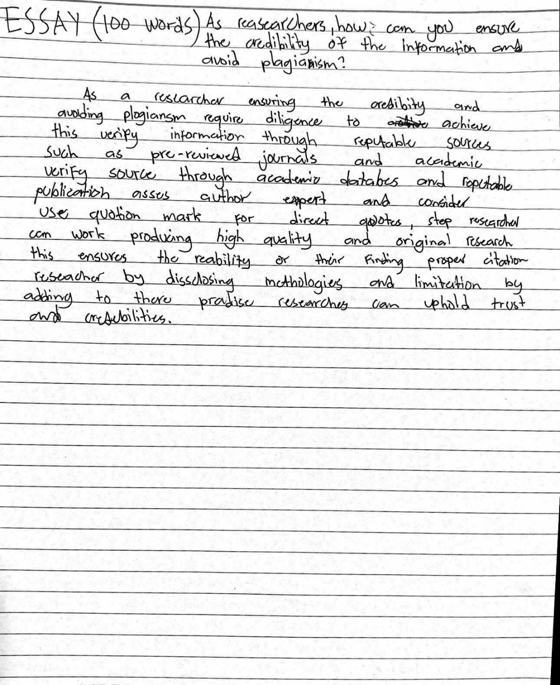

STUDENT D
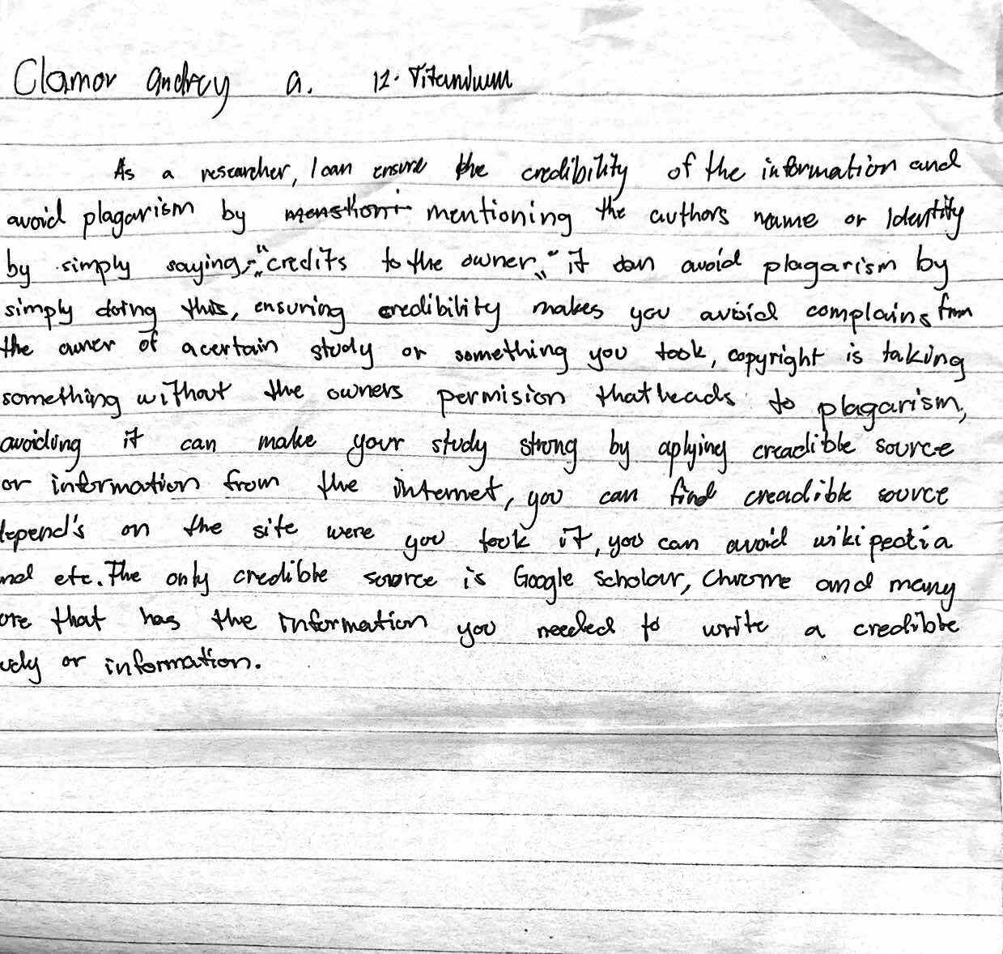

STUDENT E

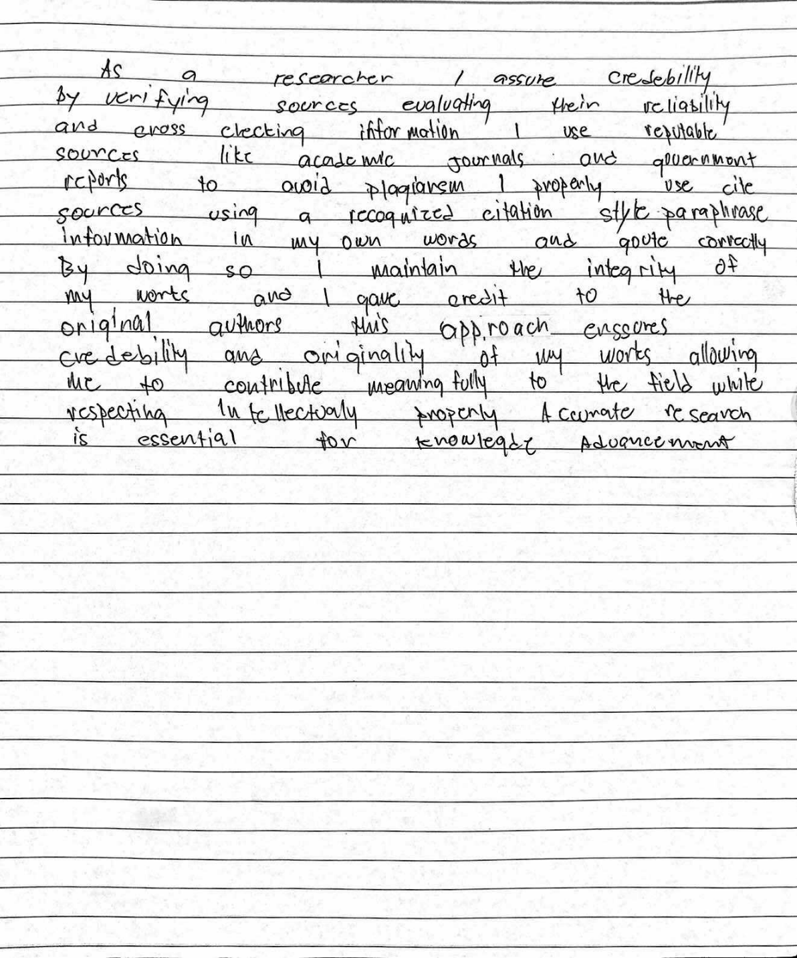

STUDENT F
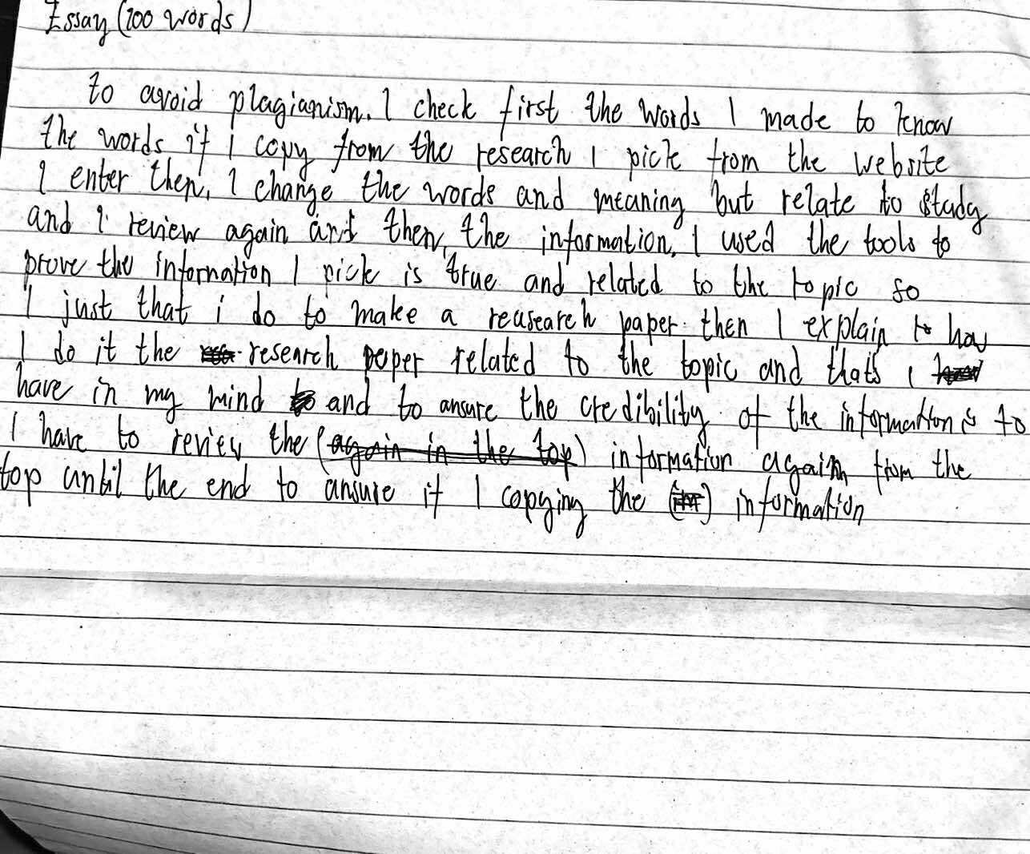

APPENDIX B
Converted digital text from handwritten essays
STUDENT A
Can you write without reading and vice versa? I ask you this question because there has been a lot of debate on this topic, and many believe that one may be more important than the other. As Humanities and Social Sciences students, I believe it is very important for us to know the significance of both, as we often use these two in our daily lives. I firmly believe that these two are equally valuable and come hand in hand with one another.
I believe that reading and writing are like two sides of the same coin - one strengthens the other. Reading helps our writing because it teaches us new words, ideas, and sentence patterns, and our grammar, coherence, and organization naturally improve when we get exposed to well-written materials. A student who reads essays and research papers, for example, will find it easier to create clear ideas in their work. On the other hand, writing makes us more involved and active as readers. Summarizing, paraphrasing, or responding to a text helps us comprehend it more deeply, and composing diary entries, book reviews or essays makes us think critically, test our beliefs, and organize our thoughts. Those who write about what they read are bound to improve their comprehension skills because they are always analyzing and interpreting information. Writing helps us express our thoughts, emotions, and perspectives while reading helps us understand different viewpoints, cultures, and ideas.
In conclusion, I believe that reading and writing are interdependent and heavily rely on each other. As Humanitas, it is important for us to know how reading and writing work together hand in hand to help us express and understand one another.
STUDENT B
“The more you read, the more things you know. The more you learn, the more places you’ll go.” This quote states that reading is where knowledge comes from. It is like breathing in the information from a textbook and inhaling it to your body, when you are knowledgeable the more powerful you become. It is important that we realize that reading is where all the learning will start. If reading is a way of breathing in, writing is a way of breathing out. There is a lot of studies stating that writing what you read is an effective way for you to understand it more and absorb it. This is where you will give yourself a freedom to express yourself in a more composed way and practice your vocabularies and spellings.
Reading and writing needs each other to be effective in communicating. Reading is when you are decoding symbols and words in order for you to understand it. It is also a complex cognitive skills. Writing in the other hand is when you are encoding words and symbols as a term of communicating your thoughts and ideas. For me, writing and reading is both an important basic skill that should be practiced more. In the 21st century, there are a lot of websites that are being created by humans to make our life easier. However, these websites is sometimes the reason why most students today are just relying on these robots like ChatGPT to do their task. This comfort can give a positive and negative effect to us. Positive in a way that we are able to accomplish our tasks faster and efficiently. Negative on the other hand because by using these tools, we are being deceived by a false intelligence.

STUDENT C
As a rescarcher ensuring the credibity and avoiding plogiansm require diligence to achieve this verify information through reputable sources such as pre-reviewed journais and academic verify source through academic databes and reputable publication asses author expert and consider use quotion mark for direct quotes, step researcher can work producing high quality and original research this ensures the reability or their finding proper citation reseacher by dissclosing methologies and limitation by adding to there pradise researches can uphold trust aa credibilities.

STUDENT D
As a researcher, I can ensure credibility of the information and avoid plagarism by mentioning the authors name or identity by simply, “credits to the owner” it can avoid plagarism by simply doing this, ensuring credibility makes you avoid complains from the owner of a certain study or somthing you took, copyright is taking something without the owners permision that leads to plagarism, avoiding it can make your study strong by aplying creadible source or information from the internet, you can find creadible source depend’s on the site were you took it, you can avoid wikipedia and etc. The only credible source is Google Scholar, Chrome and many more that has the information you needed to write a credible study or information.

STUDENT E
As a researcher, I assure credebility by verifying sources and evaluating their reliability and cross-checking information I use reliable sources like academic journals and government reports to avoid plagiarism I properly use cite sources using a recognized citation style paraphrase information in my own words and quote correctly By doing so I maintain the integrity of my works and I gave credit to the original authors this approach ensures the credebility and originality of my works allowing me to contribute meaningfully to the field while respecting intellectualy properly Accurate research is essential for knowledge advancement

STUDENT F
To avoid plagiarism. I check first the words I made to know the words if I copy from the research I pick from the website I enter then, I change the words and meaning but relate to study and I review again and then, the information I used the tools to prove the information I pick is true and related to the topic so I just that I do to make a research paper then I explain to how I do it the research paper related to the topic and that’s I have in my mind and to ensure the credibility of the information is to I have to review the information again from the top until the end to ensure it I copying the information.

