SMART SENSOR-BASED FRAMEWORK FOR HYGIENIC WASTE MANAGEMENT USING SOLAR POWER AND RF COMMUNICATION

Mrs. Yamuna Rani¹,Assistant Professor, Divya M², Kanmani K³, Madani Sultana J⁴, Gayathri V⁵
^{1,2,3,4,5}Meenakshi College of Engineering, Chennai-78, Tamil Nadu, India
ABSTRACT
Efficient waste management is crucial for maintaining environmental hygiene and ensuring the good health of residents. In this article, an automated system for waste management is proposed, utilizing smart sensors to ensure hygiene, efficiency, and sustainability. According to this proposal, the proposed system will enable the touchless opening of the dustbin using PIR and IR sensors when a human being is present. Besides, there will be an automatic system for spraying sanitizers, thus ensuring better hygienic conditions during use. The data from the sensors will be processed using a signal conditioning circuit and a comparator to detect when the dustbin reaches its threshold level. As opposed to other IoT-based approaches, this approach will use RF modules for transferring data between devices, thus making an internet connection unnecessary and ensuring the timely transfer of data. Further, the suggested system will work on the basis of solar panels, which will make it eco-friendly and suitable for sustainable implementation both in rural and urban locations. The data collected from sensors will be transferred to the monitoring facility, where the full bins will be chosen for garbage disposal, which will ensure the reduction of efforts required by sanitation staff during the process of garbage disposal. Overall, the suggested solution will demonstrate.
Keywords: Intelligent Waste Management, Automated Waste Management Using Sensors, PIR and Infrared Sensors, RF Module Communication, Solar Power System, Hands-free Disinfection, Waste Volume Monitoring
- INTRODUCTION
The last few decades have seen many urban settlements develop due to increasing urbanization trends. This has been accompanied by an increase in waste generation, especially within urban settlements. It is crucial for us to manage our waste effectively because environmental quality contributes to public safety. Traditional waste management methods are basically manual, whereby workers go to various places depending on their schedules or complaints to pick up the waste. This method is inefficient and takes time. It leads to an overload of garbage bins and unpleasant smells, among others. These factors could result in the contraction of illnesses or environmental pollution.
- RELATED WORK
There is a need to create a better solution to this problem by designing an efficient, smarter, and automated waste management system. In this regard, the project is aimed at creating a smart dustbin that will improve the hygiene and efficiency of the system. The proposed system is equipped with PIR and IR sensors for enabling users to open the lid without any physical contact. The system has a load cell that checks whether the trash reaches a certain weight, which prompts the sending of alerts to a monitoring system via RF. The other component is the automatic spray for sanitizing purposes. Several systems for smart waste management have been proposed to combat the growing difficulty of garbage collection in metropolitan areas. Several current waste management systems use IoT technologies where sensors monitor the fill level of dustbins and provide information about them through an Internet-based platform. These waste management systems usually use ultrasonic sensors and GSM modules to perform their tasks. Moreover, there are some waste management systems that employ GPS-based tracking systems and route optimizations to collect garbage more efficiently. But, IoT-based systems have limitations such as internet reliance, increased cost, and difficult maintenance. In some cases, network issues can interfere with real-time monitoring. Furthermore, some researchers have developed RFID-based systems to track waste bins. Another technique uses incentives where users will get rewarded for the appropriate disposal of garbage. Several researchers have proposed waste management systems that incorporate image processing techniques to sort garbage with machine learning models. But these waste management systems do not fulfill all criteria because of their unavailability and unreliability. They also consume more energy, are expensive, do not possess hygiene measures, and are difficult to maintain. To mitigate these challenges, the proposed system aims to incorporate several measures, such as using sensors, such as PIR.
- EXISTING SYSTEM
In the current systems used in waste management, the process of collection, transportation, and disposal depends largely on manual procedures for performing waste-related tasks. Waste is collected from urban locations manually, either following a schedule or in response to complaints raised by the residents regarding overflowing dustbins. The lack of any form of real-time waste level monitoring and analysis results in wastage of resources and inefficiencies within the waste collection process. Consequently, the dustbins get soiled and become stinky, as well as creating environmental pollution.IoT-based solutions have already been proposed as ways to monitor the levels of garbage; however, this requires a reliable communication link between all the various systems involved. Thus, there is a need to design a better solution that will enable garbage collection.

Fig 1: EXISTING SYSTEM
⚠️ Limitations
- Hard to control the movements of drivers and vehicles carrying waste
- Waste management processes are dependent on connectivity
- Continuous monitoring is necessary for the whole process
- Failures of sensors might impact the operations of the system
- Technical difficulties associated with automated systems
- Uncertainty about the efficiency of real-time operation

- PROPOSED SYSTEM
The suggested system is a smart sensor-based model, which is created to make the process of waste disposal more hygienic, efficient, and sustainable. It includes sensors, an embedded controller, an RF transmitter and receiver, and solar cells without utilizing the internet connectivity. The first step is performed with the help of the PIR sensor and reflective IR sensor, which detect the presence of a user. The presence of a person triggers the automatic opening of the lid, allowing users to dispose of their trash without making any contact with the bin itself. In order to know how much trash there is in the bin, a load cell is employed for measuring its weight. The output of this sensor is connected to the signal conditioning circuit. The next step in waste management is to compare the output from a load cell with a threshold value. If the value exceeds the threshold, then the bin is considered to be fully occupied. The status of the bin is sent by the RF transmitter to the receiver at the monitoring station. Based on the received information, the garbage collectors start collecting the trash. Energy efficiency and environmental friendliness are guaranteed as the system runs on the power generated by the solar panel. In addition to this, there will be provision made for a sanitization mechanism, which plays an essential role in keeping the system clean and preventing the transfer of germs. To get further information about the working principle of the system, each component that is used in the block diagram is explained individually. There are various kinds of sensors, controllers, communicators, and energy sources incorporated in the system.
- PIR Sensor (Human Detection)
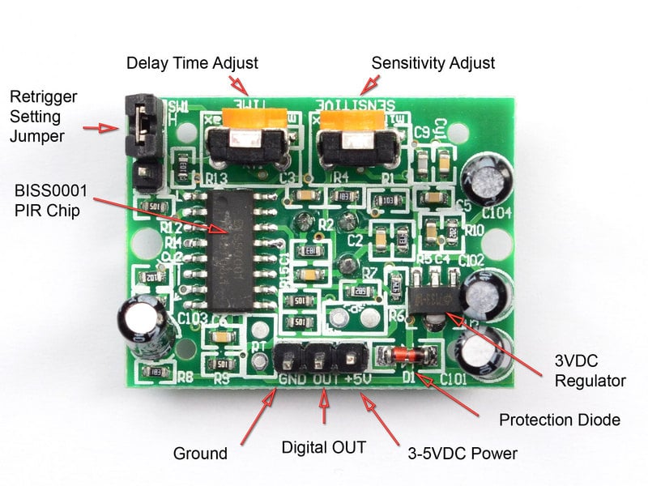
Fig 2:PIR Sensor (Human Detection)
The Passive Infra Red (PIR) sensor detects whether there is any presence of a human being near the waste basket. If a human approaches the waste basket, the human body heat is detected by the PIR sensor and then signals the microcontroller.
2.Reflective IR Sensor
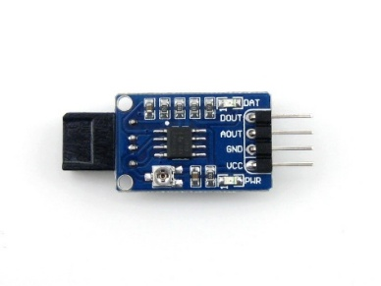
Fig 3: Reflective IR Sensor
This is done using the IR reflective sensor that senses the presence of objects close to the bin. The IR reflective sensor is used together with the PIR sensor for accurate object detection.
3. Load Cell
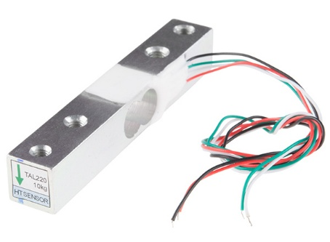
Fig 4: Load Cell
The load cell is employed for weighing the garbage in the bin. It facilitates the estimation of the amount of waste contained in the bin, yielding better accuracy than other level sensors.
4. Signal Conditioning Circuit
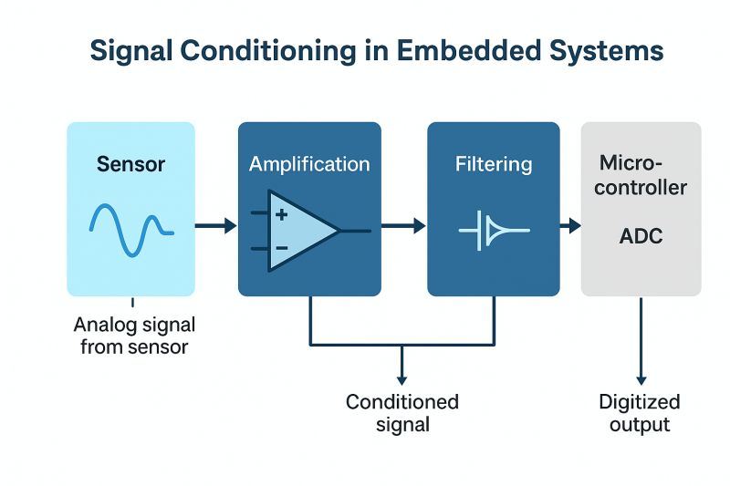
Fig 5: Signal Conditioning Circuit
The output of the load cell is relatively weak and noise-prone. The function of the signal conditioning circuit is to amplify the output signal before it is fed into the microcontroller for further processing.
5. Comparator
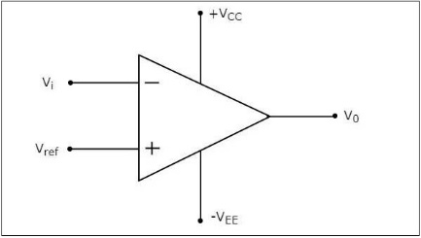
Fig 6: Comparator

A comparator is used for comparing the input signal with the threshold value. When the garbage level crosses the threshold level, the comparator shows that the bin is full.
6. Microcontroller
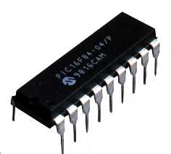
Fig 7: Microcontroller

The role of the microcontroller is that of the 'brain' for the entire system. It takes care of interpreting all the inputs from the sensors, operates the lid, and communicates with the RF unit.
7. RF Transmitter & Receiver
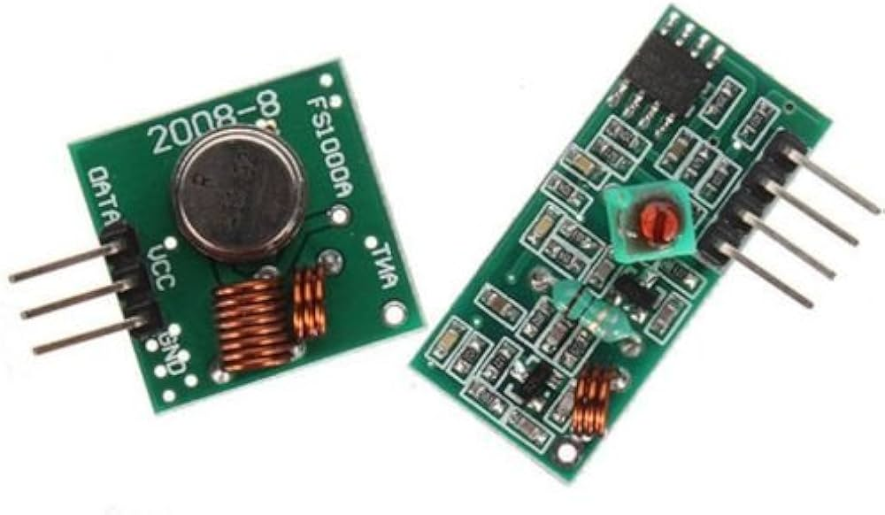
Fig 8: RF Transmitter & Receiver
The transmitter, using RF technology, transmits data from the bin in wireless mode. The receiver, again, located at the monitoring station, gets data from the bin about its fill status.

8. Solar Panels
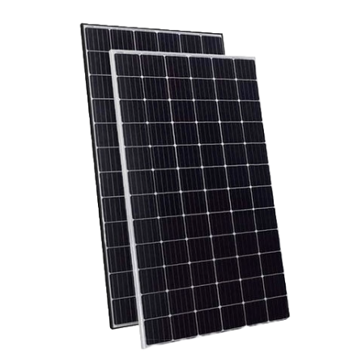
Fig 9: Solar Panels
The energy supply to the device is provided via the utilization of the solar panels, making it energy efficient as well as suited for usage outdoors. The dependence on any external source of energy is reduced.
9. Sanitization System (Solenoid Valve)
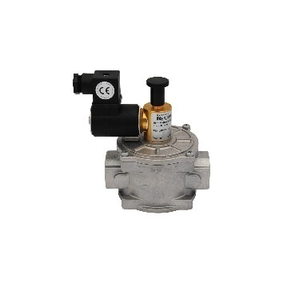
Fig 10: Solenoid Valve
The solenoid valve is responsible for spraying the sanitizing agents into the bin after a certain time interval. It ensures that the germs do not spread.

- Results and Discussion
Status :

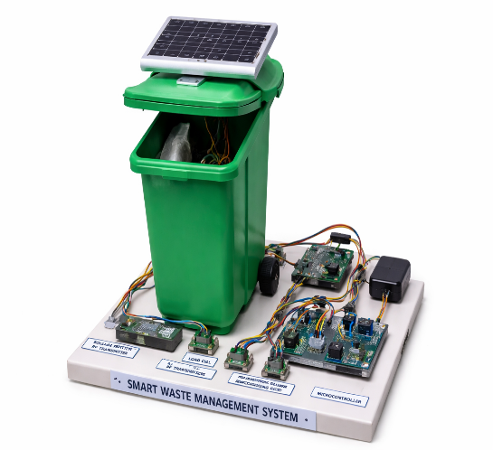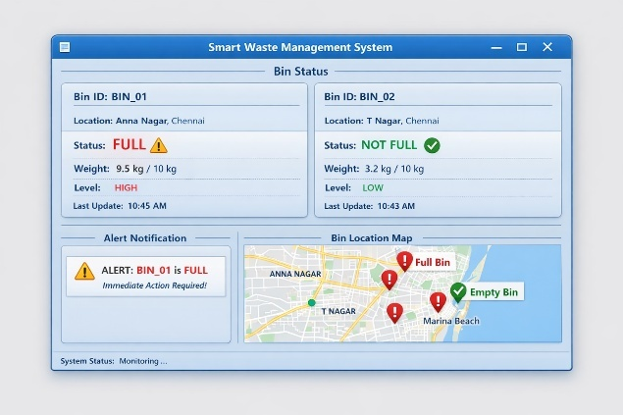
Fig 11: OUTPUT
The designed system was successfully developed and tested in order to determine the level of its performance and efficiency. Firstly, PIR and reflective infrared sensors were able to detect users' presence and open the lid automatically, thus providing a touch-free and hygienic method of waste disposal. Moreover, the load cell was able to measure the weight of garbage inside the container, while the signal conditioning circuit stabilized the output signal. Furthermore, the comparator circuit allowed comparing the measured value with the predefined threshold and determined the moment when the bin was full. The RF transmitter transmitted this information to the monitoring station, where it could be received by the RF receiver without using an Internet connection. Thus, the system was capable of identifying filled bins and prioritizing their removal. The energy consumption of the system was optimal due to the implementation of the solar panel, which provided enough power for the continuous work of the system. Besides, the operation was carried out successfully through the mechanism of sanitization.
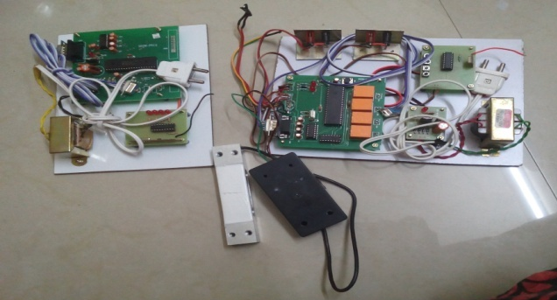
Fig 11:Hardware
- Conclusion and Future Work
All in all, one can claim that the created system demonstrated high efficiency and reliability, and performed all tasks assigned.
The proposed smart sensor-based waste management system has proven to be quite efficient in ensuring that there are hygienic, efficient, and sustainable waste management practices. The integration of sensors, embedded control, RF communication, and solar energy has ensured that the system operates without any touch from humans, and it monitors waste status effectively. The PIR and IR sensors ensure that the lid opens automatically. The load cell helps in detecting the filled status of bins, while the comparator makes sure that only the fully filled bins get identified.
RF communications do not need any internet services, thus ensuring that the cost is cut down, in addition to having reliable transmissions. Prioritizing the full bins makes sure that the waste collection agents are able to optimize their routine. Solar energy ensures that the system remains environmentally friendly. Sanitization mechanisms ensure that there is no transmission of harmful germs. Future works can include the incorporation of mobile applications, GPS modules, artificial intelligence-based waste segregation, and increased communication range, among others.
- Future Scope
There are several methods through which the proposed system could be improved. For example, we can enhance the existing model through the incorporation of a mobile or web app, which will keep track of the current state of the bin at any time. Incorporating the use of a GPS in the bins will allow us to keep track of where our bins are located. Another improvement could be the inclusion of waste segregation using artificial intelligence technology to sort out the different types of waste, whether
biodegradable or non-biodegradable. Long-range communication could be adopted via technologies such as LoR

VIII. REFERENCE

F. Annie Lincy,T. Sasikala,'Smart Dustbin Management Using IOT and Blynk Application',2021 5th International Conference on Trends in Electronics and Informatics (ICOEI)
[2]. Mohammad Abbas Hussain,Kvs Nikhil,Koppuravuri Yaswanth Pavan Kalyan,'IOT Based Smart Dustbin Monitoring With Tracking System Using ATMega 2560 Microcontroller',2019 Fifteenth International Conference on (ICINPRO)
[3]. Saurabh Information Pargaien,Amrita Processing Verma Pargaien,Dikendra Verma,Vatsala Sah,Neeraj Pandey,Neetika Tripathi,'Smart Waste Collection Monitoring System using IoT',2021 Third International Conference on Inventive Research in Computing Applications (ICIRCA)
[4]. Sahil Mirchandani,Sagar Wadhwa,Richard Wadhwa,Preeti Joseph,'IoT enabled dustbins',2017 International Conference on Big Data, IoT and Data Science (BID)
[5]. Md. Samiul Haque Sunny,Debopriya Roy Dipta,Shifat Hossain,Hossain Mansur Resalat Faruque,Eklas Hossain,'Design of a Convolutional Neural Network Based Smart Waste Disposal System',2019 1st International Conference onAdvances in Science, Engineering and Robotics Technology (ICASERT)
[6]. Ajmal Khan,Sandeep kumar Agrawal,'IOT based Smart Waste Bin to Track Dustbin and Public Complaint Management System',2018 8th International Conference on Communication Systems and Network Technologies (CSNT)
[7]. Sonali Dubey,Murari Kumar Singh,Pushpa Singh,Shivani Aggarwal,'Waste Management of Residential Society using Machine Learning and IoT Approach',2020 International Conference on Emerging Smart Computing and Informatics (ESCI)
[8]. S Kanithan,Donthi Divya,Anusha A,Abhishek B R,Siddling Siddling,'Smart Dustbin Using LoRa And Tensorflow Network',2021 International Conference on Design Innovations for 3Cs Compute Communicate Control (ICDI3C)
[9]. Sumit Badotra,Sarvesh Tanwar,Amit Sundas,Pankaj Dhiman,'Smart Waste Segregation System Using IoT',2021 9th International Conference on Reliability, Infocom Technologies and Optimization (Trends and Future Directions) (ICRITO)
[10]. Anuradha Kanade,Sanket Prakash Warkhade,'Framework of Automated Robotic Dustbin (ARD) for Garbage Collection in Smart Cities with Priority Scheduling Approach',2021 5th International Conference on Trends in Electronics and Informatics (ICOEI)
[11]. G Sai Rohit,M Bharat Chandra,Shaurabh Saha,Debanjan Das,'Smart Dual Dustbin Model for Waste Management in Smart Cities',2018 3rd International Conference for Convergence in Technology (I2CT)
[12]. Abhishek Jha,Nilotpal Ayush,Abhishek Sarkar,Suresh Moharana,Himansu Das,'Voice Kumar,Aditi Chandra Controlled Automatic Dustbin with Garbage Level Sensing',2019 International Conference on Intelligent Computing and Control Systems (ICCS)
[13]. Aayush Tripathi,Chinmay Pandey,Ankur Narwal,Devashish Negi,'Cloud Based Smart Dustbin System for Metro Station',2018 3rd International Conference On Internet of Things: Smart Innovation and Usages (IoT-SIU)
[14]. R Prem Chand,V Bavya Sri,P Maha Lakshmi,S Santosh Chakravathi,O D M Veerendra,Ch Venkateswara Rao,'Arduino Based Smart Dustbin for Waste Management during Covid-19',2021 5th International Conference on Electronics, Communication and Aerospace Technology (ICECA)
[15]. M S Pranathy,S Ranjana,P S Reenu Rita,S Rajalakshmi,S Angel Deborah,'Internet of Things enabled Smart Dustbins using Capacitated Vehicle Routing',2021 5th International Conference on Computer, Communication and Signal Processing (ICCCSP)Signal Processing (ICCCSP)

