Understanding Heart Attack Among Adults: A Silent Threat
Introduction
Cardiovascular diseases are the leading cause of death globally. It occurs when blood flow to the heart muscle is blocked, leading to tissue damage or death. In recent years, India has witnessed a sharp rise in heart-related illnesses, making it a major public health concern. Rapid urbanization, sedentary lifestyles, and increasing prevalence of diabetes and hypertension have contributed to its rise in adults.

Definition
A Heart Attack is defined as the irreversible necrosis of heart muscle resulting from prolonged ischemia due to reduced coronary blood flow.
Epidemiology
- About 45% of deaths in the 40–69 age group are due to cardiovascular diseases.
- India contributes to around 20% of global heart attack deaths.
- Around 2.8 million deaths annually are due to heart diseases
- Indians tend to develop heart disease almost 10 years earlier than the global average, affecting working-age adults and increasing economic burden.

Etiology and Risk Factors

Modifiable Factors
Modifiable factors are lifestyle-related risks that individuals can change to improve their health.
- Smoking and alcohol consumption damage the heart, lungs, and other organs, increasing the risk of chronic diseases.
- A sedentary lifestyle reduces physical fitness and contributes to weight gain and poor cardiovascular health.
- Diets high in fat and salt can lead to hypertension, obesity, and heart disease. Obesity further increases the risk of diabetes and cardiovascular problems.
- Stress and poor sleep negatively affect mental and physical well-being, weakening immunity and increasing disease risk.
- Adopting healthy habits can significantly reduce these risks and promote overall health.

Non-Modifiable Factors
Non-modifiable factors are those risks that cannot be changed but still influence a person’s health status.
- Age is a significant factor, as the risk of many diseases, especially cardiovascular conditions, increases with advancing age.
- Gender also plays a role, with males generally having a higher risk of certain heart diseases at an earlier age compared to females.
- Family history is another important factor, as genetic predisposition can increase the likelihood of developing similar health conditions.

Medical Conditions
Certain medical conditions further elevate health risks.
- Hypertension (high blood pressure) can damage blood vessels and lead to heart disease.
- Diabetes mellitus affects blood sugar regulation and increases the risk of cardiovascular complications.
- Hyperlipidemia, or high levels of lipids in the blood, contributes to plaque formation in arteries.
- Although these factors cannot always be prevented, early detection and proper management can reduce complications.

Warning Signs
Warning signs are important indicators of a possible serious health condition, especially related to the heart.

- Chest pain or discomfort is the most common symptom and may feel like pressure, tightness, or heaviness.
- Pain may also radiate to the arm, neck, or jaw, indicating reduced blood flow to the heart.
- Breathlessness can occur even at rest or with minimal activity.
- Other symptoms include excessive sweating and dizziness, which may signal poor circulation or reduced oxygen supply.
Recognizing these warning signs early and seeking immediate medical help can prevent complications and save lives.

Pathophysiology
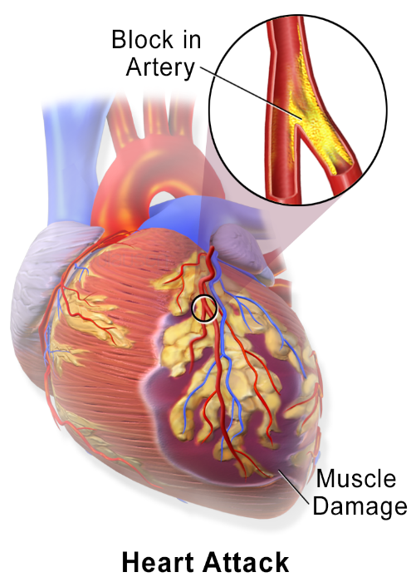
Pathophysiology of myocardial infarction begins with the development of atherosclerosis in the coronary arteries. Over time, fatty deposits known as atherosclerotic plaques accumulate within the arterial walls, causing narrowing and reduced blood flow. These plaques may become unstable and rupture due to stress or inflammation. When rupture occurs, it exposes the inner contents of the plaque, triggering platelet aggregation and thrombus (blood clot) formation.
The formed thrombus can partially or completely block the coronary artery, leading to a sudden interruption of blood supply to a portion of the heart muscle. This results in myocardial ischemia, a condition where the heart muscle does not receive adequate oxygen and nutrients. If the blockage persists for more than 20–30 minutes, irreversible damage occurs, leading to myocardial necrosis (death of heart tissue).
This sequence of events impairs the heart’s ability to pump effectively and may result in serious complications such as arrhythmias, heart failure, or even death if not treated promptly.

Clinical Manifestations (Symptoms)
Some cases may present as silent heart attacks, especially in diabetic patients. Clinical manifestations of myocardial infarction (heart attack) vary in intensity but commonly present with characteristic symptoms.
- The most prominent symptom is chest pain, often described as pressure, squeezing, or a feeling of heaviness in the chest. This pain may persist for several minutes and is not relieved by rest. It frequently radiates to the left arm, jaw, neck, or back, indicating involvement of the heart.
- Shortness of breath is another common symptom and may occur with or without chest pain, reflecting reduced cardiac function. Patients often experience sweating (diaphoresis), which is usually cold and clammy.
- Nausea and vomiting may also occur due to autonomic nervous system stimulation.
- Fatigue is especially common in women and elderly patients and may be an early or subtle sign. Some individuals may also feel anxiety or a sense of impending doom.
Recognizing these symptoms early is crucial, as prompt medical intervention can significantly reduce complications and improve survival outcomes.

Diagnostic Evaluation
Diagnostic evaluation of myocardial infarction involves several important tests.
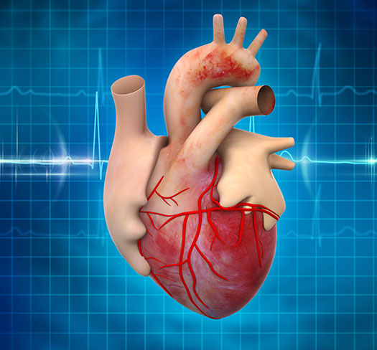
- An electrocardiogram (ECG) is the first and most essential tool, showing changes such as ST elevation or depression that indicate heart muscle injury.
- Cardiac biomarkers, including troponin and CK-MB, are measured in the blood to confirm heart muscle damage.
- Echocardiography helps assess heart function, wall motion abnormalities, and complications.
- Coronary angiography is a definitive test that visualizes blockages in coronary arteries and guides treatment such as angioplasty.
Early and accurate diagnosis using these methods is crucial for prompt management and improved patient outcomes.

Medical Management
Medical management of myocardial infarction focuses on rapid and effective treatment to save heart muscle.
- The primary goal is to restore blood flow to the heart using thrombolytic therapy or percutaneous coronary intervention (angioplasty).
- Pain relief is achieved with medications like nitrates and analgesics. Antiplatelet drugs, anticoagulants, beta-blockers, and statins are administered to prevent further clot formation and reduce cardiac workload. Oxygen therapy may be given if needed.
- Continuous monitoring helps detect complications such as arrhythmias or heart failure.
- Early and appropriate medical management significantly reduces mortality and improves recovery and long-term outcomes.

1. Immediate (Emergency) Management
Immediate (emergency) management of myocardial infarction is commonly summarized as “MONA,” focusing on rapid stabilization of the patient.
- Morphine is administered to relieve severe chest pain, reduce anxiety, and decrease cardiac workload by lowering sympathetic activity.
- Oxygen is given, especially if oxygen saturation is low, to improve oxygen delivery to the ischemic heart muscle.
- Nitroglycerin helps dilate coronary arteries, improves blood flow, and reduces chest pain as well as cardiac workload.
- Aspirin is a critical drug that inhibits platelet aggregation, thereby reducing further clot formation and preventing worsening of the blockage.
These interventions are initiated immediately upon suspicion of a heart attack to limit myocardial damage, stabilize the patient, and improve survival outcomes. Prompt administration of MONA plays a vital role in emergency cardiac care.

2. Pharmacological Management
Pharmacological management of myocardial infarction focuses on preventing further damage and improving heart function.
- Antiplatelet drugs such as Aspirin and Clopidogrel are given to prevent platelet aggregation and reduce new clot formation.
- Anticoagulants like Heparin and Enoxaparin help prevent the extension of existing clots.
- Thrombolytic (fibrinolytic) therapy, including Streptokinase and Alteplase, is used to dissolve the clot and restore blood flow, and is most effective when administered within 3–6 hours of symptom onset.
- Beta-blockers reduce heart rate, blood pressure, and myocardial oxygen demand, and also help prevent arrhythmias.
- ACE inhibitors or ARBs improve cardiac function and prevent adverse heart remodeling after infarction.
- Statins are prescribed to lower cholesterol levels and stabilize atherosclerotic plaques.
These medications play a crucial role in reducing complications, improving survival, and promoting long-term recovery.

3. Reperfusion Therapy (Restoring Blood Flow)
Reperfusion therapy is a critical component in the management of myocardial infarction, aimed at restoring blood flow to the affected heart muscle as quickly as possible.
- Percutaneous Coronary Intervention (PCI), also known as angioplasty, is the preferred method when available within 90 minutes. In this procedure, a balloon is inserted and inflated to open the blocked coronary artery, and a stent is often placed to keep the artery open and maintain blood flow. PCI provides rapid and effective reperfusion, reducing heart muscle damage and improving survival rates.
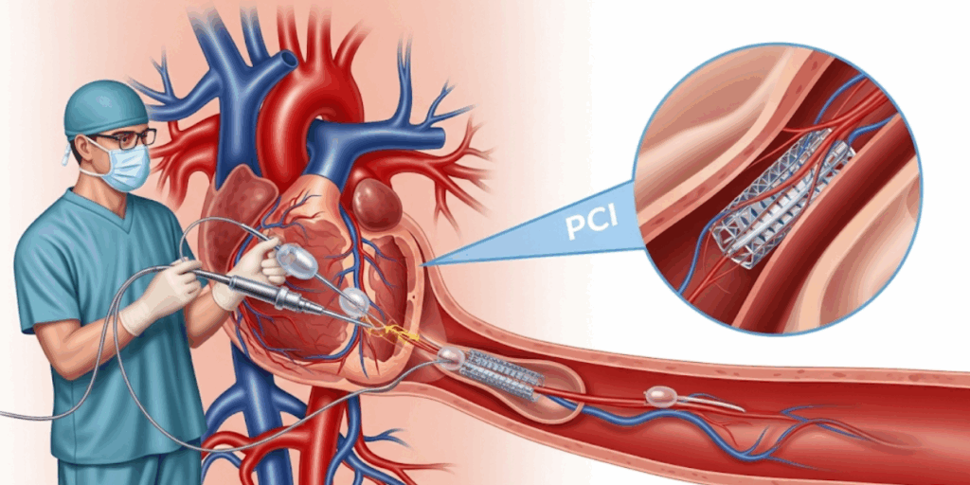

- Thrombolysis is an alternative when PCI is not readily available. It involves the administration of fibrinolytic drugs to dissolve the clot causing the blockage. Although slightly less effective than PCI, it is life-saving if given early, ideally within a few hours of symptom onset.
Both methods are essential in minimizing complications and improving patient outcomes.

4. Surgical Management

Coronary Artery Bypass Grafting (CABG)
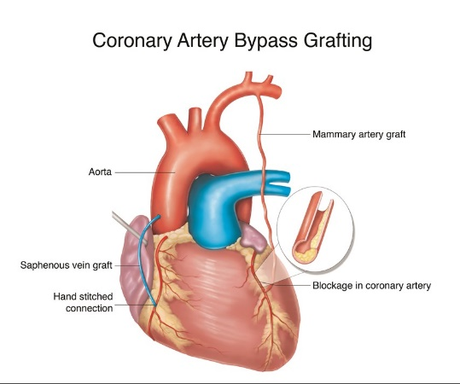
- Surgical management of myocardial infarction includes Coronary Artery Bypass Grafting (CABG), especially in patients with severe coronary artery blockage or multiple vessel disease. In this procedure, a healthy blood vessel is taken from another part of the body, such as the leg or chest, and grafted to bypass the blocked coronary artery. This creates a new pathway for blood flow to reach the heart muscle. CABG improves oxygen supply, relieves symptoms like chest pain, and enhances heart function. It is usually recommended when other treatments like angioplasty are not suitable or have failed, thereby improving long-term survival and quality of life.

5. Management of Complications
Management of complications following myocardial infarction is essential to improve survival.
- Arrhythmias are treated with antiarrhythmic drugs and continuous cardiac monitoring to maintain normal heart rhythm.
- Heart failure is managed using diuretics to reduce fluid overload and ACE inhibitors to improve cardiac function and decrease workload on the heart.
- Cardiogenic shock, a life-threatening condition, requires immediate intensive care management, including inotropes to improve heart contractility and maintain blood pressure.
- Oxygen therapy, fluid balance, and close monitoring in the ICU are crucial.
Early identification and prompt treatment of these complications significantly reduce mortality and improve patient outcomes.

6. Long-Term Medical Management (Secondary Prevention)
After recovery, patients require lifelong care. Long-term medical management (secondary prevention) after myocardial infarction is essential to prevent recurrence and improve quality of life.
- Patients are advised lifelong use of antiplatelet drugs such as aspirin to prevent clot formation.
- Statins help lower cholesterol levels and stabilize atherosclerotic plaques, while beta-blockers reduce heart rate, blood pressure, and cardiac workload.
- Lifestyle modification plays a key role, including quitting smoking, adopting a healthy diet, regular physical activity, maintaining ideal body weight, and managing stress.
- Strict control of blood pressure, diabetes, and cholesterol levels is necessary to reduce further cardiovascular risk.
- Regular follow-up and adherence to prescribed medications are crucial.
These measures collectively help in preventing future cardiac events and improving long-term survival.

Health Education
Health education is essential for preventing and managing heart disease.
- Patients should be encouraged to adopt a healthy lifestyle, including a balanced diet low in fat and salt, along with regular physical exercise.
- Strict medication adherence is important to control symptoms and prevent complications.
- Smoking cessation is strongly advised, as smoking significantly increases cardiovascular risk.
- Patients should also learn effective stress management techniques such as relaxation exercises, meditation, and adequate sleep.
- Regular health check-ups and monitoring of blood pressure, blood sugar, and cholesterol levels are important.
Proper health education empowers individuals to take responsibility for their health and improve overall well-being.

Prevention
Prevention of heart disease focuses on adopting healthy habits and reducing risk factors.
- Regular exercise, such as brisk walking for at least 30 minutes daily, helps maintain cardiovascular fitness and control weight.
- A healthy diet that is low in fat and salt and rich in fruits, vegetables, and whole grains supports heart health.
- Regular health check-ups are important for early detection of risk factors.
- Proper control of blood pressure and diabetes significantly reduces complications.
- Avoiding tobacco and limiting alcohol intake are crucial steps in preventing heart disease.
These preventive measures help promote long-term health and reduce the risk of cardiac events.

Conclusion
Heart attack is a serious yet largely preventable condition. Early recognition of symptoms and prompt medical intervention greatly improve survival and reduce complications. Effective nursing care plays a crucial role in monitoring, treatment, and recovery. Nurses also contribute significantly to patient education, rehabilitation, and promoting preventive measures for long-term heart health.

References
- World Health Organization. (2023). Cardiovascular diseases (CVDs) fact sheet. WHO.
- American Heart Association. (2020). Guidelines for Cardiopulmonary Resuscitation and Emergency Cardiovascular Care.
- American College of Cardiology. (2021). Management of Acute Myocardial Infarction.
- European Society of Cardiology. (2023). ESC Guidelines for Acute Coronary Syndromes.
- Braunwald, Eugene. (2022). Braunwald’s Heart Disease: A Textbook of Cardiovascular Medicine (12th ed.). Elsevier.
- Harrison, Tinsley Randolph. (2022). Harrison’s Principles of Internal Medicine (21st ed.). McGraw-Hill.
- Lewis, Sharon L. et al. (2020). Medical-Surgical Nursing: Assessment and Management of Clinical Problems (11th ed.). Elsevier.
- Brunner & Suddarth. (2022). Textbook of Medical-Surgical Nursing (15th ed.). Wolters Kluwer.
- Indian Council of Medical Research. (2022). Guidelines on Cardiovascular Diseases in India.
- Centers for Disease Control and Prevention. (2023). Heart Disease Facts.
- Journal of the American College of Cardiology. (2021). Acute Myocardial Infarction Management Review.
- The Lancet. (2022). Global Burden of Cardiovascular Diseases.
- National Heart, Lung, and Blood Institute. (2023). Heart Attack (Myocardial Infarction).
- Oxford Handbook of Cardiology. (2021). Oxford University Press.
- Davidson’s Principles and Practice of Medicine. (2023). Elsevier.

