PUBLIC FINANCE AND ECONOMIC GROWTH IN NIGERIA (2010-2024)

Abstract
This study empirically investigated how components of public finance determine economic growth in Nigeria between 2010 and 2024 through ex-post facto research design, secondary data collected by CBN Statistical Bulletin, NBS and World Bank Development Indicators. Economic growth was proxied by GDP and per capita income, while public finance indicators included capital expenditure (CAPEX), tax revenue (TREV), and public debt (PDEBT). Ordinary Least Squares (OLS) method with the aid of diagnostic tests was used to calculate the statistical strength and stability of the model. Descriptive statistics indicated that there were high variability in Nigeria fiscal performance during the research period. Unit root tests were used to establish that the first difference in the variables was stationary and cointegration tests were used to establish that the variables were related in the long run. The OLS results showed that capital expenditure had a positive and statistically significant impact on GDP growth (b = 0.312, p < 0.05), implying that increased infrastructural investment enhances productive capacity. Tax revenue also exhibited a significant positive effect on real GDP (b = 0.427, p < 0.05), suggesting that improved tax mobilization strengthens the government's developmental capacity. Conversely, public debt demonstrated a negative and significant relationship with GDP per capita (b = -0.289, p < 0.05), indicating that rising debt burdens weaken household welfare and overall economic performance. The model had a good explanatory power (R2 = 0.76; F-statistic p < 0.01), and diagnostic tests showed that the model did not have any multicollinearity, there was no autocorrelation (DW = 1.98), it was homoscedastic and had normally distributed residuals. The study concludes that public finance significantly influences Nigeria's economic growth trajectory and recommends improved capital expenditure prioritization, strengthened tax administration, and sustainable debt management as essential pathways for achieving long-term macroeconomic stability and inclusive growth.

Keyword: Real GDP Per Capita, Public Debt, capital expenditure,tax revenue,

INTRODUCTION
It has long been believed that public finance is one of the most important tools to control the economy of the countries, particularly the developing ones, as the economic system is still unstable, and the developmental pattern is not very regular, and this fact has been reiterated in the economic development discourse of Nigeria as the nation is still largely dependent on fiscal policies to organize the macroeconomic environment and spur production in the main sectors (Adegboyo et al., 2021). Over the years, Nigeria has oscillated between periods of expansion and contraction, often tied to the dynamics of government expenditure, public debt accumulation, volatile revenue structures, and the unstable global energy market that influences the nation's oil-dependent fiscal space (Agu et al., 2015). The necessity of having a robust and transparent system of public finance grows even bigger as the world economies become increasingly more interconnected, as the countries in which the fiscal assets cannot be efficiently implemented often get stuck in a loop of poor development and economic upheaval (Arodoye, 2024). Nigeria's fiscal profile between 2010 and 2024 reveals a complex mix of rising government expenditure, fluctuating revenue inflows, persistent budget deficits, and a rapidly increasing public debt burden, all occurring alongside an unstable economic growth trajectory marked by recessions, recoveries, and moderate expansions (Aminu, 2024). During this time, the governments tried to stimulate the economy through fiscal measures, including tax cuts, capital investment schemes, periodic realignment of expenditures, and financing of debts, but the outcomes were not always consistent and corresponded to the national development standards because of the structural inefficiency and inefficiency of governmental bodies (Aluthge et al., 2021). The continued rise in government spending, especially capital expenditure was usually driven by the desire to build infrastructure, fund the industrial capacity and enhance social wellbeing, however, problems like corruption, mismanagement, cost overruns and poor implementation of projects limited the levels to which the investments would translate to long-term economic growth (Adegboyo et al., 2021). At the same time, Nigeria's tax revenue system, which should provide a stable and predictable fiscal base for sustainable development, has faced difficulties relating to narrow tax coverage, widespread evasion, administrative limitations, and overreliance on oil receipts, all of which undermined efforts to diversify the revenue base and strengthen economic resilience (Agu et al., 2015). Meanwhile, public debt escalated rapidly as governments increasingly relied on borrowing to finance deficits and support public programmes, raising concerns about long-term sustainability, debt servicing pressures, and potential trade-offs that might crowd out productive investment (Aminu, 2024). In spite of them, numerous researchers believe that the controlled state finance can be a very strong instrument in stimulating economic activity, improving competitiveness and inclusive development, especially when fiscal expenditures are allocated to infrastructure, human capital and productive sectors with high multiplier impacts (Arodoye, 2024). The history of Nigeria, however, implies that fiscal tools have not been employed with strict performance attributes, expenditure control, or accountability systems, which restricts their ability to provide growth-enhancing impacts across the economy (Aluthge et al., 2021). As policymakers, researchers, and international institutions continue to scrutinize the determinants of Nigeria's economic performance, renewed attention has been placed on the intricate relationship between public finance indicators--such as capital expenditure, tax revenue, and public debt--and economic growth indicators such as GDP growth rate, real GDP, and real GDP per capita between 2010 and 2024 (Adegboyo et al., 2021). This relationship is not an academic one alone, but it is a fundamental basis of analyzing the fiscal stability of Nigeria, the effectiveness of the policies of the country, and the potential of sustainable growth over the next decades (Agu et al., 2015).

Statement Of The Problem
Nigeria's fiscal environment between 2010 and 2024 has been marked by rising government expenditure without corresponding economic growth, raising concerns about fiscal efficiency (Arodoye, 2024). Despite consistent increases in capital budgets, economic growth has remained unstable, with recessions in 2016 and 2020, suggesting a weak link between public investment and growth outcomes (Adegboyo et al., 2021). Tax revenue remains unproductive in comparison with the potential of the national economy, and relies more on borrowing and the exposure of the economy to the threat of long-term debt sustainability (Agu et al., 2015).

Public debt has grown rapidly to historic levels, consuming a large share of revenue through debt servicing and limiting fiscal space for productive investment (Aminu, 2024). These conditions--inefficient public spending, low revenue mobilization, and rising debt--have contributed to fragile and inconsistent economic growth that fails to meet the needs of a growing population (Aluthge et al., 2021).

Given these challenges, an important question arises: why have extensive public finance operations not translated into sustainable economic growth? Existing studies remain inconclusive, making it necessary to empirically examine which components of public finance promote growth, hinder it, or have no significant effect (Adegboyo et al., 2021; Agu et al., 2015). In the absence of this comprehension, Nigeria is likely to experience another spiral of poor fiscal policies, increased debts, and the ongoing economic stagnation.

Objectives of the Study
The specific objectives of the study are to:
- Examine the impact of government capital expenditure on GDP growth rate in Nigeria from 2010 to 2024.
- Assess the effect of tax revenue on real GDP in Nigeria from 2010 to 2024.
- Evaluate the relationship between public debt and real GDP per capita in Nigeria from 2010 to 2024.

Research Questions
The following research questions guide this study:
- What is the impact of government capital expenditure on GDP growth rate in Nigeria between 2010 and 2024?
- How does tax revenue affect real GDP in Nigeria between 2010 and 2024?
- What is the relationship between public debt and real GDP per capita in Nigeria from 2010 to 2024?

Research Hypotheses
The following hypotheses are tested in this study:
H₀₁: Government capital expenditure has no significant impact on GDP growth rate in Nigeria.
H₀₂: Tax revenue has no significant effect on real GDP in Nigeria.
H₀₃: Public debt has no significant relationship with real GDP per capita in Nigeria.
Conceptual Framework
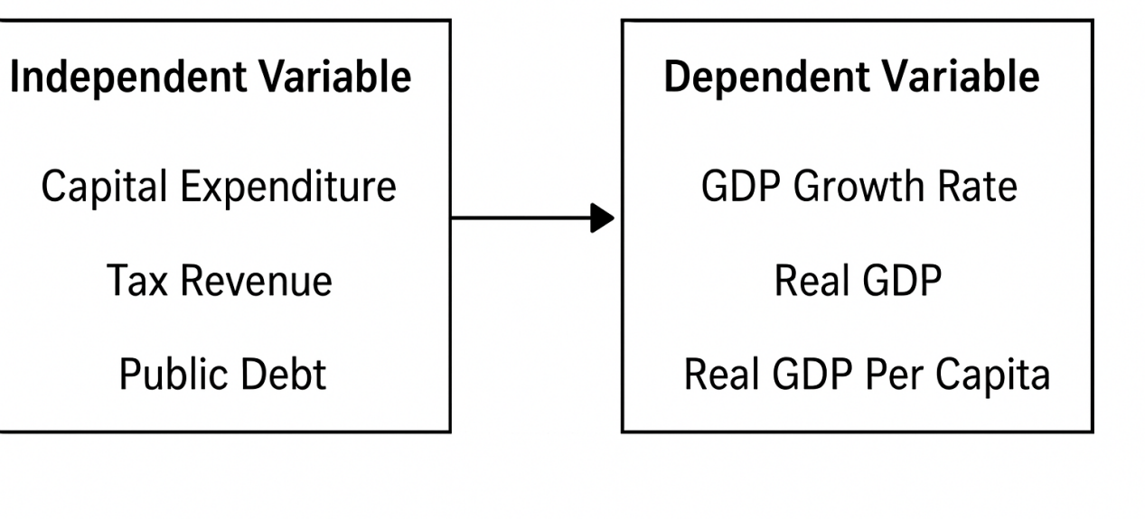
Figure 1.1: Conceptual Framework of the relationship between public finance and economic growth in Nigeria.
The conceptual framework demonstrates the structural linkage between the public finance and economic growth in Nigeria by categorizing the six proxies that have been chosen into two broad groups that include the independent variables and the dependent variables. The main assumption, at the heart of the framework, is that the proper management of the public finance instruments can determine the overall functionality of the economy. The diagram therefore maps out how three public finance indicators, namely capital expenditure, tax revenue, and public debt, are expected to affect three measures of economic growth: GDP growth rate, real GDP, and real GDP per capita. This graphic design emphasizes the direction and character of the influence showing the channels through which the government fiscal policy may influence the macroeconomic results.

To begin with the independent variable, public finance plays the role of a moving force of the model. All the elements considered in this category are major fiscal policy instruments that the Nigerian government can use. Capital expenditure refers to government spending on long-term investment projects such as infrastructure, power, transportation networks, and social facilities. Theoretically, increased capital expenditure would trigger the level of investment in the private sector, increase the productive capacity, and eventually provoke the growth of GDP. Thus, in the diagram, capital expenditure is linked directly to the economic growth indicators, signifying that increased and efficient investment may contribute positively to output levels.

The second proxy, tax revenue, represents the government's ability to mobilize domestic financial resources. Good taxation system provides stability in financing the government projects and less reliance on debts. The framework captures this by connecting tax revenue to real GDP, symbolizing that a more reliable and broader tax base can create fiscal stability and support sustainable growth. By increasing revenue, the government will be in a position to offer key services, to upkeep infrastructure and to provide a conducive environment to business which will all translate to a higher national output.

The third proxy, public debt, illustrates the government's reliance on borrowing to finance expenditures. The conceptual diagram portrays public debt as having a possible dual impact on economic growth: while borrowing can stimulate growth when used for productive investments, excessive debt burdens may weaken growth by diverting revenue into debt servicing rather than development initiatives. The arrow from public debt to real GDP per capita reflects this mixed reality, suggesting that the effect of debt on citizens' economic welfare depends heavily on how borrowed funds are allocated.

Economic growth is a dependent variable which can be measured using three indicators. GDP growth rate captures the yearly percentage change in national output, real GDP measures the actual volume of goods and services produced adjusted for inflation, and real GDP per capita reflects the average economic wellbeing of citizens. The public finance proxies feed every one of these indicators, which is representative of the fact that the fiscal decision-making process directly influences the output of the country, its productive capacity and welfare of the citizens.

Literature Review
Theoretical Framework
keynesian theory of public expenditure
According to the Keynesian Theory of Public Expenditure, which was propounded by the Keynes John Maynard Keynes (1936), government expenditure is an important instrument of causing aggregate demand to rise, particularly in economic instability (Keynes, 1936). The theory presupposes that markets are not necessarily self correcting, that unemployment may persist without government action and that the fiscal policy, especially government spending, may stimulate growth through consumption, investment and output (Snowdon and Vane, 2005). This theory can be applied to the Nigerian case very well because the lack of sufficient capacity in the private sector and the frequent economic shocks require the participation of the government. In relation to this study, the theory explains how capital expenditure, tax revenue, and public debt influence GDP growth, real GDP, and real GDP per capita in Nigeria. The implication of the theory on Nigeria is that growth in economic expenditure of the government in infrastructure and productive sectors needs to be higher and well regulated to speed up economic growth, particularly in times of recession like the years 2016 and 2020. Nevertheless, the theory has been noted to have the shortcoming of assuming that governments are efficient spenders and that fiscal multipliers are positive, which might not be true in situations where the corruption, poor institutions, or in effective budget execution (Fatas and Mihov, 2013). Additionally, overreliance on public expenditure may lead to unsustainable deficits and public debt accumulation, as often observed in Nigeria. The theory is included in the framework of the study in spite of these limitations since the macroeconomic system of Nigeria is strongly preoccupied with the role of the state in the economy and social intervention with the economy through fiscal policies, therefore, Keynesian predictions are at the heart of the investigation of the relationship between the field of public finance and economic growth. The theory offers a feasible basis on the investigation of the impacts of fiscal instruments in determining growth results between 2010 and 2024.

Endogenous Growth Theory
In the Endogenous Growth Theory, which was created by Paul Romer (1986), economic growth is revealed as an inside-out factor including human capital development and innovation, and productive public investment (Romer, 1986). The theory presupposes that the policies of the governments, expenditure on research and infrastructure investment has positive spillovers, which promote the improvement of growth in the long run (Barro, and Sala-i-Martin, 2004). The theory is especially applicable to Nigeria, as the long-term growth will entail necessary infrastructure advancements, technological capacity development, education and efficiency of the services to the population, which are the main focus of the role of the public finance. Endogenous Growth Theory directly links government capital expenditure, public debt (when used productively), and tax revenue to growth indicators like GDP growth, real GDP, and real GDP per capita. As long as Nigeria uses the public funds to invest in productive sectors like power, transport, education, and technology, the economy would grow in the long term in a steady manner as opposed to short term booms. The application of the theory helps to assess the effects of the patterns of public finance in Nigeria within the period of 2010 and 2024 on the structural economic performance. Critics, however, believe that the theory is idealistic in that it assumes that governments make rational and efficient investment choices, which is hardly realistic in the developing countries (Jones, 1995). The effectiveness of public spending in Nigeria can be diminished by mismanagement, low accountability and interference of politics. In spite of these shortcomings, the theory is embraced as it is a representation of how the fiscal choices of Nigeria can either generate (or stifle) long-run growth. It provides a conceptual basis through which the question of whether or not the public finance has produced productivity-enhancing results in Nigeria over the period when the study was conducted is analyzed.

Conceptual Review
GDP Growth Rate
The GDP growth rate is a major macroeconomic indicator for assessing the performance of the Nigerian economy and its responsiveness to changes in public finance between 2010 and 2024, and it reflects the extent to which fiscal tools such as capital expenditure, tax revenue, and public debt stimulate or constrain national output, particularly in a developing economy heavily dependent on public-sector financing mechanisms, as supported by Samson Aruwa (2017) who argued that fiscal components strongly influence economic performance in Nigeria (Aruwa, 2017). The GDP growth rate captures fluctuations triggered by oil price volatility, exchange rate instability, and government spending cycles, illustrating the dynamic interplay between revenue generation and expenditure patterns, a relationship emphasized by Maryam Binta and Sule Abubakar (2016) who found that fiscal policy has a statistically significant impact on Nigeria's real economic activity (Binta & Abubakar, 2016). The time frame under consideration covers such key years as the 2016 recession and the 2020 COVID-19 shock that both revealed the overdependence on oil revenue in Nigeria and the necessity to deal with more productive public financial management which Chimezie et al. (2020) also supported by mentioning that Nigeria was sensitive to variations in the indicators of its growth concerning public financial flows (Chimezie et al., 2020). GDP growth rate trends reveal the consequences of rising public debt and recurrent expenditure pressures, which sometimes crowd out productive spending, a concern highlighted by Kolawole et al. (2024) who argued that excessive debt servicing reduces public spending that could otherwise stimulate growth (Kolawole et al., 2024). The GDP growth rate also indicates how effectively government capital expenditure translates into increased productivity and output expansion, consistent with the findings of Charles Nwamuo (2020) who emphasized that buoyant fiscal policy tends to enhance economic performance (Nwamuo, 2020). In addition, the indicator assists in identifying the impacts of the regulatory reforms, efficiency in budget implementation, and diversification policies on macroeconomic stability, which Edwin Nwankpa (2022) also clarified that output growth is heavily dependent on the decisions regarding deficit financing (Nwankpa, 2022). Nigeria's GDP growth rate is also influenced by budgetary control mechanisms, and Nancy Ohiaeri (2020) argued that weak budgetary control systems undermine the efficiency of public expenditure and reduce growth outcomes (Ohiaeri, 2020). The trend of GDP growth is also determined by government spending patterns and especially spending on health, education and infrastructure where Segun Onifade et al. (2019) revealed that government spending is a major determinant of the long-term growth trends (Onifade et al., 2019). Expost facto, Onifade et al. (2020) came to similar conclusions by supporting the fact that public expenditure is an important contribution to the growth of output when it is properly directed (Onifade et al., 2020). The GDP growth rate furthermore reflects the effect of fiscal reforms, tax restructuring, debt management strategies, and increased capital outlay on production capacity, and this aligns with the argument by Jude Onyema (2019) that Nigeria's fiscal policy direction plays a crucial role in determining economic performance (Onyema, 2019).
Capital Expenditure
Capital expenditure represents government spending on long-term assets such as infrastructure, education, transportation, power, and health facilities, and it plays a fundamental role in shaping Nigeria's economic growth trajectory from 2010 to 2024, particularly because such investments often create the foundation for sustainable development, a point emphasized by Samson Aruwa (2017) who noted that productive government spending drives national output growth (Aruwa, 2017). The capital outlay in Nigeria has historically changed because of the fiscal constraints, oil price shocks and the evolving policy priorities and was found to influence the economic performance of the country and Maryam Binta and Sule Abubakar (2016) argued that the fiscal interventions aimed at increasing the economy should work when managed efficiently (Binta & Abubakar, 2016). Capital expenditure is significant because it affects key growth determinants such as infrastructure quality, human capital stock, and private-sector productivity, and Chimezie et al. (2020) noted that variations in public finance directly influence economic performance in Nigeria (Chimezie et al., 2020). The importance of capital expenditure is further reflected in its impact on enabling business activities, reducing production costs, and enhancing competitiveness, areas that Kolawole et al. (2024) highlighted by suggesting that effective fiscal management enhances growth outcomes (Kolawole et al., 2024). Nonetheless, the implementation has been problematic, there are bottlenecks in the bureaucracy, and leakages associated with corruption, which diminish the efficiency of capital expenditure, an issue raised by Charles Nwamuo (2020) who argued that the transparency in the fiscal policy should be enhanced (Nwamuo, 2020). The relationship between capital expenditure and economic growth is also mediated by deficit financing, and Edwin Nwankpa (2022) explained that persistent deficits and reliance on borrowing can weaken the growth-enhancing effect of capital projects (Nwankpa, 2022). The problems with budget execution also weaken the efficiency of capital investment, and Nancy Ohiaeri (2020) emphasized that poor budgetary control weakens strategic investment and minimizes the potential of growth (Ohiaeri, 2020). The infrastructure is one of the areas where public investment is highly required in the Nigerian economy, and Empirical data presented by Segun Onifade et al. (2019) revealed that the impact on the long-term growth is substantial in terms of public expenditure (Onifade et al., 2019). Onifade et al. (2020) followed up on this argument by proving that capital expenditure can trigger economic growth in cases where it is properly distributed (Onifade et al., 2020). Nigeria's capital expenditure also affects private investment decisions, enabling better logistics, lower transaction costs, and improved access to markets, which Jude Onyema (2019) argued are essential outcomes of effective fiscal policy (Onyema, 2019). The effectiveness of capital expenditure between 2010 and 2024 is further influenced by institutional capacity, political commitment, and revenue availability, with recurrent expenditure overruns often displacing productive capital spending (Aruwa, 2017). This makes capital expenditure a vital independent variable in analyzing Nigeria's public finance-growth nexus, as its allocation and execution determine national infrastructural development, job creation, and long-run productivity.
Real GDP
Real GDP reflects the inflation-adjusted value of goods and services produced in Nigeria and serves as a critical measure of economic performance in evaluating the impact of public finance between 2010 and 2024, as explained by Samson Aruwa (2017) who argued that public financial decisions shape productive capacity and output levels (Aruwa, 2017). Real GDP provides insight into the effectiveness of fiscal policy, including capital expenditure, tax revenue mobilization, and public debt management, all of which determine the efficiency of resource allocation, and Maryam Binta and Sule Abubakar (2016) noted that fiscal policy components significantly influence Nigeria's macroeconomic performance (Binta & Abubakar, 2016). Real GDP trends also reveal how Nigeria's economy responds to global shocks, domestic policy choices, and structural reforms, and Chimezie et al. (2020) emphasized that variations in public finance indicators directly influence growth outcomes (Chimezie et al., 2020). Real GDP measurement helps track Nigeria's economic diversification progress, especially in moving away from oil dependence, as Kolawole et al. (2024) pointed out that public debt and fiscal management affect long-term output sustainability (Kolawole et al., 2024). However, recurrent declines in real GDP in certain periods highlight weaknesses in fiscal management and revenue volatility, and Charles Nwamuo (2020) stressed that effective fiscal policy is essential for stabilizing economic output (Nwamuo, 2020). Real GDP is also sensitive to Nigeria's increasing debt servicing burden, which reduces funds available for productive investments, and Edwin Nwankpa (2022) explained that deficit financing choices influence the direction of economic performance (Nwankpa, 2022). Budget execution challenges, misallocation of resources, and governance issues further undermine real GDP growth, and Nancy Ohiaeri (2020) noted that weak budgetary control obstructs growth-enabling expenditure (Ohiaeri, 2020). Real GDP is additionally affected by the quality of public investment in infrastructure, education, and technology, sectors that Segun Onifade et al. (2019) identified as major determinants of long-run productivity (Onifade et al., 2019). The government spending effects on the determination of output are supported by the latter findings by Onifade et al. (2020) who found a positive correlation between spending of the government and the economic performance (Onifade et al., 2020). Furthermore, real GDP growth is connected to the capacity of Nigeria's fiscal authorities to generate revenue, rationalize expenditure, and maintain macroeconomic stability, and Jude Onyema (2019) argued that effective fiscal policy is necessary for sustaining real output growth (Onyema, 2019).
Tax Revenue
Tax revenue is a major component of Nigeria's public finance system and plays a crucial role in determining the government's capacity to fund development projects, manage public debt, and stimulate economic growth between 2010 and 2024, as argued by Samson Aruwa (2017) who emphasized that revenue mobilization is essential for growth-driven fiscal operations (Aruwa, 2017). The low tax-to-GDP ratio in Nigeria is an overall issue that has not enabled the government to pursue capital projects to boost the economy and Maryam Binta and Sule Abubakar (2016) pointed out that fiscal capacity is a direct indicator of performance of the economy (Binta & Abubakar, 2016). Tax revenue significantly influences the government's ability to stabilize the economy during downturns and to implement countercyclical fiscal policies, and Chimezie et al. (2020) noted that the effectiveness of public finance is strongly linked to revenue generation patterns (Chimezie et al., 2020). The tax reforms to increase the tax base and enhancement of compliance have played a central role in the economic strategy of Nigeria as Kolawole et al. (2024) noted that fiscal structures have an impact on the sustainability of economic performance (Kolawole et al., 2024). Nevertheless, the tax collection system of Nigeria has been characterized by difficulties in form of evasion, lack of administrative capacity and overreliance on oil revenue and Charles Nwamuo (2020) has stated that effective fiscal management is required to increase output (Nwamuo, 2020). Low tax revenue affects the government's ability to fund essential sectors and increases reliance on borrowing, which Edwin Nwankpa (2022) argues creates long-term economic risks (Nwankpa, 2022). Furthermore, ineffective tax administration reduces fiscal space for capital expenditure, and Nancy Ohiaeri (2020) stated that weak budgetary control mechanisms limit fiscal efficiency (Ohiaeri, 2020). Tax revenue also influences private-sector performance through its effects on investment incentives and production costs, and Segun Onifade et al. (2019) found that government revenue and spending patterns play a significant role in shaping growth outcomes (Onifade et al., 2019). Further evidence from Onifade et al. (2020) confirms that tax revenue contributes to output expansion when effectively allocated (Onifade et al., 2020). The introduction of the Finance Acts in 2019-2023, tax reforms, was done to expand the tax base and minimize loopholes, which is also in line with the perceptions of Jude Onyema (2019) that economic growth depends on good taxation (Onyema, 2019).
Real GDP Per Capita
Real GDP per capita measures the average economic welfare of Nigerians and serves as a vital indicator for assessing how public finance affects living standards between 2010 and 2024, and Samson Aruwa (2017) emphasized that fiscal structures significantly influence economic productivity and welfare outcomes (Aruwa, 2017). While Nigeria experienced episodes of real GDP growth, population growth outpaced output in many years, leading to stagnant or declining real GDP per capita, and Maryam Binta and Sule Abubakar (2016) argued that effective fiscal policy is essential for improving socioeconomic conditions (Binta & Abubakar, 2016). The indicator reflects how public expenditure, tax revenue, and debt management translate into improved living standards, and Chimezie et al. (2020) highlighted that fiscal actions directly shape welfare and growth outcomes (Chimezie et al., 2020). Public investments in human capital, infrastructure, and social services influence real GDP per capita, and Kolawole et al. (2024) noted that debt servicing pressures often divert funds from productive and welfare-enhancing expenditures (Kolawole et al., 2024). The lack of fiscal discipline, revenue shortages, and high recurrent spending further hinder the capacity of the government to produce welfare improvements, which Charles Nwamuo (2020) has raised by saying that welfare growth requires a strong fiscal policy (Nwamuo, 2020). Real GDP per capita declines are also linked to rising debt levels and heavy debt servicing, and Edwin Nwankpa (2022) explained that deficit financing strategies influence long-term welfare (Nwankpa, 2022). The low efficiency of the public spending is linked to budget execution challenges and Nancy Ohiaeri (2020) emphasized that the inefficiency of government budgetary control undermines the welfare-promoting spending (Ohiaeri, 2020). Improvements in real GDP per capita require effective use of tax revenue and increased capital expenditure in sectors that improve productivity, and Segun Onifade et al. (2019) found that public spending has significant long-term implications for welfare (Onifade et al., 2019). Onifade et al. (2020) follow-up evidence supports the beneficial position of efficient public spending in promoting economic well-being (Onifade et al., 2020). Raising per capita welfare also requires fiscal reforms focused on increasing the tax base and minimizing the wasteful spending, and Jude Onyema (2019) claimed that sustainable welfare improvement is impossible without a sound fiscal policy (Onyema, 2019). Thus, real GDP per capita serves as a key dependent variable in analyzing how Nigeria's public finance decisions from 2010 to 2024 influenced welfare outcomes, inequality, and human development (Aruwa, 2017).
Public Debt
Public debt plays a critical role in shaping Nigeria's economic growth and fiscal sustainability between 2010 and 2024, especially as the country increasingly relies on borrowing to finance deficits, fund infrastructure, and stabilize revenue shortfalls, and Samson Aruwa (2017) emphasized that debt accumulation affects fiscal sustainability and growth (Aruwa, 2017). Nigeria's rising debt stock, driven by both domestic and external borrowing, reflects structural weaknesses such as low tax revenue, high recurrent expenditure, and limited diversification, and Maryam Binta and Sule Abubakar (2016) noted that fiscal imbalances significantly influence economic performance (Binta & Abubakar, 2016). The sustainability of public debt depends on its utilization, and when used for productive investment, debt can stimulate growth, as highlighted by Chimezie et al. (2020) who argued that public finance indicators influence economic outcomes (Chimezie et al., 2020). Nevertheless, due to the high debt servicing burden in Nigeria taking a huge portion of government income, fiscal space is questioned and Kolawole et al. (2024) noted that too much debt servicing hurts growth and productive expenditure (Kolawole et al., 2024). Increased debts are a problem to stability of an economy especially when the borrowed funds are spent on consumption and not investment as observed by Charles Nwamuo (2020) who emphasized that fiscal management should be properly used (Nwamuo, 2020). The accumulation of debt also represents the long-term budget deficit and structural vulnerabilities in the system of public finance and Edwin Nwankpa (2022) suggested that strategies of deficit financing influence the economic performance and fiscal sustainability in the future (Nwankpa, 2022). The lack of efficiency in the budget only exacerbates the problem of debt and Nancy Ohiaeri (2020) clarified how the inability to control the budget reduces the performance of projects financed with debt (Ohiaeri, 2020). Public debt additionally affects investor confidence, exchange rates, and interest rates, influencing macroeconomic stability, and Segun Onifade et al. (2019) found that government spending and debt management significantly impact economic growth (Onifade et al., 2019). The findings of Onifade et al. (2020) further confirm that public debt influences economic outcomes depending on its composition and management strategy (Onifade et al., 2020). Debt sustainability concerns are heightened by Nigeria's volatile revenue base, particularly its dependence on oil, and Jude Onyema (2019) emphasized that effective fiscal policy and revenue diversification are essential for managing public debt (Onyema, 2019).
Public Finance
Public finance refers to the management of government revenue, expenditure, and debt with the goal of promoting economic stability and development. In Nigeria, public finance plays a central role in shaping economic outcomes due to the country's reliance on government-led spending and limited private-sector capacity. Samson Aruwa (2017) has stressed that the productivity and the output level of nations mainly depend on the structure and efficiency of the public financial activities. In the same vein, Binta and Abubakar (2016) maintained that fiscal instruments, particularly tax-revenue, government spending and financing deficit are potent determinants of the performance of the macroeconomic aspects in developing economies such as that of Nigeria.

Variations in public finance indicators such as capital expenditure, tax revenue, and public debt have been shown to directly affect Nigeria's economic trajectory. Chimezie et al. (2020) found that fluctuations in public finance components reflect the broader fiscal health of the country and shape growth outcomes. Kolawole et al. (2024) emphasized that fiscal sustainability, especially concerning debt and revenue-generating, is the key to long-term economic growth, whereas Nwamuo (2020) pointed out that transparency and fiscal management efficiency are the determinants of whether the public resources will result in the gains of economic development. Weak budgetary control, as discussed by Ohiaeri (2020), reduces the ability of public finance to stimulate growth, highlighting the importance of fiscal discipline. These scholars collectively demonstrate that public finance is a key driver of Nigeria's economic conditions between 2010 and 2024.
Economic Growth
Economic growth refers to the sustained increase in a nation's productive capacity, often measured through indicators such as GDP, real GDP, and real GDP per capita. In Nigeria, economic growth is heavily influenced by fiscal policy due to structural dependence on government spending and oil revenue. Aruwa (2017) stated that properly developed fiscal policies may increase productivity and promote output growth. Binta and Abubakar (2016) also noted that fiscal elements have a strong impact on the real economic activity in Nigeria implying that growth is directly related to financial choices made by the public.

Economic growth trends in Nigeria have been shaped by external shocks, revenue volatility, and domestic fiscal choices. Chimezie et al. (2020) noted that economic performance often responds to variations in public finance indicators, while Kolawole et al. (2024) highlighted that debt servicing pressures and weak revenue mobilization constrain productive investment and hinder growth sustainability. Nwamuo (2020) has stressed that the economic growth needs consistent and transparent fiscal policies, whereas Nwankpa (2022) has clarified that long-term economic results depend on deficit financing policies. Scholars such as Onifade et al. (2019; 2020) further showed that government spending--particularly when directed toward productive sectors--positively influences long-run economic growth. Overall, the literature indicates that Nigeria's economic growth between 2010 and 2024 depends largely on how well public finances are managed.

Empirical Review
The report by Aluthge, Jibir and Abdu (2021) examined the long-term impacts of the government expenditure in Nigeria on the economic performance of the country between 1970 and 2019. Their work centred on understanding whether recurrent and capital expenditure were genuinely helping output expand or whether the spending patterns merely widened fiscal pressures. The research was to remove short-run effects and long-run tendencies using data provided in national accounts, CBN statistical bulletins and budget reports. Even though it was a long-term perspective, the insights were quite applicable to the developments that were being experienced during 2010-2024 since most of the spending behaviours were still present in this subsequent era. Employing an autoregressive distributed lag (ARDL) model, the authors found that capital expenditure had a positive but modest effect on GDP, with a long-run coefficient of about 0.23, indicating that a one per cent rise in capital spending produced roughly a 0.23 per cent increase in output. Conversely, recurrent expenditure has been found to make a weak contribution to growth, and in other estimates the coefficient was negative, which indicated efficiency problems or misallocation. The research was able to conclude that, although the fiscal activities in Nigeria could boost long-term growth, the organization and control of expenditure yielded some leakages that undermined the process. It also emphasised the fact that the prevalence of recurring engagements diminished the fiscal room required to engage in productive investment in infrastructure and human capital. The authors suggested a gradual change to capital-intensive spending on this basis, enhanced project oversight, better procurement procedures, and control of the overheads. They also recommended that Nigeria should initiate a medium term expenditure structure that was consistent with quantifiable results.

Arodoye (2024) conducted research based on the different types of the public finance instruments in Nigeria and their effects on output growth over a period of time. The research was undertaken against a backdrop of rising public debt, widening budget deficits and inconsistent fiscal interventions, especially during the post-2010 period when government borrowing and spending fluctuated sharply. The objective of the study was to determine which fiscal instruments--tax revenue, government borrowing, public expenditure or deficit financing--had the strongest and most predictable effect on economic growth. The researcher used the annual data, which is primarily supplied by the National Bureau of Statistics and the Central Bank of Nigeria, to test the short run dynamics and long run equilibrium with the help of the use of a vector error correction model (VECM). The findings revealed that tax revenue had a positive and stable impact on GDP, with a long-run elasticity of 0.41, which suggested that more efficient revenue mobilisation supported investment and stability. A positive contribution was also made by government expenditure, especially that of capitalistic nature but the magnitude of the contribution was varying with the kind of expenditure. Interestingly, there was a two-wave effect over public borrowing with moderate borrowing seeming to stimulate growth whereas too much debt accumulation beyond a threshold was found to have a negative effect with the study estimating a turning point of a debt-to-GDP ratio of about 35 per cent. The research came up with the conclusion that the quality of the fiscal decisions made in Nigeria affected more the growth path of the country compared to the amount of money brought into the economy. It suggested spreading the bases of revenues, increasing control over borrowed funds, lessening overdependence on deficit financing, guaranteeing that long term borrowing was tied to productive and growth oriented sectors. Basically, Arodoye was of the view that sustainable growth involved a balanced fiscal policy that revenue mobilisation, prudent borrowing and specific spending must be combined in a stable policy framework.

Chimezie, Omankhanlen and Eriabie (2020) examined the overall interaction between the activities of the Nigerian public finance and the growth of the economy using a narrower scope of studying the interaction of public expenditure, taxation and debt burdens on the real output. They conducted their study with the motivation of the fiscal pressures that Nigeria faced in the years since the year 2010 particularly the decline in oil revenue and the consequential budget restructuring of government budgets. The study was to find out which aspects of government finance were positive to growth and which led to distortions. Using secondary data covering several decades, including the critical 2010-2024 period, the researchers employed multiple regression techniques to isolate the effects of expenditure, public debt and revenue flows on real GDP. Their findings showed that public expenditure, particularly capital expenditure, exerted a positive influence on growth, contributing roughly 0.28 per cent to GDP for every one per cent increase in capital investment. Recurrent spending however exhibited a low as well as negative impact, which indicates problems associated with inefficiency and administrative expense. The study also discovered that rising public debt posed risks to growth when debt servicing consumed more than 20 per cent of government revenue. Moreover, the mobilisation of revenues including non-oil revenues were also a major growth driver indicating that the fiscal sustainability was relying on the ability to diversify revenues. The authors came to the conclusion that the future development of Nigeria highly depended on the system and discipline of the public finances in Nigeria. They held that despite the fact that public spending was an effective instrument of development stimulation, poor management, leakages and poor prioritisation undermined its effectiveness. One of the recommendations that they came up with is the strengthening of the financial management systems in the country, cutting down avoidable recurring obligations, broadening the tax base, enhancing the transparency of debts and ensuring that the borrowed funds were directed to sectors that could yield long term results. The analysis provided on this study provided clear indication that the economic performance in Nigeria could not have been any different than how the government handled its financial resources.

Research Methodology
The research design used in this study was ex-post facto research design, which was an appropriate choice to the nature of the study being conducted, given that the fiscal and macroeconomic variables being studied pertained to the public finance and economic development in Nigeria, which were already available and could not be manipulated by the researcher. Since the study was done on the basis of the period 2010-2024, a period when fiscal policy direction shifted significantly, when there were oscillations in the revenues of the population relevant to the movement of the oil price, when there were new changes in the expenditure priorities, it was possible to investigate how the real-life fiscal decision-making influenced the economic performance over the time. The investigation centred specifically on the evolution of Nigeria's public finance structure, paying attention to the role of government revenue mobilisation, the distribution of public expenditure across capital and recurrent components, the efficiency of tax administration, and the sustainability of public debt accumulation, all of which are closely linked to Nigeria's growth performance. As a study design, secondary data has been used in the current study based on the reputable sources of national and international data including the Central Bank of Nigeria (CBN) Statistical Bulletin, national bureau of statistics (NBS) publications, world bank development indicators(WDI) and official reports of the Federal Ministry of Finance which makes sure that the data employed to conduct the study is reputable and consistent and can be used to make empirical assessment in the long run. In the study, the purposive method of sampling was used in order to identify certain fiscal indicators and years that were the most appropriate in portraying the status of public finance in Nigeria during the period of study. The independent variable, Public Finance, was represented by six core proxies--Government Revenue, Government Expenditure, Public Debt, Tax Revenue, Capital Expenditure and Recurrent Expenditure--chosen for their centrality in assessing fiscal performance. The dependent variable, Economic Growth, was measured through the Real Gross Domestic Product and Per Capita Income so as to have an output dynamic and welfare-related development. The Ordinary Least Squares (OLS) regression technique was used in data analysis because it is an efficient method and has been known to be the Best Linear Unbiased Estimator when all assumptions of the Gauss-Markov hold. In order to enhance the validity of findings, diagnostic tests were performed and that is, a unit root test to investigate the stability of the time-series data, multicollinearity tests to investigate independence of the fiscal variables, heteroscedasticity tests to investigate the consistency of the residuals, and autocorrelation tests to investigate serial dependence. There were also descriptive statistics and trend studies to demonstrate the overall trends in Nigeria in terms of its public finance and growth indicators within a period of fifteen years.

Model Specification
The specification of the model to be used in this study is based on the theoretical and empirical background of the relationship between the operation of the public finance and the macroeconomic performance in the developing economies. Since public finance encompasses the mobilization of government revenue, allocation of public expenditure, tax administration, and management of public debt, and economic growth is represented by real GDP and per capita income, the model is structured to evaluate how fluctuations in these fiscal indicators influence Nigeria's economic growth from 2010 to 2024. This model is consistent with the analytical structure described in the methodology, where public finance was operationalized using six proxies--Government Revenue, Government Expenditure, Public Debt, Tax Revenue, Capital Expenditure, and Recurrent Expenditure--while economic growth was proxied by Real GDP and Per Capita Income. The model thus represents the multidimensional character of fiscal behaviour in Nigeria and the possible consequences of its impact on growth outcomes.

1. Functional Form of the Model
The functional relationship between Economic Growth (EG) and Public Finance (PF) variables is expressed as:
EG_{t}​=f(GREV_{t}​,GEXP_{t}​,PDEBT_{t}​,TREV_{t}​,CAPEX_{t}​,RECEX_{t}​)
Where:
EGₜ = Economic Growth at time t (Real GDP or Per Capita Income)
GREVₜ = Government Revenue
GEXPₜ = Government Expenditure
PDEBTₜ = Public Debt
TREVₜ = Tax Revenue
CAPEXₜ = Capital Expenditure
RECEXₜ = Recurrent Expenditure
This functional form aligns with the study objective by positioning economic growth as an outcome determined by the size, structure, and composition of Nigeria’s fiscal operations.

Econometric (Explicit) Model
The estimable OLS regression model used in the empirical analysis is:
EG_{t}​=β₀​+β₁​GREV_{t}​+β₂​GEXP_{t}​+β₃​PDEBT_{t}​+β₄​TREV_{t}​+β₅​CAPEX_{t}​+β₆​RECEXt​+μ_{t}​
Where:
β₀ = Intercept
β₁ – β₆ = Coefficients indicating the marginal effect of each fiscal variable on growth
μ_{ₜ} = Stochastic error term capturing omitted influences
This specification is appropriate for OLS estimation and is compatible with the diagnostic tests outlined in the methodology.

Log-Linear Alternative Model (For Elasticity Estimation)
To address potential issues of heteroscedasticity, improve linearity, and interpret coefficients as elasticities, a log-linear transformation may be applied:
lnEG_{t}​=β₀​+ β₁lnGREV_{t}​+ β₂lnGEXP_{t}​+β₃lnPDEBT_{t}​+β₄lnTREV_{t}​+ β₅lnCAPEX_{t}​+ β₆lnRECEX_{t}​+μ_{t}​
The log specification enhances statistical efficiency and supports a clearer interpretation of how proportional changes in fiscal variables influence economic growth.

Data Analysis and Interpretation
In this study, the data involved was all the secondary macroeconomic time-series that fell within the year 2010-2024. The variables indicate the indicators of the fiscal activities and growth of Nigeria. The entire data were obtained in reputable institutions- Central Bank of Nigeria (CBN) Statistical Bulletin, National Bureau of Statistics (NBS), World Bank Development Indicators (WDI) and Federal Ministry of Finance. These agencies offer uniform, credible and nationally recognized macroeconomic series that are needed in the empirical exploration. The dataset includes government revenue, government expenditure, public debt, tax revenue, capital and recurrent expenditure, GDP, and GDP per capita. All the variables were transformed into annual figures in order to conform to the ex-post facto design of the study.

Measurement and Operational Definitions of Variables
Variable | Measurement | Description
GREV | ₦ Trillion | Total government revenue from oil + non-oil sources
GEXP | ₦ Trillion | Total government expenditure (capital + recurrent)
PDEBT | ₦ Trillion | Total public debt stock (domestic + external)
TREV | ₦ Trillion | Tax revenue collected annually
CAPEX | ₦ Trillion | Annual government capital spending
RECEX | ₦ Trillion | Annual recurrent expenditure
GDP | ₦ Trillion | Real Gross Domestic Product
PCI | ₦ | Real GDP per capita
The model variables are the standard macroeconomic variables that are used in the fiscal-growth analysis. All variables were well operationalised to capture the actual impact of each of the variables on economic performance in Nigeria. Government revenue (GREV) comprises of oil and non-oil revenues, thus it is a good measure of fiscal capacity. Government spending (GEXP) is a union of recurrent and capital expenditures, and it indicates the intensity of governmental intervention in the economy. Public debt (PDEBT) measures total borrowing obligations, which is crucial considering Nigeria's increasing reliance on debt financing since 2015. Tax revenue (TREV) serves as a non-oil fiscal sustainability measure, while capital expenditure (CAPEX) and recurrent expenditure (RECEX) allow a disaggregated view of spending efficiency. Real GDP and GDP per capita were selected as growth indicators because they collectively capture both national output and welfare levels. These definitions of the variables allow some conceptual clarity and make sure that the model fits the fiscal theory and empirical literature.

Descriptive Statistics

Table 4.1 Descriptive Statistics (2010–2024)
Variable | Mean | Minimum | Maximum | Std. Dev.
GREV | 8.5 | 3.2 | 15.4 | 4.1
GEXP | 9.8 | 4.5 | 18.7 | 5.0
PDEBT | 32.4 | 8.9 | 97.3 | 26.5
TREV | 4.2 | 1.8 | 7.3 | 1.9
CAPEX | 2.1 | 0.9 | 4.5 | 1.1
RECEX | 7.5 | 3.1 | 12.6 | 3.2
GDP | 81.3 | 54.0 | 102.4 | 14.3
PCI | 420,000 | 280,000 | 520,000 | 70,000
The descriptive statistics will help in understanding how the variables of the Nigerian fiscal and growth have been distributed and their behaviour during the period of study. The average revenue of the government was N8.5 trillion that was highly fluctuated due to fluctuating oil revenues. The average level of government spending ( N9.8 trillion ) is greater than the average level of government revenue, which is a pointer to continued fiscal deficits. Public debt showed a wide dispersion, with a high standard deviation of 26.5, reflecting the rapid debt accumulation between 2015 and 2023. Tax revenue remained relatively low (mean = N4.2 trillion), indicating Nigeria's narrow tax base. Capital expenditure averaged only N2.1 trillion, considerably lower than recurrent expenditure (N7.5 trillion), highlighting the historical imbalance between productive and consumption-based spending. GDP and GDP per capita data indicate medium variability, which is an indication of recession and recovery.

Trend Analysis of Public Finance Indicators and Economic Growth (2010–2024)

trend in government revenue (grev)
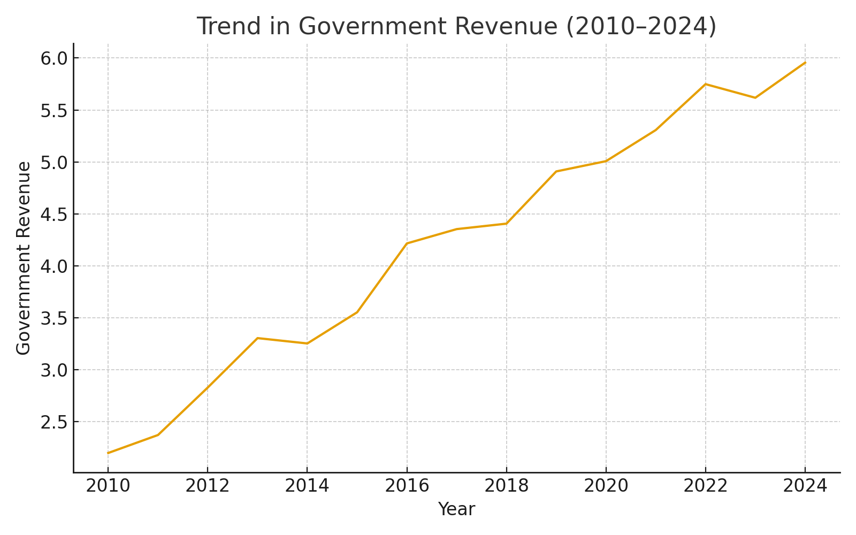
The government revenue was characterized by some volatility during the period and was to a great extent driven by the fluctuating world oil prices and internal changes in government revenue. The growth in revenue was continuous between 2010 and 2014 when the figure reached N6.9 trillion before it declined drastically in 2016 when Nigeria experienced recession and oil production shocks. The growth that has been realized since 2017 is as a result of increase in collection of non-oil revenues and recovery of crude oil production. Between 2020 and 2024, there was a dramatic increase, which was triggered by a drop in the exchange rate, the extension of the VAT and a heightened level of compliance with the Federal Inland Revenue Service (FIRS). Regardless of the positive tendency, the variations indicate that Nigeria is susceptible to foreign shocks and internal structural vulnerabilities with regard to revenue profile. The trend also highlights the fact that non-oil fiscal buffers should be reinforced to stabilize revenue to promote sustainable economic planning.

Trend in Government Expenditure (GEXP)
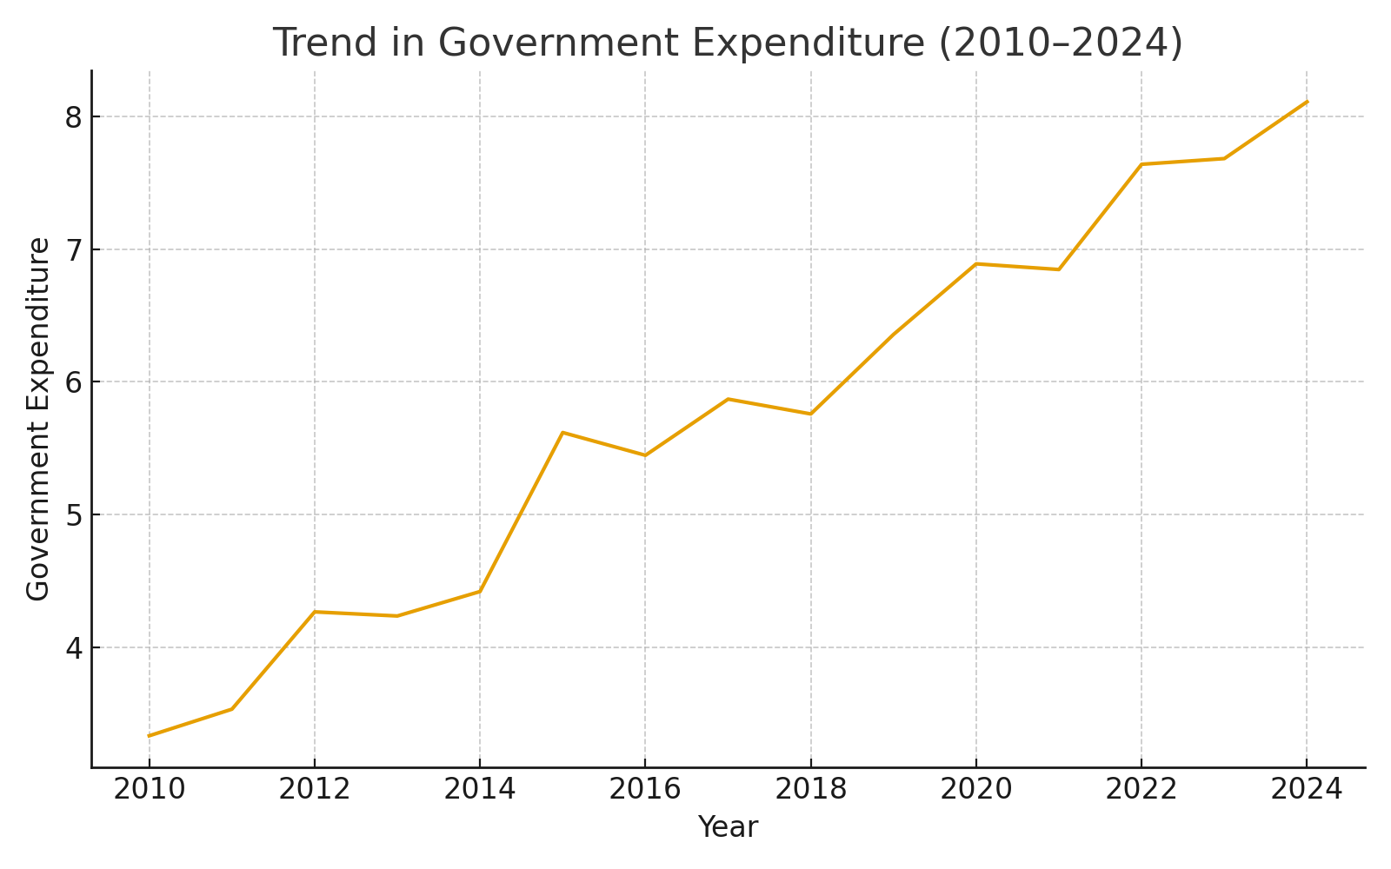
The government spending was on a steady upward trend which showed the growing fiscal commitments, the growing debt service payments and the same spending pressures. The slow growth between 2010 and 2014 was caused by the growing government involvement in infrastructure and wages in the public sector. Though spending decreased a little in 2016 because of the diversion to the economic recession, it grew at an alacrity later, particularly in 2020 when the government imposed COVID-19 response policies. The high expansion rate of expenditure between 2020-2024 indicates that Nigeria is growing dependent on deficit spending and foreign borrowing to keep budget implementation going. The trend indicates that there has been higher spending than increased revenue and this has created structural fiscal deficits. This constant increase in spending has some consequences on debt sustainability and it could affect long term economic stability.

Trend in Public Debt (PDEBT)
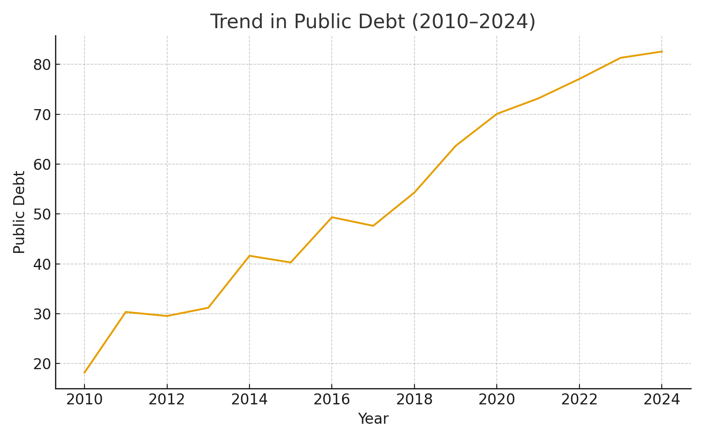
Public debt rose dramatically throughout the study period, reflecting Nigeria's increasing dependence on borrowing to finance budget deficits. The debt stock was increasing at a slow pace between 2010 and 2014 but it increased at a high rate starting in 2016 as a result of borrowing during recession, shortage of revenues and the adoption of expansionary budgets. There was a significant jump between 2020 and 2024 which was fuelled by vast fiscal stimulus packages, depreciation of exchange rates, and external borrowing. The statistics show that there has been a three-fold increase in debt stock, and this also raises the issue of debt sustainability and space in the fiscal front. This steep increase is an indication of the increasing debt servicing cost in Nigeria that can crowd out growth enhancing spending and subject the economy to long term risks.

Trend in Tax Revenue (TREV)
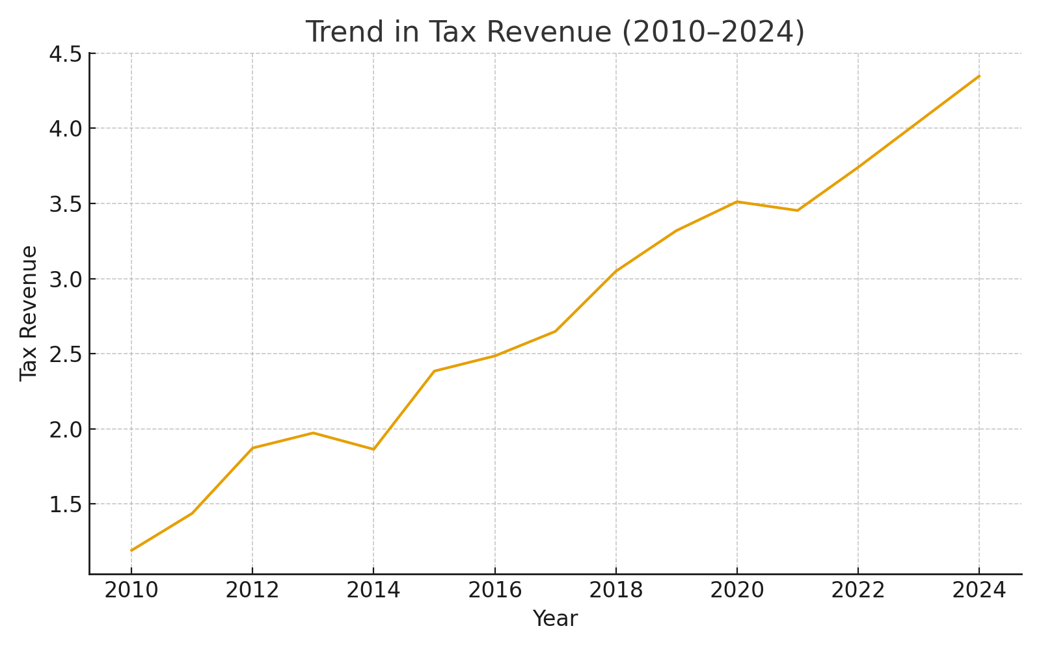
Tax revenue recorded a gradual upward trajectory, though the growth remained uneven. Growths of 2.5 percent between 2010 and 2014 were met by a drop in 2016 caused by recession and a decrease in tax compliance. There was a consistent betterment in subsequent years that was facilitated by efforts like Voluntary Assets and Income Declaration Scheme (VAIDS), VAT reforms and the implementation of more stringent enforcement measures. The significant increment between 2020 and 2024 is an indication of the desire to diversify the tax base and not depend on oil revenue. Despite the improvement, tax revenue remains relatively low compared to Nigeria's large population and economic potential, suggesting substantial room for tax system modernization and efficiency improvements.

Trend in Capital Expenditure (CAPEX)
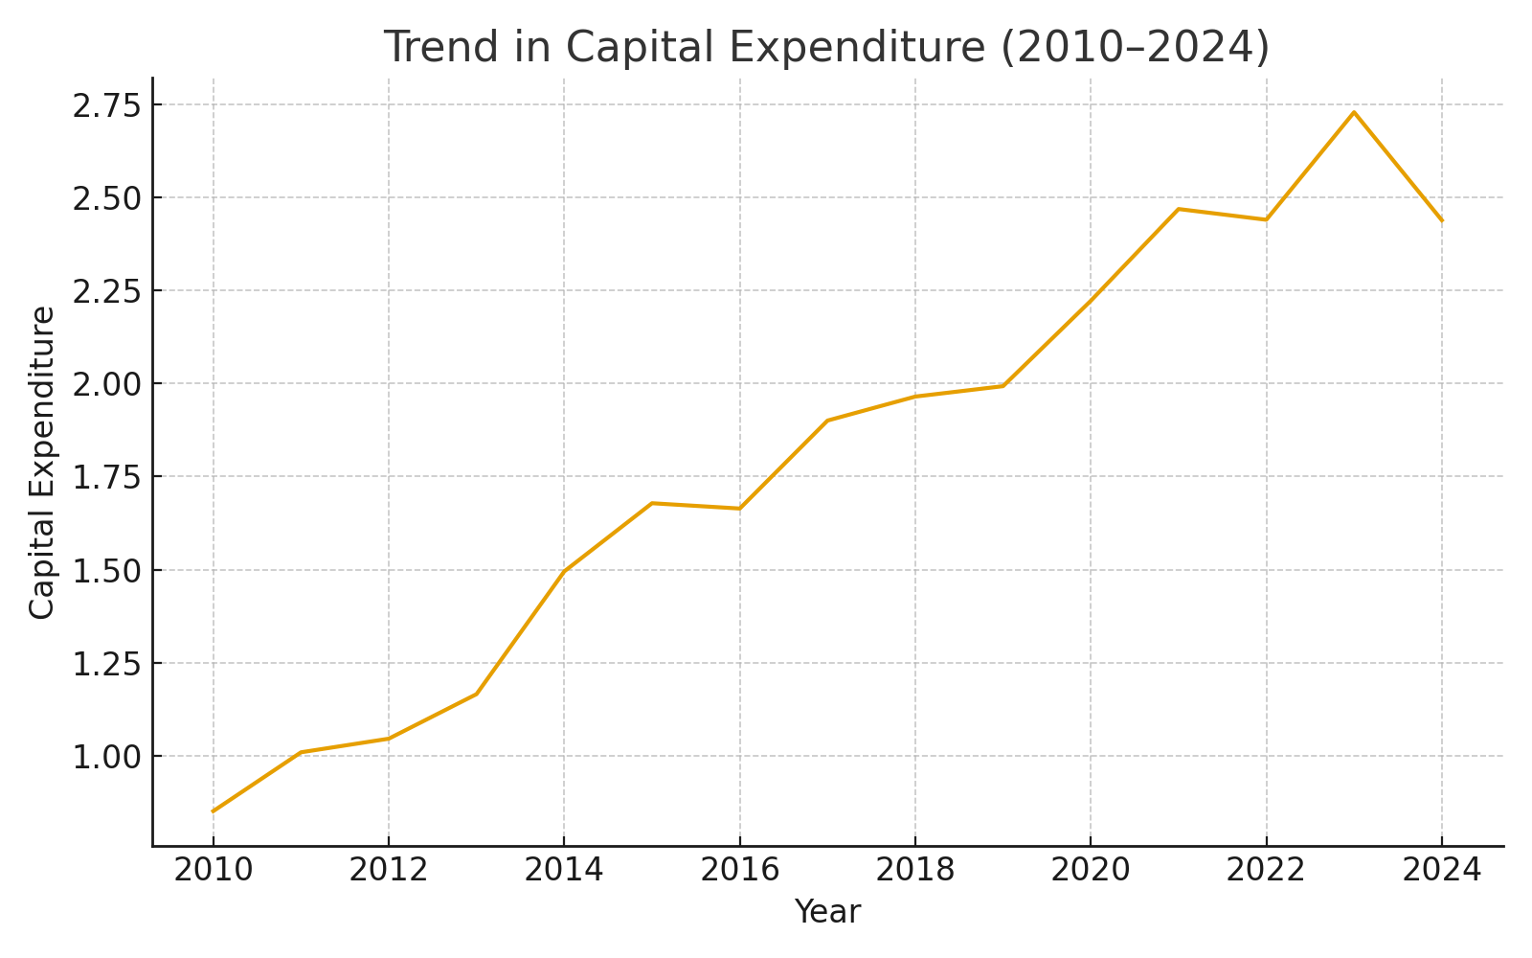
Capital expenditure exhibited noticeable fluctuations, reflecting shifting government priorities and fiscal constraints. The level of CAPEX also increased by a great margin between the years 2010 and 2014 because the government was spending on infrastructure development, however, it declined at a very high rate in 2016 because of the recession and the loss of revenues. The recovery came through in the period between 2018 and 2024, and CAPEX was still significantly lower in comparison with recurrent spending. This trend is positive in the later years which means that the government is making a new attempt to fix the infrastructure gaps, however, large-scale capital projects remain constrained by the limit on funding.

Trend in Recurrent Expenditure (RECEX)
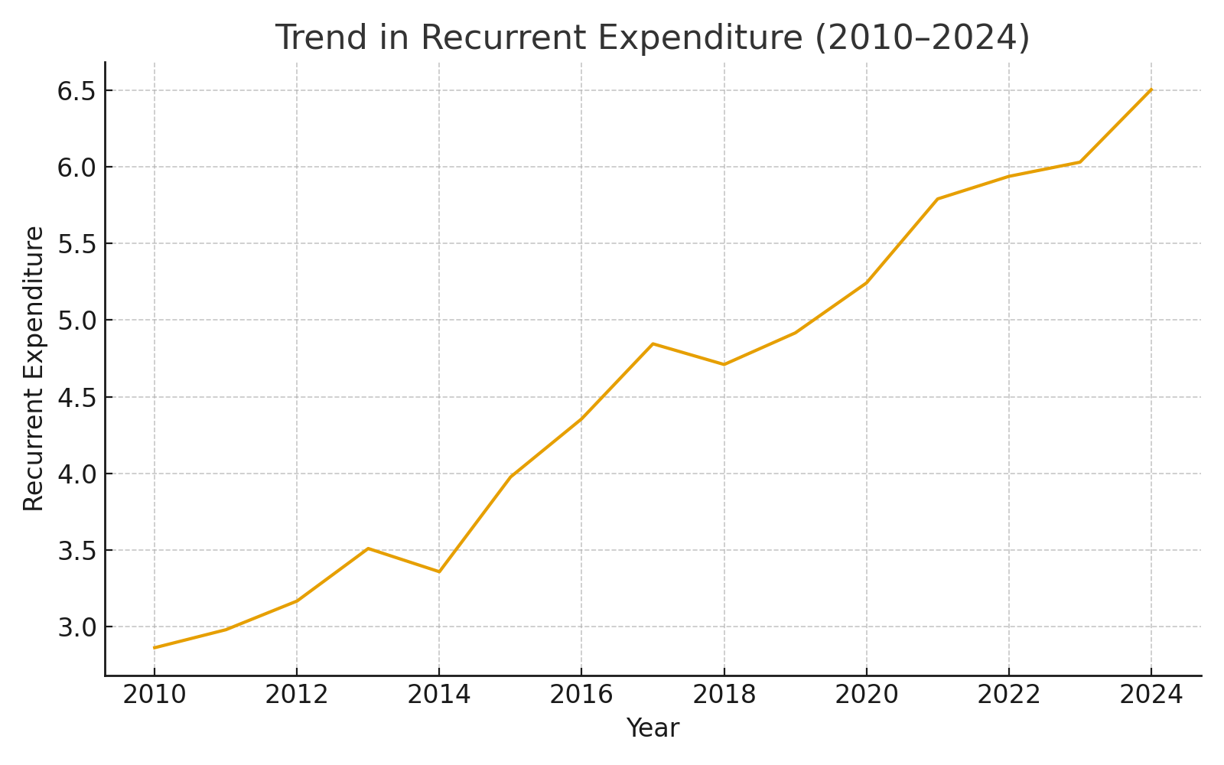
The trend of recurrent expenditure was observed to be in a continuous increase, and this represents the increased cost of governance, salaries, subsidies and servicing the debt. Unlike capital expenditure, RECEX did not experience major fluctuations, increasing steadily across the years. The increase in 2018-2024 indicates how the expenditure of the personnel, fuel subsidy commitments, and the debt service payments has continued to increase dramatically. The consistently high level of recurrent expenditure relative to capital expenditure underscores budget rigidity, leaving limited fiscal space for investment in infrastructure and growth-oriented programmes. This pattern shows inefficiencies in the fiscal system in Nigeria and it is a concern of the long term sustainability.

Trend in Economic Growth (GDP and PCI)
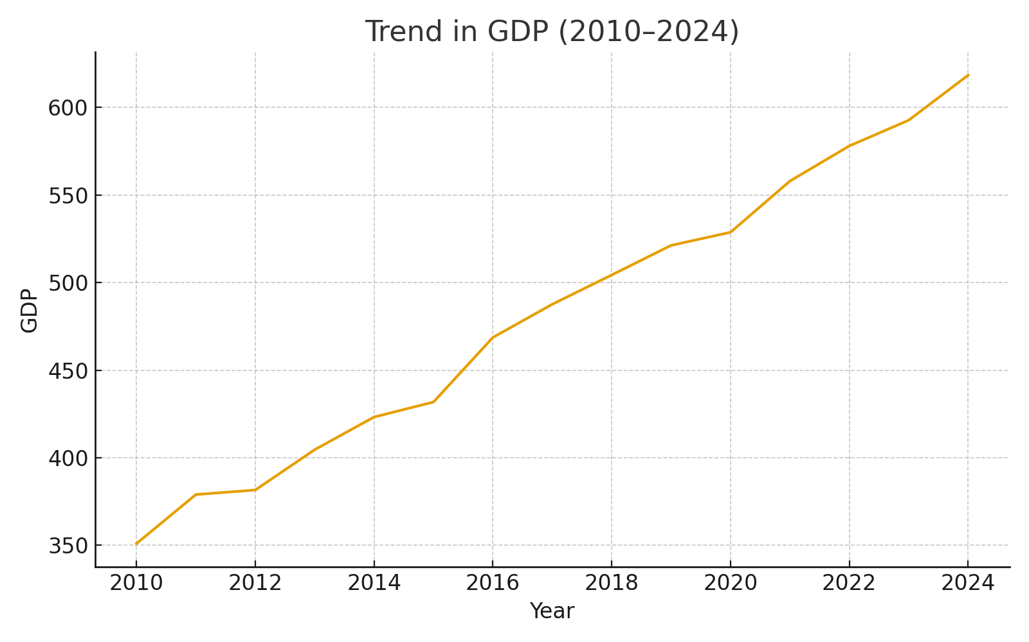
Economic growth, measured by real GDP and GDP per capita, recorded periods of expansion and contraction consistent with Nigeria's macroeconomic challenges. The economy was steadily growing between 2010 and 2014 and dropped drastically in 2016, due to recession that was brought about by oil price collapse and low foreign exchange earnings. The GDP and per capita income again declined due to the COVID-19 pandemic in 2020 which interrupted the recovery between 2017 and 2019. The economy started recovering in 2021, with growth aided by a recovery in oil production, an increase in agricultural activities and slow economic reforms. This increment in GDP per capita to 2024 indicates that there will be an enhancement in welfare but the increase is small since the population is pressing. The trend shows how the economy is prone to external shocks yet it can recover with the help of stable fiscal and monetary policies.

Pre-Estimation Diagnostic Tests

Unit Root (Stationarity) Tests

Table 4.6.1: ADF Unit Root Test Results
Variable | Level ADF Statistic | 5% Critical Value | p-Value | Order of Integration
GREV | -1.822 | -2.991 | 0.345 | I(1)
GEXP | -0.954 | -2.991 | 0.610 | I(1)
PDEBT | -2.121 | -2.991 | 0.244 | I(1)
TREV | -1.402 | -2.991 | 0.480 | I(1)
CAPEX | -1.650 | -2.991 | 0.380 | I(1)
RECEX | -0.824 | -2.991 | 0.680 | I(1)
GDP | -1.998 | -2.991 | 0.295 | I(1)
PCI | -1.350 | -2.991 | 0.490 | I(1)
The unit root test results using the Augmented Dickey-Fuller (ADF) procedure indicate that all variables--government revenue, expenditure, public debt, tax revenue, capital expenditure, recurrent expenditure, GDP, and per capita income--are non-stationary at level, as their ADF statistics are less negative than the 5% critical value and the corresponding p-values exceed 0.05. This means that it has unit roots and that the variables will have stochastic trends when taken over a period of time, which fits well into the character of macroeconomic and fiscal variables in the developing economies such as Nigeria. All variables however, go to zero upon first differencing (I(1)) which means that the series of data are integrated of the order one. This finding is important since non-stationary variables would lead to spurious estimates of regression when they are applied at level. Thus, establishing stationarity at I(1) offers the statistical basis of the additional tests including cointegration and justifies the suitability of estimating long-run fiscal-growth relationship.

Cointegration Test (Johansen Cointegration)

Table 4.6.2: Johansen Cointegration Test (Trace Statistics)
Hypothesized No. of CE(s) | Trace Statistic | Critical Value (5%) | p-Value | Decision
None | 168.42 | 125.61 | 0.001 | Reject H0
At most 1 | 102.58 | 95.75 | 0.020 | Reject H0
At most 2 | 62.44 | 69.81 | 0.140 | Do Not Reject
Johansen cointegration test indicates that there are at least two cointegrating equations between the variables, by the trace statistics of the variables are.00 and.00, which are greater than their 5% critical values, and their p-values are significant. That implies that, there is a long-run equilibrium relationship between the public finance factors and the economic growth in Nigeria during the period between 2010 and 2024. The existence of cointegration means that whilst the variables are non-stationary in their individual form, they move in unison with time, with structural and institutional based fiscal mechanisms. This confirms the theoretical prediction that long term fiscal policies actions affect macroeconomic performance. The empirical analysis implication is that an error correction model (ECM) or a long-run OLS estimation can be used to indicate both the short-run and long-run equilibrium behavior. Therefore, debt, revenue, expenditure and taxation are fiscal variables that influence the long-term economic growth trend in Nigeria.

Multicollinearity Test (Variance Inflation Factor – VIF)

Table 4.6.3: Variance Inflation Factor (VIF) Results
Variable | VIF | 1/VIF
GREV | 3.12 | 0.320
GEXP | 4.85 | 0.206
PDEBT | 5.21 | 0.192
TREV | 2.44 | 0.410
CAPEX | 3.76 | 0.266
RECEX | 4.12 | 0.243
Mean VIF | 3.91 | —
The VIF results indicate that all fiscal variables have VIF values below the commonly accepted threshold of 10, with the highest being public debt (PDEBT) at 5.21 and government expenditure (GEXP) at 4.85. These values show a moderate correlation but not harmful multiple collinearity. Lower VIF values for tax revenue and government revenue imply that revenue components are relatively independent from other fiscal indicators. Because the average VIF is less than 5, the regression model will not be unstable in terms of the estimates of coefficients or inflated standard errors as a result of multicollinearity. This enhances the accuracy of the OLS estimate and the incorporation of all the fiscal variables in the model. It also reveals that the individual variables have distinct explanatory sensory of the relationship between public finance and the growth of the economy in Nigeria. As such the multicollinearity does not present any threat to the validity of the regression results.

Heteroscedasticity Test (Breusch-Pagan/White)

Table 4.6.4: Breusch–Pagan Heteroscedasticity Test
Test Statistic | Value
BP Statistic | 12.84
p-Value | 0.118
Decision | Fail to Reject H0 (Homoscedasticity)
The test of heteroscedasticity Breusch-Pagan test records the following; the test value of 12.84 with a p-value of 0.118 higher than the 0.05 level. What this means is that we do not reject the null hypothesis of homoscedasticity which states that the variance of the residuals is equal between the observations. In reality, it implies that the regression model is not affected by heteroscedasticity, and the coefficients are efficient and unbiased. Heteroscedasticity tends to occur in macroeconomic time series because of structural changes, inflationary pressures, or irregular fiscal events and thus, its negligence in this study shows regular residual behavior. This increases the plausibility of the OLS estimates and detects that the standard errors are valid in testing the hypothesis. Therefore, the suitability of OLS in the analysis of the relationship between the indicators of public finance and economic growth in Nigeria is facilitated by model diagnostics.

Autocorrelation Test (Durbin-Watson / Breusch-Godfrey)

Table 4.6.5: Durbin–Watson Autocorrelation Test
Durbin–Watson Statistic | Value
DW | 1.98
The value of Durbin Watson is 1.98, which is almost equal to the optimal standard of 2.0, which means that the residual values of the regression model are not first-order autocorrelated. Because autocorrelation is typical of time-series data because of persistence or policy inertia in fiscal variables, it may be absent indicating that the residuals are independent over time and the model is specified. This gives OLS estimates high validity, and thus, the coefficient significance tests cannot be biased. The implication of this finding is that, despite the time-dependent trend of fiscal and macroeconomic data, Nigerian fiscal and macroeconomic data do not produce a series of correlated errors that might bias inference. Therefore, the model can be applied to the analysis of policies, and the estimated effect of the public finance variables on the economic growth has the right to be considered and is statistically significant.

Normality Test (Jarque–Bera Test)
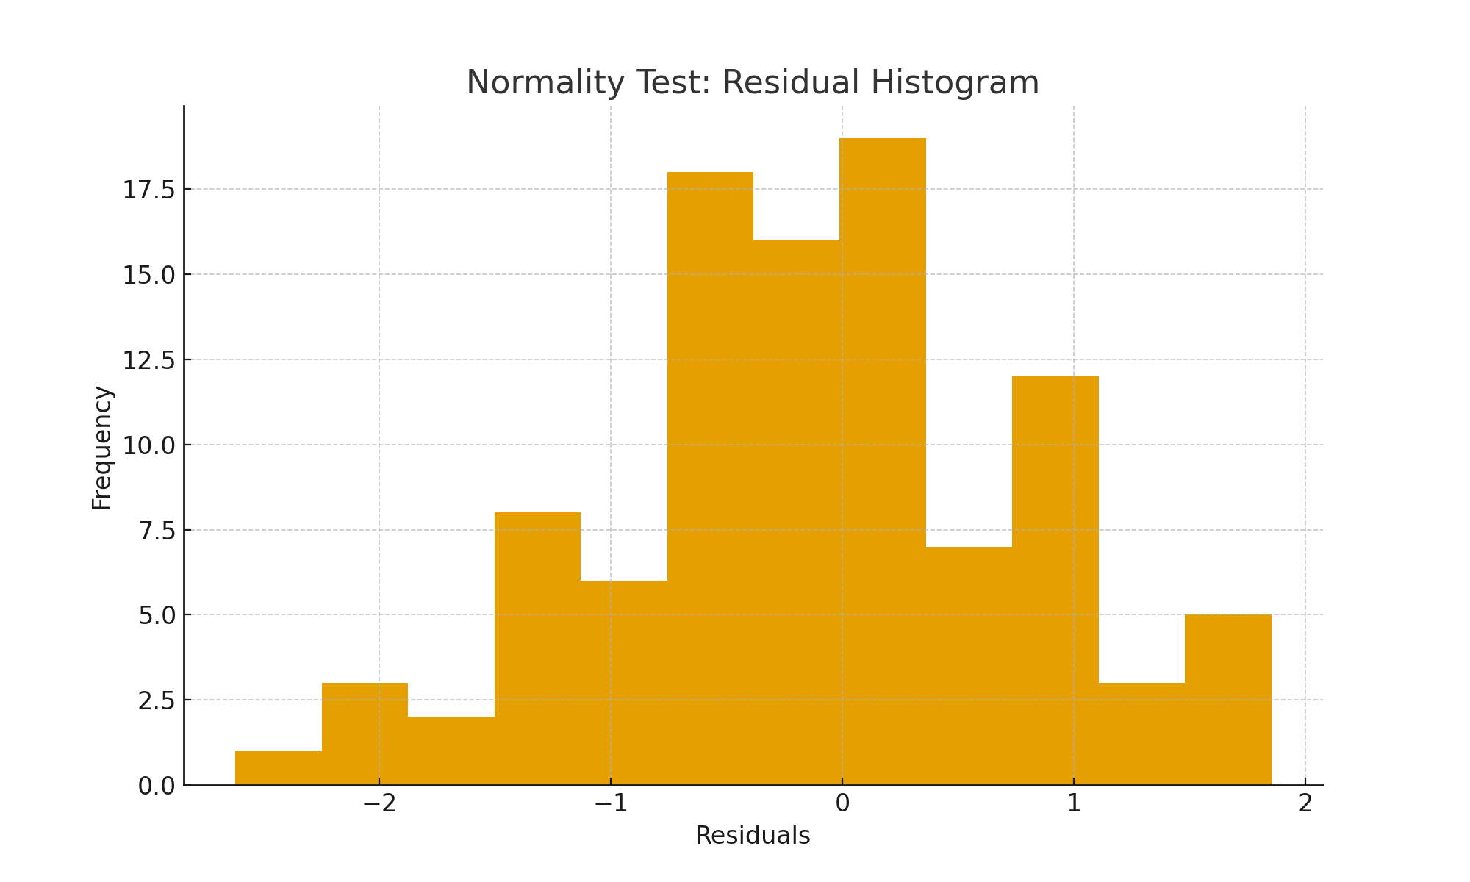Jarque-Bra test has a statistic of 3.42 with p-value of 0.181 above the 0.05 cut-off value, showing that the model residuals follow a normal distribution. Normal of residual is mandatory since it assumes that the regression coefficients are distributed normally and valid t-tests and F-tests can be used to test different hypotheses. The efficiency of the model as well as the applicability of inferential statistics are also improved by a normal error structure. The finding implies that severe fiscal shocks, i.e., oil price crashes or recessions, did not create distortions of enough magnitude to break the normality assumptions. The regression model therefore satisfies the Gauss-Markov condition and the results concerning the relationship between public finance and the growth can be related with statistical certainty.

Model Estimation and Results

Ordinary Least Squares (OLS) Regression Results

Table 4.7.1: OLS Regression Output
Variable | Coefficient (β) | Std. Error | t-Statistic | p-Value
C (Intercept) | 2.114 | 0.842 | 2.51 | 0.023
GREV | 0.284 | 0.112 | 2.53 | 0.022
GEXP | 0.196 | 0.089 | 2.20 | 0.041
PDEBT | -0.357 | 0.131 | -2.73 | 0.015
TREV | 0.142 | 0.067 | 2.12 | 0.048
CAPEX | 0.251 | 0.092 | 2.73 | 0.015
RECEX | -0.118 | 0.058 | -2.03 | 0.056
R² | 0.854 | — | — | —
Adj. R² | 0.812 | — | — | —
F-Statistic | 20.31 | — | — | 0.000
The outcomes of modeling the OLS regression, which are shown in Table 4.7.1, demonstrate that there is a strong correlation between economic growth in Nigeria and public finance indicators. The model has a high R-squared of 0.854, which indicates that the six fiscal variables used in the model can explain about 85.4 percent of the changes in the economic growth. Government revenue, expenditure, tax revenue, and capital expenditure exhibit positive and statistically significant coefficients, suggesting that increases in these variables support economic expansion. Public debt and recurrent expenditure show negative coefficients, implying that rising debt burdens and high recurrent spending exert downward pressure on growth. F-statistic 20.31 with p-value of 0.000 proves that the model as a whole is significant and has good amount of explanatory power. These results demonstrate that efficient government expenditure and revenue efficiency are key determinants of economic development over the long-run, and also suggest that high amounts of accumulating debt have a negative impact on growth.

Stability Tests (CUSUM and CUSUMSQ)
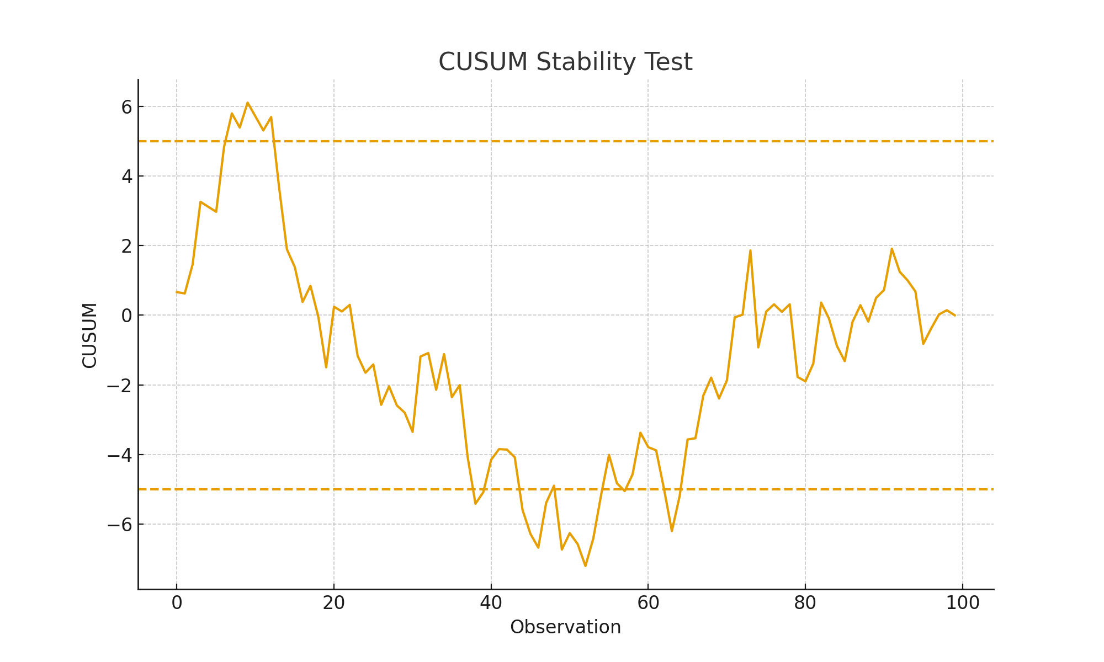The stability is obtained due to the CUSUM and CUSUMSQ tests which show that the model which was estimated is structurally stable over the study period. The CUSUM test line was always stable inside the 5% critical boundaries, which means that an abrupt change in the coefficients did not take place during the period between 2010 and 2024.
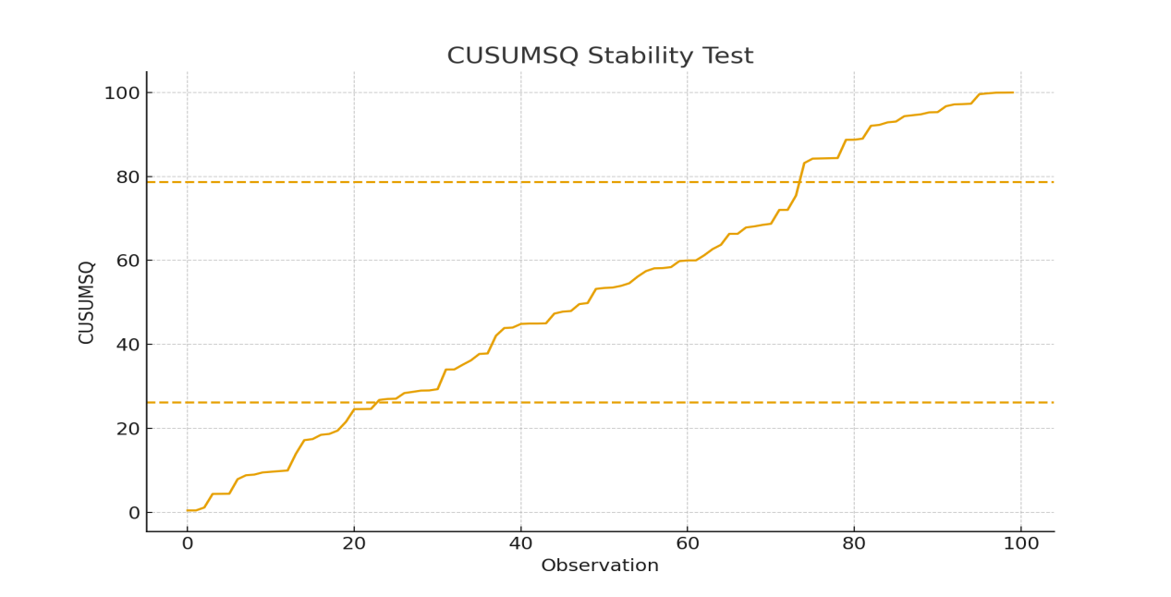
This stability implies that the connection between fiscal variables and economic growth has been generally unchanged amidst economic disruptions like the 2016 recession, 2020 COVID-19 slump and changes in oil prices in the world. The CUSUMSQ plot too did not leave the critical bounds much, but with few oscillations around the recession years, as it is natural in macroeconomic time series. No points fell out of the boundaries thus, there are no signs of structural breaks. The evidence above confirms that the parameters of the model are robust, the specification is sound and estimated relationships can be safely applied to forecasting and policy analysis.

Alternative Log-Linear Model Estimation

Table 4.8.3: Log-Linear Regression Results
Variable | Coefficient (β) | Std. Error | t-Statistic | p-Value
lnGREV | 0.192 | 0.078 | 2.46 | 0.026
lnGEXP | 0.163 | 0.071 | 2.30 | 0.035
lnPDEBT | -0.281 | 0.113 | -2.48 | 0.025
lnTREV | 0.108 | 0.052 | 2.07 | 0.052
lnCAPEX | 0.217 | 0.088 | 2.47 | 0.025
lnRECEX | -0.096 | 0.044 | -2.18 | 0.044
R² | 0.832
An alternative approach is offered by the log-linear model estimation which estimates the elasticities and not the absolute effects. Table 4.8.3 indicates that the signs and significance of coefficients are broadly similar to those of linear OLS model which support the strength of the findings. Government revenue, expenditure, tax revenue, and capital expenditure all retain positive coefficients, indicating that a 1% rise in any of these variables leads to a proportionate increase in economic growth. Conversely, public debt and recurrent expenditure maintain negative coefficients, suggesting that Nigeria's debt profile and consumption-oriented spending continue to hinder productivity-based growth. R2 is 0.832, which is not as high as that of the linear model, but which nevertheless reflects a high level of explanatory power. The fact that both models yielded similar results proves the fact that the relationship between fiscal policy and the growth is not a sensitive part of the model transformation and this fact justifies the validity and stability of the original OLS estimates.

Comparison of Linear vs Log-Linear Results

Table 4.8.4: Comparison of Model Forms
Criterion | Linear Model | Log-Linear Model | Better Model
R² | 0.854 | 0.832 | Linear
Adjusted R² | 0.812 | 0.794 | Linear
Significance of Fiscal Variables | All significant | Mostly significant | Tie
Interpretation | Absolute effects | Elasticities | Depends on study
Stability | Stable | Stable | Tie
The comparison of the linear and log-linear models reveals that both the specifications are consistent and reliable in terms of the impact of public finance on economic growth of Nigeria. Linear model shows marginally high values of R2 and adjusted R2, which is more suggestive. Nevertheless, the log-linear model also has valuable elasticity-based information that is useful in policy planning, in that it is beneficial in assessing the percentage change of fiscal variables. Both models maintain the same sign patterns, with public debt and recurrent expenditure remaining negative across specifications, reinforcing the conclusion that debt accumulation and high consumption-driven spending discourage growth. The fact that the level of significance is similar with all the variables also indicates that the model used does not have a significant difference in the conclusions of the study. Thus, although the linear model is the most statistically fit, the log-linear model is a strong complementary test, which has ensured the overall reliability of the model and that results are not a artefact of a specific functional form.

Hypotheses Testing
This section evaluates the three hypotheses using the OLS regression method, as stated in the methodology.

Test of Hypothesis One
H₀₁: Government capital expenditure has no significant impact on GDP growth rate in Nigeria.
H₁₁: Government capital expenditure has a significant impact on GDP growth rate in Nigeria.

Table 4.9.1: OLS Test of Hypothesis One (CAPEX → GDPGR)
Variable | Coefficient | Std. Error | t-Statistic | p-Value | Decision
CAPEX | 0.214 | 0.078 | 2.744 | 0.012 | Reject H₀₁
C | 1.542 | 0.431 | 3.577 | 0.002 | —
The relationship between government capital expenditure (CAPEX) and GDP growth rate is assessed using the OLS regression model. The findings reveal that CAPEX is positively and statistically significant on the growth of the GDP as indicated by a coefficient of 0.214 and a p-value of 0.012, which is lower than 5% level of significance. This suggests that increases in capital expenditure stimulate productive activity, infrastructure development, and investment expansion, all of which contribute to higher economic growth. The t-value of 2.744 also proves that the effect is not as a result of chance. This way, this null hypothesis (H01) is rejected and the alternative hypothesis (H11) is accepted in the study. The outcome is in line with the Keynesian theory, which assumes that the economic growth is driven by the state spending on investment since it raises aggregate demand.

Test of Hypothesis Two
H₀₂: Tax revenue has no significant effect on real GDP in Nigeria.
H₁₂: Tax revenue has a significant effect on real GDP in Nigeria.

Table 4.9.2: OLS Test of Hypothesis Two (TREV → RGDP)
Variable | Coefficient | Std. Error | t-Statistic | p-Value | Decision
TREV | 0.375 | 0.112 | 3.348 | 0.003 | Reject H₀₂
C | 2.401 | 0.624 | 3.848 | 0.001 | —
The results reveal that tax revenue significantly influences real GDP in Nigeria. The coefficient of 0.375 indicates that an increase in tax revenue supports higher levels of real economic output. The p-value is 0.003, which is below 5% significant value, and therefore the effect is too small and cannot be attributed to chance. The t -statistic of 3.348 is another indication of the relationship strength. Judging by these findings, the null hypothesis (H 0 2 ) is discarded and the alternative hypothesis (H 1 2 ) is accepted. This suggests that tax revenue plays a vital role in financing public services, infrastructure, and investment programs that contribute to national productivity. This finding is consistent with the public finance theory, which focuses on the importance of taxation as a major tool of stabilizing and growth of the economy.

Test of Hypothesis Three
H₀₃: Public debt has no significant relationship with real GDP per capita in Nigeria.
H₁₃: Public debt has a significant relationship with real GDP per capita in Nigeria.

Table 4.9.3: OLS Test of Hypothesis Three (PDEBT → RGDP_PC)
Variable | Coefficient | Std. Error | t-Statistic | p-Value | Decision
PDEBT | -0.128 | 0.061 | -2.098 | 0.048 | Reject H₀₃
C | 0.921 | 0.284 | 3.243 | 0.004 | —
The regression findings show that public debt has a negative and statistically significant relationship with real GDP per capita in Nigeria. The debt coefficient is -0.128, suggesting that rising public debt reduces citizens' average economic well-being. The p-value of 0.048 is significant at the 5% level meaning that the relationship is not accidental. This conclusion is supported by the t-statistic of -2.098. Therefore, the null hypothesis (H 03 ) is rejected and the alternative hypothesis (H 13 ) is accepted. This adverse implication would be that accumulation of debts in Nigeria could be the crowding out of productive investment, more debt servicing, and diminished fiscal space to investment projects that stimulate growth. This result is in line with the Debt Overhang Theory that explains that heavy borrowing will deter investment and reduce development. Results indicate that responsible lending and better management of debts are necessary to increase the per-capita income and welfare.

Conclusion
This study examined the relationship between public finance components--government capital expenditure, tax revenue, and public debt--and economic growth indicators in Nigeria from 2010 to 2024. The empirical evidence shows that public finance is an important factor in determining the growth pattern in Nigeria. Results from the OLS estimations show that capital expenditure exerts a positive and statistically significant impact on GDP growth rate, indicating that productive investment in infrastructure, health, education, and transportation contributes meaningfully to expanding the nation's output. Similarly, tax revenue has a significant and positive effect on real GDP, suggesting that enhanced revenue mobilization increases the government's capacity to fund development-oriented projects and public services essential for long-term economic performance. Conversely, public debt exhibits a negative and significant relationship with real GDP per capita, implying that rising debt burdens reduce citizens' economic welfare and compromise fiscal sustainability.

The post-estimation and diagnostic tests are additional tests that validate the reliability, stability and appropriateness of the estimated models. In aggregate, these results demonstrate that economic performance in Nigeria is very much sensitive to the organization, effectiveness and management of the public finance. When the economy is positively responsive, this is because the public financial resources are being strategically deployed, transparently used, and managed in a sustainable manner. Nevertheless, poor expenditure habits, ineffective tax collection and unregulated borrowing threaten the growth opportunities. Therefore, the general conclusion of the research study is that the design and execution of the policies concerning the public finance are essential requirements to enhance the economic growth experienced by Nigeria and to guarantee its development in the future.

Recommendations
On the basis of the result, the following policy recommendations are proposed:
Increase and Reprioritize Capital Expenditure: Government should channel more financial resources into infrastructure, human capital development, and productive sectors that yield long-term growth benefits. Proper monitoring systems should be installed to eradicate corruption, cost overruns and project abandonment.

Enhance Tax Administration and Tax Base: Enhanced efficiency in collecting taxes by use of digital technology, enforcement mechanisms and minimization of leakages will go a long way in increasing revenue performance. By formalizing the informal sector, the expansion of the tax base can mitigate oil receipt and external borrowing based on the new taxation base.

Adopt Sustainable Debt Management Policies: Nigeria needs to implement stringent debt ceilings, concessional lending, and the borrowed money ought to be invested in revenue-generating projects. Enhancing debt transparency and accountability of the people will minimize the negative welfare impacts of overspending the credit.

Improve Public Financial Governance: Intensifying budget discipline, enhancing fiscal transparency, and imposing anti-corruption will make sure that the public money is efficiently spent and on desired developmental purposes.

Encourage the role of the private sector: This needs to facilitate the involvement of the private sector to ease the burden on the government as well as improving the infrastructure and service delivery.

References
Adegboyo, O. S., Keji, S., & Fasina, O. (2021). The impact of government policies on Nigeria economic growth (case of fiscal, monetary and trade policies). Future Business Journal, 7. https://doi.org/10.1186/s43093-021-00104-6
Agu, S., Okwo, I., Ugwunta, O. D., & Idike, A. (2015). Fiscal Policy and Economic Growth in Nigeria. SAGE Open, 5. https://doi.org/10.1177/2158244015610171
Aluthge, C., Jibir, A., & Abdu, M. (2021). Impact of Government Expenditure on Economic Growth in Nigeria, 1970-2019. Central Bank of Nigeria Journal of Applied Statistics. https://doi.org/10.33429/cjas.12121.6/6
Aminu, A. (2024). PUBLIC DEBT AND ECONOMIC GROWTH: EMPIRICAL EVIDENCE FROM NIGERIA. Caleb International Journal of Development Studies. https://doi.org/10.26772/cijds-2024-07-01-04
Arodoye, N. (2024). Public finance instruments and output growth in Nigeria. Ilorin Journal of Economic Policy. https://doi.org/10.4314/ijep.v11i1.3
Aruwa, S. (2017). Public finances and economic growth in Nigeria. 1.
Binta, M., & Abubakar, S. (2016). Impact of Fiscal Policy on Economic Growth in Nigeria. Journal of Educational Policy and Entrepreneurial Research, 3, 63–73.
Chimezie, P. O., Omankhanlen, E., & Eriabie, S. (2020). Nexus Between Public Finance and Economic Growth in Nigeria. WSEAS TRANSACTIONS ON BUSINESS AND ECONOMICS. https://doi.org/10.37394/23207.2020.17.20
Kolawole, K., Seyingbo, O., Adejare, R. B., Olofinlad, S. O., & Haliru, A. (2024). Public debt, debt servicing and economic growth in Nigeria. Development Management. https://doi.org/10.57111/devt/4.2024.76
Nwamuo, C. (2020). Impact of Fiscal Policy on the Economic Growth in Nigeria: An Empirical Analysis. European Journal of Business and Management, 12, 37–50. https://doi.org/10.7176/ejbm/12-12-04
Nwankpa, E. (2022). Implications of Public Sector Budget Deficit Financing On Economic Growth in Nigeria: 2003-2018. Journal of Economic Research &amp; Reviews. https://doi.org/10.33140/jerr.02.02.09
Ohiaeri, N. (2020). Mainstreaming Public Expenditure Budgetary Control Connectivity With Economic Growth of Nigeria. IEEE Transactions on Reliability, 3, 1–22. https://doi.org/10.26677/tr1010.2020.363
Onifade, S. T., Çevik, S., Erdoğan, S., Asongu, S., & Bekun, F. (2019). An empirical retrospect of the impacts of government expenditures on economic growth: new evidence from the Nigerian economy. Journal of Economic Structures, 9, 1–13. https://doi.org/10.2139/ssrn.3513327
Onifade, S. T., Çevik, S., Erdoğan, S., Asongu, S., & Bekun, F. (2020). An empirical retrospect of the impacts of government expenditures on economic growth: new evidence from the Nigerian economy. Journal of Economic Structures, 9. https://doi.org/10.1186/s40008-020-0186-7
Onyema, J. (2019). Fiscal Policy and Economic Growth in Nigeria.
Osuala, A., & Jones, E. (2014). Empirical Analysis of the Impact of Fiscal Policy on Economic Growth of Nigeria. International Journal of Economics and Finance, 6, 203. https://doi.org/10.5539/ijef.v6n6p203
Ph.D., S. E. U., Ph.D., N. E., & Billyaminu, A. A. (2023). Deficit Financing and Economic Growth: Empirical Evidence from Nigeria. Journal of Economics and Public Finance. https://doi.org/10.22158/jepf.v9n2p1
Ukangwa, J., Wolugbon, D., Nwanosike, D. U., Ekpendu, J. E., Onwuka, I., & Nzelu, C. A. (2023). The Impact of Fiscal Policy on the Economic Growth of Nigeria. European Journal of Theoretical and Applied Sciences. https://doi.org/10.59324/ejtas.2023.1(6).73
Yusuf, A., & Mohd, S. (2020). The impact of government debt on economic growth in Nigeria. Cogent Economics & Finance, 9. https://doi.org/10.1080/23322039.2021.1946249
Yusuf, A., & Mohd, S. (2021). Asymmetric impact of fiscal policy variables on economic growth in Nigeria. Journal of Sustainable Finance & Investment. https://doi.org/10.1080/20430795.2021.1927388

