Title: Chloroquine represses Dalton’s Lymphoma cell growth in vitro and in vivo by inducing mitochondrial-mediated apoptosis and G2/M phase cell cycle arrest

Abstract
Chloroquine, a well-established antimalarial drug, has emerged as a promising anticancer agent. There is evidence that chloroquine is used as an anticancer drug in various cancer cell lines and as an immunomodulator for cancer therapy. Still, its role as an anticancer agent against Dalton’s lymphoma is unclear. The present investigation aims to examine the anticancer potential of Chloroquine against Dalton’s lymphoma cells in vitro and in vivo, specifically focusing on its ability to induce apoptosis and disrupt key cellular processes that are critical for cancer cell survival. We evaluated various concentrations of Chloroquine on DL to assess the cell viability, mitochondrial health, and the activation of apoptotic pathways. The result showed that Chloroquine significantly reduced DL cell viability in a dose-dependent manner with an IC-50 value of 12.67 ± 0.688 µM. Importantly, there was no effect of CQ on normal thymocytes at this dose. Chloroquine treatment induced apoptosis, confirmed by nuclear staining (DAPI, AO/EtBr), and Annexin V/PI staining analyzed via microscopy and flow cytometry, respectively. The treatment also caused a rise in intracellular reactive oxygen species (ROS), leading to oxidative stress and mitochondrial dysfunction, as indicated by JC-1 staining and a decrease in mitochondrial membrane potential. Chloroquine induces cell cycle arrest in the G2/M phase, as observed through flow cytometry. Further, Western blot revealed that CQ treatment upregulated key apoptotic proteins (Bax, caspase 3, and Cyt-c) while downregulating anti-apoptotic protein Bcl-2. In vivo findings indicate the repression of tumor growth by hematological parameters, body weight, and abdominal circumference. These findings collectively suggest that chloroquine holds promise as an anticancer agent capable of targeting multiple cellular pathways involved in apoptosis and cell cycle regulation in Dalton's lymphoma.
Keywords: Dalton’s lymphoma, Chloroquine, Apoptosis, Reactive oxygen species, Mitochondrial membrane potential.
Introduction
Cancer is a group of diseases in which cells grow abnormally and uncontrollably in any part of the body. As of right now, cancer continues to be the primary cause of mortality globally and the leading cause of significant harm to human life and health [1]. According to GLOBOCON, cancer was responsible for approximately 9.8 million deaths in 2022, accounting for nearly one in six deaths worldwide. With an estimated 20 million new cases identified, the incidence of cancer has been rising significantly [2]. The rising incidence of cancer is primarily driven by factors such as changing lifestyles, aging populations, and environmental exposures [3]. The fact that new strategies are being investigated to get around these obstacles is indicative of the ongoing evolution of advances in cancer research and therapy [4]. There are many cancer therapies available, but chemotherapy is the most often used due to its higher survival rate than the others [5]. Chemotherapeutic drugs can have moderate to severe side effects in patients, some of which are permanent. Consequently, it is crucial to identify an effective anticancer agent with minimal side effects and strong anticancer potential against Dalton’s lymphoma [6]. Dalton's lymphoma, a transplantable T-cell lymphoma that spontaneously originated in the murine host's thymus, has become a valuable model for cancer research due to its application in pre-clinical systems for assessing new or existing medications in the treatment of different cancers and in the process of drug discovery [7]. Chemotherapy regimens have been the focus of many studies on Dalton's lymphoma to maximize treatment efficacy while reducing toxicity. Chloroquine (CQ) is a synthetic medication used to treat malaria. The discovery of chloroquine in 1934 and its subsequent introduction into medicine throughout the 1940s made it a part of the quinoline derivatives, a significant class of chemically related antimalarial drugs [8]. It has drawn attention recently for its possible biological effects on cancer cells [9]. Chloroquine has several therapeutic effects along with malarial treatment, such as its effectiveness in rheumatoid arthritis [10] and several viral infections [11]. Additionally, CQ has been shown to induce cell death and inhibit cell growth in several cancer cell lines [12,13,14]. Chloroquine is also reported as a well-known immunomodulator in various diseases like COVID-19 [15] and cancer through macrophage polarization [16]. Given the promising preclinical data on chloroquine's anticancer effects, this study aims to investigate its efficacy against Dalton's lymphoma.
Materials and Methods
Reagents
RPMI-1640 medium and fetal bovine serum (FBS) were purchased from Gibco (Life Technologies). Antibiotic-Antimycotic solution containing Penicillin, Streptomycin, and Amphotericin B was obtained from CELLclone™ Genetix Biotech Asia Pvt. Ltd. (India). Cell culture plates were supplied by TARSONS Products Pvt. Ltd. (India). MTT (CAS No. 298-93-1) and DMSO (CAS No. 67-68-5) were from Sigma-Aldrich (Bangalore, India), while Chloroquine was procured from Sigma-Aldrich (USA). DCFH-DA, DAPI, and Rhodamine-123 were obtained from LobaChemie (Mumbai, India), and Propidium Iodide and Annexin V/PI apoptosis kit from Sigma-Aldrich and Elabscience, respectively. RIPA buffer, RNase, and protease inhibitors were from HiMedia. PVDF membranes were purchased from Merck. Antibodies were sourced from Cell Signaling Technology. All other reagents were of analytical grade.
Animal and tumor model
Balb/c mice were maintained under standard pathogen-free laboratory conditions as per the guidelines of the Institutional Animal Ethical Committee (IAEC), Department of Zoology, BHU, Varanasi (BHU/DOZ/IAEC/2024-II/004 dated 23/11/2024). Mice were provided with sterilized food and water ad libitum and housed in an infection-free conventional polystyrene cage with a 12:12 hr light/dark cycle. DL is a spontaneously developed murine lymphoma that is highly aggressive and immunosuppressive. For DL cell induction, 1 × 10⁶ cells were suspended in 500 μL PBS and serially transplanted into the intraperitoneal cavity of 8–10-week-old healthy mice [6].
MTT assay
The effect of Chloroquine on DL cell viability was studied using an MTT assay. Briefly, Dalton’s lymphoma cells and thymocyte cells were seeded in 96-well plates with 2 x 10⁴ cells per well in RPMI 1640 supplemented with 10% FBS for 24 hr with various doses of chloroquine (0,1, 2, 5, 10, 15, 20 μM) from a 1 mM stock prepared in DMSO and placed in a 5% CO₂ incubator. After incubation, cells were treated with 10 μL MTT (5 mg/ml) for 4 hr at 37 ℃. The insoluble formazan crystals were dissolved in 100 μL of DMSO, and the absorbance was taken with the help of an ELISA plate reader (Bio-Rad, CA, USA) at 595 nm. The % cell viability of the DL cell was calculated using the following equation, and IC₅₀ values were obtained by GraphPad Prism 5 software.
$$\% inhibition=\frac{Mean OD of untreated cells-Mean OD of of Treated cells}{Mean OD of untreated cells}×100$$
DAPI
Dalton's Lymphoma (DL) cells were cultured in RPMI-1640 media in a 6-well culture plate and treated with chloroquine at concentrations of 5 µM, 10 µM, and 20 µM for 24 hours, with an untreated group designated as the control. After treatment, the cells were fixed with 4% paraformaldehyde (PFA), permeabilized with 0.1% Triton X-100, and stained with a 40 µg/mL DAPI solution (4,6-diamidino-2-phenylindole). The nuclei were visualised and the images were captured with a confocal microscope.

AO/EtBr
Dalton's Lymphoma (DL) cells were cultured in complete RPMI-1640 media and inoculated into 6-well plates, and the cells were administered chloroquine at concentrations of 5 µM, 10 µM, and 20 µM for incubated for 24 hours, in combination with an untreated control group. After the treatment period, cells were collected and rinsed with phosphate-buffered saline (PBS). A staining solution comprising Acridine Orange (40 µg/mL) and Ethidium Bromide (40 µg/mL) was introduced to the cell suspension. Following a 15-minute incubation period in the dark at room temperature, the cells were promptly examined under a confocal microscope with red (TRITC) and green (FITC) filters to visualise the nuclei and the cytoplasm [21], and images were taken for the analysis.
Annexin/PI staining
Dalton's Lymphoma (DL) cells were isolated, centrifuged, and suspended in complete RPMI-1640 media and seeded in 6-well culture plate and exposed to different concentrations of chloroquine (5 µM, 10 µM, & 20 µM) for 24 hours, with a control group. After 24 hours of the treatment, cells were collected and rinsed with cold phosphate-buffered saline (PBS). The cell pellet was subsequently resuspended in 1X Annexin V binding buffer. Annexin V-FITC and Propidium Iodide (PI) were included in the cell suspension in accordance with the manufacturer's instructions. The cells were incubated in the dark at room temperature for 15 minutes. After incubation, a small aliquot of the cell suspension was dropped on a glass slide, covered with a coverslip, and examined under a confocal microscope fitted with filters for FITC (green) and PI (red) fluorescence. Further evaluated by Flow Cytometry (Beckman Coulter CytoFLEX LX flow cytometer). The data were examined to distinguish cell populations: viable cells (Annexin V-/PI-), early apoptotic cells (Annexin V+/PI-), and late apoptotic/necrotic cells (Annexin V+/PI+). and the study was done using the software FlowJo.
ROS estimation
The intracellular ROS production was measured by DCFH-DA fluorescent dye. Briefly, DL cells were cultured with chloroquine at different concentrations for 24 hours. After that cells were washed with chilled PBS and stained with DCFH-DA (2 μM) and incubated at 37 ℃ for 20 min. The morphological analysis and fluorescence intensity of stained cells were examined under 40x magnification in a confocal microscope [21]. Also observed the intensities of ROS production by using Flow Cytometry (Beckman Coulter CytoFLEX LX flow cytometer). The collected data were analysed using CytExpert software.
Mitochondrial membrane potential assay by JC-1 dyes
Dalton's Lymphoma (DL) cells were cultured in RPMI-1640 media. Cells were inoculated in 6-well culture plates and subjected to chloroquine treatment at different concentrations of 5 µM, 10 µM, and 20 µM for a duration of 24 hours, along with a control group. Subsequent to the treatment period, cells were collected and rinsed with PBS. The cell pellets were subsequently resuspended in PBS and stained with JC-1 dye (2 µM) for 25-30 minutes at 37 °C in the dark [23]. Following incubation, cells were washed to eliminate excess dye, resuspended in PBS, and a drop of the cell suspension was applied to a microscope slide. The cells were observed using a confocal microscope. Images were obtained utilising filters for red fluorescence (J-aggregates, signifying elevated mitochondrial membrane potential) and green fluorescence (JC-1 monomers, signifying diminished mitochondrial membrane potential). Further validated by flow cytometry, in which fluorescence transition from red (PE channel) to green (FITC channel) was measured to ascertain the percentage of cells exhibiting depolarised mitochondria.

Cell cycle analysis
For the cell cycle study, Dalton's Lymphoma (DL) cells were cultured in RPMI-1640 media and treated with chloroquine at concentrations of 5 µM, 10 µM, and 20 µM for 24 hours, with an untreated group labelled as a control. After treatment, cells were collected, rinsed with ice-cold phosphate-buffered saline (PBS), and preserved overnight in 70% ethanol at -20°C. Subsequent to fixation, the cells were rinsed with PBS and subsequently treated with RNase A (20 µg/ml) to guarantee that only DNA would be stained. The cells were then stained using Propidium Iodide (PI) solution (20 µg/ml). The cellular DNA content was subsequently analysed via a flow cytometer. The proportion of cells in the G0/G1, S, and G2/M stages of the cell cycle was measured using cell cycle analysis software [24].
Western blot analysis
Dalton's Lymphoma (DL) cells were cultured in RPMI-1640 media and subjected to chloroquine treatment at concentrations of 5 µM, 10 µM, and 20 µM for a duration of 24 hours. A control group was included that did not receive treatment. After treatment, cells were collected and rinsed with ice-cold PBS. Total cellular proteins were extracted utilising RIPA lysis buffer supplemented with a protease inhibitor cocktail. The cell lysates were centrifuged to eliminate cellular debris, and the supernatant containing the protein was obtained. The total protein concentration of each sample was quantified using a BCA protein assay kit to guarantee uniform loading. Equal quantities of protein (50 µg) from each sample were subjected to sodium dodecyl sulphate-polyacrylamide gel electrophoresis (SDS-PAGE) and subsequently transferred to a polyvinylidene difluoride (PVDF) membrane. The membrane was incubated with 5% non-fat dried milk or bovine serum albumin (BSA) in Tris-buffered saline with Tween 20 (TBST) for one hour to inhibit non-specific antibody binding. The membrane was treated overnight at 4°C with primary antibodies targeting essential apoptotic proteins, including Bax, Bcl-2, Cytochrome c, and cleaved Caspase-3. A β-actin antibody served as a loading control. Following TBST washing, the membrane was incubated with a horseradish peroxidase (HRP)-conjugated secondary antibody for 2-3 hours. The protein bands were visualised with an enhanced chemiluminescence (ECL) detection kit, and the band intensities were recorded and measured using a Chemidoc (Amersham Imager 680 RGB) and ImageJ software, respectively.
In vivo study
Tumor Induction
Dalton’s Lymphoma (DL) was induced in mice belonging to Groups II to V by intraperitoneal injection of 1 × 10⁶ DL cells suspended in 500 μL of phosphate-buffered saline (PBS). Mice in Group I served as the healthy control and did not receive DL cell transplantation.
Treatment Protocol
After 24 hours of DL cell transplantation, animals were administered the respective treatments alternatively for 18 days via the intraperitoneal (i.p.) route. The experimental groups (n=6/group) were organized as follows:
- Group I (Healthy Control): Normal mice without DL cell transplantation; received no treatment.
- Group II (Tumor Control): DL-transplanted mice administered vehicle (PBS, 10 mL/kg, i.p.).
- Group III (Positive Control): DL-transplanted mice treated with Doxorubicin (2 mg/kg, i.p.), serving as the standard chemotherapeutic reference.
- Group IV (Test Group – Low Dose): DL-transplanted mice treated with Chloroquine at 25 mg/kg, i.p.
- Group V (Test Group – High Dose): DL-transplanted mice treated with Chloroquine at 50 mg/kg, i.p.
Observation Period
Throughout the experimental duration, animals were observed daily for general health status, changes in body weight, survival, and physical activity. Upon completion of the 18-day treatment schedule, the animals were humanely sacrificed, and tissue samples were harvested for subsequent analyses.
Measurement of Body Weight and Abdominal Circumference
The body weight of all experimental animals was recorded at regular intervals throughout the study using a digital balance. In addition, abdominal circumference was measured with a vernier calliper to monitor tumor-associated ascites formation and physical changes. These parameters were documented systematically to evaluate treatment response and disease progression.
Measurement of Hematological Parameters
Following completion of the treatment period, mice were fasted for 24 hours before blood collection. Blood samples were obtained and transferred into EDTA-coated tubes to prevent coagulation. The samples were subjected to complete blood count (CBC) analysis for the evaluation of hematological indices, including haemoglobin (Hb) concentration and white blood cell (WBC).
Results
Chloroquine reduces the viability of DL cells
We employed the MTT test, a prevalent three-step colorimetric method, to evaluate the impact of chloroquine on several cell types. This assay is predicated on the principle that metabolically active cells possess mitochondrial dehydrogenase enzymes capable of converting yellow tetrazolium salt (MTT) into insoluble purple formazan crystals. The quantity of formazan produced correlates directly with the number of viable cells, serving as an indicator of cellular activity and health. This investigation involved exposing cells to increasing doses of chloroquine, followed by MTT dye incubation to assess mitochondrial activity. The results demonstrated that chloroquine markedly reduced the viability of Dalton's lymphoma (DL) cells in a dose-dependent manner (Fig. 1A). Quantitative investigation revealed a significant decrease in cell viability, with the IC₅₀ value determined to be 12.67 μM ± 0.688. This discovery indicates that chloroquine exerts a potent cytotoxic effect on tumor-derived DL cells, suggesting its potential to inhibit cellular proliferation. Unlike DL cells, normal thymocytes demonstrated negligible effects from chloroquine treatment (Fig. 1B). Thymocyte viability remained predominantly stable, even at concentrations nearing or surpassing the IC₅₀ value determined for DL cells.
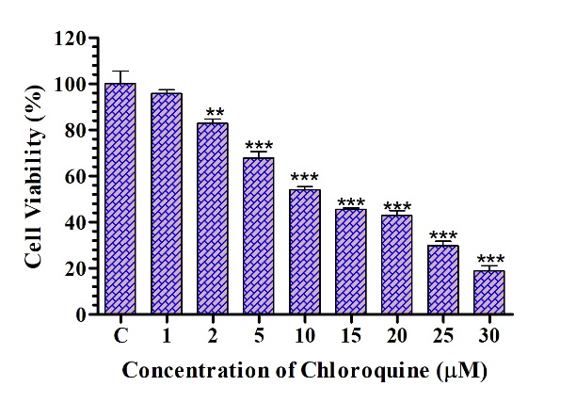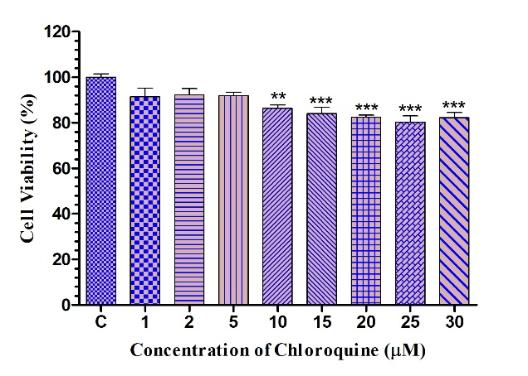
1 B
1 A
Fig. 1 The cell viability was assessed using the standard MTT Assay. The bar graph showed the cytotoxic effect of CQ on DL cells Fig. 1 (A), but did not affect Murine Thymocytes (Fig. 1 (B)). Results were expressed as mean ± SD, with statistical significance at *p < 0.05, **p < 0.01, ***p < 0.001.

DAPI assay
The impact of chloroquine on the nuclear morphology of DL cells was assessed via DAPI staining, demonstrating a distinct, dose-dependent activation of apoptosis. Control cells have spherical nuclei indicative of healthy cells. Treatment with chloroquine (0, 5, 10, 20 µM) resulted in extensive and severe nuclear deterioration, with the majority of nuclei fragmenting into discrete apoptotic bodies. These findings validate that chloroquine promotes apoptosis in DL cells in a dose-dependent manner, as shown in Fig. 2.
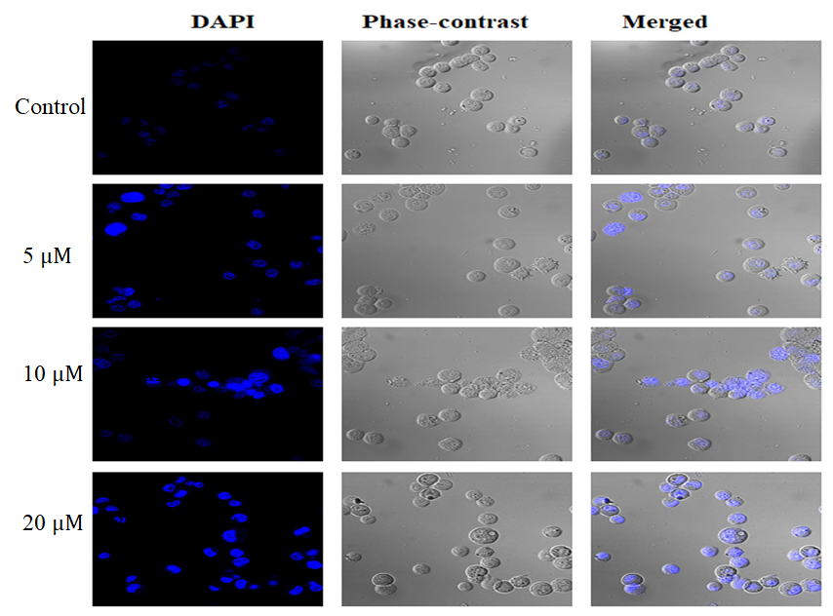
Fig. 2 DL cells were treated with CQ at 5, 10, and 20 µM for 24 hours, followed by DAPI staining. Images captured at 40X using confocal microscopy revealed alterations in nuclear morphology. The images are representatives of biological triplicates.

Cellular destruction by AO/EtBr dual staining
The induction of apoptosis in DL cells by chloroquine was evaluated by dual staining with Acridine Orange (AO) and Ethidium Bromide (EtBr), which distinguishes living, early apoptotic, and late apoptotic cells based on membrane integrity and nuclear morphology. In the untreated control group, cells displayed homogeneous green fluorescence, signifying viability and undamaged cell membranes. At a chloroquine concentration of 5 µM, the majority of cells exhibited a green stain; however, a few displayed early apoptotic features, indicated by brilliant green compacted or fragmented chromatin. Following treatment with 10 µM chloroquine, a notable rise in the population of orange-to-red fluorescent cells was detected, indicating late-stage apoptotic cells with reduced membrane integrity that allowed EtBr to penetrate and stain the nucleus. At the maximum dosage of 20 µM, most cells exhibited intense orange-red fluorescence, signifying widespread apoptosis and cellular mortality. This dose-dependent transition from a green to an orange-red cell population verifies that chloroquine successfully triggers apoptosis in DL cells, as shown in Fig. 3.
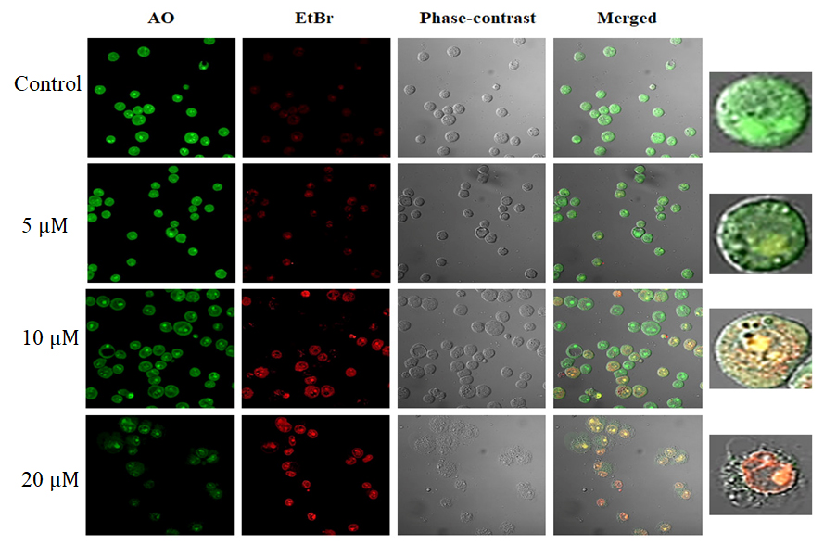
Fig. 3 Composite image of AO/EtBr-stained DL cells treated with CQ at various concentrations for 24 hrs. Data are representative of one of three similar experiments, and the magnification of the image was 40X Confocal microscope.

Chloroquine induces apoptosis in DL cells, visualized by annexin V /PI staining
Confocal microscopy of Annexin V/PI-stained cells confirmed the occurrence of apoptosis visually. The untreated control cells predominantly remained unstained, signifying their viability. In the 5 µM chloroquine treatment group, several cells displayed green fluorescence on their outer membrane, indicative of Annexin V binding to phosphatidylserine in early apoptotic cells. At 10 µM, there was an elevated quantity of green-stained (early apoptotic) cells, along with the emergence of red-stained nuclei (late apoptotic) in cells exhibiting green fluorescence. At a dose of 20 µM, most cells exhibited pronounced red and green fluorescence Fig. 4 (A), signifying they were in the advanced stages of apoptosis with impaired membrane integrity, further validated by quantitative analysis of apoptotic cells using Annexin V/PI staining followed by flow cytometry. Annexin V binds to phosphatidylserine residues that emerge on the surface of apoptotic cells, whereas Propidium iodide (PI) stains the nucleus of dead cells since it cannot penetrate intact cell membranes. Treatment with chloroquine induced a significant, concentration-dependent apoptotic response in DL cells. As determined by flow cytometry, the apoptotic cell population increased from 3.63% in control cells to 15.97% at 5 µM, 45.94% at 10 µM, and reached a maximum of 72.27% at 20 µM chloroquine, as shown in Fig. 4 (B)
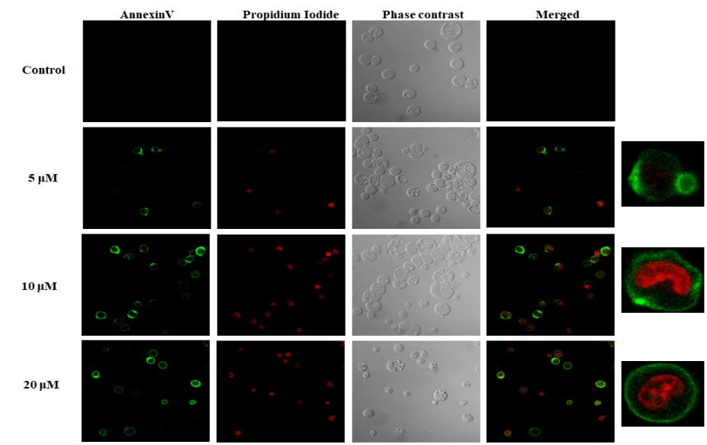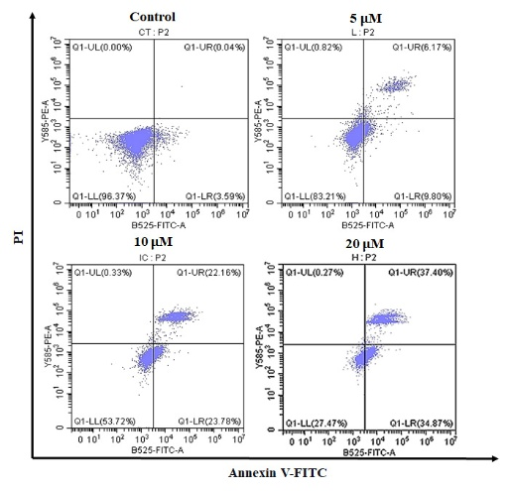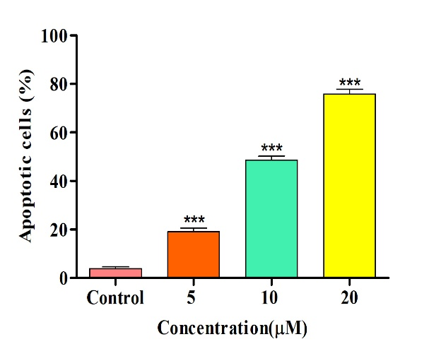
4 C
4 B
4 A
Fig. 4 (A) Annexin V/PI staining of DL cells subjected to different concentrations of CQ demonstrates dose-dependent apoptosis, with images captured at 40X magnification using a confocal microscope. (B) Quantitative evaluation of apoptosis induced by CQ was conducted using flow cytometry analysis. (C) The histogram illustrates the percentage of apoptotic cells at different concentrations of CQ, with significance denoted at ***p<0.001 relative to the control group.

Chloroquine induces intracellular ROS production
DCFH-DA staining was used to assess the intracellular generation of reactive oxygen species (ROS) after treatment with varying doses of Chloroquine. In DL cells, the production of ROS is essential for inducing apoptosis. When Chloroquine-treated cells were compared to the control group, ROS levels significantly increased in a dose-dependent manner, as seen in Fig. 5 (A). Low levels of fluorescence in the control cells indicated a low level of ROS production, whereas cells treated with Chloroquine concentrations showed increasingly brighter green fluorescence, indicating increased intracellular ROS generation determined by Confocal microscopy and further validated through Flow cytometry. This implies that Chloroquine causes oxidative stress in DL cells. The result revealed that Chloroquine-treated DL cells present increased ROS production from 20.40%, 61.85%, and 85.82% at concentrations 5 μM, 10 μM, and 20 μM respectively (Fig.5 (B)).
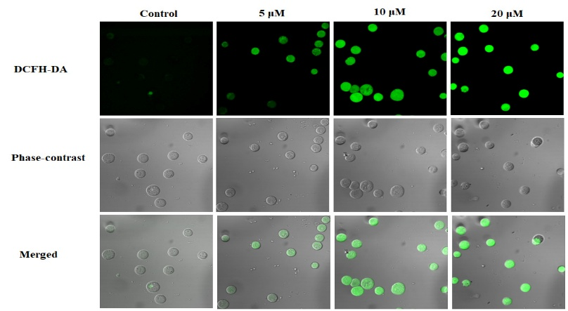
5 A

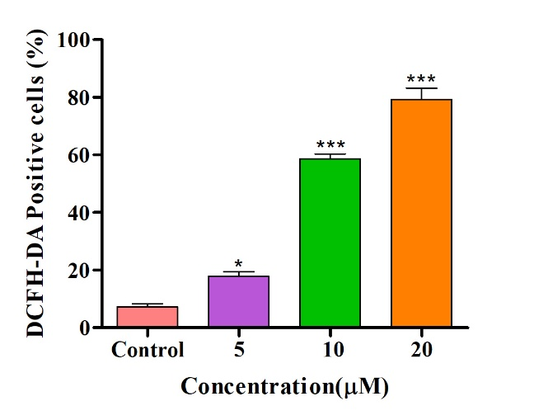
5 C
5 B
Fig. 5 (A)DL cells were treated with different concentrations of CQ, and detection of intracellular ROS was performed through DCFH-DA staining. The treatment of CQ for 24 h increased the DCF fluorescence intensity, and the images were captured at 40X magnification in a confocal microscope. (B) Intracellular ROS levels are represented as DCF Fluorescent intensity measured by Flow cytometry. Data are representative of one of three similar experiments (C). A histogram represents the ROS level in a concentration-dependent manner. *p<0.05 and ***p<0.001 were considered statistically significant vs. Control.

Downregulation of Mitochondrial membrane potential (Δψ M) in Chloroquine-treated DL cells assessed by JC-1
Chloroquine’s impact on mitochondrial membrane potential (MMP) was evaluated through the JC-1 dye, a compassionate measure of mitochondrial health. The dye appears as green fluorescent monomers in cells going through apoptosis or mitochondrial damage because of MMP damage, whereas in healthy cells with intact MMP, JC-1 builds up in the mitochondria and forms red fluorescent aggregates. Red fluorescence predominated in the untreated control cells, indicating that the mitochondrial membrane potential was intact, as shown in the Fig. 6 (A). However, in the Chloroquine-treated DL cells, there was a significant decrease in the red fluorescence and an increase in green fluorescence when compared with the control group. The result was also confirmed by a Flow cytometer and showed a 57.92% loss of Δψ M in Chloroquine-treated DL cells as compared to the control (p < 0.001), as shown in Fig. 6 (B).
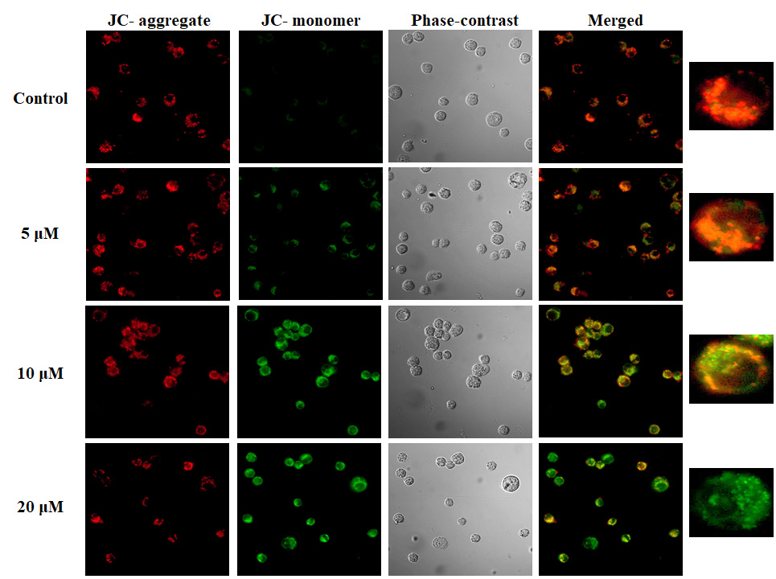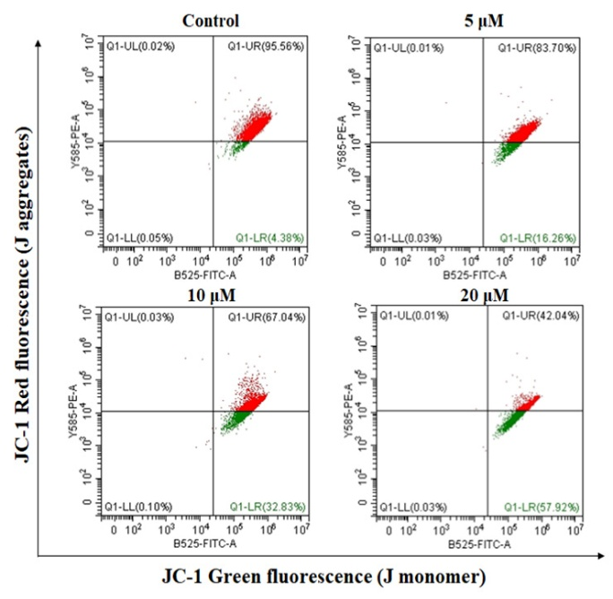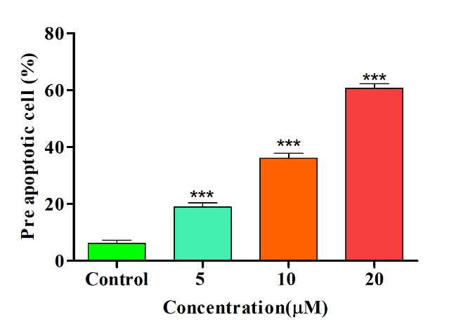
6 C
6 B
6 A
Fig. 6 (A)CQ significantly disrupted ΔΨm in DL cells after 24 h incubation with several doses. CQ-treated cells stained with JC-1 dye showed decreased red fluorescence intensity compared to the control under the Confocal microscope at 40X magnification. (B) Loss of mitochondrial membrane potential was examined in DL cells by JC-1 dye using flow cytometry. (C) A histogram represents the disruption of mitochondrial membrane potential in a concentration-dependent manner. ***p<0.001 was considered statistically significant vs. Control.

Chloroquine induces cell cycle arrest at G2/M phase
The impact of chloroquine on the cell cycle distribution of DL cells was assessed using flow cytometry. The untreated control cells exhibited a typical cell cycle profile, predominantly comprising cells in the G0/G1 phase, followed by the S and G2/M phases. Treatment with chloroquine led to a dose-dependent increase in cells in the G2/M phase. A modest elevation in the G2/M population was noted at the 5 µM concentration (31.42%). The effect was more prominent at the 10 µM concentration, demonstrating a considerable rise in the percentage of cells stopped in the G2/M phase (36.69%), alongside a corresponding decline in the G0/G1 population (35.41%). At a dose of 20 µM, a significant fraction of the cell population (42.79%) was halted in the G2/M phase, indicating a strong cell cycle arrest at this checkpoint. The results indicate that chloroquine obstructs normal cell cycle progression in DL cells, causing a G2/M phase arrest in a dose-dependent manner, as shown in Fig. 7.
7 A
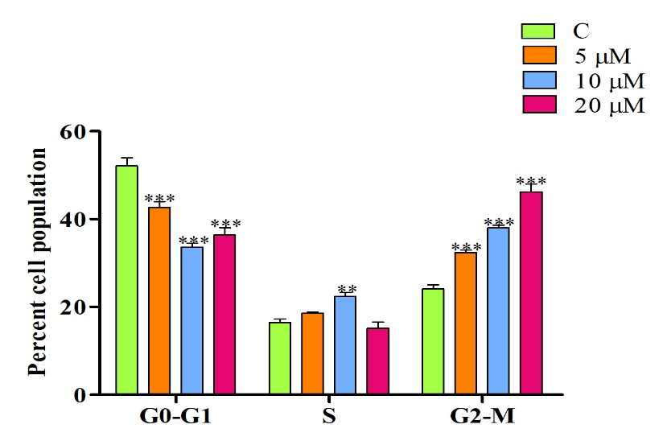
7 B
Fig.7 Cell cycle analysis of DL cells labelled with PI dye after treatment with CQ for 24 h. (A) Flow cytometry analysis showed a consistent rise in the % of cells in the G2/M phase of the cell cycle. (B) A histogram represents the percentage of the cell population in a concentration-dependent manner. **p < 0.01 and ***p<0.001 were considered statistically significant vs. Control.

Chloroquine Regulates Apoptotic Protein Expression to Trigger Mitochondrial Apoptosis
Western blot analysis demonstrated that chloroquine treatment influences the expression of critical proteins associated with the intrinsic apoptotic pathway in a dose-dependent manner. In comparison to the untreated control, a notable elevation in the expression of the pro-apoptotic protein Bax and a reduction in the anti-apoptotic protein Bcl-2 were seen with increasing doses of chloroquine. This alteration led to an increased Bax/Bcl-2 ratio, promoting apoptosis. Moreover, chloroquine administration resulted in a dose-dependent elevation of Cytochrome c levels in the cytoplasm. The release of Cytochrome c initiated the downstream caspase cascade, as indicated by elevated levels of cleaved (active) forms of Caspase-3. The expression of the loading control, β-actin, was uniform across all samples, validating equal protein loading. Collectively, our findings indicate that chloroquine promotes apoptosis in DL cells via the mitochondrial-mediated intrinsic pathway, as shown in Fig. 8.
8 B
8 A
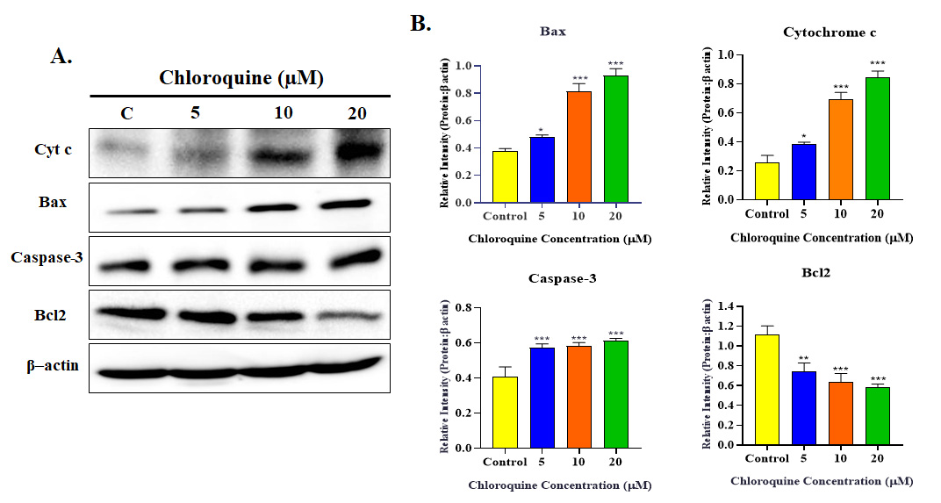
Fig. 8 CQ induces mitochondrial-mediated apoptosis in DL cells. (A) Western blot analysis for apoptosis-related proteins modulated by CQ. (B) The bar graph represents a decreased level of Bcl2 and an increased level of Bax, Cyt-c, and Caspase-3 expression. Significant at *P < 0.05, **p < 0.01, ***p < 0.001 vs. the control group.

Effect of Chloroquine on Body Weight and Abdominal Circumference in DL-Bearing Mice
At Day 0, all groups showed comparable body weights (25.1–27.6 g) and abdominal circumferences (2.2–2.8 cm). By Day 18, the Tumor Control group displayed a significant increase in body weight (27.2 g to 35.9 g) and abdominal circumference (2.2 cm to 3.9 cm). Chloroquine treatment attenuated these changes in a dose-dependent manner: the low dose group (24.8 g to 34.6 g; 2.6 cm to 3.4 cm) and the high dose group (25.1 g to 29.6 g; 2.7 cm to 2.8 cm) showed significantly lower increases than Tumor Control. Doxorubicin also reduced weight (27.8 g to 32.5 g) and circumference (2.8 cm to 3.3 cm) compared to Tumor Control, as shown in Fig. 9 (A) and 9 (B).
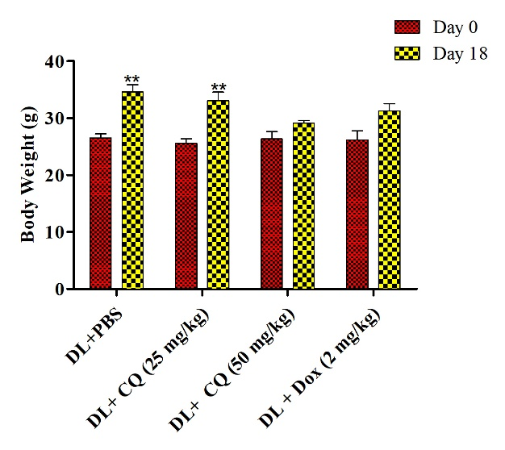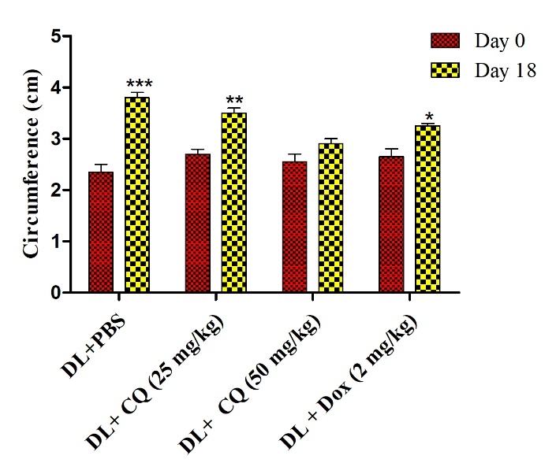
9 B
9 A
Fig. 9 (A) Comparisons of body weight (B) Abdominal circumference were performed until day 18 for the mentioned treatments. The body weight and abdominal circumference of DL mice significantly increased when compared day 0 to day 18 but there is no such increase in both CQ-treated groups. Data are significant at *P < 0.05, **p < 0.01, *** < 0.001 vs. the control group.
Effect of Chloroquine Treatment on Hematological Parameters in DL-Induced Mice
The WBC count was markedly elevated in the Tumor Control group (44.80 ×10³/µL) compared to Healthy mice (2.46×10³/µL), indicating leukocytosis associated with DL progression. Treatment with Chloroquine significantly reduced WBC count in a dose-dependent manner. The low-dose group (25 mg/kg) showed values ranging between 32.80–38.61 ×10³/µL, whereas the high-dose group (50 mg/kg) exhibited further reduction (22.38–28.60 ×10³/µL). Doxorubicin treatment produced the most pronounced effect, lowering WBC counts to 9.52–14.38 ×10³/µL, approaching near-normal levels shown in Fig. 10 (A).
Haemoglobin levels were significantly reduced in the Tumor Control group (2.7–4.2 g/dL) compared to Healthy mice (9.3–12.5 g/dL), indicating anaemia associated with DL progression. Chloroquine treatment improved Hb concentration in a dose-dependent manner. The low-dose group (25 mg/kg) recorded Hb values of 5.4–6.97 g/dL, while the high-dose group (50 mg/kg) showed further improvement (7.2–8.68 g/dL). Doxorubicin treatment also increased Hb levels (6.3–8.27 g/dL), though values remained below those of Healthy controls. shown in Fig. 10 (B).
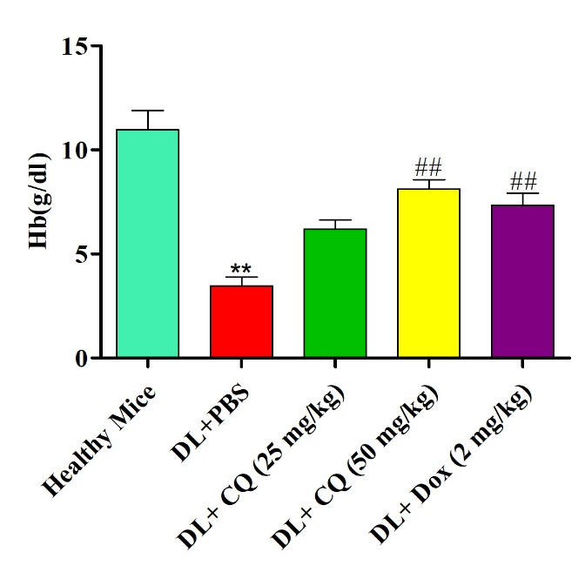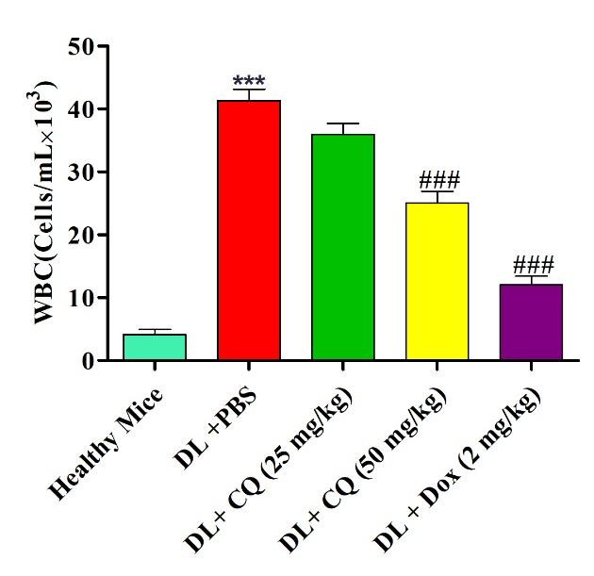
10 A AAAA A
10 B AAAA A
Fig. 10 Mice received intraperitoneal injections of 1 × 10⁶ live DL cells and were treated for a duration of up to 18 days. Blood was collected and examined for (A) white blood cells and (B) haemoglobin. All results were shown as mean ± standard deviation (n = 6). Statistically significant at ** p< 0.01 and ***p < 0.001 when comparing DL vehicle-treated animals to normal mice, and ##p ≤ 0.001 and ###p ≤ 0.001 when comparing CQ-treated DL mice to vehicle-treated DL mice.

Discussion
The combined results of this investigation offer a thorough comprehension of the cytotoxic processes of chloroquine against DL cells, emphasising its capacity to cause cell cycle arrest and then set off a strong, mitochondria-mediated cascade of apoptosis. The preliminary morphological evaluations using DAPI and AO/EtBr staining demonstrated unequivocal, dose-dependent indications of apoptosis, showcasing distinct nuclear condensation, fragmentation, and membrane integrity loss. The qualitative observations were statistically validated using Annexin V/PI staining using microscopy and flow cytometry, which demonstrated a notable shift in the cell population towards early and late apoptosis following chloroquine treatment. CQ also increases intracellular ROS production. A critical precursor to this apoptotic induction seems to be the interruption of cell cycle progression. Our flow cytometry data revealed a substantial increase in cells in the G2/M phase, suggesting that chloroquine imposes a checkpoint arrest. This arrest inhibits injured cells from undergoing mitosis and frequently represents a pivotal moment in determining the cell's fate: survival or apoptosis. The primary mechanism facilitating this cell death procedure is the activation of the intrinsic apoptotic pathway, which initiates in the mitochondria. The JC-1 assay results unequivocally demonstrated a dose-dependent depolarisation of the mitochondrial membrane potential (ΔΨm), a pivotal upstream event in this cascade. The decline of ΔΨm is regulated by the Bcl-2 protein family. The Western blot analysis validated this, demonstrating that chloroquine treatment disturbs the essential equilibrium between pro- and anti-apoptotic proteins, resulting in an elevated Bax/Bcl-2 ratio. This transition enhances the permeabilization of the outer mitochondrial membrane, enabling the release of Cytochrome c into the cytosol. The release of Cytochrome c begins the terminal execution phase. Western blotting demonstrates that cytosolic Cytochrome c initiates the activation of the initiator Caspase-9 (not shown), which subsequently activates the executioner Caspase-3, thus methodically disassembling the cell. In vivo study shows, Chloroquine treatment significantly attenuated tumor-associated changes in DL-bearing mice. The Tumor Control group showed marked increases in body weight and abdominal circumference due to tumor burden and ascitic fluid, whereas chloroquine, especially at the high dose, effectively minimized these effects, comparable to doxorubicin. Hematological analysis revealed severe leukocytosis and anaemia in Tumor Control mice, reflecting lymphoma progression. Chloroquine reduced WBC counts and improved haemoglobin levels in a dose-dependent manner, indicating suppression of abnormal proliferation and partial restoration of erythropoiesis. These findings highlight that chloroquine's anti-cancer effectiveness is multifaceted, encompassing cell cycle arrest, the direct and robust activation of the intrinsic apoptotic pathway. These findings also suggest that chloroquine can mitigate physiological and hematological alterations in DL-bearing mice, highlighting its potential as a therapeutic option in lymphoma management.
Conclusion
This study offers a thorough mechanistic insight into chloroquine's significant anti-neoplastic effects on Dalton's Lymphoma. The drug's diverse effectiveness begins with the establishment of a G2/M cell cycle arrest, which then activates a strong induction of apoptosis through the intrinsic mitochondrial route. This is supported by a dose-dependent reduction in mitochondrial membrane potential, an increased Bax/Bcl-2 ratio, and the sequential activation of the Caspase-9/Caspase-3 pathway. Importantly, these direct cytotoxic pathways result in substantial therapeutic effects in vivo, where chloroquine treatment not only managed tumour burden but also improved the related physiological and haematological disorders, including leukocytosis and anaemia. Thus, by combining the ability to directly destroy cells with the reduction of systemic diseases, this study makes chloroquine an attractive treatment option for lymphoma.
Abbreviations
AO Acridine orange
EtBr Ethidium bromide
Bcl-2 B-cell lymphoma 2
Cyt-c Cytochrome-c
CQ Chloroquine
DL cells Dalton’s lymphoma cells
DAPI 4′ 6-diamidino-2-phenylindole
DCFH-DA Dichloro-dihydro-fluorescein diacetate
ECL Enhanced chemiluminescent
FBS Fetal Bovine Serum
FITC Fluorescein iso-thiocyanate
JC-1 5,5’,6,6’-tetrachloro-1,1’,3,3’-tetraethylbenzimidazolylcarbocyanine iodide
ΔΨm Mitochondrial membrane potential
MTT 3-(4,5-Dimethylthiazol-2-yl)-2,5-Diphenyltetrazolium Bromide
PI Propidium iodide
PVDF Polyvinylidene fluoride
RIPA Radio-immunoprecipitation assay buffer
ROS Reactive oxygen species
SDS-PAGE Sodium Dodecyl Sulphate–Polyacrylamide Gel Electrophoresis

Acknowledgements
A.A. acknowledges SERB and DHR New Delhi. IoE, Banaras Hindu University for their grant. We are highly thankful to the ISLS and Central Discovery Centre, Banaras Hindu University for providing the instrumentation facility
Author Contributions
V.S. contributed to the data analysis, investigation, design, execution of the experiments, writing, and drafting the original manuscript. All experimental data were analysed and drafting by A.K.P. and., N.K., H.J contributed to the article review and editing. The manuscript was critically revised for accurate, knowledgeable content by A.A. Finally, all authors approved the final version of the manuscript for publication
Compliance with ethical standards Conflict of interest
The authors declare no competing interests.

References
- Wang, H., Wang, Z., Wei, C., Wang, J., Xu, Y., Bai, G., ... & Chen, Y. (2021). Anticancer potential of indirubins in medicinal chemistry: Biological activity, structural modification, and structure-activity relationship. European Journal of Medicinal Chemistry, 223, 113652.
- Bray, F., Laversanne, M., Sung, H., Ferlay, J., Siegel, R. L., Soerjomataram, I., & Jemal, A. (2024). Global cancer statistics 2022: GLOBOCAN estimates of incidence and mortality worldwide for 36 cancers in 185 countries. CA: a cancer journal for clinicians, 74(3), 229-263.
- Paim, J., Travassos, C., Almeida, C., Bahia, L., & Macinko, J. (2011). The Brazilian health system: history, advances, and challenges. The Lancet, 377(9779), 1778–1797.
- Kumari, R., Pandey, S. K., Patel, A. K., Kushwaha, D., Acharya, A., & Bharty, M. K. (2024). Exploring 2-(benzylthio)-5-(4-nitrophenyl)-1, 3, 4-oxadiazole as antiproliferative agent: Synthesis, single crystal XRD, DFT, Hirshfeld surface analysis, in vitro antiproliferative activity and molecular docking analysis. Journal of Molecular Structure, 1311, 138422.
- Gupta, S., Pandey, S. K., Kumar, S., Gautam, R. N., Patel, A. K., Bharty, M. K., ... & Butcher, R. J. (2023). Experimental, spectroscopic, and theoretical investigation on structural and anticancer activities of Schiff bases derived from isonicotinohydrazide. Journal of Molecular Structure, 1293, 136212.
- Kumar, S., Verma, P. K., Shukla, A., Singh, R. K., Patel, A. K., Yadav, L., ... & Acharya, A. (2023). Moringa oleifera L. leaf extract induces cell cycle arrest and mitochondrial apoptosis in Dalton's Lymphoma: An in vitro and in vivo study. Journal of Ethnopharmacology, 302, 115849.
- Koiri, R. K., Mehrotra, A., & Trigun, S. K. (2017). Dalton’s lymphoma as a murine model for understanding the progression and development of t-cell lymphoma and its role in drug discovery. Int j immunother cancer res, 3(1), 1-6.
- Britannica, T. (2020). Editors of encyclopaedia. Argon. Encyclopedia Britannica.
- Adedokun, K. A., Imodoye, S. O., Bello, I. O., & Lanihun, A. A. (2023). Therapeutic potentials of medicinal plants and significance of computational tools in anti-cancer drug discovery. In Phytochemistry, Computational Tools and Databases in Drug Discovery (pp. 393-455). Elsevier.
- Zhou, W., Wang, H., Yang, Y., Chen, Z. S., Zou, C., & Zhang, J. (2020). Chloroquine against malaria, cancers and viral diseases. Drug Discovery Today, 25(11), 2012-2022.
- Savarino, A., Boelaert, J. R., Cassone, A., Majori, G., & Cauda, R. (2003). Effects of chloroquine on viral infections: an old drug against today's diseases. The Lancet infectious diseases, 3(11), 722-727.
- Sasaki, K., Tsuno, N. H., Sunami, E., Tsurita, G., Kawai, K., Okaji, Y., ... & Nagawa, H. (2010). Chloroquine potentiates the anti-cancer effect of 5-fluorouracil on colon cancer cells. BMC cancer, 10, 1-11.
- Zhang, Y., Cao, Y., Sun, X., Feng, Y., Du, Y., Liu, F., ... & Jin, F. (2017). Chloroquine (CQ) exerts anti-breast cancer through modulating microenvironment and inducing apoptosis. International immunopharmacology, 42, 100-107.
- Zheng, Y., Zhao, Y. L., Deng, X., Yang, S., Mao, Y., Li, Z., ... & Wei, Y. (2009). Chloroquine inhibits colon cancer cell growth in vitro and tumor growth in vivo via induction of apoptosis. Cancer investigation, 27(3), 286-292.
- Zhao, M. (2020). Cytokine storm and immunomodulatory therapy in COVID-19: role of chloroquine and anti-IL-6 monoclonal antibodies. International journal of antimicrobial agents, 55(6), 105982.
- Chen, D., Xie, J., Fiskesund, R., Dong, W., Liang, X., Lv, J., ... & Huang, B. (2018). Chloroquine modulates antitumor immune response by resetting tumor-associated macrophages toward M1 phenotype. Nature communications, 9(1), 873.
- Maurya, A. K., & Vinayak, M. (2015). Quercetin regresses Dalton's lymphoma growth via suppression of PI3K/AKT signaling leading to upregulation of p53 and decrease in energy metabolism. Nutrition and cancer, 67(2), 354-363.
- Atale, N., Gupta, S., Yadav, U. C. S., & Rani, V. (2014). Cell‐death assessment by fluorescent and nonfluorescent cytosolic and nuclear staining techniques. Journal of microscopy, 255(1), 7-19.
- Fu, Y. B., Ahmed, Z., Yang, H., & Horbach, C. (2018). TUNEL assay and DAPI staining revealed few alterations of cellular morphology in naturally and artificially aged seeds of cultivated flax. Plants, 7(2), 34.
- Lugli, E., Troiano, L., Ferraresi, R., Roat, E., Prada, N., Nasi, M., ... & Cossarizza, A. (2005). Characterization of cells with different mitochondrial membrane potential during apoptosis. Cytometry Part A, 68(1), 28-35.
- Yadav, D. K., Patel, A. K., Hansda, S. R., Acharya, A., Marandi, L., Yadav, S. D., & Sinha, S. (2024). Comprehensive property combination for biomedical application achieved in a Ti35Zr35Nb15Mo5Fe5Cr5 complex concentrated alloy. Materials Today Communications, 41, 110992.
- Kumar, N., Delu, V., Ulasov, I., Kumar, S., Singh, R. K., Kumar, S., ... & Acharya, A. (2024). Pharmacological insights: Mitochondrial ROS generation by FNC (Azvudine) in Dalton’s lymphoma cells revealed by super resolution imaging. Cell biochemistry and biophysics, 82(2), 873-883.
- Kumar, S., Shukla, A., Singh, S. P., Singh, R. K., Patel, A. K., Verma, P. K., ... & Acharya, A. (2024). Synthesized gold nanoparticles with moringa oleifera leaf extract induce mitotic arrest (G2/M phase) and apoptosis in dalton’s lymphoma cells. Cell Biochemistry and Biophysics, 82(2), 1043-1059.
- Kumar, N., Shukla, A., Kumar, S., Ulasov, I., Singh, R. K., Kumar, S., ... & Acharya, A. (2024). FNC (4′-azido-2′-deoxy-2′-fluoro (arbino) cytidine) as an effective therapeutic agent for NHL: ROS generation, cell cycle arrest, and mitochondrial-mediated apoptosis. Cell biochemistry and biophysics, 82(2), 623-639.

