Prediction of Nutrient Requirements in Beef Cattle Using Statistical and Artificial Neural Network Models

ABSTRACT
This study focused on evaluating the nutrient requirements of beef cattle using data obtained from the Oklahoma State University Extension publication on beef cattle nutrition. The dataset included important production and nutritional variables such as body weight (BW), average daily gain (ADG), dry matter intake (DMI), total digestible nutrients (TDN), net energy for maintenance (NEm), net energy for gain (NEg), crude protein (CP), calcium (Ca), and phosphorus (P).
Initially, exploratory data analysis was carried out to understand the distribution and variability of the recorded variables. Correlation analysis was then performed to investigate the relationships between growth-related factors, particularly BW and ADG, and the corresponding nutrient requirements of beef cattle.
To estimate nutrient requirements, several predictive modelling approaches were explored, including Simple Linear Regression (SLR), Multiple Linear Regression (MLR), and Artificial Neural Network (ANN) models employing Rectified Linear Unit (ReLU) and Hyperbolic Tangent (Tanh) activation functions. The performance of these models was assessed using the coefficient of determination (R²) and Mean Squared Error (MSE).
The findings revealed that Multiple Linear Regression provided the most accurate predictions among the models considered. This suggests that the relationships between growth parameters and nutrient requirements in the dataset are largely linear. The study highlights the potential of statistical modeling as a practical tool for estimating nutrient requirements, thereby supporting more informed feeding strategies and management decisions in beef cattle production.
Keywords: Beef cattle, Nutrient requirement prediction, Multiple linear regression, Artificial neural networks, Predictive modelling, Livestock nutrition
INTRODUCTION
Accurate estimation of nutrient requirements is essential for maintaining the health, growth, reproductive performance, and productivity of beef cattle. Nutrient requirements vary considerably depending on factors such as body weight (BW), average daily gain (ADG), physiological status, production objectives, and environmental conditions. Appropriate nutritional management is therefore critical for optimizing feed utilization and improving production efficiency (NASEM, 2016).
To support nutritional decision-making, several organizations have developed standardized feeding recommendations for beef cattle. Among these, the Nutrient Requirements of Beef Cattle published by the National Academies of Sciences, Engineering, and Medicine serves as one of the most widely accepted references for estimating nutrient needs under different production conditions (NASEM, 2016).
The data utilized in this study were obtained from the Oklahoma State University Extension Publication Nutrient Requirements of Beef Cattle (E-974) developed by Lalman and Holder (2020). The publication contains detailed tabular information describing nutrient requirements across a range of body weights and growth rates, making it a valuable resource for investigating relationships between animal growth characteristics and nutritional demands.
Traditionally, nutrient requirement estimation has relied on tabular recommendations and empirical equations derived from experimental studies. While these approaches have proven useful, they may not fully capture the complex interactions among biological and nutritional variables. Consequently, statistical modeling techniques have increasingly been employed to improve prediction accuracy and provide quantitative insights into the relationships between growth performance and nutrient requirements (Tedeschi et al., 2021).
In recent years, machine learning approaches have gained considerable attention in animal nutrition and precision livestock farming. Artificial Neural Networks (ANNs) have demonstrated strong predictive capabilities in modeling complex biological systems characterized by nonlinear relationships and interactions among multiple variables (Lopes et al., 2022). Previous studies have reported the successful application of neural networks in predicting animal growth performance, feed efficiency, and nutrient utilization, highlighting their potential as decision-support tools in livestock production (White et al., 2023).
Despite the growing application of machine learning techniques in livestock research, limited studies have systematically compared traditional statistical models and neural network approaches for predicting nutrient requirements in beef cattle. Therefore, this study aims to evaluate and compare the performance of Simple Linear Regression (SLR), Multiple Linear Regression (MLR), and Artificial Neural Network models employing ReLU and Tanh activation functions for predicting nutrient requirements using body weight and average daily gain as predictor variables. The findings are expected to contribute toward the development of accurate and practical prediction tools that can support nutritional planning and management decisions in beef cattle production.
MATERIALS AND METHODS
Data Source and Dataset Preparation
The dataset used in this study was obtained from the Oklahoma State University Extension publication Nutrient Requirements of Beef Cattle (E-974) developed by Lalman and Holder (2020) based on the nutritional recommendations provided by the National Academies of Sciences, Engineering, and Medicine (NASEM, 2016). The publication provides nutrient requirement estimates for beef cattle under different body weight and growth conditions and serves as a valuable resource for nutritional planning and management.
Two variables were selected as predictor variables for model development:
- Body Weight (BW), measured in pounds (lbs)
- Average Daily Gain (ADG), measured in pounds per day (lbs/day)
These variables represent the physical growth characteristics of beef cattle and are commonly used in nutritional assessment and feed requirement estimation.
The developed models were used to predict the following nutrient requirement parameters:
- Dry Matter Intake (DMI) (lbs/day)
- Total Digestible Nutrients (TDN) (% of dry matter)
- Net Energy for Maintenance (NEm) (Mcal/lb)
- Net Energy for Gain (NEg) (Mcal/lb)
- Crude Protein (CP) (% of dry matter)
- Calcium (Ca) (% of dry matter)
- Phosphorus (P) (% of dry matter)
These response variables represent key nutritional components required to support growth, maintenance, and overall productive performance in beef cattle. Prior to model development, the dataset was examined for completeness and consistency to ensure the reliability of subsequent statistical and machine learning analyses.
Exploratory Data Analysis
Exploratory Data Analysis (EDA) was conducted to examine the characteristics, distribution, and variability of the dataset before model development. EDA is an important preliminary step in data-driven research, as it facilitates the identification of patterns, trends, and potential anomalies within the data (James et al., 2021; Wickham et al., 2023).
Descriptive statistical measures, including the mean, standard deviation, minimum, maximum, quartiles, and median, were calculated for all variables considered in this study. These statistics provided a comprehensive summary of the central tendency and dispersion of the nutrient and growth-related parameters.
Histograms were generated to visualize the distribution of Body Weight (BW) and Average Daily Gain (ADG), allowing assessment of data spread and variability. In addition, scatter plots were constructed to investigate the relationships between growth characteristics and nutrient requirements. Specifically, the following relationships were examined:
- Body Weight (BW) versus nutrient requirement parameters
- Average Daily Gain (ADG) versus nutrient requirement parameters
The graphical analysis provided valuable insights into potential linear and nonlinear relationships among the variables and aided in selecting appropriate modeling approaches for nutrient prediction.
Table 1 presents the descriptive statistics of the dataset. The average body weight of the cattle was 785.87 lbs, with values ranging from 300 to 1120 lbs, indicating substantial variation in animal size. Similarly, ADG exhibited a mean value of 2.89 lbs/day, reflecting differences in growth performance among animals. Nutrient requirement variables such as DMI, TDN, CP, Ca, and P also displayed moderate variability, suggesting that nutrient demands change considerably with body weight and growth rate.
Figures 1–3 illustrate the relationships between BW, ADG, and selected nutrient parameters. Visual inspection of the scatter plots indicates positive associations between growth-related variables and nutrient requirements, supporting the use of predictive modeling techniques to estimate nutrient demands in beef cattle.
Table 1. Summary Statistics of Growth and Nutrient Variables.
Statistic | Body Weight (lbs) | ADG | DM Intake | TDN | NEm | NEg | CP | Ca | P
Count | 23.00 | 23.00 | 23.00 | 23.00 | 23.00 | 23.00 | 23.00 | 23.00 | 23.00
Mean | 785.87 | 2.89 | 19.36 | 72.00 | 0.78 | 0.50 | 11.60 | 0.43 | 0.22
Std Dev | 209.69 | 1.04 | 4.67 | 10.25 | 0.15 | 0.13 | 2.12 | 0.11 | 0.04
Min | 300.00 | 1.00 | 8.60 | 59.00 | 0.57 | 0.31 | 8.30 | 0.28 | 0.16
25% | 680.00 | 2.05 | 16.95 | 62.00 | 0.63 | 0.36 | 9.75 | 0.34 | 0.19
50% (Median) | 825.00 | 3.00 | 19.80 | 70.00 | 0.76 | 0.48 | 11.40 | 0.42 | 0.22
75% | 935.00 | 3.70 | 22.10 | 80.00 | 0.90 | 0.61 | 13.60 | 0.52 | 0.26
Max | 1120.00 | 4.50 | 26.10 | 90.00 | 1.04 | 0.72 | 14.80 | 0.62 | 0.29

The descriptive statistics presented in Table 1 reveal considerable variability in body weight among the cattle, with values ranging from 300 to 1120 lbs and a standard deviation of 209.69 lbs. This wide range indicates that the dataset includes animals at different growth stages, making it suitable for evaluating nutrient requirements across diverse production conditions. Average Daily Gain (ADG) exhibited moderate variability, with a mean of 2.89 lbs/day and a standard deviation of 1.04 lbs/day, suggesting differences in growth performance among animals. Dry Matter Intake (DMI) showed a mean value of 19.36 lbs/day and increased consistently with body weight and growth rate, highlighting its importance as a key nutritional indicator. Similarly, Crude Protein (CP), Calcium (Ca), and Phosphorus (P) displayed moderate variation, reflecting the changing nutrient demands associated with animal growth and development. Overall, the observed variability in both growth and nutrient parameters provides a robust basis for developing predictive models to estimate nutrient requirements in beef cattle.
Figure 1. Relationship between Body Weight (BW) and Dry Matter Intake (DMI).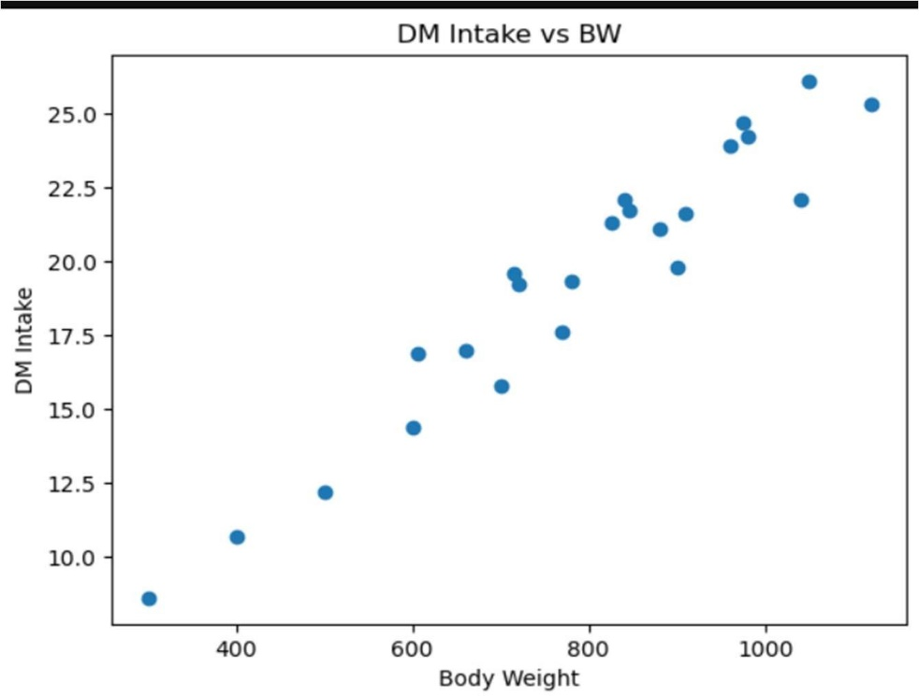
Figure 2. Relationship between Average Daily Gain (ADG) and Dry Matter Intake (DMI).
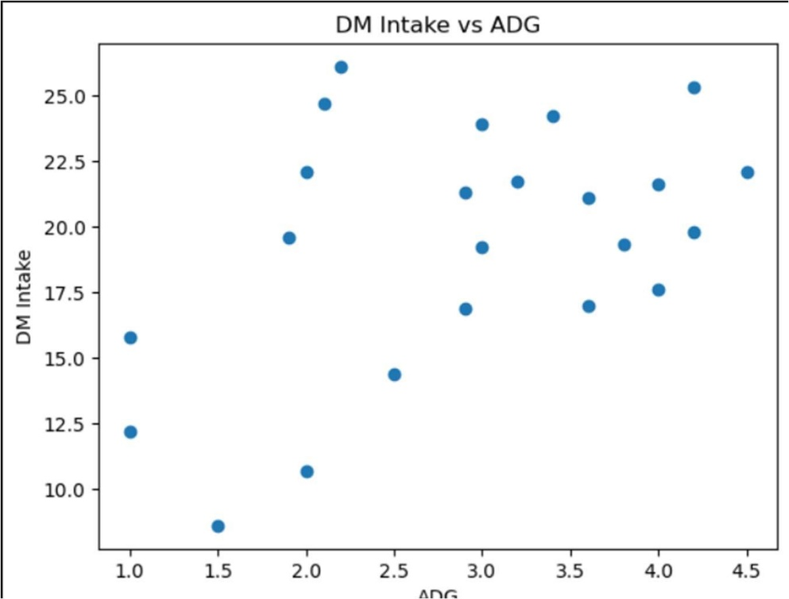
Figure 3. Relationship between Body Weight (BW) and Crude Protein (CP).
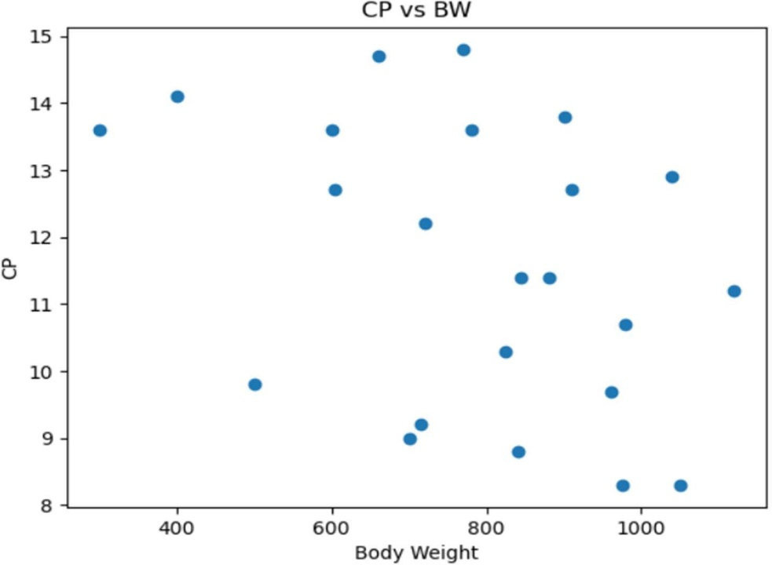
Correlation Analysis
Correlation analysis was performed to investigate the relationships between growth-related variables and nutrient requirement parameters in the dataset. Pearson’s correlation coefficient was used to quantify the strength and direction of the linear association between variables. Correlation coefficients range from −1 to +1, where values close to +1 indicate a strong positive relationship, values close to −1 indicate a strong negative relationship, and values near zero suggest little or no linear association (Montgomery et al., 2021).
A correlation matrix was constructed using Body Weight (BW), Average Daily Gain (ADG), and the nutrient variables, including Dry Matter Intake (DMI), Total Digestible Nutrients (TDN), Net Energy for Maintenance (NEm), Net Energy for Gain (NEg), Crude Protein (CP), Calcium (Ca), and Phosphorus (P). To facilitate interpretation, the correlation matrix was visualized using a heat map, where color intensity represented the magnitude and direction of the correlations.
The correlation analysis revealed varying degrees of association among the variables. Strong positive correlations were observed between Body Weight (BW) and several nutrient requirement parameters, particularly DMI and energy-related variables, indicating that larger animals generally require greater nutrient intake for maintenance and growth. Average Daily Gain (ADG) also exhibited positive correlations with nutrient requirements, reflecting the increased nutritional demands associated with higher growth rates.
In contrast, some nutrient parameters displayed weaker correlations with BW and ADG, suggesting that their requirements may be influenced by additional biological or environmental factors. These findings highlight the complexity of nutrient requirement estimation and emphasize the importance of incorporating multiple predictor variables when developing predictive models. Consequently, both BW and ADG were selected as input variables for subsequent regression and neural network analyses.
Figure 4. Correlation Matrix of Growth and Nutrient Parameters.
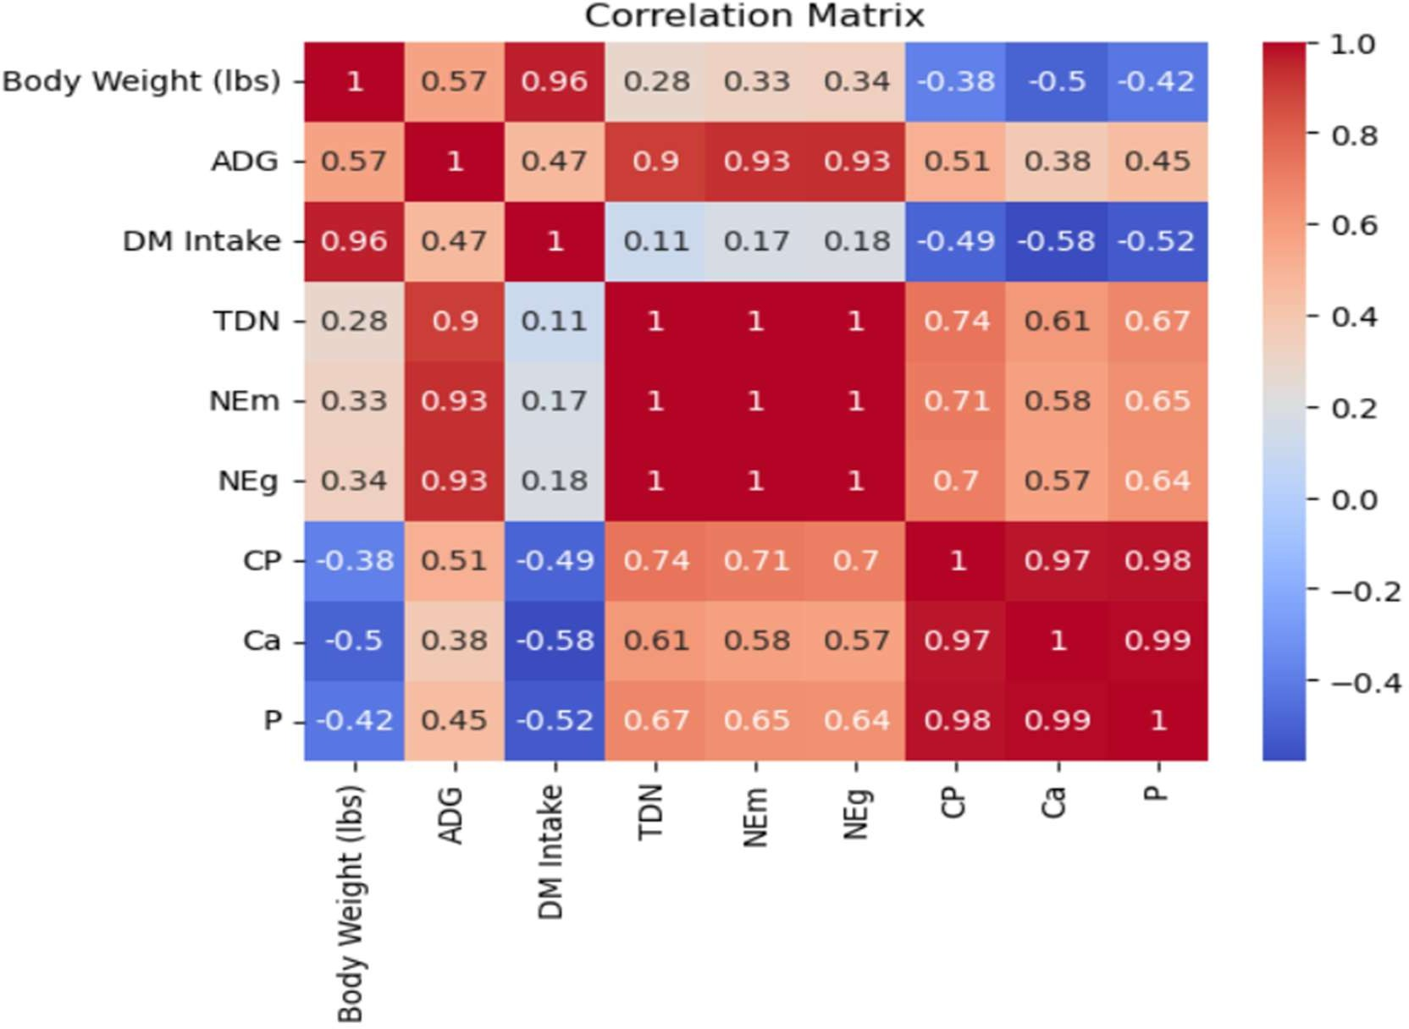
The correlation matrix indicates that Body Weight (BW) has strong positive relationships with Dry Matter Intake (DMI), Net Energy for Maintenance (NEm), and Crude Protein (CP), suggesting that nutrient requirements generally increase as animal size increases. Average Daily Gain (ADG) also demonstrates positive associations with several nutrient parameters, reflecting the additional nutritional demands required to support growth. The presence of moderate to strong correlations among multiple variables supports the use of multivariable predictive models and suggests that nutrient requirements cannot be adequately explained by a single growth parameter alone.
Model Development
The objective of this study was to develop predictive models for estimating nutrient requirements of beef cattle using Body Weight (BW) and Average Daily Gain (ADG) as input variables. Both statistical and machine learning approaches were employed to evaluate their effectiveness in predicting nutrient parameters, including Dry Matter Intake (DMI), Total Digestible Nutrients (TDN), Net Energy for Maintenance (NEm), Net Energy for Gain (NEg), Crude Protein (CP), Calcium (Ca), and Phosphorus (P).
Model development and analysis were performed using Python programming language. The dataset obtained from the Oklahoma State University Extension publication Nutrient Requirements of Beef Cattle (E-974) was used for training and evaluating the models. Prior to model development, exploratory data analysis and correlation analysis were conducted to identify relationships among variables and assess their suitability for predictive modeling.
Three different modeling approaches were considered:
- Simple Linear Regression (SLR)
- Multiple Linear Regression (MLR)
- Artificial Neural Networks (ANNs) using Rectified Linear Unit (ReLU) and Hyperbolic Tangent (Tanh) activation functions
The performance of each model was evaluated using Mean Squared Error (MSE) and the coefficient of determination (R²). MSE measures the average squared difference between observed and predicted values, while R² quantifies the proportion of variation in the response variable explained by the model. Models with lower MSE and higher R² values were considered to exhibit superior predictive performance (James et al., 2021).
The comparative evaluation of statistical and machine learning models enabled an assessment of both linear and nonlinear relationships between growth characteristics and nutrient requirements. This approach provided insights into the suitability of different modeling techniques for nutrient prediction in beef cattle production systems.
Simple Linear Regression
Simple Linear Regression (SLR) was employed to examine the relationship between Body Weight (BW) and individual nutrient requirement parameters. In this approach, BW was considered the independent variable, while each nutrient parameter served as a dependent variable.
The general form of the SLR model is given by:
y = β₀ + β₁ × BW
where y represents the predicted nutrient value, β₀ is the intercept, β₁ is the regression coefficient representing the effect of body weight, and BW denotes body weight.
SLR is one of the most widely used statistical techniques for modeling relationships between variables because of its simplicity, interpretability, and computational efficiency (James et al., 2021). However, its predictive capability may be limited when multiple factors influence the response variable or when nonlinear relationships exist among variables.
Multiple Linear Regression
To improve prediction accuracy, Multiple Linear Regression (MLR) was developed by incorporating both Body Weight (BW) and Average Daily Gain (ADG) as predictor variables. Unlike Simple Linear Regression, which considers only a single predictor, MLR enables the simultaneous evaluation of multiple factors influencing nutrient requirements.
The general form of the MLR model is expressed as:
y = β₀ + β₁ × BW + β₂ × ADG
where y represents the predicted nutrient value, β₀ is the intercept, β₁ represents the effect of body weight, β₂ represents the effect of average daily gain, BW denotes body weight, and ADG denotes average daily gain.
By incorporating both BW and ADG, the MLR model can capture a greater proportion of the variability in nutrient requirements and provide more accurate predictions. Previous studies have demonstrated that multivariable regression models often outperform single-variable models when biological responses are influenced by multiple interacting factors (James et al., 2021; Kutner et al., 2022).
In the present study, MLR was used to estimate nutrient requirement parameters including DMI, TDN, NEm, NEg, CP, Ca, and P. The predictive performance of the model was evaluated using Mean Squared Error (MSE) and the coefficient of determination (R²), and the results were compared with those obtained from Simple Linear Regression and Artificial Neural Network models.
Artificial Neural Network Models
Artificial Neural Network (ANN) models were employed to capture potential nonlinear relationships between growth characteristics and nutrient requirements of beef cattle. Unlike traditional regression techniques, ANNs can model complex interactions among variables and are widely used in predictive modeling applications involving biological and agricultural systems (Goodfellow et al., 2016; Géron, 2022).
In this study, Body Weight (BW) and Average Daily Gain (ADG) were used as input variables, while nutrient requirement parameters including DMI, TDN, NEm, NEg, CP, Ca, and P served as output variables. Two commonly used activation functions, namely Rectified Linear Unit (ReLU) and Hyperbolic Tangent (Tanh), were evaluated to assess their effectiveness in nutrient prediction.
The ReLU activation function is defined as:
f(x) = max(0, x)
whereas the Tanh activation function is expressed as:
f(x) = tanh(x) = (eˣ − e⁻ˣ) / (eˣ + e⁻ˣ)
The general structure of an artificial neuron can be represented as:
y = f(WX + b)
where X denotes the input feature vector (BW and ADG), W represents the connection weights, b is the bias term, f denotes the activation function, and y represents the predicted output.
During model training, the network adjusts its weights and biases iteratively to minimize prediction error. This learning capability enables ANNs to identify hidden patterns and nonlinear relationships that may not be captured by conventional regression models. The performance of the ANN models was evaluated using Mean Squared Error (MSE) and the coefficient of determination (R²), and the results were compared with those obtained from Simple Linear Regression (SLR) and Multiple Linear Regression (MLR) models.
RESULTS
Prediction Results
The developed models were applied to predict nutrient requirements using Body Weight (BW) and Average Daily Gain (ADG) as predictor variables. The predictive performance of Multiple Linear Regression (MLR) and Artificial Neural Network (ANN) models employing ReLU and Tanh activation functions was evaluated using Mean Squared Error (MSE) and the coefficient of determination (R²).
The results demonstrate that nutrient requirements can be effectively estimated from growth-related characteristics, particularly BW and ADG. Among the models investigated, the Multiple Linear Regression model consistently provided the most accurate predictions across the nutrient parameters considered. The model produced higher R² values and lower MSE values, indicating a stronger agreement between observed and predicted nutrient requirements.
For example, when predicting Total Digestible Nutrients (TDN), the MLR model generated more accurate estimates than the Simple Linear Regression model because it incorporated both BW and ADG as explanatory variables. This finding highlights the importance of considering growth performance in addition to body weight when estimating nutrient requirements.
Artificial Neural Network models employing ReLU and Tanh activation functions also generated reasonable predictions; however, their overall predictive performance was lower than that of the MLR model. The results suggest that the relationships between growth characteristics and nutrient requirements in the dataset are predominantly linear, thereby reducing the advantages typically associated with nonlinear machine learning approaches.
Furthermore, nutrient parameters associated with energy and feed intake, including Dry Matter Intake (DMI), Total Digestible Nutrients (TDN), Net Energy for Maintenance (NEm), and Net Energy for Gain (NEg), exhibited stronger and more consistent prediction accuracy compared to mineral-related parameters such as Calcium (Ca) and Phosphorus (P). This observation indicates that energy-related nutrient requirements are more closely associated with BW and ADG than mineral requirements.
Model Performance Evaluation
Table 2 presents the predictive performance of the evaluated models based on Mean Squared Error (MSE) and the coefficient of determination (R²).
Table 2. Performance Comparison of Prediction Models.
Model | MSE | R²
Multiple Linear Regression (MLR) | 0.0450 | 0.9600
ANN–ReLU | 0.1200 | 0.8200
ANN–Tanh | 0.1500 | 0.7800

The Multiple Linear Regression model achieved the highest predictive accuracy, with an R² value of 0.96 and the lowest MSE value of 0.045. These results indicate that approximately 96% of the variation in nutrient requirements was explained by the predictor variables included in the model. In comparison, the ANN models produced lower R² values and higher prediction errors.
Although ANN models are capable of capturing complex nonlinear relationships, their performance was limited in the present study. One possible explanation is the relatively small dataset size, which may not provide sufficient information for neural networks to learn complex patterns effectively. As a result, the additional complexity of ANN models did not translate into improved predictive performance.
Discussion of Model Performance
The findings of this study indicate that Body Weight (BW) and Average Daily Gain (ADG) are important determinants of nutrient requirements in beef cattle. The superior performance of the MLR model suggests that nutrient requirements can be adequately described using linear relationships between growth characteristics and nutritional parameters.
The Simple Linear Regression model demonstrated moderate predictive capability; however, its performance was lower than that of MLR because it relied solely on BW as a predictor. The inclusion of ADG in the MLR model significantly improved prediction accuracy by accounting for differences in animal growth rates.
The ANN models utilizing ReLU and Tanh activation functions were able to capture certain nonlinear patterns within the data; however, their predictive performance remained inferior to that of MLR. This outcome suggests that the dataset contains limited nonlinear behavior and that the relationships among variables are primarily linear. Consequently, the increased complexity associated with ANN models was not justified for the current dataset.
From a practical perspective, the MLR model offers several advantages, including ease of implementation, interpretability, and computational efficiency. These characteristics make it a valuable tool for estimating nutrient requirements and supporting nutritional management decisions in beef cattle production systems.
Key Findings
The major findings of this study can be summarized as follows:
- Body Weight (BW) and Average Daily Gain (ADG) were identified as significant predictors of nutrient requirements in beef cattle.
- Multiple Linear Regression provided the highest predictive accuracy among all evaluated models, achieving the highest R² value and the lowest prediction error.
- The inclusion of both BW and ADG substantially improved prediction performance compared with models based solely on body weight.
- Artificial Neural Network models employing ReLU and Tanh activation functions did not outperform the MLR model, indicating that the underlying relationships within the dataset are largely linear.
- Energy-related nutrient parameters, including DMI, TDN, NEm, and NEg, exhibited stronger predictive relationships with BW and ADG than mineral-related parameters such as Ca and P.
- The results demonstrate that Multiple Linear Regression is a reliable and practical approach for predicting nutrient requirements and can support informed feeding and management decisions in beef cattle production.

Figure 5. Actual versus predicted values of Total Digestible Nutrients (TDN) obtained using the Multiple Linear Regression model.
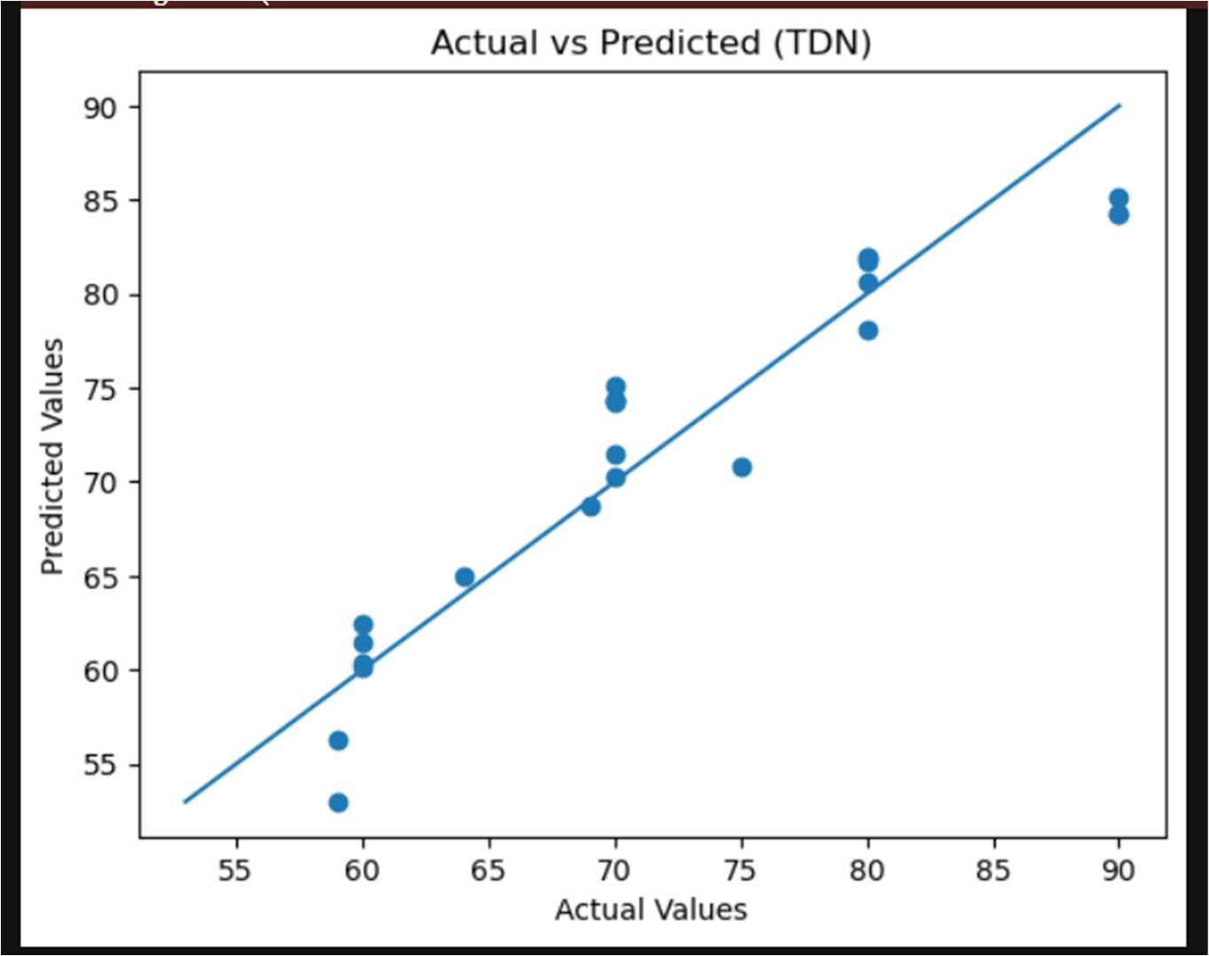
DISCUSSION
The present study evaluated the effectiveness of statistical and Artificial Neural Network (ANN) models for predicting nutrient requirements in beef cattle using Body Weight (BW) and Average Daily Gain (ADG) as predictor variables. The results demonstrated that model performance varied across nutrient parameters and depended on the ability of each approach to capture the underlying relationships within the dataset.
Among the evaluated models, Multiple Linear Regression (MLR) consistently provided superior predictive performance for most nutrient parameters. The inclusion of both BW and ADG substantially improved prediction accuracy compared with Simple Linear Regression, indicating that nutrient requirements are influenced not only by animal size but also by growth rate. This finding highlights the importance of incorporating multiple biological factors when estimating nutrient requirements in beef cattle.
The strong performance of MLR suggests that the relationships between growth characteristics and nutrient requirements in the dataset are predominantly linear. Similar findings have been reported in livestock nutrition studies, where regression-based approaches have been successfully used to estimate nutrient requirements due to the direct association between animal growth characteristics and nutritional demands (NASEM, 2016; Tedeschi et al., 2021). Furthermore, regression models offer the advantages of simplicity, interpretability, and computational efficiency, making them valuable tools for practical nutritional management.
The ANN models employing ReLU and Tanh activation functions produced reasonable predictions for certain nutrient parameters, particularly Dry Matter Intake (DMI) and Crude Protein (CP). However, their performance was generally less consistent than that of the MLR model. Although neural networks are capable of modeling complex nonlinear relationships, the results indicate that the additional flexibility provided by ANN models did not lead to substantial improvements in prediction accuracy for the current dataset.
One possible explanation for this outcome is the relatively small size of the dataset. Artificial Neural Networks typically require larger datasets to effectively learn complex nonlinear patterns and achieve stable generalization performance (Goodfellow et al., 2016; Géron, 2022). In contrast, regression-based methods often perform well when relationships among variables are primarily linear and the available data are limited. Similar observations have been reported in recent studies on precision livestock farming, where traditional statistical approaches remained competitive with machine learning techniques under conditions of limited data availability (Lopes et al., 2022; White et al., 2023).
Another important finding was that energy-related nutrient parameters, including Dry Matter Intake (DMI), Total Digestible Nutrients (TDN), Net Energy for Maintenance (NEm), and Net Energy for Gain (NEg), exhibited stronger predictive relationships with BW and ADG than mineral-related nutrients. This observation is biologically reasonable because feed intake and energy requirements are directly associated with body size and growth performance. In contrast, mineral requirements may be influenced by additional physiological and environmental factors that were not explicitly considered in the present study.
Overall, the findings demonstrate that model selection should be guided by the characteristics of the dataset rather than by model complexity alone. While machine learning techniques continue to gain attention in animal nutrition research, the present study shows that simpler and more interpretable statistical models can provide highly accurate predictions when the underlying relationships are largely linear. Therefore, Multiple Linear Regression represents a practical and reliable approach for estimating nutrient requirements in beef cattle and can serve as an effective decision-support tool for livestock nutrition management.
CONCLUSION
This study investigated the prediction of nutrient requirements in beef cattle using Body Weight (BW) and Average Daily Gain (ADG) as predictor variables. Statistical and machine learning approaches, including Simple Linear Regression (SLR), Multiple Linear Regression (MLR), and Artificial Neural Network (ANN) models employing ReLU and Tanh activation functions, were evaluated and compared.
The results demonstrated that Multiple Linear Regression provided the most accurate and consistent predictions across the nutrient parameters considered. The inclusion of both BW and ADG significantly improved predictive performance compared with models based solely on body weight, highlighting the importance of incorporating growth-related information when estimating nutrient requirements. The superior performance of MLR indicates that the relationships between growth characteristics and nutrient requirements in the dataset are predominantly linear.
Although ANN models were capable of generating reasonable predictions for certain nutrient parameters, their overall performance was less consistent than that of MLR. The findings suggest that the increased complexity of nonlinear models does not necessarily translate into improved prediction accuracy, particularly when the dataset is limited in size and the underlying relationships are largely linear.
Overall, the study demonstrates that Multiple Linear Regression is a practical, interpretable, and reliable approach for predicting nutrient requirements in beef cattle. The developed models can support nutritional planning and decision-making in livestock production systems. Future research may consider incorporating larger datasets and additional physiological, environmental, and management variables to further improve prediction accuracy and explore the potential benefits of advanced machine learning techniques.
REFERENCES
- D. L. Lalman and A. Holder, Nutrient Requirements of Beef Cattle (E-974), Oklahoma State University Extension, Stillwater, OK, USA, 2020.
- National Academies of Sciences, Engineering, and Medicine (NASEM), Nutrient Requirements of Beef Cattle, 8th Revised Edition, Washington, DC, USA: National Academies Press, 2016.
- G. James, D. Witten, T. Hastie, and R. Tibshirani, An Introduction to Statistical Learning, 2nd ed., Cham, Switzerland: Springer, 2021.
- D. C. Montgomery, G. C. Runger, and N. F. Hubele, Applied Statistics and Probability for Engineers, 8th ed., Hoboken, NJ, USA: Wiley, 2021.
- M. H. Kutner, C. J. Nachtsheim, J. Neter, and W. Li, Applied Linear Statistical Models, 6th ed., New York, NY, USA: McGraw-Hill, 2022.
- H. Wickham, M. Çetinkaya-Rundel, and G. Grolemund, R for Data Science, 2nd ed., Sebastopol, CA, USA: O’Reilly Media, 2023.
- I. Goodfellow, Y. Bengio, and A. Courville, Deep Learning, Cambridge, MA, USA: MIT Press, 2016.
- A. Géron, Hands-On Machine Learning with Scikit-Learn, Keras, and TensorFlow, 3rd ed., Sebastopol, CA, USA: O’Reilly Media, 2022.
- S. Haykin, Neural Networks and Learning Machines, 3rd ed., Upper Saddle River, NJ, USA: Pearson, 2009.
- L. O. Tedeschi, J. P. Muir, H. D. Naumann, and A. B. Norris, “Applications of machine learning in animal nutrition and livestock production,” Animal Frontiers, vol. 11, no. 4, pp. 32–41, 2021.
- J. C. Lopes, A. F. B. Magalhães, M. E. Carvalho, et al., “Artificial intelligence and precision livestock farming: A review,” Animals, vol. 12, no. 20, p. 2734, 2022.
- R. R. White, M. B. Hall, J. L. Firkins, and P. J. Kononoff, “Data-driven approaches for nutrient requirement prediction in livestock systems,” Journal of Dairy Science, vol. 106, no. 5, pp. 3148–3161, 2023.

