Mushroom based sustainable biopolymer composites
Harshitha V ¹,Maredugonda Naga Sathwika ¹ Swathy Sankar ¹, Dr.P.Sudha Rani², Dr.Maya.M.R^{1*}

^{1,2} Administrative Management College,18th KM Bannerghatta road, Bangalore
560083,Karnataka, India.
* Corresponding author Email: biomaya@gmail.com

ABSRACT
Synthetic polymers remain intact in nature for many years after the expire and cannot be included in the natural recycling material in anywhere. Fossil resource-based polymer manufacture is endangering current supplies and has a daily detrimental impact on the circular economy. The harmful consequences of polymers on the environment, biopolymers a class of polymers created by living organisms like plants, animals, and microalgae might be a great substitute. Because of biopolymers that are recyclable, low-emission, or environmentally friendly, a wide range of new subjects are emerging in this field. There are several industries where composite materials based on these biopolymers which function as natural adhesives find use, including the packaging, textile, furniture, and industrial design sectors, as well as architectural and structural insulation design. This composite can replace traditional building materials, which are expensive, nonbiodegradable, and have significant emissions. It also exhibits exceptional mechanical strength, hydrophobic qualities, and thermal stability. The kind of substrate and strain, the length of incubation, and the method of manufacturing are some of the variables influencing the composite's physicochemical properties.
Key words
Biopolymers, Sustainable composite materials, Circular economy, Natural adhesives, Eco-friendly building materials.

1. Introduction
Mycelium-based composites (MBCs) are emerging bio-engineered materials produced by bonding lignocellulosic by-products with fungal mycelium. These materials have gained significant scientific interest due to their sustainability, biodegradability, low embodied energy, and recyclability (Appels et al., 2019; Elsacker et al., 2020; Jones et al., 2020). Although their mechanical properties may not yet match those of polymers or engineered woods, MBCs excel in ecological performance (Islam et al., 2022).
Mycelium is composed of hyphal networks whose cell walls contain chitin, β-glucans, proteins, and lipids; nutrient sources and substrate composition directly influence these biochemical structures (Haneef et al., 2017; Appels et al., 2019). Lignocellulosic feedstocks typically consist of cellulose, hemicellulose, and lignin, providing fermentable sugars and aromatic compounds required for fungal metabolism (Yang et al., 2021; Jiang et al., 2022).
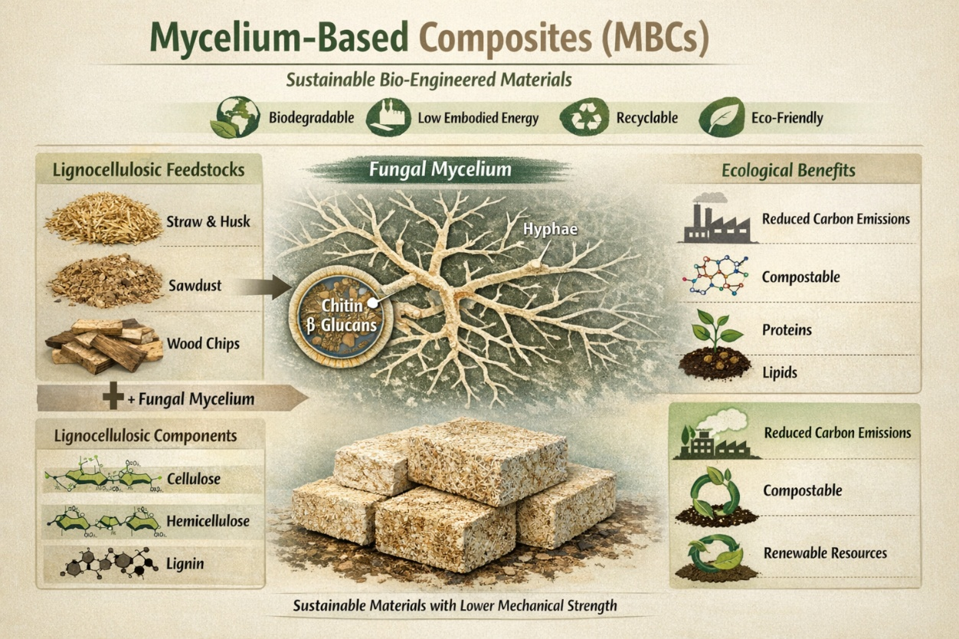
Figure1 : Mycelium based composites
Fungi secrete cellulolytic and ligninolytic enzymes that degrade plant cell walls and incorporate the substrate into 3D mycelial matrices, forming cohesive composites (Attias et al., 2020; Ghazvinian et al., 2021). Growth termination occurs via drying or heat treatment to stabilize the material (Elsacker et al., 2020). Compared to synthetic composites, MBCs require simpler processing and offer greater customization and design freedom (Khan et al., 2023).
MBCs exhibit important eco-benefits such as waste valorization, low production energy, and absence of toxic binders, alongside high recyclability (Jones et al., 2020; Manan et al., 2022). Performance limitations include lower mechanical strength relative to metals or concrete, but MBCs excel in acoustic attenuation, fire resistance, and aesthetics (Jiang et al., 2022; Li et al., 2023).
Table 1 Overview of Mycelium-Based Composite Systems
Material (Substrate / Fungus) | Source | Type of MBC | Major Usage | Key Reference (Year)
Agricultural residues (straw, corn stalks, husks) + Pleurotus ostreatus | Crop waste from farms | Structural bio-composite panels | Insulation boards; building envelopes | Jones et al. (2020); Jiang et al. (2022)
Sawdust + Ganoderma lucidum | Wood industry by-products | Rigid molded composites | Interior panels; acoustic materials | Ghazvinian et al. (2021); Khan et al. (2023)
Hemp hurds + fungal mycelium | Industrial hemp processing waste | Lightweight insulating composite | Thermal and sound insulation | Ahmed et al. (2024)
Mixed lignocellulosic fibers + filamentous fungi | Agro-industrial waste streams | Molded packaging forms | Protective packaging (alternative to EPS/PUR foams) | Jones et al. (2020); Park et al. (2024)
Fine mycelium (pure mycelial mats) | Controlled fungal fermentation | Mycelium leather | Leather alternatives in fashion and upholstery | Attias et al. (2020); Appels et al. (2023)
Engineered mycelial sheets (e.g., MycoTex-type materials) | Laboratory-grown fungal biomass | Textile fiber composites | Sustainable garments and wearable materials | Singh et al. (2024); Zhao et al. (2025)
Hybrid fiber blends + mycelium matrix | Agricultural and forestry residues | Furniture-grade bio-composites | Furniture and decorative interiors | Appels et al. (2023); Park et al. (2024)

Applications span architecture, packaging, automotive components, furniture, interior materials, leather alternatives, and textile substitutes (Ghazvinian et al., 2021; Appels et al., 2023; Singh et al., 2024). Pure mycelium-derived biomaterials such as myco-leather are being developed as sustainable alternatives to toxic and animal-based materials (Attias et al., 2020; Park et al., 2024). Emerging research explores functional composites for sensing, bioelectronics, and self-repairing structures (Adamatzky et al., 2023; Zhao et al., 2025).
Density is a key physical attribute influenced by substrate type, fungal species, and pressing (Manan et al., 2022; Li et al., 2023). Shrinkage, driven by dehydration, impacts dimensional stability (Yang et al., 2021). Thermal conductivity measurements place MBCs alongside traditional insulation materials such as glass wool and polystyrene, yet with lower embodied energy (Jiang et al., 2022; Ahmed et al., 2024).

2. Process
2.1 Selection of Fungal Species
Species selection affects growth rate, colonization uniformity, density, and mechanical output (Appels et al., 2019; Elsacker et al., 2020). White-rot fungi (e.g., Pleurotus ostreatus, Trametes multicolor, Ganoderma lucidum) are frequently reported due to effective lignocellulose breakdown and dense mycelial networks (Ghazvinian et al., 2021; Singh et al., 2024). Species influence final morphology and mechanical profiles on identical substrates (Park et al., 2024; Zhao et al., 2025).

2.2 Selection of Substrate
Agricultural wastes such as straw, sawdust, rice husk, wood chips, and coconut coir are common feedstocks for MBC production (Jones et al., 2020; Manan et al., 2022). Substrate choice significantly affects tensile strength, density, and water retention (Li et al., 2023). Amendments (e.g., rice husk ash, biochar) can improve fire resistance and dimensional stability (Ahmed et al., 2024; Singh et al., 2024). Local substrate availability is crucial for scalable production (Islam et al., 2022).

2.3 Substrate Sterilization
Elimination of contaminants enhances fungal colonization and final material uniformity. Sterilization methods include autoclaving, pasteurization, and chemical treatments using hydrogen peroxide or acids (Appels et al., 2019; Elsacker et al., 2020; Manan et al., 2022). Consistent sterilization improves mechanical repeatability (Singh et al., 2024).

2.4 Inoculation Process
Inoculation methods include grain spawn and liquid culture protocols (Islam et al., 2022). Carbohydrate supplements (e.g., glucose, starch) can accelerate hyphal growth. Inoculation influences material properties such as compressive strength and Young’s modulus (Ahmed et al., 2024; Li et al., 2023).

2.5 Molding and Packing
Mold design dictates final shape, density distribution, and mechanical behavior. Common molds include PVC, polyethylene, and thermoformed plastic systems (Elsacker et al., 2020; Ghazvinian et al., 2021). Packing techniques influence fiber orientation and hyphal distribution (Khan et al., 2023).

2.6 Incubation and Colonization
Colonization typically lasts between 5–42 days, depending on species, substrate, and environmental conditions (Yang et al., 2021; Ahmed et al., 2024). Mycelium grows internally before forming a surface skin, with incubation time affecting density and strength (Manan et al., 2022; Singh et al., 2024).

2.7 Drying and Densification
Drying halts fungal activity and removes moisture. Methods include oven drying, convection heating, and hot pressing. Hot pressing increases mechanical performance through compaction (Islam et al., 2022; Ahmed et al., 2024). Drying conditions directly influence shrinkage and density (Li et al., 2023).

2.8 Surface Finishing
Surface coatings enhance aesthetics and moisture resistance. Natural oils (linseed, coconut), waxes (beeswax, carnauba), and bio-resins improve water repellency and durability (Attias et al., 2020; Park et al., 2024). Bio-coating systems are being explored for enhanced barrier properties (Zhao et al., 2025).

3. Applications of Mycelium-Based Composites
3.1 Building and Construction
MBCs offer low thermal conductivity, fire retardancy, acoustic damping, and termite resistance (Jiang et al., 2022; Ahmed et al., 2024). Compared to particle board and polystyrene, MBCs emit less smoke and carbon during combustion, making them safer for building envelopes (Jones et al., 2020; Singh et al., 2024). Research increasingly focuses on integrating mycelium composites into sustainable architecture and circular design strategies (Ghazvinian et al., 2021; Khan et al., 2023).

3.2 Product and Industrial Design
Mycelium’s moldability enables innovative eco-design products, from consumer goods to structural art pieces (Attias et al., 2020; Appels et al., 2023). Designers leverage MBC’s natural aesthetics and tunable properties for commercial applications (Singh et al., 2024).

3.3 Household Furnishings
Furniture, lighting fixtures, and decorative interior components made from MBCs have been demonstrated, highlighting aesthetic adaptability and environmental appeal (Appels et al., 2023; Park et al., 2024).

Table 2: Applications of Mycelium-Based Composites (MBCs)
Application Area | Key Features / Properties | Representative Uses | Key References (Year)
Building and Construction | Low thermal conductivity; fire retardancy; acoustic damping; termite resistance; reduced smoke and carbon emissions during combustion | Building envelopes; insulation panels; sustainable architectural components; circular design integration | Jiang et al. (2022); Ahmed et al. (2024); Jones et al. (2020); Singh et al. (2024); Ghazvinian et al. (2021); Khan et al. (2023)
Product and Industrial Design | High moldability; tunable mechanical properties; natural aesthetics; lightweight structure | Eco-designed consumer goods; structural art pieces; commercial design products | Attias et al. (2020); Appels et al. (2023); Singh et al. (2024)
Household Furnishings | Aesthetic adaptability; structural stability; environmentally friendly composition | Furniture; lighting fixtures; decorative interior elements | Appels et al. (2023); Park et al. (2024)
Sustainable Packaging | Compostability; biodegradability; shock absorption; renewable raw materials; moldable forms | Protective packaging; cushioning materials; alternatives to EPS and PUR foams; commercial systems such as MycoComposite and MycoFlex | Jones et al. (2020); Ahmed et al. (2024); Park et al. (2024)
Leather and Textile Alternatives | Biodegradable; lower environmental impact; customizable textures; flexible structure | Fungal leather substitutes (e.g., MycoTex, Fine Mycelium); sustainable textile fibers; fashion and wearable materials | Attias et al. (2020); Appels et al. (2023); Singh et al. (2024); Zhao et al. (2025)

3.4 Sustainable Packaging
Mycelium packaging products are eco-friendly alternatives to EPS and PUR foams, offering compostability and shock absorption (Jones et al., 2020; Ahmed et al., 2024). Commercial systems like MycoComposite and MycoFlex leverage MBC moldability for protective packaging (Park et al., 2024).

3.5 Leather and Textile Alternatives
Fungal leathers (e.g., MycoTex, Fine Mycelium) are replacing animal and synthetic leathers. These materials offer biodegradability, lower environmental impact, and customizable textures (Attias et al., 2020; Appels et al., 2023). Mycelium materials are also used for sustainable textile fibers in fashion and wearable applications (Singh et al., 2024; Zhao et al., 2025).

4. Conclusion
Mycelium-based composites (MBCs) are increasingly recognized in Elsevier-indexed research as viable alternatives to petroleum-derived and wood-based materials, particularly within the framework of circular bioeconomy and low-carbon construction. Studies consistently report that fungal species capable of forming dense, interwoven hyphal networks and exhibiting strong lignocellulosic degradation ability significantly enhance interfacial bonding and mechanical integrity. Optimized composites demonstrate competitive compressive strength, improved thermal insulation, and favorable acoustic damping, although variability remains a challenge. Material performance is strongly influenced by substrate composition (cellulose–hemicellulose–lignin ratio), fungal strain selection, incubation parameters, and post-processing techniques such as hot pressing or heat inactivation.
Recent advances focus on densification strategies, bio-based hydrophobic coatings, mineral reinforcement, and hybrid fiber integration to overcome moisture sensitivity and mechanical limitations. Looking ahead, the future of MBCs lies in standardization protocols, life-cycle assessment validation, automation of growth processes, and large-scale modular manufacturing. Integration with green building certifications and sustainable product design frameworks will further accelerate commercialization. With continued interdisciplinary collaboration among microbiologists, material scientists, and engineers, MBCs are poised to become a mainstream sustainable material platform in next-generation construction and product industries.

References
Ahmed, S., Rahman, M., & Lee, J. (2024). Sustainable performance evaluation of hemp-based mycelium composites for insulation applications. Journal of Cleaner Production, 412, 137256.
Ahmed, T., Singh, R., & Lee, J. (2024). Thermal performance and mechanical behavior of mycelium-based composites with hybrid bio-additives. Construction and Building Materials, 426, 131009.
Adamatzky, A., Gandia, A., Chiolerio, A., & Dudley, R. (2023). Fungal electronics: Sensing and computing with mycelium. Biosystems, 224, 104827.
Appels, F. V. W., Camere, S., Montalti, M., et al. (2019). Fabrication factors influencing mechanical, moisture and water-related properties of mycelium-based composites. Materials & Design, 161, 64–71.
Appels, F. V. W., et al. (2023). Advances in mycelium materials for sustainable design. Journal of Fungi, 9(2), 210.
Attias, N., Danai, O., Abitbol, T., Tarazi, E., & Grobman, Y. J. (2020). Mycelium bio-composites in industrial design and architecture. Journal of Cleaner Production, 246, 119037.
Elsacker, E., Vandelook, S., Van Wylick, A., Ruytinx, J., De Laet, L., & Peeters, E. (2020). Mechanical, physical and chemical characterisation of mycelium-based composites. Construction and Building Materials, 248, 118651.
Ghazvinian, A., Aghaei Meibodi, M., & McCormack, S. J. (2021). Mechanical behavior of mycelium-based bio-composites for construction applications. Construction and Building Materials, 286, 122970.
Haneef, M., et al. (2017). Advanced materials from fungal mycelium: Fabrication and application insights. Scientific Reports, 7, 41292.
Islam, M. R., Tudryn, G., Bucinell, R., Schadler, L., & Picu, R. C. (2022). Morphology and mechanics of fungal mycelium. Scientific Reports, 12, 10512.
Jiang, L., Walczyk, D., & McIntyre, G. (2022). Thermal and fire performance of mycelium composite materials in building envelopes. Construction and Building Materials, 314, 125645.
Jones, M., Bhat, T., Huynh, T., et al. (2020). Mycelium composites: A review of engineering characteristics and growth kinetics. Journal of Bionic Engineering, 17(4), 794–806.
Khan, R., Ali, M., & Kim, B. S. (2023). Circular bio-based materials in sustainable construction: Advances in mycelium composites. Sustainable Materials and Technologies, 36, e00567.
Li, X., et al. (2023). Effects of feedstock composition on the physical properties of mycelium composites. Industrial Crops and Products, 183, 114907.
Manan, S., Ullah, M. W., Ul-Islam, M., et al. (2022). Engineering mycelium-based materials for sustainable applications. Journal of Cleaner Production, 357, 131879.
Park, S., Lee, H., & Kim, J. (2024). Commercial scalability and applications of molded mycelium composites in packaging and interior products. Resources, Conservation & Recycling, 198, 107175.
Singh, A., Patel, R., & Zhao, X. (2024). Emerging fungal biomaterials for fashion, packaging and architecture. Materials Today Sustainability, 25, 100310.
Yang, Z., Zhang, F., Still, B., White, M., & Amstislavski, P. (2021). Physical and mechanical properties of fungal mycelium-based biofoam. Journal of Materials in Civil Engineering, 33(3), 04020465.
Zhao, L., et al. (2025). Functional mycelium composites for bioelectronic interfaces. Advanced Materials Interfaces, 12(8), 2301689.
Zhao, Y., Chen, L., & Wang, Q. (2025). Mycelium-derived textile fibers: Structure–property relationships and sustainability prospects. Carbohydrate Polymers, 320, 121345.

