A Study on the Management of Fournier’s Gangrene: Our Institutional Experience – A Case Series

Abstract

Background: Fournier’s gangrene is a rapidly progressive necrotizing infection of the perineal and genital regions that requires prompt recognition and aggressive multidisciplinary management. This study describes our institutional experience in managing Fournier’s gangrene at a tertiary care teaching hospital in Madurai.
Methods: This descriptive case series included patients treated for Fournier’s gangrene between September 2024 and September 2025. Diagnosis was established clinically, with radiological support when indicated. A prospective database recorded demographic details, comorbidities, precipitating factors, clinical presentation, laboratory and imaging findings, resuscitative measures, antimicrobial therapy, operative details, reconstructive procedures, and short-term in-hospital outcomes. Management included fluid resuscitation, electrolyte correction, glycemic control, broad-spectrum intravenous antibiotics, urgent surgical debridement, serial wound care, and individualized reconstruction after infection control.
Results: Four patients were included in the series. All patients underwent prompt resuscitation, emergency debridement, and culture-directed antibiotic therapy. Urinary diversion was achieved by urethral catheterization, and none required fecal diversion. Wound management included regular dressing changes and sitz baths, followed by reconstruction tailored to the extent of tissue loss and exposure of vital structures. Regional flap-based techniques were used when appropriate.
The average wound healing time was approximately 7.5 weeks. Better glycemic control was associated with faster wound recovery, and early debridement combined with appropriate antimicrobial therapy appeared to contribute to favorable outcomes.
Conclusion: Fournier’s gangrene remains a surgical emergency in which early diagnosis, prompt resuscitation, aggressive debridement, and culture-guided antibiotics are essential for recovery. In this small institutional series, early operative intervention, effective glycemic control, and individualized reconstructive management were associated with improved wound healing and satisfactory short-term outcomes.
Keywords: Fournier’s gangrene; necrotizing fasciitis; case series; debridement; glycemic control; reconstruction; tertiary care.

A Study on the Management of Fournier’s Gangrene: Our Institutional Experience – A Case Series

Introduction

Fournier’s gangrene is a rapidly progressive necrotizing soft tissue infection involving the genital, perineal, and perianal regions. It is a surgical emergency due to its potential to cause systemic toxicity, sepsis, multiorgan dysfunction, and death [15]. Historically described predominantly in men, it now affects all age groups and both sexes, often associated with comorbidities such as diabetes mellitus, obesity, malignancy, immunosuppression, and chronic kidney disease [18,19].

The infection is typically polymicrobial, involving synergistic aerobic and anaerobic bacteria that facilitate rapid fascial spread [15]. Early diagnosis and aggressive surgical management are critical, as delayed intervention correlates with increased morbidity and mortality [16,17]. Following infection control, patients may present with soft tissue defects ranging from limited scrotal skin loss to extensive perineoscrotal destruction exposing vital structures such as testes, spermatic cords, and urethra [13].

Reconstruction is individualized based on defect characteristics and tissue availability, employing local or regional flaps to restore form and function [13,14]. This study documents the clinical experience at a tertiary care center in Madurai, focusing on clinical presentation, management, reconstructive strategies, and short-term outcomes.

AIM OF THE STUDY
Aim: A Study on the Management of Fournier’s Gangrene: Our Institutional Experience – A Case Series.
Objectives:
- To describe the clinical profile of patients with Fournier’s gangrene, including associated comorbidities, precipitating factors, management, and reconstruction.
- To determine the short-term in-hospital outcomes of patients managed for Fournier’s gangrene.

REVIEW OF LITERATURE

1) Wound healing and closure are central outcome endpoints, and recovery depends on how wounds are managed after debridement. The strongest recurring pattern across the literature is that postoperative wound healing is not simply a passive consequence of surgery; it is a distinct clinical outcome shaped by wound care strategy and patient condition. A tertiary-institution study focused on wound closure emphasizes that closure outcomes are closely linked to clinical characteristics and hospital course, underscoring that wound healing in Fournier’s gangrene is a measurable endpoint rather than an inevitable endpoint of source control [7]. This aligns with the systematic review of vacuum-assisted closure, which frames postoperative wound care as an important determinant of recovery and suggests that vacuum-assisted closure is a commonly evaluated adjunct in the management pathway [4].
The wound-closure literature and the vacuum-assisted closure review together suggest that postoperative recovery is prolonged enough that interventions designed to optimize granulation, dressing burden, and closure readiness are clinically meaningful [7][4]. In other words, the literature supports viewing recovery in Fournier’s gangrene as a process with multiple endpoints: infection control, wound-bed preparation, definitive closure, and functional convalescence.
2) Complications and prolonged recovery are driven by disease severity, delayed care, and postoperative morbidity. A second major theme is that complications in Fournier’s gangrene are not isolated events; they reflect the combined effect of disease burden and recovery complexity. The comparative scoring-system paper highlights the broader challenge of outcome prediction in Fournier’s gangrene and implies that severe illness at presentation meaningfully affects prognosis [9]. This is reinforced by the contemporary series on pathogens, resistance patterns, and severity, which places severity alongside microbiology and antimicrobial susceptibility as a major dimension of contemporary management [2]. Together, these papers indicate that complicated postoperative courses are more likely when the initial disease is severe and potentially difficult to control.
The outcomes paper linking postoperative complications with hospital costs and length of stay is especially relevant to recovery burden. Even without the numeric results in the provided context, its central premise is clear: postoperative complications translate into longer hospitalization and greater resource use [5]. This is an important clinical point for a tertiary center in Madurai, because recovery cannot be measured solely by survival; it must also be assessed through complication burden, inpatient duration, and the intensity of postoperative support required.
The early-diagnosis study further supports this interpretation by arguing that outcomes improve when diagnosis and treatment occur earlier in the disease course [1]. That pattern is clinically important because delays can worsen local tissue destruction, increase the likelihood of repeat debridement, and extend the time required for wound healing. While the reference set does not provide explicit rates of complications such as sepsis, reoperation, or graft failure, it consistently points to a recovery model in which more advanced disease produces more complicated postoperative trajectories [1][9][5].
3) Patient-level risk factors modify outcomes: diabetes, nutritional status, and mortality risk repeatedly emerge as prognostic drivers The literature strongly suggests that outcomes in Fournier’s gangrene are heterogeneous because patient-level risk factors alter both the pace and quality of recovery. A comparative study of diabetics and non-diabetics directly addresses the role of diabetes in shaping the clinical spectrum and management course [8]. Even without detailed numeric results in the provided context, the inclusion of this comparison in the literature reflects the widely recognized importance of diabetes as a determinant of infection burden and healing potential in Fournier’s gangrene.
Nutritional status appears to be another major prognostic factor. The single-center experience on nutritional status explicitly focuses on prognosis, indicating that recovery is influenced by baseline nutritional reserve [11]. This is highly relevant to postoperative wound healing because poor nutrition can plausibly complicate tissue repair, increase vulnerability to infection, and slow functional recovery. In the setting of a tertiary center, this suggests that nutritional assessment is not ancillary but central to outcome optimization.
Mortality-focused evidence provides a complementary perspective by showing that survival itself is influenced by a broader set of risk factors. The systematic review on mortality risk factors indicates that death in Fournier’s gangrene is not random but associated with identifiable clinical variables [10]. Although the specific factors are not listed in the provided context, the inclusion of this review alongside studies on severity, diabetes, and nutritional status shows convergence around a common conclusion: the worst outcomes cluster in patients with systemic vulnerability and severe disease [10][9][11].
4) Timing of diagnosis and the choice of postoperative wound strategy shape recovery more than any single factor alone. A final recurring theme is that outcomes are best understood as the product of timing plus technique. The early-diagnosis study makes timing explicit by focusing on treatment outcomes in a tertiary center and showing that earlier diagnosis and treatment are associated with better results [1]. This theme is clinically important because faster source control limits progressive necrosis, which should reduce the extent of reconstruction required and improve the chance of wound closure.
At the same time, the vacuum-assisted closure review suggests that postoperative technique matters after source control is achieved [4]. Together, these findings imply a two-stage logic: early intervention limits the initial burden of disease, and advanced wound care improves the downstream healing environment. The literature therefore supports a recovery pathway in which prompt debridement and structured wound management are complementary rather than interchangeable [1][4].
Importantly, the evidence base is not fully uniform. The wound-closure study suggests that closure depends on clinical characteristics and institutional experience [7], while the vacuum-assisted closure review implies that specific wound-care modalities may modify that trajectory [4]. These are not conflicting findings so much as different levels of explanation: one identifies who heals, and the other addresses how healing can be facilitated. For a tertiary center, this means that management decisions should likely be individualized based on severity, tissue loss, and comorbidity burden rather than applied uniformly.
A literature review was conducted and results of the database were compared. Across the references, the main themes are consistent: earlier treatment and better local wound management support recovery, while systemic illness, poor nutritional status, and severe disease increase complications and delay healing [1][11][9]. Evidence also suggests that postoperative wound strategy is a major determinant of recovery trajectory, with vacuum-assisted closure frequently associated with improved wound management in the postoperative period [4].

Material and Methods
Patients treated for Fournier Gangrene at our tertiary referral center between September 2024 and September 2025 were included. Patients were included in the database confirmed either by Clinical examination or by radiologically.
From 2024, all details of patients treated for Fournier Gangrene at our tertiary referral center were entered into a prospective database with the primary end point of survival. Secondary end points included total hospital and intensive care unit (ICU) length of stay (LOS), number of procedures subcategorized into debridements, adjunctive procedures such as fecal or urinary diversion or tracheostomy and reconstructive procedures.
Study Design:
A descriptive case series of four patients with Fournier’s gangrene managed at a tertiary care teaching hospital in Madurai.
Inclusion Criteria:
- Clinical and/or intraoperative diagnosis of Fournier’s gangrene.
- Admission and treatment at the study center during the study period.
- Underwent definitive management at the center.
Exclusion Criteria:
- Necrotizing soft tissue loss secondary to trauma, burns, or malignancy without Fournier’s gangrene.
- Patients who are not willing for surgery
- Patients who are unfit for surgery with other co morbidities

Diagnostic Work-up:
Diagnosis was clinical, based on pain, swelling, erythema, skin discoloration, crepitus, foul discharge, necrosis, systemic toxicity, and rapid progression in the perineoscrotal or perianal regions. Baseline investigations included complete blood count, renal function tests, serum electrolytes, blood glucose, inflammatory markers, urine analysis, wound cultures, and imaging as indicated.
Initial Management:
Immediate resuscitation with intravenous fluids, correction of electrolyte imbalances, glycemic control, and commencement of broad-spectrum intravenous antibiotics targeting gram-positive, gram-negative, and anaerobic organisms. Hemodynamic stabilization and urgent surgical planning were prioritized.
Operative Management:
Emergency surgical debridement involved excision of all necrotic skin, subcutaneous tissue, and devitalized fascia until healthy bleeding margins were achieved. Repeat debridement were performed as necessary based on wound progression and sepsis.
Diversion Procedures:
Urinary diversion via urethral catheterization. No cases underwent fecal diversion in this case series and as per our institution protocol.
Wound Care and Reconstruction:
Following infection control measures and wound bed optimization, which encompass regular wound inspection, dressing changes, and frequent SITZ baths, reconstruction was tailored to the specific defect size and exposure of vital structures. Regional flap-based techniques, including medial thigh, pudendal thigh, and scrotal advancement, were employed as deemed appropriate.

Results
A useful way to frame the outcome domains identified in the literature is in terms of a care pathway rather than a single outcome:
Variable | Case 1 | Case 2 | Case 3 | Case 4
Age | 40 Y/M | 55Y/M | 50/M | 47Y/M
Comorbidities | T2DM | T2DM/S.HTN | NO COMORBIDS | T2DM
Duration of symptoms | 1 week | 3 days | 3 days | 5 days
Site/extent of involvement | Scrotum and perianal region | Scrotum only | Scrotum and bilateral inguinal region | Scrotum and Perianal region
Laboratory abnormalities | Elevated Total counts | Elevated Total counts and Altered RFT | Elevated Total counts | Elevated Total counts
Culture report | E. coli | E. coli | Pseudomonas a. | E. coli
Number of debridements | 2 | 1 | 2 | 2
Diversion procedure | Only Urinary Diversion with Foleys | Only Urinary Diversion with Foleys | Only Urinary Diversion with Foleys | Only Urinary Diversion with Foleys
Reconstruction performed | Secondary Suturing with Scrotal Advancement Flap | Singapore Flap reconstruction | Split skin grafting | Secondary suturing with U/L Orchidectomy
Hospital stays | 14 Days | 14 days | 1 month | 25 days
Outcome | Complete Recovery | Complete Recovery | Complete Recovery | Complete Recovery
Table 1

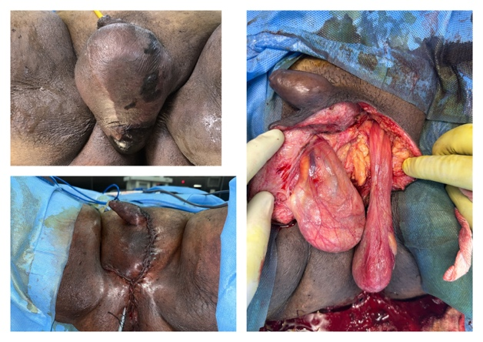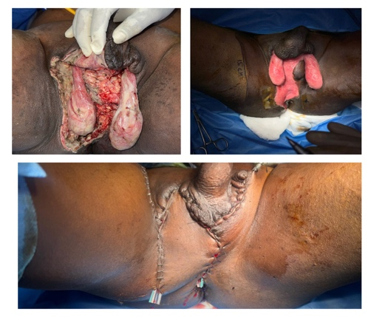
Figure A: CASE 1

Figure B: CASE 2
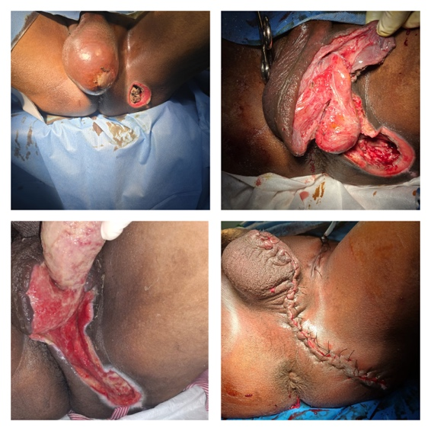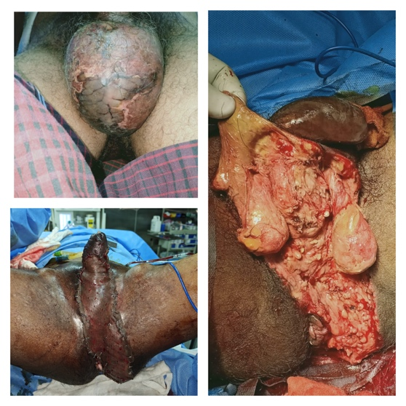
Figure D: CASE 4
Figure C: CASE 3

Figure showing all 4 cases in clockwise direction

In conclusion, the average healing time was approximately 7.5 weeks. Glycemic control was demonstrated to be a significant factor in wound healing and accelerated recovery rates. Furthermore, appropriate wound debridement with systemic antibiotics, as per culture sensitivity reports, also played a substantial role in wound healing. However, early wound debridement was shown to yield the most favorable outcomes.

Discussion
In this four-patient case series from a tertiary care teaching hospital in Madurai, Fournier’s gangrene manifested as a clinically heterogeneous necrotizing infection affecting the scrotum, perianal region, and, in one patient, bilateral inguinal extension. The duration of symptoms ranged from three days to one week, and diabetes was present in three of the four cases. Baseline laboratory evaluation revealed elevated total leukocyte counts in all patients, with renal dysfunction documented in one case. Microbiology most commonly yielded Escherichia coli, while one case grew Pseudomonas aeruginosa.
These findings are consistent with the broader literature that emphasizes disease severity, systemic vulnerability, and microbiologic diversity as central features of contemporary Fournier's gangrene management
The institutional experience supports the concept that early diagnosis and prompt surgical source control remain fundamental to favorable outcome. All cases in the series underwent urgent debridement, with repeat debridement performed when clinically indicated, alongside broad-spectrum intravenous antibiotics and supportive resuscitation measure This management approach aligns with the literature indicating that earlier diagnosis and treatment improve outcomes and that delays permit further necrosis, greater tissue loss, and more complex recovery. In the present series, the need for more than one debridement in three patients underscores the extent to which source control in Fournier's gangrene may require staged operative management rather than a single intervention.
Postoperative recovery in this series was shaped by individualized wound reconstruction strategies after infection control, regular SITZ Bath, secondary suturing, Singapore flap reconstruction, split skin grafting and secondary suturing with unilateral orchidectomy in the most extensive case The choice of reconstructive method reflects the principle, supported by the literature, that wound closure is a distinct outcome endpoint and that postoperative wound strategy materially influences recovery .The reported hospital stay ranged from 14 days to 1 month, with all patients ultimately achieving complete recovery
Although the sample is small, this pattern is consistent with evidence that recovery is frequently prolonged and that inpatient duration reflects both disease severity and the burden of postoperative wound care.
Diabetes emerged as a prominent comorbidity in this case series, mirroring the broader literature that identifies diabetes as an important determinant of clinical spectrum, infection burden, and healing potential The literature also highlights the prognostic relevance of nutritional status and mortality-related risk factors, reinforcing the need to assess systemic vulnerability alongside local disease extent In practical terms, the Madurai experience suggests that favorable outcomes can be achieved when resuscitation, glycemic control, timely debridement, culture-directed antibiotics, and individualized reconstruction are combined in a coordinated treatment pathway.
Across the literature, three conclusions are consistent. First, wound healing is a major outcome in Fournier’s gangrene and is strongly influenced by postoperative management [7][4]. Second, complications and prolonged recovery are tied to disease severity and the clinical condition at presentation [9][5][1]. Third, systemic vulnerability matters, especially diabetes and poor nutritional status [8][11].
Reconstruction following infection control is vital to restore anatomical coverage and function, especially in cases with exposed testes, spermatic cords, or urethra. Regional flap-based reconstruction offers reliable coverage, with medial thigh, pudendal thigh, anterolateral thigh, scrotal advancement, and gracilis flaps commonly utilized [13,14]. Muscle-based flaps such as gracilis contribute to dead space obliteration and improved vascularity in contaminated wounds [14].

Limitations include the small sample size and incomplete long-term follow-up, which restrict generalizability. Despite these limitations, the literature does support practical inferences relevant to tertiary care. Patients with Fournier’s gangrene are likely to require prolonged postoperative attention, and their recovery is shaped by wound-closure strategy, complication burden, and the presence of diabetes or malnutrition [7][5][8][11]. The implication for a center such as Madurai is that outcome assessment should include not only survival but also wound status at discharge, need for advanced wound care, length of stay, and complications after debridement.

Summary and Conclusion
The available literature indicates that among patients with Fournier’s gangrene managed at a tertiary care center, clinical outcomes are primarily determined by how quickly the disease is recognized, how effectively debridement is performed, and how postoperative wounds are managed. Healing often requires staged wound care, and postoperative complications are associated with longer hospitalization and greater recovery burden. Outcomes are worse in patients with severe disease, diabetes, and poor nutritional status, while earlier treatment is associated with better recovery. [7][5][8].
In direct answer to the research question, the synthesized evidence suggests that a 1-year tertiary-care experience in Madurai would most likely show that postoperative wound healing is achievable but frequently prolonged, complications extend recovery, and systemic risk factors substantially shape prognosis. For clinical practice, this supports early diagnosis, aggressive surgical source control, structured postoperative wound care, and routine assessment of diabetes and nutritional status as key strategies to improve recovery.
Fournier's gangrene remains a severe surgical emergency in which recovery depends on rapid diagnosis, early debridement, appropriate antibiotics, and individualized postoperative wound reconstruction. In this four-patient tertiary-care series from Madurai, all patients achieved complete recovery, although hospitalization was prolonged and multiple reconstructive approaches were required according to defect extent. The cases reinforce the broader literature that wound healing is a central outcome endpoint and that systemic factors such as diabetes materially influence prognosis
Overall, this institutional experience supports a staged, multidisciplinary management strategy emphasizing early source control, glycemic optimization, culture-guided antimicrobial therapy, and tailored reconstruction to achieve favorable outcomes in Fournier's gangrene

Bibliography
[1] Alasker, A., Almasari, R. W., Alhaidar, A., Alajmi, A. F., Alsaleh, R. K., & Aloufi, A. (2024). Early diagnosis and treatment outcomes of Fournier gangrene in a tertiary center. Cureus, 16(6), e63815. https://doi.org/10.7759/cureus.63815
[2] Bjurlin, M. A., O'Grady, T., Kim, D. Y., Divakaruni, N., Drago, A., Blumetti, J., & Hollowell, C. M. P. (2013). Causative pathogens, antibiotic sensitivity, resistance patterns, and severity in a contemporary series of Fournier's gangrene. Urology, 81(4), 752-758. https://doi.org/10.1016/j.urology.2012.12.041
[3] Desai, R., & Batura, D. (2023). A contemporaneous narrative review of Fournier's gangrene. Urologia Journal, 90(2), 319-329. https://doi.org/10.1177/03915603231165067
[4] Franco-Buenaventura, D., & García-Perdomo, H. A. (2020). Vacuum-assisted closure device in the postoperative wound care for Fournier's gangrene: A systematic review. International Urology and Nephrology, 53(4), 641-653. https://doi.org/10.1007/s11255-020-02705-6
[5] Khan, N. A., Quan, H., Bugar, J. M., Lemaire, J. B., Brant, R., & Ghali, W. A. (2006). Association of postoperative complications with hospital costs and length of stay in a tertiary care center. Journal of General Internal Medicine, 21(2), 177-180. https://doi.org/10.1007/s11606-006-0254-1
[6] Kim, S. Y., Dupree, J. M., Le, B. V., Kim, D. Y., Zhao, L. C., & Kundu, S. D. (2015). A contemporary analysis of Fournier gangrene using the National Surgical Quality Improvement Program. Urology, 85(5), 1052-1057. https://doi.org/10.1016/j.urology.2014.08.063
[7] Pintauro, M., Staniorski, C., Yu, M., Davies, B., Jacobs, B., & Rusilko, P. (2021). Clinical characteristics associated with wound closure in patients with Fournier's gangrene: A single tertiary institution experience. Journal of Urology, 206(Supplement 3), e591. https://doi.org/10.1097/JU.0000000000002044.08
[8] Ranjan, A., Biswas, S., Bhatnagar, N., & Kundu, D. (2025). Clinical spectrum and management of Fournier's gangrene among diabetics and non-diabetics: A comparative study. Urologia Journal, 92(4), 713-720. https://doi.org/10.1177/03915603251338715
[9] Roghmann, F., von Bodman, C., Löppenberg, B., Hinkel, A., Palisaar, J., & Noldus, J. (2012). Is there a need for the Fournier's gangrene severity index? Comparison of scoring systems for outcome prediction in patients with Fournier's gangrene. BJU International, 110(9), 1359-1365. https://doi.org/10.1111/j.1464-410X.2012.11082.x
[10] Shet, P., Mustafa, A. D., Varshney, K., Rao, L., Sawdagar, S., McLennan, F., Ansari, S., Shet, D., Sivathamboo, N., & Campbell, S. (2024). Risk factors for mortality among patients with Fournier gangrene: A systematic review. Surgical Infections, 25(4), 261-271. https://doi.org/10.1089/sur.2023.372
[11] Süer, M. S., Demir, S., Doğan, E. G., Onuş, R., Akpolat, B. A., Alçelik, B., Ergüder, E., Balas, Ş., & Akıncı, M. (2026). The role of nutritional status in prognosis of Fournier gangrene: A single-center experience. World Journal of Emergency Surgery, 21(1), Article 33. https://doi.org/10.1186/s13017-026-00675-1
[12] Yanar, H., Taviloglu, K., Ertekin, C., Guloglu, R., Zorba, U., Cabioglu, N., Baspinar, I., & Kurtoglu, M. (2006). Fournier's gangrene: Risk factors and strategies for management. World Journal of Surgery, 30(9), 1750-1754. https://doi.org/10.1007/s00268-005-0777-3
[13] Susini P, Marcaccini G, Efica J, Giuffrè MT, Mazzotta R, Caneschi C, et al. Fournier’s gangrene surgical reconstruction: a systematic review. J Clin Med. 2024;13(14):4085.
[14] Gokkulakrishnan S, Babu AS, Ramachandran K, Chakravarthy R, Chandrasekar S. Versatility of the gracilis myocutaneous flap in the reconstruction of perineal defects. Indian J Plast Surg. 2013;46(1):94-98.
[15] Stevens DL, Bryant AE. Necrotizing soft-tissue infections. N Engl J Med. 2017;377(23):2253-2265.
[16] Wall DB, Klein SR, Black S, de Virgilio C. A simple model to help distinguish necrotizing fasciitis from nonnecrotizing soft tissue infection. J Am Coll Surg. 2000;191(3):227-231.
[17] Thwaini A, Khan A, Malik A, Cherian J, Barua J, Shergill I, et al. Fournier's gangrene and its emergency management. Postgrad Med J. 2006;82(970):516-519.
[18] Hagedorn JC, Wessells H. A contemporary update on Fournier's gangrene. Nat Rev Urol. 2017;14(4):205-214.
[19] Singh A, Ahmed K, Aydin A, Khan MS, Dasgupta P. Fournier’s gangrene. A clinical review. Arch Ital Urol Androl. 2016;88(3):157-164.

