WhatsApp or WeChat? The affordance of social media for
language and cultural exchange

Sijia Guo
Macquarie University

Abstract

This mixed-methods study investigates how social media platforms—WeChat and WhatsApp—afford language learning and intercultural communicative competence (ICC) development within a mobile-supported task-based language teaching (TBLT) approach. Seventeen first-year Chinese learners at an Australian university voluntarily participated over five weeks, choosing either WeChat groups (n = 9, interacting with Chinese native speakers) or WhatsApp groups (n = 8, interacting with peers). Data sources included anonymous post-surveys, eight semi-structured interviews, and chat histories (text, images, files). Descriptive statistics and thematic analysis were used. Findings indicate WeChat provided stronger affordances for target-language communication, multimodal cultural content (Moments, built-in translation), and community building, while WhatsApp supported immediacy, ease of use, and learner-managed resource organization. Common challenges across platforms included learner anxiety (notably in one-to-one native-speaker exchanges), information overload, and sustaining motivation. Pedagogical implications include differentiated task designs that sequence peer-based confidence-building on WhatsApp before native-speaker intercultural exchanges on WeChat, scaffolding for low-proficiency learners, and explicit protocols to reduce overload and privacy concerns. The study contributes practical task-design recommendations for multimodal MALL in higher education and suggests directions for longitudinal research on language and ICC gains.
Keywords: Mobile Assisted Language Learning, (MALL), Second Language Acquisition (SLA), Social Media, Intercultural Communicative Competence (ICC).

- Introduction

In the rapidly evolving landscape of language education within Australian universities, the integration of digital technologies has become pivotal in addressing the challenges posed by globalisation, migration, and technological transformation. The Australian tertiary sector is grappling with radical transformations that reshape linguistic and cultural practices. This article examines how social media platforms, specifically WhatsApp and WeChat, serve as trans/formative tools in fostering language learning and cultural exchange among Chinese language learners in Australia. It xcritically explores the opportunities and challenges these platforms present in promoting inclusivity, diversity, and innovative perspectives on the language-culture nexus.

The Australian context is particularly salient here. According to recent data from the Australian Government (2025), there were 180,451 Chinese students enrolled in Australian educational institutions in the January-July 2025 period, making China the largest source country for international students. This influx has enriched Australia's multicultural fabric but also underscored the need for enhanced intercultural engagement. However, the COVID-19 pandemic disrupted traditional in-person interactions, forcing many Chinese students to study online and limiting their exposure to Australian culture. As relations between Australia and China navigate a complex phase, initiatives that facilitate meaningful exchanges are essential for sustaining positive educational ties and enhancing global citizenship skills (Helm, 2018).

A key issue in foreign language learning is the shift from mere communicative competence to intercultural communicative competence (ICC), which encompasses the ability to navigate cultural differences effectively (Byram, 2021). Traditional teacher-centred, face-to-face environments often fall short in providing authentic interaction opportunities with native speakers or peers. Mobile-assisted language learning (MALL) emerges as a cost-effective alternative, enabling connections for language practice and cultural immersion (Kukulska-Hulme & Lee, 2020; Lee & Song, 2020b).

This project employs a mobile-supported task-based language teaching (TBLT) approach to scaffold linguistic and intercultural tasks. TBLT, rooted in interactionist theories of SLA (Gass & Mackey, 2014) and sociocultural theory emphasises real-world tasks that promote negotiation of meaning, modification, and collaboration (Pica, 2008; Ziegler, 2016). As Ellis (2003) argues, “[t]asks that stimulate negotiation and through this provide comprehensible input and feedback and push learners to reformulate are the ones that will work best for acquisition” (p. 80). Sociocultural theory believes that interaction can engage learners in collaboration, scaffolding and group work with peers (Vygotsky, 1978). Unlike form-focused methods, TBLT replicates authentic scenarios, enhancing engagement and acquisition (González-Lloret & Ortega, 2014; Nunan, 2004). While literature demonstrates MALL's integration into TBLT (Burston, 2014), gaps remain in exploring collaborative learning in fluid contexts (formal/informal, in/out-of-class) and its effects on motivation and ICC (Viberg et al., 2020).

The urgency of this research is amplified by declining Mandarin proficiency among non-Chinese heritage Australians. As noted by Orton (2016), only 130 Australians of non-Chinese heritage speak Mandarin proficiently out of 25 million, with a 20% drop in Chinese as a second language enrolments from 2008-2015. This decline hampers Australia's engagement with its largest trading partner, China. By facilitating onshore/offshore interactions via social media, this project integrates Chinese international students into Australian communities while providing Mandarin learners with native speaker exposure, aligning with trans/formative educational practices that promote inclusivity and diversity.

To bridge these gaps, this study investigates the affordances of WhatsApp and WeChat in a telecollaborative setting at an Australian university. It compares interactions, linguistic gains, and intercultural outcomes to identify benefits and limitations (Berns et al., 2016; Fang et al., 2021). This paper studies the educational affordances of WeChat and WhatsApp for language and intercultural exchange purposes. It also studies how participants perceive their exchange experience with peers and native speakers.

- Literature review

  - The affordances of social media for collaborative language learning and intercultural communicative competence (ICC)
The concept of affordances, originally proposed by Gibson (1979), refers to the actionable possibilities that environments or tools provide to users. In language education, technological affordances enable authentic interactions, cultural exchanges, and collaborative practices (Hafner et al., 2015). Social media platforms like WhatsApp and WeChat exemplify this by supporting MALL within TBLT frameworks, fostering SLA through interaction and sociocultural scaffolding (Kukulska‐Hulme & Viberg, 2018; Lee & Song, 2020a).
Grounded in Vygotsky's (1978) sociocultural theory, these platforms allow learners to collaborate on tasks beyond individual capabilities. Meanwhile, it helps enhance negotiation and output for learners (Gass & Mackey, 2014). Social networking sites, as defined by boyd and Ellison (2007), reinforce cultural norms and relational affinities via computer-mediated communication (CMC), making them ideal for ICC development. ICC involves knowledge, skills, and attitudes for effective cross-cultural interaction (Byram, 1997). In Australian contexts, where multiculturalism is central, MALL tools address policy calls for language diversity and cultural competence (Lo Bianco, 2010).
Recent studies emphasise MALL's trans/formative potential. For instance, Godwin-Jones (2019) highlights how social media bridges formal and informal learning, promoting learner autonomy and cultural immersion. This section compares WhatsApp and WeChat's affordances, drawing on empirical evidence to inform pedagogical implications. Additionally, emerging research on post-pandemic MALL (e.g., Kukulska-Hulme et al., 2022) underscores how these platforms adapted to remote learning, providing continuity in intercultural exchanges when physical mobility was restricted. This adaptation has led to innovative practices, such as hybrid synchronous-asynchronous tasks, which further amplify the affordances for collaborative learning.

  - Affordances of WhatsApp for Collaborative Language Learning and ICC

WhatsApp, with its global user base exceeding 2 billion (Statista, 2025), offers affordances like instant messaging, multimedia sharing, and group chats, making it accessible for collaborative language learning (CLL) in diverse contexts. The integration of mobile technologies into language education has revolutionised pedagogical approaches, creating opportunities for CLL. WhatsApp, a widely adopted mobile instant messaging platform, offers unique affordances—features that enable specific interactions—that enhance communication, resource sharing, and learner engagement in second language and foreign language contexts.
WhatsApp’s immediacy, accessibility, and user-friendly interface make it a powerful tool for interaction and scaffolding (Andujar, 2016). Its text, voice, and multimedia messaging features enable real-time peer interaction, vocabulary practice, and autonomous learning. Namaziandost et al. (2025) found that WhatsApp significantly improved English achievement (EA) and academic engagement (AE) by facilitating collaborative tasks and reducing foreign language anxiety through informal group chats. They further highlighted that voice notes and video sharing created a comfortable environment for EFL learners to practice and share resources, enhancing linguistic skills. Kukulska-Hulme and Viberg (2018) noted that WhatsApp’s multimedia affordances allow instructors to distribute authentic materials, transcending classroom constraints. However, challenges such as internet connectivity issues and participants’ lack of motivation have been noted, with some students perceiving group chats as an extra workload. Alshammari et al. (2017) observed that WhatsApp encourages autonomous and peer learning, shifts the role of instructors toward facilitation, and helps organise learning communities. Conversely, the informal nature of WhatsApp and other social media-based learning requires careful guiding principles to ensure effective use. Supporting this, Kartal (2022) argued that instant messaging via MALL apps like WhatsApp can positively influence writing and vocabulary development. Furthermore, Kartal highlighted the flexibility and freedom WhatsApp offers for language learning outside the classroom, potentially enhancing students’ motivation.
WhatsApp’s asynchronous communication accommodates diverse learner schedules, fostering sustained collaboration across contexts (Andujar, 2020). Privacy concerns and distractions from off-topic chats also pose challenges, necessitating structured task design to maintain focus (Barhoumi, 2015). In a study of Australian Chinese learners, WhatsApp’s simplicity was valued for quick exchanges, however, learners noted a lack of cultural richness compared to native speaker interactions, highlighting the need for supplementary cultural content in task design (Andujar, 2020).

  - Affordances of WeChat for Collaborative Language Learning and ICC

WeChat, prevalent in Chinese-speaking contexts, offers a multifaceted platform for collaborative language learning through its group chats, voice messaging, Moment feature, and translation tools. Grounded in ecological linguistics, WeChat’s affordances enable learners to engage with authentic linguistic and cultural contexts (Jin, 2018).However, WeChat’s complex interface and regional accessibility issues, such as server restrictions outside China, challenge non-Chinese learners, with 60% reporting navigation difficulties (Jin, 2018).

Extending these insights, a systematic review by Xue and Churchill (2019) of 21 empirical studies on mobile social media educational adoption identifies seven key affordances: Resources Sharing (e.g., distributing multimedia materials), Authentic Learning (e.g., real-world cultural exposure via Moments), Collaboration (e.g., group chats for joint tasks), Community Building (e.g., fostering learner networks), Motivating Environment (e.g., gamified interactions), Evaluation and Feedback (e.g., voice message critiques), and Administration for Learning (e.g., announcements and attendance tracking). This framework underscores WeChat's potential for flipped classrooms and hybrid learning, particularly in Chinese contexts. Similarly, Bradford (2021) adapted ICC and Spanish courses during COVID-19 using Zoom, WeChat and pre-recorded videos for group discussions, homework submission, and private feedback, finding that WeChat’s low-bandwidth requirements and familiarity among Chinese students enhanced participation and reduced anxiety compared to Zoom. Questionnaire data from 25 Likert-scale and 15 open-ended items revealed strengths in asynchronous discussions for ICC topics like cultural norms, but drawbacks included distractions from non-educational notifications and information overload. Bradford's findings align with Xue and Churchill's affordances, particularly in collaboration and community building, where WeChat groups enabled shy learners to contribute without real-time pressure, boosting ICC through reflective cultural exchanges.

  - Comparative Insights and Pedagogical Implications

WhatsApp and WeChat share affordances like group communication and multimedia sharing but differ in their design and cultural applicability, reflecting distinct ecological niches for language learning (Hafner et al., 2015). WhatsApp’s minimalist interface and global reach make it ideal for peer collaboration, particularly in non-native settings, while WeChat’s multimedia-rich ecosystem and native speaker integration enhance ICC for Chinese language learners.

However, learners with lower proficiency reported anxiety in one-on-one native speaker interactions on WeChat, preferring group chats for a safer learning environment (Lee & Song, 2020a). WhatsApp’s ease of use was valued for quick, informal exchanges, but its lack of integrated translation slowed communication for some learners (Andujar, 2020). These findings underscore the need for tailored task designs, such as TBLT activities that balance individual and group interactions, to address learner anxiety and maximise affordances. Xue and Churchill (2019) further emphasise WeChat's superiority in authentic learning and community building for ICC.

Pedagogically, WhatsApp and WeChat support TBLT by enabling authentic, task-based interactions that replicate real-world communication (González-Lloret & Ortega, 2014). For instance, problem-solving tasks like discussing cultural differences or creating dialogues enhance negotiation of meaning and cultural awareness (Lee & Song, 2020a). Structured tasks, such as those integrating WeChat’s Moments for cultural analysis or WhatsApp’s group chats for peer feedback, can optimise learning outcomes (Barhoumi, 2015). Challenges include WhatsApp’s reliance on mobile data and limited cultural depth, and WeChat’s accessibility and privacy issues. Instructors should design tasks with clear guidelines, moderate group dynamics, and incorporate cultural content to enhance ICC, such as using WeChat’s Moments for cultural discussions or WhatsApp for peer-based role-plays (Luo & Yang, 2016). Bradford (2021) suggests combining WeChat with pre-recorded videos for flipped ICC classes, addressing overload by limiting group sizes, while Xue and Churchill (2019) advocate guidelines like focused prompts to leverage affordances without distractions.

  - Theoretical Frameworks Underpinning MALL in Language Education
MALL is underpinned by several theoretical frameworks that explain its efficacy in language learning. Sociocultural theory (Vygotsky, 1978) posits that learning occurs through social interaction, with tools like WeChat and WhatsApp serving as mediators for scaffolded learning. Interactionist theory (Gass & Mackey, 2014) emphasises input, output, and feedback, which mobile platforms facilitate through chats and multimedia.
Communicative language teaching advocates authentic communication, aligned with MALL's real-world tasks (Savignon, 2018). The Community of Inquiry (CoI) framework (Garrison et al., 1999) categorises presences—cognitive, social, teaching—which Annamalai et al. (2025) applied to WhatsApp, showing cognitive dominance. In Australian contexts, these frameworks support trans/formative pedagogies, integrating technology to foster ICC amid cultural diversity (Lo Bianco, 2010).

- Methodology

  - Context of the study
This study involved seventeen first-year Chinese language learners (aged 18-22, mixed heritage/non-heritage backgrounds) at an Australian university participating in an intercultural and language exchange program. Participants chose to join either WeChat groups with Chinese native speakers, who were students at the university’s English Language Centre studying remotely, or WhatsApp groups with their peers in the same language unit.
Participants voluntarily chose platforms: nine joined WeChat for native interactions, eight joined WhatsApp for peer exchanges. To foster meaningful dialogue and a community-based learning environment, both groups discussed two cultural topics: introducing hometowns and cultural differences between Australia and China (see Figures 1 and 2). Participants were also encouraged to share personal interests, such as their experiences at Australian universities and challenges in learning English or Chinese, and so forth.
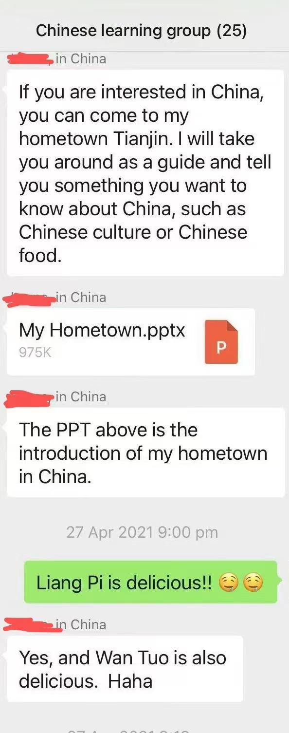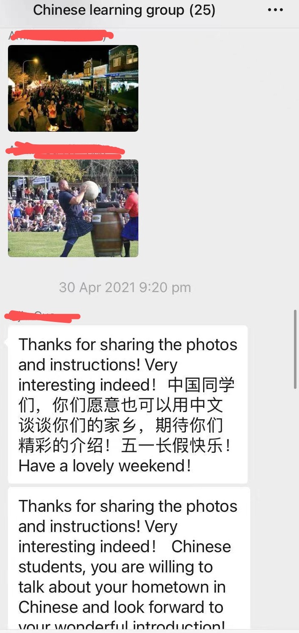
Figure 1. Students (non-native to native speaker) group cultural discussion in the WeChat group
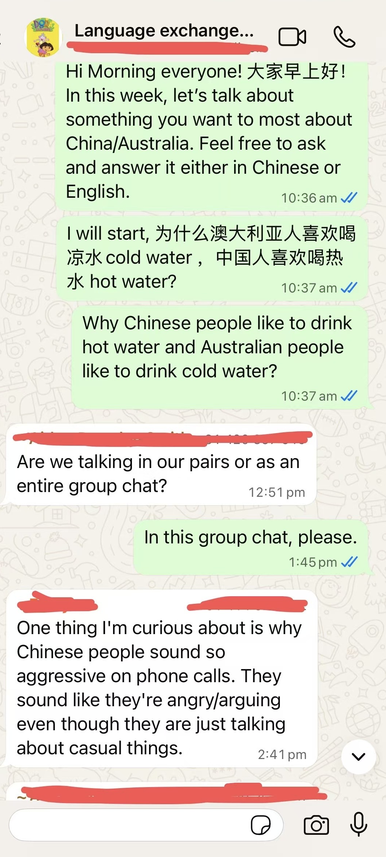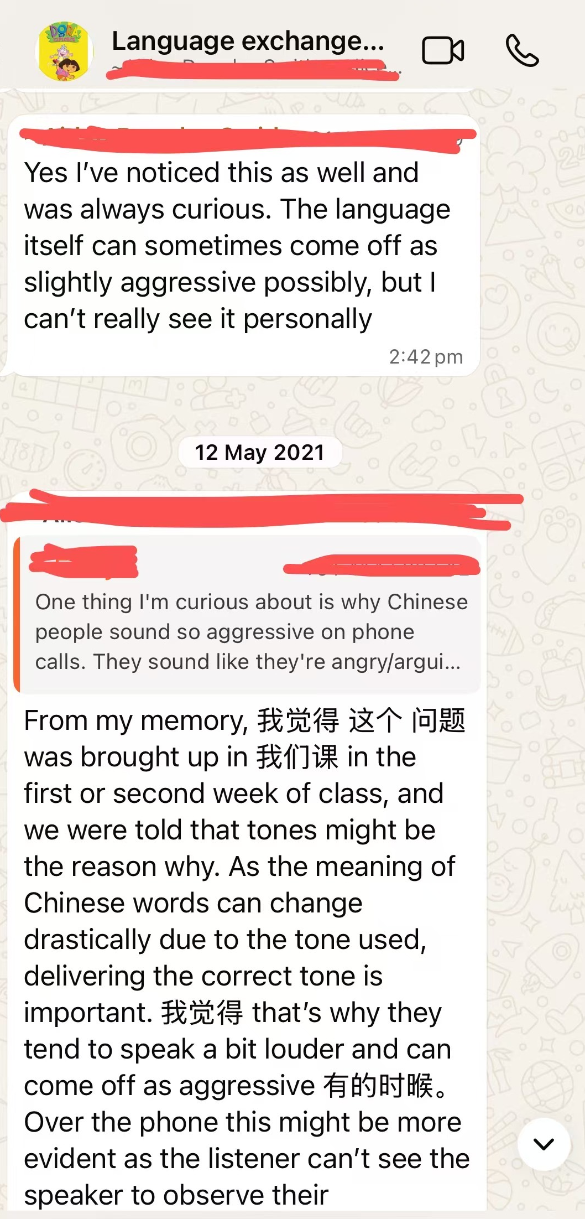
Figure 2. Students (non-native to non-native speaker) group cultural discussion in the WhatsApp group
Besides the intercultural discussions, participants were organised into small groups for language task completion. Two problem-solving linguistic tasks were assigned to both the WeChat (non-native to native speaker) and WhatsApp (non-native to non-native) groups to promote one-on-one or small group interactions and reinforce their linguistic knowledge. (see Figure 3 below). The WhatsApp chat history was generated by the students within their respective groups. Due to word limits and the scope of this article, the linguistic gains derived from the problem-solving tasks will be discussed in a separate paper.
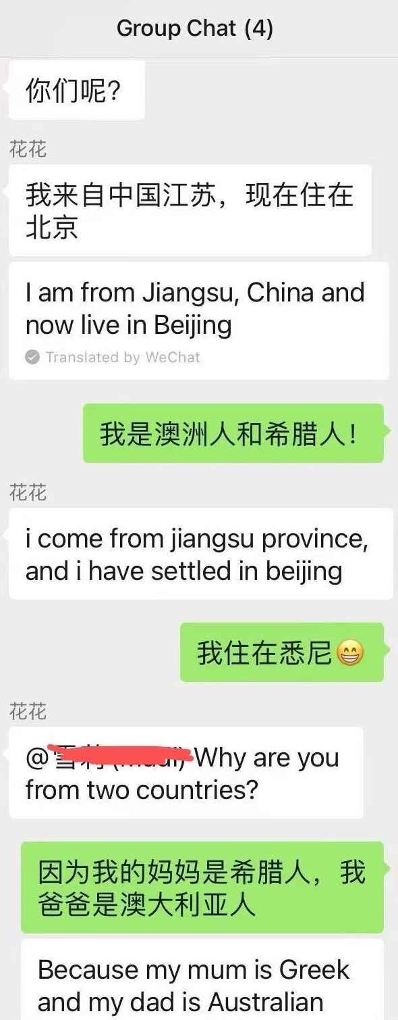
Figure 3. Student task communication in the WeChat group (with texts being translated by WeChat)
Ethical approval was obtained from the university's Human Research Ethics Committee, with informed consent emphasising voluntary participation and data anonymity.
  - Research Design

This study adopts a mixed-methods approach, combining quantitative and qualitative methods over a five-week period. Participants were assigned to two groups based on their preferences: one group of learners paired with peers used WhatsApp, while another paired with Chinese native speakers used WeChat. In weeks 9 and 11, both groups completed assigned tasks via their respective platforms, with task outcomes contributing to two written assignments to encourage engagement. In weeks 8 and 10, each group discussed two intercultural topics (hometowns and Australia-China cultural differences), and chat histories were collected for analysis.
At the end of the term, participants including Chinese and Australian students completed an anonymous survey based on an adapted Technology Acceptance Model (TAM) to evaluate their perceptions of WeChat and WhatsApp for language learning and intercultural exchange. The survey, consisting of multiple-choice questions, took 5 minutes to complete. Eight participants voluntarily conducted the follow-up interviews to explore their experiences further. All of them were Chinese language learners who used both platforms in this study. None of the Chinese native speakers expressed interested in participating in the interviews.

Quantitative data from surveys were analysed using descriptive statistics to compare platform affordances and perceptions, while qualitative data from interviews underwent thematic analysis with NVivo software, ensuring inter-coder reliability. This triangulation enhanced validity, providing a comprehensive view of affordances and perceptions.

  - Research Questions

The data were analysed to address the following questions:
- What are the educational affordances of WeChat and WhatsApp for collaborative language learning among Chinese language learners?
- How do participants perceive their virtual exchange experiences with peers and native speakers on these platforms?
- In what ways do these platforms support the development of intercultural communicative competence (ICC)?

- Data analysis and discussion

  - Learners’ perceptions of the affordance of the two platforms in the survey

In the follow-up surveys, participants including both Chinese native speakers and non-native speakers) were asked regarding their perceptions on the affordance of the two apps (see Chart 4.1 below).

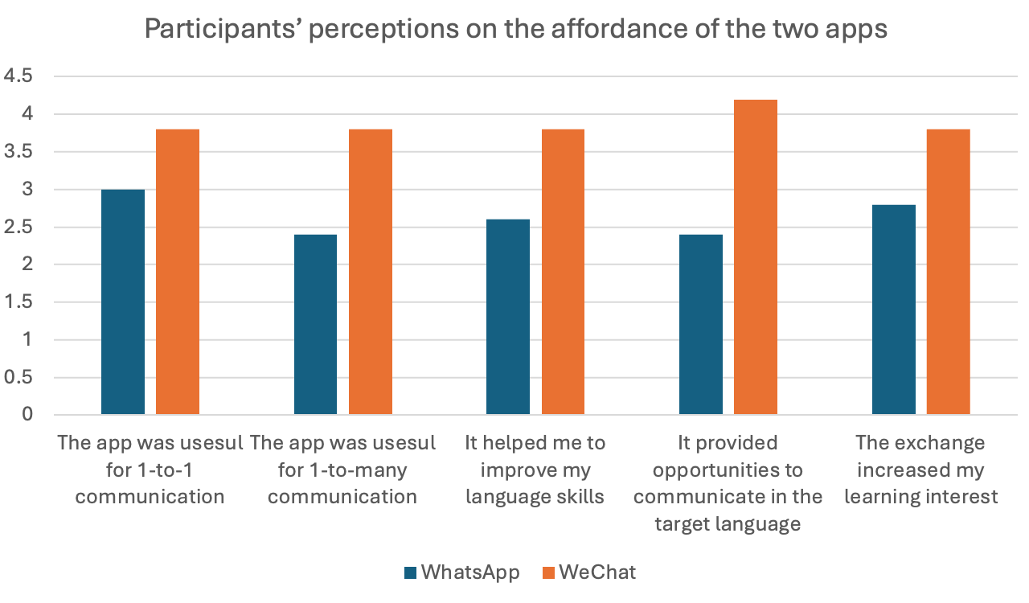
Chart 4.1 Participants’ perceptions on the affordance of the two apps

The findings indicated that both apps provided perceived benefits for language learning, though these benefits may differ. Overall, WeChat was regarded as relatively more useful than WhatsApp for language development, particularly in facilitating both one-to-one and group communication, enhancing language skills, and increasing learning engagement. These perceptions were also supported by interview data, where participants agreed that each app contributed to their language learning in distinct ways. Notably, significantly higher scores were awarded to WeChat compared to WhatsApp in terms of WeChat’s ability to provide opportunities for target language communication. This may be attributed to the fact that in WeChat groups, learners were paired with native speakers. Especially with the teacher’s presence, learners completed cultural tasks following specific instructions—Australian learners interacted in Chinese, while Chinese native speakers communicated in English. In contrast, WhatsApp groups, which lacked native speakers, occasionally noticed that non-native speakers were switching to English during collaborative tasks, to facilitate communication or clarify understanding.

Table 4.1 presents data on the type and number of messages exchanged between learners using WeChat and WhatsApp in group chats.

Type of message | WeChat (26 students) | WhatsApp (9 students)
Text message | 64 | 39
Pictures | 23 | 0
Files | 1 (ppt slides) | 0
Emojis | 10 | 10
Total | 88 | 39
Table 4.1 Participants’ types of messages in the two apps

In terms of text messages, WeChat saw significantly more text message use (n=64) compared to WhatsApp (n=39). This indicated WeChat was the preferred platform for text-based communication in this study. Picture sharing was more prevalent on WeChat (n=23) than on WhatsApp (n=0). This suggests WeChat was more suitable for visually rich communication. For files sharing, a small number of files (PowerPoint slides) were shared on WeChat (1), while none were shared on WhatsApp. Finally, regarding emojis use, both platforms saw equal use of emojis (n=10 each), indicating emojis were a standard feature of communication across both platforms.

To sum up, WeChat appeared to have been used more extensively for various types of messaging, including text, images, and file sharing, while WhatsApp was primarily used for text-based communication and emojis.

  - Participant Perceptions of WhatsApp and WeChat in the in-depth interviews

This section presents an analysis of participants' perceptions regarding the use of WhatsApp and WeChat for MALL and intercultural communication outside of the classroom. The data reveals distinct benefits and limitations associated with each platform, impacting their suitability for different aspects of language acquisition and intercultural exchange.

WhatsApp:

In the interviews, the participants consistently highlighted WhatsApp's ease of use and accessibility as a primary advantage, particularly in Western contexts where the app enjoys widespread adoption. This familiarity facilitated seamless integration into language learning routines. Student 1 quote exemplifies this sentiment: “the App itself, I think it was designed to do just send messages. It was easy enough to use and navigate...No complaints at all there.” This suggests that WhatsApp's low barrier to entry makes it attractive for learners regardless of their technological proficiency.

Secondly, the real-time communication feature was another key benefit, enabling immediate interaction and reinforcement of vocabulary and phrases. As Student 3 emphasised, “it's just real time, so we can talk without any delay,” pointing to the value of spontaneous exchanges in language practice. This immediacy aligns with the interaction approach which posits that interaction is crucial for SLA.

Thirdly, several participants described leveraging WhatsApp for individual learning and resource organisation. The ability to save messages, links, and media under personal contact names created a personalised library of language materials. As Student 7 noted, “I really found WhatsApp helpful... to save my sentences. You know, use it a little bit like a draft piece of paper. I save them in WhatsApp under my own name, so that I have a little list of them.” This highlights WhatsApp's potential as a tool for autonomous learning and personalised language practice. However, this was tempered by the recognition that exporting chats might not be useful for actual learning. Student 4 noted, “by using WhatsApp we had more ability to manipulate [the language]”, despite recognising that exporting chats was “not going to be useful for people actually learning”. This indicates a perceived value in using the app for language play but a lack of confidence in its ability to support more language study.

Fourthly, WhatsApp was considered suitable for non-native environments, particularly in circumstances where native speakers were absent, suggesting its value in creating safe spaces for language practice. Further emphasising its broader role, Student 4 appreciated that “WhatsApp helps us do something on top of just the classroom study,” indicating its role in extending learning beyond formal sessions.

However, participants also voiced limitations for intercultural communication, with concerns that WhatsApp conversations often lacked depth and cultural richness. For example, Student 7 mentioned, “my partner said that she likes to drink Chinese tea, but there was no picture, or what type of Chinese tea and she's Australian anyway, but it didn't really have real meaning.” This suggests that while WhatsApp facilitates basic exchanges, it may not effectively convey cultural contexts without supplementary content like images or videos. Some also mentioned reliance on other translation apps and found it slow down the flow of communication. Student 7 said, “If I recognise some of the characters, but not one or two and I'd have to copy it and look it up, so it took longer.”

WeChat:

In contrast to WhatsApp, participants generally regarded WeChat as superior in facilitating more meaningful, culturally enriched exchanges. The integrated translation feature was a key advantage, streamlining communication and comprehension for language learners. As Student 10 stated, “if I didn't know exactly what was being said, I could just translate it, and it would translate straight to English.” This highlights the importance of seamless translation tools in reducing barriers to communication, promoting spontaneous interaction and facilitating comprehension during conversations.

Secondly, WeChat was also perceived as effective in overcoming geographical and cultural distances. The “Moments” feature allows users to “see what others post, (mentioned by Student 10)" providing a window into everyday life and traditions in China, which promotes intercultural understanding. Student 10 elaborated, “I can kind of see what goes on from them when they post on their ‘Moments’, so I can see, like a little bit of an insight into their life in China, which is really cool. You cannot do it on any other apps.” The act of “following Chinese students on WeChat” was considered to enhance “cross-cultural awareness”. Student 9 noted that “it's more helpful for understanding cultural differences than just WhatsApp exercises”. This highlights the potential of WeChat for promoting intercultural competence through authentic exposure, which cannot be achieved on WhatsApp.

Thirdly, participants appreciated WeChat's “aesthetic” and user-friendly interface, with Student 9 stating, “I just prefer the entire aesthetic of WeChat.” Furthermore, its features support multimedia and cultural engagement. The ability to attach images/videos and share content makes interactions more authentic and richer. Student 9 stated “I can attach images, especially when we did the task about our hometown. Like we could attach images and videos”. As previously mentioned, the analysis of the chat history showed that more pictures and file sharing were noticed in the WeChat groups.

Despite these strengths, some students noted limitations and challenges, such as technical or situational drawbacks. As Student 1 noted, “My account got deactivated when I tried to use WeChat again after a long time,” indicating potential barriers to sustained use. Moreover, some participants, especially those with lower language proficiency, felt anxious when communicating one-on-one with native speakers on WeChat despite they had warm-up self-introduction exercises and casual free talks in the group chats. These students reported greater comfort participating in group chats. As Student 6 noted, “it is a little bit difficult to have conversation with someone that you don't know entirely”. This underscores the importance of building trust and rapport when engaging in intercultural communication, regardless of the platform used.

Finally, privacy and ethical concerns were raised. Participants expressed unease about data sharing, particularly in intercultural contexts involving sensitive cultural topics. WeChat's ties to Chinese regulations raised fears of surveillance. Student 8 stated, “if I’m talking to them in China, sometimes you know they say that the Internet isn't as free as they are in Australia.” This concern can inhibit open cultural exchanges, essential for ICC development (Byram, 2021).

  - Common Challenges on Both Platforms
While WhatsApp and WeChat offer distinct affordances for MALL and ICC, participants in this study identified several common challenges that transcend platform-specific features, impacting the overall efficacy of these tools in language and cultural exchange. These challenges highlight the need for nuanced pedagogical strategies to mitigate barriers and optimise learning outcomes.
First, learner anxiety and proficiency-related barriers were commonly reported across both platforms. Low-proficiency learners, in particular, experienced heightened anxiety during interactions, fearing judgment or misunderstanding. This was evident in one-on-one exchanges, where the pressure to respond quickly amplified feelings of inadequacy. Student 6 shared, “even on WhatsApp with peers, I worried about making mistakes—it's embarrassing when everyone sees your errors.” For WeChat, this anxiety was compounded by cultural differences and the presence of native speakers, aligning with findings from Lee and Song (2020a). Group chats offered some relief, providing a buffer through collective participation, but individual tasks still provoked stress. This challenge underscores the interplay between affective factors and SLA, as anxiety can inhibit output and negotiation of meaning (Krashen, 1982). Pedagogically, this suggests the importance of scaffolding activities with pre-task language support and gradual exposure to native interactions.
Second, distractions and information overload posed significant obstacles. Both platforms are designed for social networking, leading to off-topic diversions and notifications from non-educational contacts. Student 8 complained, “once I start using WeChat, I have to click on something. And it takes me to another Chinese app or I might have to log in”. Similarly, WhatsApp's group chats often devolved into casual banter, diluting task-oriented discussions (Barhoumi, 2015). Information overload was particularly noted in multimedia-heavy exchanges, where excessive images or videos overwhelmed learners, especially those with limited digital literacy. This aligns with Bradford (2021), who highlighted the need for moderated group sizes to prevent overload.
Third, motivation and engagement sustainability were common hurdles. While initial novelty boosted participation, some learners reported waning interest over time, viewing platform use as an “extra burden” alongside coursework. This was exacerbated by the lack of immediate feedback in asynchronous modes, leading to disengagement. Student 8 reflected, “At first, it was exciting, but without regular check-ins from the teacher, it felt optional”. The low survey completion rate among native Chinese participants also reflected this, and no Chinese native speakers expressed their interests in participating in the in-depth interviews. It echoes Viberg et al. (2020), emphasising the role of self-regulated learning in MALL, yet highlighting the need for integrated incentives like gamification or assessment linkage.
Addressing these challenges requires holistic task designs that incorporate digital literacy training, anxiety-reduction strategies, clear guidelines for focused interactions, and privacy protocols. By acknowledging these shared barriers, educators can enhance the trans/formative potential of WhatsApp and WeChat, ensuring equitable and effective MALL experiences.

- Conclusion

The participants' perceptions reveal a nuanced differentiation in the utility of WhatsApp and WeChat for both language learning and intercultural communication. While WhatsApp's simplicity and immediacy make it a practical tool for reinforcing language in familiar, informal contexts, however, it may fall short in fostering deep intercultural understanding. Conversely, WeChat's integrated translation, multimedia sharing, and social media-like features such as “Moments” significantly enhance intercultural engagement, providing learners with exposure to authentic cultural content and native speakers' perspectives. The study also highlights that those with lower language proficiency may experience anxiety while communicating with native speakers, preferring group chats. This underscores the importance of designing activities with these individual needs in mind.
Overall, the data suggests that while both apps support MALL and ICC. WeChat's rich intercultural features make it better suited for fostering intercultural competence, whereas WhatsApp predominantly enhances practical language use. For optimal language and intercultural development, learners may benefit from a complementary approach that leverages the strengths of both platforms - using WhatsApp for conversational fluency and WeChat for cultural immersion.
These findings call for educators to mindfully integrate these platforms into their curricula, tailoring the choice of platform and activity design to the specific learning goals and learner profiles. For instance, beginners might benefit from WhatsApp-based peer interactions to build confidence before engaging in more complex intercultural exchanges on WeChat. Future research could explore the impact of integrating structured cultural content into WhatsApp conversations and investigate the long-term effects of WeChat-based intercultural exchanges on language proficiency and cultural competence. Furthermore, investigation is needed in the long-term impact of these platforms on both linguistic proficiency and intercultural sensitivity, using longitudinal study designs. Additionally, exploring the use of mixed-modality approaches, combining asynchronous and synchronous communication on both platforms, could offer further insights.
The complementary strengths of WhatsApp and WeChat suggest potential for a hybrid MALL framework combining peer and native speaker interactions. Future research should explore optimal task designs, such as integrating WhatsApp's simplicity for peer collaboration with WeChat's cultural affordances for native speaker engagement. Long-term studies could investigate the sustained impact of these platforms on SLA and ICC, particularly for learners with varying proficiency levels. A conceptual task design framework for MALL should include structured TBLT activities, such as problem-solving tasks, cultural discussions, and multimedia-based projects, to leverage both platforms’ affordances while addressing learner anxiety and privacy concerns (see author, 2022, 2016). Drawing from Xue and Churchill (2019), this framework could incorporate WeChat's affordances as evaluation criteria for task efficacy, tested in diverse contexts like Bradford's (2021) pandemic adaptation.
In the ever-evolving digital landscape, embracing these nuances is not just about adopting new tools, but about crafting meaningful, inclusive, and transformative language learning experiences. As Australian universities continue to navigate global challenges, such as geopolitical tensions and digital divides, MALL via platforms like WhatsApp and WeChat offers a pathway to resilient education, fostering not only linguistic skills but also empathetic global citizens equipped for cross-cultural collaboration.

Reference

Alshammari, R., Parkes, M., & Adlington, R. (2017). Using WhatsApp in EFL Instruction with Saudi Arabian University Students. Arab World English Journal, 8(4), 68-84. https://doi.org/10.24093/awej/vol8no4.5
Andujar, A. (2016). Benefits of mobile instant messaging to develop ESL writing. System, 62, 63-76. https://doi.org/https://doi.org/10.1016/j.system.2016.07.004
Andujar, A. (2020). Mobile-mediated dynamic assessment: A new perspective for second language development. ReCALL (Cambridge, England), 32(2), 178-194. https://doi.org/10.1017/S0958344019000247
Barhoumi, C. (2015). The Effectiveness of WhatsApp Mobile Learning Activities Guided by Activity Theory on Students' Knowledge Management. Contemporary educational technology, 6(3), 221.
Berns, A., Isla-Montes, J.-L., Palomo-Duarte, M., & Dodero, J.-M. (2016). Motivation, students’ needs and learning outcomes: a hybrid game-based app for enhanced language learning. SpringerPlus, 5(1), 1305. https://doi.org/10.1186/s40064-016-2971-1
boyd, d. m., & Ellison, N. B. (2007). Social Network Sites: Definition, History, and Scholarship. Journal of computer-mediated communication, 13(1), 210-230. https://doi.org/10.1111/j.1083-6101.2007.00393.x
Bradford, M. R. (2021). Adapting Intercultural Communication and Spanish Classes at Shanghai University during COVID-19: Zoom, WeChat, and Beyond. International journal of education and development using information and communication technology, 17(4), 22-42.
Burston, J. (2014). The Reality of MALL: Still on the Fringes. CALICO journal, 31(1), 103-125. https://doi.org/10.11139/cj.31.1.103-125
Byram, M. (1997). Teaching and Assessing Intercultural Communicative Competence. Multilingual Matters.
Byram, M. (2021). Teaching and assessing intercultural communicative competence : revisited (Second edition. ed.). Multilingual Matters. https://doi.org/10.21832/9781800410251
Ellis, R. (2003). Task-based Language Learning and Teaching. Oxford University Press.
Fang, W.-C., Yeh, H.-C., Luo, B.-R., & Chen, N.-S. (2021). Effects of mobile-supported task-based language teaching on EFL students’ linguistic achievement and conversational interaction. ReCALL (Cambridge, England), 33(1), 71-87. https://doi.org/10.1017/S0958344020000208
Garrison, D. R., Anderson, T., & Archer, W. (1999). Critical Inquiry in a Text-Based Environment: Computer Conferencing in Higher Education. The Internet and higher education, 2(2), 87-105. https://doi.org/10.1016/S1096-7516(00)00016-6
Gass, S. M., & Mackey, A. (2014). Input, interaction, and output in second language acquisition. In B. VanPatten & J. Williams (Eds.), Theories in second language acquisition : an introduction. Taylor and Francis
Gibson, J. J. (1979). The Ecological Approach to Visual Perception. Houghton Mifflin.
Godwin-Jones, R. (2019). Telecollaboration as an approach to developing intercultural communication competence. Language Learning & Technology,, 23(3), 8-28. http://hdl.handle.net/10125/44691
González-Lloret, M., & Ortega, L. (2014). Technology-mediated TBLT : Researching technology and tasks. John Benjamins Publishing Company.
Goverment, A. (2025). International student numbers by country, by state and territory. https://www.education.gov.au/international-education-data-and-research/international-student-numbers-country-state-and-territory
Hafner, C. A., Chik, A., & Jones, R. H. (2015). Digital literacies and language learning. Language learning & technology, 19(3), 1-7.
Helm, F. (2018). Emerging identities in virtual exchange. Researchpublishing.net.
Jin, L. (2018). Digital affordances on WeChat: learning Chinese as a second language. Computer assisted language learning, 31(1-2), 27-52. https://doi.org/10.1080/09588221.2017.1376687
Kartal, G. (2022). What’s up with WhatsApp? A Critical Analysis of Mobile Instant Messaging Research in Language Learning. International journal of contemporary educational research, 6(2), 352-365. https://doi.org/10.33200/ijcer.599138
Krashen, S. (1982). Principles and practice in second language acquisition. Pergamon.
Kukulska-Hulme, A., & Lee, H. (2020). Mobile Collaboration for Language Learning and Cultural Learning. In M. Dressman & R. W. Sadler (Eds.), The Handbook of Informal Language Learning Chichester (pp. 169-180). Wiley Blackwell.
Kukulska‐Hulme, A., & Viberg, O. (2018). Mobile collaborative language learning: State of the art. British journal of educational technology, 49(2), 207-218. https://doi.org/10.1111/bjet.12580
Lee, J., & Song, J. (2020a). The impact of group composition and task design on foreign language learners’ interactions in mobile-based intercultural exchanges. ReCALL (Cambridge, England), 32(1), 63-84. https://doi.org/10.1017/S0958344019000119
Lee, J., & Song, J. (2020b). The impact of group composition and task design on foreign language learners’ interactions in mobile-based intercultural exchanges. ReCALL, 32(1), 63-84. https://doi.org/10.1017/S0958344019000119
Lo Bianco, J. (2010). Language Policy and Planning. In N. H. Hornberger & S. L. McKay (Eds.), Sociolinguistics and language education (pp. 143-176). Multilingual Matters.
Luo, H., & Yang, C. (2016). Using WeChat in Teaching L2 Chinese: An Exploratory Study (微信在中文教学中的应用：低年级教学活动初探). 7.
Namaziandost, E., Heydarnejad, T., & Goodarzi, A. (2025). Unboxing the gifts of WhatsApp in language learning: magnifying the impacts on english achievement, academic engagement, foreign language anxiety, and learner autonomy. Smart learning environments, 12(1), 28-30. https://doi.org/10.1186/s40561-025-00383-4
Nunan, D. (2004). Task-based language teaching. Cambridge University Press.
Orton, J. (2016). Building Chinese language capacity in Australia. Australia-China Relations Institute (ACRI).
Pica, T. (2008). Task-Based Teaching and Learning. In The Handbook of Educational Linguistics (pp. 523-538). Blackwell Publishing Ltd. https://doi.org/10.1002/9780470694138.ch37
Savignon, S. J. (2018). Communicative competence. In The TESOL encyclopedia of English language teaching (pp. 1-7). Wiley.
Statista. (2025). Number of WhatsApp users worldwide. https://www.statista.com/statistics/260819/number-of-monthly-active-whatsapp-users/
Viberg, O., Wasson, B., & Kukulska-Hulme, A. (2020). Mobile-assisted language learning through learning analytics for self-regulated learning (MALLAS): A conceptual framework. Australasian Journal of Educational Technology, 36(6), 34-52. https://doi.org/10.14742/ajet.6494
Vygotsky, L. S. (1978). Mind in society: The development of higher psychological processes. Harvard University Press.
Xue, S., & Churchill, D. (2019). A review of empirical studies of affordances and development of a framework for educational adoption of mobile social media. Educational Technology Research and Development, 67(5), 1231-1257. http://www.jstor.org/stable/45217358
Ziegler, N. (2016). Taking Technology to Task: Technology-Mediated TBLT, Performance, and Production. Annual Review of Applied Linguistics, 36, 136-163.

