TOXIC PEOPLE AND RELATED MENTAL HEALTH CONDITIONS

Mental health is a crucial aspect of human well-being and is significantly influenced by the quality of interpersonal relationships. While positive relationships contribute to emotional stability and psychological growth, negative and unhealthy relationships can have serious consequences on mental health. One such negative influence arises from interactions with toxic people, whose persistent behaviors create emotional distress, psychological strain, and long-term mental health challenges. Toxic people are characterized by patterns of manipulation, constant criticism, lack of empathy, emotional invalidation, and controlling behavior, which collectively undermine the emotional well-being of those around them.
The present paper aims to examine the concept of toxic people and analyze their impact on mental health conditions. It explores how prolonged exposure to toxic individuals in various social contexts, including family, academic, workplace, and personal relationships, contributes to psychological distress. The paper highlights the mechanisms through which toxic behavior affects mental health, such as chronic stress, emotional exhaustion, and the internalization of negative self-beliefs. These psychological processes often lead to mental health conditions including anxiety disorders, depression, low self-esteem, stress-related disorders, emotional burnout, and trauma-related symptoms.
This study adopts a qualitative and conceptual review approach by synthesizing existing psychological and mental health literature related to toxic relationships and emotional well-being. Through this analysis, the paper emphasizes that toxic relationships are not isolated incidents but ongoing patterns that can deeply influence an individual’s emotional regulation, self-perception, and social functioning. The findings suggest that individuals who are empathetic, emotionally sensitive, or socially dependent may be more vulnerable to the harmful effects of toxic interactions.
Furthermore, the paper discusses the importance of mental health awareness, early identification of toxic behavior, and the adoption of effective coping strategies such as boundary setting, emotional self-care, and seeking social or professional support. By increasing awareness of the psychological impact of toxic people, this paper aims to encourage healthier interpersonal relationships and promote mental well-being. The study concludes that recognizing and addressing toxic behavior is essential for preventing mental health deterioration and fostering supportive social environments.
KEY WORDS
Emotional Toxicity, Psychological Distress, Mental Well-Being, Chronic Stress, Low Self-Esteem, Emotional Exhaustion, Gaslighting, Manipulative Behavior, Social Relationships, Mental Health Awareness, Stress-Related Disorders, Interpersonal Conflict, Emotional Neglect, Psychological Impact.
INTRODUCTION
Mental health is an essential component of overall well-being and plays a vital role in determining how individuals think, feel, behave, and interact with others. In recent years, increasing attention has been given to mental health due to rising levels of stress, anxiety, and emotional difficulties among people of all age groups. While factors such as academic pressure, workplace stress, economic challenges, and social changes are commonly discussed, the impact of interpersonal relationships on mental health is often overlooked. Among these interpersonal factors, the influence of toxic people has emerged as a significant concern in understanding mental health problems.
Toxic people are individuals whose repeated behaviors, attitudes, and communication patterns create emotional distress, psychological discomfort, and mental exhaustion in others. Unlike occasional disagreements or misunderstandings, toxic behavior is persistent and damaging. These individuals may engage in constant criticism, manipulation, emotional invalidation, blame-shifting, or controlling actions that negatively affect the emotional stability of those around them. Toxic people can be found in various social contexts, including families, friendships, educational institutions, workplaces, and romantic relationships, making their impact widespread and difficult to avoid.
In many cases, people remain in toxic relationships due to emotional attachment, social expectations, cultural norms, or power dynamics. For example, students may be unable to avoid toxic peers or authority figures in academic settings, while employees may face toxic supervisors or coworkers in the workplace. Family relationships can also become toxic when patterns of emotional neglect, excessive control, or verbal abuse are normalized over time. Prolonged exposure to such unhealthy environments can lead to chronic emotional stress and psychological imbalance.
From a psychological perspective, continuous interaction with toxic individuals can disrupt emotional regulation and cognitive functioning. The human brain is sensitive to social experiences, and repeated exposure to negativity and emotional harm can activate stress responses for extended periods. This ongoing stress affects mental health by increasing vulnerability to conditions such as anxiety, depression, low self-esteem, and emotional burnout. Individuals may begin to internalize negative messages, doubt their self-worth, and experience persistent feelings of fear, sadness, or helplessness.
Research in psychology and mental health has shown that unhealthy relationships are a major contributor to emotional distress. Toxic interactions often involve power imbalance, lack of empathy, and emotional manipulation, which can erode an individual’s sense of identity and autonomy. Over time, victims of toxic relationships may struggle to trust others, express emotions freely, or form healthy social connections. These difficulties further contribute to mental health problems and reduce overall quality of life.
Despite the growing recognition of mental health issues, toxic behavior is frequently normalized or ignored, especially in societies where emotional expression is discouraged or where authority figures are rarely questioned. Many individuals fail to recognize toxic patterns until they experience severe emotional or psychological consequences. This highlights the importance of understanding toxic behavior and its impact on mental health in order to promote awareness, early identification, and effective coping strategies.
The present study focuses on exploring the concept of toxic people and examining the mental health conditions associated with prolonged exposure to toxic relationships. By analyzing the characteristics of toxic individuals and their psychological impact, this paper aims to contribute to mental health awareness and encourage healthier interpersonal relationships. Understanding these dynamics is essential for protecting emotional well-being, improving social environments, and promoting a culture of empathy and psychological safety.
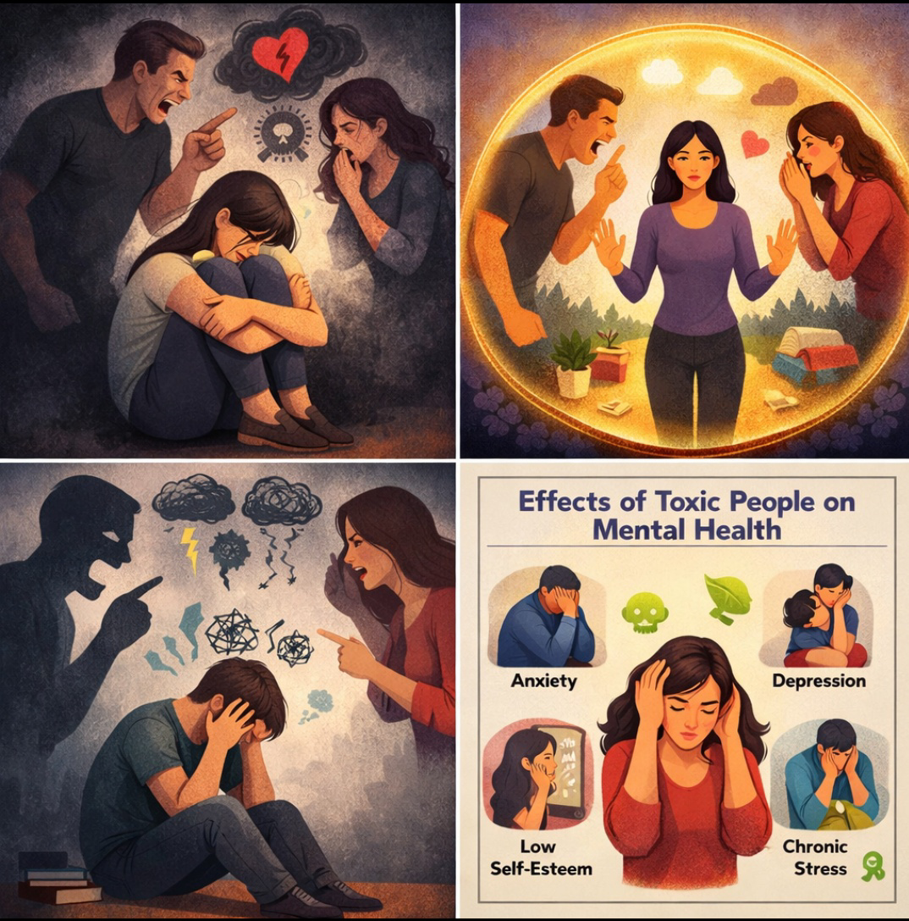
In recent years, mental health awareness has increased significantly, and one important factor influencing mental well-being is the nature of interpersonal relationships. Among these, interactions with toxic people have gained attention due to their harmful psychological effects. Toxic people are individuals whose behaviors, attitudes, and communication styles consistently create emotional distress, negativity, and psychological harm to others. Prolonged exposure to such individuals can contribute to various mental health conditions and emotional difficulties.
WHAT IS TOXICITY
Toxic people are those who repeatedly display behaviors that drain emotional energy, reduce self-esteem, and create stress. They may not always intend harm, but their actions negatively affect the mental and emotional health of others. Toxicity can exist in different relationships, including family, friendships, workplaces, and academic environments.

Common characteristics of toxic people include:

- Constant criticism and judgment
- Manipulation and controlling behavior
- Lack of empathy
- Excessive negativity
- Gaslighting (making others doubt their feelings or reality)
- Blaming others for their own mistakes
Such behaviors can create an unhealthy environment where individuals feel unsafe, undervalued, and emotionally exhausted.
IMPACT OF TOXIC PEOPLE ON MENTAL HEALTH
Continuous interaction with toxic individuals can lead to chronic stress and emotional imbalance. When a person is repeatedly exposed to negativity or manipulation, the brain remains in a constant state of alertness, which affects emotional regulation and psychological stability. Over time, this can weaken coping mechanisms and contribute to mental health problems.
WHAT ARE THE IMPACT ON MENTAL HEALTH
Due to long-term exposure to toxic behavior, a person may experience:
- Increased stress and anxiety
- Low self-confidence and self-esteem
- Depression and sadness
- Emotional instability
- Overthinking and fear
- Loss of motivation
- Sleep problems
- Difficulty in trusting others
- Social withdrawal
- Poor academic/work performance
HOW THIS IMPACT WAS HAPPENING
The impact of toxic people on mental health happens slowly and continuously through their negative behavior. Toxic people often criticize, blame, insult, manipulate, control, or ignore others’ feelings. When a person is exposed to such behavior regularly, it creates emotional pressure and mental stress.
In the beginning, the person may try to adjust, ignore the behavior, or believe that it is normal. However, as the toxic behavior continues, the mind starts feeling unsafe and uncomfortable. The person becomes worried about what the toxic person might say or do next. This creates fear, tension, and confusion in the mind.
Due to repeated negativity, the brain remains in a constant state of alertness. It is always ready to protect itself from emotional harm. This condition is called mental hyper-alertness. Because of this, the person finds it difficult to relax or feel peaceful. Even small problems may feel big and stressful.
Toxic people often use manipulation and emotional pressure. They may make the person feel guilty, worthless, or responsible for everything. Over time, the person begins to believe these negative messages. This damages self-confidence and self-respect. The person may start doubting their own abilities and decisions.
Continuous emotional stress also affects thinking patterns. The person starts overthinking, worrying too much, and expecting negative outcomes. Positive thoughts become less, and negative thoughts become stronger. This weakens emotional balance and mental strength.
Because of long-term stress, the body also reacts. Stress hormones increase in the body, which affects sleep, appetite, and energy levels. The person may feel tired, restless, and mentally exhausted even without physical work.
Slowly, the person may stop expressing their feelings. They may fear being judged, blamed, or misunderstood. As a result, they become silent and emotionally distant. This leads to loneliness and isolation.
When this situation continues for a long time, coping ability becomes weak. The person finds it difficult to handle normal life problems. Small challenges feel overwhelming. Emotional breakdowns, mood swings, and loss of motivation may occur.
Thus, the impact of toxic people happens through continuous emotional pressure, fear, manipulation, and negativity. These factors slowly damage mental peace, confidence, emotional stability, and overall well-being.
TYPES OF TOXIC PEOPLE
1.Negative person
Always complains and focuses only on problems.
They spread sadness and demotivation.
👉 Example: “Nothing is good. Everything is bad.”
2. Controlling person
Tries to control others’ actions and decisions.
Does not respect freedom.
👉 Example: “Do only what I say.”
3. Critical person
Always finds mistakes and criticizes.
Never appreciates.
👉 Example: “You are never good enough.”
4. Manipulating person
Uses emotions to get what they want.
Makes others feel guilty.
👉 Example: “If you loved me, you would do this.”
5. Self - centred person
Thinks only about themselves.
Ignores others’ feelings.
👉 Example: Talks only about “me, me, me.”
6. Jealous person
Feels unhappy about others’ success.
Tries to pull them down.
👉 Example: “You don’t deserve this success.”
7. Blaming person
Never accepts mistakes.
Always blames others.
👉 Example: “It’s your fault, not mine.”
8. Drama creater
Creates unnecessary problems and fights.
Loves attention.
👉 Example: Turns small issues into big fights.
9. Dishonest person
Often lies and hides the truth.
Breaks trust.
👉 Example: Promises but never keeps them.
10. Emotionally abusive person
Uses words to hurt, insult, or threaten.
Damages mental health.
👉 Example: “You are useless.”
RELATED MENTAL HEALTH CONDITIONS
1.ANXIETY DISORDER
One of the most common mental health conditions associated with toxic people is anxiety. Toxic individuals often create unpredictable or hostile environments, making others feel constantly worried or fearful. Victims may overthink conversations, fear judgment, or feel tense before interacting with the toxic person. This can develop into generalized anxiety, social anxiety, or panic-related symptoms.
2. DEPRESSION
Long-term exposure to emotional abuse, criticism, or neglect can contribute to depression. Toxic people may belittle achievements, dismiss emotions, or invalidate feelings, leading individuals to feel hopeless, sad, or emotionally numb. Over time, this can reduce motivation, self-worth, and interest in daily activities.
3. LOW-SELF ESTEEM
Toxic relationships often involve constant comparison, criticism, or blame. These behaviors can severely damage self-esteem. Individuals may start believing negative messages about themselves, doubting their abilities and worth. Low self-esteem can further increase vulnerability to anxiety and depression.
4. EMOTIONAL EXHAUSTION AND BURNOUT
Being around toxic people is emotionally draining. Individuals may feel mentally tired, irritable, or detached. In academic or workplace settings, this can lead to burnout, reduced concentration, and poor performance.
5. STRESS-RELATED DISORDER
Chronic stress caused by toxic interactions can lead to physical and psychological symptoms such as headaches, sleep disturbances, digestive issues, and mood swings. Prolonged stress can also weaken the immune system and worsen existing mental health conditions.
6. STRESS ISSUE AND RELATIONSHIP DIFFICULTIES
After repeated exposure to manipulation or emotional harm, individuals may develop trust issues. They may find it difficult to form healthy relationships, fear emotional closeness, or expect negativity from others, which further affects mental well-being.
COPPING AND PREVENTION STRATEGIES
Although toxic people can significantly affect mental health, individuals can protect themselves by adopting healthy coping strategies. These include:
- Setting healthy boundaries to limit emotional harm
- Reducing exposure to toxic individuals when possible
- Developing emotional awareness and self-confidence
- Seeking social support from friends, mentors, or family
- Professional help, such as counseling or therapy

TYPES OF TOXIC BEHAVIOUR
Toxic behavior can appear in different forms depending on the relationship and context:
EMOTIONAL TOXICITY
Includes emotional manipulation, silent treatment, humiliation, and emotional neglect.
VERBAL TOXICITY
Involves insults, sarcasm, shouting, or constant criticism that lowers self-esteem.
PSYCHOLOGICAL TOXICITY
Includes gaslighting, blame-shifting, and making others doubt their own thoughts or feelings.
SOCIAL TOXICITY
Seen in gossiping, spreading rumors, isolating individuals from others, or public humiliation
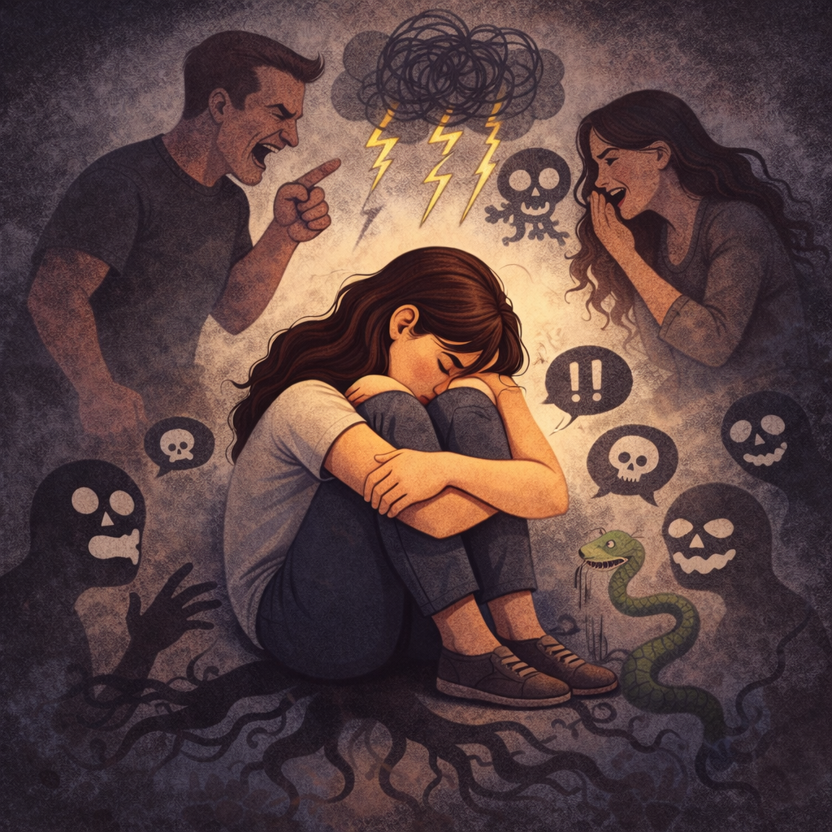

ROLE OF MENTAL HEALTH AWARENESS
Raising awareness about toxic behavior and its psychological effects is crucial. Many individuals normalize toxic relationships due to cultural, familial, or social pressures. Awareness helps people identify unhealthy patterns early and take steps to protect their well-being.
Mental health education can empower individuals to build healthy relationships based on respect, empathy, and communication.
SIGNIFICANCE OF THE STUDY
The present study holds significant value in the field of mental health and social psychology as it highlights the often-overlooked impact of toxic people on psychological well-being. While mental health issues are increasingly discussed in academic and social contexts, the role of interpersonal toxicity in contributing to emotional distress and mental health conditions is frequently underestimated. This study brings attention to how everyday interactions with toxic individuals can gradually harm mental health and reduce overall quality of life.
One of the major contributions of this study is its focus on awareness and identification. Many individuals remain unaware that the emotional discomfort, anxiety, or stress they experience may be linked to toxic relationships rather than personal weakness or failure. By clearly defining toxic behaviors and their psychological effects, this study helps individuals recognize unhealthy relationship patterns at an early stage, enabling timely intervention and self-protection.
The study is also significant for students and young adults, who are particularly vulnerable to toxic interactions in academic, social, and family environments. Academic pressure combined with exposure to toxic peers, teachers, or authority figures can negatively affect emotional stability, academic performance, and self-esteem. This research encourages educational institutions to consider the emotional environment of students and promote supportive and respectful interactions.
From a clinical and psychological perspective, this study contributes to a deeper understanding of the link between chronic interpersonal stress and mental health conditions such as anxiety, depression, emotional exhaustion, and low self-esteem. Mental health professionals, counselors, and educators can use the insights from this study to better assess the social factors influencing psychological distress and to design effective coping and intervention strategies.
Additionally, the study holds social significance by promoting the importance of healthy interpersonal relationships. By emphasizing empathy, emotional boundaries, and respectful communication, the research supports the development of positive social environments in families, workplaces, and communities. It also encourages individuals to prioritize mental well-being and seek help without stigma.
Overall, this study is significant because it contributes to mental health awareness, supports early identification of toxic behavior, and promotes psychological resilience. By addressing the harmful effects of toxic people, the research aims to foster healthier relationships, improve emotional well-being, and support a more mentally healthy society.
METHODOLOGY
The present study follows a qualitative, descriptive, and conceptual research approach to examine the influence of toxic people on mental health conditions. This research is primarily review-based in nature and does not involve direct data collection from participants. Instead, the study relies on secondary data to gain a comprehensive understanding of toxic behavior and its psychological consequences. A qualitative approach was considered appropriate for this study because it allows for an in-depth exploration of complex emotional and psychological experiences associated with toxic interpersonal relationships, which cannot be fully captured through numerical data alone.
Data for the study were collected from a wide range of academic and professional sources, including peer-reviewed research journals, psychology and mental health textbooks, review articles, conference papers, and credible online academic databases. Special care was taken to select sources that were relevant, authentic, and recent in order to ensure the accuracy and reliability of the information. Keywords such as toxic people, toxic relationships, emotional abuse, psychological distress, mental health, anxiety, depression, and interpersonal relationships were used to identify suitable literature. The selected studies were thoroughly read and evaluated to understand their objectives, methodologies, findings, and conclusions.
The collected literature was analyzed using a thematic analysis method. Through this process, recurring concepts and patterns related to toxic behavior and mental health outcomes were identified and organized. Themes such as characteristics of toxic individuals, types of toxic interactions, emotional and psychological effects, vulnerability factors, and coping mechanisms were examined in detail. Findings from different studies were compared and synthesized to develop a clear and integrated understanding of how toxic people contribute to mental health problems. This method enabled the study to draw meaningful connections between toxic interpersonal behavior and psychological conditions such as anxiety, depression, low self-esteem, emotional exhaustion, chronic stress, and trauma-related symptoms.
The study also considers the impact of toxic people across various social contexts, including family environments, educational institutions, workplaces, and social relationships. By examining multiple settings, the research highlights that toxic behavior is not limited to a specific relationship type but can occur in everyday interactions. The study emphasizes that prolonged exposure to toxic individuals can disrupt emotional regulation, affect self-perception, and weaken psychological resilience. Attention is also given to individual vulnerability factors such as emotional sensitivity, dependency, lack of social support, and low self-confidence, which may intensify the negative impact of toxic relationships on mental health.
Since the study is based entirely on secondary data, it does not involve the use of questionnaires, interviews, or experimental procedures. As a result, statistical analysis is not employed. This limitation may affect the generalizability of the findings; however, the use of diverse and credible literature strengthens the validity of the conclusions. Ethical considerations were maintained by appropriately acknowledging original authors and ensuring that all sources were used for academic purposes only.
Overall, this methodological approach enables a detailed and systematic examination of the relationship between toxic people and mental health conditions. By synthesizing existing research and theoretical perspectives, the study provides a strong foundation for understanding the psychological impact of toxic interpersonal behavior and offers valuable insights for future research, mental health professionals, educators, and individuals seeking to promote emotional well-being.
DISCUSSION
The discussion of the present study focuses on interpreting and integrating the findings from existing literature on toxic people and their impact on mental health. The review of previous research clearly indicates that toxic interpersonal relationships play a significant role in contributing to psychological distress and emotional imbalance. Across various studies, toxic behavior has been consistently associated with negative mental health outcomes, highlighting the importance of social relationships in shaping psychological well-being.
One of the key findings discussed in this study is that prolonged exposure to toxic individuals creates a continuous state of emotional stress. Toxic people often engage in behaviors such as manipulation, constant criticism, emotional invalidation, and lack of empathy, which gradually erode an individual’s emotional stability. The literature suggests that repeated negative interactions activate the body’s stress response system for extended periods, leading to emotional exhaustion and difficulty in regulating emotions. This ongoing stress explains the strong association between toxic relationships and mental health conditions such as anxiety and depression.
The discussion also highlights that toxic relationships significantly affect self-perception and self-esteem. Many studies reviewed indicate that individuals exposed to toxic behavior often internalize negative messages conveyed by toxic people. Continuous belittling, blame, and emotional manipulation can cause individuals to doubt their abilities and worth. Over time, this damaged self-image contributes to feelings of helplessness, low confidence, and emotional withdrawal, which are common features of depressive symptoms. This finding emphasizes that the psychological harm caused by toxic people extends beyond temporary emotional discomfort and can result in long-term mental health challenges.
Another important aspect discussed is the role of context in determining the severity of mental health impact. Toxic behavior occurring in close and unavoidable relationships, such as within families, academic environments, or workplaces, tends to have a stronger psychological effect. The literature indicates that when individuals are unable to distance themselves from toxic people due to social, emotional, or power-related constraints, the sense of being trapped intensifies stress and emotional suffering. This lack of control further increases vulnerability to anxiety, burnout, and emotional fatigue.
The discussion also considers individual vulnerability factors that influence how people respond to toxic relationships. Research suggests that individuals who are empathetic, emotionally sensitive, or dependent on external validation are more likely to experience severe psychological effects. Limited social support and poor coping skills further increase the negative impact of toxic interactions. This finding highlights the need for strengthening emotional resilience and coping mechanisms as part of mental health promotion efforts.
In addition, the discussion emphasizes that toxic behavior is often normalized or overlooked in many social settings. Cultural norms, fear of conflict, and lack of mental health awareness contribute to the acceptance of unhealthy relationships. As a result, individuals may delay seeking help or fail to recognize the source of their emotional distress. The literature strongly supports the importance of mental health education and awareness programs in helping individuals identify toxic patterns and take appropriate steps to protect their well-being.
The findings discussed in this study also suggest practical implications for mental health professionals, educators, and institutions. Counselors and psychologists can benefit from considering interpersonal toxicity as a contributing factor when assessing mental health concerns. Educational institutions and workplaces should promote supportive environments, encourage open communication, and address toxic behaviors to prevent psychological harm. Developing policies that support emotional safety and respect can significantly reduce the negative impact of toxic interactions.
Overall, the discussion reinforces the view that toxic people are a significant yet often underestimated factor influencing mental health. The integration of existing research confirms that toxic interpersonal relationships contribute to a wide range of psychological difficulties, including anxiety, depression, low self-esteem, stress, and emotional exhaustion. Addressing toxic behavior through awareness, early identification, and effective coping strategies is essential for promoting mental well-being and fostering healthier social relationships.
CONCLUSION
The present study concludes that toxic people play a significant role in influencing mental health and emotional well-being. Interpersonal relationships have a powerful impact on psychological functioning, and when these relationships become toxic, they can cause serious and long-lasting emotional harm. The review of existing literature clearly indicates that persistent exposure to toxic behaviors such as manipulation, emotional invalidation, constant criticism, and lack of empathy contributes to increased psychological distress and mental health challenges.
The findings of this study highlight that toxic relationships are strongly associated with mental health conditions including anxiety, depression, chronic stress, low self-esteem, and emotional exhaustion. Continuous negative interactions create an unhealthy emotional environment that disrupts emotional regulation and weakens psychological resilience. Over time, individuals may internalize negative messages, develop feelings of helplessness, and experience difficulty trusting others or forming healthy relationships. These effects significantly reduce overall quality of life and emotional stability.
The study also emphasizes that the impact of toxic people is more severe in relationships where individuals are unable to limit or avoid interaction, such as within families, academic institutions, or workplaces. In such situations, prolonged exposure increases emotional pressure and contributes to burnout and long-term psychological discomfort. The findings further suggest that individuals with limited social support, low self-confidence, or high emotional sensitivity may be more vulnerable to the harmful effects of toxic relationships.
In addition, the study underscores the importance of mental health awareness and early identification of toxic behavior. Many individuals normalize unhealthy interactions due to social or cultural pressures, which delays recognition and intervention. By increasing awareness about toxic behaviors and their psychological impact, individuals can take proactive steps to protect their mental well-being through boundary setting, self-care, and seeking support.
In conclusion, addressing the influence of toxic people is essential for promoting mental health and emotional well-being. Creating awareness, encouraging healthy interpersonal relationships, and fostering supportive social environments can significantly reduce the negative impact of toxic interactions. The study highlights the need for continued research and practical interventions to better understand and manage the psychological effects of toxic people, ultimately contributing to a healthier and more emotionally resilient society.
REFERENCE
- American Psychiatric Association. (2013). Diagnostic and statistical manual of mental disorders (5th ed.). American Psychiatric Publishing.
- Bandura, A. (1997). Self-efficacy: The exercise of control. W. H. Freeman and Company.
- Beck, A. T. (1976). Cognitive therapy and the emotional disorders. International Universities Press.
- Goleman, D. (1995). Emotional intelligence: Why it can matter more than IQ. Bantam Books.
- Hobfoll, S. E. (1989). Conservation of resources: A new attempt at conceptualizing stress. American Psychologist, 44(3), 513–524.
- Kernis, M. H. (2003). Toward a conceptualization of optimal self-esteem. Psychological Inquiry, 14(1), 1–26.
- Linehan, M. M. (1993). Cognitive-behavioral treatment of borderline personality disorder. Guilford Press.
- Maslach, C., Schaufeli, W. B., & Leiter, M. P. (2001). Job burnout. Annual Review of Psychology, 52, 397–422.
- Rosenberg, M. (1965). Society and the adolescent self-image. Princeton University Press.
- Seligman, M. E. P. (1975). Helplessness: On depression, development, and death. W. H. Freeman.
- World Health Organization. (2022). Mental health: Strengthening our response. World Health Organization.

