An Integrated AI, Blockchain and Smart Technology Framework for Sustainable Digital Economic Growth

Abstract
The rapid advancement of Artificial Intelligence (AI), Blockchain and Smart Technologies presents significant opportunities for sustainable digital economic growth. This study proposes an integrated AI, blockchain and smart technologies framework comprising six interconnected layers. A quantitative approach was employed using a survey instrument with 25 measurement items across five constructs: Artificial Intelligence Adoption (AIA), Blockchain Utilization (BCU), Smart Technology Integration (STI), Sustainability Impact (SI) and Digital Economic Growth (DEG). The results revealed high respondent agreement, with mean scores ranging from 4.15 to 4.32. Reliability analysis showed strong internal consistency, with Cronbach’s Alpha values between 0.852 and 0.903 and Composite Reliability values between 0.889 and 0.926. The validity assessment confirmed the suitability of the data (KMO = 0.893, p < 0.001). Regression results indicated that Smart Technology Integration (β = 0.392), Artificial Intelligence Adoption (β = 0.347) and Blockchain Utilization (β = 0.289) significantly and positively influenced Digital Economic Growth (p < 0.001). The model explained 79.6% of the variance in Digital Economic Growth (R² = 0.796). The findings demonstrate that the integration of AI, blockchain and smart technologies can significantly enhance innovation, productivity, financial inclusion and sustainable economic development. The framework offers a practical roadmap for achieving sustainable digital transformation and long-term economic growth.

Keywords: Artificial Intelligence, Blockchain, Smart Technologies, Digital Economic Growth, Sustainable Development and Digital Transformation.

Introduction
The rapid advancement of digital technologies has transformed traditional economic systems into interconnected digital ecosystems characterized by intelligent automation, data-driven decision-making and real-time communication. The emergence of the digital economy has fundamentally reshaped how governments, organizations and individuals create, exchange and consume value. Digital technologies such as Artificial Intelligence (AI), Blockchain, the Internet of Things (IoT), Big Data Analytics, Cloud Computing and other smart technologies have become key enablers of economic growth, innovation and sustainable development (George et al., 2021; Liu et al., 2022). These technologies facilitate operational efficiency, enhance productivity, improve service delivery and create new business models capable of addressing contemporary socioeconomic challenges (Ojei et al., 2026).
Artificial Intelligence has emerged as one of the most influential technologies driving digital transformation across industries. Through machine learning, deep learning, natural language processing and predictive analytics, AI enables organizations to automate processes, optimize resource allocation, improve decision-making and generate actionable insights from large volumes of data. Recent studies have demonstrated that AI contributes significantly to productivity enhancement, innovation capacity and economic competitiveness, making it a critical component of modern digital economies (Anazia, 2026; Dwivedi et al., 2023).
According to Khan et al. (2021), blockchain technology has gained global recognition as a decentralized and immutable digital ledger capable of enhancing transparency, trust, security and accountability within digital ecosystems. Blockchain facilitates secure peer-to-peer transactions, smart contract execution and decentralized governance mechanisms, thereby reducing fraud, operational inefficiencies and information asymmetry. The technology has been increasingly adopted in sectors such as finance, healthcare, supply chain management, education and public administration due to its ability to ensure data integrity and establish trust among stakeholders (Eti et al., 2025; Wang et al., 2022).
Beyond AI and blockchain, smart technologies such as IoT, cloud computing, edge computing, big data analytics, digital twins and fifth-generation (5G) communication systems have accelerated the development of intelligent digital ecosystems. These technologies facilitate real-time data collection, seamless connectivity, advanced analytics and intelligent automation, thereby enabling the creation of smart cities, smart industries, intelligent healthcare systems and sustainable digital infrastructures. The convergence of these technologies has become a cornerstone of digital transformation initiatives worldwide, supporting economic modernization and sustainable development objectives (Verhoef et al., 2021).
Globally, governments and organizations are increasingly investing in digital transformation strategies to improve competitiveness, enhance economic resilience and achieve sustainable development goals. The growing importance of emerging technologies in promoting innovation-driven growth, digital inclusion and sustainable economic development has made the integration of AI, blockchain and smart technologies a strategic priority for nations seeking to build resilient and sustainable digital economies (Wang et al., 2023).
Despite the growing adoption of emerging technologies, their implementation remains largely fragmented across organizations and industries. Many institutions deploy AI, blockchain, IoT, cloud computing and big data analytics as independent solutions without establishing integrated ecosystems capable of maximizing their collective benefits (Budiarto & Nordin, 2024). Such fragmented adoption often results in interoperability challenges, duplicated investments, inefficient resource utilization and limited realization of digital transformation objectives.
Data security, privacy, transparency and trust also remain significant challenges within digital economies. The increasing volume of digital transactions and data exchanges has heightened concerns regarding cyberattacks, data breaches, identity theft and regulatory compliance. While blockchain technology provides mechanisms for enhancing trust and transparency, many existing digital transformation initiatives fail to adequately address data governance and security challenges across interconnected systems.
Oloyede et al. (2023) identified digital inclusion as a critical challenge in developing economies. Although digital technologies create opportunities for economic growth and social development, unequal access to digital infrastructure, technological resources and digital skills continues to widen the digital divide. Furthermore, concerns regarding environmental sustainability, energy consumption, electronic waste and the carbon footprint of digital infrastructures require integrated approaches that align technological advancement with sustainable development goals (Nasser & Abdelkaoui, 2025).
Review of Related Literatures
The growing prominence of the digital economy has transformed the global economic landscape through the integration of digital technologies, data-driven innovations and intelligent systems into economic activities. The emergence of digital transformation has accelerated the transition from traditional industrial economies to digitally enabled economies characterized by connectivity, automation, innovation and real-time decision-making. Verhoef et al. (2021) argued that digital transformation extends beyond technology adoption to encompass organizational restructuring, business model innovation and the creation of new value propositions. Consequently, governments and organizations increasingly view digital transformation as a strategic approach for improving competitiveness, productivity and sustainable economic development (Bocean, 2025).
Among the technologies driving digital transformation, Artificial Intelligence (AI) has emerged as a critical enabler of economic growth and innovation. AI encompasses computational techniques such as machine learning, deep learning, computer vision, natural language processing and predictive analytics that enable machines to perform tasks traditionally requiring human intelligence (Madanchian, 2025; Maduabuchukwu et al., 2026a). The adoption of AI has significantly improved operational efficiency, decision-making, automation and resource optimization across various sectors. AI-driven systems facilitate predictive maintenance, intelligent customer service, risk assessment and business intelligence, thereby contributing to increased productivity and organizational performance. As a core component of Industry 4.0, AI supports smart manufacturing, intelligent supply chains and data-driven governance systems. The technology also plays a vital role in fostering innovation and supporting sustainable digital economic growth (Ilager et al., 2020; Maduabuchukwu et al., 2026b).
Blockchain technology has also attracted considerable attention as a transformative technology capable of addressing trust, transparency and security challenges within digital ecosystems. Blockchain is a decentralized distributed ledger technology that records transactions in a secure, transparent, immutable and traceable manner. The technology has found applications in finance, healthcare, logistics, education, public administration and supply chain management. Smart contracts further enhance blockchain functionality by automating transactions and reducing operational costs (Singh et al., 2020). Moreover, the integration of blockchain with AI has emerged as a promising approach for addressing challenges related to data security, decentralized decision-making, explainability and trust management in intelligent systems (Saif & Islam, 2022).
IoT enables real-time data collection and communication among interconnected devices, while cloud computing provides scalable computing resources and storage capabilities. Big data analytics facilitates the extraction of valuable insights from large volumes of structured and unstructured data, thereby supporting strategic decision-making (Mohammedi et al., 2025). Digital twins create virtual representations of physical systems, allowing organizations to monitor, simulate and optimize operations in real time. These technologies collectively contribute to operational efficiency, innovation, sustainability and intelligent service delivery. Their integration with AI and blockchain further enhances system reliability, transparency, scalability and automation capabilities (Charfeddine & Umlai, 2023).
Sustainable digital economic growth refers to the long-term expansion of economic activities through the effective use of digital technologies while promoting environmental sustainability, social inclusion and economic resilience. Technologies such as Artificial Intelligence (AI), blockchain and smart systems are key drivers of innovation, resource optimization, transparency and sustainable development (Atieh, 2026).
Artificial Intelligence (AI), Blockchain and Smart Technologies is proposed to be key drivers of sustainable digital economic growth. AI enhances decision-making, automation and operational efficiency; blockchain promotes transparency, security and trust in digital transactions; while smart technologies such as IoT, smart grids, and digital twins enable real-time monitoring and resource optimization. Together, these technologies foster innovation, improve productivity, strengthen governance and create new economic opportunities, making them essential for sustainable digital transformation and economic development (Cai & Hong, 2024)

Table 1: Major AI, Blockchain and Smart Technologies Tools
S/N | Technology Category | Tools Included | Contribution to Sustainable Digital Economic Growth
1 | Artificial Intelligence (AI) | Predictive Analytics Platform, Automation System, Chatbot/Virtual Assistant | Enhances productivity, automates business processes, improves decision-making, supports innovation and increases operational efficiency across sectors.
2 | Blockchain | Digital Identity System, Smart Contract Platform, Supply Chain Platform | Promotes transparency, security, accountability, financial inclusion and trust in digital transactions while reducing fraud and transaction costs.
3 | Smart Technology | IoT Sensor Network, Smart Grid System, Smart Agriculture System, Digital Twin Technology | Enables real-time monitoring, resource optimization, sustainable infrastructure management, precision agriculture, energy efficiency and data-driven economic development.
Source: Cai & Hong, 2024

Table 1 presents the major categories of AI, Blockchain and Smart Technologies tools and their respective contributions towards sustainable digital economic growth.
This study is anchored on the Technology–Organization–Environment (TOE) Framework and the Resource-Based View (RBV) Theory. The TOE framework explains technology adoption through technological, organizational and environmental factors, while RBV views AI capabilities, blockchain infrastructure and smart technology ecosystems as strategic resources that enhance innovation, efficiency and competitiveness (Al Balushi, 2026). Previous studies have demonstrated the positive effects of digital transformation and emerging technologies on organizational performance and economic development. However, most studies examine these technologies separately and rarely provide an integrated framework for sustainable digital economic growth. Therefore, this study proposes an Integrated AI, Blockchain and Smart Technology Framework for Sustainable Digital Economic Growth to enhance innovation, security, transparency, productivity and sustainability within a unified digital ecosystem.

Methodology

Research Design
This study adopted a quantitative survey research design to evaluate the effectiveness of the integrated Artificial Intelligence (AI), Blockchain and Smart Technology framework for promoting sustainable digital economic growth. The quantitative approach was selected because it enables the collection and analysis of measurable data from a large population of stakeholders involved in the digital economy ecosystem.

The Architecture of the Framework
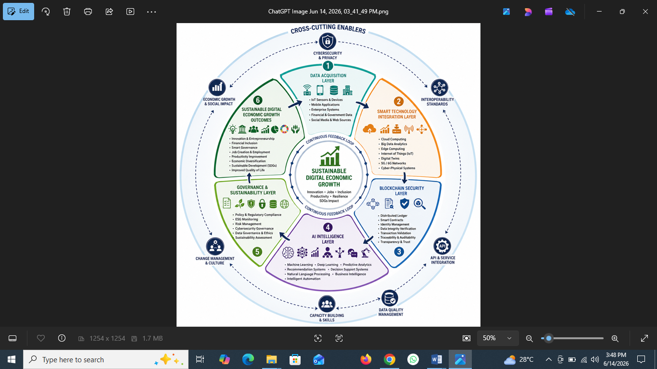

Figure 1: The Architecture of the Framework

The architecture of the framework consists of six interconnected layers arranged in a circular lifecycle around the central objective of Sustainable Digital Economic Growth. The process begins with the Data Acquisition Layer, which gathers data from sources such as IoT devices, mobile applications, enterprise systems and digital platforms. The collected data is processed and integrated within the Smart Technology Integration Layer using technologies such as cloud computing, big data analytics, edge computing, IoT, digital twins and 5G/6G networks. To ensure security, transparency and trust, the data passes through the Blockchain Security Layer, which utilizes distributed ledgers, smart contracts, identity management and data verification mechanisms.
The secured data is then transformed into actionable insights within the AI Intelligence Layer through machine learning, predictive analytics, decision support systems and intelligent automation. These insights are managed within the Governance and Sustainability Layer, which ensures regulatory compliance, risk management, cybersecurity governance, data ethics and sustainability assessment. The integration of these layers ultimately produces Sustainable Digital Economic Growth Outcomes, including innovation, financial inclusion, smart governance, job creation, productivity improvement, economic diversification, SDG achievement and enhanced quality of life.
At the center of the framework is Sustainable Digital Economic Growth, representing the overall goal of innovation, digital transformation, economic resilience, productivity growth and social inclusion. Supporting all stages of the lifecycle are cross-cutting enablers such as cybersecurity and privacy, interoperability standards, API integration, data quality management, capacity building and change management. The framework operates as a continuous feedback-driven cycle, where outcomes generated from one phase inform future data acquisition and decision-making processes, ensuring continuous improvement, adaptation and sustainable digital transformation.

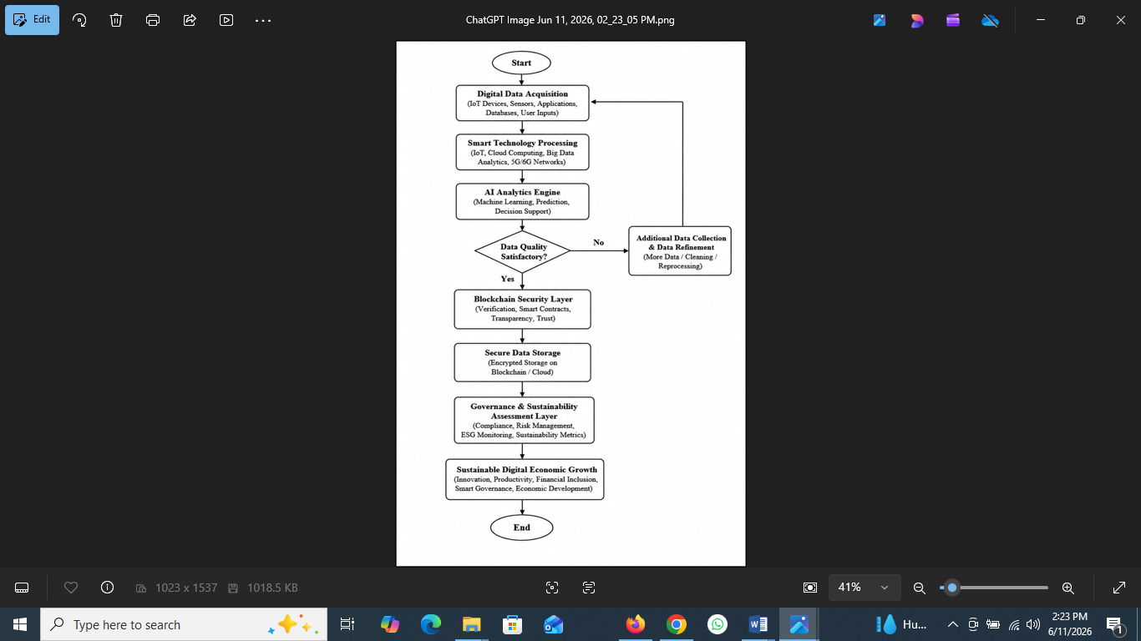

Figure 2: The Framework’s Flowchart

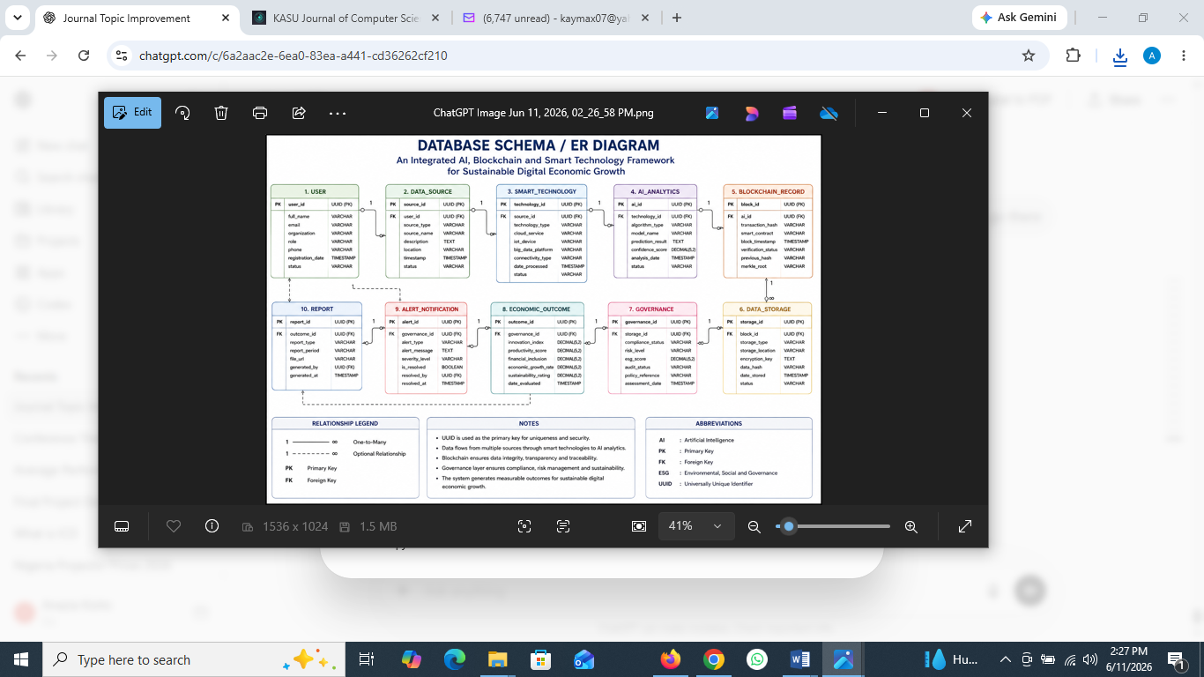

Figure 3: The ER/Database Diagram of the Framework

Population and Sample Size
The target population comprised information technology professionals, digital entrepreneurs, blockchain developers, fintech operators, policymakers, researchers and other stakeholders actively participating in the digital economy sector. A total of 300 structured questionnaires were distributed to respondents selected through purposive and stratified sampling techniques. Out of the distributed questionnaires, 276 were successfully completed and returned, representing a response rate of 92.0%. After data screening and validation, 250 questionnaires were found suitable for statistical analysis. The final sample size of 250 respondents exceeds the minimum threshold recommended for multivariate statistical analysis and structural equation modeling, thereby ensuring adequate statistical power and generalizability of the findings.

Data Generation and Constructs
Five latent constructs were considered in this study, namely Artificial Intelligence Adoption (AIA), Blockchain Utilization (BCU), Smart Technology Integration (STI), Sustainability and Innovation (SI) and Digital Economic Growth (DEG). A total of 25 measurement items were developed to assess these constructs, with each construct represented by five indicators. The items were measured using a five-point Likert scale ranging from Strongly Disagree (1) to Strongly Agree (5). This scale enabled respondents to express their level of agreement with statements related to the adoption and impact of emerging digital technologies on sustainable digital economic growth as shown in table 2.

Table 2: Data Generation and Constructs Table
S/N | Construct | Code | Items
1 | Artificial Intelligence Adoption | AIA | 5
2 | Blockchain Utilization | BCU | 5
3 | Smart Technology Integration | STI | 5
4 | Sustainability Impact | SI | 5
5 | Digital Economic Growth | DEG | 5

Data Analysis Techniques
The data were analyzed using a combination of descriptive, reliability, validity and inferential statistical techniques. The analytical methods employed in this study include descriptive statistics (mean and standard deviation), reliability analysis (Cronbach's Alpha), validity analysis (Kaiser-Meyer-Olkin Measure of Sampling Adequacy and Bartlett's Test of Sphericity), Pearson's correlation analysis, multiple regression analysis and Structural Equation Modeling (SEM).
Descriptive Statistics
Descriptive statistics are statistical techniques used to organize, summarize and present data in a meaningful form. In this study, the mean and standard deviation are used for data analysis.
The mean is a measure of central tendency that represents the average value of a dataset and is obtained by dividing the sum of all observations by the total number of observations.

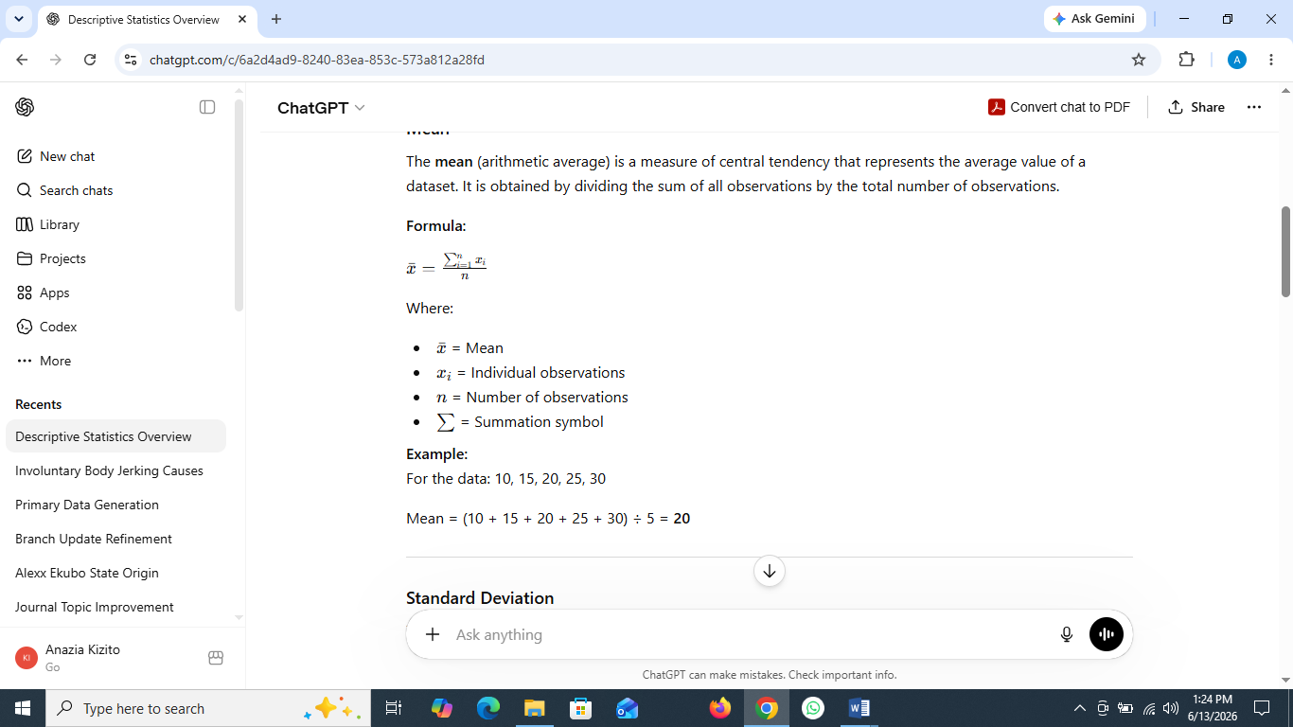
(1)
Where;
ẋ= Mean
x_{i}= Individual observations
n = Number of observations
∑ = Summation symbol
The standard deviation is a measure of dispersion that shows how much the data values vary from the mean. A low standard deviation indicates that the data points are close to the mean, while a high standard deviation indicates greater variability.

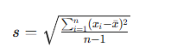
(2)
Where:
s = Sample standard deviation
x_{i}​ = Individual observations
ẋ = Mean of the observations
n = Number of observations

Reliability Analysis
Reliability analysis is used to assess the consistency and dependability of a research instrument, such as a questionnaire. It ensures that the instrument produces reliable and consistent results. In this study, reliability will be evaluated using Cronbach's Alpha. Cronbach's Alpha (α) is a measure of internal consistency that assesses how well a set of items measures the same construct. The coefficient ranges from 0 to 1, with higher values indicating greater reliability. A Cronbach's Alpha value of 0.70 or above is generally considered acceptable, indicating that the instrument is reliable for data collection and analysis.

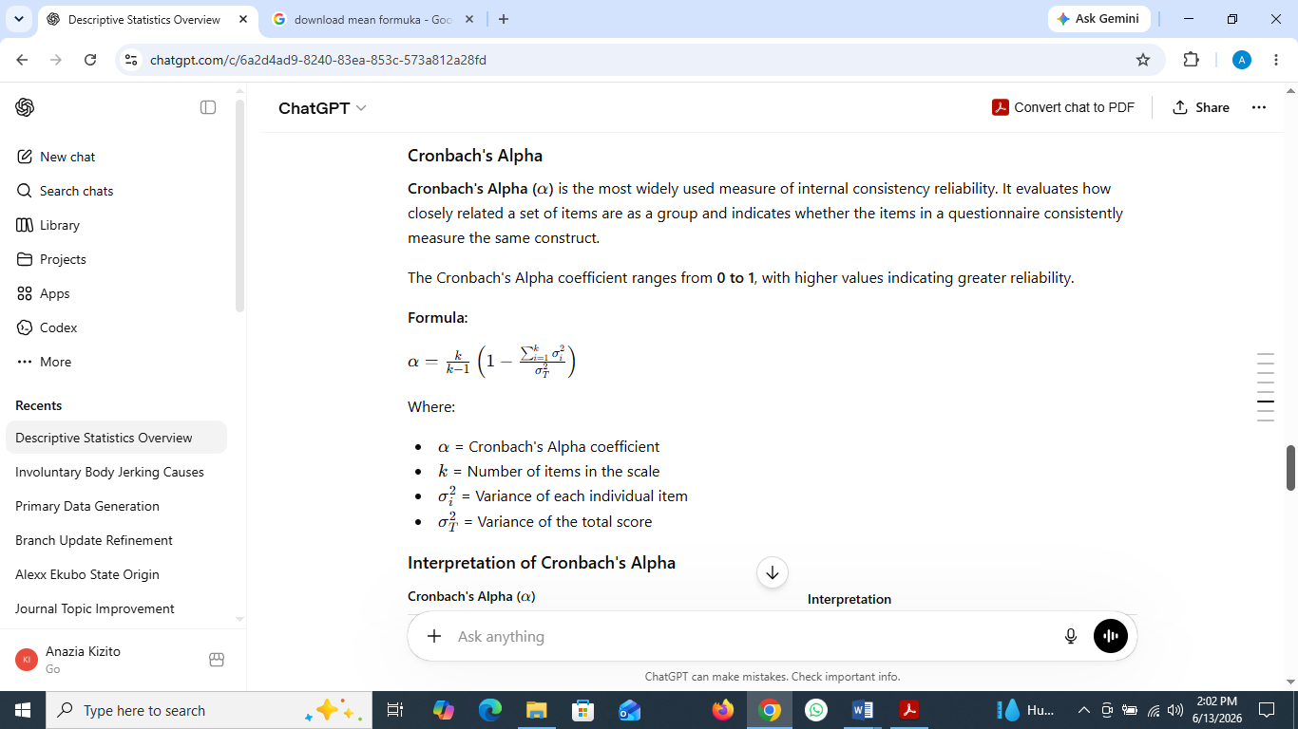
(3)
Where:
a = Cronbach's Alpha coefficient
k = Number of items in the scale
σ_{i}² ​ = Variance of each individual item
σ_{T}² = Variance of the total score

Validity Analysis
Validity analysis assesses whether a research instrument accurately measures the intended construct. In this study, validity will be evaluated using the Kaiser-Meyer-Olkin (KMO) Measure of Sampling Adequacy and Bartlett's Test of Sphericity. The KMO measure assesses the suitability of data for factor analysis. Values range from 0 to 1, with 0.60 or higher indicating adequate sampling and suitability for analysis while Bartlett's Test of Sphericity examines whether the variables are sufficiently correlated for factor analysis. A significant p-value (p < 0.05) indicates that the data are suitable for factor analysis and demonstrate acceptable construct validity.

Correlation Analysis
Correlation analysis is a statistical technique used to examine the strength and direction of the relationship between two or more variables. It helps determine whether changes in one variable are associated with changes in another variable. In this work, we will use the Pearson Correlation Coefficient (r), which ranges from -1 to +1. A positive value indicates a direct relationship, a negative value indicates an inverse relationship and a value close to zero indicates little or no relationship between the variables.


(4)
Where:
r = Pearson correlation coefficient
x_{i}​,y_{i}​ = Individual observations
ẋ, ỳ = Means of the variables

Regression Analysis
Regression analysis is a statistical technique used to examine the effect of one or more independent variables on a dependent variable. It helps determine the strength, direction and significance of the relationships among variables and is commonly used to test research hypotheses. In this study, multiple regression analysis will be employed to assess the influence of the independent variables on the dependent variable. The analysis will be based on the regression coefficients (β), coefficient of determination (R²), t-statistics and p-values. A p-value less than 0.05 will be considered statistically significant.
Y = β₀ + β₁X₁ + β₂X₂ +⋯+β_{n}X_{n+ε}
(5)
Where:
Y = Dependent variable
β₀= Intercept (constant)
β₁, β₂ …, β_{n} ​ = Regression coefficients
X₁, X₂, …, X_{n}​ = Independent variables
ε = Error term

Structural Model Evaluation
The SEM results indicate that all hypothesized relationships are statistically significant. Smart Technology Integration emerged as the strongest predictor of Digital Economic Growth, followed by Artificial Intelligence Adoption and Blockchain Utilization. Sustainability Impact was found to mediate the relationship between technological integration and economic growth.

Results and Discussion
Table 3: Descriptive Statistics Analysis Table
S/N | Construct | Mean | Std. Dev
1 | AIA | 4.28 | 0.61
2 | BCU | 4.15 | 0.67
3 | STI | 4.32 | 0.58
4 | SI | 4.25 | 0.63
5 | DEG | 4.31 | 0.54

Table 3 presents the descriptive statistics of the study constructs. The results show that all variables recorded high mean scores, ranging from 4.15 to 4.32, indicating strong agreement among respondents regarding the importance of the constructs. Smart Technology Integration (STI) recorded the highest mean score (Mean = 4.32, SD = 0.58), followed by Digital Economic Growth (DEG) (Mean = 4.31, SD = 0.54), Artificial Intelligence Adoption (AIA) (Mean = 4.28, SD = 0.61) and Sustainability Impact (SI) (Mean = 4.25, SD = 0.63). Blockchain Utilization (BCU) recorded the lowest mean score (Mean = 4.15, SD = 0.67). The relatively low standard deviation values indicate a high level of consistency in respondents' opinions. Overall, the findings suggest positive perceptions of all the study constructs.

Table 4: Reliability Analysis Table
S/N | Construct | Cronbach Alpha | CR
1 | AIA | 0.874 | 0.901
2 | BCU | 0.852 | 0.889
3 | STI | 0.891 | 0.915
4 | SI | 0.865 | 0.897
5 | DEG | 0.903 | 0.926

Table 4 presents the reliability analysis results for the study constructs using Cronbach's Alpha and Composite Reliability (CR). The findings show that all constructs achieved Cronbach's Alpha values ranging from 0.852 to 0.903 and Composite Reliability values ranging from 0.889 to 0.926, exceeding the recommended threshold of 0.70. Among the constructs, Digital Economic Growth (DEG) recorded the highest reliability (α = 0.903, CR = 0.926), while Blockchain Utilization (BCU) recorded the lowest values (α = 0.852, CR = 0.889). Overall, the results indicate that all measurement scales demonstrate satisfactory internal consistency and reliability.

Table 5: Validity Analysis Table
S/N | Measure | Value
1 | KMO | 0.893
2 | Bartlett's Test (χ²) | 3264.571
3 | p-value | <0.001

Table 5 presents the results of the validity analysis using the Kaiser-Meyer-Olkin (KMO) Measure of Sampling Adequacy and Bartlett's Test of Sphericity. The KMO value of 0.893 exceeds the recommended threshold of 0.60, indicating that the data are suitable for factor analysis. Furthermore, Bartlett's Test of Sphericity was significant (χ² = 3264.571, p < 0.001), confirming that the variables are sufficiently correlated for further analysis. Overall, the results demonstrate that the measurement instrument possesses adequate construct validity and that the dataset is appropriate for subsequent statistical analyses.

Table 6: Correlation Analysis Table
S/N | Variable | AIA | BCU | STI | SI | DEG
1 | AIA | 1.000 | 0.721 | 0.744 | 0.775 | 0.813
2 | BCU | 0.721 | 1.000 | 0.701 | 0.748 | 0.792
3 | STI | 0.744 | 0.701 | 1.000 | 0.781 | 0.835
4 | SI | 0.775 | 0.748 | 0.781 | 1.000 | 0.846
5 | DEG | 0.813 | 0.792 | 0.835 | 0.846 | 1.000

Table 6 presents the Pearson correlation coefficients among the study variables. The results indicate positive and strong relationships among all constructs, with correlation coefficients ranging from 0.701 to 0.846.
Digital Economic Growth (DEG) exhibited strong positive correlations with Artificial Intelligence Adoption (AIA) (r = 0.813), Blockchain Utilization (BCU) (r = 0.792), Smart Technology Integration (STI) (r = 0.835) and Sustainability Impact (SI) (r = 0.846). The strongest relationship was observed between Sustainability Impact (SI) and Digital Economic Growth (DEG) (r = 0.846), while the weakest relationship was between Blockchain Utilization (BCU) and Smart Technology Integration (STI) (r = 0.701). Overall, the findings suggest that the study variables are positively associated, providing preliminary support for the research model.

Table 7: Regression Analysis Table
S/N | Predictor | β | t-value | p-value
1 | AIA | 0.347 | 6.921 | 0.000
2 | BCU | 0.289 | 5.842 | 0.000
3 | STI | 0.392 | 7.315 | 0.000

Model Summary
- R = 0.892
- R² = 0.796
- Adjusted R² = 0.792
- F = 319.640
- p < 0.001

Table 7 presents the results of the multiple regression analysis. The findings indicate that Artificial Intelligence Adoption (AIA) (β = 0.347, t = 6.921, p < 0.001), Blockchain Utilization (BCU) (β = 0.289, t = 5.842, p < 0.001) and Smart Technology Integration (STI) (β = 0.392, t = 7.315, p < 0.001) all have positive and statistically significant effects on the dependent variable.
Among the predictors, Smart Technology Integration (STI) exerted the strongest influence (β = 0.392), followed by Artificial Intelligence Adoption (AIA) (β = 0.347) and Blockchain Utilization (BCU) (β = 0.289).
The model summary shows a strong relationship between the predictors and the dependent variable (R = 0.892). The coefficient of determination (R² = 0.796) indicates that 79.6% of the variance in the dependent variable is explained by the predictors. The adjusted R² value of 0.792 further confirms the robustness of the model. Additionally, the overall regression model was statistically significant (F = 319.640, p < 0.001), demonstrating a good fit to the data.

Structural Model Evaluation
The structural model was evaluated using path coefficients, t-values and p-values to assess the hypothesized relationships among the study constructs. The results indicate that all hypothesized relationships are statistically significant (p < 0.05). Smart Technology Integration (STI) emerged as the strongest predictor of Digital Economic Growth (DEG), followed by Artificial Intelligence Adoption (AIA) and Blockchain Utilization (BCU). Furthermore, Sustainability Impact (SI) was found to significantly mediate the relationship between technological integration and digital economic growth.

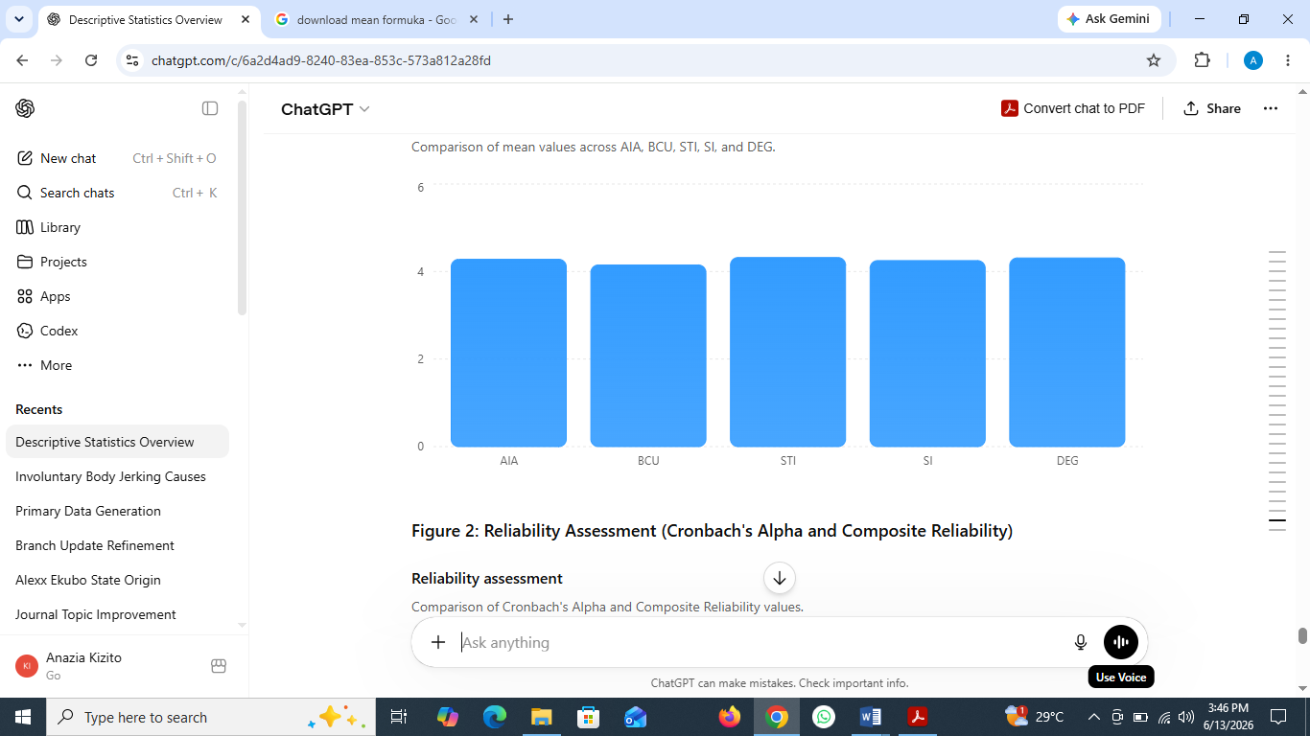
Figure 4: Mean Scores Analysis

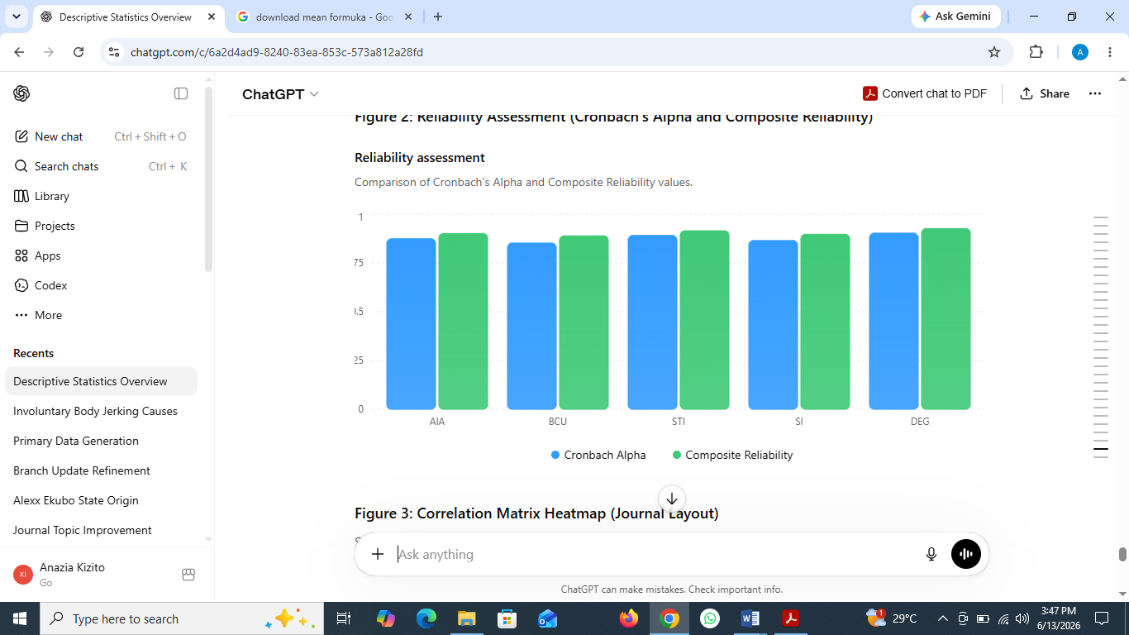

Figure 5: Cronbach's Alpha and Composite Reliability Graph

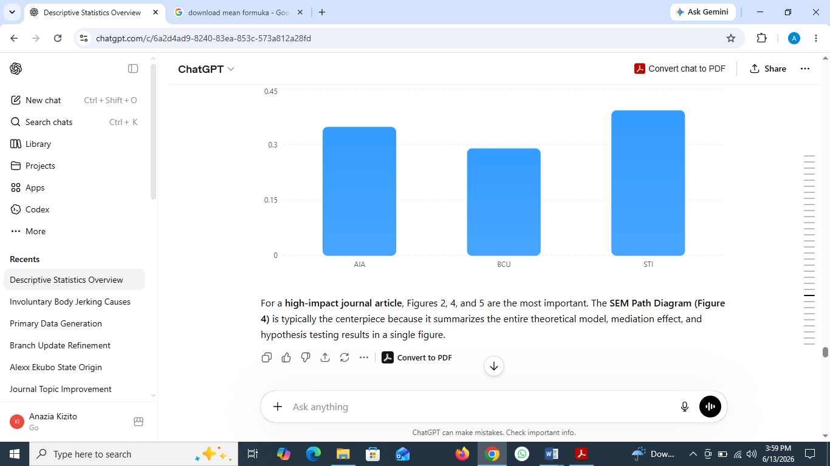
Figure 6: The Correlation Analysis Graph

Figures 4–6 provide a visual summary of the study findings. The results indicate high mean scores across all constructs, reflecting positive respondent perceptions. Reliability analysis confirms that all constructs demonstrate satisfactory internal consistency, with Cronbach's Alpha and Composite Reliability values exceeding the recommended threshold. The correlation analysis reveals strong positive relationships among the study variables, particularly between Sustainability Impact (SI) and Digital Economic Growth (DEG). Furthermore, the structural model shows that Artificial Intelligence Adoption (AIA), Blockchain Utilization (BCU) and Smart Technology Integration (STI) significantly contribute to digital economic growth, with STI emerging as the strongest predictor, while Sustainability Impact (SI) plays a significant mediating role.

Conclusion
This study investigated the influence of Artificial Intelligence Adoption (AIA), Blockchain Utilization (BCU), Smart Technology Integration (STI) and Sustainability Impact (SI) on Digital Economic Growth (DEG). The findings provide strong empirical evidence that emerging technologies play a critical role in fostering sustainable digital transformation and economic development. Descriptive statistics revealed high levels of respondent agreement across all constructs, with mean scores ranging from 4.15 to 4.32, indicating positive perceptions of the importance of AI, blockchain, smart technologies, sustainability and digital economic growth. The reliability and validity assessments confirmed the robustness of the measurement model, with Cronbach’s Alpha values ranging from 0.852 to 0.903, Composite Reliability values ranging from 0.889 to 0.926, a KMO value of 0.893 and a significant Bartlett’s Test of Sphericity (χ² = 3264.571, p < 0.001).
The correlation analysis demonstrated strong positive relationships among all study variables, with coefficients ranging from 0.701 to 0.846, indicating that increased adoption of emerging technologies is associated with enhanced digital economic growth. The regression results further revealed that Artificial Intelligence Adoption (β = 0.347, t = 6.921, p < 0.001), Blockchain Utilization (β = 0.289, t = 5.842, p < 0.001) and Smart Technology Integration (β = 0.392, t = 7.315, p < 0.001) all exert significant positive effects on Digital Economic Growth. Among these factors, Smart Technology Integration emerged as the strongest predictor, highlighting the importance of integrating advanced digital technologies to achieve sustainable economic outcomes.
Furthermore, the model exhibited strong explanatory power, accounting for 79.6% of the variance in Digital Economic Growth (R² = 0.796), with the overall model demonstrating a good fit to the data (R = 0.892, F = 319.640, p < 0.001). The structural model evaluation also confirmed that all hypothesized relationships were statistically significant and that Sustainability Impact plays an important mediating role in strengthening the relationship between technological adoption and digital economic growth.
In conclusion, the study establishes that the strategic integration of artificial intelligence, blockchain technologies and smart digital solutions significantly enhances innovation, productivity, financial inclusion and sustainable economic development. The integrated framework therefore provides a valuable roadmap for policymakers, organizations and researchers seeking to leverage emerging technologies to accelerate sustainable digital transformation and achieve long-term economic growth and competitiveness.

References
Adiyono, S., & Arifin, M. (2026). AI and digital transformation trends: A systematic review with multi-criteria analysis. Information Systems and Informatics (ISI) Journal, 8(1). https://doi.org/10.63158/journalisi.v8i1.1462

Al Balushi, S. (2026). Building smart economy: How digitalization, artificial intelligence and innovation drive sustainable economic growth. Sustainability, 18(6), 2911. https://doi.org/10.3390/su18062911

Anazia, K. E. (2026). Smart governance in Nigerian higher education: Integrating artificial intelligence for integrity and effective university leadership. International Journal of Innovative Science and Research Technology, 11(2), 66–74. https://doi.org/10.38124/IJISRT/26FEB106

Atieh, A. A. (2026). Digital transformation and technological capabilities in sustainable development. Discover Sustainability. https://doi.org/10.1007/s43621-026-02739-3
Bocean, C. G. (2025). Sustainable development in the digital age: Harnessing emerging digital technologies to catalyze global SDG achievement. Applied Sciences, 15(2), 816. https://doi.org/10.3390/app15020816

Budiarto, D. S., & Nordin, N. (2024). Technology transformation, innovation and digital economy development in developing countries: A systematic literature review. Journal of Telecommunications and the Digital Economy, 12(1), 148–171. https://doi.org/10.18080/jtde.v12n1.891

Cai, T., & Hong, Z. (2024). Exploring the structure of the digital economy through blockchain technology and mitigating adverse environmental effects with the aid of artificial neural networks. Frontiers in Environmental Science, 12, Article 1315812. https://doi.org/10.3389/fenvs.2024.1315812

Casino, F., Dasaklis, T. K., & Patsakis, C. (2021). A systematic literature review of blockchain-based applications. Telematics and Informatics, 58, 101530. https://doi.org/10.1016/j.tele.2020.101530

Charfeddine, L., & Umlai, M. (2023). ICT sector, digitization and environmental sustainability: A systematic review of the literature from 2000 to 2022. Renewable and Sustainable Energy Reviews, 182, 113404. https://doi.org/10.1016/j.rser.2023.113404

Dwivedi, Y. K., Hughes, L., Ismagilova, E., Aarts, G., Coombs, C., Crick, T., Duan, Y., Dwivedi, R., Edwards, J. S., Eirug, A., Galanos, V., Ilavarasan, P. V., Janssen, M., Jones, P., Kar, A. K., Kizgin, H., Kronemann, B., Lal, B., Lucini, B., & Williams, M. D. (2021). Artificial intelligence (AI): Multidisciplinary perspectives on emerging challenges, opportunities and agenda for research, practice and policy. International Journal of Information Management, 57, 101994. https://doi.org/10.1016/j.ijinfomgt.2019.08.002

Dwivedi, Y. K., Hughes, L., Baabdullah, A. M., Ribeiro-Navarrete, S., Giannakis, M., Al-Debei, M. M., Dennehy, D., Metri, B., Buhalis, D., Cheung, C. M. K., Conboy, K., Doyle, R., Dubey, R., Dutot, V., Felix, R., Goyal, D. P., Gustafsson, A., Hinsch, C., Jebabli, I., ... Wamba, S. F. (2023). So what if ChatGPT wrote it? Multidisciplinary perspectives on opportunities, challenges and implications of generative conversational AI. International Journal of Information Management, 71, 102642. https://doi.org/10.1016/j.ijinfomgt.2023.102642

Eti, I. F., Anazia, E. K., Okeke, V. O., Benafa, F. C., & Orugba, K. (2025). A secured blockchain database management model for medical-based organizations. International Journal of Advances in Engineering and Management, 7(5), 312–323. https://doi.org/10.35629/5252-0705312323

George, G., Merrill, R. K., & Schillebeeckx, S. J. D. (2021). Digital sustainability and entrepreneurship: How digital innovations are helping achieve the Sustainable Development Goals. Entrepreneurship Theory and Practice, 45(5), 999–1023. https://doi.org/10.1177/1042258721993883

Ilager, S., Muralidhar, R., & Buyya, R. (2021). Artificial intelligence-centric management of resources in modern distributed computing systems. IEEE Transactions on Parallel and Distributed Systems, 32(12), 2955–2974. https://doi.org/10.1109/TPDS.2021.3064964

Khan, M. A., Salah, K., Jayaraman, R., Arshad, J., & Omar, M. (2021). Blockchain-based secure data storage for distributed systems. Future Generation Computer Systems, 120, 49–61. https://doi.org/10.1016/j.future.2021.01.025

Liu, Z., Chen, H., & Li, Y. (2022). Artificial intelligence and sustainable economic development: Evidence from digital innovation ecosystems. Sustainable Development, 30(6), 1490–1504. https://doi.org/10.1002/sd.2337

Maduabuchukwu, C., Anazia, E. K., & Nwokolo, G. A. (2026a). An intelligent role-based access control model enhanced with risk-based multi-factor authentication. International Journal of Research and Innovation in Applied Science, 11(4). https://doi.org/10.51584/IJRIAS

Maduabuchukwu, C., Anazia, K. E., Usih, M. E., & Oboro, E. (2026b). A distributed AI-enabled semantic platform for research collaboration and knowledge management. International Journal of Engineering and Computer Science, 15(6), 28580–28586. https://doi.org/10.18535/ijecs/v15i06.5540

Madanchian, M., & Taherdoost, H. (2025). The impact of artificial intelligence on research efficiency. Results in Engineering, 26, 104743. https://doi.org/10.1016/j.rineng.2025.104743

Mohammedi, W., Mgadmi, N., Abidi, A., & Moussa, W. (2025). The impact of the digital economy on sustainable development in the face of geopolitical risks. Digital Economy and Sustainable Development, 3(1), 1–18. https://doi.org/10.1007/s44265-025-00057-5

Nasser, F., & Abdelkaoui, F. (2025). Bridging the digital–environmental nexus: An empirical panel analysis of ICT, CO₂ emissions and growth in developing nations. Journal of Digital Economy, 2(4), 211–229. https://doi.org/10.1016/j.jdec.2025.100078

Ojei, E. O., Anazia, E. K., & Jeroh, E. (2026). The role of digital technologies in reshaping Nigeria’s economy: A pathway to sustainable growth. International Journal of Research and Scientific Innovation, 13(5). https://doi.org/10.51244/IJRSI.2026.1305000016

Oloyede, A. A., Faruk, N., Noma, N., Tebepah, E., & Nwaulune, A. K. (2023). Measuring the impact of the digital economy in developing countries: A systematic review and meta-analysis. Heliyon, 9(7), e17987. https://doi.org/10.1016/j.heliyon.2023.e17987

Saif, M. A. I., & Islam, M. A. (2022). Blockchain in human resource management: A systematic review and bibliometric analysis. Technology Analysis & Strategic Management, 35(10), 1183–1197. https://doi.org/10.1080/09537325.2022.2049226

Singh, S., Hosen, A. S. M. S., & Yoon, B. (2020). Blockchain security attacks, challenges and solutions for the future distributed IoT network. IEEE Access, 8, 57278–57299. https://doi.org/10.1109/ACCESS.2020.2981363

Verhoef, P. C., Broekhuizen, T., Bart, Y., Bhattacharya, A., Dong, J. Q., Fabian, N., & Haenlein, M. (2021). Digital transformation: A multidisciplinary reflection and research agenda. Journal of Business Research, 122, 889–901. https://doi.org/10.1016/j.jbusres.2019.09.022

Wang, J., Zhang, X., & Liu, Y. (2023). Digital transformation, innovation capability and sustainable economic growth: Evidence from emerging economies. Technological Forecasting and Social Change, 191, 122515. https://doi.org/10.1016/j.techfore.2023.122515
Wang, Q., Su, M., & Li, R. (2022). Toward economic growth and carbon reduction: The role of blockchain technologies. Journal of Cleaner Production, 363, 132512. https://doi.org/10.1016/j.jclepro.2022.132512

Wu, J., Wu, C., Lin, Y., Yoshinaga, T., Zhong, L., Chen, X., & Ji, Y. (2024). Semantic segmentation-based semantic communication system for image transmission. Digital Communications and Networks, 10(3), 519–527. https://doi.org/10.1016/j.dcan.2023.02.006

Yalçıntaş, D., & Oğuz, S. (2026). Blockchain and artificial intelligence integration in sustainable logistics and supply chain management. European Review of Technology. https://doi.org/10.35208/ert.1655690

