Assessing the Ethical Climate and Moral Judgments of Higher Education Support Staff: A Descriptive Baseline Study

Abstract

This study establishes a baseline descriptive profile of the ethical decision-making landscape among 141 higher education support staff. Utilizing the Hunt-Vitell general theory of ethics, the study examines the prevailing ethical organizational climate, the cognitive balancing of deontological and teleological moral evaluations, and overall ethical judgments. The data collected via a 5-point Likert scale was normally distributed and analysed using descriptive statistics. The results reveal a highly robust and unified Ethical Organizational Climate alongside a balanced cognitive approach between Deontological and Teleological evaluations, culminating in strong Ethical Judgments. Demographically, the sample is characterized by high institutional tenure, dominated by the Executor tier. The findings suggest that extensive organizational longevity serves as a stabilizing mechanism, institutionalizing high ethical consensus across departments. These results provide insight into the role of tenure in fostering a shared ethical culture and balanced moral reasoning within higher education institutions. However, the study is limited by its descriptive design, reliance on self-reported data, and conducted within a specific organisational context, which may constrain generalizability. Future research should employ inferential and longitudinal approaches across diverse organizational contexts to further examine the relationships among ethical climate, moral evaluations, and ethical decision-making.

Keywords: Ethical Organizational Climate, Deontological, Teleological, Ethical Judgments, Higher Education

INTRODUCTION

Ethics is a branch of philosophy concerned with the systematization, defence, and recommendation of conceptions of right and wrong. The ideas help people navigate their lives and make choices. Although making ethical decisions might cost the decision-maker more money in the long run, many parties would benefit in the end (Nguyen & Crossan, 2022). On the other hand, an immoral choice can benefit the decision-maker but it would be harmful to society and stakeholders (Cragg, 2017, cited in Werhane et al., 2017). Ethics have become more important in business, especially after several companies worldwide went into bankruptcy due to unethical accounting practices (Western Governors University, 2021). If people uphold high moral and ethical ideals, they are more likely to avoid unethical situations (Zakaria et al., 2010).
Ethical judgment is a major concern in many industries, including the public sector; thus, local government employees are not exempt. This is because one of the primary responsibilities of public servants is to provide services for the community's benefit and to contribute to public welfare (Hassan & Ahmad, 2021). Public sector employees have been entrusted with the responsibility of keeping the territories under their jurisdiction free of misconduct or unethical behaviour (Osman et al., 2014). Recent academic literature reinforces this ongoing challenge, highlighting that despite established regulatory and legislative frameworks, local authorities continuously struggle with systemic unethical behaviours such as nepotism, unauthorized expenditures, and bribery, which directly threaten effective governance and public service delivery (Nyikadzino & Shikha, 2026).
According to Transparency International (TI) Corruption Perception Index (CPI), there have been incidents of corruption claims in newspapers and social media that highlighted unethical behaviour and integrity as the top problem in the public sector (Johari et al., 2021). Having a corporate integrity framework in a firm leads to higher levels of ethics and integrity in the workplace. Sajari et al. (2023) investigated the factors affecting ethics and integrity in the Malaysian public sector. They found that the quality of Chief Integrity Officers (CIOs), as reflected in their competency, work performance, and ability to cultivate an ethical climate, significantly influences the level of ethics and integrity within organisations. In addition, employees who demonstrate higher ethical standards tend to show stronger organisational commitment and are more likely to remain with their organisations. Consequently, these findings help the government in identifying factors that can nurture and promote integrity in the public sector.
While extensive literature exists on how corporate executives or private-sector managers handle ethical dilemmas, there is a notable scarcity of empirical data focusing on the operational frontline that handles day-to-day administration, student affairs, and institutional assets. Recent literature confirms that while macro-level executive ethics are thoroughly explored, empirical focus frequently overlooks the unique systemic talent demands and day-to-day operational dilemmas encountered by frontline university administrative staff (Matlakala & Bezuidenhout, 2024). This oversight poses a significant risk, as frontline staff in departments are the primary implementers of institutional policies. When frontline workers operate within fractured institutional landscapes where external narratives or technocratic rules diverge from actual daily practices, it invites institutional vulnerabilities, resulting in administrative failures and a pronounced degradation of overall public service quality (Bimantoro et al., 2026).
Therefore, this study addresses this empirical gap by providing a comprehensive descriptive analysis of the ethical climate, moral evaluation frameworks, and ethical judgments among a sample of 141 higher education support staff. Specifically, this study will look into the demographic characteristics, level of perceived ethical organizational climate, degree of Deontological and Teleological evaluation, and the level of ethical judgment among the respondents. With clear baseline data, a clear mapping of the current ethical context, and an understanding of how these higher education support staff evaluate moral dilemmas, institutional leaders can design targeted integrity modules that fit the organisation. Thus, it offers recommendations to the management of academic institutions by creating a conducive ethical environment in the organization that would trigger ethical judgment among higher education support staff in Malaysia.
LITERATURE REVIEW
Ethical conduct is becoming more important in today's organizations because stakeholders want accountability, transparency, and integrity. Ethical conduct in higher education institutions goes beyond academics to include administrative and support functions that assist the institution to function effectively and gain public trust. Support staff carry out tasks such as student administration, financial management, procurement, human resources and regulatory compliance, all of which can raise ethical issues. However, despite their critical role in governance, there has been little research on ethical views and moral judgements of support staff, especially in higher education contexts.
This study’s framework is based on the General Theory of Marketing Ethics developed by Hunt and Vitell (1986). The theory proposes that when individuals encounter ethical dilemmas, they engage in two parallel cognitive evaluation processes: deontological and teleological. These evaluations are influenced by environmental factors, including organisational culture and ethical climate, which provide cues regarding acceptable behaviour and ethical expectations. The resulting ethical judgment subsequently influences behavioural intentions and actions (Hunt & Vitell, 1986; Hunt & Vitell, 2006). Although originally developed within the marketing discipline, the theory has been widely applied in organisational ethics research to explain how individuals evaluate ethical issues and make moral decisions. Prior studies that have followed the Hunt and Vitell (1986) theory of ethics examined the impact of organizational ethical climate (Alteer et al., 2013; Haron et al., 2015), and the effects of deontological and teleological evaluations (Clark & Dawson, 1996; Zakaria et al., 2010) on ethical judgement.
An ethical decision is one that is legally and morally sound. Ethical judgment refers to an individual's evaluation of whether a particular action or behaviour is morally right or wrong (Rest, 1994). It is a critical component of the ethical decision-making process because it influences how individuals respond when confronted with ethical dilemmas. Hunt and Vitell (1986) conceptualised ethical judgment as an assessment based on both deontological (non-consequences) and teleological (consequences) evaluations.
Ethical judgments are often reflected in individuals’ perceptions of what constitutes appropriate or inappropriate behaviour according to accepted social and organisational norms. However, ethical judgments are not formed in isolation. Treviño (1986) and Jones (1991) argued that both individual characteristics and contextual factors influence ethical decision-making. In organisational settings, employees are guided by prevailing norms, expectations, policies, and practices that shape their interpretations of ethical issues and influence their judgments. Consequently, individuals working in environments that emphasise ethical values and responsible conduct are more likely to demonstrate higher levels of ethical judgment.
Recent empirical evidence further supports the view that ethical judgments are influenced by both personal and situational factors. For example, Borhani et al., (2021) found that individuals' perspectives and decision-making approaches significantly affect their moral choices when facing ethical dilemmas. Their findings suggest that ethical judgments vary according to the decision-making context and the way individuals evaluate moral situations. Taken together, the literature indicates that ethical judgment is a complex cognitive process shaped by moral reasoning, individual values, and environmental influences, making it a central element in understanding ethical behaviour within organisations.
The concept of organizational climate is inextricably linked to the idea of the workplace as a community. The organizational ethical environment is defined as the majority of employees' perceptions of ethical organizational norms and procedures, as well as what constitutes appropriate behaviour (Victor & Cullen, 1988). In most firms, leaders appear to be focused on the relevance of ethical outcomes if an ethical atmosphere and culture develop. As a result, the ethical atmosphere of an organization can influence ethical judgement and ethical decisions in ethical problems. The significance of ethical climate is well-supported in the literature. Martin and Cullen (2006), in their meta-analysis of ethical climate research, found that ethical climate is linked to positive organizational outcomes, such as job satisfaction, organizational commitment, and ethical behaviour. Similarly, Schwepker (2001) reported that an ethical climate positively impacts employee commitment while decreasing intentions to engage in undesirable workplace behaviours. More recently, Aloustani et al., (2020) discovered that ethical climate significantly influences organizational citizenship behaviour among nurses, indicating that ethical work environments promote positive discretionary behaviours that enhance organizational effectiveness. Overall, these findings highlight that ethical climate plays a crucial role in shaping employees' attitudes, behaviours, and ethical judgments.
An organization's ethical culture encourages employees to consider two simultaneous evaluation paths when addressing a moral problem: rules and duties (deontological) and outcomes and consequences (teleological). Deontological evaluations focus on the inherent rightness or wrongness of a behaviour based on established rules, duties, compliance codes, and standard operating procedures (SOPs). In contrast, teleological evaluations emphasize the perceived consequences of an action, weighing the overall goodness against the badness that may result (Hunt & Vitell, 2006).
From a deontological perspective, ethical decisions are guided by compliance with moral duties, professional standards, and organisational rules, irrespective of the outcomes that may result from those decisions (Hunt & Vitell, 1986). In this view, legal requirements or duties take precedence over ethical obligations or strict adherence to the constitution (Russo, 2018). Therefore, when individuals adopt a deontological approach, their decision-making process is consistent, as they have a clear understanding of their moral responsibilities and the necessary norms that govern those duties. Consequently, they are likely to act in a morally responsible manner.
In contrast, teleological evaluation assesses ethical actions based on their anticipated consequences (Hunt & Vitell, 1986). Teleological evaluations consider the benefits to stakeholders, the intentions and potential consequences, along with personal feelings and characteristics. Consequently, ethical decisions are judged according to the desirability and likely impact of their consequences. Hunt and Vitell (2006) argued that ethical decision-making often involves balancing both deontological and teleological considerations, rather than relying exclusively on one evaluative approach.
Previous studies have demonstrated the relevance of these reasoning processes across organisational contexts. Clark and Dawson (1996) reported that ethical judgments are motivated by personal religiousness, while Zakaria et al., (2010) found that auditors' ethical judgments are influenced by both deontological and teleological moral philosophies. The study suggests that auditors evaluate ethical issues based on adherence to moral principles and professional obligations, as well as the potential consequences of their actions. These findings support the argument that moral philosophy plays a significant role in shaping ethical judgments and ethical decision-making within professional settings. Similarly, Zakaria et al.,(2021) found that government employees’ whistleblowing intentions were influenced by organizational ethical culture, deontological and teleological evaluations. These findings support the proposition that employees draw upon both rule-based and consequence-based evaluations when making ethical judgments.
There are many studies on ethical climate and ethical judgement in business, healthcare, auditing and public-sector organisations (Borhani et al., 2021; Zakaria et al., 2021; Zakaria et al., 2010). However, there has been limited research on support staff in higher education institutions. Much of the research on ethics in higher education has been focused on academic integrity, faculty behaviour, ethical leadership and ethical issues related to students, while the ethical experiences of non-academic employees have been largely ignored. The omission is significant as support staff carry out operational and administrative functions that have a direct bearing on institutional integrity, service delivery and stakeholder confidence.
As higher education focuses more on good governance and integrity, it is important to understand the ethical environment and moral choices of support staff. This study looks at the ethical climate and moral judgment among support staff in higher education. The findings add to the knowledge about organizational ethics and human resource management and may help shape policies and ethics initiatives in colleges and universities.

METHODOLOGY

Research Design and Sampling
The research design serves as a guideline for the researcher on how to conduct the study. This study applied a quantitative non-experimental research design with a single dependent variable, which is ethical judgments, and three independent variables, namely organizational ethical climate, deontological evaluations, and teleological evaluations.
The focus of this study was ethical work behaviour in a higher education institution. The unit of analysis was higher education support staff working in various departments at a public university in Peninsular Malaysia. The list contained managers, executives, and supervisors, who served as the sampling frame for the study. This study used a stratified random sampling method to select the sample, ensuring that every member of the population had an equal chance of being selected as a respondent. Initially, the population was divided into several position levels before selecting the final sample. A sample size of 141 respondents was determined using Krejcie and Morgan’s (1970) table, based on a population of 220 staff.

Instrumentation and Data Analysis
The questionnaire comprised four sections: A, B, C, and D. Section A collected the demographic profile of the respondents, including gender, age, marital status, years of work experience, department, and position level. Section B covered ten questions that measured organizational ethical climate. Section C consisted of eighteen questions to measure deontological evaluations and teleological evaluations. Finally, Section D comprised five scenario cases to measure ethical judgements.
The data for Sections B, C and D were captured using a 5-point Likert scale (ranging from 1 = Strongly Disagree to 5 = Strongly Agree). Descriptive statistical analysis of the dataset was conducted using SPSS. The categorical data on demographics were analysed for frequencies and percentages, while means and standard deviations were computed to describe continuous ethical constructs. Skewness and kurtosis tests confirmed the normality of the data, validating the use of central tendency metrics (Field, 2024).

RESULTS AND DISCUSSION

Demographic Profile of Respondents
The demographic characteristics of the 141 respondents are summarized in Table 1.

Table 1: Demographic Profile of Respondents
Demographic Variable | Category | Frequency | Percentage
Gender | Male | 83 | 58.9
 | Female | 58 | 41.1
Marital Status | Single | 29 | 20.6
 | Married | 106 | 75.2
 | Widow / Widower | 6 | 4.2
Age | Less than 30 years old | 37 | 26.2
 | 31–40 years old | 42 | 29.8
 | 41–50 years old | 33 | 23.4
 | 51–60 years old | 29 | 20.6
Years of Service | Less than 5 years | 44 | 31.2
 | 6–10 years | 5 | 3.5
 | 11–20 years | 48 | 34.0
 | 21–30 years | 44 | 31.2
Department | Registrar Department | 40 | 28.4
 | Internal Audit Department | 23 | 16.3
 | Human Resource Faculty | 16 | 11.3
 | Residential College | 43 | 30.5
 | ICT Department | 19 | 13.5
Position | Mgt. & Professional (Grade 41 and above) | 19 | 13.5
 | Executor (Grade 19 – 38) | 122 | 86.5

The sample is dominated by males (58.9%) and married (75.2%), with a balanced distribution across all age brackets. Notably, organizational tenure displays a distinct U-shaped distribution: 31.2% are new hires of less than 5 years, while a combined 65.2% are long-serving staff with 11 to 30 years of experience. The Executor tier (Grade 19–38) forms the overwhelming majority, representing 86.5% of the sample.

Descriptive Analysis of Ethical Constructs
The central tendency and dispersion metrics for the primary ethical variables are presented in Table 2.

Table 2: Descriptive Statistics for Ethical Variables
Variable | Minimum | Maximum | Mean | Std. Deviation
Ethical Organizational Climate | 2.20 | 5.00 | 4.28 | 0.5063
Deontological Evaluations | 2.30 | 5.00 | 4.24 | 0.4547
Teleological Evaluations | 2.56 | 5.00 | 4.21 | 0.4655
Ethical Judgment | 2.33 | 5.00 | 4.22 | 0.5609

Based on Table 2, high scores are reported across all dimensions, with the perceptions of Ethical Organizational Climate yielding the highest average score (Mean = 4.28, S.D = 0.5063). Comparing the cognitive frameworks, Deontological Evaluations scored slightly higher than Teleological Evaluations, with respective mean values of 4.24 and 4.21; and, standard deviation of 0.4547 and 0.4655. Finally, Ethical Judgment demonstrated a high baseline mean of 4.22 (S.D = 0.5609). The descriptive findings provide critical insights into the institution's ethical ecosystem, which suggests that respondents perceive their organisational environment as ethical and tend to make ethical evaluations and judgments when confronted with moral dilemmas.
The results of descriptive statistics are further visualised in Figures 1, 2 and 3. Overall, the respondents demonstrate consistently high levels of ethical perceptions and evaluations across all variables, with mean values exceeding 4.20 on a 5-point Likert scale. This suggests a generally strong ethical orientation among the respondents.
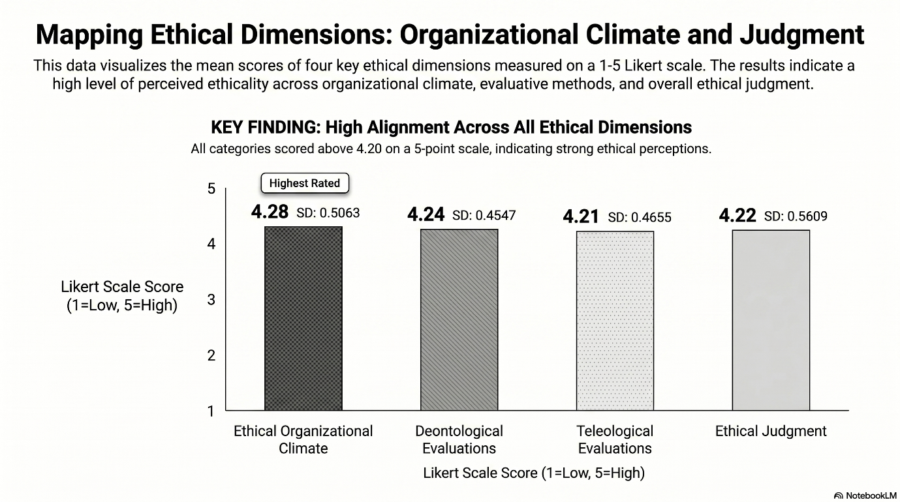
Figure 1: Comparison of Mean Scores
Figure 1 shows the comparison of mean scores across all constructs. Specifically, the highest mean score recorded for Ethical Organizational Climate (Mean = 4.28, S.D = 0.5063) reflects that the respondents generally perceive their organizational environment as supportive of ethical values, ethical behaviour, and responsible decision-making. It further indicates that ethical standards and expectations are well recognized within the organization. Besides, the relatively low standard deviation suggests a strong consensus among respondents regarding the ethical climate. It also suggests that institutional ethical norms are universally understood, and embedded across all surveyed sub-units, validating Victor and Cullen’s (1988) assertions that organisational norms and ethical expectations play an important role in guiding employee behaviour and decision-making. A positive ethical climate may encourage employees to consider ethical implications before taking action and reduce the likelihood of unethical behaviour. This aligns with recent empirical studies indicating that institutional environments with tight regulatory oversight tend to show a unidimensional, highly converged ethical climate perception among staff (Din et al., 2025).
Meanwhile, the second-highest construct - Deontological Evaluations achieved a mean score of 4.24 (S.D = 0.4547), revealing a strong tendency among respondents to assess ethical issues based on adherence to rules, duties, and moral principles. The high score suggests a strong preference for principle-based ethical reasoning, while the comparatively lower standard deviation indicates high degree of agreement across respondents.
The mean score for Deontological Evaluations was slightly higher than mean score observed for Teleological Evaluations (Mean = 4.21, S.D = 0.4655). Although slightly lower than the other constructs, the difference is minimal, and the score remains substantially above the scale midpoint. This indicates that respondents also consider the consequences and outcomes of actions when making ethical decisions, but to a slightly lesser extent than they rely on duty- or rule-based considerations. The findings support Hunt and Vitell’s (1986) General Theory of Marketing Ethics, which proposes that ethical decision-making involves both deontological and teleological reasoning processes.
Similarly, Ethical Judgment reported a mean score of 4.22 (S.D = 0.5609), suggesting that respondents generally perceive unethical actions negatively and are inclined to make ethical decisions. This finding may reflect the influence of both a supportive ethical climate and strong moral evaluation processes. Previous studies have shown that individuals operating in ethical organisational environments are more likely to demonstrate higher levels of ethical judgment and ethical behaviour (Martin & Cullen, 2006; Zakaria et al., 2010).
The standard deviations ranged from 0.4547 to 0.5609, indicating relatively low variability in responses. This suggests a reasonable degree of consensus among respondents regarding the ethical climate of their organisation and the importance of both deontological and teleological considerations in ethical decision-making. Additionally, the data indicate that when encountering ethical dilemmas, the respondents utilize both major moral frameworks almost equally, with a difference of only 0.03 in mean value. Interpreted through the Hunt-Vitell theory, this indicates a highly mature, dual-layered moral reasoning process (Hunt & Vitell, 2006). Higher education support staff do not blindly prioritize rigid compliance over outcomes, nor do they strictly justify questionable means for a good outcome. Instead, they actively weigh their procedural, duty-bound mandates alongside the potential real-world impacts of their decisions.
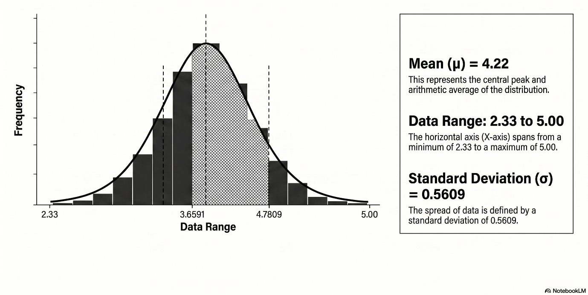
Figure 2: Distribution of Ethical Judgment Scores
Gauging further on ethical judgment score, Figure 2 illustrates the normal distribution curve and standard deviation shading. The distribution of Ethical Judgment scores appears approximately normal, centred around the mean value of 4.22, with most observations clustered between 4.0 and 4.5. This pattern indicates that respondents generally possess a high level of ethical judgment, with limited dispersion around the mean.
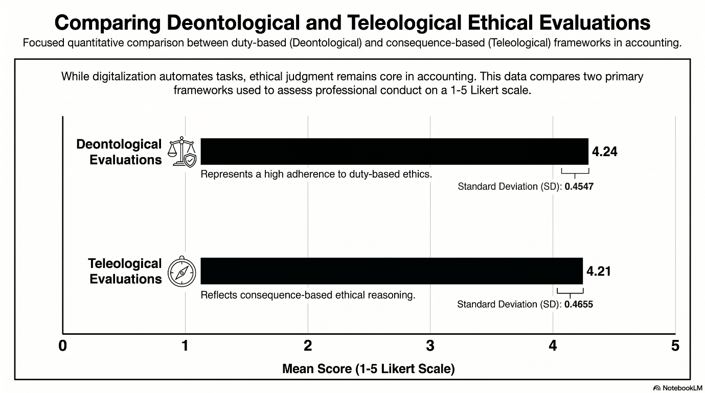
Figure 3: Inter-Construct Comparison (Deontology vs. Teleology)

Apart from that, the Inter-Construct Comparison as depicted in Figure 3 highlights the close relationship between Deontological Evaluations (Mean = 4.24) and Teleological Evaluations (Mean = 4.21). The minimal difference of 0.03 points suggests that respondents employ both rule-based and consequence-based reasoning when assessing ethical situations. However, the slightly higher deontological score implies a marginal preference for evaluating ethical issues based on principles and obligations rather than solely on outcomes.
To sum up, the descriptive analysis revealed high mean scores across all ethical constructs, ranging from 4.21 to 4.28 on a five-point Likert scale. This narrow range suggests a high degree of consistency across the ethical constructs. Respondents appear to possess a balanced ethical orientation in their evaluation towards Ethical Organizational Climate, Deontological Evaluations, Teleological Evaluations, and Ethical Judgment.
The findings further suggest that respondents place slightly greater emphasis on principle-based ethical considerations than consequence-based evaluations when assessing ethical situations. Overall, the results reflect a highly ethical orientation supported by a positive ethical organizational climate. It demonstrates that ethical considerations are deeply embedded in respondents' evaluations and judgments, reflecting a generally robust ethical orientation within the sample.

CONCLUSION
This study successfully maps out an organization characterized by strong ethical health. The findings of this study provide valuable insights into the ethical perceptions and moral reasoning of the respondents. The descriptive analysis yields a clear baseline: the institution possesses a unified, high-integrity workplace climate that fosters a balanced approach to moral reasoning. The descriptive results indicate that Ethical Organizational Climate, Deontological Evaluations, Teleological Evaluations, and Ethical Judgment all recorded relatively high mean scores, suggesting that respondents generally perceive their organisations as fostering ethical values and demonstrate strong ethical orientations when making decisions. Ethical Organizational Climate recorded the highest mean score, indicating that respondents view their organisations as promoting ethical behaviour, accountability, and responsible decision-making.
The findings further suggest that both deontological and teleological moral philosophies contribute to ethical judgment. Respondents appear to rely on moral principles, professional obligations, and organisational rules when evaluating ethical issues, while also considering the potential consequences of their actions on stakeholders. This demonstrates that ethical decision-making is influenced by both rule-based and consequence-based reasoning. The high mean score for Ethical Judgment indicates that respondents are generally capable of recognising ethical issues and making decisions that align with accepted ethical standards. Furthermore, the relatively low standard deviations across all variables suggest a high degree of consistency in respondents’ perceptions and evaluations.
Despite these contributions, several limitations should be acknowledged. First, the study relied solely on self-reported data, which may be subject to social desirability bias, whereby respondents provide answers that reflect socially acceptable behaviour rather than their actual practices. Second, the use of a cross-sectional design limits the ability to establish causal relationships among the variables. Third, the study was conducted within a specific organisational context, which may limit the generalisability of the findings to other sectors or populations.
Future research could address these limitations by employing longitudinal designs to examine changes in ethical perceptions and judgments over time. Researchers may also expand the study to different industries, professional groups, or cultural settings to enhance the generalisability of the findings. Additionally, future studies could investigate the influence of demographic factors, ethical leadership, organisational culture, or individual characteristics as potential antecedents of ethical judgment. Such research would contribute to a more comprehensive understanding of the factors that shape ethical decision-making within organisations.
AUTHORS’ CONTRIBUTION
All authors are involved in the conceptualization of the article. All authors have read and agreed to the published version of the manuscript.

ETHICAL CONSIDERATION
The research participants were provided with sufficient information to assist in an informed decision as to whether to take part in research (informed consent) through the cover letter of the questionnaire. Informed consent was obtained from all subjects involved in the study.

DATA AVAILABILITY STATEMENT
Not applicable.
CONFLICTS OF INTEREST
The authors declare no conflict of interest.

REFERENCES
1. Aloustani, S., Atashzadeh-Shoorideh, F., Zagheri-Tafreshi, M., Nasiri, M., Barkhordari-Sharifabad, M., & Skerrett, V. (2020). Association between ethical leadership, ethical climate and organizational citizenship behavior from nurses’ perspective: a descriptive correlational study. BMC nursing, 19(1), 15.
2. Alteer, A. M., Yahya, S. B., & Haron, M. H. (2013). Auditors' personal values and ethical judgement at different levels of ethical climate: A conceptual link. Journal of Asian Scientific Research, 3(8), 862.
3. Bimantoro, T., Sasongko, A. B., & Kamilia, A. (2026). Indications of manufactured incompetence: Neopatrimonial governance and public service erosion in Indonesia's Free Nutritious Meal Program. Priviet Social Sciences Journal, 6(4), 284-300.
4. Borhani, F., Abbaszadeh, A., Bahrampour, A., Ameri, G. F., & Aryaeenezhad, A. (2021). Role of judgment in promoting nurses’ decisions and ethical behavior. Journal of education and health promotion, 10(1), 88.
5. Clark, J. W., & Dawson, L. E. (1996). Personal religiousness and ethical judgements: An empirical analysis. Journal of Business Ethics, 15(3), 359-372.
6. Din, Q. M. U., Tahir, A., Xiaojuan, Y., Alqahtani, S., & Gul, N. (2025). Ethical climate in higher education: The interplay of leadership, moral efficacy, and team cohesion in diverse cultural contexts. Acta Psychologica, 255, 104986.
7. Field, A. (2024). Discovering statistics using IBM SPSS statistics. Sage publications limited.
8. Haron, H., Ismail, I., & Na, A. L. (2015). The effect of moral reasoning, exposure to ethics and perceived ethical climate on ethical judgement of auditors in Malaysia. Asian Journal of Business and Accounting, 8(2), 25-66.
9. Hassan, H. A., & Ahmad, A. B. (2021). The relationship between Islamic work ethic and public service motivation. Administration & Society, 53(9), 1390-1417.
10. Hunt, S. D., & Vitell, S. (1986). A general theory of marketing ethics. Journal of macromarketing, 6(1), 5-16.
11. Hunt, S. D., & Vitell, S. J. (2006). The general theory of marketing ethics: A revision and three questions. Journal of macromarketing, 26(2), 143-153.
12. Johari, R. J., Alam, M. M., & Said, J. (2021). Empirical assessment on factors contributing to integrity practices of Malaysian public sector officers. Business Process Management Journal, 27(4), 1217-1237.
13. Jones, T. M. (1991). Ethical decision making by individuals in organizations: An issue-contingent model. Academy of management review, 16(2), 366-395.
14. Krejcie, R. V., & Morgan, D. W. (1970). Determining sample size for research activities. . Educational and Psychological Measurement, 30(3), 607–610. https://doi.org/10.1177/001316447003000308
15. Martin, K. D., & Cullen, J. B. (2006). Continuities and Extensions of Ethical Climate Theory: A Meta-Analytic Review: Kelly D. Martin and John B. Cullen. Journal of Business Ethics, 69(2), 175-194.
16. Matlakala, H. N., & Bezuidenhout, A. (2024). Administrative staffs' training needs and talent development at a Health Sciences University. SA Journal of Human Resource Management, 22, 1-14.
17. Nguyen, B., & Crossan, M. (2022). Character-infused ethical decision making. Journal of Business Ethics, 178(1), 171-191.
18. Nyikadzino, T., & Shikha, V.-D. (2026). Challenges to Promoting Ethical Conduct in Zimbabwe’s Local Authorities. International Journal of Environmental, Sustainability, and Social Science, 7(3), 642-653.
19. Osman, M. M., Bachok, S., Bakri, N. I. M., & Harun, N. Z. (2014). Government delivery system: effectiveness of local authorities in Perak, Malaysia. Procedia-Social and Behavioral Sciences, 153, 452-462.
20. Rest, J. R. (1994). Background: Theory and research. In Moral development in the professions (pp. 13-38). Psychology Press.
21. Russo, C. M. (2018). Influence of Individual and Sociocultural Characteristics on Ethical Decision-making among Students. Capella University.
22. Sajari, A., Haron, H., Ganesan, Y., & Khalid, A. A. (2023). Factors influencing the level of ethics and integrity in Malaysian public sector. Journal of Islamic Accounting and Business Research, 14(1), 141-158.
23. Schwepker Jr, C. H. (2001). Ethical climate's relationship to job satisfaction, organizational commitment, and turnover intention in the salesforce. Journal of business research, 54(1), 39-52.
24. Trevino, L. K. (1986). Ethical decision making in organizations: A person-situation interactionist model. Academy of management review, 11(3), 601-617.
25. Victor, B., & Cullen, J. B. (1988). The organizational bases of ethical work climates. Administrative science quarterly, 101-125.
26. Werhane, P., Freeman, R., & Dmytriyev, S. (2017). The use of historical figures as a research approach. Cambridge handbook of research approaches to business ethics and corporate responsibility, 12-24.
27. Western Governors University. (2021). Ethical dilemmas: How scandals damage companies. https://www.wgu.edu/blog/ethical-dilemmas-how-scandals-damage-companies1909.html#close
28. Zakaria, M., Abd Manaf, K., Nurmala Sari, E., Syed Yusuf, S. N., Abdul Rahman, R., & Hamoudah, M. M. (2021). Effective internal controls and governance: Analysis of ethical culture and ethical evaluations on whistleblowing intentions of government officials. Polish Journal of Management Studies, 23(1), 487-502.
29. Zakaria, M., Haron, H., & Ismail, I. (2010). Do moral philosophies influence auditors’ ethical judgments? Management & Accounting Review (MAR), 9(1), 1-23.

