Regional Patterns of Employability Outcomes under the Pradhan Mantri Kaushal Vikas Yojana in India’s Workforce Development Landscape
Manish Rathore ¹, Dr. Anisha Satsangi ²
1 Research Scholar, Faculty of Commerce, Dayalbagh Educational Institute, Agra | Email. Id: manishrathore2306659@dei.ac.in | ORCID: 0009-0004-2542-7657
2 Assistant Professor, Faculty of Commerce, Dayalbagh Educational Institute, Agra | Email. Id: anishasatsangi@dei.ac.in
Abstract
This study assesses the impact of the Pradhan Mantri Kaushal Vikas Yojana (PMKVY) on the employability of certified students through a state-wise analysis of certification and placement data. Using secondary data and chart-based visualization techniques, the study identifies significant variations across states in translating skill certification into employment. The results indicate that although PMKVY has achieved wide coverage in terms of certification, the employability outcomes of certified candidates remain inconsistent, with substantial gaps observed between certified and placed students in several states. States with stronger industry linkages and employment ecosystems show relatively better placement performance, while others face challenges related to skill job mismatch and limited labour market absorption. The findings suggest that PMKVY’s impact on employability depends not only on certification volume but also on the effectiveness of placement mechanisms, industry participation, and demand-driven skill development.
Keywords: Pradhan Mantri Kaushal Vikas Yojana, PMKVY, Employability Outcomes, Regional Patterns, Workforce Development, Human Capital Formation, Skill Development, India
INTRODUCTION
Human capital development is widely recognised as a fundamental driver of economic growth, productivity enhancement, and social mobility. In developing economies such as India, the challenge of transforming a large and young workforce into a skilled and employable labour force has been persistent. Despite rapid economic expansion in recent decades, India continues to face structural issues including high informal employment, skill mismatches, low productivity, and limited access to formal vocational training. A significant proportion of the workforce lacks industry-relevant skills, thereby restricting their employment opportunities and income potential.
To address these challenges, the Government of India launched the Pradhan Mantri Kaushal Vikas Yojana (PMKVY) in 2015 as the flagship skill development initiative under the broader Skill India Mission. The scheme aims to provide short-term training, certification, and placement assistance to youth across diverse sectors, with particular emphasis on enhancing employability in both formal and informal segments of the economy. PMKVY operates through multiple components including Short-Term Training (STT), Recognition of Prior Learning (RPL), and special projects, implemented through central and state-level mechanisms.
Over successive phases—PMKVY 1.0, 2.0, 3.0, and the recently introduced PMKVY 4.0—the programme has expanded significantly in scale, reaching millions of beneficiaries across all states and union territories. The scheme has also undergone several structural modifications aimed at improving industry linkages, training quality, and employment outcomes. However, despite its extensive coverage, concerns have emerged regarding the effectiveness of PMKVY in translating training and certification into actual employment.
One of the most striking features of PMKVY’s performance is the significant regional variation in certification rates, placement outcomes, and overall effectiveness. While some states have demonstrated relatively higher employment outcomes and better alignment with local labour market demand, others have reported low placement percentages despite high volumes of trained candidates. These disparities raise critical questions about implementation capacity, sectoral focus, industry engagement, and the socio-economic context across regions.
Understanding these regional patterns is crucial for evaluating the success of PMKVY as a national workforce development strategy. A uniform policy applied across a diverse country like India may yield uneven outcomes due to variations in economic structure, industrial base, governance capacity, and labour market conditions. Therefore, a region-specific analysis of employability outcomes can provide valuable insights for improving policy design and resource allocation.
This paper seeks to examine the regional distribution of certification and placement outcomes under PMKVY, identify factors contributing to inter-state disparities, and assess the implications for India’s workforce development landscape. By focusing on spatial patterns rather than aggregate national figures, the study aims to highlight areas of success as well as structural weaknesses within the scheme.
REVIEW OF LITERATURE
Skill development has been extensively studied as a tool for improving labour market outcomes and economic productivity. Becker’s human capital theory emphasises investment in education and training as a means to enhance individual earnings and national growth. In the Indian context, the role of vocational training and skill development programs has gained increasing attention in recent decades due to demographic pressures and employment challenges.
Several studies have highlighted the persistent skill mismatch in India’s labour market. Mehrotra et al. (2014) argue that while India possesses a demographic dividend, the lack of adequate vocational training infrastructure undermines its potential benefits. Similarly, World Bank (2018) reports suggest that a large share of Indian employers face difficulty in hiring workers with appropriate skills, reflecting systemic gaps between training supply and industry demand.
Research on government-led skill initiatives indicates mixed results. Aggarwal (2016) observes that earlier vocational training programs in India suffered from poor industry linkage and low placement effectiveness. The introduction of PMKVY was seen as a corrective step aimed at standardising training and improving accountability through outcome-based funding.
Impact evaluations of PMKVY present varied conclusions. Some government-sponsored assessments report improvements in self-employment prospects, income levels, and skill recognition among beneficiaries. However, independent studies and audits have raised concerns regarding placement verification, training quality, and regional imbalances.
Kumar and Mishra (2020) highlight that placement outcomes under PMKVY vary significantly across states, with economically advanced regions demonstrating better absorption of trained workers. They attribute this to stronger industrial bases and employer participation. In contrast, less industrialised states often struggle to provide adequate employment opportunities despite high training volumes.
The Comptroller and Auditor General (CAG) of India, in its performance audit, identified deficiencies in monitoring mechanisms, lack of reliable placement data, and instances of training not aligned with local demand. The report emphasised that certification alone does not ensure employability unless accompanied by market-relevant skills and robust placement support.
Recent analytical work by data journalism platforms has pointed out a decline in reported placement rates in later phases of PMKVY. These findings suggest that while enrolment and certification numbers remain high, the scheme’s success in generating sustainable employment has weakened over time.
From a regional perspective, studies indicate that southern and western states tend to perform better in terms of employment outcomes due to higher industrialisation, urbanisation, and governance efficiency. Northern and eastern states, despite having large beneficiary numbers, often show lower placement ratios.
Overall, existing literature underscores the importance of demand-driven training, industry engagement, and region-specific policy design. However, there remains limited comprehensive academic work focusing explicitly on spatial patterns of employability outcomes under PMKVY. This study seeks to fill that gap by systematically analysing regional disparities in certification and placement performance.
RESEARCH GAP
Existing literature on skill development initiatives in India, particularly the Pradhan Mantri Kaushal Vikas Yojana (PMKVY), has primarily focused on aggregate programme performance, beneficiary perceptions, and short-term employment impacts. Most evaluations assess overall enrolment figures, certification rates, or national-level placement outcomes without sufficiently disaggregating results across regions.
While some studies acknowledge inter-state variation in employability outcomes, they do not systematically examine spatial patterns or analyse the extent to which regional economic structures and implementation mechanisms influence certification and placement performance. Furthermore, much of the available research relies on either programme-level averages or limited case studies, which obscure significant disparities among states and regions.
Another limitation in existing literature is the inadequate integration of regional labour market context into the assessment of PMKVY outcomes. Few studies link employability performance with factors such as industrial concentration, sectoral training composition, and state-level implementation capacity. As a result, policy conclusions often remain generalized and insufficiently tailored to diverse regional conditions.
Additionally, changes in programme design across successive PMKVY phases have not been comprehensively analysed from a regional perspective. The impact of evolving implementation models and industry engagement strategies on employability outcomes across different states remains underexplored.
Therefore, there exists a clear research gap in conducting a systematic, region-wise analysis of certification and placement outcomes under PMKVY, with a focus on identifying spatial disparities and underlying determinants. This study seeks to address this gap by providing a comparative regional assessment of employability outcomes within India’s workforce development framework.
RESEARCH METHODOLOGY
The study adopts a descriptive and analytical research design to examine state wise patterns of employability outcomes under the Pradhan Mantri Kaushal Vikas Yojana (PMKVY). It relies primarily on secondary data obtained from official website of PMKVY and including reports and statistical releases of the Ministry of Skill Development and Entrepreneurship. Study considers time frame from PMKVY inception to Jan 2026. Data for the study includes certified and placed students of PMKVY programme. Google Colab, MS Office used to visualise data.
ANALYSIS
Table 1: State-Wise Certified and Placement Data
States | Certified | Placed
Andaman And Nicobar Islands | 2618 | 124
Andhra Pradesh | 380146 | 93011
Arunachal Pradesh | 65115 | 13926
Assam | 527867 | 63563
Bihar | 494092 | 115808
Chandigarh | 21990 | 5965
Chhattisgarh | 128785 | 26791
Delhi | 398742 | 73105
Goa | 7668 | 892
Gujarat | 335972 | 66137
Haryana | 536263 | 150703
Himachal Pradesh | 121186 | 25027
Jammu And Kashmir | 255121 | 53382
Jharkhand | 218696 | 27606
Karnataka | 416475 | 60348
Kerala | 198539 | 24898
Ladakh | 1923 | 1063
Lakshadweep | 131 | 0
Madhya Pradesh | 715045 | 199110
Maharashtra | 970302 | 70106
Manipur | 73976 | 15595
Meghalaya | 38529 | 13498
Mizoram | 23723 | 9589
Nagaland | 32875 | 6104
Odisha | 431722 | 60636
Puducherry | 26197 | 9600
Punjab | 354716 | 118283
Rajasthan | 954354 | 172792
Sikkim | 10614 | 3929
Tamil Nadu | 621329 | 127584
Telangana | 348434 | 92044
The Dadra and Nagar Haveli and Daman and Diu | 8613 | 2610
Tripura | 103150 | 13447
Uttar Pradesh | 1593134 | 314479
Uttarakhand | 158085 | 51417
West Bengal | 464864 | 101391

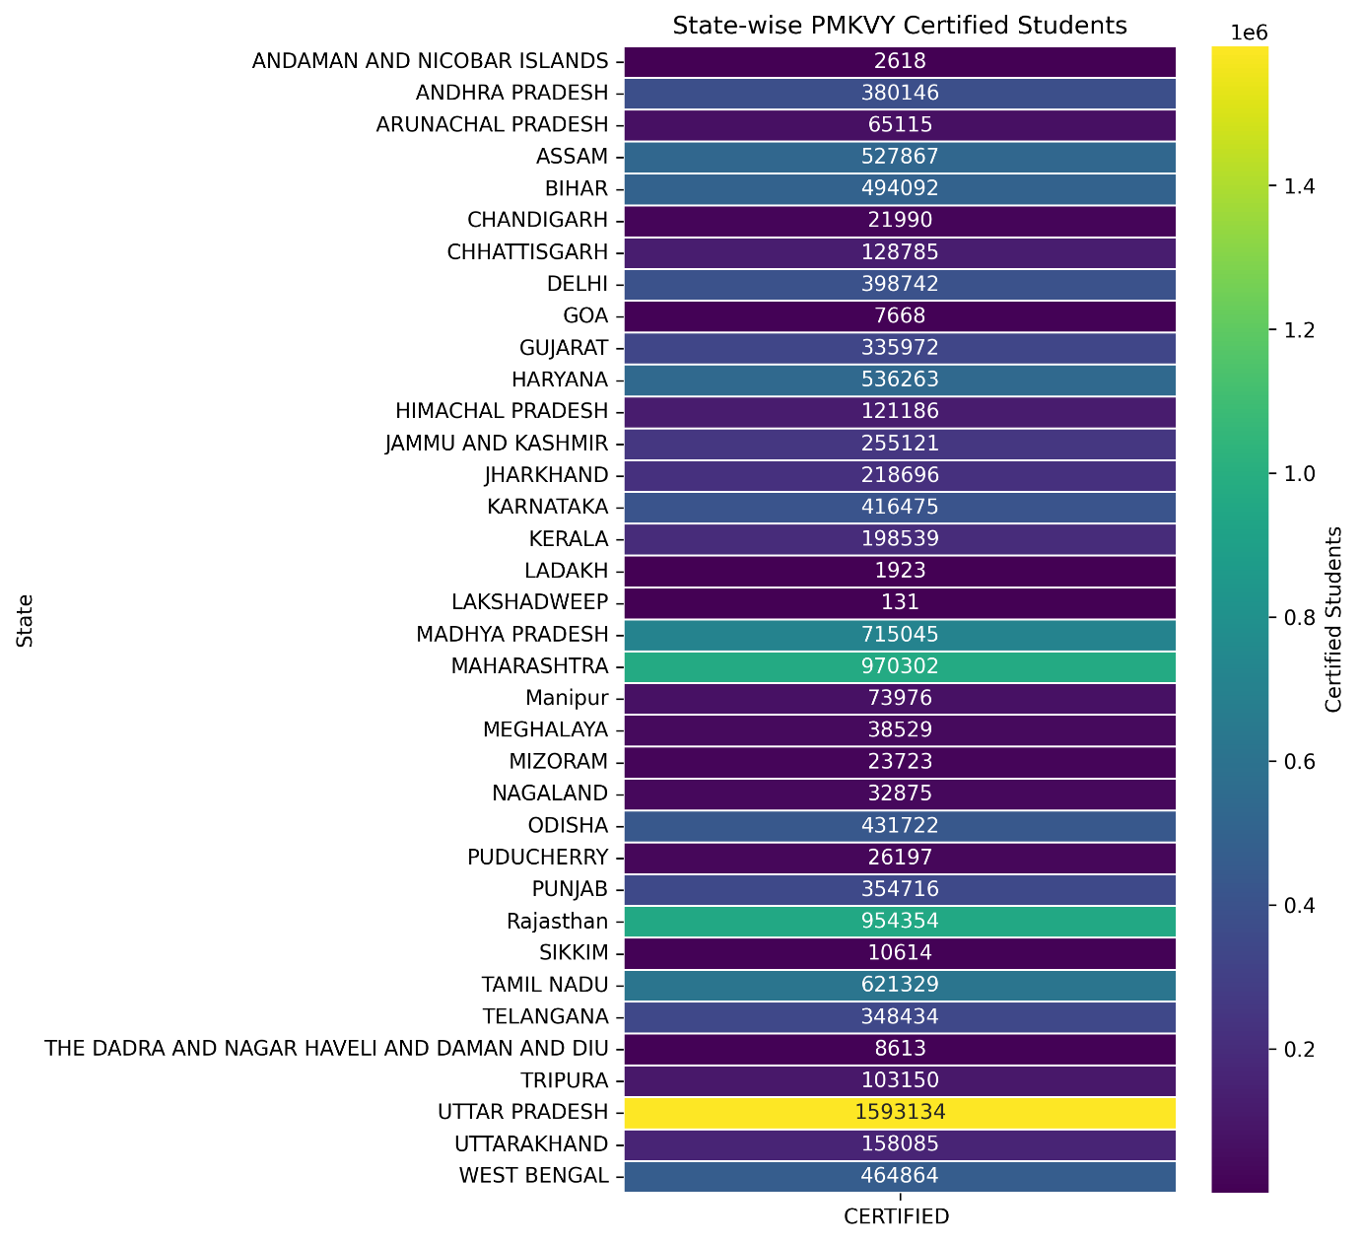
Fig. 1: Certified Students of PMKVY

It shows that Uttar Pradesh has the highest number of certified candidates, followed by Maharashtra, Rajasthan, Madhya Pradesh, and Tamil Nadu. These states dominate PMKVY participation due to larger populations and extensive training infrastructure. In contrast, Union Territories and North-Eastern states such as Lakshadweep, Ladakh, Sikkim, and Andaman & Nicobar Islands record very low certification figures.

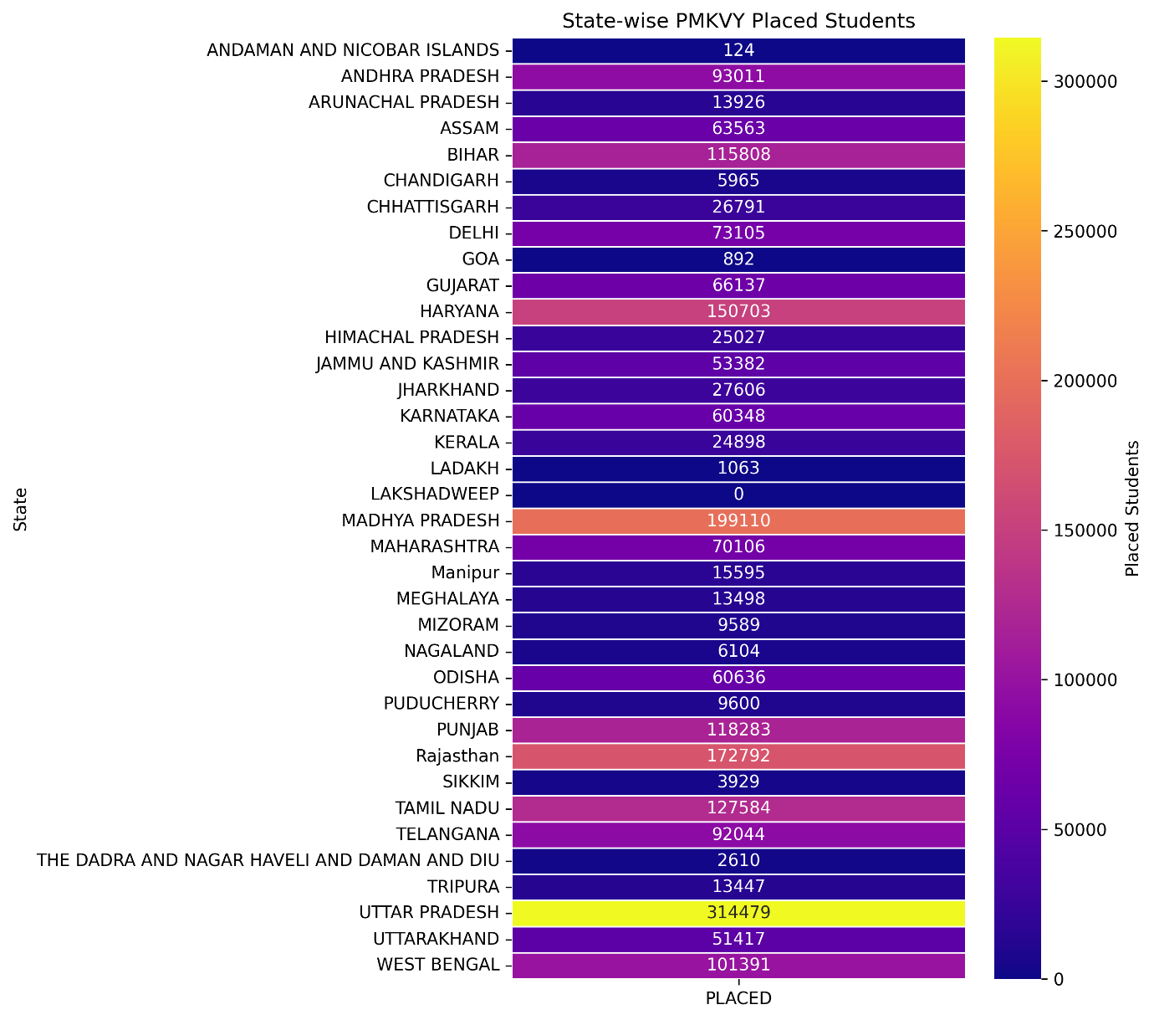
Fig. 2: Placed Students of PMKVY

Placement outcomes show that Uttar Pradesh leads with the highest number of placed candidates (314,479), followed by Madhya Pradesh, Rajasthan, Haryana, Tamil Nadu, and Punjab. States such as Haryana and Madhya Pradesh demonstrate comparatively better placement performance relative to their certified numbers. Several states and UTs, including Lakshadweep and Goa, report negligible or zero placements.
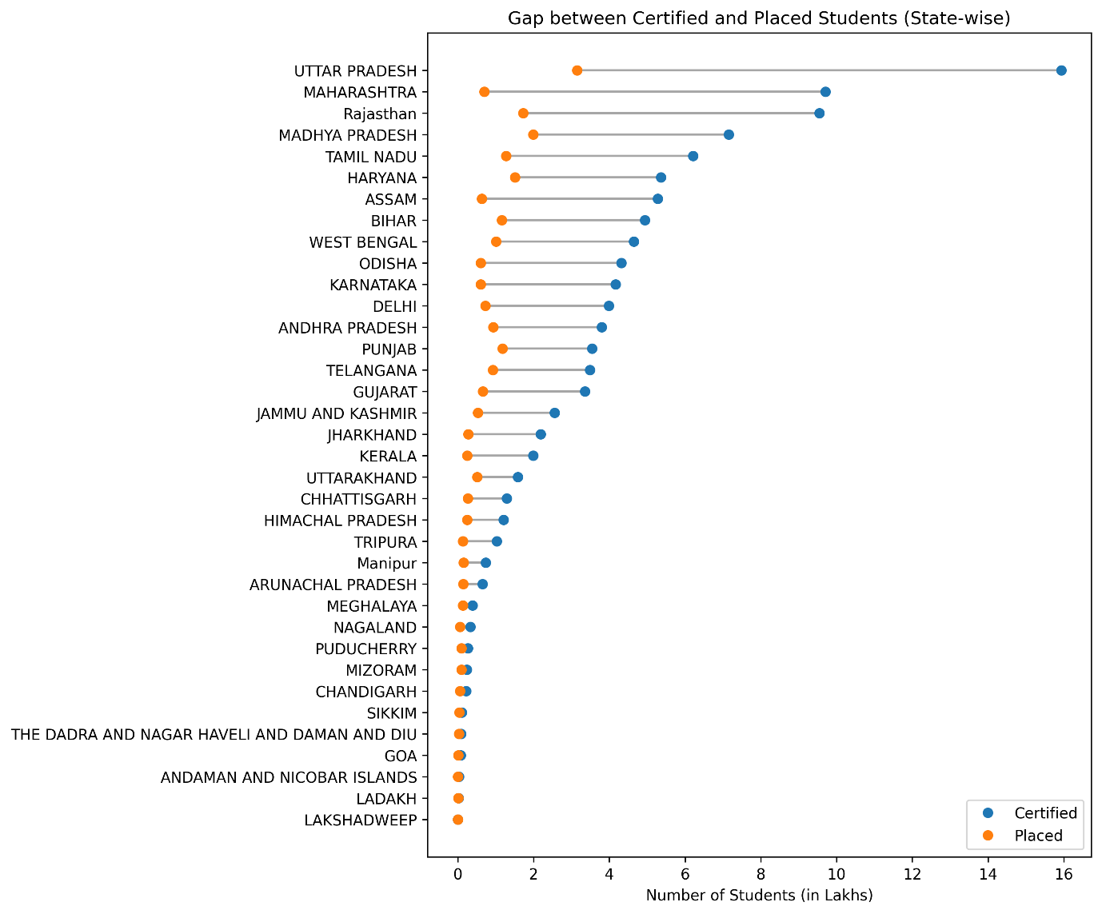
Fig. 3: Gap Between Certified and Placed Students of PMKVY
The dumbbell graph highlights a substantial gap between the number of certified and placed candidates across almost all Indian states and Union Territories under PMKVY. States such as Uttar Pradesh, Maharashtra, Rajasthan, Madhya Pradesh, and Tamil Nadu show the widest gaps, indicating that a large proportion of certified candidates did not translate into employment. Conversely, smaller states and Union Territories like Lakshadweep, Ladakh, Goa, and Andaman & Nicobar Islands show minimal gaps, primarily due to their lower certification volumes.
DISCUSSION
The results demonstrate PMKVY’s wide outreach in populous states, reflecting effective enrolment and training coverage. However, high certification numbers alone do not reflect program success unless supported by employment outcomes. The low certification figures in smaller regions highlight geographical and infrastructural limitations, indicating the need for region-specific skill development models tailored to local economic activities.
The placement data highlights uneven employment generation under PMKVY across states. States with stronger industrial bases and employer participation tend to perform better in placements. However, even top-performing states exhibit a large pool of unplaced certified candidates, indicating inefficiencies in post-training placement support. The results emphasize the importance of employer engagement, apprenticeship opportunities, and post-certification tracking to enhance employment outcomes.
The observed gap suggests that certification alone does not ensure employability. High-population states generate a large skilled workforce, but labour market absorption remains limited due to factors such as inadequate industry linkages, regional employment constraints, and skill–job mismatch. The findings indicate a need to shift policy focus from quantity-driven certification to demand-driven and placement-oriented skilling strategies.
CONCLUSION
The chart-wise analysis of PMKVY reveals that while the scheme has achieved extensive outreach in terms of skill certification across Indian states, its success in translating certifications into actual employment remains uneven. High-population states such as Uttar Pradesh, Maharashtra, and Rajasthan dominate certification and placement numbers, yet continue to exhibit a significant gap between trained and employed candidates, indicating challenges related to skill–job mismatch and limited labour market absorption. In contrast, states with relatively stronger industry linkages demonstrate better placement performance despite lower certification volumes. Overall, the findings suggest that PMKVY’s effectiveness depends not only on expanding training coverage but also on strengthening demand-driven skilling, industry participation, and post-training placement mechanisms to ensure sustainable employment outcomes.
REFERENCES
Aggarwal, A. (2016). Skill development in India: Challenges and strategies. International Journal of Training and Development, 20(3), 190–202.
Becker, G. S. (1964). Human capital: A theoretical and empirical analysis, with special reference to education. University of Chicago Press.
Comptroller and Auditor General of India (CAG). (2022). Performance audit of Pradhan Mantri Kaushal Vikas Yojana (PMKVY). Government of India.
Kumar, S., & Mishra, R. (2020). Skill development initiatives and employment outcomes in India: An inter-state analysis. Journal of Labour and Development, 26(1), 45–67.
Mehrotra, S., Gandhi, A., Saha, P., & Sahoo, B. K. (2014). Joblessness and informalization: Challenges to inclusive growth in India. Oxford University Press.
Ministry of Skill Development and Entrepreneurship (MSDE). (2015). Guidelines for Pradhan Mantri Kaushal Vikas Yojana (PMKVY) 1.0. Government of India.
Ministry of Skill Development and Entrepreneurship (MSDE). (2020). Pradhan Mantri Kaushal Vikas Yojana 2.0 and 3.0: Programme reports. Government of India.
Ministry of Skill Development and Entrepreneurship (MSDE). (2023). PMKVY 4.0 framework and implementation guidelines. Government of India.
National Skill Development Corporation (NSDC). (2019). Impact evaluation of PMKVY 2.0. NSDC, New Delhi.
National Skill Development Corporation (NSDC). (2021). Sector skill performance and placement outcomes under PMKVY. NSDC.
World Bank. (2018). Skill development in India: The vocational education and training system. World Bank Publications.
World Bank. (2020). Enhancing employability through skill development programs in developing economies. World Bank Group.

