IMPACTS OF CLIMATE VARIABILITY ON FISH PRODUCTION AND COMMUNITY HEALTH IN THE BAKASSI COASTAL AREA, CAMEROON

Abstract
Climate keeps varying across coastal areas posing challenges on fishing communities and human health vulnerabilities, thus affecting livelihoods and lives. These challenges are replicate of the situation in the Bakassi coastal area in Cameroon. The study aims to examine the impacts of climate variability on fish production and community health in the Bakassi area of Cameroon. It was an investigatory and explanatory study that employed a mixed-research approach involving the qualitative and quantitative techniques. Through a stratified random sampling technique, 200 participants were randomly selected and information was obtained from them using primary tools such as questionnaires, interview guides, focused group discussions and direct field observations. These data were supplemented with secondary data collected from magazines, scholarly, statistics platforms, databases and relevant literature. Data was analysed using descriptive and inferential statistics on Excel Version 18 and SPSS Version 25.0., and frequencies, percentiles, mean, correlation and relationships were established and presented on Tables, Chart and figures. Results revealed that climate variability has been taking place in the Bakassi area manifesting by varying rainfall with a CV of 44.3% and 138.6% for the rainy and dry season respectively, rising temperatures (23.6⁰C & 38.8⁰C for the minimum and maximum, respectively. and fluctuating relatively humidity visible on monthly, seasonal, and inter-annual scales. Further results show that climate variability affects community health with a greater case of malaria and typhoid occurring during the rainy season while fish production drops about 35% in the month of July and August due to torrential rainfall and flood events. Local adaptation strategies such as livelihood diversification, health consultation and seasonal fishing are implemented but only temporal successes are yielded and everything seem futile. The concludes that fish production and community health are crucial for the local population in the Bakassi area and recommends that objective and holistic adaptation strategies like public vaccination, artificial fish ponds, sleeping nets, and water purification be timely done in the Bakassi coastal area.
Keywords: Climate Variability, Fish Production, Community Health, Bakassi Coastal Area, Cameroon
- Introduction
There is a global consensus that a number of environmental impacts of climate change have been observed in recent decades (IPCC, 2023 & United Nation, 2016). These include, but are not limited to, increasing air and ocean temperatures; widespread melting of snow and ice, thermal expansion of the oceans, thus accelerating sea-level rise; altered rainfall patterns; extended periods of drought; an increase in the frequency of extreme heat events; and an increase in the frequency of extreme weather events and associated impacts on the physical environment and ecosystems, upon which our livelihoods depend. Climate change adds “considerable stress” to individuals, social groups, communities, sectors, countries and regions (UN, 2016). From sea-level rise that increases flood risk to changing patterns of weather that threaten the production of food, its impacts are “global in scope and unprecedented in scale” (UN, 2016).
Climate change has varied impacts on communities or regions especially the islands communities which are highly sensitive to these various climatic parameters. With these variations, the IPCC projects that an increase of 2°C in temperature poses a risk to both fauna, flora, settlements, infrastructures and public health and an increase in annual economic losses due to flood and drought (IPCC, 2007). Global human-induced climate change, combined with other anthropogenic effects such as overfishing and environmental degradation, can dramatically impact the structure and functioning of marine food webs (1PCC, 2023). These changes can greatly affect marine fisheries' production and potential catches of historically exploited species, with implications for food security and ecosystem services (UN, 2016).
In most island communities in the Pacific Island states, the current forecasts for rising sea levels due to climate change will severely impact their territory, affecting lucrative activities such as fishing and impacting human health by increasing the incidences of typhoid, malaria, dysentery diarrhoea and stomach ache (Wyeth, 2017). The Island communities in Countries such as Tuvalu, Kiribati and the Marshal Islands are already experiencing sea level rise where ocean flooding has washed saltwater onto agricultural lands and inundated sources of drinking water. These low-lying islands do not have forest cover, thus, making ocean levels to rise at a much faster rate with devastating effects on ecosystems and livelihoods and lives (Goulding, 2015).
Temperature is a crucial factor affecting organisms' life cycle and can directly influence ecosystems (Free et al., 2019). Smaller fish species tend to perform better in warm, oxygen-depleted waters than larger species, suggesting they may become more abundant relative to their larger counterparts as climate change progresses (Pauly, 2021). Climate change may shorten food webs (for example, reduce the number of trophic levels) by increasing metabolic costs, reducing energy flow efficiency, and limiting the energy available for top predators (Barneche et al., 2021). Nonetheless, warming waters can affect species' productivity and distribution at global scales via direct (e.g., increasing metabolism rates) or indirect processes (e.g., water stratification, oxygen supply, and acidification) (Baumann, 2019). Previous studies indicate species distributions are already moving toward higher latitudes and deeper areas to track optimum temperature ranges (Pinsky et al., 2020).
A primary concern is how climate change will affect the yield of commercial and small-scale fisheries (Hoegh-Guldberg and Bruno, 2010). Fish protein is essential for food security for over 2.9 billion people (FAO, 2023). In addition, small-scale fisheries employ 40 million people worldwide and supply nearly 80% of the fishery production of several countries (FAO, 2023). In many regions worldwide, fishing stocks have already been dangerously depleted due to overfishing, and fish communities have lost large, highly-valued top predators that are more sensitive to fisheries due to a series of life-history traits, such as slow growth and late-maturity (Pauly et al., 1998; Winemiller, 2005).The impacts of climate change on ocean systems has impacts on the sustainability of fisheries and aquaculture, on the livelihoods of the communities that depend on fisheries, and on the ability of the oceans to capture and store carbon (biological pump). The effect of sea level rise means that coastal fishing communities are significantly impacted by climate change, while changing rainfall patterns and water use impact on inland freshwater fisheries and aquaculture. Increased risks of floods, diseases, parasites and harmful algal blooms are climate change impacts on aquaculture which can lead to losses of production and infrastructure. Intergovernmental Panel on Climate Change (IPCC, 2022).
The Fourth Assessment Report (AR4) of the Intergovernmental Panel on Climate Change (IPCC, 2018) stated that Africa is one of the most vulnerable continents to climate change and climate variability with regard to health conditions (IPCC, 2007), while Dasgupta et al., (2009) further stressed that reduction in rainfall and increasing temperature conditions will consequently accelerate coastal risks, particularly health hazards. These include malaria, typhoid, cholera, dysentery and rashes and these will pose serious threats to low-lying coastal communities (Michael, 2007). The Bakassi coastal area in Cameroon with its multiple and extensive Island communities has over the years experienced severe climate variability, manifesting through irregular rainfall, rising temperatures, sea level rise, storms and flooding which have had drastic effects on fishing activities which are the dominant livelihood activities in the area. Further, climate variability has affected human health; manifesting through the increase incidence of typhoid, malaria, dysentery, diarrhoea and cholera which have been enhanced storm surges, floods, waterlogging, torrential rainfall and increasing heatwaves. These have further been worsened by the inability of the local population to cope with the challenges. With regard to this, this research therefore analysis the trend of climate variability in the Bakassi coastal area, examine the impacts of the variations on fish production and human health and proposes sustainable adaptation measures.
- The context of study
The Bakassi Peninsula is located at the extreme western end of the Gulf of Guinea and spans through latitudes 4°25' to 5°10' N and longitudes 8°20' to 9°08' E. of the Greenwich Meridian, with a total population of 151,772 (Council development plans (PNDP) 2011) Bakassi is an access route to Rio Del Rey and parts of South West Region (Njoku 2012). The Bakassi Peninsula can also be described as a swampy mangrove within the space of 1,000 kilometres that protrudes into the Bight of Bonny otherwise known as the Bight of Biafra with available reserves of petroleum (Aghemelo & Ibhasebhor 2006; Tarlebbea & Baroni 2010; Oluyemi 2014) (Map 1).

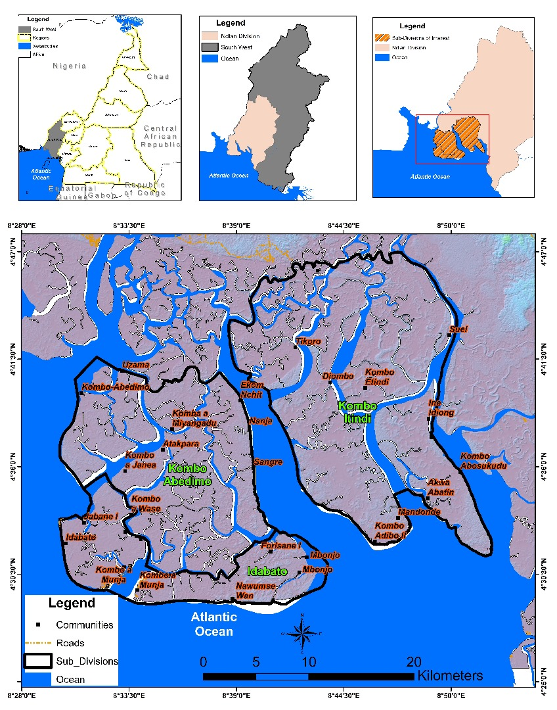
Map 1: Location Map of the study area
Source: NIC (National Institute of Cartography database,
OMS (Open Street Maps) modified, 2025
The climate is purely a maritime type with average temperatures of about 25 º c to 35ºc. The rainfall is generally heavy and ranges between 7,000 mm and 12,000 mm which is almost uniformly distributed within 8 months and 4 months of dry season. The relief of the study area is low-lying terrain with some areas such Idabato municipality as low as -16m below sea level and the most elevated is 14m given an average altitude of -2m for the entire council area. The area has alluvial soils, and vegetation dominated by mangrove characterized by the abundance of Rhizophora recemosa (mangrove red) and of Avicennia (white mangrove). The major economic activities here are agriculture, fishing, trade and the exploitation of hydrocarbons by the Cameroon government. The main trade partners are the Cameroon main land but also with neighbouring Nigeria.
- Research Methods
The study was descriptive and investigatory in nature, adopting the mixed research design, involving the qualitative and quantitative techniques. The investigatory approach necessitated inquiries on the trend of climate variability and its effects on human health and local fishing activities within the Bakassi Island, while the descriptive approach facilitated enquiries on the various adaptation strategies, challenges and recommendations. The mixed research design was adopted so as to tap the advantages enshrined in both qualitative and quantitative methods, thereby reducing their inherent biases. The Targeted populations for this study were households within the Bakassi Island, care givers, local health centers, agro-based institutions, NGOs, and workers of the Bakassi meteorological weather station, as well as, the local council. During the preliminary field survey, there were transact walks within the various Island communities in order to identify the communities mostly affected by climate variability such as, storms, heat-waves and floods. Thereafter, through a simple random sampling technique, 200 people were randomly selected to administer questionnaires. Added to these primary data source, were direct field observation, focused group discussions and interviews conducted with 8 key informants of the aforementioned institutions. Respondents were selected from the various Island communities as presented on Table 1.
Table 1: Questionnaire distribution in the study area
 | Community | Selected Population | Percentage (%)
1 | Kombo Adibo II | 54 | 27
2 | Mbonjo | 40 | 20
3 | Nawumse Wan | 36 | 18
4 | Mandonde | 24 | 12
5 | Kombo a Munja | 20 | 10
6 | Idabato | 26 | 13
 | Total | 200 | 100%
Source: Fieldwork (2026)
The Bakassi weather station was a reliable source of climatic data which was complemented with the data downloaded using the NASA Software. More so, GPS tools helped in capturing the coordinates of targeted communities, thus, easing the production of cartographic maps. Secondary data sources, magazines, online and offline libraries, published related articles and monthly and annual data of fishing and health related issues were collected from agro-based institutions and health centres, respectively and integrated with the primary data. The collected data were analysed using two main statistical techniques, that is, the qualitative data were analysed through content analysis while for the quantitative data, the descriptive and inferential statistical techniques was implemented. The former helped in establishing frequencies, standard deviations, ranges and percentiles while that latter helped in establishing correlations, regression and projections. The calculation and establishment of climate variability was done using a linear regression and the main parameters analyse were rainfall, temperatures and relative humidity. Storms frequencies and magnitudes were analysed in considering the perceptions of the respondents. Island vulnerability to sea inundation has been analysed using a change detection map. The relationship between climate variability, fishing activities and health impacts were determined through a Pearson Product Moment Correlation. The analysed results were presented on tables, figures, histograms and pie-charts whereas; photographs taken during fieldwork were displayed to show the realities on within the Island communities. Ethic-wise, the responses of the respondents were kept confidential and candid field observations were highly practice.
- Results
Results of the study have been presently sequentially, starting with the analysis on the trend of climate variability, impacts on fishing and health vulnerabilities, local adaptation strategies and proposed sustainable adaptation measures. The details of these are presented in the subsequent paragraphs:
  - Trend of climate variability in the Bakassi Island communities
The trend of climate variability has been analyze in considering the monthly, seasonal and inter-annual trends of rainfall, temperature, and relative humidity.
    - Trend in monthly temperature conditions
Monthly temperature variations in the study area showed variations across different months. January to December, showed significant fluctuations in monthly temperatures. This was seen also to be influenced by the changing seasons (the dry and the rainy season). These changes in season brought about changes in temperature because of the changes in insolation, cloud cover, precipitation and atmospheric humidity. From the month of January, temperatures steadily rose from about 26˚C to 27.7˚C in February and 27.8˚C in March (Figure 1). These are the hottest months in the study area. These are also the dry season months characterized by clear skies and increased insolation.

Figure 1: Trend of Monthly Temperature
With the arrival of the Southwest monsoon winds that are moist, Island communities experienced rainy season and temperatures begin to drop from the month of March to its lowest at 25˚C in July and 24.9˚C in August, recording the highest amounts of rainfall. Temperatures then increased to 26.3˚C in November, a drop to 25.6˚C in December. These variations influence the health conditions and fishing activities within these Islands either positively or negatively.
4.4.2: Inter-Annual Trend in Temperature Conditions
Temperature conditions also show variations on inter-annual basis from 1990 to 2024. Between 1990 and 2024, the hottest year recorded in Bakassi was 2023 with an average of 28.7˚C which is similar to that which was experienced in 1998 with 28.7˚C. The coldest temperature in Bakassi was recorded in the year 1991 with 24.3˚C. The trends show an increasing temperature pattern with a general increase of 0.9˚C during the last three decades. These temperature increments are attributed to the effect of climate change and the El Nino event (Figure 2).

Figure 2: Inter-Annual Trend in Temperature Conditions
Source: NASA Data (2025)
In Bakassi, the highest positive temperature anomaly was recorded in 1998. There was +2.175˚C above the mean of 26.6˚C. Other years with positive anomalies included 1990, 2020 and 2023 with +1.83˚C, +1.99˚C and +2.125˚C respectively. Negative anomalies were also recorded in Bakassi. The lowest temperature below the mean was recorded in 1991 with a -2.24˚C. Some of the years also recorded negative anomalies such as 2001, 2006 and 2011 with -2.08˚C, -1.86˚C. These fluctuations negatively both human health and fishing activities.
Summary of temperature conditions
Parameter | Bakassi
Average Temperature (˚C) | 26.6
Max Temp (˚C) | 38.89
Min Temp (˚C) | 23.6
SD | 1.6
CV (%) | 6.1
Source: NASA Data (2025)
4.1.3: Rainfall variability in the Bakassi coastal region.
Rainfall trend in the Bakassi coastal area shows a fluctuation and downward trend specifically on monthly, seasonal and inter-annual basis. The actual condition of rainfall in the area has been determine through the calculation of the coefficient of variations over the years. with regard to the seasonal trend, it was established that the study area has two seasons; the dry and rainy season. The dry season is brought about by the southward shift of the Inter Tropical Convergence Zone (ITCZ) which facilities the arrival of dry tropical Easterlies also known as the Northeast Trade winds (Harmattan).
At the inter-annual basis, for the duration of the study, significant variations were also observed in inter-annual rainfall patterns in the Bakassi coastal region (Figure 3). The average annual rainfall was 3609mm. The highest rainfall during the period of study was recorded in the year 2007 with 5220mm. Also, other years such as 2001, 2000 and 2022 recorded very high amounts of rainfall (5114mm, 4920mm, and 4808mm respectively). Some years recorded rainfall below the average. These included 1991, 2014 and 2024 with 2050mm, 2784mm and 2495mm respectively. Despite these variations, the regression line showed a slight increase in rainfall pattern over the last three decades with significant fluctuations, but 55% of the years recording of rainfalls is just equal or slightly above the mean (3609mm). In the same light, rainfall anomalies and extreme events were recorded (Figure 4). Years such as +1680mm above the mean and 1991 recorded -1440mm below the mean. The findings corroborate the observations of Ngala et al. (2023) and Tata (2016) who reported increasing rainfall irregularities and intensified precipitation events across tropical Cameroon (Fig 3)

Figure 1: Monthly rainfall variations in the study area
Source: NASA Data (2025)
These take place in the months of November, December, January and February with little or no rainfall and less than 80mm. The rainy season spans for 8 months with the coming of the south west monsoon from March to October with a monthly average rainfall of 411mm. The wettest rainy season months are July (569mm) and August (602mm). Changes in the CV shows highest fluctuation during the month of November and December (59% and 276%) where there is the change from the rainy season to the dry season (Fig 4)

Fig 4: Monthly changes in CV in the study area
Source: NASA Data (2025)
From April to October, the CVs have minimal values because this is the period of rainfall and although the trend is not upto expectations, there are always increasing frequency, intensity and durations as compared to the dry season. During this period, increasing torrential rainfall results into floods thereby pollution living environments and natural fishing grounds.
The Bakassi coastal area has also experienced year-to-year variations in the rainfall conditions. Some years due to the natural influence of the Inter Tropical Convergence Zone (ITCZ) and anthropogenic activities, encourage high rainfall while seasonality and increasing heatwaves encourage dry conditions leading to little evapotranspiration and decreasing rainfall (Figure 5).

Figure 5; Inter-annual rainfall variations in Bakassi coastal area
Source: NASA Data (2025)
From Figure 5, the year 1992, 1993 to 1995, 2008 and 2022 recorded a high rainfall of above 4000mm. With this high amount, it provides enough water for fishing activities and all swampy areas are swept away, thus, little cases of water-borne diseases occur. Yet, when such high amounts result to flood in unstable communities there are higher chances of water borne diseases. Contrastingly, the year 1991, 2004, 2010 and 2024 recorded lower amounts of rainfall below 3000mm such situations are recipes from increasing heatwaves and the survival of malaria parasites.
4.1.4: Relative humidity variability in the Bakassi coastal region
Atmospheric Relative Humidity for the Bakassi coastal area over the study period recorded an average of 77%. The highest relative humidity stood at 92% while the lowest stood at 62%. This gave a range of 30 with a CV of 36.5. This high RH is as a result of the presence of large water bodies and the equatorial rain forest including mangroves in this environment (Fig 6).

Figure 7: Trends in Monthly Relative humidity
Source: NASA Data (2025)

Monthly variation in RH (Figure 7) showed that the months of July, August and September had the highest RH; 88.2%, 89.02% and 89.1% respectively. The lowest RH was recorded in January with 78%. February and December which are the dry season months recorded the same average relative humidity of 79%. High relative humidity there affects the human body by reducing the efficiency of sweat evaporation. This can result to heat stress, dehydration and heat stroke. High relative humidity can result to heavy rain and floods which negatively affect fishing. The month of December, March and February experienced very low relative humidity below 80% which can result to skin dryness, cracked lips, and irritating eyes while reducing water level in streams, ponds and shallow lakes.
Inter-annual variations in RH were observed with some years such as 2004, 2009, and 2013 recording the highest RH of 86.35%, 85.56% and 86.63% respectively (Fig 8)

Figure 8: Trends in Inter-annual relative humidity
Source: NASA Data (2025)
On the contrary, some years such as 1990, 1998 and 2024 recorded high RH of 83.36%, 83.67% and 83.25 respectively. And the repercussions of such increasing amounts on fishing and health are as indicated in the above-mentioned paragraphs

4.2: Land loss and coastal erosion
Most vulnerabilities in the Bakassi coastal are have been instigated by land loss and erosion which are provoke by climate variability particularly during increasing torrential rainfall. In the Bakassi coastal area, sea level rise has also contributed greatly to land loss and soil erosion especially from the Months of July to September when rainfall is always at its peak. Some of these Island communities have lost considerable portions of the land to the expanding ocean waters. Many of the communities have been inundated with their infrastructure completely or partially damaged by encroaching seawater. Map 2 shows the detail evidences of land lost and soil erosion in the Bakassi coastal areas.
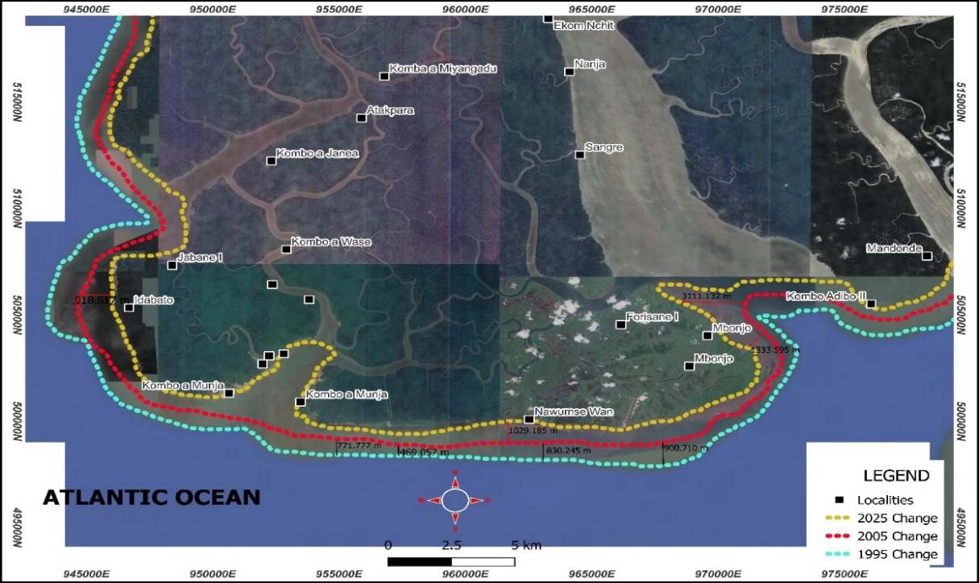
Map 2: land loss to the ocean between 1995 and 2025
Source: USGS (United State Geologic Surveys) Landsat 5 ETM and Landsat 9 (2025)
As seen on Map 1, the case of land loss by some Island communities have been drastic. For instance, in Forisare 1, 3111.132m of land has been loss between 2005 and 2025 as well as Nawumse Wan which has lost land of about 1029.185m within this same period of time. further details on these have been presented on Table 2.
Table 2: Changes in land encroachment by Ocean waters in Bakassi.
 | Area in meters
Period | SW | SSE | SE | SSW | S
2005 – 2025 | 3111.1 | 1333.6 | 1029.2 | 918.6 | 1598.1
1995- 2005 | 900.7 | 830.3 | 469.1 | 771.8 | 742.9
Average | 2005.9 | 1081.9 | 749.1 | 845.2 | 1170.5
Minimum | 900.7 | 830.3 | 469.1 | 771.8 | 742.9
Maximum | 3111.1 | 1333.6 | 1029.2 | 918.6 | 1598.1
Standard D. | 1563.0 | 355.9 | 396.1 | 103.8 | 604.7
Cv | 173.5 | 42.9 | 84.4 | 13.5 | 81.4
Source: Extracted from Map 4.1
As presented on Table 2, between 1995 and 2005 (Blue to red line), the average encroachment of the sea inland was 742m. In some areas around the South South East (SSE) of the study area, the encroachment went up to 900m and 830m in the South. Between the year 2005 and 2025, the average encroachment of the water body into dry land stands at 1598m. However, some areas in the South East have seen up to 3000m of once dry land, covered by the water body. These scenarios show the level at which rising sea levels have been increasing, causing more floods, salt water intrusion, loss of arable land, abandonment of homes and a reduction in arable land. The loss of land and encroachment has resulted in an increase in the cost of transportation of people and goods between these island communities as well as the transportation of goods between the main land and neighbouring Nigeria on which most of the Island communities depend on for most of their basic commodities such as food, water and other goods and services.
4.3: Respondents perceptions of the effects of climate change on community health
Investigations confirmed approximately 90% of the population attesting that climate variability significantly affects their health conditions and further investigations revealed that the most common diseases in the Bakassi coastal area are Malaria, typhoid as presented on Figure 8.

Figure 8: Respondents perceptions of common Diseases in Bakassi coastal area
Source: Fieldwork (2026)
As presented on Figure 8, 50% pointed out that they are faced with vector-borne diseases such as malaria and dengue fever 30% of the population confirmed that they suffer from waterborne related diseases such as cholera, typhoid, Hepatitis A and Hepatitis E and 20% said that they suffer from sanitation related diseases such as skin infections (fungal and bacterial wounds). Plates 1 show details of climate challenges on housing infrastures.

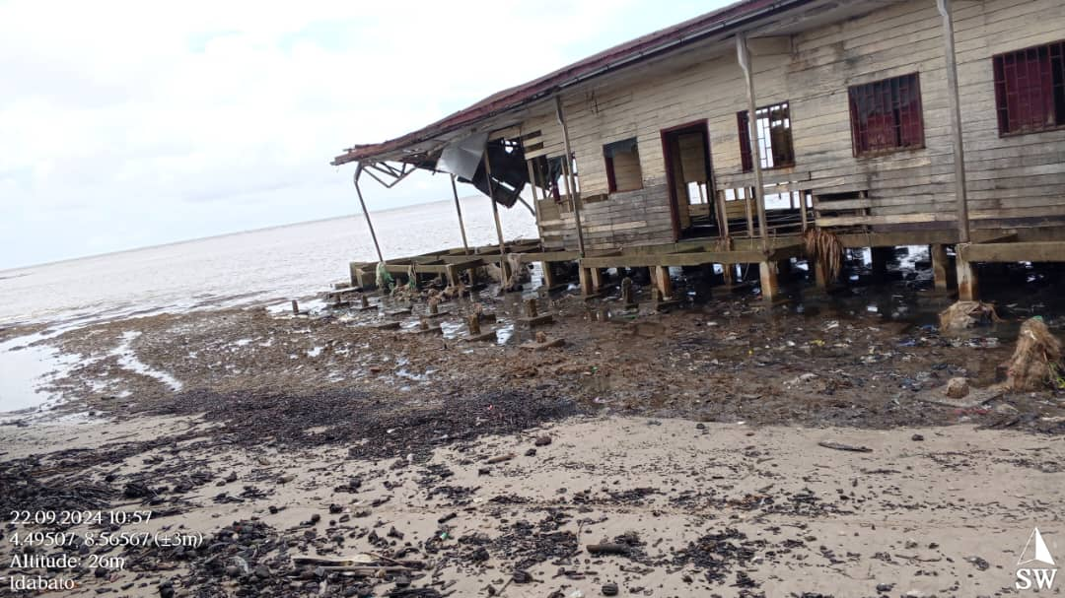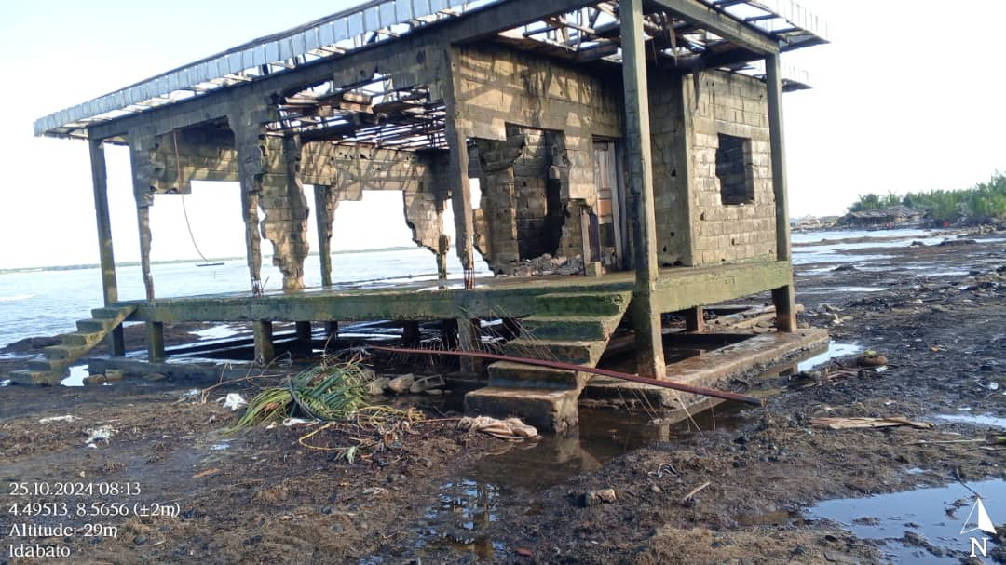
Plate1: Housing structures destroyed by windstorm and flood water in Nawumse Wan (Bakassi)
Source: Fieldwork (2026)
4.4: Empirical analysis of the effects of climate variability on human health.
Climate variability has severe impacts on human health in the Bakassi coastal area particularly malaria and typhoid diseases which are strongly influence by the immediate environmental and seasonal conditions. For example, mmalaria transmission is significantly related to seasonal changes, especially in terms of temperature and rainfall. In considering the between rainfall, temperature and incidence of malaria in the Bakasi coastal area , higher malaria incidence occurs at certain seasons, usually after the rainy season. This phenomenon occurs with the changes in seasons in the study area. The rainy season runs from March to November characterized by heavy downpours. The dry season on the other hand comes with little or no rainfall from November to February (Figure 9)

Figure 9: Seasonal changes and its effects on malariain the study area
Source: NASA and Statistics of Bakassi Health District (2025)
As seen on Figure 9, the highest percentages of malaria cases were recorded during the rainy season (14% and 15% in July and August respectively) while the least cases are recorded during the dry season (3% for January and December). Warmer temperatures and high rainfall provide ideal circumstances for mosquito breeding and parasite development. The main malaria vectors, Anopheles mosquitoes, have more breeding grounds within these communities resulting from the large pools of water often created as floodwaters move into the islands during periods of high tides especially during the rainy season. As a result, the number of mosquitoes rise, which increases the spread of malaria. Furthermore, shorter lifecycles and higher rates of transmission result from warmer temperatures, which also hasten the development of the malaria parasite (Plasmodium) within the mosquito.
Similarly, Typhoid incidence was equally affected by seasonal variations, which were characterised by temperature and precipitation variations, with more cases recorded within the rainy season with high rainfall, which explained the high frequency in the occurrence of floods often of very high intensity and magnitude resulting from climate change. The devastating nature of these floods is alarming in these Island communities as they often contaminate the various drinking water sources such as the wells and boreholes as well as foodstuff on which the local inhabitants depend on for their survival. Thus, temperature and precipitation may influence the spread of the illness, because of tainted water supplies and bacterial growth, typhoid cases typically rise during rainy seasons. Warmer temperatures can also encourage the growth of germs, which helps typhoid spread (Fig 10).

Figure 10: Seasonal changes and its effects on typhoid Cases in the study area
Source: NASA and Statistics of Bakassi Health District (2025)
As shown on Figure 10, the most typhoid cases (70%) were observed during the rainy season represented by the upward sloping bars from March to October while less than 30% was recorded during the rainy season represented by the downward sloping bars from November to February. The months with the highest amounts of rainfall recorded the greatest number of cases and vice versa. This is because heavy rainfall during the rainy season could cause flooding and contaminate drinking water sources such as wells with sewage and other garbage. Typhoid bacteria readily spread by this tainted water if consumed or utilized for other purposes. Also, the development and survival of typhoid germs in food and water could be accelerated by warmer temperatures, especially during heat waves. Higher infection rates may result from this as well as from people consuming food prepared under poor hygienic conditions and drinks that might have been made with tainted water during the warmer months.
4.5: Respondents perceptions of the effects of climate change on community health
Approximately 86% of the respondents accepted that climate variability affects their fishing activities. With regard to this, 26% of the respondents said that climate variability has caused a reduction in the quantity of fish caught, 22% said that they have experienced a reduction income, and 20% complained of insecurity during fishing particularly the rise in sea level (Figure 10)

Figure 10: Effects of climate variability on Fishing activities in the Bakassi coastal area
Source: Fieldwork (2026)
From Figure 10, 18% of the respondents complained of destruction of storage infrastructures, 10% pointed out to the damage on access routes, and 4% complained of siltation of waterways. Plates 2 show evidences of storm damages on storage infrastructures.
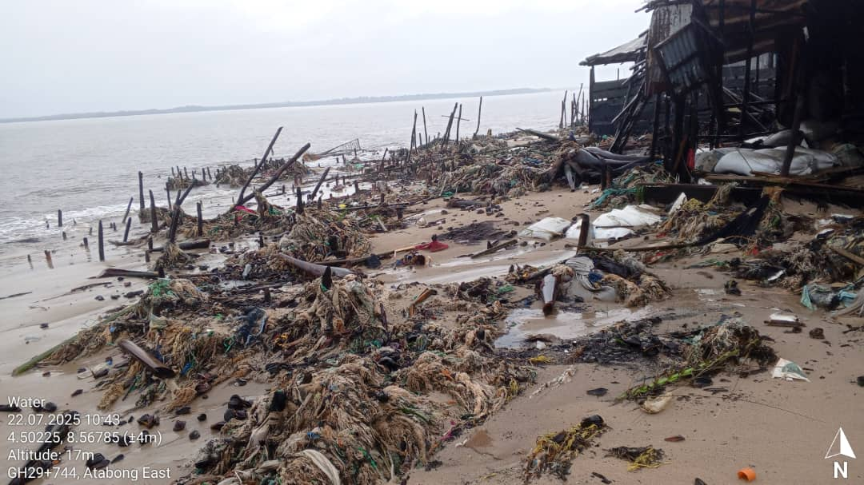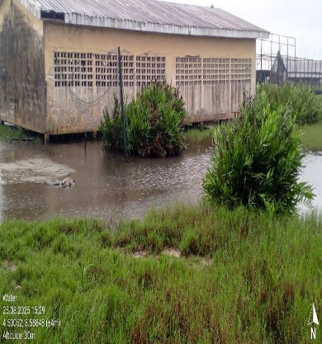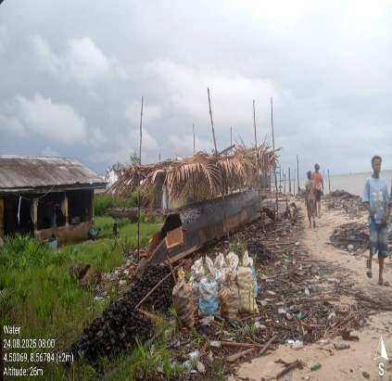
Plates 1: A fish sore destroy by sea storms in Mbonjo (Bakassi)
Source: Fieldwork (2026)
Plates 1 show some of the effects of climate variability on fish production in Mbonjo Bakassi. These usually happen when there is intensive rainfall such that sea water inundates nearby communities.
4.6: Empirical analysis of the effects of climate variability on fishing output.
Although most of the respondents complained that climate variability has posed significant negative effects on fishing activities, the study went further establishing a linear graph and running a correlation analysis which reflected their perceptions (11)

Figure 11: The relationship rainfall, temperature and fishing outputs
Source: NASA and Divisional Delegation of Livestock and Fisheries for Ndian (2025)
Results in Figure 11, show that with increasing fluctuations in climatic parameter of rainfall and temperature also results to fluctuation in fish catch. For instance, in 2012, the annual rainfall was over 3969mm and an annual average sea surface temperature of 27˚C, the annual fish caught stood at 1414MT. Also, in 2023, the annual rainfall stood at 2969mm and sea surface temperature of 29.47˚C and it recorded a reduced quantity of fresh fish caught which stood at 759.7MT. However, in 2007, the study area recorded the highest amount of rainfall (5407mm) but recorded one of the lowest fishes caught (160MT). However, the relationship has not been uniform across the periods under study and to make the analysis valid and reliable, a Pearson Product Moment Correlation was run with results confirmed at 0.05%.
4.7: Correlation between climate variability, human health and fishing outputs
In order to investigate this, a Kendall’s Kau-b correlation analysis was run between rainfall, temperature, malaria, typhoid and fish outputs. Temperature has a significant positive relationship with malaria (t=0.337, P<0.05), indicating that increase in temperature are associated with higher malaria incidence, while its relation typhoid (t=-0.027, P=0.820) and fish outputs (t=0.027, P=0.0820) are very weak and not statistically significant.

Table 3: Correlation
 |  |  | Rainfall | Temperature | Malaria | Typhoid | Fish outputs
Kendall's tau_b | Rainfall | Correlation Coefficient | 1.000 | -.184 | -.007 | .175 | .175
Kendall's tau_b | Rainfall | Sig.(2-tailed) | . | .122 | .963 | .140 | .140
Kendall's tau_b | Rainfall | N | 35 | 35 | 25 | 35 | 35
Kendall's tau_b | Temperature | Correlation Coefficient | -.184 | 1.000 | .337* | -.027 | -.027
Kendall's tau_b | Temperature | Sig.(2-tailed) | .122 | . | .018 | .820 | .820
Kendall's tau_b | Temperature | N | 35 | 35 | 25 | 35 | 35
Kendall's tau_b | Temperature | Sig.(2-tailed) | .140 | .820 | .038 | . | .
Kendall's tau_b | Temperature | N | 35 | 35 | 25 | 35 | 35
*. Correlation is significant at the 0.05 level (2-tailed).
**. Correlation is significant at the 0.01 level (2-tailed).
Rainfall on the other hand, shows no significant relationship with malaria (t=-0.007, P=0,963), typhoid (t=0.175, P=0.140), or fish outputs (t=0.175, P=0.140), suggesting that rainfall variations in the study area do not have measurable direct effects on disease occurrence or fish production in this dataset. Overall, temperature appears to be the more influential climatic factor in explaining malaria patterns, while rainfall shows minimal explanatory power for the health and fish outputs variable considered
4.8: Adaptation strategies to climate variability in the Bakassi coastal area
The local population in Bakassi do implement adaptation strategies to cope with the effects of climate variability. 43.7% said that they do construct returning walls, 31.8% said there is always the provision of medical facilities and 13.5% spoke of diversification of livelihoods (Fig 12)

Figure 12: Adaptation strategies to climate variability in the Bakassi coastal area
Source: Fieldwork (2026)
From figure 12, 6.7% attributed it to policy and governance, 3.5% said that there is education and capacity strengthening and 0.8% confirmed that there is the practice of mangrove restoration.
5: Discussion
Results have revealed that climate variability is taking place in the Bakassi coastal area manifesting through irregular rainfall patterns, rising temperatures, fluctuating relative humidity and rising storm surges. These have been measured on monthly, seasonal and inter-annual basis. Rainfall patterns have shifted from what used to be and occurring less often but intensively and with longer durations associated by drastic floods while temperatures are on an increasing trend characterised by rising heatwaves which posed multiple challenges to the inhabitants. Variations in temperature trends were also observed in the Bakassi coastal region. The maximum temperatures reaching 36.72˚C and the minimum is 15.48˚C (a range difference of 21.24˚C) in January. These findings are true with that of Nkemasong et al., (2023) who in investigating the climate variability impacts across the Southern-West coastal zones of Cameroon noted that there were unprecedented shifts in rainfall patterns and rising temperature conditions. These therefore create awareness the coastal zones are suffering from climate change and variability.
Further results confirmed that climate variability affect fish production in the Bakassi coastal area. That increasing temperature conditions affect sea temperatures and influencing the metabolisms of fishes making them less productive and extinct. Also, torrential rainfall and floods often pollute fishing grounds, while a majority are killed, more are also swept away by runoff. In addition, fishing equipment are easy destroy by windstorm while access to the various local markets are being blocked. A very high relative humidity like the cases of July, August and September usually linked with reduced oxygen exchange between air water, resulting to a lower dissolved oxygen levels which stresses fishes and reduce growth rate. These findings directly relate with those of Baumann (2019) who noted that warming waters affect species' productivity and distribution at global scales via increasing metabolism rates, or indirect processes (e.g., water stratification, oxygen supply, and acidification). The IPCC, (2022) also noted that increased risks of floods, diseases, parasites and harmful algal blooms are climate change impacts on aquaculture which can lead to losses of production and infrastructure. Intergovernmental Panel on Climate Change.
Also, results have depicted a negative relationship between climate variability and human health, particular typhoid and malaria. With the increased rainfall intensity and duration like the case of July, August and September, most of the inhabited areas of the Bakassi coast are inundated and flooded with polluted water. These waterlogging environment act as as breeding grounds for malaria parasite which affects people. Also, flood pollutes some of the potable natural water catchment most at times, making life difficult for people living in this coast. During the dry season, increasing temperatures provoke heatwaves which bring about dehydration, eye irritation, heat stroke and cracked lips. Community health remains fragile to climate variability and one of the greatest issues to deal with. These findings reflected that Dasgupta et al., (2009) who carried a scientific inquiry and stressed that reduction in rainfall and increasing temperature conditions will consequently accelerate coastal risks, particularly health hazards and Michael (2007) stated that most of these diseases include malaria, typhoid, cholera, dysentery and rashes and further stressed that these will pose serious threats to low-lying coastal communities.

- Conclusion
Climate variability is a reality in the Bakassi Island, manifesting through irregular rainfall, rising temperature conditions and unstable relative humidity. These fluctuations have affected one of the key human resources in the undertaken by the local population which is fishing. The quantity, intensive and magnitude of fishing activities have drastically drop in the Bakassi Island subjecting the lives of a majority who depend on fishing as their livelihood option into severe poverty. Further, the fluctuations in these climatic parameters have negatively affected human health conditions which have been so visible through increasing malaria incidences, typhoid, heatwaves, headache and cases of stomach bites. Climate variability remains a big challenge to the population inhabiting this island community because while a greater proportion of the incomes they generate from fishing activities are being disrupted by increasing storms, rising temperature, and flood events, they end up spending their hard end savings in paying hospital bills for the treatment of the abovementioned diseases. The Bakassi Island which was long ago consider as a center for food security is today face with a precarious climate variability situation with which local adaptation like the increase frequency of fishing, seasonal fishing practices, the consumption of traditional herbs for malaria and typhoid appear to have less effects in reversing the effects. The work recognises the scientific statement of the WMO (2013) which stressed that climate on earth will continue to vary on seasonal, monthly and inte-annual bases, yet proposing that objective and holistic measures such as the creation of natural barriers, health campaigns, education and awareness, government intervention through public vaccination and early warning system be improve in the area.these measures will improve food security, and income while keeping the population healthy and comfortable.
- Recommendations
To cope with climate variability, tree, marshlands, and wetlands should be preserve and deforestation as well as unfriendly environmental farming systems should be avoided. In regard to the relevance of fish production to the local population in the Bakassi coastal area, the government support local fishermen with modern fishing tools, the local council should support financial for the creation of local fishing ponds, and the local population should also diversified livelihoods to crop production and local businesses in order to conquer diseases and improve health conditions, the government should develop health facilities in the area and invest in seasonal vaccinations. Also, NGOs and the local councils should encourage water purification, public hygiene and personal hygiene. Natural water sources should be protected and flood prone zones and unstable around the coast should not be inhabited by the local population.
References
Bindoff, N. L., Willebrand, J., Artale, V., et al. (2007) Observation, oceanic climate change and sea level. In: Climate Change 2007: The Physical Science Basis. Contribution of Essam Yassin Mohammed and Zenebe Bashaw Uraguch
Brander, K. (2010). Impacts of climate change on fisheries. Journal of Marine Systems, 79 (3-4), 389–402
Bieg, C. (2020). Fisheries restoration potential: optimizing fisheries profits while maintaining food web structure Food Webs
Ani, C.J. (2021). Responses of marine ecosystems to climate change impacts and their treatment in biogeochemical ecosystem models Mar.
Corrales, D. (2017). Modeling the role and impact of alien species and fisheries on the Israeli marine continental shelf ecosystem.
D. Atkinson (1994). Temperature and organism size – a biological law for ectotherms Adv.
Garcia, S. M. and Rosenberg, A. A. 2010. Food security and marine capture fisheries: characteristics, trends, drivers and future perspectives. Phil. Trans. R. Soc. B, 365, 2869–2880
H. Baumann (2019). Experimental assessments of marine species sensitivities to ocean acidification and co-stressors: how far have we come? Can. J. Zool. (2019) A.H.V. Bevilacqua et al.Following the fish: the role of subsistence in a fish-based value chain Ecol. Econ. (2019)
Hlohowskyjl, I. Michael S. Brody and Robert T. Lackey. 1996. Methods for assessing the vulnerability of African fisheries resources to climate change. Climate Research, 6: 97-106.
Intergovernmental Panel on Climate Change (IPCC), ed. (2022), "Sea Level Rise and Implications for Low-Lying Islands, Coasts and Communities", The Ocean and Cryosphere in a Changing Climate: Special Report of the Intergovernmental Panel on Climate Change, Cambridge: Cambridge University Press, pp. 321–446, doi:10.1017/9781009157964.006, ISBN 978-1-00-915796-4, S2CID 246522316, retrieved 2022-04-06
Bentley J.W. (2020). Retrospective analysis of the influence of environmental drivers on commercial stocks and fishing opportunities in the Irish Sea Fish. Oceanogr. (2020)
R. Angelini et al (2013). Aquatic food webs of the oxbow lakes in the Pantanal: a new site for fisheries guaranteed by alternated control? Ecol. Model. (2013)
IPCC (2018) Global Warming of 1.5⁰C. An IPCC Special Report on the impacts of global warming of 1.5C above pre-industrial levels and related global greenhouse gas emissions pathways, in the context of strengthening the global response to climate change, sustainable development and efforts to eradicate poverty Cambridge University Press, Cambridge UK and New York, USA
IPCC. (2007). Synthesis Report. Geneva, Switzerland. Retrieved from https://www.ipcc.ch/pdf/assessment-report/ar4/syr/ar4_syr_full_report.pdf
Dasgupta, S., Laplante, B., Murray, S., & Wheeler, D. (2009). Sea Level Rise and Storm Surges. Policy Research Working Paper 4901.
UN (2016). Sustainable Development Goals [accessed 2018 Aug 1]. Available from: https://sustainabledevelopment.un.org/?menu=1300
Wyeth,G.(2017).ForPacificIslandStates,ClimateChangeisanExistentialThreat.TheDiplomat,[online]Available at: https://thediplomat.com/2017/06/for-pacific-island-states-climate-change-is-an-existential-threat/ [Accessed 29 Dec. 2023].
Goulding, N. (2015). Marshalling a Pacific Response to Climate Change. In: G. Fry and S. Tarte, ed., the New Pacific Diplomacy, 1st ed. Canberra: ANU Press, pp. 191-202
IPCC (Intergovernmental Panel on Climate Change) (2007). Working Group II Summary for Policy Makers, Cambridge University Press: Cambridge
IPCC, (2023). Climate Change 2023: Synthesis Report. Contribution of Working Groups I, II and III to the Sixth Assessment Report of the Intergovernmental Panel on Climate Change [Core Writing Team, H. Lee and J. Romero (eds.)]. IPCC, Geneva, Switzerland, 184 pp., doi: 10.59327/IPCC/AR6-9789291691647.
Nkemasong N.A., Yinkfu, R.N., Anunvweh, N., Ngala, B.S., Enongene, F., Nkemndem, A., Kigha, P., Landoh, N., Ayellni, L. (2023). Ascribing the capricious weather thes is to the unprecedented July-september 2022 flood hazards in the Kumba and Mutengene-likomba agglomerations of the south west Cameroon Plain of Cameroon. International Journal of Development Research, 13, (06), 63038-63050.

