ISO/IEC 17025-Compliant Calibration of Biomedical Equipment: Frameworks, Methods, and Measurement Uncertainty Assessment
Moktar Hossain ^{a*}, Mirola Afroze ª, Anila Pasha ª, Md Abu Hasan ^{b}
ª Instrumentation and Calibration Division, Bangladesh Reference Institute for Chemical Measurements (BRiCM), Dhaka-1205, Bangladesh
^{b} Proficiency Testing Division, Bangladesh Reference Institute for Chemical Measurements (BRiCM), Dhaka-1205, Bangladesh
*Corresponding Author: Moktar Hossain, moktar@bricm.gov.bd

ABSTRACT
Modern healthcare would not be possible without the use of biomedical equipment, which is crucial in supporting diagnosis, therapy, monitoring of patients, and life-sustaining processes. Clinical devices like ventilators, infusion pumps, defibrillators, patient monitors, ECG systems, thermometers, and laboratory instruments directly relate to the clinical decision-making and delivery of treatment. Thus, they necessitate regular calibration and frequent validation of these instruments to maintain reliability, safety, accuracy and consistent performance over the entire life of the instrument. Any inaccuracy in measuring or in performance of functions can result into wrong diagnosis, ineffective treatment or a greater risk to patient safety. The ISO/IEC 17025 standard of competence of testing and calibration laboratories offers a robust and internationally recognized framework of ensuring technically valid, traceable and reliable results of calibration [1]. It provides rules of lab competence, unbiasedness, traceability of measurements, validation of methods, qualification of personnel, control of the environment and quality management systems. By adhering to this standard, biomedical calibration labs are able to maintain high standards of technical accuracy, and to express a degree of confidence in their results. The paper provides a critical review of ISO/IEC 17025-conforming calibration practices of biomedical equipment, including quality system, metrological traceability, estimation of uncertainty, risk-based calibration timeframes, documentation control, personnel competence, and internal quality assurance. It also talks about calibration methodology of commonly used biomedical devices such as patient monitors, infusion pumps, defibrillators, electrosurgical units, ventilators, thermometers, sphygmomanometers, pulse oximeters, ECG systems, and weighing scales. Particular attention is paid to evaluation of the uncertainty of measurements, environmental factors, and rules to evaluate conformity. Moreover, the paper examines some of the major issues that healthcare facilities and labs in developing nations face, including the lack of strong chains of traceability, trained staff, regulatory control, and reliance on non-accredited service providers [2]. Lastly, practical recommendations are made to the hospitals, regulators and laboratories to have sustainable biomedical metrology systems in accordance with the ISO/IEC 17025 requirements. The paper concludes that systematic calibration within a certified structure is a significant intervention to improve patient safety, clinical confidence, regulatory compliance, operational efficiency, and overall healthcare outcomes.
Keywords: Biomedical equipment, ISO/IEC 17025, calibration, measurement uncertainty, healthcare metrology, patient safety, accreditation.
INTRODUCTION

A broad family of instruments employed in prevention, diagnosis, monitoring, treatment and rehabilitation make up biomedical equipment. Examples are electrocardiographs, ventilators, infusion pumps, patient monitors, X-ray systems, ultrasound scanners, incubators, laboratory analyzers and surgical equipment [3]. These tools create or regulate the quantifiable variables like pressure, flow, temperature, voltage, current, time, mass, oxygen concentration, and radiation dose. Any bias or inaccuracy in these parameters could jeopardize patient safety and clinical decision-making. The World Health Organization (WHO) suggested that as many as half of medical devices in low- and middle-income nations were out-of-service or misused, frequently due to lack of calibration and maintenance [4]. The set of operations that determine the relationship between the values that an instrument indicates and the reference standards of the specified conditions is the calibration [5]. Calibration is used in healthcare settings to ensure that all equipment is used within the manufacturer specifications and within the clinically acceptable tolerances. As an example, a malfunctioning infusion pump can under dose medication (which can cause a therapeutic failure) or overdose (which can cause toxicity) and a faulty defibrillator may not provide the necessary energy to the patient during a resuscitation attempt, which can directly affect the survival rates [6]. The ISO/IEC 17025:2017 outlines the general provisions of competence, impartiality, and consistency in the working of laboratories. It is applicable to any organizations that carry out calibration or testing irrespective of its size. Accredited laboratories that comply with ISO/IEC 17025 are competent in technical aspects, have validated methods, traceable measurements, competent personnel, and effective quality management systems [1]. The use of ISO/IEC 17025 in the biomedical equipment calibration is gaining prominence due to the increasing healthcare technology, regulatory requirements and risk management requirements as stipulated in ISO 14971 [7]. Hospitals are anticipated to have trustworthy equipment fleets, minimize downtime, and exhibit maintenance efficacy to the accreditation organizations like the Joint Commission and JCI [8]. This paper is a review of the principles, implementation strategies, technical procedures and benefits of ISO/IEC 17025-compliant calibration of biomedical equipment.

2. Overview of ISO/IEC 17025:2017
The ISO/IEC 17025:2017 has five large clauses that include General requirements, Structural requirements, Resource requirements, Process requirements, and Management system requirements [1]. Figure 1 shows the hierarchy of structures of ISO/IEC 17025:2017 requirements regarding biomedical calibration laboratories.
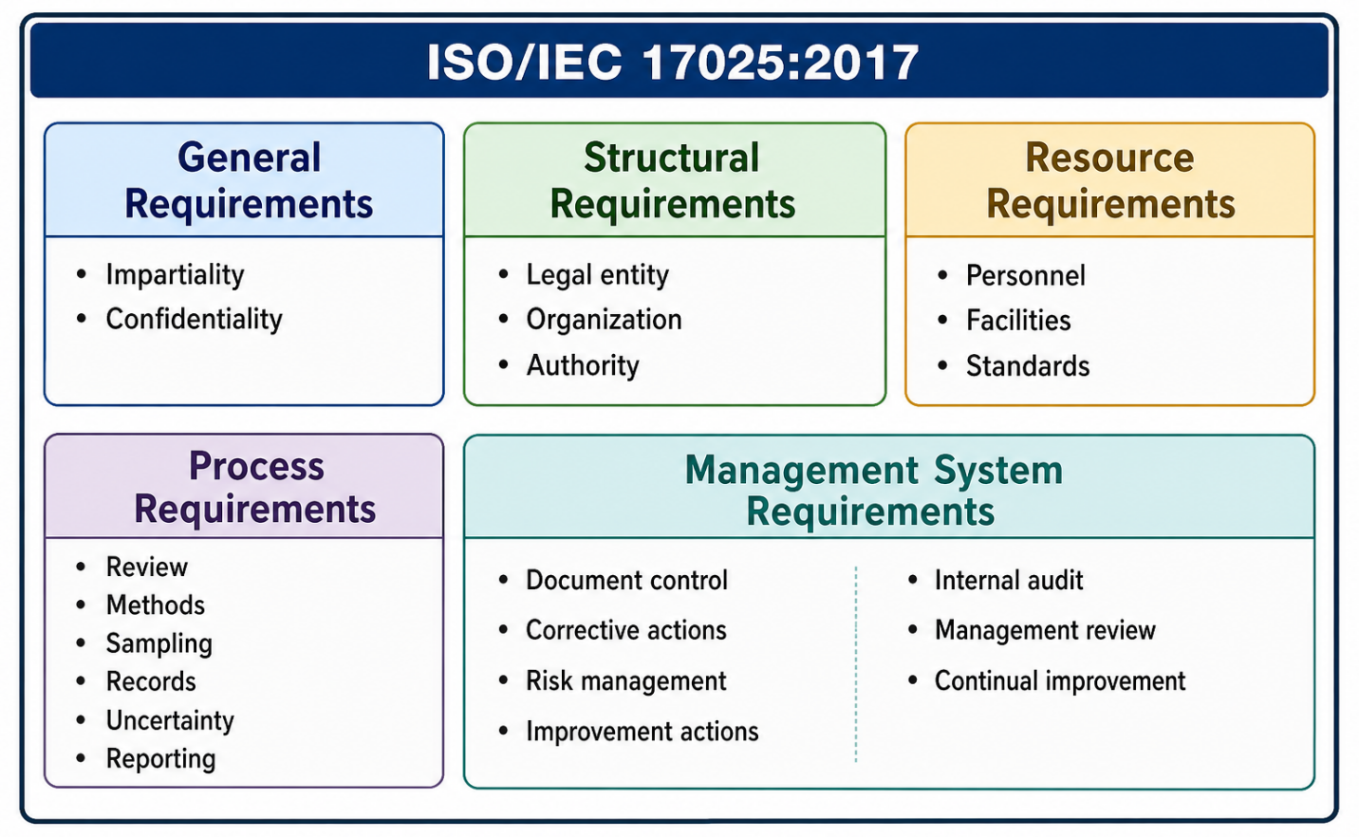
Figure 1: ISO/IEC 17025:2017 Hierarchical Structure of Biomedical Calibration laboratories.
General Requirement: The laboratory should be able to guarantee impartiality and confidentiality. The biomedical calibration data can have an impact on procurement, warranty claims, litigation and regulatory actions hence independence and confidentiality are necessary. The standard mandates the identification of risks and mitigation of the risks to impartiality [1].
Structural Requirements: Laboratory should establish legal identity, management, authority and responsibilities. Hospitals with in-house calibration units ought to have clear governance, frequently in line with structures of the clinical engineering department [9].
Resource Requirements: Resources are in the form of competent personnel, appropriate facilities, calibrated standards, software, environmental control and external services. The clause 6.3 deals in particular with the facilities and environmental conditions, which are very critical in the biomedical calibrations [1].
Process Requirements These include contract review, method selection, sampling (where applicable), handling items, technical records, uncertainty, validity of results, reporting, complaints and non-conforming work. The necessity of measuring the uncertainty of the measurements is explained in clause 7.6 [1].
Management System Requirements They need internal audits, corrective actions, risk management (in line with ISO 14971 [7]) and document control, management review and Continuous Improvement. There are two options (Option A and B) available to the laboratories: (A) based on ISO 9001 principles; and (B) integrated with the existing ISO 9001 system [1].
SIGNIFICANCE OF CALIBRATION IN HEALTHCARE
Calibration has a direct effect on diagnostic accuracy, treatment effectiveness, patient safety, equipment lifespan, regulatory compliance, cost control and reputation of healthcare institutions [10]. Table 1 summarizes the clinical consequences of error in calibration of typical biomedical equipment.
Table 1: Clinical Effect of Biomedical equipment calibration error.
Device Type | Parameter | Typical Tolerance | Consequence of Undetected Error | Relevant Standard
Infusion pump | Flow rate | ±5% | Underdose (therapeutic failure) or overdose (toxicity) | IEC 60601-2-24 [19]
Defibrillator | Energy | ±15% or ±4 J | Failed resuscitation, myocardial damage | IEC 60601-2-4 [13]
Ventilator | Tidal volume | ±10% | Hypoventilation (brain injury) or barotrauma | ISO 80601-2-12 [12]
Patient monitor (NIBP) | Pressure | ±3 mmHg or ±5% | Missed hypertension/hypotension, wrong treatment | IEC 60601-2-49 [40]
Thermometer | Temperature | ±0.1°C (clinical) | Missed fever, incorrect neonatal incubator settings | ASTM E2877 [38]
Electrosurgical unit | Output power | ±20% | Ineffective cutting/burning, patient burns | IEC 60601-2-2 [21]
Pulse oximeter | SpO₂ | ±3% (70-100%) | Undetected hypoxia, unnecessary oxygen therapy | ISO 80601-2-61
Certain clinical examples are:
- Even the slightest error in a blood pressure monitor of even 5 mmHg can result in incorrect diagnosis of hypertension or even missed treatment thresholds that affect millions of patients worldwide [11].
- 1°C drift in incubator temperature can be detrimental to neonates, especially those who are premature and who need to be given precise thermal regulation [4].
- Drift of ventilators may result in poor ventilation or barotrauma; research demonstrates that ventilators drift by up to ten percent of tidal volume with more than six months of continuous use [12].
- Any error in defibrillator energy of greater than ±15 percent can decrease resuscitation success; IEC 60601-2-4 requires energy accuracy within ±15 percent or within ±4 J, whichever is the greater [13].
According to the WHO Medical Device Technical Series, calibration is a fundamental part in any medical device management system [4].

METROLOGICAL TRACEABILITY
Metrological traceability is the property whereby the measurement results can be linked to a reference by an unbroken chain of calibrations, each contributing to uncertainty. According to the International Vocabulary of Metrology (VIM), traceability can be defined as the property of a measurement result whereby it can be related to a stated reference by a documented continuous chain of calibrations, each of which contributes to the measurement uncertainty [5]. The traceability chain of biomedical equipment calibration is shown in figure 2.
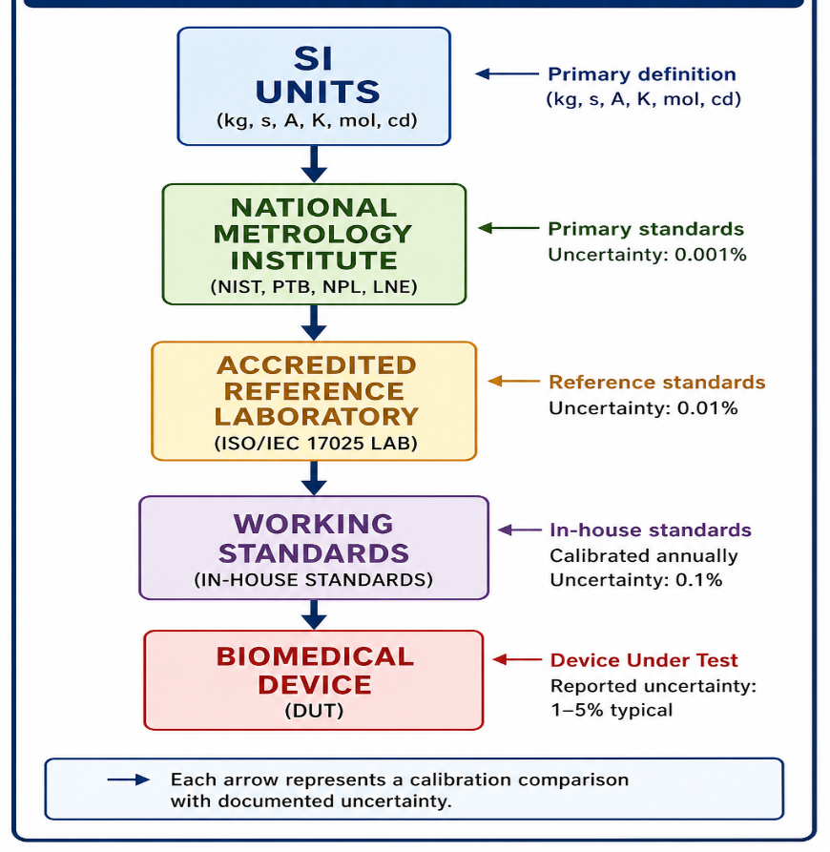
Figure 2: Metrological Traceability Chain for Biomedical Device Calibration
Examples of traceability:
- Pressure that can be related to national pressure standards by use of primary manometers or deadweight testers [14].
- Temperature measurement that can be traced to ITS-90 fixed points with SPRTs [15]. Electrical signals that can be traced to national metrology institutes standards of voltage/current [16].
- Time traceable to references of an atomic clock using GPS-disciplined oscillators [5].
In the absence of traceability, the calibration values cannot be relied on and compared in other institutions. The ILAC P14 states that accredited calibration certificates must include traceability statements [17].

BIOMEDICAL EQUIPMENT COMMONLY REQUIRING CALIBRATION
Table 2 provides a comprehensive listing of biomedical equipment types, their critical parameters, typical calibration intervals, and applicable standards.
Table 2: Biomedical Equipment Calibration Requirements
Equipment Category | Critical Parameters | Typical Interval | Applicable Standards
Patient monitors | ECG, NIBP, SpO₂, temperature, respiration | 12 months | IEC 60601-2-25, IEC 60601-2-49 [18,40]
Infusion/syringe pumps | Flow rate, occlusion pressure, volume | 6-12 months | IEC 60601-2-24 [19]
Defibrillators | Energy, charge time, synchronization | 6-12 months | IEC 60601-2-4 [13]
Ventilators | Tidal volume, pressure, flow, FiO₂ | 6-12 months | ISO 80601-2-12, ISO 80601-2-13 [12,20]
Electrosurgical units | Output power, HF leakage, CVP | 12 months | IEC 60601-2-2 [21]
Thermometers/incubators | Temperature accuracy, uniformity | 6-12 months | ASTM E2877, ITS-90 [15,38]
Weighing devices (infant/patient) | Mass indication, repeatability | 6 months | OIML R111 [22]
Anesthesia workstations | Gas flow, pressure, agent concentration | 12 months | ISO 80601-2-13 [20]
Laboratory analyzers | Various (pH, glucose, electrolytes) | 6-12 months | ISO/IEC 17025 [1]
Dialysis machines | Flow rate, conductivity, temperature, pressure | 12 months | IEC 60601-2-16
Patient Monitors: Parameters can include ECG frequency/amplitude (reference: IEC 60601-2-25), ventilation rate (impedance pneumography validation), SpO₂ simulation response (tested with functional testers traceable to international standards), NIBP pressure channels (tested against calibrated pressure sources), and thermal channels (tested against ITS-90 traceable simulators).
Infusion Pumps and Syringe Pumps. Parameters of particular importance: flow rate (usually 0.1-1200 mL/h), volume delivered (tested by gravimetric or volumetric method depending on the IEC 60601-2-24), occlusion pressure alarm (measured by calibrated pressure transducers), and time accuracy [19].
Defibrillators Parameters: Delivered energy (tested at 50, 100, 200, 360 J into a calibrated load), charge time, and synchronization delay (to synchronized cardioversion) [13].
Ventilators Parameters: Tidal volume (measured using calibrated test lungs and flow analyzers) and flow (peak inspiratory and expiratory) and pressure (PEEP, peak inspiratory, plateau) and oxygen concentration (measured using calibrated O 2 analyzers) [20].
Electrosurgical Units Parameters: Output power (at different load resistances and cut/coag modes), HF leakage (tested per IEC 60601-2-2) and frequency stability [21].
Thermometers and Incubators Parameters: Temperature accuracy (when compared to SPRT or calibrated PRT), uniformity (temperature mapping across infant compartments), and stability with time [15].
Weighing Devices Parameters: Mass indication (tested with OIML E2 or F1 class weights), repeatability (10 measurements at same load), and eccentric loading (localized loading effects) [22].

CALIBRATION METHODOLOGY
Pre-Calibration Preparation Phase
Identifying the device and its incoming inspection: When a biomedical device is received by the laboratory to be calibrated, the laboratory should first cross-check the device identity with the request to calibrate the device. This consists of documenting the manufacturer, model number, serial number, firmware version (where applicable) and any hospital asset identifier [1]. Physical examination is conducted to determine any physical damage, parts missing, fluid intrusion, corrosion, and unauthorized alterations. Devices whose physical damage can be seen are not calibrated until the damage is recorded, and the customer accepts any restrictions. This is an important step since the calibration results can be invalidated by the physical defects [6].
Functional Safety Check: A functional safety check is conducted before technical calibration. This applies to all medical equipment which is electrically driven, including:
- Earth continuity test (≤ 0.2 Ω protection earth resistance)
- Resistance insulation test (resistance must be at least 2 M o to 500 V DC)
- Measurement of leakage current (touch current ≤ 100 μA in case of BF/CF type)
- Presence of mains voltage and check power consumption.
These tests are conducted in line with IEC 62353:2014 [23] and are obligatory to equipment that is connected to patients. Any non-conformity stops the calibration process until corrected by an appropriate biomedical engineering service.
Warm-Up and Environmental Stabilization: EMDs also have a warm-up period, which can be 30 minutes to patient monitors and infusion pumps, 60 minutes to precision laboratory balances, and 15 minutes to portable thermometers. In the warm-up, the device is turned on, but it is not exposed to measurement stimuli. At the same time, the laboratory conditions should be brought to a certain standard level. In the ISO/IEC 17025 clause 6.3.3 [1], the monitoring and recording of environmental conditions shall occur.
Reference Standard Setup: The reference standards applied in the calibration should have current calibration certificates that indicate unbroken traceability to national or international standards [17]. The below checks are carried out before connection:
- Validity (not expired) of the calibration certificate
- Physical state of Standard (no damages, clean connectors)
- Equipment compatibility (range, resolution, accuracy class)
- Connection integrity (appropriate cables, adapters, terminators)
In electrical calibrations (ECG simulators, defibrillator analyzers) reference standards should be at least 4 times more precise than the DUT (4:1 test accuracy ratio) or the contribution of uncertainty should be properly accounted in the combined uncertainty budget [24]. In critical parameters where 4:1 cannot be achieved (e.g., high voltage defibrillator pulses), uncertainty analysis is required in detail.
Measurement Execution Phase
Choosing Calibration Points: The calibration points are chosen to represent the whole operating range of the device, with a special focus on clinically important values. In the case of linear instruments, 5 or more points equally spaced are suggested, although 10 or more points will be a better characterization of non-linearity.
Multi-Point Measurement Sequence: At every point of the calibration, the minimum of three replicate measurements is done (clause 7.11.1 of ISO/IEC 17025 recommends repeatability assessment [1]). For each replicate:
- Adjust the DUT to the desired nominal value (when source mode) or apply the reference stimulus (when measure mode)
- Give it time to settle- normally 5-30 seconds depending on the parameter
- At the same time note the DUT indication and the value of the reference standard
- Determine the error of that replicate: Error = DUT Reading - Reference Value
- Raw data should be recorded by a pre-formatted worksheet.
Measurement Simulated Clinical Conditions: In some biomedical devices, using simulation alone to calibrate the instrument should also be accompanied by simulation of conditions of clinical use. For example:
- Ventilators: Calibrated with test lungs of varying compliance (0.02, 0.05, 0.1 L/cmH₂O) and resistance (5, 20, 50 cmH₂O/L/s) [20].
- Infusion pumps: Tested with back pressures of 0, 100, 200, 300 mmHg [19].
- Defibrillators: Tested at multiple patient impedance values (25, 50, 75, 100, 125, 150 ohms) [13].
Adjustment (Trimming) Procedure: When the actual errors are more than the tolerances of the manufacturer and the owner of the equipment has given an authorization to carry out an electronic or mechanical adjustment. Important principles of adaptation [1]:
- Record the errors that have occurred pre-adjustment prior to any adjustment
- Use the recommended order of adjustments
- Once adjusted, run the whole calibration (post-adjustment check)
- Do not modify devices that are beyond tolerance level but do not have authorized access
Errors and Uncertainties Calculation: To compute the error, the error is computed as:
Error = Indicated Value - Reference Value
Correction = Reference Value - Indicated Value
At each point the mean error,
$\overline{E}= \frac{1}{n} \sum_{i=1}^{n}{E_{i}}$

The standard deviation of the experiment (Type A uncertainty) equals,
$s(E)= \sqrt{\frac{1}{n-1}}\sum_{i=1}^{n}{{\left(E_{i}-\overline{E}\right)}^{2}}$

Post-Calibration Procedures
Documentation and Certificate Generation: The results of the calibration are immediate:
  - Raw data worksheet (sign and date by the technician)
  - Calibration certificate (in accordance with ILAC P14 requirements [17])
  - Calibration label (with date due, technician ID, certificate number)
Post-Calibration Verification: The adjusted devices are checked in a post-calibration check: a single measurement at a previously calibrated point is repeated after 30 minutes of operation. The outcome should concur in the published measurement uncertainty.
Labeling and Return: The device is calibrated by attaching a calibration label in a non-interfering area, and then cleaned, packed and sent back to the customer with the certificate.
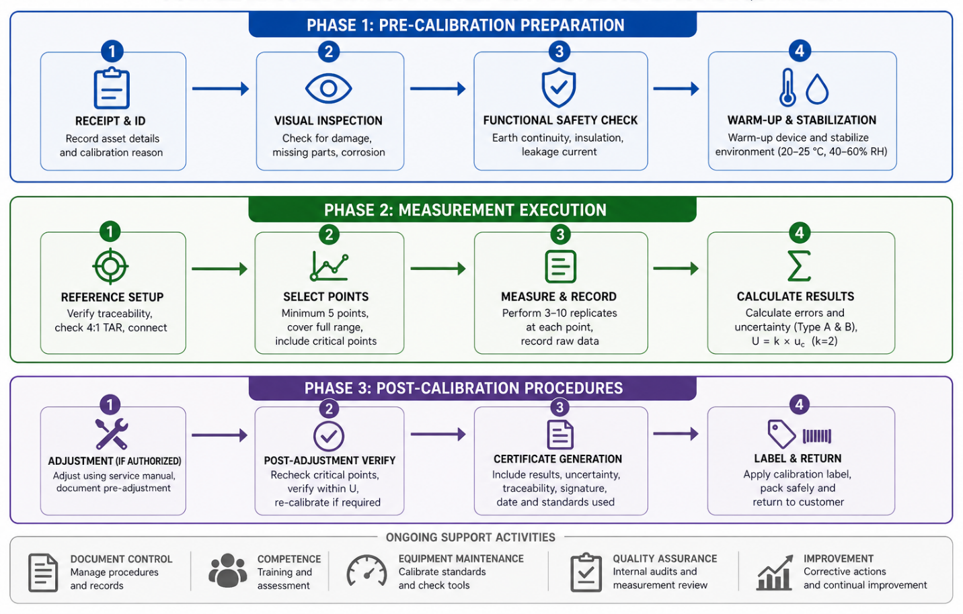
Figure 3: Complete calibration workflow for Biomedical Equipment

MEASUREMENT UNCERTAINTY
Measurement uncertainty is a value that quantifies uncertainty with regard to the result. According to ISO/IEC 17025, the laboratories are required to assess the uncertainty of all the calibrations where applicable and the uncertainty in relation to the conformity to specifications [1]. The internationally recognized framework [24] is provided by the Guide to the Expression of Uncertainty in Measurement (GUM). Table 3 is a detailed uncertainty budget template to use in biomedical calibration.
Table 3: Typical Measurement Uncertainty Budget of Biomedical Calibration (Example- Infusion Pump at 100 mL/h)
Uncertainty Source | Type | Value (±) | Probability Distribution | Divisor | Standard Uncertainty (mL/h) | Sensitivity Coefficient | Contribution (mL/h)
Reference standard | B | 0.30 mL/h | Normal | 2 | 0.150 | 1.0 | 0.150
Repeatability (n=10) | A | 0.28 mL/h | Normal | 1 | 0.280 | 1.0 | 0.280
DUT resolution | B | 0.10 mL/h | Rectangular | √12 | 0.029 | 1.0 | 0.029
Temperature effect | B | 0.03 mL/h | Rectangular | √12 | 0.009 | 1.0 | 0.009
Back pressure variation | B | 0.15 mL/h | Triangular | √6 | 0.061 | 1.0 | 0.061
Operator timing | B | 0.10 mL/h | Rectangular | √12 | 0.029 | 1.0 | 0.029
Combined standard uncertainty (Uc) |  |  |  |  |  |  | 0.325
Expanded uncertainty U (k=2) |  |  |  |  |  |  | 0.65 mL/h

Sources of Uncertainty in Biomedical Calibration
  - Reference standard uncertainty (calibration certificate (usually Type B))
  - DUT (digital: u=resolution/12u=resolution/12; analog: estimated to 1/5 of smallest division) resolution. A repeatability (Type A where n is at least 10 measurements where possible)
  - Reproducibility (different days, operators, setups)
  - Environmental effects (temperature coefficient, humidity, barometric pressure)
  - operator influence (connection torque, positioning, interpretation)
  - Calibration to Calibration drift of standards.
  - Loading effects
  - Hysteresis (Pressure Hysteresis & Force Hysteresis)
Type A and Type B Assessment:
  - Type A: measured by statistical analysis of repeated measurements (e.g., repeatability)
  - Type B: evaluated by means other than statistical analysis (calibration certificates, manufacturer specifications, published constants, experience) [24]
Combined Standard Uncertainty: $u_{c}=\sqrt{{(u}_{1}^{2}+u_{1}^{2}}+u_{1}^{2}+…+2\sum_{i<j}{r_{ij}}u_{i}u_{j})$
Expanded Uncertainty: $U=k×u_{c}$
With confidence levels of about 95% (k = 2) or 99.7% (k = 3), respectively. Accredited calibration certificates must have k = 2 unless indicated otherwise [17].
Detailed Worked Problem
Calibration of the Infusion Pump Flow Rate. Background: Hospital-grade volumetric infusion pump set to 100 mL/h and measured using gravimetric procedure with calibrated balance and timer.
Uncertainty budget as in Table 3 gives:
$u_{c}$= 0.325 mL/h
U = 2×0.325 = 0.65 mL/h
Reported result: Flow rate error = +0.2 mL/h ± 0.7 mL/h (k = 2) at 100 mL/h setting.
Uncertainty of Non-linear Devices: In devices with high non-linearity, uncertainty should be assessed at various points over the range. Guidance documents of EURAMET give specific procedures of pressure, temperature, and electrical quantities [14,15,16].
Conformity Assessment and Decision Rules: In comparing a measured value to a specification (tolerance), uncertainty has to be taken into consideration. The graph of decision rules is shown in figure 4.
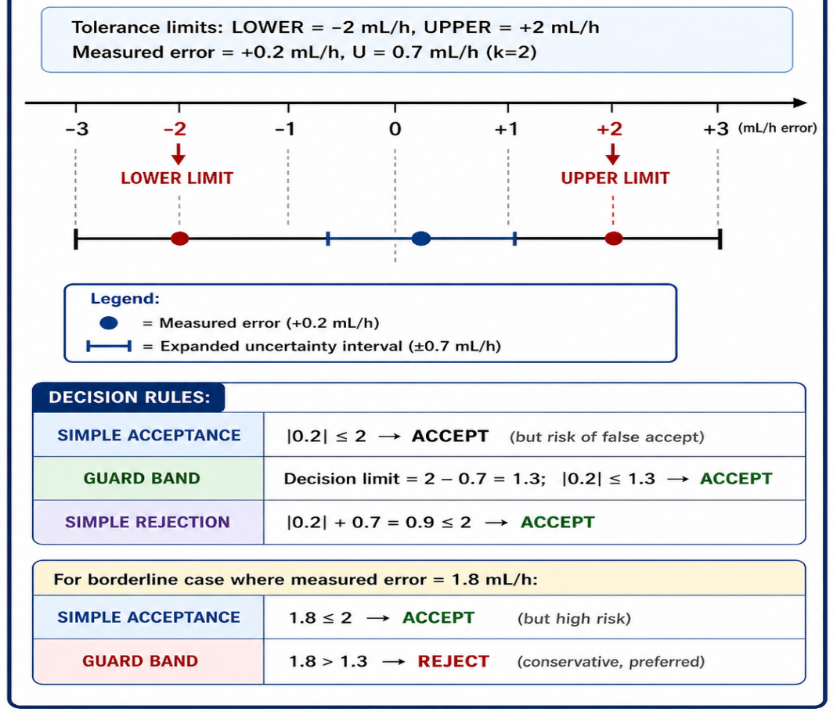
Figure 4: Decision Rules of Conformity Assessment when Measurement Uncertainty is involved.
The decision rules according to ILAC G8 [26] have:
- Simple acceptance (more risky): Accept when error is less than tolerance.
- Simple rejection (conservative): Reject when error + U > tolerance.
- Guard banding (recommended for safety-critical): Use decision limit = tolerance - U
- Shared risk approach: Report both the result of measurement and uncertainty, and leave the final decision to clinical engineering.
When it comes to safety-critical biomedical devices, ILAC G8 suggests guard banding [26].

ENVIRONMENTAL CONDITIONS
There is a tendency to use controlled conditions in biomedical calibration as indicated in ISO/IEC 17025 clause 6.3 [1]:
- Temperature: 20-25 C (can be reduced to 21-23 C to obtain more accurate measurements with precision instruments) Relative humidity: 4060% (to eliminate electrostatic discharge and condensation)
- Constant power (±2% voltage, less than 2% THD)
- Low vibration (especially for mass and pressure calibrations)
- Clean environment (no dust, no chemical vapors)
- Electromagnetic compatibility control
The results may be skewed by uncontrolled environments. Even a 5°C change in temperature can cause a 0.5 percent full scale movement of pressure transducers [14].

COMPETENCE OF PERSONNEL

According to ISO/ IEC 17025 clause 6.2, all the personnel in the calibration activities are required to have documented competence [1]. Training of personnel should be done in: Essentials:
- Basic electronics and electrical safety (IEC 60601 series [6])
- Principles of medical devices and context of physiology.
- Basic metrology concepts (traceability, uncertainty, units)
- Calculation of uncertainty (Type A, Type B, GUM method [24])
- Risk management (ISO 14971) [7]
- Safety standards (IEC 62353) [23]
- Documentation systems
Periodic reassessment of competence should be done. Textbooks in clinical engineering give the background knowledge [27,28].

Documentation and Records
ISO/IEC 17025 stipulates extensive documentation (clause 7.5 to technical records, clause 8.3 to document control) [1]:
Required records include:
- Equipment registers
- Calibration procedures (validated, version-controlled)
- Raw data sheets
- Calibration certificates (according to ILAC P14) [17].
- Traceability evidence
- Environmental logs
- Corrective actions
- Training records
Table 4 enumerates the required contents of an accredited calibration certificate.
Element | Requirement | Reference
Title | "Calibration Certificate" | ISO/IEC 17025:2017 cl. 7.8.2
Laboratory identification | Name, address, accreditation symbol | ILAC P14 [17]
Unique certificate ID | Sequential numbering for traceability | ISO/IEC 17025 cl. 7.8.2
Customer identification | Name and address | ISO/IEC 17025 cl. 7.8.2
Device identification | Manufacturer, model, serial number | ISO/IEC 17025 cl. 7.8.2
Calibration date | When performed | ISO/IEC 17025 cl. 7.8.2
Reference standards | IDs, calibration dates, traceability | ILAC P14 [17]
Environmental conditions | Temperature, humidity during calibration | ISO/IEC 17025 cl. 7.8.2
Measurement results | Values, errors at each point | ISO/IEC 17025 cl. 7.8.2
Measurement uncertainty | Expanded uncertainty (U, k=2) | ILAC P14 [17]
Statement of conformity | Pass/fail (if requested) | ILAC G8 [26]
Signature | Authorized signatory | ISO/IEC 17025 cl. 7.8.2
Digital resource management systems (CMMS) improve efficiency. AAMI EQ56 recommends such systems [29].

Internal Quality Control
The ISO/IEC 17025 clause 7.7 stipulates that internal QC [1] should be provided. Methods include:
- Intermediate checks of standards
- Proficiency testing (PT) and interlaboratory comparisons [30] Control charts on reference standards.
- Trend analysis
- Repeat calibrations
Determination of Calibration Interval
Factors for interval determination [31]:
- Manufacturer guidance
- Usage frequency
- Criticality
- Historical drift
- Repair history
- Environmental severity
Guidelines are given in OIML D10 [31]. Average intervals: defibrillator (6-12 months), infusion pump (6-12 months), patient monitor (12 months), precision balance (6 months) [7,29].
DEVELOPING COUNTRIES DIFFICULTIES
Common barriers [2,4,32]:
- Limited accredited labs
- Very expensive standards
- Lack of awareness
- Poor maintenance culture
- Spare parts shortage
- Inadequate regulation
- Insufficient trained personnel
In certain African nations up to 80% of the medical equipment is working without any legitimate calibration [4]. WHO suggests that critical equipment should be calibrated as a mandatory rule [33]; IAEA underlines that calibration of radiation equipment is a mandatory rule [34].

RECOMMENDATIONS
Based on the analysis [2,4,29,35]:
- Develop national policy of biomedical metrology.
- Enlarge the ISO/IEC 17025 accredited laboratories.
- Educate biomedical engineers in metrology.
- Use CMMS systems for scheduling
- Introduce risk-based intervals
- Require calibration evidence during audits
- Promote interlaboratory comparisons [36]
- Promote local capacity building.

CONCLUSION
Biomedical equipment that is calibrated to ISO/IEC 17025 is a significant foundation of patient safety in healthcare. The standard offers an internationally recognized framework on competence, traceability, and uncertainty, documentation, and continuous improvement. Properly applied, it averts clinical risk and improves the reliability of devices [1].
As shown in Figure 1 and Table 1, even minimal calibration errors result in extreme harm to the patients, either due to defects in infusion pumps dosing or due to failed defibrillation or ventilator hypoventilation, which are documented causes of adverse events worldwide [4,6]. The methodology in Figure 3 highlights the focus on calibration as a rigorous, multi-phase process necessitating electrical safety as per IEC 62353 [23]. Figure 2 shows that all calibration links to SI units via national metrology institutes (NIST, PTB, NPL). Table 2 gives the general intervals of 6-12 months of most biomedical devices.
Close treatment of uncertainty (Section 7, Table 3) is vital. Without expanded uncertainty (U with k = 2), then the conformity decisions are not reliable. Figure 4 indicates that guard banding (ILAC G8 [26]) leads to a lower risk of false acceptance. Table 4 enumerates the elements of required certificates to be accredited. Other than technical accuracy, accreditation guarantees impartiality, management reviews and documented competence (clause 6.2) -directly enhancing the management of hospital assets.
The problems of developing countries are still acute. According to WHO, 50-80 percent of the medical devices used in low-income countries are uncalibrated [4]. The national metrology infrastructure, the regional standards hubs, and interlaboratory comparisons are the requirements of the sustainable solution [36]. Digital technologies do not eliminate but instead complement periodic traceable calibration. The basic rule is the same; all measurement systems should be traceable by use of an unbroken chain [5].
The last, the ethical aspect: every time an uncalibrated device is used, it is assumed that the patient is at risk. Brain injury can occur when a ventilator in use delivers 20 percent of the normal tidal volume. These are everyday realities un-metrologically disciplined. We recommend that the hospital administrators and international organizations view ISO/IEC 17025-compliant calibration as a key patient safety approach. Formal calibration in a recognized structure is helpful in enhancing patient safety and health outcomes.

REFERENCES
- ISO/IEC 17025:2017. General requirements for the competence of testing and calibration laboratories. Geneva: International Organization for Standardization; 2017.
- World Health Organization. Barriers to medical device maintenance in low-resource settings. WHO Medical Device Technical Series. Geneva: WHO; 2015.
- Khandpur RS. Biomedical Instrumentation: Technology and Applications. New York: McGraw-Hill; 2019.
- World Health Organization. Medical device equipment management: How to manage the maintenance of medical devices. WHO Medical Device Technical Series. Geneva: WHO; 2011.
- Joint Committee for Guides in Metrology. International vocabulary of metrology – Basic and general concepts and associated terms (VIM). JCGM 200:2012. Sèvres: BIPM; 2012.
- IEC 60601-1:2020. Medical electrical equipment – Part 1: General requirements for basic safety and essential performance. Geneva: IEC; 2020.
- ISO 14971:2019. Medical devices – Application of risk management to medical devices. Geneva: ISO; 2019.
- Joint Commission International. JCI Accreditation Standards for Hospitals. 7th ed. Oak Brook: JCI; 2020.
- Carr JJ, Brown JM. Introduction to Biomedical Equipment Technology. 4th ed. Upper Saddle River: Prentice Hall; 2000.
- Dyro JF. Clinical Engineering Handbook. Burlington: Elsevier Academic Press; 2004.
- O’Brien E, Atkins N, Stergiou G, et al. European Society of Hypertension International Protocol for the validation of blood pressure monitors. J Hypertens. 2010;28(Suppl 2):S3-S8.
- ISO 80601-2-12:2020. Medical electrical equipment – Part 2-12: Particular requirements for basic safety and essential performance of critical care ventilators. Geneva: ISO; 2020.
- IEC 60601-2-4:2018. Medical electrical equipment – Part 2-4: Particular requirements for the basic safety and essential performance of defibrillators. Geneva: IEC; 2018.
- EURAMET cg-13. Calibration of pressure transducers. EURAMET; 2018.
- EURAMET cg-8. Calibration of temperature sensors. EURAMET; 2019.
- EURAMET cg-15. Calibration of electrical measuring instruments. EURAMET; 2020.
- ILAC P14:09/2020. ILAC policy for measurement uncertainty in calibration. ILAC; 2020.
- IEC 60601-2-25:2011. Medical electrical equipment – Part 2-25: Particular requirements for the basic safety and essential performance of electrocardiographs. Geneva: IEC; 2011.
- IEC 60601-2-24:2012. Medical electrical equipment – Part 2-24: Particular requirements for the basic safety and essential performance of infusion pumps and controllers. Geneva: IEC; 2012.
- ISO 80601-2-13:2022. Medical electrical equipment – Part 2-13: Particular requirements for basic safety and essential performance of anaesthetic workstations. Geneva: ISO; 2022.
- IEC 60601-2-2:2017. Medical electrical equipment – Part 2-2: Particular requirements for the basic safety and essential performance of high frequency surgical equipment. Geneva: IEC; 2017.
- OIML R 111-1:2004. Weights of classes E1, E2, F1, F2, M1, M2, M3. Paris: OIML; 2004.
- IEC 62353:2014. Medical electrical equipment – Recurrent test and test after repair of medical electrical equipment. Geneva: IEC; 2014.
- Joint Committee for Guides in Metrology. Evaluation of measurement data – Guide to the expression of uncertainty in measurement (GUM). JCGM 100:2008. Sèvres: BIPM; 2008.
- [25] EA-4/02 M:2022. Expression of the uncertainty of measurement in calibration. European co-operation for Accreditation; 2022.
- ILAC G8:09/2019. Guidelines on decision rules and statements of conformity. ILAC; 2019.
- Webster JG, editor. Medical Instrumentation: Application and Design. 5th ed. Hoboken: John Wiley & Sons; 2020.
- Dyro JF, editor. Clinical Engineering Handbook. 2nd ed. Burlington: Elsevier; 2019.
- AAMI EQ56:2022. Recommended practice for a medical equipment management program. Arlington: AAMI; 2022.
- ISO/IEC 17043:2023. Conformity assessment – General requirements for proficiency testing. Geneva: ISO; 2023.
- OIML D 10:2007. Guidelines for the determination of recalibration intervals of measuring equipment. Paris: OIML; 2007.
- Perry L, Malkin R. Effectiveness of medical equipment donations to improve health systems: a systematic review of the literature. J Glob Health. 2019;9(1):010301.
- World Health Organization. Global model regulatory framework for medical devices. Geneva: WHO; 2017.
- [34] IAEA Human Health Series No. 33. Quality assurance and calibration of radiation therapy equipment. Vienna: IAEA; 2017.
- NIST Technical Note 1297. Guidelines for evaluating and expressing the uncertainty of NIST measurement results. Gaithersburg: NIST; 1994.
- PTB. Metrology for health: Publications of the Physikalisch-Technische Bundesanstalt. Braunschweig: PTB; 2020.
- ANSI/AAMI/ISO 17664-1:2021. Processing of health care products – Information to be provided by the medical device manufacturer for the processing of medical devices. Arlington: AAMI; 2021.
- ASTM E2877-21. Standard guide for digital contact thermometers. West Conshohocken: ASTM; 2021.
- NPL. A beginner's guide to measurement uncertainty (Good Practice Guide No. 11). Teddington: National Physical Laboratory; 2018.
- IEC 60601-2-49:2022. Medical electrical equipment – Part 2-49: Particular requirements for the basic safety and essential performance of multifunction patient monitors. Geneva: IEC; 2022.
- FDA. Medical Device Quality Systems Regulation (21 CFR 820). Silver Spring: FDA; 2020.
- IFMBE. Clinical engineering recommendations for calibration intervals. IFMBE White Paper. Singapore: IFMBE; 2019.
- NABL 100:2020. National Accreditation Board for Testing and Calibration Laboratories – General criteria for accreditation. New Delhi: NABL; 2020.
- APMP. APMP guidance on healthcare metrology. Asia Pacific Metrology Programme; 2014.
- UNICEF. Medical device procurement and quality assurance manual. Copenhagen: UNICEF; 2018.
- Cohen ER, Cvitas T, Frey JG, et al. Quantities, Units and Symbols in Physical Chemistry (IUPAC Green Book). 3rd ed. Cambridge: RSC Publishing; 2007.
- BSI. BS 7000-2:2018 Design management systems – Guide to managing the design of medical devices. London: BSI; 2018.

