Smart Fleet Management System
Mrs. M. Saranya*, Sowmiya A**, Roshan K H**, Sridhar T**, Vetrivel R**
* Assistant professor, IT, Hindusthan Institute of Technology, Coimbatore
** Student, Fourth year, IT, Hindusthan Institute of Technology, Coimbatore

Abstract- The increasing demand for efficient transportation and logistics management has led to the development of intelligent fleet monitoring systems. This paper presents a Smart Fleet Management System using Internet of Things (IoT) technology to enable real-time tracking, monitoring, and analysis of vehicle operations. The proposed system integrates GPS modules, onboard sensors, and an ESP32 microcontroller to collect and transmit data such as vehicle location, speed, fuel level, and driver behavior. The collected data is sent to a cloud-based platform for storage, processing, and visualization through a user-friendly dashboard. The system provides real-time alerts for abnormal conditions such as overspeeding, fuel theft, and unauthorized vehicle usage. It improves operational efficiency, enhances safety, and reduces maintenance costs. The proposed system is cost-effective, scalable, and suitable for modern smart transportation systems.

Keywords: Smart Fleet Management, IoT, ESP32, GPS Tracking, Vehicle Monitoring, Cloud Computing, Driver Behavior, Real-Time Monitoring, Smart Transportation

I. Introduction
Fleet management plays a crucial role in modern transportation systems, particularly in logistics, delivery services, and public transport. Efficient fleet management ensures timely delivery, reduced fuel consumption, and improved safety. However, traditional fleet management systems often depend on manual monitoring and limited communication technologies, which can lead to inefficiencies, delayed responses, and increased operational costs.
With the advancement of Internet of Things (IoT), it has become possible to develop intelligent systems capable of real-time monitoring and automated decision-making. IoT-based systems use sensors and communication modules to collect and transmit data continuously, providing valuable insights into vehicle operations. This enables fleet managers to monitor vehicle performance, detect issues early, and optimize routes effectively.
. Despite these advancements, many existing systems focus only on basic GPS tracking and lack integration of multiple features such as fuel monitoring, driver
behavior analysis, and intelligent alert mechanisms. This limitation reduces the overall effectiveness of fleet management systems.
To address these challenges, this paper proposes a Smart Fleet Management System that integrates IoT devices, cloud computing, and real-time analytics into a unified platform. The system is designed to improve efficiency, enhance safety, and reduce operational costs by providing accurate and timely information to fleet managers.

II BLOCK DIAGRAM

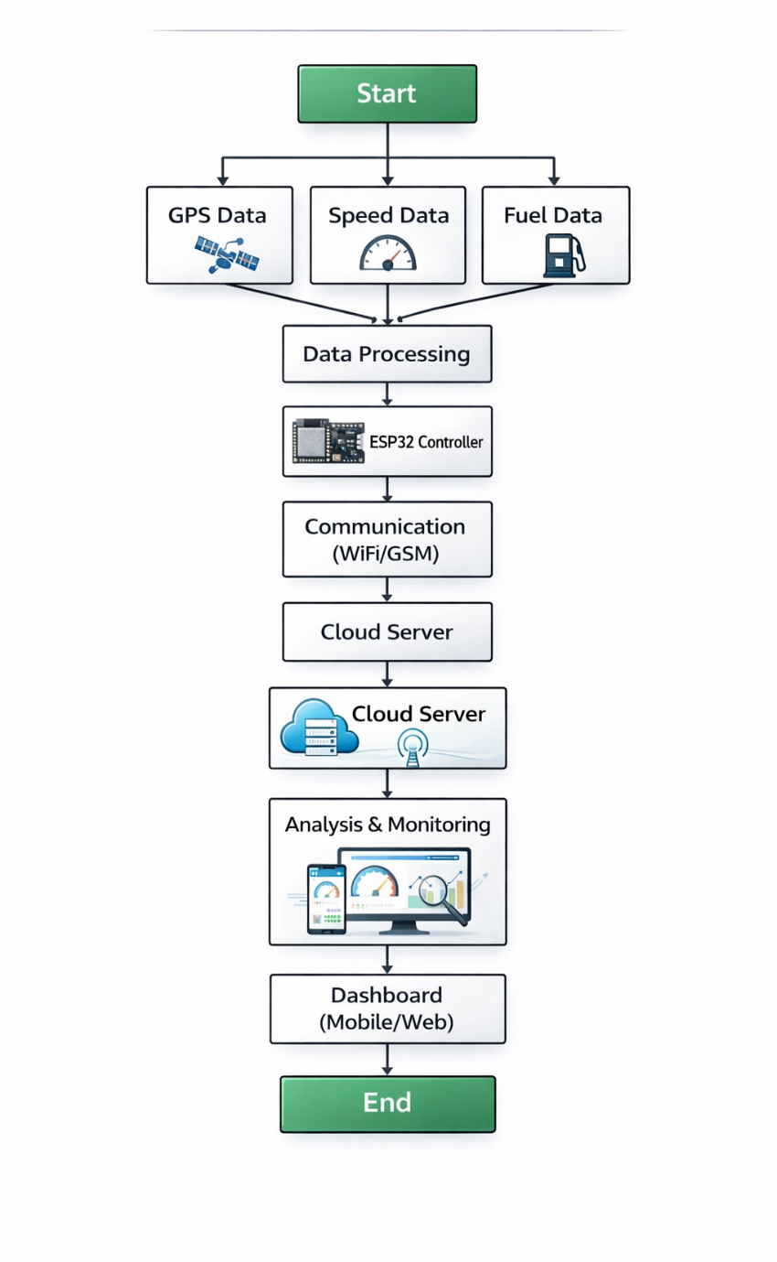

- FEASIBILITY STUDY

The feasibility of the Smart Fleet Management System is evaluated based on economic, technical, and behavioral aspects to ensure that the system can be successfully implemented in real-world applications.
  - Economic feasibility
  - Technical feasibility
  - Behavioral feasibility

ECONOMIC FEASIBILITY:
The Smart Fleet Management System is economically feasible as it utilizes cost-effective components such as ESP32 microcontrollers, GPS modules, and sensors instead of expensive infrastructure. The implementation cost mainly includes hardware components, cloud services, and system maintenance, which are relatively affordable compared to traditional fleet monitoring systems.
By enabling real-time monitoring and automation, the system reduces operational costs such as fuel wastage, vehicle misuse, and manual supervision. Early detection of issues also helps prevent major failures, thereby reducing maintenance expenses. Overall, the system provides a cost-effective solution with long-term financial benefits.

TECHNICAL FEASIBILITY:

The system is technically feasible as it is built using well-established technologies such as IoT, embedded systems, and cloud computing. The ESP32 microcontroller efficiently handles real-time data processing and communication. GPS modules provide accurate location tracking, while sensors monitor various vehicle parameters.

The system uses wireless communication technologies such as Wi-Fi or GSM to transmit data to the cloud. Cloud platforms support data storage, processing, and visualization through dashboards. With proper hardware integration and stable network connectivity, the system can be implemented effectively.

3.3 BEHAVIORAL FEASIBILITY

The Smart Fleet Management System is designed to be user-friendly and easy to operate. Fleet managers can monitor vehicle data through a simple dashboard interface and receive alerts in real time. The system presents information in a clear and understandable manner, allowing users to take quick and appropriate actions.
The system reduces the need for manual monitoring and simplifies fleet management tasks, making it suitable for operators with basic technical knowledge.

4.1 REQUIREMENTS

4.1.1 Functional Requirements
The Smart Fleet Management System should be capable of performing the following functions:
- Allow continuous monitoring of vehicle location using GPS technology.
- Track real-time speed of vehicles and detect overspeed conditions.
- Monitor fuel levels to identify consumption patterns and detect fuel loss.
- Analyze driver behavior such as harsh braking and sudden acceleration.
- Generate alerts for abnormal conditions such as over speeding and low fuel.
- Provide notifications through cloud-based IoT platforms.
- Display system data on a user-friendly dashboard interface.
- Ensure high accuracy in data collection and monitoring.
- Provide fast response time for real-time tracking and alerts.
- Enable remote monitoring through mobile and web applications.
- Support internet connectivity for continuous data transmission.

4.1.2 Non-Functional Requirements
In addition to functional capabilities, the system should meet the following quality requirements:
- The system should be reliable and provide consistent monitoring results.
- It should be scalable to support multiple vehicles in large fleets.
- The system should ensure secure data transmission and user authentication.
- The interface should be user-friendly and easy to understand.
- The system should maintain high performance with minimal delay.
4.1.3 Hardware Requirements
The following hardware components are required for the effective operation of the system:
- An ESP32 microcontroller for processing and communication.
- GPS module for real-time vehicle location tracking.
- Speed sensor for monitoring vehicle speed.
- Fuel sensor for detecting fuel levels and consumption.
- Communication modules such as Wi-Fi or GSM for data transmission.
- Power supply unit to provide stable system operation.
- These hardware components ensure smooth system functioning and support accurate monitoring and data communication.

4.1.4 Software Requirements
The system requires the following software tools and technologies:
- Embedded programming (C/C++) for ESP32 microcontroller operation.
- IoT cloud platform for real-time data monitoring and storage.
- Web or mobile application for user interaction and data visualization.
The software should be reliable, scalable, and capable of handling real time data efficiently.

4.2 ANALYSIS

4.2.1 Functional Analysis
The system is designed to support key operations that help in efficient fleet monitoring and management. The major functions include:
- Monitoring of vehicle location and movement in real time.
- Detection of abnormal conditions such as overspeeding and fuel loss.
- Analysis of driver behavior for safety and performance improvement.
- Storage of system data for future analysis and reporting.
These functionalities enable efficient fault management, reduce downtime, and improve the reliability of power distribution systems.

METHODOLOGY

  - SYSTEM DESIGN AND DEVELOPMENT METHODOLOGY

Requirement Analysis:
The first step in developing the Smart Fleet Management System is identifying the needs of fleet managers and transportation systems. In this phase, important factors such as vehicle tracking, fuel monitoring, driver behavior, and safety requirements are analyzed. The system requirements are studied to determine the features needed, such as real-time tracking, alert generation, and remote monitoring.

Data Collection
In this stage, relevant data is collected from different sources within the vehicle system. The data includes GPS location, speed readings, and fuel levels obtained from sensors and modules.

These data sources help the system understand vehicle conditions and detect potential issues. The collected data is then transmitted to the microcontroller for further processing and analysis.

5.2. FEATURES
The Smart Fleet Management System includes several features that improve fleet monitoring and management. The system continuously tracks vehicle location, speed, and fuel levels to ensure efficient operation. It provides real-time alerts for abnormal conditions such as overspeeding, fuel loss, and unauthorized vehicle usage. Another important feature of the system is driver behavior analysis, which helps in improving safety and performance. The system also supports remote monitoring through cloud-based platforms, allowing users to access data from anywhere..
5.3. Machine Learning Model Implementation
The Smart Fleet Management System uses embedded logic and threshold-based algorithms for monitoring and analysis. The system processes data collected from sensors such as GPS, speed sensors, and fuel sensors to identify abnormal conditions.
Data preprocessing involves filtering noise, validating sensor inputs, and setting threshold limits for parameters such as speed and fuel levels. Parameter selection is performed to identify values that indicate unsafe or inefficient conditions.
The system performs real-time monitoring to analyze incoming data and detect anomalies instantly. The processed data is stored in the cloud for future analysis, ensuring reliable system performance.

VI. IMPLEMENTATION

6.1. IMPLEMENTATION TECHNIQUES
The Smart Fleet Management System uses real-time data collection and processing techniques for efficient monitoring. It gathers data such as vehicle location, speed, and fuel levels from sensors and modules installed in the vehicle.
The data is continuously collected and transmitted to the microcontroller. It is then processed and filtered to remove noise and convert it into a structured format for analysis.
After preprocessing, the system applies threshold-based logic to analyze the data. These thresholds are defined based on safe and efficient operating conditions. The system also compares current data with previously stored data to identify abnormal patterns.
Finally, the analyzed results are used to trigger appropriate actions. The system generates alerts, updates the cloud dashboard, and provides notifications to users. These actions help in quick decision-making and improve fleet efficiency..

6.2 MAINTENANCE
Maintenance of the Smart Fleet Management System involves regular activities to ensure proper functioning and accuracy. This includes:

- Software Updates: Updating system software and cloud platforms to improve performance and add new features.
- Hardware Checks: Inspecting components such as ESP32, GPS module, and sensors for proper operation.
- Data Backup: Storing system data securely to prevent loss and support future analysis..
- Error Correction: Identifying and fixing issues related to sensors, communication, or system errors..
Proper maintenance ensures long-term reliability and efficiency of the system.

VI. WEAKNESS
The Smart Fleet Management System has certain limitations that may affect its performance. The system depends on continuous internet connectivity for real-time data transmission and monitoring. Any interruption in connectivity may delay alerts and data updates.
Sensor accuracy can also be influenced by environmental conditions, which may lead to incorrect readings. The system operates based on predefined threshold values, which may not cover all complex scenarios. Additionally, hardware components require regular maintenance and may need replacement over time.
VII. TESTING TECHNIQUES
Testing techniques are applied to ensure that the Smart Fleet Management System functions correctly and reliably. The major testing methods are as follows:
8.1 UNIT TESTING
Unit testing is performed to ensure that each individual component of the Smart Fleet Management System functions correctly before integration. Modules such as GPS, speed sensor, fuel sensor, and ESP32 are tested separately for accuracy and performance. Each component is verified to ensure correct data collection and processing. This helps in identifying errors early and ensures smooth system integration.
8.2 INTEGRATION TESTING
Integration testing is carried out after the unit testing to verify the proper interaction between all system components. It ensures that sensors, microcontroller,
and communication modules work together without issues. Data flow between modules and cloud transmission is tested for consistency. This ensures the system functions as a unified solution.
8.3 SYSTEM TESTING
System testing is performed to evaluate the overall performance of the Smart Fleet Management System. It ensures that all hardware and software components function correctly according to requirements. The system is tested under different conditions to check reliability and stability. This helps in validating the complete system before deployment.
8.4 USER ACCEPTANCE TESTING
User Acceptance Testing is conducted to ensure that the system meets user expectations and requirements. It involves real users such as fleet managers testing the system functionality. The usability, interface, and accuracy of alerts are verified during this phase. This ensures the system is user-friendly and ready for practical use.
8.5 REGRESSION TESTING
Regression testing is performed to ensure that system updates or changes do not affect existing functionalities. It verifies that previously working features continue to operate correctly after modifications. The system is re-tested after updates to maintain stability and consistency. This ensures long-term reliability of the system.

IX. ADVANTAGES

- Provides real-time vehicle tracking and monitoring.
- Improves decision-making for fleet management operations.
- Reduces fuel consumption and operational costs.
- Enhances safety through driver behavior analysis.
- User-friendly and easy to operate.
- Supports efficient and optimized fleet management.

X. DISADVANTAGES
- Depends on internet connectivity for real-time monitoring.
- Sensor inaccuracies may affect data accuracy and performance.

XI. CONCLUSION
The Smart Fleet Management System is a technology-driven solution designed to improve the efficiency and reliability of fleet operations. By integrating components such as GPS modules, sensors, ESP32 microcontroller, and IoT technology, the system provides accurate and real-time monitoring of vehicle location, speed, and fuel levels. This helps in reducing operational delays and improving overall fleet performance.
The system combines features such as data collection, processing, and real-time alert mechanisms to ensure effective monitoring and management. Its user-friendly interface and cloud-based dashboard make it easy for operators to monitor
vehicle conditions and take quick action. Overall, the system provides a cost-effective and scalable solution that enhances safety, reduces operational costs, and supports modern transportation systems.

XII. REFERENCES

- S. Metvaei, “A GPS-Integrated IoT Framework for Real-Time Monitoring,” MDPI Sensors, 2025.
- “Real-Time Vehicle Monitoring and Safety Alert System with ESP32,” HBRP Publication, 2025
- A. Idris et al., “Vehicle Tracking System Based on Internet of Things Utilizing TTGO T-CALL ESP32 SIM800l,” Journal of Advanced Research in Applied Sciences and Engineering Technology, 2024.

- J. Sharma and A. Kumar, “GPS Based Real Time Vehicle Tracking and Monitoring System using IoT,” RV College of Engineering, 2024.

- S. Raj and M. Karthik, “IoT-enabled voltage monitoring and fault detection system,” Journal of Smart Grid Technology, 2024.

- A. Aman, R. Sharma, and A. Jindal, “IoT based Vehicle Management System using ESP32,” International Journal of Engineering and Management Research, vol. 13, no. 3, 2023.

- M. M. Raikar et al., “Fleet Tracking and Geofencing using the Internet of Things (IoT),” 2023 International Conference on Secure Cyber Computing and Communication (ICSCCC), 2023.

- D. Prakash, "Temperature monitoring and protection system for battery units using IoT," 2023.

- Z. Wei, M. Zhu, N. Zhang et al., “UAV Assisted Data Collection for Internet of Things: A Survey,” arXiv preprint arXiv:2211.09555, 2022.

- T. Salman and R. Jain, “A Survey of Protocols and Standards for Internet of Things,” arXiv, 2019

