INDISCRIMINATE SOLID WASTE DISPOSAL AND THE PROBLEM OF ENVIRONMENTAL QUALITY IN IDAH, KOGI STATE; NIGERIA.
Jegede, Joy Anwuli¹ jegedeja@dsust.edu.ng
Department of Urban and Regional Planning, Southern Delta University, Ozoro. Delta State. Nigeria

Okoye, Boniface Stephen Adim² bsa.okoye@coou.edu.ng
Department of Architecture, Odimegwu Ojukwu University, Uli, Anambra State. Nigeria

Nomuoja, Omonigho Francisca³ nomuojao@dsust.edu.ng
Department of Urban and Regional Planning, Southern Delta University, Ozoro. Delta State. Nigeria

Azagbaesuweli, Monday Joseph⁴ azagbaesuwelimj@dsust.edu.ng
Department of Urban and Regional Planning, Southern Delta University, Ozoro. Delta State. Nigeria

Abstract
The issue of waste generation and management in any living environment is very critical since almost every activity of man leads to waste production including the metabolism of the human body system. Solid waste applies to non-liquid wastes generated by households and those of similar character from shops, offices, commercial units and health facilities. This paper addresses the problems associated with the management of these wastes and the measures adopted by stakeholders in ensuring proper management for an enhanced environmental quality. Three methods of waste disposal were adopted in the study area – waste drums, open dumbing and burning. The Pair-wise correlation was employed to analyse the relationship between the waste generation/disposal methods and the management mechanisms by the Kogi State Waste Management and Sanitation Board and other stakeholders as well as their knowledge and performance level to ensure safe environmental quality and health for the people. The result revealed that the major factors that drive waste problems in Idah include poverty, high population and urbanization growth rate as well as funding and infrastructural deficiencies. Amongst the recommendations made from this study is that the government of Kogi State should carry out a review of the waste management Act in order to enhance the proper management of solid waste and ensure a safe environment for a healthy living in Idah.
Keywords: Solid waste; Management; Environmental Quality; Health; and Stakeholders.

Introduction
Indiscriminate waste disposal no doubt affects the environmental quality of any geographical space. Waste if not properly managed is liable to contaminate the air, water and soil, thereby breeding disease vectors and affecting human health negatively. The current state of waste management in Nigeria is of major concern due to the high rate of waste generation and poor management practices. According to World Bank Report as stated by Braimah [1], Nigeria produces an estimation of 32million tons of solid waste per year with only about 20-30 percent of it collected and managed properly. The rest of the waste is either dumped in unauthorised places like drainage channels, undeveloped lands or even along streets or buried thereby leading to pollution and health risks. The World Bank has however, projected the waste generation of Nigeria to 107million tonnes by 2050 considering the present rate of urbanisation. This reality portends a very dire future for urban dwellers in low income areas who are unable to manage the volume of waste they presently generate which may give access to certain environmental and health challenges for the people; blockage of drainage, contamination of groundwater, sanitation problems which thus affect the food chain and drinking water sources and even agriculture through the leaching of dioxins which is a hazardous chemical from the disposal of Batteries into the surrounding soils thereby polluting the soils. Burning of these wastes could also lead to the release of carcinogens into the atmosphere causing respiratory disorder in human [2]. The overall result of this indiscriminate disposal and management of the wastes is seen the degrading of the quality of the environment.
The continuous indiscriminate disposal of solid waste is accelerating and it is linked to poverty, poor standards of living and low level of environmental awareness and inadequate management of environmental knowledge. Most of these wastes are generated from domestic sources [3]. The persisting problems of municipal solid waste management in Nigeria prompted the need for communicating innovations and knowledge to achieve the desired transformation in overcoming socio-economic and environmental challenges.
The practices of solid waste management in Nigeria have led to adverse health and environmental consequences including destruction of aesthetics and negative impact on tourism. Some of these practices are characterised by inefficient collection methods, insufficient coverage of the collection system and improper disposal. Such disposal practices in most Nigerian cities involve co-disposal of hazardous and municipal waste in open unlined dumps, open burning of municipal solid wastes, dumping in water bodies, dumping along drainage channels and in other unauthorized places. This has resulted to a situation whereby Nigeria cannot boast of a single properly engineered sanitary landfill for its municipal solid wastes [4].
Solid waste management is the most pressing environmental challenge faced by urban and rural areas of Nigeria. There is no doubt that Nigeria is one of the largest producers of solid waste in Africa with her population exceeding 170 million. According to the United Nations Habitat Watch, African city populations will move more triple over the next 40years. These cities are already inundated with slums, a phenomenon that could triple urban populations and spell disaster, unless urgent actions are initiated. Out of the 36 States and the Federal Capital Territory in Nigeria currently, only a few have shown a considerable level of resolve to proactive steps in fighting this scourge, while the rest have merely paid lip services to issues of waste management indicating a huge lack of interest to develop the waste sector.
This paper is designed to address the problems of environmental quality that emanate from indiscriminate solid wastes disposal as well as the impact on the people of Idah in Kogi State; Nigeria.
Problems of Solid Waste Disposal Management
The problems confronting waste management in Nigeria today are in various dimensions ranging from environmental, health, technology, economic, psychological to even political, funding and awareness creation. The issue of solid waste is directly linked to rapid urbanisation which results from the increase in population. Idah being one of the local government headquarters in Kogi State is witnessing rapid urbanisation considering her functions and recent developments in the area. This has exposed the town to some environmental challenges due of poor waste management as noted by Olusegun, Ohunene, Ajare, Adeyemo and Adefabi [5]. Efforts to implement an integrated solid waste management programme are hampered by lack of current estimates on the quantity of waste generated and disposed of in the area [6].
According to Ibe, Opara, Amaobi and Ibe [7], the major problem is how to identify a model that best describe the policy that can solve the problem of solid waste management in Idah. The problems of solid waste disposal have become one of the major environmental problems facing many cities in Nigeria in recent times. This is multi-faceted and explains its persistence despite government efforts [8]. The devastating state of solid waste management in the world’s poor cities has attracted attention even at global level as pointed out in Agenda 21 Document. To address the waste problem confronting the World, four major programme areas were identified;
- Minimizing waste
- Maximizing environmental solid waste reuse and recycling
- Promoting environmental solid waste disposal and treatment
- Extending waste service coverage.
In Kogi State, the government institution responsible for solid waste management in Idah is the Kogi State Waste Management and Sanitation Board (KSWMSB). The management of waste has to be environmentally responsible and economically viable in order to achieve the sustainability of a contemporary society [9]. This Board has the following components of activities – city cleaning, street sweeping and litter control, solid [10]. Unfortunately, the Board has no program for recycling of recyclable wastes and as such does not fit into the contemporary waste management concept such as the Reduce, Recycle and Reuse concept which is the globally accepted approach [11].
The Concept of Environmental Quality
Environmental quality from science and environmental perspective refers to the properties and attributes of the environment generalized or on a small scale, encompassing the physical, chemical, and biological components as they affect human beings and other organisms. It is a measure of the condition of an environment concerning the requirements of species and their needs or demands. It is a broad concept that includes the natural and built environments such as air, water purity or pollution noise levels, access to open space and the visual effects of the built environment all of which can influence the physical and mental health [12]
Human activities in Nigeria have also resulted in environmental challenges like biodiversity loss, oil spillage, bush burning, urban housing problem, water scarcity as well as pollution (water, air, soil, marine, noise, thermal, radioactive and vehicular). Broader worries have also arisen about environmental challenges of deforestation, urban flooding, destuction of aquatic habitats, illegal mining activities, dereliction, and over-exploitation of forest resources, road transportation mishaps as well as solid waste problems. Other forms of environmental degradation are desert encroachment, ozone layer depletion, global warming, poor environmental sanitation, unlawful exploitation of fossil fuel resources, oil spillage, gas flaring and many other challenges relating to oil exploitation and production [13, 14]. The environmental challenges are aggravated by poverty and rapid increase in human population.
MATERIALS AND METHODS
The Study Area
The town Idah is one of the urban centres in Kogi State and one of the oldest settlements in Igala land. It is the traditional and cultural headquarter of the Igala kingdom and a host of the seat of the Monarch (Attah of Igala Kingdom). It is geographically located at the south eastern part of the state and on the eastern bank of River Niger. It is lying beside the middle course of the River Niger. It is the Headquarter of Idah local government area of Kogi State. It has commercial routes (waterways) on the River Niger linking Lokoja to the north of the country; Onitsha in Anambra to the south; Agenebode in Edo State to the west; and Enugu to the east. It is a homogeneous community dominated by the Igala’s and few of other tribes [15]. The population of the area from the 2006 census is 79,755 [16], and by projection using geometric growth model [17] the figure is put at 102,092 for 2016 [15].
Pattern of Solid Waste Disposal in Idah
The result of the survey carried out on the performance of solid waste collection agents indicates that 35.6% of the total solid waste generated in the town (Idah) were disposed within the premises of the residents and later burnt. About 22.4% of the solid wastes generated from the town were collected by private waste collectors who collect mostly waste from households and business premises. Scavengers which are also waste collection agents collect and dispose waste on ad-hoc basis and account for about 16% of total waste generated from the town. In some instances, members of the family especially young children directly collect and dispose their waste indiscriminately along unauthorised places like streets, drainages and in some undeveloped plots within the residential areas. The private collector account for 12.2% and personal collection accounts for 13.8%.
Analysis of Solid Waste Disposal Methods in Idah
The study identified three major disposal methods of solid waste in Idah. They include – waste drums, open dumping, and burning. The study also revealed that the wastes are composed of household, office, business and clinically generated wastes like – food remnants, plastic (bottles) and polythene materials, papers roughages from fruits and agricultural products, metals and clinical materials. The field survey showed that 12.7% of the respondents said their wastes were disposed in waste drums.
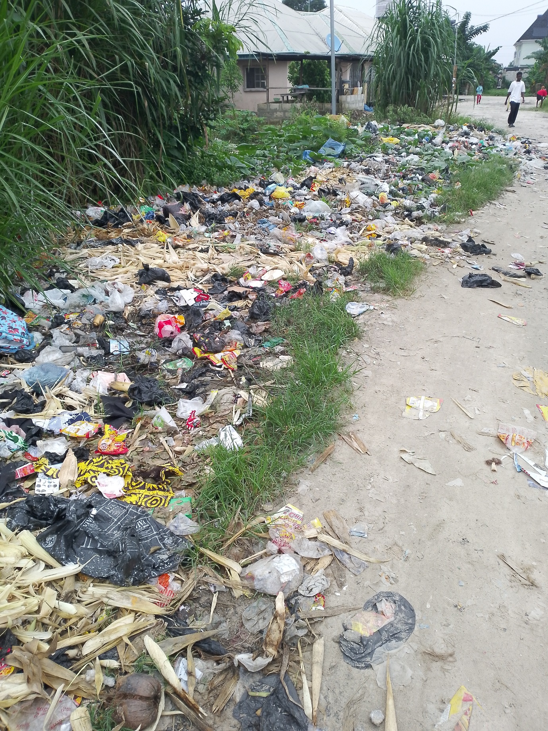
Plate 1: Indiscriminate dumping of refuse along the street
Though the town does not have any designated waste drum presently as shown on Plate 1 where waste are dumped indiscriminately along the street, the misconception may be from those who thought that disposing waste in drums is a safe practise. The analysis revealed that 48.5% of the respondents dump their waste in open spaces or along the street while 28.2% dump their waste in open dumpsites and 10.3% practice waste burning. Most of the wastes generated from the market are disposed at the central dumpsite in Ega market area or separately by individuals at isolated illegal dumpsites that litter and degrade the environment.
Table 1: Result of the Pair-wise Correlations of the Variables
 | 1 | 2 | 3 | 4 | 5 | 6 | 7 | 8
1 Waste disposal | 1.00
2 Waste generation | 0.06 | 1.00
3 Waste composition | 0.01 | 0.30 | 1.00
4 Waste collection | 0.06 | 0.91 | 0.32 | 1.00
5 Household waste drum | 0.03 | 0.03 | 0.05 | 0.05 | 1.00
6 Board operations | 0.05 | 0.03 | 0.01 | 0.02 | -0.02 | 1.00
7 Engagement of Respondent | 0.03 | 0.11 | 0.10 | 0.12 | -0.00 | 0.01 | 1.00
8 Income level | -0.0 | -0.01 | -0.01 | -0.0 | 0.04 | 0.00 | 0.00 | 1.00
Author’s Field Survey, 2024.
From the Pair-wise Correlations of the dependent variables on Table 1, it can be revealed that there is a very high correlation between waste disposal variables with knowledge of waste recycling, the amount of waste collected, types of drums used for waste collection, Kogi State Waste Management Board operations on household and the engagement of the respondents. The regression has weak correlation with each other, aside from knowledge of waste recycling and Kogi State Waste Management Board operations on households.
Table 2: Analysis of Pair-wise Correlation of Knowledge of Waste Management
Dependent Variable | Group 1 | Group 2 | Mean Difference | Std. Error
Waste Board Regulation on sanitation | Businesses | Households  Policy makers | -363.17  16.67 | 22.80  22.80
 | Households | Businesses  Policy makers | 363.17  379.83 | 22.80  22.80
 | Policy makers | Businesses  Households | -16.67  -379.83 | 222.80  22.80
Waste Board Regulation on Reuse & Recycling | Businesses  Households  Policy makers | Household  Policy makers  Businesses  Policy makers  Businesses  Households | -408.67  16.67  408.67  425.33  -16.67  -425.33 | 35.36  35.36  35.36  35.36  35.36  35.36
Waste Board Regulation on Burning | Businesses  Households  Policy makers | Households  Policy makers  Businesses  Policy makers  Businesses  Households | -363.17  16.67  363.17  379.83  -16.67  -379.83 | 20.68  20.68  20.68  20.68  20.68  20.68

Table 2 above shows that the mean difference is significant at 0.05 level. Household performed better than knowledge from Businesses and Policy makers in recycling with a mean of 363.67. This implies that businesses were second best performers while policy makers were the least performers in recycling with a mean value of 16.33. On the whole, there was a fair tending towards poor performance in recycling by all three groups. Household also performed better in burning with a mean value of 363.17 while the other two performed less. It can however be deduced that household has a good performance rating and indeed possess a better knowledge.
Findings
The key factors that drive waste problems in Idah include – poverty, high population and urbanization growth rates as well as funding and infrastructural deficiencies. About 80% of the waste generated from most households and offices within the town are disposed indiscriminately. These wastes are stored in covered plastics, baskets, and receptacles or in bags especially at household levels thereby degrading the quality of the environment.
Waste disposal in Idah has no laid down rules or pattern, exercise (waste collection) has no pattern for households while it is carried out more often say interval of two days for business premises, offices, hospitals and other collection points.
Due to the absence of any formal recycling programme in the State, there is no material recovery facility in the town, hence material reuse and recycling activities in the town is limited to household reuse and scavenging activities of the urban poor.
The study also revealed that there are two classes of scavengers in the town; the itinerant waste pickers who go from house to house picking valuable items from waste bins. This group consist mainly of the unemployed young men with little basic education as pointed out by Nzeadibe, [18].
The second class of scavengers are those who operate solely at the dumpsites picking recyclable materials. This group consists of young men who have no formal education. They commute daily with push-on trucks and barrows in search of wastes at various dumpsites.
Hindrances to Achieving a Sustainable Solid Waste Management for Enhanced Environmental Quality in Idah
This study has identified some major impediments to the attainment of a sustainable solid waste management in Idah. They include the following;
- The existence of an inactive waste management institution.
- Non-enlightenment of the public on the need for a proper waste management.
- Difficulty in accessing some areas for waste collection due to poor road network.
- Poor organisation in the operations of the waste collectors.
- Non-implementation of urban policies that address the issue of waste management.
- Inadequate regulations on waste management.
- Inefficient workers due to poor training.
- Lack of modern/sophisticated equipment for waste collection.
- Poor knowledge of the impact of improper waste disposal on the environment.
Way Forward to Achieving a Proper Waste Management Strategy for a Quality Environment
Considering the findings from this study, the following recommendations were put forward so as to curb the problems associated with municipal solid waste management in Idah;
- There should be a review of the Waste Management Act or Edict by the Kogi State Government in order to enhance the management of solid waste in Idah.
- It is essential to develop and adopt certain strategies that will give room for a sustainable solid waste management in Idah.
- There should be public enlightenment programmes that dwell on environmental management as well as waste management.
- It is very important to organise training programmes for the waste workers.
- There is also need for a proper physical planning of the area to enhance easy access to houses by the waste collectors
- The waste management outfit in the town should be refurbished especially by providing more modern equipment by the government for effectiveness in waste collection.
- Drainage channels should be evacuated for easy flow of run-off water to enhance environmental quality as shown on Plate 2.
- Enlightenment campaign should be carried out by environmental health practitioners on the need to have a good quality environment for healthy living.
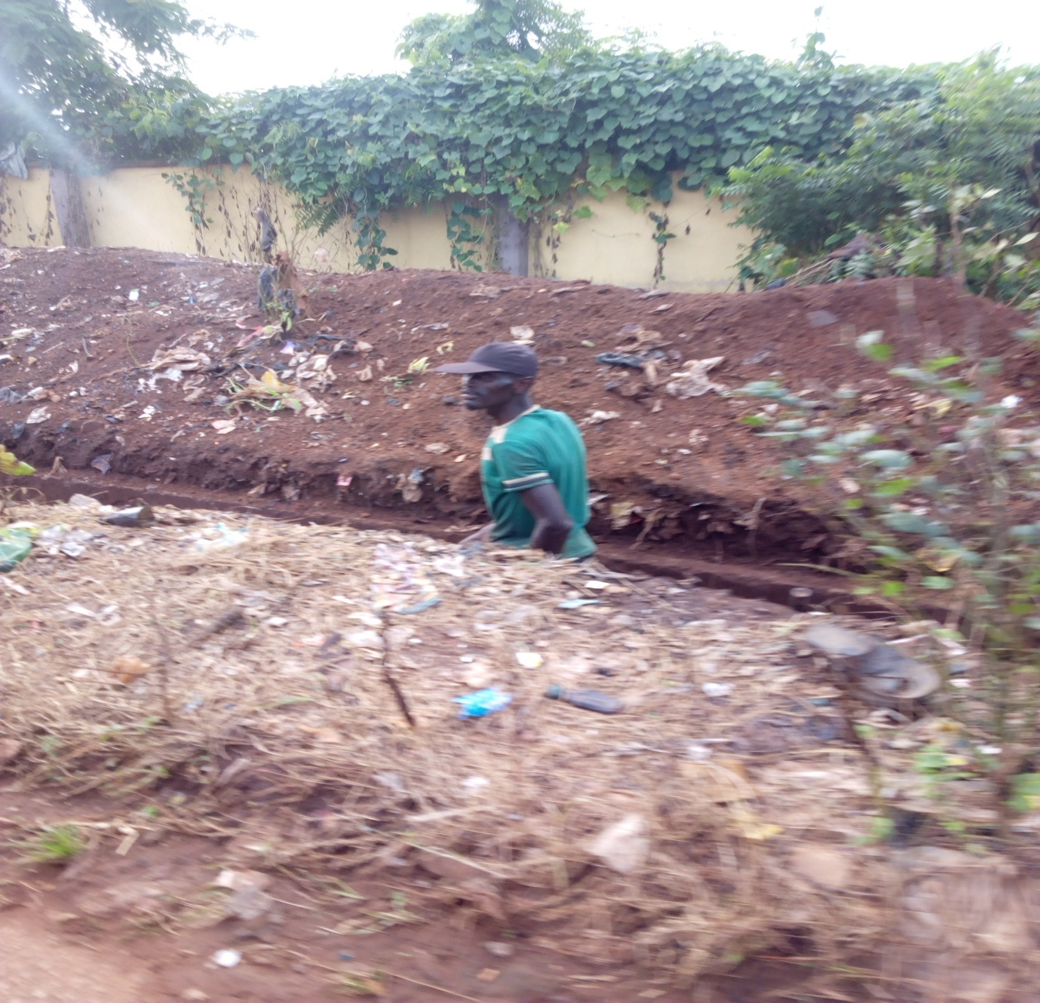
Plate 2: Evacuation of drainage channel for easy flow of run-off water
Conclusion
From the study, it can be deduced that the solid waste management system in Idah town is faced with enormous challenges ranging from the generation and disposal methods to collection as well as evacuation from the environment. It is important to note therefore, that proper environmental management is key to good health, hence the solid waste management system in Idah town should be given utmost priority and proper funding and should be well organised to ensure a good environmental quality and a safe health for the people and the image as well as the physical environment of the town is not jeopardised,

References
- Braimah, E. (2023). The current state of waste management in Nigeria and the challenges of transioning to a circular economy. Hewsletter. The Greenleaf Project. Investment II, Sustainable Finance II, Climate.
- Agbo, M. (2023). The problem with solid waste management in Nigeria’s low-income Neighbourhoods. Earth.org
- Abila, B. and Kantola, J. (2019). Municipal solid waste management problems in Nigeria. Evolving knowledge management solutions. Le débat de WA THI. Climate change. WATHNOTE.
- Babade, O.O. (2017). Status of solid waste management in Nigeria (including plastic). Pollution Control and Environmental Health. Federal Ministry of Environment, Abuja.
- Olusegun, A.; Ohunene, J.E.l Ajare, E.O.; Adeyemo, A. and Adefabi, A. (2024). Statistical Analysis of some Barriers to Market Waste Management in Federal University Lokoja and its Environment. Research and Scientific Innovaeion Society (RSIS). Pp 658-626
- Nwosu, O. U. and Nwachukwu, C.S. (2021). Evaluation of waste management practices at the Federal University of Technology, Owerri (FUTO), Imo State of Nigeria. Journal doi: www.doi.org. 7(3)
- Ibe, F.C.; Opara, A.I.; Amaobi, C.F. and Ibe, B.O. (2021). Environmental risk assessment of the intake of contaminants in aquifers in the vicinity of a reclaimed waste dumpsite in Owerri municipal, South Eastern Nigeria. Applied Water Science 11(21) 1-19.
- Olanrewaju, O.O. and Ilemobade, A.A. (2009). Waste to wealth. A case study of the Ondo State integrated waste recycling and treatment project, Nigeria. European Journal of Social Sciences. 8(1).
- Jatto, I.; Isah, Y.; Omeje, E. and Akubo, A. (2023). Conversion of Domestic and Industrial Water in Lokoja to sustainable low Carbon Footprint Energy. Research Gate. https//www.researchgate.net
- Akoni, J. (2007). Municipal solid waste management in Abuja. Internal Departmental Evaluation Paper. Waste Management Department, Abuja Environmental Protection Board. Ministry of FCT, Abuja. Nigeria.
- Opaluwa, H. and Ibrahim, S.I. (2022). An Assessment of Solid Waste Management System in Lokoja Metropolis. Sapientia Foundation Journal of Education, Sciences and Gender Studies (SFJESGS). Vol.4 (3). Pp 173-186.
- https://en.wikipedia.org
- Ibimilua, F.O. and Ibimilua, A.F. (2014). Environmental Challenges in Nigeria: Typology, Spatial distribution, Repercussion and way forward. American International of Social Science. Vol.3 (2).
- Jegede, J.A. (2019). Managing the Built Environment through Capacity Building. A Paper presented at the 5th National Engineering Conference. The Federal Polytechnic, Idah, Kogi State. 30th July – 2nd August.
- Jegede, J.A. (2017). Metal Waste Enterprise: A Tool for Revamping the Economy of Idah, Kogi State. International Journal of Management Studies, Business and Entrepreneurship Research. Vol.2, No.4. Pp 106-114.
- National Population Commission (NPC) (2006). Federal Republic of Nigeria.
- Agbola, S.B.; Olatubara, C.o.; Yusuf, D.O.; Alabi, M. (2003). Contemporary social science research methods: A practical guide. Lagos. MURLAB Publishers.
- Nzeadibe, T. (2009). Development drivers of waste recycling in Nsukka urban area, south- eastern Nigeria. Theoretical and Empirical Researches in Urban Management. 3(12). 137-145.

