Comparative analysis of the influence of coil and fin materials on the performance of the Condenser of a split AC with Puron (R- 410A) as refrigerant.
Ryne P M¹, Dr. P Sridharan², Dr. S Christopher Ezhil Singh³
¹Associate Professor, Department of Mechanical Engineering, Vimal Jyothi Engineering College, Kannur, Kerala.
^{2,3} Professor ,Department of Mechanical Engineering, Vimal Jyothi Engineering College, Kannur, Kerala -670632.

Abstract
The condenser is a critical component of an air-conditioning system, where the refrigerant rejects latent heat and undergoes phase change from vapor to liquid. The compressor elevates the pressure and temperature of the refrigerant, enabling effective heat rejection to the surrounding air. The performance of the condenser is strongly influenced by the thermal properties of the coil and fin materials, with high-conductivity materials such as copper and aluminium offering enhanced heat transfer characteristics. In addition, geometric parameters including coil length, fin area, and fin spacing play a significant role in determining the overall efficiency of the system. This study focuses on the optimization of condenser performance through systematic design and analysis of coil fin configurations. Conventional heat exchanger design methodologies are integrated with computational approaches to evaluate thermal performance under varying operating conditions. In particular, Computational Fluid Dynamics (CFD) is employed to analyse different material combinations of copper and aluminium for coils and fins. The refrigerant used in this study is Puron (R-410A), widely adopted in modern HVAC systems. The results provide insights into the influence of material selection and geometric parameters on heat transfer efficiency and condenser effectiveness. The findings demonstrate the potential of CFD as a reliable tool for enhancing condenser design and improving the overall performance of HVAC systems.
Keywords: CFD Simulation, HVAC, condenser, Refrigerant
- Introduction
Condenser is the device which rejects the heat of condensation to the surrounding fluid . Heat transfer from the condenser surface depends up on the area of heat transfer, convection coefficient and temperature difference between the condenser surface and ambient air. Smaller capacity systems like splt air-conditioners and packaged air-conditioners use air cooled condensers which prevents the unnecessory usage of water from the condensing power cycle. Air cooled condensers with fins are preffered for systems less than 10 TR . Air cooled condenser consists of coils made up of stainless steel,copper or aluminium through which refrigerant to be condensed flows. Selection of the material is done based on the factors like type of refrigreant, thermal conductivity and corrossion. [1] Volume of the air circulated ,area of the heat transfer surface and convection coefficient are the factors which effecte heat transfer rate. Split air-conditioners use aircooled condensers and since the convection coefficient is less in this case, fans are used for the forced circulation of the air over the coil and fins are provided over the condenser coil to increase the heat transfer area. Proper design of the condenser coil, fins and its spacing are to be done so that sufficient amount of air passes over the coil and fins. Convection coefficient depends up on the material of the cooling coil,material of the fin and materials with higher thermal conductivity are preffered for higer heat transef rate. Optimization of the cooling coil length, fin area and spacing will improve the efficiency of the condenser coil. Even if the design satisfies the required conditions, its possible to improve the design by optimizing it. The design can be improved by modifying the basic design by changing the assumed data and using the data based on the new design. HVAC condensers play a key role in heating, ventilation, and air conditioning systems by removing heat extracted from indoor spaces. Their primary function involves condensing the refrigerant from vapor to liquid form through effective heat rejection, which is essential for maintaining thermal comfort and indoor air quality. With increasing energy demands and growing environmental concerns, improving the efficiency of HVAC systems has become a significant priority. In this context, Computational Fluid Dynamics (CFD) has become an important analytical tool for enhancing condenser design and performance. CFD enables detailed simulation of fluid flow and heat transfer phenomena within condensers, allowing engineers to examine temperature and pressure distributions, detect performance limitations, and refine design configurations for better thermal efficiency. Furthermore, the use of CFD in condenser analysis supports the development of energy-efficient and sustainable building systems. Research indicates that design variables such as geometry and material selection have a substantial influence on system performance, highlighting the importance of accurate numerical modelling. As the need for energy conservation intensifies, the application of CFD in optimizing HVAC condensers is becoming increasingly critical for addressing both economic and environmental challenges in modern engineering. The study by Madhu Jhariya et al. [2] experimentally compared the performance of a window air conditioner using single-channel and multi-channel condensers under different refrigerants (R-22 and R-410A). The performance parameters such as coefficient of performance (COP), cooling capacity, energy consumption, and compressor work were evaluated, showing that the multi-channel condenser significantly improved system performance. The results indicated that the multi-channel condenser achieved about 6.6% higher COP and 38.4% higher cooling capacity compared to the single-channel condenser, highlighting its superiority in enhancing air conditioner efficiency. V. Srividhy and G. Venkateswarao [3] focused on improving the heat transfer rate of an air conditioner condenser through material selection and design parameter optimization. The authors analyzed the impact of different condenser materials and operating parameters on thermal performance, aiming to enhance heat dissipation efficiency. The results showed that appropriate material choice and optimized design parameters significantly improve heat transfer rate and overall performance of the air conditioning system. Jeffrey K. et al. [4] investigated the effect of condenser shading on the performance of residential air conditioning systems. Through experimental measurements, the authors evaluated how reducing solar exposure to the outdoor condenser unit influences energy consumption and system efficiency. The results indicated that condenser shading can improve air conditioner performance and reduce power usage, although the extent of improvement depends on installation conditions and environmental factors. The study by K. Nagalakshmi and G. Maruthi Prasad Yaldar [5] presents the design and performance analysis of a refrigeration system using R22 and R134a refrigerants. The authors compared key performance parameters such as coefficient of performance (COP), cooling effect, and compressor work under different operating conditions. The results indicated that while both refrigerants are effective, R134a can be considered a suitable alternative to R22 with comparable performance and improved environmental characteristics. Dr. Akash Langde et al. [6] investigated an air conditioning system enhanced with modified condenser ducts and evaporative cooling techniques. The authors analysed how these modifications improve heat rejection from the condenser, thereby increasing overall system efficiency. The results showed that integrating evaporative cooling with optimized duct design can significantly enhance cooling performance and reduce energy consumption. Modh Hazwan Yosif et al. [7] investigated the effect of refrigerant charge and outdoor temperature on the performance of a split-unit air conditioner using R22 refrigerant. The authors analysed how variations in refrigerant quantity and ambient conditions influence the heat transfer characteristics of the condenser and evaporator. The results showed that optimal refrigerant charge and moderate outdoor temperature conditions are crucial for achieving efficient system performance, while deviations lead to reduced cooling efficiency and increased energy consumption. Akusu O.M. et al. [8] focused on the design and construction of a split unit air conditioner system. The authors detailed the development process, including component selection, system assembly, and operational analysis to evaluate performance. The results demonstrated that the constructed system achieved satisfactory cooling performance, validating the effectiveness of proper design and fabrication techniques in air conditioning systems. Samantha Ayres [9] presented the design and development of a 12-kW air-cooled water chiller system. The work includes detailed analysis of key components such as the compressor, condenser, evaporator, and expansion device to achieve the desired cooling capacity. The results demonstrated that proper system design and component selection are essential for achieving efficient performance and reliable operation of air-cooled chillers. Robert Weed and John Hipchen [10] examined the advantages of using reduced diameter copper tubes in evaporators and condensers of air conditioning systems. The authors analysed how smaller tube diameters enhance heat transfer efficiency due to improved refrigerant flow characteristics and increased surface area-to-volume ratio. The results indicated that reduced diameter tubes can improve system performance, reduce refrigerant charge, and contribute to overall energy savings. Ali Hussain Tarrad and Ali Farhan Al-Tameemi [11] presented experimental and numerical analyses for the thermal design of an air-cooled condenser. The authors developed a mathematical model and validated it with experimental data to evaluate heat transfer performance under various operating conditions. The results showed good agreement between experimental and numerical findings, confirming that proper thermal design and modeling can significantly enhance condenser efficiency and system performance. Anna Pacak [12] used computational fluid dynamics to determine the drop of pressure and characteristics of air distribution in recuperative heat exchangers. Numerical calculations were performed for a counter flow heat exchanger with a relatively complex structure providing a large heat exchange surface. Numerical and empirical calculations were compared with certified data obtained according to EN308:1997 standards. The results showed that the numerical methods can predict the pressure drop in operating parameters of the heat exchanger, in the absence of experimental data. Vemula Nagarjuna [13] designed an air-cooled condenser for vapor compression system and performed CFD analysis to evaluate the effects of using different materials as fins using copper as tube material. Performance of the condenser using the refrigerants R134a and R32 were compared and based on the analysis optimal combination of materials and refrigerant was obtained. Based on the reviewed literature, it is evident that the performance of air-cooled condensers is significantly influenced by material selection, geometric parameters, and operating conditions. Previous studies have demonstrated improvements in heat transfer and system efficiency through modifications in condenser design, use of high thermal conductivity materials, and optimization of parameters such as fin spacing, coil length, and airflow characteristics. Moreover, the application of Computational Fluid Dynamics (CFD) has emerged as a reliable and effective tool for analysing thermal behaviour and predicting system performance with reduced experimental effort. However, a comprehensive approach that combines material selection and geometric optimization using CFD for modern refrigerants remains limited. Therefore, the present study focuses on enhancing the performance of an air-cooled condenser by analysing different combinations of copper and aluminium for coil–fin configurations using R-410A refrigerant. The work aims to provide a systematic evaluation of design parameters and demonstrate the effectiveness of CFD in optimizing condenser performance for improved efficiency in HVAC systems.
- Methodology

2.1 Condenser coil and Fins
In air cooled condenser, fins are very important componentand are made up of thin metal plates that helps to increase the rate of heat expel from the fluid flowing through tube and thus cooling the fluid more rapidly and therby increasing the heat rejection rate and condensation rate. Heat dissipation rate is higher in rectangular fins than that of any other shape of similar volume. Effectiveness of the rectangular fin is higher than any other configuration. Improper design of the fins can stifle the heat rejection capacity of the unit, reduces the efficiency of the condenser and hence effectes the performance of the entre air conditioning unit. Inefficiant system has to work more than the normal conditions and this leads to higher working load on the compressor and this over heats the compressor, cause higher electricity consumption and increases the wear rate.Continuous-plate fins are mainly used in air cooled condensers of lower capacity air conditioners such as split air conditioners. Convective heat transfer area can be increased by providing fins around the condenser coil.Convection heat transfer rate,
Q_{conv} = U_{o}A∆T_{m} (1)
Where U_{o} = Overall heat transfer coefficient, A = the area of contact, ∆T_{m} is temperature difference.following equation can be used for finding the overall heat transfer coefficient
$\frac{1}{Uo}$= $\frac{1}{h_{i}A_{i}}+$ $\frac{rₒ ln(\frac{rₒ}{ri})}{k}+\frac{1}{h_{o}A_{o}}$ K/W (2)
For heat exchangers including condensers and evaporators, the temperature difference between the cooling fluid and the hot fluid is not constant and hence logarithmic temperature difference is to be considered while designing the cooling coil. If, ΔT_{i} is the difference between hot refrigerant inlet temperature (Th_{i}) and cold air inlet temperature (Tci) and ΔT_{o} is the difference between refrigerant outlet temperature (Th_{o}) and cold air outlet temperature (Tc_{o}). Log Mean Tempertatue difference LMTD can be determined by using
∆T_{m =}$\frac{ΔTi-ΔTo}{ ln(\frac{ΔTi}{ΔTo})}$ (3)
Condensers of air conditioners of smaller capacity comprehensively uses continuous plate fins which extends from tube to tube. Figure 1. shows a plate fin with rectangular tube aray. In such arrangements, attaining a closed analytical solutin is impossible and suitable approximate methods only can be used in which circular fin can be assumed that has the same efficiency of the plate fin and can be analyzed. The air-cooled condenser used in air-conditioning systems is fabricated as a compact fin-and-tube heat exchanger in which tubes, fins, end plates, and structural supports are integrated into a rigid assembly. Initially, copper or aluminum tubes are cut, cleaned, and bent into the required serpentine or arranged in straight parallel configurations depending on the design. Thin aluminum fins are manufactured separately with precisely punched holes corresponding to the tube layout, and these fins are stacked over the tubes to form a closely spaced fin-tube matrix. The tubes are then mechanically expanded so that they make tight contact with the fins, ensuring efficient heat transfer. The tube ends are inserted into end plates (tube sheets), which maintain proper alignment and spacing, and are subsequently brazed to form leak-proof joints. Headers or manifolds are attached at the inlet and outlet ends to distribute and collect the refrigerant uniformly across the tubes. The entire assembly is held together using connecting rods or tie rods that fasten the end plates and provide structural rigidity, preventing deformation due to vibration and thermal stresses. Finally, the condenser coil is mounted within a protective frame or casing, and necessary connections are provided for integration with the refrigeration system. This fabrication process ensures good mechanical strength, effective heat transfer, and reliable operation of the condenser under varying thermal and pressure conditions. In an HVAC condenser, multiple components function in coordination to ensure effective heat rejection and improved system efficiency. The end plates provide mechanical support by holding the tubes and coils in proper alignment, thereby maintaining structural integrity during operation. Fins are attached to the tubes to increase the available surface area, which enhances heat transfer from the refrigerant to the ambient air. Connecting rods or tie rods add rigidity to the assembly, helping to maintain uniform spacing and overall stability. The bends in the tubing are carefully designed to allow smooth refrigerant flow with minimal pressure drop, thereby supporting efficient phase change processes. Copper tubes serve as the primary pathways for refrigerant flow, utilizing their high thermal conductivity to promote rapid heat transfer. Convection coefficient can be increased by increasing the mass flow rate of the air surrounding the fins and coil by blowing air using fans. Axial flow forced draft fan blows air on the tubes and fins. Coils and fins of the air cooled condenser are made up of the materials such as stainless steel, copper or aluminium. Even though the thermal conductivity aluminium is 237W/mK and that of copper is 398W/mK which is around 1.7 times higher, copper is 2 times costlier than aluminum. Copper tubes and aluminium fins are used under normal operating conditions and this combination provides the best heat transfer efficiency for the cost. Collectively, these components form an integrated condenser structure designed to deliver reliable and energy-efficient thermal performance in HVAC systems. Convection coefficient can be increased by increasing the mass flow rate of the air surrounding the fins and coil by blowing air using fans. Axial flow forced draft fan blows air on the tubes and fins. Coils and fins of the air cooled condenser are made up of the materials such as stainless steel, copper or aluminium. Even though the thermal conductivity aluminium is 237W/mK and that of copper is 398W/mK which is around 1.7 times higher, copper is 2 times costlier than aluminum. Copper tubes and aluminium fins are used under normal operating conditions and this combination provides the best heat transfer efficiency for the cost. Proper spacing between the fins helps to pass the air between the fins and prevent the sticking of debries particles between the fins.
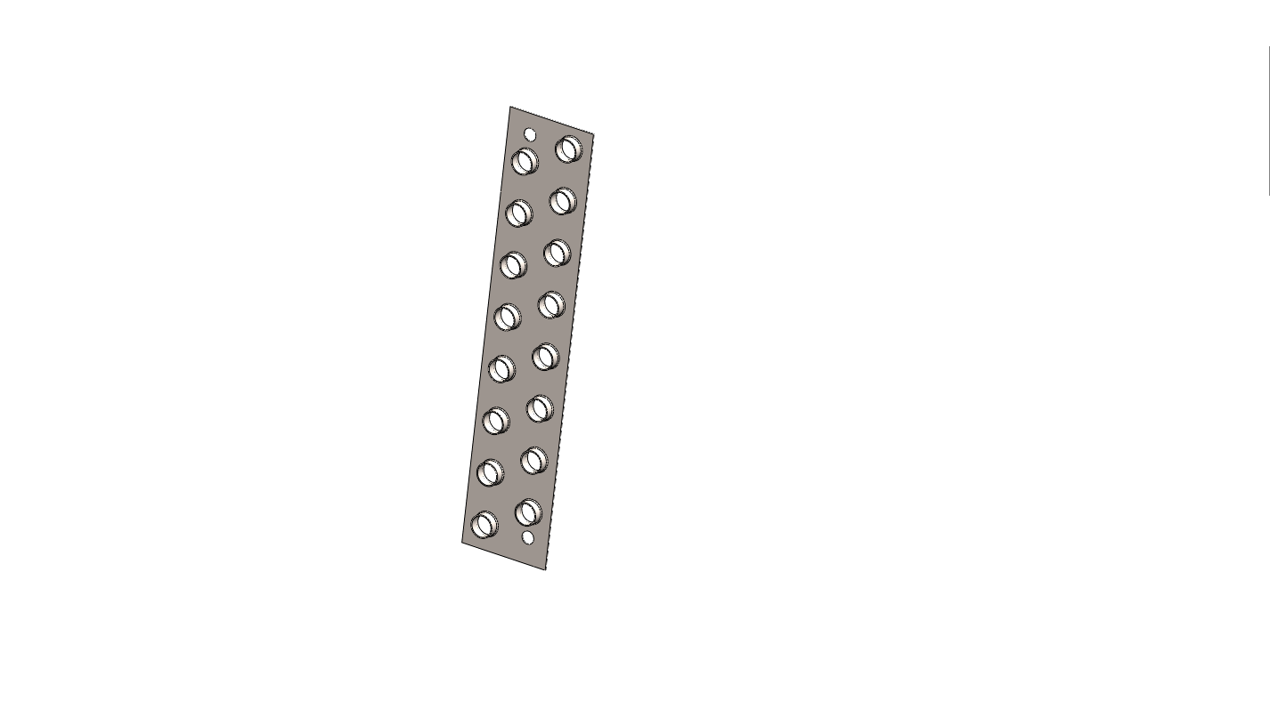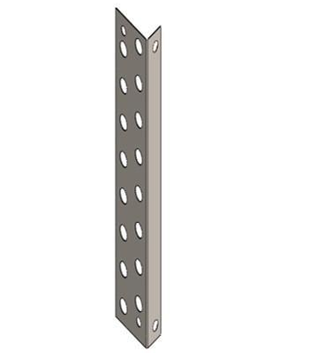
Figure 1a. Plate fin Figure 1b. End plate

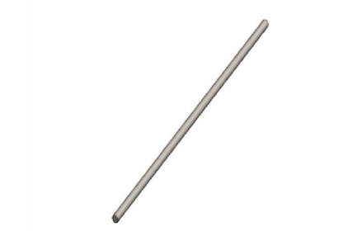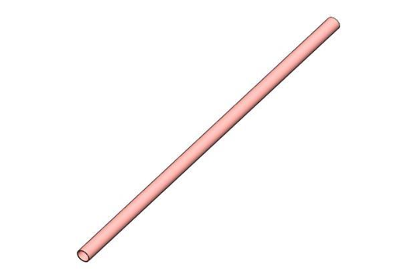
Figure 1c. Connecting rod Figure 1d. Condenser tube
2.2 Refrigerant R- 410A
Puron is the brand name of the refrigerant R-410A and is a hydro fluorocarbon (HFC) and it does not cause ozone depletion. It is mostly used for the domestic air conditioners like split air conditioners and it absorbs and releases heat at a rate better than that of R22. This prevents the compressor from overheating and also to run at a higher pressure so that it can handle greater stresses and will not crack as easily. R-410a uses synthetic oil for lubrication whereas mineral oils are used in R-22 systems. Solubility of synthetic oil better than mineral oils and this makes the whole system more efficient. Therefore, R-410a works better than R-22 and has more efficient systems and its latent heat is 220kJ/kg and mass flow rate for 1.5 TR system is 0.24 kg /sec.
  - 3D Modeling, Boundary Conditions and Simulation
A 3D model of the condenser coil was developed using SOLIDWORKS software. Total length of coil is 10 m with an outer diameter of 12 mm and thickness of 1 mm as depicted in Figure 2. Spacing of 2 to 5 mm is provided for the efficient passage of air between the annular fins. Total of 56 fins of 1 mm thickness is used and thickness of the fin is 1mm and spacing between fins is 4 mm. Flow fluid selected was R-410a with a mass flow rate of 0.024kg/sec. Simulations were carried out using the Flow Wizard CFD solver for steady-state internal airflow and flow dynamics were evaluated. At first coil material and fin material were chosen as aluminum and simulation was done. Gravity was included in the negative y-direction with a magnitude of 9.81 m/s². The operating pressure and ambient conditions were set to 1.01325 bar, 35 °C, and 50% relative humidity. Next copper coil and aluminum fins were selected and flow simulation was done. Simulation was also done with copper coil and copper fins.
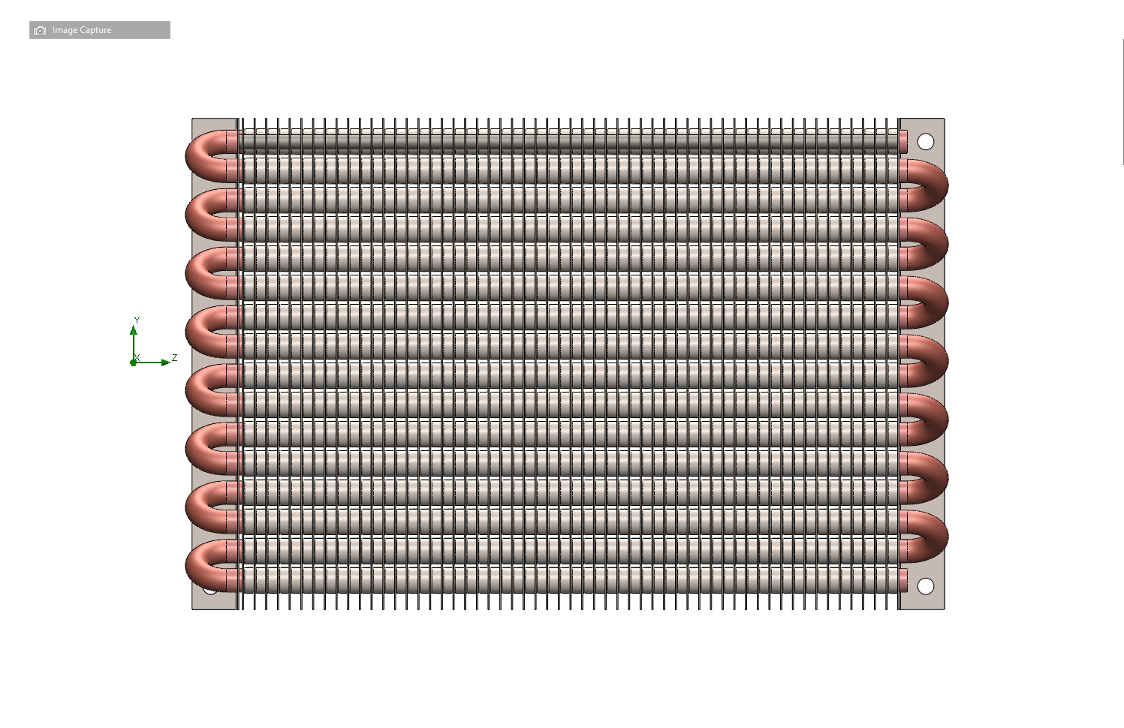
Figure 2. CFD model of the Condenser

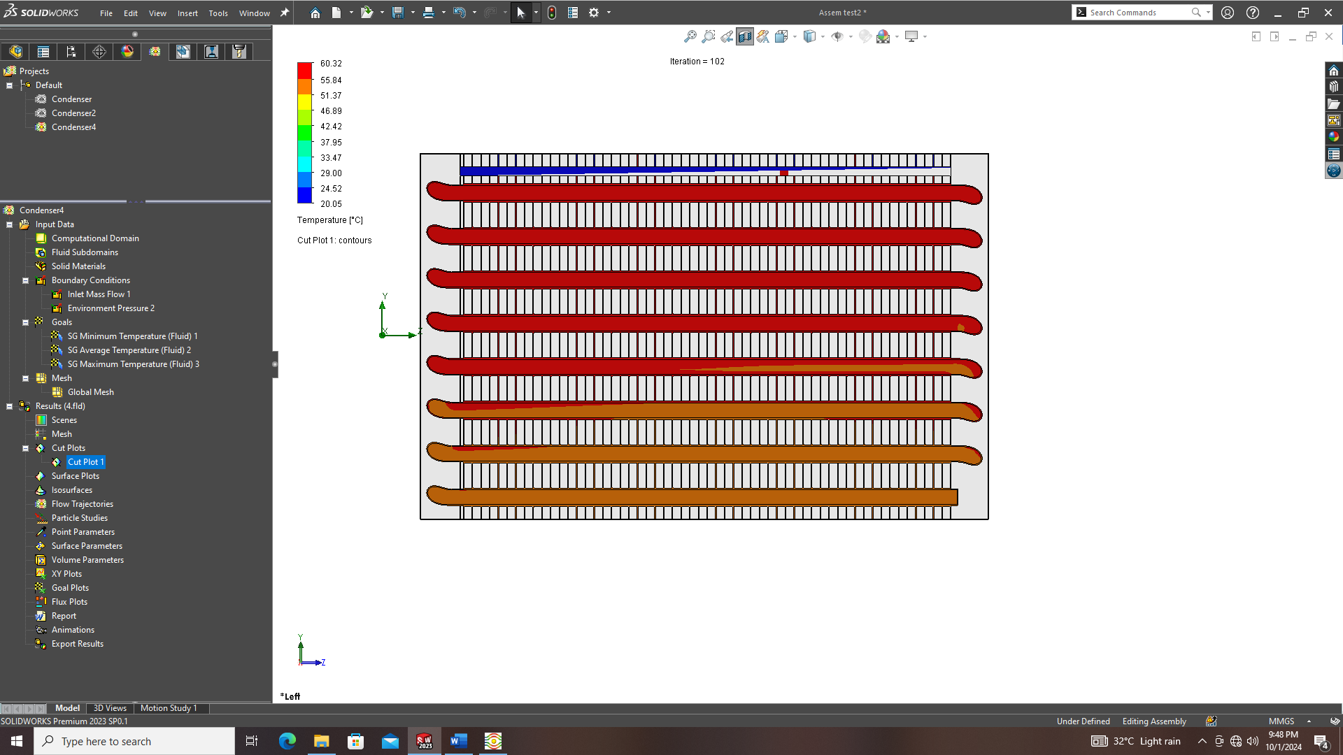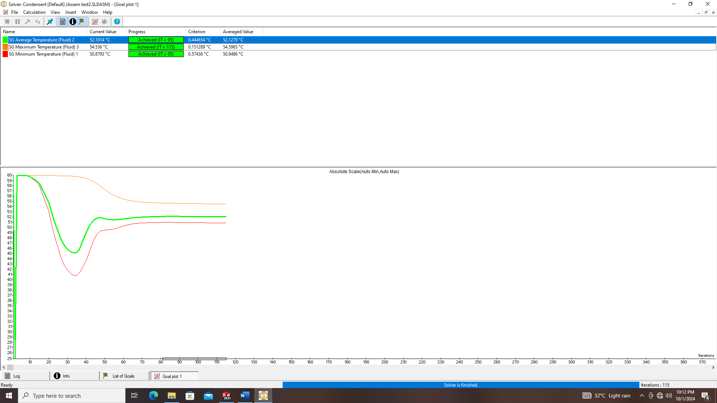
Figure 3. Cut section contour for aluminum coil and aluminum fin
When aluminum coil and aluminum fins are used, there is de superheating and condensation but complete condensation didn’t happen and still there is some part of refrigerant which is in the vapor form. Corresponding cut section contour and flow simulation curves are given in Figure 3. From the cut section contour, it is clear that the exit temperature is 52⁰C and this shows that the refrigerant is in the wet vapor form and not completely condensed.

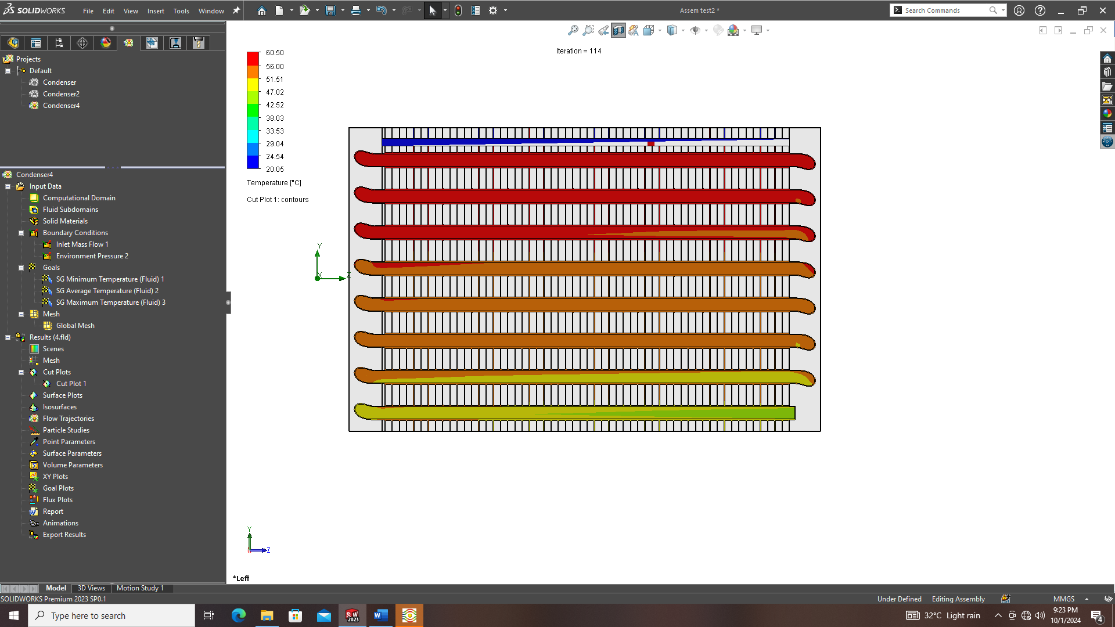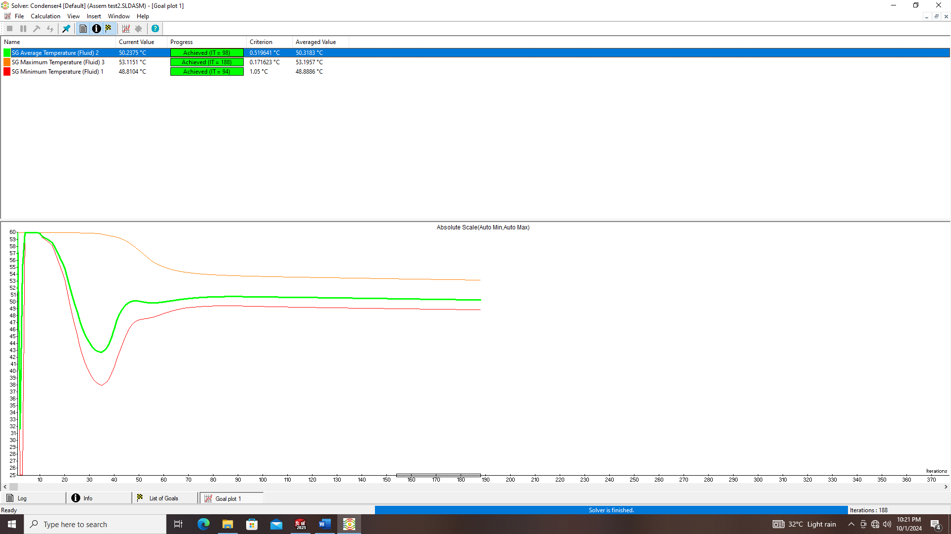
Figure 4. Cut section contour for copper coil and aluminum fin
When copper coil and aluminum fins are used, there is de superheating, complete condensation and slight sub cooling. From the cut section contour shown in Figure 4 it is clear that the exit temperature is around 42⁰C and this shows that the refrigerant is in the subcooled form and it is clear that degree of sub cooling is around 5⁰C as the condensation temperature is 47⁰C.
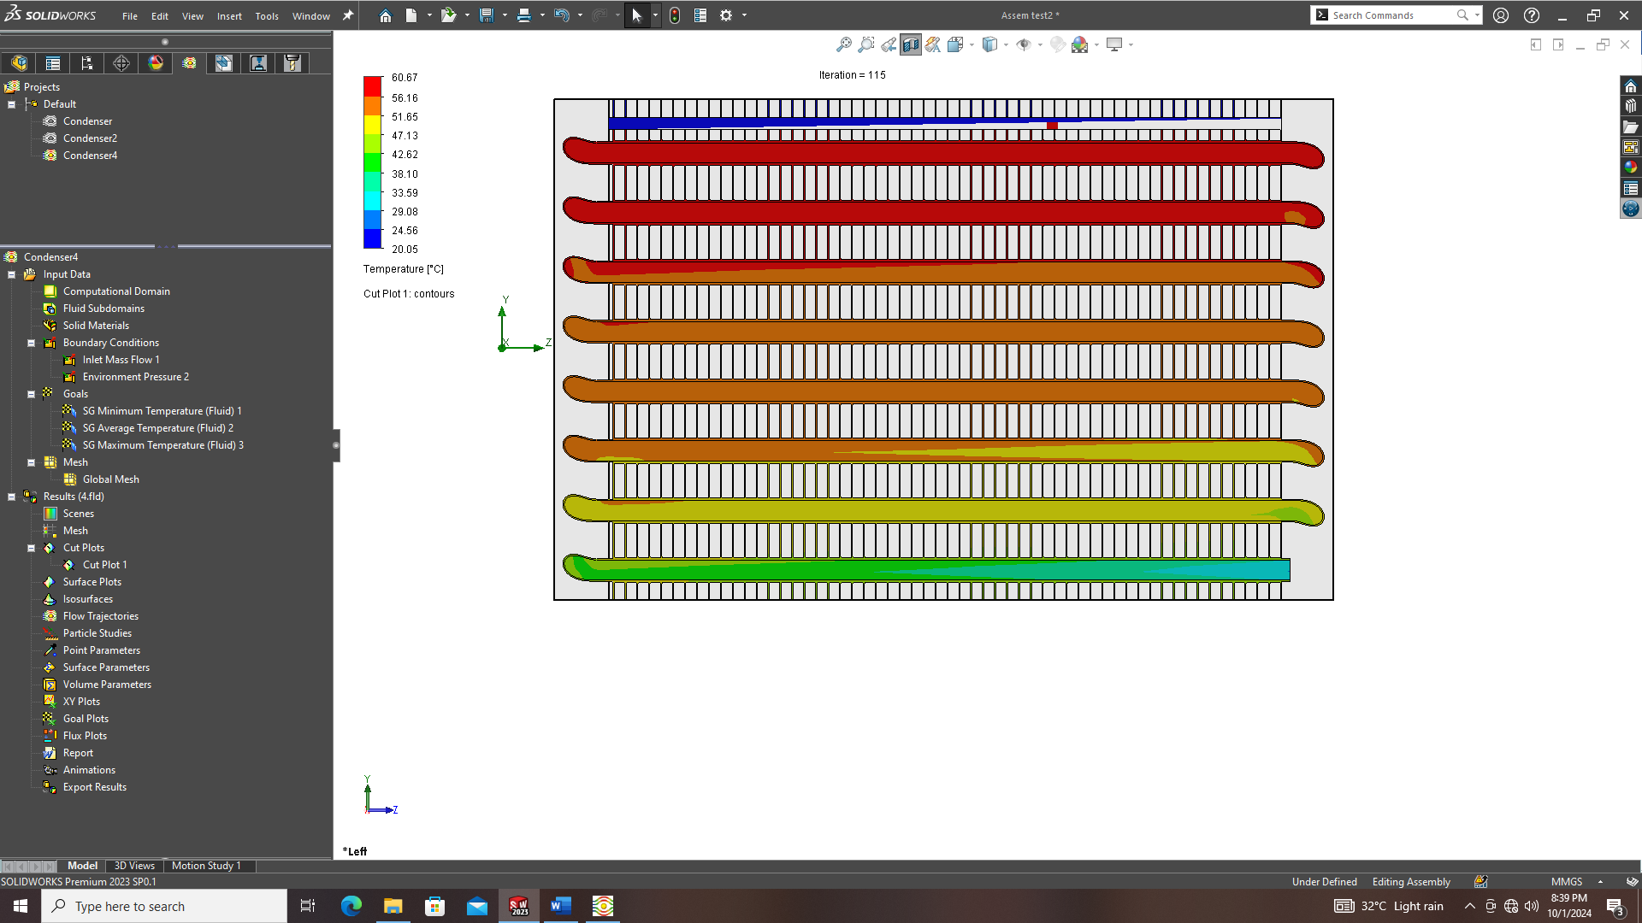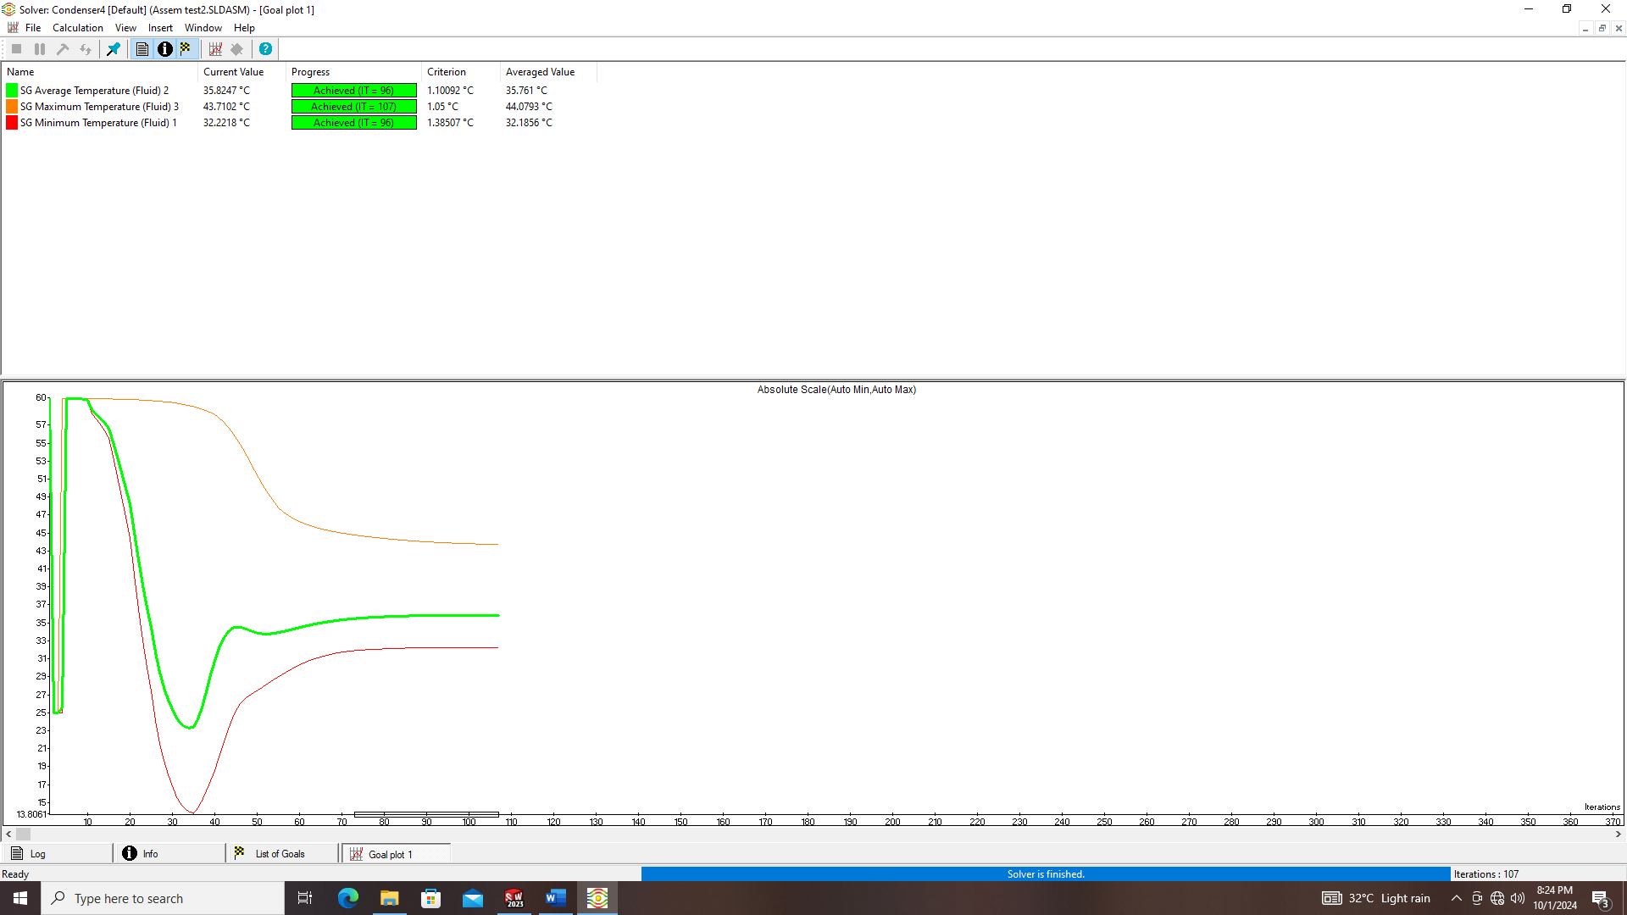
Figure 5. Cut section contour for copper coil and copper fin
When copper coil and copper fins are used, there is de superheating, complete condensation and sub cooling. From the cut section contour shown in Figure 5 it is clear that the exit temperature is around 35⁰C and this shows that the refrigerant is in the sub form and it is clear that degree of sub cooling is around 12⁰C as the condensation temperature is 47⁰C. Such a value of sub cooling is not required in practical refrigeration cycles.
- Conclusion
The present study evaluates the thermal performance of different condenser configurations based on combinations of coil and fin materials, with a focus on their influence on refrigerant phase change characteristics. The results clearly demonstrate that material selection plays a critical role in determining the extent of DE superheating, condensation, and subcooling within the condenser. In the case of aluminium coils with aluminium fins, the heat transfer rate is comparatively lower, leading to incomplete condensation and the presence of wet vapor at the outlet. This indicates insufficient thermal effectiveness of the condenser, which can adversely affect system performance and reliability. The configuration employing copper coils with aluminium fins exhibits significantly improved performance, achieving complete condensation along with a moderate degree of subcooling (approximately 5°C). This level of subcooling is considered desirable in practical refrigeration systems, as it ensures liquid refrigerant at the expansion device while avoiding excessive energy penalties. Further enhancement is observed with copper coils and copper fins, where higher thermal conductivity results in complete condensation and substantial subcooling (approximately 12°C). However, such a high degree of subcooling is generally not required in conventional refrigeration cycles and may lead to unnecessary heat rejection and increased system cost without proportional performance benefits. Overall, the study concludes that the copper coil–aluminium fin configuration provides an optimal balance between thermal performance and practical applicability. It ensures complete condensation with adequate subcooling while maintaining material and manufacturing efficiency. These findings highlight the importance of material optimization in condenser design for achieving improved energy efficiency and system performance.
References
[1]W.F. Stoecker & J.W. Jones. Refregeration and air conditioning, Second Edition. 1982.
[2]MadhuJhariya , P.K. Jhinge and R.C Gupta. Experimental Study on performance of Condenser of two different types used in window air conditioner. International Journal of Current Research and Academic Review. 1(4). 2013.
[3]V. Srividhy, G. Venkateswarao. Improving the heat transfer rate for AC condenser by material and parameter design optimzating , International Journal of Engineering Research & Technology. Vol.Isseue 1. January 2020.
[4]Jeffrey K. Sonue, Danny S. Parker, Stephen F. Barkaszi Measured Impacts of air conditioner Condenser shading Residential Buildings, Technologies, Design, Performance Analysis, and Building Industry Trends (1997)
[5].K.Nagalakshmi, G. MarurhiprasedYaldar. The design and performance analysis of refrigeration system Using R22 & R134a Refrigerants. Journal of Engineering Research and Applications. Vol., Issue 2. 2014.
[6]Dr.Akashlangde, Zeeshan Jamal, Shahrukh Jamal. Mohamed Shumoil Ansari. Air Conditioning system with modified condenser ducts and evaporative cooling). International research Journal of Engineering and Technology, Volume 05 Issue o1/Jan.2018.
[7]ModhHazwanYosif , SulaimanMohd Muslim , Muhammad FadhuliSuhaimi. The effect of refrigerant charge and outdoor temperature on the condenser and evaporator of a split – unit type air conditioner using R22 refrigerant, MATEC Web of conference 225 , 2018.
[8]Akusu O.M , Salisu. S , Akinfaloye. Design and Construction of split unit air conditioner. International Journal of Emerging Engineering Research and Technology, volume G , Issue 6 , 2018.
[9]Samantha Ayres. Design of a 12 KW air – cooled water chiller. University of Pretoria, Mechanical and Aeronautical Engineering. 5/ 27/2013.
[10]Robert Weed, John Hipchen. Benefits of Reduced diameter Copper Tubes in Evaporator and Condensers. October 2012.
[11]Ali Hussain Tarrad & Ali Farhan Al-Tameemi (Experimental and Numerical Model for Thermal Design of air Cooled Condenser), Global Journal of Researches in Engineering: A Mechanical and Mechanics Engineering, Volume 15 Issue 3 Version10 Year 2015 , Publisher: Double Blind Peer Reviewed International Research Journal.
[12]Anna Pacak, Blazej Baran, Korneliusz Sierpowski, Ziemowit Malecha, Demis Pandelidis― Application of computational fluid dynamics (CFD) methods to analyze energy efficiency of indirect evaporative coolers. International Communications in Heat and Mass Transfer 143(2023) 106727
[13] Vemula Nagarjuna, Vasili Srinivas ― Study on heat transfer analysis of AC condenser by varying materials and refrigerants. International Journal of Advance Research, Ideas and Innovations in Technology 7(4) (2021)

