Core Muscle Activation Levels Assessed Using a Pressure Biofeedback Unit Among College-Going Students: A Cross-Sectional Study

Dr. Kruti Desai¹,
Assistant Professor¹
NAMO College of Allied Health Sciences^{1,2}

ABSTRACT

Background: Core stability, mediated by the transversus abdominis (TrA), is vital for spinal protection and functional movement. Impaired activation of these deep stabilizers is a recognized precursor to musculoskeletal dysfunction and low back pain. While the Pressure Biofeedback Unit (PBU) is a validated tool for assessing TrA recruitment during the abdominal drawing-in maneuver, normative data for healthy young adults is limited.

Objectives: This study sought to quantify transversus abdominis activation using the Pressure Biofeedback Unit (PBU) and categorize the distribution of core stability levels among healthy college students aged 18–22 years.

Methods: A community-based cross-sectional study was conducted at the NAMO College of Allied Health Sciences among 185 participants recruited via purposive sampling. Healthy students aged 18–22 years were included, while those with a history of low back pain, fractures, or neuromuscular disorders were excluded. Core activation was assessed using a Pressure Biofeedback Unit (PBU) in a supine crook-lying position during the Abdominal Drawing-in Maneuver (ADIM) from a 40-mmHg baseline. Participants were classified based on 10-second pressure deviations: Optimal (38-42mmHg), Weak-Increased (> 42mmHg), and Weak-Reduced (< 38mmHg).

Results: The mean pressure recorded for the cohort was 41.69 \pm 5.62 mmHg. Data analysis revealed that only 41.1% (n=76) of participants demonstrated Optimal core activation. The majority of the sample (58.9%) exhibited dysfunctional patterns: 42.7% (n=79) showed Weak-Increased pressure, indicating compensatory bracing by global stabilizers, while 16.2% (n=30) showed Weak-Reduced pressure, indicating insufficient deep muscle recruitment.

Conclusion: The study identifies a significant prevalence (58.9%) of suboptimal core stabilizer control among college students. The high rate of compensatory global muscle recruitment underscores a critical need for targeted neuromuscular re-education and core stability programming to prevent early-onset postural and musculoskeletal dysfunctions.

Keyword: Core Stability, Pressure Biofeedback Unit, Transversus Abdominis, College Students

Introduction
Core stability is fundamental to maintaining spinal alignment, optimizing postural control, and ensuring functional movement efficiency ⁽¹⁾. Central to this stability is the coordinated activation of the deep trunk musculature—specifically the transversus abdominis which serves as a primary stabilizer of the lumbar spine and a safeguard against musculoskeletal dysfunction ^{(1,2)}. Current literature suggests that suboptimal neuromuscular control and impaired core muscle activation are significant predictors of reduced physical performance and a heightened risk of chronic low back pain ⁽³⁾.
In clinical settings, the Pressure Biofeedback Unit (PBU) has emerged as a reliable, non-invasive tool for the indirect assessment of transversus abdominis recruitment ^{(1,4)}. By monitoring pressure fluctuations during the Abdominal Drawing-in Maneuver (ADIM), the PBU offers a practical alternative to resource-intensive techniques such as rehabilitative ultrasound imaging or electromyography ^{(1,5)}. Evidence indicates that PBU-guided interventions not only enhance trunk muscle recruitment but also significantly improve lumbopelvic stability across various functional tasks and postural orientations ^{(3, 6)}.
While the clinical utility of the PBU is well-documented in symptomatic populations, there is a distinct lack of normative data concerning core muscle activation patterns in healthy young adults. This demographic, particularly college-going individuals, represents a critical group for early intervention due to the increasing prevalence of sedentary behaviors and postural stresses associated with academic environments. Addressing this knowledge gap is essential for establishing baseline functional metrics and developing preventative rehabilitation protocols. Consequently, this study aims to evaluate the distribution of core muscle activation levels using pressure biofeedback among college students aged 18–22 years.

AIMS:
To assess core muscle activation using a Pressure Biofeedback Unit among college-going students aged 18–22 years.

OBJECTIVES:
- To quantify core muscle activation levels using Pressure Biofeedback Unit measurements.
- To categorize participants into strong and weak core muscle groups based on pressure values.
- To determine the distribution (percentage) of core muscle activation levels among participants.

MATERIALS AND METHODOLOGY
Study Design and Setting:
A community-based cross-sectional study was conducted at the NAMO College of Allied Health Sciences in Silvassa. The study protocol was approved by the Institutional Ethics Committee, and all participants provided written informed consent prior to data collection.

Participant Recruitment and Selection
A total of 185 participants were recruited using a purposive sampling technique from the student population. The study focused on a healthy young adult demographic to establish baseline functional metrics.
Inclusion Criteria:
- Healthy students aged 18–22 years.
- Voluntary consent to participate in the clinical assessment.

Exclusion Criteria:
- History of chronic low back pain, spinal fractures, or major abdominal surgeries.
- Presence of radicular symptoms, including tingling or numbness.
- Diagnosed neuromuscular or vestibular disorders.
- Inability to comprehend or follow standardized verbal instructions.
Instrumentation
The primary evaluative tool utilized was the Pressure Biofeedback Unit (PBU). The PBU is a validated, non-invasive clinical device designed to monitor pressure fluctuations that indirectly reflect the recruitment of the Transversus Abdominis (TrA). It consists of a three-chambered inflatable bladder connected to a sphygmomanometer gauge, allowing for the assessment of lumbopelvic stability during specific motor control tasks.
Testing Protocol
Standardized procedures were followed to ensure the reliability of the measurements:
- Familiarization: Participants were coached on the Abdominal Drawing-in Maneuver (ADIM) using standardized verbal cues to facilitate isolated TrA activation without global muscle compensation.
- Positioning: Subjects were placed in a supine crook-lying position on a firm clinical plinth.
- Calibration: The uninflated pressure bladder was positioned under the lumbar spine, centered at the L3-L4 level, and inflated to a steady-state baseline of 40 mmHg.
- The Test: Participant were asked to activate core muscles (tuck in) and maintain it between 40 to 50 mm Hg for 10 seconds (not more than 50 mm Hg as rectus abdominis gets activated and not less than 40 mm Hg, as it indicates arching of the lumbar spine).
- Data Recording: Three trials were conducted for each participant, with a 60-second rest interval between trials. The mean pressure deviation from the baseline was recorded as the final value.

Statistical Analysis
Data were analyzed using SPSS Version 26.0. Descriptive statistics (mean, standard deviation, and percentages) were employed to summarize the demographic profile and the distribution of core activation levels. Participants were classified into three functional categories based on their ability to maintain the target pressure:
- Optimal Activation: 38-42mmHg.
- Weak (Increased Pressure): > 42mmHg (indicating global muscle compensation).
- Weak (Reduced Pressure): < 38mmHg (indicating insufficient recruitment).

REULTS AND STATISTICAL ANALYSIS
Participant Characteristics
A total of 185 college-going students aged 18–22 years participated in the study. The demographic profile of the cohort represented a healthy, non-athletic population currently enrolled in academic programs.

Core Muscle Activation Quantification
The primary outcome was the quantification of Transversus Abdominis (TrA) recruitment through pressure deviations from a 40 mmHg baseline during the Abdominal Drawing-in Maneuver (ADIM). The descriptive analysis of the cohort’s performance is summarized in Table 1.

Table 1: Descriptive Statistics of Pressure Biofeedback Values (N=185)
Metric | Value (mmHg)
Mean Pressure | 41.69
Standard Deviation (SD) | ± 5.62
Minimum Recorded Value | 8.00
Maximum Recorded Value | 48.00
Median | 42.00

Categorization of Core Muscle Competency
Participants were categorized into three functional groups based on their ability to isolate the TrA and maintain lumbar stability. "Optimal" activation was defined as a deviation within ± 2mmHg of the baseline (38-42mmHg).
- Optimal/Strong Core: 76 participants (41.1%) demonstrated the ability to maintain baseline pressure within the target range, indicating successful deep muscle isolation.
- Weak (Increased Pressure): 79 participants (42.7%) exhibited pressure values exceeding 42 mmHg. This indicates a "bracing" strategy characterized by the compensatory recruitment of global stabilizers such as the rectus abdominis and external obliques.
- Weak (Reduced Pressure): 30 participants (16.2%) demonstrated pressure values below 38 mmHg, suggesting an inability to sustain the Abdominal Drawing-in Maneuver or maintain lumbar spine support against the pressure cell.

Distribution of Activation Levels
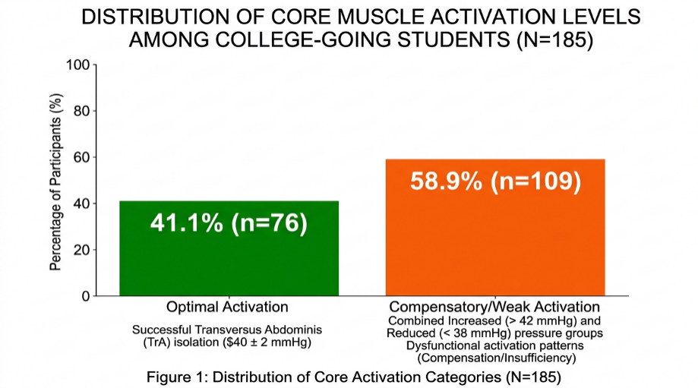
The findings indicate that a majority (58.9%) of the college-going population lacks isolated control of the deep core stabilizers, with a significant tendency toward compensatory global muscle recruitment.

DISCUSSION
The primary objective of this study was to evaluate core muscle activation levels among college students using a Pressure Biofeedback Unit (PBU). Our findings revealed that only 41.1% of the participants demonstrated optimal transversus abdominis (TrA) isolation, while the majority (58.9%) exhibited dysfunctional activation patterns. The PBU is established as a reliable, non-invasive clinical method for monitoring these pressure fluctuations, which indirectly reflect the recruitment of the TrA during stabilization maneuvers. ^{(1,2)}
A significant finding was that 42.7% of participants showed pressure increases exceeding 42 mmHg. While often misinterpreted as "strength," this pressure rise during the Abdominal Drawing-in Maneuver (ADIM) typically indicates a "bracing" strategy, where global stabilizers like the rectus abdominis and external obliques override the deep local system.^{(3,4)} This is consistent with established theories suggesting that healthy young adults should ideally demonstrate anticipatory, isolated TrA activation to stiffen the spine without global compensatory torque.^{(1,4)}
The remaining 16.2% of participants who fell below 38 mmHg suggest a total inability to maintain lumbar pressure. This is likely due to poor neuromuscular endurance or a lack of awareness regarding deep muscle recruitment.^{(2,5)} Given that core stability acts as a kinetic link for force transfer between extremities, the high prevalence of suboptimal activation (58.9%) in this 18–22 age group may predispose them to future musculoskeletal injuries or chronic low back pain.^{(3,6)}
Previous research has noted that improving core stability leads to tangible improvements in lower back injury outcomes.^{(1,5)} The role of specific muscles during core stability and strength exercises enables the implementation of more functional training programs, which may result in a more effective translation of training into improved physical performance.^{(3,6)} Furthermore, optimal abdominal core recruitment contributes significantly to maintaining ideal posture and preventing long-term back problems.⁽⁴⁾

CONCLUSION
This study concludes that there is a significant prevalence of suboptimal core muscle activation among college-going students aged 18–22 years. While the cohort mean was 41.69 ± 5.62 mmHg, only 41.1% demonstrated optimal isolation of the deep stabilizers. The majority of students relied on compensatory global muscle recruitment (42.7%) or showed insufficient recruitment (16.2%). These results highlight a critical need for targeted neuromuscular re-education and core stability programs within the college population to prevent the early onset of postural and musculoskeletal dysfunctions.

REFERENCES :
- Raj VS, Thomas M. Measuring transversus abdominis activity using pressure biofeedback unit: a technical report. Physiother Res Int. 2023;28(3):e2033. doi:10.1002/pri.2033
- Mahmod SR, Baharuddin MLI, Azaman A, Sahalan M. A prototype validation study of a digitized pressure biofeedback unit versus electromyography during transverse abdominis muscle activation. J Med Device Technol. 2024;3(2):84–89. doi:10.11113/jmeditec.v3.64
- Kim SY, Yu IY, Kang MH. Effects of pressure biofeedback on hip and trunk muscle activity and lumbopelvic alignment during one-leg standing. Isokinet Exerc Sci. 2021;29(1):1–8. doi:10.3233/IES-202173
- Kim JH, Lee DK, Kim EK. The effect of abdominal drawing-in maneuver with pressure biofeedback unit in various postures on abdominal muscle contraction. Phys Ther Rehabil Sci. 2022;11:136–144. Published online 2022 Jun 30. doi:10.14474/ptrs.2022.11.2.136
- Daigle F, Léonard G, Émond M, Benoit-Piau J, Gaudreault N. Comparison of the pressure biofeedback unit and real-time ultrasound imaging as feedback tools to contract the transversus abdominis muscle: a randomized controlled trial in healthy older adults. J Geriatr Phys Ther. 2022;45(1):25–33. doi:10.1519/JPT.0000000000000295
- Achens JT, Raj Victor VS, Joseph JK. Early activation of quadriceps with pressure biofeedback for the prevention of arthrogenic muscle inhibition following lower limb orthopedic surgeries: a proof of concept clinical trial. J Chiropr Med. 2022;21(4):296–304. doi:10.1016/j.jcm.2022.05.005

