Title

Isolated Aberrant Right Subclavian Artery Detected Prenatally in a Low-Risk Primigravida: A Case Report

ABSTRACT

Background: Aberrant right subclavian artery (ARSA) is the most common aortic arch variant increasingly recognised during routine fetal echocardiography. Although historically linked to chromosomal abnormalities, emerging evidence shows that isolated ARSA in screen-negative pregnancies has a favourable prognosis.

Case: We report a 24-year-old primigravida with a normal Level II ultrasound and a negative quadruple screening test. A routine fetal echocardiogram at 24 weeks demonstrated an isolated ARSA without any other cardiac or extracardiac anomalies. Pregnancy and delivery were uneventful. Postnatal echocardiography confirmed isolated ARSA, and the neonate remained asymptomatic.

Conclusion: When identified as an isolated finding in the setting of normal aneuploidy screening, ARSA represents a benign vascular variant with excellent perinatal outcomes. Comprehensive counselling helps avoid unnecessary invasive testing and parental anxiety.

Keywords: Aberrant right subclavian artery, fetal echocardiography, prenatal diagnosis, vascular variant, aneuploidy screening.

INTRODUCTION
Aberrant right subclavian artery (ARSA) is the most frequent congenital anomaly of the aortic arch, with a reported prevalence of 0.5–2% in the general population and approximately 1% in fetuses evaluated by prenatal ultrasonography(1). In this anomaly, the right subclavian artery arises as the last branch of the aortic arch from the descending aorta and courses posterior to the trachea and oesophagus.
Earlier literature described ARSA as a soft marker for chromosomal abnormalities, particularly Trisomy 21, Trisomy 18 and 22q11.2 deletion syndrome(2,3). However, recent cohort studies and meta-analyses have demonstrated that when ARSA is detected as an isolated finding in the setting of normal biochemical or non-invasive prenatal screening, the risk of aneuploidy is significantly reduced(4,6). With advances in imaging, especially the three-vessel–trachea view, ARSA is increasingly detected in otherwise low-risk pregnancies. We present a case of prenatally diagnosed isolated ARSA in a screen-negative primigravida and discuss its clinical implications in light of current evidence.

Case Report
A 24-year-old primigravida with no significant medical or family history presented for routine antenatal care at aiims bilaspur. The pregnancy was spontaneous and uncomplicated. A detailed Level II anomaly scan performed at 20 weeks of gestation revealed normal fetal anatomy. The quadruple marker screening test indicated low risk for chromosomal abnormalities.
As part of routine radiology departmental protocol, fetal echocardiography was performed at 24 weeks of gestation. The four-chamber view and both ventricular outflow tracts were normal. On evaluation of the three-vessel–trachea view, the right subclavian artery was noted to arise from the descending aorta and course posterior to the trachea, forming a characteristic U-shaped configuration suggestive of ARSA. No intracardiac structural abnormalities or extracardiac anomalies were identified.
In view of the isolated finding and negative aneuploidy screening, the couple was counselled regarding the likely benign nature of isolated ARSA. The option of invasive diagnostic testing was discussed; however, after informed counselling, they declined further genetic evaluation. Serial antenatal visits demonstrated appropriate fetal growth and normal Doppler studies.
At 39 weeks of gestation, she delivered a healthy female neonate weighing 3.4 kg by spontaneous vaginal delivery. Apgar scores were 9 and 10 at one and five minutes, respectively. Postnatal echocardiography performed on day two of life confirmed the presence of isolated ARSA with otherwise normal cardiac anatomy. The neonate remained asymptomatic, with no feeding difficulties or respiratory compromise during hospital stay and early follow-up.

Discussion
ARSA results from abnormal regression of the right fourth aortic arch with persistence of the right dorsal aorta during embryogenesis(1). Prenatally, it is best visualised in the three-vessel–trachea view, where the aberrant vessel arises distal to the left subclavian artery and courses posterior to the trachea.
Historically, ARSA was considered a soft marker for Trisomy 21, with earlier studies reporting a higher association in affected fetuses(2,3). However, more recent evidence has refined this association. Esmer et al. demonstrated that isolated ARSA carries a very low risk of chromosomal abnormalities, particularly when first- or second-trimester screening is normal(4).Similarly, Li et al. reported that chromosomal microarray analysis was normal in the majority of fetuses with isolated ARSA and negative screening tests(5). Zhang et al. further concluded that invasive testing is not routinely warranted in cases of isolated ARSA in NIPT-negative pregnancies(6).
Current understanding therefore emphasizes that the overall aneuploidy risk depends primarily on the presence of additional structural anomalies, multiple soft markers, or abnormal screening results rather than ARSA alone. In truly isolated cases with reassuring screening, ARSA is best regarded as a benign anatomical variant.
Postnatally, most individuals with isolated ARSA remain asymptomatic throughout life. Rarely, oesophageal or tracheal compression may result in dysphagia lusoria or respiratory symptoms, typically presenting later in childhood(7,8). Surgical intervention is reserved for symptomatic cases and is uncommon. In our case, the infant remained asymptomatic, supporting the favourable prognosis associated with isolated ARSA in low-risk pregnancies.
This case reinforces the importance of comprehensive anatomical evaluation and appropriate interpretation of screening results. Overemphasis on ARSA as a solitary soft marker may lead to unnecessary invasive procedures and increased parental anxiety.

Conclusion
Isolated ARSA detected on prenatal ultrasonography in the setting of normal anomaly scan findings and negative aneuploidy screening should be considered a benign vascular variant. The prognosis is excellent, and routine neonatal follow-up is sufficient. Careful evaluation and structured counselling are essential to ensure appropriate management and to avoid unnecessary invasive testing.

References:
- Yagel S, et al. Advanced three-vessel–trachea imaging and aortic arch variants. Ultrasound Obstet Gynecol. 2018;51:661–670.
- Paladini D, et al. Aberrant right subclavian artery and chromosomal abnormalities. Prenat Diagn. 2012;32:968–973.
- Borenstein M, et al. Aberrant right subclavian artery and aneuploidy risk. Ultrasound Obstet Gynecol. 2010;36:414–418.
- Esmer AC, et al. Meta-analysis of isolated ARSA and chromosomal abnormality risk. Prenat Diagn. 2020;40:1504–1512.
- Li Y, et al. Chromosomal microarray outcomes in isolated ARSA. Ultrasound Obstet Gynecol. 2021;58:883–890.
- Zhang W, et al. ARSA and NIPT-negative pregnancies. BMC Pregnancy Childbirth. 2022;22:456.
- Backer CL, et al. Long-term outcomes in vascular ring anomalies. J Pediatr Surg. 2019;54:2281–2287.
- Contreras J, et al. Management of symptomatic arteria lusoria in children. Ann Thorac Surg. 2017;104:101–107.
Title:
Isolated Aberrant Right Subclavian Artery Detected Prenatally in a Low-Risk Primigravida: A Case Report
Authors: Shri Ram Rundla, Anjali Bijarniya, Tanvi Katoch, Komal Tiwari
Author Affiliations:
Dr. Shri Ram Rundla: Senior Resident, Department of Obstetrics and Gynecology, All India Institute of Medical Sciences, Bilaspur, Himachal Pradesh, India 174001; Email ID: shriram.rundla@gmail.com, ORCID ID-0009-0003-9896-9206
Dr. Anjali Bijarniya: MBBS, Internship, Parul institute of medical science & research Vadodara, Gujarat, India 391760. Email ID: anjalibijarnyia@gmail.com
Dr. Tanvi Katoch: Assistant professor, Department of Obstetrics and Gynecology, All India Institute of Medical Sciences, Bilaspur, Himachal Pradesh, India 174001; Email ID: tanvikatoch@gmail.com
Dr. Komal Tiwari: DNB, Department of Obstetrics and Gynecology, R.D.B.P Jaipuriya hospital, jaipur, rajasthan,302018;Email ID:Tiwarikomal014@gmail.com
Correspondence: Dr. Shri Ram Rundla: Senior Resident, Department of Obstetrics and Gynecology, All India Institute of Medical Sciences, Bilaspur, Himachal Pradesh, India 174001; Email ID:shriram.rundla@gmail.com, ORCID ID-0009-0003-9896-9206
Author Contributions All the authors have contributed significantly to the manuscript and are in agreement with the final content.
Funding: No financial support was received from any external agency.
Conflict of Interest: None

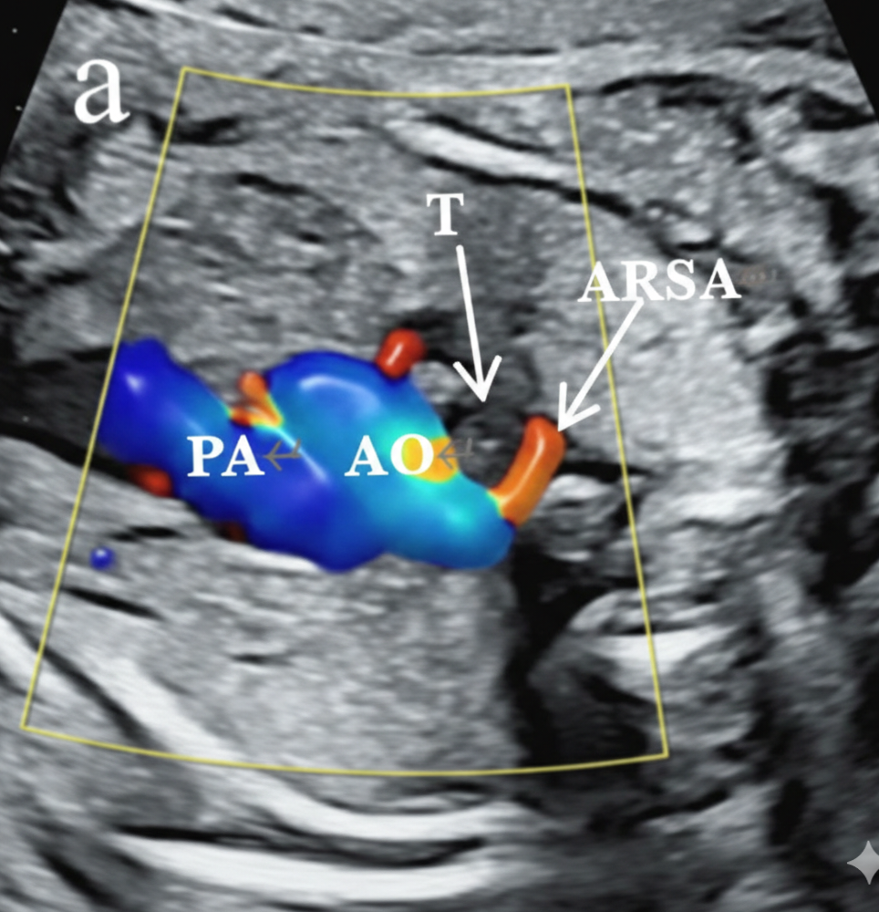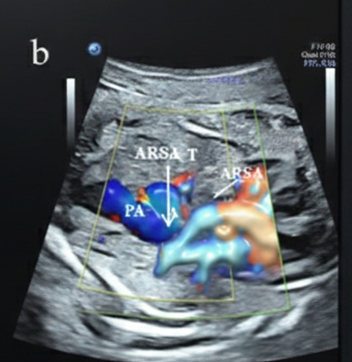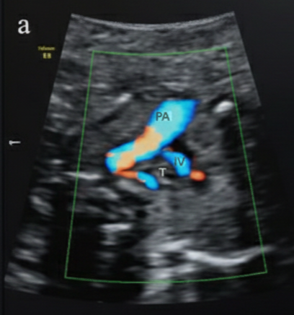
Figure:1. Figure:2. Figure:3

Figure: 1,2&3 Fetal Echocardiogram at post natal day-2, showing isolated aberrant right subclavian artery.

