DETERMINATION OF THE PROXIMATE, MINERAL AND VITAMIN COMPOSITION OF THREE LOCAL VARIETIES OF TOMATOES (Solanum lycopersicum Lin.) CONSUMED IN MUBI, ADAMAWA STATE NIGERIA

Midawa, S.M*., Tizhe, T.Dꙶ., Comfort, S.Y² and Sabastine, I.A³.

*Corresponding Author: Department of Botany, Faculty of Science and Computing, Adamawa State University, Mubi. P.M.B 25, Mubi. Adamawa State - Nigeria.
¹,²Department of Botany, Faculty of Science and computing, Adamawa State University, Mubi. Adamawa State- Nigeria.
₃ Department of Biochemistry, Faculty of Science and Computing, Adamawa State University, Mubi.. Adamawa State-Nigeria.

E-mail: mallummidawa@gmail.com Mobile phone No. 07063585993.

Abstract
This study assessed the proximate, mineral, and vitamin composition of three local tomato varieties, Roma, Globe, and Seria—commonly consumed in Mubi, Adamawa State, Nigeria. Fresh red-ripe fruits, 6 kg per variety, were randomly collected from three vendors in each of three markets (Mubi main market, Sabon kasuwa and Tashan Gella), totaling 18 kg. Fruits were washed in bulked per variety, and homogenized to form composite samples. Proximate composition was determined by standard methods. Minerals were quantified using Atomic Absorption Spectrophotometry and colorimetry, while vitamins were analyzed by spectrophotometry and HPLC. All analyses were done in triplicate and data were subjected to one-way ANOVA at p < 0.05. Significant variations (p < 0.05) occurred among varieties. Seria had the highest protein (0.33%), ash (0.22%), carbohydrate (9.20%), magnesium, potassium, calcium, phosphorus, vitamins A, C, and K. Globe recorded the highest iron (4.24 mg/100 g) and vitamin B3, while Roma showed the highest moisture (93.50%), crude fiber, fat, and zinc. Vitamins B1 and B2 did not differ significantly. Nutrient composition varied with variety. Seria was richer in most nutrients, while Roma and Globe excelled in specific ones. The findings can guide varietal selection and nutrition planning in the study area.
Keyword: Tomato fruit, Local variety, Mubi, Proximate composition, Nutritional composition, Vitamin composition

INTRODUCTION

Tomato fruits is a vegetable that is very rich in nutrients that are beneficial to the body systems and organ. It is currently amongst the most widely cultivated and consumed vegetable. Tomato fruit are usually red when ripped, but they can be found in different colors such as orange, yellow, purple, and green (Onuguh et al., 2025) Tomato (Solanum lycopersicum L.), belonging to the Solanaceae family, is one of the most widely cultivated and consumed vegetable crops across the globe, and it plays a significant role in global food security and nutrition. Its origin is traced to South America, particularly in the Andean region, but it has become naturalized and integrated into the agricultural and dietary systems of virtually every continent (Hernández-Suárez et al., 2022). The economic, nutritional, and cultural value of tomato production has continued to attract research interest, especially in developing countries like Nigeria, where it serves as a major dietary staple and a source of livelihood for millions of smallholder farmers (Azeez et al., 2023).
Tomatoes are one of the most consumed vegetables in Nigeria, used daily in preparing stews, soups, sauces, salads, and other delicacies. This high level of consumption is not merely due to their culinary versatility but also their affordability and year-round availability in local markets (Adeyeye et al., 2022). Mubi, a prominent agricultural hub in Adamawa State, is well-known for tomato cultivation due to its favorable agro-climatic conditions, fertile soils, and long-standing agricultural traditions. Despite its importance, tomato production in this region is still faced with several constraints such as post-harvest losses, nutrient degradation during storage, and limited awareness of the nutritional differences among varieties (Hussein et al., 2023).
From a nutritional standpoint, tomatoes are a rich source of essential macronutrients and micronutrients. They contain significant amounts of carbohydrates, proteins, dietary fiber, and trace amounts of fats, making them a healthy, low-calorie food option suitable for weight management and disease prevention (Yadav et al., 2023). Moreover, they are abundant in vitamins, particularly vitamin C (ascorbic acid), vitamin A (as beta-carotene), vitamin E (tocopherol), and vitamin K, all of which play critical roles in maintaining immune function, vision, skin health, and blood coagulation (Okonji et al., 2024). Minerals such as potassium, calcium, magnesium, phosphorus, and iron are also present in appreciable quantities, contributing to electrolyte balance, bone formation, oxygen transport, and enzymatic activity (Hussein et al., 2023; Oladipo et al., 2023).
Globally, malnutrition remains a pressing public health challenge, particularly in developing nations. Micronutrient deficiencies, often referred to as "hidden hunger," affect over two billion people worldwide, with the highest prevalence recorded in sub-Saharan Africa (WHO, 2023). Deficiencies in iron, vitamin A, and zinc are particularly widespread, contributing to impaired growth, weakened immune function, and increased morbidity and mortality among vulnerable groups such as children and pregnant women (Okonji et al., 2024). In Nigeria, the situation is no different; rural populations, including those in Adamawa State, continue to experience high rates of micronutrient deficiencies due to limited dietary diversity and poor nutritional awareness (Oladipo et al., 2023). Tomatoes, being nutrient-dense and widely consumed, present a cost-effective and practical solution to mitigate these deficiencies if their nutritional potential is properly understood and harnessed (Azeez et al., 2023).
Furthermore, the rising incidence of non-communicable diseases (NCDs) such as hypertension, diabetes, and obesity has intensified the global focus on nutrition-sensitive agriculture and the promotion of functional foods (Oladipo et al., 2023). Research indicates that diets rich in tomatoes and other vegetables are strongly associated with reduced NCD risk and improved health outcomes (Zhao et al., 2022). Therefore, an in-depth understanding of the nutritional profiles of local tomato varieties is essential not only for improving public health but also for guiding agricultural policy, food fortification strategies, and consumer education campaigns (Okonji et al., 2024).
In addition, climate change and soil degradation have been shown to alter the nutrient content of crops, including tomatoes, further underscoring the importance of continuous nutritional evaluation (Yadav et al., 2023). Identifying varieties with higher nutrient retention and resilience under changing environmental conditions can help ensure food and nutrition security in vulnerable communities such as Mubi. This aligns with the broader goals of sustainable development and food system transformation aimed at combating hunger and malnutrition (WHO, 2023).
In Mubi, the most common tomato varieties include Roma, Seria, and Globes. While these varieties are widely cultivated and consumed because of their yield and market demand, there is limited scientific data comparing their proximate, mineral, and vitamin compositions Consumers often make their choices based primarily on appearance, price, and availability, rather than nutritional value. In light of the above this study aimed at ascertaining the proximate, nutrients and vitamin compositions of the local Tomato fruits consumed in Mubi, adamawa State, Nigeria.
MATERIALS AND METHODS

Study Area
This study was carried out in the Botany Laboratory, Adamawa State University, Mubi, between May and July 2025. The study area lies within Latitude 10°16′06″N and Longitude 13°16′01″E and has an elevation of approximately 882 meters above sea level. The area experiences an average annual temperature of 32°C and a relative humidity range of 28–45% during the wet season. The region is located within the Sudan Savannah vegetation zone of Nigeria, which is characterized by scattered trees, grasslands, and fertile soil suitable for vegetable production (Adebayo, 2004).

Sample Collection
Fresh mature and healthy foods of three tomato varieties- Roma, Globe, and Seria were randomly purchased from three vendors in each of the three markets: Mubi main market, Sabon kasuwa and Tashan Gella. This created nine (9) sampling point, calculated as 3 vendors × 3 local market. All the three varieties were collected exactly 2kg per vendor in each of the three markets. This give rise to 6 kg pavariety making a total of 18 kg.

Proximate Composition Analysis
The proximate composition of the samples, including moisture content, crude protein, crude fiber, crude fat, ash content, and carbohydrate content, was determined using standard methods as described by the Association of Official Analytical Chemists (AOAC, 2019).
Determination of Crude Protein
Crude protein was determined using the Kjeldahl method. The sample underwent digestion with sulfuric acid, followed by distillation and titration. The amount of nitrogen obtained was multiplied by a conversion factor of 6.25 to estimate the protein content.

Determination of Crude Fiber
Crude fiber content was analyzed by subjecting the sample to sequential digestion using dilute sulfuric acid and sodium hydroxide. The resulting residue was dried, weighed, and incinerated in a muffle furnace. The difference in weight before and after ashing was used to calculate the fiber content.
Determination of Crude Fat
Crude fat content was extracted using the Soxhlet extraction method. The sample was placed in an extraction unit and refluxed with petroleum ether for six hours. The solvent was evaporated, and the residue weighed to determine the percentage of fat present.
Determination of Ash Content
Ash content was determined by weighing a known quantity of the sample and incinerating it in a muffle furnace at 550°C until a constant white or gray residue is obtained. The weight of the ash represent the total mineral content of the sample.
Determination of Carbohydrate Content
Carbohydrate content was estimated by difference using the formula:
Carbohydrate (%) = 100 – (Moisture + Protein + Fat + Fiber + Ash)

Mineral Composition Analysis
The mineral composition of the samples were determined using Atomic Absorption Spectrophotometry (AAS) and a UV-visible spectrophotometer where applicable. The minerals to be analyzed include calcium (Ca), magnesium (Mg), potassium (K), iron (Fe), and phosphorus (P).
Sample Digestion
For mineral analysis, 1 gram of each powdered tomato sample was digested using a mixture of nitric acid (HNO₃) and perchloric acid (HClO₄) in a fume hood. The digest was filtered and made up to a known volume with distilled water.
Determination of Calcium and Magnesium
Calcium and magnesium contents were determined using Atomic Absorption Spectrophotometry (AAS) at their respective wavelengths after proper calibration with standard solutions.
Determination of Potassium and Iron
Potassium and iron were also analyzed using the AAS, with standard reference solutions used to ensure accuracy and precision.

Determination of Phosphorus
Phosphorus content was determined using the colorimetric method with ammonium molybdate and ascorbic acid as reagents. The absorbance was read at 880 nm using a spectrophotometer.

Vitamin Composition Analysis
Vitamin analysis was carried out to determine the levels of vitamin C, vitamin A (β-carotene), and vitamin E in the tomato samples using spectrophotometric methods and High-Performance Liquid Chromatography (HPLC) where necessary. Vitamin C was determined using the 2,6-dichlorophenolindophenol titration method. Vitamin A (as β-carotene) was extracted using acetone-petroleum ether and measured spectrophotometrically at 450 nm.

Data Analysis
Data obtained from the proximate, mineral, and vitamin analyses was statistically analyzed using SPSS version 25.0.. One-way Analysis of Variance (ANOVA) was used to determine significant differences between the three tomato varieties at a 5% level of significance (p < 0.05). Results was presented in tables for ease of interpretation.

RESULTS

4.1 Proximate Composition of Tomato Fruit
The results of the proximate composition of the three varieties of Tomatoes are shown in table 1

Table 1: Proximate Composition of Tomato Fruit
 | Proximate Composition (%)
Plant sample | Protein | Fat | Fibre | Ash | Moisture | Carbohydrate
Roma | 0.24±0.02^{b} | 0.17±0.02ª | 0.094±0.003ª | 0.14±0.01^{b} | 93.50±0.03ª | 5.85±0.03^{c}
Globe | 0.18±0.02^{b} | 0.12±0.01ª | 0.083±0.002^{b} | 0.17±0.03^{ab} | 91.34±0.03^{b} | 8.18±0.02^{b}
Seria | 0.33±0.02ª | 0.16±0.02ª | 0.077±0.002^{b} | 0.22±0.02ª | 90.84±0.03^{c} | 9.20±0.04ª
Means along the column with similar superscript alphabet are not significantly different at p˃0.05.

Mineral Composition of Tomato Fruit
The results of the mineral compositions of the three varieties of Tomatoes are shown in table 2.

Table 2: Mineral Composition of Tomato Fruit
 | Mineral Composition (mg/100g)
Plant sample | Mg | Zn | K | Ca | Fe | P
Roma | 30.35±0.03^{c} | 2.43±0.03ª | 368.13±0.03^{c} | 117.33±0.03^{c} | 3.25±0.02^{b} | 84.69±0.01^{b}
Globe | 36.23±0.03^{b} | 1.58±0.03^{c} | 385.46±0.03^{b} | 147.34±0.03^{b} | 4.24±0.03ª | 78.03±0.02^{c}
Seria | 41.30±0.03ª | 1.67±0.03^{b} | 392.17±0.03ª | 158.43±0.03ª | 3.12±0.03^{c} | 87.55±0.03ª
Means along the column with similar superscript alphabet are not significantly different at p˃0.05.

Vitamin Composition of Tomato Fruit
The results of the vitamin composition of the three varieties of Tomatoes are shown in table 3.

Table .3: Vitamin Composition of Tomato Fruit
 | Vitamin Composition (µg100g)
Plant sample | A (ug/100g) | B1 | B2 | B3 | C | K
Roma | 42.17±0.03^{b} | 0.27±0.03ª | 0.26±0.02ª | 0.036±0.002^{ab} | 61.47±0.03^{c} | 7.24±0.03^{b}
Globe | 40.24±0.03^{c} | 0.30±0.03ª | 0.28±0.03ª | 0.040±0.001ª | 73.24±0.03^{b} | 5.13±0.02^{c}
Seria | 57.19±0.01ª | 0.31±0.01ª | 0.23±0.03ª | 0.032±0.002^{b} | 82.25±0.02ª | 9.52±0.03ª
Means along the column with similar superscript alphabet are not significantly different at p˃0.05.

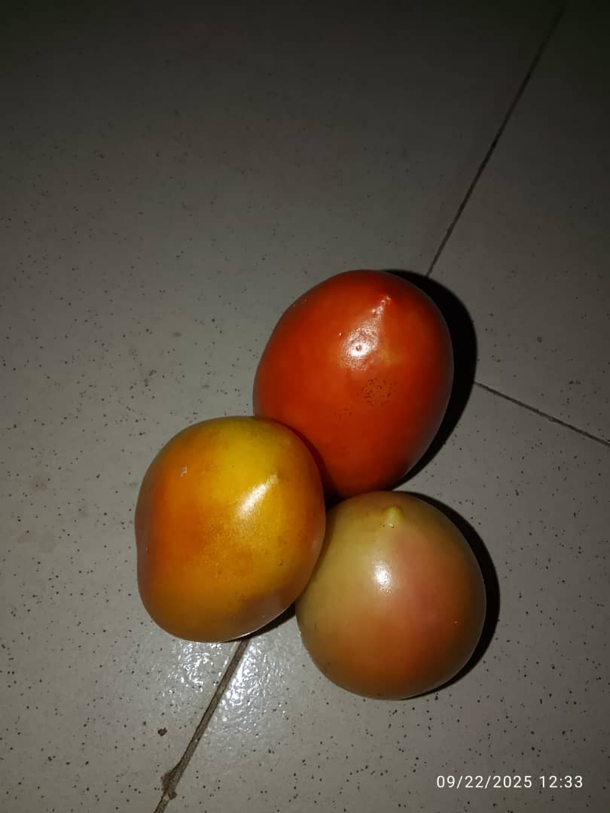
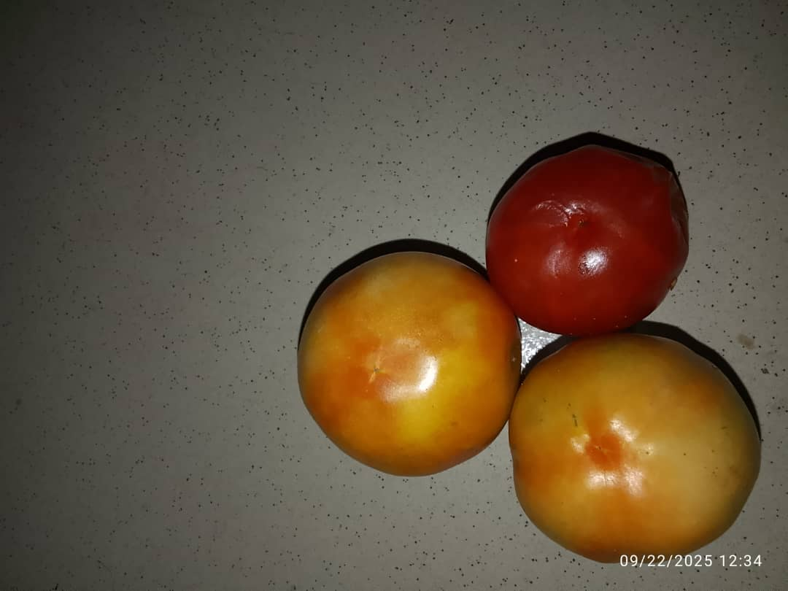
Plate: 1. Roma Plate. 2. Globes

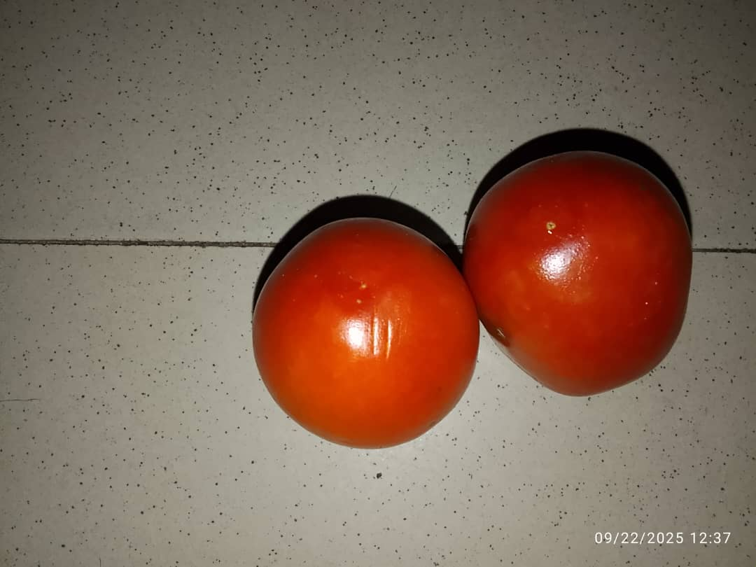
Plate: 3. Seria

Discussion
Proximate Composition of Tomato Fruit
The present study assessed the proximate, mineral, and vitamin composition of three tomato varieties (Roma, Globe and Seria) commonly consumed in Mubi, Adamawa State, Nigeria. The findings revealed marked differences in the nutritional composition across the varieties, thereby confirming that tomato nutrient profiles are significantly influenced by varietal characteristics. This aligns with the general assertion of Yadav et al., (2023) that genotype, environmental conditions, and post-harvest handling strongly affect the proximate and micronutrient composition of tomato fruits. The proximate analysis revealed that the Seria variety had the highest protein content (0.33%), followed by the Roma (0.24%) and Globe (0.18%). Although tomatoes are not considered a major protein source, this difference underscores the relevance of varietal selection in enhancing dietary protein intake, particularly in regions where protein-energy malnutrition persists. Hussein et al., (2023) similarly observed significant protein variations among tomato varieties cultivated in northern Nigeria, attributing these differences to genetic factors and soil fertility. The relatively higher protein concentration in the Seria variety suggests that, when consumed regularly, it may contribute more substantially to meeting protein requirements, especially when combined with other staples. Fat content across the varieties did not differ significantly, ranging from 0.12–0.17%. This observation is consistent with earlier reports by Adeyeye et al., (2022), who noted that tomatoes are naturally low in fat and therefore suitable for weight management and cardiovascular health. The low fat levels further validate the classification of tomatoes as low-calorie foods that can be integrated into dietary plans aimed at reducing obesity and related non-communicable diseases. Crude fiber content showed slight variation, being highest in the Roma (0.094%) and lowest in the Seria(0.077%), though the differences were not statistically pronounced. Fiber is vital for bowel function, glycemic control, and cholesterol reduction, and these findings emphasize that tomato varieties, regardless of type, can serve as complementary sources of dietary fiber (Oladipo et al., 2023).
Moisture content was significantly highest in the Roma variety (93.50%) and lowest in the Seria (90.84%). This high water content is typical of fresh tomatoes and contributes to their perishable nature, as highlighted by Alao et al., (2021), who reported that the high perishability of tomatoes is largely due to their high water activity. The moisture levels also determine the concentration of dry matter, explaining why the Seria variety, with lower water content, had higher carbohydrate concentration (9.20%) compared to the Roma (5.85%). Yadav et al., (2023) confirmed this inverse relationship, explaining that varieties with lower water content often exhibit higher dry matter, which translates into higher carbohydrate accumulation.
Mineral Composition of Tomato Fruit
The mineral composition results further emphasized the importance of varietal selection. The Seria variety contained the highest levels of calcium (188.43 mg/100g), potassium (392.17 mg/100g), magnesium (41.30 mg/100g), and phosphorus (87.55 mg/100g). Calcium and phosphorus are critical in bone formation, while potassium plays a central role in regulating blood pressure and fluid balance (WHO, 2021). There are relatively high potassium (392.17%/100g) concentration in the Seria variety, potassium-rich diets help reduce hypertension and cardiovascular risk. Conversely, iron concentration was highest in the Globe variety (4.24 mg/100g). This is of great nutritional relevance, as iron deficiency anemia is widespread in sub-Saharan Africa, with WHO (2023) estimating that nearly 40% of women of reproductive age are anemic. Promoting the consumption of Globe tomatoes could therefore help alleviate iron deficiency in vulnerable groups.
Interestingly, the Roma variety recorded the highest zinc concentration (2.43 mg/100g). Zinc is an essential trace element involved in immune function, wound healing, and enzymatic activity (Okonji et al., 2024). This implies that the Roma variety could be prioritized in dietary recommendations aimed at boosting immunity, particularly in communities vulnerable to infections. These variations corroborate the findings of Eze et al., (2022), who emphasized that farmers and consumers often neglect varietal nutrient differences, yet these differences can play a decisive role in combating micronutrient deficiencies.
Vitamin Composition of Tomato Fruit
The vitamin composition results revealed that the Seria variety was particularly nutrient-dense, containing the highest levels of vitamin A (57.19 µg/100g), vitamin C (82.25 µg/100g), and vitamin K (9.52 µg /100g). Vitamin A is essential for vision and immune function, vitamin C is a powerful antioxidant involved in collagen synthesis and immune defense, while vitamin K supports blood clotting and bone metabolism. The high vitamin C content observed in the Seria variety aligns with Zhao et al., (2022), who reported that vitamin C-rich tomatoes are highly effective in neutralizing oxidative stress, thereby reducing the risk of chronic diseases such as cancer and cardiovascular disorders. On the other hand, the Globe variety recorded the highest vitamin B3 (0.040 mg/100g), while vitamins B1 and B2 did not differ significantly across varieties. Niacin (vitamin B3) is essential in energy metabolism and nervous system function, implying that the Globe variety may provide additional benefits for individuals with higher energy demands. The Roma recorded the lowest vitamin C content (61.47 mg/100g), which may reduce its antioxidant potential compared to the Seria. These findings support the observations of Azeez et al., (2023), who stressed that varietal and environmental factors strongly influence the micronutrient concentration of tomatoes.
Conclusion
These variations highlight the need for increased awareness among consumers and policymakers on the importance of varietal differences in tomatoes. Promoting the cultivation and consumption of nutrient-dense varieties, especially the Seria could help improve dietary quality, reduce micronutrient deficiencies, and contribute to better public health outcomes. This study recommend that farmers in Mubi and similar regions prioritize the cultivation of the Seria tomato variety due to its superior nutritional qualities, especially in vitamins and minerals.
Further investigations involving wider range of varieties for a broader understanding of their nutritional elements and potential contribution to nutrition and food security.

References
Adebayo, A.A. (204). Mubi Region: A Geographical synthesis. Paraclate
Adepoju, O. T., and Oyewole, O. E. (2014). Nutrient composition and consumption of fruits and vegetables among households in Oyo State, Nigeria. African Journal of Food, Agriculture, Nutrition and Development, 14(6), 2155–2170.
Adeyeye, A. S., Adedeji, A. O., and Aluko, A. A. (2022). Nutritional and economic significance of tomato production in Nigeria. Nigerian Journal of Agricultural Sciences, 18(2), 55–63
Alao, R.B., Oluwalana, I.B., and Oke, M.O. (2021). Tomato Production and Consumption in Nigeria: Analysis of the Value Chain. African Journal of Agricultural Research, 16(5), 671–679.
Association of Official analatical Chemist. (2019). Association of Official Chemist.AOAC International (21st ed)
Azeez, A. O., Olayemi, O. J., and Bello, A. F. (2023). Tomato value chain analysis in Nigeria: Production and consumption trends. African Journal of Food, Agriculture, Nutrition and Development, 23(1), 11834–11849.
Eze, J. I., Okeke, C. N., and Anya, C. A. (2022). Consumer preference and nutritional awareness of tomato varieties in rural Nigeria. International Journal of Nutrition and Food Sciences, 11(3), 89–96.
Hussein, M. A., Ibrahim, Y. K., and Yusuf, A. M. (2023). Proximate and micronutrient composition of selected tomato varieties cultivated in Northern Nigeria. Journal of Food Quality, 2023, 1–8.
Okonji, C. J., Adeyemi, T. T., and Abiodun, O. S. (2024). Role of nutrient-rich crops in combating hidden hunger in Sub-Saharan Africa. Frontiers in Sustainable Food Systems, 8, 1356429.
Oladipo, A. F., Ajayi, K. O., and Adetola, A. S. (2023). Nutrition-sensitive agriculture: Pathways to improved dietary quality in Nigeria. Journal of Public Health Nutrition, 26(5), 785–794
Onuguh, I.C., Imuetinya,A.T., Nnandazie, R.I and Ozor, J.U. (2025). Comparative proximate Analysis of Tomato (Solanum lycopersicum L.) Fruits Sold in Markets in Benin City, Nigeria, International Journal of Emergent Technologies. Vol. 16(10, Pp, 121-125.
WHO (2021). Micronutrient Deficiencies: Iron, Vitamin A, and Iodine. World Health Organization.
WHO (2023). Micronutrient deficiencies: Global prevalence and public health significance. World Health Organization.
Yadav, S., Kumar, P., and Singh, R. (2023). Influence of agronomic factors on the nutritional quality of tomato. Scientia Horticulturae, 317, 112052.
Zhao, X., Li, Y., and Wang, J. (2022). Lycopene and human health: Current evidence and future directions. Critical Reviews in Food Science and Nutrition, 62(22), 6030–6042.

