STAKEHOLDERS’ ENGAGEMENT AS A CATALYST FOR SCHOOL DEVELOPMENT

- INTRODUCTION
This study examines the role of stakeholder engagement as a catalyst for school development within Barcelona District Schools in the Philippine public education context. Internationally, research demonstrates that collaborative governance involving teachers, parents, community members, and policymakers enhances program implementation and student performance, as highlighted by Anderson and Green in Scandinavian elementary schools and supported by comparative studies from the OECD. Global frameworks, including UNESCO’s Education 2030 Framework for Action and World Bank initiatives, reinforce stakeholder participation as essential for achieving quality, equity, and accountability, while scholars such as Bryk and Schneider, and Epstein emphasize the importance of relational trust and structured partnerships in school improvement.
In the Philippines, stakeholder engagement is constitutionally and statutorily mandated through the 1987 Constitution, Republic Act No. 9155 (Governance of Basic Education Act of 2001), and Republic Act No. 10533 (Enhanced Basic Education Act of 2013). The Department of Education's School-Based Management (SBM) policy operationalizes these mandates through participatory structures and shared responsibility. Research cited within the Philippine context—including studies by Bernado and King, Malaluan and Caoli-Rodriguez, and Rubio-Codina et al.—confirms that effective stakeholder engagement improves program implementation, learner support, and school performance when stakeholders are genuinely involved in decision-making.
Despite strong policy support, challenges persist, including socio-economic constraints, limited stakeholder capacity, and communication gaps, as noted by David and Albert, which often result in fragmented engagement. This study addresses three key research questions: the influence of stakeholder engagement on school development planning, its impact on implementation, and strategies for sustaining engagement. Focusing on Barcelona District Schools, this research aims to clarify stakeholder roles, strengthen shared responsibility, and develop sustainable strategies to enhance learner performance, improve school climate, and ensure development initiatives remain responsive to community needs under the decentralized governance framework of Philippine public education.
This study investigated the current dynamics, contributions, challenges, and potential sustainability strategies related to stakeholders’ engagement, providing an evidence-based foundation for enhancing collaborative efforts that promote the continuous growth and improvement of Sta. Cruz Elementary School. Specifically, this study answered the following research questions:
1. How does stakeholder engagement influence the planning and implementation of school development initiatives?
2. In what ways do parents, teachers, and community members contribute to the success of school development programs?
3. What is the impact of stakeholders’ engagement on school development outcomes?
4. What challenges hinder effective stakeholder engagement in the context of school development?
5. What intervention can be proposed to improve stakeholders’ engagement to promote long-term growth in school development?
This study focused on investigating stakeholders’ engagement as a catalyst for school development at Sta. Cruz Elementary School in Barcelona, Sorsogon. Specifically, the research explored the dynamics, contributions, challenges, and potential sustainability strategies of stakeholders’ involvement in the planning, implementation, and outcomes of school development initiatives. This study were limited to the participation of key stakeholders directly associated with the school: 5 teachers, 5 parents, 5 Barangay Local Government Unit (BLGU) Officials, 5 private individuals supporting school programs, 5 beneficiaries of the 4Ps (Pantawid Pamilyang Pilipino Program), 5 Local Government Unit (LGU) employees, and 5 alumni association officers of Sta. Cruz Elementary School. These groups were selected because of their significant and direct role in supporting school programs, contributing resources, providing feedback, and participating in decision-making processes that affect the school’s growth and development.

- LITERATURE REVIEW
International and local research confirmed that sustainable school development and improved student outcomes are fundamentally driven by structured, multi-stakeholder engagement across five key groups. Parental engagement, as demonstrated by the study of O'Connor and Williams, Tanaka and Fujimoto, Ibrahim and Yusuf, and confirmed by the scholastic works of Cruz and Bautista, De la Cruz and Mendoza, and Caballero and Aquino. They showed that structured communication and formal participation in school activities significantly enhance student achievement and program implementation through parent-teacher councils and consultation mechanisms. Teacher collaboration and participatory governance emerge as vital elements, with international studies by Allen and Baker, Brown et. al, and Torres and Villanueva, alongside the research of Torres and Mendoz, Ramos and De Leon, and Martinez and Cruz, who indicated that involving teachers in planning and decision-making through committees and leadership workshops fosters staff cohesion and higher program success rates.
Alumni engagement proves beneficial, as foreign studies by Rojas and Salazar, Diaz and Morales and the works of Santos and Delos Reyes, Lopez and Rivera; and, Torres and Ramos, who showed that alumni networks contributed resources, mentorship, and infrastructure support through formal associations and structured mentorship programs. Community involvement is repeatedly identified as essential, with international evidence from the studies of Xie and Wang; Foster and Nguyen; and Green and Thompson, as well as the research findings from Garcia and Lopez; Delos Santos and Fernandez; and Tadeo and Mercado, highlighting that community participation provides volunteers, materials, and facility maintenance through formalized volunteer programs and recognition mechanisms.
Local government unit support serves as a crucial enabler, as illustrated by the study of Park and Choi; Kim and Thomas; Delos Santos and Fernandez; Torres and Bautista; and Fernandez et. Al was conducted in the Philippines, where LGU partnerships facilitate funding, infrastructure, and program execution through formal agreements and regular coordination. Multi-Stakeholders’ engagement, integrating all groups consistently, enhances outcomes, with studies by Turner and Wallace; Valerio and Gomez; and Quinn and Rogers abroad, together with the study of Delos Reyes and Torres; Reyes and Bautista; and Santos and Valdez locally, demonstrating that Stakeholders’ councils and participatory frameworks ensure coordinated efforts. For Sta. Cruz Elementary School, this integrated approach, leveraging parents, teachers, alumni, community, and LGU partners, is essential for maximizing resources, ensuring program effectiveness, and achieving long-term institutional resilience.

Theoretical Framework
The theoretical framework for this study is grounded in educational management, participatory governance, and community development theories, which collectively explain how stakeholders’ engagement influences school development outcomes. The framework posits that effective school growth is a multidimensional process shaped by the contributions of parents, teachers, alumni, community members, and local government units. This study is anchored on the following theories:
Participatory Governance Theory. Arnstein posits that by fostering shared responsibilities, consultative mechanisms, and collaborative committees, schools can ensure that development initiatives are inclusive, relevant, and reflective of the needs of their learning community.
Partnership Model / Theory of School-Family-Community Partnerships. Epstein argues that Student success and school improvement are maximized when families, schools, and communities form intentional, overlapping partnerships. These partnerships require shared responsibility and coordinated action.
Systems Theory. This theory states that schools, organizations, and communities are interconnected systems where changes in one part affect the whole. Thus, applied systems thinking to organizations, emphasizing that sustainable improvement requires understanding interrelationships rather than linear cause-and-effect.
Collaborative Governance Theory. Ansell & Gash theorized that multiple stakeholders collectively make decisions and implement policies through formal consensus-building processes, and success depends on trust, shared ownership, face-to-face dialogue, and commitment to collaboration.

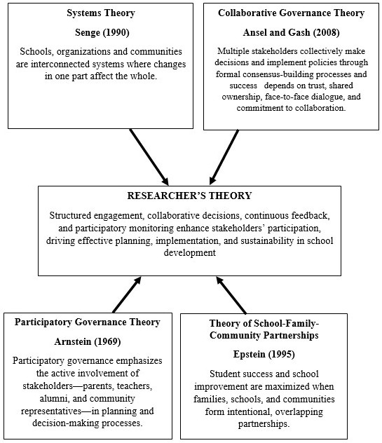
Figure 1. Theoretical Paradigm

Conceptual Framework
This study investigated stakeholders’ engagement as a catalyst for school development at Sta. Cruz Elementary School, examining the contributions, participation, and collaboration of teachers, parents, local government units, alumni, 4Ps beneficiaries, community members, and private individuals. Recognizing that effective school development relies on shared responsibility, this research systematically analyzes how stakeholder involvement influences the planning, implementation, and sustainability of school programs. Understanding these dynamics is essential for administrators, school heads, and policymakers seeking to foster collaborative practices that enhance institutional growth, improve student outcomes, and strengthen community–school relationships.
The Input Phase collects baseline data on stakeholder engagement levels, existing policies, and communication mechanisms.
The Process Phase utilizes a mixed-methods approach, combining structured quantitative questionnaires with qualitative interviews, focus group discussions, and direct observation to assess participation levels, perceptions, and barriers such as time constraints, resource limitations, communication gaps, and unclear role definitions.
The Output Phase synthesizes findings into comprehensive stakeholder profiles, highlighting participation types, specific contributions, and collaboration challenges. This phase also introduces the BRIDGES Program (Building Relationships and Inclusive Dialogue for Growth and Engagement in Schools) as a targeted intervention to address identified gaps and improve coordination.
The Outcome Phase evaluates both direct and indirect impacts—including program implementation efficiency, facility quality, student academic and socio-emotional outcomes, institutional capacity, and stakeholder satisfaction—while also assessing the long-term sustainability of initiatives and stakeholder commitment to ongoing collaboration.

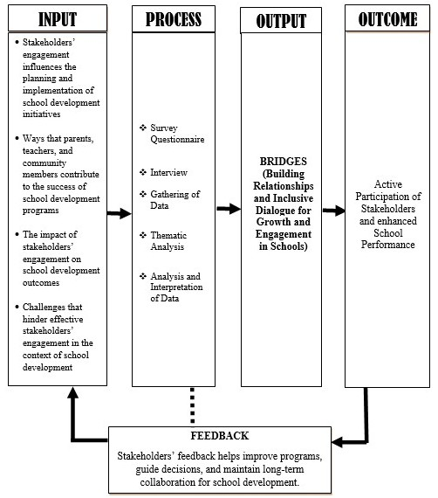
Figure 2. Conceptual Framework

- METHOD AND PROCEDURES
Method
The method employed in this study was the quantitative research method. This methodology systematically collected and analyzed numerical data to examine relationships, measured variables, and test objective theories within a single investigation to provide a statistical understanding of the research problem (Creswell & Clark). In this study, the quantitative method was used to systematically examine the involvement of teachers, parents, community members, alumni, 4Ps beneficiaries, local government units, private individuals, and the Barangay Local Government Unit (BLGU) in school development initiatives at Sta. Cruz Elementary School in Barcelona, Sorsogon.
To deeply understand the lived experience and subjective dimensions of teacher emotional competence, a qualitative strand was implemented using semi-structured interviews and classroom observations with selected elementary teachers, with data analyzed through thematic analysis

Respondents
The respondents of this study were carefully selected stakeholders who were directly involved in the development and growth of Sta. Cruz Elementary School in Barcelona, Sorsogon. A total of 35 participants were included, representing various groups that play significant roles in school programs and initiatives. The stakeholders comprised 5 teachers/faculty members, 5 parents, 5 members of the alumni association, 5 beneficiaries of the 4Ps program, 5 local government unit (LGU) employees, 5 Barangay Local Government Unit (BLGU) representatives, and 5 other community members.
These respondents were chosen to provide a comprehensive view of stakeholders' engagement, encompassing those involved in teaching, school management, program support, community participation, and governance. Their inclusion ensured that multiple perspectives were captured, allowing for a holistic understanding of the contributions, challenges, and potential strategies for enhancing collaborative efforts in school development. The selection of these stakeholders also aligned with the objectives of the study, which assessed the impact of stakeholder involvement on planning, implementation, and sustainability of school development initiatives.

Research Instruments
To comprehensively assess stakeholder engagement at Sta. Cruz Elementary School, the researchers developed structured questionnaires and interview guides tailored to evaluate current dynamics, contributions, challenges, and sustainability strategies among teachers, parents, alumni, 4Ps beneficiaries, LGU and BLGU representatives, and community members.
The questionnaire is organized into four sections: the first collects respondent demographics to establish participant profiles; the second measures stakeholder contributions to school programs, resource mobilization, mentoring, and community activities; the third identifies key barriers to collaboration, including limited participation, communication gaps, resource constraints, and the absence of formal engagement structures; and the fourth explores potential sustainability strategies, such as formal committees, participatory decision-making, training programs, and recognition initiatives.

Complementing the quantitative instrument, the interview guide employs open-ended questions to elicit qualitative insights into stakeholders' experiences, specific examples of successful collaboration, challenges faced, and recommendations for program improvement. To ensure validity and reliability, both instruments were reviewed and validated by educational experts, school administrators, and community development professionals, guaranteeing clarity and relevance. By integrating quantitative Likert-scale measures with qualitative components, this mixed-methods approach enables a holistic understanding of engagement dynamics, facilitating the identification of gaps and the formulation of evidence-based recommendations for strengthening collaborative school development efforts.

Statistical Treatment
Data from thirty-five (35) stakeholders were analyzed using a mixed-methods approach aligned with each research objective. Frequency counts and percentages described respondent demographics, while Likert scales and weighted means quantified levels of engagement in planning, implementation, resource mobilization, and monitoring. Correlational analysis determined the relationship between stakeholder engagement and school development outcomes, and qualitative thematic analysis of open-ended responses identified challenges and barriers. This comprehensive analytical framework ensured reliable, valid findings for developing evidence-based strategies to enhance collaborative school development efforts at Sta. Cruz Elementary School.

- PRESENTATION, ANALYSIS, AND INTERPRETATION OF DATA
This chapter presents the data gathered from the respondents by the researcher. These data are analyzed and interpreted in this section.

Stakeholders’ Engagement that Influences the Planning and Implementation of School Development Initiatives
Stakeholder engagement plays a vital role in the effective operation of schools, especially in the planning and implementation of development initiatives. By involving parents, teachers, community members, and other partners, schools are able to draw on diverse perspectives that ensure programs are responsive to the actual needs of learners and the community.
Stakeholders engagement is widely recognized as a cornerstone of effective school operations, particularly in the planning of development initiatives. Table 1.1 presents the data highlighting how stakeholders’ engagement directly shapes the planning of school development initiatives.
Involving stakeholders in planning improves clarity of school goals and objectives, had a weighted mean of 4.57 and received a description of agree, reflecting the essential role of stakeholders in clarifying the school’s purpose during the planning stage. This high rating underscores that active participation ensures goals are well-defined and aligned with institutional priorities.
Table 1.1
Stakeholders’ Engagement that Influences the Planning of School Development Initiatives
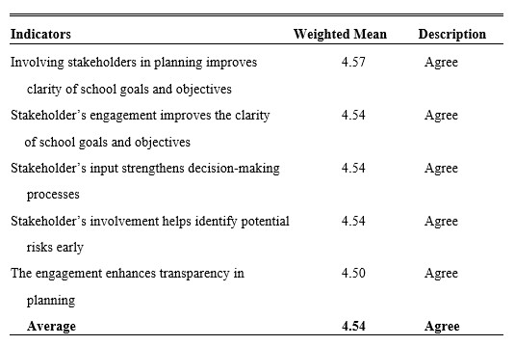
Stakeholder engagement improves the clarity of school goals and objectives, obtaining a weighted mean of 4.54, with a description of agree, highlighting that collaboration among stakeholders contributes to transparent and coherent planning. This finding suggests that schools benefit from collective input in articulating objectives that resonate with both internal and external communities.
Stakeholders’ input strengthens decision-making processes, with a weighted mean of 4.54 and was described as agree, indicating that stakeholders’ perspectives enhance the quality and inclusiveness of decisions. Their involvement provides diverse insights that help schools adopt more balanced and effective strategies.
Stakeholder involvement helps identify potential risks early, also receiving a weighted mean of 4.54 with a description of agree, showing that early participation enables schools to anticipate challenges before they escalate. This proactive role of stakeholders supports risk management and contributes to the smoother implementation of development initiatives.
Table 1.2 presents data that captures how stakeholders’ engagement influences the implementation of school development initiatives, looking specifically at areas such as resource use, execution, innovation, accountability, and the ability to manage change. Stakeholders’ feedback on resource allocation received the highest weighted mean of 4.69, with a description of Strongly Agree, standing out as the most strongly endorsed indicator in this table. This exceptional rating reflects the recognition that those closest to implementation—teachers, parents, and community partners—possess valuable insights about where resources are most needed and how they can be used most effectively. Their feedback helps schools avoid misallocations and ensures that materials, funding, and support reach the areas that will benefit learners most.
Table 1.2
Stakeholders’ Engagement that Influences the Implementation of School Development Initiatives
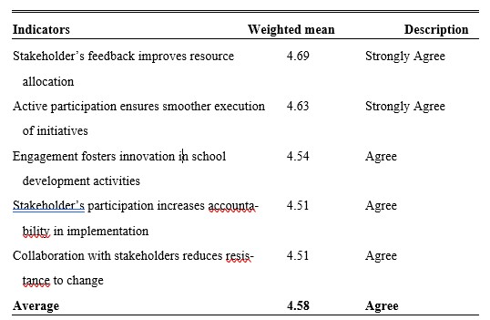
Active participation ensures smoother execution of initiatives, obtaining a weighted mean of 4.63 and was described as Strongly Agree, indicating that when stakeholders roll up their sleeves and take part in the work, implementation proceeds with fewer obstacles. This finding suggests that schools benefit tremendously from having willing hands and collaborative spirits during the sometimes-difficult work of putting new programs into practice. The presence of engaged stakeholders creates a sense of shared responsibility that keeps initiatives moving forward even when challenges arise.
Engagement fosters innovation in school development activities, with a weighted mean of 4.54 with a description of Agree, showing that diverse stakeholders’ perspectives spark creative solutions that might not emerge from school administrators alone. Parents see things from home, teachers notice what works in classrooms, and community members bring outside experiences—all this collective wisdom generates fresh ideas that make school initiatives more relevant and effective.
Stakeholder participation increases accountability in implementation, received a weighted mean of 4.51, and was described as Agree, highlighting that when people are involved in doing the work, they also take ownership of the results. This sense of shared responsibility weighted mean that stakeholders hold themselves and each other accountable for following through on commitments, creating a culture where promises are kept, and progress is monitored by all.
Collaboration with stakeholders reduces resistance to change, and also obtained a weighted mean of 4.51 with a description of Agree, demonstrating that people are more likely to accept and support new initiatives when they have been part of the process. Change can feel threatening, but when stakeholders have had a voice and a role, they understand the reasons behind new directions and are more willing to adapt. Their collaboration becomes a bridge that carries the entire school community through periods of transition.

Ways Parents, Teachers, and Community Members Contribute to School Development
Table 2.0 presents data that capture the many ways parents, teachers, and community members step up and contribute to making their schools better places for children to learn and grow.
Table 2.0
Ways Parents, Teachers, and Community Members Contribute to School Development
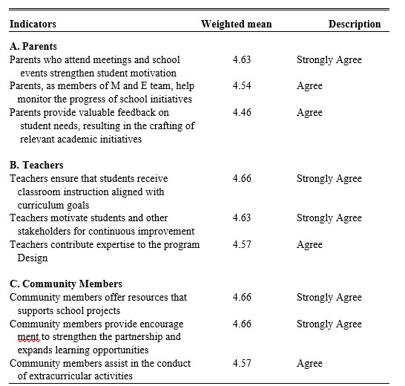
The findings reveal that teachers, parents, and community members make substantial contributions to school development at Sta. Cruz Elementary School, with all indicators rated Agree to Strongly Agree. Teachers demonstrated the highest overall contribution, particularly in ensuring classroom instruction aligned with curriculum goals (weighted mean of 4.66, Strongly Agree), affirming their fundamental role in translating plans into actual learning experiences.
Teachers also motivate students and stakeholders for continuous improvement (4.63, Strongly Agree), serving as the heart of the school community, while their contribution to program design (4.57, Agree) suggests they are sometimes involved only at implementation rather than planning stages. These findings are supported by research from Nigeria emphasizing curriculum-instruction alignment, and Supangjit and Chansirisira's study on teacher innovator competence in Thailand.
Parents recorded their highest rating in attending meetings and school events, strengthening student motivation (4.63, Strongly Agree), reflecting research by Barger et al. and Zaff et al. that parental presence communicates education's value and enhances engagement and graduation outcomes. Parents participating in Monitoring and Evaluation teams obtained 4.54 (Agree), demonstrating active roles in tracking initiatives and ensuring accountability, while providing feedback on student needs received 4.46 (Agree), suggesting room for schools to more intentionally act upon parental insights.
Community members tied for the highest rating in offering resources that support school projects and providing encouragement to strengthen partnerships and expand learning opportunities (both 4.66, Strongly Agree), reflecting tangible generosity and intangible support that demonstrate education as a shared responsibility. Assisting in extracurricular activities received 4.57 (Agree), highlighting community volunteers' role in enriching student life beyond the classroom. These findings align with Contato and Ronsivalle's research on community engagement fostering social inclusion, and Jiménez-Chávez's work on community-based participatory research emphasizing trust-building and sustainable partnerships. Overall, the results confirm that teachers, parents, and community members are essential drivers of school development, with teachers excelling in instructional delivery, parents contributing through presence and monitoring, and communities providing vital resources and encouragement.

Impacts of Stakeholders’ Engagement on School Development Outcomes
Table 3.0 presents data that capture the impact of stakeholders’ engagement on school development outcomes, showing how the involvement of parents, teachers, and community members translates into real results for schools and the children they serve.
Table 3.0
Impact of Stakeholders’ Engagement on School Development Outcomes
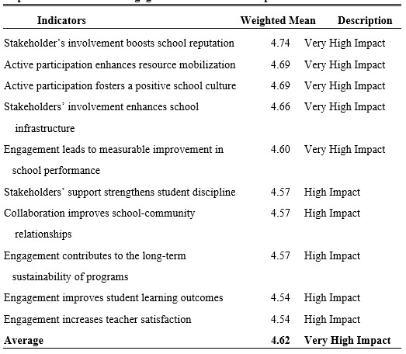
The findings reveal that stakeholders' involvement produces substantial positive impacts on school development at Sta. Cruz Elementary School, with all indicators rated as High to Very High Impact. Stakeholders' involvement boosting school reputation received the highest rating (weighted mean of 4.74, Very High Impact), reflecting that a school's reputation is collectively shaped by positive stakeholder voices, partnerships, and community support, creating a self-reinforcing cycle of trust and engagement. This aligns with a 2025 study by Stoica et al., which found that community engagement and stakeholder trust are fundamental to building and sustaining institutional credibility.
Active participation, enhancing resource mobilization, and fostering a positive school culture both tied for the second-highest rating (weighted mean of 4.69, Very High Impact), highlighting that engaged stakeholders provide tangible resources beyond government budgets while co-creating a warm, collaborative school atmosphere where improvements take root. Enhancing school infrastructure followed closely (4.66, Very High Impact), reflecting visible physical improvements from stakeholder contributions.
Measurable improvement in school performance (4.60, Very High Impact) confirms that engagement produces results seen in higher passing rates, completion rates, and co-curricular achievements. Strengthening student discipline, improving school-community relationships, and contributing to long-term program sustainability each received weighted means of 4.57 (High Impact), emphasizing that stakeholder support creates consistent behavioral expectations, builds relational bridges, and ensures program ownership and longevity.
Improving student learning outcomes and increasing teacher satisfaction both received weighted means of 4.54 (High Impact), representing the lowest ratings. The former may reflect the complex, indirect relationship between engagement and learning outcomes influenced by multiple factors, while the latter suggests teacher satisfaction is shaped by working conditions and administrative support alongside stakeholder involvement. Overall, the findings confirm that stakeholders' engagement drives comprehensive school development across reputation, resources, culture, infrastructure, performance, discipline, community relationships, sustainability, learning outcomes, and teacher satisfaction.

Challenges Hindering Effective Stakeholders’ Engagement in the Context of School Development
Table 4.0 presents data that captures the challenges hindering effective stakeholder engagement in the context of school development, revealing the real-world obstacles that schools face when trying to build genuine partnerships with parents, teachers, and community members.

Table 4.0
Challenges Hindering Effective Stakeholders’ Engagement in the Context of School Development
The findings reveal that despite the documented benefits of stakeholder engagement, schools face significant real-world obstacles that hinder meaningful participation. Limited communication and leadership inconsistencies both ranked as the most critical challenges (frequency of 21, ranked 1.5th), indicating that poor communication systems—such as inconsistent announcements and information lost in transit—systematically exclude stakeholders from participation, while frequent leadership turnover erodes trust and continuity, forcing relationships to be rebuilt with each new administration. These findings are supported by Alcala et al.'s study on barriers to School-Based Management in the Philippines, which identified poor communication systems and lack of transparency as significant impediments, and Gardner's doctoral research on relational trust, which concluded that leadership transitions undermine partnership sustainability.
Lack of clear roles and lack of trust between school and stakeholders both ranked 3.5th (frequency of 18), revealing that when stakeholders are invited to participate without defined responsibilities or decision-making authority, commitment weakens, and when schools solicit input but ignore it or fail to keep promises, trust deficits emerge that make stakeholders withhold honest feedback and guard their resources. Resistance to change among some stakeholders ranked 5th (frequency of 17), reflecting that not all barriers originate from school systems—some parents prefer professional autonomy for teachers, some teachers view community engagement as interference, and some community members resist new partnership models—often stemming from past negative experiences or comfort with existing routines.
Collectively, these challenges underscore that communication breakdowns, leadership instability, role ambiguity, mistrust, and resistance are not signs of stakeholder apathy but systemic barriers that schools must address through transparent systems, consistent leadership, clear role definitions, relationship-building, and demonstration of tangible benefits to enable genuine, sustained partnerships.

Proposed Intervention for Improving Stakeholders’ Engagement to Promote Long-Term Growth in School Development
Schools cannot succeed alone. This fundamental truth lies at the heart of the BRIDGES program. While teachers and administrators carry the primary responsibility for education, parents, community members, and local organizations have always been essential partners—even if they have not always known how to step into that role. The education of a child is not a task that can be completed within four walls and six hours of instruction.
It is a continuous, holistic process that unfolds at home, in the neighborhood, during after-school hours, and through countless interactions with adults who shape a child's understanding of the world. Raising a child truly does take a village, and schools must be intentional about inviting that village to participate.
BRIDGES (BUILDING RELATIONSHIPS AND INCLUSIVE DIALOGUE FOR GROWTH AND ENGAGEMENT IN SCHOOLS)
The legal mandate for this partnership is clear and firmly established in Philippine educational policy. Republic Act No. 9155, the Governance of Basic Education Act of 2001, requires that the values and aspirations of the school community be reflected in education programs and that democratic consultation guide decision-making. The law explicitly states that the State shall encourage local initiatives for improving the quality of basic education and that feedback mechanisms shall be established to ensure open communication between schools and the communities they serve. Building upon this foundation, DepEd Order No. 44, series of 2015, provides concrete guidelines for implementing stakeholders’ engagement through the enhanced School Improvement Planning process and the School Report Card, explicitly aiming to strengthen School-Based Management by expanding community participation and involvement.
Despite these clear policies, a significant gap remains between intention and practice. Research consistently shows that poor communication systems keep stakeholders from learning about opportunities to participate. Leadership changes disrupt carefully built partnerships, leaving communities weary of investing in relationships that seem to reset every few years. Unclear roles leave well-weighted meaning volunteers unsure of what they are supposed to do. Trust erodes when schools ask for input but never act on it, leading to conflict and alienation among the very people schools need most. Resistance to change emerges when stakeholders feel left out of decisions that affect them. The consequences of this gap are significant: parents who might have reinforced learning at home remain unsure how to help, local businesses that could have offered support remain unaware of opportunities, and teachers who could have felt supported continue working in isolation.
The BRIDGES program is designed to address this gap. It provides schools with a systematic, practical approach to removing barriers and building lasting structures for collaboration. The name BRIDGES reflects the core purpose of the intervention—to build connections across the gaps that currently separate schools from their stakeholders and to create lasting structures for collaboration that can weather leadership changes, resource limitations, and the inevitable challenges of educational work. The program recognizes that most schools already have some form of parent involvement and community partnerships. What they often lack is coherence, a way of pulling all these efforts together into a unified approach that addresses underlying barriers and creates sustainable change.
This program is grounded in the conviction that when schools and communities work together as equal partners, children thrive. It is about fulfilling the promise of Philippine educational policy—not as a bureaucratic requirement, but as a living reality where democratic consultation is not just a phrase but a genuine experience, where school improvement plans truly reflect community aspirations, and where every stakeholder knows they have both the right and the responsibility to participate.

- SUMMARY, FINDINGS, CONCLUSIONS, RECOMMENDATIONS
This chapter presents the salient results of the study about the statement of the problem. It also explains the conclusions and recommendations made based on the relevant outcome of the present work.

Findings
- Stakeholder’s engagement that influenced the planning and implementation of school development initiatives are involving stakeholders in planning improves clarity of school goals and objectives, which obtained a weighted mean of 4.57 and described as Agree, stakeholder’s engagement follows this improves the clarity of school goals and objectives, stakeholder’s input strengthens decision-making processes, and stakeholder’s involvement helps identify potential risks all of the three indicators got a weighted mean of 4.54 and described as Agree.
- There are many ways parents, teachers, and the community contribute to the success of the school development program. The indicator that parents who attend meetings and school events strengthen student motivation obtained the weighted mean of 4.63, described as Strongly Agree, Teachers ensure that students receive classroom instruction aligned with curriculum goals, Community members offer resources that support school projects, and Community members provide encouragement to strengthen partnership and expand learning opportunities, with weighted mean of 4.66, all were described as Strongly Agree, respectively.
- The impact of stakeholders’ engagement on school development outcomes have the following findings: stakeholder involvement boosts school reputation with a weighted mean of 4.74 and is described as Very High Impact, followed by Active participation enhances resource mobilization and Active participation fosters a positive school culture, with a weighted mean of 4.69 and described as Very High Impact. This was followed by stakeholders’ involvement, which enhances school infrastructure, which has a weighted mean of 4.66, described as Very High Impact.
- The challenges that hindered effective stakeholder engagement in the context of school development are: limited communication, which restricts stakeholders, and leadership inconsistencies that pose challenges to sustaining stakeholders’ engagement, got a frequency of 21 and rank 1.5th, followed by lack of clear roles weaken stakeholders’ commitment and lack of trust between school and stakeholders affect engagement, got a frequency of 18 and rank 3.5th.
- Implementing BRIDGES (Building Relationships and Inclusive Dialogue for Growth and Engagement in Schools) as an innovation strengthens stakeholder commitment.
Conclusions
The following recommendations were necessary for the present study:
1. Involve and represent school stakeholders in planning, decision-making, and implementation of activities.
2. Consider stakeholder feedback alongside plans and implemented activities.
3. Maintain continued stakeholder involvement in all school activities and feedback processes.
4. Establish clear roles and responsibilities for parents, teachers, and community members.
5. Implement BRIDGES (Building Relationships and Inclusive Dialogue for Growth and Engagement in Schools) as an innovation to strengthen stakeholder commitment.

ACKNOWLEDGEMENT
The researcher humbly and sincerely extends her deepest gratitude to all individuals who, in one way or another, contributed to the successful completion of this study.
Foremost, she expresses her profound appreciation to her thesis adviser, Dr. Virginia D. Detera, for her unwavering guidance, invaluable insights, scholarly expertise, and steadfast encouragement throughout the entire research journey. Her constructive criticism and thoughtful recommendations significantly enriched and strengthened this work.
The researcher is equally grateful to the distinguished panel members. Danilo E. Despi, Dr. Belen L. Dominguiano, Dr. Rolando F. Embile, and Dr. Joseph F. Guab for their time, expertise, and meaningful suggestions that greatly enhanced the quality of this study.
Special thanks are also extended to the Dean of the Graduate School, Ma. Jean C. Deuda, for her support and leadership
Heartfelt appreciation is also conveyed to her OIC, Public School District Supervisor, Dr. Gloria E. Reymundo, for her consistent support, encouragement, guidance, and inspiring leadership. Her empathy and genuine concern have served as a motivating force in the completion of this academic endeavor.
With deepest love and gratitude, she dedicates this work to her beloved husband, Mr. Edwin F. Bucio, and her sons, Engr. Riwin Bryan F. Bucio, Ian Bryle F. Bucio, Edianne Rouie F. Bucio, and her daughter-in-law, Ma’am Christine F. Bucio, and her granddaughter, Maliyah Brielle F. Bucio. Their love, understanding, patience, and constant encouragement have been her greatest source of inspiration throughout this scholarly pursuit.
And above all, she offers her highest praise and thanksgiving to Almighty God for His divine guidance, wisdom, and countless blessings.
To God be the glory!

A.R.F.B

