“A STUDY ON THE DAIGNOSTIC ROLE OF DIFFUSION WEIGHTED MRI IN ACUTE ISHEMIC STROKE’’
SAQIB RAFIQ KHAN, MR. BHARAT BHUSHAN DAGUR.
1. Bsc Radioloy and Imaging Technology, Mewar University Gangrar Chittorgarh Rajasthan India
2 Assistant Professor at Mahatma Gandhi University of Medical Sciences and Technology (MGUMST), Jaipur, Rajasthan India.
1-contact no –6005255839
2-contact no – 6394892343
E-mail-sakikhan034@gmail.com
E-mail-bharatdagur9413@gmail.com
ABSTRACT

INTRODUCTION: Acute ischemic stroke is a leading cause of morbidity and mortality worldwide. Early diagnosis is critical for timely intervention, especially within the narrow therapeutic window. Non-contrast CT has limited sensitivity in early detection. Diffusion-weighted MRI (DWI) offers superior early diagnostic capability.

AIMS AND OBJECTIVES: To evaluate the diagnostic accuracy and clinical role of diffusion-weighted MRI in detecting acute ischemic stroke.

MATERIALS AND METHODS: A prospective observational study was conducted on 50–100 patients presenting with clinical features of acute ischemic stroke. MRI, including DWI and ADC mapping, was performed within 24 hours of symptom onset, findings were compared with non-contrast CT where available.

RESULTS: DWI MRI detected acute infarcts in the majority of cases, including those with normal CT findings. Hyperintense signals on DWI with corresponding hypointensity on ADC maps confirmed restricted diffusion. The middle cerebral artery (MCA) territory was most commonly involved (42%). DWI showed significantly higher sensitivity (96%) compared to CT (28%).

CONCLUSION: DWI MRI is a highly sensitive and reliable imaging modality for early detection of acute ischemic stroke and should be routinely used when available.

KEYWORDS: Diffusion-weighted imaging, Acute ischemic stroke, MRI, ADC, CT comparison.

1. Introduction

Stroke is a major global health burden and a leading cause of long-term disability. Acute ischemic stroke occurs due to sudden interruption of cerebral blood flow, leading to neuronal damage within minutes. Early diagnosis is essential as treatment options such as thrombolysis are time-dependent.

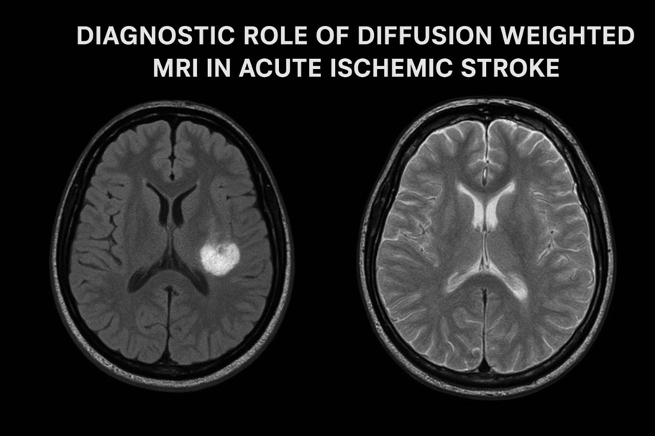

Fig: Acute ischemic stroke on DWI [hyperintensity].

Diffusion-weighted imaging (DWI) has revolutionized stroke imaging by detecting cytotoxic edema within minutes of onset. It is more sensitive than conventional MRI sequences and CT in early stroke detection. The combination of DWI with ADC mapping helps confirm true diffusion restriction and differentiate acute infarcts from chronic lesions or artifacts.

Diffusion-Weighted MRI (DWI) is the most sensitive imaging technique for detecting acute ischemic stroke, often within minutes of symptom onset. It identifies acute infarcts as bright (hyperintense) areas, indicating restricted water motion, typically confirmed by corresponding dark (hypointense) areas on the Apparent Diffusion Coefficient (ADC) map.

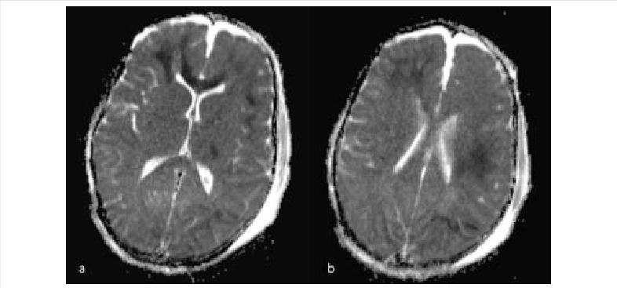

Fig: ADC map showing corresponding hypointensity

2. Aim

To evaluate the diagnostic role and accuracy of Diffusion-Weighted Magnetic Resonance Imaging [DWI MRI] in the early detection of acute ischemic stroke.

3. Objectives
- To assess the sensitivity of DWI MRI in identifying early ischemic changes in the brain.
- To evaluate the correlation between DWI findings and Apparent Diffusion Coefficient [ADC] maps in confirming restricted diffusion.
- To compare the diagnostic accuracy of DWI MRI with non-contrast CT [NCCT] in the hyperacute phase of stroke.
- To correlate radiological findings with clinical presentation in patients with suspected acute ischemic stroke.
- To analyse the distribution and location of infarcts detected on DWI MRI.
- To highlight the role of DWI MRI in early diagnosis and guiding timely management, including thrombolytic therapy.
- DWI MRI plays a crucial role in identifying ischemic at risk within the narrow therapeutic window, emphasizing the concept that “Time is Brain”.

4. Materials and Methods

Study Design

Prospective observational study conducted during clinical internship at SKIMS MCH Bemina, Srinagar, J&k, India.

Study Population
- Patients aged ≥18 years
- Clinically suspected acute ischemic stroke
- MRI performed within 24 hours of symptom onset.

Imaging Protocol:

MRI was performed using 1.5T scanners with the following sequences:
- Diffusion-Weighted Imaging (DWI)
- Apparent Diffusion Coefficient (ADC)
- T1-weighted
- T2-weighted
- FLAIR
- SWI (to rule out hemorrhage)

5. Data Analysis

A total of 100 patients with clinically suspected acute ischemic stroke were included in this study. Descriptive statistical analysis was performed using frequencies[n], percentages [%], and tabular representation.

Descriptive statistics (percentages, tables) were used to evaluate diagnostic accuracy and distribution patterns.

Demographic Analysis
Male | 61%
Female | 39%

This shows a male predominance, which is consistent with increased stroke risk factors such as hypertension and smoking in males.

The age wise distribution are as;
18-30 years | 7%
31-40 years | 10%
41-50 years | 20%
51-60 years | 30%
70 years | 10%

The majority of patients [53%] were in the 51-70 years age group, indicating higher prevalence in middle-aged and elderly populations.

Clinical presentation analysis:

Patients presented with various neurological symptoms:
- Hemiparesis [most common]
- Slurred speech
- Facial deviation
- Aphasia
- Visual disturbances
- Dizziness and ataxia
- Approximate distribution:
- Motor weakness [hemiparesis]: 60-70%
- Speech disturbances: 40-50%
- Brainstem/cerebellar symptoms: 10-15%

CT Finding Analysis

Non-contrast CT [NCCT] findings:

Positive for infarct | 28 cases | 28%
Normal/Inconclusive | 72 cases | 72%

This indicates that CT has low sensitivity in early ischemic stroke, especially in the hyperacute phase.

MRI DWI & ADC Analysis

MRI findings using DWI and ADC sequences:

DWI cases Positive | 96 | 96%
DWI Negative cases | 4 | 4%?

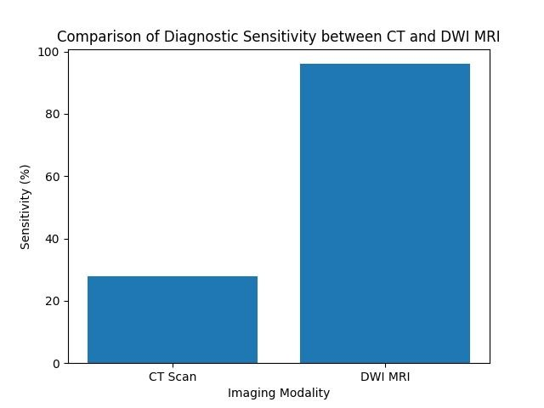

Characteristic findings:

Hperintensity on DWI

Corresponding hypointensity on ADC

These confirm restricted diffusion, which is a diagnostic of acute ischemic infarction.

Infarct Distribution Analysis

Middle cerebral artery | MCA | 42%
Posterior cerebral artery | PCA | 15%
Anterior cerebral artery | ACA | 18%
Basal Ganglia | BG | 8%
Brainstem | B | 10%
Cerebellum | C | 8%
Multiple territories | MT | 5%

The MCA territory was the most commonly involved region.

6. Results

The present study demonstrates that Diffusion-Weighted MRI [DWI] is highly effective in the early diagnosis of acute ischemic stroke.

Key Findings:
- DWI detected infarcts in 96% of patients.
- Whereas CT detected only 28%
- Majority of patients were in the 51-70 years age group.
- Male predominance was observed.
- The middle cerebral artery [MCA] was the most commonly affected territory.

DWI showed:
- Hyperintensity
- Corresponding ADC hypointensity
- Demographic Distribution___confirming acute infarction.

Comperative Outcomes:
Modality | Sensitivity | Percentage
CT SCAN | Low | 28%
DWI MRI | Very High | 96%

DWI MRI demonstrated superior diagnostic accuracy, particularly in the hyperacute phase, where CT findings were often normal.

DWI MRI is highly sensitive and reliable for early stroke detection.

CT Scan has a limited role in detecting early ischemic changes.

Combined DWI and ADC imaging significantly improves:

Diagnostic confidence

Early clinical decision making.

7. DISCUSSION

The present study was conducted to evaluate the diagnostic role of Diffusion-Weighted Magnetic Resonance Imaging (DWI MRI) in patients with clinically suspected acute ischemic stroke. Acute ischemic stroke is a major cause of morbidity and mortality worldwide, and early diagnosis plays a crucial role in improving patient outcomes.

In the current study, a total of 100 patients were evaluated using both CT and MRI imaging modalities.

The demographic analysis revealed a male predominance, with 61% males and 39% females.

This finding is consistent with previous studies, which have reported a higher incidence of stroke among males due to increased exposure to risk factors such as hypertension, smoking, and lifestyle variations.

The age distribution in this study showed that the majority of patients belonged to the 51–70 years age group, this supports the well-established fact that stroke incidence increases with advancing age, particularly in middle-aged and elderly populations.

Clinically, most patients presented with sudden onset neurological deficits.

Hemiparesis was the most common presenting symptom, followed by slurred speech, facial deviation, and aphasia.

These findings correlate well with the vascular territories affected, particularly the middle cerebral artery.

In this study, non-contrast CT (NCCT) demonstrated limited sensitivity in detecting early ischemic changes.

Only 28% of cases showed positive findings on CT, while 72% were reported as normal or inconclusive. This highlights the well-known limitation of CT in the hyperacute phase of ischemic stroke.

CT primarily detects structural changes, which may take several hours to become apparent.

However, CT remains important as a first-line imaging modality for excluding intracranial hemorrhage. In contrast, Diffusion-Weighted MRI demonstrated a significantly higher sensitivity in detecting acute ischemic stroke. In this study, DWI was positive in 96% of cases. This clearly establishes the superiority of DWI over CT in early stroke detection.

The high sensitivity of DWI is attributed to its ability to detect cytotoxic edema, which occurs within minutes of arterial occlusion.

The characteristic imaging findings observed in this study included hyperintensity on DWI sequences. These findings were consistently associated with corresponding hypointensity on ADC maps. This combination confirms true restricted diffusion and helps differentiate acute infarction from T2 shine-through effects. The use of ADC mapping further enhances diagnostic accuracy and confidence. Infarct distribution analysis revealed that the middle cerebral artery territory was the most commonly affected region, accounting for 42% of cases. This is in agreement with existing literature, as the MCA supplies a large portion of the cerebral hemisphere and is most vulnerable to ischemic events. Other regions involved included the posterior cerebral artery, anterior cerebral artery, basal ganglia, brainstem, and cerebellum. The involvement of posterior circulation structures such as the brainstem and cerebellum was less frequent but clinically significant. The findings of this study are comparable with previous studies that have reported DWI sensitivity ranging from 90% to 100% in acute ischemic stroke. The results strongly support the use of DWI MRI as a reliable imaging modality in the hyperacute phase. The comparison between CT and DWI in this study clearly demonstrates the limitations of CT in early detection. While CT is widely available and rapid, it lacks sensitivity in detecting early ischemic changes. DWI MRI, on the other hand, provides early and accurate detection, allowing timely clinical intervention. Early diagnosis is essential for initiating thrombolytic therapy within the therapeutic window.

The concept of “time is brain” emphasizes the importance of rapid and accurate imaging in stroke management. DWI MRI plays a vital role in identifying salvageable brain tissue and guiding treatment decisions.

Overall study strongly support its routine use in clinical practice wherever available.

8. CONCLUSION

Diffusion-Weighted MRI [DWI] MRI is a highly sensitive and reliable imaging modality for the early detection of acute ischemic stroke. In this study, DWI demonstrated significantly higher detection rates compared to non- contrast CT Scan, particularly in the hyperacute phase. The characteristic apperance of hyperintensity on DWI with corresponding ADC hypointensity confirms restricted diffusion and acute infarction.

The majority of patients were middle-aged to elderly, with a male predominance and the middle cerebral artery territory was most commonly affected, CT, although useful for excluding haemorrhage, has limited sensitivity in early ischemia. The combined use of DWI and ADC improves diagnostic accuracy and clinical confidence.

Early and accurate diagnosis using DWI MRI plays a crucial role in guiding timely management and improving patient outcomes, Therefore, DWI MRI should be considered an essential imaging tool in suspected cases of acute ischemic stroke.

9. REFRENCES
- Moseley ME, Kucharczyk J, Mintorovitch J, et al. Diffusion-weighted MR imaging of acute stroke. Radiology. 1990;176(2):439445.
- Warach S, Chien D, Li W, Ronthal M, Edelman RR. Fast magnetic resonance diffusion-weighted imaging of acute human stroke. Neurology. 1992;42(9):17171723.
- Baird AE, Lovblad KO, Dashe JF, et al. Clinical correlations of diffusion and perfusion lesion volumes in acute ischemic stroke. Cerebrovascular Diseases. 2000;10(6):441448.
- Provenzale JM, Sorensen AG. Diffusion-weighted MR imaging in acute stroke: theoretical considerations and clinical applications. AJR Am J Roentgenol. 1999;173(6):14591467.
- Kidwell CS, Chalela JA, Saver JL, et al. Comparison of MRI and CT for detection of acute intracerebral hemorrhage. JAMA. 2004;292(15):18231830.
- Lansberg MG, Thijs VN, OBrien MW, et al. Evolution of apparent diffusion coefficient, diffusion-weighted, and T2-weighted signal intensity of acute stroke. AJNR Am J Neuroradiol. 2001;22(4):637644.
- González RG. Clinical MRI of acute ischemic stroke. J Magn Reson Imaging. 2012;36(2):259271.
- Barber PA, Darby DG, Desmond PM, et al. Prediction of stroke outcome with diffusion-weighted MRI. Neurology. 1998;51(2):418426.

