Sustained Engagement, Assurance and Cooperation in Healthcare Provider–Patient Relationships: A Mixed-Methods Study in Malaysia

Abstract

Sustained engagement between healthcare providers and patients has been associated with positive healthcare outcomes; however, limited research has examined this relationship within a theoretical framework. This study investigates the relationship between continuity of care, assurance and cooperation in primary care using principles derived from probability theory. A mixed-methods approach was employed, involving a questionnaire survey of 279 patients and qualitative interviews with patients and healthcare providers.

Patients who reported positive experiences and anticipated future consultations with the same healthcare practitioner were more likely to express higher levels of assurance in the care provided. Interpersonal aspects of the consultation also appeared to play an important role in shaping these perceptions. Repeated interactions reduced uncertainty and fostered stronger collaborative relationships between patients and healthcare providers. Patients reported a greater willingness to disclose information and adhere to treatment recommendations once assurance had been established. Healthcare providers also highlighted the role of ongoing relationships in enhancing quality of care and patient adherence.

The study proposes a conceptual model of assurance and cooperation in primary care informed by probability theory and demonstrates the importance of repeated interactions in fostering mutual assurance and positive healthcare outcomes. These findings highlight the value of relationship continuity in primary care and suggest that repeated interactions may play an important role in supporting effective communication, collaborative patient involvement, and improved quality of care.
Keywords: continuity of care, assurance, cooperation, primary care, healthcare practitioner-patient relationship, probability theory.

INTRODUCTION

Primary healthcare relies heavily on the quality of interactions between healthcare providers and patients. Beyond diagnosis and treatment, ongoing interactions allow healthcare providers to develop a deeper understanding of patients’ medical histories, personal circumstances, and healthcare needs. Patients, in turn, gain familiarity with their healthcare providers, which may influence their confidence in the care they receive and their willingness to engage actively in treatment decisions. Changes in healthcare delivery models have made it increasingly difficult to maintain continuity in provider-patient relationships, raising important questions about the implications for patient care and healthcare outcomes .

Studies conducted across different healthcare settings have linked continuity of care to improved patient satisfaction, better treatment adherence, enhanced communication, and higher quality care. Patients often value the opportunity to consult the same healthcare provider over time, particularly when managing chronic conditions or addressing complex health concerns. Although these benefits are well documented, less is known about the processes through which ongoing provider-patient relationships encourage confidence and cooperation.

Assurance is widely regarded as a key element of effective provider-patient relationships. Patients frequently seek healthcare during periods of uncertainty, vulnerability, or illness, making confidence in healthcare providers an important element of the therapeutic relationship. Assurance may influence a patient’s willingness to disclose sensitive information, accept medical advice, and participate actively in treatment plans. At the same time, healthcare providers rely on patient cooperation to ensure effective diagnosis, treatment, and long-term disease management. In practice, assurance and cooperation often develop alongside one another during healthcare interactions.

Although the importance of these concepts has been widely acknowledged, much of the existing literature has examined them independently and without a clear theoretical framework explaining how they develop through repeated interactions. Probability theory helps explain how individuals make decisions about cooperation based on previous experiences, expectations of future interactions, and perceptions of the likely behaviour of others. Within healthcare settings, these principles may help explain why repeated encounters between patients and providers strengthen assurance, reduce uncertainty, and encourage cooperative behaviour.

Building on these observations, the present study examines the relationship between continuity of care, assurance and cooperation in primary care. Using a mixed-methods approach that combines survey findings with interview data, the study explores how ongoing provider-patient relationships shape patients’ experiences and behaviours while also considering healthcare providers’ perspectives. Particular attention is given to the mechanisms through which continuity of care influences assurance and cooperation within primary healthcare settings.

Research Objectives

This present study, entitled “Sustained Engagement, Assurance and Cooperation in Healthcare Provider–Patient Relationships: A Mixed-Methods Study in Malaysia” guided by the following objectives:
- To examine the relationship between continuity of care, assurance, and cooperation in primary care settings.

- To explore how repeated interactions between patients and healthcare providers influence assurance and cooperative behaviour.

- To develop conceptual models of assurance and cooperation in primary care informed by probability theory.

Research Questions (RQ)

In line with the above objectives, this study seeks to answer the following research questions:

- How does continuity of care influence patient assurance in primary care settings?

- In what ways do repeated interactions between patients and healthcare providers promote cooperative behaviour?

- How can probability theory explain the development of assurance and cooperation within provider-patient relationships?

By addressing these questions, the study explores the role of continuity of care in shaping assurance and cooperation within provider-patient relationships. The findings provide insight into how repeated interactions may influence patient experiences, collaborative behaviour, and the delivery of care in primary healthcare settings.

LITERATURE REVIEW

Continuity of Care in Primary Healthcare

Continuity of care remains a central consideration in primary healthcare because many patients rely on ongoing relationships with healthcare providers to manage their heath needs. While definitions vary across healthcare systems the concept generally reflects the extent to which care is coordinated, connected, and responsive to patients’ needs over time. Haggerty et al. (2023) conceptualised continuity of care as comprising informational continuity, management continuity, and relational continuity, with each dimension contributing to the overall quality of patient care. Freeman et al. (2022) similarly described continuity as a process through which healthcare services are delivered in a coherent and consistent manner, allowing patients to experience care as integrated rather than fragmented. Of these dimensions, relational continuity is especially relevant to the present study because it focuses on the ongoing interactions through which provider-patient relationships are established and maintained.

Importance of Continuity of Care

A substantial body of research has linked continuity of care with improved outcomes for patients and more effective healthcare delivery. Patients who regularly consult the same healthcare provider are more likely to report higher levels of satisfaction, improved communication, and greater adherence to treatment recommendations (Pereira Gray et al., 2023; Saultz & Lochner, 2015). Continuity also enables healthcare providers to develop a better understanding of patients’ medical histories, preferences, and personal circumstances, helping providers deliver more personalised and effective care. For individuals managing chronic illnesses or complex health conditions, continuity may provide additional reassurance through consistent monitoring and familiar professional support (Saultz, 2023).

Continuity of Care and Provider-Patient Relationships

At the heart of continuity of care is the ongoing relationship between healthcare providers and patients. Repeated encounters create opportunities for healthcare providers and patients to become familiar with one another, facilitating communication and mutual understanding. As these interactions accumulate, both patients and providers may develop greater confidence in the relationship, while uncertainty gradually diminishes. Although the benefits of continuity of care are well documented, the processes through which ongoing provider–patient relationships foster assurance and cooperation remain less clearly understood. This issue is especially relevant in primary healthcare, where long-term relationships frequently underpin the delivery of care.

Assurance in Provider-Patient Relationships

Assurance has been recognised as a key factor influencing the quality of provider–patient relationships. Patients frequently seek medical care when faced with uncertainty regarding symptoms, diagnoses, or treatment outcomes. Under such circumstances, confidence in healthcare providers may influence patients’ healthcare experiences and decision-making. Gambetta (2021) described assurance as a belief that another individual will act in a manner that is beneficial, or at least not detrimental, to one’s interests. Within healthcare settings, assurance reflects patients’ confidence in the competence, reliability, and intentions of healthcare providers.

Factors Influencing Assurance

Several factors contribute to the development of assurance within provider–patient relationships. Patients’ confidence in healthcare relationships may be influenced by previous experiences, perceptions of provider competence, interpersonal communication, and the quality of care received. Kelley and Stahelski (1970) argued that expectations regarding future behaviour are often shaped by previous interactions, while Henrich et al. (2022) suggested that repeated positive experiences strengthen confidence and reduce uncertainty. In healthcare settings, ongoing interactions provide opportunities for patients to evaluate providers’ actions over time, allowing assurance to develop gradually through experience rather than assumption alone. This process may be particularly relevant in primary care, where repeated encounters are common.

Assurance and Patient Behaviour

The level of assurance patients place in their healthcare providers may shape how they engage with healthcare services and respond to professional advice. Individuals who have confidence in their providers are often more willing to disclose personal information, discuss sensitive concerns, and participate actively in treatment decisions. Assurance may also influence the extent to which patients accept medical recommendations and adhere to prescribed treatment plans. As healthcare interactions become more familiar and predictable, uncertainty may decline while confidence in the care provided increases, which may encourage greater cooperation within the provider–patient relationship (Henrich et al., 2022).

Cooperation in Healthcare Interactions

Cooperation is generally understood as behaviour that promotes mutually beneficial outcomes between individuals (Axelrod, 1984). Within healthcare settings, cooperation involves the active participation of both healthcare providers and patients in achieving shared healthcare goals. Effective diagnosis, treatment, and long-term disease management often depend on patients’ willingness to follow recommendations and engage with healthcare services, as well as healthcare providers’ commitment to delivering appropriate care and support.

Cooperation in Provider-Patient Relationships

The provider–patient relationship can be viewed as a collaborative partnership in which both parties contribute to healthcare outcomes. Patients provide information regarding symptoms, experiences, and treatment responses, while healthcare providers offer expertise, guidance, and clinical support. The effectiveness of this partnership depends largely on the quality of the relationship and the degree of assurance established between both parties. Research on repeated interactions indicates that cooperation tends to develop when individuals recognise the benefits of maintaining positive relationships and expect future contact with one another (Heide & Miner, 1992; Axelrod, 1984).

Probability Theory and Repeated Interactions

Probability theory explains how individuals make decisions under conditions of uncertainty, particularly when future interactions are expected. From this perspective, decisions about cooperation are influenced by previous experiences, expectations of future encounters, and perceptions of how others are likely to behave. Axelrod (1984) demonstrated that cooperation is more likely to emerge when individuals expect future interactions, while Trivers (1971) highlighted the role of reciprocity in sustaining cooperative relationships. Alexander (1987) further argued that reputation and repeated contact encourage cooperative behaviour because future interactions create incentives for maintaining positive relationships.

Probability Theory, Assurance and Cooperation

Probability theory suggests that assurance and cooperation are shaped by repeated interactions and expectations regarding future behaviour. Repeated interactions allow patients and healthcare providers to accumulate information about one another’s behaviour, reducing uncertainty and facilitating more informed expectations. As positive experiences accumulate over time, patients may develop greater assurance in their healthcare providers, which can encourage cooperative behaviour. Heide and Miner (1992) observed that anticipation of future interactions encourages individuals to invest in maintaining constructive relationships. Within primary healthcare settings, these processes may strengthen provider–patient relationships by fostering assurance, cooperation, and continuity of care.

Summary of Literature Review

Existing evidence points to a close relationship between continuity of care, assurance, and cooperation within provider–patient interactions. Continuity of care creates opportunities for repeated interactions, while assurance develops through positive experiences and reduced uncertainty. In turn, assurance may encourage cooperative behaviours that support effective healthcare delivery. While continuity of care, assurance, and cooperation have each received attention in the literature, fewer studies have considered how these concepts interact within a probability theory framework. Building on these observations, the present study examines how continuity of care influences assurance and cooperation in primary healthcare settings using a mixed-methods approach.

Theoretical Foundation: Probability Theory and Provider–Patient Relationships

Probability theory provides a useful framework for understanding how assurance and cooperation develop within healthcare relationships. Although originally applied to decision-making under uncertainty, probability theory has increasingly been used to explain social interactions where individuals continuously evaluate the likely behaviour of others based on previous experiences (Axelrod, 1984; Gambetta, 2021). In repeated interactions, individuals accumulate information that allows them to estimate the probability that future encounters will be beneficial, cooperative, and trustworthy.

Within healthcare settings, patients often seek care under conditions of uncertainty. Decisions regarding disclosure of symptoms, adherence to treatment, and participation in healthcare planning are influenced by patients’ expectations regarding healthcare providers' competence, reliability, and intentions. Repeated encounters provide opportunities for patients to revise these expectations based on observed behaviours and healthcare outcomes. Positive experiences increase confidence and reduce uncertainty, thereby increasing the probability of future cooperation.

The principles of reciprocity proposed by Trivers (1971) further support this perspective. When patients perceive healthcare providers as acting consistently in their best interests, reciprocal cooperative behaviours become more likely. Similarly, healthcare providers who anticipate ongoing relationships may invest more effort in communication, patient-centred care, and collaborative decision-making. These processes create conditions that support the development of assurance and sustained cooperation over time.

Accordingly, probability theory provides a useful lens through which continuity of care, assurance, and cooperation may be understood as interconnected processes shaped by repeated interactions and expectations of future encounters.

METHODOLOGY

Understanding how continuity of care shapes assurance and cooperation within primary care relationships formed the focus of this study. Because the research examined both observable patterns and individual experiences, quantitative and qualitative methods were used. Quantitative data were analysed to explore relationships between continuity of care, assurance, and cooperation, while qualitative data provided insights into how these processes developed through repeated interactions between patients and healthcare providers. Combining both approaches offered a broader perspective on the factors that influence provider–patient relationships in primary care.

Research Design

A mixed-methods design was used to explore the relationship between continuity of care, assurance, and cooperation in primary care. Quantitative and qualitative approaches were combined to capture different aspects of assurance and cooperative behaviour within provider–patient relationships. The quantitative component examined associations between continuity of care, assurance, and cooperation, while the qualitative component explored how these processes were experienced by patients and healthcare providers in everyday healthcare interactions.
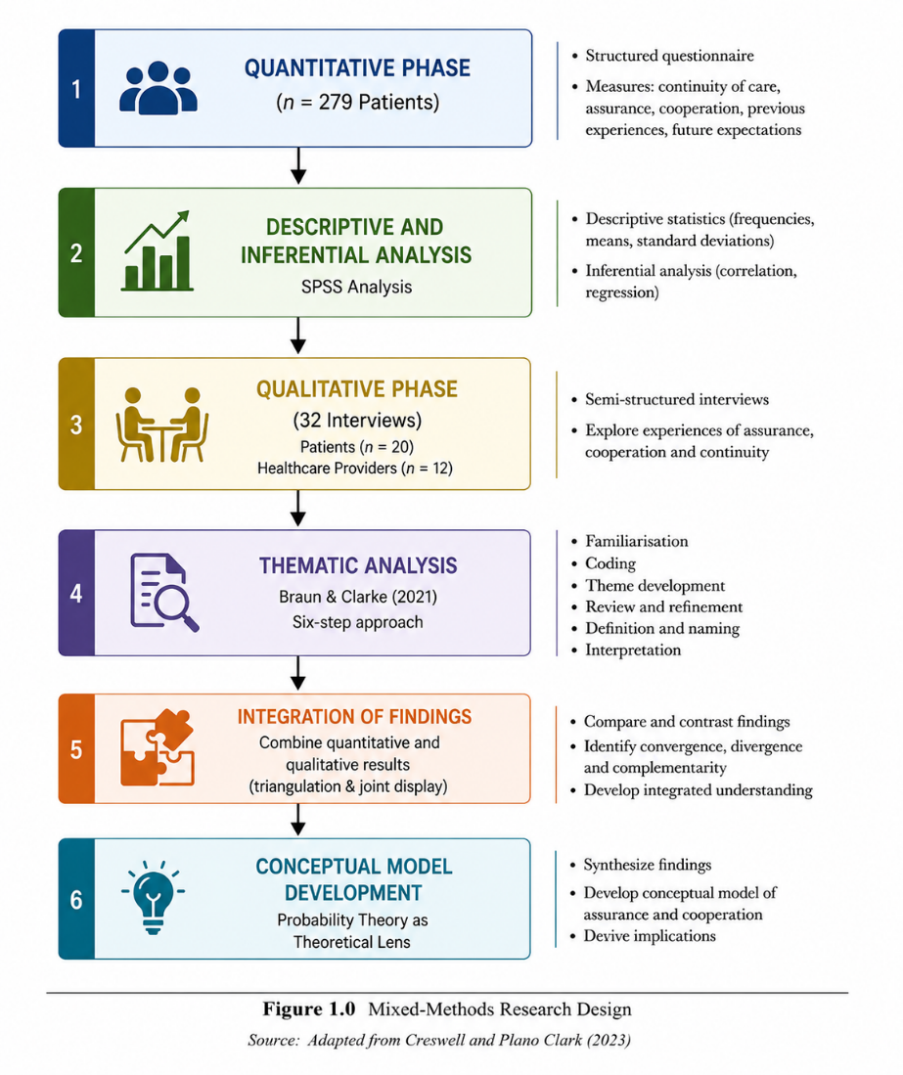

Participants and Data Collection

The quantitative phase involved a cross-sectional questionnaire survey administered to patients attending three primary care practices. A total of 279 completed questionnaires were included in the analysis. The questionnaire measured perceptions of continuity of care, assurance, cooperation, previous healthcare experiences, and expectations of future interactions with healthcare providers.

The qualitative phase consisted of a secondary analysis of interview data obtained from an earlier study on personal care in general practice. A purposive sample of 32 interview transcripts was selected, comprising 20 patient interviews and 12 healthcare provider interviews. The transcripts reflected diverse patient and provider experiences, allowing the study to explore assurance and cooperation from multiple perspectives within primary care settings.

Research Instrument

The quantitative instrument consisted of a structured questionnaire designed to measure perceptions of continuity of care, assurance, cooperation, previous healthcare experiences, and expectations of future interactions. All items were measured using a five-point Likert scale ranging from 1 (Strongly Disagree) to 5 (Strongly Agree). The questionnaire was developed based on constructs identified in previous studies on continuity of care and provider–patient relationships.

Research Instrument Constructs and Sources
Construct | Number of Items | Source
Continuity of Care | 8 | Adapted from Haggerty et al. (2023)
Assurance | 7 | Adapted from Gambetta (2021)
Cooperation | 6 | Adapted from Axelrod (1984)
Future Expectations | 5 | Researcher Adapted
Previous Experiences | 4 | Researcher Adapted
Total | 30 | -

Reliability and Validity

The reliability of the questionnaire was assessed using Cronbach's Alpha coefficient. According to Hair et al. (2022), values above .70 indicate acceptable internal consistency. Content validity was established through expert review involving specialists in healthcare communication and social science research. Construct validity was ensured through alignment between questionnaire items and established theoretical constructs identified in the literature.

Data Analysis

Quantitative data were analysed using descriptive and inferential statistics to explore relationships between continuity of care, assurance, and cooperation. Both univariate and multivariate analyses were conducted to identify factors associated with patients’ levels of assurance and cooperative behaviour.

Qualitative data were analysed using Braun and Clarke’s (2021) six-step thematic analysis framework. The process involved familiarisation with the interview transcripts, initial coding, theme generation, theme review, theme definition, and final interpretation. A deductive approach was employed, guided by concepts derived from probability theory, continuity of care, assurance, and cooperation. This analytical framework enabled the identification of recurring patterns regarding how repeated interactions influence assurance and cooperative behaviour within healthcare relationships.

Ethical Considerations

All interview transcripts used in the secondary analysis were anonymised before analysis. Ethical approval had been obtained for the original study, and the secondary analysis was undertaken in accordance with the relevant ethical requirements.

RESULTS AND DISCUSSIONS

Quantitative Findings

Survey findings identified several factors linked to patient assurance and cooperation in primary care. Results indicated that assurance was positively related to continuity of care and interpersonal aspects of healthcare interactions. Patients who reported positive previous experiences with their healthcare providers demonstrated higher levels of assurance than those with less favourable experiences. Expectations of future interactions with the same healthcare provider were also linked to greater assurance. Together, these results indicate that confidence in healthcare providers is shaped by both previous experiences and expectations of future contact.

Multiple regression analysis identified interpersonal care as the strongest predictor of assurance. Patients who perceived their healthcare providers as concerned, understanding, and responsive during consultations reported higher levels of assurance. Greater assurance was also reported by patients who believed that their healthcare provider was aware of whether treatment recommendations had been followed. Belief that the provider had consistently acted in the patient’s best interests emerged as another significant predictor. Collectively, these variables accounted for 72% of the variance in assurance (Adjusted R² = 0.72).

These findings suggest that assurance is influenced not only by clinical competence but also by the quality of interpersonal interactions. From a probability theory perspective, repeated positive interactions provide information that reduces uncertainty about future encounters, which may strengthen confidence and promote cooperative behaviour. The findings further suggest that continuity of care contributes to assurance through both relational and experiential processes.

Table 1
Predictor of Assurance | Significance
Interpersonal care | Significant (p < .001)
Healthcare provider knows whether advice is followed | Significant (p < .001)
Healthcare provider acted in patient's best interests previously | Significant (p < .05)

Qualitative Findings
The qualitative analysis revealed that assurance and cooperation within healthcare provider–patient relationships developed progressively through sustained and repeated interactions. Four major themes emerged from the interview data: (1) Development of Assurance, (2) Reduced Uncertainty Through Familiarity, (3) Cooperation and Active Participation, and (4) Provider Perspectives on Relationship Continuity.

Theme 1: Development of Assurance
Patient interviews indicated that assurance developed gradually through repeated encounters with the same healthcare provider. Although many participants initially expressed a general willingness to trust healthcare professionals, ongoing interactions enabled this confidence to be reinforced through direct experience. Participants reported that repeated consultations allowed them to evaluate the competence, reliability, and consistency of their healthcare providers, thereby strengthening their confidence in the relationship over time.

One participant explained:
“I felt more comfortable discussing my health concerns after seeing the same doctor several times.”
(Patient 6)

This finding suggests that assurance is not established instantaneously but evolves through repeated positive experiences that reinforce confidence and strengthen provider–patient relationships.

Theme 2: Reduced Uncertainty Through Familiarity
A second theme concerned the reduction of uncertainty through familiarity. Participants frequently reported that repeated interactions enabled them to become more familiar with their healthcare providers’ communication styles, decision-making approaches, and consultation practices. As familiarity increased, patients experienced greater comfort during consultations and felt more confident about healthcare decisions.

As one participant stated:
“The doctor already knew my medical history, so I didn’t have to explain everything again.”
(Patient 11)

The findings suggest that familiarity enhances predictability within healthcare interactions, reducing uncertainty and allowing patients to approach consultations with greater confidence and ease.

Theme 3: Cooperation and Active Participation
Interview data also highlighted a strong relationship between assurance and cooperative behaviour. Participants who expressed higher levels of assurance were generally more willing to engage actively in healthcare consultations, share personal information, and follow professional advice. Cooperation was not viewed merely as compliance with treatment recommendations but as a collaborative process involving communication, shared understanding, and mutual commitment to achieving positive health outcomes.

One participant remarked:
“I followed the treatment because I trusted the doctor’s advice.”
(Patient 14)

These findings indicate that assurance may serve as an important foundation for patient cooperation, encouraging greater participation in treatment planning and healthcare decision-making.

Theme 4: Provider Perspectives on Relationship Continuity

Healthcare providers similarly emphasised the value of sustained provider–patient relationships in supporting effective care delivery. Participants noted that repeated interactions enabled them to develop a deeper understanding of patients’ health histories, personal circumstances, and treatment challenges. This knowledge facilitated more personalised care and assisted healthcare providers in identifying barriers to treatment adherence.

Healthcare providers further observed that patients who maintained ongoing relationships with the same practitioner were often more engaged during consultations and demonstrated greater willingness to cooperate with treatment plans. Relationship continuity was therefore perceived as an important contributor to patient engagement, communication, and overall quality of care.

Overall, the qualitative findings suggest that repeated interactions foster assurance by increasing familiarity and reducing uncertainty. As assurance strengthens, patients become more willing to cooperate and participate actively in healthcare processes, thereby contributing to more effective provider–patient relationships and improved healthcare outcomes.

Table 2
Theme | Description
Development of Assurance | Confidence strengthened through repeated interactions
Reduced Uncertainty | Familiarity increased predictability and comfort
Cooperation and Participation | Patients became more willing to engage in care
Provider Perspectives | Ongoing relationships improved understanding and quality of care

Integration of Quantitative and Quantitative Findings

Taken together, the quantitative and qualitative findings highlight the role of continuity of care in shaping assurance and cooperation. Survey findings showed that positive past experiences and expectations of future interactions were linked to higher levels of assurance, while interview data illustrated how these experiences influenced everyday healthcare interactions. Patients described assurance as developing through repeated encounters that reduced uncertainty and reinforced positive expectations regarding future care. Healthcare providers also highlighted the value of ongoing relationships in supporting communication, cooperation, and quality of care.

The findings are consistent with probability theory, which proposes that cooperation becomes more likely when individuals have a history of positive interactions and expect future encounters. Repeated interactions create opportunities for patients and healthcare providers to develop confidence in one another, strengthening assurance over time. Collectively, the findings suggest that continuity of care contributes to stronger provider–patient relationships by encouraging assurance, cooperation, and sustained engagement over time.

Proposed Conceptual Model

Drawing on both the quantitative and qualitative findings, a conceptual model was developed to explain the relationship between assurance and cooperation in primary care. The model proposes that continuity of care creates opportunities for repeated interactions between patients and healthcare providers. Through these encounters, uncertainty is gradually reduced and positive expectations are reinforced, allowing assurance to develop over time. As assurance strengthens, patients become more willing to cooperate through greater information disclosure, active participation in consultations, and adherence to treatment recommendations. Together, these processes support more positive healthcare experiences and may enhance the overall quality of care.
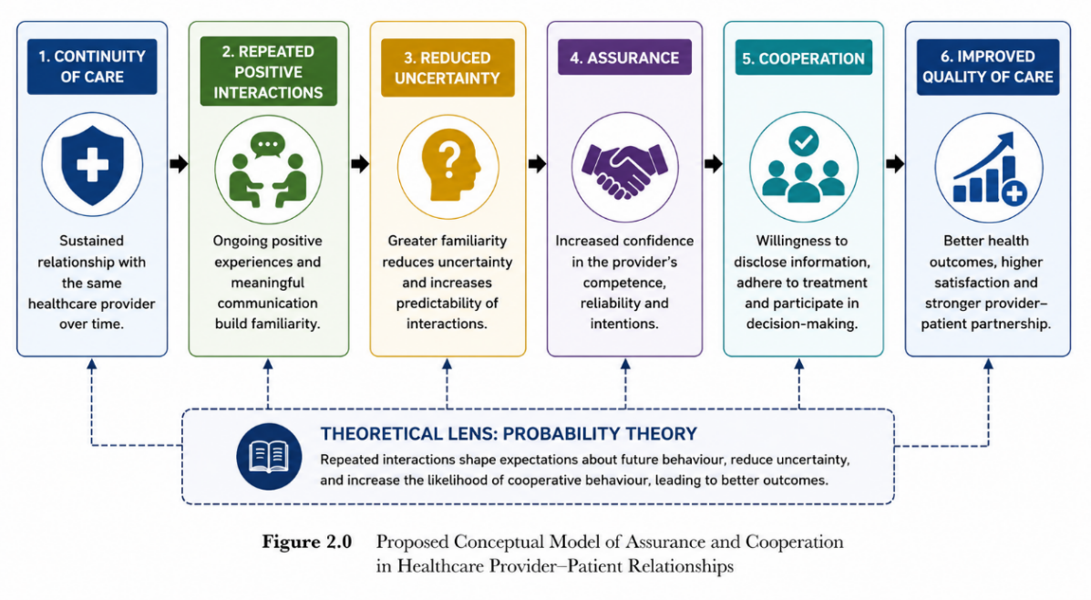

Discussion
Continuity of care emerged as an important factor influencing assurance and cooperation within primary healthcare relationships. The quantitative and qualitative findings indicate that repeated interactions between patients and healthcare providers help reduce uncertainty and reinforce positive expectations regarding future encounters. Patients who experienced continuity in their healthcare relationships were generally more confident in their healthcare providers and demonstrated a greater willingness to participate in healthcare decisions and treatment processes.

The results align with earlier studies linking continuity of care to improved communication, patient satisfaction, and treatment adherence. They also extend existing knowledge by showing how assurance develops through repeated interactions and how this process influences cooperative behaviour. While continuity of care, assurance, and cooperation have often been examined as separate concepts, the present findings suggest that they are closely interconnected within provider–patient relationships.

The findings can also be interpreted through the lens of probability theory. The theory proposes that cooperation becomes more likely when individuals expect future interactions and have opportunities to learn from previous experiences. In this study, repeated encounters allowed patients and healthcare providers to develop familiarity, establish positive expectations, and reduce uncertainty regarding future behaviour. These conditions supported the development of assurance and encouraged cooperative engagement in healthcare consultations and treatment decisions.

The conceptual model developed from the findings helps explain how continuity of care influences assurance and cooperation through repeated interactions and reduce uncertainty. The model illustrates a process in which ongoing encounters strengthen confidence, encourage cooperation, and support more positive healthcare experiences. By combining quantitative and qualitative evidence, the study provides a clearer understanding of the mechanisms that underpin effective provider–patient relationships in primary healthcare settings.

The practical implications of these findings are particularly relevant for primary healthcare services. Supporting long-term provider–patient relationships may strengthen communication, encourage patient participation, and contribute to higher quality care. Continuity of care should therefore be viewed not only as an organisational feature of healthcare delivery but also as an important mechanism for promoting assurance and cooperation within healthcare relationships.

The findings extend previous research by demonstrating that continuity of care influences healthcare outcomes not only through improved communication and care coordination but also through the gradual development of assurance. While earlier studies have emphasised the importance of relational continuity (Pereira Gray et al., 2023; Saultz, 2023), the present study highlights the mechanisms through which repeated interactions reduce uncertainty and strengthen cooperative behaviour. This contributes to the growing body of literature that views healthcare relationships as dynamic social processes shaped by expectations, reciprocity, and repeated encounters.

The study also contributes theoretically by applying principles of probability theory to provider–patient relationships. Previous healthcare studies have largely discussed assurance and cooperation independently. By integrating these concepts within a probability framework, the study demonstrates how expectations regarding future interactions influence patients’ willingness to cooperate and participate actively in healthcare decisions. This perspective offers a more comprehensive understanding of the behavioural mechanisms underlying continuity of care.

Practical Implications

The findings have several practical implications for healthcare providers, healthcare organisations, and policy makers. Healthcare providers should prioritise relationship-centred approaches that encourage continuity and foster meaningful long-term interactions with patients. Healthcare organisations should consider systems that support relational continuity, particularly for patients with chronic conditions who benefit most from ongoing provider–patient relationships. Policy makers should recognise continuity of care as an important determinant of healthcare quality and develop strategies that facilitate sustained engagement between healthcare providers and patients.

Limitations of the Study

Several limitations should be considered when interpreting the findings of this study. First, the quantitative component relied on self-reported questionnaire responses, which may be influenced by response bias and participants’ subjective perceptions of their healthcare experiences. Second, the cross-sectional design of the survey limits the ability to establish causal relationships between continuity of care, assurance, and cooperation. While significant associations were identified, the direction of these relationships cannot be determined with certainty. Third, the qualitative findings were based on a secondary analysis of existing interview data. Although the interviews provided rich insights into provider–patient relationships, they were not originally conducted to examine assurance and cooperation from a probability theory perspective. Finally, the study was conducted within primary healthcare settings, which may limit the transferability of the findings to specialist or hospital-based contexts. Despite these limitations, the combination of quantitative and qualitative evidence provides valuable insight into the role of continuity of care in shaping assurance and cooperation within provider–patient relationships.
CONCLUSION
Continuity of care emerged as an important factor in the development of assurance and cooperation within primary healthcare relationships. The findings showed that positive healthcare experiences, expectations of future encounters, and interpersonal aspects of care were associated with higher levels of assurance among patients.

The qualitative findings further indicated that assurance develops gradually through repeated interactions between patients and healthcare providers. As familiarity increased and uncertainty decreased, patients became more willing to participate in healthcare discussions, disclose information, and follow treatment recommendations. Healthcare providers also recognised the value of ongoing relationships in supporting communication and quality of care.

Overall, continuity of care appears to strengthen provider–patient relationships by fostering assurance and encouraging cooperative behaviour. Sustained interactions may therefore contribute to more positive healthcare experiences and improved quality of care within primary healthcare settings.

Recommendations and Future Research
The findings suggest that healthcare organisations should support greater continuity of care within primary healthcare settings. Providing opportunities for patients to consult the same healthcare provider over time may strengthen assurance, encourage cooperation, and contribute to improved healthcare experiences. Particular attention should be given to patients managing chronic or complex health conditions, as ongoing relationships may facilitate more effective communication and long-term care management.

The study also highlights the importance of interpersonal aspects of care in shaping patient assurance. Healthcare providers may benefit from professional development initiatives that emphasise communication skills, patient engagement, and relationship-centred care. Future research could employ longitudinal designs to examine how assurance and cooperation develop over time and explore whether similar patterns are evident in other healthcare settings.

REFERENCES

- Fan, V. S., Burman, M. B., McDonell, M. B., & Fihn, S. D. (2005). Continuity of care and other determinants of patient satisfaction with primary care. Journal of General Internal Medicine, 20(3), 226–233. https://doi.org/10.1111/j.1525-1497.2005.40135.x

- Ng, J. H. Y., & Luk, B. H. K. (2019). Patient satisfaction: Concept analysis in the healthcare context. Patient Education and Counseling, 102(4), 790–796. https://doi.org/10.1016/j.pec.2018.11.013

- Batbaatar, E., Dorjdagva, J., Luvsannyam, A., Savino, M. M., & Amenta, P. (2017). Determinants of patient satisfaction: A systematic review. Perspectives in Public Health, 137(2), 89–101. https://doi.org/10.1177/1757913916634136

- Pansari, A., & Kumar, V. (2017). Customer engagement: The construct, antecedents, and consequences. Journal of the Academy of Marketing Science, 45(3), 294–311. https://doi.org/10.1007/s11747-016-0485-6

- Ayanian, J. Z., & Markel, H. (2016). Donabedian's lasting framework for health care quality. New England Journal of Medicine, 375(3), 205–207. https://doi.org/10.1056/NEJMp1605101

- Sofaer, S., & Firminger, K. (2005). Patient perceptions of the quality of health services. Annual Review of Public Health, 26, 513–559. https://doi.org/10.1146/annurev.publhealth.25.050503.153958

- Andaleeb, S. S. (2001). Service quality perceptions and patient satisfaction: A study of hospitals in a developing country. Social Science & Medicine, 52(9), 1359–1370. https://doi.org/10.1016/S0277-9536(00)00235-5

- Shilling, V., Jenkins, V., & Fallowfield, L. (2003). Factors affecting patient and clinician satisfaction with the clinical consultation: Can communication skills training for clinicians improve satisfaction? Psycho-Oncology, 12(6), 599–611. https://doi.org/10.1002/pon.731

- Cheng, S. H., Yang, M. C., & Chiang, T. L. (2003). Patient satisfaction with and recommendation of a hospital: Effects of interpersonal and technical aspects of hospital care. International Journal for Quality in Health Care, 15(4), 345–355. https://doi.org/10.1093/intqhc/mzg045

- Westaway, M. S., Rheeder, P., Van Zyl, D. G., & Seager, J. R. (2003). Interpersonal and organizational dimensions of patient satisfaction: The moderating effects of health status. International Journal for Quality in Health Care, 15(4), 337–344. https://doi.org/10.1093/intqhc/mzg038

- Pansari, A., & Kumar, V. (2017). Customer engagement: The construct, antecedents, and consequences. Journal of the Academy of Marketing Science, 45(3), 294–311. https://doi.org/10.1007/s11747-016-0485-6

