A Review On Ferroptosis An Emerging Form Of Regulated Cell Death And Its Pharmacological Relevance

INTRODUCTION:
Role of iron: Iron is an essential trace metal that is necessary for many biological processes, including oxygen transport, mitochondrial respiration, DNA synthesis, and enzymatic activities. Iron is necessary to maintain cellular balance, but it may also be a double-edged sword. Excess intracellular free iron, particularly in its ferrous (Fe2⁺) state, can promote the generation of highly reactive oxygen species (ROS) through Fenton and Haber-Weiss processes. The tendency of these ROS to oxidatively damage lipids, proteins, and nucleic acids may ultimately endanger cell life. Iron metabolism needs to be strictly controlled for cells to live and function.[1] The increased attention in recent years to iron-dependent processes of cell death has led to the identification of ferroptosis, a unique type of regulated cell death.[2] Unlike other well-known Ferroptosis is characterized by the accumulation of iron-dependent lipid peroxides to lethal levels, in contrast to other forms of cell death such apoptosis, necrosis, and autophagy. The normal apoptotic features of apoptosis, including as caspase activation and DNA breakage, are absent in ferroptosis. Instead, it is brought on by oxidative stress and lipid peroxidation, which causes catastrophic membrane damage.

History: Ferroptosis was first described in 2012. The term "ferroptosis" was first used by Brent R. Stockwell, after research revealed that certain tiny chemicals, like elastin and RSL3, have the ability to trigger a non-apoptotic, iron-dependent mode of cellular death. Through mechanisms including the disruption of cellular redox balance and the weakening of antioxidant defences, these compounds were found to be catalysts for cell death. Since then, ferroptosis has gained recognition as an essential biological process with significant implications in both healthy and pathological settings.[3]

Key mechanism: The disruption of lipid metabolism, particularly the peroxidation of polyunsaturated fatty acids (PUFAs), which are essential parts of cellular membranes, is a feature of ferroptosis. These PUFAs are highly susceptible to oxidative stress, which leads to the production of lipid hydroperoxides. Cells have extensive antioxidant systems in place during physiological conditions to prevent the buildup of these harmful lipid compounds. Glutathione (GSH) and glutathione peroxidase 4 (GPX4) play crucial roles in these processes. GPX4 is an essential enzyme that protects cells from oxidative damage by converting lipid hydroperoxides into harmless lipid alcohols. Nevertheless, uncontrolled lipid peroxidation results from GSH depletion or GPX4 activity suppression, which finally triggers ferroptotic cell death. Another key regulator of ferroptosis is the cystine/glutamate antiporter system Xc⁻, which imports cystine into the cell in exchange for glutamate. Cysteine, which is required for the synthesis of GSH, is then produced from cystine. Reduced intracellular cysteine levels, GSH depletion, and increased susceptibility to oxidative stress are the outcomes of system Xc⁻ inhibition. Thus, it is believed that a major mechanism in the induction of ferroptosis is the disruption of the Xc⁻–GSH–GPX4 axis.

How it differs from other cell deaths: Ferroptosis is not like other forms of cell death in terms of morphology.[4] Its distinguishing features include rupture of the outer mitochondrial membrane, fewer or non-existent mitochondrial cristae, and smaller mitochondria with increased membrane density. In contrast to apoptosis, ferroptosis lacks chromatin condensation and leaves the nucleus mostly intact. Iron accumulation, the generation of lipid ROS, and the depletion of antioxidant defence are the biochemical characteristics of ferroptosis. There is mounting evidence that cellular metabolism, particularly redox biology, lipid metabolism, and iron metabolism, is intimately linked to ferroptosis. Iron homeostasis is carefully regulated by proteins such as ferritin, ferroprotein, and transferrin. Iron overload brought on by deregulation of these proteins may promote ferroptosis. Similarly, ferroptosis signalling pathways and lipid peroxidation depend on lipoxygenases and other lipid metabolism-related enzymes.

Applications in several diseases: Ferroptosis has been connected to a number of disease conditions. Ferroptosis has attracted a lot of interest as a potential cancer treatment target. Because of their altered iron metabolism and increased oxidative stress, many cancer cells are more vulnerable to ferroptosis. A unique strategy for eliminating cancer cells, especially those that are resistant to conventional therapies like chemotherapy and radiation, has been proposed: ferroptosis induction. However, disorders including organ damage, ischemia-reperfusion injury, and neurodegenerative diseases like Parkinson's and Alzheimer's that result in excessive cell death may benefit from ferroptosis inhibition. In addition to its role in disease, ferroptosis is an intriguing target for pharmacological intervention. Numerous small substances have the ability to either promote or prevent ferroptosis. Ferroptosis inducers like erastin and RSL3 function by interfering with antioxidant defences or directly disrupting GPX4, whereas ferroptosis inhibitors like iron chelators and lipid antioxidants work by preventing lipid peroxidation and maintaining redox equilibrium. These findings show that ferroptosis regulation has therapeutic promise in a variety of clinical contexts.

Future and Scope: Because of its unique characteristics and role in numerous biological processes, ferroptosis has become a rapidly expanding area of study in pharmacology and biomedical science. It is necessary to comprehend the molecular processes and regulatory pathways of ferroptosis in order to develop novel treatment approaches that target this kind of cell death. This review's objective is to provide a comprehensive overview of ferroptosis, highlighting its molecular mechanisms, significant regulatory pathways, and growing significance in the aetiology and treatment of many diseases.

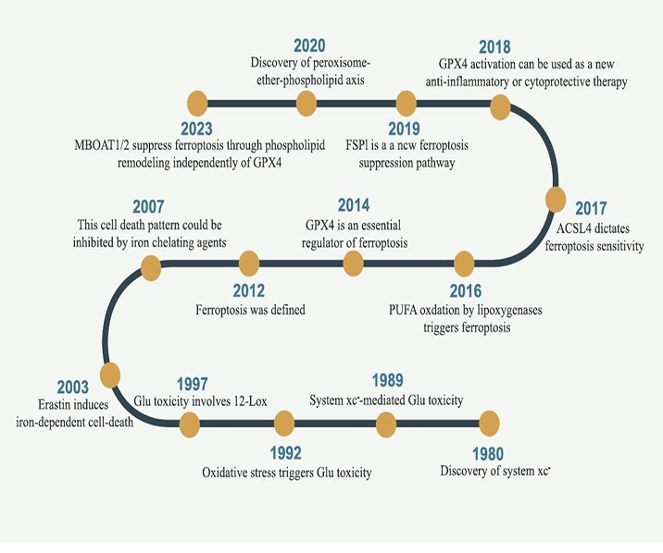
Figure No.1 Timeline diagram illustrating pivotal breakthroughs within the domain of ferroptosis investigation. The inquiry into ferroptosis commenced with the discovery of system xc-, which was first documented in 1980. However, the precise nomenclature "ferroptosis" was formally established and presented to the scientific community in 2012.

Some key features of Ferroptosis and other cell deaths:
Table No. 1[5], [6], [7]

Feature | Ferroptosis | Apoptosis | Autophagy | Necroptosis
Morphological features | Small mitochondria with increased member density: reduced or vanished cristea; outer memberane rupture | Cell shrinkage,  chromatin  Condensation ,membrane  ,blebbing, apoptotic bodies | Formation of double membrane  autophagosomes;  fusion with  lysosome | Cell swelling,  Plasma  Membrane  Rupture,  Organelle  swelling
Biochemical  features | Iron-dependent lipid peroxidation;  Accumulation of ROS; GSH depletion; GPX4 inactivation | Caspase activation ; DNA fragmentation; asymmetry (phosphatidylserine-exposure) | Increased Lysosomal activity; degradation of cytoplasmic contents | Loss of membrane integrity; release of intracellular-r contents; ATP depletion
Regulatory pathways | Xc system (SLC7A11), GPX4, iron metabolism , lipid peroxidation pathways | Death receptor pathway, mitochondrial pathway (Bcl-2 family), caspase cascade | mTOR pathway, Beclin-1, ATG proteins lysosomal signaling | TNF-alpha ,RIPK1, RIPK3,  MLKL  signaling pathway
Key genes/protein | GPX4, SLC7A11,  ACSL4, FSP1, NCOA4, p53 | Caspases (3,8,9), Bcl-2, Bax, p53 | ATG5, ATG7, LC3, Beclin-1 | RIP1, RIPK3, MLKL

AIM AND OBJECTIVES OF FERROPTOSIS STUDY:
The main goal of studying ferroptosis is to clarify its basic molecular mechanisms, especially those related to iron homeostasis, lipid peroxidation, and the antioxidant defence system (GSH/GPX4), in order to identify and validate it as a potential therapeutic target for a variety of illnesses, such as cancer, neurological disorders, and ischemia-reperfusion injuries
Key Objectives:
Disease Therapy (Induction): The goal is to identify ferroptosis inducers (such as erastin and RSL3) that can trigger this specific mode of cell death in resistant cancerous cells (such as hepatocellular carcinoma, triple-negative breast cancer, and ovarian carcinoma).

Cytoprotection (Inhibition): To develop ferroptosis inhibitors, such as ferrostatin-1 and deferoxamine, to prevent excessive cell death in conditions including acute kidney injury, strokes, and neurological illnesses like Parkinson's and Alzheimer's.

Modulating Iron/Redox Balance: to prevent excessive lipid peroxides from being produced by the iron-driven Fenton reaction by controlling the labile iron pool (LIP) and limiting lipid peroxidation in cells.

Defining Signalling Pathways: To identify the regulatory networks that control ferroptosis sensitivity, including both GPX4-dependent and independent pathways (such FSP1/CoQ10).

Developing Biomarkers: To develop distinct and trustworthy markers (such oxidized phospholipids or particular protein changes) to detect ferroptosis in vivo for clinical assessment.
Ferroptosis participates in immune surveillance and cell death during development and acts as a natural defence mechanism to suppress tumours (via p53).[17]

HISTORY AND OVERVIEW: In 2003, Dolma et al. discovered a new material known as Erastin. It killed cancer cells that expressed RAS in a way that was different from what had been seen before. There was no caspase activation, nuclear morphological changes, or DNA fragmentation, and caspase inhibitors could not halt this process.[8] Later, Yang and Yagoda found that RSL3 may cause this pattern of cell death and that iron chelating chemicals might prevent it. In 2012, Dixon et al. formally named this cell death ferroptosis based on its characteristics.[2] Erastin's ability to eradicate cancer cells with RAS mutations [9] Ferroptosis is a new type of death. Reduced mitochondrial volume and increased bilayer membrane density are the main morphological signs of ferroptosis in cells. and mitochondrial cristae reduction or disappearance, but the cell membrane remains intact, the nucleus is normal in size, and there is no chromatin concentration; biochemically, intracellular glutathione (GSH) depletion and decreased activity of glutathione peroxidase 4 (GPX4); lipid peroxides cannot be metabolized by the reduction reaction catalysed by GPX4; and Fe2+ oxidizes lipids in a Fenton-like fashion, which encourages ferroptosis. Genetic changes in iron homeostasis and lipid peroxidation metabolism are the main causes of ferroptosis; however, more research is needed to determine the exact regulatory mechanisms. Ferroptosis-inducing chemicals can be divided into four classes. One category includes erastin, which is known as the archetypal ferroptosis inducer and reduces GSH levels by directly inhibiting system Xc-. However, erastin also targets voltage-dependent anion channels (VDACs), It causes malfunction in the mitochondria. According to recent studies, erastin-induced ferroptosis raises lysosomal-associated membrane protein 2a levels, which in turn promotes chaperone-mediated autophagy, which in turn increases GPX4 degradation. RSL3 and DPI7, which both directly obstruct GPX4 action and cause ferroptosis, are included in the second category. FIN56, which induces ferroptosis through two pathways, is included in the third categorization. First, FIN56 makes GPX4 easier to degrade. The natural antioxidant coenzyme Q10 (COQ10) is then reduced as a result of FIN56's interaction with the enzyme squalene synthase. This process increases the vulnerability of cells to ferroptosis caused by FIN56. FINO2, an organic peroxide that shares several traits with artemisinin and causes ferroptosis through a synergistic effect, is included in the final categorization. involves GPX4 inactivation and direct oxidation of labile iron.[10]
Along with iron chelators, a number of particular inhibitors of ferroptosis, such as ferrostatin-1 (Fer-1), liproxstatin-1, and vitamin E, have been discovered as research into the mechanisms underlying this type of cell death progresses. By preventing the production of lipid peroxides, these substances inhibit ferroptosis. In 2014, Skouta et al. showed that Fer-1 successfully reduced cell mortality in three different in vitro models related to renal insufficiency, periventricular leukomalacia (PVL), and Huntington's disease (HD). This discovery represents a major breakthrough in understanding the consequences of ferroptosis outside of cellular culture settings and sets a fundamental precedent for the use of ferrostatin in a variety of disease models. To sum up, ferroptosis has been identified as a novel mechanism of cellular death offers fresh perspectives for comprehending and treating a variety of illnesses.

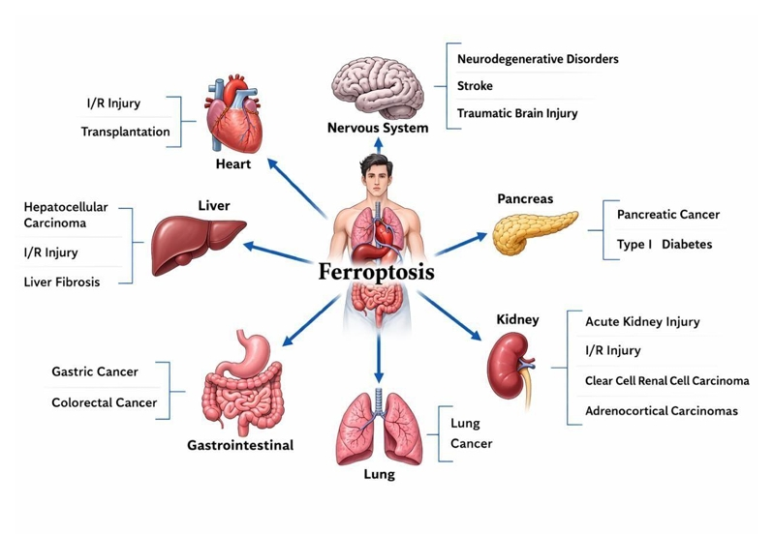
Figure No.2 Ferroptosis has played important roles in multiple system diseases, such as nervous system diseases, heart diseases, liver diseases, gastrointestinal diseases, lung diseases, kidney diseases, pancreatic diseases, and so on.

MECHANISM AND REGULATION OF FERROPTOSIS:
Promoting ferroptosis through the inhibition of system Xc-
System Xc is a widely distributed amino acid antiporter found in phospholipid bilayers. It is a heterodimer made up of two subunits, SLC7A11 and SLC3A2, and is an essential part of an intracellular antioxidant system. System Xc- transports glutamate and cystine across the cellular membrane in a 1:1 stoichiometric ratio. Internalized cysteine is then reduced to cysteine in cellular settings, where it is essential for the production of glutathione (GSH). Through the catalytic action of glutathione peroxidases (GPXs), GSH helps to reduce reactive oxygen species (ROS) and reactive nitrogen species. By preventing cystine uptake, system Xc-functional inhibition negatively affects GSH production, leading to decreased GPX activity, decreased cellular antioxidant capacity, buildup of ROS, which in turn causes ferroptosis and oxidative damage. Additionally, by downregulating the expression of SLC7A11, the tumor suppressor protein P53 can hinder the uptake of cystine via system Xc-. This affects GPX4 activity, which results in a reduction in cellular antioxidant capability, lipid ROS buildup, and the triggering of ferroptosis.[11] [12]

Induction of ferroptosis through the inhibition of GPX4:
GPX4, one of the many members of the GPX family, is the main regulator of ferroptosis and is essential to its occurrence, mostly through inhibiting the generation of lipid peroxides. GPX4 converts GSH into oxidized glutathione and reduces toxic lipid peroxides (L-OOH) to the equivalent alcohols (L-OH). When GPX4 activity is suppressed, lipid peroxides, an indication of ferroptosis, may accumulate. According to Yang et al., cells with increased GPX4 expression suppress ferroptosis, while cells with downregulated GPX4 expression are more vulnerable to it. RSL3, a ferroptosis inducer, directly acts on GPX4 and inhibits its function, reducing cells' antioxidant capacity and resulting in the accumulation of ROS. Additionally, DPI7 and DPI10 directly impact GPX4 and induce ferroptosis. Selenium is one of the amino acids required for the GPX4 active group. Selenocysteine tRNA is necessary to add selenocysteine to GPX4.[14] The mevalonate (MVA) pathway can affect the synthesis of GPX4 by regulating the maturation of selenocysteine tRNA and hence regulating the occurrence of ferroptosis. Two important byproducts of the MVA process are IPP and COQ10. Therefore, inhibiting the MVA pathway can reduce the generation of selenocysteine tRNA, which will affect GPX4 activity and result in ferroptosis.[13][15]

Ferroptosis that is influenced by mitochondrial VDACs:
Voltage-dependent anion channels (VDACs) are essential membrane proteins that play a critical regulatory role in ferroptosis by facilitating the movement of ions and metabolites. According to Yagoda et al. [9], erastin interacts with VDACs to cause mitochondrial malfunction. This leads to a significant production of reactive oxygen species, which in turn causes iron-mediated cellular death.[16]

P53-Mediated ferroptosis:
One important tumor suppressor is the p53 gene. Its control over cell cycle arrest, aging, and apoptosis is essential for the development and spread of tumor. Its role in ferroptosis is yet unclear, though. According to recent research, ferroptosis may be enhanced by p53 mutants that lack acetylation. Reactive oxygen species therapy has little effect on cell activity in H1299 cells with silenced p53, according to Jiang [11] et al. However, almost 90% of the cells died when exposed to ROS after p53 was activated, suggesting that p53 activation impairs the cells' antioxidant defences. Ferrostatin-1 treatment dramatically decreased cell death, indicating that p53 may encourage ferroptosis. Additional studies have demonstrated that p53 inhibits cystine absorption through system Xc⁻ by downregulating the expression of SLC7A11. This then affects GPX4 activity, which results in reduced antioxidant capacity, ROS buildup, and ferroptosis induction. Ferroptosis control is also aided by the p53–SAT1–ALOX15 pathway. One important rate-limiting enzyme in polyamine catabolism is SAT1, a transcriptional target of p53.[18] ALOX-15 expression is intimately linked to ROS-induced lipid peroxidation and ferroptosis, which are facilitated by SAT1 activation. Other research, however, indicates that p53 may also inhibit ferroptosis in specific cell types. For example, persistent wild-type p53 diminishes system Xc⁻ activity while also reducing some cells' sensitivity to ferroptosis, according to Tarangelo A and colleagues.[19] Treatment with the p53 activator Nutlin-3 rendered the wild-type p53-expressing HT-1080 cells resistant to ferroptosis caused by Erastin-2. Other cell lines, such as U-2OS cells, ACHN cells, Caki-1 cells, and A549 cells, showed similar resistance, with Nutlin-3 raising p53 levels and decreasing ferroptosis susceptibility. CDKN1A (p21), a transcriptional target of p53 that controls intracellular GSH levels and glutathione metabolism, is necessary for this protective action. These results suggest that ferroptosis in cancer cells can be adversely regulated by the p53–p21 axis. Furthermore, Xie et al. [20] showed that ferroptosis in colorectal cancer cells is inhibited by p53 expression. Overall, it seems that p53 controls ferroptosis by both promoting and suppressing it, albeit the exact processes are yet unclear.

Role of ferroptosis suppressor protein 1 (FSP1) {previously known as apoptosis- inducing factor mitochondrial 2 (AIF-M2)}:
The relevance of FSP1/AIFM2 in ferroptosis has been highlighted in two recent investigations, revealing a novel mechanism for its regulation and rekindling interest in apoptosis-inducing factor (AIF). Interestingly, AIF has long been investigated for its function in apoptosis and was identified prior to the notion of ferroptosis.[21, 22] When studying non-caspase-dependent apoptosis, Susin et al. [23] discovered that AIF is a mitochondrial flavoprotein that acts as an effector of apoptotic cell death. It has been demonstrated that recombinant AIF causes significant DNA fragmentation and chromatin condensation in isolated nuclei. Additionally, it encourages the mitochondria to release apoptogenic proteins such cytochrome c and caspase-9. Because it resembles another pro-apoptotic protein, AIF-M2, a flavoprotein, is thought to be a p53-responsive gene that can cause apoptosis. AIFM-1 (apoptosis-inducing factor mitochondria-associated 1). Recently, Bersuker et al. [21] confirmed that FSP1, formerly known as AIFM2, functions as a strong factor providing resistance to ferroptosis using a synthetic fatal CRISPR-Cas9 screening method. In a similar vein, Doll et al. [22] used expression cloning to find genes in human cancer cells that make up for the loss of GPX4. According to their research, the flavoprotein AIFM2, which is now known as FSP1, is a hitherto unknown anti-ferroptotic gene that shields cells against ferroptosis brought on by GPX4 loss. Furthermore, cells that lacked FSP1 were more susceptible to ferroptosis inducers; this effect was reversed when FSP1 expression was restored. Furthermore, activation of p53 does not increase the production of FSP1, nor does overexpression of FSP1 cause apoptosis. Myristoylation aids in localizing FSP1 to the plasma, according to another study. membrane, where it reduces coenzyme Q10 (CoQ10) by acting as an oxidoreductase. By doing this, it stops lipid peroxidation from spreading by acting as a lipophilic antioxidant. According to Doll et al. [22], FSP1 forms the FSP1–CoQ10–NAD(P)H pathway by using NAD(P)H to replenish CoQ10. This route inhibits ferroptosis and phospholipid peroxidation both independently and in conjunction with the GPX4-glutathione system. By connecting ubiquinone metabolism to FSP1, this method also explains how NAD(P)H works inside the mevalonate pathway, affecting cellular vulnerability to ferroptosis. Furthermore, increasing resistance to ferroptosis is linked to higher FSP1 expression in a variety of tumor cell lines, including lung cancer models in vitro and in mouse xenografts. All things considered, these results imply that FSP1 is an essential part of the ferroptosis regulation network. Targeting FSP1 may be a viable method to overcome ferroptosis resistance in cancer treatment, and its expression may assist predict the efficacy of ferroptosis-inducing medicines.

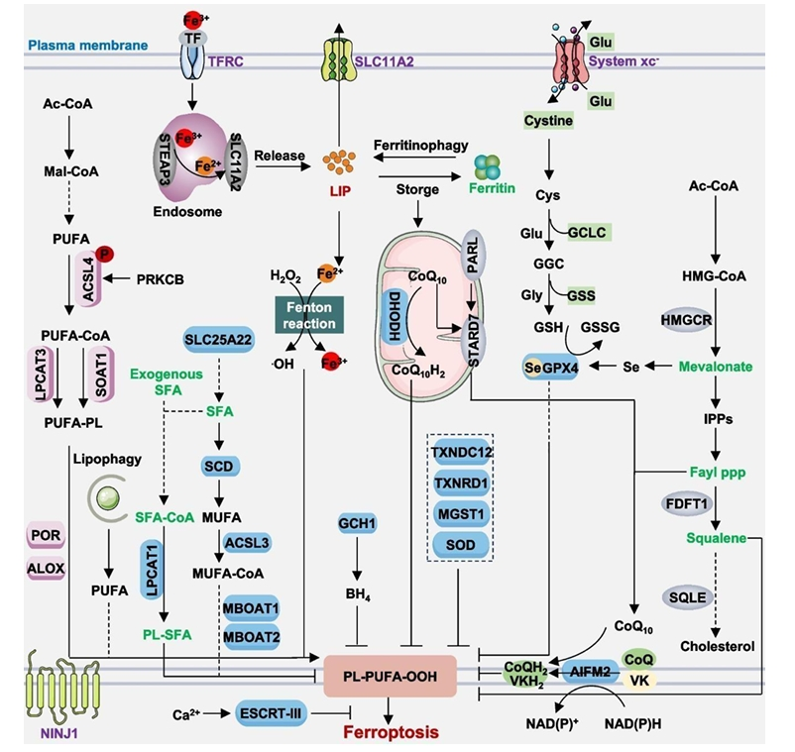

Figure No.3 showing Ferroptosis is a type of regulated cell death driven by iron-dependent lipid peroxidation, ultimately leading to rupture of the plasma membrane. It can occur through two main routes: an extrinsic pathway involving membrane transporters—such as activation of TFRC or inhibition of system xc⁻—and an intrinsic pathway controlled by enzymes, for example through inhibition of GPX4 or AIFM2.

This process is brought on by aberrant activity of redox-related enzymes that either produce or neutralize free radicals and lipid peroxides, upsetting the equilibrium between oxidants and antioxidants. Protective mechanisms involving the NINJ1 protein or the ESCRT-III complex can partially repair damage to the plasma membrane during ferroptosis.[24]

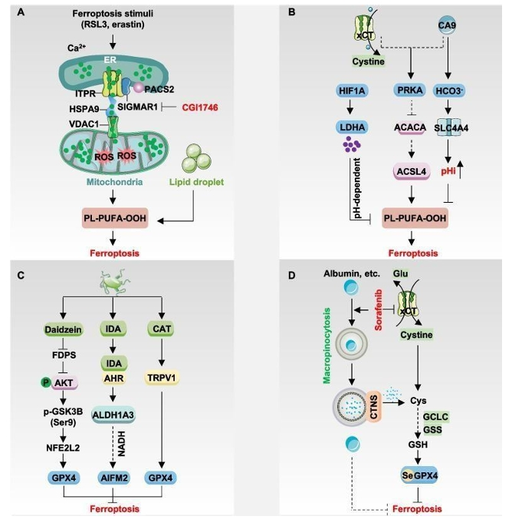
Figure No.4 showing ferroptosis is regulated through multiple cellular mechanisms. SIGMAR1 interacts with ITPR to promote calcium transfer between the endoplasmic reticulum and mitochondria, stimulate lipid droplet breakdown, and increase susceptibility to ferroptosis. In addition, the PACS2 and HSPA9/VDAC1 complex facilitates the transmission of ferroptotic signals from the ER to mitochondria. CA9 suppresses ferroptosis either by activating the AMPK pathway or by increasing intracellular pH. Similarly, accumulation of lactate driven by HIF1A can inhibit ferroptosis through pH-dependent effects. Metabolites produced by intestinal microbiota, such as IDA, CAT, and daidzein, can downregulate ferroptosis by modulating the expression of AIFM2 or GPX4. Furthermore, cancer cells can counteract ferroptosis under system xc⁻ inhibition by using macropinocytosis to take up extracellular proteins like albumin, which provides cysteine and may also directly reduce lipid peroxidation.[24]
Significance of iron metabolism:

Cellular Absorption, Transport, and Homeostasis
- The duodenum and proximal jejunum absorb dietary iron (Fe3+) through DMT1 [25], but it must first be reduced to Fe2+ or bind to cofactors such as heme. [26]
- Fe2+ enters the bloodstream through the exporter ferroportin (FPN) after binding to transferrin (Tf) inside cells. [27]
- TfR1 allows iron to enter endosomes, and DMT1 releases it into the cytosol to create the labile iron pool (LIP), which controls iron metabolism. [28]
- Endosomes (via DMT1-mitoferrin interaction) or the LIP (through DMT1, mitoferrin, and SFXN1) are the sources of mitochondrial iron.
- Ferritin stores excess LIP iron, which is returned to the LIP by ferritin's lysosomal breakdown. [29] [30]
- Hepatocytes and spleen macrophages serve as important storage sites for cell iron export, which is mediated by FPN. [31]
- By encouraging FPN internalization and breakdown, controlling diet absorption, and recycling red blood cells, the hepcidin–ferroportin axis regulates systemic iron.

Physiological Functions and ROS Generation
- The transportation of oxygen, energy production, immunological response, DNA replication, and the tricarboxylic acid (TCA) cycle all depend on iron.
- Endogenous reactive oxygen species (ROS) are produced via electron transport that is dependent on the mitochondrial iron-sulfur cluster (ISC). [32]
- Oxidative damage is caused by an excess of ROS. Through the Fenton reaction, iron increases ROS, necessitating strict level control. [33]
- Homeostasis is disrupted and ferroptosis susceptibility is increased when iron absorption, storage, or export are disrupted.
- Ferroptosis is triggered by elevated ROS due to increased iron intake, ferritin breakdown, and iron derivative buildup.

The Mechanism of Ferroptosis Induction
- A crucial step in ferroptosis is the production of ROS through the iron-driven Fenton reaction.
- Superoxide radicals O_2 are produced by cytochrome P450, NADPH oxidases (NOXs), and components of the mitochondrial electron transport chain [34].
- O_2 is changed into hydrogen peroxide (H_2O_2) by superoxide dismutase (SOD).
- Heme proteins are oxidized by O_2 and H_2O_2, which releases reactive Fe2+ and increases the LIP.
- Increased Fe2+ triggers the Fenton reaction, which results in hydroxyl radicals OH attacking polyunsaturated lipids to create lipid radicals L, which start ferroptosis and lipid peroxidation. [35]
- Lipid hydroperoxides (LOOH) are created when radical L combines with other lipids; Fe2+ and Fe3+ then transform them into lipid alkoxyl {LO} and peroxyl {LOO} radicals.
- Polyunsaturated lipids are oxidized into LOOH by iron-dependent enzymes such as arachidonate-15-lipoxygenase and other lipoxygenases.
- Iron-dependent lipoxygenase activity initiates ferroptosis, which is then amplified by the Fenton reaction. However, the precise iron threshold that triggers ferroptosis is still unknown.

Cross-Talk with Other Metabolic Pathways
- While excess iron promotes insulin resistance and diminishes insulin sensitivity in vitro, it may have the reverse impact in vivo. Iron deficiency inhibits glucose consumption but enhances uptake and transport through GLUT1. [36, 37]
- By lowering fatty acid oxidation/desaturation, increasing lipid synthesis, and decreasing CPT-1 activity in the fetal liver, iron shortage interferes with lipid metabolism.
- Iron overload inhibits PPAR $\alpha$ expression in the liver [38], whilst polyunsaturated fatty acids (PUFAs) are oxidized by Fenton reaction hydroxyl radicals and nitrate species.
- Prolyl-4-hydroxylase, which converts proline into 4-hydroxyproline, and cysteine dioxygenase, which breaks down cysteine, are iron-dependent for amino acid metabolism [39], although specific regulation mechanisms are still unclear.

Pathways Promoting or Suppressing Ferroptosis
- STEAP3 increases intracellular Fe2+ to power the Fenton process and lipid peroxidation by decreasing absorption iron (Fe3+ to Fe2+).
- Ferritin breakdown, or ferritinophagy, causes ferroptosis by releasing free Fe2+. [40]
- Increased expression of mitochondrial membrane SFXN1, which carries Fe2+ into mitochondria and enhances ROS and ferroptosis, as a result of elevated cytoplasmic Fe2+ from ferritinophagy.
- By increasing ferritinophagy and mitochondrial iron transport and upregulating SFXN1 and NCOA4, apelin-13 facilitates ferroptosis. [41]

Clinical Context and Research Challenges
- The exact functions of iron-dependent enzymes, iron-driven ROS, and iron-regulating proteins following lipid peroxidation are still unknown.
- Ferroptosis is associated with ischemia-reperfusion injury, cancer, and neurological diseases.
- For iron overload circumstances, targeting routes can be beneficial; iron chelators are being investigated, but further in vivo study is required.
- Developing safe and effective iron-chelating drugs and determining whether iron overload is sufficient to cause ferroptosis in various tissues are future challenges.

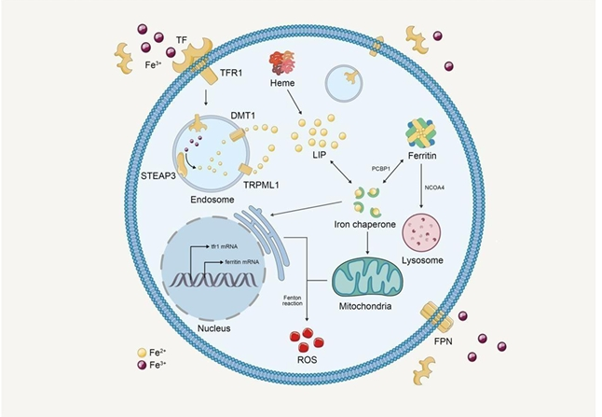
Figure No.5 Iron metabolism in ferroptosis

Lipid peroxidation:
A crucial step in ferroptosis is lipid peroxidation, in which oxidizing agents, notably free radicals, target lipids with carbon–carbon double bonds, especially polyunsaturated fatty acids (PUFAs).[42] The three primary phases of this process are start, propagation, and termination.[43] Reactive chemicals such as hydroxyl radicals take an electron out of lipids during the initiation stage, creating a lipid radical (L•). This unstable lipid radical rapidly combines with oxygen during the propagation phase to create a lipid peroxyl radical (LOO•). The chain reaction is then continued when this new radical takes a hydrogen atom from another lipid molecule, producing a new lipid radical and lipid hydroperoxide (LOOH).[44] Antioxidants like vitamin E finally neutralize these radicals by giving them a hydrogen atom during the termination phase, creating more stable, non-radical products. Until sufficient antioxidants are present to halt the process, these reactions proceed in a chain-like fashion. The accumulation of lipid peroxides to hazardous amounts during the ferroptotic process is the link between lipid peroxidation and ferroptosis. Specifically, ferroptosis requires the oxidation of polyunsaturated fatty acids (PUFAs), which is facilitated by iron and lipoxygenases. Protective systems like the glutathione/GPX4 pathway and the FSP1/CoQ10 system, which function to neutralize lipid peroxides and stop cell death, strictly regulate lipid peroxidation. Understanding lipid peroxidation is essential for managing and regulating ferroptosis since this type of cell death can be directly caused by a disruption in lipid balance [45]. Lipid peroxidation and ferroptosis are closely related but distinct processes. Iron-dependent lipid peroxide accumulation causes ferroptosis, a particular kind of controlled cell death that eventually destroys the cell membrane and results in cell death. Lipid peroxidation, on the other hand, is a more comprehensive biochemical process that involves the oxidative degradation of membrane lipids. It does not always lead to cell death and can be brought on by a variety of stimuli, including chemicals and UV radiation. To put it simply, lipid peroxidation can happen in a variety of circumstances, but ferroptosis only occurs when this process gets out of control and becomes excessive. As a result, ferroptosis can be viewed as a specific result with unique mechanisms and effects within the broader range of lipid peroxidation.

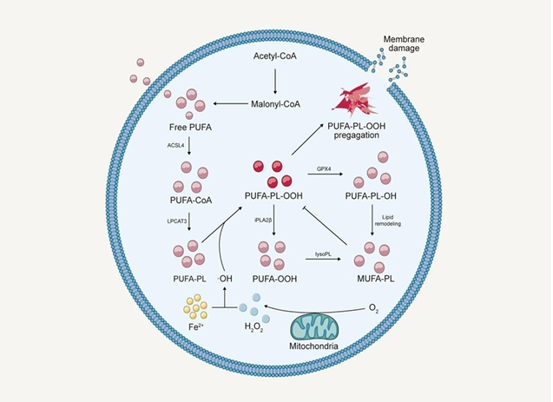
Figure No.6 Lipid peroxidation in ferroptosis involves several key enzymes that regulate the formation and remodeling of membrane lipids:

• Polyunsaturated fatty acids (PUFAs) are activated by ACSL4 (Acyl-CoA synthetase long-chain family member 4), which transforms them into acyl-CoA forms and increases their susceptibility to peroxidation.
•These activated acids are incorporated by LPCAT3 (lysophosphatidylcholine acyltransferase 3). phosphatidylethanolamines.
• By degrading lysophospholipids, LysoPL (lysophospholipase) takes part in lipid remodeling.
These elements work together to increase the amount of oxidizable lipids in membranes, which facilitates lipid peroxidation and aids in ferroptosis.

Some other pathways: Sulfur transport and other metabolic processes can also influence ferroptosis. The sulfur transfer process transforms methionine into cystine under oxidative stress, which is then utilized to create GSH, strengthening antioxidant defenses. Ferroptosis is also influenced by the p62-Keap1-NRF2, ATG5-ATG7-NCOA4, and glutamine metabolism pathways, which control intracellular iron levels and ROS generation.[46, 47]

PHARMACOLOGICAL MANIPULATION OF FERROPTOSIS:
For a variety of diseases associated with abnormal ferroptosis, pharmacologically modifying ferroptosis has significant therapeutic potential. Numerous current medications and bioactive substances have been identified as having the ability to either stimulate or inhibit ferroptosis.

Inducers:

Mechanism / Target | Compounds Involved | Key Scientific Data &  Observations
System x_c- Inhibition | • Erastin and its derivatives (IKE, piperazine erastin)  •FDA-approved medications (Sorafenib, Sulfasalazine, Metformin, Acetaminophen)  • BSO | •Targets human foreskin fibroblasts (BJeLR) that have a KRAS mutation.  •Erastin inhibits VDAC2/VDAC3 to raise ROS and lowers GSH levels to prevent GPX4 production.  •Certain lines (HT-1080, A375, A549, HT29, MDA-MB-436, Hep G2) may not be adequately inhibited by sorafenib.  • BSO increases ferroptosis susceptibility by inhibiting GCLC.  •Because of off-target effects or a wider function in amino acid uptake, blocking SLC7A11 can result in ferrostatin-1-resistant cell death.  • Cell density affects erastin's effectiveness.  [48]
Inhibition of GPX4 | • Covalent (RSL3, ML162)  • Intracellular (BCP-T.A., ML210, and diacylfuroxans)  • PROTACs (dGPX4, DC2, 8e)  • Cell-specific (N6F11) | • Covalent: binds irreversibly to selenocysteine Sec46 (and close to Cys66) in GPX4; selectivity issues arise due to the absence of a drug-like pocket. ML162 is more effective than RSL3.  •Intracellular: Hetero-aromatic (BCP-T.A.) and nitrile oxide (ML210, diacylfuroxans) electrophiles avoid direct acellular GPX4 contact.  •PROTACs: Exploitez le système UPS à travers un agent de liaison E3 ligase et un linker. dGPX4, DC2, et 8e utilisent respectivement ML162, ML210 et RSL3 comme têtes explosives.  Vous avez été formé sur des données jusqu'à octobre 2023.  • N6F11: Cible de manière sélective la dégradation du GPX4 au sein des cellules cancéreuses pour préserver les cellules saines.  Vous avez été formé sur des données jusqu'en octobre 2023.
CoQ10 & Mevalonate Pathways | • CIL56, FIN56  • Statins  • FSEN1, icFSP1 | • CIL56 et FIN56 épuisent le CoQ10, probablement par l'activation du FDFT1, facilitant ainsi la dégradation du GPX4.  • Les statines freinent HMGCR (l'enzyme limitante de la voie du mévalonate), ce qui diminue les niveaux de CoQ10.  • La voie AIFM2-CoQ10 fonctionne comme un mécanisme essentiel en parallèle du GPX4. • FSEN1 inhibe de manière non compétitive AIFM2 pour sensibiliser les cellules cancéreuses ; nécessite une amélioration in vivo.  •icFSP1 déclenche la ferroptose grâce à la séparation de phases dans les cellules Pfa1 et HT-1080 avec une surexpression d'AIFM2 et une inhibition de GPX4.
Iron & Lipid Peroxidation | • Excess nonheme iron  • FINO2  • Artemisinin,  Dihydroartemisinin, Artesunate | • In mouse cardiomyocytes, hepatocytes, bone marrow macrophages, and hippocampus slices, excess nonheme iron induces ferroptosis.  • FINO2, an organic peroxide with a 1,2-dioxolane structure, either directly oxidizes iron or inhibits GPX4.  • Ferroptotic cell death in cancer cells is successfully induced by artemisinin and its derivatives (dihydroartemisinin, artesunate).  [51]

Inhibitors:

Category / Mechanism | Inhibitor Compounds | Key Scientific Observations & Properties
Iron Chelators | • Deferoxamine  • Deferiprone  • Ciclopirox | • Reduce the availability of iron ions for metabolic reactions by binding them in cells or tissues.  •Preclinical research indicates that it is effective in avoiding ferroptosis, but creating safe clinical treatments is difficult.  • Iron selectivity is crucial since it can bind other metals, resulting in off-target effects and possible toxicity.[52]
Radical-Trapping Antioxidants (RTAs) | Endogenous / Natural:  •alpha-tocopherol(vitaminE)  • Glutathione (GSH)  • Coenzyme Q10 (CoQ10)  •Carotenoids(e.g.,beta-carotene)  •Polyphenols(e.g.,resveratrol)  •Flavonoids  •7-dehydrocholesterol  •Tryptophan metabolites  (Serotonin,3-hydroxy-o  cyclohexanecarboxylic acid)  Synthetic & Other:  •Liproxstatin-1  •Ferrostatin-1  •N-acetylcysteine  •Mito-TEMPO | • Stop lipid peroxidation, stop oxidative chain reactions, and scavenge free radicals and stabilize them by electron donation or hydrogen atom transfer to prevent ferroptosis.  • Ferroptosis-relevant lipid peroxidation takes place at intracellular membranes because serotonin needs to be transported via the solute carrier SLC6A4.  •Liproxstatin-1:  Shows strong anti-ferroptotic effects in models of intestinal, cardiac, and renal ischemia-reperfusion injury at nanomolar concentrations.  •Ferrostatin-1:  Uses a reductive method to protect lipid membranes, although it is mostly utilized in vitro and is metabolically unstable.  •Mito-TEMPO & N-acetylcysteine: Can, in certain circumstances, prevent ferroptosis. • The necessity for thorough comparisons is highlighted by the fact that activity varies depending on the experimental situation; not all cell death prevented by these drugs necessarily corresponds to ferroptosis.
Enzyme-Mediated Lipid Metabolism | ACSL4 Inhibitors:  • Troglitazone  •Rosiglitazone  •Triacsin C  ALOX Inhibitors:  •Baicalein  •PD146176  •Zileuton  •AA-861  •ML351  SCD Pathway & Selenium:  •A939572 (SCD blocker)  •Selenium | •ACSL4: Initiates lipid peroxidation in membranes via LPCAT3, POR, and ALOXs by catalyzing the CoA conjugation of PUFAs (arachidonic, adrenic, and eicosapentaenoic acid).  • Ferroptosis is efficiently suppressed by ALOX and ACSL4 inhibitors.  • Although arachidonic acid is a substrate of ACSL4, it can encourage its ubiquitination and degradation, suggesting that other ACSL4-independent mechanisms might be involved.  • MUFAs: produced by SCD and prevent ferroptosis; ferroptotic sensitivity is increased by blocking SCD with A939572.  •Selenium: increases GPX4 levels and accelerates lipid peroxide detoxification to improve ferroptosis resistance.[53]

Table No.2 Examples of inducers and inhibitors
Ferroptosis Modulator | Example
Inducer | Erastin, Imidazole ketone erastin (IKE), RSL3, Artemisinin, Arachidonic acid, SCD inhibitor(A939572)
Inhibitor | Liproxstatin-1, Ferrostatine-1,Vitamine E (alpha-tocopherol),GSH,CoQ10, Flavonoids, Carotenoids(beta-carotene). Resveratrol, ACSL4 inhibitor (Troglitazone, Rosiglitazone, Triacsin C),  ALOX inhibitors (Baicalein,PD146176,Zileuton,AA-861,ML351), Selenium,NAC,Mito-TEMPO

SIGNIFICANCE OF FERROPTOSIS IN DISEASES:
Iron overload-related cell death, or ferroptosis, has a complicated role in illnesses like cancer (Chen et al., 2020a; Conrad et al., 2020; Tang et al., 2020). On the one hand, tumor development can be slowed by using specific tiny chemicals to induce ferroptosis. For example, when cyst(e)inase is administered to tumor in mice models of pancreatic cancer, the tumor exhibit typical ferroptotic symptoms such damaged mitochondria and an abundance of lipid droplets (Badgley et al., 2020). Polyunsaturated fatty acids (PUFAs) that promote lipid peroxidation may be supplied by these lipid droplets (Bai et al., 2019). Higher levels of lipid peroxidation in these tumor are supported by immunohistochemistry staining for 4-HNE (Badgley et al., 2020). Ferroptosis, however, may also have unexpected repercussions. DAMPs, which are molecules generated from dying cells, have the ability to depress the immune system, which in turn promotes the formation of tumor. For instance, lowering GPX4 in pancreatic cells or giving mice a diet high in iron can release nuclear DNA or mutant KRAS^G12D protein, which then stimulates macrophages in a way that promotes tumor growth (Dai et al., 2020a,b). Patients with pancreatic cancer who have higher KRAS^G12D levels in these macrophages have a lower chance of survival (Dai et al., 2020a). Together, these results demonstrate the dual nature of ferroptosis, which has the ability to both support and suppress tumor. This implies that the diagnosis and treatment of disorders involving ferroptosis damage may benefit from the monitoring of both intracellular and extracellular ferroptosis indicators.

Tumours and Ferroptosis:
Pancreatic cancer:
Eling and associates found that in pancreatic ductal adenocarcinoma cell lines, artesunate (ART) specifically raises ROS levels and causes ferroptosis. Similar to this, the combination of phenylethyl isothiocyanate (PEITC) and cotylenin A (CN-A) increases the production of ROS, which causes ferroptotic cell death and inhibits the growth of pancreatic cancer cells such MIAPaCa-2 and PANC-1. According to more recent research, a combination of piperlongumine (PL), CN-A, and sulfasalazine had an even more powerful effect, significantly increasing ferroptosis in these pancreatic cancer cell lines.[54]

Stomach/Gastric cancer:
According to Hao and associates, erastin causes ferroptosis in gastric cancer (GC) cells, and a crucial regulator is cysteine dioxygenase type 1 (CDO1). By competing for cysteine absorption, CDO1 inhibits the synthesis of glutathione (GSH) and increases ferroptosis. On the other hand, blocking CDO1 activity lowers the generation of reactive oxygen species (ROS) and lipid peroxidation, restores intracellular GSH levels, and eventually inhibits ferroptotic cell death.[55]
Lung cancer:
The iron-sulfur cluster biosynthesis enzyme NFS1 is abundantly expressed in highly differentiated lung adenocarcinomas, contributing to the maintenance of iron-sulfur cluster levels. NFS1 suppression causes iron depletion, which encourages ferroptotic cell death in situations of increased reactive oxygen species (ROS), even if NFS1 inhibition alone is insufficient to cause ferroptosis. Furthermore, research has demonstrated that the p53 tumor suppressor protein contributes to the induction of ferroptosis in lung cancer A549 cells. Erastin elevates and activates p53 in these cells, upregulating downstream target genes such bax and P21. Ferroptosis is the final outcome of this process, which also increases ROS buildup and reduces SLC7A11 activity.[56]

Breast cancer:
Triple-negative breast cancer (TNBC) accounts for 15–18% of cases, and breast cancer is still a leading cause of cancer-related death in women. Chemotherapy is the primary treatment for TNBC, which frequently has poor results due to the absence of effective targeted medicines. For TNBC cells to survive, cystine is essential. Ferroptosis results from reducing cystine uptake through inhibition of the system Xc⁻ transporter. However, substances like ferrostatin-1 (Fer-1) and deferoxamine (DFO) can stop this cell death. Furthermore, the transmembrane protein MUC1-C, which is abundantly expressed in TNBC, contributes to the preservation of glutathione (GSH) levels and redox equilibrium by acting similarly to the xCT subunit of system Xc⁻. MUC1-C interacts with xCT to regulate GSH levels by forming a complex with xCT and CD44 variations (CD44v). Ferroptosis in TNBC cells can be induced by blocking the MUC1-C/xCT signaling pathway, which increases tumor cell death and decreases the cells' ability to self-renew.[57]

Ferroptosis and neurological diseases:
Neurodegenerative disorders:
Numerous neurodegenerative illnesses are linked to aberrant iron accumulation in certain areas of the central or peripheral nervous system, according to a considerable body of research. This accumulation can encourage iron-driven Fenton reactions and is frequently caused by abnormal iron distribution inside cells. Reduced glutathione (GSH) and GPX4 levels are usually associated with elevated iron levels and lipid peroxidation, which are frequently connected to neurological diseases. The most common neurodegenerative illness, Alzheimer's disease, is characterized by cognitive deterioration. Iron levels in the hippocampus are markedly increased in AD patients, which leads to severe oxidative damage to neuronal structures and excessive formation of reactive oxygen species (ROS).According to experimental research, GPX4 deficiency causes age-related neurodegeneration and neuronal loss in mice, which is exacerbated by vitamin E insufficiency. Therefore, preventing ferroptosis in neurons may enhance the results of AD. Degeneration of dopaminergic neurons in the iron-rich substantia nigra is a major characteristic of Parkinson's disease. Deferoxamine (DFO) treatment improves motor symptoms, especially in the early stages, lowers oxidative stress, and increases dopamine activity.[58] Iron buildup, glutamate imbalance, and decreased GSH levels are the main pathogenic characteristics of Huntington's disease, which is typified by progressive neuronal degeneration. Patients frequently have decreased GPX activity and plasma GSH, both of which are strongly associated with ferroptosis. Neurons are protected by ferroptosis inhibitors like ferrostatin-1 (Fer-1) and iron chelators. Motor neurons in the brain and spinal cord degenerate in amyotrophic lateral sclerosis. Reduced GSH levels, elevated lipid peroxidation, and iron buildup in the spinal cord all play a part to the advancement of the illness, exacerbating the damage to neurons. GAA trinucleotide expansion causes mitochondrial iron overload in Friedreich's ataxia, a hereditary disorder. Reduced GSH and increased ROS and lipid peroxides make neurons more susceptible to oxidative stress, which suggests a close connection to ferroptosis. Oligodendrocyte destruction is linked to periventricular leukomalacia. According to studies, ferrostatin-1 can prevent ferroptosis by raising GSH levels in these cells, providing a possible treatment option. Overall, these results point to ferroptosis as a crucial mechanism in neurodegenerative illnesses and imply that focusing on it could lead to novel treatment strategies.

Traumatic brain injury:
Iron buildup, altered iron metabolism, increased expression of ferroptosis-related genes, decreased GPX activity, and higher reactive oxygen species (ROS) are among the pathogenic alterations linked to the course of traumatic brain injury.[59] Ferrostatin-1 (Fer-1), a ferroptosis inhibitor, has been proven in studies to dramatically reduce iron deposition, minimize neuronal injury and degeneration, and enhance overall results. These results imply that ferroptosis targeting may be a promising treatment strategy for traumatic brain injury.

Ferroptosis and other diseases:
Ferroptosis is linked to the emergence of a variety of diseases, according to growing research. For example, in mice models of liver fibrosis, where hepatocytes display morphological characteristics of ferroptosis, artesunate (ART) has been shown to drastically reduce liver damage and suppress fibrotic scar development. Ferroptosis has also been demonstrated to be extremely sensitive to pancreatic islet cells in vitro. Ferroptosis inhibitors can restore islet function when ferroptosis is induced, indicating potential uses in islet transplantation for the management of Type 1 diabetes. The development of a number of illnesses, such as acute myeloid leukemia, age-related macular degeneration, psoriasis, and different hemolytic disorders, is further linked to ferroptosis. Its connection to inflammation has also drawn a lot of study. Necrotic inflammation linked to ferroptosis has been seen in kidney damage models, including acute renal injury caused by crystal (oxalate) and folic acid, as well as in mice lacking GPX4. It has been demonstrated that GPX4 activation inhibits lipid peroxidation-driven inflammatory pathways, such as the NF-κB and arachidonic acid (AA) pathways. This suggests that GPX4 activation may be a promising anti-inflammatory and cytoprotective treatment approach since it decreases ROS generation and prevents ferroptosis.

CONCLUSION AND PERSPECTIVE:
Iron-dependent lipid hydroperoxide buildup characterizes ferroptosis, a controlled type of cell death. In contrast to other cell death mechanisms like apoptosis, necrosis, and autophagy, it is intimately linked to several metabolic pathways, such as those involving amino acids, iron, and polyunsaturated fatty acids, as well as the production of glutathione, phospholipids, NADPH, and CoQ10.[11] In a variety of circumstances, such as degenerative illnesses, cancer development, stroke, intracerebral hemorrhage, traumatic brain injury, ischemia–reperfusion injury, and renal diseases, its role in disease-related cell death is becoming more widely acknowledged. Notably, ferroptosis exhibits potential as a tumor-suppressive mechanism that could be used to treat cancer. Therapeutic strategies, however, vary greatly depending on the situation; for example, preventing ferroptosis is frequently preferred in organ damage, whilst promoting it may be advantageous in cancer. Therefore, designing precise therapy options requires a deeper understanding of iron-dependent cell death pathways at various disease stages. Furthermore, the necessity for more thorough research into the interactions between these processes in disease is highlighted by recently discovered types of controlled cell death, such as cuproptosis. Clarifying the molecular mechanisms of ferroptosis, in particular the functions of important regulators like GPX4, FSP1, NRF2, NADPH oxidase, and p53, should be the main goal of future research. Despite the fact that numerous substances have been found to either cause or prevent ferroptosis, their therapeutic use is still restricted. The creation of efficient treatments that alter ferroptosis may have significant effects on the management of illnesses such as acute renal injury, cancer, and neurological diseases. Finding trustworthy ferroptosis-specific biomarkers is another crucial area that would aid in drug development and assist differentiate it from other types of oxidative cell death. Ensuring safety, efficacy, targeted delivery, and reducing off-target effects are still major challenges. In general, improved preventative and treatment approaches will depend on expanding our knowledge of ferroptosis across many illnesses and stages.
.
REFERENCES:
[1] Hotchkiss, R. S., Strasser, A., McDunn, J. E., & Swanson, P. E. (2009). Cell death. The New England Journal of Medicine, 361(16), 1570–1583.
[2] Dixon, S. J., et al. (2012). Ferroptosis: An iron-dependent form of nonapoptotic cell death. Cell, 149(5), 1060–1072.
[3] Hallberg, L. (1982). Iron absorption and iron deficiency. Human Nutrition: Clinical Nutrition, 36, 259–278.
[4] Galluzzi, L., Vitale, I., Aaronson, S. A., Abrams, J. M., Adam, D., et al. (2018). Molecular mechanisms of cell death: Recommendations of the Nomenclature Committee on Cell Death 2018. Cell Death & Differentiation, 25(3), 486–541.
[5] Taylor, R. C., Cullen, S. P., & Martin, S. J. (2008). Apoptosis: Controlled demolition at the cellular level. Nature Reviews Molecular Cell Biology, 9(3), 231–241.
[6] Zong, W. X., & Thompson, C. B. (2006). Necrotic death as a cell fate. Genes & Development, 20(1), 1–15.
[7] Bertheloot, D., Latz, E., & Franklin, B. S. (2021). Necroptosis, pyroptosis and apoptosis: An intricate game of cell death. Cellular & Molecular Immunology, 18(5), 1106–1121.
[8] Yang, W. S., & Stockwell, B. R. (2008). Synthetic lethal screening identifies compounds activating iron-dependent, nonapoptotic cell death in oncogenic-RAS– harboring cancer cells. Chemistry & Biology, 15(3), 234–245.
[9] Yagoda, N., et al. (2007). RAS–RAF–MEK-dependent oxidative cell death involving voltage-dependent anion channels. Nature, 447, 864–868.
[10] Friedmann Angeli, J. P., et al. (2014). Inactivation of the ferroptosis regulator Gpx4 triggers acute renal failure in mice. Nature Cell Biology, 16, 1180–1191.
[11] Jiang, L., Hickman, J. H., Wang, S. J., & Gu, W. (2015). Dynamic roles of p53- mediated metabolic activities in ROS-induced stress responses. Cell Cycle, 14(18), 2881– 2885.
[12] Jiang, L., Kon, N., Li, T., Wang, S. J., Su, T., Hibshoosh, H., Baer, R., & Gu, W. (2015). Ferroptosis as a p53-mediated activity during tumour suppression. Nature, 520(7545), 57–62. [13] Yang, W. S., SriRamaratnam, R., Welsch, M. E., Shimada, K., Skouta, R., Viswanathan, V. S., Cheah, J. H., Clemons, P. A., Shamji, A. F., Clish, C. B., Brown, L. M., Girotti, A. W., Cornish, V. W., Schreiber, S. L., & Stockwell, B. R. (2014). Regulation of ferroptotic cancer cell death by GPX4. Cell, 156(1–2), 317–331.
[14] Kryukov, G. V., Castellano, S., Novoselov, S. V., Lobanov, A. V., Zehtab, O., Guigó, R., & Gladyshev, V. N. (2003). Characterization of mammalian selenoproteomes. Science, 300(5624), 1439–1443.
[15] Warner, G. J., Berry, M. J., Moustafa, M. E., Carlson, B. A., Hatfield, D. L., & Faust, J. R. (2000). Inhibition of selenoprotein synthesis by selenocysteine tRNA[Ser]Sec lacking isopentenyladenosine. Journal of Biological Chemistry, 275(36), 28110–28119.
[16] Skonieczna, M., et al. (2017). The impact of DIDS-induced inhibition of voltage- dependent anion channels (VDAC) on cellular response of lymphoblastoid cells to ionizing radiation. Med Chem, 13, 477–483.
[17] Raj, S., Jaiswal, S. K., & DePamphilis, M. L. (2022). Cell death and the p53 enigma during mammalian embryonic development. Stem Cells, 40(3), 227–238.
[18] Ou, Y., Wang, S. J., Li, D., Chu, B., & Gu, W. (2016). Activation of SAT1 engages polyamine metabolism with p53-mediated ferroptotic responses. Proceedings of the National Academy of Sciences of the United States of America, 113(44), E6806–E6812.
[19] Tarangelo, A., et al. (2018). p53 suppresses metabolic stress-induced ferroptosis in cancer cells. Cell Reports, 22(3), 569–575.
[20] Xie, Y., et al. (2017). The tumor suppressor p53 limits ferroptosis by blocking DPP4 activity. Cell Reports, 20(7), 1692–1704.
[21] Bersuker, K., et al. (2019). The CoQ oxidoreductase FSP1 acts parallel to GPX4 to inhibit ferroptosis. Nature, 575(7784), 688–692.
[22] Doll, S., et al. (2019). FSP1 is a glutathione-independent ferroptosis suppressor. Nature, 575(7784), 693–698.
[23] Susin, S. A., et al. (1999). Molecular characterization of mitochondrial apoptosis- inducing factor. Nature, 397(6718), 441–446.
[24] J Hematol Oncol. 2024 Jun 6;17:41. doi: 10.1186/s13045-024-01564-3
[25] Gunshin, H., Mackenzie, B., Berger, U. V., Gunshin, Y., Romero, M. F., Boron, W. F., et al. (1997). Cloning and characterization of a mammalian proton-coupled metal-ion transporter. Nature, 388(6641), 482–488.
[26] Wang, C.-Y., & Knutson, M. D. (2013). Hepatocyte divalent metal-ion transporter-1 is dispensable for hepatic iron accumulation and non-transferrin-bound iron uptake in mice. Hepatology, 58(2), 788–798.
[27] Ems, T., St. Lucia, K., & Huecker, M. R. (2023). Biochemistry, iron absorption. StatPearls Publishing.
[28] Fillebeen, C., Charlebois, E., Wagner, J., Katsarou, A., Mui, J., Vali, H., et al. (2019). Transferrin receptor 1 controls systemic iron homeostasis by fine-tuning hepcidin expression to hepatocellular iron load. Blood, 133(4), 344–355.
[29] Kakhlon, O., & Cabantchik, Z. I. (2002). The labile iron pool: Characterization, measurement, and participation in cellular processes. Free Radical Biology and Medicine, 33(8), 1037–1046.
[30] Acoba, M. G., Alpergin, E. S. S., Renuse, S., Fernández-Del-Río, L., Lu, Y. W., Khalimonchuk, O., et al. (2021). The mitochondrial carrier SFXN1 is critical for complex III integrity and cellular metabolism. Cell Reports, 34(11), 108869.
[31] Anderson, G. J., & Frazer, D. M. (2017). Current understanding of iron homeostasis. The American Journal of Clinical Nutrition, 106(Suppl 6), 1559S–1566S.
[32] Coffey, R., & Ganz, T. (2017). Iron homeostasis: An anthropocentric perspective. Journal of Biological Chemistry, 292(31), 12727–12734.
[33] Zhang, S., Xin, W., Anderson, G. J., Li, R., Gao, L., Chen, S., et al. (2022). Double- edged sword roles of iron in driving energy production versus instigating ferroptosis. Cell Death & Disease, 13(1), 40.
[34] Su, L.-J., Zhang, J.-H., Gomez, H., Murugan, R., Hong, X., Xu, D., et al. (2019). Reactive oxygen species-induced lipid peroxidation in apoptosis, autophagy, and ferroptosis. Oxidative Medicine and Cellular Longevity, 2019, 5080843.
[35] Stadtman, E. R., & Berlett, B. S. (1991). Fenton chemistry: Amino acid oxidation. Journal of Biological Chemistry, 266(26), 17201–17211.
[36] Huang, J., Simcox, J., Mitchell, T. C., Jones, D., Cox, J., Luo, B., et al. (2013). Iron regulates glucose homeostasis in liver and muscle via AMP-activated protein kinase in mice. FASEB Journal, 27(7), 2845–2854.
[37] Potashnik, R., Kozlovsky, N., Ben-Ezra, S., Rudich, A., & Bashan, N. (1995). Regulation of glucose transport and GLUT-1 expression by iron chelators in muscle cells in culture. American Journal of Physiology, 269(6), E1052–E1058.
[38] Radi, R. (2018). Oxygen radicals, nitric oxide, and peroxynitrite: Redox pathways in molecular medicine. Proceedings of the National Academy of Sciences of the United States of America, 115(23), 5839–5848.
[39] Myllyharju, J. (2003). Prolyl 4-hydroxylases, the key enzymes of collagen biosynthesis. Matrix Biology, 22(1), 15–24.
[40] Hou, W., Xie, Y., Song, X., Sun, X., Lotze, M. T., Zeh, H. J., et al. (2016). Autophagy promotes ferroptosis by degradation of ferritin. Autophagy, 12(8), 1425– 1428.
[41] Tang, M., Huang, Z., Luo, X., Liu, M., Wang, L., Qi, Z., et al. (2019). Ferritinophagy activation and sideroflexin 1-dependent mitochondrial iron overload is involved in apelin-13-induced cardiomyocyte hypertrophy. Free Radical Biology and Medicine, 134, 445–457.
[42] Nigam, S., & Schewe, T. (2000). Phospholipase A(2)s and lipid peroxidation. Biochimica et Biophysica Acta, 1488(1–2), 167–181.
[43] Negre-Salvayre, A., Auge, N., Ayala, V., Basaga, H., Boada, J., Brenke, R., et al. (2010). Pathological aspects of lipid peroxidation. Free Radical Research, 44(10), 1125– 1171.
[44] Kanner, J., German, J. B., & Kinsella, J. E. (1987). Initiation of lipid peroxidation in biological systems. Critical Reviews in Food Science and Nutrition, 25(4), 317–364.
[45] Bayir, H., Dixon, S. J., Tyurina, Y. Y., Kellum, J. A., & Kagan, V. E. (2023). Ferroptotic mechanisms and therapeutic targeting of iron metabolism and lipid peroxidation in the kidney. Nature Reviews Nephrology, 19(5), 315–336.
[46] McBean, G. J. (2012). The transsulfuration pathway: A source of cysteine for glutathione in astrocytes. Amino Acids, 42(1), 199–205. In
[47] Sun, X., et al. (2016). Activation of the p62-Keap1-NRF2 pathway protects against ferroptosis hepatocellular carcinoma cells. Hepatology, 63(1), 173–184. https://doi.org/10.1002/hep.28392
[48] Zhang, Y., Tan, H., Daniels, J. D., Zandkarimi, F., Liu, H., Brown, L. M., et al. (2019). Imidazole ketone erastin induces ferroptosis and slows tumor growth in a mouse lymphoma model. Cell Chemical Biology, 26(5), 623–633.
[49] Nguyen, K. A., Conilh, L., Falson, P., Dumontet, C., & Boumendjel, A. (2022). The first ADC bearing the ferroptosis inducer RSL3 as a payload with conservation of the fragile electrophilic warhead. European Journal of Medicinal Chemistry, 244, 114863
[50] Li, J., Liu, J., Zhou, Z., Wu, R., Chen, X., Yu, C., et al. (2023). Tumor-specific GPX4 degradation enhances ferroptosis-initiated antitumor immune response in mouse models of pancreatic cancer. Science Translational Medicine, 15(720), eadg3049.
[51] Chen, G. Q., Benthani, F. A., Wu, J., Liang, D., Bian, Z. X., & Jiang, X. (2020). Artemisinin compounds sensitize cancer cells to ferroptosis by regulating iron homeostasis. Cell Death & Differentiation, 27(1), 242–254.
[52] Masaldan, S., Clatworthy, S. A. S., Gamell, C., Meggyesy, P. M., Rigopoulos, A. T., Haupt, S., et al. (2018). Iron accumulation in senescent cells is coupled with impaired ferritinophagy and inhibition of ferroptosis. Redox Biology, 14, 100–115.
[53] Ingold, I., Berndt, C., Schmitt, S., Doll, S., Poschmann, G., Buday, K., et al. (2018). Selenium utilization by GPX4 is required to prevent hydroperoxide-induced ferroptosis. Cell, 172(3), 409–422.
[54] Eling, N., Reuter, L., Hazin, J., Hamacher-Brady, A., & Brady, N. R. (2015). Identification of artesunate as a specific activator of ferroptosis in pancreatic cancer cells. Oncoscience, 2(6), 517–532.
[55] Hao, S., et al. (2017). Cysteine dioxygenase 1 mediates erastin-induced ferroptosis in human gastric cancer cells. Neoplasia, 19(12), 1022–1032.
[56] Alvarez, S. W., et al. (2017). NFS1 undergoes positive selection in lung tumours and protects cells from ferroptosis. Nature, 551(7682), 639–643.
[57] Masanori, H., et al. (2016). Functional interactions of the cystine/glutamate antiporter, CD44v and MUC1-C oncoprotein in triple-negative breast cancer cells. Oncotarget, 7(11), 11756–11769. .
[58] Johnson, W. M., Wilson-Delfosse, A. L., & Mieyal, J. J. (2012). Dysregulation of glutathione homeostasis in neurodegenerative diseases. Nutrients, 4(10), 1399–1440.
[59] Codazzi, F., et al. (2016). Friedreich ataxia-induced pluripotent stem cell-derived neurons show a cellular phenotype that is corrected by a benzamide HDAC inhibitor. Human Molecular Genetics, 25(22), 4847–4855.

