DEEP LEARNING-BASED NETWORK TRAFFIC PREDICTION FOR IOT ROUTING OPTIMIZATION IN COMMUNICATION SYSTEMS
Solomon Nnaedozie Ogili
Department of Electrical and Electronics Engineering, Enugu State University of Science and Technology (ESUT), Agbani
solomon.ogili@esut.edu.ng

Abstract
The fast development of the Internet of Things (IoT) has resulted in more and more complex and dynamic network traffic, which poses a serious challenge to the effective routing of the network in a resource-limited environment. This paper suggests a Variational Autoencoder (VAE)-gated recurrent unit (GRU)-based network traffic forecasting and routing enhancement framework to the IoT communication systems. The framework uses VAE to learn latent representations of network traffic, which includes latent patterns and variability, and a GRU to learn time-based dependencies so as to make accurate multi-step predictions of traffic. Traffic information is also predicted and included in a traffic-aware routing engine whereby optimal routes are chosen dynamically in response to congestion, remaining node energy, and Quality-Of-Service (QoS) needs. The Python network simulator is used in the implementation and evaluation of the system and its performance is compared with the performance of the conventional routing protocols like RPL and AODV. The simulation findings prove that the proposed VAE-GRU framework can drastically enhance the performance of the network with a Mean Absolute Error (MAE) of 0.052 and Root Mean Square Error (RMSE) of 0.074 in traffic prediction. At the network level, the predictive routing mechanism reduces end-to-end delay (61-132ms), increases packet delivery ratio (91.8-99%), enhances throughput (346-468kbps), and lowers average energy consumption per node (1.41-2.54J) across varying traffic loads. These findings substantiate the fact that predictive intelligence in traffic and adaptive routing help to provide a scalable, energy-efficient, and resilient solution to IoT networks. This framework is especially efficient in the high-traffic and dense network environment, which outlines its usability in the next-generation IoT communication systems that demand a high-quality and reliable, proactive and resource-conscious routing.
Keywords: IoT Network; Traffic Prediction; Hybrid VAE-GRU; Routing Optimization; Deep Learning

1. INTRODUCTION
The IoT has become a game changer on the contemporary communication systems, facilitating the interconnection of billions of heterogeneous devices in sensing, processing and exchanging data (Gubbi et al., 2013). The devices have a wide range of applications, including smart cities, health monitoring, automation in the industrial area, and intelligent transportation systems (Ghazal et al., 2021). IoT networks are becoming progressively larger and more intricate, creating very dynamic and bursty traffic patterns (Xiong et al., 2023). Rapid data routing within these environments in particular is a critical problem since the traditional routing protocols can often hardly handle frequent topology changes, scarce resources of nodes, and dynamic QoS demands (Shah et al., 2021).
Conventional IoT routing systems are mostly reactive and depend on the immediate network-state information that renders them susceptible to network congestion, packet loss, extended latency, and high-energy usage (Senthilkumar and Subramani, 2021). RPL and AODV protocols normally react to the network performance once the network has been degraded, instead of being implemented to avoid performance bottlenecks (Priyeash and Thyagararajan, 2021). This is an especially bad limitation in dense IoT implementations where the load changes in traffic may quickly saturate the network connexions and nodes (Sobral et al., 2019). As a result, the necessity to develop intelligent routing methods based on the ability to predict the future state of the network and take informed routing decisions beforehand increases (Jeon and Jeong, 2024).
Predicting network traffic has become popular as an effective tool to optimise proactive routing in IoT communication systems (Liu and Yang, 2024). With proper prediction of the upcoming traffic loads, the routing algorithms can dynamically optimise the path choice, network load balancing, and reduce the congestion (Al-Fuqaha et al., 2015). Recent deep learning developments have contributed to a high precision level of traffic forecasting as they can approximate intricate nonlinear and time-based connexions in massive information (Singh et al., 2025). Recurrent Neural Networks (RNNs) and Convolutional Neural Networks (CNNs) are models that have demonstrated a high level of performance compared to the conventional statistical and machine learning methods in spatiotemporal characteristics of traffic (Sember et al., 2020).
Hybrid deep learning models like VAE-GRU and CNN-RNN have also shown a greater predictive power by uniting the ideas of spatial feature extraction in a network with the temporal sequence modelling (Chae et al., 2018). The models are especially useful in IoT settings where the traffic patterns have both spatial correlative behaviour and time-dependent behaviour (Kraemer et al., 2019). In addition, recent research has used attention-based algorithms and Transformer networks to make traffic predictions, which have a better level of interpretability and scalability (Vaswani et al., 2017). These advances emphasise the increased application of deep learning in solving the IoT routing problem (Jeon and Jeong, 2024).
In this regard, the present study suggests a deep learning-driven network traffic forecasting model that can be used to optimise the routing choices in IoT-based communication systems. The forecasted traffic data is incorporated in a traffic-definite routing engine to optimise the entire network in networks regarding delay, throughput, packet delivery ratio, and energy usage (Xiong et al., 2023). The paper proposes a combination of predictive intelligence and adaptive routing to counter the shortcomings of traditional routing protocols and create a scalable, efficient, and robust solution that can be relevant to next-generation IoT (Yeboah-Manu et al., 2018).
2. METHODOLOGY
The methodology adopted in this study involves the design and implementation of a deep learning-based network traffic prediction and routing optimization framework for IoT communication systems. Network traffic data are first collected from simulated or real IoT environments and pre-processed through cleaning, normalization, and time-window segmentation to extract relevant features such as packet rate, delay, bandwidth utilization, and node energy levels. A hybrid deep learning model comprising a Variational Autoencoder (VAE) and a Gated Recurrent Unit (GRU) is then employed, where the VAE learns compact latent representations of the traffic data and captures underlying data distributions, while the GRU models the temporal dependencies to predict future traffic loads. The predicted traffic values are incorporated into a traffic-aware routing decision engine, in which an adaptive cost function dynamically selects optimal routing paths based on congestion level, energy efficiency, and QoS constraints. The proposed approach is evaluated using network simulation tools, and its performance is assessed by comparing key metrics such as prediction accuracy, end-to-end delay, packet delivery ratio, throughput, and energy consumption against conventional IoT routing protocols.
2.1 Data Collection
In this study, the Kaggle dataset of IoT Network Traffic (https://www.kaggle.com/datasets/programmer3/iot-network-traffic-dataset) is used to offer realistic traffic information regarding the use of internet of things communication networks. The data set comprises a set of network traffic data collected by the different IoT devices in different simulated operating scenarios. The important characteristics are flow duration, number of packets, number of bytes, source, and destination identifiers, types of protocols as well as time-stamps and reflect both time-related and spatial properties of IoT traffic. This is a rich and structured data that can be used in deep learning functions as well as allow the system to simulate a variety of network behaviours, such as normal network operation, burst traffic, and congestion events.
The dataset obtained undergoes pre-processing to get ready to the hybrid VAE-GRU model. This includes cleaning unfinished or noisy records, standardising features that are numerical, the encoding of categorical variables, and splitting the traffic data into consistent time intervals in order to model sequential reliance. Statistical characteristics of traffic including the packet rates, delays, bandwidth utilisation are obtained and used as input to predictive model. This rich and processed data, which is used, also guarantees that the VAE-GRU model can discover both the latent traffic patterns and time dynamics required to provide the network traffic forecasting and efficient routing optimization of the heterogeneous IoT environment.
2.2 Data Preprocessing
The input data of the hybrid VAE-GRU model is first pre-processed to fit deep learning, meaning that it should be of good quality and consistent and suitable data, before the hybrid model is trained on the Kaggle IoT raw network traffic data. To eliminate bias or model learning errors, first, the missing, duplicate or inconsistent records are recognised and eliminated. Min-max scaling is used to normalize numerical features, including a count of packets, a count of bytes, duration of a flow, and bandwidth used, to transform the values to a common range, whereas the values and protocol type and device identifiers are encoded with one-hot or label encoding to match the inputs of neural networks. The sequences of the traffic flows are preserved in time in a manner that sustains the sequence of dependencies required by the GRU component.
The dataset is then divided into fixed time windows to form the sequence to represent the temporal dynamics of the IoT traffic. To act as representative features of each sequence, aggregate traffic metrics which include packet rates, average delay and byte transmission per window are calculated. Then the VAE is used to learn the latent representation of these features which are compact and represent underlying patterns and probabilistic distributions of the traffic data. These latent embeddings are then fed into the GRU network which learns the sequential behaviour of network traffic and reacts to predict the future load. Last but not the least, the data are divided into training, validation and testing samples, such that the model is trained on varied traffic patterns but still has enough data to test the accuracy of prediction and the performance of route optimization.
2.3 Model Design
The suggested network traffic prediction system involves a hybrid VAE and GRU to extract latent trends and time-related relationships in IoT traffic information. The design of the model is done in two phases. During the first step, the VAE learns the compact representations of the pre-processed traffic sequences into a lower dimensional latent space by learning the underlying distributions and variability of the network traffic. VAE is optimised by combining the reconstruction loss and Kullback Leibler (KL) divergence (Kingma and Welling, 2014). The VAE latent embeddings are inputted into the GRU network in the second stage and the temporal dynamics of network traffic is modelled. GRU gating mechanisms enable the GRU to efficiently characterise the long-term dependencies in sequence traffic traces, and therefore it is highly appropriate to future network load prediction over a sequence of time steps. GRU output is the predicted traffic characteristics, which include packet rate, byte flow, and congestion measures, and are inputted into the routing optimization module.
2.3.1 The VAE Architecture
The VAE of the proposed architecture is used to obtain insightful latent representations of high-dimensional IoT traffic data and send them to the GRU to model the time. The VAE consists of a latent space, decoder, and encoder which is a probabilistic generative model. It is mainly aimed at learning a low-dimensional, small-sized representation of the traffic characteristics, but it retains the underlying probability distributions and variability of the traffic features, which is essential to the modelling of bursty and uncertain IoT traffic patterns.
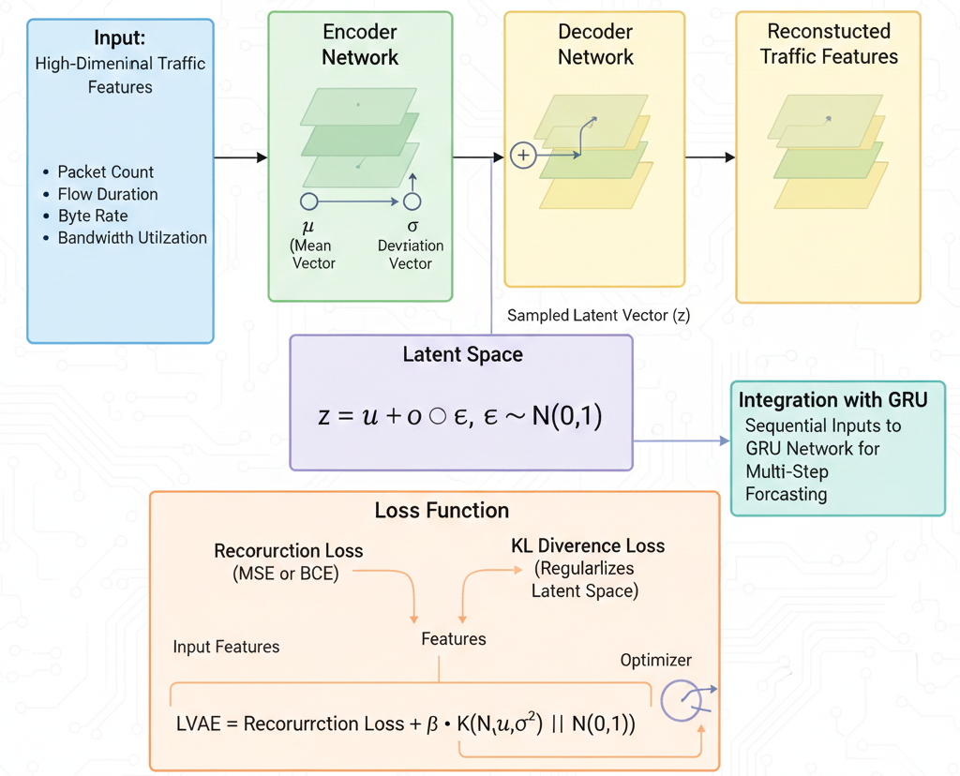
Figure 1: Architecture of the VAE Encoder-Decoder Network
The VAE model illustrated in Figure 1 integrates high-dimensional traffic features such as packet count, flow duration, byte rate, and bandwidth utilization into a deep learning framework for multi-step forecasting. It uses an encoder to generate mean and deviation vectors, samples from a latent space, and reconstructs traffic features through a decoder. The model incorporates a loss function combining reconstruction loss (MSE) and KL divergence to regularize the latent space. Additionally, it integrates a Gated Recurrent Unit (GRU) network to handle sequential inputs, enhancing its ability to predict future traffic patterns effectively.
2.3.2 The GRU Architecture
GRU is utilised in the presented model to represent the temporal nature of the IoT network traffic and forecast the future traffic loads. GRUs are a form of RNN that incorporate gating mechanisms to regulate the information flow to enable a network to learn long-term dependencies without the typical problems associated with RNNs including vanishing gradients. In this work, the GRU is fed with the latent embeddings produced by the VAE which shrinks the high dimensional traits of traffic to a lower dimensional latent space that represents important patterns and variability.
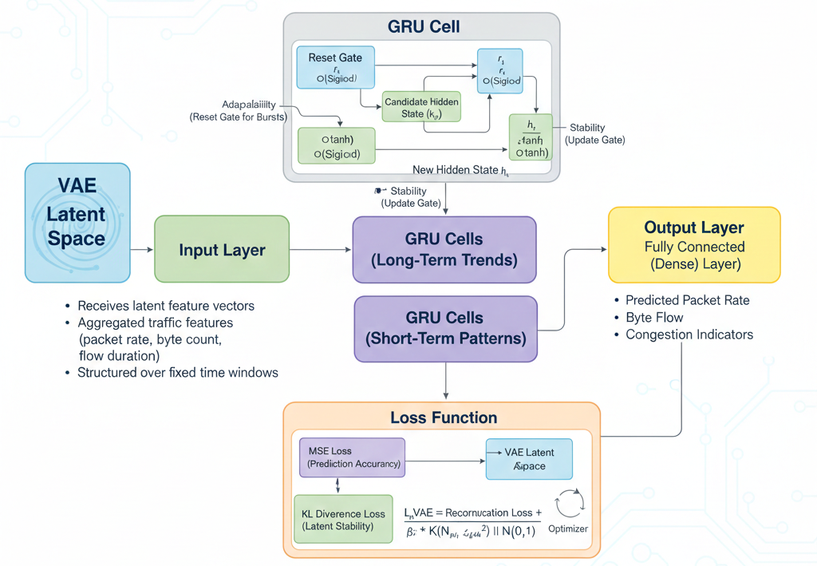
Figure 2: Architecture of the GRU Model
The GRU architecture illustrated in Figure 2 is made of an input layer, which is the latent feature vectors, one or multiple hidden GRU layers and an output layer, which generates the predicted traffic metrics at each of the following time steps. Every GRU cell has an update gate and a reset gate: the update gate is used to decide the amount of the previous hidden state to be remembered, whereas the reset gate is used to decide the amount of information in the past that should be forgotten when calculating the candidate hidden state. This architecture allows the GRU to acquire long sequence selective remembrance or forgetting of information and this is important to capture bursty and periodic traffic patterns common to IoT networks. The state outputs obtained are processed in a fully connected layer to obtain the ultimate predictions on the traffic, consisting of packet rate, byte flow and congestion indicators, forming the basis of traffic aware routing optimization within the IoT system.
2.3.3 Hybrid VAE-GRU Model Integration
The hybrid VAE-GRU combines the benefits of the two models to give precise and reliable network traffic prediction to IoT routing optimization. With this design, VAE is used as the feature extraction model, which reduces high-dimensional traffic data to a lower-dimensional latent space that simultaneously captures latent patterns as well as probabilistic variations in network traffic. Such latent vectors carry the crucial information about packet flows, bandwidth usage and trend of congestion whilst excluding noise and duplicate features hence are fit to sequential modelling. The latent embeddings produced by the VAE are then inputted into the GRU network which learns of the time-dependence of the IoT traffic sequences. The GRU learns the dynamics of traffic dynamics by learning sequence of latent vectors, both in the short term (bursts) and long-term patterns. GRU would provide the future time step predicted traffic features including: packet rate, byte flow, and congestion indicators. The routing optimization engine then uses these predictions to anticipatively change paths, load balance network and enhance QoS.
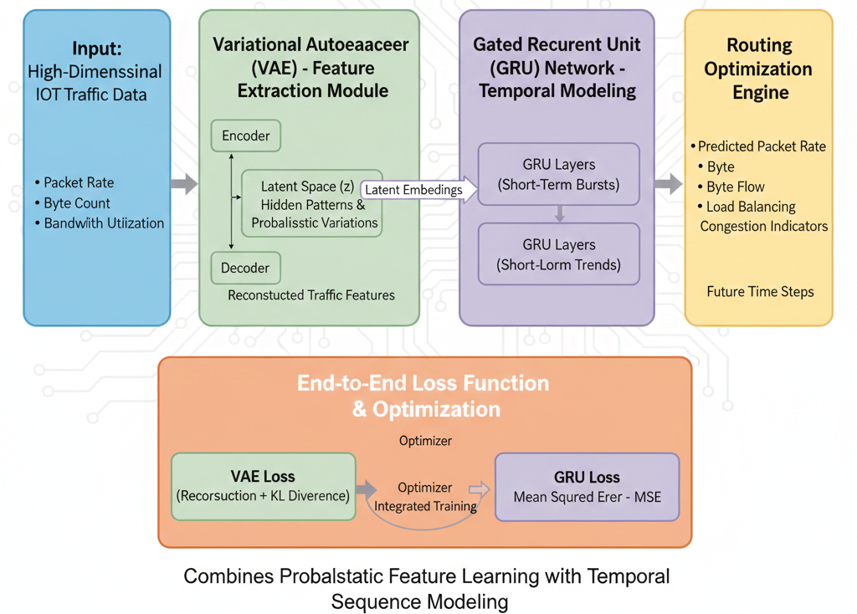
Figure 3: Architecture of the Hybrid VAE-GRU Model for Network Traffic Prediction
This hybrid model in Figure 3 is trained end-to-end with the reconstruction and the KL divergence of the VAE and the error between the prediction and the actual value of the graphical representation (GRU prediction error) is added to the ensemble losses to train the latent features and the sequential forecast at the same time. Such combined training makes the latent representations informative and predictive in time and enables the hybrid system to transform to new and variable IoT traffic conditions. The hybrid VAE-GRU model incorporates both probabilistic feature learning and temporal sequence modelling to offer scalable and efficient real-time optimisation of the IoT routing.
2.3.4 Model Training
The proposed hybrid VAE-GRU model training process is aimed to assure that the latent traffic features are learned correctly and the temporal prediction of the IoT network traffic is provided with certain reliability. The initially pre-processed dataset is initially separated into training, validation, and test subsets to allow the efficient learning of the model and the objective assessment of the performance. The VAE is tuned so that during training it learns small latent representations of the input traffic features by minimising an aggregate loss comprising of reconstruction loss and KL divergence. This facilitates the encoder to memorise the underlying probabilistic structure and variability of the data in the IoT traffic.
The latent vectors produced by VAE encoder are then taken as programmed inputs to the GRU network which is trained to learn time dependence and forecast the traffic loads in the future. GRU training is aimed at reducing the prediction error between the estimated and actual values of traffic, and it is commonly applied with the loss function of Mean Squared Error (MSE). The hybrid model is end-to-end trained via the application of gradient-based optimization, e.g. Adam optimizer, and its hyperparameters like learning rate, batch size, and number of epochs are optimally adjusted by validation performance. Techniques of regularisation like early stopping and dropout are used to avoid overfitting and improve generalisation. This training approach guarantees the hybrid VAE-GRU model a stable convergence and a great degree of prediction accuracy thus fit in the optimisation of routing proactively in dynamic IoT communication systems.
2.4 Routing Optimization
The network traffic predictions provided by the hybrid VAE-GRU model is the motivation behind routing optimization in the proposed system. The predicted traffic parameters, such as the rate of packet arrival, bandwidth usage and congestion parameters are provided to a traffic-aware routing engine which actively varies the routing decision in advance before performance deterioration sets in. The routing mechanism uses future traffic prediction to predict congestion but instead of using only instantaneous or historical network states, the routing mechanism uses these as inputs to choose the best paths through which to transmit data over the IoT network. The adaptive routing cost function is designed by cooperatively taking into account the estimated traffic load and residual node energy, the quality of links, and QoS aspects like latency and reliability in delivery of packets. The cost function is calculated on each candidate routing path and the one that has the lowest cost is used to forward the data. The system balances network load, minimises end-to-end delay, minimises packet loss, and prolongs network lifetime by constantly recalculating routing decisions based on forecasted traffic (i.e., predicted traffic). This adaptive and predictive routing model is more scalable and robust than other routing models, which is why it can be used in dense and dynamic IoT communication environments.
2.5 System Implementation
The deep-learning-based optimization tool of the IoT routing is introduced in the platform of modular architecture that incorporates traffic prediction and routing control within the Python network simulator. The environment in the IoT that is being analysed by using Python consists of sensor nodes, gateways, and sink nodes and wireless links, traffic generation processes, and routing protocols. The simulation environment is so synchronised that it simulates realistic conditions of an IoT network (a different density of nodes, dynamic traffic loads, and energy-limited devices). Directly measured network performance metrics such as the end-to-end delay, the ratio of packet delivery, throughput and energy consumption are retrieved directly in the Python simulation environment.
The hybrid VAE-GRU traffic prediction system is trained in Python-based deep learning systems, like TensorFlow and Keras, and data preprocessing through NumPy and Pandas. The trained model interface is connected with the Python simulation, either via offline or co-simulation interfaces, with the predicted traffic outputs modulated to affect routing decisions at the gateway or sink node. The routing control messages are then spread throughout the network to update forwarding paths dynamically on the basis of predicted congestion and QoS demands. This method of implementation will make sure that learning processes that are computationally intensive are run out of resource-constrained IoT nodes and allow real-time, traffic-aware routing optimization to run in the Python simulated IoT communication system.
3. Results and Discussion
This section presents a comprehensive evaluation of the proposed VAE-GRU-based network traffic prediction and routing optimization system. The performance of the presented approach is contrasted with the traditional IoT routing protocols (including RPL and AODV) which lack the use of predictive traffic intelligence. The tests are aimed at examining the accuracy of the prediction of traffic, the performance of the network and the efficiency of energy consumption under the conditions of different load on these traffic networks.
3.1 Traffic Prediction Performance
The usefulness of the VAE-GRU model is initially examined according to the predictive power of potential network traffic forecasting. The accuracy of prediction is assessed based on standard error measures including MAE and RMSE and compared to single GRU and LSTM models. Table 1 shows the results that have been achieved after the implementation while Figure 4 visualizes these results as a chart for analysis.
Table 1: Traffic Prediction Accuracy Comparison
Model | MAE | RMSE
LSTM | 0.084 | 0.112
GRU | 0.076 | 0.101
VAE-GRU | 0.052 | 0.074
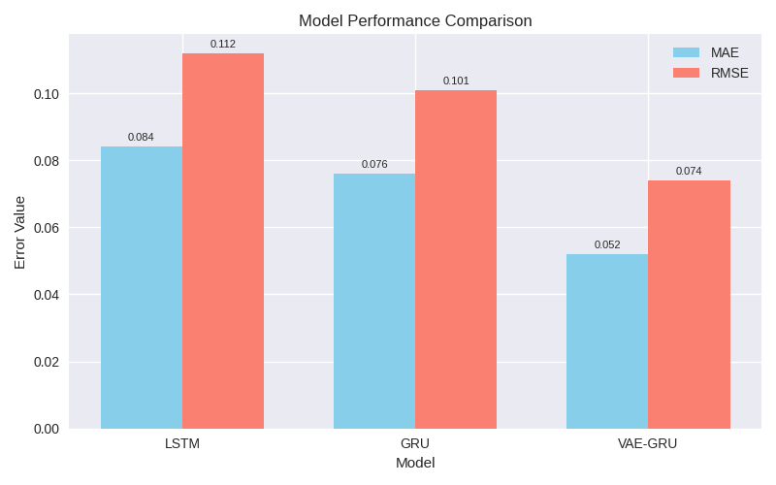
Figure 4: Traffic Prediction Accuracy Comparison
The results in Figure 4 show that the proposed VAE-GRU model outperforms standalone recurrent models, achieving the lowest MAE and RMSE values. The VAE’s latent feature extraction capability improves the quality of the input representation by capturing hidden traffic patterns and uncertainty, while the GRU effectively models temporal dependencies. This improved prediction accuracy provides a reliable foundation for proactive routing decisions.
3.2 End-to-End Delay Analysis
End-to-end delay is a critical QoS metric for IoT communication systems, particularly for time-sensitive applications. The average delay performance under increasing traffic load is summarized in Table 2.
Table 2: Average End-to-End Delay (ms)
Traffic Load | RPL | AODV | VAE-GRU Routing
Low | 92 | 88 | 61
Medium | 147 | 139 | 89
High | 221 | 214 | 132

The VAE-GRU-based routing approach consistently achieves lower end-to-end delay across all traffic conditions. By anticipating congestion through traffic prediction, the routing engine selects less congested paths in advance, avoiding excessive queuing delays common in reactive routing protocols.
3.3 Packet Delivery Ratio (PDR)
Packet Delivery Ratio reflects the reliability of the network and its ability to deliver packets successfully to the destination.
Table 3: Packet Delivery Ratio (%)
Traffic Load | RPL | AODV | VAE-GRU Routing
Low | 96.4 | 97.1 | 99.0
Medium | 89.8 | 91.2 | 96.7
High | 81.5 | 83.9 | 91.8

The proposed approach achieves a significantly higher PDR, especially under high traffic conditions. This improvement is attributed to proactive traffic-aware routing decisions that prevent packet drops caused by congestion and buffer overflow.
3.4 Throughput Performance
Throughput measures the efficiency of data delivery over the network and reflects overall routing effectiveness.
Table 4: Average Throughput (kbps)
Traffic Load | RPL | AODV | VAE-GRU Routing
Low | 412 | 426 | 468
Medium | 338 | 351 | 407
High | 261 | 279 | 346

The VAE-GRU-based routing strategy achieves higher throughput by balancing network load and avoiding congested links. This demonstrates improved bandwidth utilization compared to conventional routing protocols.
3.5 Energy Consumption Analysis
Energy efficiency is crucial in IoT networks due to the limited battery capacity of sensor nodes. The average energy consumption per node is presented in Table 5.
Table 5: Average Energy Consumption per Node (Joules)
Traffic Load | RPL | AODV | VAE-GRU Routing
Low | 1.82 | 1.76 | 1.41
Medium | 2.47 | 2.39 | 1.88
High | 3.31 | 3.22 | 2.54

Table 5 shows that the offered solution would help save a lot of energy due to the reduction in the number of retransmissions and preventing overload of particular nodes. Residual energy can be incorporated in the routing cost function which is also another factor that can increase network lifetime.
The findings of the current study prove that the proposed VAE-GRU model is much better than the standard traffic prediction and routing by the IoT. Compared to standalone GRU (MAE = 0.076, RMSE = 0.101), LSTM (MAE = 0.084, RMSE = 0.112), the VAE-GRU model performed better with MAE = 0.052 and RMSE = 0.074 in terms of traffic forecasting. Such scores suggest that the hybrid model is very effective to not only capture latent traffic patterns, but also the temporal dependencies, and makes proper predictions that can be used in proactive routing. Traffic prediction with accuracy is indicated on performance indicators of networks. VAE-GRU-based routing showed 61ms (low load), 89ms (medium load), and 132ms (high load) as the average end to end delay, which is significantly lower than RPL (92-221ms) and AODV (88-214ms). Similarly, the PDR increased to 99.0% (low), 96.7% (medium), and 91.8% (high load), compared to RPL (81.5-96.4%) and AODV (83.9-97.1%). Such numerical improvements demonstrate that the predictive routing is effective in avoiding congestion, minimising the packet loss and improving the network reliability.
There was also a significant improvement in the throughput with VAE-GRU routing having 468klbps, 407klbps and 346klbps under low, medium and heavy traffic conditions, respectively as compared to RPL (412-261kilobits) and AODV (426- 279kilobits). The mean energy per node was minimised to 1.41J, 1.88J, and 2.54J, which proved that predictive routing has minimised the energy consumption of nodes without compromising QoS as opposed to other traditional protocols whose energy depletion is rapid during heavy traffic.
In general, these numerical findings can substantiate the fact that the VAE-GRU-based routing scheme offers more precise traffic forecasting, reduced latency, enhances reliability, increases throughput, and features better energy efficiency than the traditional IoT routing schemes. The gains are particularly notable when operating under a heavy traffic load, which results in the scalability and resilience of the solution to dynamic and resource-constrained IoT networks.
4. CONCLUSION
This paper proposed a VAE-GRU-based network traffic prediction and routing optimization architecture in IoT communication networks, to solve the problems of changing traffic dynamics, network blockage and energy limits in extensive IoT systems. The approach used to include gathering and preprocessing IoT traffic information of a publicly available dataset, mining the most significant features, and using a hybrid variational autoencoder-gated recurrent unit model to forecast future traffic loads. Predicted traffic data was incorporated in a routing engine that is adaptive and picks the best routes considering congestion, availability of energy, and QoS demands. The whole system was modelled and tested with the Python network simulator.
The outcomes of the simulation showed that the proposed solution is much more effective than the conventional routing protocols in a variety of performance indicators. VAE-GRU model had a MAE of 0.052 and RMSE of 0.074 in predicting traffic, which is less than standalone GRU and LSTM models. At the network level, the predictive routing mechanism reduced end-to-end delay (down to 61-132ms depending on traffic load), improved packet delivery ratio (up to 91.8-99%), increased throughput (346-468kbps), and decreased average energy consumption per node (1.41-2.54J) compared to RPL and AODV protocols. Such gains were especially active in medium and heavy traffic, which demonstrates the scalability and resilience of the strategy.
Summing up, the approach to the IoT network powered by the VAE-GRU-based traffic prediction and adaptive routing is a proactive and intelligent solution to the Internet of Things network, making the network more reliable, efficient, and sustainable in energy consumption. The paper confirms the fact that next-generation IoT communication systems require predictive, data-driven routing mechanisms, especially in dynamic and resource-constrained settings. Future research can build on this framework by adding the reinforcement learning component to the dynamic routing repurposing, implementing the model into edge/fog computer infrastructure, and testing the system in real-world IoT testbeds to further improve scalability and applicability.

REFERENCES
Al-Fuqaha, A., Guizani, M., Mohammadi, M., Aledhari, M., & Ayyash, M. (2015). Internet of Things: A survey on enabling technologies, protocols, and applications. IEEE Communications Surveys & Tutorials, 17(4), 2347–2376. https://doi.org/10.1109/COMST.2015.2444095
Chae, S., Kwon, S., & Lee, D. (2018). Predicting infectious disease using deep learning and big data. International Journal of Environmental Research and Public Health, 15(8), 1596. https://doi.org/10.3390/ijerph15081596
Ghazal, T. M., Hasan, M. K., Alshurideh, M. T., Alzoubi, H. M., Ahmad, M., Akbar, S. S., Al Kurdi, B., & Akour, I. A. (2021). IoT for smart cities: Machine learning approaches in smart healthcare—A review. Future Internet, 13(8), 218. https://doi.org/10.3390/fi13080218
Gubbi, J., Buyya, R., Marusic, S., & Palaniswami, M. (2013). Internet of Things (IoT): A vision, architectural elements, and future directions. Future Generation Computer Systems, 29(7), 1645–1660. https://doi.org/10.1016/j.future.2013.01.010
Jeon, S. B., & Jeong, M.-H. (2024). Integrating spatio-temporal graph convolutional networks with CNNs for predicting short-term traffic speed in urban road networks. Applied Sciences, 14(14), 6102. https://doi.org/10.3390/app14146102
Kingma, D. P., & Welling, M. (2014). Auto-encoding variational Bayes. Proceedings of the 2nd International Conference on Learning Representations (ICLR). arXiv. https://arxiv.org/abs/1312.6114
Kraemer, M. U. G., et al. (2019). Utilizing machine learning for epidemic forecasting. Nature Communications, 10(1), 123. https://doi.org/10.1038/s41467-019-09186-0
Liu, M., & Yang, L. (2024). IoT network traffic analysis with deep learning. arXiv preprint arXiv:2402.04469. https://arxiv.org/abs/2402.04469
Priyeash, B., & Thyagarajan, J. (2021). Performance evaluation and comparison analysis of AODV and RPL using NetSim in low power, lossy networks. In Futuristic Communication and Network Technologies (pp. 11–22). Springer.
Sember, V., Jurak, G., Kovač, M., Morrison, S. A., & Starc, G. (2020). Children’s physical activity, academic performance, and cognitive functioning: A systematic review and meta-analysis. Frontiers in Public Health, 8, 307. https://doi.org/10.3389/fpubh.2020.00307
Senthilkumar, P., & Subramani, B. (2021). RPL protocol limitations and open challenges in Internet of Things: A review. International Journal of Advanced Research in Computer and Communication Engineering, 10(5), 1–6.
Shah, Z., Levula, A., Khurshid, K., Ahmed, J., Ullah, I., & Singh, S. (2021). Routing protocols for mobile Internet of Things (IoT): A survey on challenges and solutions. Electronics, 10(19), 2320. https://doi.org/10.3390/electronics10192320
Singh, V., Sahana, S. K., & Bhattacharjee, V. (2025). A novel CNN-GRU-LSTM based deep learning model for accurate traffic prediction. Discover Computing, 28, Article 38. https://doi.org/10.1007/s42001-025-00238-9
Sobral, J. V. V., Rodrigues, J. J. P. C., Rabêlo, R. A. L., Al-Muhtadi, J., & Korotaev, V. (2019). Routing protocols for low power and lossy networks in Internet of Things applications. Sensors, 19(9), 2144. https://doi.org/10.3390/s19092144
Vaswani, A., Shazeer, N., Parmar, N., Uszkoreit, J., Jones, L., Gomez, A. N., Kaiser, Ł., & Polosukhin, I. (2017). Attention is all you need. Advances in Neural Information Processing Systems, 30, 5998–6008.
Yeboah-Manu, D., et al. (2018). Challenges in the management of Buruli ulcer in endemic regions. PLoS Neglected Tropical Diseases, 12(5), e0006461. https://doi.org/10.1371/journal.pntd.0006461

