Evidence-Density-Weighted Multi-Criteria Decision Analysis: A Mathematical Framework with Application to Comparative Evaluation of Managed Pressure Drilling Approaches

ABSTRACT
Standard multi-criteria decision analysis (MCDA) treats criterion weights as exogenous to the underlying evidence base, producing decision-support outputs that do not communicate the strength of the evidence on which they rest. This is a limitation in real-world decision contexts where evidence density and consistency vary systematically across criteria. This paper develops an evidence-density-weighted extension of the standard weighted-sum MCDA aggregation in which criterion weights are made endogenous to the frequency (density) and the agreement (consistency) of the supporting evidence. The framework introduces an evidence-density factor, an evidence-consistency factor, and a combined evidence-confidence weight, supplemented by a three-tier confidence calibration of decision-support outputs. The framework reduces to the standard weighted-sum aggregation in the limiting case of uniform evidence density and consistency, establishing it as a proper generalisation. The framework is demonstrated through application to a corpus of fourteen Managed Pressure Drilling (MPD) case studies from the SPE and IADC literature of 2015-2025, producing an evaluation matrix, a cross-case synthesis, and an application-domain selection map with explicit confidence-tier calibration. The principal substantive finding is that MPD achieves detection sensitivity approximately one to two orders of magnitude superior to conventional drilling, a finding cross-validated against a Gaussian detection-sensitivity model. The framework is computationally tractable with complexity linear in the problem size, generalises to adjacent engineering-comparison problems, and offers an operationally accessible alternative to more complex evidence-aware MCDA methods while addressing the same underlying concern of evidence heterogeneity across criteria.
Keywords: Multi-criteria decision analysis, evidence-density weighting, confidence calibration, managed pressure drilling, structured comparative analysis.
INTRODUCTION
Multi-criteria decision analysis (MCDA) provides a structured mathematical apparatus for comparing alternatives across multiple evaluation criteria, with foundations in multi-attribute utility theory (Keeney and Raiffa, 1976), outranking methods (Roy, 1968), and the Analytic Hierarchy Process (Saaty, 1980). A persistent limitation of standard MCDA is its treatment of criterion weights as exogenous parameters specified before evaluation, without regard to the strength of the evidence supporting the criterion evaluations. When the evidence base across criteria is heterogeneous in density and consistency, as is characteristic of decision contexts based on case-study or empirical literature, the standard aggregation produces scores that are formally identical but epistemically very different, with consequences for the operational defensibility of the resulting recommendations.
This paper develops a tractable mathematical extension of the standard weighted-sum aggregation that addresses this limitation by making criterion weights endogenous to the frequency and consistency of the supporting evidence. The framework is demonstrated through application to the comparative evaluation of fourteen Managed Pressure Drilling (MPD) case studies, a substantial real-world decision problem exhibiting precisely the evidence heterogeneity the framework is designed to address. MPD is a drilling technology that manages annular pressure within the narrow operating window between formation pore pressure and fracture gradient through controllable surface back-pressure, and the choice of MPD variant for a given well is a consequential engineering decision that the published literature has not previously addressed through structured comparative synthesis.
METHODOLOGY
Foundational structure
Let A = {a₁, ..., aₙ} be a finite set of n alternatives and D = {d₁, ..., dₘ} a finite set of m evaluation dimensions. Define the evaluation function f mapping A × D to the codomain E = {0, 1, 2}, where 0 denotes that dimension dⱼ is absent from alternative aᵢ, 1 denotes secondary treatment, and 2 denotes primary treatment. The function induces the evaluation matrix F with entries Fᵢⱼ = f(aᵢ, dⱼ). The column sum C(dⱼ) = Σᵢ Fᵢⱼ measures the total evidence on dimension dⱼ across the corpus.
The density factor
The evidence-density factor expresses the frequency of evidence on a dimension as a fraction of the maximum attainable:
ρ(dⱼ) = C(dⱼ) / (2n) (1)
with ρ(dⱼ) in the interval [0, 1], taking value 1 when every alternative treats dⱼ as primary and 0 when dⱼ is absent throughout. The divisor 2n is the maximum possible column sum, corresponding to every alternative scoring the maximum value 2.
The consistency factor
Evidence density addresses quantity but not agreement. Define the within-dimension mean μ(dⱼ) = C(dⱼ)/n and the within-dimension variance:
σ²(dⱼ) = (1/n) Σᵢ (Fᵢⱼ − μ(dⱼ))² (2)
The evidence-consistency factor is defined as the complement of the variance:
κ(dⱼ) = 1 − σ²(dⱼ) (3)
with κ(dⱼ) in the interval [0, 1], taking value 1 under perfect agreement, when all alternatives score dⱼ identically, and decreasing as cross-alternative disagreement increases.
The combined weight and aggregation
The evidence-confidence weight combines the exogenous decision-maker weight wⱼ with the endogenous density and consistency factors, normalised to sum to unity:
ŵⱼ = (wⱼ · ρ(dⱼ) · κ(dⱼ)) / Σₖ (wₖ · ρ(dₖ) · κ(dₖ)) (4)
and the evidence-confidence-weighted score of alternative aᵢ is:
S(aᵢ) = Σⱼ ŵⱼ · Fᵢⱼ (5)
If ρ(dⱼ) and κ(dⱼ) are constant across dimensions, the factors cancel in the normalisation and the score reduces exactly to the standard weighted-sum aggregation, establishing the framework as a proper generalisation. The aggregation is monotonic non-decreasing in each matrix entry and bounded in the interval [0, 2].
Confidence-tier calibration
Define the dimensional confidence as the product ψ(dⱼ) = ρ(dⱼ) · κ(dⱼ) and partition the unit interval using thresholds θ₁ = 0.35 and θ₂ = 0.65 into three tiers: Tier 1 (ψ at least θ₂, direct decision-support), Tier 2 (ψ between θ₁ and θ₂, working hypothesis requiring verification), and Tier 3 (ψ below θ₁, directional indication only). The tier calibration communicates the evidential basis of each decision-support output, addressing a limitation of standard MCDA output that presents continuous scores without confidence information.
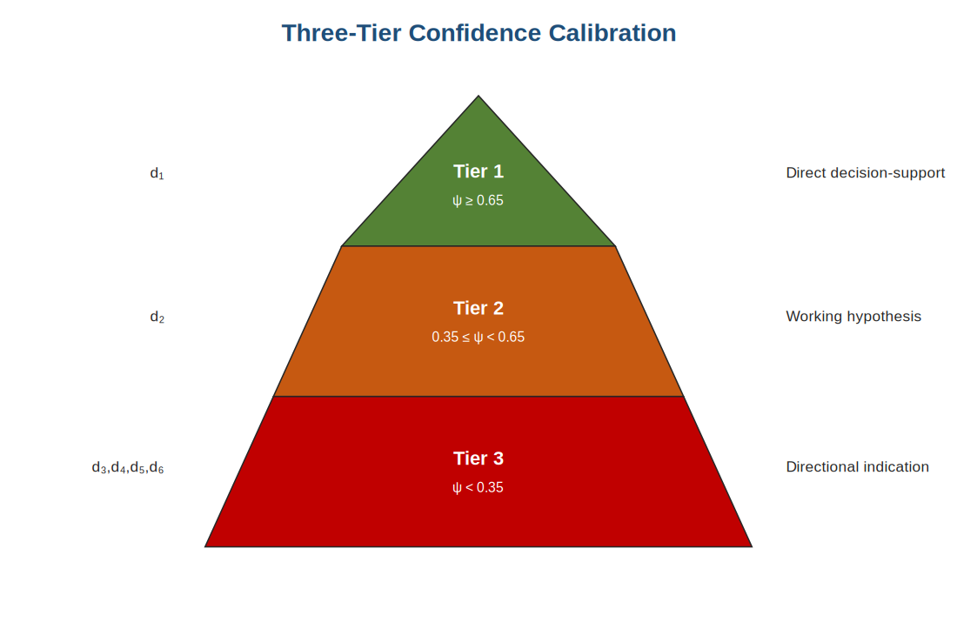
Figure 1: Three-tier confidence calibration based on dimensional confidence.
RESULTS
The framework was applied to a corpus of fourteen MPD case studies from the SPE and IADC literature of 2015-2025, spanning North America, Asia-Pacific, the Middle East, Europe, South America, and laboratory settings. Each paper was scored against six dimensions derived inductively from the corpus: well-control sensitivity (d₁), narrow-margin navigation (d₂), non-productive-time reduction (d₃), rate-of-penetration enhancement (d₄), cementing and tripping reliability (d₅), and economic performance (d₆). Table 1 reports the resulting density, consistency, and confidence factors.
Table 1: Density, consistency, and confidence factors for the six dimensions (n = 14).
Dimension | C(dⱼ) | ρ(dⱼ) | κ(dⱼ) | ψ(dⱼ) | Tier
d₁ Well-control sensitivity | 23 | 0.82 | 0.73 | 0.60 | 1–2
d₂ Narrow-margin navigation | 21 | 0.75 | 0.73 | 0.55 | 2
d₃ NPT reduction | 16 | 0.57 | 0.55 | 0.31 | 3
d₄ ROP enhancement | 6 | 0.21 | 0.57 | 0.12 | 3
d₅ Cementing / tripping | 13 | 0.46 | 0.66 | 0.30 | 3
d₆ Economic performance | 14 | 0.50 | 0.59 | 0.30 | 3
Applying equation (4) with equal base weights yields the evidence-confidence weights (0.273, 0.250, 0.141, 0.055, 0.136, 0.145). The well-control weight 0.273 substantially exceeds the equal-weighting value of 0.167, reflecting the high density and consistency of well-control evidence; the ROP weight 0.055 falls well below 0.167, reflecting the thin and inconsistent ROP evidence base. Figure 2 compares the resulting per-approach scores under standard and evidence-confidence weighting.
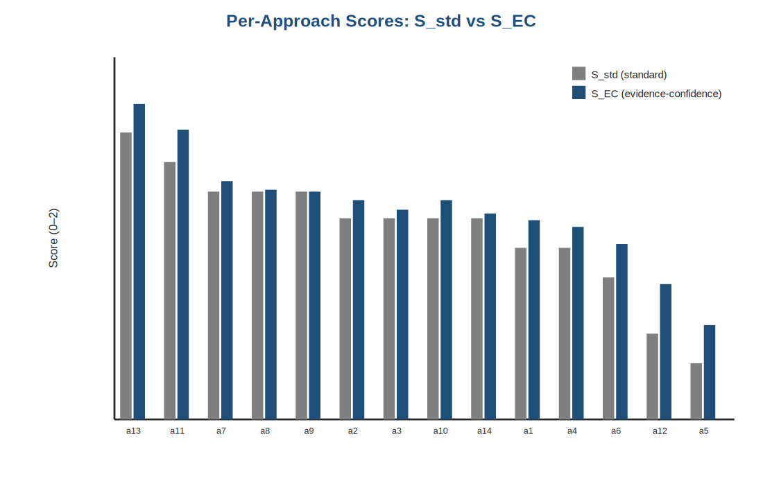
Figure 2: Per-approach scores under standard and evidence-confidence-weighted aggregation.
The Saudi 53-well constant-bottom-hole-pressure campaign ranks highest with a score of 1.84, followed by the UK North Sea HPHT infill well at 1.69 and the South China Sea ultra-HPHT well at 1.39. The framework's differentiation among approaches with equal standard scores is grounded in the evidence-confidence structure of the corpus, providing an analytically defensible basis that standard weighted-sum aggregation does not supply.
Detection-sensitivity cross-validation
The principal substantive finding concerns well-control detection sensitivity. Treating kick detection as a Gaussian hypothesis-testing problem on the mass-balance discrepancy between return and pump-in flow rates, the minimum detectable influx for a false-alarm probability α* and detection power π* is:
δ_min = σ · [Φ⁻¹(1 − α*) + Φ⁻¹(π*)] (6)
where σ is the measurement-noise standard deviation and Φ the standard normal cumulative distribution function. The minimum detectable influx scales linearly with σ. MPD Coriolis return-flow measurement, with σ of approximately 0.02 to 0.15 barrels, yields a minimum detectable influx approximately one to two orders of magnitude below that of conventional pit-volume measurement, with σ of approximately 2 barrels. This prediction is consistent with the empirical corpus evidence, including the 3 gallon-per-minute detection threshold reported in the Saudi campaign and the 0.06 cubic-metre single-circulation containment in the UK North Sea infill. The convergence of the analytical model with the empirical evidence cross-validates both.
DISCUSSION
Synthesising the per-approach evidence with the confidence calibration yields an application-domain selection map matching operational situations to preferred MPD variants. Tier 1 recommendations, such as constant-bottom-hole-pressure MPD for HPHT exploration supported by multiple consistent approaches, can be adopted directly. Tier 2 recommendations, such as managed pressure cementing for ultra-HPHT cementing supported by a single substantive approach, are working hypotheses requiring operational-context verification. Tier 3 recommendations, such as autonomous well-control supported by foundational evidence only, are directional indications. The map communicates not only which variant is preferred for each situation but how strongly the corpus evidence supports the recommendation, which is the framework's specific contribution to operational decision-support.
The comparison of the framework with standard weighted-sum aggregation and with the Technique for Order Preference by Similarity to Ideal Solution shows that the three methods produce broadly similar rankings, but only the present framework supplies the confidence-tier calibration. The framework's analytical value is therefore best assessed not on ranking differences but on the additional confidence information it provides. The framework is computationally tractable, with complexity linear in the product of the number of alternatives and dimensions, and it offers an operationally accessible alternative to more complex evidence-aware methods such as the Dempster-Shafer extension of the Analytic Hierarchy Process, which carries substantially higher computational cost.
CONCLUSION
The evidence-density-weighted MCDA framework extends the standard weighted-sum aggregation by making criterion weights endogenous to the frequency and consistency of the supporting evidence, supplemented by a confidence-tier calibration of decision-support outputs. The framework reduces to the standard aggregation in the uniform-evidence limit and generalises to adjacent engineering-comparison problems including wellbore-strengthening, completion-technology, and drilling-automation evaluation. Applied to the MPD corpus, it establishes that MPD achieves qualitatively superior detection sensitivity to conventional drilling, that variant choice is consequential and supported by structured variant-to-situation matching, and that specific evidence gaps, notably the thin rate-of-penetration evidence, define a structured research agenda. The framework addresses the underlying concern of evidence heterogeneity across criteria while remaining operationally accessible.
ACKNOWLEDGEMENTS
The authors thank Shri Venkateshwara University, Gajraula, for institutional support, and acknowledge the authors of the fourteen SPE and IADC technical papers that constitute the analytical corpus.
REFERENCES
1. Beynon, M. J. (2002). DS/AHP method: A mathematical analysis, including an understanding of uncertainty. European Journal of Operational Research, 140(1), 148-164.
2. Hwang, C. L., & Yoon, K. (1981). Multiple Attribute Decision Making: Methods and Applications. Berlin: Springer-Verlag.
3. Keeney, R. L., & Raiffa, H. (1976). Decisions with Multiple Objectives: Preferences and Value Tradeoffs. New York: Wiley.
4. Kinik, K., Wojtanowicz, A. K., & Gumus, F. (2015). Constant bottom-hole pressure managed pressure drilling and dynamic well control: Western Canada field application. SPE Journal, SPE 168948-PA.
5. Roy, B. (1968). Classement et choix en presence de points de vue multiples (la methode ELECTRE). Revue Francaise d'Informatique et de Recherche Operationnelle, 8, 57-75.
6. Saaty, T. L. (1980). The Analytic Hierarchy Process. New York: McGraw-Hill.
7. Uddin, M., et al. (2024). Constant bottom-hole pressure managed pressure drilling across fifty-three horizontal wells in a Saudi unconventional tight-gas field. SPE/IADC 219602-MS.
8. Yin, R. K. (2014). Case Study Research: Design and Methods (5th ed.). Thousand Oaks: Sage Publications.

