AN INVESTIGATION INTO THE CAUSES AND EFFECTS OF FEMALE

ABSTRACT
An Investigation into the Causes and Effects of Female Student Dropout at Albert Daniel Peabody (ADP) Public School in the Marshall Education District, Margibi County, Liberia (2023–2026). The study emphasizes the need to address factors contributing to female student dropout, which undermines girls’ educational attainment, gender equity, and national development. It provides practical insights for policymakers, educators, community stakeholders, and researchers to improve girls’ retention, strengthen interventions, and guide policy development. A descriptive quantitative research design was used. The population comprised 1,008 individuals, including administrators, teachers, female students, dropout victims, PTA members, and community representatives. A sample of 50 participants was selected using simple random sampling based on Curry’s (1984) sampling theory. Data were collected through structured closed-ended questionnaires and documentary review of school records. Findings revealed that financial constraints are the leading cause of dropout, with 90.9% of respondents identifying lack of school fees (Table 4). Socio-cultural factors such as early marriage and teenage pregnancy were also significant, supported by 71.4% of students and 72.73% of PTA members (Tables 5 and 7). School-related issues, including bullying and harassment (92.86%) and inadequate sanitation facilities (85.71%), further contributed to dropout (Table 5). Consequences identified include loss of future female leaders, increased family financial burden (92.31%), and rising early marriage and poverty rates (Table 8). The study concludes that female student dropout is a multifaceted issue shaped by financial, socio-cultural, and school-related factors. It recommends sustainable financial support, stronger policies addressing early marriage and teenage pregnancy, and improved school environments to ensure safety, sanitation, and inclusivity, thereby enhancing girls’ retention and completion rates.

TABLE OF CONTENTS

DECLARATION BY RESEARCHER i
DECLARATION BY ADVISOR ii
DECLARATION BY THE DEAN iii
DECLARATION BY VICE PRESIDENT iv
DEDICATION v
ACKNOWLEDGEMENT vi
ABSTRACT vii
CHAPTER 1: INTRODUCTION
  - Background 1
  - Statement of Problem 2
  - Research Questions 3
  - Delimitations 3
  - Limitations 4
  - Significance of the Study 4
  - Definition of Key Terms 5
  - Organization of the Study 5
CHAPTER TWO: REVIEW OF RELATED LITERATURE
  - Causes of Female Students Dropout 7
  - Effect of Girl School Dropouts on the Community 11
CHAPTER THREE: METHODOLOGY
  - Research Design 14
  - Population 14
  - Sample Size and Sample Techniques 14
  - Data collection instrument 15
  - Data Collection Procedures 15
  - Data analysis procedures 16
CHAPTER FOUR: DATA PRESENTATION AND INTERPRETATION
  - Data Presentation and Interpretation 17
  - Findings 32
  - Discussion of Findings 35
CHAPTER FIVE: SUMMARY/CONCLUSION AND RECOMMENDATIONS
  - Summary 39
  - Conclusion 40
  - Recommendations 41
Bibliography 43
Appendices:
- Letter from the Dean 48
- Research Questionnaire:
- Questionnaire for students 49
- Questionnaire for Principle and Teachers 53
- Questionnaire for Parents (PTA Committee) 59
- Questionnaire for Community Members 61
- Documentary Review (School Records) 65
CHAPTER ONE: INTRODUCTION

1.1 Background of the Study
Education is the best legacy a nation can offer its citizens. As noted by Orji and Job (2013), education shapes every aspect of human life by equipping individuals to become useful tools in society. It is widely regarded as the foundation of national development across all sectors (Anho, 2011). Through education, individuals acquire the knowledge, skills, attitudes, values and behavior necessary to function effectively as responsible citizens (Boonprasert, 2010).
Access to education for women is a key indicator of societal progress. The level of education attained by a woman influences a nation’s social, economic, natural, physical and human capitals, thereby contributing to its overall growth and development (Andiema & Manasi, 2021).
Globally, about 129 million girls are out of school, including 32 million primary school-aged, 30 million lower secondary school-aged, and 67 million upper secondary school-aged. In countries affected by conflict, girls are more than twice as likely to be out of school as girls living in non-affected countries (UNICEF, 2021). Several findings revealed that girls who dropped out of school were due to early pregnancies, poverty levels, gender-based violence, cultural practices, lack of financial support and repetition. At the macro level, female dropout contributes to slower economic growth, higher dependency ratios, and a reduction in human capital.
Africa continues to face a gaping hole in educational access, retention, and completion rates, with female students disproportionately affected. In Sub-Saharan Africa (SSA), female enrolment increased notably during the 1990s, with gender parity rising from 0.83% to 0.88% in 2000 for primary education and from 0.63% to 0.82% at the secondary level during the same year (UNESCO, 2006). Despite these gains, the continent still faces persistent challenges that hinder girls from completing their Education.
The Liberian education system has been severely affected by successive national crises, including intermittent civil wars (1989-2003), the Ebola outbreak (2014-2015), and the COVID-19 pandemic. These disruptions have exacerbated existing inequalities and weakened educational progress nationwide. Statistics from Insights Liberia indicate that only 40% of Liberian girls aged 15-19 are in school, placing the country among those with the lowest retention rates for female students in Africa. While national enrollment data shows near gender parity at both primary and secondary levels, significant gender gaps emerge in completion rates and widen at each successive educational stage. For senior secondary education, male completion rates stand at 17% compared to 9% for females. These disparities are even more severe in rural areas, where secondary school completion drops to a stark 2% for girls (JAC Group of Companies/EducateHer, 2021).
In this regard, a study investigating the causes and effects of female student dropout at Albert Daniel Peabody Public School in the Marshall Education District, Lower Margibi County, is essential to inform the adoption and implementation of girl-centered policies and programmes aimed at keeping girls in school at rates comparable to those of their male counterparts.

1.2 Statement of the Problem
Despite comparable enrollment rates for girls and boys in Liberia, the completion rates of female students remain markedly lower than those of their male counterparts. Moreover, the proportion of girls in the education system decreases progressively as they advance up the academic ladder.
In response to this challenge, the Government of Liberia has introduced several policies and strategies, including the National Policy on Girls’ Education (NPGE, 2021–2026), aimed at improving girls’ access to education, retention, and completion rates. These interventions include the provision of scholarships and incentives, the recruitment of female guidance counselors, the distribution of learning and recreational materials, and the promotion of gender-responsive learning environments.
However, despite these efforts, dropout rates among female students remain a serious concern, suggesting the existence of gaps in policy implementation and support systems. Therefore, this study aims to generate empirical evidence to inform the adoption and implementation of girl-centered policies and programmes that will improve girls’ retention and completion rates. Ultimately, the study seeks to provide practical insights for policymakers, educators, and community stakeholders in their efforts to reduce female student dropout and promote gender equity in education in Liberia.

1.3 Research Questions
This study was guided by the following three (3) research questions:
- What are the major causes of female students dropout in Albert Daniel Peabody Public School, Marshall Education District, Margibi County, Liberia?
- What are the social, economic, and psychological effects dropout have on female students at Albert Daniel Peabody Public School, Marshall Education District, Margibi County, Liberia?
- How can the high rate of female students dropout be reduced at Albert Daniel Peabody Public School, Marshall Education District, Margibi County, Liberia?

1.4 Delimitations
This This research was conducted at Albert Daniel Peabody Public School, located in the Marshall Education District, Margibi County, Liberia. It excluded all other schools, districts, and counties within Liberia. The study focused on female dropout rates within the 2023–2025 timeframe. Although historical data prior to 2023 were utilized to provide contextual background, they did not constitute the primary focus of the investigation. Furthermore, the study relied on existing school records, which were in some instances incomplete or inaccurate, thereby posing challenges to the collection of precise data on dropout rates.

1.5 Limitations
The study faced several limitations that may have influenced the findings. Incomplete or inconsistent school records potentially affected the accuracy of reported dropout statistics. Additionally, the study was confined to a single school, which limits the generalizability of the findings to other schools or regions within Liberia. Tracing former students proved difficult, particularly when contact information was unavailable or outdated. Sensitive issues, such as pregnancy, early marriage, and household financial conditions, may have contributed to respondents’ reluctance or introduced potential bias in their answers. Financial and logistical constraints further limited the scope and depth of fieldwork. Moreover, language and cultural differences posed challenges to effective communication and data interpretation, although efforts were made to mitigate these difficulties using local facilitators.

1.6 Significance of the Study
The findings of this study are of great significance to various stakeholders. For educational administrators, planners, and policymakers, the study provides a solid, evidence-based foundation for identifying the root causes and effects of female student dropout, thereby enabling the design of effective, data-driven interventions. School leaders and nongovernmental organizations (NGOs) also benefit, as the study informs the development of targeted programs and support systems aimed at reducing female dropout rates. At the community level, the research raises awareness of the importance of girls’ education and underscores the broader social and economic consequences of female dropout, thereby promoting collective action and local support. For the academic community, the study serves as a rigorous empirical reference that stimulates further inquiry and critical analysis of the contextual factors influencing female student dropout in rural Liberian settings.

1.7 Definition of Key Terms
Education: refers to the process of facilitating learning, acquiring knowledge, skills, values, beliefs, and habits through teaching, training, research, or self-directed learning. It is a fundamental human right and a key driver of social and economic development.
Retention: refers to the continued participation of students in schooling rather than their withdrawal.
Completion: refers to the act or process of finishing something, or the state of being finished or completed. For this study, completion refers to the successful finishing of secondary education.
Dropout: refers to student who fails to complete the full educational cycle up to Grade12
Community: refers to all people who live in a particular area or country. It also means the feeling of sharing things and belonging to a group in the place where you live.
Early marriage: refers to the formal or informal union of individuals under the age of 18. This practice disproportionately affects girls and is often driven by poverty, cultural norms, and lack of education.
Poverty: refers to individuals or communities that lack the financial resources to meet basic needs such as food, shelter, education, and healthcare. It is a root cause of many social issues, including low educational attainment and early marriage.

1.8 Organization of the Study
This thesis is organized into five chapters. Chapter One presents the background of the study, statement of the problem, research questions, and significance of the study. It also includes the limitations, delimitations, definition of key terms, and the organization of the study. Chapter Two contains the literature review of existing information relevant to the topic. Chapter Three describes the research methodology, including research design, population, sample size and sampling techniques, data collection instruments, as well as data collection and analysis procedures. Chapter Four focuses on data presentation, analysis, findings, and discussion of the findings. Chapter Five presents summary, conclusions, and recommendations on how the problem and the research questions were addressed and suggestions for further study.

CHAPTER TWO: REVIEW OF RELATED LITERATURE

Dropouts are those who leave school before the end of the final year of an education cycle in which they are enrolled. A significant number of children who enroll in high school in Africa, particularly in sub-Sahara Africa, do not complete their school. According to (Lockheed and Verspoor 1991), fewer than 60% of the children who enter school in the low-income countries and about 70% of those who enter schooling the low-middle income countries reach the last year of the secondary school. From all these female students account the large percentage. Dropout rates are high at the high school level in general, with slightly more girls dropping out than boys. Female dropout is more common to Africa and Asian countries where their completion rate is very low. This shows that there are some unique factors contributing to the increase in the dropout rate, particularly for females (Ricardo et al., 2010).
  - Causes of female Students Dropouts.
A 2011 household survey conducted in Liberia on out-of-school children revealed the main reasons students drop out of school, with particular emphasis on the factors affecting girls and young women (UIS & UNICEF, 2012). As Hunt (2008) noted, school dropout is not attributable to a single cause; instead, it is a process resulting from multiple, interconnected factors that contribute to female students' dropout.

Early Pregnancy and Marriage
According to the 2011 household survey in Liberia, 68% of respondents reported that girls in their households dropped out of school due to pregnancy (UIS & UNICEF, 2012). One of the reasons for high levels of early pregnancy in Liberia is a lack of easily available and accurate information on sex matters, including pregnancy (FORWARD and IPPF, 2012: 22). Furthermore, many pregnant girls are often expelled from school by authorities who fear they might “influence” or “encourage” similar behavior among other students (FORWARD & IPPF, 2012). Although the Ministry of Education has established a policy, the National Policy on Girls' Education (NPGE), that permits pregnant students to continue their education through ‘night schools’, ensuring they still have access to education, this policy is not consistently enforced across the country (FORWARD & IPPF, 2012). JAC Group of Companies/EducateHer (2021) noted Liberia has one of the world’s highest teenage pregnancy rates, with 33.5% of young women aged 15-19 bearing children, making it a major barrier to educational achievement.
Several studies (UNESCO, 2011; Carleton University, 2021; Birdshall, 2005; Bhorat, 2003; Bledsoe, 2002) noted that Early marriage and teenage pregnancy are leading causes of girls' dropout rate in school. Several studies have identified teenage pregnancy as a major factor contributing to school dropout among girls (Boyle et al., 2002).
- Poverty and Economic Constraints
In Liberia, widespread poverty and limited parental support for education have led many children, particularly among girls, to leave school to work. Findings from the household survey indicated that 17% of respondents reported their children dropped out of school to earn income, with some working children reported to be as young as eight years old (UIS & UNICEF, 2012).
According to Kose (2011), a family’s economic conditions play a crucial role in determining students’ academic attainment. Ayot (1995) further explains that widespread poverty often makes it difficult for parents to pay school fees and meet other basic educational needs, leading to an increased dropout rate among female students. Similarly, Stack (1976) observed that girls from poor families are often influenced by circumstances that push them into premarital sexual relationships without the use of contraceptives, leading to unwanted pregnancies. He further explained that the rising costs of education have disproportionately affected girls' education, leaving many of them without the opportunity to acquire a proper education. Leung and Zhang (2008) observed that parents often prefer sons over daughters because sons are traditionally expected to care for their parents in the future. This gender bias becomes particularly evident in situations where family resources are limited.
Many studies have also shown that the high cost of schooling, especially school fees, often causes students to drop out early. In most cases, girls are the ones who suffer the most because some parents choose to prioritize paying for their sons’ education instead. For example, in rural China, Brown and Park (2002) found that an inability to pay school fees caused 47% of girls to drop out of elementary school, compared to 33% of boys. Similarly, Hunter and May (2002) reported that in South Africa, fees were a significant reason for dropout for 30% of girls versus 27% of boys before secondary graduation.
- Cultural Norms and Beliefs
Save the Children (2005) highlights that cultural norms and beliefs continue to hinder girls' education, especially in many developing regions of the world. In Liberia, the JAC Group of Companies/EducateHer (2021) identified that traditional initiation practices, such as Female Genital Mutilation (FGM), which is part of an initiation into the powerful Sande secret society, are a major cause of poor school enrollment and attendance. The operation of "bush schools" for FGM during academic instructional time has led to a "huge dropout of girls”, particularly in rural communities where the practices persist despite attempts at prohibition. Similarly, Abena (1991) and Atayi (2008) observed that across many African societies, parents often believe girls belong at home rather than in school. They think a girl’s main duty is to care for children and prepare meals, and that formal education is unnecessary for girls.
- School Facilities for Female Students
Lack of access to separate, clean toilets and washing facilities in schools may lead to chronic absenteeism and dropout by female students, particularly when they reach puberty and begin to menstruate. In many developing countries, basic sanitation facilities in schools often fall below acceptable standards. For instance, a 2009/2010 survey conducted in Tanzanian schools by SNV, WaterAid, and UNICEF revealed that only 11% of schools met the government’s requirement of one latrine for every 20 girls and 25 boys. The study also found that 20% of schools had more than 100 students sharing a single latrine, while 6% had no latrines at all. Additionally, 52% of girls’ latrines lacked doors, compromising privacy and dignity, and 92% of schools did not have functioning handwashing facilities (SNV, WaterAid & UNICEF, 2009).
According to Lizettee (2000), while poor hygiene and a lack of facilities affect both boys and girls, the consequences are particularly severe for girls. Parents expect schools to provide safe and separate sanitation facilities for their daughters, especially as they grow older. For girls who have reached puberty, access to private and hygienic facilities during menstruation is essential. Without these facilities, many girls feel uncomfortable or unsafe attending school, which often leads them to stay home or drop out entirely. Birdsall et al. (2005) also emphasize that the issue of privacy is one of the main reasons girls leave school. When schools fail to provide separate toilets or proper hygiene arrangements, girls’ dignity and comfort are compromised, discouraging their continued attendance.
- Absenteeism
Research has shown that irregular school attendance is one of the major warning signs of eventual school dropout, regardless of a student’s gender. However, absenteeism tends to have a stronger negative effect on female students, often leading to early withdrawal from school. Manacord (2012) explains that girls are more vulnerable to absenteeism, grade repetition, and dropout, and generally achieve lower educational outcomes than boys, especially at the upper secondary level.
There are several reasons why girls are more likely to be absent from school. One major factor is teenage pregnancy, which often begins with frequent absences and eventually results in either temporary or permanent dropout. Additionally, many girls miss school due to household responsibilities or child labor. Studies have consistently shown that girls spend more time on domestic chores than boys, reducing their time and energy for school and increasing the likelihood of non-attendance (Manacord, 2012).
- School Distance
The distance between home and school is a major factor influencing girls’ school attendance and dropout rates. Juneja (2001) notes that when schools are located far from home, young girls are more likely to drop out due to concerns about their safety and vulnerability to sexual harassment (Colclough et al., 2000; Nekatibeb, 2002). Many parents hesitate to let their daughters travel long distances alone, fearing for their well-being on the way to and from school. Nekatibeb (2002) identifies distance as one of the most significant barriers to girls’ education across many African countries.
  - Effect of Girl School Dropouts on the Community
Subrahmanyam (2016) argues that the negative effects of dropping out of school, combined with low educational attainment among female students, extend beyond the individual, affecting the health, economic stability and well-being of households as well as communities. This highlights that school dropouts create multiple challenges and expose young people to a range of social and health-related risks.
Mawere (2012) notes that a school dropout becomes a liability to the broader society, as individuals who leave school prematurely are less likely to make any meaningful contribution to both societal and national building. Furthermore, high rates of female school dropout contribute significantly to increased poverty levels, as many of these girls end up in low-paying jobs due to their limited educational qualifications. This reduces their potential to participate in and contribute to the socio-economic development of their communities. Consequently, households headed by or dependent on women with low educational attainment often struggle to rise out of poverty, especially when the woman is unable to contribute meaningfully to the family’s livelihood (Mawere, 2012; Subrahmanyam, 2016). This further reflects that poverty traps especially women in a vicious downward circle of denied rights, leading them to be excluded from the mainstream economy and become less likely to access credits and social protection (Illo et al., 2014; Ahmed et al., 2015; Subrahmanyam, 2016; Mokoena and van Breda, 2021). Thus, school dropouts are viewed as a prejudice to the development of their local communities, considering that leaving school early robs young people of the skills necessary for them to compete in the new world (Mokoena and van Breda, 2021).
Studies have also shown that high rates of female school dropout have a detrimental impact on national literacy levels. Pakistan, for example, is cited as a country where nearly half of the population is unable to read or write, posing a significant challenge to acquiring the skills and knowledge for improved productivity and higher earnings (Satti and Jamil, 2021). Mawere (2012) also argues that uneducated mothers who dropped out of school are of no socio-economic value both to their husbands and the community at large, as their dignity is affected. This led to entrenched unequal power structures, which make such women vulnerable to gender-based violence (GBV).
Furthermore, it is argued that domestic violence experienced by women who dropped out of school at a tender age has lasting, severe effects on the health and well-being of their children. This is in the sense that children of such women tend to suffer the same emotional and behavioral problems as children who have been physically abused. This led to intergenerational reproduction of such negative effects within society (Subrahmanyam, 2016). These consequences ultimately diminish productivity and hinder economic growth at both the micro and macro levels of society. This underscores the reality that high rates of female school dropout pose significant social, economic, political, and cultural challenges for any nation (Satti & Jamil, 2021).

CHAPTER THREE: RESEARCH METHODOLOGY

3.1 Research Design
Research design provides the conceptual framework that underpins a study, serving as the blueprint for data collection, measurement, and analysis (Creswell & Creswell, 2018). It outlines the procedures and strategies employed to address research questions and ensures that the investigation remains systematic, coherent, and replicable (Saunders, Lewis, & Thornhill, 2019).
In this study, a descriptive survey design was adopted, incorporating both quantitative and qualitative approaches to collect, analyze, and interpret data on the causes and effects of female student dropout at Albert Daniel Peabody (ADP) Public School in the Marshall Education District, Margibi County, Liberia. A descriptive survey design enables the researcher to examine a phenomenon within its real-life context using multiple sources of evidence, thereby providing a comprehensive and detailed understanding of the issue under investigation (Creswell & Plano Clark, 2018).

3.2 Population
A population refers to the entire group of individuals, events, or objects sharing common characteristics from which a researcher collects data (Creswell & Creswell, 2018).
The study population consisted of respondents selected through simple random sampling, including 5 school administrators, 7 teachers, 5 female school dropout victims, 9 female final-year high school students, 11 Parent-Teacher Association (PTA) members, and 13 local community members, making a total of 50 participants. These groups were selected because they possess relevant knowledge, experiences, and perspectives necessary to provide reliable and valid data for the study.

3.3 Sample Size and Sampling Techniques
A sample is a subset of a population selected to represent the entire group, allowing the researcher to draw generalizations (Etikan & Bala, 2017). A sampling technique refers to the procedure used to select participants for inclusion in a study (Taherdoost, 2016).
For this study, a sample size of 50 participants was drawn from an estimated population of 1,008 individuals. The sample size determination was guided by Curry’s (1984) sampling principle, which suggests that for populations between 1,001 and 5,000, a sample of approximately 5% is adequate for meaningful analysis. Simple random sampling was used to ensure that each member of the population had an equal chance of being selected, thereby minimizing bias and enhancing the representativeness of the sample. A structured questionnaire consisting of closed-ended questions was administered to all participants.

3.4 Data Collection Instrument
Data collection instruments are tools used by researchers to gather information necessary for answering research questions or testing hypotheses (Kumar, 2019).
Data for this study were obtained from both primary and secondary sources. Primary data were collected using a structured questionnaire comprising closed-ended questions to generate quantitative data. Additionally, documentary review of relevant school records was conducted to complement and validate the primary data, thereby enhancing the reliability and credibility of the findings.

3.5 Data Collection Procedures
An official letter was obtained from the Dean of the School of Education granting permission to conduct the study. The researcher presented this letter to school administrators, teachers, community stakeholders, and members of the Parent–Teacher Association (PTA) at Albert Daniel Peabody (ADP) Public School in Marshall.
Following approval, questionnaires were distributed to respondents after providing a clear explanation of the purpose of the study. Participants were given one week to complete and return the questionnaires.
Ethical standards were strictly observed throughout the study. Participation was voluntary, informed consent was obtained from all respondents, and confidentiality and anonymity were maintained. Participants were also informed of their right to withdraw from the study at any time without any consequences (Resnik, 2020).

3.6 Data Analysis Procedures
Data analysis refers to the process of organizing, summarizing, and interpreting collected data to draw meaningful conclusions (Creswell & Creswell, 2018).
The data collected were coded, checked for completeness, and organized for analysis. Quantitative data were analyzed using Microsoft Word and Microsoft Excel, where descriptive statistics such as frequencies, percentages, tables, and charts were generated to facilitate clear presentation and interpretation of the findings. These tools enabled the researcher to systematically summarize the data and present results in an understandable and accessible format.

CHAPTER FOUR: DATA PRESENTATION AND INTERPRETATION
4.1 Data Presentation and Interpretation
A total of 50 questionnaires were administered to the study participants, comprising 12 school administrators and teachers, 14 female students, 11 members of the Parent-Teacher Association (PTA), and 13 local community representatives. All distributed questionnaires were duly completed and returned, resulting in a 100% response rate. The data obtained from these respondents were systematically analyzed and presented using tables and figures.
Table 1: Age of student respondents (N = 14)
AGE | Frequency | Percentage (%)
14 - 17 | 2 | 14
18 - 21 | 5 | 36
22 - 25 | 7 | 50
Total | 14 | 100
Source: Researcher’s Field Data, 2026
Table 1 presents the frequency and percentage distribution of student respondents by age group. The largest proportion of participants (50%) fell within the age range of 22–25 years. Respondents aged 18–21 account for 36%, while those aged 14–17 constitute the remaining 14%.
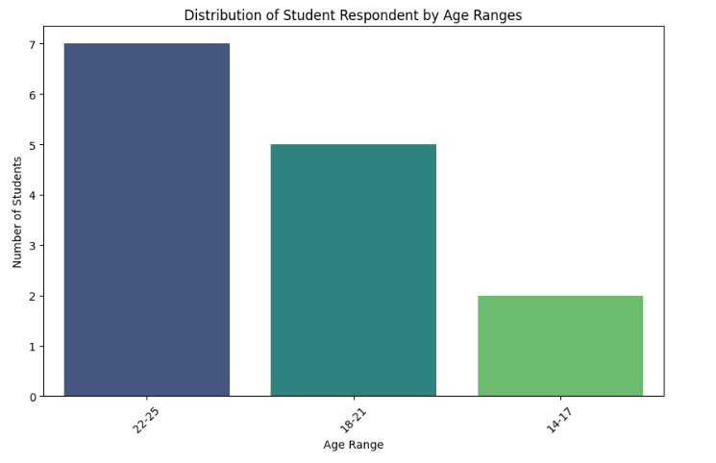
Figure 2: Age of student respondents
Source: Researcher’s Field Data, 2026

Table 2: Students’ response on Family support by age group
AGE | Frequency | Percentage | Frequency | Percentage | Frequency | Percentage | Frequency | Percentage | Total
AGE | Very Supportive |  | Supportive |  | Not Very Supportive |  | Not Supportive at all |  | Total
14 - 17 | 1 | 50 | 1 | 50 | 0 | 0 | 0 |  | 2
18 - 21 | 3 | 60 |  | 0 | 1 | 20 | 1 | 20 | 5
22 - 25 | 3 | 42.9 | 1 | 14 | 2 | 29 | 1 | 14.3 | 7
Total | 7 | — | 2 | — | 3 | — | 2 |  | 14
Source: Researcher’s Field Data, 2026
Table 2 presents students’ responses on family support across three age groups (14–17, 18–21, and 22–25 years). The responses are classified into four levels of support: Very Supportive, Supportive, Not Very Supportive, and Not Supportive at All. A total of 14 students participated in this segment of the study. Among respondents aged 14–17 years, all participants reported positive perceptions of family support. Specifically, 50.0% indicated that their families were Very Supportive, while the remaining 50.0% described them as Supportive. No respondents in this group reported low or absent support. In the 18–21 years age group, responses show a mixed pattern. While a majority (60.0%) perceived their families as Very Supportive, a notable proportion (40.0%) reported lower levels of support, with 20.0% indicating Not Very Supportive and another 20.0% Not Supportive at All. Among respondents aged 22–25 years, perceptions of family support show the greatest variability. While 42.9% reported Very Supportive and 14.3% indicated Supportive, a notable proportion expressed less favorable perceptions, with 28.6% reporting Not Very Supportive and 14.3% Not Supportive at All.
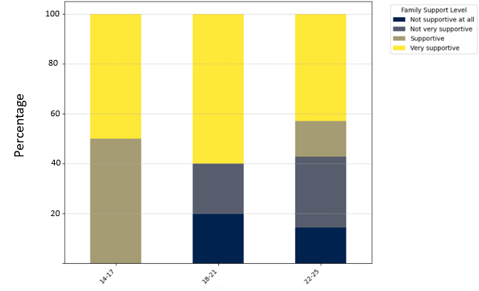
Figure 2: Family support
Source: Researcher’s Field Data, 2026

Table 3: Have you ever dropped out of school (for any period longer than one semester)?
AGE | Frequency | Percentage | Frequency | Percentage | Total
AGE | Yes | Percentage | No | Percentage | Total
14 - 17 | 1 | 50 | 1 | 50 | 2
18 - 21 | 4 | 80 | 1 | 20 | 5
22 - 25 | 5 | 83.3 | 1 | 16.7 | 6
Total | 10 | — | 3 | — | 13
Source: Researcher’s Field Data, 2026
Table 3 presents the distribution of dropout status by age group (N = 13). The overall prevalence of dropout among the respondents was 76.9% (10 out of 13). The proportion of dropout was lowest among students aged 14–17 years, at 50%. In contrast, the highest dropout rate was observed among those aged 22–25 years, at 83.3%, followed closely by the 18–21 age group, which recorded a dropout rate of 80%.
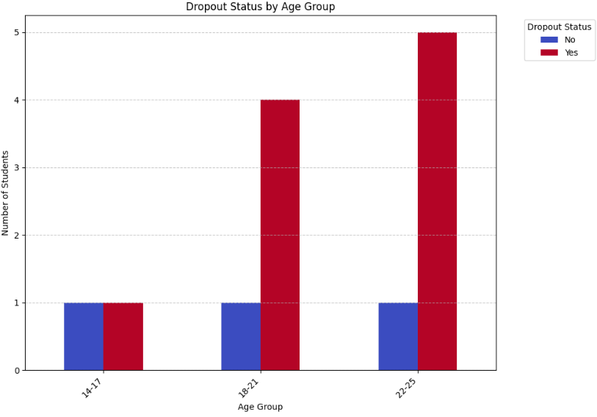
Figure 3: Dropout Status by Age Group
Source: Researcher’s Field Data, 2026

Table 4: If YES, please indicate the main reason for dropout?
AGE | Frequency | Percentage | Frequency | Percentage | Total
AGE | Lack of school fees/money | Percentage | Poor academic performance | Percentage | Total
14 - 17 | 0 | 0 | 1 | 100 | 1
18 - 21 | 4 | 100 | 0 | 0 | 4
22 - 25 | 6 | 100 | 0 | 16 | 6
Total | 10 | — | 1 | — | 11
Source: Researcher’s Field Data, 2026
The data presented in Table 4 indicate that most respondents who provided reasons for dropping out of school identified financial constraints as the primary factor. Specifically, 90.9% (10 out of 11) cited lack of school fees or money, while only 9.1% (1 out of 11) attributed their dropout to poor academic performance. Notably, financial constraints were reported by all respondents within the 18–25 age group

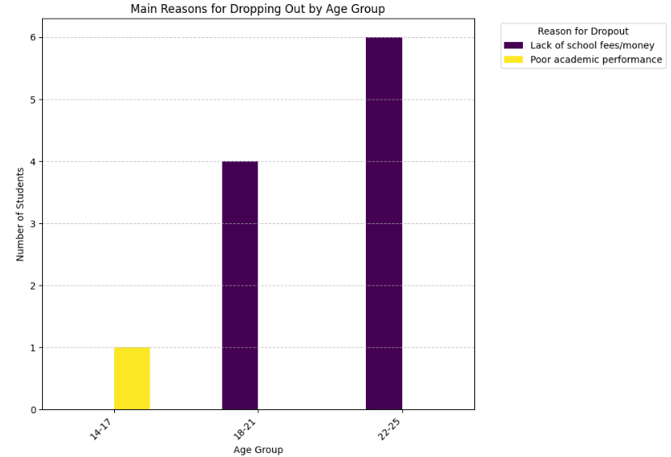
Figure 4: Main reasons for students’ dropout by age
Source: Researcher’s Field Data, 2026

Table 5: Contributing factors to female students’ dropout (Students' response)

Factor | Strongly Agree  n (%) | Agree  n (%) | Neutral  n (%) | Disagree  n (%) | Strongly Disagree  n (%) | Total n
Early Marriage | 7 (50.0%) | 3(21.4%) | 2(14.29%) | 2(14.29%) | 0 (0.00%) | 14
Cost of school supplies & uniforms | 3(21.43%) | 2(14.29%) | 1(7.14%) | 8(57.14%) | 0 (0.00%) | 14
Poor academic performance / difficulty keeping up | 3(21.43%) | 6(42.86%) | 0(0.00%) | 3(21.43%) | 2(14.29%) | 14
Bullying or harassment (by students or teachers) | 7(50.00%) | 6(42.86%) | 0(0.00%) | 1(7.14%) | 0 (0.00%) | 14
Inadequate sanitation (no separate/clean facilities for girls) | 7(50.00%) | 5(35.71%) | 0(0.00%) | 2(14.29%) | 0 (0.00%) | 14
Source: Researcher’s Field Data, 2026
Table 5 presents respondents’ perceptions of the factors contributing to female student dropout. The findings reveal that bullying or harassment is perceived as a major contributing factor, with 50.0% of respondents strongly agreeing and 42.86% agreeing, while only 7.14% disagreed. Similarly, early marriage was identified as a significant factor influencing dropout. Half of the respondents (50.0%) strongly agreed, and 21.4% agreed that early marriage contributes to female student dropout, while 14.29% remained neutral and 14.29% disagreed. Inadequate Sanitation (No Separate/Clean Facilities for Girls) also received high endorsement, with 50.0% strongly agreeing and 35.71% agreeing. A small portion (14.29%) disagreed. Poor academic performance was considered a moderate contributor, with 21.43% strongly agreed and 14.29% agreed, whereas 57.14% disagreed.
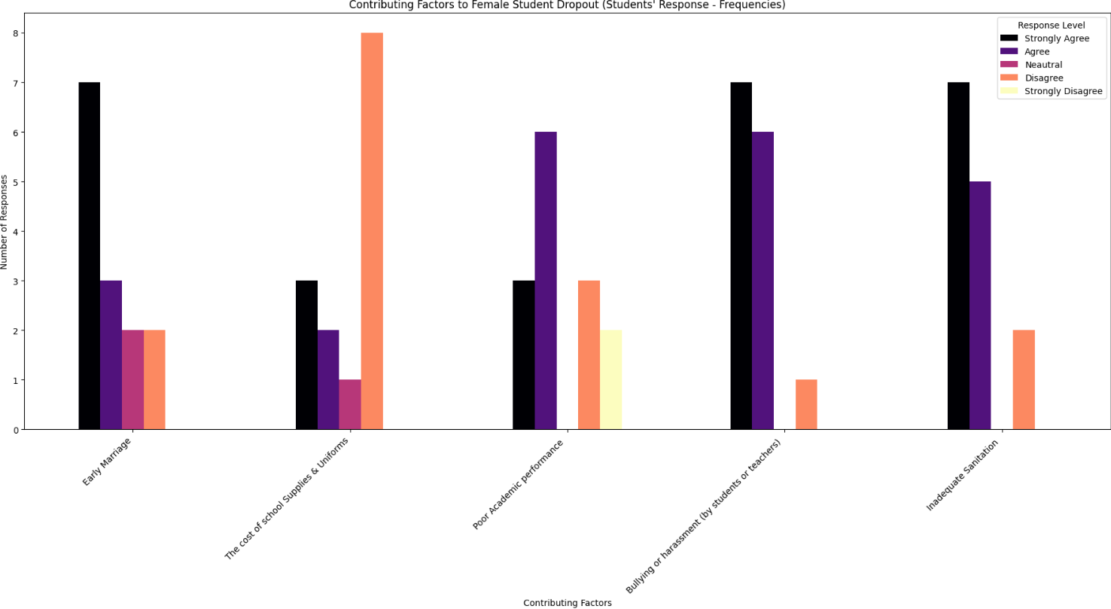
Figure 5: Contributing factors (Students' response)
Source: Researcher’s Field Data, 2026

Table 6: Contributing factors to female students’ dropout (the school administrators and teachers’ response)

Factor | Major Contributor  n (%) | Minor Contributor  n (%) | Moderate Contributor  n (%) | Not a Contributor  n (%) | Total  n
Early Marriage | 6 (50.00%) | 4 (33.33%) | 0 (0.00%) | 2 (16.67%) | 12
Girls' Labor | 4 (33.33%) | 3 (25.00%) | 3 (25.00%) | 2 (16.67%) | 12
Poverty / inability to afford school costs | 2 (16.67%) | 8 (66.67%) | 0 (0.00%) | 2 (16.67%) | 12
Cultural beliefs prioritizing male education | 1 (8.33%) | 3 (25.00%) | 2 (16.67%) | 6 (50.00%) | 12
Peer pressure / negative influence | 1 (8.33%) | 5 (41.67%) | 3 (25.00%) | 3 (25.00%) | 12
Inadequate sanitation | 0 (0.00%) | 6 (50.00%) | 0 (0.00%) | 6 (50.00%) | 12
Long distance from home to school | 7 (58.33%) | 4 (33.33%) | 1 (8.33%) | 0 (0.00%) | 12
Safety concerns / fear of harassment | 0 (0.00%) | 2 (16.67%) | 4 (33.33%) | 6 (50.00%) | 12
Unfriendly school environment | 3 (25.00%) | 5 (41.67%) | 3 (25.00%) | 1 (8.33%) | 12
Poor academic performance | 2 (16.67%) | 3 (25.00%) | 7 (58.33%) | 0 (0.00%) | 12
Bullying / harassment | 0 (0.00%) | 5 (41.67%) | 5 (41.67%) | 2 (16.67%) | 12
Source: Researcher’s Field Data, 2026
Table 6 presents the perceptions of school administrators and teachers regarding the factors contributing to female students’ dropout (N = 12). The findings indicate that long distance from home to school is perceived as the most significant contributor, with most respondents (58.33%) identifying it as a major factor and an additional 33.33% as a minor factor.
Early marriage is also recognized as a key contributor, with 50.00% of respondents rating it as a major factor and 33.33% as a minor factor, while only 16.67% considered it not a contributor.
In contrast, poverty or inability to afford school costs is largely viewed as a minor contributor, as indicated by 66.67% of respondents, while only 16.67% considered it a major factor. Similarly, girls’ labor is perceived as a mixed contributor, with responses distributed across major (33.33%), minor (25.00%), and moderate (25.00%) categories, indicating varying opinions on its impact. Factors such as unfriendly school environment and peer pressure or negative influence are predominantly viewed as minor contributors, with 41.67% of respondents in each case selecting this category. Meanwhile, poor academic performance is primarily considered a moderate contributor (58.33%).
On the other hand, factors such as cultural beliefs prioritizing male education (50.00%) and safety concerns or fear of harassment (50.00%) are predominantly viewed as not contributing to dropout. Similarly, inadequate sanitation is equally split between being a minor contributor (50.00%) and not a contributor (50.00%), suggesting divided opinions among respondents.
Lastly, bullying or harassment was perceived as both a minor (41.67%) and moderate (41.67%) contributor, with fewer respondents considering it not a contributor (16.67%).
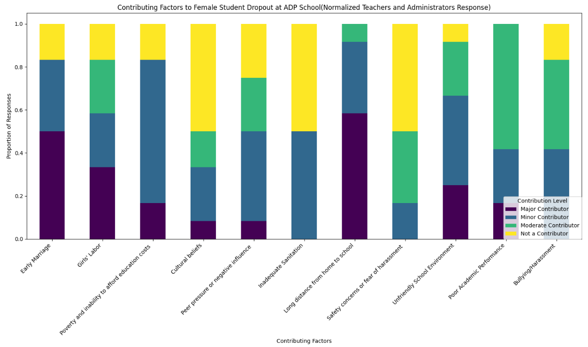
Figure 6: Contributing factors (the school administrators and teachers’ response)
Source: Researcher’s Field Data, 2026

Table 7: Contributing factors to female students’ dropout (PTA'S response)

Factor | Major Contributor  n (%) | Moderate Contributor n (%) | Minor Contributor n (%) | Not a Contributor n (%) | Total (n)
Early Marriage | 5 (45.45%) | 2 (18.18%) | 4 (36.36%) | 0 (0.00%) | 11
Teenage Pregnancy | 8 (72.73%) | 1 (18.18%) | 2 (18.18%) | 0 (0.00%) | 11
Poverty (economic factor) | 4 (36.36%) | 3 (27.27%) | 3 (27.27%) | 1 (9.09%) | 11
Cultural beliefs prioritizing male education | 0 (0.00%) | 4 (36.36%) | 5 (45.45%) | 2 (18.18%) | 11
Inadequate sanitation (lack of separate/clean facilities) | 1 (9.09%) | 1 (9.09%) | 6 (54.55%) | 3 (27.27%) | 11
Source: Researcher’s Field Data, 2026
Table 7 presents the responses of Parent-Teacher Association (PTA) members regarding factors contributing to female students’ dropout (N = 11). The results indicate that teenage pregnancy is considered the most important contributor to female student dropout, with a substantial majority of respondents (72.73%) identifying it as a major contributor. A smaller proportion (18.18%) rated it as moderate, while another 18.18% viewed it as a minor contributor.
Early marriage is also perceived as a key factor, with 45.45% of respondents identifying it as a major contributor, while 36.36% and 18.18% rated it as minor and moderate contributors, respectively. Notably, none of the respondents considered it as not a contributor.
Poverty (economic factors) shows a more mixed of responses. While 36.36% of respondents identified it as a major contributor, equal proportions (27.27%) rated it as moderate and minor contributors, and only 9.09% considered it not a contributor.
In contrast, cultural beliefs prioritizing male education are largely viewed as less influential. Most respondents rated this factor as a minor (45.45%) or moderate contributor (36.36%), while 18.18% considered it not a contributor, and no one identified it as a major factor.
Similarly, inadequate sanitation facilities are generally perceived as having limited impact on dropout. Most respondents (54.55%) rated it as a minor contributor, and 27.27% as not a contributor, with only 9.09% each identifying it as major or moderate.

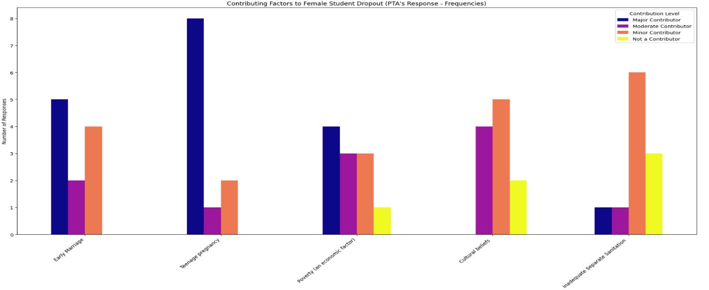
Figure 7: Contributing factors (PTA'S response)
Source: Researcher’s Field Data, 2026

Table 8: Effects of female students dropout (Community members' response)
Effect of female students dropout | Strongly  Agree No. (%) | Agree No. (%) | Neutral No. (%) | Disagree No. (%) | Strongly Disagree No. (%) | Total  No.
Earlier marriages and pregnancies | 8(61.54) | 3(23.08) | 0(0.00) | 0(0.00) | 2(15.40) | 13
Reduced income and increased poverty for future families | 7 (53.85) | 4(30.77) | 0(0.00) | 0(0.00) | 2(15.40) | 13
Lower educational attainment/literacy rate | 9(69.23) | 2(15.38) | 0(0.00) | 0(0.00) | 2(15.40) | 13
Loss of future female leaders | 9(69.23) | 3(23.08) | 0(0.00) | 0(0.00) | 1(7.69) | 13
Increased financial burden on families | 9(69.23) | 3(23.08 | 1(7.69) | 0(0.00) | 0(0.00) | 13
Source: Researcher’s Field Data, 2026

Table 8 presents community members’ views on the effects of female students’ dropout. A large majority of respondents indicated that dropout leads to lower educational attainment and literacy, with 69.23% strongly agreeing and 15.38% agreeing. Similarly, the loss of future female leaders was emphasized, with 69.23% strongly agreeing and 23.08% agreeing.
In terms of economic impact, 69.23% of respondents strongly agreed and 23.08% agreed that dropout results in an increased financial burden on families. Additionally, 53.85% strongly agreed and 30.77% agreed that it contributes to reduced income levels and increased poverty in the future. From a social perspective, 61.54% strongly agreed and 23.08% agreed that dropout leads to earlier marriages and pregnancies.

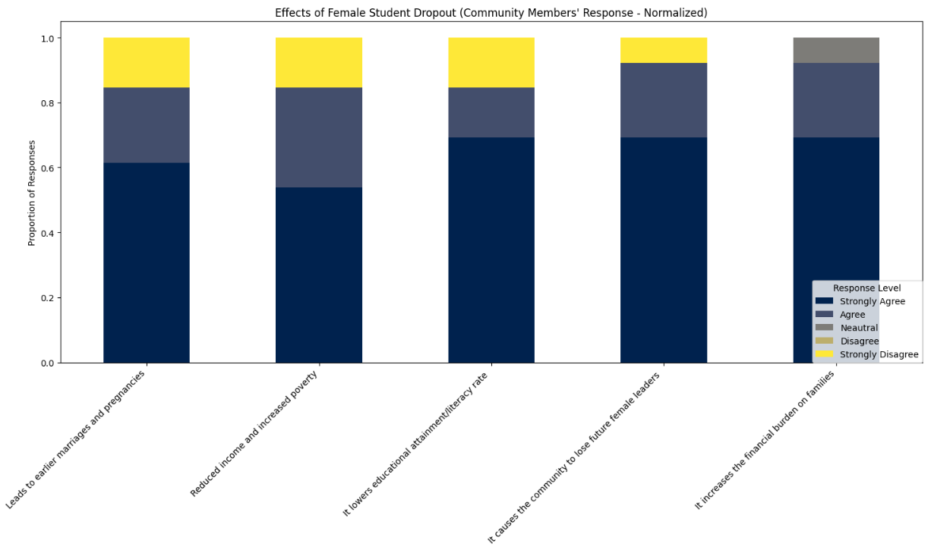
Figure 8: Effects of female dropout (Community members' response)
Year | Enrolment Male  No. (%) | Enrolment Female  No. (%) | Total  No. (%) | Dropout Male  No. (%) | Dropout Female  No. (%) | Total  No. (%)
2023 | 167 (49.41%) | 171 (50.59%) | 338 | 12 (46.15%) | 14 (53.85%) | 26
2024 | 366 (64.66%) | 200 (35.34%) | 566 | 10 (38.46%) | 16 (61.54%) | 26
2025 | 426 (64.35%) | 236 (41.70%) | 662 | 5 (35.65%) | 8 (61.54%) | 13
Source: Researcher’s Field Data, 2026

Table 9: Documentary review (school records)

Source: Researcher’s Field Data, 2026
Table 9 shows the enrolment and dropout trends at Albert Daniel Peabody Public School from 2023 to 2025. Overall, the number of students increased steadily, from 338 in 2023 to 566 in 2024, and then to 662 in 2025. Looking at enrolment by gender, female students slightly outnumbered males, constituting 50.59% of total enrolment, compared to 49.41% for males. However, in 2024 and 2025, male enrolment became predominant (64.66% and 64.35% respectively), while female enrolment dropped proportionally (35.34% and 41.70%).
Dropout patterns reveal that female students were consistently more affected than males. In 2023, 53.85% of dropouts were female, increasing to 61.54% in both 2024 and 2025. Male dropout rates declined over the same period, from 46.15% in 2023 to 35.65% in 2025. Despite the decrease in total dropout numbers in 2025 (13 students) compared to previous years (26 students in 2023 and 2024), female students remain disproportionately vulnerable to leaving school prematurely.

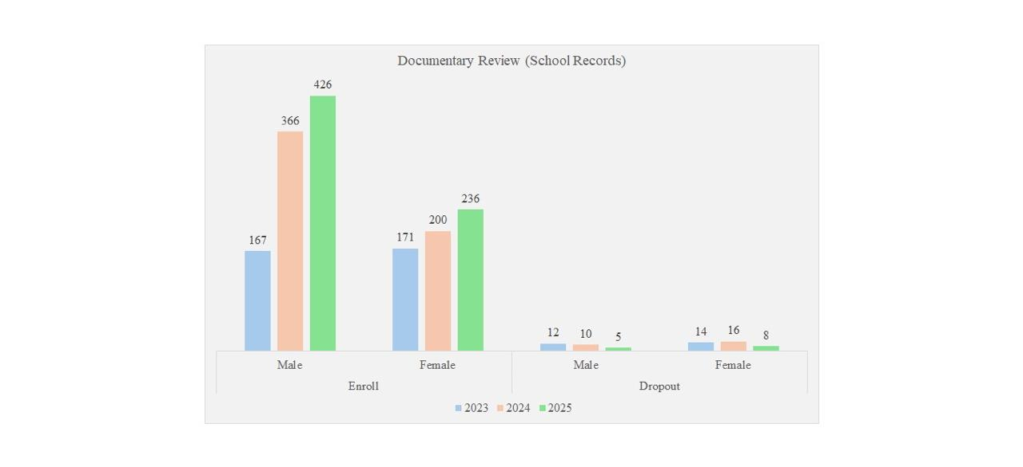
Figure 9: Documentary review (school records)
Source: Researcher’s Field Data, 2026
Table 10: School Administrators’ and Teachers’ Views on MOE Policy Guidance for Female Student Dropout
Response | Frequency | Percentage
Strongly Agree | 1 | 8.3
Agree | 6 | 50
Strongly Disagree | 3 | 25
Disagree | 1 | 8.3
Neutral | 1 | 8.3
Total | 12 | 100
Source: Researcher’s Field Data, 2026
Table 10 presents the perceptions of school administrators and teachers regarding whether the Ministry of Education (MOE) provides sufficient policy guidance to address female student dropout (N = 12). The findings indicate that a majority of respondents hold a positive view, with 50% agreeing and 8.3% strongly agreeing, suggesting that over half (58.3%) perceive the existing MOE policy framework as adequate.
However, a considerable proportion of respondents expressed dissatisfaction. Specifically, 25% strongly disagreed and 8.3% disagreed, indicating that 33.3% of participants believe that the current policy guidance is insufficient to effectively tackle female student dropout. Additionally, 8.3% of respondents remained neutral, reflecting some level of uncertainty or lack of clear awareness regarding the effectiveness of MOE policies.
Overall, while the findings suggest moderate confidence in MOE policy guidance, the notable level of disagreement highlights the need for strengthening, clarifying, and effectively implementing policies aimed at reducing female student dropout.

Figure 10: School Administrators’ and Teachers’ Views on MOE Policy Guidance for Female Student Dropout
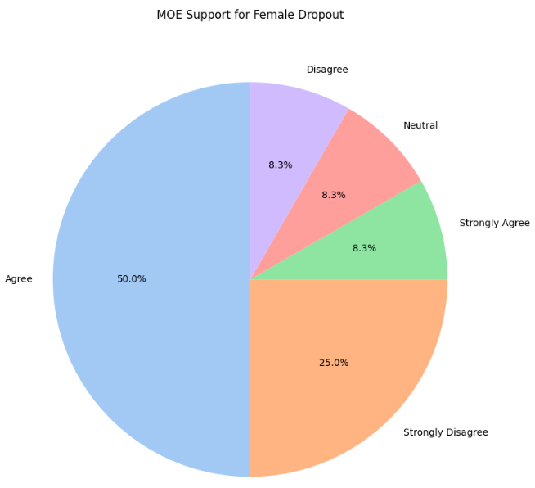
Source: Researcher’s Field Data, 2026

4.2 Findings
The investigation yielded the following key findings based on the analysis and interpretation of Tables 1 to 9:
Table 1: Indicates that most student respondents (50%) were within the 22–25 years age group, followed by those aged 18–21 years (36%), while only 14% were aged 14–17 years. This distribution suggests that older students constituted the largest proportion of the study population.
Table 2: Reveals that family support was generally perceived as positive across all age groups. However, it was most pronounced among respondents aged 14–17 years, where 100% reported their families as either very supportive or supportive. As age increased, there was a noticeable rise in perceptions of inadequate family support, particularly among respondents aged 22–25 years. This trend suggests a gradual decline in perceived family support with increasing age.
Table 3: Indicates that the overall prevalence of dropout among respondents was high (76.9%). The findings further show that dropout rates increased with age, with the lowest rate recorded among students aged 14–17 years (50%) and the highest among those aged 22–25 years (83.3%). This pattern suggests that older students are more likely to experience interruptions in their schooling.
Table 4: Reveals that financial difficulties were the main reason why students dropped out of school, with an overwhelming 90.9% of respondents stating that they left due to a lack of school fees or money. In comparison, only a small number (9.1%) identified poor academic performance as the cause of their withdrawal. This suggests that economic hardship, rather than academic ability, plays a much greater role in influencing students’ decisions to leave school.
Table 5: Shows that most students believe bullying or harassment (92.86%) and poor sanitation in schools (85.71%) are the main reasons why students drop out. A large number also pointed to early marriage (71.4%) as an important factor. Poor academic performance was mentioned by some students, but it was not seen as a major cause compared to the others. On the other hand, most respondents did not consider the cost of school supplies to be a key reason for dropout.
Table 6: Shows that school administrators and teachers considered long distances to school (58.33%) and early marriage (50%) as the main reasons for student dropout. Poverty was mostly seen as a minor factor (66.67%), and poor academic performance was viewed as a moderate contributor (58.33%). Cultural beliefs and safety concerns were generally not regarded as important causes of dropout.
Table 7: Indicates that PTA members viewed teenage pregnancy (72.73%) as the main reason for female student dropout, with early marriage (45.45%) also seen as an important factor. Poverty received mixed responses, while cultural beliefs and poor sanitation were generally considered less significant in contributing to dropouts.
Table 8: Reveals that community members believe female student dropout has serious social and economic effects on both society and families. The highest concerns were the loss of future female leaders (92.31%) and greater financial pressure on families (92.31%), followed by reduced income and increased poverty (84.62%) and higher rates of early marriage and pregnancy (84.62%). The lowest, though still significant, was lower education levels (84.61%).
Table 9: Indicate a steady increase in school enrolment, rising from 338 students in 2023 to 662 students in 2025, which reflects a notable improvement in access to education over the three-year period. However, despite this overall growth, female students consistently experienced higher dropout rates, accounting for more than 53% of all cases each year. Although the total number of dropouts decreased in 2025, gender disparities persisted, with female students remaining disproportionately vulnerable to school withdrawal compared to their male counterparts.
Table 10: Reveals the views of school administrators and teachers regarding the adequacy of policy guidance provided by the Ministry of Education (MOE) in addressing female student dropout. The findings indicate that most respondents hold a positive perception of the Ministry’s role. Specifically, 50% of respondents agreed, while 8.3% strongly agreed that the MOE provides sufficient policy guidance. This suggests that more than half of the participants acknowledge the presence of supportive policies aimed at reducing female student dropout.
However, a notable proportion of respondents expressed dissatisfaction. About 25% strongly disagreed and 8.3% disagreed, indicating concerns about the effectiveness, implementation, or adequacy of these policies. Additionally, 8.3% of respondents remained neutral, reflecting uncertainty or lack of sufficient information regarding the Ministry’s policy efforts.

4.3 Discussion of Findings
The findings of this study reveal that female student dropout at ADP Public School is driven by a complex interaction of financial, socio-cultural, and school-related factors. These results are consistent with a broad body of global research, which frames girls’ dropout as a multidimensional issue requiring integrated interventions.
Financial constraints emerged as the most significant determinant, with 90.9% of respondents identifying inability to pay school fees as the primary cause of dropout. This aligns with studies across Sub-Saharan Africa, where household poverty remains a dominant barrier to girls’ education (UNESCO, 2022; World Bank, 2023). Research indicates that even in contexts where tuition is nominal or officially free, indirect costs such as uniforms, learning materials, and transportation disproportionately affect girls, especially in low-income households (Evans & Yuan, 2024). The present study reinforces this reality, suggesting that economic vulnerability directly translates into interrupted educational trajectories for female students in Margibi County.
Socio-cultural factors, particularly early marriage and teenage pregnancy, were also identified as major contributors to dropout, supported by over 70% of both students and PTA members. This finding is consistent with global evidence showing that entrenched gender norms and cultural expectations significantly limit girls’ educational opportunities (UNICEF, 2023). In many developing contexts, early marriage is often perceived as an economic coping strategy for families, further perpetuating cycles of poverty and educational exclusion (Bicchieri et al., 2023). Similarly, teenage pregnancy has been widely documented as both a cause and consequence of school dropout, often linked to inadequate sexual and reproductive health education and limited access to support systems (WHO, 2022). The convergence of these factors in this study underscores the persistent influence of socio-cultural norms on girls’ education.
School-related factors were also found to play a critical role. A striking 92.86% of respondents identified bullying and harassment as key contributors to dropout, while 85.71% pointed to inadequate sanitation facilities. These findings are supported by international research emphasizing the importance of safe and gender-responsive school environments. Studies show that school-related gender-based violence significantly undermines girls’ participation and retention (Global Partnership for Education, 2023).
Additionally, lack of adequate sanitation particularly menstrual hygiene facilities has been linked to absenteeism and eventual dropout among adolescent girls (Sommer et al., 2021; UNICEF, 2023). The results of this study therefore highlight the urgent need for schools to provide safe, inclusive, and supportive learning environments.
The consequences of female student dropout identified in this study further reinforce its broader societal implications. The loss of future female leaders and increased family financial burden (92.31%) reflect findings from global development literature, which emphasizes the long-term economic and social costs of girls’ educational exclusion (World Bank, 2023). Educated women are more likely to contribute to economic growth, improve family health outcomes, and support the education of future generations (Psaki et al., 2022). Conversely, dropout is associated with higher rates of early marriage, poverty, and intergenerational disadvantage. The findings from ADP Public School therefore mirror global patterns, demonstrating that female dropout is not only an educational issue but also a development challenge.
From a general perspective, the study confirms that female student dropout is a multifaceted problem requiring coordinated interventions across economic, social, and institutional domains. The consistency of these findings with international research strengthens their validity and underscores the urgency of targeted policy and programmatic responses.

CHAPTER FIVE: SUMMARY/CONCLUSION AND RECOMMENDATIONS
5.1 Summary
This study investigated the causes and effects of female student dropout at ADP Public School in the Marshall Education District, Margibi County, Liberia. The findings demonstrate that dropout among female students is influenced by a combination of financial hardship, socio-cultural pressures, and unfavorable school conditions.
Financial barriers, particularly the inability to afford school-related costs, were identified as the most critical factor driving dropout. Socio-cultural practices such as early marriage and teenage pregnancy further exacerbate the problem, reflecting deeply rooted gender norms that limit girls’ educational opportunities. Additionally, school-related challenges including bullying, harassment, and inadequate sanitation facilities create an environment that discourages female students from remaining in school.
The consequences of dropout are far-reaching, affecting not only the individuals involved but also families, communities, and national development. The loss of educated female citizens undermines gender equity, economic progress, and social advancement.
5.2 Conclusion
In conclusion, female student dropout at ADP Public School is a complex and pressing issue that requires comprehensive and sustained interventions. Addressing this challenge is essential for improving girls’ educational outcomes and achieving broader development goals in Liberia.

5.3 Recommendations
- The government and stakeholders should implement targeted financial assistance programs, such as scholarships, fee waivers, and provision of learning materials, to reduce the economic burden on families and ensure that girls can remain in school.
- Policymakers and community leaders should enforce existing laws and implement awareness programs that discourage early marriage and teenage pregnancy, while promoting girls’ education and empowerment.
- School authorities should ensure a safe and supportive learning environment by addressing bullying and harassment, and by providing adequate gender-sensitive sanitation facilities to enhance girls’ comfort, safety, and retention.
Top of Form
Bottom of Form

BIBLIOGRAPHY
Abena, F. D.(1991). The Emancipation of Women An African Perspective. Accra: Ghana Universities Press. ww.jstor.org/stable/525186
Achoka (2007). ‘Perspectives of school dropouts’ dilemma in Palestinian refugee camps in Lebanon: An ethnographic study’. International Journal of Educational Development (35): 5366
African Development Bank. 2011. African Development: Fund United Republic Of Tanzania 2011-2015 Regional Department East 1 Orea June 2011. Country Strategy Paper.[Online]. Available:http://www.afdb.org/fileadmin/uploads/afdb/Documents/ProjectandOperation s/Tanzania-%202011-2015%20CSP.pdf. [Accessed on 12, June 2013]
African Youth Charter 2006. Addis Ababa: African Union. [Online]. Available:http://www.africaunion.org/root/ua/conferences/mai/hrst/charter%20english.pdf. [Accessed on 08 June, 2013]
Ahmed, M.A., Salman, M.F., Ogunlade, O.O. and Ahmed, R.B. (2015) ‘Enhancing women/girl education: a panacea for national development’, Conference paper of the 2nd International Conference on Education and Social Sciences, 2–4 February, Istanbul, Turkey.
Ainsworth, M. (2005). Socioeconomic Determinants of Fertility in Sub-Saharan Africa: A Summary of the Findings of a World Bank Research Project. Washington D.C.: The World Bank
Akinyi, O. P. (2013) factors that influence the retention of female students in secondary schools in Muhoroni division Muhoroni district, Kisumu County Auman, B. Johnson, O. (2014) the effect of gender and Racial differences on high school dropout rates Link:http://www.gradschool.umd.edu/summerprogram/PostersSRI/BeverlyA uman.pdf
Andiema, N., & Manasi, E. (2021). Female students’ participation in technical vocational education and training in West Pokot County, Kenya. East Africa Journal of Education Studies, 3(1), 61 – 69. https://doi.org/10.37284/eajes.31.314
Anho (2011). ‘Tradition, enlightenment, and the role of schooling in gender politics among Somali girls and women in Dadaab’. In Bartlett, L. and Ghaffar - Kucher, A. (eds.) Refugees, immigrants, and education in the Global South: Lives in motion. New York: Routledge, pp. 116-132.
Ani, K.J. and Osakwe, C. (2014) ‘Girl child education in post-war Sierra Leone’, Journal of Conflictology, Vol. 5, No. 2, pp.31–38.
Ary, et al (1996). Introduction to Research in Education (Sed, New York: Holt Rinehart and Winston, Inc.
Atayi, J. B. (2008). Disabling Barriers to Girls’ Primary Education in Aura District (Uganda) – An Intersectional Analysis. A Research Paper presented in partial fulfilment of the requirements for obtaining the degree of Master of Arts in Development Studies.
Bhorat, H. (2003). The Post-apartheid Challenge: Labour Demand Trends in the South African Labour Markefinancial 1999. Development Policy Research Unit Working paper 03/82. Cape Town: University of Cape Town.
Birdsall, N (2005). Towards Universal Primary Education: investments, incentives, and institutions. European Journal of Education, 40 (3), 337 – 349.
Bledsoe C. (2002). Contingent lives: Fertility, time, and aging in West Africa. Chicago: University of Chicago Press.
Boonprasert (2010). ‘Dropout Syndrome among Girls in Secondary Schools and Human Resources Development in Nigeria’ CORE. URL: https://core.ac.uk/download/pdf/234633906.pdf
Brimer, M.A. (1971). Wastage in Education, a World Problem, Paris: UNESCO.
Carleton University. (2021). The causes of female student dropout in a secondary school in the Dadaab Refugee Camps of Kenya (LERRN Working Paper No. 12). https://carleton.ca/lerrn/wp-content/uploads/Final-LERRN-Working-Paper-No.-12-Female-Student-Drop-Out.pdf
Chinyoka, K. (2014) ‘Causes of school dropout among ordinary level learners in a resettlement area in Masvingo’, Journal of Emerging Trends in Educational Research and Policy Studies, Vol. 5, No. 3, pp.106–128.
DE SMEDT, J. (1998) ‘Child Marriages in Rwandan Refugee Camps’. Journal of the International African Institute 68(2): 211-237.
Development and International Planned Parenthood Federation (2012). In Their Own Words: Girls from Liberia on Sexuality, Pregnancy and Services (Monrovia: FORWARD and IPPF).
Education Directory (2013): Iftin Foundation
Ellington H. (1995), Understanding Schools’ Organisations. Penguin Books Ltd. London. Pg 43-89.
Farah, M. M. (1987). A study on why there is a high turn-over of primary school level teachers in the Somali education system. Unpublished Ms Thesis, United States International University-Africa International Journal of Business and Social Science Vol. 3 No. 7; April 2012
Girl-Pupil Dropout in Secondary Schools in Botswana: Influencing Factors, Prevalence and Consequences
Grant, M. and Hallman, K. (2006). Disadvantages and Youth Schooling, Working and Child Bearing in South Africa. Paper presented at the annual meeting of population of America.
Hornby, A.S. (2004). Oxford Advanced Learner`s Dictionary of Current English. Oxford University Press
Hunt, F. (2008). Dropping out from school: A cross-country review of literature. Create Pathways to Access No 16. Consortium for Research on Educational Access, Transitions and Equity: University of Sussex.
IFPRI (2004) Human Capital, Household Welfare, and Children Schooling in Mozambique. Research Report Abstract Washington, DC.
Illo, C.O., Lawal, R.O., Ezekiel, A.I.D. and Loko, S.T. (2014). Investing in girl child education for national development’, Mediterranean Journal of Social Sciences, Vol. 5, No. 27, pp.692–697.
Insights Liberia. (2024, December 4). The hidden crisis: Liberia's school dropout epidemic among girls and the danger to economic empowerment. Insights Liberia. https://www.insightsliberia.com/post/hidden-crisis-liberias-school-dropout-epidemic-girls-economic-empowerment
JAC Group of Companies/EducateHer. (2021). Educate HER: Barriers to girls' attendance, retention and completion from secondary schools in Liberia. Education Out Loud.
Juneja, N. (2001). Primary Education for All in the City of Mumbai, India: The Challenge Set by Local Actors. School Mapping and Local-Level Planning. Paris: UNESCO.
Kose, K. (2011). Effects of School and Private Courses on students' academic achievement taking the high school entrance exams from the aspect of socio-economic and demographic characteristics of the family. Education Journal, 5(17), 46-7
National University of Educational Planning and Administration, Occasional Paper 37
Nur, M. A. (2010), Factors that influence secondary school students’ performance in mathematics in Banadir region, Somalia
Somali Development and Reconstruction Bank (2014): Somali Education Survey Report Somali
Sunita Chugh (2011) Dropout in Secondary Education, A study of Children living in Slums in Delhi
Sweeten G. A. (2004) school dropout and subsequent offending distinguishing selection from causation. Thesis submitted to the Faculty of the Graduate School of the University of Maryland, College Park in partial fulfillment of the requirements of the degree of Master of Arts
UNESCO (2007) EFA Global Monitoring Report 2007: Strong Foundations, Early, Childhood Care and Education. Paris UNESCO Publishing

APPENDIX A: LETTER FROM THE DEAN


APPENDIX B(i): QUESTIONNAIRE FOR STUDENTS.

INTRODUCTION:
This questionnaire is anonymous and confidential. Please tick (✓) the box that best reflects your opinion.
PART 1: Socio-Demographic Characteristics
Please tick the appropriate box or write your answer in the space provided.
  - Age:
☐ 10–13 ☐ 14– 17 ☐ 18–21
☐ 22 – 25 ☐ 26–29+
  - Marital status:
☐ Single ☐ Engaged ☐ Married ☐ Divorced ☐ Widowed
  - Educational level:
☐ Primary ☐ Secondary ☐ Dropout
  - Religion:
☐ Catholic ☐ Muslim ☐ Protestant ☐ Others
  - Number of Children (if any):______________
PART 2: School Status and Experience
  - Do you feel safe and supported by teachers and staff at this school?
☐Always ☐ Often ☐ Sometimes ☐ Never
Do you currently benefit from any form of Free/subsidized education?
☐ Yes ☐ No
  - How supportive is your family of your education?
☐ Very supportive ☐ Supportive ☐ Not very supportive ☐ Not supportive at all
  - Have you ever dropped out of school (for any period longer than one semester)?
☐ Yes ☐ No
  - If YES to question 4, please indicate the main reason (Select only ONE):
☐ Lack of school fees/money ☐ Family issues/illness
☐ Needed to work (Labor) ☐ Poor academic performance
☐ Early marriage/Pregnancy ☐ Bullying/Unsafe school environment ☐ Other (e.g., expelled)

PART 3: Perceived Causes of Female Dropouts
Please tick (✓) the box that best reflects your opinion.
No | Statement | Strongly Disagree | Disagree | Neutral | Agree | Strongly Agree
3.1 | The cost of school supplies and uniforms causes many students to drop out. | ( ) | ( ) | ( ) | ( ) | ( )
3.2 | Poor grades or difficulty keeping up with studies cause students to leave. | ( ) | ( ) | ( ) | ( ) | ( )
3.3 | Bullying or harassment (by students or teachers) makes students want to drop out. | ( ) | ( ) | ( ) | ( ) | ( )
3.4 | Early marriage or pregnancy is a significant cause of female student dropout. | ( ) | ( ) | ( ) | ( ) | ( )
3.5 | Students drop out because they feel the school facilities (e.g., toilets, classrooms) are poor. | ( ) | ( ) | ( ) | ( ) | ( )

PART 4: Perceived Effects of Female Dropouts
Please tick (✓) the box that best reflects your opinion
# | Statement | Strongly Disagree | Disagree | Neutral | Agree | Strongly Agree
4.1 | School dropout leads to increased youth unemployment in our community. | ( ) | ( ) | ( ) | ( ) | ( )
4.2 | School dropout leads to increased crime or social problems in society. | ( ) | ( ) | ( ) | ( ) | ( )
4.3 | Dropouts are more likely to have fewer job opportunities in the future. | ( ) | ( ) | ( ) | ( ) | ( )
4.4 | Girls who drop out are more likely to face early marriage and pregnancy | ( ) | ( ) | ( ) | ( ) | ( )
4.5 | Dropouts may face more health problems because they lack knowledge. | ( ) | ( ) | ( ) | ( ) | ( )

PART 5: Proposed Solutions and Interventions

Please indicate how effective you believe the following solutions are for reducing female dropouts at ADP School.

# | Statement | Strongly Disagree | Disagree | Neutral | Agree | Strongly Agree
5.1 | Providing financial assistance (scholarships or fee waivers) would greatly reduce dropouts. | ( ) | ( ) | ( ) | ( ) | ( )
5.2 | Improving teacher support and tutoring for struggling students would help prevent dropouts. | ( ) | ( ) | ( ) | ( ) | ( )
5.3 | Stricter rules against bullying and harassment would make students feel safer and stay. | ( ) | ( ) | ( ) | ( ) | ( )
5.4 | The school should start a counselling or mentorship program for students. | ( ) | ( ) | ( ) | ( ) | ( )
5.5 | The community leaders and parents need to be more involved in supporting the school. | ( ) | ( ) | ( ) | ( ) | ( )

Thank you for being so cooperative!

APPENDIX B(ii): QUESTIONNAIRE FOR SCHOOL ADMINISTRATORS AND TEACHERS
This questionnaire is anonymous and confidential. Please tick (✓) the box that best reflects your opinion
PART 1: Status of Female Student Dropout
  - Since 2023, has the female-to-male student enrolment ratio in grade 7 generally:
☐ Increased ☐ Stayed the same (approx. 50:50) ☐ Decreased
  - DO most female students who reach Grade 7 go on to complete Grade 12?
☐ Yes, almost all (90 –100%) ☐ Most (70–89%)
☐ About half (50–69%) ☐ Less than half (Below 50%)
  - How effective have the school's current strategies been in improving female student completion rates?
☐Very effective ☐ Effective ☐Somewhat effective ☐Not effective
  - How would you rate the parents' opinions concerning girls' education in this area?
☐ (Very Negative) ☐ (Negative) ☐ (Neutral/Mixed)
☐ (Positive) ☐ (Very Positive)
Please tick (✓) the box that best reflects your opinion.
No. | Statement | Strongly Agree | Agree | Neutral | Disagree | Strongly Disagree
1.5 | The dropout rate among female students remains a serious and persistent challenge at ADP Public School in Marshall. | ( ) | ( ) | ( ) | ( ) | ( )
1.6 | The female dropout rate has noticeably increased over the last five years. | ( ) | ( ) | ( ) | ( ) | ( )
1.7 | Dropout rates are higher among female students than male students in this school | ( ) | ( ) | ( ) | ( ) | ( )

PART 2: Contributing Factor (Socio-Economic and Cultural Factors)
Please tick (✓) the box that best reflects your opinion.
No. | Factor | Major Contributor | Moderate Contributor | Minor Contributor | Not a Contributor
2.1 | Early marriage
2.2 | The demand for girls' labor (household chores, family business). | ( ) | ( ) | ( ) | ( )
2.3 | Poverty and inability to afford education costs (uniform, books, fees). | ( ) | ( ) | ( ) | ( )
2.4 | Cultural beliefs that prioritize male education over female education. | ( ) | ( ) | ( ) | ( )
2.5 | Peer pressure or negative influence from friends who have dropped out. | ( ) | ( ) | ( ) | ( )
2.6 | Lack of separate and adequate sanitation facilities for girls causes frequent absenteeism and dropout | ( ) | ( ) | ( ) | ( )

PART 3: School-Related Factors
Please tick (✓) the box that best reflects your opinion
# | Factor | Major Contributor | Moderate Contributor | Minor Contributor | Not a Contributor
3.1 | Long distance from home to school. | ( ) | ( ) | ( ) | ( )
3.2 | Safety concerns or fear of harassment (including gender-based violence) on the way to/from school. | ( ) | ( ) | ( ) | ( )
3.3 | Unfriendly school environment (e.g., inadequate sanitation, poor student-teacher relationships). | ( ) | ( ) | ( ) | ( )
3.4 | Poor academic performance and lack of targeted support/tutoring. | ( ) | ( ) | ( ) | ( )
3.5 | Bullying or harassment by male students. | ( ) | ( ) | ( ) | ( )

PART 4: Stakeholder Measures and Effectiveness
Please tick (✓) the box that best reflects your opinion
# | Statement | Strongly Agree | Agree | Neutral | Disagree | Strongly Disagree
4.1 | The school administration and teachers have adequate mechanisms (e.g., counselling, home visits) to follow up on absent female students. | ( ) | ( ) | ( ) | ( ) | ( )
4.2 | The MOE provides sufficient policy guidance and resources to tackle female dropout. | ( ) | ( ) | ( ) | ( ) | ( )
4.3 | The PTA/Community leaders are effectively supporting the school's efforts to retain female students. | ( ) | ( ) | ( ) | ( ) | ( )
4.4 | Financial/Scholarship programs aimed at vulnerable female students are adequately addressing the economic barrier. | ( ) | ( ) | ( ) | ( ) | ( )
4.5 | Gender-sensitive training for teachers has significantly helped in creating a supportive learning environment for girls. | ( ) | ( ) | ( ) | ( ) | ( )

PART 5: Proposed Solutions (Minimizing Dropout)
Please assess the potential effectiveness of the following strategies for reducing female student dropout rates.
# | Strategy | Very Effective | Effective | Moderately Effective | Not Effective
5.1 | Providing school feeding programs or financial incentives (stipends) to vulnerable girls. | ( ) | ( ) | ( ) | ( )
5.2 | Establishing girls' clubs or mentoring programs within the school. | ( ) | ( ) | ( ) | ( )
5.3 | Conducting mandatory community awareness campaigns against early marriage and child labor. | ( ) | ( ) | ( ) | ( )
5.4 | Enforcing strong disciplinary action against students or staff involved in harassment/bullying. | ( ) | ( ) | ( ) | ( )
 | Improving and maintaining female-friendly sanitation and water facilities in the school. | ( ) | ( ) | ( ) | ( )
5.5 | Implementing a policy allowing the re-entry of students who dropped out due to pregnancy. | ( ) | ( ) | ( ) | ( )

APPENDIX B(iii): QUESTIONNAIRE FOR PARENTS (PTA COMMITTEE)
This questionnaire is anonymous and confidential. Please tick (✓) the box that best reflects your opinion

PART 1: Perception of the Dropout Problem

How much do you agree that the following factors contribute to female student dropout in your school?
No. | Factor | Not a Factor | Minor Factor | Moderate Factor | Major Factor
1.1 | Early marriage is a major cause of female students leaving school. | ( ) | ( ) | ( ) | ( )
1.2 | Teenage pregnancy contributes to female students dropping out. | ( ) | ( ) | ( ) | ( )
1.3 | Poverty and the inability to pay for school fees or materials (an economic factor) lead to dropout. | ( ) | ( ) | ( ) | ( )
1.4 | Cultural beliefs that favor boys' education over girls' education contribute to dropouts. | ( ) | ( ) | ( ) | ( )
1.6 | Lack of separate and clean facilities for girls in the school is a problem. | ( ) | ( ) | ( ) | ( )

PART 2: Role of Stakeholders

To what extent do you agree with the following statements regarding the roles played by stakeholders in minimizing female student dropout? (1 = Strongly Disagree, 5 = Strongly Agree)
# | Statement | Strongly Disagree (1) | Disagree (2) | Neutral (3) | Agree (4) | Strongly Agree (5)
2.1 | The PTA committee is effectively playing its role in reducing female student dropout. | ( ) | ( ) | ( ) | ( ) | ( )
2.2 | Parents/Guardians in the community are actively supporting their daughters to stay in school. | ( ) | ( ) | ( ) | ( ) | ( )
2.3 | School Administrators/Teachers are doing enough to address the dropout issue. | ( ) | ( ) | ( ) | ( ) | ( )
2.4 | The Ministry of Education provides adequate support to address female dropouts. | ( ) | ( ) | ( ) | ( ) | ( )

PART 3: PTA Action
  - How often does the PTA committee discuss the issue of female student dropout?
☐ Weekly ☐ Monthly ☐ Quarterly ☐ Never
  - How effective are current PTA initiatives (e.g., awareness campaigns) in minimizing female student dropout?
☐ Very Effective ☐ Effective ☐ Not Effective

APPENDIX B(iv): QUESTIONNAIRE FOR COMMUNITY MEMBERS

Please tick (✓) the box that best reflects your opinion.
PART 1: Value of Girls' Education
What is your relationship with ADP School?
- ☐ (Parent/Guardian of a student (current or former)
- ☐ School Staff/Teacher
- ☐ Community Elder/Leader
- ☐ Other Community Member
  - What is your gender?
- ☐ Female ☐ Male ☐ Prefer not to say
  - How important is it for girls in your community to complete their full secondary education (e.g., up to Grade 12)?
☐ Very Important ☐ Important ☐ Slightly Important ☐ Not Important
  - Do you believe educating a girl provides significant long-term benefits (e.g., for the family or community)?
☐Yes, strongly ☐ Yes, moderately
☐ No, only slight benefit ☐ No, not a priority
  - If resources were limited, would you generally prioritize a boy's or a girl's education?
☐ Boy's education ☐ Girl's education ☐ Treat both equally

PART 2: Perceived Causes of Female Dropouts

Please indicate how much you agree that the following factors are a major cause of female dropouts from ADP School.
NO. | Factor | Not a Cause | Minor Cause | Moderate Cause | Major Cause | Very Major Cause
2.1 | Financial constraints/inability to afford school fees or materials. | ( ) | ( ) | ( ) | ( ) | ( )
2.2 | Early marriage or forced marriage by parents/guardians. | ( ) | ( ) | ( ) | ( ) | ( )
 | Teenage pregnancy or the need for childcare. | ( ) | ( ) | ( ) | ( ) | ( )
2.3 | Lack of parental support/Belief that educating girls is less important than educating boys | ( ) | ( ) | ( ) | ( ) | ( )
2.4 | Lack of separate and clean toilet facilities for girls at the school. | ( ) | ( ) | ( ) | ( ) | ( )
2.5 | Bullying, harassment, or a lack of safety at school. | ( ) | ( ) | ( ) | ( ) | ( )
26 | Poor academic performance or lack of interest. | ( ) | ( ) | ( ) | ( ) | ( )

PART 3: Perceived Effects of Female Dropouts

Please indicate the extent to which you agree or disagree with the following statements regarding the effects of female student dropouts on the student and the community.
NO. | Statement | Strongly Agree | Agree | Neutral | Disagree | Strongly Disagree
3.1 | It leads to earlier marriages and pregnancies in the community. | ( ) | ( ) | ( ) | ( ) | ( )
3.2 | It results in reduced income and increased poverty for their future families. | ( ) | ( ) | ( ) | ( ) | ( )
3.3 | It lowers the overall educational attainment/literacy rate in Marshall. | ( ) | ( ) | ( ) | ( ) | ( )
3.4 | It causes the community to lose future female leaders (e.g., nurses, teachers) and role models. | ( ) | ( ) | ( ) | ( ) | ( )
3.5 | It increases the financial burden on families (e.g., higher dependence on government/aid). | ( ) | ( ) | ( ) | ( ) | ( )

PART 4: Proposed Solutions and Interventions

Please indicate how effective you believe the following solutions are for reducing female dropouts at ADP School.
NO. | Solution | Not Effective | Slightly Effective | Moderately Effective | Very Effective | Extremely Effective
4.1 | Providing scholarships/financial aid specifically for female students. | ( ) | ( ) | ( ) | ( ) | ( )
 | Establishing and promoting mentorship or girls' clubs at the school. | ( ) | ( ) | ( ) | ( ) | ( )
4.2 | Improving guidance and counselling services for girls and their families. | ( ) | ( ) | ( ) | ( ) | ( )
4.3 | Organizing community awareness campaigns on the value of girls' education. | ( ) | ( ) | ( ) | ( ) | ( )
4.4 | Recruiting more female teachers and school administrators. | ( ) | ( ) | ( ) | ( ) | ( )
4.5 | Implementing a policy to allow pregnant girls to continue attending school. | ( ) | ( ) | ( ) | ( ) | ( )
4.6 | Collaborating with community leaders to discourage early marriage. | ( ) | ( ) | ( ) | ( ) | ( )

APPENDIX B(v): DOCUMENTARY REVIEW (SCHOOL RECORDS)
NAME OF SCHOOL…………………………………………………………

A: STUDENTS' ENROLMENT IN THE SCHOOL BY SEX (2023 – 2025)

YEAR | MALE | % | FEMALE | % | TOTAL
2023
2024
2025

B: DROPOUT RATES BY SEX (2023 – 2025)
YEAR | MALE | % | FEMALE | % | TOTAL
2023
2024
2025

