FORMULATION AND EVALUATION OF POLYHERBAL ANTI-DANDRUFF HAIR GEL
ABSTRACT
The present study focuses on the development, formulation, and evaluation of a polyherbal anti-dandruff hair gel intended for the effective management of dandruff and associated scalp disorders. Conventional treatments available in the market may cause side effects with prolonged use; therefore, there is an increasing demand for safe, natural, and herbal alternatives. The herbal anti-dandruff hair gel was formulated using selected medicinal plant extracts including guava leaves (Psidium guajava), curry leaves (Murraya koenigii), amla (Emblica officinalis), and aloe vera (Aloe barbadensis). These herbal ingredients are known for their antifungal, antibacterial, anti-inflammatory, antioxidant, and nourishing properties, which help in reducing dandruff, soothing scalp irritation, strengthening hair roots, and promoting healthy hair growth. The gel formulation was prepared using a suitable gel base by a simple and economical method. The formulated herbal gel was evaluated for various parameters such as physical appearance, colour, odour, consistency, pH, spreadability, viscosity, washability, homogeneity, and stability to ensure product quality and acceptability. Antimicrobial activity was assessed using the Agar well diffusion method against dandruff-causing microorganisms, namely Candida albicans and Staphylococcus aureus. The results indicated that the formulated gel showed good physical characteristics, stability, and effective antimicrobial activity. In conclusion, the developed polyherbal anti-dandruff hair gel demonstrates promising potential as a safe, effective, and eco-friendly formulation for the treatment of dandruff and improvement of overall scalp health. The use of herbal ingredients minimizes the risk of side effects and supports the growing preference for natural and sustainable hair care products.
Keywords: Herbal hair gel, Anti-dandruff, Guava leaves extract, Scalp health, Anti-microbial activity.

INTRODUCTION
Hair is a special feature of mammals, playing an essential role in physical protection, sensory perception, and social communication. In humans, hair is not only for its aesthetic and psychological significance but also for its practical functions, such as protecting the scalp from ultraviolet radiation, cold, and mechanical damage. Eyebrows and eyelashes act as barriers to foreign particles, and scalp hair helps in thermoregulation, maintaining an optimal body temperature. Additionally, hair contributes significantly to sensory perception, enhancing the skin's ability to respond to tactile stimuli. Disorders such as hair loss, dandruff, and other scalp conditions can profoundly impact psychological well-being, highlighting the importance of maintaining healthy hair. As people understand more about how important hair is for health, it becomes necessary to have effective treatments for common hair and scalp problems like dandruff.
Dandruff, a common and often frustrating scalp condition, is characterized by the shedding of dead skin cells, often accompanied by mild itching. It can result from various factors, including the proliferation of opportunistic microbes such as Candida albicans and Staphylococcus aureus. Individuals with compromised immunity or poor scalp hygiene are more susceptible to these infections, leading to frequent scalp issues. While numerous conventional treatments are available in the market, herbal remedies are becoming increasingly preferred due to their proven effectiveness, safety, and ability to prevent recurrence. This growing preference for herbal solutions highlights the need for developing safe and natural alternatives to combat dandruff. Herbal extracts from plants like guava leaves (Psidium guajava), curry leaves (Murraya koenigii), amla (Emblica officinalis), and aloe vera (Aloe barbadensis) have shown promising results in treating various scalp infections, including candidiasis. Guava leaves are rich in vitamins B and C, which help nourish the scalp, promote hair growth, and exhibit antibacterial and antifungal properties. Similarly, curry leaves, containing monoterpenoids and sesquiterpenoids, have strong antimicrobial and anti-inflammatory effects. Amla, abundant in vitamin C, prevents premature graying and enhances hair strength, while aloe vera is known for its soothing properties, providing relief from scalp irritation and promoting overall scalp health.
This study focuses on the development and evaluation of a polyherbal anti-dandruff hair gel, combining these potent extracts. The gel was tested using the Agar well diffusion method to assess its effectiveness against Candida albicans and Staphylococcus aureus, two major contributors to dandruff and other scalp infections. The results indicate that the gel not only helps in treating candidiasis but also nourishes the scalp, promotes hair growth, and prevents premature graying, making it a potential natural and sustainable solution for managing dandruff and improving scalp health.
Scalp Infection
Scalp infections commonly include conditions such as dandruff, fungal infections (ringworm), inflammatory disorders like psoriasis and seborrheic dermatitis, parasitic infestations such as pediculosis (head lice), and allergic reactions. Tinea Capitis (Ringworm) is a highly contagious fungal infection resulting in scaly, inflamed, circular bald patches. Folliculitis is Inflammation or bacterial infection of the hair follicles, causing small, pimple-like bumps that may be tender or itchy. Scalp psoriasis is a chronic autoimmune skin condition that causes skin cells to multiply too rapidly, marked by thick, silvery scales and redness.
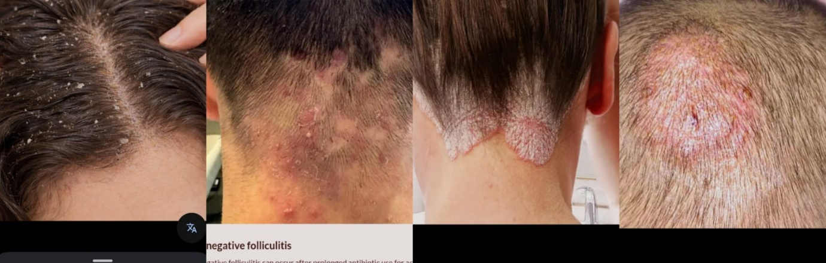
Dandruff is a prevalent scalp condition characterized by the excessive shedding of dead skin cells, often accompanied by symptoms such as itching, redness, and flaking. It affects a significant portion of the global population and can have psychological effects, impacting self-esteem and social interactions. The primary causes of dandruff are multifactorial, including the overgrowth of microorganisms such as Malassezia species, Candida albicans, and Staphylococcus aureus, which thrive in oily scalp conditions, disrupting the skin microbiome and accelerating skin cell shedding. Other factors like dry scalp conditions, excessive sebum production, hormonal imbalances, and nutritional deficiencies can exacerbate dandruff. In severe cases, scaling and redness may extend to other areas like the forehead, eyebrows, and behind the ears, causing social embarrassment and discomfort.
Dandruff Folliculitis Scalp Psoriasis Scalp Ringworm
Figure 1. Scalp infections

Gel
Gels are semisolid systems that consist of dispersions of molecules in an aqueous liquid vehicle thickened with a gelling agent. These systems possess intermediate properties between solids and liquids, making them easy to apply to the skin without being greasy. Gels are used in pharmaceutical and cosmetic formulations to deliver active ingredients to the skin.
Types of gels:
- Hydrogels
- Organogels
- Xerogels
Why use of Gels?
- Controlled release
- Topical applications
- Non-greasy
- Easy absorption
- Reduced systemic side effects
Herbal Hair Gel
Gels are semi-solid suspensions of small inorganic particles or large organic molecules impregnated with a liquid, consisting of a gelling agent and a liquid component. Ideal hair gel properties include antimicrobial properties, non-stickiness, cost-effectiveness, ease of washing, spreading, and safety. Herbal hair gel is a type of hair gel that is made from natural herbs, plants, and botanicals. These gels are designed to provide a natural and chemical-free alternative to traditional hair gels.
Benefits-
• Promotes healthy hair growth: Can help to stimulate hair growth and strengthen hair follicles.
• Reduce dandruff and itchiness: Can help to soothe and calm the scalp, healthy and vibrant.
• Add shine and luster: Can help shine and luster to hair, leaving it looking healthy and vibrant.
• Antibacterial and Antifungal.
Literature review
1. Boni E. Elewski (2000) highlighted that common scalp disorders such as dandruff and dermatitis require proper clinical diagnosis as they are often associated with microbial infections.
2. Vaidya and Devasagayam (2007) reported that herbal drugs in India have gained importance due to their safety, efficacy, and wide acceptance in the management of chronic disorders.
3. Patrick Yesudian (2011) discussed the biological and evolutionary significance of human hair and stressed the importance of maintaining scalp and hair health.
4. James R. Schwartz et al. (2013) explained the pathophysiology of dandruff and seborrheic dermatitis and emphasized the role of microbial imbalance and impaired scalp health.
5. M. F. Gavazzoni Dias (2015) reviewed hair cosmetics and emphasized that herbal-based hair care products improve hair quality with fewer side effects compared to synthetic products.
6. Sumra Naseer et al. (2018) reported that Psidium guajava (guava) possesses significant antimicrobial and medicinal properties useful in hair and scalp treatments.
7. Maria Caterina Fortuna et al. (2018) described scalp infections caused by Candida albicans, indicating the role of fungal pathogens in scalp disorders.
8. Ralph M. et al. (2018) concluded that poor scalp conditions and oxidative stress negatively affect hair growth and hair retention.
9. Rashmi S. Pal et al. (2020) reported that polyherbal anti-dandruff formulations demonstrated significant effectiveness in reducing dandruff and improving scalp condition.
10. R. Abiyarasu et al. (2022) reported that polyherbal hair gel formulations containing plant extracts show effective antifungal and antibacterial activity against dandruff-causing microorganisms. The study highlighted that herbal gels improve scalp health and hair strength while being safer than synthetic formulations.
11. Nilofar Khan et al. (2022) reported that polyherbal hair gel formulations showed good antimicrobial activity, improved scalp health, and better safety compared to synthetic hair gels.

AIM AND OBJECTIVES
Aim:
This study aims to harness the advantages of herbal gels in treating dandruff, utilizing the properties of natural ingredients to offer a safe, effective, and sustainable treatment for managing dandruff and promoting healthy scalp conditions.
Objectives:
- To select suitable herbal ingredients with anti-dandruff and hair-nourishing properties.
- To prepare herbal extracts containing active phytoconstituents.
- To determine the active phytochemical constituents, present in the formulation.
- To evaluate the anti-dandruff effectiveness of the herbal formulation.

Need of Research
Dandruff, a common and often frustrating scalp condition, affecting a large population worldwide and is mainly associated with excessive scaling, itching, irritation, and microbial growth. Various factors such as poor scalp hygiene, hormonal imbalance, stress, climatic conditions, and the use of chemical-based hair products. To effectively manage this condition, polyherbal anti-dandruff hair gel is formulated because –
- Gel is effective in reducing dandruff-causing microorganisms.
- It controls fungal growth on the scalp.
- Gel formulation is non-greasy and easy to apply on scalp.
- It is suitable for regular and long-term use.
- Herbal ingredients minimize side effects compared to synthetic products.
- It improves scalp health hair condition.

PLAN OF WORK
PART A:
- Literature survey.
- Selection and procurement of herbal materials from identified sources.
PART B:
Experimental work:
- Preformulation study
- Organoleptic studies – color, odor, appearance, texture.
- Solubility studies.
- Phytochemical screening.
- Compatibility studies of herbal extracts with gel base.

- Preparation of Extract
- Collection of plant materials.
- Drying, powdering, and extraction of plant materials.
- Selection of suitable gel base formulation.
- Incorporation of polyherbal extracts into the base formulation and optimization.
- Development and optimization of final polyherbal anti-dandruff hair gel formulation.
- Evaluation of formulation
- pH determination.
- Viscosity.
- Spreadability.
- Homogeneity.
- Washability.
- Skin irritation test.
- Antimicrobial activity.

MATERIALS AND METHOD
Materials:
Guava leaves extract, Curry leaves extract, Aloe vera juice, Amla juice, Carbopol 940, Propylene glycol, Propyl and Methyl paraben, Triethanolamine, Water.
INGREDIENTS AND THEIR USES IN HERBAL HAIR GEL
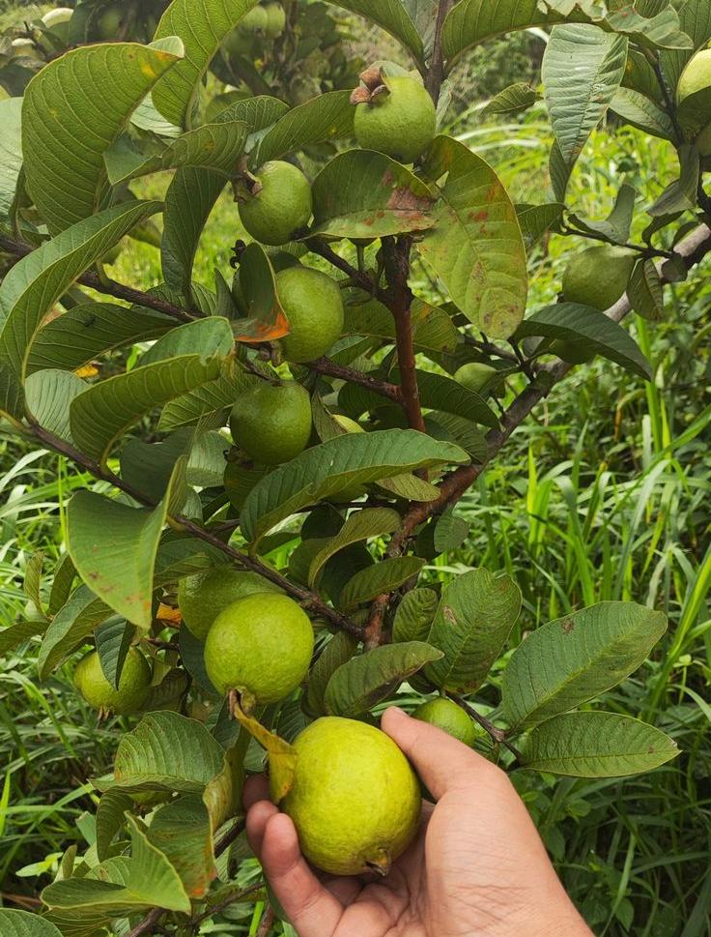
1.GUAVA
Synonyms: Guava, Amrud, Peru,
Biological source: Guava consist of fresh and dried leaves of Psidium guajava Linn (lemon guava, apple guava)
Family: Myrtaceae.
Chemical constituents: The chemical constituents of guava are Flavonoids (Quercetin, Guaijaverin), Tannins (Ellagic acid), Saponins, Essential oils (Eucalyptol), terpenoids, Alkaloids, Phenolic compounds, Vitamin B & C.
Figure 2. Guava leaves
Uses:
- Promotes Hair Growth: Contains antioxidants and flavonoids (like quercetin) that improve blood circulation to the scalp and stimulate hair follicles.
- Reduces Hair Fall: Strengthens hair roots and prevents breakage due to antimicrobial and anti-inflammatory properties.
- Controls Dandruff: Antibacterial and antifungal properties help maintain scalp hygiene and reduce dandruff.
- Improves scalp hairs: Reduces itching and inflammation.
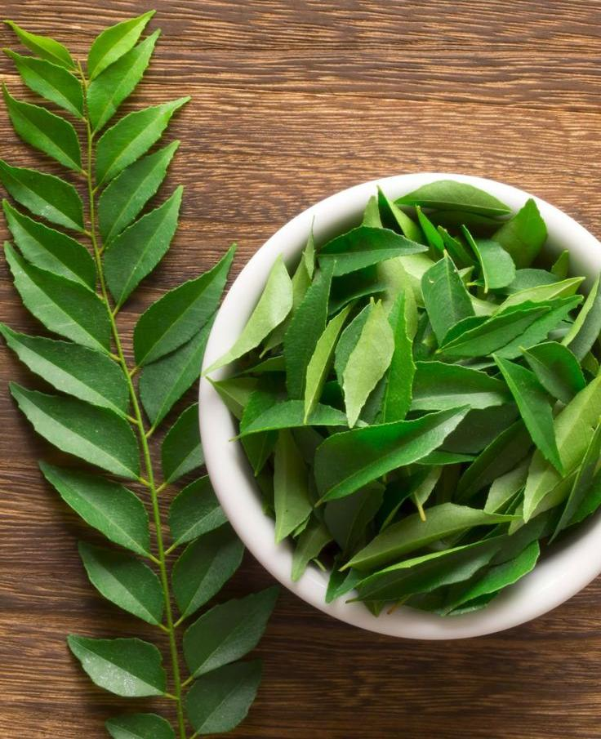
2. CURRY LEAVES
Synonyms: Curry leaf, kadhi patta, meetha neem
Biological source: Curry leaves consist of the fresh and dried leaves of Murraya koenigii (L.) Spreng.
Family: Rutaceae
Chemical constituents: The Chemical constituents of curry leaves are carbazole alkaloids (mahanine, koenine, girinimbine), essential oils (caryophyllene, phellandrene), flavonoids, tannins and glycosides. They also contain high levels of vitamins A, B, C, and E, plus iron, calcium, and phosphorus,
Figure 3. Curry leaves
Uses:
- Promote hair growth by strengthening hair follicles.
- Reduce hair fall and nourish the scalp.
- Prevent premature greying of hair.
- Improve natural hair pigmentation.
- Also support better blood circulation to hair roots.
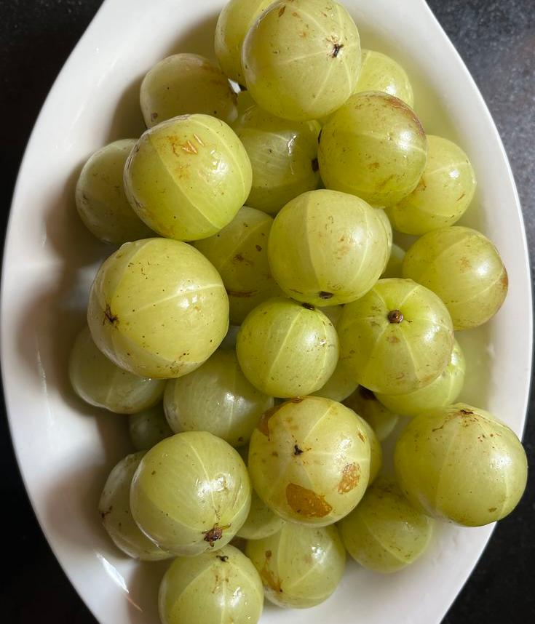
3. AMLA
Synonyms: Amla, Indian gooseberry, Emblica.
Biological source:
This consist of fresh as well as dried fruits of plants, Phyllanthus emblica Linn (syn. Embilica officinalis Gaertn)
Family: Euphorbiaceae.
Chemical constituents: The chemical constituents of amla are vitamin C (ascorbic acid is highly stable in amla), Tannins (Emblicanin A & B, Punigluconin), Flavonoids (Quercetin, kaempferol), Phenolic compounds, gallic acid, ellagic acid & Minerals (iron, calcium).
Figure 4. Amla
Uses:
- Strengthens hair roots: Rich in Vitamin C and antioxidants that nourish the scalp.
- Promotes hair growth & hair nourishment.
- Prevents dandruff: Has antimicrobial and anti-inflammatory effects.
- It also used as antifungal and antioxidant.
- Prevents premature graying of hairs.
- Add shine, thickness and smoothness to hair.
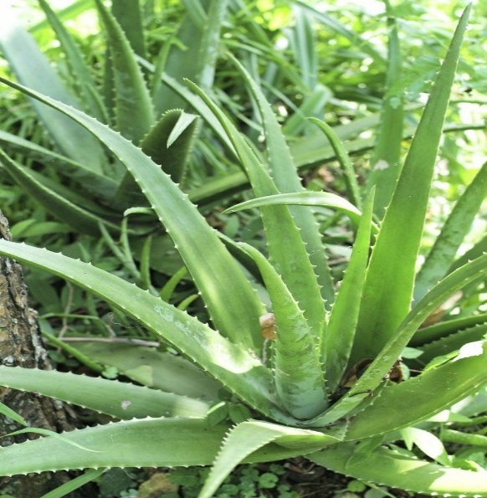
4. Aloe vera
Synonyms: Aloe
Biological source: Aloes is the dried juice of the leaves of various species of Aloe; Aloe barbadensis, Aloe ferox, Aloe officinalis, Aloe vulgaris
Chemical constituents: The chemical constituents of aloe vera are Polysaccharides, Anthraquinones (Aloin, barbaloin), Enzymes (Amylase, catalase, cellulose), Vitamins (A, C, E, B12, folic acid) Minerals (Calcium, magnesium), Saponins, amino acids, lignin, salicylic acid.
Figure 5. Aloe vera
Uses:
- Moisturizes Hair and Scalp: Hydrates dry hair and soothes itchy, flaky scalp.
- Promotes Hair Growth: Contains enzymes that help stimulate hair follicles and reduce hair fall.
- Reduces Dandruff: Its antifungal and antibacterial properties help combat dandruff and scalp infections.
- Adds Shine and Smoothness: Makes hair softer, shinier, and more manageable.
- Reduces Frizz: Helps tame frizz and flyaway by locking in moisture.
- Natural Styling Gel: Provides a light hold for natural hairstyles without chemicals.

Methods:
1. Preparation of Guava leaves extract:
The fresh curry leaves were thoroughly washed with water and dried in shade for 3 days. After drying, leaves were ground into coarse powder using a mechanical grinder. Phytochemical extract of guava is obtained by immersion extraction method. The methanol extract is prepared by mixing 10 grams of guava leaf powder with 70 ml of methanol and 30 ml of distilled water. This mixture is kept in a dark place to avoid sunlight for 3 days at room temperature. Beakers are used for storage; the clone bottle is sterilized and wrapped in aluminum foil to prevent evaporation. After the 3-day soaking process, the mixtures were filtered with filter paper, and the solvent was allowed to evaporate at 37 °C.
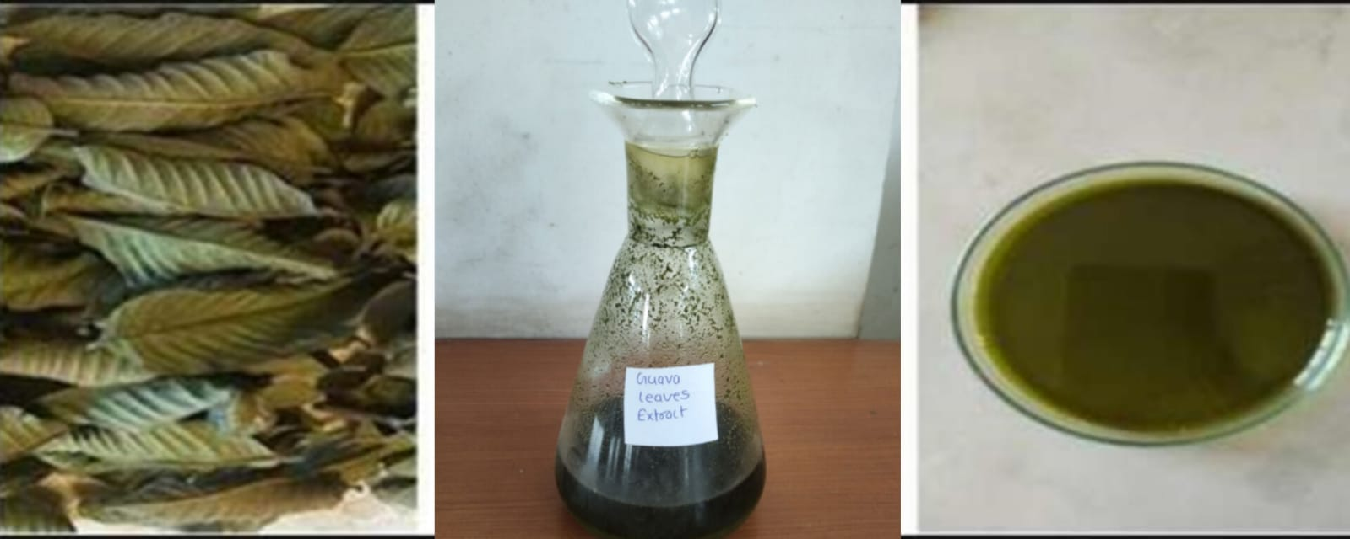Figure 6. Guava leaves extract

2. Preparation of Curry leaves extract:
The fresh curry leaves were thoroughly washed with water and dried in shade for 3 days. After drying, leaves were ground into coarse powder using a mechanical grinder. About 10 grams of the powdered plant material was subjected to extraction. The leaves were extracted using ethanol (150 mL) by the maceration process for 3 days at room temperature. The obtained extracts were filtered using filter paper, and the solvent was allowed to evaporate at 37 °C.
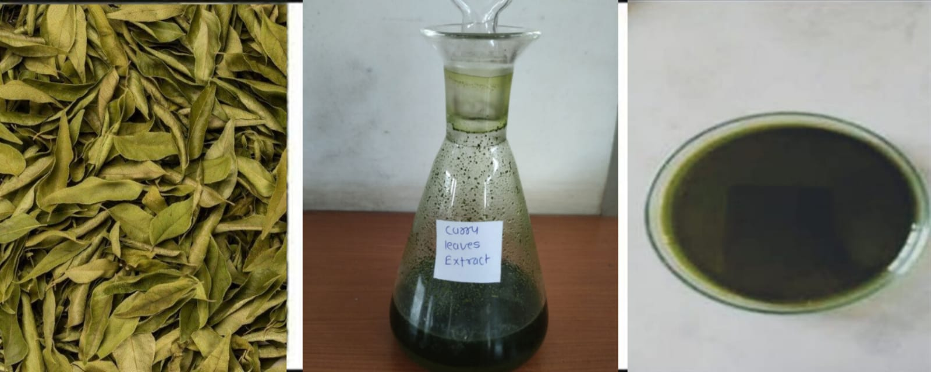
Figure 7. Curry leaves extract

3. Preparation of Amla juice:
The fresh Amla fruit was collected and cut into small pieces. It was crush by using some required amount of water with the help of mixer to form juice. And then filtered through a clean cotton cloth and the Amla Juice was obtained.
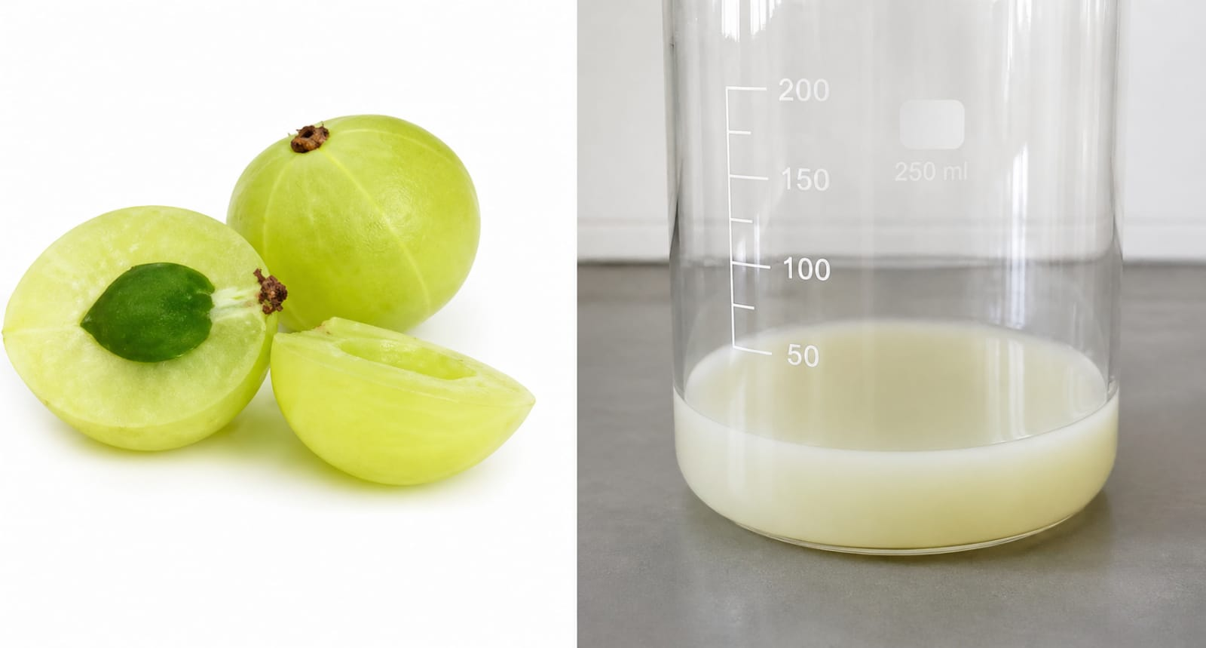
Figure 8. Amla juice

4. Preparation of Aloe vera juice:
The aloe leaves were cleaned and placed upright in a beaker for 15-20 min to drain out all the yellow color sap present. The pulps from the aloe leaf were removed and collected in beaker and grind it into the mixer to form liquid foam. This liquid was filtered to remove any remaining particles.
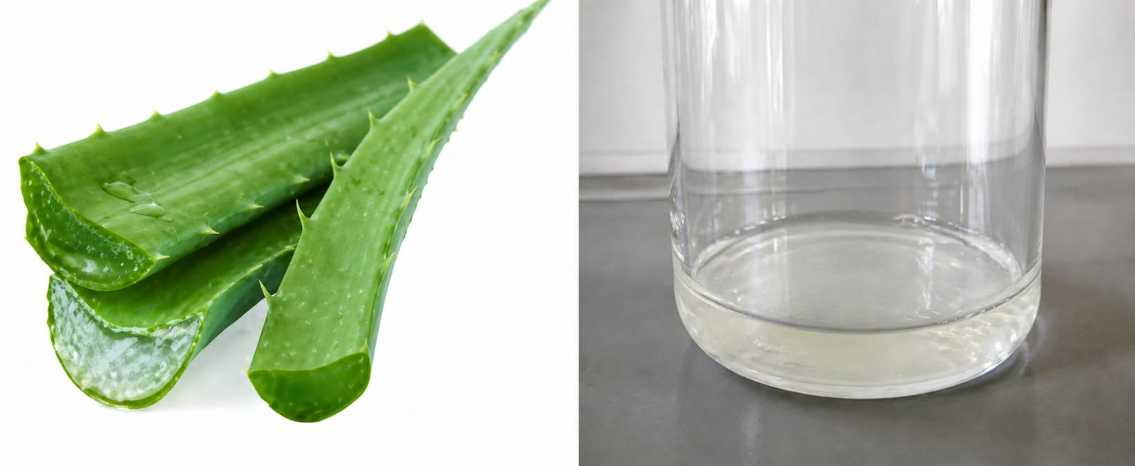
Figure 9. Aloe juice

PHYTOCHEMICAL TEST FOR GUAVA LEAVES EXTRACT

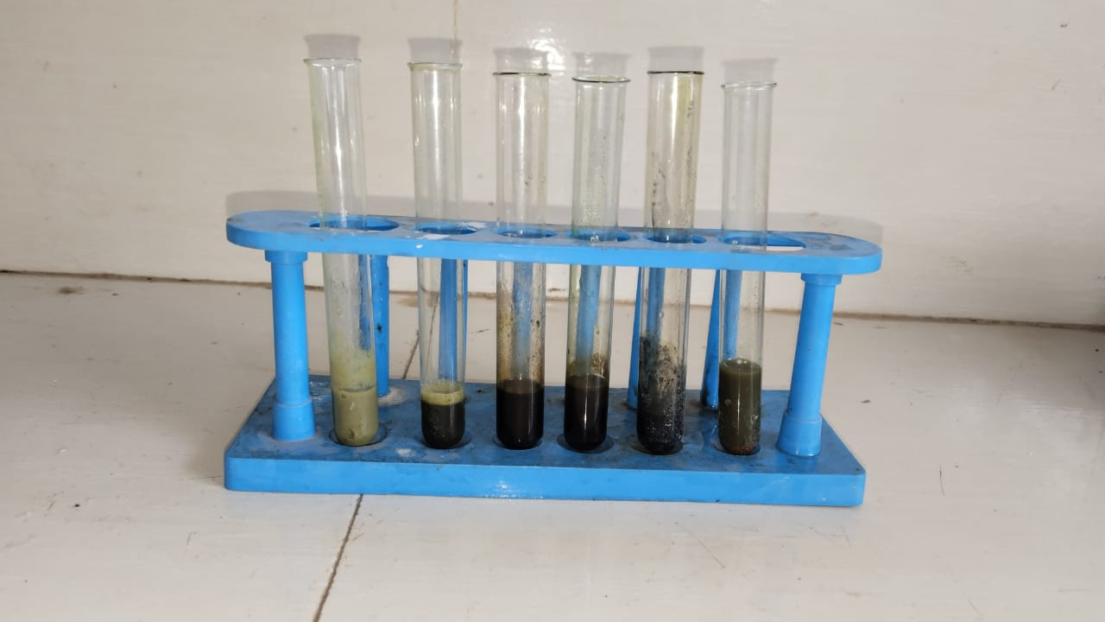
Figure 10. Phytochemical screening of guava extract

Phytochemical | Reagents/ Test | Procedure | Observation | Inference
Alkaloids | Mayer’s test | Add a few drops Mayer’s reagent (potassium mercuric iodide) to the extract | White or creamy precipitate formation | Present
Saponins | Froth Test | Shake the extract with distilled water vigorously | Stable froth formation | Present
Tannins and Phenols | Ferric Chloride test | Add a few drops of 5% ferric chloride (FeCl₃) solution to the extract | Blue, green, or black coloration | Present
Flavonoids | Lead acetate test | Add few drops of 10% lead acetate  solution to the extract | Formation of yellow  precipitate | Present
Glycosides | Keller-Kiliani test | Extract + glacial acetic acid + FeCl₃ + conc. H₂SO₄ | Formation of reddish-brown ring | Present
Terpenoids | Salkowski test | Extract mixed with chloroform and conc.  sulfuric acid (H₂SO₄) | Reddish brown color at interface | Present

Table 1. Phytochemical analysis of the extract

PREPARATION OF POLYHERBAL HAIR GEL
1) Weigh required quantity of Carbopol 940 and dispersed in 25 ml of distilled water in beaker.
2) Keep beaker aside for half an hour to swell Carbopol 940 & then start stirring at 1200 rpm by using mechanical stirrer for 30 min
3) Formulation A: Take 1ml or 2ml of guava extract & add in 5ml of propylene glycol in one beaker & stirred properly.
4) Formulation B: Add aloe juice, Amla juice, Methyl paraben & propyl paraben in 5ml propylene glycol in another beaker.
5) Disperse solution A & B in Carbopol 940 with constant stirring.
6) Finally add remaining amount of distilled water (i.e. makeup the solution) to make 50ml of formulation & add triethanolamine dropwise to the formulation until pH becomes neutral and the gel get required consistency.
INGREDIENTS | Batch (F1) | Batch (F2) | Batch (F3) | USES
Guava leaves extract | 1 ml | 1.5ml | 2ml | Antibacterial, Antifungal
Curry leaves extract | 1 ml | 1ml | 2ml | Antioxidant, Antimicrobial
Amla juice | 1ml | 1.5ml | 2ml | Hair nourishment
Aloe extract | 1ml | 1.5ml | 2ml | Moisturizer
Carbopol 940 | 2g | 0.45g | 0.70g | Gelling agent
Propylene Glycol | 10ml | 10ml | 10ml | Humectant
Propyl and methyl paraben | 0.1g | 0.1g | 0.1g | Preservative
Triethanolamine | 1-2drops | 3-4drops | 3-4drops | PH adjuster
Water | Q.S | Q.S | Q. S | Vehicle

Table 2. Composition of Polyherbal hair gel
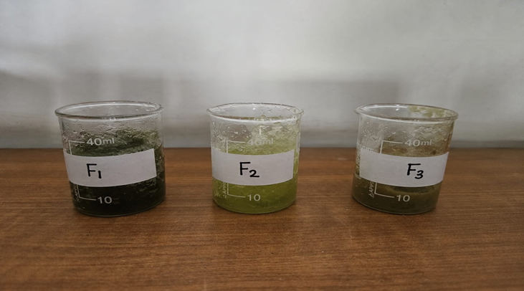
Figure 11. Formulation of hair gel

- Directions for use:
Take a generous amount of gel and gently massage it into the scalp and damp hair roots. Leave it on for 20–30 minutes, then rinse thoroughly with fresh water. Use three times a week for best results.
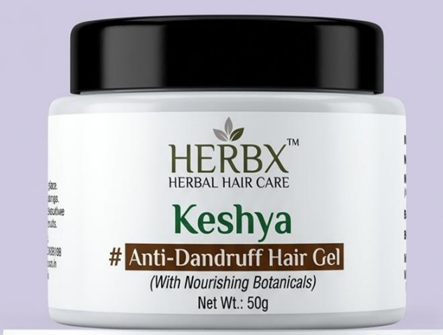
- Caution:
• For external use only.
• Avoid contact with eyes.
• Store in a cool, dry, and dark place.
• Close the cap tightly after every use.
• Kindly do a patch test before regular use.
Figure 12. Anti-dandruff hair gel

EVALUATION PARAMETERS
1. Organoleptic Evaluation
The organoleptic properties of the gel, including colour, odour, taste and special features such as texture, were analyzed using sensory organs. Parameters like touch and texture were also observed to ensure the gel's appeal and uniformity.
2. pH Measurement
The pH of the formulated herbal gels was determined using a calibrated digital pH meter. Approximately 0.5 g of the gel was dissolved in 50 mL of distilled water, and the pH of the solution was measured to ensure it is within an acceptable range for skin application. The pH of a polyherbal hair gel should ideally be in the range of 5.0 to 7.0, as this range is compatible with the natural pH of the scalp and hair.
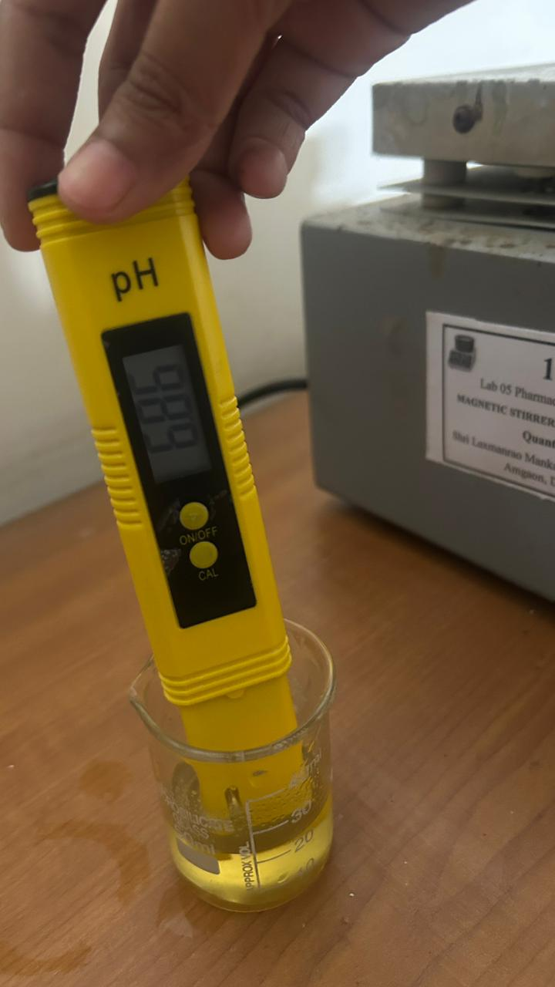
Figure 13. PH measurement
3. Homogeneity
The homogeneity of the gel was assessed visually to check for uniformity and the absence of lumps, flocculates, or aggregates. Additionally, a qualitative evaluation was performed by sorting the gel between the thumb and forefinger to identify any aggregates or inconsistencies in texture.
4. Spreadability Test
The spreadability of the gel was determined using the parallel plate method. A specified amount of gel (approximately 1 g) was placed between two glass plates. A weight of 500 g was placed on the upper plate for 5 minutes to compress the gel into a uniform layer. The spread diameter of the gel was then measured. This method ensures the gel's ease of application and uniform distribution on the skin. Spreadability was determined using the following formula,
S=M.L/T
Where, S= Spreadability, M= Weight tied to upper slide, L= Length of glass slide, T= Time taken to separate the slide completely from each other.
5. Washability
The washability of the gel was tested by applying it to the skin and assessing the ease and extent of removal with water under normal conditions.
6. Skin Irritation Test
The herbal gel formulation was applied to the skin, and the area was monitored for any signs of irritation, redness, or rashes over a specific period to ensure its suitability for topical use.
7. Viscosity Measurement
The viscosity of the gel was measured using a Brookfield viscometer at 60 rpm with spindle number L3. 5gm of the gel were placed in a beaker, and the spindle was immersed in the gel for about 5 minutes before taking readings to ensure proper consistency.
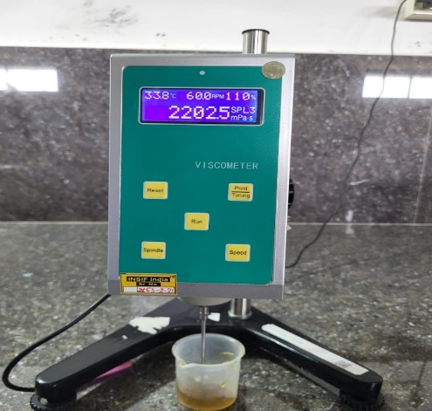
Figure 14. Brookefield viscometer
8. Stability study
The formulation was kept in batches of varies conditions of temperature. The system was stable at 25℃ & no changes were noticeable when kept at room temperature (30±2℃) & 2nd batch was kept at refrigerated (4±2℃). No changes were found in pH, viscosity, homogeneity, & spreadability.
9. Antibacterial Activity
The microbial test for an herbal hair gel is carried out to evaluate its antimicrobial activity and to ensure that the formulation is free from harmful microbial contamination. In this test, the herbal hair gel is tested against common scalp microorganisms (Candida albicans and Staphylococcus aureus) such as bacteria and fungi using microbiological methods like the agar well diffusion method or disc diffusion method. The formulation is introduced onto a culture medium inoculated with microorganisms, and the zone of inhibition around the sample is measured after incubation at 37°C For 24 h. A larger zone of inhibition indicates stronger antimicrobial activity. In addition, microbial limit tests may also be performed to confirm that the product does not contain excessive microbial load during storage. This test helps in assessing the effectiveness, purity, safety, and quality of the formulation. Antibacterial activity was evaluated by measuring the diameters of the zone of inhibitions.
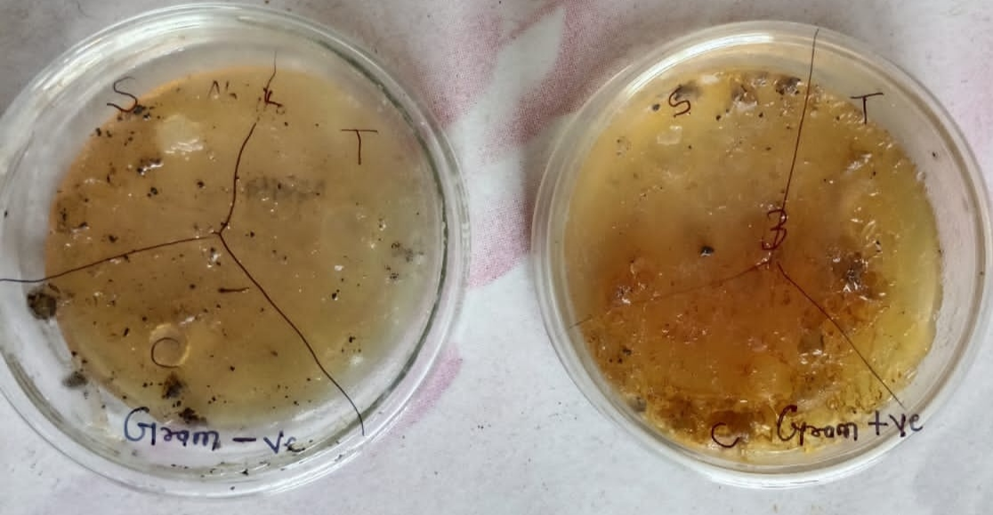
Figure 15. Zone of inhibition of Candida albicans and Staphylococcus aureus.

Compound | Zone of inhibition (mm)
Compound | Candida albicans | Staphylococcus aureus
Sample | 05 | 04
Standard | 18 | 22

RESULT AND DISCUSSION
Sr. no | Parameters |  | Observations
Sr. no | Parameters | F1 | F2 | F3
1 | Colour | Green | Yellowish green | Olive/Pale green
2 | Odour | Pleasant | Pleasant | Pleasant
3 | Appearance | Smooth | Smooth | Smooth
4 | pH | 6.8 | 5.9 | 6.8
5 | Viscosity | 32130 cP | 22085 cP | 22025 cP
6 | Homogeneity | Lump | Lump | Excellent
7 | Spreadability | 3 gmcm/sec | 4 gmcm/sec | 6 gmcm/sec
8 | Stability | Stable | Stable | Stable
9 | Skin irritation | No irritation | No irritation | No irritation
10 | Washability | Easily washable | Easily washable | Easily washable
11 | Antimicrobial activity | No microbial growth | No microbial growth | No microbial growth

Table 3. Evaluation parameter

CONCLUSION
The study evaluated the formulation and properties of herbal gels (F1 to F3) containing natural extracts like guava, curry leaves, aloe, and amla. The gels exhibited stable organoleptic characteristics, including consistent olive green colour, mild pleasant odour, and smooth texture, indicating effective preparation and ingredient blending. Most formulations had skin-compatible pH values, with F2 being slightly acidic. F3 showed the best performance in terms of spreadability, washability, and viscosity, making it the most effective formulation. The antimicrobial activity of the gels was confirmed by their ability to inhibit Candida albicans and Staphylococcus aureus, with higher concentrations showing increased inhibition zones. Overall, F3 emerges as the most promising formulation, offering excellent therapeutic potential for effective and long-lasting topical treatment.

REFERENCES
- A. D. B. Vaidya and T. P. A. Devasagayam, ‘Current status of herbal drugs in India: An overview’, J Clin Biochem Nutr, vol. 41, no. 1, pp. 1–11, Jul. 2007, doi: 10.3164/JCBN.2007001.
- A. R, P. B, P. K, Y. V, K. D, and S. K. K, ‘Review on formulation and evaluation of polyherbal hair gel formulation’, The Journal of Multidisciplinary Research, pp. 31–36, Dec. 2022, doi: 10.37022/TJMDR.V2I3.400.
- Biswas, B., Rogers, K., McLaughlin, F., Daniels, D. and Yadav, A., 2013. Antimicrobial activities of leaf extracts of guava (Psidium guajava L.) on two gram-negative and gram-positive bacteria. International journal of microbiology, 2013.
- Boni E. Elewski, Clinical Diagnosis of Common Scalp Disorders, Journal of investigative symposium proceedings Volume 10, Issue 3P190-193 December 200
- D. S. Sandeep, P. Nayak, J. Jose, M. R. Relita, and D. R. Sumana, ‘Formulation and evaluation of antibacterial herbal gels of Murraya koenigii leaves extract’, Res J Pharm Technol, vol. 10, no. 6, p. 1798, 2017, doi: 10.5958/0974-360X.2017.00317.1.
- Dal'Belo SE, Gaspar LR, Berardo PM, Campos GM. Moisturizing effect of cosmetic formulations containing Aloe Vera extract in different concentrations assessed by skin bioengineering techniques. Skin Research and Technology. 2006;12(4):241-246.
- Gupta R. Amla: A Novel Ayurvedic Herb with its Health Benefits. 2017;6(6):923-7.
- J. R. Schwartz et al., ‘A comprehensive pathophysiology of dandruff and seborrheic dermatitis - Towards a more precise definition of scalp health’, Acta Derm Venereol, vol. 93, no. 2, pp. 131–137, Mar. 2013, doi: 10.2340/00015555-1382.
- Khan, N., Jadhav, P., Jagadale, S., Kachare, K., Kamble, S., Gandhe, S., Yewale, R., Kale, M. and Kshirsagar, S., 2022. Formulation and evaluation of polyherbal hair gel formulation. Journal of Pharmacognosy and Phytochemistry, 11(1), pp.32-36.
- M. C. Fortuna, V. Garelli, G. Pranteda, M. Carlesimo, A. D’Arino, and A. Rossi, ‘Scalp infection by Candida Albicans in an immunocompetent patient: a description of a rare case’, Journal of Chemotherapy, vol. 30, no. 5, pp. 316–317, Jul. 2018, doi: 10.1080/1120009X.2018.1518200.
- M. F. Gavazzoni Dias, ‘Hair cosmetics: An overview’, Int J Trichology, vol. 7, no. 1, p. 2, 2015, doi: 10.4103/0974-7753.153450.
- P. Yesudian, ‘Human Hair – An Evolutionary Relic?’, Int J Trichology, vol. 3, no. 2, p. 69, 2011, doi: 10.4103/0974-7753.90799.
- R. S. Pal, N. Saraswat, P. Wal, A. Wal, and Y. Pal, ‘Preparation &amp; Assessment of Poly-Herbal Anti-Dandruff Formulation’, Open Dermatol J, vol. 14, no. 1, pp. 22–27, Jul. 2020, doi: 10.2174/1874372202014010022
- R. Trueb, J. Henry, M. Davis, and J. Schwartz, ‘Scalp condition impacts hair growth and retention via oxidative stress’, Int J Trichology, vol. 10, no. 6, p. 262, 2018, doi: 10.4103/ijt.ijt_57_18.
- S. Naseer, S. Hussain, N. Naeem, M. Pervaiz, and M. Rahman, ‘The phytochemistry and medicinal value of Psidium guajava (guava)’, Clinical Phytoscience, vol. 4, no. 1, Dec. 2018, doi: 10.1186/S40816018-0093-8.

