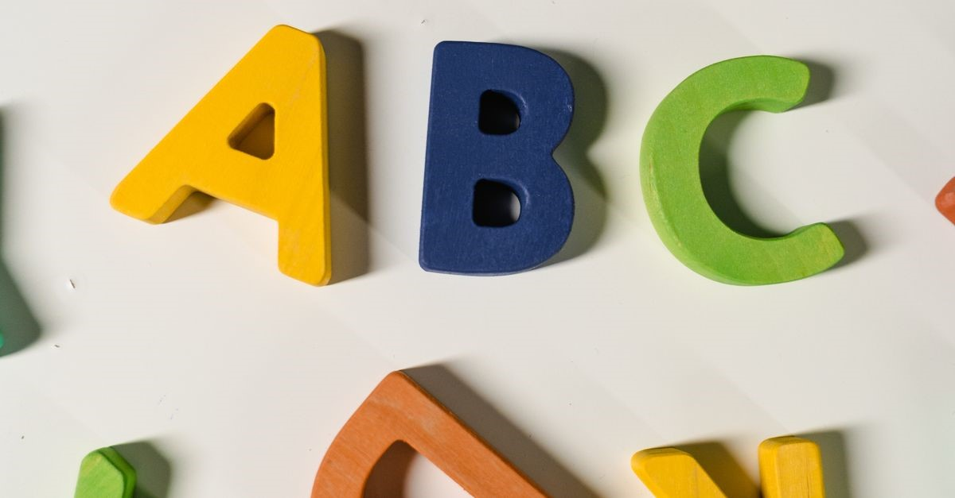
Title: AGWEP Alphabet: The Cosmic Code

[Scene opens in a futuristic cityscape, neon lights flickering against a starry sky. A voiceover begins, echoing with a sense of wonder and intrigue.]

Voiceover (V.O.):
In a universe where communication transcends the boundaries of time and space, a new language emerges—one that holds the key to understanding the cosmos. Welcome to the AGWEP Alphabet, a revolutionary script that bridges worlds and connects minds.

[Cut to a holographic display of the AGWEP Alphabet, each letter glowing with vibrant energy.]

V.O.:
AGWEP Ʌlphabet—a symphony of symbols that resonates with the very fabric of existence. From A to Z, and beyond, each character is a portal to new dimensions.

[The camera zooms in on each letter as it is pronounced, accompanied by visual effects that illustrate its meaning.]

V.O.:
A, B, C, D, E, F, G, H, I, Ⅎ, K, L, M, N, O, P, Q, R, S, T, U, V, W, X, Y, Z, Ǝ, Ʌ, Ө, Ð, Ŧ, , Ԉ, И, Ŋ, Ƨ, Ƶ, Æ, Ͻ, П, , , , Ꝏ, Ѥ, Ꞇ, Ø, Є, Э, Ш, Ѧ.

[As each letter is pronounced, the screen displays its unique symbol alongside an animation that reflects its essence—like a dance of light and sound.]

V.O.:
But what about the Smͻll Skrєpt? The whispers of the universe, the subtle nuances that shape our thoughts and dreams.

[The camera shifts to a serene landscape, where the small script flows like a gentle breeze.]

V.O.: a, b, c, d, e, f, g, h, i, ⅎ, k, l, m, n, o, p, q, r, s, t, u, v, w, x, y, z, ǝ, ʌ, ө, ð, ŧ, , ԉ, и, ŋ, ƨ, ƶ, æ, ͻ, п, , , , ꝏ, ѥ, ꞇ, ø, є, э, ш, ѧ.

[The visuals become more dynamic, showcasing the interplay between the capital and small scripts, illustrating their connection.]

V.O.:
Each letter, each symbol, is a building block of thought, a thread in the tapestry of communication. Together, they form a language that speaks to the soul of the universe.

[The scene transitions to a futuristic classroom, where diverse beings from different planets gather, learning the AGWEP Alphabet.]

V.O.:
In this age of interstellar exploration, the AGWEP Alphabet is not just a tool; it’s a bridge to understanding. A universal language that transcends species, cultures, and galaxies.

[Cut to a scene of a spaceship navigating through a nebula, the crew using the AGWEP
Alphabet to communicate vital information.]

V.O.:
Imagine a world where every being can share their thoughts, their dreams, their fears. A world where the AGWEP Alphabet unites us all, creating harmony amidst the chaos of the cosmos.

[The visuals shift to a cosmic library, filled with ancient texts and futuristic holograms, showcasing the rich history of the AGWEP Alphabet.]

V.O.:
Prөnuncєeƨiөn:
ए, बी, सी, डी, ई, एफ, जी, एच, आय, जे, के, एल, एम, एन, ओ, पी, क्यू, आर, एस, टी, यू, व्ही, डब्ल्यू, एक्स, वाय, झेड, ऐ, औ, यूटा, डीटा, टीटा, एल्फा, एन्फा, एन्स, एन्ज, एस्फा, झेस्फा, ॲ, ऑ, ॲय, ऑय, ऑव, डब्ली, डब्लो, केच, सेच, फाय, इक्वल, डीव, उइ, एम्न.

[As the pronunciation is spoken, the letters appear in a swirling galaxy, each sound resonating with the stars.]

V.O.:
This is not just an alphabet; it’s a cosmic code, a key to unlocking the mysteries of the universe.

[The scene fades to black, leaving only the glowing AGWEP Alphabet on the screen.]

V.O.:
Join us on this journey. Embrace the AGWEP Alphabet. Let it guide you through the stars, and together, we will write the future of communication.

[The screen displays the tagline: “AGWEP Alphabet: Write Your Destiny Among the Stars.”]

[End scene with a soft, ethereal music fading out.]

