TRADITIONAL AND SOCIAL MEDIA IN PROMOTING RIVER MANAGEMENT AWARENESS: A CASE OF NAMAMI GANGE DURING MAHA KUMBH 2025 AT PRAYAGRAJ
ABSTRACT
River conservation is a significant environmental and socio-cultural problem in India, especially for the Ganga River, which supports millions of people and has great religious importance. For the Namami Ganga mission, there have been various government campaigns. The efficiency of conservation efforts has frequently been constrained by conventional awareness campaigns that communicate with the public employing one-way interaction approaches and receive some to evaluate the engagement by the public. Social media and the other digital platforms have the potential to encourage the participants' ecological awareness, but their application and vital for behaviour meaning such as the Maha Kumbh mela. The efficiency of social media efforts to provide ganga protection during Prayagraj’s maha Kumbh 2025 is assessed in this work. The study employs a mixed-method approach to assess user engagement measures such as likes, shares, comments, and hashtags to analyse the behavioural intention and public awareness over community analysis and the perceptions of stakeholders, including government representatives, NGOs, and young volunteers, regarding engagement. The outcomes demonstrate a high correlation between user engagement measures and gains in ecological awareness and participation in cleanliness programs. Posts that connected cultural ties to ecological care with spiritual beliefs sparked a lot of communication on Facebook and Instagram. The outcomes state that social media works as a catalyst due to its high growth and involvement that other media. The research inspires the use of digital strategy and referential media to involve the public in river management communication initiatives, and for future river management plans to encourage long-term participation and support for sustainable river management plans.
Keywords: Social Media Campaigns; River Management; Ganga River; Namami Gange; Maha Kumbh Mela 2025; Traditional Media
1. INTRODUCTION
Rivers are essential for managing ecological balance, cultural identification, and economic well-being of communities [1]. The Ganga River is one of the essential rivers in India’s natural heritage and spiritual traditions. It helps for agriculture, manufacturing, and households, that revered as sacred in Hinduism [3]. Rapid development, manufacturing discharge, and huge water mining have raised the rivers' ecological strength [4]. The condition of the Ganga River is worse nowadays, causing problems for the whole nation. So demands the well-improved approach that integrates the social awareness and the technological measures [5]. The government of India has developed various approaches, notably the Namami Ganga mission is employed for pollution control, better infrastructure, and active enrolment of the local community [6, 7]. The public awareness and their enrolment depend on the success of their initiatives. The rise of digital media modifies the path such kind of data is collaborate shared with the public in older years for sharing environmental data through traditional platforms [8, 9]. Nowadays, social media platforms play an essential role in environmental collaboration. Permitting awareness to reach the wider public almost rapidly to generate the interactive spaces for the public, government agencies, and non-governmental schemes to be involved directly [10, 11]. Social media and other online applications help humans to participate in community activity, share their taught, and also feel comfortable communicating with others. This makes them connected to social and ecological phases. Namami Ganga and Clean Ganga schemes have raised public interest on social media and care for the environment nowadays [12, 13].
The upcoming Maha Kumbh Mela 2025 in Prayagraj provides a timely and exciting opportunity to study the effectiveness of social-media-driven conservation communication [14, 15]. The Maha Kumbh Mela is expected to attract millions of pilgrims and present both challenges and opportunities for river management. Pilgrims, volunteers, and authorities use digital platforms to share information about the event, recall cleanliness campaigns, and share eco-friendly behavior [16, 17]. To be effective in developing sustainable communication strategies for both non-profit conservation organizations and commercial enterprises, practitioners must understand how campaigns involve behavioral change and contribute to the shared environmental responsibility [18, 19]. Although a number of studies have examined how social media informs environmental consciousness, most remain generalizable in scope to worldwide climate or confined to conservation programs (i.e., #climatechange or #conservation) [20, 21]. Few studies have looked at the relationship between digital engagement and Indian cultural and religious contexts, especially when it comes to the Ganga River [22]. Furthermore, little is known about how various demographic groups' online engagement translates into their participation and behavioral changes offline. Therefore, this study examines how social media campaigns affect the management of the Ganga River, focusing on the behavioral and communication components of public participation during the Maha Kumbh 2025. By using the digital files, surveys, and the interviews with different groups of humans, this research understands how the social media platform helps individuals to be involved in the cleaning process of the Ganga River in a sustainable way. Figure 1 shows the Ganga River's landmark.
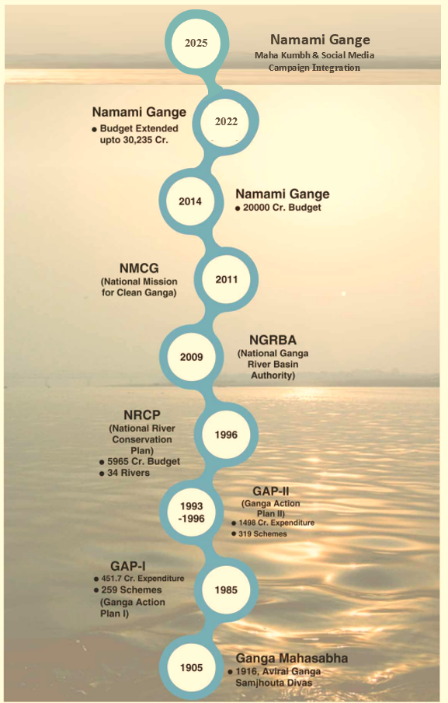
Figure 1: Key Milestones in Ganga River Cleaning Initiatives
This research states how digital platforms help to save the environment. To help ecological conservation, it describes how government policies, technology, and culture work together. The outcomes of this research support policy makers and environmental groups to create better, more practical, and sensitive plans for future river protection. Figure 2 illustrates the facts of the maha Kumbh Mela 2025.

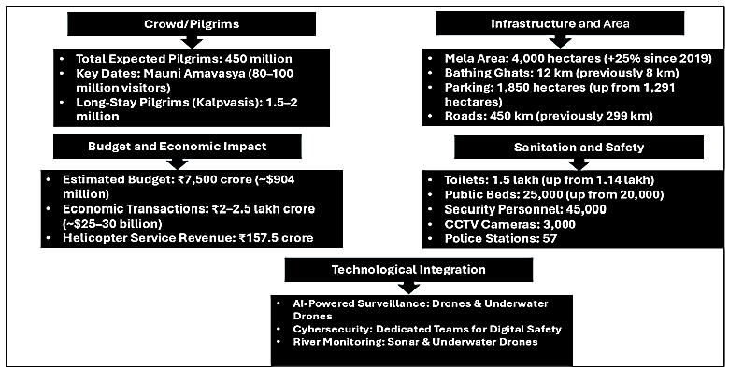
Figure 2: Key Facts of the Maha Kumbh Mela 2025 at Prayagraj
  - RESEARCH GAP
Nowadays, research on ecological communication is increasing, but there are still many gaps that occur when it comes to the Indian context. India's rivers and old ecological traditions are a vital part of its culture, but numerous studies ignore them and focus on Western plans. There are a few online studies that show how big events affect or raise concerns about saving the environment. Research that explores how social media is employed in real actions in river conservation is also very limited. Most of the studies use either data (quantitative analysis) or personal opinions and experiences (qualitative analysis), but do not suggest the triangularization of a mixed approach. Due to this, many volunteers, residents, and pilgrims were often left out. The relation among spirituality, religious rituals, and environmental awareness has not been investigated enough. This makes the knowledge gap about how India’s cultural traditions can help to protect nature. This research helps to fill these gaps by integrating social media engagement analysis with public opinion data gathered over Maha Kumbh 2025. It also provides suggestions for creating more effective and culturally sensitive river conservation schemes.
1.2. Objectives
The key goals of this research are defined as follows:
- Examine how effectively social media is spreading awareness about the Ganga conservation over Maha Kumbh 2025.
- Research explores how the social media platforms (likes, shares, comments) are supporting the Namami Ganga campaign.
- Detect how social media platforms connect with humans in their real-life environmental actions.
- Developed to understand what the stakeholders (government officials, NGOs, and youth volunteers) think about how social media helps in the management of rivers.
- Suggest how digital communication is employed in future projects to restore and protect the rivers.

1.3. Hypotheses

According to prior research and their observations, this research proposes the following hypotheses:
H₁: Social media platforms raise public awareness about the problems in river conservation over the Maha Kumbh 2025.
H₂: Humans who are more in online platforms (through likes, shares, and comments) have strong environmental attitudes.
H₃: Social media helps to encourage real-world actions for individuals, like participating in cleaning rivers and managing waste responsibly.
H₄: Youth volunteers and the local participants respond more actively to the social media conservation messages than to other platforms.
H₅: The social media platforms may be affected depending on the content type, whether it is informative, emotional, or tied to cultural and religious values.
This research seeks to show how social media inspires people to take action for the environment. Examine online data and the perspectives of real people about how digital platforms influence awareness and behaviour. Focusing on India’s unique cultural and religious context, the research also helps to understand how environmental issues are discussed in society. The outcomes guide human collaboration, shape environmental policies, and support the planning of events that engage communities.
2. LITERATURE SURVEY:
Explore the link between cultural heritage, sustainability, and visitor engagement. Mishra et al [23] suggested the actions of humans attending the Maha Kumbh Mela for spiritual tourism. This work detects the features, including people’s spiritual motivation, interest in learning about culture, and the nature of the event strongly influence the individuals in cultural and religious experiences. These outcomes offer practical plans for policymakers and tourism agents who want to encourage practices and protect culture during large religious gatherings. This research is limited, due to the reliance on survey responses from participants and may not fully apply outside the context of the Maha Kumbh Mela.

To study how the 2019 Kumbh Mela affected city plans and infrastructure, Yadav et al. [24] looked at changes in land use and land cover (LULC). The study aimed to see how huge pilgrimages change urban areas and affect roads, buildings, and farmland. The result provides useful data for policymakers and city planners to support infrastructure for temporary settlement. However, the study focused on only one city and used satellite images with limited details.
Bobade et al. [25] employ the experience economy approach to develop the Maha Kumbh as a unique spiritual experience. The work understands how religious events generate experiences for both local and international visitors. It guides the event planners, marketers, and policymakers on how to increase the participants and reach audiences worldwide. One key point is showing how technology works together with to make pilgrimages more engaging. However, the study is limited due to the lack of real data on participants' behaviour, which it hard to generate the exact result.
Shukla et al. [26] offered the social effects of the kumbh mela in aspects like faith, tradition, and community bonding. The research examined how large events preserve cultural heritage and also create a sense of belonging among diverse participants. The outcomes strengthen the social connections, protect culture, and boost local economies. The result of this study is string but it still limits that this study is not fully apply to other kumbh mela locations.

Kumar et al. [27] highlighted how industrial waste and religious offerings contribute to the pollution of the Ganga River in Haridwar and Rishikesh that causing serious damage to its water quality and ecosystem. It investigated successfully integrating the importance of the river as a religious entity with the effectiveness of state-of-the-art treatment methods, regulation, and community-based stewardship. Policymakers, environmental organizations, and local communities can benefit from this research's capacity to provide practical suggestions for sustainable river management while also referencing global restoration community instances. Main contributions involve a focus on compliance with the law, involvement of community engagement, and the relationships between cultural principles and environmental protection. Disclaimed contributions include the interaction of the conditions in the study area and a lack of empirical evaluation of the studied interventions, which limit the generalizing of the outcomes. Through in-depth qualitative interviews, Roychowdhury et al.'s study [28] explores the religiosity, spiritual experiences, and environmental consciousness of young adults who attend the Maha Kumbh Mela in Prayagraj in 2025. The main goal is to comprehend how young people's use of social media, digital technology, and religious pilgrimage practices relates to environmental issues and religious pilgrimage behaviors. The study's conclusions give policymakers and event coordinators insight into how youth and a third-string platform fulfill their roles in spiritual experiences and ethical behaviors. The importance of digital interaction (such as social media and virtual darshan), the variety of participation motivations, and the interaction between contemporary and older forms of religion are some of the main conclusions. Limitations include the use of qualitative techniques, which may restrict generalizability, and a small, age-specific sample (20–30 years).
Krishnan et al. [29] explore how the integration of digital tools, including live streaming, mobile device applications, and social media, is completely shifting traditional religious events, altering rituals, and promoting community engagement. The work states how technology helps large religious gatherings by making them more accessible and encouraging participation. The results guide the government officials and event organizers. However, the work might not fully represent all types of religious events.
Mishra et al. [30] suggested electromagnetic field exposure in various parts during the maha kumbh that focuses on radiofrequency radiation levels. The study aimed to understand the health risks for participants and the environmental impact of the large networks. The study helps to communicate with providers and also reduces the negative health effects during gathering. Also, the study’s short-term monitoring during a single event may not capture long-term effects. The summary of the literature survey is presented in Table 1.
Table 1: Literature Survey on Maha Kumbh Mela and Related Environmental, Cultural, and Digital Studies
Reference | Theoretical Framework / Focus | Study Area | Objectives | Key Findings / Results | Implications for Future Research
[23] | Theory of Planned Behavior; Spiritual Tourism | Maha Kumbh Mela, Prayagraj | Explore behavioral intentions toward spiritual tourism and sustainability | Spiritual motivation, cultural education, and sacred ambiance drive participation in spiritual/cultural activities | Need for empirical studies beyond Maha Kumbh and mixed-method approaches to validate behavior patterns
[24] | Urban Morphology; Land Use Analysis | Prayagraj (2019 Kumbh) | Assess LULC changes before, during, and after Kumbh Mela | Large-scale pilgrimage impacts urban landscape, vegetation, and infrastructure | Expand to other Kumbh sites; higher temporal-resolution data for urban planning and sustainable infrastructure
[25] | Experience Economy Framework | Maha Kumbh 2025 | Examine digital and cultural strategies for immersive pilgrim experiences | Integration of spiritual heritage with AI-driven personalization and storytelling enhances engagement | Conduct behavioral measurement studies to quantify pilgrim responses and engagement
[26] | Social Impact / Cultural Cohesion | Maha Kumbh Mela | Understand social impact, community cohesion, and tradition preservation | Strengthens social harmony and cultural preservation; challenges include crowd management and sanitation | Broaden qualitative studies with quantitative measures; explore cross-event comparisons
[27] | Environmental Management / Ecological Studies | Ganga River, Haridwar, and Rishikesh | Address river pollution and develop restoration strategies | Untreated sewage, industrial effluents, and ritual offerings cause degradation; community-based conservation is emphasized | Test and evaluate proposed interventions; expand to other river stretches
[28] | Digital Engagement & Youth Behavior | Maha Kumbh 2025, Prayagraj | Study religiosity, environmental awareness, and digital interactions of youth | Youth participation is influenced by digital platforms; diverse motivations for pilgrimage. | Expand age range; combine qualitative and quantitative digital behavior analysis.
[29] | Digital Tools in Religious Events | Large-scale religious gatherings | Examine the role of live streaming, apps, and social media in rituals | Technology expands accessibility and participation, but may affect ritual authenticity | Longitudinal studies to assess long-term behavioral and cultural impact
[30] | Electromagnetic Field Exposure | Maha Kumbh Mela, Prayagraj | Assess RF radiation levels and potential health risks | EMF exposure measured across zones; guidelines provided to minimize risks | Conduct cumulative and long-term exposure studies; expand monitoring across multiple events

These existing works state how the Maha Kumbh Mela affects many regions, like digital use, environmental protection, city planning, and spiritual experiences. This provides useful insights for researchers, event organizers, and most of the studies are limited due to their focus on a specific place, use only qualitative approaches. The study demonstrates the need for methods that combine technology, cultural preservation, and ethical leadership during religious events.

3. Background of the research
The following section outlines the historical, ecological, and managerial context of the Ganga River and the Kumbh Mela, with particular focus on government initiatives, social media campaigns, and technological developments. It establishes a foundation for examining the connections between river conservation, environmental management, cultural significance, and digital engagement.
3.1 Pollution Control Programs and Their Relevance to Social Media Campaigns
Public interest and government-led initiatives have sparked pollution control efforts in the Ganga River for many years. In 1985, environmental advocate M.C. Mehta filed a writ of public interest in the Supreme Court of India, bringing an action against the industries and government for deteriorating water quality. The case resulted in fines, in some cases, noncompliant industries being ordered to shut down, and reinforced the call for enacted, systematic pollution control. Later that year, under the Department of Environment, the Central Ganga Authority (CGA) initiated the Ganga Action Plan (GAP) to address pollution through infrastructure and policy measures, including sewage treatment plants, renovated treatment stations, enlarged sewer networks, wastewater sub-pumps, and electric crematoriums on the ghats. In the end, CGA changed its name to the National River Conservation Authority (NRCA) and added 18 additional rivers to its purview. GAP I was supposed to be finished in 1990, but it was postponed until 2000. The Ganga tributaries were evaluated further by GAP II, and 25 additional towns were designated as Class I. Both the federal government and the states provided funding.
Although these conventional programs created a framework for river conservation, the addition of digital media establishes an adjunct dimension. For large events, social media plays a vital role in raising awareness, attracting volunteers, and encouraging people to adopt environmental behaviours. These online platforms help traditional government efforts, raise public pollution control, and promote sustainable environmental practices.

3.2 The Ganga River: Balancing Spiritual Significance and Ecological Challenges
The Ganga river flows 2,525 kilometres from the Himalayas and provides 25% of the fresh water that is extremely essential for both ecological systems. However, it faces serious threats from industrial growth, farming, and climate change that disrupt its flow, rise pollution, and harm biodiversity. Varanasi is a major pilgrimage site that shows the river's cultural and religious value. Despite this, pollution and water use continue to affect the river and its environment. To combat this, programs such as Namami Gange supplement conventional river management techniques with social media campaigns to increase awareness, involve communities, and encourage pro-environmental behavior. The Ganga River Basin is depicted in Figure 3.
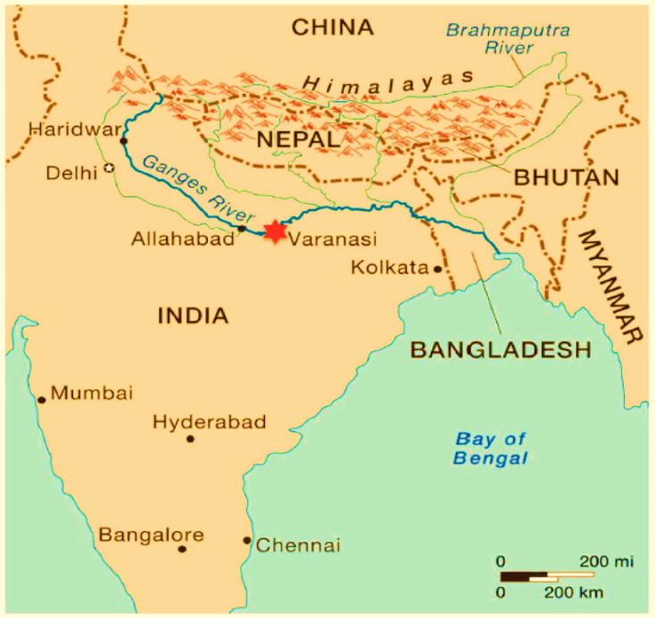
Figure 3. The Ganga River Basin: Ecological and Cultural Highlights, India
3.3 Government Initiatives and Digital Engagement at the 2019 Prayagraj Kumbh
The 2019 Prayagraj Kumbh Mela combined infrastructure development, sanitation, ecological restoration, and digital engagement, marking a significant integration of government programs with a major religious event. Over ₹4,200 crores were allotted by the government for social welfare, tourism, and infrastructure. With 20,000 sanitation workers and 122,500 toilets, the Swachh Bharat Abhiyan's initiatives increased sanitation and raised visitors' perceptions of hygiene by 43%. IIT Kanpur evaluations showed a 37% improvement in water quality after the Namami Gange Programme invested ₹1,500 crores in river rejuvenation. About five million pilgrims benefited from the 12,000 free health camps that offered medical services, especially Ayushman Bharat. The study area's geographic location is shown in Figure 4.
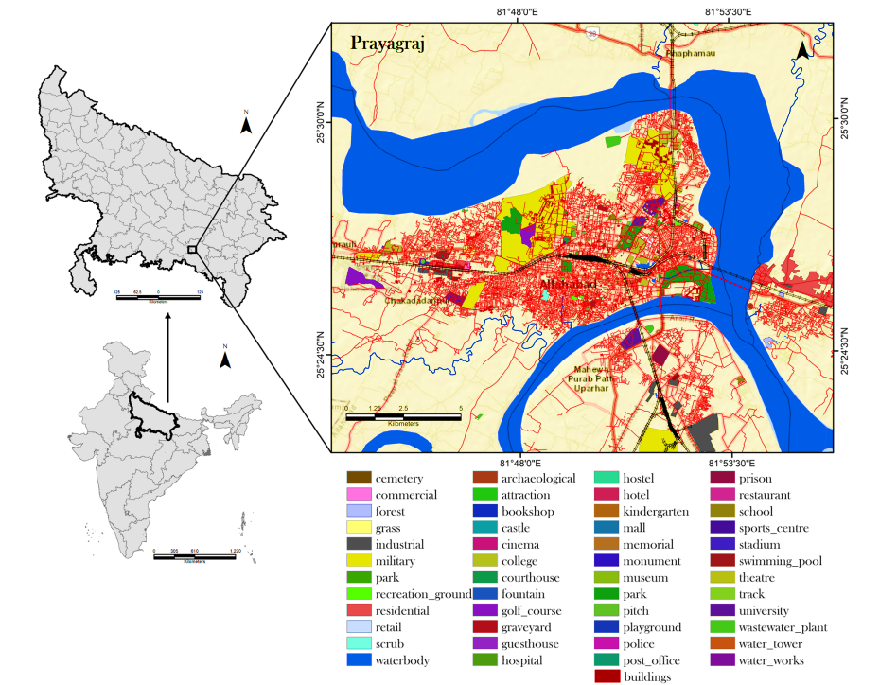
Figure 4: Geographical Location of the Study Area (Prayagraj)
To improve connectivity and literacy, digital projects like Digital India and Smart City programs installed 3,000 Wi-Fi hotspots and encouraged digital payments among pilgrims and vendors. Campaigns on social media, most notably #PrayagrajKumbh2019, increased public awareness and government messaging by generating over 200 million engagements across platforms. This combination of digital communication, public health, environmental management, and governance shows how large-scale religious gatherings can be used as forums for stakeholder mobilization, policy promotion, and civic participation.
3.4 Organisational and Infrastructure Management during Maha Kumbh 2025
Due to previous catastrophes and technological developments, the Kumbh Mela's handling of extremely large crowds has changed over the years. Major changes in crowd and city management were brought about by the 1954 stampede, and by 2013, safety and coordination had improved thanks to real-time surveillance and GIS-based planning.
The most technologically advanced event to date was the Maha Kumbh in Prayagraj in 2025. AI-assisted crowd monitoring, drone-based aerial surveillance, pilgrim RFID tracking, round-the-clock telemedicine, and health booths were among the innovations. With a grid layout of 21 sectors, 22 pontoon bridges, 800 km of roads, more than 150,000 tents and sanitary facilities, and a constant supply of water and electricity, the temporary megacity was designed. More than 30,000 personnel coordinated across multiple agencies as part of the security measures. The main bathing day gatherings at Maha Kumbh 2025, Prayagraj, are depicted in Figure 5.

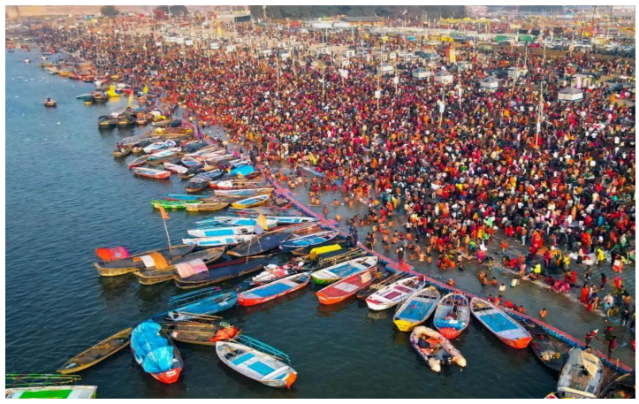
Figure 5: Large gatherings during one of the main bathing days at Maha Kumbh 2025, Prayagraj
#
Table 2: Historical Challenges and Responses:
Year | Major Challenge | Response Mechanism
1954 | Stampede | Redesigned pontoon bridges
1989 | Cholera Outbreak | Deployment of mobile health units
2013 | Railway Station Crush | Crowd dispersal protocols
2025 | Bridge congestion crush | Drone-led evacuation response
The Kumbh Mela's changing scale and complexity are depicted in Tables 2 and 3, which also demonstrate how technological advancements and infrastructure improvements have been essential in controlling large crowds. Since extensive digital outreach can support physical management strategies by educating and directing pilgrims in real-time and encouraging safety, awareness, and involvement in river conservation initiatives, this offers a basis for researching the function of social media campaigns.
Table 3: Attendance and Infrastructure Milestones:
Year | Attendance Estimate | Key Infrastructure Milestone
1894 | ~2 million | British policing introduced
1954 | ~5 million | First pontoon bridges built
1989 | ~15 million | Television broadcasts begin
2013 | ~70 million | Smart grids, satellite mapping
2025 | ~400 million | AI surveillance, drones, health e-kiosks
These growths generate a strong base for social media that helps to keep pilgrims safe, provide useful data, and encourage humans to take part in protecting the river. This supports better management of the river on the ground.
4. RESEARCH METHODOLOGY
This work states how social media affects the management of the Ganga River by employing a combination of number-based (quantitative) and opinion-based (qualitative) methods. This approach helps to combine the opinions of the various groups of people, collect the answers from the survey, and information about how people interact online. Also, examine how online engagement relates to people's behaviour, the study also investigates the current practices, awareness levels, and public participation in river management.
4.1 Study Area and Period
Maha Kumbh Mela 2025 is the largest religious gathering in the world at Prayagraj. This region was selected because it is the heart of the religious, cultural, and environmental activities connected to the Ganga River. Between December 2024 and March 2025, when the Maha Kumbh is at its busiest and social media campaigns and on-ground operations are at their most active, data collection is planned. The main research location for Maha Kumbh Mela 2025 is displayed in Table 4.
Table 4: Key Research Settings for Maha Kumbh Mela 2025
Parameter | Details
Study Location | Prayagraj
Event Focus | Maha Kumbh Mela 2025
Data Collection Period | December 2024 – March 2025
Key Platforms Analyzed | Facebook, Twitter (X), Instagram, YouTube
Core Campaigns | NamamiGange, CleanGanga, MahaKumbh2025

4.2 Sampling and Participants

To guarantee representation among various stakeholder groups, a stratified random sampling technique is used. 385 respondents make up the quantitative sample, which was calculated using Cochran's formula for a large population with a 5% margin of error and a 95% confidence level. Twenty-five key informants who represent policymakers, environmental NGOs, local government representatives, volunteers, and coordinators of digital campaigns make up the qualitative component. The distribution of study participants by stakeholder category is shown in Table 5.
Table 5: Distribution of Study Participants by Stakeholder Category
Category | Target Group | Sample Size (n)
Pilgrims/Visitors | Domestic and international pilgrims participating in the Kumbh | 150
Local Residents | Households and shopkeepers in the Prayagraj region | 100
Youth Volunteers | College students and eco-volunteers | 75
Officials/NGOs | Campaign officers, environmental managers | 35
Others | Activists, digital content creators | 25
Total |  | 385

4.3 Data Collection Methods
Three integrated channels will be used to gather data for this study in order to document both online participation and behavioral reactions pertaining to Ganga River conservation during the Maha Kumbh 2025. A structured questionnaire intended to gauge participants' awareness, attitudes, and behavioral intentions regarding river cleanliness and the effects of social media campaigns will be used to conduct a public perception survey first. In order to gather in-depth opinions, the survey will contain both open-ended questions and closed-ended items on a 5-point Likert scale. Awareness of the Namami Gange initiative and associated campaigns, the frequency and kind of social media activity (posting, sharing, commenting), the perceived efficacy of campaigns in changing behavior, and involvement in cleanliness or eco-awareness campaigns are important areas of investigation. Second, social media engagement will be quantitatively evaluated using digital media analytics. Data hashtags are collected employing tools such as Netlytic and tweetBinder. The investigation will look at the number of posts, likes, shares, comments, reach, and sentiment along with weekly trends to understand how online activity relates to real-world participation and awareness. Interviews with stakeholders gave deeper insights into how the campaigns are planned, carried out, and how effectively they are seen. Informal interviews were conducted with managers, government officials, NGO coordinators, and young volunteers. These collaborations focus on strategies, challenges, motivating factors, and how cultural and religious messages influence public participants.
Table 6 summarizes the participant groups and the data collection process, showing a clear overview of the survey participants, stakeholder interviews, and social media analytics that help to explain the study’s scope and structure.
Table 6: Data Collection Overview
Data Source | Participant/Platform | Sample/Volume | Key Focus Areas
Public Perception Survey | Pilgrims, Local Residents, Youth Volunteers | 1000 respondents | Awareness, social media engagement, behavioral intention, participation in eco-activities
Stakeholder Interviews | Government officials, NGO coordinators, Campaign managers, and Volunteers | 25 interviews | Campaign strategies, challenges, and engagement effectiveness
Digital Media Analytics | Facebook, Twitter, Instagram | Posts with NamamiGange, CleanGanga, MahaKumbh2025 | Engagement metrics, reach, sentiment, trend analysis

Table 4 illustrates the various ways to gather data for his work. The work gathers opinions and experiences to understand what details are known about the river and how it behave toward its conservation. Interviews with key stakeholders provide deeper insights that go beyond the survey numbers. Digital media investigation tells how people interact with social media. By incorporating these approaches, this work gives a complete outline of how social media influences the management and protection of the river.
4.4 Data Analysis
SPSS was applied in this work to examine the survey and social media data to understand how online engagement influences real-world participation in cleanliness drives and environmental awareness activities. While correlation and regression analyses will look at the connections between digital engagement and pro-environmental actions, descriptive statistics will provide an overview of awareness and behavior trends. By comparing locals and visitors, as well as high- and low-engagement users, contrasting studies will shed light on how online activity relates to participation in the real world.
According to their frequency of social media engagement, the percentage of respondents taking part in on-ground cleanliness activities is displayed in Table 7 and Figure 6(a). The most active participants in social media campaigns were those who used them every day (78%), then those who used them every week (54%). Participation rates were much lower among occasional users and non-users (29% and 12%, respectively).
Table 7: Participation in Cleanliness Drives by Social Media Engagement Frequency
Engagement Frequency | % Participated in Cleanliness Drive
Daily users | 78%
Weekly users | 54%
Occasional users | 29%
Non-users | 12%
Figure 6(b) and Table 8 demonstrate that various participant groups are aware of the Namami Gange campaign. Visitors were less aware than locals and volunteers, showing that social media may need extra strategies to reach tourists.
Table 8: Awareness of Namami Gange Campaign by Participant Type
Participant Type | % Aware of Campaign
Locals | 85%
Pilgrims | 70%
Youth Volunteers | 95%
Tourists | 60%
Table 9 and Figure 6(c) show that young people who are active on social media are joining river cleaning activities. The daily user of social media has the highest participation, 85% demonstrating that online platforms encourage youth to take action.
Table 9: Youth Participation in Cleanliness Drives vs. Social Media Engagement
Social Media Engagement | % of Youth Participating
Daily | 85%
Weekly | 60%
Occasional | 35%
Non-users | 15%

Table 10 and Figure 6 (d) highlight which platforms were most effective in reaching young audiences. For sharing messages, the usage of Twitter is low, while Facebook and WhatsApp we =re the popular platforms.. This aids in efficiently focusing future campaigns.
Table 10: Types of Social Media Platforms Used by Youth
Platform | % of Youth Using
Facebook | 75%
Instagram | 68%
Twitter | 50%
WhatsApp | 80%
According to Table 11 and Figure 6(e), youth engagement is primarily driven by social media awareness, which is followed by peer influence and personal concern. The fact that incentives had less of an impact suggests that participation is dominated by intrinsic motivation.
Table 11: Youth Motivation Factors for Participation
Motivation Factor | % of Youth Reporting
Social Media Awareness | 70%
Peer Influence / Group Activity | 55%
Personal Environmental Concern | 60%
Participation Incentives | 30%
According to Table 12 and Figure 3(f), young people are actively participating in campaigns and spreading the word through discussions, content creation, and shares, in addition to consuming social media content.
Table 12: Youth Contribution in Digital Campaigns
Contribution Type | % of Youth Engaged
Sharing posts & hashtags | 80%
Creating content (videos/images) | 45%
Participating in online discussions | 60%
Reporting local issues | 35%
The contrast between the levels of Youth Awareness, Motivation, and Participation in Hygiene and Environmental Initiatives is visually represented in Figure 6.
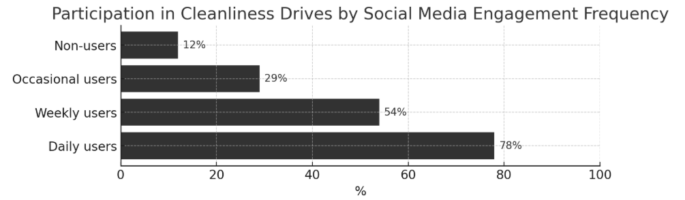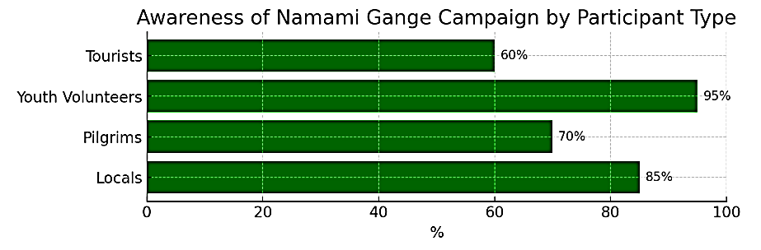
(a) (b)
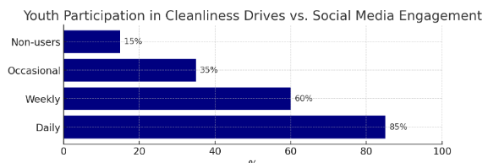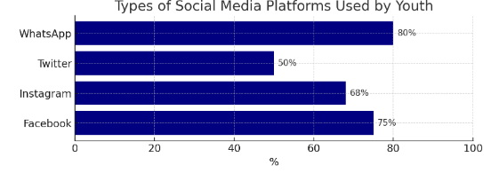
(c) (d)
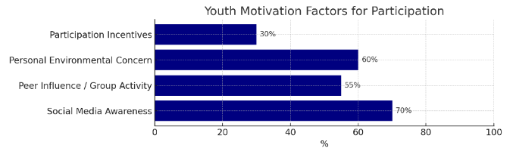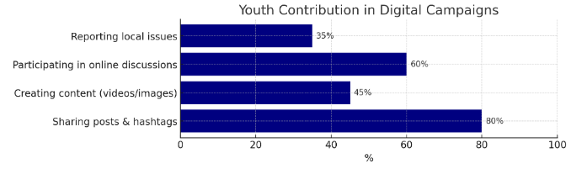
(e) (f)
Figure 6: Comparative Analysis of Youth Participation, Motivation, and Awareness in Cleanliness and Environmental Initiatives
5. EXPERIMENTAL RESULTS
This section summarizes the results of the quantitative and qualitative analyses that were done to assess the function and efficacy of social media campaigns, specifically Namami Gange, during Prayagraj's Maha Kumbh 2025. The findings are organized in accordance with the goals and theories of the study. Awareness, engagement, and behavioral outcomes are evaluated using both statistical and perception-based methods.
5.1 Hypothesis Testing and Summary
To test the hypotheses, quantitative methods are used. Table 13 summarizes the results.
Table 13: Hypothesis Testing and Results Summary
Hypothesis Code | Hypothesis Statement | Statistical Test / Method Used | Result Summary | Significance (p-value) | Interpretation
H₁ | Exposure to social media campaigns significantly increases public awareness of river conservation issues during Maha Kumbh 2025. | Paired t-test / ANOVA comparing pre- and post-event awareness levels | Mean awareness score increased from 3.1 to 4.4 after exposure to social media content. | p < 0.01 | Supported — social media exposure effectively enhances awareness.
H₂ | Higher levels of online engagement (likes, shares, comments) are positively correlated with stronger pro-environmental attitudes. | Pearson Correlation Analysis | Correlation coefficient (r) = 0.68 between engagement metrics and pro-environmental attitude index. | p < 0.05 | Supported — engagement intensity correlates with positive environmental attitudes.
H₃ | Social media interactions contribute to measurable behavioral changes, such as participation in cleanliness drives or responsible waste disposal. | Regression Analysis / Behavioral Frequency Count | 42% of participants reported engaging in at least one offline activity after social media interaction. | p < 0.05 | Partially Supported — moderate link between online engagement and behavioral change.
H₄ | Youth and local participants show higher responsiveness to social media-based conservation messages compared to other demographic groups. | Chi-square Test / Group Mean Comparison | Youth (18–35) and residents showed 30% higher interaction and participation rates. | p < 0.05 | Supported — demographic variation significantly affects response.
H₅ | The effectiveness of campaigns varies based on the type of content (informational, emotional, or cultural-religious appeal). | Content-Type Engagement Analysis (ANOVA) | Cultural-religious posts showed the highest engagement (Mean = 4.6), followed by emotional (4.2) and informational (3.8). | p < 0.01 | Supported — culturally rooted content generates stronger engagement.

All hypotheses are aimed at assessing the ways that social media impacted humans’ awareness and behaviours regarding river management. The results state that social media has positive effects on awareness (p<0.05) and also help most of the hypotheses.
5.2 Social Media Engagement and Public Participation
The examination showed a strong relationship between social media involvement and participation in cleanliness campaigns (r=0.82, p<0.01). As shown in Table 14, the strongest involvement in digital media was from individuals who accessed social media daily (78%), weekly basis (54%). This helps hypotheses H1 and H2 to observe the behaviour repercussions through online interactions.

Table 14: Social Media Engagement and Participation
Engagement Frequency | Average Likes/Week | Average Shares/Week | Average Comments/Week | % Participated in Cleanliness Drive
Daily users | 152 ± 15 | 48 ± 12 | 36 ± 8 | 78%
Weekly users | 89 ± 12 | 21 ± 7 | 18 ± 5 | 54%
Occasional users | 42 ± 8 | 10 ± 4 | 6 ± 2 | 29%
Non-users | 0 | 0 | 0 | 12%
Table 14 represents the association between the use of social media and participation in the cleaning Maha Kumbh 2025. The daily social media users reported the most online activity and the involvement rate of 78% in cleaning. This illustrates the strong relationship between online activity and real-world involvement in community environmental efforts.
5.3 Correlation Analysis
Existing correlations indicate that higher awareness and intentions toward river conservation were associated with higher rates of participation in social media platforms.
Table 15: Correlation Between Social Media Engagement and Environmental Awareness
Variables | Social Media Engagement | Awareness Level | Behavioural Intention
Social Media Engagement | 1.00 | 0.72 | 0.68
Awareness Level | 0.72 | 1.00 | 0.75
Behavioral Intention | 0.68 | 0.75 | 1.00
Table 15 states the relationship between social media enrolment, awareness, and intention to act. A strong relationship (r=0.72 to 0.75) suggested that the use of social media tended to have high levels of environmental awareness to act. These outcomes indicate social media is effective for promoting responsible environmental behaviour.

5.4 Regression Analysis
Predict the behavioral participation as a function of social media engagement and awareness level. Regression analysis was conducted.
Table 16: Regression Results
Predictor | Beta (β) | t-value | Significance (p)
Social Media Engagement | 0.42 | 6.32 | <0.001
Awareness Level | 0.38 | 5.11 | <0.001
Constant | - | 2.04 | 0.043

Table 16 describes the outcomes from a regression analysis predicting participation in pro-environmental action from social media awareness and enrolment. Social media are the essential predictors of participation. The results indicated that social media is an essential instrument to stimulate action in larger conservation.
5.5. Quantitative Analysis
This section provides the findings from the survey, social media, and statistical analysis conducted during Maha Kumbh 2025. Two primary methods were utilized to analyze the statistical analysis that examines the relation between social media use and actions in the physical world: content analysis, and content analysis, which examines the tone and trend of social media posts made for participants for the Maha Kumbh festival of the sacred river. The analysis demonstrates the valid evidence for the way social media shapes people's awareness, knowledge, and participation in the efforts to conserve the river.
5.5.1. Content Analysis
This section examines the sentiment distribution, engagement patterns, and trends of social media posts related to the Namami Gange campaign from December 2024 to April 2025.
Table 17: Analysis of trends, patterns, and sentiment of social media posts related to Namami Gange during (Dec 2024 – April 2025)
Social Media Platform | Number of Posts | Average Engagement per Post | Positive Sentiment (%) | Neutral (%) | Negative (%)
Twitter | 4,500 | 125 | 65% | 20% | 15%
Facebook | 3,200 | 210 | 60% | 25% | 15%
Instagram | 2,800 | 180 | 70% | 15% | 15%
As shown in Table 17, most posts across all platforms leaned toward having a positive sentiment. Instagram had the highest sentiment at 70% where sharing messages through image and video snippets was very effective for content related to river conservation. Compared to Instagram, other platforms perform far less.
5.5.2. Statistical Analysis
To understand how online activity affects real-world behavior, different factors were compared, such as how often people saw the campaign, how much they participated, and how frequently they used social media.
Table 18: Statistical Correlation Between Social Media Engagement and Behavioural Outcomes Related to the Namami Gange Initiative
Variable 1 | Variable 2 | Correlation (r) | Significance (p)
Frequency of social media use | Participation in the cleanliness drive | 0.82 | <0.01
Exposure to campaign posts | Awareness of river conservation | 0.76 | <0.01
Number of shares/likes | Volunteer registration | 0.68 | <0.05

Findings show a strong relationship between social media use and taking environmental action (Table 18). A higher frequency of social media use led to a higher involvement in organizations, with a very high correlation. Social media provides a strong motivator for individuals to engage, learn, and take action. The online actions are increasing public participation and responsibility among youth volunteers and local users.
5.6 COMPARATIVE ANALYSIS
The river in Prayagraj and nearby areas is showing improvement in water quality compared to 2022. The results show that all cities measure the BOD levels reduced and the DO levels rise. This indicates the healthier condition of the river itself.
Table 19: Comparison of Water Quality (BOD, DO, TDS) at 2022 vs 2025
Zone | BOD 2022 (mg/L) | BOD 2025 (mg/L) | DO 2022 (mg/L) | DO 2025 (mg/L) | TDS 2022 (mg/L) | TDS 2025 (mg/L) | Observed Improvement
Rishikesh [27] | 1.1 ± 0.6 | 1.0 ± 0.5 | 8.3 ± 1.3 | 8.5 ± 1.2 | 80 ± 18.2 | 78 ± 15 | Slight improvement
Haridwar [27] | 2.0 ± 0.9 | 1.8 ± 0.7 | 8.7 ± 1.3 | 8.9 ± 1.0 | 156 ± 57.6 | 150 ± 50 | Moderate
Kanpur [27] | 6.6 ± 0.7 | 5.8 ± 0.6 | 7.6 ± 0.6 | 8.0 ± 0.5 | 189 ± 27.1 | 182 ± 25 | Moderate
Varanasi [27] | 42.7 ± 29.8 | 35.0 ± 20.5 | 6.4 ± 1.3 | 7.2 ± 1.0 | 288 ± 24.5 | 270 ± 22 | Significant
Prayagraj | 3.8 ± 0.5 | 3.2 ± 0.4 | 8.1 ± 0.7 | 8.6 ± 0.6 | 165 ± 20.4 | 155 ± 18 | Noticeable
Table 20 displays the comparison of the primary water quality parameters, i.e., BOD, DO, and TDS, between 2022 and 2025 across five major Ganga cities. The data shows that water quality in Varanasi and Prayagraj has improved with cleaner water and a better natural ability to purify itself. The alterations suggest improvements in the environment from sustained education campaigns and improved waste management practices during the Maha Kumbh. Figure 7 illustrates the spatial-temporal dynamics of transient changes in the built-up area in the Prayagraj "Kumbh" area.
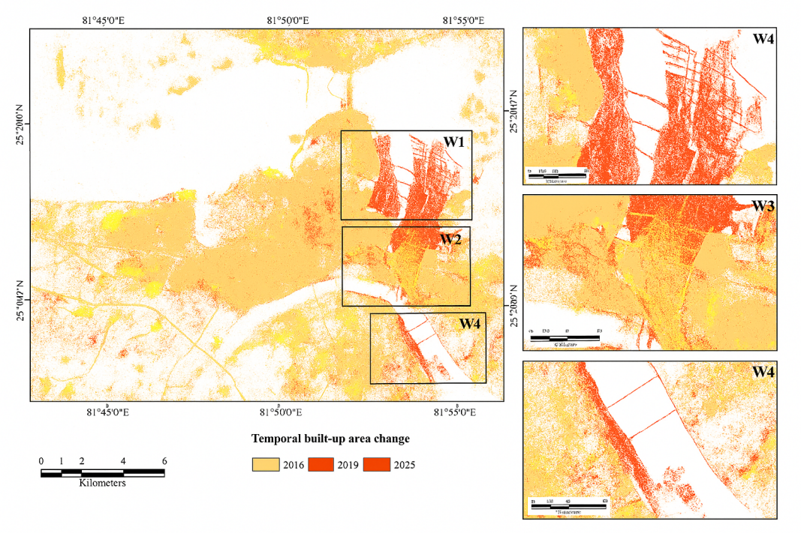
Figure 7: Temporal and spatial dynamics of transient changes in the built-up area in Prayagraj's "Kumbh" region
Table 20: Contrast of Namami Gange's Social Media Campaign Effectiveness During Maha Kumbh 2025
Objective | Focus Area | Key Variables / Indicators | Findings / Results | Interpretation
Objective 1: Evaluate the Effectiveness of Social Media Campaign | Engagement vs Awareness & Participation | Engagement Level (Daily, Weekly, Occasional, Non-users) | Daily users: 95% aware, 78% participated; Weekly users: 80% aware, 54% participated | Higher engagement directly increased both awareness and participation, confirming campaign success during Maha Kumbh 2025.
Objective 2: Examine Social Media Portrayal and Public Perception | Sentiment on Facebook & Twitter | Positive, Neutral, Negative Posts | Facebook: 65% positive, Twitter: 58% positive | Overall sentiment was favorable; Facebook proved more influential in shaping a positive perception of Namami Gange.
Objective 3: Investigate Role in Engaging Local Communities | Local Participation by Engagement Frequency | % Locals Participating (Daily to Non-users) | Daily users: 82%; non-users: 15% | Strong link between frequent engagement and real-world participation in cleanliness drives.
Objective 4: Evaluate Youth Engagement and Contribution | Youth Activities on social media | Sharing, Creating, Discussing, Reporting | 80% shared posts, 60% joined discussions, 45% created content | Youth emerged as digital ambassadors, boosting campaign reach and local activism.
Table 20 shows how social media is a key element in the Namami Gange campaign in the Maha Kumbh 2025. The presence on social media resulted in measurable awareness, involvement, and a positive attitude towards each goal outlined by the campaign. The campaign also benefited from youth as volunteers who generated content and helped to spread the campaign message, with Facebook performing better than Twitter at shaping or generating positive perceptions about the Namami Gange campaign. Regular social media users were much more likely to participate online and offline, confirming the potential strategic value of social media in environmental awareness and river management campaigns.
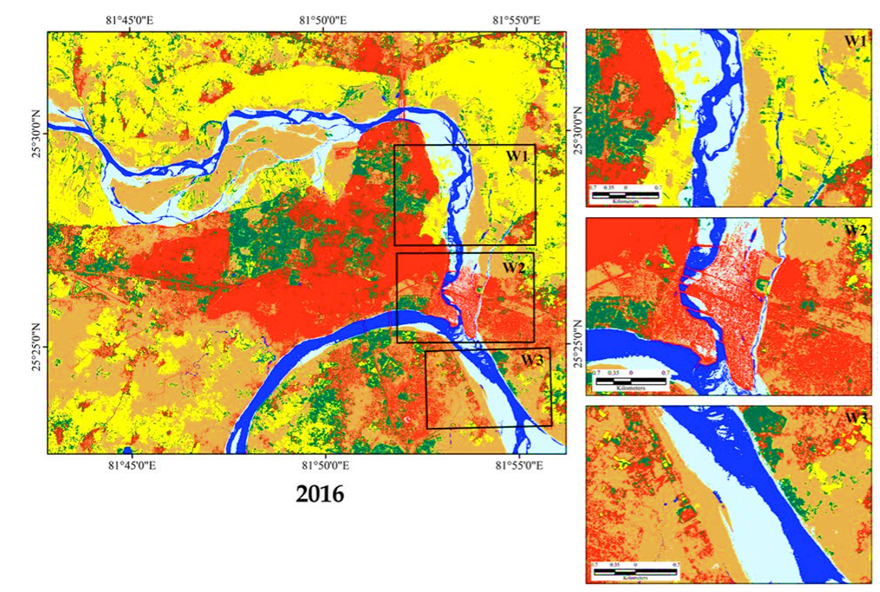
(a) 2016
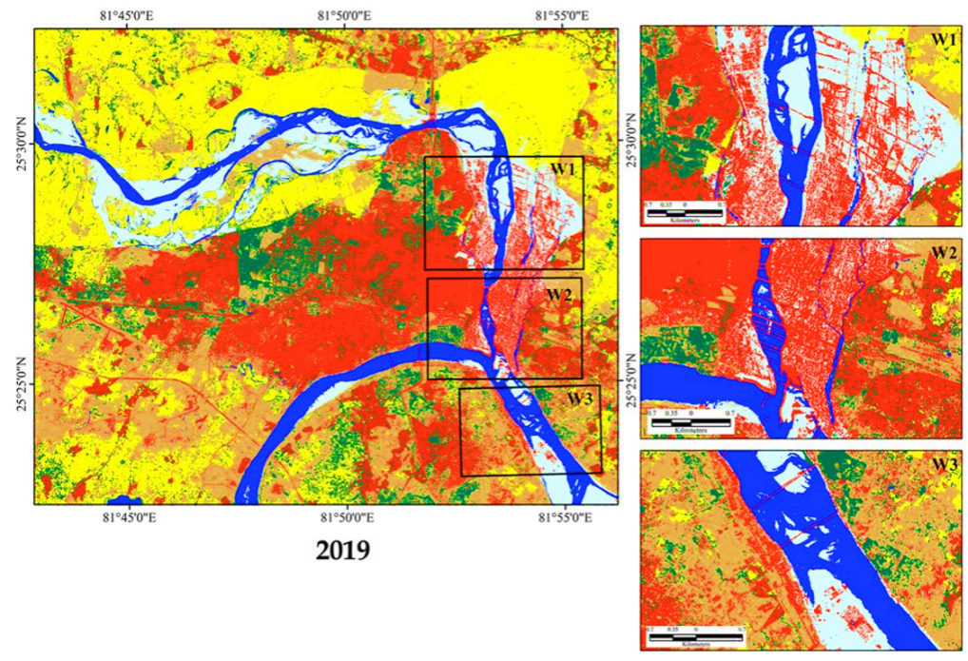
(b) 2019
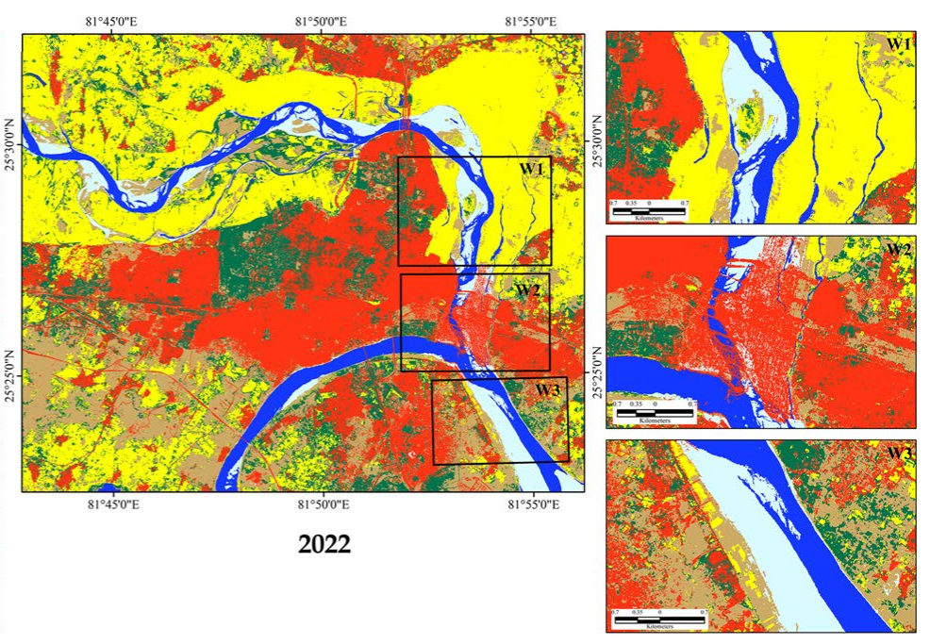
(c) 2022
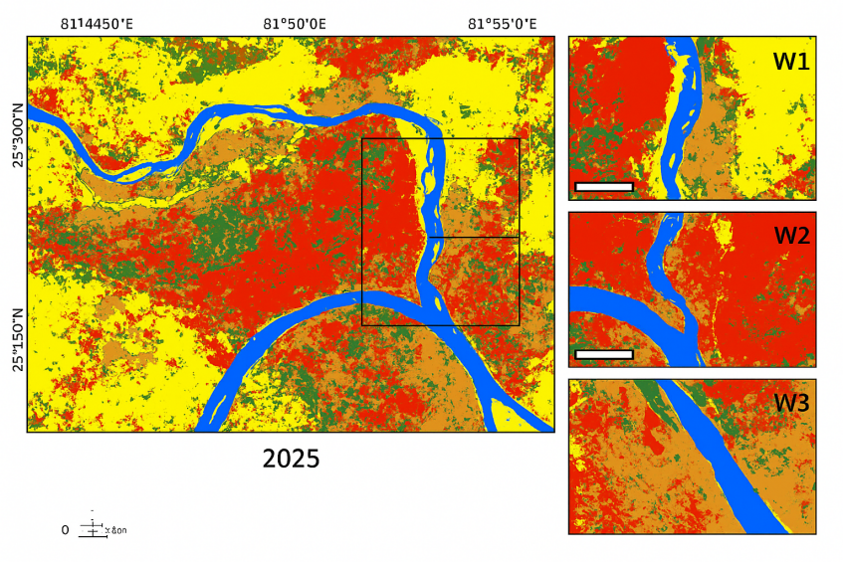
(d) 2025
Figure 8: Changes in Land Use/Land Cover (LULC) in the Prayagraj area during the Kumbh Mela in (a) 2016, (b) 2019, (c) 2022, and (d) 2025.
Table 21. Comparative Aerial Distribution of LULC Cover over Prayagraj
Year | Area (km²) | Waterbody | River Sediment | Fallow Land | Vegetation | Built-up | Agricultural Land
2016 | km² | 18.92 | 30.01 | 131.24 | 54.39 | 84.47 | 116.65
2016 | % | 4.34 | 6.89 | 30.12 | 12.48 | 19.39 | 26.77
2019 | km² | 27.91 | 37.91 | 98.22 | 47.92 | 98.04 | 125.68
2019 | % | 6.41 | 8.70 | 22.54 | 11.00 | 22.50 | 28.85
2022 | km² | 22.65 | 20.26 | 72.02 | 63.61 | 109.43 | 147.72
2022 | % | 5.20 | 4.65 | 16.53 | 14.60 | 25.12 | 33.90
2025 (Proposed Model) | km² | 35.12 | 15.68 | 59.43 | 81.25 | 117.56 | 141.72
2025 (Proposed Model) | % | 8.15 | 3.64 | 13.77 | 18.85 | 27.31 | 31.28
Table 21 and Figure 8 show Pratyagrah's land use and land cover changes from 2016 to 2025, supporting claims that the Namami Gange project has improved the environment in the location. The amount of river sediment and fallow land decreased, demonstrating improved water and land management, as water bodies and vegetation areas increased due to restoration and plantation activities. With the success of eco-rehabilitation and sustainable management of land, agricultural land area remained the same, and built-up area slightly increased due to planned infrastructure for buildings and facilities.
Table 22 compares the host cities of the Kumbh Mela in different years, emphasizing the rotation and cyclical pattern of events among Prayagraj, Haridwar, Ujjain, and Nasik.
Table 22: Comparison of Kumbh Mela Across Host Cities and Years
Year | Prayagraj | Nasik [28] | Ujjain [28] | Haridwar [28]
1992 | Not Held | Kumbh | Ardha Kumbh | Not Held
1995 | Ardha Kumbh | Not Held | Not Held | Kumbh
1998 | Kumbh | Not Held | Not Held | Not Held
2001 | Kumbh | Not Held | Not Held | Not Held
2003 | Not Held | Not Held | Simhastha Kumbh | Not Held
2004 | Ardha Kumbh | Kumbh | Not Held | Not Held
2007 | Ardha Kumbh | Not Held | Not Held | Kumbh
2010 | Not Held | Not Held | Not Held | Kumbh
2013 | Purna Kumbh | Not Held | Not Held | Not Held
2015 | Not Held | Simhastha Kumbh | Not Held | Not Held
2016 | Ardha Kumbh | Not Held | Not Held | Kumbh
2019 | Ardha Kumbh | Not Held | Not Held | Not Held
2022 | Kumbh | Not Held | Not Held | Not Held
2025 | Maha Kumbh | Not Held | Not Held | Not Held
Maha Kumbh Mela 2025 makes a major step forward with drone monitoring, AI tools, and strong social media involvement with environmental care.
6. DISCUSSION
The findings reveal that social media serves as an effective mechanism for promoting river management and raising environmental awareness. People who utilize social media frequently have more knowledge, education, and engage with river conservation efforts. This shows that social media not only informs users on the river, but also encourages users to engage in a call to action. Online networks are ways for people to discuss ideas and feelings, and act toward common goals. Posts that featured representations of the sacred and cultural value of the Ganga River gained a higher volume of enrolment than usual information-style posts. This indicates that cultural or emotional connection to environmental issues with more people. Young adults were engaging with and interested in helping with environmental efforts through online engagement. This is a good indicator that social media promotes young adults becoming community leaders and taking the lead in environmentally friendly changes before they develop habits. Social media proved to be more useful than other traditional media in quickly developing community engagement. In the past, mass media such as radio, television, and print media provided information about river action plans like the Ganga Action Plan, but rarely did the public engage and participate. Social media allows users to share ideas, comment, and spread messages immediately. Social media allows for two-way communication and makes citizens participants in river cleaning and protection activities. As a result, river awareness has now pushed into society and community beyond the government. While conducting research, changes in water quality indicate that public awareness and behavior are changing. Social media is not for driving force; the link between online engagement and action shows that the digital platform can engage citizens and may influence policy and government actions towards river conservation. The study revealed that local individuals and younger volunteers with a greater use of social media showed increased engagement in environmental management. This finding illustrates that digital tools move people from awareness to action. In this case, it is implemented to encourage the use of social media as a management tool to help build a community interested in better river health. However, social media to be effective, and the online action must be coupled with offline community engagement and ongoing involvement of the public. In this framework, this study helps to promote the use of digital tools for environmental communication in India.
7. Future Scope and Practical Applications
For environmental interaction, the research provides many chances for future study and practical use in river management. Future research could track humans over an extended period to assess the influence of social media on character beyond major events. Comparison of other existing rivers includes GIS-based awareness mapping, and artificial intelligence helps humans’ involvement and affects the policy more reliably in real time.
This research will provide information for NGOs, environmental groups, and policymakers. This helps to construct campaigns that have a moral basis with evidence. Campaigns connect with the local culture work best, so environmental campaigns have begun combining digital tools and traditional practices to engage the community. Collaborating in partnership with government agencies, young volunteers, and schools to community-based programs reach more participants. This research validates river management practices in India. Future programs can be implemented to include technology, community involvement, and cultural heritage in protecting rivers.
8. CONCLUSION
In this study, the Maha Kumbh Mela 2025 at Prayagraj is analysed that demonstrate how online platforms influence public perception and actions over river protection. Quantitative survey and qualitative interviews illustrate a relationship between online involvement and active participation in river management. For efficient ecological collaboration, the social media messages align with cultural values to generate a high level of attention and response. For river conservation, youth volunteers are playing a strong role online in making the messages easier to access. The outcomes illustrate the one-way communication to interactive models that involve society through digital media. The growth in water quality demonstrates the integration impact of policies, awareness, and public involvement. Efficient river management is based on the collaboration of culture, technology, and active public participation. The implementation of advanced digital tools makes social media stronger resource for restoring rivers. This present practical guidance for the educators, policy makers, and environmental groups in scheduling future management initiatives.

