Teachers’ Assessment Literacy and Challenges in Constructing Valid Classroom Tests Across Five Administrative Regions of Guyana

ABSTRACT
Assessment literacy is an essential professional competency that enables teachers to construct valid, reliable, and instructionally useful classroom assessments. This quantitative cross-sectional study investigated teachers’ assessment literacy and the challenges encountered in constructing valid classroom tests across five administrative regions of Guyana. Data were collected through an online questionnaire administered using Google Forms and distributed to 841 teachers. A total of 748 usable responses were received, producing an 88.9% response rate. The instrument used a five-point Likert scale to examine teachers’ perceptions of assessment literacy, educational measurement, validity principles, test blueprint use, and classroom test-construction challenges. Descriptive statistics, including frequencies, percentages, means, standard deviations, and rankings, were used to summarize the data. Chi-Square Tests of Independence were conducted to test associations among demographic, professional, and assessment-related variables; Cramer’s V was added to clarify the practical strength of statistically significant relationships. Findings revealed that limited knowledge of test validity principles, inadequate training in educational measurement, lack of assessment resources, limited professional development opportunities, and workload-related time constraints were the most frequently reported challenges. Significant associations were found between classroom test-construction challenges and educational level, teaching experience, assessment literacy, and test blueprint usage. However, the administrative region was not significantly associated with reported challenges, suggesting that assessment-related difficulties are broadly systemic rather than region-specific. The study concludes that strengthening teachers’ assessment literacy, expanding professional development in educational measurement, and promoting the routine use of tables of specifications may improve the quality of classroom assessment and support more defensible educational decision-making in Guyana.
Keywords: assessment literacy; classroom testing; educational measurement; test validity; Guyana
INTRODUCTION
Assessment is a central component of the teaching and learning process because it provides evidence about students’ knowledge, skills, attitudes, and competencies. Through assessment, teachers determine the extent to which instructional objectives have been achieved, identify areas requiring remediation or enrichment, and make decisions about instruction, grading, progression, and support. Effective classroom assessment, therefore, has both pedagogical and accountability functions, especially in education systems where teachers are expected to align assessment with curriculum standards and learning outcomes.
Teacher-made classroom tests remain among the most widely used methods for measuring student achievement. These assessments are commonly used to evaluate content mastery, monitor academic progress, assign grades, and inform instructional planning. The quality of classroom tests consequently influences not only student scores but also the validity of decisions based on those scores. Poorly designed tests may misrepresent student learning, reward memorization at the expense of understanding, or fail to capture the intended range of curriculum objectives.
The effectiveness of classroom testing depends largely on teachers’ assessment literacy. Assessment literacy refers to the knowledge, skills, principles, and practices required to design, administer, interpret, and use assessments appropriately (Popham, 2020). Teachers with strong assessment literacy are better positioned to construct valid and reliable assessments, align test items with learning objectives, apply appropriate item formats, prepare tables of specifications, and interpret results in ways that support learning. Conversely, limited assessment literacy can lead to tests that are unclear, misaligned, overly narrow, or weak in content validity.
Validity is especially important in classroom testing. In educational measurement, validity concerns the extent to which evidence and theory support the interpretations and uses of test scores for their intended purposes (Nitko & Brookhart, 2022). For classroom teachers, content validity is particularly important because teachers must ensure that assessment items adequately represent the taught content and the cognitive demands of the curriculum. Validity is therefore not a property of the test alone; it is a judgment about the appropriateness of score interpretation and use.
Within Guyana, classroom assessment is an essential component of teaching and learning across primary, secondary, and tertiary educational institutions. Teachers are expected to develop tests that align with curriculum objectives and accurately measure student achievement. However, empirical evidence on teachers’ assessment literacy and test-construction practices in Guyana remains limited. This study addresses that gap by investigating teachers’ assessment literacy and the challenges they experience when constructing valid classroom tests across five administrative regions of Guyana.
Statement of the Problem
Although teachers are responsible for developing classroom assessments that guide instructional and administrative decisions, many may not have sufficient training in educational measurement, validity principles, test blueprinting, and item construction. International research suggests that teachers often experience difficulties constructing valid assessments, particularly when measuring higher-order thinking skills or ensuring adequate content representation. In Guyana, limited empirical research has examined the extent to which teachers possess the knowledge and skills required to construct valid classroom tests. This study, therefore, investigated teachers’ assessment literacy and challenges encountered in constructing valid classroom tests across five administrative regions of Guyana.
Purpose and Objectives of the Study
The purpose of this study was to investigate teachers’ assessment literacy and the challenges they encounter in constructing valid classroom tests across five administrative regions of Guyana. Specifically, the study sought to determine the major challenges teachers encounter, examine teachers’ levels of assessment literacy, and determine whether educational level, teaching experience, administrative region, assessment literacy, and test blueprint usage are associated with classroom test-construction challenges.
Hypotheses
• H01: There is no statistically significant association between educational level and challenges encountered in constructing valid classroom tests.
• H02: There is no statistically significant association between teaching experience and challenges encountered in constructing valid classroom tests.
• H03: There is no statistically significant association between administrative region and challenges encountered in constructing valid classroom tests.
• H04: There is no statistically significant association between teachers’ assessment literacy and challenges encountered in constructing valid classroom tests.
• H05: There is no statistically significant association between the use of test blueprints and challenges encountered in constructing valid classroom tests.
LITERATURE REVIEW
Assessment literacy has become a critical competency for educators in systems emphasizing standards-based learning, accountability, and data-informed decision-making. It includes the ability to select appropriate assessment methods, construct valid instruments, interpret student performance, communicate results, and use assessment evidence to improve instruction. Brookhart (2020) and Popham (2020) emphasize that assessment literacy extends beyond technical knowledge of testing to include ethical use of assessment, feedback, fairness, and the defensibility of educational decisions.
The Assessment Literacy Framework provides the conceptual basis for this study. The framework assumes that teachers’ assessment knowledge influences the quality of classroom assessment practice and, by extension, the quality of educational decisions. Core competencies within the framework include knowledge of assessment principles, understanding of validity and reliability, item-construction competence, interpretation of results, use of assessment information for instructional improvement, and ethical assessment practices (Fulmer et al., 2023).
Classroom assessment and educational measurement are closely related. Classroom assessment involves collecting and interpreting evidence about student learning, whereas educational measurement involves assigning scores to educational outcomes according to established rules and procedures. Effective classroom assessments should align with instructional objectives, adequately represent the content domain, contain clear and fair items, and support valid interpretations (Mertler, 2021; Nitko & Brookhart, 2022).
Test construction is a systematic process that requires teachers to identify instructional objectives, define content areas, determine cognitive levels, prepare a table of specifications, write items, review items, and administer the assessment. Tests may include multiple-choice, matching, true-false, short-answer, essay, and performance-based assessments. Regardless of item format, teachers must ensure that each item measures the intended learning outcome and contributes to the validity of the total assessment.
A table of specifications, also called a test blueprint, is an assessment planning tool that links content areas, instructional objectives, and assessment items. It assists teachers in achieving content coverage, reducing item-selection bias, balancing cognitive levels, and strengthening content validity. Despite its importance, many teachers do not routinely prepare tables of specifications because of limited training, time constraints, or insufficient assessment resources (Volante & Fazio, 2021).
The assessment of higher-order thinking skills remains a persistent challenge. Bloom’s Revised Taxonomy identifies remembering, understanding, applying, analyzing, evaluating, and creating as cognitive levels. The upper levels require more sophisticated item construction than simple recall questions. Teachers may find it difficult to write valid items that measure analysis, evaluation, creativity, and problem-solving while maintaining clarity and fairness (Yan et al., 2022).
Professional development is a key mechanism for strengthening teachers’ assessment competence. Effective professional learning can improve teachers’ understanding of validity, reliability, item construction, score interpretation, and feedback practices. DeLuca et al. (2022) argue that assessment-focused professional development contributes to improved assessment practices when it is sustained, contextualized, and linked to classroom realities.
METHODOLOGY
Research Design
This study employed a quantitative cross-sectional survey design. The quantitative approach was appropriate because it enabled the collection of numerical data from a large sample and its analysis to identify patterns, trends, and associations among variables. The cross-sectional design was suitable because data were collected at a single point in time from teachers representing different educational levels and administrative regions. The study also included a correlational component through Chi-Square Tests of Independence.
Population, Sample, and Sampling Procedure
The target population comprised teachers employed at primary, secondary, and tertiary educational institutions across Administrative Regions 2, 3, 4, 5, and 6 of Guyana. A non-probability, voluntary-response sampling approach was used. An online questionnaire was distributed electronically through professional networks, educational groups, institutional contacts, and digital communication platforms. The survey was distributed to approximately 841 teachers, and 748 completed questionnaires were returned and deemed usable for analysis, resulting in an 88.9% response rate.
Instrument
Data were collected using a structured online questionnaire developed from literature on assessment literacy, educational measurement, classroom testing, and test validity. Section A collected demographic information, including gender, age, educational level, teaching experience, and administrative region. Section B measured teachers’ perceptions of assessment literacy and classroom test-construction challenges using a five-point Likert scale ranging from 1 = Strongly Disagree to 5 = Strongly Agree. Items addressed professional development in assessment, knowledge of validity principles, construction of higher-order thinking questions, workload constraints, alignment with learning objectives, assessment resources, tables of specifications, educational measurement training, content validity, and class size.
Validity, Reliability, and Ethics
Content validity was established through alignment with current literature and review by specialists in educational measurement and classroom assessment, who examined item relevance, clarity, wording, and alignment with the study objectives. The internal consistency of the questionnaire was assessed using Cronbach’s Alpha, yielding an overall reliability coefficient of α = .89, indicating good reliability for educational research. Ethical principles were observed throughout the study: participation was voluntary, informed consent was obtained, confidentiality and anonymity were maintained, and no personally identifiable information was collected.
Data Analysis
Data were analyzed using descriptive and inferential statistics. Frequencies, percentages, means, standard deviations, and rankings were used to summarize demographic characteristics and identify major challenges. Chi-Square Tests of Independence were used to test associations between classroom test-construction challenges and educational level, teaching experience, administrative region, assessment literacy, and test blueprint usage. All hypotheses were tested at the .05 level of significance. Cramer’s V was computed to interpret the strength of association for each Chi-Square test.
RESULTS
Table 1. Demographic Characteristics of Respondents (N = 748)
Variable | Category | Frequency | Percentage
Gender | Female | 463 | 61.9
Gender | Male | 285 | 38.1
Age | 21-29 Years | 399 | 53.3
Age | 30-39 Years | 189 | 25.3
Age | 40 Years and Above | 160 | 21.4
Educational Level | Primary | 476 | 63.6
Educational Level | Secondary | 165 | 22.1
Educational Level | Tertiary | 107 | 14.3
Region | Region 2 | 139 | 18.6
Region | Region 3 | 105 | 14.0
Region | Region 4 | 202 | 27.0
Region | Region 5 | 122 | 16.3
Region | Region 6 | 180 | 24.1
Note. Percentages are based on N = 748.
Female teachers constituted the majority of respondents (61.9%), while male teachers represented 38.1% of the sample. More than half of the respondents were between 21 and 29 years old (53.3%). Primary school teachers represented the largest educational category (63.6%), followed by secondary school teachers (22.1%) and tertiary educators (14.3%). Region 4 contributed the largest proportion of respondents (27.0%), while Region 3 contributed the smallest proportion (14.0%).
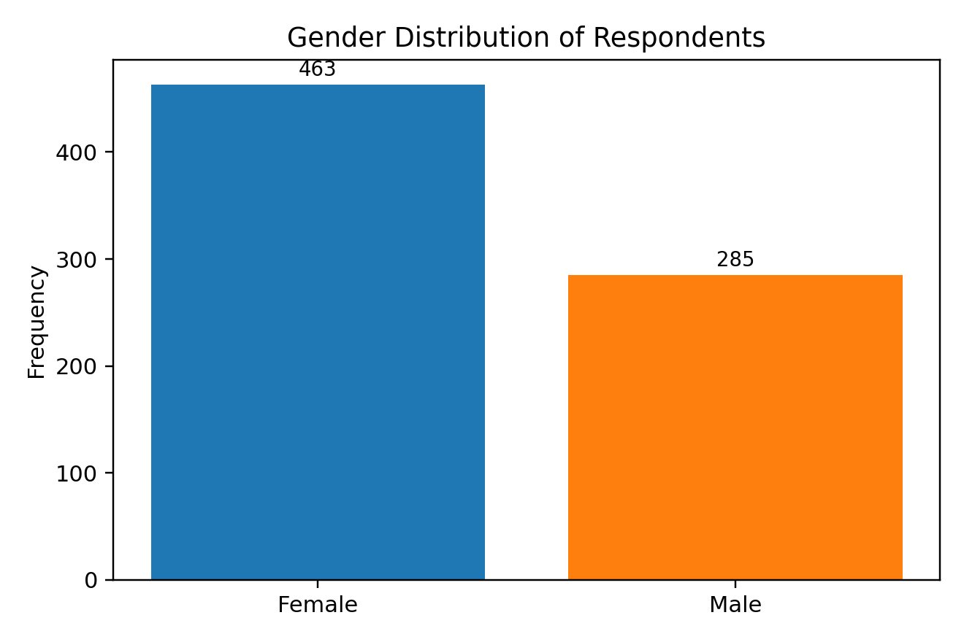
Figure 1. Gender Distribution of Respondents
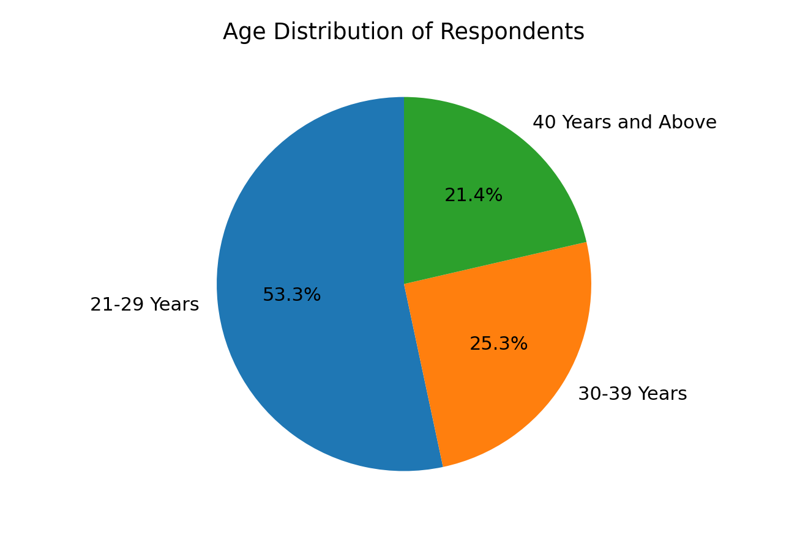
Figure 2. Age Distribution of Respondents
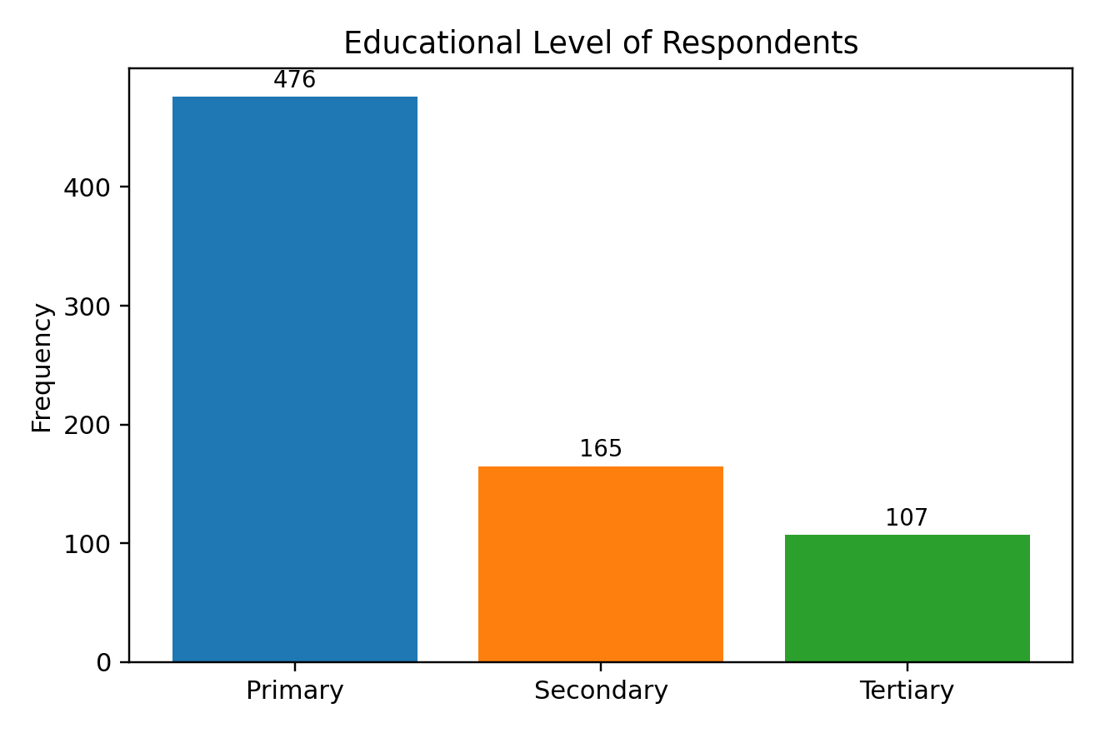
Figure 3. Educational Level of Respondents
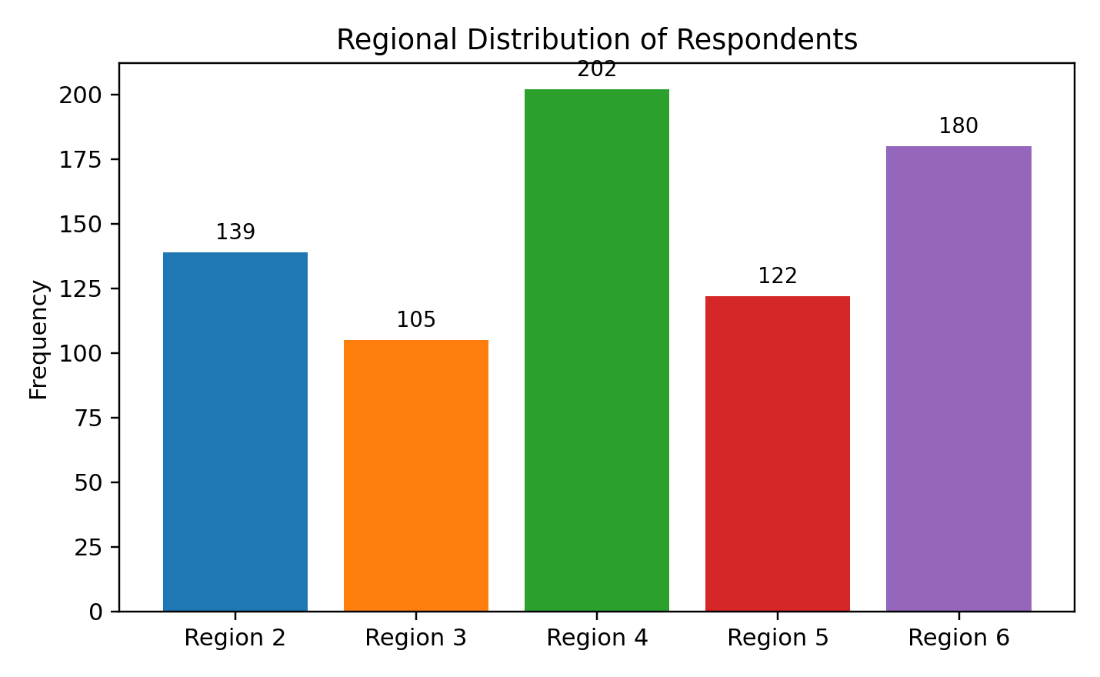
Figure 4. Regional Distribution of Respondents
Table 2. Mean Ratings and Rankings of Challenges Encountered in Constructing Valid Classroom Tests
Challenge | Mean | Rank
Limited Knowledge of Test Validity Principles | 3.75 | 1
Inadequate Training in Educational Measurement | 3.67 | 2
Lack of Assessment Resources | 3.61 | 3
Lack of Professional Development Opportunities | 3.59 | 4
Time Constraints Due to Workload | 3.56 | 5
Difficulty Aligning Test Items with Learning Objectives | 3.56 | 6
Difficulty Ensuring Content Validity | 3.55 | 7
Difficulty Developing a Table of Specifications | 3.4 | 8
Difficulty Constructing Higher-Order Thinking Questions | 3.38 | 9
Large Class Sizes Affect Assessment Planning | 3.33 | 10
Note. Higher mean values indicate stronger agreement regarding the challenge.
Limited knowledge of test validity principles emerged as the most significant challenge (M = 3.75), followed by inadequate training in educational measurement (M = 3.67) and lack of assessment resources (M = 3.61). These results suggest that knowledge, training, and resource gaps are central barriers to the construction of valid classroom tests. Difficulty constructing higher-order thinking questions and large class sizes were also reported, although their mean ratings were lower than the leading challenges.
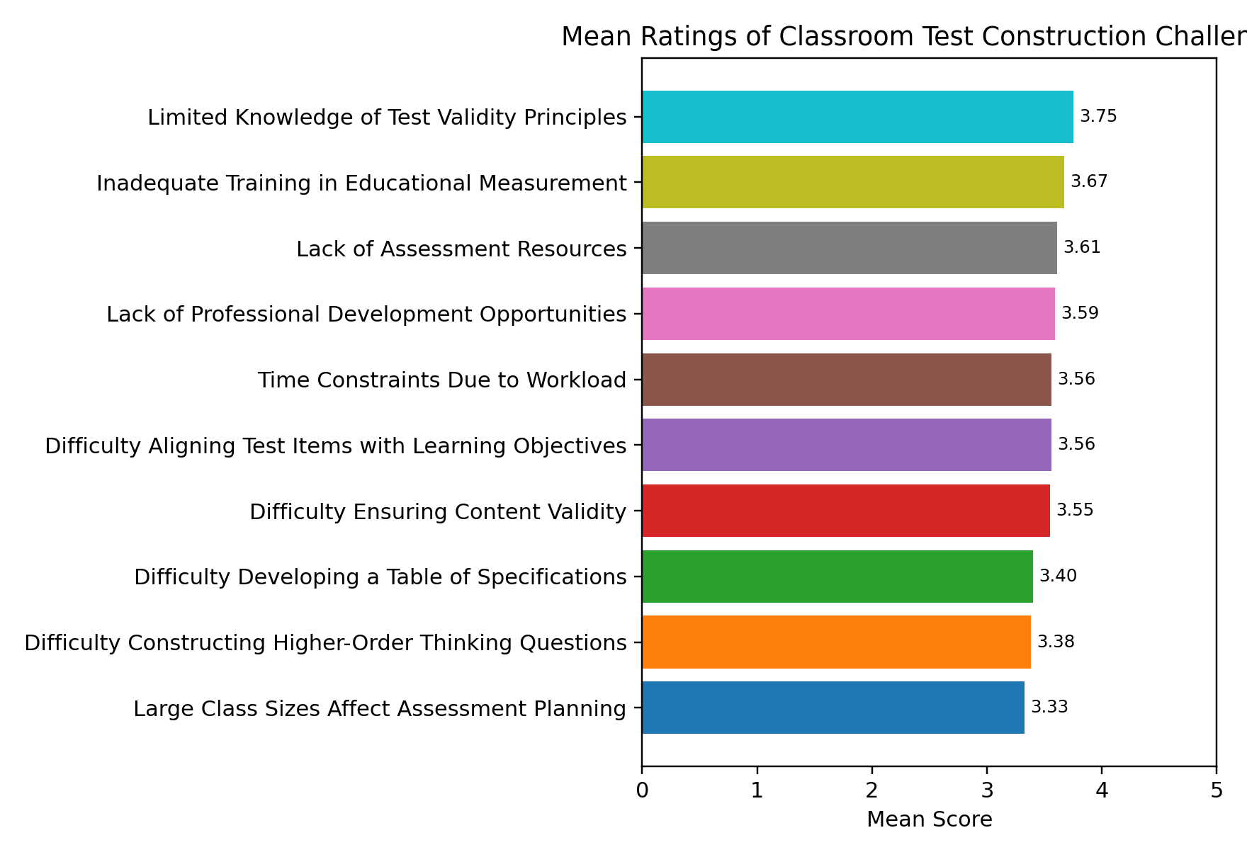
Figure 5. Mean Ratings of Classroom Test-Construction Challenges
Table 3. Chi-Square Test of Educational Level and Challenge Level
Educational Level | Low | Moderate | High | Total
Primary | 112 | 185 | 179 | 476
Secondary | 31 | 66 | 68 | 165
Tertiary | 42 | 39 | 26 | 107
Total | 185 | 290 | 273 | 748
Note. χ²(4) = 28.46, p < .001, Cramer’s V = .138.
Table 4. Chi-Square Test of Teaching Experience and Challenge Level
Experience | Low | Moderate | High | Total
1-5 Years | 62 | 123 | 123 | 308
6-10 Years | 38 | 71 | 65 | 174
11-15 Years | 44 | 59 | 43 | 146
16+ Years | 41 | 37 | 42 | 120
Total | 185 | 290 | 273 | 748
Note. χ²(6) = 14.37, p = .026, Cramer’s V = .098.
Table 5. Chi-Square Test of Administrative Region and Challenge Level
Region | Low | Moderate | High | Total
Region 2 | 33 | 54 | 52 | 139
Region 3 | 25 | 42 | 38 | 105
Region 4 | 51 | 77 | 74 | 202
Region 5 | 31 | 48 | 43 | 122
Region 6 | 45 | 69 | 66 | 180
Total | 185 | 290 | 273 | 748
Note. χ²(8) = 6.83, p = .554, Cramer’s V = .068.
Table 6. Chi-Square Test of Assessment Literacy and Challenge Level
Assessment Literacy | Low | Moderate | High | Total
High | 98 | 75 | 41 | 214
Moderate | 71 | 144 | 113 | 328
Low | 16 | 71 | 119 | 206
Total | 185 | 290 | 273 | 748
Note. χ²(4) = 102.64, p < .001, Cramer’s V = .262.
Table 7. Chi-Square Test of Blueprint Usage and Challenge Level
Blueprint Usage | Low | Moderate | High | Total
Regularly | 91 | 77 | 37 | 205
Occasionally | 58 | 109 | 76 | 243
Never | 36 | 104 | 160 | 300
Total | 185 | 290 | 273 | 748
Note. χ²(4) = 96.18, p < .001, Cramer’s V = .254.
The Chi-Square results indicated statistically significant associations between classroom test-construction challenges and educational level, teaching experience, assessment literacy, and test blueprint usage. The null hypotheses for H01, H02, H04, and H05 were therefore rejected. Administrative region was not significantly associated with classroom test-construction challenges; consequently, H03 was not rejected. The effect sizes suggest that the strongest practical associations were found for assessment literacy and blueprint usage, while educational level and teaching experience showed weaker but statistically significant associations.
DISCUSSION
The study revealed that limited knowledge of test validity principles was the most significant challenge reported by teachers. This finding is important because validity is the foundation of defensible classroom assessment. If teachers lack a sound understanding of validity, they may construct tests that do not adequately measure intended learning outcomes or that provide misleading information about student achievement. The finding aligns with Brookhart (2020), who emphasizes that assessment quality depends on the strength of the evidence supporting the interpretation and use of scores.
Inadequate training in educational measurement ranked as the second major challenge. This result suggests that many teachers require deeper preparation in test construction, item analysis, reliability, validity, and score interpretation. It also supports the argument that assessment literacy should be treated as a core component of teacher education and continuing professional development rather than as a peripheral skill. Without adequate measurement training, teachers may rely heavily on informal judgment or inherited test formats rather than systematic assessment design procedures.
Lack of assessment resources and limited professional development opportunities were also major concerns. These findings point to institutional and systemic factors that influence assessment quality. Teachers may understand the importance of valid testing but still struggle to prepare high-quality assessments when they lack examples, templates, time, training, or access to assessment tools. Professional development should therefore focus not only on theory but also on practical test construction, blueprint preparation, item writing, moderation, and use of assessment data.
Educational level was significantly associated with classroom test-construction challenges, although the effect size was small. Primary and secondary teachers reported relatively higher levels of difficulty than tertiary educators. One possible explanation is that tertiary educators may have greater exposure to research, postgraduate study, or educational measurement concepts. However, this interpretation should be approached with caution because the study used voluntary response sampling and did not directly measure the depth of each teacher’s formal assessment preparation.
Teaching experience was also significantly associated with classroom test-construction challenges, but the effect size was weak. Less experienced teachers reported more difficulty than more experienced teachers. This suggests that classroom assessment competence may develop partly through accumulated practice. Nevertheless, experience alone should not be treated as a substitute for formal training, as teachers may continue to reproduce weak assessment practices unless they are supported by structured professional learning and feedback.
Administrative region was not significantly associated with classroom test-construction challenges. This finding suggests that the challenges identified in the study are broadly systemic rather than region-specific. Teachers across Regions 2, 3, 4, 5, and 6 appear to face similar issues related to validity knowledge, measurement training, resources, and blueprint use. A national professional development strategy may therefore be more appropriate than isolated regional interventions.
Assessment literacy had one of the strongest associations with classroom test-construction challenges. Teachers with higher assessment literacy reported fewer difficulties than those with lower assessment literacy. This supports the Assessment Literacy Framework and reinforces the importance of strengthening teachers’ knowledge of validity, reliability, item construction, alignment, and assessment interpretation. Similarly, regular use of test blueprints was associated with fewer challenges, suggesting that tables of specifications may serve as practical tools for improving the quality of classroom assessment.
CONCLUSION
This study investigated teachers’ assessment literacy and challenges encountered in constructing valid classroom tests across five administrative regions of Guyana. The findings show that teachers experience several challenges related to validity principles, educational measurement training, assessment resources, professional development opportunities, workload, item alignment, content validity, blueprint development, higher-order thinking questions, and large class sizes. Limited knowledge of test validity principles was the highest-ranked challenge. Significant associations were found between classroom test-construction challenges and educational level, teaching experience, assessment literacy, and blueprint usage. No significant association was found between administrative region and assessment challenges. Overall, the findings suggest that strengthening assessment literacy and promoting systematic test planning may improve the quality of classroom assessment in Guyana.
RECOMMENDATIONS
• The Ministry of Education should provide regular professional development programmes focused on assessment literacy, educational measurement, validity, reliability, and classroom test construction.
• Teacher education institutions should strengthen coursework related to classroom assessment, item writing, content validity, test blueprinting, and interpretation of assessment results.
• Schools should encourage teachers to use tables of specifications when developing classroom tests to improve content coverage, item balance, and validity.
• Educational authorities should provide teachers with practical assessment resources, item-writing guides, blueprint templates, and examples of valid classroom tests.
• School administrators should allocate structured time for assessment planning, peer review of test items, and moderation of classroom assessments.
• Future studies should use mixed-methods designs incorporating interviews, document analysis, and classroom observations to provide deeper insight into teachers’ assessment practices.
IMPLICATIONS FOR EDUCATIONAL PRACTICE
The findings have important implications for teacher education, professional development, school leadership, and educational policy. Assessment literacy should be treated as a core professional competency for teachers at all levels. Professional development should prioritize validity, alignment, blueprint construction, item quality, and use of assessment evidence to support instruction. Strengthening these areas can improve the quality of classroom assessments, reduce measurement error, and support more effective educational decision-making.
LIMITATIONS
Several limitations should be considered when interpreting the findings. First, the study relied on self-reported data, which may be affected by respondent bias. Second, the online survey format may have excluded teachers with limited internet access. Third, the voluntary response sampling procedure limits the generalisability of the findings. Fourth, the cross-sectional design captured teachers’ perceptions at one point in time and did not examine changes in assessment literacy over time. Despite these limitations, the large sample size and representation of teachers from multiple educational levels and administrative regions provide useful evidence on assessment literacy and classroom testing practices in Guyana.
DECLARATIONS
Ethical Approval
The study adhered to accepted ethical principles governing educational research involving human participants. Participation was voluntary, informed consent was obtained from all respondents, and participants were assured of anonymity and confidentiality. No personally identifiable information was collected, and all data were used solely for academic and research purposes.
Conflict of Interest
The author declares that there are no conflicts of interest regarding the publication of this research.
Funding Statement
This research received no external funding from any public, commercial, governmental, or non-profit organization.
Data Availability
The data supporting the findings of this study are not publicly available because the respondents were assured confidentiality and anonymity. Aggregated data may be made available by the author upon reasonable academic request.
Author Contribution
Davin Persaud conceptualized and designed the study, developed the research instrument, collected and analyzed the data, interpreted the findings, conducted the literature review, prepared the manuscript, and approved the final version for submission.
Acknowledgements
The author expresses sincere gratitude to the teachers from Administrative Regions 2, 3, 4, 5, and 6 of Guyana who voluntarily participated in this study.
REFERENCES
1. Andrade, H. L. (2020). Classroom assessment as the co-regulation of learning. Assessment in Education: Principles, Policy & Practice, 27(4), 350-372.
2. Brookhart, S. M. (2020). Classroom assessment and educational measurement. Routledge.
3. Brown, G. T. L., & Gao, L. (2021). Teacher assessment literacy and classroom assessment practices. Assessment in Education: Principles, Policy & Practice, 28(3), 245-261.
4. Creswell, J. W., & Creswell, J. D. (2023). Research design: Qualitative, quantitative, and mixed methods approaches (6th ed.). Sage Publications.
5. DeLuca, C., Chapman-Chin, A., & Klinger, D. A. (2022). Toward a teacher professional learning framework for assessment literacy. Educational Assessment, Evaluation and Accountability, 34(2), 115-134.
6. DeLuca, C., Coombs, A., & LaPointe-McEwan, D. (2019). Assessment mindset: Exploring teacher conceptions of assessment. Studies in Educational Evaluation, 62, 1-9.
7. Fulmer, G. W., Lee, I. C. H., & Tan, K. H. K. (2023). Multi-dimensional teacher assessment literacy. Studies in Educational Evaluation, 76, 101236.
8. George, D., & Mallery, P. (2020). SPSS for Windows step by step: A simple guide and reference (18th ed.). Routledge.
9. Greenstein, L. (2020). Assessing 21st century skills: A guide to evaluating mastery and authentic learning. Corwin Press.
10. Heritage, M. (2020). Formative assessment in practice: A process of inquiry and action. Harvard Education Press.
11. McMillan, J. H. (2021). Classroom assessment: Principles and practice for effective standards-based instruction (8th ed.). Pearson.
12. Mertler, C. A. (2021). Classroom assessment: A practical guide for educators (3rd ed.). Routledge.
13. Nitko, A. J., & Brookhart, S. M. (2022). Educational assessment of students (9th ed.). Pearson.
14. Pastore, S., & Andrade, H. (2023). Teacher assessment literacy: A systematic review. Frontiers in Education, 8, 1217167.
15. Popham, W. J. (2020). Classroom assessment: What teachers need to know (9th ed.). Pearson.
16. Stiggins, R. J. (2020). Classroom assessment for student learning: Doing it right-Using it well (3rd ed.). Pearson.
17. Tierney, R. D. (2022). Assessment literacy and educational improvement. Educational Measurement: Issues and Practice, 41(3), 15-27.
18. Volante, L., & Fazio, X. (2021). Teacher assessment literacy and professional development. Assessment in Education: Principles, Policy & Practice, 28(4), 403-420.
19. Wiliam, D. (2021). Embedded formative assessment (3rd ed.). Solution Tree Press.
20. Willis, J. (2021). Assessment for learning and teacher competence. Journal of Educational Assessment, 18(2), 77-92.
21. Xu, Y., & Brown, G. T. L. (2021). Teacher assessment literacy in practice. Teaching and Teacher Education, 98, 103256.
22. Yan, Z., Zhang, C., & Fan, Y. (2022). Assessment literacy and classroom practice. Studies in Educational Evaluation, 73, 101140.

