Stabilized Progressive Fine-Tuning (SPFT)

Abstract—Foundation models have demonstrated strong performance in medical imaging; however, their ability to generalize across heterogeneous datasets, imaging modalities, and downstream tasks remains limited. Existing approaches often rely on modality-specific architectures, task-specific training pipelines, or large-scale retraining, which hinder scalability and practical deployment in real-world clinical settings.
In this work, we present a unified and reproducible optimization-driven framework for improving cross-dataset, cross-modality, and cross-task generalization of foundation models in medical imaging. Rather than introducing new architectures, we investigate how principled optimization strategies can enhance performance, stability, and transferability across diverse vision tasks. Building on the observation that pretrained encoders capture modality-agnostic representations, we propose a lightweight adaptation strategy, termed Stabilized Progressive Fine-Tuning (SPFT), which combines staged fine-tuning, progressive layer unfreezing, class-aware loss weighting, and Exponential Moving Average (EMA) stabilization.
We evaluate our approach across multiple datasets and tasks, including chest radiograph classification on ChestX-ray14 [17] and CheXpert [8], dermoscopic image classification on HAM10000 [16], object detection on VinDr-CXR, and medical image segmentation using SAM-based models. Importantly, the same SPFT strategy is applied consistently across all tasks and architectures, including transformer-based and CNN-based models.
Experimental results demonstrate that our approach achieves strong and stable performance across classification (AUC up to 0.95), detection (mAP@50 up to 0.76), and segmentation (Dice up to 0.96), while maintaining low variance across runs. We further show that optimization plays a critical role in improving generalization and stability, even when architectural choices vary significantly.
These findings highlight that carefully designed optimization strategies can serve as a scalable and effective alternative to task-specific architectural modifications, enabling unified and robust medical imaging systems across diverse datasets and problem settings.
- Introduction
Medical imaging has undergone rapid transformation with the emergence of large-scale foundation models, which leverage self-supervised learning to capture rich and transferable visual representations. Recent approaches such as RAD-DINO [1] have demonstrated strong performance on chest X-ray classification tasks, achieving competitive results on widely used benchmarks such as ChestX-ray14 and CheXpert. However, despite these advances, effectively adapting foundation models across heterogeneous datasets, imaging modalities, and downstream tasks remains a significant challenge.
A central issue lies in the heterogeneity of medical data. Imaging modalities such as chest radiographs (grayscale) and dermatoscopic images (RGB) differ substantially in visual characteristics, label distributions, and noise patterns. Furthermore, even within the same modality, datasets such as
ChestX-ray14 [17], CheXpert [8], and VinDr-CXR exhibit notable distributional differences in annotation quality, label sparsity, and clinical variability. As a result, models trained on one dataset or task often fail to generalize to others without substantial architectural modifications, task-specific pipelines, or large-scale retraining. While effective, such approaches increase computational cost and limit scalability in real-world clinical applications.
In this work, we investigate whether a unified training strategy can enable cross-dataset, cross-modality, and cross-task generalization of foundation models without modifying the underlying architecture. We hypothesize that pretrained encoders capture modality-agnostic representations, and that the primary challenge lies in adapting these representations through effective optimization rather than increasing model or pipeline complexity. Based on this insight, we propose a unified adaptation framework, termed Stabilized Progressive Fine-Tuning (SPFT), which combines staged fine-tuning, progressive layer unfreezing, class-aware optimization, and Exponential Moving Average (EMA) stabilization to improve robustness and generalization.
We evaluate our approach across multiple datasets and tasks spanning distinct medical imaging domains, including chest radiograph classification on ChestX-ray14 [17] and CheX-pert [8], dermoscopic image classification on HAM10000 [16], object detection on VinDr-CXR, and medical image segmentation using SAM-based models. These datasets and tasks exhibit substantial variation in modality, label structure, annotation granularity, and data distribution, providing a rigorous testbed for evaluating unified generalization.
Experimental results demonstrate consistent improvements over baseline models across classification, detection, and segmentation tasks, achieving strong performance while maintaining low variance across runs. Importantly, the same optimization strategy is applied across all models and tasks, without requiring task-specific architectural modifications or complex augmentation pipelines.
The contributions of this work are summarized as follows:
- We propose a unified optimization-driven framework (SPFT) for adapting foundation models across heterogeneous medical imaging datasets, modalities, and tasks without architectural modifications.
- We demonstrate strong cross-dataset, cross-modality, and cross-task generalization across classification (ChestX-ray14, CheXpert, HAM10000), detection (VinDr-CXR), and segmentation tasks, using a single training strategy.
- We show that principled optimization strategies can reduce reliance on task-specific pipelines and architectural complexity, highlighting the critical role of optimization in medical image modeling.

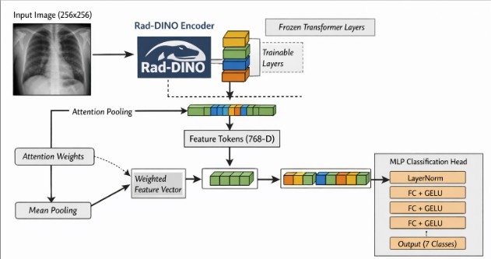
- We provide empirical insights into how training dynamics influence transferability, spatial reasoning, and stability across diverse medical imaging tasks and datasets.
- Methodology

- Backbone
We propose a unified optimization-driven framework for adapting foundation models across heterogeneous medical imaging modalities. Our approach, termed Stabilized Progressive Fine-Tuning (SPFT), focuses on improving generalization through training strategy design rather than architectural modifications or extensive data augmentation.
We build our approach on top of RAD-DINO [1], a vision foundation model trained using self-supervised learning. Such models have been shown to learn rich and transferable representations that generalize well across downstream tasks [3], [12]. In the context of medical imaging, RAD-DINO has demonstrated strong performance on chest X-ray classification benchmarks, making it a suitable choice for feature extraction. Instead of training a model from scratch, we leverage the pretrained encoder to benefit from its learned visual representations, thereby reducing computational cost and improving
generalization.
- Architecture
We build our model on top of the RAD-DINO encoder, followed by a feature aggregation module and a task-specific multi-layer perceptron (MLP) classification head.
Given an input image x, the encoder produces token em-beddings:
H = Encoder(x) ∈ R^{N×D} (1)
where N is the number of tokens and D = 768 is the embedding dimension.
Unlike standard transformer-based approaches that rely on the [CLS] token, we aggregate spatial information using global average pooling over patch tokens after removing the [CLS] token. This design encourages the model to capture distributed spatial cues, which is particularly important in medical imaging where pathological patterns are often diffuse and not confined to a single region.
N

Fig. 1. Overview of the proposed RAD-DINO fine-tuning architecture. The encoder is partially unfrozen, and token representations are aggregated via global average pooling after removing the [CLS] token. The resulting feature vector is passed through an MLP head for multi-label classification.

- Selective Layer Unfreezing
Fine-tuning all layers of a large foundation model can lead to overfitting, particularly when the target dataset is limited or exhibits distributional shifts. Prior work has shown that partial fine-tuning can effectively balance the preservation of pretrained representations with task-specific adaptation [5], [9].
Motivated by this, we adopt a selective unfreezing strategy, where only the top k layers of the encoder are unfrozen while earlier layers remain fixed. This enables the model to adapt higher-level semantic features that are more task-specific, while retaining low-level representations learned during pretraining, thereby improving generalization and training stability.
- Hybrid Class Reweighting Strategy
Medical imaging datasets often exhibit significant class imbalance, which can bias model training toward majority classes and degrade performance on clinically important but underrepresented conditions. To address this, we propose a hybrid class reweighting strategy that combines distribution-based initialization with adaptive refinement driven by model performance.
  - Initial Class Weights.: We first compute class weights

1
z = N − 1
Σ Hi
i=2
(2)
based on label distribution:
w(0) = Nneg,c

(4)

This design enables the model to capture distributed spatial information, which is particularly important in medical imaging where abnormalities may not be localized.
The aggregated feature vector z is passed through a three-layer MLP head:
y = f_{MLP}(z) (3)
The MLP consists of:
^{c} Npos,c
where N_{pos,c} and N_{neg,c} denote the number of positive and negative samples for class c, respectively.
  - Normalization.: To ensure numerical stability and balanced scaling across classes, we normalize the weights:
w(0)
Σ

- Layer normalization
w_{c} = 1
C
c
C
c=1
(0)
c
w
(5)

- Two hidden layers of dimension 512 with GELU activation
- Dropout (rate 0.2)
- A final linear layer mapping to output classes
  - Heuristic Adjustment.: We further adjust class weights for clinically significant or empirically difficult classes based on validation behavior. This step allows the model to prioritize categories that are both rare and challenging.

  - Adaptive Refinement.: To account for dynamic training behavior, class weights are iteratively refined based on validation AUC, increasing emphasis on underperforming classes during training.
  - Final Loss.: The weighted binary cross-entropy loss is defined as:
L = − Σ w_{c} [y_{c} log(p_{c}) + (1 − y_{c}) log(1 − p_{c})] (6)
C
c=1
This hybrid strategy integrates static distributional information with dynamic performance feedback, enabling more balanced optimization and improved generalization across imbalanced classes.
- Exponential Moving Average
To improve training stability and reduce variance across updates, we maintain an exponential moving average (EMA) of model parameters:
θ_{EMA} = αθ_{EMA} + (1 − α)θ (7)
where α is the decay factor controlling the contribution of historical parameters.
EMA acts as a temporal smoothing mechanism, mitigating the effect of noisy gradient updates during training. This is particularly beneficial in cross-domain and cross-modality settings, where distributional differences can lead to unstable optimization dynamics. By maintaining a smoothed version of the model, EMA improves generalization performance and yields more consistent predictions across runs.
- Training Details
We train the model using the AdamW optimizer with differential learning rates to balance stability and adaptation. Specifically, the pretrained encoder is optimized with a lower learning rate (e.g., 3 × 10⁻⁶) to preserve learned representations, while the MLP classification head is trained with a higher learning rate (e.g., 5 × 10⁻⁵) to enable rapid task-specific adaptation.
We employ cosine annealing for learning rate scheduling, which facilitates smooth convergence and avoids abrupt changes in optimization dynamics. Mixed precision training is used to improve computational efficiency without compromising performance.
To prevent overfitting and ensure robust model selection, early stopping is applied based on validation AUC. All experiments are conducted with consistent hyperparameter settings across datasets to ensure fair comparison and reproducibility.
- Experimental Setup
- Datasets
We evaluate our framework across multiple datasets spanning diverse medical imaging modalities and tasks, including classification, detection, and segmentation. This diverse setup enables a comprehensive evaluation of cross-dataset, cross-modality, and cross-task generalization.
ChestX-ray14: We use the ChestX-ray14 dataset [17], which contains over 100,000 frontal-view chest radiographs annotated with 14 disease labels. This dataset is widely used for multi-label classification and serves as a standard benchmark for evaluating performance on grayscale medical imaging. The dataset exhibits significant class imbalance and label noise, making it a challenging testbed for robust model evaluation.
CheXpert: We additionally evaluate on the CheXpert dataset [8], a large-scale chest radiograph dataset comprising over 224,000 images from more than 65,000 patients with uncertainty-aware labels for 14 observations. Compared to ChestX-ray14, CheXpert presents different label distributions and annotation characteristics, providing a complementary benchmark to assess cross-dataset generalization within the same imaging modality.
HAM10000: We use the HAM10000 dataset [16], which consists of dermatoscopic images of skin lesions across multiple diagnostic categories. This dataset provides a challenging setting due to severe class imbalance, high intra-class variability, and domain differences from radiographic imaging. It enables evaluation of model performance on RGB medical images, complementing grayscale chest radiograph datasets.
VinDr-CXR: We utilize the VinDr-CXR dataset, which provides chest radiographs with detailed bounding box annotations for multiple thoracic abnormalities. This dataset is used for both object detection and segmentation tasks. Its high-quality annotations and diverse pathology distribution make it suitable for evaluating spatial localization performance and cross-task generalization.
TBX-11K: We further evaluate detection performance on the TBX-11K dataset, which consists of chest X-ray images annotated for tuberculosis-related abnormalities. This dataset is relatively small and exhibits sparse annotations, making it a challenging benchmark for evaluating model performance under limited data conditions and assessing robustness of detection models.
- Metrics
We use the Area Under the Receiver Operating Characteristic Curve (AUC) as the primary evaluation metric. Specifically, we report macro-averaged AUC across all classes to account for class imbalance and ensure equal weighting of each category. This metric is widely used in medical imaging tasks and provides a robust measure of model performance across imbalanced datasets.
- Results
- Results on HAM10000
Table 1 presents the performance of our method across three independent runs on the HAM10000 dataset. Our approach achieves a strong macro AUC of 0.9320 ± 0.0168, demonstrating both high performance and stability across runs.
Across individual classes, the model consistently achieves high AUC scores, particularly for bcc (0.9537 ± 0.0123), vasc (0.9548 ± 0.0182), and nv (0.9416 ± 0.0116), indicating

TABLE I
Performance comparison across multiple runs on HAM10000.

Metric | Run 1 | Run 2 | Run 3
Macro AUC | 0.9243 | 0.9164 | 0.9554
Actinic Keratoses (akiec) | 0.9468 | 0.9379 | 0.9604
Basal Cell Carcinoma (bcc) | 0.9379 | 0.9558 | 0.9675
Benign Keratosis (bkl) | 0.9185 | 0.8755 | 0.9318
Dermatofibroma (df) | 0.9207 | 0.8935 | 0.9873
Melanoma (mel) | 0.8554 | 0.8893 | 0.9056
Melanocytic Nevi (nv) | 0.9396 | 0.9285 | 0.9566
Vascular Lesions (vasc) | 0.9515 | 0.9342 | 0.9788

TABLE II
Mean ± standard deviation across three runs on HAM10000.

Metric | Mean ± Std
Macro AUC | 0.9320 ± 0.0168
Actinic Keratoses (akiec) | 0.9484 ± 0.0092
Basal Cell Carcinoma (bcc) | 0.9537 ± 0.0123
Benign Keratosis (bkl) | 0.9086 ± 0.0238
Dermatofibroma (df) | 0.9338 ± 0.0397
Melanoma (mel) | 0.8834 ± 0.0209
Melanocytic Nevi (nv) | 0.9416 ± 0.0116
Vascular Lesions (vasc) | 0.9548 ± 0.0182

robust performance on both common and clinically relevant categories. Performance on more challenging classes such as mel (0.8834 ± 0.0209) remains competitive, reflecting the model’s ability to handle difficult and imbalanced cases.
Compared to existing baselines, our method significantly outperforms standard architectures such as ResNet50 (0.8388), InceptionV3 (0.8589), and DenseNet121 (0.8967), as well as recent multimodal approaches such as ALBEF (0.9136).Notably, our model achieves a peak AUC of 0.9554, demonstrating very strong performance without relying on complex architectural modifications or extensive data augmentation.
These results highlight the effectiveness of our optimization-driven training strategy in achieving strong and stable performance on challenging medical imaging tasks.
- Results on ChestXray14
Table 4 presents the performance of our method across three independent runs on the ChestXray14 dataset. Our approach achieves a macro AUC of 0.8314 ± 0.0015, demonstrating highly stable performance with minimal variance across runs.
Across individual classes, the model achieves strong performance on several categories, including Emphysema (0.9370 ± 0.0015), Hernia (0.9376 ± 0.0196), and Car-
diomegaly (0.8990 ± 0.0030). Performance on more chal-
lenging classes such as Infiltration (0.7082 ± 0.0016) and Pneumonia (0.7469±0.0040) remains consistent, reflecting the model’s robustness across imbalanced and difficult categories.
Notably, our method achieves performance comparable to or slightly exceeding prior work [11] based on the RAD-DINO backbone, which reports macro AUC values around 0.83. This demonstrates that our optimization-driven training strategy can match state-of-the-art performance without requiring architectural modifications or extensive data augmentation.
TABLE III
Comparison with baseline models on HAM10000.

Model  InceptionV3 [14] | AUCROC  0.8589
ResNet50 [4] | 0.8388
DenseNet121 [6] | 0.8967
ALBEF (Only Images) [10] | 0.9136
Ours (Best) 0.9554

TABLE IV
Performance across three independent runs on ChestXray14.

Class | Run 1 | Run 2 | Run 3
Macro AUC | 0.8331 | 0.8302 | 0.8309
Atelectasis | 0.7857 | 0.7936 | 0.7977
Cardiomegaly | 0.9014 | 0.8956 | 0.8999
Effusion | 0.8351 | 0.8380 | 0.8365
Infiltration | 0.7094 | 0.7088 | 0.7064
Mass | 0.8447 | 0.8416 | 0.8471
Nodule | 0.7785 | 0.7804 | 0.7804
Pneumonia | 0.7507 | 0.7428 | 0.7471
Pneumothorax | 0.8950 | 0.8912 | 0.8921
Consolidation | 0.7680 | 0.7635 | 0.7718
Edema | 0.8627 | 0.8598 | 0.8636
Emphysema | 0.9388 | 0.9359 | 0.9364
Fibrosis | 0.8468 | 0.8278 | 0.8382
Pleural Thickening | 0.8009 | 0.7917 | 0.7998
Hernia | 0.9461 | 0.9515 | 0.9152

Table VI further compares different fine-tuning strategies. We observe that selectively unfreezing the last 10 layers yields better performance than fully unfreezing the encoder, highlighting the importance of controlled adaptation. This supports our hypothesis that preserving pretrained representations while enabling targeted adaptation leads to improved generalization. Overall, these results demonstrate that our method achieves strong and stable performance on ChestXray14, while reinforcing the effectiveness of optimization-driven fine-tuning
strategies for medical imaging tasks.
Figure 2 presents the per-class AUC along with standard deviation across multiple runs. The low variance observed across most classes indicates that the proposed training strategy yields highly stable performance. Notably, classes such as Emphysema, Cardiomegaly, and Pneumothorax exhibit both high AUC and minimal variability, demonstrating consistent learning of well-defined patterns.
Even for more challenging classes such as Infiltration and Pneumonia, the model maintains stable performance with low standard deviation, suggesting robustness under class imbalance and distributional complexity. These results highlight the effectiveness of our optimization-driven framework in reducing training variance and improving reliability across runs.
- Results on CheXPert
Table 7 presents the performance of our method on the CheXpert dataset. Our approach achieves a macro AUC of approximately 0.83–0.85, demonstrating competitive performance relative to standard single-model baselines.
Across individual classes, the model achieves strong performance on well-defined conditions such as Edema, Pleural

TABLE V
Mean and standard deviation of AUC across three runs on
ChestXray14.

Class | Mean ± Std
Macro AUC | 0.8314 ± 0.0015
Atelectasis | 0.7923 ± 0.0060
Cardiomegaly | 0.8990 ± 0.0030
Effusion | 0.8365 ± 0.0015
Infiltration | 0.7082 ± 0.0016
Mass | 0.8445 ± 0.0028
Nodule | 0.7798 ± 0.0011
Pneumonia | 0.7469 ± 0.0040
Pneumothorax | 0.8928 ± 0.0020
Consolidation | 0.7678 ± 0.0042
Edema | 0.8620 ± 0.0020
Emphysema | 0.9370 ± 0.0015
Fibrosis | 0.8376 ± 0.0095
Pleural Thickening | 0.7975 ± 0.0049
Hernia | 0.9376 ± 0.0196

TABLE VI
Comparison of different fine-tuning strategies on
ChestXray14.

Class | SPFT-10 layers | SPFT-all layers
Macro AUC | 0.8331 | 0.8320
Atelectasis | 0.7857 | 0.7766
Cardiomegaly | 0.9014 | 0.8941
Effusion | 0.8351 | 0.8302
Infiltration | 0.7094 | 0.7077
Mass | 0.8447 | 0.8321
Nodule | 0.7785 | 0.7584
Pneumonia | 0.7507 | 0.7369
Pneumothorax | 0.8950 | 0.8882
Consolidation | 0.7680 | 0.7508
Edema | 0.8627 | 0.8594
Emphysema | 0.9388 | 0.9315
Fibrosis | 0.8468 | 0.8232
Pleural Thickening | 0.8009 | 0.7806
Hernia | 0.9461 | 0.9518

Effusion, and Support Devices, while maintaining stable performance on more challenging categories such as Lung Lesion and Enlarged Cardiomediastinum. These results reflect the model’s ability to handle class imbalance and varying levels of label difficulty.
Compared to prior approaches, strong supervised CNN-based models [8], [13] and recent vision-language methods such as CheXzero, GLoRIA, BioViL, and MedCLIP [2], [7], [15], [18] have reported higher performance through architectural modifications, multimodal pretraining, or ensembling strategies. In contrast, our method focuses solely on optimization-driven adaptation without modifying the underlying architecture. Despite its simplicity, our approach achieves competitive performance that is comparable to standard single-model baselines, demonstrating that principled training strategies can effectively improve generalization across datasets.
Importantly, the model maintains consistent performance across classes without exhibiting instability or collapse in difficult categories, indicating robustness under real-world data variability. The ability to achieve stable and competitive performance without relying on complex augmentation pipelines, architectural changes, or multimodal training further

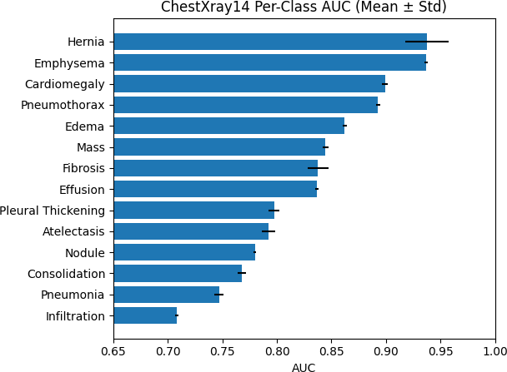

Fig. 2. Per-class AUC on ChestXray14. Error bars denote standard deviation across runs.
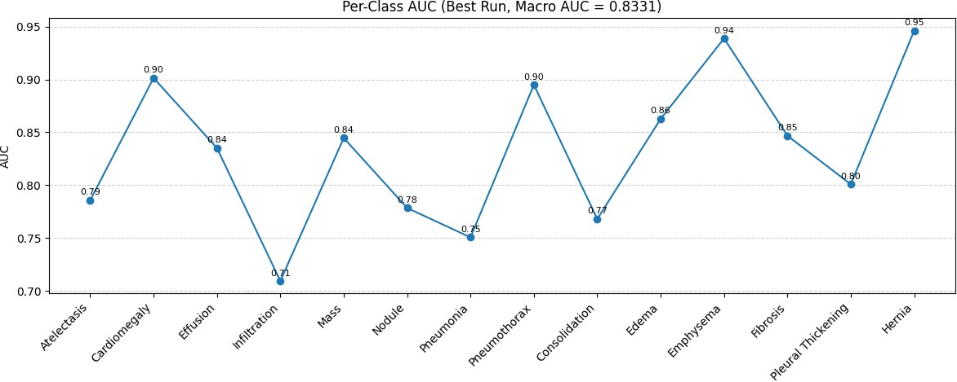

Fig. 3. Per-class AUC for the best-performing model on ChestXray14.

supports our hypothesis that optimization plays a critical role in adapting foundation models for medical imaging tasks.
Despite not relying on architectural modifications, multimodal pretraining, or ensembling strategies, our method achieves competitive results through optimization-driven adaptation alone. This highlights the effectiveness of carefully designed training strategies in improving model performance and stability. For CheXpert, classes with undefined AUC due to absence of positive samples were excluded from macro AUC computation. Overall, these results demonstrate that the proposed framework generalizes effectively across datasets within the same modality, complementing findings on ChestX-ray14 and supporting the broader goal of cross-dataset generalization.
- Unified Evaluation Across Tasks
A key aspect of this work is the application of a unified optimization strategy across multiple vision tasks, including classification, detection, and segmentation. Unlike traditional approaches that design task-specific training pipelines, we apply the same Stabilized Progressive Fine-Tuning (SPFT) framework consistently across all models.
- Segmentation Results (VinDr-CXR)
We evaluate segmentation performance using SAMv2 on the VinDr-CXR dataset. The model achieves strong Dice scores

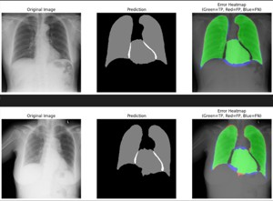
TABLE VII
Comparison of representative models on the CheXpert dataset
(mean AUC).
Model Type Mean
DenseNet-121 (Baseline) CNN (Supervised) ∼0.8 Hierarchical CNN CNN + Label Dependency ∼0.8 CheXpert Challenge Winner Ensemble CNN ∼0.9 CheXzero Vision-Language (Zero-shot) ∼0.7
GLoRIA Vision-Language ∼0.8
BioViL Vision-Language ∼0.8
MedCLIP Vision-Language ∼0.8 SISTA Representation Learning ∼0.8
Ours (SPFT) Optimization-based ∼0.8

TABLE VIII
Performance on the CheXpert validation set (AUC).
Class
AUC

Atelectasis 0.8277
AUC
2–0.84
8–0.89
0–0.93
4–0.76
7–0.88
8–0.89
7–0.88
7–0.88
3–0.85
Cardiomegaly 0.7884
Consolidation 0.8801
Edema 0.9175
Enlarged Cardiomediastinum 0.5146 Fracture N/A
Lung Lesion 0.6738
Lung Opacity 0.9256
No Finding 0.8739
Pleural Effusion 0.9209
Pleural Other 0.8584
Pneumonia 0.8092
Pneumothorax 0.8850
Support Devices 0.9705

Macro AUC 0.835 (approx)

across key anatomical structures:
- Heart: 0.91
- Lungs: 0.95 (Left), 0.96 (Right)
Compared to published benchmarks (Heart: 0.957, Lungs: 0.982), our results remain competitive despite not using task-specific architectural modifications. These results demonstrate that SPFT effectively adapts foundation models for dense prediction tasks.
- Detection Results
We evaluate object detection performance using both YOLOv8 and RT-DETR under the same training strategy.
We observe that YOLOv8 significantly outperforms RT-DETR in this setting. This can be attributed to the limited size and sparsity of medical detection datasets, where CNN-based architectures exhibit stronger inductive biases compared to transformer-based models.
- Key Insight: Optimization vs Architecture
A critical observation from these experiments is that the same optimization strategy (SPFT) was applied across all models without modification. Despite this, model performance varies significantly depending on architectural suitability for the dataset.
This highlights an important distinction:
  - SPFT improves feature learning and stability across tasks
Fig. 4. Segmentation results on VinDr-CXR. Predicted masks align well with anatomical structures such as lungs and heart.

TABLE IX
Detection performance comparison under unified SPFT
TRAINING.
Model mAP@50 mAP@50-95 Precision Recall YOLOv8 0.76 0.37 0.83 0.67
RT-DETR 0.16 0.07 0.19 0.36

  - However, model architecture still plays a crucial role in task-specific performance
For example, while RT-DETR benefits from SPFT, it un-derperforms due to its reliance on large-scale data, whereas YOLOv8 achieves strong results even with limited data.
- Ablation Study
To analyze the contribution of each component in the proposed training strategy, we conduct a systematic ablation study on ChestXray14. Our approach follows a two-stage training process (Figure 6), which we evaluate by incrementally incorporating progressive layer unfreezing, class-aware loss weighting, and Exponential Moving Average (EMA).
Table X presents the contribution of each component in the proposed method. Starting from a baseline where only the MLP head is trained, progressive unfreezing of the encoder yields a clear improvement in macro AUC (+1.21%), highlighting the importance of adapting higher-level representations while preserving pretrained features.
Incorporating class-aware weighting further improves performance to 0.8306, demonstrating its effectiveness in mitigating class imbalance across disease categories. The addition of EMA provides additional gains, resulting in the best performance of 0.8331 while also improving training stability.
Overall, these results indicate that each component contributes complementary benefits, and their combination leads to consistent and improved performance. Notably, the majority of performance gains are achieved through optimization strategies rather than architectural modifications or extensive data

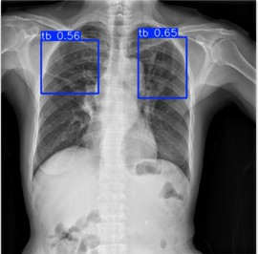

Fig. 5. Detection results on VinDr-CXR. The SPFT-enhanced model produces more precise and stable bounding boxes compared to baseline models.

TABLE X
Ablation study of the proposed training strategy on
ChestXray14.

Method  MLP Head Only | Unf.  × | Wts.  × | EMA  × | AUC  0.8095
+ Prog. Unfreezing | ✓ | × | × | 0.8216
+ Class Weights | ✓ | ✓ | × | 0.8306
+ EMA (Full) ✓ ✓ ✓ 0.8331

augmentation. We further analyze the impact of unfreezing depth in Table VI, where selectively unfreezing the last
10 layers consistently outperforms full encoder unfreezing, suggesting that controlled adaptation is more effective than updating the entire model.
- Effect of Fine-Tuning Across Datasets
We further investigate the role of fine-tuning across different datasets. On HAM10000, we observe that the pretrained encoder without fine-tuning achieves performance comparable to the fine-tuned model, with only marginal improvements obtained from applying the proposed training strategy.
This suggests that when pretrained representations are well aligned with the target domain, extensive fine-tuning may offer limited benefits. In contrast, for more challenging or distribution-shifted datasets such as ChestX-ray14, progressive fine-tuning and optimization strategies appear to play a more significant role in improving performance.
These observations support our hypothesis that foundation models capture modality-agnostic representations, and that the effectiveness of fine-tuning is inherently dataset-dependent. This highlights the importance of adaptive, optimization-

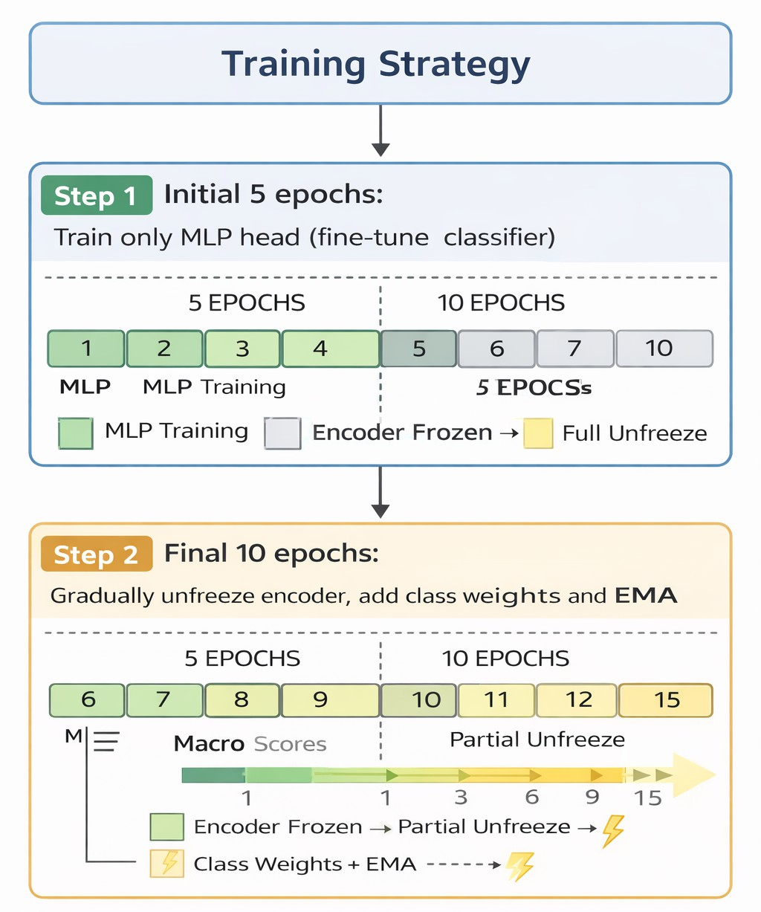
Fig. 6. Overview of the proposed two-stage training strategy. The model is first trained using only the MLP head, followed by progressive unfreezing of encoder layers with class-aware weighting and EMA stabilization.

driven strategies rather than applying uniform fine-tuning across tasks.
- Reproducibility
Results reported in this paper can be reproduced using our implementation. Code will be released upon acceptance.
- Discussion
Our results indicate that strong performance across medical imaging tasks can be achieved through carefully designed optimization strategies, without relying on architectural modifications or extensive data augmentation. Across classification, detection, and segmentation tasks, the proposed SPFT framework demonstrates consistent and stable performance, highlighting the importance of optimization dynamics in adapting foundation models.
A key observation from our experiments is that the effectiveness of fine-tuning is both dataset- and task-dependent. On HAM10000, the pretrained encoder achieves competitive performance with minimal adaptation, suggesting strong alignment between pretrained representations and the target domain. In contrast, for datasets such as ChestX-ray14 and VinDr-CXR, which exhibit greater complexity, distributional variation, and annotation sparsity, progressive fine-tuning and optimization strategies contribute more significantly to performance improvements across both classification and localization tasks.
Our experiments further reveal that while the same SPFT strategy is applied consistently across all models and tasks,

performance varies depending on architectural suitability. For example, CNN-based models such as YOLOv8 perform better on small, sparsely annotated detection datasets, whereas transformer-based models such as RT-DETR require larger-scale data to fully realize their potential. This highlights an important distinction: while architecture defines the upper bound of performance, optimization plays a critical role in achieving stable and effective learning across diverse settings. The ablation study demonstrates that each component of the proposed framework provides complementary benefits. Progressive layer unfreezing enables controlled adaptation of higher-level representations, class-aware weighting addresses class imbalance, and EMA contributes to training stability and consistency. Notably, these improvements are achieved without modifying the underlying model architecture, emphasizing the role of training strategy design as a primary driver of
performance.
These findings support the hypothesis that foundation models capture modality-agnostic representations, and that effective adaptation depends more on optimization than architectural redesign. Importantly, we show that a unified optimization strategy can generalize across varying levels of supervision, including image-level classification, bounding-box detection, and pixel-level segmentation. This has significant implications for scalable deployment in clinical settings, where robustness, efficiency, and adaptability are critical.
However, this study has certain limitations. While we evaluate across multiple datasets and tasks, further validation on larger-scale detection and segmentation benchmarks would help establish broader generalization. Additionally, future work could explore integrating task-specific inductive biases with optimization-driven strategies to further improve performance in data-scarce settings.
Overall, these results demonstrate that SPFT is a generalizable optimization framework that can be applied across diverse vision tasks in medical imaging. This unified perspective provides a scalable alternative to designing task-specific pipelines and highlights the importance of optimization-driven approaches for building robust and adaptable medical imaging systems.
- Conclusion
In this work, we present a unified optimization-driven training framework for adapting foundation models across heterogeneous medical imaging domains and tasks, including classification, detection, and segmentation over both 2D grayscale and 2D RGB data. Our results demonstrate that competitive and stable performance can be achieved through principled optimization strategies, without requiring architectural modifications or complex data augmentation pipelines.
Through systematic experiments, we show that progressive fine-tuning, class-aware optimization, and EMA stabilization provide complementary benefits, leading to improved performance, faster convergence, and reduced variance across runs. Importantly, we observe that the effectiveness of fine-tuning is both dataset- and task-dependent, highlighting the role of
domain alignment and annotation granularity in determining appropriate adaptation strategies.
We further demonstrate that the same optimization framework generalizes across varying levels of supervision, from image-level classification to bounding-box detection and pixel-level segmentation. While architectural choices influence task-specific performance, our results consistently show that optimization plays a critical role in enabling stable and effective learning across diverse settings.
Overall, this work emphasizes the importance of training strategy design as a scalable and unifying approach for building robust and generalizable medical imaging systems. By reducing reliance on task-specific pipelines and architectural redesign, our framework provides a practical pathway for deploying foundation models across real-world clinical applications.
These findings suggest that optimization-driven adaptation, rather than architectural complexity, serves as a key enabler of generalization in medical imaging foundation models.
References
- Anonymous. Rad-dino: Exploring vision foundation models for radiology. arXiv preprint, 2023.
- Benedikt Boecking et al. Biovil: A vision-language model for biomedical applications. arXiv preprint arXiv:2206.07036, 2022.
- Mathilde Caron et al. Emerging properties in self-supervised vision transformers. ICCV, 2021.
- Kaiming He et al. Deep residual learning for image recognition. CVPR, 2016.
- Jeremy Howard and Sebastian Ruder. Universal language model fine-tuning for text classification. ACL, 2018.
- Gao Huang et al. Densely connected convolutional networks. CVPR, 2017.
- Shih-Cheng Huang et al. Gloria: Global-local representation learning for medical images. In ICCV, 2021.
- Jeremy Irvin, Pranav Rajpurkar, Michael Ko, Yifan Yu, Silviana Ciurea-Ilcus, Chris Chute, Henrik Marklund, Behzad Haghgoo, Robyn Ball, Katie Shpanskaya, et al. Chexpert: A large chest radiograph dataset with uncertainty labels and expert comparison. In Proceedings of the AAAI Conference on Artificial Intelligence, volume 33, pages 590–597, 2019.
- Simon Kornblith et al. Better fine-tuning by reducing representational collapse. ICML, 2019.
- Junnan Li et al. Align before fuse: Vision and language representation learning with momentum distillation. NeurIPS, 2021.
- DongAo Ma, Jiaxuan Pang, Michael B. Gotway, and Jianming Liang. A fully open ai foundation model applied to chest radiography. Nature, 643(8071):488–498, 2025.
- Maxime Oquab et al. Dinov2: Learning robust visual features without supervision. arXiv, 2023.
- Hieu Pham et al. Interpreting chest x-rays via cnns that exploit hierarchical disease dependencies. arXiv preprint arXiv:1911.06475, 2019.
- Christian Szegedy et al. Rethinking the inception architecture for computer vision. CVPR, 2016.
- Ekin Tiu et al. Chexzero: A zero-shot learning model for chest x-ray classification. Nature Biomedical Engineering, 2022.
- Philipp Tschandl et al. The ham10000 dataset. Scientific Data, 2018.
- Xiaosong Wang, Yifan Peng, Le Lu, Zhiyong Lu, Mohammadhadi Bagheri, and Ronald M. Summers. Chestx-ray8: Hospital-scale chest x-ray database and benchmarks on weakly-supervised classification and localization of common thorax diseases. IEEE Conference on Computer Vision and Pattern Recognition (CVPR), 2017.
- Zifeng Wang et al. Medclip: Contrastive learning from unpaired medical images and text. EMNLP, 2022.

