Combinatorial Chemistry in Modern Medicinal Chemistry
Abstract
Combinatorial chemistry has revolutionized modern drug discovery by enabling the rapid generation and screening of vast, structurally diverse compound libraries. Built on principles of combinatorial synthesis and high-throughput screening, this approach integrates solid-phase, solution-phase, split-mix, and parallel synthesis techniques to efficiently explore chemical space. Advanced strategies such as diversity-oriented synthesis, dynamic combinatorial chemistry, and microwave-assisted protocols further enhance structural variety, speed, and yield. Computational tools—including virtual screening, molecular docking, QSAR modelling, and fragment-based design—complement experimental methods, allowing in silico library construction and prioritization of drug-like candidates. Applications span the identification of enzyme inhibitors, selective receptor ligands, and synergistic drug combinations, with innovations like microfluidic droplet-based screening reducing scale and cost. Despite challenges in chemical space vastness, predictive accuracy, and synthetic feasibility, combinatorial chemistry remains a cornerstone of medicinal chemistry, offering a systematic, high-throughput framework for lead generation, optimization, and integration with biological and computational tools.
Keywords: Combinatorial Chemistry, Drug Discovery, High-Throughput Screening, Library Design, Molecular Docking Simulation

INTRODUCTION
The central aim of drug discovery is to find compounds that can effectively interact with molecular targets linked to specific diseases, producing beneficial effects. Historically, natural products have served as the foundation for most drug development. However, modern approaches to identifying and refining lead compounds now depend on assembling extensive collections of synthetic molecules known as "libraries." These libraries are designed to reflect the structural diversity seen in natural products, although replicating such complexity often demands significant time, effort, and expense.
A computational analysis by Bohacek and colleagues estimated that the number of potential "drug-like" molecules—defined as those with fewer than 30 heavy atoms, a molecular weight under 500 Daltons, composed of common elements (H, C, N, O, P, S, F, Cl, Br), and stable in water and oxygen—could reach up to 10⁶³. This suggests that only a tiny fraction of viable drug candidates has been explored.
To address the challenge of generating large compound libraries, scientists turned to combinatorial chemistry. This method involves using simple chemical building blocks to create a wide array of more complex molecules through systematic synthesis. Each resulting compound is then individually tested to assess its biological activity. [1]
Combinatorial chemistry has transformed drug discovery and development by enabling the creation of vast and diverse libraries of chemical compounds. Several advanced techniques—such as phage display, yeast display, and DNA-encoded libraries—can generate millions of unique molecules. These methods not only produce large numbers of compounds but also allow for rapid and parallel screening against specific biological targets, making the search for effective drug candidates faster and more efficient.
On the other hand, some approaches like parallel synthesis and synthetic microarrays produce smaller, more focused libraries. While they don't match the scale of the high-throughput methods, they are particularly valuable for fine-tuning and optimizing lead compounds, especially when combined with computational tools. These focused libraries are often used in later stages of drug development to improve the potency, selectivity, or pharmacokinetic properties of promising molecules. [2]
PRINCIPLE OF COMBINATORIAL CHEMISTRY
Combinatorial technology refers to the approach of creating peptide mixtures that contain hundreds or even thousands of different peptides in roughly equal concentrations, rather than synthesizing each peptide individually. These mixtures are then subjected to screening tests. This method significantly reduces the amount of effort required in both the synthesis and testing phases, making the overall process more efficient.The core concept behind this innovation is to substitute individual chemical compounds in reactions with mixtures of multiple compounds. This principle forms the foundation of combinatorial technology, which consists of two main elements: combinatorial synthesis and combinatorial screening.
In combinatorial synthesis, one or more reactants are replaced with compound mixtures, enabling the simultaneous creation of millions—or even trillions—of different molecules in a single procedure. To make this approach practical, a method known as split-and-pool or split-mix synthesis is used, where mixtures are combined and thoroughly mixed before reacting with a single compound. Combinatorial screening, on the other hand, involves testing these complex mixtures rather than individual compounds, significantly lowering the cost and effort required for screening. [3]
Combinatorial chemistry is a powerful technique that enables the fast production and testing of vast numbers of chemical compounds to identify those with beneficial properties. It is built on three core principles: designing diverse compound libraries, employing efficient synthesis methods, and using high-throughput screening to assess biological or physical characteristics.
Library design is a critical step in the development of combinatorial chemistry, as it directly influences the diversity and effectiveness of the compounds generated. The process begins with the careful selection of building blocks—small molecules that contain reactive functional groups. These serve as the foundational units for generating a wide array of compounds through chemical reactions. Central to this design are scaffolds, which act as molecular frameworks to which building blocks are attached. Scaffolds provide a common structural base, enabling the creation of multiple derivatives and facilitating systematic exploration of chemical space.
Diversity within a combinatorial library is essential for maximizing the potential to discover compounds with desired properties. Chemical diversity refers to the range of unique molecular structures present, while functional group diversity involves incorporating a variety of reactive groups to enhance interactions with biological targets or materials. To achieve this diversity, combinatorial strategies such as positional scanning and iterative combinatorial chemistry are employed. Positional scanning involves systematically varying substituents at different positions on a scaffold to understand how structural changes influence biological activity. Iterative combinatorial chemistry expands the chemical space by sequentially adding building blocks over multiple rounds of synthesis.
Efficient synthesis techniques are vital for constructing combinatorial libraries. Solid-phase synthesis is a widely used method where starting materials are bound to an insoluble resin. This approach simplifies purification by allowing by-products to be washed away, supports automation for high-throughput synthesis, and enables the reuse of the solid support across multiple cycles. In contrast, solution-phase synthesis occurs in a uniform liquid medium, offering easier monitoring and optimization of reaction conditions, greater flexibility for diverse chemical reactions, and better scalability for large-scale production. Another powerful method is split-and-mix synthesis, which generates highly diverse libraries by dividing resin-bound reactants into smaller groups, subjecting each to different reactions, and then recombining and splitting them again for further transformations. This iterative cycle significantly enhances the diversity of the resulting compounds.
High-throughput screening (HTS) is an essential process for rapidly evaluating large libraries of compounds. It begins with assay development, which includes biological assays to measure effects such as enzyme inhibition, receptor binding, or cellular responses, and physical assays to assess properties like solubility, thermal stability, or catalytic behavior. Detection techniques play a crucial role in HTS, with fluorescence-based assays using fluorescent markers to quantify biological interactions, luminescence assays measuring light emitted from reactions for high sensitivity, mass spectrometry providing precise identification and quantification of compounds, and cell-based assays employing living cells to evaluate compound effects in a biologically relevant context. To enhance efficiency and throughput, HTS incorporates automation and miniaturization. Robotics and automated systems enable the simultaneous handling of numerous samples, ensuring consistency and speed, while miniaturization reduces reagent consumption and allows for parallel testing of a larger number of compounds. [4]
Parallel synthesis refers to the simultaneous execution of multiple chemical reactions; each carried out in a separate vessel rather than sequentially. This approach becomes feasible and highly efficient with advancements in automation. While parallel synthesis enables the generation of a large number of distinct compounds, split-and-pool techniques can produce even greater diversity in a significantly shorter time frame. These methods are particularly advantageous during the early phases of drug discovery. A notable variant of this approach is automated parallel synthesis, which further enhances throughput and consistency. [5]
Diversity-Oriented Synthesis (DOS) is a strategy aimed at enhancing the structural variety within compound libraries. By utilizing a wide range of building blocks and synthetic techniques, DOS enables a broad exploration of chemical space, thereby improving the chances of identifying compounds with valuable biological or physical characteristics.
Combinatorial libraries can be assembled in various scales—from small sets crafted manually to extensive collections produced through automated systems. The design of these libraries is increasingly guided by advanced computational methods and machine learning, which help ensure high chemical diversity and optimize the properties of the compounds for specific applications. [6]
Integration with drug discovery
Combinatorial chemistry accelerates drug discovery by enabling automated, parallel synthesis of large and targeted libraries, allowing broader exploration of chemical space than traditional one-by-one methods. It facilitates rapid analogue generation and testing to identify and refine lead compounds. When integrated with structure-based design and computational tools such as molecular docking and pharmacophore modeling, it enables the creation of libraries enriched for target-binding potential, thereby improving hit quality and reducing synthetic burden. Successful applications include the development of nanomolar inhibitors for thrombin, factor Xa, cathepsin D, matrix metalloproteinases, and neuraminidase. These strategies also support SAR and QSAR model development, virtual screening, and fragment-based approaches like SAR-by-NMR, enabling the assembly of potent ligands from weakly binding fragments. Collectively, these methods reduce time and cost while enhancing lead identification. Nonetheless, challenges persist, including the vastness of chemical space, limitations in scoring accuracy and affinity prediction, and practical constraints such as solubility, synthetic feasibility, and protein availability. [7]
In silico library design and virtual screening
Computational approaches such as virtual combinatorial chemistry and virtual screening have transformed early drug discovery by replacing traditional, resource-intensive synthesis and testing with efficient in silico techniques. Instead of physically producing thousands of compounds, researchers can now generate vast libraries of structurally related molecules using digital methods. These libraries are constructed either by simulating chemical reactions (synthetic route-based) or by modifying a core molecular scaffold (scaffold-based), enabling targeted exploration of chemical space around known pharmacophores. Various software platforms support this process, including reaction-driven tools like KNIME and RDKit, scaffold-focused systems like MOE and Schrödinger, and multi-objective optimizers such as CCLab and MoSELECT, which incorporate parameters like drug-likeness, cost, and diversity.
Virtual screening complements library generation by evaluating compounds computationally for potential biological activity. It acts as a digital filter, prioritizing candidates before synthesis. Screening methods fall into two categories: ligand-based, which uses known active molecules to identify similar structures via QSAR and pharmacophore modelling ; and structure-based, which relies on molecular docking to predict how well compounds bind to a target protein. Scoring functions—empirical, knowledge-based, or physics-based—estimate binding affinity and guide compound selection.
These strategies have been successfully applied to identify novel antibacterial, antiviral, and CNS-active agents, often using public databases like DrugBank, ZINC, and PubChem. Together, virtual combinatorial chemistry and screening offer a powerful, cost-effective framework for accelerating drug discovery and repurposing existing compounds.[8]
Virtual high-throughput screening
Modern drug discovery increasingly relies on computational strategies to design multi-target anticancer agents, moving beyond the traditional single-target paradigm. Computer-aided drug design (CADD) integrates molecular modelling , quantum mechanics, and informatics to predict how candidate molecules interact with biological targets, guiding synthesis and optimization. These methods accelerate lead identification by reducing experimental iterations and enabling early prediction of binding affinity and drug-like properties.
Virtual screening, a key component of CADD, evaluates large chemical libraries using either ligand-based or structure-based approaches. Ligand-based methods use known active compounds to build pharmacophore models or QSAR correlations, while structure-based methods rely on 3D target structures for molecular docking and scoring. Fragment-based design further enhances this process by assembling small molecular units within the binding site, allowing for novel compound generation and efficient lead optimization. Drug-likeness and ADMET properties are assessed early using in silico models to improve bioavailability and reduce toxicity. Tools like Lipinski’s rule of five and physiologically based pharmacokinetic (PBPK) modelling help predict absorption, distribution, metabolism, and excretion. These predictions guide structural modifications and reduce attrition rates.
Virtual high-throughput screening (vHTS) leverages computational power and vast chemical databases to identify promising candidates from millions of molecules. By narrowing the chemical space and prioritizing compounds for synthesis, vHTS enhances efficiency and cost-effectiveness in drug development.[9]
Lead generation and optimisation
N
N
R
3
O
R
2
R
1
Fig1: 1,4- Benzodiazipine- Based libraries
HOOC
N
H
O
H
N
O
HN
N
O
O
O
O
N
NH
2
O
OH
Fig 2: N-(substituted) glycine peptoid-based compounds and cinnamic acid derivatives
Combinatorial chemistry represents a paradigm shift in the methodology of drug discovery, offering a systematic and high-throughput approach to the generation of structurally diverse small molecules. Traditional lead identification strategies—such as rational drug design and the screening of natural product libraries—have yielded notable successes but are often constrained by limited chemical diversity, sample instability, and the complexity of natural product structures. These limitations hinder the rapid identification and optimization of pharmacologically active compounds. The advent of automated high-throughput screening technologies has significantly increased the demand for novel chemical entities, surpassing the output capacity of conventional synthetic methods. To address this gap, combinatorial chemistry employs techniques such as solid-phase synthesis, split-bead encoded libraries, and solution-phase pooling to produce large libraries of compounds efficiently. These methods facilitate the rapid assembly of molecular frameworks with varied functional groups, enabling the exploration of vast chemical space.
A central concept in combinatorial chemistry is the use of privileged scaffolds—core molecular structures that can be systematically modified to interact with a range of biological targets. For example, 1,4-benzodiazepine-based libraries (fig1) have demonstrated therapeutic potential in treating gastrointestinal disorders, while peptoid-based compounds have shown efficacy in modulating G-protein-coupled receptors. Additionally, cinnamic acid derivatives have been identified as potent inhibitors of hematopoietic protein tyrosine phosphatase (HePTP),(fig 2) illustrating the versatility of combinatorial approaches in targeting diverse enzymatic pathways.
The iterative nature of combinatorial synthesis allows for the refinement of lead compounds by fixing favorable reagent inputs and varying others to enhance biological activity, selectivity, and pharmacokinetic properties. This process is supported by high-throughput analytical techniques that enable rapid characterization and validation of compound libraries.[10]
Dynamic combinatorial chemistry
Table 1: Revesible reactions used in protein-templated DCC to generate bioactive compounds
s.no | Reaction name | Reaction
1 | Imine formation | 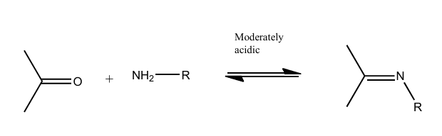
2 | Hydrazone  formation | 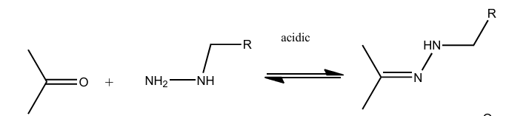
3 | Acylhydrazone  formation | 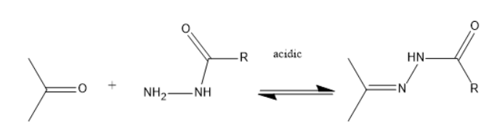
4 | Alkene cross  metathesis | 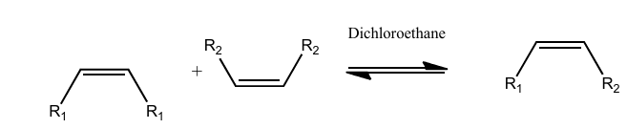
5 | Hemithioacetal  formation | 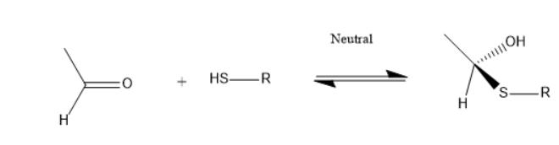
6 | Thioether  formation | 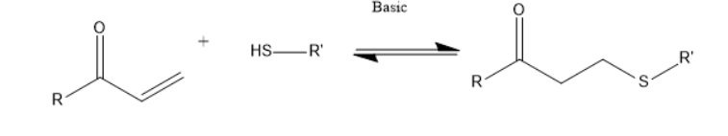
7 | Disulfide  formation | 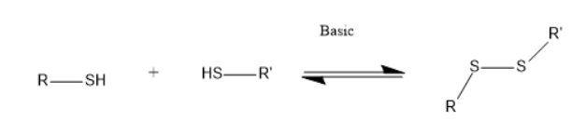
8 | Boronate ester  formation | 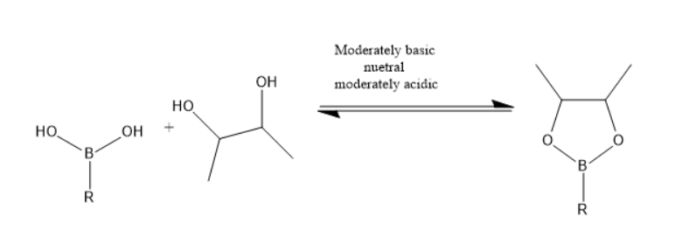
Dynamic combinatorial chemistry (DCC) is a target-responsive strategy for discovering bioactive ligands, particularly protein inhibitors, through reversible chemical reactions that generate dynamic combinatorial libraries (DCLs). These libraries exist in thermodynamic equilibrium, and the introduction of a protein target shifts the equilibrium toward the most stable ligand–target complexes, resulting in selective amplification of high-affinity binders. This process integrates synthesis and screening, allowing the protein to act as a molecular template that guides the formation of its optimal binding partners. The success of DCC depends on the reversibility and biocompatibility of the reactions used, the system’s adaptability to either pre-equilibrated or target-present conditions, and the ability to arrest the equilibrium for analysis, typically achieved through chemical reduction, pH modulation, or catalyst removal.
A wide range of reversible reactions has been employed in DCC, (table1) including imine formation, hydrazone and acyl hydrazone exchange, disulfide reshuffling, thioether and hemithioacetal formation, alkene metathesis, boronate ester formation, and metal-ligand coordination. These reactions offer distinct advantages in terms of selectivity, aqueous compatibility, and analytical accessibility. Analytical techniques such as mass spectrometry, nuclear magnetic resonance spectroscopy, high-performance liquid chromatography, fluorescence-based assays, and size-exclusion chromatography are used to identify and quantify amplified binders.
DCC has demonstrated efficacy across diverse targets. Imine-based DCC enabled the discovery of non-peptidic SARS-CoV MPro inhibitors. Isozyme-specific inhibitors of human carbonic anhydrase II were identified using imine libraries. Hydrazone-based DCC yielded ligands for cyclin-dependent kinase 2, confirmed by X-ray crystallography. Acylhydrazone chemistry facilitated selective inhibition of glutathione S-transferase isozymes, while hemithioacetal formation was used to identify β-galactosidase inhibitors. Thioether formation via conjugate addition produced GST inhibitors with amplification correlating to binding affinity. Disulfide-based DCC revealed potent inhibitors for metallo-β-lactamase and JMJD2 histone demethylase. Boronate ester formation was applied to prolyl hydroxylase domain isoform 2, yielding nanomolar inhibitors. Metal-ligand coordination strategies, including Fe(II)-bipyridine and oxorhenium complexes, were explored for lectin and cyclophilin targets, demonstrating enhanced binding through multivalent interactions.
DCC is particularly valuable in early-stage drug discovery, where structural data may be limited and conventional screening methods are resource-intensive. It streamlines hit identification and supports rapid optimization through iterative library design. Despite challenges such as ensuring protein-compatible reversible reactions, analyzing complex libraries, and stabilizing labile hits, ongoing advances in analytical techniques and library design continue to expand the scope of DCC in medicinal chemistry. [11]
Protein directed dynamic combinatorial chemistry
Protein-directed dynamic combinatorial chemistry (P-D DCC) is a thermodynamically controlled method for discovering ligands that bind to protein targets of therapeutic interest. It operates by generating a dynamic combinatorial library (DCL) of reversibly reacting compounds in the presence of a protein, which acts as a template. The protein selectively stabilizes its best binders, shifting the equilibrium to amplify these species while suppressing weaker ones. This allows for the identification of high-affinity ligands without the need to synthesize and screen large static libraries.
Unlike kinetic target-guided synthesis (KTGS), which relies on irreversible reactions and may favor fast-forming products, P-D DCC enables the selection of the most stable complexes regardless of their formation rate. It also requires only substoichiometric amounts of protein, making it suitable for scarce or sensitive targets.
Designing a P-D DCC experiment involves ensuring protein stability under specific conditions (pH, temperature, buffer, cosolvent), selecting soluble and functionally diverse building blocks, and choosing a reversible chemistry compatible with the protein. Common reversible reactions include boronate ester, imine, hydrazone, acylhydrazone, oxime, disulfide, and hemithioacetal exchanges. Each has distinct requirements and applications.
For example, boronate ester exchange was used to identify nanomolar inhibitors of PHD2, while imine-based DCLs yielded binders for hen egg-white lysozyme (HEWL). Hydrazone and acylhydrazone systems have produced inhibitors for MPO, GAT1, and NCS-1/Ric8a, the latter showing therapeutic potential in Alzheimer’s disease. Disulfide exchange enabled the discovery of TGR inhibitors, and hemithioacetal chemistry was applied to β-galactosidase. [12]
Microwave-assisted combinatorial chemistry
(a)
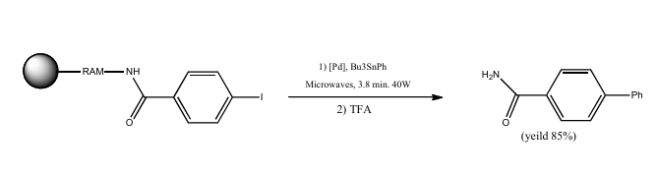
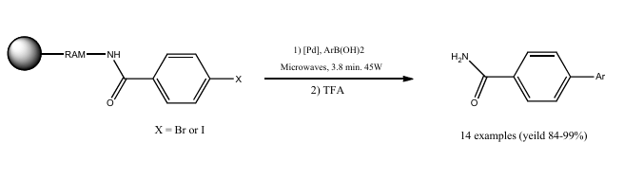

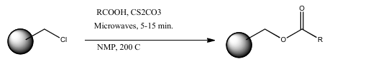
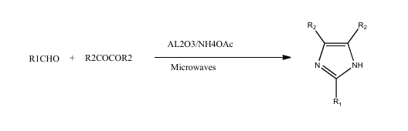
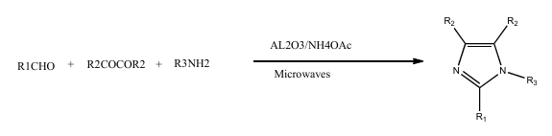
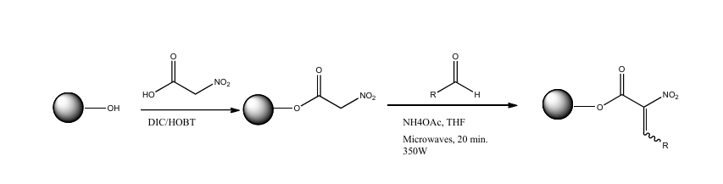
Fig3a: Suziki coupling on solid phase assisted by microwave irradiation
3b: microwave assisted stille reaction on polymer tethered 4-iodobenzoic acid
3c: micerowave assisted solid phase organic synthesis high speed coupling of aromatic carboxylic acids to chloromethylated PS resin at high temperature
3d: Microwave assisted synthesis of substituted imidazoles on solid support under solvent free conditions
3e : preparation of resin bound nitroalkenes via microwave assisted Knoevenagel reaction
Microwave-assisted combinatorial chemistry represents a significant advancement in accelerating drug discovery by integrating microwave energy into high-throughput synthesis workflows. Traditional combinatorial chemistry, particularly solid-phase synthesis, has enabled the rapid generation of large chemical libraries for biological screening. However, the need for faster and more efficient methodologies has led to the adoption of microwave irradiation, which offers substantial benefits including reduced reaction times, improved product purity, and enhanced yields.
Microwave heating operates through dipolar polarization and ionic conduction mechanisms, where polar molecules and ionic solutions absorb microwave energy and convert it into heat. This process is governed by the dielectric properties of the reaction medium, particularly the dielectric loss tangent (tan δ), which determines the efficiency of energy absorption. Solvents with high tan δ values, such as dimethyl sulfoxide and ethanol, are especially suitable for microwave-promoted reactions. The development of specialized microwave reactors has further refined this technique. While early experiments relied on domestic multimode ovens with limited control and reproducibility, modern monomode reactors offer precise temperature regulation, uniform energy distribution, and integration with automated systems. These reactors enable controlled reactions under atmospheric or pressurized conditions and support various formats including solvent-free, reflux, and continuous flow systems.
Applications of microwave-assisted combinatorial chemistry span a wide range of synthetic protocols. Solid-phase synthesis has been notably enhanced, with reactions such as Suzuki (fig 3a) and Stille couplings (fig 3b), N-arylation of heterocycles, and Knoevenagel condensations (fig 3e) achieving significant rate acceleration and higher loadings. Microwave irradiation has also facilitated the synthesis of substituted pyridines, enones, tetrazoles, and imidazoles,(fig 3d) often reducing reaction times from hours or days to mere minutes. Furthermore, microwave-assisted cleavage of resin-bound intermediates and coupling of aromatic carboxylic acids to polymer supports (fig 3c) have demonstrated improved efficiency and scalability.
The integration of microwave energy into combinatorial chemistry has transformed the landscape of medicinal chemistry by enabling rapid, reproducible, and high-yield synthesis of diverse chemical libraries. This approach not only streamlines lead identification and optimization but also supports the development of automated, parallel synthesis platforms essential for modern drug discovery. [13]
Microfluidic Droplet-Based Combinatorial Screening
Recent innovations in microfluidic engineering have enabled scalable, high-throughput platforms for combinatorial drug screening, addressing longstanding limitations in reagent consumption, assay complexity, and logistical throughput. Kulesa et al. introduced a nanoliter-scale droplet-based system that facilitates the spontaneous construction and phenotypic evaluation of drug combinations within microwell arrays. This platform encapsulates compounds, cells, and fluorescent barcodes into aqueous droplets, which are randomly paired and merged in microwells. The biological response—such as bacterial growth inhibition—is then quantified optically, allowing for rapid and reproducible screening without robotic liquid handling.
The system was applied to screen over 4,000 compounds in combination with 10 antibiotics against Escherichia coli, a model gram-negative pathogen. Notably, the study identified several synergistic interactions involving drugs not previously associated with antibacterial activity. These included potentiators of antibiotics such as vancomycin and erythromycin, which are typically ineffective against gram-negative bacteria due to membrane impermeability and efflux mechanisms. Synergistic effects were quantified using Bliss independence and fractional inhibitory concentration (FIC) index criteria, with selected hits validated through eight-point checkerboard assays in conventional broth-culture formats. The platform demonstrated high sensitivity and low false-positive rates, with over 84% of compound–antibiotic combinations successfully measured across 156 microwell array chips. The use of surfactant depletion and mechanical sealing minimized cross-contamination between droplets, ensuring assay fidelity. Furthermore, replicate measurements across microwells suppressed technical noise, enabling robust statistical analysis of synergy metrics.
This droplet-based approach significantly reduces the scale and cost of combinatorial screening while maintaining analytical rigor. It supports the discovery of novel synergistic pairs and the repurposing of existing compounds, offering a powerful strategy for expanding the therapeutic utility of antibiotics and addressing drug resistance. The methodology is broadly adaptable to other phenotypic assays and disease models, positioning it as a transformative tool in early-stage drug discovery.[14]
Integrating Combinatorial Chemistry with Computational and Biological Tools
A
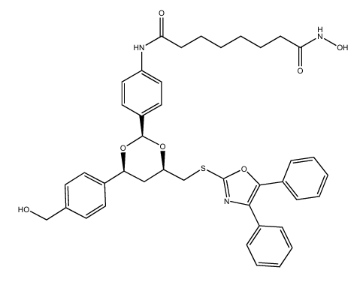
Fig4: structures of HDAC6-selective tubacin
B
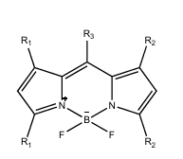
4B: BODIPY Scaffold
Combinatorial chemistry has played a pivotal role in advancing drug discovery and biotechnology by introducing efficient methods for synthesizing and screening diverse chemical libraries. Initially gaining prominence in the late 1990s, its widespread adoption was driven by the promise of accelerating pharmaceutical development. Although enthusiasm waned due to technical limitations and unmet expectations, the core methodologies established during this period continue to support contemporary research.
In medicinal chemistry, combinatorial strategies have facilitated the identification of selective inhibitors for specific biological targets. A prominent example is the discovery of histone deacetylase inhibitors, which enabled detailed investigation into the functional roles of HDAC isoforms in various disease processes (fig 4a). The field of chemical biology has benefited from the development of fluorescent probes, particularly those based on BODIPY scaffolds (fig 4b). These probes, synthesized through combinatorial techniques, demonstrate high specificity and sensitivity toward biomolecular targets, making them valuable tools for diagnostic and imaging applications. The use of multicomponent reactions has further expanded the structural diversity and functional capabilities of these molecules.
Computational tools have significantly enhanced the precision of combinatorial chemistry. Techniques such as molecular docking, virtual screening, and QSAR modelling have enabled the rational design of focused libraries aimed at specific biological targets. These approaches have improved the efficiency of hit identification and optimized pharmacological profiles, reducing the need for extensive experimental screening. In biotechnology, combinatorial technologies have been applied to biological display systems and antibody engineering. These methods utilize natural mechanisms of molecular diversity to generate high-affinity binders and catalytic antibodies, demonstrating the broad applicability of combinatorial principles across scientific disciplines. The integration of computational design with experimental techniques continues to drive innovation in therapeutic development.[15]
Applications of combinatorial chemistry
Combinatorial chemistry has significantly advanced drug discovery and materials science by enabling rapid and systematic exploration of chemical diversity. In pharmaceutical research, it has transformed the identification of lead compounds through integration with high-throughput screening (HTS). This allows for the efficient evaluation of vast compound libraries against specific therapeutic targets. Modern screening technologies, such as fluorescence-based assays, surface plasmon resonance (SPR), and label-free detection methods, help identify biologically active molecules with desirable properties.In structure-activity relationship (SAR) studies, focused chemical libraries are used to investigate how molecular changes affect biological activity. These libraries are often designed using molecular modeling and computational tools, which guide structural modifications to optimize properties like solubility, target binding, and pharmacokinetics (ADME).
Combinatorial approaches also play a crucial role in peptide and protein chemistry. For therapeutic peptide development, libraries incorporating unnatural amino acids, backbone modifications, and cyclization strategies enhance stability and bioavailability. These specialized libraries are tailored to interact with protein-protein interfaces, enzyme active sites, and cell surface receptors. Additionally, epitope mapping benefits from systematic peptide libraries that reveal antibody binding sites and protein interaction surfaces through overlapping sequences and diverse presentation formats.
In materials science, combinatorial chemistry facilitates the development of polymers by exploring various monomer combinations, polymerization conditions, and catalysts. High-throughput synthesis platforms enable rapid optimization of mechanical, thermal, and surface properties. Catalyst discovery is accelerated through parallel synthesis and screening of heterogeneous and homogeneous systems, with advanced techniques like spatially resolved spectroscopy aiding performance evaluation. For electronic and optical materials, gradient thin film deposition and spatial characterization help uncover relationships between composition, structure, and properties.
Analytical methods such as LC-MS, NMR, MALDI-TOF, flow cytometry, and SPR support these applications by providing high-resolution data on molecular structure, mass, binding interactions, and screening outcomes, ensuring precise and efficient analysis across diverse chemical domains. [16]
Limitations of combinatorial chemistry
Combinatorial chemistry, despite its revolutionary impact on drug discovery, faces several challenges that limit its efficiency. Problems begin with library design, where random subset selection may reduce chemical diversity, while rational selection takes considerable time, defeating the purpose of rapid lead identification. Combinatorial synthesis itself is complex — suitable chemistries, especially for solid-phase synthesis, are limited, and automation is difficult due to poor integration and inefficient interfaces. Large-scale synthesis requires extensive handling steps, while solid-phase methods demand polar groups for attachment and often suffer from resin-related issues such as poor loading or uneven swelling. Screening limitations include difficulties with miniaturization, incomplete library representation, and the testing of impure compounds that compromise data reliability. Additionally, data management poses a major hurdle, as tracking thousands of compounds and their locations is challenging. Analytical evaluation of massive libraries also strains research resources. Moreover, the concept of “diversity” is debated — only biologically relevant chemical diversity truly benefits drug discovery. Strategic issues, such as limited genetic diversity for biological targets, further constrain the approach. Although these drawbacks once tempered enthusiasm for combinatorial chemistry, advances in automation, data handling, and analytical methods continue to address these problems and enhance its potential. [17]
Conclusion
Combinatorial chemistry has transformed the landscape of modern drug discovery by enabling the rapid generation and systematic evaluation of diverse chemical libraries. Through its integration with computational modeling, structure-based drug design, high-throughput and virtual screening, and biotechnology, it provides a unified framework that accelerates every stage of the discovery pipeline—from hit identification to lead optimization. The evolution from static libraries to dynamic and protein-directed dynamic combinatorial systems has further enhanced the capacity to identify high-affinity binders directly in the presence of biological targets, thereby improving efficiency and success rates in lead selection. Advances in enabling technologies such as microwave-assisted synthesis, nanoliter droplet platforms, and automated screening systems have expanded the chemical and biological space that can be explored within practical timeframes.Overall, combinatorial chemistry continues to serve as a cornerstone of innovative drug discovery, offering unparalleled speed, diversity, and adaptability. As it becomes increasingly integrated with artificial intelligence, machine learning, and biotechnological approaches, the next generation of combinatorial strategies is expected to yield more targeted, sustainable, and efficient routes to novel therapeutics, bridging chemistry and biology in a truly interdisciplinary manner.
References
- Maraković N, Šinko G. The Lock is the Key: Development of Novel Drugs through Receptor Based Combinatorial Chemistry. Acta chimica slovenica. 2017 Mar 1;64(1).
- Liu R, Li X, Lam KS. Combinatorial chemistry in drug discovery. Current opinion in chemical biology. 2017 Jun 1;38:117-26.
- Furka Á. Forty years of combinatorial technology. Drug Discovery Today. 2022 Oct 1;27(10):103308.
- Talreja S, Tiwari S. From one to millions: The revolution of combinatorial chemistry. Journal of Analytical Techniques and Research. 2024;6(2):37-42.
- Shaikh SM, Nalawade SA, Doijad RC. A review on combinatorial chemistry. RRJCHEM. 2017;6(2):14-26.
- Clairoux A. Combinatorial Chemistry: Innovations and Applications. J Med Org Chem. 2024;7(6):275–276.
- Kubinyi H. Combinatorial and computational approaches in structure-based drug design. Current Opinion in Drug Discovery and Development. 1998 Jul 1;1(1):16-27.
- Suay-García B, Bueso-Bordils JI, Falcó A, Antón-Fos GM, Alemán-López PA. Virtual combinatorial chemistry and pharmacological screening: a short guide to drug design. International Journal of Molecular Sciences. 2022 Jan 30;23(3):1620.
- Geromichalos GD, Alifieris CE, Geromichalou EG, Trafalis DT. Overview on the current status of virtual high-throughput screening and combinatorial chemistry approaches in multi-target anticancer drug discovery; Part I. J buon. 2016 Jul 1;21(4):764-9.
- Mjalli AM, Harris AL. Lead Generation Using Combinatorial Chemistry in Drug Discovery. Journal of Biomolecular Screening. 1996 Feb;1(1):17-8.
- Mondal M, Hirsch AK. Dynamic combinatorial chemistry: a tool to facilitate the identification of inhibitors for protein targets. Chemical Society Reviews. 2015;44(8):2455-88.
- Canal-Martín A, Pérez-Fernández R. Protein-directed dynamic combinatorial chemistry: an efficient strategy in drug design. ACS omega. 2020 Oct 8;5(41):26307-15.
- Rajak H, Mishra P. Microwave-assisted combinatorial chemistry: The potential approach for acceleration of drug discovery. Journal of Scientific and Industrial Research. 2004 Aug 1;63(8):641-54.
- Kulesa A, Kehe J, Hurtado JE, Tawde P, Blainey PC. Combinatorial drug discovery in nanoliter droplets. Proceedings of the National Academy of Sciences. 2018 Jun 26;115(26):6685-90.
- Seneci P, Fassina G, Frecer V, Miertus S. The effects of combinatorial chemistry and technologies on drug discovery and biotechnology: A mini review. Nova biotechnologica et chimica. 2014;13(2):87-108.
- Pujari RD, Kamala GR. A Review on Uses of Combinatorial Chemistry in Drug Discovery. Journal of Pharma Insights and Research. 2025 Aug 5;3(4):055-61.
- Galande AK. Combinatorial Technology: An Overview. Indian J Pharm Sci. 2000;62(2):84–91.

