Emerging Trends of Generative AI in Healthcare: A Survey and Future Direction
S Shibin¹, T Meganathan² , S Shanmugapriya³
^{1,2}UG Student, Department of Computer Science and Data Science,Nehru Arts and Science College, Coimbatore, Tamil Nadu, India
³Assistant Professor, Department of Computer Science and Data Science,Nehru Arts and Science College, Coimbatore, Tamil Nadu, India
¹shibushibin0510@gmail.com, ²tgmeganathan@gmail.com,
³sspriya818@gmail.com,

ABSTRACT
Generative Artificial Intelligence (AI) is rapidly changing the healthcare field by allowing new solutions in diagnostics, treatment planning, drug discovery, medical imaging, and patient care. This survey reviews the latest advancements in generative AI models, especially deep generative frameworks like Generative Adversarial Networks (GANs), Variational Autoencoders (VAEs), and large language models (LLMs), and their uses in healthcare. We look at how these models improve diagnostic accuracy by creating realistic medical images, support personalized medicine through predictive modeling, and speed up drug design by generating candidate compounds. We also discuss key challenges like data privacy, model interpretability, ethical issues, and regulatory hurdles to provide a well-rounded view. The survey highlights emerging trends such as multimodal generative systems, federated generative learning, and integration with electronic health records (EHRs), showing their potential to improve clinical results. Finally, we suggest future directions for research and deployment, stressing the need for strong evaluation frameworks, collaboration across fields, and responsible AI practices. This work aims to give researchers, clinicians, and policymakers a clear understanding of current capabilities and future developments at the intersection of generative AI and healthcare. In addition to clinical and research uses, generative AI is transforming healthcare operations and medical education. Hospitals and healthcare systems are looking into generative models to improve resource allocation, predict patient admissions, and simulate emergency response scenarios. AI-generated virtual patients are used in medical training to create realistic case studies. This allows students and professionals to practice diagnostic reasoning in safe, controlled environments.
Keywords:
Generative Artificial Intelligence (Generative AI), healthcare innovation, medical imaging synthesis, drug discovery and molecular design, personalized medicine, federated and multimodal learning.
INTRODUCTION
Generative Artificial Intelligence marks a shift from traditional rule-based and predictive machine learning systems to models that can create new data instances. This includes medical images, clinical notes, molecular structures, and patient simulations. In healthcare, this change is especially important because clinical decision-making depends on complex, varied, and often incomplete data. Generative models do more than just analyze patterns; they also create realistic outputs that can aid in diagnosis, treatment planning, and medical education. This section lays out the basic ideas of generative AI, describes its transformative role in modern healthcare, and emphasizes the reasons for a thorough survey in this fast-changing field. The growing use of generative AI in clinical settings is fueled by the increasing digitization of healthcare data.
Traditional analytical models mainly focus on classification or prediction tasks. In contrast, generative models broaden these abilities by learning the underlying data distributions and producing high-quality synthetic outputs. This feature is particularly useful in healthcare, where labeled data may be limited, sensitive, or unbalanced. By creating realistic medical samples and simulating different clinical situations, generative AI improves model reliability, enhances training datasets, and lessens the need for expensive data collection.
Moreover, generative AI encourages better teamwork between human expertise and intelligent systems in clinical workflows. Instead of taking over the roles of healthcare professionals, these systems serve as supportive tools that enhance decision-making, lighten cognitive load, and simplify routine tasks. For example, AI-generated summaries can help doctors review complex patient histories, and simulated patient paths can aid in assessing treatment options before they are put into practice.

2. Foundations of Generative Models for Healthcare Applications
Generative AI in healthcare is mainly based on deep learning structures like Generative Adversarial Networks (GANs), Variational Autoencoders (VAEs), diffusion models, and transformer-based large language models (LLMs). GANs allow for realistic medical image generation using adversarial training. VAEs help with data representation and reconstruction based on probabilities. Recently, diffusion models have shown better stability and produce high-quality images. Transformer architectures make it easier to understand sequential clinical data and natural language. However, healthcare datasets come with specific challenges, such as small sample sizes, high annotation costs, data imbalance, and strict privacy rules. This section looks at how basic generative techniques are adjusted to meet healthcare needs.
Each generative structure has unique advantages when modified for healthcare tasks. GAN-based systems are especially good for image-to-image translation tasks. This includes improving low-resolution scans or switching between different imaging types. VAEs are useful for detecting anomalies and estimating uncertainty in clinical data due to their probabilistic latent space. Diffusion models offer better training stability and less mode collapse, making them appealing for generating high-quality medical images. Meanwhile, transformer-based LLMs are effective in managing long-term patient records and finding relationships in clinical narratives, as well as generating clear medical text. Choosing the right model structure largely depends on the clinical goal, data availability, and need for interpretability.
Modifying these basic models for healthcare also involves specific preprocessing methods, targeted training strategies, and strict validation protocols. For example, medical images often need normalization across various imaging devices and institutions, while clinical text requires careful de-identification to maintain patient privacy. Transfer learning and self-supervised learning approaches are often used to address the challenges of limited labeled data. Furthermore, evaluation metrics should go beyond traditional accuracy measures to include clinical relevance, safety, and robustness. These adjustments ensure that generative models are not only technically effective but also clinically dependable and suitable for real-world healthcare needs.

3. Generative AI For Medical Imaging Enhancement And Synthesis
Medical imaging is one of the most promising areas for generative AI applications. Generative models can improve low-resolution scans, reconstruct missing imaging data, reduce noise, and create high-quality synthetic images for rare diseases. For instance, GAN-based systems can turn low-dose CT scans into high-quality images, lowering patient radiation exposure. Techniques for translating between different imaging types allow MRI images to become more like CT representations, which helps with multi-modal diagnostics. Additionally, generating synthetic images improves dataset diversity, which can help solve class imbalance issues in training diagnostic systems.
This section looks at the latest developments and assesses their impact on radiology workflows. Another key application of generative AI in medical imaging is helping with image segmentation and lesion detection. Generative models can outline tumors, organs, and other anatomical structures by learning spatial patterns from labeled datasets and producing refined segmentation maps. This ability enhances accuracy in radiation therapy planning, surgical preparation, and disease monitoring.
By improving existing segmentation algorithms with generative techniques, clinicians can achieve more consistent and reliable results, especially in complex or unclear cases. Generative AI also speeds up imaging acquisition and optimizes workflow. Techniques like AI-based image reconstruction allow for shorter MRI scanning times while keeping diagnostic quality, which improves patient comfort and increases scanner use in busy hospitals. Moreover, real-time generative enhancement tools can help radiologists by highlighting areas of concern and creating comparative visualizations, thus cutting down interpretation time and reducing diagnostic errors. These advancements together improve efficiency, accuracy, and accessibility in modern radiology practices.

4. Clinical Text Generation and Medical Documentation Automation
Healthcare professionals spend a lot of time on documentation tasks. Generative language models can automate clinical note generation, discharge summaries, pathology reports, and patient communication messages. By using contextual patient information from Electronic Health Records (EHRs), LLMs can help draft structured and standardized documents. Conversational AI systems also improve telemedicine services by providing preliminary assessments and answering patient questions. However, challenges like factual accuracy, risks of incorrect information, and legal liability are still major concerns.
This section looks at how generative language technologies are changing administrative and communication processes in healthcare systems. Besides routine documentation, generative language models can aid clinical decision workflows. They do this by summarizing long patient histories, extracting key findings from lab reports, and highlighting potential risk factors. Automated summarization tools can turn multi-visit records into short overviews, helping doctors quickly understand important information before consultations. These systems can also help with coding and billing by suggesting appropriate medical codes based on clinical narratives, which reduces administrative tasks and lessens human error.

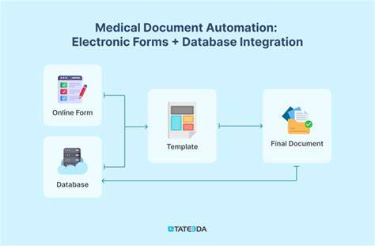

By making these processes easier, generative AI helps improve efficiency and gives healthcare professionals more time for direct patient care. Even with these advantages, ensuring reliability and safety is crucial for real-world use. Clinical text needs to be precise, aware of context, and free from misleading or made-up information. So, human oversight, validation steps, and specific adjustments for the field are needed to keep accuracy. Clear guidelines for responsibility, transparency in model outputs, and integration with secure hospital IT systems are also important. As generative language technologies keep evolving, finding a balance between automation and professional judgment will be essential for creating trustworthy and effective healthcare communication systems.

5. Personalized Medicine through Generative Modeling
Generative AI helps advance personalized medicine by modeling individual health paths and simulating treatment outcomes. By combining genomic data, clinical history, and lifestyle details, these systems can create tailored treatment simulations. The idea of digital twins, which are virtual copies of patients, has surfaced as a promising tool. This allows for real-time monitoring and planning of interventions. Generative models also support biomarker discovery and precision oncology by combining complex biological interactions. This section explains how generative modeling aids in customized treatment strategies and proactive healthcare management. Another important role of generative AI in personalized medicine is in pharmacogenomics and predicting drug responses.
By examining genetic differences along with clinical and demographic information, these models can simulate how various patients might react to specific medications. This helps doctors choose the best drugs and dosages while reducing side effects. These predictive abilities are especially useful in complex treatments like chemotherapy, immunotherapy, and psychiatric care, where patient responses can vary significantly. By effectively modeling gene-drug interactions, generative AI improves the safety and effectiveness of personalized treatments. Additionally, generative AI helps incorporate behavioral and environmental factors into personalized healthcare plans. Lifestyle habits, diet, physical activity, and environmental exposures greatly affect health outcomes.
Generative systems can combine these different data sources to provide well-rounded health recommendations, including preventive care and wellness strategies. By understanding how biological, clinical, and lifestyle factors interact, generative AI offers a fuller picture of individual health profiles. This integrated approach supports long-term health management and encourages patients to play an active role in their care decisions.
Key Components of the Generative Modeling:
- Data Collection and Preprocessing
- Model Architecture Selection
- Latent Space Representation
- Training Strategy and Loss Functions
- Evaluation and Validation Metrics
- Deployment and Clinical Integration

6. Drug Discovery and Molecular Design Acceleration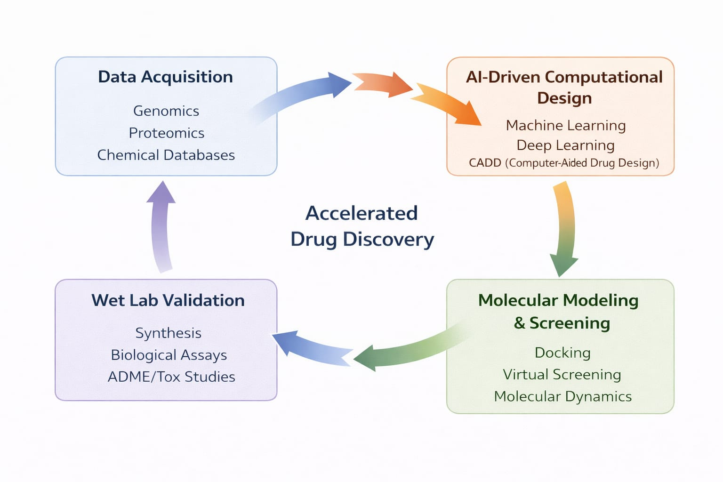
Drug discovery is often costly and takes a long time. Generative AI speeds this up by creating new molecular structures with the desired effects. Deep generative models can create candidate compounds, predict how molecules interact, and improve drug-like qualities like solubility and toxicity. Generating protein structures and predicting target binding also makes pharmaceutical research more efficient. Additionally, AI-driven simulations can support virtual clinical trials, lowering development costs and timelines. This section looks at how generative AI is changing pharmaceutical innovation and biomedical research processes. Generative AI also allows for quick exploration of large chemical spaces that traditional lab methods can't easily examine. By learning patterns from existing compound databases, generative models can suggest a variety of valid molecules with optimized therapeutic potential.
These systems can include specific requirements, such as target selectivity, fewer side effects, or better bioavailability, during the design phase. This increases the chances of finding successful drug candidates. The targeted generation reduces the need for extensive trial-and-error experiments and lets researchers concentrate on the most promising compounds. Furthermore, generative AI helps with drug repurposing and discovering combination therapies by finding new uses for existing medications. By modeling complex biological networks and disease pathways, generative systems can predict how approved drugs might interact with new targets or work well with other compounds. This method significantly shortens development timelines since the safety of existing drugs is already well known. As a result, generative AI not only speeds up the creation of new drugs but also improves decision-making in pharmaceutical development, leading to more efficient and cost-effective biomedical innovation.

7.Synthetic Healthcare Data and Privacy-Preserving AI
Healthcare data privacy regulations limit data sharing and hinder large-scale collaborative research. Generative AI provides solutions by creating synthetic datasets that keep statistical properties while protecting real patient identities. Techniques like differential privacy and federated generative learning allow for training models across different locations while keeping data confidential. Synthetic data can improve the strength of algorithms, reduce class imbalance, and aid in researching rare diseases. However, ensuring that synthetic data does not unintentionally reveal sensitive information is still a major research focus. This section looks at privacy-preserving generative methods and their impact on secure AI deployment in healthcare.
Besides enabling secure data sharing, generating synthetic data allows for collaboration between multiple institutions without needing to share raw patient records directly. Hospitals and research centers can train generative models locally and only share model parameters or aggregated updates, which lowers the chance of privacy violations. This collaborative setup aids the creation of more generalized and unbiased AI systems by including varied data from different geographic and demographic areas. Consequently, federated and privacy-aware generative methods help break down data silos that typically slow down medical research. Nevertheless, strong safeguards are needed to avoid risks like model inversion attacks, membership inference attacks, or unintentional memorization of sensitive records. Enhanced privacy technologies, such as secure multi-party computation, encryption methods, and thorough auditing processes, are being integrated into generative modeling workflows. Additionally, clear governance policies and ethical oversight are crucial for ensuring compliance with healthcare laws and building public trust. By merging technical safeguards with regulatory frameworks, privacy-preserving generative AI can foster innovation while upholding strict standards for patient confidentiality and data security.
importance of Healthcare Data and Privacy:
- Patient Data Confidentiality
- Data Anonymization and De-identification
- Regulatory Compliance
- Secure Data Storage and Transmission
- Privacy-Preserving AI Techniques

REFERENCE

- I. Goodfellow et al., “Generative Adversarial Nets,” in Proc. Advances in Neural Information Processing Systems (NeurIPS), 2014, pp. 2672–2680.

- D. P. Kingma and M. Welling, “Auto-Encoding Variational Bayes,” in Proc. International Conference on Learning Representations (ICLR), 2014.

- J. Ho, A. Jain, and P. Abbeel, “Denoising Diffusion Probabilistic Models,” in Proc. Advances in Neural Information Processing Systems (NeurIPS), 2020.

- A. Esteva et al., “A Guide to Deep Learning in Healthcare,” Nature Medicine, vol. 25, no. 1, pp. 24–29, 2019.

- E. Topol, “High-performance medicine: the convergence of human and artificial intelligence,” Nature Medicine, vol. 25, no. 1, pp. 44–56, 2019.

- T. Davenport and R. Kalakota, “The potential for artificial intelligence in healthcare,” Future Healthcare Journal, vol. 6, no. 2, pp. 94–98, 2019.

- J. Yu, Z. Zhang, and J. Wang, “Medical Image Synthesis using Generative Adversarial Networks: A Review,” Medical Image Analysis, vol. 70, pp. 101–114, 2021.

- K. Armanious et al., “MedGAN: Medical Image Translation using GANs,” IEEE Journal of Biomedical and Health Informatics, vol. 24, no. 10, pp. 2785–2796, 2020.

- S. Chen et al., “Synthetic Medical Images with Deep Learning: A Survey,” Artificial Intelligence in Medicine, vol. 115, 2021.

- A. Rajkomar, J. Dean, and I. Kohane, “Machine Learning in Medicine,” New England Journal of Medicine, vol. 380, pp. 1347–1358, 2019.

- Y. LeCun, Y. Bengio, and G. Hinton, “Deep Learning,” Nature, vol. 521, pp. 436–444, 2015.

- S. Vaswani et al., “Attention Is All You Need,” in Proc. Advances in Neural Information Processing Systems (NeurIPS), 2017.

- T. Brown et al., “Language Models are Few-Shot Learners,” in Proc. NeurIPS, 2020.

- H. K. Lee et al., “Deep Learning in Drug Discovery,” Drug Discovery Today, vol. 25, no. 8, pp. 1313–1320, 2020.

- N. Stokes et al., “Generative AI for Molecular Design and Drug Discovery,” Nature Reviews Drug Discovery, vol. 20, pp. 101–120, 2021.

- J. Jumper et al., “Highly Accurate Protein Structure Prediction with AlphaFold,” Nature, vol. 596, pp. 583–589, 2021.

- S. Rombach et al., “High-Resolution Image Synthesis with Latent Diffusion Models,” in Proc. CVPR, 2022.

- R. Miotto et al., “Deep Learning for Healthcare: Review, Opportunities and Challenges,” Briefings in Bioinformatics, vol. 19, no. 6, pp. 1236–1246, 2018.

- C. Shorten and T. Khoshgoftaar, “A Survey on Image Data Augmentation for Deep Learning,” Journal of Big Data, vol. 6, no. 60, 2019.

- B. McMahan et al., “Communication-Efficient Learning of Deep Networks from Decentralized Data,” in Proc. Artificial Intelligence and Statistics (AISTATS), 2017.

- C. Dwork, “Differential Privacy,” in Proc. International Colloquium on Automata, Languages and Programming, 2006.

- J. Konečný et al., “Federated Learning: Strategies for Improving Communication Efficiency,” arXiv preprint arXiv:1610.05492, 2016.

- Z. Obermeyer and E. Emanuel, “Predicting the Future — Big Data, Machine Learning, and Clinical Medicine,” New England Journal of Medicine, vol. 375, pp. 1216–1219, 2016.

- R. Miotto et al., “Artificial Intelligence in Healthcare: Past, Present and Future,” Journal of Biomedical Informatics, vol. 90, 2019.

- P. Rajpurkar et al., “AI in Health and Medicine,” Nature Medicine, vol. 28, pp. 31–38, 2022.

