• Paper Title : The AGWEP Alphabet highlights its innovative approach to enhancing language learning.
• Author : Anna Bhujang Gawhane

• Organization Name : ANNAGAWHANE WORLD EDUCATION POLICY OPC PVT LTD
• Abstract : The AGWEP Alphabet presents a unique structure of symbols and sounds that enhances communication in a distinctive way.The AGWEP Alphabet features a set of symbols designed to streamline communication while incorporating distinctive phonetic elements.The AGWEP Alphabet presents a unique system of symbols that blend phonetic sounds with intricate visual designs, offering a fresh approach to written communication.

• Introduction : The AGWEP Alphabet aims to simplify communication in diverse linguistic communities. The AGWEP Alphabet aims to improve written communication by providing a simplified and efficient system for language representation.The AGWEP Alphabet aims to enhance communication through a simplified and phonetic writing system.The AGWEP Alphabet aims to enhance communication and promote literacy among diverse communities.The AGWEP Alphabet aims to streamline communication in digital spaces.

AGWEP Alphabet

- Strong Script :
- Small Script :
- Pronunciations :
- Manuscript of AGWEP Alphabet

  - Strong Script 2. Small Script
A B C D E F G H I Ⅎ K L M N O P Q R S T U V W X Y Z Ǝ Ʌ Ө Ð Ŧ Ⴈ Ԉ И Ŋ Ƨ Ƶ Æ Ͻ П 𐐅 Ⳙ Ⱗ Ꝏ Ѥ Ꞇ Ø Є Э Ш Ѧ | A b c d e f g h i ⅎ k l m n o p q r s t u v w x y z ǝ ʌ ө ð ŧ ⴈ ԉ и ŋ ƨ ƶ æ ͻ п 𐐭 ⳙ ⱗ ꝏ ѥ ꞇ ø є э ш ѧ

- Pronunciations : ए बी सी डी ई एफ जी एच आय जे के एल एम एन ओ पी क्यू आर एस टी यू व्ही डब्ल्यू एक्स वाय झेड ऐ औ यूटा डीटा टीटा एल्फा एन्फा एन्स एन्ज एस्फा झेस्फा ॲ ऑ ॲय ऑय ऑव डब्ली डब्लो केच सेच फाय इक्वल डीव उइ एम्न

- Manuscript of AGWEP Alphabet

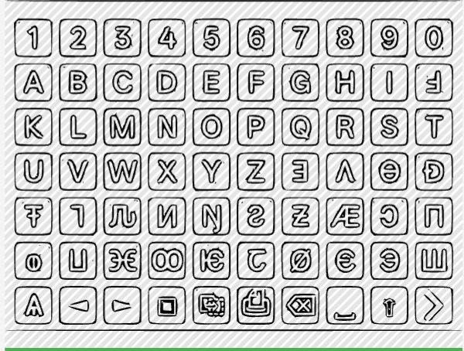

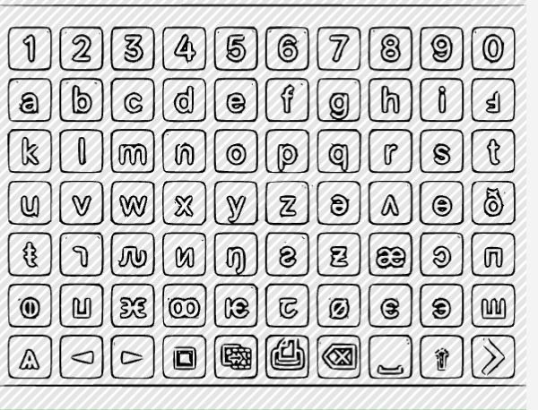
AGWEP Keyboard Image

AGWEP Keyboard Abstract :
In AGWEP Keyboard included 51 Strong Fonts and 51 Small Fonts as soon as 31 Symbols like as Gboard symbols.

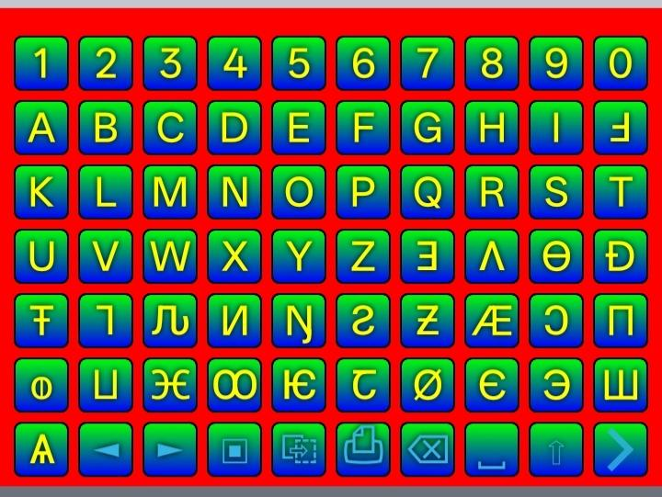

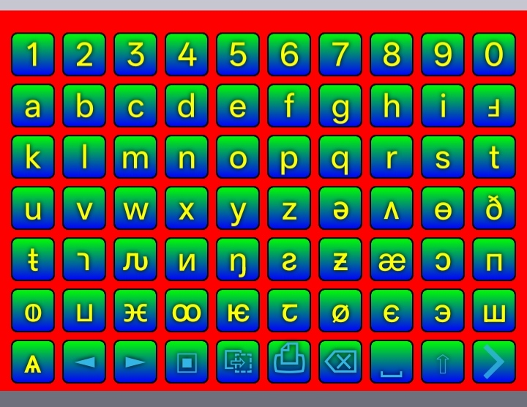
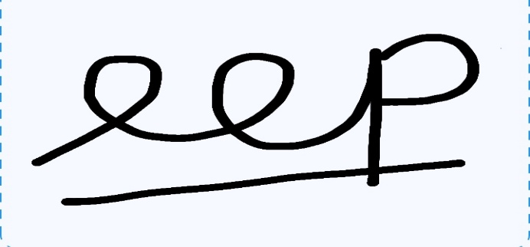
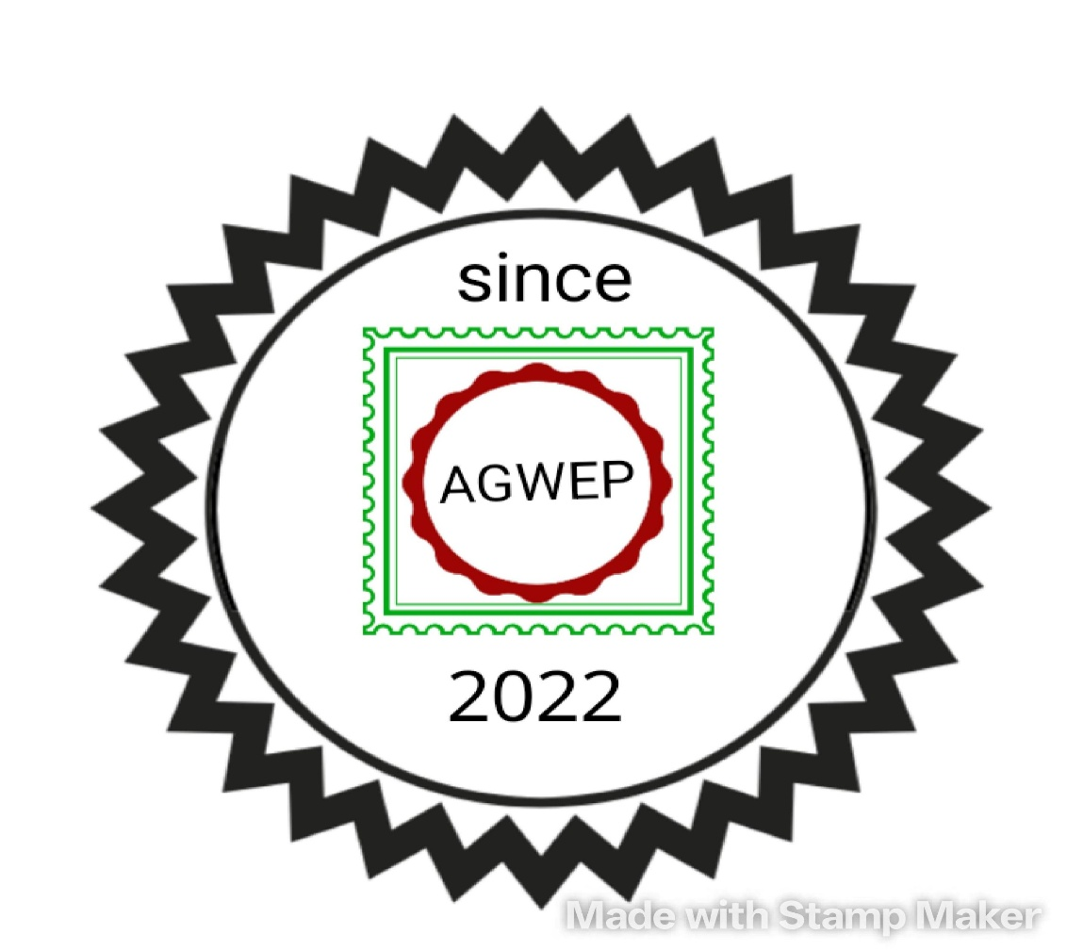
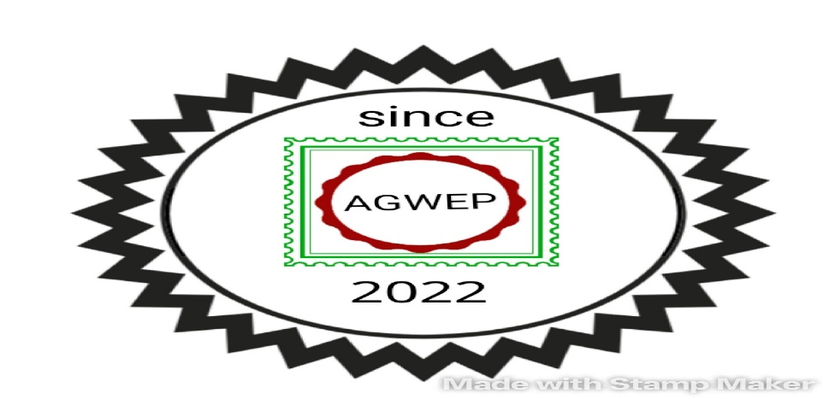
Yours Faithfully : AGWEP

