Clinical Outcomes of Open Flap Debridement with Metronidazole-Infused Titanium Platelet-Rich Fibrin versus Titanium Platelet-Rich Fibrin Alone: A Randomized Clinical Trial

ABSTRACT
Background: Residual periodontal pockets following conventional periodontal therapy may continue to harbor pathogenic microorganisms and compromise healing. Metronidazole is an effective antimicrobial agent against anaerobic periodontal pathogens, while Titanium-Platelet Rich Fibrin (T-PRF) provides a biologically active scaffold that promotes periodontal regeneration. This study evaluated the clinical efficacy of Metronidazole-infused T-PRF as an adjunct to open flap debridement (OFD) in the management of periodontal pockets.
Materials and Methods: Thirty patients diagnosed with Stage III–IV periodontitis presenting with residual periodontal pockets (PPD ≥5 mm) were enrolled in this single-blinded randomized clinical trial and allocated into two groups (n=15 each). The test group received OFD with Metronidazole-infused T-PRF, while the control group received OFD with T-PRF alone. Plaque Index (PI), Gingival Index (GI), Probing Pocket Depth (PPD), and Relative Clinical Attachment Level (RCAL) were recorded at baseline, 3 months, and 6 months postoperatively.
Results: Both groups demonstrated significant improvements in all clinical parameters from baseline to 6 months (p<0.001). The test group showed greater reductions in PPD (2.2 ± 0.6 mm) compared with the control group (1.8 ± 0.7 mm), although the difference was not statistically significant (p>0.05). RCAL gain was significantly greater in the Metronidazole-infused T-PRF group (2.3 ± 0.6 mm) than in the T-PRF group (1.7 ± 0.7 mm) (p<0.05). No significant intergroup differences were observed for PI and GI.
Conclusion: Both T-PRF and Metronidazole-infused T-PRF used in conjunction with OFD resulted in significant clinical improvements. However, Metronidazole-infused T-PRF demonstrated superior clinical attachment gain, suggesting that incorporation of metronidazole into the T-PRF matrix may enhance periodontal healing and improve treatment outcomes in periodontal pocket therapy.
Keywords: Periodontitis, Titanium-Platelet Rich Fibrin, T-PRF, Metronidazole, Open Flap Debridement, Periodontal Pockets.
INTRODUCTION
Periodontitis is a chronic inflammatory disease characterized by destruction of the periodontal ligament, cementum, and alveolar bone, leading to clinical attachment loss, periodontal pocket formation, and eventual tooth loss if left untreated. The primary goals of periodontal therapy are elimination of infection, reduction of inflammation, arrest of disease progression, and regeneration of lost periodontal tissues (Tonetti, 2018).
Although scaling and root planing (SRP) remains the gold standard for periodontal treatment, complete elimination of pathogenic microorganisms from deep periodontal pockets and anatomically complex sites is often difficult (Cobb, 2002; Caffesse, 1986). Consequently, residual periodontal pockets frequently require surgical intervention. Open flap debridement (OFD) provides improved access for root instrumentation and pocket reduction; however, healing often occurs through repair rather than true periodontal regeneration ( Heitz‐Mayfield, 2013).
Persistent microbial infection remains a major challenge in periodontal therapy and may compromise wound healing and regenerative outcomes. Therefore, adjunctive antimicrobial therapy has been extensively investigated. Among the available antimicrobial agents, metronidazole is widely used because of its potent activity against anaerobic periodontal pathogens, including Porphyromonas gingivalis, Tannerella forsythia, and Prevotella intermedia (Rams, 1996; Feres, 2015). Local delivery of metronidazole offers several advantages over systemic administration, including higher drug concentrations at the target site, reduced systemic exposure, and lower risk of adverse effects (Goodson, 1994). However, maintaining sustained drug release within the periodontal pocket remains a clinical challenge.
To overcome this limitation, platelet concentrates have recently been explored as biological drug-delivery systems. Platelet-rich fibrin (PRF), introduced by Choukroun et al., is a second-generation autologous platelet concentrate composed of a fibrin matrix enriched with platelets, leukocytes, cytokines, and growth factors (Choukroun, 2001). In addition to promoting angiogenesis, cell proliferation, and tissue regeneration, the fibrin matrix can entrap therapeutic agents and facilitate their gradual release at the treatment site (Bennardo, 2023). Studies have demonstrated that incorporation of antibiotics into PRF enhances antimicrobial activity without adversely affecting its biological properties (Thamaraiselvan, 2024; Gasparro, 2024).
Titanium-Platelet Rich Fibrin (T-PRF), introduced by Tunali et al., is a third-generation platelet concentrate prepared using medical-grade titanium tubes (Tunali, 2014). Compared with conventional PRF, T-PRF exhibits a denser fibrin architecture, prolonged degradation time, and sustained growth factor release, making it a promising scaffold for both periodontal regeneration and local drug delivery (Tunali, 2014; Tunali, 2013). Recent investigations have demonstrated favorable antibiotic-loading and sustained-release characteristics of T-PRF, highlighting its potential as a carrier for antimicrobial agents (Ercan, 2022).
Despite the established antimicrobial efficacy of metronidazole and the regenerative potential of T-PRF, clinical evidence evaluating their combined use in periodontal therapy remains limited. Therefore, the present randomized clinical trial was undertaken to evaluate the clinical efficacy of Metronidazole-infused T-PRF as an adjunct to OFD in the management of periodontal pockets and to compare its outcomes with T-PRF alone.
MATERIALS AND METHODS
Study Design and Patient Selection
This single-blinded, parallel-arm randomized clinical trial was conducted in the Department of Periodontology and Oral Implantology after Institutional Ethics Committee approval. Thirty patients (15 per group) were enrolled. Patients aged 30–65 years with Stage III–IV periodontitis and residual periodontal pockets (PPD ≥5 mm, CAL ≥4 mm) were included. Following Phase I therapy and revaluation after 4–6 weeks, eligible participants were randomly assigned to the test or control group using a computer-generated randomization sequence. Patients with systemic conditions affecting periodontal healing, smokers, pregnant or lactating women, recent antibiotic use, bleeding disorders, anticoagulant therapy, or known drug allergies were excluded.
Clinical Parameters
The following clinical parameters were recorded at baseline, 3 months, and 6 months:
- Plaque Index (Silness and Löe, 1964)
- Gingival Index (Löe and Silness, 1963)
- Probing Pocket Depth (PPD)
- Relative Clinical Attachment Level (RCAL)
PPD and RCAL measurements were obtained using a UNC-15 periodontal probe with the aid of customized acrylic stents to ensure reproducibility of measurements.
Presurgical Therapy
All participants underwent full-mouth scaling and root planing, oral hygiene instructions, and reinforcement of the Modified Bass brushing technique. Patients were revaluated after 4–6 weeks, and only sites demonstrating residual periodontal pockets (PPD ≥5 mm) were included in the study.
Surgical Procedure
Following intraoral antisepsis with 0.2% chlorhexidine and administration of local anesthesia (2% lignocaine hydrochloride with 1:200,000 adrenaline), intracrevicular incisions were made and full-thickness mucoperiosteal flaps were elevated. Thorough debridement and root surface instrumentation were performed before placement of the assigned biomaterial.
Group I (Test Group)
Open flap debridement (OFD) followed by placement of Metronidazole-infused Titanium-Platelet Rich Fibrin (T-PRF).
Group II (Control Group)
Open flap debridement (OFD) followed by placement of Titanium-Platelet Rich Fibrin (T-PRF) alone.
Preparation of T-PRF
T-PRF was prepared according to the protocol described by Tunali et al (2014). Briefly, 10 mL of venous blood was collected in sterile Grade IV titanium tubes without anticoagulant and centrifuged at 2700 rpm for 12 minutes. The resultant fibrin clot was separated from the red blood cell layer and used immediately.
Preparation of Metronidazole-Infused T-PRF
For the test group, 2 mL of metronidazole solution (3 mg/mL)(Meterkem®) was added to the titanium tube immediately before centrifugation. The remaining preparation protocol was identical to that used for conventional T-PRF.
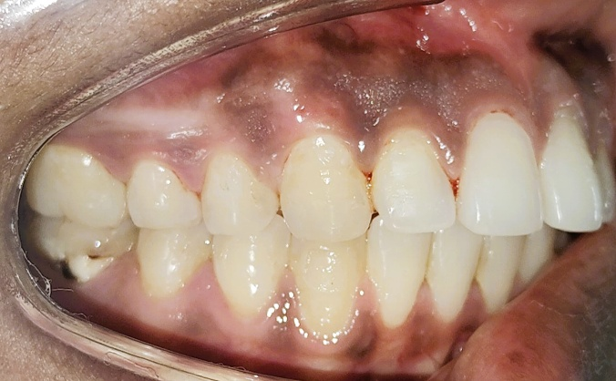
Figure 1 – Pre-operative

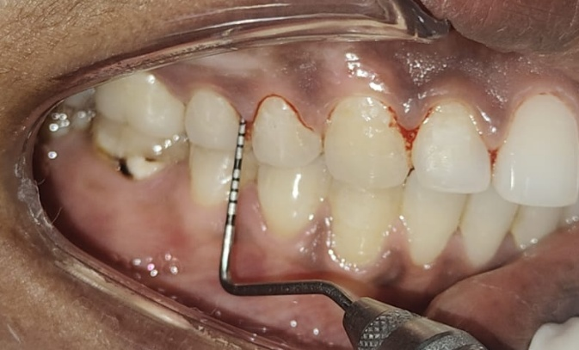
Figure 2 – Probing depth at baseline
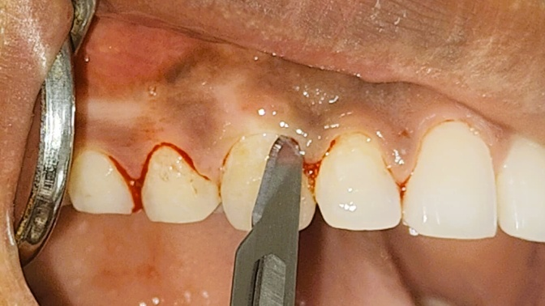
Figure 3 – Crevicular incisions given
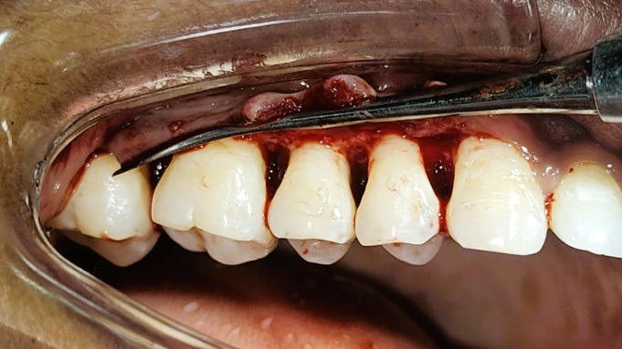
Figure 4 – Full thickness mucoperiosteal flap reflected and debridement done.
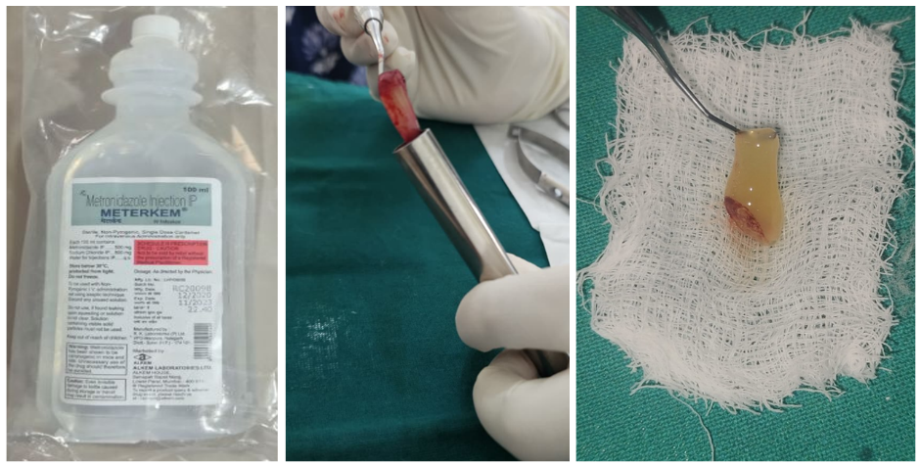
Figure 5 – Preparation of Metronidazole infused TPRF
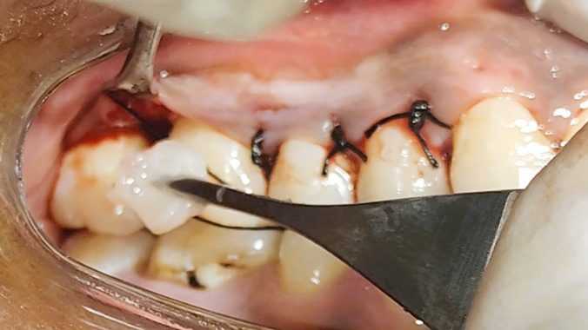
Figure 6 – Placement of Metronidazole infused TPRF
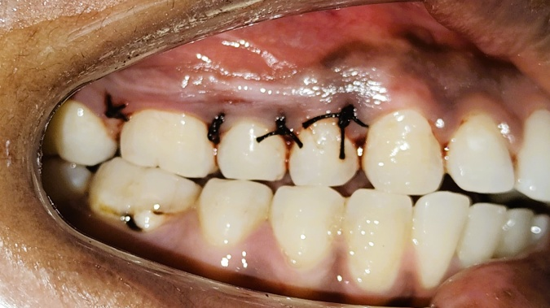
Figure 7 – Interrupted sutures given using 4‑0 silk suture
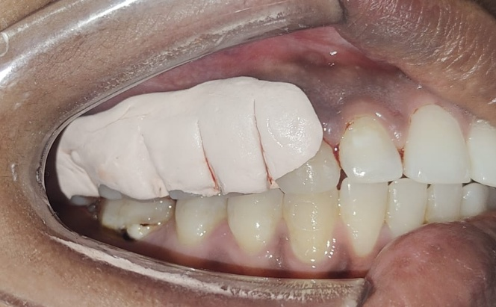
Figure 8 – Placement of periodontal dressing
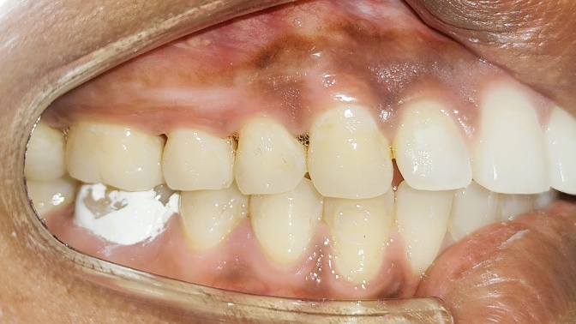
Figure 9 – Follow up after 6 months
Postoperative Care
All participants received paracetamol 500 mg three times daily for five days and were instructed to rinse twice daily with 0.2% chlorhexidine mouthwash for two weeks. Sutures were removed after 7–10 days. Oral hygiene instructions were reinforced at each follow-up visit.
Follow-Up Evaluation
Clinical parameters were reassessed at 3 and 6 months postoperatively by a blinded examiner.
Statistical Analysis
Data were analyzed using SPSS software version 21.0 (IBM Corp., Chicago, IL, USA). Quantitative variables were expressed as mean ± standard deviation. Normality of data distribution was assessed using the Shapiro–Wilk test. Intragroup comparisons over time were performed using repeated-measures ANOVA followed by Tukey's post hoc test. Statistical significance was set at P < 0.05.
RESULTS
Parameter | Group | Baseline (Mean ± SD) | 3 Months (Mean ± SD) | 6 Months (Mean ± SD)
Plaque Index | Test | 1.92 ± 0.31 | 0.98 ± 0.20 | 0.62 ± 0.15
 | Control | 1.89 ± 0.28 | 1.05 ± 0.24 | 0.71 ± 0.18
Gingival Index | Test | 1.86 ± 0.27 | 0.92 ± 0.18 | 0.54 ± 0.12
 | Control | 1.83 ± 0.30 | 1.01 ± 0.20 | 0.69 ± 0.15
PPD (mm) | Test | 6.8 ± 0.8 | 5.3 ± 0.6 | 4.6 ± 0.6
 | Control | 6.7 ± 0.7 | 5.8 ± 0.7 | 4.9 ± 0.7
RCAL (mm) | Test | 10.8 ± 0.8 | 9.3 ± 0.6 | 8.5 ± 0.6
 | Control | 10.7 ± 0.7 | 9.8 ± 0.7 | 9.0 ± 0.7
Mean changes from baseline to 6 months:
Parameter | Test Group | Control Group
Mean PPD Reduction (Baseline–6 Months) | 2.2 ± 0.6 mm | 1.8 ± 0.7 mm
Mean RCAL Gain (Baseline–6 Months) | 2.3 ± 0.6 mm | 1.7 ± 0.7 mm
Thirty patients completed the study and were included in the final analysis. No significant differences were observed between the test and control groups at baseline for any clinical parameter (p > 0.05).
Both groups demonstrated significant reductions in Plaque Index (PI) and Gingival Index (GI) from baseline to 6 months (p < 0.001). However, intergroup differences were not statistically significant at any time point (p > 0.05).
A significant reduction in probing pocket depth (PPD) was observed in both groups over the study period (p < 0.001). The test group exhibited a mean PPD reduction of 2.2 mm, compared with 1.8 mm in the control group. Although greater pocket reduction was observed in the Metronidazole-infused T-PRF group, the intergroup difference was not statistically significant (p > 0.05).
Both groups also demonstrated significant gains in relative clinical attachment level (RCAL) from baseline to 6 months (p < 0.001). The mean RCAL gain was 2.3 mm in the test group and 1.7 mm in the control group. Intergroup comparison revealed significantly greater attachment gain in the Metronidazole-infused T-PRF group at 6 months (p < 0.05).
DISCUSSION
The present study evaluated the clinical efficacy of Metronidazole-infused Titanium-Platelet Rich Fibrin (T-PRF) as an adjunct to open flap debridement (OFD) in the management of periodontal pockets. Both treatment groups demonstrated significant improvements in all clinical parameters over the 6-month follow-up period. However, the Metronidazole-infused T-PRF group exhibited greater probing pocket depth (PPD) reduction and significantly greater relative clinical attachment level (RCAL) gain compared with T-PRF alone.
Persistent subgingival infection remains a major challenge in periodontal therapy and may compromise healing following surgical intervention. The rationale for incorporating metronidazole into T-PRF was based on its well-established efficacy against anaerobic periodontal pathogens. The significantly greater RCAL gain observed in the test group (2.3 mm) compared with the control group (1.7 mm) suggests that local delivery of metronidazole may have enhanced the healing response by reducing residual microbial activity during the critical postoperative period.
A major limitation of local antimicrobial therapy is maintaining therapeutic drug concentrations within the periodontal pocket for a sufficient duration. In recent years, platelet concentrates have been investigated as biological drug-delivery systems capable of providing sustained release of incorporated therapeutic agents. Polak et al. (2019) demonstrated that antibiotics can be successfully incorporated into platelet-rich fibrin matrices without adversely affecting their structural integrity or biological activity. Similarly, Indurkar et al. (2024) reported favorable antibiotic-loading and sustained-release characteristics of T-PRF, supporting its potential use as a local antimicrobial delivery vehicle.
In addition to serving as a carrier for metronidazole, T-PRF itself possesses favorable regenerative properties that may have contributed to the clinical improvements observed in both groups. Tunali et al. (2013) reported that titanium-mediated platelet activation results in a thicker and more organized fibrin network with prolonged growth factor release compared with conventional PRF. Furthermore, Ravi et al. (2020) demonstrated superior tensile strength and delayed degradation of T-PRF, suggesting prolonged biological activity at the surgical site. These characteristics may enhance wound stabilization, angiogenesis, and cellular migration during periodontal healing.
Both groups demonstrated significant reductions in plaque index and gingival index throughout the study period. These improvements may be attributed to comprehensive initial periodontal therapy, reinforcement of oral hygiene instructions, and regular maintenance care. Similar observations have been reported by Drisko (2001), who emphasized the importance of plaque control and supportive periodontal therapy in achieving favorable periodontal outcomes.
A significant reduction in PPD was observed in both groups, with mean reductions of 2.2 mm and 1.8 mm in the test and control groups, respectively. Although the intergroup difference was not statistically significant, the greater reduction observed in the Metronidazole-infused T-PRF group may reflect the combined effects of improved microbial control and enhanced wound healing. These findings are comparable to those reported by Chatterjee et al. (2017), who demonstrated significant probing depth reduction following the use of T-PRF in periodontal intrabony defects.
Clinical attachment gain is considered one of the most reliable indicators of successful periodontal regeneration. In the present study, the significantly greater RCAL gain observed in the test group suggests a potential synergistic effect between the antimicrobial action of metronidazole and the regenerative properties of T-PRF. Similar improvements in attachment levels have been reported with platelet concentrates used as adjuncts to periodontal surgery. Miron et al. (2017) reported consistent improvements in clinical attachment gain and pocket reduction following the use of platelet concentrates in regenerative periodontal procedures.
The limitations of the present study include the relatively small sample size and short follow-up period of six months. Furthermore, radiographic and microbiological evaluations were not performed, limiting assessment of hard-tissue regeneration and microbial changes. Future studies with larger sample sizes, longer follow-up periods, and comprehensive radiographic and microbiological analyses are necessary to further validate the clinical efficacy of Metronidazole-infused T-PRF.
Within the limitations of the present study, both T-PRF and Metronidazole-infused T-PRF used in conjunction with OFD resulted in significant clinical improvements. However, the significantly greater RCAL gain observed in the Metronidazole-infused T-PRF group suggests that incorporation of metronidazole into the T-PRF matrix may enhance periodontal healing and improve clinical outcomes compared with T-PRF alone.
CONCLUSION
Metronidazole-infused T-PRF demonstrated superior clinical outcomes compared with T-PRF alone when used in conjunction with open flap debridement for the treatment of periodontal pockets. Further studies with larger sample sizes and longer follow-up periods are recommended to validate these findings.
ACKNOWLEDGMENT
The author reports no conflicts of interest related to the cases presented.
REFERENCES
1. Bennardo F, Gallelli L, Palleria C, Colosimo M, Fortunato L, De Sarro G, Giudice A. Can platelet-rich fibrin act as a natural carrier for antibiotics delivery? A proof-of-concept study for oral surgical procedures. BMC Oral Health. 2023 Mar 9;23(1):134. https://doi.org/10.1186/s12903-023-02814-5
2. Caffesse RG, Sweeney PL, Smith BA. Scaling and root planing with and without periodontal flap surgery. Journal of Clinical Periodontology. 1986 Mar;13(3):205-10. https://doi.org/10.1111/j.1600-051X.1986.tb01461.x
3. Chatterjee A, Pradeep AR, Garg V, Yajamanya S, Ali MM, Priya VS. Treatment of periodontal intrabony defects using autologous platelet‐rich fibrin and titanium platelet‐rich fibrin: a randomized, clinical, comparative study. Journal of Investigative and Clinical Dentistry. 2017 Aug;8(3):e12231. https://doi.org/10.1111/jicd.12231
4. Choukroun J, Adda F, Schoeffler C, Vervelle AP. Une opportunité en paro-implantologie: le PRF. Implantodontie.2001Jan1;42(55):e62. https://www.researchgate.net/publication/284049099_Une_opportunit_en_paro-implantologie_Le_PRF
5. Cobb CM. Clinical significance of non‐surgical periodontal therapy: an evidence‐based perspective of scaling and root planing. Journal of Clinical Periodontology. 2002 May;29:22-32. https://doi.org/10.1034/j.1600-051X.29.s2.4.x
6. Drisko CH. Nonsurgical periodontal therapy. Periodontology 2000. 2001 Feb 1;25(1). https://doi.org/10.1034/j.1600-0757.2001.22250106.x
7. Ercan E, Suner SS, Silan C, Yilmaz S, Siddikoglu D, Sahiner N, Tunali M. Titanium platelet–rich fibrin (T-PRF) as high-capacity doxycycline delivery system. Clinical Oral Investigations. 2022 Aug;26(8):5429-38. https://doi.org/10.1007/s00784-022-04510-0
8. Feres M, Figueiredo LC, Soares GM, Faveri M. Systemic antibiotics in the treatment of periodontitis. Periodontology 2000. 2015 Feb;67(1):131-86. https://doi.org/10.1111/prd.12075
9. Gasparro R, Di Spirito F, Campana MD, Sammartino G, Di Lauro AE. The role of autologous platelet concentrates as a local antibiotic delivery system: a systematic scoping review. Antibiotics. 2024 Sep 6;13(9):856. https://doi.org/10.3390/antibiotics13090856
10. Goodson JM. Antimicrobial strategies for treatment of periodontal diseases. Periodontology 2000. 1994 Jun;5(1):142-68. https://doi.org/10.1111/j.1600-0757.1994.tb00022.x
11. Heitz‐Mayfield LJ, Lang NP. Surgical and nonsurgical periodontal therapy. Learned and unlearned concepts. Periodontology 2000. 2013 Jun;62(1):218-31. https://doi.org/10.1111/prd.12008
12. Indurkar MS, Purohit JN. Titanium platelet-rich fibrin (T-PRF) as doxycycline delivery system: an in-vitro study. Int J Oral Health Dent. 2024;10:91-4. https://doi.org/10.18231/j.ijohd.2024.019
13. Löe H, Silness J. Periodontal disease in pregnancy I. Prevalence and severity. Acta Odontologica Scandinavica. 1963 Jan 1;21(6):533-51. https://doi.org/10.3109/00016356309011240
14. Miron RJ, Choukroun J. Platelet Rich Fibrin in Regenerative Dentistry. Hoboken: Wiley Online Library; 2017. https://doi.org/10.1002/9781119406792
15. Polak D, Clemer‐Shamai N, Shapira L. Incorporating antibiotics into platelet‐rich fibrin: a novel antibiotics slow‐release biological device. Journal of Clinical Periodontology. 2019 Feb;46(2):241-7. https://doi.org/10.1111/jcpe.13063
16. Rams TE, Slots J. Local delivery of antimicrobial agents in the periodontal pocket. Periodontology 2000. 1996 Feb;10(1):139-59. https://doi.org/10.1111/j.1600-0757.1996.tb00072.x
17. Ravi S, Santhanakrishnan M. Mechanical, chemical, structural analysis and comparative release of PDGF-AA from L-PRF, A-PRF and T-PRF—an in vitro study. Biomaterials Research. 2020 Sep 11;24(1):16. https://doi.org/10.1186/s40824-020-00193-4
18. Silness J, Löe H. Periodontal disease in pregnancy II. Correlation between oral hygiene and periodontal condition. Acta Odontologica Scandinavica. 1964 Jan 1;22(1):121-35. https://doi.org/10.3109/00016356408993968
19. Thamaraiselvan M, Jayakumar ND. Efficacy of injectable platelet-rich fibrin (i-PRF) as a novel vehicle for local drug delivery in non-surgical periodontal pocket therapy: A randomized controlled clinical trial. Journal of Advanced Periodontology & Implant Dentistry. 2024 Sep 11;16(2):94. https://doi.org/10.34172/japid.2024.021
20. Tonetti MS, Greenwell H, Kornman KS. Staging and grading of periodontitis: Framework and proposal of a new classification and case definition. Journal of Periodontology. 2018 Jun;89:S159-72. https://doi.org/10.1002/JPER.18-0006
21. Tunalı M, Özdemir H, Küçükodacı Z, Akman S, Fıratlı E. In vivo evaluation of titanium-prepared platelet-rich fibrin (T-PRF): a new platelet concentrate. British Journal of Oral and Maxillofacial Surgery. 2013 Jul 1;51(5):438-43. https://doi.org/10.1016/j.bjoms.2012.08.003
22. Tunalı M, Özdemir H, Küçükodacı Z, Akman S, Yaprak E, Toker H, Fıratlı E. A novel platelet concentrate: titanium‐prepared platelet‐rich fibrin. BioMed Research International. 2014;2014(1):209548. https://doi.org/10.1155/2014/209548

