WELLNESS TOURISM MEETS SUSTAINABILITY: GLOBAL TRENDS AND

ABSTRACT
Wellness tourism is one of the emerging sectors in the tourism industry, where travelers go for rejuvenation and refreshment by enhancing and balancing their body, mind, and spirit. It focuses on creating overall balance and preventing disease rather than treating the cause or symptoms. It can be termed the most sustainable way to enjoy journeys. Most wellness tourism activities are intertwined with nature and the environment. Even studies show that wellness tourists are looking for destinations that offer a calm atmosphere and warmly welcome them to nature's serene beauty. So it is important to understand the interconnectivity and role of wellness tourism and sustainability in the global tourism sector. This bibliometric study examines the role of sustainability in wellness tourism and, in turn, the importance of wellness tourism in advancing sustainable practices. For a period of ten years from 2006 to 2006, there was a rise in the number of articles, with only 24 in 2025. It was identified that wellness tourism and sustainability are emerging areas of research with immense opportunities for in-depth study to protect the environment. Most globally cited documents, average citations, themes concentrated in the study so far, and words associated with it were identified through this bibliometric study.
Keywords: wellness tourism, Sustainability, bibliometric analysis, Thematic evaluation

INTRODUCTION
Wellness and sustainability go hand in hand as they both aim at preserving and maintaining the natural aura that comes from the environment as well as humans. Wellness tourism refers to travelling with the primary purpose of maintaining or improving personal health and wellbeing. It includes yoga, meditation, holistic and spiritual wellness programs, healthy lifestyle tourism, and so on. As well, sustainable tourism aims to minimize negative environmental, social, and economic impacts while maximizing benefits to local communities(Cernat et al., 2007; Shokri Garjan et al., 2023). It focuses on environmental protection, responsible use of natural resources, cultural preservation, etc. Both focus on holistic well-being for people, nature, and communities. Natural resources are acknowledged as one of the primary factors influencing the enhancement of wellness, and thus the growth and long-term viability of tourism locations(Pessot et al., 2021). Currently, the most successful and notable wellness tourism centers incorporate aspects of sustainable development into their tourism practices(Shokri Garjan et al., 2023).
However, despite the rising academic and industry focus on sustainability, few studies have specifically examined wellness tourism as a strategic tool for enhancing environmental sustainability(Nel-lo Andreu et al., 2021). This gap highlights the need to better understand how wellness tourism contributes to sustainable resource use, nature protection, and ecological awareness. To address this, the present study conducts a comprehensive bibliometric analysis of existing literature on wellness tourism and sustainability, mapping publication patterns, thematic trends, and knowledge structures. By identifying key research clusters and uncovering underexplored areas, this study provides valuable insights into the evolution, current state, and future directions of sustainable wellness tourism research.

METHODOLOGY
The literature for the study was collected from one of the most trusted academic databases, Scopus. On November 16, 2025, the search was conducted using keywords commonly employed in bibliometric searches on wellness tourism. Data was retrieved using the keyword search ‘sustainability’ OR ‘environment sustainability’ AND ‘Wellness tourism’ OR ’Wellbeing tourism’ OR ‘Holistic Wellness’ .A comprehensive bibliometric search within the tourism area was conducted to include the latest AI trends in the field. The search operation retrieved 86 documents. To refine the dataset, only English-language documents were considered. After this refinement, 84 documents remained. The bibliometric analysis was conducted using R software (Bibliometrix package) to identify key trends, influential works, most cited countries, and research networks, and so on.

LITERATURE REVIEW
The sustainability strategy, which is still in use today, was initially implemented in the middle of the 1990s. In addition to implementing tools for environmental management and control, it seeks to preserve and improve natural and cultural attractions(Nel-lo Andreu et al., 2021). Sustainable tourism refers to the responsible use of resources, including biodiversity, while minimizing negative impacts on the environment, culture, and society. It emphasises maximizing the benefits of tourism in ways that safeguard the natural and cultural heritage of local communities(Farsani et al., 2012; Mihardja et al., 2023). The term sustainable travel is broad and might mean different things to different people(Nikolić et al., 2021; Shokri Garjan et al., 2023). The attractiveness of a destination reflects its capacity to enable and prosper through tourism(Mihardja et al., 2023). When tourism relies heavily on natural resources, its development can generate negative consequences. The intricate relationship between tourism and the environment includes multiple activities and operations that, if not managed responsibly, can lead to significant environmental harm(Shokri Garjan et al., 2023; Tan, 2021). Developing nature-integrated wellness practices upholds destination branding and entails the development of communities in that region while conserving the environment(Mihardja et al., 2023; Pessot et al., 2021; Zeng et al., 2021).
Wellness tourism has emerged as one of the fastest-growing segments of global tourism, driven by travelers seeking experiences that enhance physical, mental, and emotional well-being. Closely linked to this growth is the increasing emphasis on sustainability, as wellnessbased experiences often depend on pristine natural environments, culturally rooted healing traditions, and socially responsible practices(Lee et al., 2020; Nel-lo Andreu et al., 2021). To become appealing, wellness destinations require cultural attractions, outdoor activities, a temperate environment, authenticity, sustainability, healthful regional food, and traditional remedies(Nel-lo Andreu et al., 2021). Incorporating wellness tourism practices with the natural environment not only enhances the effectiveness of the healing experience but also contributes to the protection of nature. Compared to artificial settings, forest environments have a significantly more positive effect on human physiological activity.(Mihardja et al., 2023). Nature therapy, as a healthpromotion technique and a potential universal health model, has been shown to reduce modern stress states and technostress. In Japan and China, a new mode of wellness healing that immerses oneself with nature as’ forest bathing’ initiated as a means to escape from the stresses and, in turn, to preserve their natural settings(Hansen et al., 2017). Wellness tourism also focuses on sun and beach destinations, which are directly linked to living or traveling close to the sea, or engaging in activities there termed as coastal wellness(Kelly, 2018; Nel-lo Andreu et al., 2021).
Geo tourism is another form of sustainable tourism practice(Mihardja et al., 2023).
Facing intense competition from tourism locales, tourist entities typically highlight a destination’s sustainable management practices as a way to stimulate tourists’ desire to explore and refer it to others(Zeng et al., 2021). Sustainable travel is more preferable but expensive for travelers(Shokri Garjan et al., 2023). When tourism is combined with sustainability principles, supply chain management becomes a strategic tool for minimizing environmental impact, supporting local economies, and promoting responsible resource use. Sustainable tourism supply chains prioritize ecofriendly procurement, renewable energy, waste reduction, ethical labour practices, and partnerships with local producers and service providers(Morrison et al., 2004; Shokri Garjan et al., 2023). Incorporating the concept of tourism supply chain management within the wellness tourism industry can significantly enhance its overall performance by efficiently responding to diverse tourist demands. By integrating supply chain strategies, wellness destinations are better equipped to address the persistent challenge of limited resources while simultaneously supporting the economic development of the region(Chen 2009, n.d.; Nayeri et al., 2022; Shokri Garjan et al., 2023).
ANALYSIS AND DISCUSSION

TABLE 1

Descriptive Summary of The Bibliometric Data Set (2006-2026)

MAIN INFORMATION ABOUT DATA
Description | Results
Timespan | 2006:2026
Sources (Journals, Books, etc) | 45
Documents | 84
Document Average Age | 2.62
Average citations per doc | 12.63
References | 701
DOCUMENT CONTENTS  Keywords Plus (ID) | 245
Author's Keywords (DE) | 298
AUTHORS  Authors | 288
AUTHORS COLLABORATION  Single-authored docs | 0
Co-Authors per Doc | 5.26
International co-authorships % | 23.81
DOCUMENT TYPES  article | 50
book | 1
book chapter | 17
conference paper | 10
conference review | 3
review | 3
Note: Retrieved from Biblioshiny
Table 1 shows the descriptive summary of the bibliometric dataset. The Scopus database served as the source for the paper's bibliometric study. The study was conducted between 2006 and 2026.
There are 45 sources, which include books and journals. The average documents are 2.62 years old, indicating the literature is fairly recent. Each document receives around 12 citations on average, showing that the research in this field has a moderate academic impact.
The 84 documents together cite 701 references, implying that authors are drawing on a wide academic base, indicating a rich foundational literature. The 245 keywords plus indicate that the intellectual structure of the field is broad, covering various themes and related concepts.
The authors offered 298 distinct keywords, demonstrating a wide range of subjects and implying that the field's study is multifaceted with numerous new or specialised subtopics. The percentage of international co-authorships is 23.81%. This indicates that there is potential to improve cross-national cooperation while also demonstrating positive global participation. Journal articles, which are the main output of science and are usually subject to peer review, make up the bulk of publications.

Figure 1

Annual Scientific Production
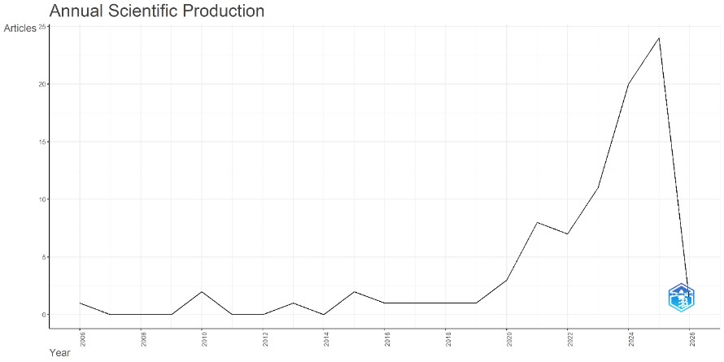
Note: Retrieved from Biblioshiny
Figure 1 represents the annual scientific production each year. From 2006 to 2018, there was low annual scientific production, i.e., 0-2 publications. This indicates the period of minimal research activity. The production began to rise gradually, reaching around eleven articles between 2019 and 2021. A strong interest in the field emerged during these periods with strong collaboration. A major uptrend occurs from 2022 with 7 articles. Then it rose to 11 articles in 2023, and in 2024, it reached nearly 20 articles. The highest production was about 24 articles in 2025. As a conclusion, there was a stagnant progress of production up to 2019, and it began to saturate up to 2025. The peak efforts occurred in the subject area because of high activity and influence in the concerned area.

Figure 2

Most Global Cited Documents
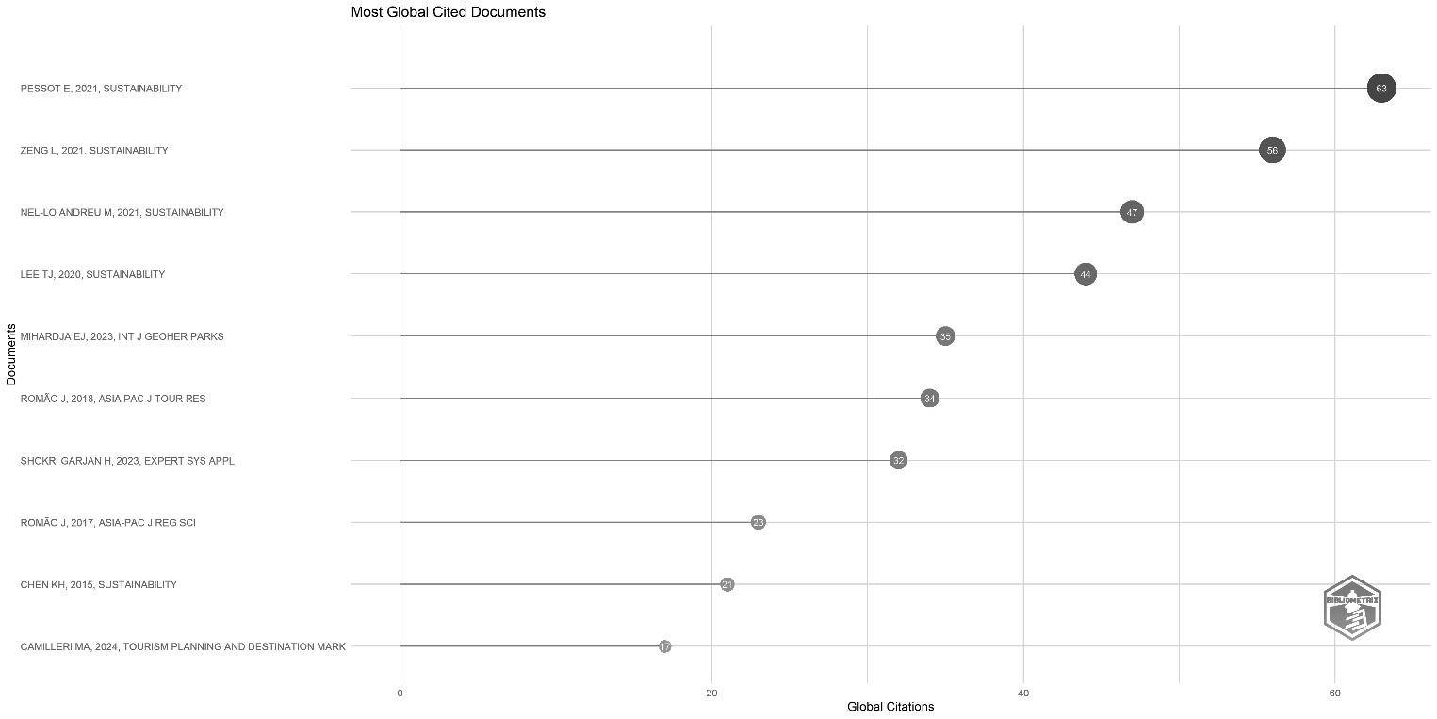
Note: Retrieved from Biblioshiny
Figure 2 highlights the most influential documents in the field, ranked by their global citation counts. The document by Pessot et al. (2021), published in Sustainability emerges as the most globally cited work, with 68 citations, indicating its strong impact on research related to sustainability and tourism. This is followed by Zeng (2021) with 56 citations, and Neu-Lo AndreU (2021) with 47 citations, both also contributing significant foundational insights within the sustainability domain.Among the mid-ranked documents, Lee (2020) and Mihardja (2023) show citation strengths of 44 and 35 respectively, reflecting continued scholarly engagement with sustainability and geotourism themes. Other notable contributions include Romão (2018, 2017) and Shokr (2023), each receiving citation counts in the low 30s, suggesting their relevance in topics such as tourism development, expert systems, and regional science.
Finally, Chen (2015) and Camilleri (2024) appear with relatively lower citation counts compared to the others but still form part of the most influential group within the dataset. The distribution suggests that the bulk of highly cited literature has been published in the last decade, emphasising a growing research interest in sustainability, geotourism, and tourism planning. Overall, the chart reveals a welldefined cluster of highly impactful studies that shape current academic discourse in sustainable and wellness tourism research.

Figure 3

Average Citations per year
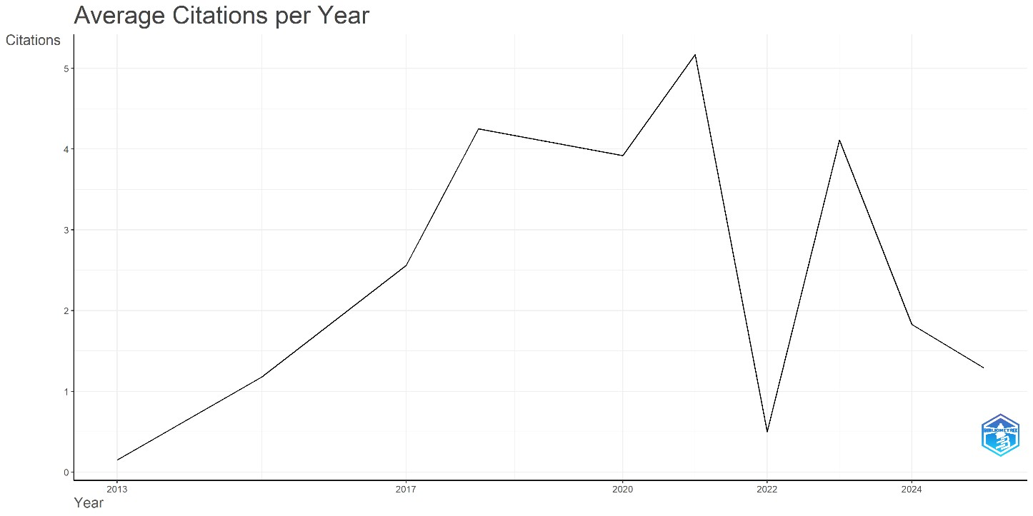
Note: Retrieved from Biblioshiny
The trend of average citations per year shows a fluctuating but generally upward trajectory in scholarly attention to the field over time. Beginning at a very low citation rate in 2013, the average citations steadily increased through 2017, indicating growing academic engagement. A sharp rise is evident around 2019–2020, where the average citation rate peaks above 5, reflecting a period of heightened research activity and influence—possibly driven by increased interest in wellness, sustainability, and nature-based tourism during the pre- and post-pandemic years.
However, this upward trend is followed by a dramatic decline in 2022, suggesting either fewer impactful publications in that year or insufficient time for recent articles to accumulate citations. The citation rate rises again in 2023 before dropping once more in 2024, which is expected since newer publications often require time to gain visibility and citations. Overall, the pattern suggests that the field’s impact has grown significantly over the last decade, with periodic fluctuations likely associated with publication cycles, emerging themes, and time-lag effects in citation accumulation.

Figure 4

Thematical Map
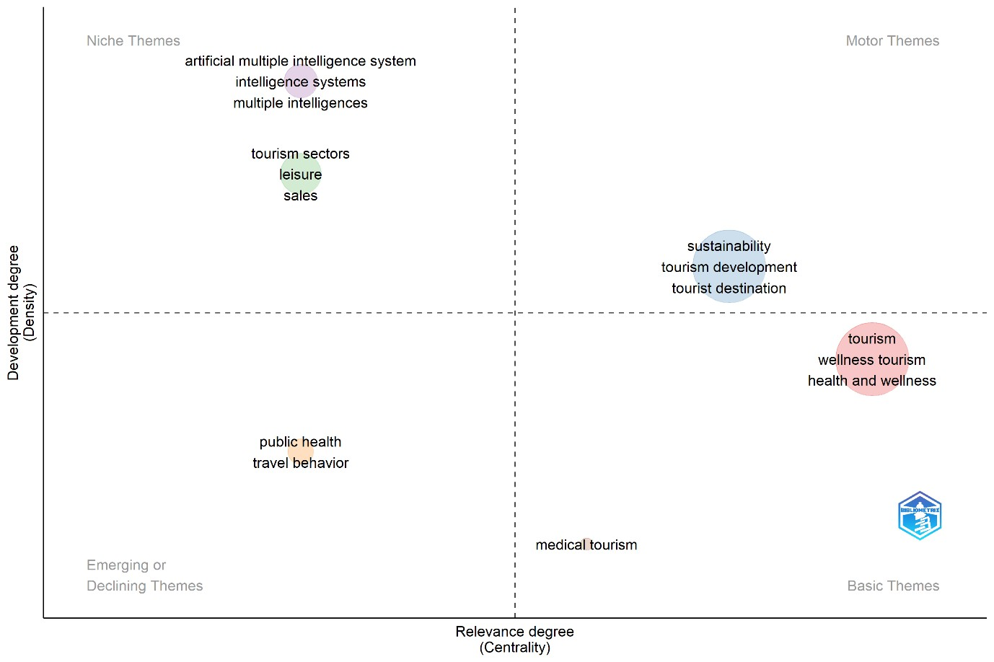
Note: Retrieved from Biblioshiny
Figure 4 represents the thematic map. Based on the centrality and density, there were four quadrants, which are motor themes, niche themes, emerging/declining trends, and basic themes.
Motor themes have high centrality and high density. These quadrants consist of both well-developed and highly relevant topics to the study field. The key themes are sustainability, tourism development, and tourist destinations. The motor themes indicate the sustainability concepts and their relation with wellness tourism, tourism development, and destinations. This represents the global reach of the study area. Niche themes have high density but low centrality to the field. The key themes are artificial multiple intelligence systems, intelligence systems, multiple intelligences, tourism sectors, leisure, and sales. Niche themes represent technical areas. These terms are specialised, but neither has a direct influence.
The emerging or declining themes are weakly developed and not strongly connected. These themes have low density and low centrality. These themes may be new or an underexplored area. The basic key themes are public health and travel behaviour. These terms appear to have been developed early. The academic importance is fading for these terms.Those themes that have high centrality and low density are known as basic themes. Even if these themes are not yet fully developed, they are fundamental themes. The key term includes medical tourism. In fact, medical tourism is a fundamental aspect of wellness tourism. The importance of medical services in tourism is an attractive one. So, medical tourism is a highly relevant term in wellness tourism. Medical tourism is a highly promising area to develop and needs in-depth investigation.
As a concluding remark, sustainability and wellness tourism were dominant in the area of study.
Although the fundamental theme is medical tourism, more studies on the theme are yet to be developed.

Figure 5

Word Cloud
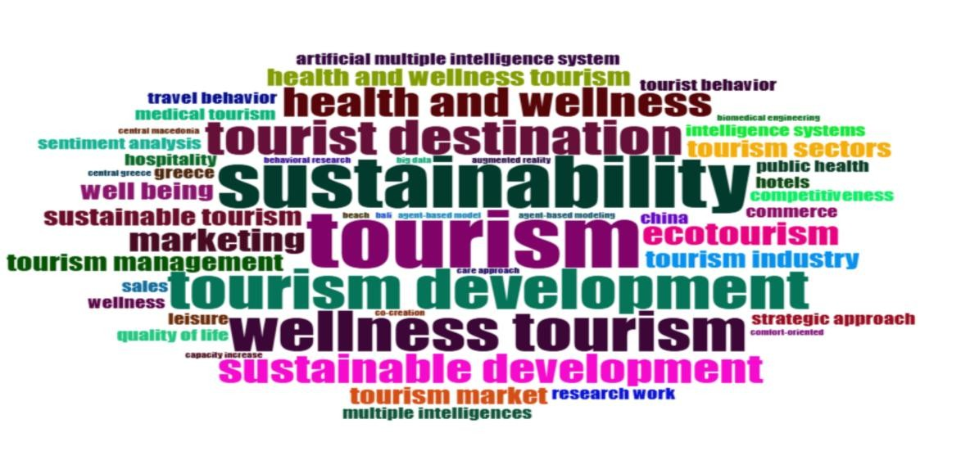
Note: Retrieved from Biblioshiny
Figure 5 shows the word cloud of the study area. The word cloud represents the frequently occurring keywords. Larger words indicate higher occurrence or usage. They are tourism, sustainability, tourism development, tourism destination, wellness tourism, health and wellness, and sustainable development. These are the core focus of the study area. These terms emphasise global trends as regards sustainability, wellness, and destination development. The medium-sized terms are to appear as frequently used, but not at the core level. These terms are tourism management, marketing, quality of life, ecotourism, well-being, tourism industry, tourism sectors, hospitality, and competitiveness.

CONCLUSION
As travellers become more health-conscious and environmentally aware, wellness tourism is evolving into a model that not only nurtures individual well-being but also aligns with broader goals of environmental stewardship and socio-cultural preservation. This interconnectedness has positioned sustainable wellness tourism as a significant area of academic interest, especially with the rise of postpandemic preferences for holistic and mindful travel. The integration of sustainability in wellness tourism promotes the protection of natural resources, supports local communities, and ensures the longterm viability of wellness destinations.(Mihardja et al., 2023)
This bibliometric study provides a comprehensive overview of the scholarly landscape on wellness tourism and sustainability, highlighting key publication trends, influential authors, dominant journals, and emerging thematic clusters. The mapping of themes shows that while sustainability and wellness are widely discussed independently, their combined potential—especially in promoting ecological protection, reducing environmental pressures, and fostering responsible tourism behaviour—requires deeper academic investigation. The insights generated in this study contribute to a better understanding of the intellectual structure of the field and offer direction for scholars aiming to advance sustainable wellness tourism research. Overall, this bibliometric assessment not only consolidates existing knowledge but also underscores the need for integrated, multidisciplinary approaches that position wellness tourism as a strategic driver of environmental sustainability and long-term destination resilience.

REFERENCES
Cernat, L., Gourdon, J., & UNCTAD. (2007). Is the concept of sustainable tourism sustainable? :: developing the sustainable tourism benchmarking tool /: Lucian Cernat and Julien Gourdon. UN,. https://digitallibrary.un.org/record/615255
Chen 2009. (n.d.). Innovation of tourism supply chain management. Ieeexplore.Ieee.OrgD Chen2009
International Conference on Management of e-Commerce and e, 2009•ieeexplore.Ieee.Org. Retrieved November 20, 2025, from https://ieeexplore.ieee.org/abstract/document/5279878/
Farsani, N. T., Coelho, C., & Costa, C. (2012). Geotourism and Geoparks as Gateways to Socio-cultural
Sustainability in Qeshm Rural Areas, Iran. Asia Pacific Journal of Tourism Research, 17(1), 30–48. https://doi.org/10.1080/10941665.2011.610145
Hansen, M. M., Jones, R., & Tocchini, K. (2017). Shinrin-Yoku (Forest Bathing) and Nature Therapy: A State-ofthe-Art Review. International Journal of Environmental Research and Public Health 2017, Vol. 14, Page
851, 14(8), 851. https://doi.org/10.3390/IJERPH14080851
Kelly, C. (2018). ‘I Need the Sea and the Sea Needs Me’: Symbiotic coastal policy narratives for human wellbeing and sustainability in the UK. Marine Policy, 97, 223–231. https://doi.org/10.1016/J.MARPOL.2018.03.023
Lee, T. J., Han, J. S., & Ko, T. G. (2020). Health-oriented tourists and sustainable domestic tourism. Sustainability (Switzerland), 12(12). https://doi.org/10.3390/su12124988
Mihardja, E. J., Alisjahbana, S., Agustini, P. M., Sari, D. A. P., & Pardede, T. S. (2023). Forest wellness tourism destination branding for supporting disaster mitigation: A case of Batur UNESCO Global Geopark, Bali.
International Journal of Geoheritage and Parks, 11(1), 169–181. https://doi.org/10.1016/j.ijgeop.2023.01.003
Morrison, A., Lynch, P., & Johns, N. (2004). International tourism networks. Emerald.ComA Morrison, P Lynch,
N JohnsInternational Journal of Contemporary Hospitality Management, 2004•emerald.Com, 16(3),
197–202. https://doi.org/10.1108/09596110410531195/FULL/HTML
Nayeri, S., Sazvar, Z., & Heydari, J. (2022). A global-responsive supply chain considering sustainability and resiliency: Application in the medical devices industry. Socio-Economic Planning Sciences, 82, 101303. https://doi.org/10.1016/J.SEPS.2022.101303
Nel-lo Andreu, M. G., Font-Barnet, A., & Espasa Roca, M. (2021). Wellness tourism-new challenges and opportunities for tourism in Salou. Sustainability (Switzerland), 13(15). https://doi.org/10.3390/su13158246
Nikolić, T. M., Pantić, S. P., Paunović, I., & Filipović, S. (2021). Sustainable Travel Decision-Making of
Europeans: Insights from a Household Survey. Sustainability 2021, Vol. 13, Page 1960, 13(4), 1960. https://doi.org/10.3390/SU13041960
Pessot, E., Spoladore, D., Zangiacomi, A., & Sacco, M. (2021). Natural resources in health tourism: A systematic literature review. In Sustainability (Switzerland) (Vol. 13, Issue 5, pp. 1–17). MDPI.
https://doi.org/10.3390/su13052661
Shokri Garjan, H., Paydar, M. M., & Divsalar, A. (2023). A sustainable supply chain for a wellness tourism center considering discount and quality of service. Expert Systems with Applications, 211. https://doi.org/10.1016/j.eswa.2022.118682
Tan, D. N. (2021). The effects of noise pollution on the citizens in Ho Chi Minh City. E3S Web of Conferences,
234, 00071. https://doi.org/10.1051/E3SCONF/202123400071
Zeng, L., Li, R. Y. M., & Huang, X. (2021). Sustainable mountain-based health and wellness tourist destinations: The interrelationships between tourists’ satisfaction, behavioral intentions, and competitiveness. Sustainability (Switzerland), 13(23). https://doi.org/10.3390/su132313314

