SMART MONITORING APP FOR CROP MANAGEMENT

ABSTRACT
Many agricultural academic programs still depend on manual recordkeeping, paper-based calendars, and spreadsheets to manage farm activities and crop-related tasks. Because of this, records can become unorganized, reports may be delayed, and monitoring agricultural activities becomes more difficult for students. These challenges can affect learning efficiency and proper farm management practices. To address these concerns, a Mobile-Based Crop Management Application was designed and developed for agronomy students at Mindanao State University – Sultan Naga Dimaporo (MSU-SND). The application offers a more organized and convenient way of handling agricultural activities through features such as a planting calendar, crop care guides, plant disease identification assistance, crop monitoring, and automated reminders. The development of the system followed the Spiral Model under the System Development Life Cycle (SDLC), allowing continuous improvement through iterative development, prototyping, and risk analysis. Mobile development tools were used in building the application, while its evaluation involved adapted questionnaires answered by selected agronomy students and instructors through purposive sampling. Weighted mean was used to analyze the gathered data and measure the system’s usability, functionality, and overall performance. The evaluation showed that users were highly satisfied with the application in terms of usefulness, ease of use, functionality, and overall performance. The use of mobile technology in agricultural education also helped improve record accuracy, task management, and practical learning experiences, while providing students with a more organized and accessible digital tool for agricultural activities.

Keywords: Mobile Application, Planting Calendar, Plant Population, Disease Identification, Crop
Management

INTRODUCTION
The pervasive integration of technology has transformed global industries over the past decade, revolutionizing processes ranging from communication to professional workflows. This transformation has also extended to the agricultural sector, where technological adoption has become increasingly significant in addressing long-standing farming challenges. According to Laveglia et al. (2024), technology integration in agriculture enhances resource efficiency, improves crop health monitoring, and enables real-time data analysis, thereby modernizing traditional farming practices. Similarly, Khan et al. (2021) emphasized that emerging agricultural technologies contribute to sustainable farming by improving productivity, optimizing resource utilization, and supporting evidence-based decision-making.
The advancement of digital technologies has paved the way for the development of smart farming practices. Smart farming involves the application of digital tools, sensors, mobile applications, and data-driven systems to improve agricultural productivity and sustainability. According to Shamshiri et al. (2024), the digitalization of agriculture enables farmers and agricultural practitioners to monitor crop conditions, manage resources efficiently, and respond promptly to challenges affecting crop production. Likewise, Tiwari (2023) highlighted that technology integration in agriculture plays a vital role in increasing operational efficiency while promoting sustainable agricultural practices.
Among the various digital technologies available, mobile applications have emerged as one of the most accessible and practical tools for agricultural management. Smartphones are widely used due to their portability, affordability, and capability to provide real-time access to information. Mendes et al. (2020) noted that smartphone-based agricultural applications support precision farming practices by allowing users to collect, manage, and analyze agricultural data efficiently. Furthermore, Oteyo et al. (2021) reported that mobile applications have become increasingly important in modern agriculture because they provide convenient access to crop monitoring, decision support systems, weather information, and farm management tools.
The increasing adoption of mobile technologies has also contributed to the improvement of agricultural recordkeeping and monitoring practices. Traditional methods of maintaining farm records often rely on manual documentation, which may result in data loss, inaccuracies, and inefficient information retrieval. Basir et al. (2024) emphasized that digital recordkeeping systems provide a more reliable and efficient approach to managing agricultural information by improving data accessibility, organization, and accuracy. Similarly, Ogunti et al. (2018) found that mobile-based agricultural management systems support better decision-making by providing users with timely access to information related to crop conditions and farm activities.
Despite the recognized benefits of agricultural technologies, challenges related to technology adoption continue to exist. Emeana et al. (2020) observed that many agricultural technology initiatives face sustainability issues due to infrastructure limitations, user accessibility concerns, and varying levels of digital literacy among users. In addition, Adofo and Mukawloon (2021) identified disparities in agricultural technology utilization across different regions, indicating that access to digital tools remains unequal. These challenges highlight the importance of developing accessible, user-friendly, and context-specific technological solutions that can effectively support agricultural stakeholders.
Educational institutions offering agriculture-related programs also face challenges in integrating digital technologies into learning and practical activities. Agronomy students are expected to manage crop production activities, monitor plant health, record observations, and apply agricultural knowledge in real-world settings. However, many students continue to rely on traditional methods such as handwritten records, printed references, and multiple disconnected tools. This approach can be time-consuming, prone to human error, and inefficient when managing large amounts of information. The absence of a centralized platform may result in missed tasks, inconsistent records, and difficulties in monitoring crop conditions effectively.
At Mindanao State University–Sultan Naga Dimaporo (MSU-SND), Agronomy students encounter similar challenges in managing agricultural activities and monitoring crop-related information. Existing practices often involve manual documentation and fragmented processes for recording crop data, scheduling agricultural tasks, and identifying crop diseases. These limitations may affect productivity, data accuracy, and learning outcomes. Consequently, there is a need for a technological solution that can consolidate essential agricultural functions into a single platform while remaining accessible and user-friendly for students.
To address these challenges, this study developed a Smart Monitoring App for Crop Management designed specifically for Agronomy students. The application integrates crop monitoring, digital recordkeeping, task scheduling, disease identification, reminder notifications, and agricultural learning resources into a unified mobile platform. By combining these functionalities, the system aims to improve efficiency, enhance organization, and support informed decision-making among users. The application also promotes the adoption of digital technologies in agricultural education by providing students with practical tools that support both learning and agricultural management activities.
The significance of this study extends beyond the development of a mobile application. It contributes to the growing body of knowledge on the application of digital technologies in agriculture and agricultural education. The study also responds to the increasing demand for innovative solutions that improve agricultural productivity, support sustainable farming practices, and enhance technology adoption among future agricultural professionals.
Furthermore, this study aligns with the United Nations Sustainable Development Goals (SDGs), particularly SDG 2 (Zero Hunger), which promotes food security and sustainable agriculture; SDG 4 (Quality Education), which emphasizes the integration of innovative technologies to improve learning outcomes; and SDG 9 (Industry, Innovation, and Infrastructure), which encourages the development of sustainable and inclusive technological solutions. Through the development and evaluation of the Smart Monitoring App for Crop Management, this research supports efforts to modernize agricultural practices while fostering technological innovation and educational advancement.

Statement of the Problem
Despite the continuous advancement of digital technologies in agriculture, many Agronomy students at Mindanao State University–Sultan Naga Dimaporo (MSU-SND) continue to rely on traditional methods for recording, monitoring, and managing agricultural activities. These methods commonly involve the use of paper-based calendars, notebooks, and spreadsheets, which often require significant time and effort to maintain. Furthermore, manual recordkeeping increases the likelihood of data inconsistencies, missing entries, and difficulties in tracking agricultural tasks and crop-related information. The absence of a centralized and integrated digital platform limits students' ability to efficiently organize agricultural records, monitor crop conditions, and manage essential farming activities. Consequently, these challenges may affect productivity, decision-making, and the overall learning experience of Agronomy students.
Specifically, this study sought to answer the following questions:

- What are the functional requirements needed for the development of a Smart Monitoring App for Crop Management?
- How can a Smart Monitoring App for Crop Management be designed and developed to support crop monitoring, digital recordkeeping, task scheduling, disease identification, and agricultural learning activities?
- What is the level of acceptability of the developed Smart Monitoring App for Crop Management in terms of:
- Interface;
- Design;
- Performance; and
- User Satisfaction?
- Based on the evaluation results, what improvements can be recommended to further enhance the Smart Monitoring App for Crop Management?

Objectives of the Study
The primary objective of this study was to design, develop, and evaluate a Smart Monitoring App for Crop Management that supports Agronomy students in managing agricultural activities through a mobile-based platform. The application aims to improve the efficiency, organization, and accessibility of crop-related information and management tasks.
Specifically, this study sought to:
- Identify the functional requirements necessary for the development of a Smart Monitoring App for Crop Management.
- Design and develop a mobile application that integrates crop monitoring, digital recordkeeping, task scheduling, disease identification, reminder notifications, and agricultural learning resources.
- Evaluate the acceptability of the developed Smart Monitoring App for Crop Management in terms of:
- Interface;
- Design;
- Performance; and
- User Satisfaction.
- Determine the effectiveness of the application in improving the organization and management of agricultural activities among Agronomy students.
- Propose recommendations for enhancing the functionality and usability of the Smart Monitoring App based on the evaluation results.

Conceptual Framework
This study adopted the Input–Process–Output (IPO) model as the conceptual framework for the development of the Smart Monitoring App for Crop Management. The framework illustrates the flow of information and activities involved in transforming user-provided data into meaningful outputs that support crop management and agricultural learning.
The input component consists of user account information, crop records, task schedules, disease-related inputs, reminder settings, and other agricultural data entered by users. These inputs provide the information required for the system to perform its core functions.
The process component involves user authentication, data storage and management, crop monitoring, task scheduling, reminder generation, disease identification, report generation, and data synchronization. Through these processes, the system organizes and analyzes user data to support efficient agricultural management.
The output component includes organized crop records, task reminders, planting schedules, crop care recommendations, disease management information, synchronized records, and generated reports. These outputs provide Agronomy students with timely information and decision-support tools that facilitate effective crop monitoring and management.
The IPO framework served as a guide in designing, developing, and evaluating the Smart Monitoring App for Crop Management, ensuring that user inputs were systematically transformed into useful and accessible information for agricultural activities.

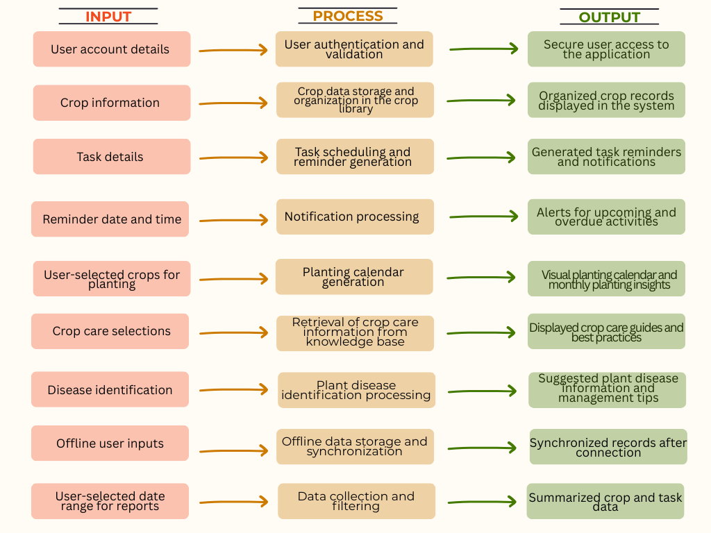

Figure 1. Conceptual Framework of the Study

METHODOLOGY
The researchers adopted the Spiral Model guided by Agile principles, emphasizing iterative development, adaptability, and continuous user feedback. Through iterative cycles of planning, designing, coding, and testing, the approach helped improve software quality, reduce development risks, and ensure that the application met user needs effectively.

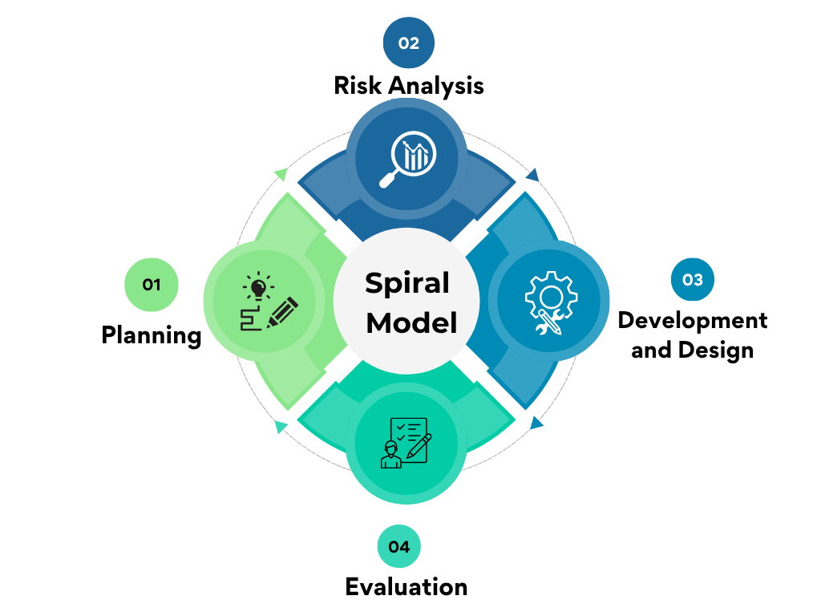

Figure 2. System Development Life Cycle Spiral Model

System Design
The Smart Monitoring App for Crop Management was designed as a mobile-based platform that integrates crop monitoring, record management, task scheduling, disease identification, and agricultural learning resources into a single system. The application utilizes a mobile frontend, cloud-based storage, and AI-assisted support services to provide users with real-time access to crop information and management tools. The architecture also supports offline functionality through local data storage and synchronization, allowing users to continue using the application even in areas with limited internet connectivity. The design emphasizes usability, accessibility, and efficient management of agricultural activities among Agronomy students.

Testing Method
In the testing process, unit testing was applied to ensure that each component of the Smart Monitoring App for Crop Management functions correctly and is compatible with the Android platform. Individual modules were tested separately, including data input, crop monitoring, task management, and reminder features used by students and faculty. On the admin side, modules such as user account management and subscription processing were also tested to ensure accurate performance. This approach ensured that each unit works properly before integration, supporting the overall reliability and effectiveness of the system.

Population and Sample of the Study
Purposive sampling was employed to select the participants of the study. The respondents consisted of at least 30 Agronomy students from Mindanao State University – Sultan Naga Dimaporo (MSU-SND) who were directly involved in crop management-related coursework or training. Eligible participants were required to own a mobile phone and possess basic knowledge of crop and fertilizer management to ensure that they could properly evaluate the system. Students who did not meet these qualifications were excluded to maintain the relevance and accuracy of the data gathered. The use of purposive sampling is appropriate in quantitative research when the participants possess specific characteristics, knowledge, or experiences relevant to the objectives of the study. According to Creswell and Creswell (2018), purposive sampling enables researchers to intentionally select respondents who can provide the most relevant and reliable information needed for the investigation. Furthermore, a minimum of 30 participants is considered acceptable in quantitative studies, as it satisfies the commonly recommended sample size for basic statistical analysis and supports the generation of reliable results.

Instrument Use
The research instrument used to evaluate the Smart Monitoring App for Crop Management is a modified version of the QUIS (Questionnaire for User Interaction Satisfaction). This instrument was used to assess the system’s functionality, usability, interface design, and user satisfaction. A checklist questionnaire based on a 5-point Likert scale was utilized to gather user feedback. Prior to data collection, participants were given a brief orientation to ensure proper understanding of the questionnaire. All responses were then tabulated and analyzed using Microsoft Excel to determine the system’s performance and identify areas for improvement.

Ethical Considerations
The researchers adhered to ethical standards throughout the conduct of the study. Participation in the evaluation of the Smart Monitoring App for Crop Management was voluntary, and respondents were informed about the objectives and procedures of the study before data collection. Informed consent was obtained from all participants. The confidentiality and anonymity of the respondents were maintained by ensuring that no personally identifiable information was disclosed. All data collected were used solely for academic and research purposes. Participants were also given the freedom to withdraw from the study at any stage without any penalty. These measures ensured the protection of the respondents' rights, privacy, and welfare throughout the research process.

RESULTS AND DISCUSSION

System Overview
The Smart Monitoring App for Crop Management was developed to provide Agronomy students with a digital platform for organizing and managing agricultural activities. The application integrates crop monitoring, digital recordkeeping, task scheduling, crop care guidance, disease identification, and agricultural insights within a single mobile environment. Through these features, users can efficiently manage crop information, monitor activities, receive reminders, and access relevant agricultural knowledge to support crop production and learning activities.

User Evaluation Results
Table 1 presents the acceptability evaluation results of the Smart Monitoring App for Crop Management based on responses from Agronomy students.

Table 1. Acceptability Evaluation of the Smart Monitoring App for Crop Management
EVALUATION CRITERIA | WM | INTERPRETATION
Interface | 4.70 | Highly Acceptable
Design | 4.52 | Highly Acceptable
Performance | 4.65 | Highly Acceptable
Satisfaction | 4.73 | Highly Acceptable
Overall Mean | 4.63 | Highly Acceptable

The evaluation results revealed that the Smart Monitoring App for Crop Management obtained an overall weighted mean of 4.63, interpreted as Highly Acceptable. Among the evaluated criteria, Satisfaction obtained the highest weighted mean of 4.73, followed by Interface (4.70) and Performance (4.65). Design received the lowest weighted mean of 4.52, although it remained within the Highly Acceptable category.

Interface
The Interface criterion obtained a weighted mean of 4.70, indicating that respondents found the application easy to navigate and use. The result suggests that the organization of menus, layout structure, and accessibility of features contributed positively to the overall user experience. This finding supports the study of João Mendes et al. (2020), which emphasized that user-friendly interfaces significantly influence the effectiveness and adoption of mobile agricultural applications.

Design
The Design criterion received a weighted mean of 4.52. Although this was the lowest among the evaluated dimensions, it still indicates a high level of user acceptance. The result suggests that respondents generally appreciated the application's visual appearance and organization while identifying opportunities for future improvements in aesthetics and interface consistency.

Performance
Performance obtained a weighted mean of 4.65, demonstrating that the application effectively supported crop monitoring, task scheduling, and record management activities. The result indicates that users perceived the application as responsive, reliable, and capable of supporting their agricultural activities with minimal operational issues.

Satisfaction
Satisfaction achieved the highest weighted mean of 4.73, indicating strong acceptance among respondents. The result suggests that the application successfully addressed the needs of Agronomy students in managing crop-related tasks. Similar findings were reported by Isaac N. Oteyo et al. (2021), who observed that agricultural mobile applications are more likely to be adopted when they directly support users' daily farming activities.

Overall Acceptability
The consistently high ratings across all evaluation criteria indicate that the Smart Monitoring App for Crop Management effectively supports crop monitoring, task scheduling, digital recordkeeping, and agricultural learning activities. The findings demonstrate the potential of mobile-based agricultural technologies to improve efficiency, organization, and decision-making among Agronomy students.

Comparative Analysis
Previous studies have demonstrated the effectiveness of mobile technologies in agriculture. However, many existing systems focus only on specific functions such as precision agriculture, information dissemination, fertilizer management, or recordkeeping. In contrast, the Smart Monitoring App for Crop Management integrates crop monitoring, reminder notifications, disease identification, digital recordkeeping, and agricultural learning resources within a single platform.

The integration of these features addresses limitations identified in previous studies and provides a more comprehensive solution for Agronomy students. Furthermore, the application's support for both online and offline functionality increases accessibility and usability in areas with limited internet connectivity. These characteristics distinguish the present study from existing agricultural mobile applications and demonstrate its potential as an educational and agricultural management tool.

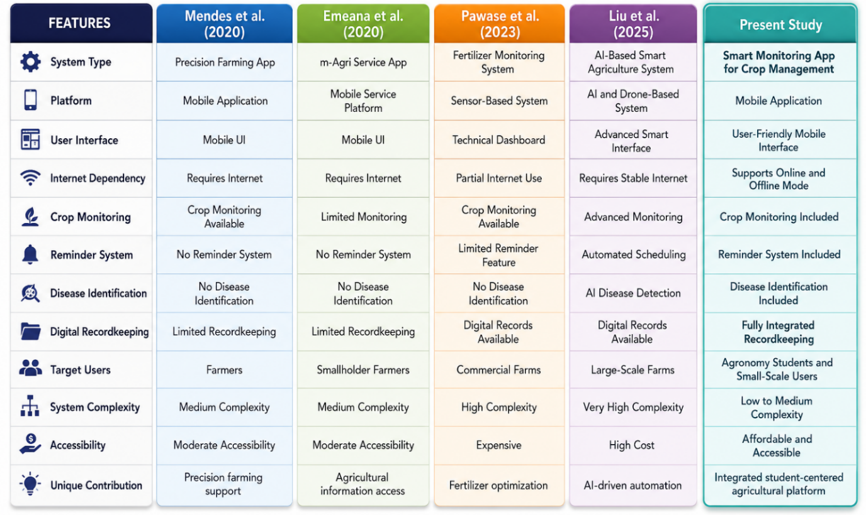

Figure 11. Comparative Analysis

CONCLUSIONS AND RECOMMENDATIONS
The Smart Monitoring App for Crop Management successfully achieved its objective of providing Agronomy students with a mobile-based platform for crop monitoring and management. The evaluation results revealed a high level of user acceptance, obtaining an overall weighted mean of 4.63, which indicates that the application is highly acceptable in terms of interface, design, performance, and user satisfaction. The findings demonstrate that integrating crop monitoring, digital recordkeeping, task scheduling, disease identification, and agricultural knowledge resources into a single platform can improve efficiency, organization, and accessibility in agricultural activities.
Furthermore, the application serves as an effective educational tool that supports practical learning experiences and encourages the adoption of digital technologies in agriculture. The positive evaluation results suggest that mobile-based agricultural systems can contribute significantly to modernizing crop management practices among students and future agricultural practitioners.
It is also recommended to expand the database by adding more crop varieties and fertilizer options to improve the system’s flexibility and applicability in different agricultural settings. Enhancing the application’s offline functionality is likewise essential to ensure accessibility and usability in areas with limited or unstable internet connectivity.
Furthermore, future enhancements may include a more advanced automated reminder system. Once users enter the planting date of a crop, the application can automatically generate notifications and reminders for important crop management activities such as fertilizer application schedules, irrigation, pest control measures, and expected harvest dates. This feature can help ensure that critical farming tasks are performed on time and improve overall crop management efficiency.
Future versions of the application may also integrate weather forecasting capabilities to provide users with real-time weather updates and forecasts, enabling them to make informed decisions regarding planting, fertilization, irrigation, and harvesting activities. In addition, disease and pest identification through image capture may be incorporated, allowing users to upload or capture images of affected crops. The system can then assist in identifying possible diseases or pests and provide appropriate recommendations for management and treatment.
In addition, future researchers are encouraged to examine the long-term effects of digital agricultural tools on students’ productivity, efficiency, and crop management performance. Conducting training programs and workshops for both students and instructors is also highly recommended to maximize the effective utilization of the application. Collaboration with agricultural institutions and organizations may further contribute to the continuous improvement, validation, and wider adoption of the system.
Overall, the Smart Monitoring App for Crop Management has strong potential to support the advancement of smart farming practices and contribute to the modernization of agricultural education and crop management.

REFERENCES

Adofo, E., & Mukawloon, S. (2021). Disparities in agricultural industrial technology use between Asia, Africa, and Europe. Journal of Systems and Software, 2, 7–13. https://doi.org/10.48173/JSS.V2I1.77

Al-Saqqa, S., Sawalha, S., & AbdelNabi, H. (2020). Agile software development: Methodologies and trends. International Journal of Interactive Mobile Technologies (iJIM), 14(11), 246–256. https://doi.org/10.3991/ijim.v14i11.13269

Aung, T. H., Naing, Z. M., & Hlaing, K. M. M. (2024). Cross-platform mobile application development using Flutter framework. Information, 15(8), 464. https://doi.org/10.3390/info15080464

Barbosa, J. Z., Prior, S. A., Pedreira, G. Q., Motta, A. C. V., Poggere, G. C., & Goularte, G. D. (2020). Global trends in apps for agriculture. Multi-Science Journal, 3(1), 16–20. https://doi.org/10.33837/msj.v3i1.1095

Basir, M. S., Buckmaster, D., Raturi, A., & Zhang, Y. (2024). From pen and paper to digital precision: A comprehensive review of on-farm recordkeeping. Precision Agriculture, 25(7), 2643–2682. https://doi.org/10.1007/s11119-024-10172-7

Boehm, B. W. (1988). A spiral model of software development and enhancement. Computer, 21(5), 61–72. https://doi.org/10.1109/2.59

Campbell, S., Greenwood, M., Prior, S., Shearer, T., Walkem, K., Young, S., Bywaters, D., & Walker, K. (2020). Purposive sampling: Complex or simple? Research case examples. Journal of Research in Nursing, 25(8), 652–661. https://doi.org/10.1177/1744987120927206

Chin, J. P., Diehl, V. A., & Norman, K. L. (1988). Development of an instrument measuring user satisfaction of the human-computer interface. Proceedings of the SIGCHI Conference on Human Factors in Computing Systems, 213–218. https://doi.org/10.1145/57167.57203

Creswell, J. W., & Creswell, J. D. (2018). Research design: Qualitative, quantitative, and mixed methods approaches (5th ed.). SAGE Publications.

Emeana, E. M., Trenchard, L., & Dehnen-Schmutz, K. (2020). The revolution of mobile phone-enabled services for agricultural development (m-Agri services) in Africa: The challenges for sustainability. Sustainability, 12, 485. https://doi.org/10.3390/su12020485

Erdisna, E., Restu Ningsih, S., Suryana, F., Hidayat, R., & Marse Putra, D. (2024). Development of mobile learning applications as learning media using Android Studio. Jurnal Teknologi Informasi dan Pendidikan, 17(2), 412–426. https://doi.org/10.24036/jtip.v17i2.923

Fraenkel, J. R., Wallen, N. E., & Hyun, H. H. (2019). How to design and evaluate research in education (10th ed.). McGraw-Hill Education.

Glover, D., Sumberg, J., Ton, G., Andersson, J., & Badstue, L. (2019). Rethinking technological change in smallholder agriculture. Outlook on Agriculture, 48(3), 169–180. https://doi.org/10.1177/0030727019864978

Hajesmaeel-Gohari, S., & Bahaadinbeigy, K. (2021). The most used questionnaires for evaluating telemedicine services. BMC Medical Informatics and Decision Making, 21, 36. https://doi.org/10.1186/s12911-021-01407-y

Kalfas, D., Kalogiannidis, S., Papaevangelou, O., Melfou, K., & Chatzitheodoridis, F. (2024). Integration of technology in agricultural practices towards agricultural sustainability: A case study of Greece. Sustainability, 16(7), 2664. https://doi.org/10.3390/su16072664

Khan, N., Ray, R. L., Sargani, G. R., Ihtisham, M., Khayyam, M., & Ismail, S. (2021). Current progress and future prospects of agriculture technology: Gateway to sustainable agriculture. Sustainability, 13(9), 4883. https://doi.org/10.3390/su13094883

Lakens, D. (2022). Sample size justification. Collabra: Psychology, 8(1). https://doi.org/10.1525/collabra.33267
Laveglia, S., Altieri, G., Genovese, F., Matera, A., & Di Renzo, G. C. (2024). Advances in sustainable crop management: Integrating precision agriculture and proximal sensing. AgriEngineering, 6(3), 3084–3120. https://doi.org/10.3390/agriengineering6030177

Meena, R. L., Jirli, B., Kanwat, M., & Meena, N. K. (2018). Mobile applications for agriculture and allied sector. International Journal of Current Microbiology and Applied Sciences, 7(2), 2317–2326. https://doi.org/10.20546/ijcmas.2018.702.281

Mendes, J., Pinho, T. M., dos Santos, F. N., Sousa, J. J., Peres, E., Boaventura-Cunha, J., Cunha, M., & Morais, R. (2020). Smartphone applications targeting precision agriculture practices—A systematic review. Agronomy, 10(6), 855. https://doi.org/10.3390/agronomy10060855

Niedbała, G., & Kujawa, S. (2023). Digital innovations in agriculture. Agriculture, 13(9), 1686. https://doi.org/10.3390/agriculture13091686

Ogunti, E. O., Akingbade, F. K., Segun, A., & Oladimeji, O. (2018). Decision support system using mobile applications in the provision of day-to-day information about farm status to improve crop yield. Periodicals of Engineering and Natural Sciences, 6(2), 89–99. https://doi.org/10.21533/pen.v6i2.183

Okoroji, V., Lees, N. J., & Lucock, X. (2021). Factors affecting the adoption of mobile applications by farmers: An empirical investigation. African Journal of Agricultural Research, 17(1), 19–29. https://doi.org/10.5897/AJAR2020.14909

Oteyo, I. N., Marra, M., Kimani, S., De Meuter, W., & Gonzalez Boix, E. (2021). A survey on mobile applications for smart agriculture: Making use of mobile software in modern farming. SN Computer Science, 2, 293. https://doi.org/10.1007/s42979-021-00700-x

Pawase, P. P., Nalawade, S. M., Bhanage, G. B., Walunj, A. A., Kadam, P. B., Durgude, A. G., & Patil, M. R. (2023). Variable rate fertilizer application technology for nutrient management: A review. International Journal of Agricultural and Biological Engineering, 16(4), 11–19. https://doi.org/10.25165/j.ijabe.20231604.7671

Shamshiri, R. R., Sturm, B., Weltzien, C., Fulton, J., Khosla, R., Schirrmann, M., Raut, S., Basavegowda, D. H., Yamin, M., & Hameed, I. A. (2024). Digitalization of agriculture for sustainable crop production: A use-case review. Frontiers in Environmental Science, 12, 1375193. https://doi.org/10.3389/fenvs.2024.1375193

Tiwari, S. P. (2023). Towards Industry 4.0: Increasing efficiency and effectiveness through technology integration in agriculture. Management and Entrepreneurship: Trends of Development, 2(24), 17–25. https://doi.org/10.26661/2522-1566/2023-2/24-02

Xue, H. (2019). User satisfaction in augmented reality-based training using Microsoft HoloLens. Computers, 8(1), 9. https://doi.org/10.3390/computers8010009

