Satellite Observation of Aerosol Optical Depth Anomalies Associated with Major Earthquakes in the Indian Region
Anil K Das¹, Vikram Singh¹, Reena Garg², Vishal Chauahan³
- Department of Physics, St. John’s College, Agra-282002, India
- Department of Computer Science, St. John’s College, Agra-282002, India
- Department of Physics, Graphic Era Hill university, Dehradun-248002, India
Abstract
Many studies on precursor signals of seismic activity are currently being conducted. Among these, electromagnetic signals, thermal variations, ionospheric disturbances, and chlorophyll changes near seashores have received considerable attention. Recently, researchers have also started focusing on lower atmospheric parameters, such as aerosols. Aerosols are found up to an altitude of about 50 km above the Earth's surface. It has been observed that the density and vertical distribution of aerosols change before and during earthquakes. These observations are now being extensively studied to explore the possibility of earthquake prediction and to better understand the Earth–atmospheric coupling mechanism.
In this study, we analyzed Aerosol Optical Depth (AOD) data obtained from the MODIS satellite to examine the effects of two earthquakes with magnitudes greater than 7.0 in the Indian region. The results indicate that AOD anomalies were observed both before and during these earthquakes.
Introduction
Earthquakes are among the most devastating natural geophysical phenomena. Various techniques have been developed and used by scientists to study and predict earthquakes. Several researchers have reported the effects of earthquakes on different geophysical parameters such as Very Low Frequency (VLF) transmitter signals, Ultra Low Frequency (ULF) magnetic fields, and ionospheric parameters. The effects of earthquakes on the atmosphere and ionosphere have been explained on the basis of mechanisms such as electromagnetic emissions, gravity wave generation, and gas emanation during crustal movements.
Changes in lower atmospheric parameters, particularly aerosols, during earthquakes have been reported by many researchers. Ping Lu et al. (2025) reported aerosol anomalies associated with multiple shallow earthquakes using MODIS Aerosol Optical Depth (AOD) products. Their study showed that aerosol anomalies were observed up to four days before and after the occurrence of earthquakes. Mehdi et al. (2016) analyzed the time series of AOD derived from the MODIS sensor onboard the TERRA satellite for 16 major earthquakes and found seismic-related anomalies both before and after the events. They suggested that before large earthquakes, the rate of AOD increases due to pre-seismic processes that release gaseous molecules into the atmosphere, thereby enhancing aerosol concentration.
Satellite observations have indicated that such AOD anomalies may appear several days before strong earthquakes. For example, Guo and Wang (2008) reported abnormal variations in satellite-derived aerosol parameters prior to major seismic events. Similarly, Qiang et al. (2011) found that significant aerosol anomalies were detected over epicentral regions before several strong earthquakes using satellite observations. These anomalies are often observed within a limited spatial region around the epicenter, typically within about 1°–3° latitude and longitude, and may occur approximately one to several days before the earthquake.
Ganguly (2016) reported that Aerosol Optical Depth (AOD) and columnar ozone increased by about 40% and 6%, respectively, prior to the massive earthquake that struck Nepal on 25 April 2015 with a moment magnitude of 7.9 Mw. Qinqin Liu et al. (2019) also reported abnormal fluctuations in AOD before and after the 2008 Wenchuan and 2013 Lushan earthquakes. Similarly, Okada et al. (2004) analyzed aerosol parameters using SeaWiFS satellite data and reported higher AOD values following the Mw 7.7 Gujarat earthquake of 26 January 2001.
Data analysis
In this study, we used data from the MODIS sensor to analyze Aerosol Optical Depth (AOD) corresponding to two earthquakes (NASA, 2023) These earthquakes have magnitudes greater than 7. The earthquake data used in this study were obtained from the United States Geological Survey (USGS) earthquake catalogue, and the details are presented in Table 1. The locations of the earthquakes are shown on the map in Figure 1
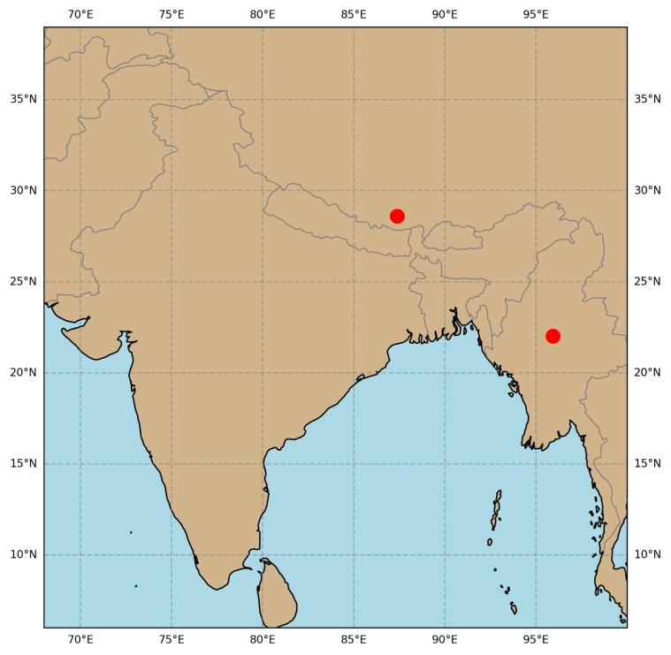
Figure.1
For the analysis, we selected an area of 4° × 4° around the earthquake epicenter. AOD represents the amount of sunlight that is scattered or absorbed by aerosol particles in the atmosphere. The MODIS sensor measures the top-of-atmosphere (TOA) reflected radiance in several spectral bands in the visible and near-infrared regions(Salomonson et al.,1989).From these measurements, AOD values are retrieved using standard atmospheric algorithms.( Remer et al.,2005),
In the present study, we used AOD at a wavelength of 0.55 µm (550 nm). We analyzed the AOD data for a period of 7days before and 7 days after the occurrence of each earthquake. Additionally, the mean AOD and its standard deviation were calculated for this time period of one month to examine possible variations associated with the seismic events.
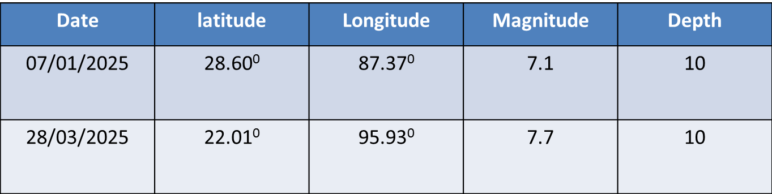
Table.1
Results and discussions
In Figure 2, the distribution of Aerosol Optical Depth (AOD) obtained from MODIS (Moderate Resolution Imaging Spectroradiometer) data is shown for the period from 30 December,2024 to 14 January 2005 over the grid region surrounding the epicenter of the earthquake that occurred on 7 January 2005. The figure clearly indicates an enhancement in AOD values prior to and during the occurrence of the earthquake.
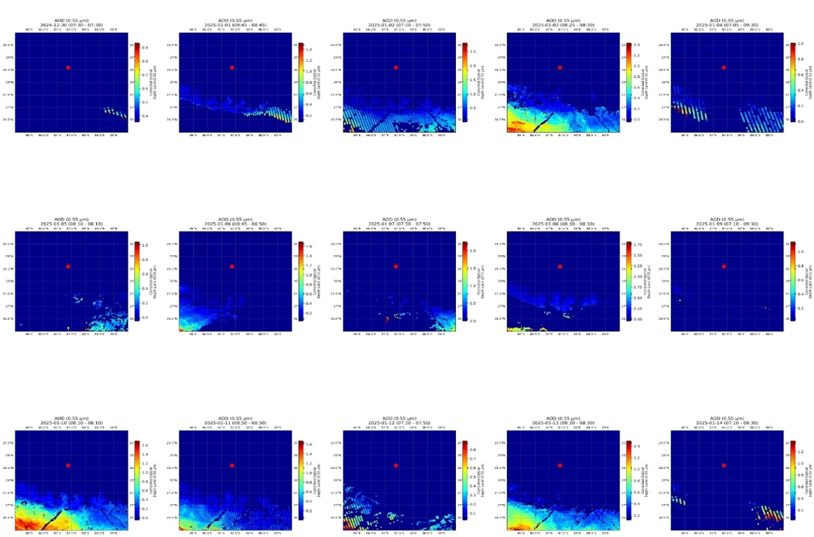
Figure 2
To confirm the anomalous behaviour of AOD, a statistical analysis was also carried out. In Figure 3, the daily mean AOD values along with the monthly mean (m) and standard deviation(σ) are plotted for a period extending from 7 days before to 7 days after the earthquake. The analysis shows that on the day of the earthquake the AOD value increases significantly and exceeds the mean plus standard deviation level. Such an increase can be considered anomalous and may be associated with processes related to earthquake activity.
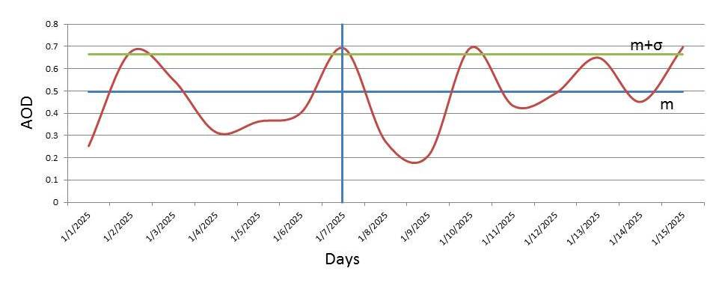
Figure.3
A similar analysis was performed for another earthquake that occurred on 28 March 2025. In Figure 4, the spatial distribution of AOD is presented for the period from 21 March 2025 to 5 April 2025. This figure also shows an enhancement in AOD values before and during the earthquake event.
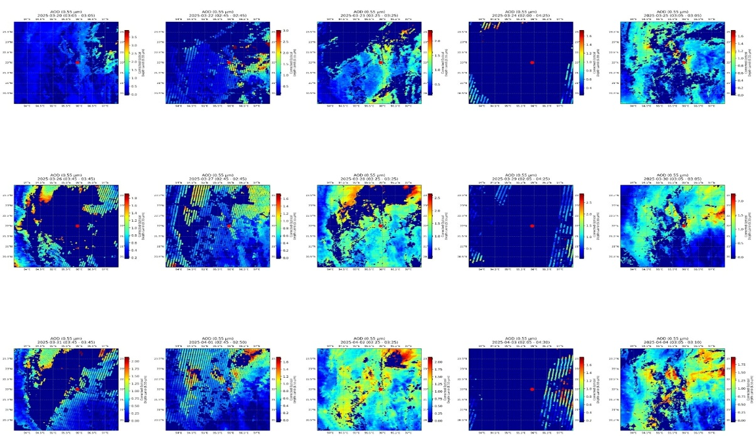
Figure.4
In Figure 5, the daily mean AOD, monthly mean(m), and standard deviation(σ) are plotted for the same period. The results indicate that a clear anomaly in AOD appears around 29 March 2025, where the AOD values exceed the normal background variation.
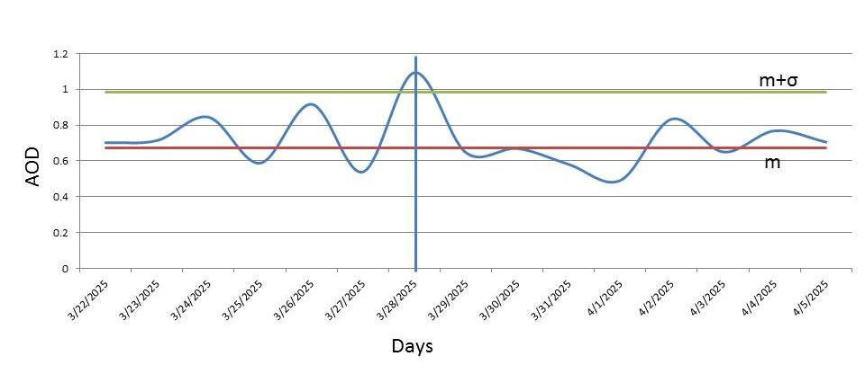
Figure.5
The results presented here suggest that noticeable variations in AOD may occur before and during strong earthquakes. Similar anomalous behaviour in atmospheric parameters has been reported by several researchers and is often interpreted within the framework of lithosphere–atmosphere coupling processes associated with earthquake preparation. These observations indicate that satellite-derived AOD anomalies may provide useful information for understanding atmospheric responses to seismic activity and could contribute to ongoing studies related to earthquake precursor detection.
Earthquake-related anomalies in Aerosol Optical Depth (AOD) observed from satellite data have been reported in several studies and are often interpreted within the framework of the Lithosphere–Atmosphere–Ionosphere Coupling (LAIC) mechanism. According to this concept, physical and chemical processes occurring in the Earth’s crust during the earthquake preparation phase may induce measurable disturbances in the atmosphere (Pulinets and Ouzounov, 2011).
Before the occurrence of a large earthquake, tectonic stress gradually accumulates in the crust. This stress can cause micro-fracturing of rocks and activation of faults, which may lead to the release of gases such as radon, carbon dioxide, methane, and other trace gases from the lithosphere into the lower atmosphere (Pulinets and Ouzounov, 2011). Radon decay in the atmosphere produces ionization, increasing the concentration of charged particles in the air. The enhanced ionization can stimulate aerosol nucleation and condensation processes, leading to the formation of additional aerosol particles. As a result, the concentration of aerosols in the atmosphere may increase, which can be detected by satellite sensors as an increase in AOD values (Qiang et al., 2011).
Researchers identify AOD anomalies by analyzing temporal variations of AOD over the earthquake epicentral region. Daily AOD values are compared with the background or climatological mean to determine deviations from normal atmospheric conditions. Significant deviations occurring near the epicenter prior to an earthquake may indicate a possible atmospheric response associated with the earthquake preparation process (Guo and Wang, 2008; Qiang et al., 2011). However, since aerosol concentrations are also affected by meteorological factors such as dust transport, wind, humidity, and cloud formation, additional atmospheric parameters must be examined. Therefore, AOD anomalies alone cannot be considered definitive earthquake precursors and should be interpreted together with other geophysical and atmospheric indicators (Ouzounov et al., 2007; Pulinets and Ouzounov, 2011).
Overall, satellite-observed AOD anomalies provide important evidence for possible lithosphere–atmosphere interactions during the earthquake preparation phase. Although these observations contribute to understanding the coupling processes between the lithosphere and the atmosphere, further investigations using multiple parameters and long-term datasets are required to confirm their reliability as earthquake-related signals.
Conclusion
The present study demonstrates a clear influence of earthquakes on the variations of Aerosol Optical Depth (AOD) derived from satellite observations. The results indicate that noticeable anomalies in AOD may appear before and during earthquake events over the epicentral region. These variations may be associated with processes occurring during the earthquake preparation phase and can be interpreted within the framework of lithosphere–atmosphere coupling mechanisms.The study of earthquake-induced variations in AOD may therefore provide useful information for earthquake precursor investigations and can contribute to a better understanding of the interaction between lithospheric processes and atmospheric parameters. Such investigations can also help in improving our understanding of lower atmospheric variability that may arise due to lithospheric movements associated with seismic activity. Continued analysis using long-term satellite datasets and multi-parameter observations will further clarify the role of atmospheric anomalies in earthquake-related studies.

References
Akhoondzadeh, M., Jahani Chehrebargh, F., 2016. Feasibility of anomaly occurrence in aerosol time series obtained from MODIS satellite images during hazardous earthquakes. Advances in Space Research 58, 890–896.
Ganguly, N.D., 2016. Increase in aerosol optical depth and column ozone prior to the 25 April 2015 Nepal earthquake (Mw 7.9). Natural Hazards.
Guo, G., Wang, J., 2008. Possible atmospheric anomalies associated with strong earthquakes observed by satellite aerosol products. Advances in Space Research 42, 1377–1383.
Liu, Q., Zhang, M., Guo, J., Li, Z., 2019. Abnormal aerosol optical depth variations associated with the 2008 Wenchuan and 2013 Lushan earthquakes. Remote Sensing 11, 1940.
Lu, P., Gao, X., Xiong, Z., Shang, Y., 2025. Extraction and analysis of aerosol anomalies associated with multiple shallow earthquakes based on MODIS AOD products. International Journal of Applied Earth Observation and Geoinformation, 104671.
Okada, Y., Mukai, S., Nakata, M., 2004. Changes in aerosol optical properties after the 26 January 2001 Gujarat earthquake detected from SeaWiFS satellite observations. Advances in Space Research 33, 274–279.
Ouzounov, D., Liu, D., Kang, C., Cervone, G., Kafatos, M., Taylor, P., 2007. Outgoing long-wave radiation variability from IR satellite data prior to major earthquakes. Tectonophysics 431, 211–220.
Pulinets, S., Ouzounov, D., 2011. Lithosphere–Atmosphere–Ionosphere Coupling (LAIC) model—An unified concept for earthquake precursors validation. Journal of Asian Earth Sciences 41, 371–382.
Qiang, Z., Xu, X., Dian, C., 2011. Satellite detection of atmospheric aerosol anomalies associated with earthquakes. Natural Hazards and Earth System Sciences 11, 279–286.
Remer, L.A., Kaufman, Y.J., Tanré, D., Mattoo, S., Levy, R.C., Chu, D.A., Martins, J.V., Li, R.R., Ichoku, C., Levy, R.C., Holben, B.N., 2005. The MODIS aerosol algorithm, products, and validation. Journal of the Atmospheric Sciences 62, 947–973.
Salomonson, V.V., Barnes, W.L., Maymon, P.W., Montgomery, H.E., Ostrow, H., 1989. Moderate Resolution Imaging Spectroradiometer (MODIS): Advanced facility instrument for studies of the Earth as a system. IEEE Transactions on Geoscience and Remote Sensing 27, 145–153.
NASA, 2023. MODIS Atmosphere Level-2 Aerosol Product (MOD04_L2 / MYD04_L2). NASA Goddard Space Flight Center, Greenbelt, Maryland, USA.

