ANTIFUNGAL, ANTIMICROBIAL AND LARVICIDAL ACTIVITIES OF ZINC OXIDE NANOPARTICLES SYNTHESIZED FROM THE LEAF EXTRACT OF BALANITES AEGYPTIACA

Abstract
This study investigates the Antifungal, Antimicrobial and Larvicidal Activities Zinc oxide nanoparticles (ZnO-NPs) produced from the leaf extract of Balanites aegyptiaca. The nanoparticles were characterized using UV-Visible spectrophotometry, FTIR, XRD, and SEM techniques. Their antimicrobial activity was assessed against two Gram-positive bacteria (Staphylococcus aureus, Streptococcus pyogenes), two Gram-negative bacteria (Salmonella typhi, Klebsiella pneumoniae), and two fungi (Candida albicans, Aspergillus niger). The ZnO-NPs demonstrated strong inhibitory effects on Klebsiella pneumoniae, Streptococcus pyogenes and Salmonella typhi. Larvicidal activity against Anopheles mosquito larvae at concentrations of 40, 50, and 60 mg/L showed 100% mortality in first instar larvae, with LC₅₀ values ranging from 36.24 to 38.07 mg/L across instars. These results highlight the strong dose-dependent larvicidal and antimicrobial properties of ZnO-NPs derived from Balanites aegyptiaca leaf extract demonstrating their potential as eco-friendly nanobiopesticides and plant-based therapeutics for controlling disease vectors and pathogens.

Keywords: Anopheles Larvae, Antimicrobial, Balanites aegyptiaca (Leaf), Green Synthesis, Larvicidal Activity, Nanoparticles,

INTRODUCTION
Nanoparticles are materials with at least one dimension smaller than 100 nanometers, possessing distinctive characteristics such as a high surface area-to-volume ratio, specific crystalline structures, adjustable pore sizes, and the capacity to affect cellular and molecular processes in living systems [1]. Generally ranging from 1 to 100 nanometers, these particles are engineered or modified at the atomic scale. Their nanoscale size imparts physical and chemical properties that are markedly different from those of bulk materials, with the increased surface area further enhancing their reactivity and functionality [2].
Nanoparticles (NPs) encompass the characterization, design, and fabrication of biological and non-biological structures measuring less than 100 nanometers, distinguished by their unique and novel functional properties [3]. Interest in NPs has grown rapidly, driven by their superior electrochemical reactivity, thermal conductivity, and nonlinear optical behavior, which open avenues for diverse applications [4]. In particular, metal nanoparticles have attracted substantial attention owing to their exceptional features, including high surface area, stability, ease of chemical modification, suitability as fillers to enhance permeability, and flexible synthesis methods. Nanoparticles can be synthesized in sizes ranging from the micrometer to the nanometer scale through either top-down (destructive) or bottom-up (constructive) methods. Zinc oxide (ZnO) is recognized as a biologically safe material with notable photo-oxidizing and photocatalytic effects on chemical and biological systems [2]. In its nano-sized form, ZnO can adopt various morphologies and has been widely reported to exhibit strong antibacterial activity against diverse bacterial species [5]. Both micro- and nano-scale ZnO are being investigated for antibacterial applications; however, reducing ZnO to the nanometer scale significantly enhances its antimicrobial potential. This is due to the nanoparticles’ increased surface interaction with bacterial membranes and their ability to potentially penetrate bacterial cells. Such interactions trigger distinctive bactericidal mechanisms, with the primary mode of action involving toxic interactions that compromise bacterial cell integrity. These properties make nano-sized ZnO particularly valuable for antimicrobial applications, including use in the food industry [6]. Zinc oxide nanoparticles (ZnO-NPs) possess strong antibacterial properties, largely attributed to their high specific surface area resulting from reduced particle size, which enhances surface reactivity [2]. They have garnered considerable global research interest for their broad-spectrum biological activity, relative non-toxicity to human cells, biodegradability, and potential to improve the bioactivity of pharmacophores. Compared to bulk ZnO, ZnO-NPs display superior antibacterial efficiency due to quantum confinement and other size-dependent effects. Their ability to inhibit bacterial growth through multiple pathways makes them highly effective against bacterial contamination-related diseases—an increasingly critical advantage as conventional antibiotics face diminishing efficacy due to rising bacterial resistance [7]. The biosynthesis of zinc oxide nanoparticles (ZnO-NPs) using extracts from medicinal plants, fungi, bacteria, and algae enhances their stability and biocompatibility in diverse biological environments. This green synthesis approach also modifies their physicochemical properties, thereby improving their biological performance. Additionally, ZnO-NPs serve as efficient nanocarriers for conventional drugs due to their affordability, biodegradability, and compatibility with living systems [8]. Their versatility has led to applications in areas such as drug delivery, biosensing, gene therapy, nanomedicine, bioimaging, coatings for medical implants, electronic sensors, wastewater treatment, and communication technologies [9].
Balanites aegyptiaca (L.) Del., commonly referred to as the “desert date,” is an evergreen, woody, spiny flowering tree that can reach heights of up to 10 meters. Belonging to the Balanitaceae family, it is widely distributed across arid regions of Africa and southern Asia. The plant is a rich source of bioactive compounds, including saponins, flavonoids, alkaloids, lipids, proteins, carbohydrates, and organic acids. Traditionally, various parts of B. aegyptiaca have been used in herbal medicine to treat numerous ailments [10]. It is recognized for its diverse pharmacological properties, including antidiabetic, anthelmintic, antibacterial, and antiviral activities. Additionally, the bark, unripe fruits, and leaves have been reported to possess anthelmintic, antifertility, purgative, and antidysentery effects [11].
Balanites aegyptiaca is a widely cultivated desert plant valued for its diverse applications, particularly in arid and semi-arid regions of Africa, the Middle East, and South Asia [12]. Traditionally, various parts of the plant have been used in the treatment of ailments such as skin boils, leukoderma, malaria, wounds, colds, syphilis, and disorders of the liver and spleen. The fruit, known as the desert date, is the most prominent part of the tree. This drupe is initially pubescent when unripe, turning yellowish and smooth upon ripening, and consists of four distinct layers: the outer skin (epicarp), fleshy pulp (mesocarp), woody shell (endocarp), and the inner seed (kernel). All four layers have potential applications in both industrial and pharmaceutical fields. The edible components—particularly the pulp and kernel—are sources of oil, while the pulp is nutritionally rich in carbohydrates (62.63%) and protein (9.19%), with lower levels of fat (2.58%) and dietary fiber (2.93%) [13]. The fruits are commonly used by local communities to treat various health conditions [14]. Specifically, the fruit is employed in the treatment of jaundice, and oil extracted from the seeds serves as a laxative and is traditionally used to manage hemorrhoids, stomach ailments, jaundice, yellow fever, syphilis, and epilepsy [11].
MATERIALS AND METHODS
Collection of Plant Materials
Leaves of Balanites aegyptiaca were collected from the field within the premises of the University of Maiduguri, Borno State, Nigeria, and taken to the Department of Plant Science for proper identification and authentication. Sampling was conducted during the dry season, after which the leaves were sorted and stored in clean polythene bags for subsequent analysis.

Anopheles mosquito larvae were obtained from various identified breeding sites within Gombe metropolis using a ladle and collection bottles. For sampling, the ladle was positioned at an angle of about 45° and gently lowered into the water until one side was just beneath the surface, minimizing disturbance to prevent the larvae from diving. The collected larvae were then transferred to the laboratory, where they were maintained and reared for larvicidal bioassay experiments. Collection procedures followed the method described by Abba et al. [9].

Sample Preparation

Leaves of Balanites aegyptiaca were collected, thoroughly rinsed with distilled water, and air-dried in the shade to minimize phytochemical degradation. The dried leaves were then ground into a fine powder using a mechanical blender.

Preparation of Balanites aegyptiaca Leaf Extract
The aqueous extraction of Balanites aegyptiaca leaves followed the method described by Al-Senani (2020) [15], with slight modifications. Ten grams (10 g) of powdered sample were mixed with 200 mL of distilled water in a 250 mL conical flask and heated in a water bath at 60 °C for 3 hours with continuous stirring. The mixture was then allowed to cool to room temperature and filtered through Whatman No. 1 filter paper. The freshly prepared aqueous extract was subsequently used for the synthesis of zinc oxide nanoparticles.
Synthesis of Zinc Oxide Nanoparticles.
Twenty millilitres (20 mL) of Balanites aegyptiaca leaf extract were combined with 100 mL of 0.1 M ZnCl₂ solution and 5 mL of 0.5 M NaOH. The mixture was stirred on a magnetic stirrer hot plate at 50 °C for 45 minutes, during which a distinct colour change signified the formation of zinc oxide nanoparticles. The resulting nanoparticles were collected by filtration, dried, and stored for subsequent use [15].
Characterization of Zinc Oxide Nanoparticles and Leaf Extract
The optical properties of the synthesized zinc oxide nanoparticles and the Balanites aegyptiaca leaf extract were examined using UV–Visible spectrophotometry over a wavelength range of 200–800 nm. Fourier Transform Infrared Spectroscopy (FTIR) was employed to identify functional groups present in the samples, while X-ray Diffraction (XRD) was used to determine the crystalline structure of the nanoparticles. Scanning Electron Microscopy (SEM) was further utilized to investigate their morphology and particle size.
Antimicrobial Activity
The antimicrobial activity of the synthesized zinc oxide nanoparticles was assessed against selected bacterial and fungal pathogens using the agar well diffusion method. This standard laboratory technique evaluates the capacity of a substance to inhibit microbial growth and is frequently applied in testing the antimicrobial potential of plant- and microbe-derived products. In this assay, a bacterial suspension was uniformly spread over the surface of an agar plate, after which wells were created using a sterile borer. The nanoparticle solution was then introduced into each well, and the plates were incubated under appropriate conditions. Following incubation, clear zones of inhibition surrounding the wells were measured to determine antimicrobial activity. Larger inhibition zones observed with increasing nanoparticle concentrations indicated greater antimicrobial efficacy.
Larvicidal Activity
Larvicidal activity was evaluated following the method of Abba et al. [9], with minor modifications. A stock solution of zinc oxide nanoparticles (100 mg/L) was prepared by dissolving 0.1 g of the nanoparticles in distilled water using a 1000 mL volumetric flask. The bioassay involved introducing different larval instars (1st to 4th) into 200 mL plastic cups, with four replicates and a control for each instar, each containing twenty-five larvae. To each replicate, 100 mL of dechlorinated water was added, followed by the addition of zinc oxide nanoparticles at concentrations of 40 mg/L, 50 mg/L, and 60 mg/L. Larval mortality was recorded, and percentage mortality was calculated using the formula:
$$Percentage Mortality=\frac{Number of Dead Larvae}{Number of Introduced Larvae} X 100$$

RESULTS AND DISCUSSIONS
Electronic Spectra Results of Zinc Oxide Nanoparticles and Leaf Extract
The electronic spectra of Balanites aegyptiaca leaf extract and ZnO nanoparticles are shown in Figure 1A and 1B. ZnO nanoparticles displayed absorbance band at 237 nm and leaf extract shows absorbance band at 282 nm. The shift in the absorbance band to a higher wavelength suggests a reduction in size from bulk molecules to the nanoscale. This shift may result from material transitions, where an electron gains energy and moves from a lower to a higher energy level Perumal et al. [16]. This corresponds with the literature of Kiranmai et al. [17] and Vijay et al. [18] which showed the highest absorbance peaks at around 280nm and 300 and also suggested that, this variation depends on the reducing agent and the type of metal salt used as a precursor.
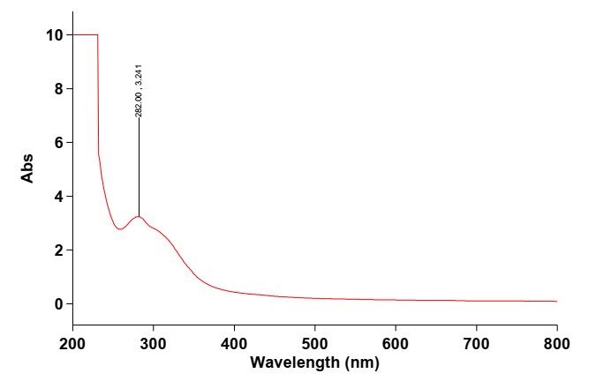
Figure 1A: Electronic Spectra of Balanites aegyptiaca Leaf Extract
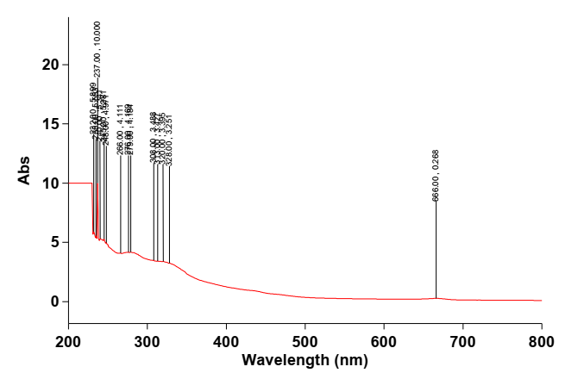
Figure 1B: Electronic Spectra of ZnO Nanoparticles Synthesized Using Leaf Extract
Fourier Transform Infrared (FTIR) Results of Leaf Extract and Zinc Oxide Nanoparticles

The FTIR spectrum of Balanites aegyptiaca leaf extract and ZnO nanoparticles are presented in Figures 2A and 2B. The absorption bands observed for leaf extract were 3291 cm⁻¹, 2120 cm⁻¹ and 1636 cm⁻¹ respectively. The band at 3291 cm⁻¹ indicates OH stretching while the band at 2120 cm⁻¹ is for C=C alkenes and the band at 1636 cm⁻¹ represents C=O stretching. While the ZnO nanoparticles shows the following bands 2996 cm⁻¹, 2914 cm⁻¹, 2094 cm⁻¹, 1435 cm⁻¹, 1312 cm⁻¹, 1043 cm⁻¹ and 667 cm⁻¹. These bands are absent in the spectra of the extract, signifying the formation of nanoparticles [19]. The band at 2996 cm⁻¹ and 2094 cm⁻¹ are due to C-H stretching of aromatic alkanes, 1435 cm⁻¹ stretching for C=C in ring aromatic alkenes, 1312 cm⁻¹ for C-H bend alkanes, 1043 cm⁻¹ stretching for C=N aliphatic amines and 667 cm⁻¹ are due to C-Br alkyl halides respectively.

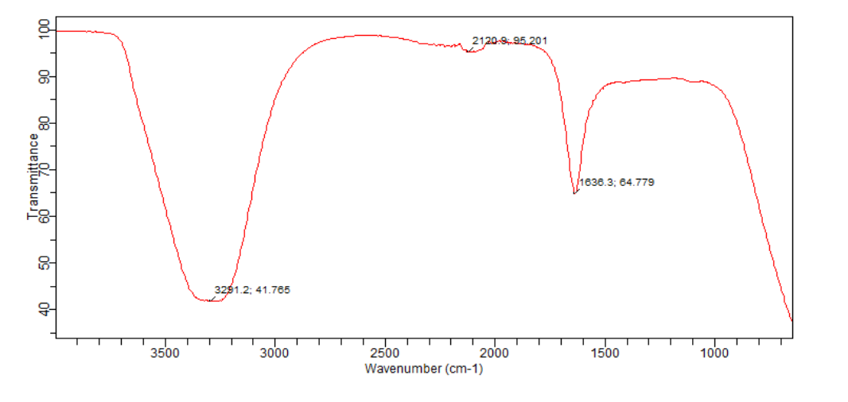
Figure 2A: FTIR spectra of Balanites aegyptiaca Leaf Extract

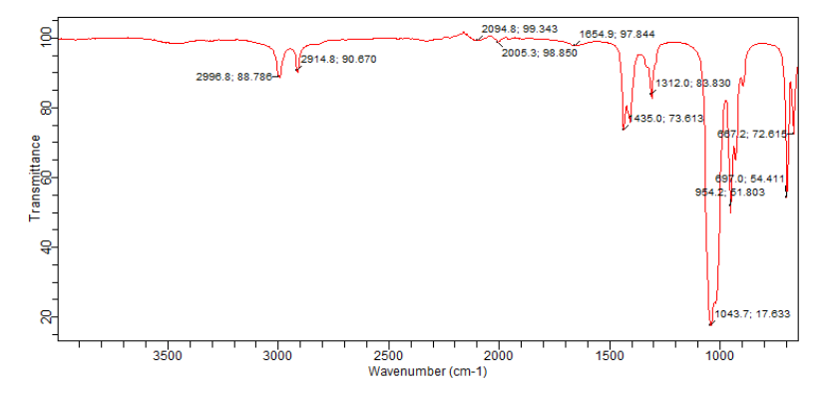
Figure 2B: FTIR Spectra of ZnO Nanoparticles Synthesized Using Leaf Extract
XRD Results of ZnO Nanoparticle Synthesized from The Leaf
The XRD result for the ZnO nanoparticle synthesized from the fruit is presented in Figure 3. It was found that five prominent peaks were observed at 2θ =12.32º, 26.61º, 37.93º ,46.32º and 64.11º with respect to the plane of (110), (101), (201) (210) and (320). It shows hexagonal crystalline structure with the average crystalline size of 38.78nm according to the Scherer equation calculated and it corresponds to the literature reported by Yangma and Jinhou (2020) [20].

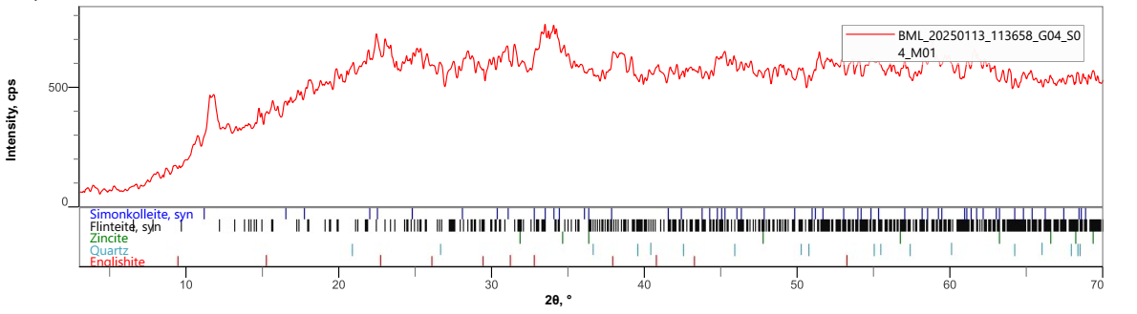
Figure 3: XRD Result of ZnO Nanoparticle Synthesized using Leaf Extract
SEM Analysis of Zinc Oxide Nanoparticle Synthesized from The Leaf

The SEM result for the ZnO nanoparticles synthesized from the leaf is presented in Figure 4. The morphology of the green synthesized zinc oxide nanoparticle shows that the particles have mono dispersed compacted morphology. The result obtained is in agreement with the result reported by Pindiga et al. (2022) [21] which shows mono dispersed morphology for the green synthesized copper nanoparticles.

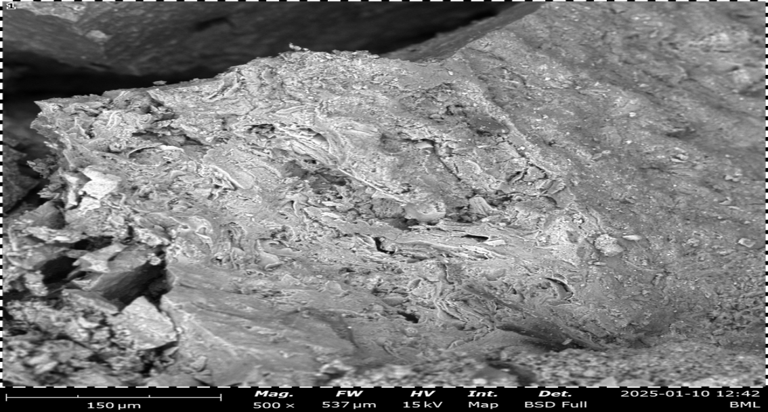

Figure 4: SEM Result of ZnO Nanoparticle Synthesized Using Leaf Extract

Antimicrobial Activity Results
The antimicrobial activity test result for zinc oxide nanoparticle synthesized from the leaf of Balanites aegyptiaca are presented in Table 1. The results have shown dose dependent effect across the micro-organisms studied. From the results, the Gram-positive bacteria (Streptococcus pyogene) have showed remarkable sensitivity with 18.00±0.00 mm zone of inhibition as compared to standard drug Augmentin (23.00 mm) at the highest concentration of (30 µg/ml). The Gram – negative bacteria (Klebsiella pneumoniae) have shown the highest sensitivity with 22.00 mm zone of inhibition which is even greater as compared to standard drug Augmentin (20.00) at the highest concentration of (30 µg/ml). The fungal strain (Candida albicans) has showed the least susceptibility effect with (12.00 mm) zone of inhibition compared to the standard drug (fulcin) with 20.00 mm zone of inhibition. The fungal strain (Aspergillus niger) has shown resistance across the zinc oxide nanoparticle treated. This corresponds to that obtained by Zacchaeus et al. [22] which shows an activity of 29, 18 and 12 mm at concentration 100, 150 and 250 mg/L respectively.

Table 1: Antimicrobial Susceptibility Test of ZnO-NP of Balanites aegyptiaca Leaf
 | Concentration (mg/ml)/ Mean Zone of Inhibition in diameter (mm)
S/N | Organism | 30 | 20 | 10 | Aug. (30µg/ml) | Ful. (50µg/ml)
1 | Staphylococcus aureus | 13.00 | 08.00 | 0.00 | 24.00 | -
2 | Streptococcus pyogenes | 18.00 | 12.00 | 7.00 | 23.00 | ⁻
3 | Klebsiella pneumoniae | 22.00 | 16.00 | 11.00 | 20.00 | -
4 | Salmonella typhi | 17.00 | 12.00 | 07.00 | 22.00 | ⁻
5 | Aspergillus niger | 0.00 | 0.00 | 0.00 | ⁻ | 21.00
6 | Candida albicans | 12.00 | 7.00 | 00.00 | ⁻ | 20.00
Key: Aug = Augmentin, Ful = Fulcin

Larvicidal Test Activity of ZnO Nanoparticle Synthesized from The Leaf
Table 2 shows the larvicidal activity of ZnO nanoparticle synthesized from the leaf of Balanites aegyptiaca on Anopheles’ larvae. The results indicated that the percentage mortality of the first instar larvae at 40, 50 and 60 mg/L concentrations of ZnO nanoparticle are 92, 96 and 100% respectively. The second instar showed 92, 80 and 96% mortality when tested with 40, 50 and 60 mg/L concentrations of the nanoparticle respectively. For the third instar larvae, the percentage mortality for the 40, 50 and 60 mg/L concentrations were 68, 80 and 92% respectively. While for the fourth instar, the mortality at 40, 50 and 60 mg/L concentrations were 60, 64 and 84% respectively. This agrees with the findings of Bello et al. [23] and Shehu et al. [24], where they reported a high toxicity of Cu Nanoparticles and ZnO – CuO nanoporous composite against the larvae of anopheles and malaria vector after exposure for 24 hours. Overall, the highest mortality was observed in the first instar (100%) at the concentration of 60 mg/L while the lowest was found in the fourth instar (60%) at 40 mg/L concentration. Murugan et al. [25] and Danbature et al. [26] reported that the first instar larvae are more susceptible to nanoparticles and the susceptibility decreases with the growing larval instars subjected to the same concentration of nanoparticles. In a similar work reported by Sharon et al. [27], the first instar larva of Aedes aegypti showed high susceptibility to copper nanoparticles than the 2nd, 3rd and 4th larval instars. This revealed that the more matured the larva, the less susceptible they are to nanoparticles. This is due to the fact that most juvenile larvae are more delicate and therefore easily intoxicated by nanoparticles [9]. The calculated LC₅₀ values were 36.24, 36.04, 37.38 and 38.07 mg/L for the first to fourth instars larvae respectively. The findings of Bello et al. [23] revealed that the larvicidal activity of bio – synthesized Copper nanoparticles of African spinach on Anopheles’ larvae (LC₅₀ = 47.20 mg/L), a higher LC₅₀ compared to the findings of the present work. On the other hand, Rawani et al. [28] reported the larvicidal activity of Ag Nanoparticles which showed LC₅₀ value of 1.59 ppm for berries dry leaf and fresh leaf against the larvae of Anopheles stephensi. These variations may be attributed to several factors such as the reducing agent (species of plant or parts) used in the synthesis, the type of metal and the mode of action [9]. The mortality rate recorded in this work showed that the activity of the ZnO nanoparticle synthesized from the leaf of Balanites aegyptiaca on the Anopheles Mosquito larvae is dose-dependent as reported by other works [29], [25], [30], [31], [26], [9] and [24].

Table 2: Larvicidal Activity of ZnO Nanoparticle Synthesized from The Leaf Against first to fourth Instars Larvae of Anopheles Mosquito
Conc. % Mortality LC₅₀
Anopheles S/N (mg/L) At 48 Hours (mg/L) R²

First 1 40 92
Instar 2 50 96 36.24 0.981
3 60 100

Second 1 40 92
Instar 2 50 80 36.04 0.929
3 60 96

Third 1 40 68
Instar 2 50 80 37.48 0.912
3 60 92

Fourth 1 40 60
Instar 2 50 64 38.07 0.837
3 60 84

Conflict of interest: The authors declare that there is no conflict of interest
Acknowledgement: The authors are grateful to the University of Maiduguri, Nigeria for providing the laboratory space and reagents for this research. Similarly, the authors wish to appreciate Gombe State University Gombe, Nigeria for providing their Mosquito Research Centre for use by the authors for the larvicidal test.

REFERENCES
- Alsamadany, H., and El-zohri, M. Bioscience Research Green Synthesis of Phytogenic Nanoparticles Using Plant Extracts and their Promising Roles in Sustainable Agriculture : Innovative Scientific Information & Science Network (2024), 21(4), 738–749.
- Sirelkhatim, A., Mahmud, S., and Seeni, A. Review on Zinc Oxide Nanoparticles : Antibacterial Activity and Toxicity Mechanism. Nano-Micro Letters, (2015), 7, 219–242. https://doi.org/10.1007/s40820-015-0040-x
- Khan, I., Saeed, K., and Khan, I. Nanoparticles : Properties, Applications and Toxicities. Arabian Journal of Chemistry. (2017). https://doi.org/10.1016/j.arabjc.2017.05.011
- Agarwal, H., Kumar, S. V., and Rajeshkumar, S. Resource-Efficient Technologies Review Article. A Review on Green Synthesis of Zinc Oxide Nanoparticles – An Eco-Friendly Approach. Resource-Efficient Technologies, 3(4), 406–413. https://doi.org/10.1016/j.reffit.2017.03.002
- Raghupathi, K. R., Koodali, R. T., and Manna, A. C. Size-Dependent Bacterial Growth Inhibition and Mechanism of Antibacterial Activity of Zinc Oxide Nanoparticles. American Chemical Society Publications, (2011), 27, 4020–4028.
- Webster, T. J. (2012). Antimicrobial applications of Nanotechnology : Methods and Literature. International Journal of Nanomedicine, 7, 2767–2781.
- Huq, A., Apu, A. I., and Rahman, M. Bioactive ZnO Nanoparticles : Biosynthesis, Characterization and Potential Antimicrobial Applications. Pharmaceutics, (2023), 15(2634), 1–22.
- Mandal, A. K., Katuwal, S., Tettey, F., Gupta, A., Bhattarai, S., Jaisi, S., Bhandari, D. P., Shah, A. K., Bhattarai, N., and Parajuli, N. Current Research on Zinc Oxide Nanoparticles : Synthesis, Characterization, and Biomedical Applications. MDPI (Nanomaterials), (2022), 12(3066), 1–31.
- Abba, E., Shehu, Z., Wilson, D., and Poloma, K. Novel Developments of ZnO / SiO2 Nanocomposite : A Nanotechnological Approach Towards Insect Vector Control. Journal of the Nigerian Society of Physical Sciences, (2021), 3, 262–266. https://doi.org/10.46481/jnsps.2021.198
- Al Thobati, S., and Zeid, I. A.. Medicinal Properties of Desert Date Plants ( Balanites aegyptiaca ) -An Overview. Global Journal of Pharmacology, (2018), 12(1), 1–12. https://doi.org/10.5829/idosi.gjp.2018.01.12
- Kabbashi, A. S. Activity, Cytoxicity and Phytochemicals of Ethanolic Fruit Extract of Balanites aegyptiaca ( L .). World Journal of Pharmaceutical Research, (2015), 4(3), 1–21.
- Teklu, B., Kumari, S., and Vidavalur, S. Green Synthesis of Copper Oxide Nanoparticles Using Balanites aegyptiaca Stem Bark Extract and Investigation of Antibacterial Activity. Results in Chemistry, (2023), 6(September), 101152. https://doi.org/10.1016/j.rechem.2023.101152
- Achaglinkame, M. A., Aderibigbe, R. O., Hensel, O., Sturm, B., and Korese, J. K. Nutritional Characteristics of Four Underutilized Edible Wild Fruits of Dietary Interest in Ghana. Foods, (2019), 8(104), 1–12. https://doi.org/10.3390/foods8030104
- Murthy, H. N., Yadav, G. G., Dewir, Y. H., & Ibrahim, A. Phytochemicals and Biological Activity of Desert Date ( Balanites aegyptiaca (L.) Delile). MDPI (Plants), (2021), 10(32), 1–22.
- Al-senani, G. M. Synthesis of ZnO-NPs Using a Convolvulus arvensis Leaf Extract and Proving Its Efficiency as an Inhibitor of Carbon Steel Corrosion. MDPI (Materials), (2020), 13(890), 1–16.
- Perumal, P., Sathakkathulla, N. A., Kumaran, K., Ravikumar, R., Selvaraj, J. J., Nagendran, V., Gurusamy, M., Shaik, N., Prabhakaran, S. G., Palanichamy, V. S., Ganesan, V., Thiraviam, P. P., Gunalan, S., & Rathinasamy, S. Green synthesis of zinc oxide nanoparticles using aqueous extract of shilajit and their anticancer activity against HeLa cells. Scientific Reports, (2024), 14(2204), 1–11. https://doi.org/10.1038/s41598-024-52217-x
- Kiranmai, M., Keethi, K., Charla, N., Keesara, S., Fatima, P. B. and Umar, B. Green synthesis of stable copper nanoparticles and synergistic activity with antibiotics” Indian journal of pharmaceutical science, (2017), 79(5): 695-700.
- Vijay, K.P.P.N, Shamreen, U.P, Alvini, R.H and Pammi, S.V.N. Green synthesis of copper oxide nanoparticles using aloe vera leaf extract and its anti-bacterial activity against fish bacterial pathogen. Bionano science, (2015), 5(2),135-139
- Perumal, P., Sathakkathulla, N. A., Kumaran, K., Ravikumar, R., Selvaraj, J. J., Nagendran, V., Gurusamy, M., Shaik, N., Prabhakaran, S. G., Palanichamy, V. S., Ganesan, V., Thiraviam, P. P., Gunalan, S., & Rathinasamy, S. Green Synthesis of Zinc Oxide Nanoparticles Using Aqueous Extract of Shilajit and their Anticancer Activity against HeLa Cells. Scientific Reports, (2024), 14(2204), 1–11. https://doi.org/10.1038/s41598-024-52217-x
- Yangma, Y. and Jinhou, J. Preparation and Antibacterial Activity of Nano Copper Oxides Loaded Zeolite 10X” International Journal of Molecular Science, (2020), 23(8421):1-10.
- Pindiga, N. Y., Adamu, A., Wilson, L. D. and Usman, Y. M. (2022). Green Synthesis and Characterization of Iron Nanoparticles from the Leaf Extract of Khaya senegalensis (Mahogany) and its Antimicrobial Activity.Letter in Applied Nano Science,12 (3):1-9
- Zacchaeus S., Danbature W.L, Maisanda A, Sabo and Musa M. S. “Synthesis, Characterization and Antibacterial Activity of Kaolin Gum Arabic Nanocomposite on Escherichia-coli and pseudomonas aureginosa. Research Journal of Nanoscieence and Engineering; (2018), 2 (2), 23-29.
- A. M. Bello, E. Karu, S. Abubakar and R. Atiko. “Larvicidal Activity of Amaranthus Hybridus Extract and Bio-synthesized Copper Nanoparticles against Mosquito Vectors”. Journal of Science and Technology, (2025), 30(5), 91 – 100. https://doi.org/10.20428/jst.v30i5.2829
- Shehu Z., Abba E., Wilson D. L., Poloma K. Y., Adamu Z. A. and Namau Z. K., (2020). "Bio-fabrication of ZnO-CuO Nanoporous Composite and its Application as Nanolarvicidal Agent for Malaria Vectors”. Journal of Pharmaceutical Research International. 32(34), 31–39. doi:10.9734/JPRI/2020/v32i3430962.
- Murugan K, Benelli G, Ayyappan S, Dinesh D, Panneerselvam C, Nicoletti M, Hwang JS, Mahesh KP, Subramaniam J, and Suresh U. “Toxicity of Seaweed-Synthesised Silver Nanoparticles Against the Filariasis Vector Culex Quinquefasciatus and its Impact on Predation Efficiency of the Cyclopoid Crustacean Mesocyclops Longisetus”. Parasitology Research, (2015).114:2243- 2253.

- Danbature, W. L., Yoro, M., Nasiru, Y. P. and Zaccheus, S. Synthesis, Characterization and Catalytic Application of Magnetic Iron Nanoparticles (Fe3O4) in Biodiesel Production from Mahogany Khaya Senegalensis Seed Oil” Online Journal of Chemistry, (2022), 1:85-9 .
- Sharon EA, Velayutham K, and Ramanibai R. “Biosynthesis of Copper Nanoparticles using Artocarpus Heterophyllus against Dengue Vector Aedes aegypti”. International Journal of Life-Sciences Scientific Reserch. (2018), 4(4):1872- 1879
- Rawani, A., Ghosh, A. and Chandra, G.” Mosquito Larvicidal and Antimicrobial Activity of Synthesized Nano-Crystalline Silver Particles Using Leaves and Green Berry Extract of Solanum nigrum L. (Solanaceae: Solanales)”. Acta Tropica., (2013), 128(3):613 622.
- Shanmugasundaram T. and Balagurunathan R. “Mosquito Larvicidal Activity of Silver Nanoparticles Synthesized Using Actinobacterium, Streptomyces sp. M25 against Anopheles Subpictus, Culex quinquefasciatus and Aedes aegypti”. Journal of Parasitic Diseases, (2015), 39(4): 677–684.
- Wilson L D, Zaccheus S, Abigail JM, Buhari M, Muhammad MA and Musa AB. “Green Synthesis, Characterization and Larvicidal Activity of Cu/Ni Bimetallic Nanoparticles Using Fruit Extract of Palmyra palm”. International Journal of Chemistry and Material Research, (2020), 8(1):20-25.
- Raman, N, Sudharsan, S, Veerakumar, V, Pravin, N., and Vithiya, K. “Pithecellobium dulce mediated extra-cellular green synthesis of larvicidal silver nanoparticles”. Spectrochimica Acta Part A: Molecular and Biomolecular Spectroscopy, (2012), 96:1031 1037.

