MANUSCRIPT

FOR

EVUALUATION OF WASTE ON THE PHYSIOCOCHEMICAL PARAMETERS OF UMUDEMOCHE -AKWA RIVER, ETCHE LGA RIVERS STATE

ABSTRACT
The‍‌ research assessed the effects of waste on the physicochemical aspects of the Umudemoche-Akwa River in Etche Local Government Area, Rivers State, Nigeria. It aimed at determining the water quality status of the river by using physicochemical indices as indicators over different months and sampling stations, thereby establishing the level of pollution due to waste discharges from human activities.Samples were taken from the river at various points and were tested for physical and chemical parameters such as temperature, pH, dissolved oxygen (DO), biochemical oxygen demand (BOD), electrical conductivity (EC), total dissolved solids (TDS), chemical oxygen demand (COD), total suspended solids (TSS), and salinity. The data obtained were analyzed statistically to find out the variations over time and across locations, and the outcomes were set against the standards for water quality. The study results showed that most physicochemical parameters changed significantly from month to month (p ≤ 0.05) which means that temporal (time-related) factors greatly influenced water quality. Parameters like DO, BOD, EC, TDS, and COD changed a lot, and the water quality was worse during times when a lot of waste was released. On the other hand, differences between stations in space were not significant (p > 0.05), so it's likely that the pollution along the river is quite uniform and that the main sources of pollution are diffuse rather than point sources. The paper reports that the river is impacted moderately to seriously by waste inputs and that seasonal changes majorly influence the quality of the water. While the river does have the potential to naturally heal itself to some extent, ongoing waste disposal will make it vulnerable to ecological instability and it may not be fit for domestic use. It is advised that there be better waste disposal methods, periodic checks of water quality, and the use of environmental protection laws to maintain the river ‍‌ecosystem.
Keywords:Umudemoche-AkwaRiver, Pollution, Physiocochemical Aspects,Waste Discharges, Dissolve Oxygen, Biochemical Oxygen Demand, Chemical Oxygen Demand, Temporal Varieties , Ecological Instability.

INTRODUCTION
Water‍‌ is a major factor of life, the ecological balance of the planet, and the economic and social development of the human population. Surface water like rivers has been a fundamental part of human activities providing water for household consumption, agriculture, fishery, transportation, and industry. In fact, the negative effects of human pressures and especially wrong waste disposal have drastically changed the water quality of human water systems becoming a major problem in developing areas.
Physicochemical parameters represent one of the water quality indicators as they can reveal in a quantifiable way the degree of pollution and the aquatic system's health. Some parameters, for example, water temperature, pH, electrical conductivity, dissolved oxygen (DO), total dissolved solids (TDS), turbidity, nitrate, phosphate, and heavy metal levels are commonly utilized in determining the acceptability of water in human consumption as well as the ecological sustainability of the environment. At times when such parameters surpass prescribed limits by organizations such as the World Health Organization (WHO) and the Nigerian Standard for Drinking Water Quality (NSDWQ), it most likely means human-related activities such as waste dumping, agricultural runoff, and sewage discharge have led to contamination.
In many river systems in the Niger Delta region and Rivers State, in particular, it has been reported through research that rising waste loads greatly compromise the quality of water resulting in the decline of dissolved oxygen content, the spread of microbes, and concentration of dangerous chemicals in the riverbed and fish. Besides endangering water biodiversity, these factors may also cause harm to the health of people, especially those using the unprocessed river water for household purposes.
The Umudemoche–Akwa River located in Etche Local Government Area of Rivers State serves as a major source of freshwater for its neighbors. Similar to other rivers in the Niger Delta, it is facing an escalating challenge of waste inputs from domestic settlements, farming activities, and small-scale commercial operations. These wastes are disposed of directly into the river without any form of treatment most of the time which has raised concerns about the continuous degradation of water quality. However, the river's status, especially in terms of waste pollution-related physicochemical data, is still largely unknown.
Water pollution can be simply explained as the contamination of water by introducing harmful substances like untreated domestic waste, industrial effluents, agricultural runoff, and other human-made substances that disrupt the water's natural composition and ecological balance. Surface water bodies are really at risk since they act as a natural dumping ground for wastes in many developing countries (Ogbe et al., 2025).
Physicochemical parameters are commonly employed and most accurate means of judging water quality. These cover all aspects of the physical as well as chemical components of water such as pH, temperature, turbidity, electrical conductivity (EC), total dissolved solids (TDS), dissolved oxygen (DO), and nutrient levels. Fluctuations in these factors can signal pollution levels and provide general information on the health of the waterbody (Adomi., 2025).
Waste generation and disposal practices continue to be major environmental issues that plague Nigeria, particularly the rural and semi-urban areas where infrastructure for waste management is weak or absent. Commonly, domestic waste, agricultural residue, and sewage are dumped directly into nearby rivers which mark the beginning of the water quality degradation ‍‌cycle.
Researches conducted in the Niger Delta showed that rivers that receive continuous waste dumps have their turbidity and conductivity increased while the levels of dissolved oxygen being decreased as a result of the microbial degradation of organic materials (Okoroagu River Study, 2025). These changes in the river environment are unfavorable to aquatic life and even pose a threat of waterborne diseases not only for humans but other animals as well which depend on those water bodies.
Hence, it is necessary to know the extent of impact of waste on the physico-chemical parameters of the Umudemoche–Akwa River if we want to protect environment, public health, and have sustainable planning of water resources in the region.
MATERIALS AND METHODS
A descriptive field survey along with laboratory water quality analysis was the chosen methodology of this study. It aimed at measuring physicochemical characteristics of river water at different sampling locations. The research took place in the Umudemoche–Akwa River, Etche Local Government Area, Rivers State, Nigeria. The area is known to consist of scattered rural settlements, land cultivation, and small-scale dumping of domestic wastes into water bodies nearby.
Water samples were first taken into sterile polyethylene containers. In order to avoid collection of surface debris, the sample have been taken approximately at the depth of 20–30 cm below the water surface.
These are the parameters analyzed by the means of the standard methods of APHA:
pH (pH meter),Temperature (thermometer),Turbidity (turbidimeter),Electrical Conductivity (conductivity meter),Total Dissolved Solids (gravimetric method or TDS meter),Dissolved Oxygen (Winkler ‍‌method).etc

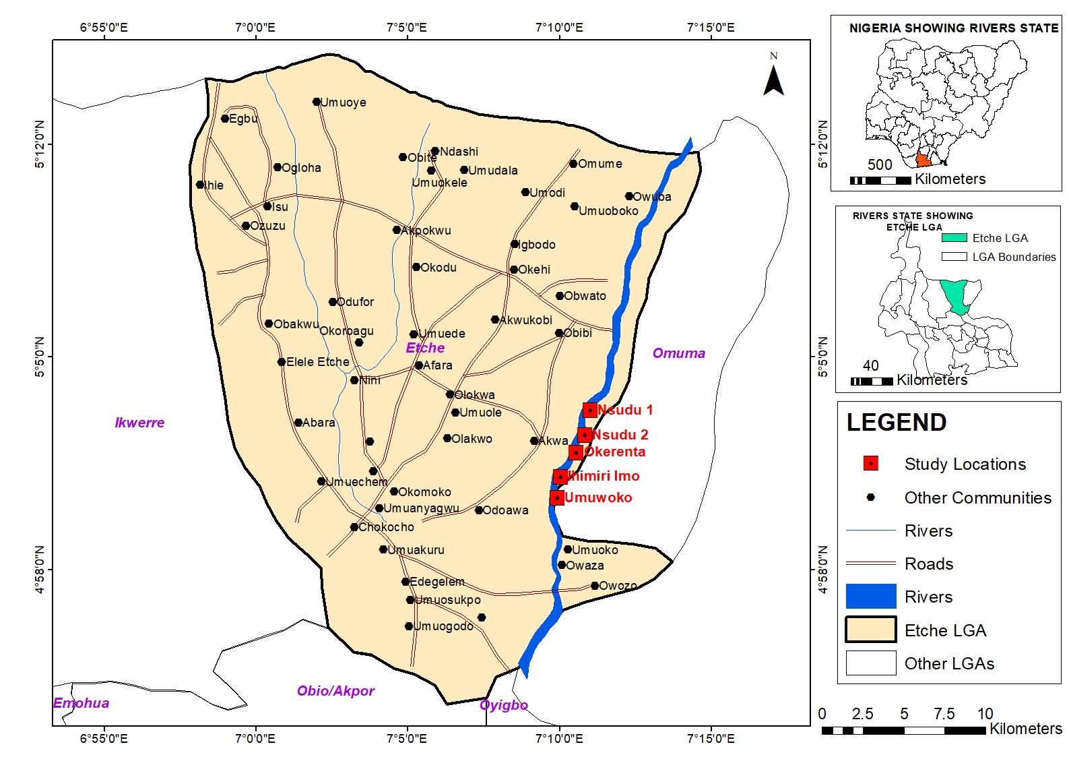

RESULTS
Table 1a: Physiocochemical Parameters showing monthly variation
The ‌ table shows the monthly changes of the water quality parameters . Each parameter is shown as mean ± standard deviation. The Sig. column shows statistical significance, i.e., if the variations over months are significant. In fact, temperature and pH changed over the months, DO and BOD have opposite trends, and salinity and TDS are the most affected by the changes in the river chemistry, probably due to the season or pollution. BOD and TSS levels are high in February, which denotes an increase in organic and particulate matter, whereas DO level was high in April, which signifies that water quality has temporarily ‍‌recovered.

Table 1a: Physiocochemical Parameters showing monthly variation
Parameters | February | March | April | May | Sig.
Temp. | 31.36 ± 0.68ª | 27.94 ± 0.17^{b} | 23.08 ± 0.24^{c} | 28.02 ± 0.35^{b} | 0.00
pH | 5.36 ± 0.12ª | 7.78 ± 0.81^{b} | 7.28 ± 0.05^{b} | 7.86 ± 0.12^{b} | 0.00
DO | 0.44 ± 0.05ª | 4.62 ± 2.21^{b} | 9.20 ± 0.16^{c} | 6.20 ± 0.16^{d} | 0.00
BOD | 62.70 ± 3.46ª | 2.26 ± 0.21^{b} | 0.68 ± 0.08^{b} | 2.36 ± 0.21^{b} | 0.00
Salinity | 0.24 ± 0.05ª | 12.82 ± 15.82ª | 0.00 ± 0.00ª | 42.80 ± 26.57^{b} | 0.01
TDS | 1225.00 ± 222.43ª | 45.00 ± 19.00^{b} | 28.40 ± 2.30^{b} | 35.80 ± 5.31^{b} | 0.00
EC | 2428.00 ± 436.66ª | 46.20 ± 27.69^{b} | 56.00 ± 4.47^{b} | 71.60 ± 10.60^{b} | 0.00
COD | 142.80 ± 12.91ª | 19.80 ± 8.17^{b} | 4.40 ± 0.55^{c} | 20.80 ± 7.19^{b} | 0.00
TSS | 170.20 ± 12.56ª | 35.20 ± 24.20^{b} | 2.40 ± 0.55^{c} | 15.80 ± 5.31^{c} | 0.00
Alkalinity | 16.80 ± 0.84ª | 80.40 ± 12.38^{b} | 48.60 ± 2.41^{c} | 76.40 ± 11.72^{b} | 0.00

Table 1.b gives the mean ± standard deviation of the values of the physicochemical parameters measured across the five sampling stations in Umudemoche-Akwa River. The data reveals minor spatial differences among the stations, with Stations 3 and 4 usually recording higher levels of EC, TDS, COD, and alkalinity, which implies more human impact. Nevertheless, the statistical test did not find any significant difference among the stations for all the physicochemical parameters (p > 0.05).
Regarding temperature, no significant change was recorded between the various stations. The temperature of Station 1 was 27.65 ± 3.20, Station 2 was 27.83 ± 3.44, Station 3 was 27.50 ± 3.56, Station 4 was 27.83 ± 3.69 and Station 5 was 27.21 ± 3.21. The difference in the highest and lowest mean values is quite minimal.
pH levels were also fairly stable when comparing one station to another. Station 1 recorded 7.04 ± 1.26, Station 2 recorded 7.13 ± 1.23, Station 3 recorded 7.14 ± 1.14, Station 4 recorded 7.36 ± 1.35, and Station 5 recorded 6.67 ± 1.10. Station 4 had the highest average pH, while Station 5 had the lowest.
Dissolved oxygen varied from 4.45 ± 3.86 at Station 1 to 5.55 ± 3.75 at Station 3. Stations 2 and 4 both recorded 5.53, whereas Station 5 recorded 4.53. Numerically, Station 3 had the highest average DO, and Station 1 had the lowest. BOD‍‌ values were approximately the same at all the stations too, statistically speaking. Station 1 got 16.03 ± 28.26, Station 2 16.93 ±. 30.52, Station 3 17.70 ± 32.27, Station 4 17.98 ± 32.10, and Station 5 16.38 ± 29.23. Station 4 had the highest average BOD while Station 1 had the lowest, but the differences in numbers were very small compared to the large standard deviations.
Salinity changed in number from one station to another, but the changes were small enough that statistically they were not significant. Station 1 14.05 ± 17.09, Station 2 7.80 ± 14.16, Station 3 8.78 ± 16.17, Station 4 23.15 ± 44.58, and Station 5 16.05 ± 18.86. The highest average salinity was at Station 4, while the lowest was at Station 2. Total dissolved solids (TDS) increased gradually from Station 1 to Stations 3 and 4. Station 1 recorded 271.00 ± 472.76, Station 2 309.25 ± 557.18, Station 3 390.50 ± 713.02, Station 4 392.25 ± 711.85, and Station 5 304.75 ± 517.27. Station 4 had the highest mean TDS, closely followed by Station 3, while Station 1 had the lowest. Electrical conductivity corresponded to the TDS almost perfectly. station 1 gave 522.50 ± 958.53, station 2 614.75 ± 1110.18, station 3 769.75 ± 1413.53, station 4 777.50 ± 1408.38, and station 5 567.75 ± 1035.12. Above station 4 again registered the highest average whereas station 1 recorded the lowest. COD ‍‌ showed a steady albeit small upward trend from Station 1 to Station 4. Station 1 had a mean COD of 40.00 ± 58.95; Station 2, 44.50 ± 64.67; Station 3, 52.75 ± 69.58; Station 4, 55.00 ± 68.32; and Station 5, 42.50 ± 60.69. Station 4 had the highest average COD whereas Station 1 had the lowest. Total suspended solids registered 57.25 ± 69.91 at Station 1, 49.00 ± 79.47 at Station 2, 55.00 ± 85.65 at Station 3, 58.00 ± 83.87 at Station 4 and 60.25 ± 72.78 at Station 5. Station 5 had the highest average concentration of TSS while Station 2 had the lowest. Alkalinity was from 50.25 ± 23.47 at Station 1 to 65.25 ± 39.79 at Station 4. Station 2 recorded 54.00 ± 26.70, Station 3 recorded 56.75 ± 32.22 and Station 5 recorded 51.50 ± 25.65. Station 4 registered the highest mean alkalinity and Station 1 the lowest one.

Physicochemical Parameters Showing Variations Across Sampling Stations in Umudemoche-Akwa River
Parameters | Station 1 | Station 2 | Station 3 | Station 4 | Station 5 | Sig.
Temp. | 27.65 ± 3.20 | 27.83 ± 3.44 | 27.50 ± 3.56 | 27.83 ± 3.69 | 27.21 ± 3.21 | 1.00
pH | 7.04 ± 1.26 | 7.13 ± 1.23 | 7.14 ± 1.14 | 7.36 ± 1.35 | 6.67 ± 1.10 | 1.00
DO | 4.45 ± 3.86 | 5.53 ± 3.72 | 5.55 ± 3.75 | 5.53 ± 3.69 | 4.53 ± 3.88 | 0.997
BOD | 16.03 ± 28.26 | 16.93 ± 30.52 | 17.70 ± 32.27 | 17.98 ± 32.10 | 16.38 ± 29.23 | 0.995
Salinity | 14.05 ± 17.09 | 7.80 ± 14.16 | 8.78 ± 16.17 | 23.15 ± 44.58 | 16.05 ± 18.86 | 0.976
TDS | 271.00 ± 472.76 | 309.25 ± 557.18 | 390.50 ± 713.02 | 392.25 ± 711.85 | 304.75 ± 517.27 | 0.692
EC | 522.50 ± 958.53 | 614.75 ± 1110.18 | 769.75 ± 1413.53 | 777.50 ± 1408.38 | 567.75 ± 1035.12 | 0.399
COD | 40.00 ± 58.95 | 44.50 ± 64.67 | 52.75 ± 69.58 | 55.00 ± 68.32 | 42.50 ± 60.69 | 0.960
TSS | 57.25 ± 69.91 | 49.00 ± 79.47 | 55.00 ± 85.65 | 58.00 ± 83.87 | 60.25 ± 72.78 | 0.972
Alkalinity | 50.25 ± 23.47 | 54.00 ± 26.70 | 56.75 ± 32.22 | 65.25 ± 39.79 | 51.50 ± 25.65 | 0.960

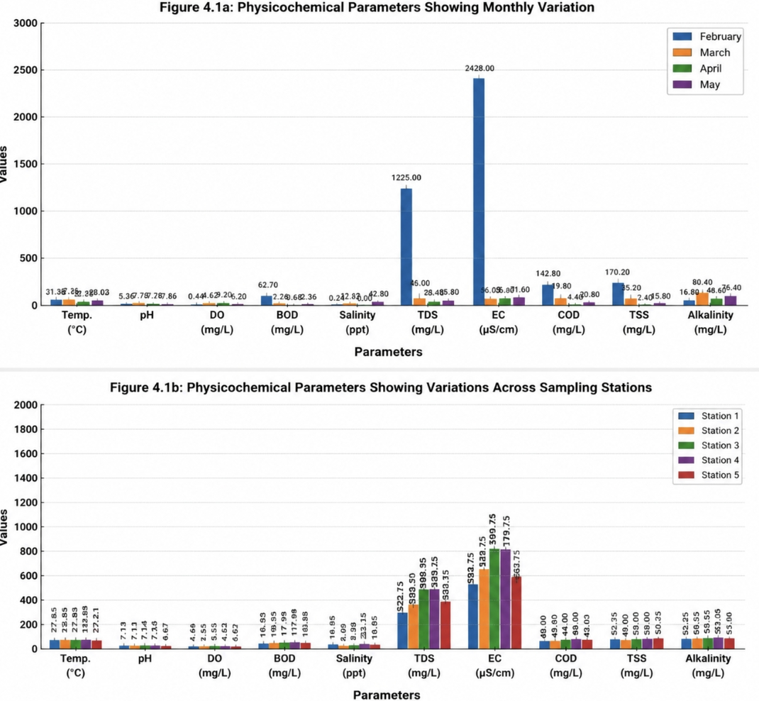

Fig 1: Temporal and Special Distribution of Physiocochemical Parameters in Umudemoche-Akwa River

DISCUSSION AND CONCLUSION
Table‍‌ 1a results reveal that all parameters changed significantly from one month to another (p ≤ 0.05), demonstrating that water quality fluctuated over time with a high rate of change.
Seasonal variations are reflected in temperature measurements, which varied between 23.08ºC and 31.36ºC. The drop in temperature observed in April can be explained by the rainfall and increased cloudiness that lead to less solar heating of the river surface.
The pH values varied between 5.36 and 7.86, which means that the water changed from being slightly acidic to slightly alkaline. The acidic environment in February is speculated to be due to organic waste decomposing more actively, and the neutralization later on could be due to dilution by rain and runoff.
DO fluctuated significantly, going up from 0.44 mg/L to 9.20 mg/L, which marked periods of extreme depletion of oxygen along with the peak of pollution, and then a recovery. The very low level of DO in February is typical of scenarios of high organic pollution, in which microbial decomposition is the main process of oxygen consumption.
BOD's trend was identical to that of DO, with peak BOD in February (62.70 mg/L) and a steep drop afterwards. This is in line with higher presence of organic wastes during the initial sampling, which lessened over the period of time.
EC, TDS, salinity, COD, and TSS recorded the highest readings in February as well. EC was 2428 µS/cm and TDS was 1225 mg/L, which portray a high presence of dissolved ions and pollutants in the river. These levels are indicative of a significant amount of domestic waste discharge, runoff, and possibly agricultural inputs.
Reduction of these parameters in later months points at dilution as well as river's self-purification and decreasing levels of waste loading.
On the other hand, Table 1b depicts that physico-chemical parameters did not differ significantly between sampling points (p > 0.05).
The temperature did not change significantly from one station to another (about 27°C), which means that thermal conditions were uniform. Likewise, the pH values were between 6.67 and 7.36, which means that acidity levels were quite stable in the river.
Dissolved oxygen and BOD showed the least changes but were not significant statistically, which means that oxygen availability is largely the same all along the river.
The four parameters EC, TDS, COD, and TSS displayed slight rises at the midstream and downstream points (especially Stations 3 and 4), however, these rises were statistically non-significant. This, therefore, means that even though pollutant level may increase a bit downstream, the change is not strong enough to indicate that there are pollution hotspots.
Generally, the spatial similarity suggests that the river is receiving pollution from various scattered sources rather than only one or two discharges, and pollutants are being evenly spread through water flow and mixing processes.
The findings of the study suggest that Umudemoche–Akwa River is under moderate to high environmental stress due to waste discharges.
Instances of oxygen depletion coincide with times of major pollution and may have a negative impact on aquatic life, especially fish and benthic macroinvertebrates. High BOD and COD are indicators of continuous organic pollution while high values of TDS and EC are a sign of high concentration of dissolved wastes.
The river, although in some degree capable of recovering through natural processes, may end up being severely polluted due to continued cycles of pollution, which may result ‍‌in:
Decrease in water life diversity,Higher chances of eutrophication,Lessen the ability for domestic use ,Major damages and changes to the river environment.
By examining the temporal (monthly) and spatial (sampling station) analyses the paper assessed the effects of waste on the physicochemical characteristics of Umudemoche–Akwa River, Etche Local Government Area, Rivers State. The finding showed that the river’s water quality was considerably jeopardized by the introduction of waste; however the extent of harm with time was more significant than the variation with location.
The physicochemical aspects experienced considerable monthly variations as many parameters such as dissolved oxygen, biochemical oxygen demand, electrical conductivity, total dissolved solids, and chemical oxygen demand recorded very high or very low values at certain times. These changes imply that the river is subjected to periods of high pollution loading, particularly from organic and dissolved waste materials, followed by partial recovery which is probably as a result of dilution and natural self-purification processes. On the other hand, spatial variation across sampling stations was not found to be statistically significant, which means that the pollution level is more or less the same along the whole stretch of the river and there are no particular hotspots.
Generally, the results point at Umudemoche–Akwa River as a river with moderate to high level of human-caused pressure most of which is due to diffuse waste disposal and seasonal environmental changes. The river is able to stand against and recover from impacts somewhat but the constant introduction of waste will lead to a long time degradation of the environment which will at a end result in reduction in the quality of the water, depletion of oxygen, and threats to aquatic life. This is why practicing effective waste management and continuous monitoring is necessary in order to maintain the ecological balance and usability of the water ‍‌body.

REFERENCES
Adomi, P. O. (2025). Microbial and physicochemical quality of river water in Delta State, Nigeria. Environmental Research Journal, 18(2), 45–60.
Ifelebuegu, A. O. (2017). Environmental effects of crude oil spill on physicochemical characteristics of Niger Delta rivers. Environmental Monitoring and Assessment, 189(3), 112–125.
Nti, B. U. (2025). Assessment of physicochemical parameters of selected creeks in Rivers State. Journal of Water Pollution and Purification Research, 12(1), 32–44.
Tjest.org.ng
Ogbe, K. U., Dauda, T., Somdare, P. O., et al. (2025). Water quality status of Nigeria surface water through physicochemical parameters: An empirical review. Sahel Journal of Life Sciences, 3(2), 139–147.
ResearchGate
Okoro, B., Ezekiel, E. N., Sarogoro, N. S., & Charles, K. (2025). Seasonal variation of physicochemical parameters of rivers in Rivers State. European Academic Research, 7(12), 5945–5958.

