A STUDY ON CARBON FOOTPRINT AWARENESS AND SUSTAINABLE BEHAVIOUR WITH REFERENCE TO UNDERGRADUATE AND POSTGRADUATE STUDENTS

Authors: Prabhu Konar, Pavan M, Afreen Begum
Bengaluru North University
Master of Business Administration (MBA),
Patel Institute of Science and Management (PISM),
Bengaluru, India

ABSTRACT
This study fully analysing the level of carbon footprint awareness and sustainable behaviour among undergraduate student and postgraduate students. It mainly examines key dimensions that are environmental knowledge, identification of carbon intensive activity, attitudes towards sustainability, personal responsibility, institutional support, and willingness to adopt environment responsible action for the study. Primary data were collected from UG and PG 155 respondent using a structured questionnaire, these indicates strong awareness and favourable attitudes toward sustainable behaviour from this result High levels of awareness observed in particular area such as energy conservation, waste management, environmental consciousness, reflecting the positive impact of academic exposure and campus-based sustainability initiatives. However, lower scores it's related to carbon footprint measurement and consistent sustainable practices it will highlight gaps between awareness and practical implementation. The study shows that environmental education is really important. We need to teach students about the environment in a way. Universities should also try to be sustainable. Encourage students to behave in ways that help the environment. This will help students develop habits that they will keep for a long time. This way they can help create people who really care about the environment. When students get jobs and become leaders, they can make an impact on the sustainability in their working organisations which would lead to the development of the country and on how society thinks about the environment. Higher education institutions are not places where people go to learn things they are also places that can help make the world a better place by fighting climate change and helping environment.
Keywords: Carbon footprint awareness, Sustainable behaviour, Environmental literacy, Higher education students, Sustainability initiatives.
INTRODUCTION
The environment is getting worse now a days because people are putting carbon into the air. This is causing problems, like climate change and it is really hurting the earth. People are making the climate change problem worse and also damaging the earth. The concept of carbon footprint is important now because it measures how harm our daily activities cause to the environment. Colleges that teach education are very important in teaching people to take care of the environment. Students are the leaders and decision makers who will help make the earth a sustainable place.
We need to know how much students understand about carbon footprint and if they are doing things to help the environment. This is necessary to solve the problems that will affect us in the long run. Students who are getting postgraduate degrees are in different colleges and social settings that affect what they think and do about sustainability. Carbon footprint is an issue and students need to know about it to make a difference. Universities play a role, in teaching students about carbon footprint and how to live in a way that helps the environment. Understanding carbon footprint which enables students to recognise the environmental challenges of daily activities such as electricity consumption, transportation choices, and waste disposal. However, awareness alone does not always convey into consistent sustainable practices. In now days, universities and colleges have introduced sustainability initiatives, environmental courses, and green campus programmes make to promote eco-friendly behaviour. Despite these an all efforts, variations persist in student's understanding and regularly adopting of sustainable practices. This study mainly aims to evaluate carbon footprint awareness and institutions.
LITERATURE REVIEW
Kalpana, Rajkumar, and Rita (2013). examined students’ awareness and behaviour related to energy conservation in higher education institutions in the Vellore district of Tamil Nadu. Their study reveals that while most students possessed basic environmental knowledge, actual conservation behaviour was influenced by convenience and motivation. Institutional interventions such as stair-use reminders and improved campus transportation which I will positively affected student behaviour and the authors concluded that sustained and visible awareness initiatives are essential for encouraging energy-efficient practices.
Doddapanen, et al. (2024). evaluated that the environmental awareness, education, and ethics among undergraduate and post graduate students in Mysuru, Karnataka. The findings specify a generally positive level of awareness regarding pollution, resource conservation, and sustainability. Environmental education was identified as an important factor in influencing students’ attitudes towards environmental protection, emphasising the importance of early and continuous environmental learnings.
Manjunath, Ravikumar (2025). investigated stakeholder awareness of carbon trading and found an above average level of understanding, while awareness of sustainability goals and government communication was strong, knowledge of global carbon market trends was relatively less. The study highlighted the need for the targeted training programmes to enhance participation in carbon trading initiatives.

OBJECTIVES OF THE STUDY
- To study the level of carbon footprint awareness among degree students.
- To evaluate the inclusion of carbon education within academic curriculum.
- To analyse behavioural changes related to carbon-conscious decision-making.
- To know strategies for improving carbon literacy in higher education institutions.

SCOPE OF THE STUDY

The study focuses on undergraduate and postgraduate students.

It analyses students’ awareness and understanding of carbon footprints.

Its disclosures student knowledge of sustainable and eco-friendly practices.

It analyses students’ attitudes and perceptions towards carbon awareness behaviour.

The study is limited to universities and colleges as the area of review.

It aims to understand sustainable practices followed within the higher education institutions.

HYPOTHESIS OF THE STUDY
H0: Being aware of carbon footprint does not really change how undergraduate and postgraduate students behave in terms of sustainability. This awareness includes knowing about issues recognising activities that produce a lot of carbon understanding school sustainability programs being personally responsible and ready to live in an eco-friendly way.
H1: Awareness of carbon footprint-which includes knowledge of environmental issues, recognition of carbon heavy activities, understanding of sustainability programs in institutions, personal accountability, and readiness to embrace eco-friendly habits-substantially impacts sustainable behaviour among both undergraduate and postgraduate students.

RESEARCH METHODOLOGY
This study looks at how students know about the carbon footprint they make and how it affects the way they behave in a way. The responses were collected from 155 students who are doing undergraduate and postgraduate work. They filled out a questionnaire with five answers, to each question. The study is trying to see what students think about their carbon footprint and how it affects the way they live in a way.
Statistical methods were employed to summarize the awareness and comprehension levels of students; Inferential analysis was utilized to investigate the connection between awareness of carbon footprint and sustainable behaviour. Ethical principles were up held by guaranteeing voluntary involvement, obtaining informed consent, and ensuring respondents confidentially.

INTERPRETATION OF DATA
The Analysis of responses from 155 students that indicates a moderate to higher level of awareness regarding this carbon foot print and environmental issues. Most respondents Displaying an understanding of the carbon footprint concept and identified in everyday activities such as energy usage, transportation and consumption habits as major contributors to carbon emissions. Postgraduate students, exhibited relatively higher awareness levels than the undergraduate students, suggesting the influence of advanced academic exposures.
Table1. Analysing Awareness of Carbon Footprints.
Sl No | Description | Respondents | Percentage
1 | Yes | 113.46 | 73.2%
2 | No | 41.54 | 26.8%
 | Total | 155 | 100%

Figure 1 Analysing Awareness of Carbon Footprints.
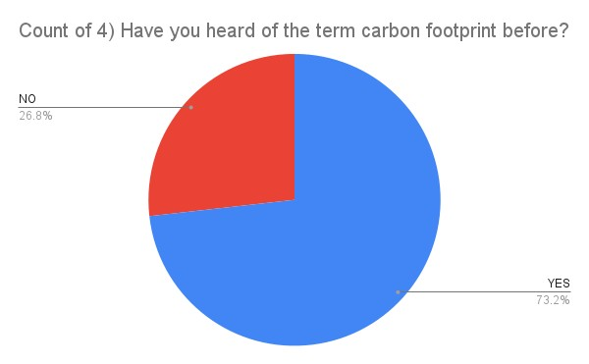
The results shows that 73.2 percent of people know what the term carbon footprint means. This is a sign that people have a basic understanding of environmental causes. On the hand 26.8 percent of people do not know what carbon footprint means. This shows that there is a gap, in what people know about the environment and we need to teach people about it. We need to do a job of educating people about carbon footprint and other environmental causes.
Table 2. Responses On Challenges Accepted to Reduce Carbon Footprint.

Sl No | Description | Respondents | Percentage
1 | Waste segregation Support Green Campus | 8.37 | 5.4%
2 | Waste Segregation | 11.005 | 7.1%
3 | Cycle to College Day | 11.005 | 7.1%
4 | Switch off Hour ,Support Green | 2.79 | 1.8%
5 | Switch off Hour, Cycle to College | 2.79 | 1.8%
6 | Green Campus Initiative | 77.5 | 50.0%
7 | Cycle to College Day Support Green | 5.4 | 3.6%
8 | Switch off Hour, No Print Week | 5.4 | 3.6%
9 | Switch Off Hour | 24.95 | 16.1%
 | Total | 155 | 100%

Figure 2 Responses on Challenges Accepted to Reduce Carbon Footprint.
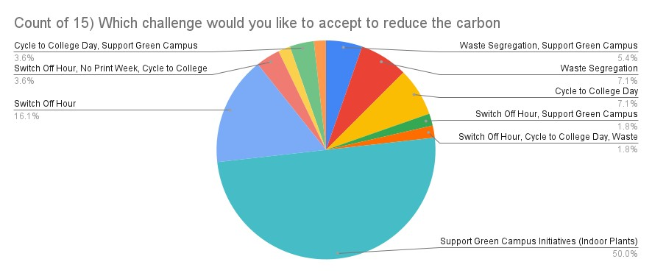
Regarding sustainability initiatives, 50% of respondents expressed willingness to support green campus which measures such as indoor plants, highlighting strong support for institution-led efforts. About 16.1% shown interested to participate in initiatives like “Switch Off Hour," Displaying awareness of energy conservation. Other actions such as waste segregation and cycling to college received moderate responses, while combined initiatives were less frequently chosen.
These results give suggestions like students should prefer simple, organised, and institution-supported sustainability measures.
Although awareness levels were relatively high and the regular practice of sustainable behaviour was found to be medium. Students expressed willingness to conserve electricity, choose sustainable transport, reduce wastage, and support environmental responsible actions. Overall, the findings show a good relationship between awareness and intention to act sustainably, Highlighting the role of institutional support in converting the knowledge into stable Behaviour.

KEY FINDINGS
- Most students possess basic knowledge of carbon footprint and environmental issues
- Postgraduate students display a higher awareness and better sustainable behaviour more than the undergraduate students
- Education will play a very important role in creating environmental awareness and Despite awareness, sustainable practices are not consistently followed in daily life.
- Students are more likes to adopting the eco-friendly practices when supported by institutional initiatives.

SUGGESTIONS
- The Carbon footprint and sustainability topics should be integrated across all academic programmes.
- Regular workshops and awareness campaigns must should be conducted to promote simple environmental protection practices and Institutions should encourage practical actions such as energy conservation, Wastage reduction, and use of public transport.
- Students should be encouraged to participate in environmental clubs and green activities.
- Periodic assessment of student awareness can help to improve institutional sustainability strategies.

CONCLUSION
The study concludes that the undergraduate and postgraduate students possess a good level of understanding about the carbon footprint and environmental issues. Most students identified that in daily activities such as electricity consumption, transportation, and consumption choices contribute to carbon emissions. Postgraduate students exhibited higher awareness and more frequent engagement in eco-friendly behaviour, reflecting the influence in higher education.
However, the noticeable gap exists between awareness and consistent practices. While students display a positive attitude and interested to adopt sustainable behaviour, such actions are not always carried out regularly but the findings highlight the importance of structured carbon education, practical sustainability initiatives, and strong institutional support to transform awareness into long-term sustainable behaviour among the students.

REFERENCES.
- Doddapanen, N., Lakshmegowda, Y. K., Aardhya, S., Rajashekar, R., Doolgindachbaporn, T., & Nagaraju, P. (2024). Environmental awareness, education, and ethics regarding the environment among pre-university students in Mysuru City, Karnataka, India. Global Journal of Environmental Biosciences, 13, 13-20.

- Kalpana, K., Rajkumar, A. D., & Rita, S. (2013). Students’ knowledge, perspective and actions regarding energy saving. Global Journal of Utilized Business and Economic Studies 11, No.2, 241-250.

- Manjunath, N., & Ravikumar, K. (2025). An investigation into the factors influencing knowledge of carbon trading and its contribution to sustainable development. Global Journal of Innovative Research Ideas.

