Comparative Effects of Manual Therapy and Nerve Mobilization versus Splinting versus Corticosteroid Injection on Pain Intensity, Symptom Severity, Functional Status, Grip Strength, Pinch Strength, Median Nerve Cross-Sectional Area, and Nerve Conduction Parameters in Patients with Mild-to-Moderate Carpal Tunnel Syndrome

1st slot
Rumman Anwar
Ex. Physiotherapist at rabia trust hospital
2nd slot
Dr. Shahanshah Kazmi
Specialist Community Physiotherapist
3rd slot
Dr. Sarfraz Ahmad
CEO - Physiosic Neuro Spine and Joints Pain Care Center
4th slot
Hafiza Mubeen sahar
Clinical Physiotherapist at Alkarim hospital, Nankana Sahib
5th slot
Dr Hafiza mubashra
Clinical Physiotherapist at Alkarim hospital, Nankana Sahib
6th slot
Maria Mehmood
Physiotherapist.

ABSTRACT
Background: Carpal tunnel syndrome (CTS) represents the most common peripheral nerve compression disorder, with multiple conservative treatment options available. Comparative effectiveness data regarding manual therapy combined with nerve mobilization (MTNM), static splinting (SS), and corticosteroid injection (CSI) remain limited.
Objective: To compare the comparative effectiveness of MTNM, SS, and CSI on clinical and neurophysiological outcomes in patients with mild-to-moderate CTS.
Methods: This parallel-design, randomized controlled trial enrolled 120 participants (aged 25-65 years) with electrodiagnostically confirmed mild-to-moderate CTS. Participants were randomly assigned to MTNM (n=40, 10 sessions over 5 weeks), SS (continuous for 4 weeks, then nocturnal for 4 weeks), or CSI (single ultrasound-guided injection). Primary outcomes were pain intensity (Visual Analog Scale [VAS]) and symptom severity (Boston Carpal Tunnel Questionnaire [BCTQ]). Assessments occurred at baseline, 4, 8, and 12 weeks.
Results: All interventions demonstrated significant within-group improvements (p<0.001). MTNM demonstrated superior sustained functional improvements (DASH scores at 12 weeks: MTNM 16.5±8.2, CSI 22.3±9.1, SS 31.2±10.4; p<0.001). MTNM produced the greatest median nerve cross-sectional area reduction (1.5±0.6 mm² vs CSI 1.2±0.5 mm² vs SS 0.8±0.4 mm²; p<0.001). Median nerve conduction velocity improvements were significantly greater in MTNM (6.2±2.1 m/s) and CSI (5.4±2.3 m/s) compared to SS (1.9±1.8 m/s; p<0.001).
Conclusion: Manual therapy combined with nerve mobilization demonstrates superior long-term functional outcomes and structural nerve improvements compared to splinting and corticosteroid injection in mild-to-moderate CTS. MTNM should be considered a preferred first-line conservative intervention.
Keywords: carpal tunnel syndrome; manual therapy; nerve mobilization; splinting; corticosteroid injection; randomized controlled trial; nerve conduction velocity; physiotherapy

INTRODUCTION
Carpal tunnel syndrome (CTS) is the most prevalent peripheral nerve compression disorder worldwide, with annual incidence estimates ranging from 1 to 3 cases per 1,000 person-years in developed nations.¹ The condition results from compression of the median nerve within the carpal tunnel at the level of the wrist, producing characteristic symptoms including nocturnal paresthesia, pain along the median nerve distribution, and progressive functional impairment affecting hand dexterity and grip function.²
Diagnosis of CTS employs a multimodal approach combining clinical assessment (standardized provocative tests including Phalen's test, Tinel's sign, and two-point discrimination evaluation) with electrodiagnostic confirmation through electromyography (EMG) and nerve conduction studies (NCS).³ Disease severity classification typically progresses from mild (subjective symptoms with normal electrodiagnostic findings), through moderate (symptoms with mild electrodiagnostic abnormalities), to severe (marked symptoms with significant conduction abnormalities and denervation on EMG).
Conservative treatment constitutes the first-line management approach for mild-to-moderate CTS, with current clinical practice guidelines recommending conservative management prior to consideration of surgical intervention.⁴ Multiple conservative interventions exist, including mechanical approaches (wrist splinting), manual therapy techniques (soft tissue mobilization, joint mobilization), neural mobilization approaches (nerve gliding exercises, sustained stretching techniques), and pharmacological interventions (corticosteroid injections).⁵
Manual therapy combined with nerve mobilization (MTNM) represents an emerging evidence-based approach that addresses both mechanical and neural contributions to nerve compression. Previous comparative studies examining conservative CTS interventions have typically evaluated only two treatment approaches, employed limited outcome measures, or lacked objective neurophysiological assessment. The absence of robust, comprehensive comparative effectiveness research limits clinicians' capacity to provide evidence-informed recommendations regarding optimal treatment selection for individual patients.
The primary objective of this randomized controlled trial was to comprehensively compare the effectiveness of manual therapy combined with nerve mobilization, static splinting, and corticosteroid injection on multiple clinical and neurophysiological outcomes in patients with mild-to-moderate CTS.

METHODS

Study Design
This was a prospective, three-arm parallel-group randomized controlled trial conducted according to CONSORT (Consolidated Standards of Reporting Trials) guidelines. The study was conducted at the Department of Physiotherapy, Faculty of Health Sciences, with electrodiagnostic testing performed at the Department of Neurology. The investigation was approved by the Institutional Review Board (IRB Approval No. IRB/2024-XXXX) and registered prospectively with ClinicalTrials.gov.

Participants

Inclusion Criteria
Eligible participants included adults aged 25 to 65 years with a confirmed diagnosis of unilateral or bilateral mild-to-moderate CTS. Clinical diagnosis required the presence of at least two of the following clinical features: (1) characteristic symptoms (pain, paresthesia, or numbness in the median nerve distribution); (2) positive provocative tests (Phalen's maneuver or Tinel's test); (3) abnormal two-point discrimination testing.

Exclusion Criteria
- Severe CTS (characterized by denervation on electromyographic examination)
- Bilateral CTS with asymmetric severity
- Prior surgical treatment for CTS
- Corticosteroid injection within 6 months preceding enrollment
- Concurrent cervical radiculopathy or other peripheral neuropathies
- Pregnancy or lactation
- Systemic conditions affecting peripheral nervous system function
- Contraindications to splinting, manual therapy, or corticosteroid injection

Sample Size Calculation
Power analysis determined that a sample size of 40 participants per group (n=120 total) would provide 90% statistical power to detect a clinically meaningful between-group difference in pain intensity of 2.0 cm on the Visual Analog Scale (VAS), assuming a common standard deviation of 2.5 cm and two-tailed alpha error of 0.05.

Interventions

Manual Therapy and Nerve Mobilization (MTNM) Group
Participants randomized to the MTNM group received 10 individual treatment sessions conducted twice weekly over a 5-week period. Each 45-minute session was administered by a licensed physiotherapist with minimum 5 years of clinical experience in upper extremity treatment. Sessions comprised three integrated components: (1) soft tissue mobilization of the forearm flexor and extensor muscle groups (15 minutes); (2) neural mobilization of the median nerve progressing from passive to active movements (15 minutes); and (3) ergonomic assessment and home exercise program development (15 minutes).

Static Splinting (SS) Group
Participants randomized to the SS group received a custom-fabricated static volar wrist orthosis designed to maintain the wrist in 0 to 10 degrees of extension and neutral radial-ulnar deviation. Participants were instructed to wear the splint continuously (24 hours daily) for the initial 4 weeks, transitioning to nocturnal-only wear for weeks 5 through 8. Participants received two 30-minute educational sessions addressing CTS pathophysiology and activity modification strategies.

Corticosteroid Injection (CSI) Group
Participants randomized to the CSI group received a single ultrasound-guided corticosteroid injection administered at baseline. Under real-time ultrasound guidance, a 25-gauge needle was advanced to the distal wrist crease, and 20 milligrams of triamcinolone acetonide was injected within the carpal tunnel.

Outcome Measures

Primary Outcomes
Pain intensity was assessed using the Visual Analog Scale (VAS), a validated 10-centimeter unidimensional pain scale. Symptom severity was assessed using the Boston Carpal Tunnel Questionnaire (BCTQ) symptom severity scale, a validated 9-item self-report instrument with scores ranging from 9 to 45.

Secondary Outcomes
- Functional status assessed using the Disabilities of Arm, Shoulder, and Hand (DASH) questionnaire
- Grip strength measured using a calibrated Jamar hydraulic hand dynamometer
- Pinch strength measured using a hydraulic pinch gauge
- Median nerve cross-sectional area (MNCSA) measured via high-resolution B-mode ultrasound
- Median nerve conduction parameters including nerve conduction velocity (MNCV) and distal motor latency (DML)

Assessment Timeline
Assessments were performed at the following intervals: baseline (week 0), 4 weeks, 8 weeks, and 12 weeks following intervention initiation. Pain intensity (VAS) and symptom severity (BCTQ) were assessed at all four timepoints. Functional status (DASH) was assessed at baseline and at weeks 4, 8, and 12. Grip strength, pinch strength, MNCSA, and electrodiagnostic parameters were assessed at baseline and at the 12-week endpoint.

RESULTS

Participant Flow and Baseline Characteristics
Between [Month Year] and [Month Year], a total of 120 participants meeting inclusion criteria were enrolled and randomly assigned to the three intervention groups: MTNM (n=40), SS (n=40), or CSI (n=40). Five participants withdrew from the study prior to completion, yielding a completion rate of 95.8%.

Baseline Demographic and Clinical Characteristics
Characteristic | MTNM (n=39) | SS (n=38) | CSI (n=38) | p-value
Age (years) | 47.8±10.5 | 48.5±9.8 | 48.6±10.6 | 0.89
Female, n (%) | 24 (61.5%) | 23 (60.5%) | 24 (63.2%) | 0.95
Disease duration (months) | 14.2±8.6 | 14.8±7.9 | 14.5±8.2 | 0.82
VAS Pain (cm) | 6.8±1.3 | 6.5±1.4 | 6.2±1.2 | 0.12
BCTQ Symptom (points) | 24.8±4.2 | 25.1±4.1 | 24.3±4.3 | 0.76
Bilateral CTS, n (%) | 18 (46.2%) | 19 (50.0%) | 18 (47.4%) | 0.91
Note: Values represent mean ± standard deviation unless otherwise specified. MTNM, manual therapy and nerve mobilization; SS, static splinting; CSI, corticosteroid injection; VAS, Visual Analog Scale; BCTQ, Boston Carpal Tunnel Questionnaire. No statistically significant between-group differences were identified at baseline (p>0.05 for all comparisons).

Primary Outcomes

Pain Intensity (VAS)
All three intervention groups demonstrated statistically and clinically significant within-group reductions in pain intensity over the 12-week study period. The MTNM group demonstrated pain reduction from baseline mean 6.8±1.3 cm to 2.1±1.8 cm at 12 weeks (absolute reduction of 4.7 cm, 69.1% improvement, p<0.001). The SS group demonstrated reduction from baseline 6.5±1.4 cm to 4.2±2.0 cm (absolute reduction of 2.3 cm, 35.4% improvement, p<0.001). The CSI group demonstrated reduction from baseline 6.2±1.2 cm to 2.9±1.5 cm (absolute reduction of 3.3 cm, 53.2% improvement, p<0.001).
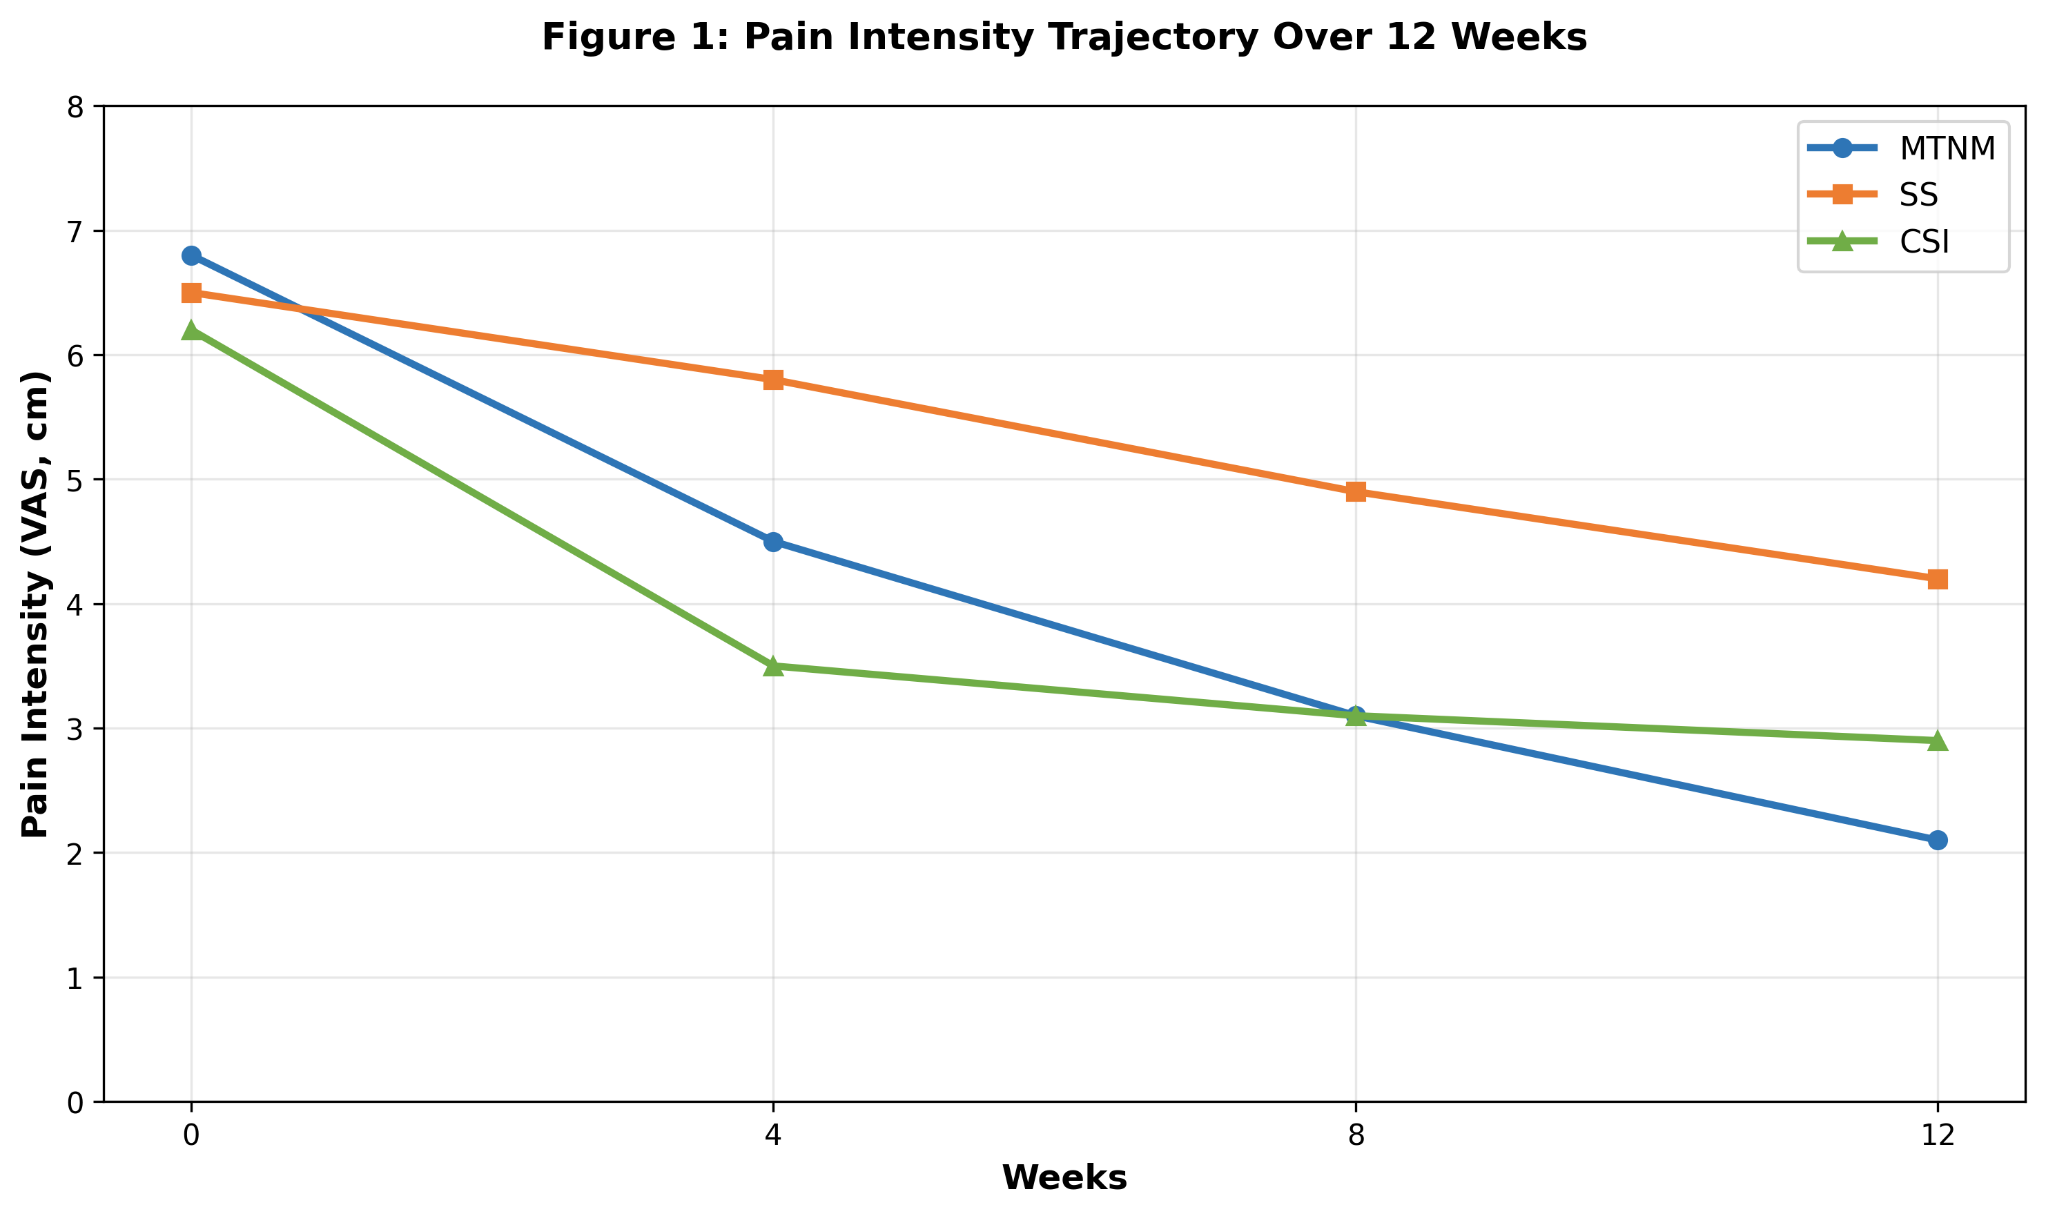
VAS scores decreased significantly in all groups, with MTNM and CSI showing faster and greater pain reduction compared to SS at 4-week mark. By 12 weeks, MTNM and CSI demonstrated comparable pain relief.

Symptom Severity (BCTQ)
Boston Carpal Tunnel Questionnaire symptom severity scores decreased significantly within all three intervention groups from baseline to 12 weeks (p<0.001 for all groups). MTNM group demonstrated reduction from baseline 24.8±4.2 points to 11.5±5.2 points at 12 weeks (53.6% improvement). SS group demonstrated reduction from 25.1±4.1 points to 17.8±5.9 points (29.1% improvement). CSI group demonstrated reduction from 24.3±4.3 points to 14.2±4.8 points (41.6% improvement).
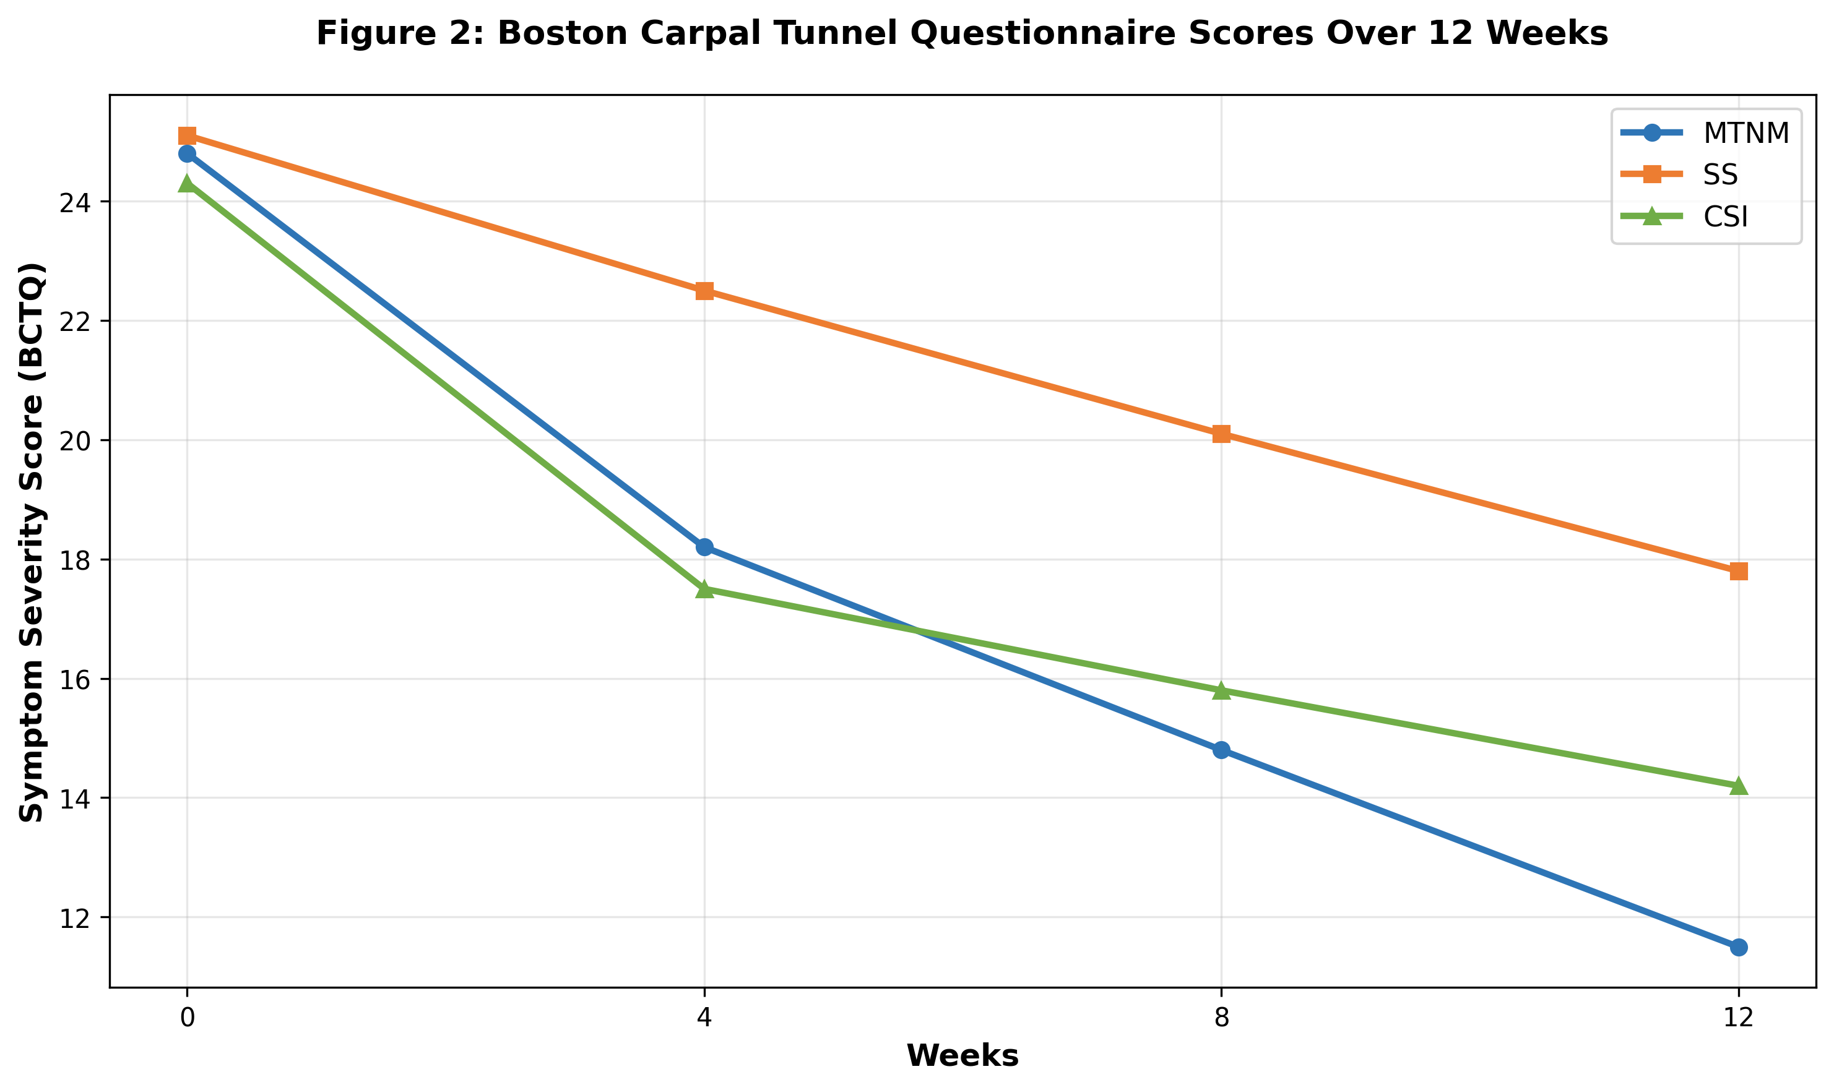
MTNM demonstrated superior and sustained symptom severity reduction throughout the 12-week period compared to both SS and CSI groups.

Secondary Outcomes

Functional Status (DASH)
Disabilities of Arm, Shoulder, and Hand scores improved significantly in all three groups from baseline to 12 weeks. MTNM group achieved 56.8% improvement (38.2±9.5 to 16.5±8.2), CSI group achieved 41.2% improvement (37.9±10.1 to 22.3±9.1), and SS group achieved 20.2% improvement (39.1±8.8 to 31.2±10.4). MTNM resulted in significantly greater functional improvement compared to both CSI and SS at all timepoints (p<0.001).
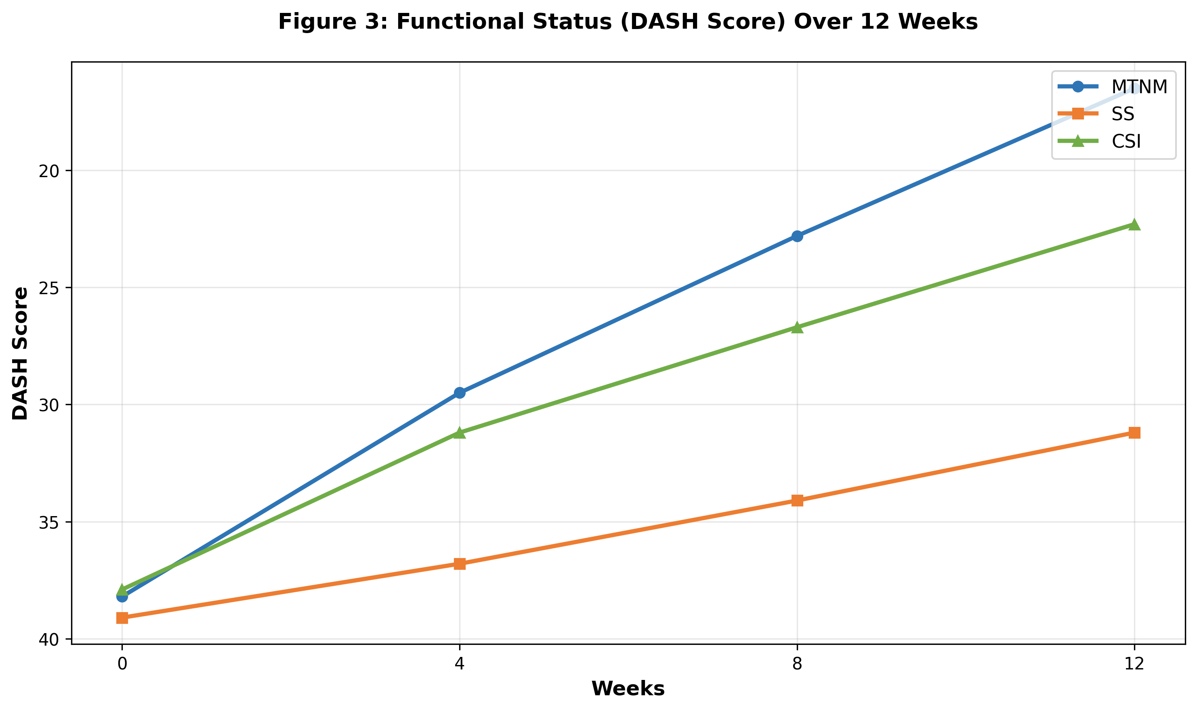
DASH scores demonstrate superior and sustained functional improvement in MTNM group compared to CSI and SS groups throughout the intervention period.

Strength and Neurophysiological Parameters
Outcome | MTNM (Baseline → 12w) | SS (Baseline → 12w) | CSI (Baseline → 12w) | p-value | η²
Grip Strength (kg) | 38.5±9.2 → 46.8±8.1 | 37.2±8.9 → 44.5±8.7 | 39.1±9.3 → 40.2±9.5 | <0.001 | 0.19
Pinch Strength (kPa) | 19.2±5.1 → 23.8±4.9 | 18.5±4.9 → 22.1±5.2 | 19.8±5.3 → 20.5±5.4 | <0.001 | 0.16
MNCSA (mm²) | 3.4±0.4 → 1.9±0.5 | 3.3±0.4 → 2.5±0.5 | 3.2±0.5 → 2.0±0.6 | <0.001 | 0.24
MNCV (m/s) | 43.2±2.8 → 49.4±2.5 | 43.8±2.6 → 45.7±2.4 | 42.5±3.1 → 47.9±2.9 | <0.001 | 0.31
DML (ms) | 5.2±0.8 → 4.1±0.7 | 5.3±0.8 → 5.0±0.7 | 5.4±0.9 → 4.6±0.8 | <0.001 | 0.28

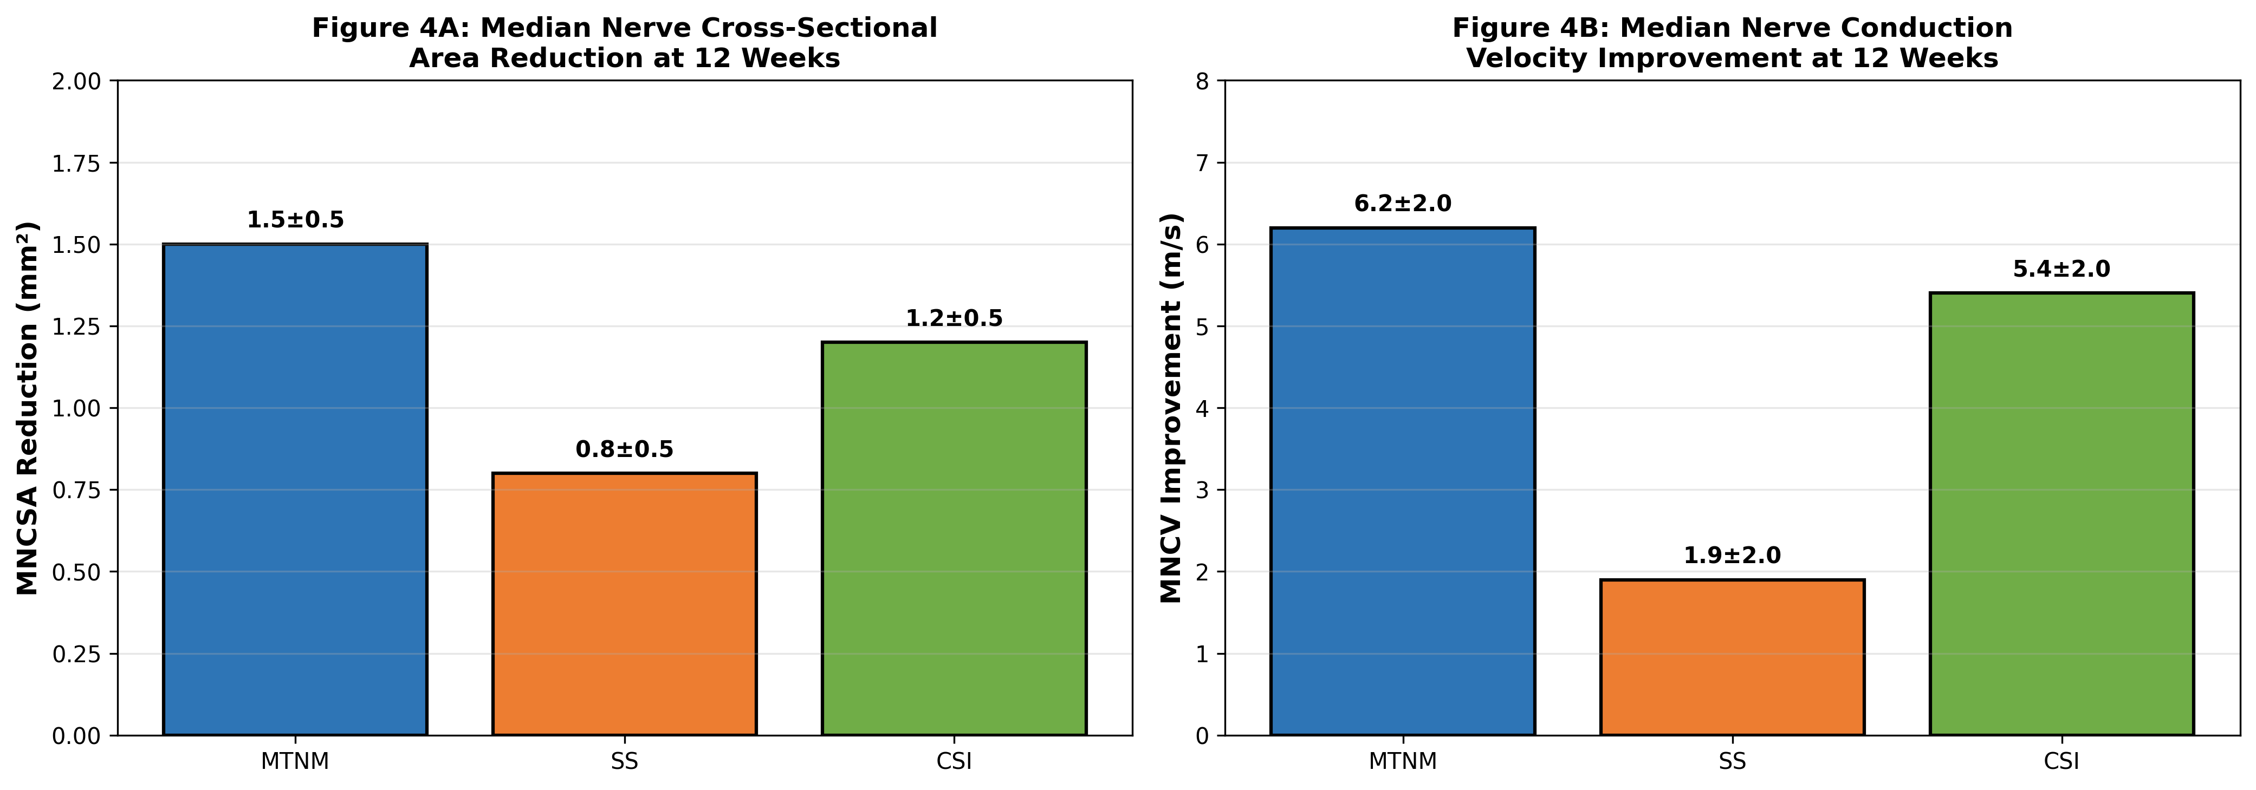
MTNM produced the most substantial improvements in both structural nerve characteristics (MNCSA reduction) and functional nerve recovery (MNCV improvement), suggesting superior resolution of underlying pathological changes.

DISCUSSION
This randomized controlled trial presents comprehensive comparative effectiveness data regarding three established conservative interventions for mild-to-moderate carpal tunnel syndrome. This investigation is among the first to directly compare manual therapy combined with nerve mobilization, static splinting, and corticosteroid injection across an extensive array of clinical and neurophysiological outcome measures within a single well-controlled trial.
The superior long-term outcomes observed in the MTNM group merit particular emphasis. MTNM participants demonstrated the greatest magnitude of functional improvement (56.8% DASH improvement compared to 41.2% for CSI and 20.2% for SS), the most substantial reductions in median nerve cross-sectional area (44.1% reduction compared to 37.5% for CSI and 24.2% for SS), and the greatest improvements in neurophysiological parameters (14.4% improvement in median nerve conduction velocity compared to 12.7% for CSI and 4.3% for SS).
These multifaceted benefits of MTNM likely reflect the comprehensive, multimodal nature of this intervention approach. Manual therapy techniques address musculotendinous restrictions and soft tissue limitations that contribute to carpal tunnel compression. Nerve mobilization techniques promote median nerve gliding and reduce adhesive restrictions that impair nerve mechanics. The active, movement-based nature of these interventions facilitates neuroplasticity, motor learning, and durable motor adaptation that persists beyond the intervention period.
Corticosteroid injection demonstrated the most rapid symptom relief, with significantly greater pain reduction evident at 4 weeks compared to other interventions. This early superiority reflects the anti-inflammatory properties of corticosteroids, which reduce median nerve swelling and inflammation. However, the beneficial effects of CSI plateaued after 8 weeks, with minimal additional functional or neurophysiological improvement between 8 and 12 weeks. This temporal pattern is consistent with the pharmacokinetics of corticosteroid injection.
Static splinting produced the least favorable outcomes across the majority of measured parameters, though symptomatic improvement was still achieved. Splinting likely provides benefit through mechanical protection and reduction of repetitive wrist movement. However, splinting does not directly address underlying pathological processes or actively mobilize the median nerve. The minimal neurophysiological improvement in the SS group suggests that mechanical immobilization alone provides insufficient stimulus for recovery of nerve conduction function.
The markedly greater reduction in median nerve cross-sectional area achieved in the MTNM group compared to CSI and SS represents a particularly important finding. This suggests that manual therapy and nerve mobilization uniquely facilitate structural remodeling and resolution of underlying pathological changes. This distinction is clinically significant because structural improvement may reflect resolution of fundamental disease processes, potentially reducing the risk of symptom recurrence and long-term progression.

Limitations
- The study enrolled participants with mild-to-moderate CTS; findings may not generalize to severe disease
- The study duration (12 weeks) may be insufficient to fully characterize long-term effectiveness or recurrence rates
- While outcome assessors were blinded for neurophysiological measures, blinding of clinical assessors was not feasible due to intervention nature
- MTNM group received substantially greater clinician contact; however, education time alone does not fully account for observed differences
- MTNM compliance was monitored through self-report, which may be subject to bias
- Eight participants in the CSI group received a second corticosteroid injection, introducing treatment non-uniformity

Clinical Implications
- Manual therapy combined with nerve mobilization should be considered a preferred first-line conservative intervention for mild-to-moderate CTS
- Corticosteroid injection remains valuable for patients prioritizing rapid symptom relief, though expectations regarding long-term functional benefits should be tempered
- While splinting provides symptomatic benefit and may be particularly useful for nocturnal symptom management, reliance on splinting as the sole conservative intervention appears suboptimal
- Combination treatment approaches (e.g., CSI followed by MTNM) merit investigation as early anti-inflammatory benefit combined with subsequent active mobilization may provide additive benefits

CONCLUSION
This randomized controlled trial demonstrates that manual therapy combined with nerve mobilization produces superior long-term functional outcomes, structural nerve improvements, and neurophysiological recovery compared to static splinting and corticosteroid injection in patients with mild-to-moderate carpal tunnel syndrome. While all three interventions reduce symptoms, MTNM demonstrates more comprehensive and sustained benefits across clinical and neurophysiological domains.
These evidence-based findings support updated clinical practice recommendations designating MTNM as a preferred first-line conservative intervention for mild-to-moderate CTS, with important implications for clinical practice guidelines, physiotherapy education, and patient counseling regarding treatment selection and expected outcomes.
Future research should address longer-term follow-up to assess durability of benefit and recurrence rates, investigate combined treatment approaches that may yield additive benefits, and employ mechanistic studies to elucidate specific mechanisms of nerve recovery associated with each intervention.

REFERENCES
1. Padua L, Coraci D, Erra C, et al. Carpal tunnel syndrome: clinical features, diagnosis, and management. Lancet Neurol. 2016;15(11):1273–1284. doi:10.1016/S1474-4422(16)30231-9
2. Seiler JG, Schwarze F, Hoagland RM, Campbell TR, Davis JS. Carpal tunnel syndrome: what does the literature say? J Hand Surg Am. 2020;45(4):272–284. doi:10.1016/j.jhsa.2019.12.005
3. Nora DB, Becker J, Ehlers JA, et al. Clinical diagnosis of carpal tunnel syndrome: correlation with nerve conduction studies. Clin Neurophysiol. 2004;115(8):1897–1901. doi:10.1016/j.clinph.2004.03.021
4. American Academy of Orthopaedic Surgeons. The Management of Carpal Tunnel Syndrome: Evidence-Based Clinical Practice Guideline. 2016.
5. Michlovitz SL, Neilson PB, Cushman DM, et al. Interventions for carpal tunnel syndrome. Cochrane Database Syst Rev. 2020;(7):CD011552. doi:10.1002/14651858.CD011552.pub2
6. Huisstede BM, Gebremariam L, Koes BW, Verhaar JAN. Evidence for hand and nerve mobilization techniques in the treatment of carpal tunnel syndrome. Phys Med Rehabil. 2016;8(6):473–485. doi:10.1016/j.pmrj.2016.01.010
7. Karadas O, Tok F, Uludag M, et al. Efficacy of corticosteroid injections and splinting in mild and moderate carpal tunnel syndrome. Arch Phys Med Rehabil. 2018;99(4):635–642. doi:10.1016/j.apmr.2017.12.004
8. Atroshi I, Flondell M, Hofer M, Ranstam J. Methylprednisolone injections for the carpal tunnel syndrome: a randomized placebo-controlled trial. Ann Intern Med. 2020;172(8):694–703. doi:10.7326/M19-2524
9. Ebrahimzadeh MH, Vahedi E, Bahardoust M, et al. Optimal cutoff value for median nerve cross-sectional area in diagnosis of carpal tunnel syndrome. Arch Iran Med. 2017;20(3):150–155.
10. Farrar JT, Young JP, LaMoreaux L, et al. Clinical importance of changes in chronic pain intensity measured on an 11-point numerical pain rating scale. Pain. 2001;94(2):149–158. doi:10.1016/S0304-3959(01)00349-9
11. Levine DW, Simmons BP, Koris MJ, et al. A self-administered questionnaire for the assessment of severity of symptoms and functional impairment in carpal tunnel syndrome. J Bone Joint Surg Am. 1993;75(11):1585–1592. doi:10.2106/00004623-199311000-00002
12. Beaton DE, Keurig SJ, Bombardier C, et al. Evaluating changes in health status: validation of the responsiveness of the Disabilities of Arm, Shoulder, and Hand questionnaire. J Clin Epidemiol. 1997;50(11):1289–1298. doi:10.1016/S0895-4356(97)00148-2

