From Classrooms to Clicks: Transforming Entrepreneurship Education in the Digital Era
Dr.R. Rathidevi, Assistant Professor, Department of Management Studies, Mother Teresa Women’s University, Kodaikanal
P.Santhanamalar, Department of Management Studies, Mother Teresa Women’s University, Kodaikanal

Abstract

The digital era has transformed the entrepreneurial landscape by redefining how businesses are created, managed, and scaled. Digital technologies such as artificial intelligence, big data analytics, cloud computing, social media, and digital platforms have accelerated innovation while increasing market complexity and uncertainty. As a result, entrepreneurship education must evolve to equip learners with relevant digital competencies, innovative thinking abilities, and adaptive mindsets. This article examines the evolution of entrepreneurship education, explores key entrepreneurship education models suited to the digital era, and evaluate contemporary entrepreneurship education models such as experiential learning, lean startup, design thinking, and technology-enabled approaches for their effectiveness in the digital era. This paper also identifies the critical digital skills, innovative, managerial, and adaptive competencies required for entrepreneurial success in technology driven markets and to propose strategic recommendations for educators and policymakers. This article goes to explore future skill needs, entrepreneurship education has to move beyond lectures and business plan writing toward experiential, technology-integrated, and competency-driven methods.
Keywords: Entrepreneurship education, digital skills, innovation, experiential learning, digital economy, technology-integrated, and competency-driven.

Introduction
Entrepreneurship is widely recognized as a catalyst for economic development, employment generation, and innovation. In recent years, the emergence of the digital economy has significantly altered entrepreneurial processes, enabling entrepreneurs to reach global markets, reduce operational costs, and scale rapidly through technology-driven business models. Digital startups now dominate sectors such as e-commerce, fintech, edtech, and health technology, emphasizing the strategic role of digital competence in entrepreneurial success. In this context, entrepreneurship education has gained prominence as a mechanism for nurturing entrepreneurial intentions and capabilities. However, traditional education approaches largely centered on business plans and theoretical instruction are increasingly inadequate for addressing the complexities of digital entrepreneurship. There is a growing demand for education models that foster experiential learning, innovation, and technological proficiency. Therefore, this article aims to analyze entrepreneurship education models suitable for the digital era and identify the essential skills entrepreneurs must acquire to thrive in digitally driven markets.

Review of Literature:
Sitaridis,I.,&Kitsios,F. (2024), “Digital entrepreneurship and entrepreneurship education: A review of the literature”, International Journal of Entrepreneurial Behavior & Research, 30(2/3), 277–304. The study reviews how digital technologies transform entrepreneurial activity and argues that entrepreneurship education must adopt experiential, technology-driven approaches to develop digital competencies and innovative capabilities,
Jardim,J.(2021), “Entrepreneurial skills to be successful in the global and digital world: Proposal for a frame of reference for entrepreneurial education”, Education Sciences, 11(7), 356. This study proposes a comprehensive framework of entrepreneurial skills required for success in a global and digital environment, emphasizing digital literacy, creativity, problem-solving, and adaptability as core competencies for entrepreneurship education.
Fleacă, E. (2017), “Entrepreneurial curriculum through digital-age learning in higher education: A process-based model”, TEM, Journal, 6(3),591–598. The study proposes a digital-age, process-based model for entrepreneurship education, emphasizing experiential learning and digital tools to develop innovation, adaptability, and entrepreneurial skills.
Erdisna, E., Ridwan,M., & Syahputra,H. (2022), “Developing digital entrepreneurship learning model: 4-D competencies-based for millennial generation in higher education”, Utamax: Journal of Ultimate Research and Trends in Education, 4(2), 84–100. This study develops a 4-D competency-based digital entrepreneurship learning model tailored for millennial students in higher education, emphasizing digital skills, creativity, innovation, and entrepreneurial mindset to enhance learning effectiveness.

Research Objectives
- To know the evolution of entrepreneurship education in relation to digital transformation.
- To examine and evaluate contemporary entrepreneurship education models like experiential learning, lean startup, design thinking, and technology-enabled approaches for their effectiveness in the digital era.
- To investigate the critical digital, innovative, managerial, and adaptive competencies required for entrepreneurial success in technology-driven markets and to propose strategic recommendations for educators and policymakers.

Research Methodology
Research Design
This study applies a qualitative and descriptive research design to examine the transformation of entrepreneurship education in the digital era. The research is exploratory in nature, as it seeks to understand emerging trends, models, and competencies required for digital entrepreneurship. A conceptual and analytical framework is used to synthesize existing knowledge and identify key dimensions of digital entrepreneurship education.

The study primarily relies on secondary data to provide a comprehensive understanding of the subject. By integrating theoretical perspectives with contemporary developments in digital transformation, the research gives a structured evaluation of entrepreneurship education models and required competencies.
Scope and Limitation:
The study is conceptual and limited to secondary data analysis. It does not include primary empirical data such as surveys or interviews. Therefore, while the findings provide strong theoretical and analytical insights, future empirical research may validate the proposed frameworks and recommendations.

Evolution of Entrepreneurship Education
Entrepreneurship education has undergone significant transformation over the past few decades. Initially, it focused on awareness creation, highlighting the role of entrepreneurs in economic growth. Subsequently, it evolved into skill-based education emphasizing venture creation, opportunity identification, and resource mobilization. In the digital era, entrepreneurship education has shifted toward innovation-driven and technology-enabled learning. According to Fayolle and Gailly (2015), modern entrepreneurship education emphasizes mindset development rather than mere business creation. Digital transformation has further expanded this focus to include digital literacy, data-driven decision-making, and platform-based entrepreneurship.

Entrepreneurship Education Models in the Digital Era
- Traditional Entrepreneurship Education Model
The traditional model relies on classroom lectures, textbooks, and case studies. It focuses on foundational business concepts such as marketing, finance, and management. While this model provides theoretical grounding, it often lacks real-world exposure and digital relevance (Neck & Greene, 2011). Consequently, it is insufficient as a standalone approach in the digital era.
- Experiential learning model
Experiential learning emphasizes learning through action, reflection, and experimentation. Students engage in live projects, internships, simulations, startup incubators, and industry interactions. Kolb’s experiential learning theory supports this approach, arguing that knowledge is created through experience. In the digital context, experiential learning is enhanced through online simulations, virtual incubators, and digital collaboration tools. This model enables learners to develop practical problem-solving skills and adapt to uncertain entrepreneurial environments.
- Lean Startup and Agile Learning Model
The lean startup model, popularized by Ries (2011), focuses on rapid experimentation, minimum viable products, customer validation, and iterative learning. Entrepreneurship education adopting this model encourages students to test ideas quickly using digital tools such as analytics dashboards, online surveys, and social media platforms.This approach develops adaptability, resilience, and evidence-based decision-making, which are critical in technology- driven markets.

- Design Thinking-Based Education Model
Design thinking is a human-centered approach to innovation that emphasizes empathy, ideation, prototyping, and testing. In entrepreneurship education, design thinking helps students identify real-world problems and develop innovative solutions. Digital tools such as prototyping software, user experience analytics, and digital design platforms enhance this model by enabling rapid testing and refinement of entrepreneurial ideas.
- Technology-Enabled and Online Entrepreneurship Education Model
Technology-enabled education leverages digital platforms, MOOCs, learning management systems, and virtual mentoring. This model promotes flexible, inclusive, and scalable entrepreneurship education. Online incubators and global learning communities provide access to mentors, investors, and peers beyond geographical boundaries. According to Kuratko (2020), technology-enabled entrepreneurship education is essential for preparing entrepreneurs for digitally networked economies.

Skills Needed for Entrepreneurs in the Digital Era
- Digital and Technological Skills
Digital literacy is a foundational requirement for modern entrepreneurs. Skills in digital marketing, e-commerce, data analytics, artificial intelligence, cloud computing, and cybersecurity enable entrepreneurs to operate efficiently and competitively. Entrepreneurs must understand how to leverage digital platforms for customer acquisition, branding, and value creation.
- Innovation and Creative Thinking Skills
Innovation lies at the core of entrepreneurship. Creative problem-solving, opportunity recognition, and ideation skills allow entrepreneurs to develop differentiated products and services. In the digital era, innovation is increasingly data-driven and customer-centric, requiring entrepreneurs to integrate creativity with analytical thinking.
- Managerial and Strategic Skills
Despite technological advancements, traditional managerial skills remain crucial. Strategic planning, financial management, operations control, and leadership are essential for sustaining entrepreneurial ventures. Digital tools enhance these skills by enabling real-time performance tracking and strategic decision-making.
- Entrepreneurial Mindset and Adaptability
Entrepreneurs must possess resilience, risk tolerance, and adaptability to cope with rapid technological change and market uncertainty. A growth mindset and continuous learning orientation are essential for navigating digital disruption (Dweck, 2006).
- Communication and Networking Skills
Effective communication through digital channels is critical in the digital era. Entrepreneurs must engage customers, investors, and stakeholders through social media, digital storytelling, and online branding. Networking skills facilitate access to resources, partnerships, and global opportunities.

- Data-Driven Decision-Making and Analytical Skills
In the digital era, entrepreneurs must be capable of making informed decisions based on data rather than intuition alone. Skills in interpreting market data, customer analytics, and performance metrics enable entrepreneurs to identify trends, evaluate risks, and optimize business strategies. Data-driven decision-making enhances efficiency, reduces uncertainty, and supports scalable growth.

Challenges in Implementing Digital Entrepreneurship Education
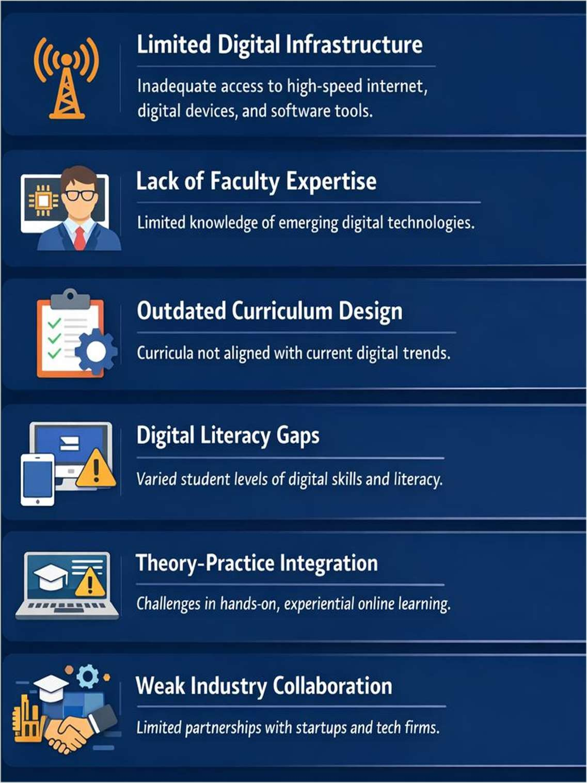

- Limited Digital Infrastructure: Inadequate access to high-speed internet, digital devices, and advanced software tools restricts effective delivery of digital entrepreneurship education. This challenge is particularly evident in developing regions, leading to unequal learning opportunities and outcomes.
- Lack of Faculty Expertise in Emerging Technologies :Many educators have limited exposure to rapidly evolving digital technologies such as artificial intelligence, data analytics, and digital platforms. This skills gap reduces the effectiveness of teaching and limits the integration of practical digital applications into entrepreneurship curricula.
- Outdated and Rigid Curriculum Design: Entrepreneurship curricula often fail to keep pace with technological advancements and digital business models. The slow process of curriculum revision results in insufficient coverage of contemporary topics such as platform-based entrepreneurship and digital innovation.
- Digital Literacy Disparities Among Learners: Students enter entrepreneurship programs with varying levels of digital skills and technological confidence. These disparities hinder uniform learning progress and reduce the effectiveness of technology-enabled teaching methods.
- Difficulty in Integrating Theory with Practice in Online Learning: Online and blended learning environments make it challenging to provide hands-on entrepreneurial experiences. The lack of real-time interaction, mentoring, and experiential activities limits practical exposure and skill development.
- Weak Industry–Academia Collaboration: Limited partnerships with startups, technology firms, and incubators reduce opportunities for experiential learning. As a result, students often lack exposure to real-world digital entrepreneurial challenges and market dynamics.

Thematical major findings:
- Entrepreneurship education is transitioning from traditional theory-based method of classes to experiential, technology-integrated, and competency-driven models to meet the demands of the digital transformation.
- From the study it is found that digital and data-driven competencies have become essential entrepreneurial skills, alongside creativity, innovation, strategic thinking, and adaptability.
- Experiential, lean startup, design thinking, and technology-enabled learning approaches are more effective in preparing students for digital entrepreneurial environments than conventional classroom methods.
- Challenges been faced while implementing digital technology driven classes such as inadequate digital infrastructure, limited faculty expertise, curriculum rigidity, and digital skill disparities hinder effective transformation.
- Strengthening industry academia collaboration policy frameworks are critical for successfully aligning entrepreneurship education with digital transformation and future workforce requirements.

Future Directions and Recommendations
Interdisciplinary Curriculum Development
Strengthening Industry– Academia Collaboration
Investment in Digital Infrastructure
Faculty Training & capacity building
Adoption of technology enabled learning model
Policy support & regulatory alignment

- Interdisciplinary Curriculum Development: Entrepreneurship education should integrate business management, digital technologies, innovation, and design thinking into a unified curriculum. This interdisciplinary approach equips learners with holistic problem-solving abilities required in digitally driven entrepreneurial environments.
- Strengthening Industry–Academia Collaboration: Collaboration with startups, industry experts, incubators, and technology firms provides students with real-world exposure and experiential learning opportunities. Such partnerships bridge the gap between theory and practice and enhance entrepreneurial readiness.
- Investment in Digital Infrastructure: Governments and institutions must invest in high- speed internet, digital labs, and advanced learning platforms. Robust digital infrastructure ensures equitable access to technology-enabled entrepreneurship education and supports innovative teaching methods.
- Faculty Training and Capacity Building: Continuous professional development programs should be introduced to enhance faculty expertise in emerging digital technologies and modern pedagogical approaches. Skilled educators are essential for effectively delivering digital entrepreneurship education.
- Adoption of Technology-Enabled Learning Models: Institutions should adopt blended learning, virtual incubators, online mentoring, and simulation-based learning tools. These models offer flexibility, scalability, and global exposure, improving the quality of entrepreneurship education.
- Policy Support and Regulatory Alignment: Policymakers should support entrepreneurship education reforms aligned with national innovation and digital economy strategies. Supportive policies, funding mechanisms, and startup-friendly regulations foster a conducive ecosystem for digital entrepreneurship.

Conclusion
Transforming entrepreneurship education in the digital era is essential for nurturing innovative, technology-oriented, and globally competitive entrepreneurs. Traditional pedagogical approaches have to evolve into dynamic, experiential, and technology-enabled learning ecosystems that foster creativity, problem-solving ability, and data-driven decision-making among students’ community. By integrating digital competencies with entrepreneurial mindset of learners will enable them to effectively navigate the complexities of modern business environments.
From a policy perspective, governments and educational institutions are concentrating on adopting a comprehensive framework that supports interdisciplinary curriculum development, strengthens industry–academia collaboration, enhances digital infrastructure, and promotes continuous faculty capacity building. Strategic policy interventions, supported by innovation- driven regulatory frameworks and startup-friendly ecosystems, can significantly accelerate the development of entrepreneurial capabilities among students.

References
- Dweck, C. S. (2006). Mindset: The new psychology of success. Random House.
- Neck, H. M., & Greene, P. G. (2011). Entrepreneurship education: Known worlds and new frontiers. Journal of Small Business Management, 49(1), 55–70.
- Fayolle, A., & Gailly, B. (2015). The impact of entrepreneurship education on entrepreneurial attitudes and intention. Journal of Small Business Management, 53(1), 75–93.
- Fleacă, E. (2017). Entrepreneurial curriculum through digital-age learning in higher education: A process-based model. TEM, Journal, 6(3), 591–598.
- OECD. (2019). Entrepreneurship education in the digital age. OECD Publishing.
- World Economic Forum. (2020). The future of jobs report. WEF.
- Kuratko, D. F. (2020). Entrepreneurship education in the 21st century. Journal of Entrepreneurship Education, 23(1), 1–10.
- Jardim,J. (2021). Entrepreneurial skills to be successful in the global and digital world: Proposal for a frame of reference for entrepreneurial education. Education Sciences, 11(7),356.
- Erdisna,E., Ridwan,M., & Syahputra,H. (2022). Developing digital entrepreneurship learning model: 4-D competencies-based for millennial generation in higher education. Utamax: Journal of Ultimate Research and Trends in Education, 4(2), 84–100.
- Sitaridis,I and Kitsios,F. (2024). Digital entrepreneurship and entrepreneurship education: A review of the literature. International Journal of Entrepreneurial Behavior & Research, 30(2/3), 277–304.

*******************************************************************

