LAXATIVE ACTIVITIES OF Securidaca longepedunculata ROOT BARK AQUEOUS EXTRACT IN LOPERAMIDE-INDUCED CONSTIPATED WISTAR RATS

S. L. Mangbon, BSc., MSc. (Author 1). Department of Human Physiology, Ahmadu Bello University, Zaria, Nigeria, Tel:+2348164767151, Email: sufficientlot@gmail.com/sufficientlot@yahoo.com
Prof. M.I.A Saleh, MBBS, MSc., PhD. (Author 2). Department of Human Physiology, Ahmadu Bello University, Zaria, Nigeria, Email: salehibrahim507@gmail.com, Tel: +2348036031271
Prof. A. Abdul Wahab, BSc., MBBS, MSc., PhD. (Author 3). Department of Human Physiology, Ahmadu Bello University, Zaria, Nigeria Tel: +2348035962471.
Prof. M. U. Kawu, DVM., M.Sc., PhD. (Co-Author), Department of Veterinary Medicine, Ahmadu Bello University, Zaria. Tel: +2348037016456
Dr. F.A Dawud B.Sc., M.Sc., PhD. (Co-Author). Department of Human Physiology, Ahmadu Bello University, Zaria, Nigeria Tel: +2348182988120
Prof. D. Sani, B.Sc., M.Sc., PhD. (Co-Author). Department of Pharmacology and Toxicology, Ahmadu Bello University, Zaria. Tel: +2348064026034. Prof. Rabiu AbduSSALAM Magaji, B.Sc., M.Sc., PhD. (Co-Author), Department of Human Physiology, Ahmadu Bello University, Zaria Tel: 08023558721 Email: rabiumagaji@gmail.com
Prof. Sunday A. Musa B.Sc., M.Sc., PhD. (Co- Author), Department of Human Anatomy, Ahmadu Bello University, Zaria, Tel: +234 8060 9015 98, Email: samusa@abu.edu.ng.

Abstract
Constipation is a digestive tract disorder that can cause painful, stiff, and infrequent stools as well as difficulty in passage of the stool. The intestines may close as a result of acute constipation, necessitating surgery. Constipation is one of several ailments that plants have long been used as a source of medicine. In loperamide-induced constipated wistar rats, the current study evaluated the laxative activity of Securidaca longepedunculata root bark aqueous extract to determine the water intake, feed intake, body weight gain, and fecal characteristics. For each objective, twenty-ﬁve animals (5 constipated and 20 non-constipated) were selected and randomly divided into ﬁve groups of ﬁve rats each. They were treated with 5, 10, and 20 mg/kg of the aqueous extract via i.p. injections, and 5 ml/kg of normal saline was administered to normal and constipated control groups. The study revealed a significant (p<0.05) increase in the number, weight, and water content of faecal pellets at 5 mg/kg, 10 mg/kg and 20 mg/kg graded doses of S. longepedunculata extract when compared to the constipated control group. There was a significant (p<0.05) decrease in water intake at 5 mg/kg, feed intake and body weight at 5 mg/kg, and 10 mg/kg doses of S. longepedunculata extract. Highest dose (20 mg/kg) of the extract caused a significant (p<0.05) increase in water intake and faecal parameters when compared to the normal and constipated control groups; thus, making the dose an effective laxative dose. Body weight decreased significantly (p<0.05) in the extract-treated group when compared to normal and constipated control groups. It was therefore concluded that graded doses (5 mg/kg, 10 mg/kg, and 20 mg/kg) of S. longepedunculata aqueous root-bark extracts are effective laxatives in albino Wistar rats and might have therapeutic potential in the management of bowel emptying disorders.

Keywords — laxative, S. longependunculata, aqueous, extract, loperamide, constipation, wistar, rats.

1.0 Introduction
1.1 The Study Background
Constipation is the delayed transit of faeces through the large intestine, which is frequently accompanied by an accumulation of large amounts of dry, hard feces in the descending colon as a result of excessive fluid absorption (Anthony, 2014). According to Benninga et al. (2005), acute constipation can lead to intestinal closure that may possibly necessitate surgery. According to Wintola et al. (2010) and Meite et al. (2010), 3–15% of the general population suffers from constipation, a very common and frequently chronic functional gastrointestinal disorder. Constipation is a common clinical issue with a constellation of symptoms including excessive straining, hard stools, a sense of incomplete evacuation or infrequent defaecation. Constipation can be brought on by a number of conditions, including drug use, fiber deficiency, metabolic issues, and anorectal issues. It is well known that loperamide can cause constipation. According to Akapa et al. (2014) and Ashafa et al. (2011), the medication is an opioid agonist anti-diarrheal agent that reduces intestinal water secretion and colonic peristalsis. This inhibition slows intestinal luminal transit and increases the time needed for faecal evacuation (Akapa et al., 2014; Ashafa et al., 2011).
Laxatives are substances that either stimulate intestinal secretion or motility to increase the frequency and ease of defaecation, or they add bulk to the intestinal contents by retaining water within the bowel lumen as a result of their osmotic effects (Ashafa et al., 2011).
In Nigeria, the plant Securidaca longepedunculata Fres. (Polygalaceae) is frequently used as a purgative (Us et al., 2019). Its common names include violet tree, Fibre tree, wild vesteria, and Rhodesian violet. It is also referred to locally as Uwar magunguna or Sanya (Hausa), Ipeta (Yoruba), Alali (Arabic), and Umfufu, mzigi (Swahili). Based on the traditional use of S. longepedunculata extracts as a purgative and laxative, this study scientifically investigated its laxative effects on the gastrointestinal tract using experimental animal models to confirm the claim of traditional healers.

1.2 Statement of the Problem
Constipation is a common gastrointestinal condition that costs communities a lot of expenses, with a prevalence range of 1% to 80% worldwide (Sanchez and Bercik, 2011). A wide geographic variation in the condition is one of its defining features. Older people who experience chronic constipation often struggle to pass stool (Suares and Ford, 2011). Accordingly, this condition has a close connection to patients' quality of life and the use of healthcare resources (Rajindrajith and Devanarayana, 2020). Constipation has serious negative effects on both one's personal and societal health (Rajindrajith and Devanarayana, 2020). Physical, social, academic, and emotional well-being are all negatively impacted by constipation in children (Vriesman et al., 2019). According to Youssef et al. (2005), children with constipation have a lower health-related quality of life than kids with severe organic gastrointestinal diseases like inflammatory bowel disease. Children with constipation also showed high rates of absenteeism from school and poor academic performance, which has serious consequences for their future as adults (Olaru et al., 2016). Constipation is regarded as a serious health issue in children, with an estimated global prevalence of 9.5% (Koppen et al., 2018).
1.3 The Study Justification
For the treatment of constipation, affected people frequently use chemical medications like Senna®, Correctol®, Exlax®, Senokot®, and Gaviscon®, which have sennosides as active ingredients. Ashafa et al. (2011) note that using these conventional medications has drawbacks including high cost, unfavorable side effects (such as stomach pain and cramps), and slow activity (up to 8 h) in treating constipation. As a result, almost half of patients with constipation are dissatisfied with how well traditional laxatives work at enhancing quality of life (Ashafa et al., 2011). As a result, focus has shifted to the use of medicinal plants, particularly in Nigeria, for the treatment of constipation (Ashafa et al., 2011). Users generally believe that plant extracts are affordable, fast acting, and easily accessible, and there are many options available (Ashafa et al., 2011). This research was therefore necessary as a result of the ongoing search for a laxative of plant origin that is more natural, potent, affordable, and accessible.
1.4 Study Aim
The present study assessed the laxative activities of Securidaca longepedunculata root bark aqueous extracts in loperamide-induced constipated wistar rats.

1.5 Specific Objectives
- To assess the phytochemical constituents of S. longepedunculata root bark aqueous extract
- To assess the lethal dose (LD₅₀) anticipated to result in 50% mortality in the population of the rats
- To assess the laxative effects of S. longepedunculata root bark aqueous extract by determining the water intake, feed intake, body weight gain and faecal properties of the rats
1.6 Null Hypothesis (H₀)
Securidaca longepedunculata root bark aqueous extract has no laxative effect in loperamide-induced constipated wistar rats.
2.0 MATERIALS AND METHODS
2.1 Collection of Plant Materials
The S. longepedunculata root bark was collected from the Department of Botany, Ahmadu Bello University Zaria. Identification and authentication were completed in the same herbarium area of the Department of Botany at Ahmadu Bello University Zaria where a voucher number was provided.
2.2 Aqueous Extraction of Plant Materials
The root bark was carefully collected, washed in clean water, and allowed to air dry. They were then ground into a rough powder. 16g of the powdered root bark was placed in a conical flask along with 120cm³ of distilled water. After shaking vigorously, the flask's contents were kept for 48 hours at room temperature with the top covered with aluminum foil. After filtering it through Whatman's No. 1 filter paper, the crude extract was then concentrated and obtained using a vacuum evaporator (Auwal et al., 2012).
2.3 Materials and Drugs
Male Albino wistar rats weighing 140-170 g, standard laboratory rodent feeds and drinking water, normal saline, digital weighing balance, loperamide hydrochloride a carboxymethyl-cellulose (products of BDH Chemicals Ltd. Poole, England), cages, blotting paper, S. longepedunculata aqueous extracts, 5ml and 1ml syringe, stomach tube or a suitable intubation cannula, cages, distilled water, universal bottles, bottled water, Maggi cubes.
2.4 Formal Ethical Approval
An ethical approval and clearance for performing the experiment was sought from the Committee on Animal Use and Care of the Ahmadu Bello University, Zaria (ABUCAUC) an approval number ABUCAUC/2022/048 was given.
2.5 Lethal Dose Determination
The Lorke (1982) method was used to determine the acute toxicity LD₅₀. Eighteen rats were used for acute toxicity testing for the determination of LD₅₀ in two phases (Lorke, 1982), and Lorke's method was used because less than half of the grouped rats dosed at 2000 mg/kg survived (Oecd, 2008). Nine rats were divided into three groups (A, B, and C) of three rats each for the first phase. They received oral treatments with extract doses of 20 mg/kg, 200 mg/kg, and 2000 mg/kg. The rats were monitored for any mortality for 24 hours. The rats were divided into three groups (A, B, and C) of three rats each, and they were given oral treatments with the extract at different doses (250 mg/kg, 500 mg/kg, and 750 mg/kg) during the second phase. The final LD₅₀ value was calculated using the highest dose that results in no mortality and the lowest dose that results in mortality in both phases after 24 hours of observation of the animals. The following formula (Oecd, 2008) describes the lethal dose anticipated to result in 50% mortality in the population of the rats:
LD₅₀ = √ 500 x 750 = 612mg/kg
Doses of 5 mg/kg, 10 mg/kg and 20 mg/kg of S. longipedunculata as adopted from Olumayokun et al. (1999) were used in the experiment since it’s below the LD₅₀ and has been confirmed safe.
2.6 Qualitative Phytochemical Screening
Several classes of secondary metabolites from S. longepedunculata were examined in the aqueous extracts using the established techniques described by Roghini and Vijayalakshmi (2018), Soforawa (1993), and Harborne (1973) with minor modifications. Alkaloids, steroids, anthraquinones, glycosides, flavonoids, saponin, tannins, terpenoids, ninhydrin, and coumarins were all examined in the extract.
2.6.1 Test for Saponins
Frothing test: In order to perform a frothing test for saponin, 2g of the extract was dissolved in 10ml of distilled water. After vigorously shaking for 30 seconds, it was left for 30 minutes. Saponin was detected when a honey comb-shaped froth formed for more than 30 minutes.
2.6.2 Test for Glycosides
Chloroform-Ammonia Test: 2 ml of extract were mixed with 3 ml of chloroform and 10 ml of 10% ammonia solution. Pink color formation indicated glycoside presence. (Roghini and Vijayalakshmi, 2018)
2.6.3 Test for Tannins
Test for ferric chloride: 10ml of distilled water were used to dissolve 0.5g of extract, and the resulting solution was filtered. To the filtrate, 1-2 drops of ferric chloride solution were added. The appearance of green precipitates and the formation of a blue-black precipitate indicated the presence of hydrolyzable tannins, respectively.
2.6.4 Test for Anthraquinones
Bornirager's Test: After being shocked with 10ml of benzene, 2g of the extract was filtered. The filtrate was stirred after 5ml of a 10% ammonia solution was added. Free anthraquinone was present when a pink-red or violet color was produced.
2.6.5 Test for Flavonoids
Test for sodium hydroxide: 0.5 g of plant material were shaken with petroleum ether to remove the lipid layer. The filtered defatted residue was dissolved in 20 ml of 80% ethanol. The subsequent test was performed using the filtrate: A test tube containing 3ml of the filtrate and 4ml of 1% potassium hydroxide was used to determine the color. Flavonoids were indicated by a dark yellow color.
2.6.6 Test for Terpenoids
Salkowski's Test: To create a layer, 5 ml of the extract was combined with 2 ml of chloroform and 3 ml of concentrated sulfuric acid. Terpenoids were present because the interface developed a reddish-brown coloration.

2.6.7 Test for Alkaloids
Dragendoff's/Mayers reagents test: In two separate test tubes containing 10 ml of the extract, 2–3 drops of each of the two reagents were separately added. Alkaloids were indicated by an orange-red precipitate, turbidity with Dragendoff's reagent, or white precipitates with Mayer's reagent.
2.6.8 Test for Steroids
Test using chloroform and concentrated sulphuric acid: 1 ml of the extract was mixed with an equal amount of chloroform, and a few drops of concentrated sulphuric acid were also added. The presence of steroids was indicated by a brown ring, and the presence of phytosteroids was indicated by a bluish brown ring.
2.6.9 Ninhydrin Test
Ninhydrin reagent test: 2 drops of 0.2% ninhydrin reagent were added to Two milliliters of the extract and heated for five minutes. The development of blue color denotes the presence of amino acids.
2.6.10 Test for Coumarins
Test with sodium hydroxide: 1ml of the extract was mixed with 10ml of sodium hydroxide. The presence of coumarins is indicated by the formation of a yellow color.

2.7 Induction of Constipation
In contrast to the normal control rats, who only received saline solution, the animals were given an oral dose of 1 ml of loperamide (3 mg/kg body weight in 0.9% sodium chloride) to induce constipation. Constipation in the rats was indicated by the passage of reduced, hard, and dry fecal pellets (Bustos et al., 1991).
2.8 Laxative Effect Determination
This was done using the methods outlined by Mikhail et al., (2015) and Olumayokun et al., (1999) with minor modifications. 25 male adult albino wistar rats were kept individually in cages with blotting paper floors, weighing an average of 160 g each. Six hours prior to the start of the experiment, food and water were withheld, and any animals that produced wet or watery feces during this time were removed. Twenty-ﬁve animals (N=25), twenty constipated and five non-constipated were selected and randomly divided into ﬁve groups of ﬁve rats each. They were treated with 5 mg/kg, 10 mg/kg and 20 mg/kg of the aqueous extract via i.p. injections, and 5ml/kg of normal saline was administered to the animals in the normal control and constipated control groups. Drinking water was restored after treatment and the animals were observed for 24 hrs. The total number of wet spots faeces in blotting paper produced by each rat was noted. The water intake, feed intake, body weight gain/loss, number, water content, weight of faecal pellets of all the rats were recorded during the experiment. The total number of wet faeces, weight, and water content of the fecal pellets was determined. The water content was calculated as the difference between the wet and dry weights of the fecal pellet (Ashafa et al., 2011; Olumayokun et al., 1999).
Water content = Fecal pellet wet weights – Fecal pellet dry weights
2.11 Data Analysis
Data from this research were summarized and analyzed statistically with one-way analysis of variance (ANOVA) using SPSS 25.0 and were expressed as mean ± standard error of mean (M±SEM), followed by Tukey’s post hoc test of multiple comparisons to compare the effects between control and test groups. Values with P< 0.05 were considered statistically significant.

3.0 RESULTS
3.1 Phytochemical Constituents of S. longepedunculata Root-Bark Aqueous Extracts
Table 3.1 shows the qualitative phytochemical analysis conducted on S. longepedunculata extract which indicated the presence of the following plant’s secondary metabolites viz: Saponins, Glycosides, Tannins, Anthraquinone, Flavonoids, Triterpenoids, Alkaloids, Steriods, Ninhydrin and Coumarins were absent.
Table 3.1: Phytochemical Constituents of S. longepedunculata Root-Bark Aqueous Extracts
Constituents Inferences
Saponins +
Glycosides +
Tannins +
Anthraquinone +
Flavonoids +
Terpenoids +
Alkaloids +
Steriods +
Ninhydrin -
Coumarins -

key: + denotes presence, - denotes absence
3.2 Acute Toxicity Test of S. longepedunculata Root-Bark Aqueous Extracts
Table 4.2 shows acute toxicity test results of S. longepedunculata extracts. At phase one of the experiment, three mortalities were recorded at 2000mg/kg dose of the extract administered, whereas, at phase two only a single mortality was recorded at 750mg/kg dose of the extract administered. The LD₅₀ was calculated as thus:
LD₅₀ = √ 500 x 750 = 612mg/kg
Table 3.2: Acute Toxicity Test of S. longepedunculata Root-Bark Aqueous Extracts
Phases Doses (mg/kg) Rats Survivors Mortality
Phase One
Group A 20 3 3 0
Group B 200 3 3 0
Group C 2000 3 0 3
Phase Two
Group A 250 3 3 0
Group B 500 3 3 0
Group C 750 3 2 1
LD₅₀ = √ 500 x 750 = 612mg/kg

3.3 Effect of S. Longepedunculata Root-Bark Aqueous Extracts on Water Intake
Figure 3.1 shows a significant decrease (p<0.05) in water intake in the constipated group (13.86 ± 0.96 ml) compared to normal control (20.44 ± 0.75 ml) water intake was significantly increased (p<0.05) in the S. longepedunculata extract treated group at 10 mg/kg (22.42 ± 2.03ml) and 20mg/kg (24.69 ± 1.64ml) compared to constipated control. The 5mg/kg (14.50 ± 0.41ml) also showed an increase compared to constipated control but was not statistically significant.
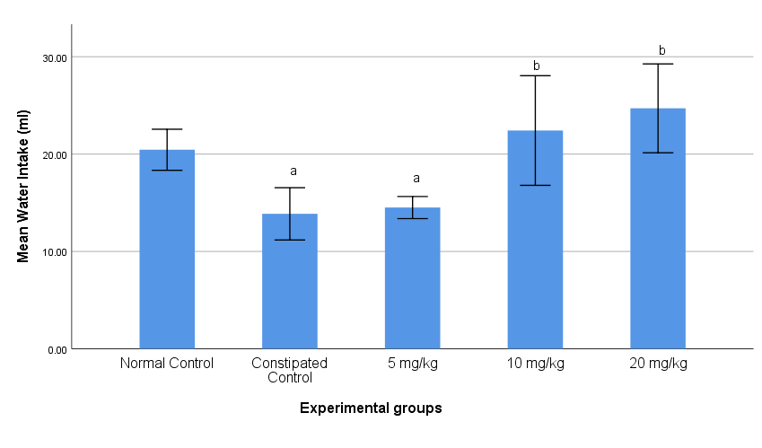

Figure 3.1: Effect of S. longepedunculata Root-Bark Aqueous Extracts on Water Intake
Key: Bars with superscript letter “a” show significant decrease (p<0.05) as compared to normal control. Bars with superscript letter “b” show significant increase (p<0.05) as compared to constipated control group.

3.4 Effect of S. longepedunculata Root-Bark Aqueous Extracts on Feed Intake
Figure 3.2 shows a significant decrease (p<0.05) in feed intake in the constipated group of wistar rats (16.67 ± 0.48g) compared to normal control (20.83 ± 0.44g). Similarly, feed intake was significantly decreased (p<0.05) at 5 mg/kg (12.11 ± 0.38g), 10 mg/kg (12.72 ± 0.41g) compared to normal control and constipated control. However, there was a significant increase (p<0.05) in feed intake in the 20 mg/kg (31.37 ± 0.60g) treated group compared to normal and constipated control.
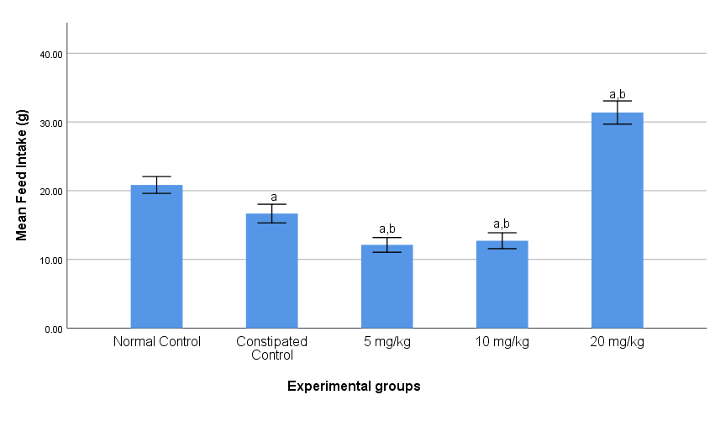

Figure 3.2: Effect of S. longepedunculata Root-Bark Aqueous Extracts on Feed Intake
Key: Bar with superscript letter “a” shows significant decrease (p<0.05) as compared to normal control. Bars with superscript letter “ab” show significant decrease in 5 mg/kg and 10 mg/kg and a significant increase (p<0.05) in 20 mg/kg group as compared to normal control and constipated control group.

3.5 Effect of S. longepedunculata Root-Bark Aqueous Extracts on Body Weight
Figure 3.3 shows a significant increase in body weight in the constipated group wistar rats (8.21 ± 0.60g) compared to normal control (2.53 ± 0.22g). The body weight was significantly decreased (p<0.05) in the S. longepedunculata extract treated group at 5 mg/kg (1.76 ± 0.24g), 10 mg/kg (3.29 ± 0.38g) and 20 mg/kg (3.36 ± 0.48g) compared to constipated control.
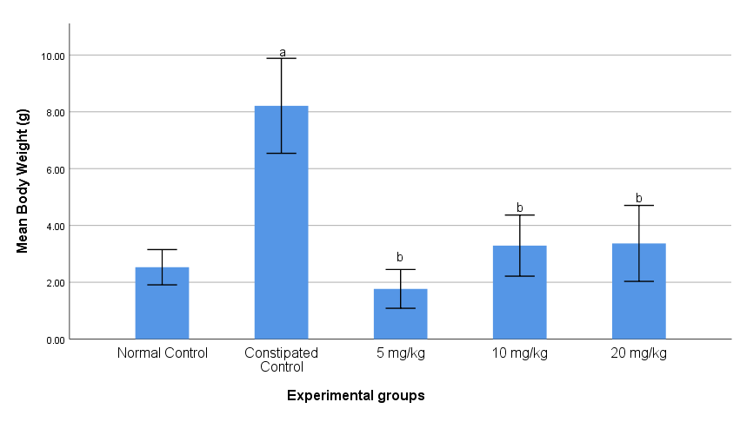
Figure 3.3: Effect of S. longepedunculata Root-Bark Aqueous Extracts on Body Weight
Key: Bar with superscript letter “a” shows significant increase (p<0.05) as compared to normal control. Bars with superscript letter “b” show significant decrease (p<0.05) as compared to constipated control group.

3.6 Effect of S. longepedunculata Root-Bark Aqueous Extracts on Faecal Number
Figure 3.4 shows a significant decrease (p<0.05) in faeces number in the constipated group wistar rats (63.00 ± 1.04g) compared to normal control (84.00 ± 1.51). The faeces number was significantly increased (p<0.05) in the S. longepedunculata treated group at 5 mg/kg (83.40 ±1.20g) and 10 mg/kg (86.80 ± 1.02g). Similarly, there was significant increase (p<0.05) in faecal numbers at 20 mg/kg (126.80 ± 5.28g) compared to normal and constipated control.

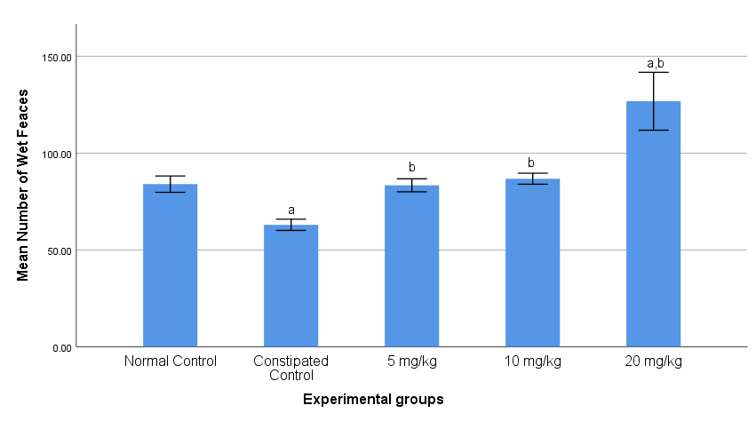
Figure 3.4: Effect of S. longepedunculata Root-Bark Aqueous Extracts on Faecal Number
Key: Bar with superscript letter “a” shows significant decrease (p<0.05) as compared to normal control. Bars with superscript letter “b” show significant increase (p<0.05) as compared to constipated control. Bar with superscript letter “ab” shows significant increase (p<0.05) as compared to normal control and constipated control groups.

3.7 Effect of S. longepedunculata Root-Bark Aqueous Extracts on Faecal Parameters
Figure 3.5 shows a significant decrease (p<0.05) in faeces wet weight in the constipated group wistar rats (6.65 ± 0.26g) compared to normal control (9.67 ± 0.06g). Faeces wet weight was significantly increased (p<0.05) in the S. longepedunculata root-bark aqueous extract treated group at 5 mg/kg (9.65 ±0.36g), 10 mg/kg (9.77 ± 0.08g). Similarly, there was a significant (p<0.05) increase in faecal wet weight at 20 mg/kg (13.68 ± 0.53) compared to normal and constipated control. There was a significant decrease (p<0.05) in faecal dry weight in the constipated group wistar rats (5.16 ± 0.21g) compared to normal control group (6.32 ± 0.15g). Faeces dry weight was significantly increased (p<0.05) in the S. longepedunculata extract treated group at 5 mg/kg (6.32 ±0.10g), 10 mg/kg (6.23 ± 0.11g). Similarly, there was a significant increasein faecal weight (p<0.05) at 20 mg/kg (7.08 ± 0.27g) compared to normal and constipated control.
There was a significant decrease (p<0.05) in faecal water content in the constipated group (1.45 ± 0.13g) compared to normal control (3.34 ± 0.15g). Faeces water content was significantly increased (p<0.05) in the S. longepedunculata extract treated group at 5 mg/kg (3.32 ± 0.09g) and 10 mg/kg (3.54 ± 0.17g) as compared to normal and constipated control groups. Similarly, there was also a significant increase in faecal water content (p<0.05) at 20 mg/kg (7.17 ±0.62g) compared to normal and constipated control.

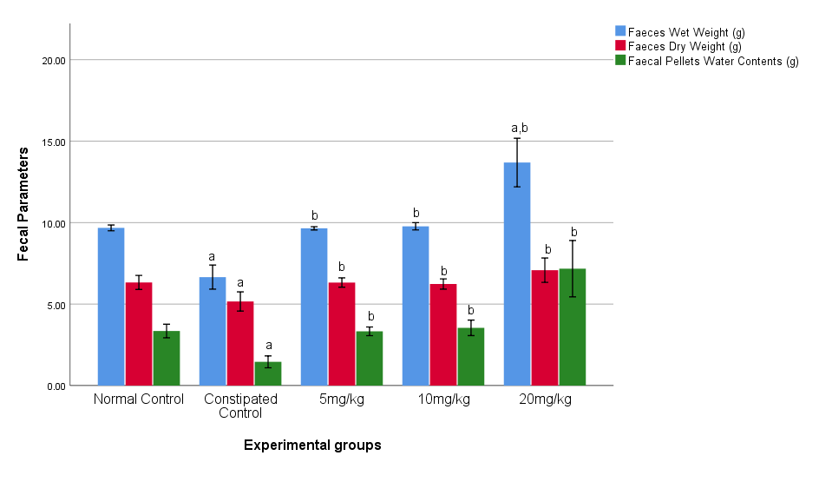
Figure 3.5: Effect of S. longepedunculata Root-Bark Aqueous Extracts on Fecal Parameters
Key: Bars with superscript letter “a” show significant decrease (p<0.05) as compared to normal control. Bars with superscript letter “b” show significant increase (p<0.05) as compared to constipated control. Bar with superscript letter “ab” shows significant increase (p<0.05) as compared to normal control and constipated control groups

4.0 DISCUSSION
Phytochemical is a term used to describe plant secondary metabolite. Plants naturally produce chemicals called phytochemicals, which are not necessary for the majority of the metabolic processes that take place within them. According to Srivastava et al. (2012), phytochemicals are primarily produced in response to environmental pressures such as unfavorable climatic conditions, immune responses to infectious agents, etc. The current study has verified the presence of saponins, glycosides, tannins, anthraquinones, flavonoids, triterpenoids, alkaloids, and phytosteriods in the aqueous extracts from S. longepedunculata root-bark. The results of Etuk et al. (2006), who reported the presence of flavonoids, alkaloids, saponins, triterpenoids, and volatile oils in the root-bark aqueous extract of S. longepedunculata, are therefore consistent with this. The aqueous extract of the root and leaf contains significant amounts of glycosides, saponins, and tannins, according to Maiga et al. (2005).
The LD₅₀ for oral administration of S. longepedunculata root-bark aqueous extract was determined in the current study to be 612 mg/kg. However, in the constipated test group III that received 20 mg/kg of the extract via intraperitoneal route, acute toxicological effects including reduced feeding, weight loss, reduced urination, and reduced activity were observed. Similar observations was reported by Adeyemi et al., (2010) who reported LD₅₀ values of 740 mg/kg and 20 mg/kg body weight for oral and intraperitoneal application routes of aqueous root-bark extract of the plant respectively, while Dapar et al., (2007) and Keshebo et al., (2014) reported LD₅₀ values 547 mg/kg and 37 mg/kg LD₅₀ values for aqueous and ethanol S. longepedunculata root-bark extracts via oral and intraperitoneal route respectively. The aqueous extracts of S. longepedunculata had an LD₅₀ of 771 mg/kg, according to Auwal et al. (2012). However, Etuk et al. (2006) found that when various doses (300, 900, and 2700 mg/kg body weight) of the aqueous root extract were given orally once daily for 28 days, no deaths were reported. The graded doses of S. longepedunculata extract administered at 5 mg/kg, 10 mg/kg, and 20 mg/kg were toxicologically safe, according to the LD₅₀ value of 612 mg/kg recorded in this study.
In the present study, when compared to constipated control, the root-bark aqueous extract of S. longepedunculata at doses of 10 mg/kg and 20 mg/kg significantly (p<0.05) increased water intake, faecal pellet weight, number of faecal pellets, and water content of faecal pellets at doses of 5 mg/kg, 10 mg/kg, and 20 mg/kg. The results demonstrate a dose-dependent pattern, indicating that higher doses of 10 mg/kg and 20 mg/kg had more laxative effects. The secondary metabolites (flavonoids, glycosides) of the extract may have an antagonistic effect on loperamide, which lowers intestinal reabsorption of water and electrolytes and increases colonic peristalsis. This is one potential mechanism for the laxative effect of the extract. According to well-established research, loperamide eliminates experimental osmotic diarrhea by affecting intestinal motility and, as a result, lowering the flow of faecal matter into the colon (Meite et al., 2010). The polyphenol (Flavonoids) in the extract may have had a laxative effect by stimulating peristalsis and, like other laxatives, water reabsorption reduction, which softens stools (Meite et al., 2010). The majority of natural laxatives work by stimulating Cl⁻ secretion and/or inhibiting Na⁺ reabsorption, which causes fluid to accumulate and be retained while also increasing colonic motility (Meite et al., 2010).
Furthermore, in the present study, there was a significant (p<0.05) decrease in water intake and feed intake at dose 5 mg/kg, feed intake at 5 mg/kg and 10 mg/kg as compared to normal control and constipated control groups; while body weight also decreased significantly (p<0.05) in the extract treated group as compared to constipated control groups Despite the fact that the feed intake varies between the groups, the constipated rats gained more body weight than the groups that received the extract treatment. The extra weight may be explained by the buildup of faecal pellets in their bodies (Niwa et al., 2002). Similar findings were reported by Nafiu et al. (2015), who found that giving rats with constipation L. cupanioides extract can effectively normalize their defecation frequency, weight gain, faecal volume, and colon motility. This could be as a result of the natural anthraquinone derivatives that are present in the root extract and have been linked to laxative effects (Nweje et al., 2019). According to Nweje et al. (2019), this substance may work by upsetting the balance between water secretion into the intestinal lumen and water absorption from the lumen via an active sodium transport mechanism.

5.0 SUMMARY, CONCLUSION AND RECOMMENDATIONS

5.1 Summary
The present study has established that S. longepedunculata root-bark aqeuous extract at doses of 10 mg/kg and 20 mg/kg significantly (p<0.05) increased water intake; number of faecal pellets at doses of 5 mg/kg, 10 mg/kg and 20 mg/kg; weight of faecal pellets at doses of 5 mg/kg, 10 mg/kg, 20 mg/kg; and water content of faecal pellets at doses of 5 mg/kg, 10 mg/kg, 20 mg/kg respectively as compared to constipated control group. The study showed a dose dependent response with higher doses of 10 mg/kg and 20 mg/kg being more effective laxative doses.

5.2 Conclusion
Therefore, from the findings of this study, it was concluded: graded doses of S. longepedunculata aqueous root-bark extracts at 5 mg/kg, 10 mg/kg and 20 mg/kg have effective laxative effects in Wistar rats. High dose of 20 mg/kg S. longepedunclatais has effective laxative principles by increasing the number, weight and water content of faecal matter.

5.3 Recommendations
Based on the findings of this study, we therefore make the following recommendations:
- Graded doses (5 mg/kg, 10 mg/kg and 20 mg/kg) of S. longepedunculata root-bark aqueous extracts might have therapeutic potential in the management of constipation.
- Further studies should be conducted to determine the effect of S. longepedunculata root-bark aqueous extracts on intestinal and gastric contractility rate.
- Further studies should be conducted to determine the histopathological effects S. longepedunculata root-bark aqueous extract on the GIT to ascertain its anti-ulcerative potentials.
- Further studies should be conducted to determine the mechanism(s) of action of S. longepedunculata on GIT secretions and contractility as compared to standard stimulant laxative drug.

5.4 Contributions to Knowledge
Graded doses of of S. longepedunculata extracts at 5 mg/kg, 10 mg/kg and 20 mg/kg significantly (p<0.05) increased water intake, number of faecal pellets, weight of faecal pellets, and water content of faecal pellets of constipated wistar rats when compared to normal and constipated controls. Therefore, it can be used for the development of laxatives of plant origin.

5.5 Conflict of Interest
None declared
5.6 Acknowledgement
My gratitude goes to God Almighty for His love, protection, guidance and inspiration from the onset to the successful completion of this course. My appreciation goes to the people who were influential in this work, my studies, and my professional growth. My advisors and mentors, Prof. M.I.A Saleh, Prof. A. Abdulwahab, Prof M. U. Kawu, Prof. D. Sani who have influenced my professional and personal life in numerous ways and devoted time making useful constructive criticisms and suggestions. I’am grateful, may the Almighty God reward you all in hundredfold. My special gratitude goes to my able talented and tireless lecturers, Prof. A. Mohammed, Prof. R. A. Magaji, Prof. M.I.A Saleh, Prof. A. Abdulwahab, Prof. I. G Bako, Prof. Y. Tanko, Dr. J. Abdulazeez, Dr. A. H. Umar, Dr. M. A Umar, Dr. M. B. Akor-Dewu, Dr. F. A. Dawud, Dr. J. Tende, Dr. N.S Emmanuel, Dr. Sheriff and Dr. Y. Yusuf; who took sincere interest in my development and showed me that they were committed to seeing me become the best I could be. I also wish to register my sincere thanks for the academic and moral support of Prof. S. A. Musa and Mrs. Lot Mangbon, whose encouragement have made this dissertation work less stressful. To all of these people, I will be forever grateful. I also want to appreciate all other lecturers of the Department of Human Physiology, Faculty of Basic Medical Sciences, College of Medical Sciences who contributed in various ways making this work a success. May the Almighty God bless you all. I am also most grateful to all Human Physiology laboratory technicians and research assistants for their tireless effort in ensuring the successful completion of the laboratory work. May God almighty bless and reward you all. Finally, my appreciation goes to my beloved family members, especially my parents Mr/Mrs Lot Mangbon and uncle Amos Mangbon who have been unfailing support throughout my studies and every endeavor I have undertaken. Special thanks to my friends and classmates, for your prayers, love and encouragement during my period of study. May the Almighty God abundantly reward you all.
REFERENCES
Adeyemi, O. O., Akindele, A. J., Yemitan, O. K., Aigbe, F. R., and Fagbo, F. I. (2010). Anticonvulsant, anxiolytic and sedative activities of the aqueous root extract of Securidaca longepedunculata Fresen. Journal of Ethnopharmacology, 130(2): 191–195.
Akapa, T. C., Obidola, S. M., and Philip, F. O. (2014). Loperamide induced constipated wister rats: Laxative role of aqueous extract of acacia Ataxacantha leaves. World journal of pharmacy and pharmaceutical sciences. 3(12), 189--199
Anthony, E. O. (2014). Constipation in pregnancy and the effect of vegetable consumption in different socio–economic class in warri, delta state. Journal of Medical and Applied Biosciences. 3(4):13
Ashafa, A. O. T., Sunmonu, T. O., Abass, A. A., and Ogbe, A. A. (2011) Laxative potential of the ethanolic leaf extract of Aloe vera (L.) Burm. f. in Wistar rats with loperamide induced constipation. Journal of Natural Pharmaceuticals, 2(3), pp. 161.
Auwal, S., Atiku, M., Wudil, A., and Sule, M. (2012). Phytochemical composition and acute toxicity evaluation of aqueous root bark extract of Securidaca longipedunculata (Linn). Bayero Journal of Pure and Applied Sciences, 5(2): p. 67-72
Benninga, M., Candy, D. C., and Catto-Smith, A. G. (2005). The Paris Consensus on Childhood Constipation Terminology (PACCT) Group. Journal of Pediatrics, Gastroenterology and Nutrition, 40:273–5.
Bustos, D., Ogawa, K., Pons, S., Soriano, E., Bandi, J. C., and Bustos, Fernández, L. (1991). Effect of loperamide and bisacodyl on intestinal transit time, fecal weight and short chain fatty acid excretion in the rat. Acta Gastroenterology Latinoam, 21: 3-9
Dapar, L. P. M., Aguiyi, C. J., Wannang, N. N., Gyang, S. S., and Tanko, M. N. (2007). The histopathologic effects of Securidaca longepedunculata on heart, liver, kidney and lungs of rats. African Journal of Biotechnology, 6(5), 591–595.
Etuk, E. U., Adebiyi, R. A., Elsa, A. T., and Agaic, B. M. (2006). Acute and subchronic (28-day) oral toxicity studies of the aqueous root extract of Securidaca longepedunculata fresen (polygalaceae) in mice. International Journal of Pharmacology, 2(4), 421–425.
Harborne, J. B. (1973). Phytochemical Methods: A Guide to Modern Techniques of plant Analysis. Chapman and Hall Ltd., London. P. 279
Keshebo, D. L., Choudhury, K., & Dekebo, and A. H. (2014). Investigation on Toxicity, hypoglycemic effect of the root bark of Securidaca longepedunculata Fresen (Polygalaceae) and determination of heavy metals in it. Scholars Research Library Annals of Biological Research, 5(6), 15–19.
Koppen, I. J. N., Vriesman, M. H., Saps, M., Rajindrajith, S., Shi, X., and van Etten-Jamaludin, F. S., (2018). Prevalence of Functional Defecation Disorders in Children: A Systematic Review and Meta-Analysis. Journal of Pediatrics, 198:121-30.
Lorke, D., Bass, R., Gűnzel, P., Henschler, D., Kȍnig, J., Neubert, D., Shűtz, E., Schuppan, D., and Zbinden, G. (1982). LD₅₀ Versu Acute Toxicity, Critical Assessment of the Methodology Currently in Use. Archives of Toxicology, 51: 183-186
Maiga, A., Diallo, D., Fane, S., Sanogo, R., Paulsen, B. S., & Cisse, B. (2005). A survey of toxic plants on the market in the district of Bamako, Mali: Traditional knowledge compared with a literature search of modern pharmacology and toxicology. Journal of Ethnopharmacology, 96(1–2), 183–193.
Meite, S., Bahi, C., Yeo, D., Datte, J. Y., Djaman, J. A., and N’guessan, D. J. (2010). Laxative activities of Mareya micrantha (Benth.) Mull. Arg. (Euphorbiaceae) leaf aqueous extract in rats. BMC Complement Altern Med, 10:7-11.
Nafiu M. O., Abdulsalam T. A., Jimoh R. O., and Kazeem M. I. (2015). Ameliorative Effect of Lecaniodiscus cupanioides(Sapindaceae) Aqueous Root Extract in Loperamide-Induced Constipated Rats. Tropical Journal of Pharmacological Research, 14(6): 1057
Niwa, T., Nakao, M., Hoshi, S., Yamada, K., Inagaki, K., and Nishida, M. (2002). Effect of dietary fiber on morphine-induced constipation in rats. Bioscience, Biotechnologyand Biochemistry Journal, 66,1233-40.
Nweje-Anyalowa, P. C., Idakwoji P. A., Iserhienrhien L. O., Sheneni V. D and Momoh T. B (2019). Laxative Effect of Aqueous Extract of Sida acuta Leaves in Loperamide-induced Constipation in Wistar Rats. Asian Journal of Research in Medical and Phatmaceutical Sciences, 6(1):1-7
Obidike N. A. (2012). Effect on Crude Oil on Intestinal Motility and Histology of Illeum of Wistar Rats. Biomedical and Pharmacology Journal, 5(1). p. 2
Organisation for Economic Co-operation and Development (OECD) (2008). OECD Information Technology Outlook, Paris.
Olaru, C., Diaconescu, S., Trandafir, L., Gimiga, N., Olaru, R. A., and Stefanescu, G.(2016). Chronic Functional Constipation and Encopresis in Children in Relationship with the Psychosocial Environment. Gastroenterology Research and Practice, 78(2). p 8576.
Olumayokun A. Olajide, F.F. Ajayi, A.I. Ekhelar, S.O. Awe, J.M. Makinde and Alada A.R.A. (1999). Gastrointestinal Tract Effects of Securidaca longepedunculata Root Extract, Pharmaceutical Biology, 37:2, 134-137
Rajindrajith, S., and Devanarayana, N. M. (2020). Constipation in Children: The Bird’s Eye view. Galle Medical Journal, 25(3), 69-71
Roghini and Vijayalakshmi, (2018). Phytochemical screening, quantitative analysis of flvonoids and minerals in ethanolic extracts of Citrus paradisi. International journal of pharmaceutical science and researh, 9(11): 1000-1006
Sanchez, M. I., and Bercik, P. (2011). Epidemiology and burden of chronic constipation. Canadian Journal of Gastroenterology, 25.
Sofowora, E. A. (1993). Phytochemical screening of Nigerian medicinal plants. Part II L loydia, 41(3):234-2
Suares, N. C., and Ford, A. C. (2011). Systematic review: the effects of fibre in the management of chronic idiopathic constipation. Alimentary Pharmacology and Therapeutics, 33: 895–901.
Srivastava, N., Chauhan, A. S., and Sharma, B. (2012). Isolation and Characterization of Some Phytochemicals from Indian Traditional Plants. Biotechnology Research International, 2012, 1–8.
Us, A., Uh, D., Ibrahim H, and Bob, M. (2019). Science Arena Publications Specialty Journal of Chemistry A Review on African Violet Tree (Securidaca longipedunculata) : A Traditional Drug with Multiple Medicinal Uses. 4(3): 7–14.
Vriesman, M. H., Rajindrajith, S., Koppen, I. J. N., van Etten- Jamaludin, F. S., and van Dijk M., Devanarayana, N. M. (2019). Quality of Life in Children with Functional Constipation: A Systematic Review and Meta-Analysis. Journal of Pediatrics,214; 141-50.
Wintola, O. A., Sunmonu, T. O., and Afolayan, A. J. (2010). The effect of Aloe ferox Mill. in the treatment of loperamide-induced constipation in Wistar rats. Gastroenteroogy10: 95-9.
Youssef, N. N., Langseder, A. L., Verga, B. J., Mones, R. L., and Rosh, J. R. (2005). Chronic childhood constipation is associated with impaired quality of life: a case-controlled study. Journal of Pediatrics, Gastroenterology and Nutrition, 41(1): 56-60.

